Morgan_Fiona_2501925-BMDS7007-CW1.docx
Assignement Title: Digital Strategy Evaluation Report
I confirm this essay is my own original work and does not include text created by a genterated artificial intelligence tool.

Title: A critical evaluation of Aneurin Bevan University Health Boards digital transformation Stategy- ‘Digital Strategy, Transformation through Digital 2019’.


(Digital Healthcare Planning And Strategy Powerpoint Presentation Slides | Presentation Graphics | PowerPoint PPT Presentation Example | Slide Templates, no date)(Digital Healthcare Planning And Strategy Powerpoint Presentation Slides | Presentation Graphics | PowerPoint PPT Presentation Example | Slide Templates, no date)

Executive Summary
This report evaluates the Aneurin Bevan University Health Boards (ABUHB) 2019 Digital strategy – ‘Digital Strategy, Transformation through digital’. It identifies implementation gaps caused by lack of detail and direction.
The digital stratagy’s focus was to empower patients to take care of their own healthcare and provide a more viable way of working for staff through digital technology. It highlighted the need for accessable systems for patients, staff and stakeholders to provide care and support nearer to the patients community setting.The health board has been dedicated into implementing digital projects which are at different stages of their completion- from citizen portal, welsh nursing records to prescribing systems.
This report evaluated the key elements of the strategy by using a triangular analysis of SWOT, PESTEL and NHS provider frameworks tools, allowing a multi-faceted analysis providing different perspectives of ABUHB’s digital strategy. The analysis showed the health boards vision to incorperate digital into their values with specific goals and themes.The analysis magnifies how the strategy has limited guidance and detail of implementation of digital within the health board. The implementation of intergration to all wales should have focussed more on standardisation within the strategy. With ABUHB covering a varyed demographic areas, the strategy needed to concentrate on connnecting digitally with rural areas to ensure inclusion. The strategy had scope gaps therefore lacked direction which in turn could have caused delays or scope creep when implementation of projects.
Busniness Drivers
ABUHB was established in 2009 and provides intergrated acute, primary and community care providing support to the population of 650,000 people and employing over 16,000 staff covering the county of Gwents, five local boroughs: Blaenau Gwent, Caerphilly, Monmouthshire, Newport, and Torfaen. The demographics are diverse from urban areas, rural countryside to South Wales valleys (Aneurin Bevan University Health Board, 2025). Figure 1 illustrates ABUHB geographical Coverage of ABUHB.
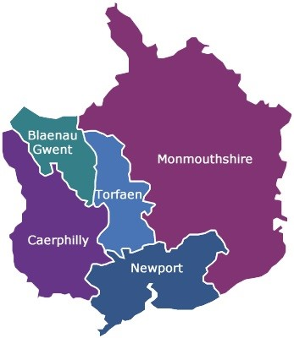
Figure 1 Map of gwent(Map_of_Gwent.jpg - Aneurin Bevan University Health Board, no date)
ABUHB has four large district hospitals and vast amount of community and mental health facilities. Figure 2 shows the facilities ABUHB digital strategy would need to cover across Gwent.
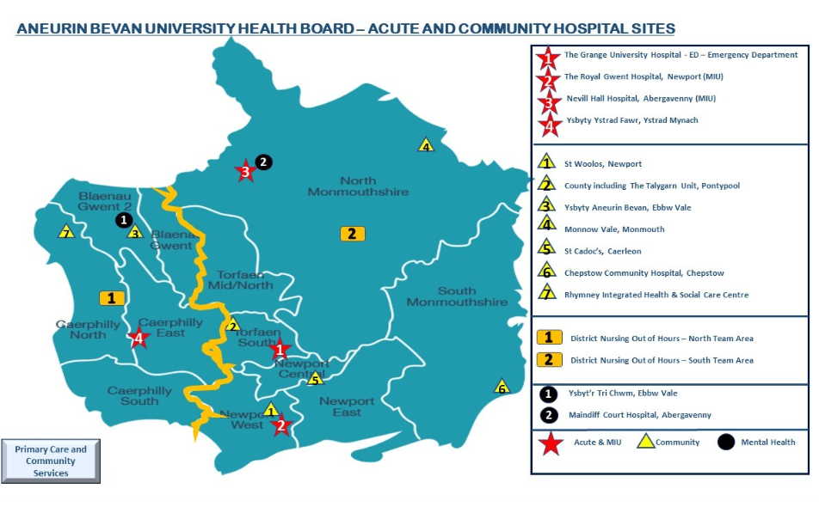 Figure 2 Map of ABUHB’s Facilities (Aneurin Bevan University Health Board, 2026a).
The ABUHB’s role is to ensure efficient planning and to deliver NHS systems, using strong governance framework to be able to achieve the high standards needed to provide the best care to patients. The digital strategy must be versatile enough to encompass the wide and varied demographic coverage and ABUHB’s facilities to provide care and support to the population of Gwent. Due to these diverse demographics (urban vs valleys) they create a complex environment, therefore mindfulness of a ‘one size fits all’ approach to digital could lead to failure due to varying sensitivities. Using the Complex Adaptive System theory would assist in making adaptions to ensure inclusivity (The Health Foundation, 2010).
Digital technology is always evolving and the National Health Service (NHS) must not fall behind, therefore digital transformation stategies within the NHS are essential to ensure better patient care. The welsh government in 2015 wrote ‘A Digital Health and Social Care Strategy for Wales’ (Welsh Government, 2015). The main focus was to use technology to provide greater access to information, to help improve health and well-being to Wales’s population. The strategy wanted health care professionals to have the necessary digital tools to deliver high quality care. The stratgey wanted to empower and enable both staff and service users to be able to access information through digital platforms, ensuring support to those who cannot access digital information and provide an alternative (Welsh Government, 2015). Therefore this strategy wanted to transform services digitally accross Wales to ensure a better future. Figure 3 demonstrates what the health boards across Wales would need to consider when writing their digital strategy.
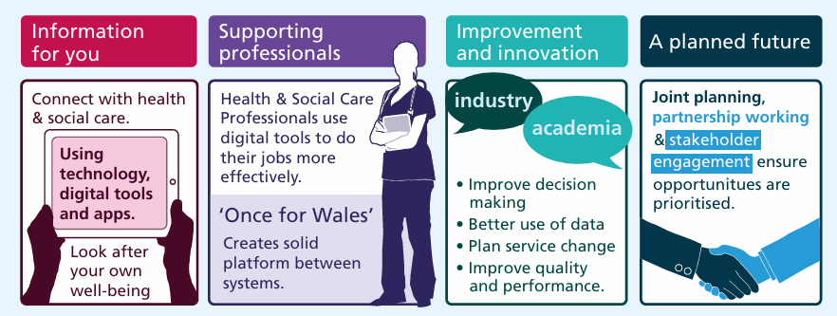
Figure 3 4 main principles of the A digital Health aand Social Care Stratagy for Wales (Welsh Government, 2015)
Consequently ABUHB established a digital stragegy in 2019 (Digital Strategy,Trasformation through digital) to address these guidelines. ABUHB took its focus from the Well-being of Future Generations Act 2015 and the Social Services and Well-being Act 2014 (Aneurin Bevan University Health Board, 2019)to write the digital strategy for their health board. Both of these Acts influenced ABUHB to look at health and social care differently, moving towards prevention health and community based care and delivering through a digital approach (Aneurin Bevan University Health Board, 2019).The stratagy needed to deliver 4 key elements of the Welsh govements colabrative approach to health and social care through providing digital means:
- Improving population health and wellbeing.
- Having better quality and accesable health care.
- Having high value care.
- Having a motivated and sustainable health and social care workforce.
(The Welsh NHS Confederation, 2019),
The strategy was influenced by ABUHB’s Clinical Furtures strategy (Aneurin Bevan University Health Board, 2019) This strategy was establish to ensure a sustainable health and care service across the 5 boroughs in Gwent. Figure 4 demonstrates how ABUHB was wanting to ensure patients got the best care in the right place at the right time.
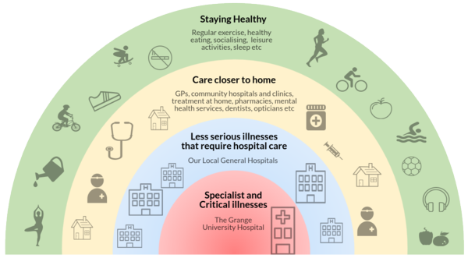
Figure 4 ABUHB Clinical futures strategy (Aneurin Bevan University Health Board., 2025)
In 2019 ABUHB digital strategy was published to provide guidance and set out specific goals in a timeline of 3-4years to guide the health board through digital transformation. ABUHB’s digital stragegy aligned the 4 Health and Social care principles with ABUHBs Clinical Future strategy. Figure 5 illustatrates the 4 main digital themes of the health boards mission to improve digital healthcare, which interconnects with the Welsh governments digital approach to improving health care and wellbeing to all and providing resouces to ensure high quality care.
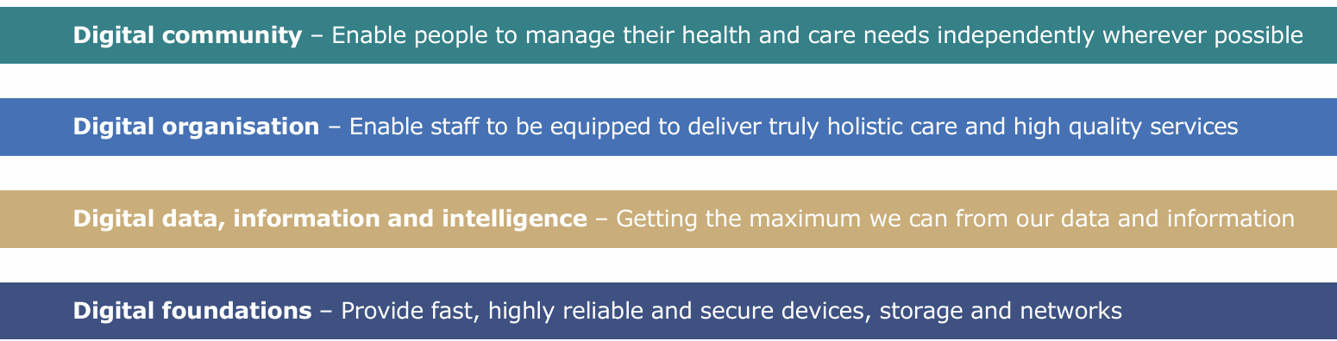
Figure 5 ABUHBs digital mission (Aneurin Bevan University Health Board, 2019).
The digital strategy will assist to provide patients access to services to help manage their own health/well-being needs. Having access to help when they need it, in their own home or their communities. It will enable staff to have the tools to deliver quality services to achieve the best outcomes (Aneurin Bevan University Health Board, 2019). However the digital strategy has not recognised the challenges that may occur whilst implementing the strategy. It is clear from demographics of the diverse areas, there may be difficulties with digital inclusion through the infrastructure. The amount of facliities ABUHB have, could cause problems with modifying the technology architecture to provide the tools needed to implement the plans (Betton, 2025).
Technology and digital Transformation
The ABUHB Digital strategy 2019 has outlined 4 main digital areas to be improved however the strategy has not identified how the progression of these key performance indicators would develop. Therefore the strategy timescales of 2022/2023 has expanded into 3 further years. This section of the analysis will look at the 4 key digital elements of the strategy examining the current technology status of ABUHB.
Digital Community
The strategy aimed to enable patients to manage their own health needs independently. At the time of the strategy implementation, there had already been steps to provide on line/telephone services to assit with patients health. For example My Health on line, Dewis, Dr Doctor, choose well and the 111 service. The health board had introduced a patient appointment text reminder service which meant fewer missed appointments had occurred (Aneurin Bevan University Health Board, 2026b).
By the end of 2022/23 the Digital Transformation strategy was committed to provide a citizen portal, allowing people access to help and advice, making appointments, see results and ordering medication. However due to not mapping out the process and the timescales for this to be completed the health board has only implemented phase 1 of the mailing system, which provided a patient text reminder allowing them to view, cancel and rebook appointments. Phase 2 of the project which will allow patients to received their appointments letters to their smartphone will be introduced this year in 2026 therefore having a substantial delay in the target times (Aneurin Bevan University Health Board, 2026b).
The key element of the digital strategy was to provide technologies for individuals to stay local in their communities. The health board committed to provide telehealth, telecare and telemedicine. The strategy was vague on how this was going to be implemented with only describing the desired outcome with no guidence of platforms or systems that could have been used. (Aneurin Bevan University Health Board, 2019). During the time of this strategy COVID 19 struck and the health board had to address Telemedicine quickly by providing a platform for video consultation using ‘Attend Anywhere’ for staff in primary, secondary and communuty care to carry out patient appointments (Aneurin Bevan University Health Board, 2026). Although this assisted with the rapid implementation of this software, the strategy failed to provide contingency plans for any unforeseen circumstances like COVID 19 therefore the implementation of this could have gone terrible wrong. (Hutchings, 2020).
Digital Organisation
ABUHB Digital Strategy emphasised within the digital organisation principle, staff should provide holistic care and high quality standards. In 2019 there was progress in the organisation of digital processes. The single electronic health records within the health board had digitalized 300,000 paper records however this was under half of ABUHBs population (as mentioned in the Buisness Drivers section).
The Welsh Nursing Care Records (WNCR) have been established and aligns with the strategies 2019 principles of Digital organisation. It is transforming the way nurses records are stored or how the nurses accessed patient information. For this to be an all Wales nursing record, the strategy needed to consider interoperability by using a system like FHIR or OpenAIRE, providing specific coding (for example SNOMED CT) and paramerters (Digital Health and Care Wales, 2026). The strategy failed to identify this, without these standards the organisation are at risk of inaccurate interpretations within the records. The technology (ipads/ software) for WNCR has been readily available to the health board, yet the slow rollout to peadiatrics (noted to 2026) suggests that ABUHB is behind in its implementation capacity (Aneurin Bevan University Health Board, 2026b). The strategy had underestimated the work that was needed for the nurses too be able to adjust from their existing workflow and to normalize the new digital format into their workplace (Murray et al., 2010). This is classed as a social digital gap as the technology was there but the socail systems had not been prepared properly.
The strategy highlighted the need for an intergrated health and social care settings with a welsh community care information system (WCCIS). The WCCIS program has been introduced to allow community mental health to share care records in both health and social care (Aneurin Bevan University Health Board, 2019). Again within the strategy it does not provide an implicit plan of how this was going to be implemented therefore the implementation time has not been met and are still awaiting the rollout of peadiatrics and therapy services to be included. This was due to the technical issues and the varyed requirments need within the organisations (Senedd Wales, 2023).
An electronic patient flow need was highlighted in the strategy as a requirement for ABUHB (Aneurin Bevan University Health Board, 2019).This has been a strategy success, as a careflow-care management system not only has been implemented but it was the first organisation in Wales to do so. It has allowed staff to use a programmed IPAD to capture digital observations at the bedside.However the implementation capacity has been compromised and the electronic handover is yet to be completed (Aneurin Bevan University Health Board, 2026b)
Later than planned in the Health boards digital strategy in 2025 electronic prescribing was introduced (Hospital Times, 2025). The system/platform the health board used was not idicated in the stratagy there was no clear consideration of the procurement processes of how they will source, negotiate and aquire the system. There was no indication of how they would ensure the quality of the platform, the design process, workforce and how governance would meet ethical standards (Betton, 2025). Although electronic prescribing was idenified with in the strategy it failed to specify the adoption of standards. Without standardisation of terminnology (for example Dm+d (dictionary of medicine and devices) the organisation is at risk of inaccurate data which will not read with other organisation within Wales. This would overthrow the goal of a single intergrated system.

Digital data, information and intelligence.
ABUHB’s digital strategy targeted maximising the analytic information from the digital data and information ABUHB receives. At the time of the strategy the health board had introduced a new business intelligence technology resulting in 240,000 consultants consultations being coded in the period of 2017/18. The strategy indicates it wanted this extended to access patients information and guidelines. Furthermore to use digital data to assist with forward planning, predicting the resouces that may be needed ahead of time and have an understanding of the populations health needs (Aneurin Bevan University Health Board, 2019). The strategy has assisted with continuing clinical coding to support audits, clinical governence and assit in determining the direction of ABUHB (Anerurin Bevan University Health Board, 2026).
Digital Foundations
The final element of ABUBH digital strategy focuses on the technology equipment; wanting to provide fast, reliable and secure devices, storgage and networks. When the strategy was introduced, the health board had 14,400 end user devices, 22,500 fixed network points and 2500 wireless access points 600 network switches 450+ data servers Wireless network usage up to 700% since 2011 (Aneurin Bevan University Health Board, 2019) The strategy was central to ensure a seamless ‘go-live’ for the Grange University Hospital with the digital capasity of 10,000 fixed points and 130 network switches supported by next generation software, moderised operating systems and robust cyber security (Aneurin Bevan University Health Board, 2019).
Within the element of digital foundations, ABUHB was to adopt next generation Software, the health board migrated to Microsoft 365 within the time capacity of 2022/2023. Microsoft 365 is cloud based including the Office suite and additional tools to assist with collaboration communication and security. (Aneurin Bevan University Health Board, 2026). The strategy failed to provide details of the software (Microsoft 365) and no plans of how this would be implemented. This could have led to digital infrastructure failure within ABUHB (Hakim R, Wheatland B and Inch A., 2025). ABUHB provided consultation with nominated stakeholders however the dissemination of the information to the workforce was poor. The digital foundations were strong but socially weak.
Strategic Analysis
To provide robust evaluation of the ABUHB’s digital strategy, a triangulated approach will be used. SWOT, PESTLE, and the NHS provder framework will be adopted.
A SWOT analysis was used due to its effectiveness in looking at the strengths, weaknesses, opportunities and threats of ABUHB’S digital strategy. SWOT analysis provides a framework to look at internal and external factors regarding the strategies success (Nurse.com, 2025). This analysis will assist in recognising what the strategies good points are, areas for improvement, new opportunities and the impactful challenges that could occur (Strongitharm J, 2025). Figure 6 identifies how the SWOT analyis assist with analysing the strategies capabilities to determine its strengths, weaknesses, opportunities and threats.
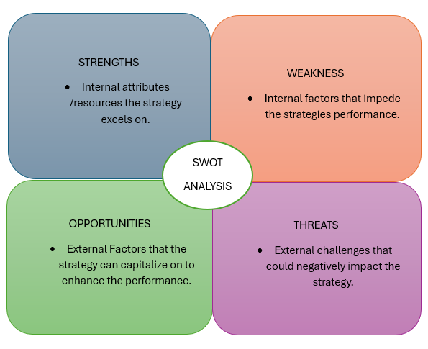
Figure 6 SWOT analysis adapted from (Nurse.com, 2025).
The SWOT anaylis looks at elements of the external factors of the digital strategy. To provide a more explicit investigation of the external environmental factors impacting the implementation of the strategy, the PESTAL tool would be effective. The tool considers Political, Economic, social, Technology, Environmental and Legal factors (Williams, 2024). By closely examining the ABUBH’s digtal strategy, the PESTEL tool can assist with highlighting the challenges and capture the opportunities for the organisations digital transformation (Makos J., 2025). Figure 7 demonstrates the PESTEL’s analysis key factors needed when scrutinizing the ABUBH’s digital strategy.
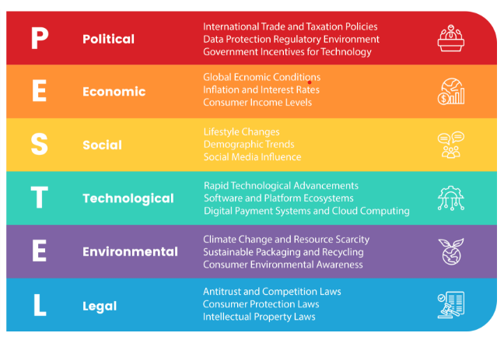
Figure 7 PESTEL analysis (Makos J, 2025).
The NHS provider Framework is the final analysis which helps to bring the 3 analysis together. Providing a framework to question if this digital strategy works within a NHS setting. The framework provides 6 funderment components to ensure the digital strategy is Intergrated, User- centred, Mainstream, Useful to the team, Realistic and Focused (NHS Provider, 2023). Using this framework will highlight how the strategy is effective, the inequalities and ensuring if the strategy is sustainable.
Using all 3 tools to anaylise the strategy will allow a robust evaluation to obtain a comprehensive and accurate interpretation from different perspectives. Using multiple tools will allow the strategy to be examine from different context allowing a multi-faceted analysis.
ABUHB’s Digital Strategies analysis using SWOT, PESTEL, and NHS Provder Framework
The SWOT analysis tool in figure 8, highlighted the ABUHB’s Digital stratagies attributes, impediments, the enhancements and challenges. It demonstrates the key elements of the strategies strengths, weaknesses, opportunities and threats idenifying the internal and external forces influencing the organisation.
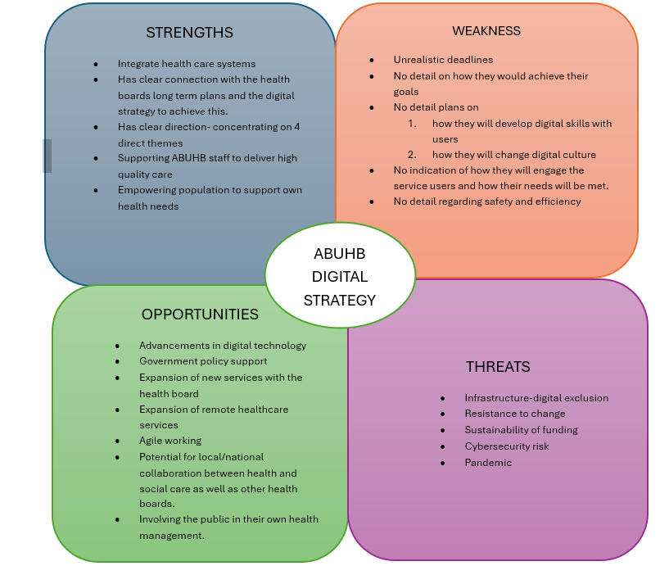
Figure 8 SWOT analysis of ABUHB digital Strategy 2019
The tool has provided an outlook into the strategies internal and external factors. To strengthen the analayis, the external factors need to be looked at further, as these have influcenced the strategy greatly. Figure 9 illustrates the evaluation of the digital strategy using PESTEL tool looking at the strategic decision making that took place and any gaps that are present.
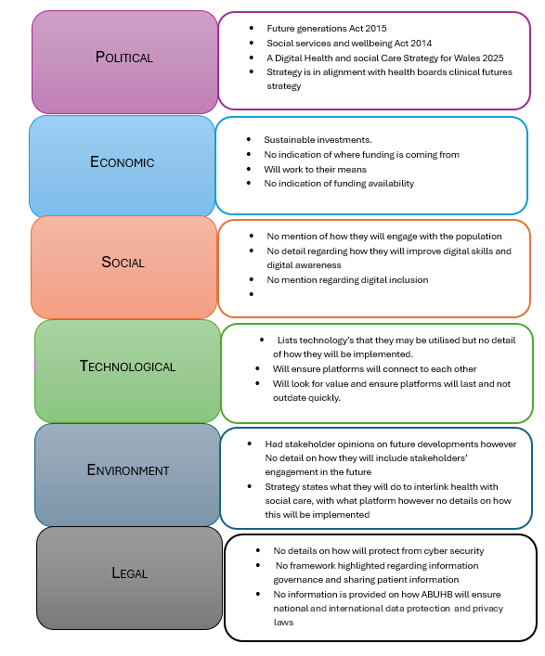
Figure 9 PESTEL analysis of ABUHB Digital Strategy 2019.

The PESTEL tool allows a clear look at the external factors wihin the digital strategy and how these are affective within it. An important factor is to ensure how digital alines with the NHS. Therefore utilising the NHS Providers framework will ensure digital transformation of the stratgey embeds within healthcare, estabilshing whether the digital changes will become part of the NHS culture. This analysis will be broken down into the six componiments of the NHS Providers framework to examine the strategy.
Intergrated
The digital strategy was produced in conjuction with the health boards Clinical Futures intergrating the A Digital Health and Social Care Strategy for Wales 2015, the Well-being of Future Generations Act 2015 and the Social services and Well-being Act 2015(Aneurin Bevan University Health Board, 2019). These strategies and Acts all have a simular goal to improve health and social care looking at prevention health and providing care closer to patients home. The plan aims to intergrate health and social care however it does not acknowledge the involvement with wider stakeholders from primary and social care or identify how this would be achieved.
User centred
The strategy looks at patients centred approach wanting to deliver care closer to patients home and focusing on patients health and wellbeing and preventing illness. It states the platforms the health board might use however there is no detail on what this would look like, how they would engage the patients and ensure patient inclusion. The strategy acknowledges that peoples digital skills may need to be developed and are aware of these risks. There is not a plan of how this will be addressed. ABUHB should untilise the Inclusion Charter for Wales 2025 to support the organisation to understand the importance of enabling the population to be digitally inclusive and meet the minimum digital standards and for ABUHB to reconise their role to ensure patients are supported to become digital (Welsh Government, 2026).
Mainstream.
The strategy itself has been completed on a powerpoint document with many visual aids to help individuals to understand the strategy. It lays out the core themes and what the strategy wants to achieve. However it lacks depth and does not have detail how the service users /staff in the health board can contribute to the strategy.
Useful for the team
The aims of the strategy are based on the key princples of the organisation, in alignment with the health boards ‘Clinical futures’ as the key elements of why the strategy is in place(Aneurin Bevan University Health Board, 2019).The health board main ways to promoting this is using a powerpoint presentation and spreading the information on the health boards intranet sharepoint page.

Realistic
The timescale of the strategy was not realistic with completion dates of 2022/2023. The health board is still using this strategy today. The report did not make strategic plans for any unforseen circumstances. For example COVID 19 panademic caused interuptions in the running of the health board which caused delays with certain digital transformations but also advanced other digital projects. This strategy gap could have caused the strategy to become static and it lacked the agility to adapt to the panademic.
The health board was realistic as the emphasis was on aiming to take small managable approaches which was key to preventing buying larger platforms where technology overtakes the implementation of the project.
Focused
This strategy has clear aims and themes to concentrate on in the designated period of time, It shows what platforms they may use to accompish these themes. NHS Provider, (2023) suggests a good digital stragegy should indicate what the health board will not be able to do. ABUHB digital strategy has not defined the lack of scope therefore the organisation are at risk of ‘scope creep’. This could lead to resources being spread too widely and could lead to failure of projects.
The three analysis tools have highlighted the ABUHB’s digital strategy 2019 (Aneurin Bevan University Health Board, 2019)had a clear direction from national and health board led stratgies and guidelines, with specific goals and key themes.The digital strategy was set out in a clear manner that was easy for the stakeholders to understand the health boards vision. It was realistic with taking on small manageble projects however this could have caused resources to be spread thinly and cause project failure.
The strategy time scales were unrealistic as many of the key projects had been started but not completed. The digital strategys life span had expired in 2023 but the health board is still using it in 2026 showing the organisation fell behind in their implementation capasity. Scope creep occurred due to expansions of projects which led to delays. The strategy lacked scope due to the apparent lack of detail. As stated previously the strategy has clears goals but does not provide guidence. There was strategy gaps due to not planning for unforseen circumstances, or providing the limits of the scope of the strategy.
Lack of clarity and detail regarding digital security for cyber attacks, data protection and sharing information to others within the strategy could increase vulnerability to the organisation, and the population of Gwent. Gwents infrastucture could cause difficulties with inclusion due to the geographics and the polulation itself. The strategy did not provide detail of how they would connect rural areas with the digital technology they wanted to implement and how they would ensure everyone is included with this. No provision had been made for those who could have resistance to change.
Assumptions were made within the strategy that the citizen portal would improve patients health and well-being, however the strategy failed to map out the requirements needed for example digital literacy training in the more rural areas. By not mapping backwards after setting the main goal (Theory of change model) could lead to technology being push forward rather than meeting the demands (Taplin et al., 2013).
References
Anerurin Bevan University Health Board (2026) Clinical coding, https//nhswales365.sharpoint.com/sites/ABB_Pulse/Clinical-coding.aspx.
Aneurin Bevan University Health Board (2019) Digital Strategy - Transformation Through digital, https://abuhb.nhs.wales/files/key-documents/digital-strategy/.
Aneurin Bevan University Health Board. (2025) Aneurin Bevan University Health Board Ysbyty Nevill Hall Hospital Staff Handbook, https://nhswales365.sharepoint.com/:w:/r/sites/ABB_Pulse_Clinical_Futures/_layouts/15/Doc.aspx?sourcedoc=%7B7981911B-C13E-4EFE-93BE-13876A2ABF56%7D&file=NHH%20Handbook%20v5%20AMENDED%202025.docx&action=default&mobileredirect=true&DefaultItemOpen=1.
Aneurin Bevan University Health Board (2025) Aneurin Bevan University Health Board Annual Report and Annual Accounts, abuhb.nhs.wales/files/key-documents/annual-reports-and-annual-accounts/abuhb-annual-report-and-accounts-2024-25-signed-pdf/.
Aneurin Bevan University Health Board (2026a) Aneurin Bevan University Health Board -Acute and Community Hospital Sites, https://nhswales365.sharepoint.com/sites/ABB_Pulse_Primary_Care/SiteAssets/Forms/AllItems.aspx?
Aneurin Bevan University Health Board (2026b) Digital, Data & Technology, https://nhswales365.sharepoint.com/sites/ABB_Pulse_Informatics/SitePages/Informatics-Proggrammes.aspx.
Aneurin Bevan University Health Board (2026c) Over a quarter of a million Video Consultations delivered across Wales - Aneurin Bevan University Health Board. Available at: https://abuhb.nhs.wales/news/news/over-a-quarter-of-a-million-video-consultations-delivered-across-wales/ (Accessed: January 27, 2026).
Betton (2025) 10 questions NHS board members should be asking to ensure equity in digital transformation. Available at: https://nhsproviders.org/resources/equity-in-digital-transformation-10-questions-nhs-board-members-should-be-asking (Accessed: March 16, 2026).
Digital Health and Care Wales (2026) FHIR at DHCW - Digital Health and Care Wales, https://dhcw.nhs.wales/our-programmes/national-data-resource1/fhir-at-dhcw/. Available at: https://dhcw.nhs.wales/our-programmes/national-data-resource1/fhir-at-dhcw/ (Accessed: April 2, 2026).
Digital Healthcare Planning And Strategy PowerPoint Presentation Slides | Presentation Graphics | PowerPoint PPT Presentation Example | Slide Templates (no date). Available at: https://www.slideteam.net/digital-healthcare-planning-and-strategy-powerpoint-presentation-slides.html (Accessed: March 16, 2026).
Hakim R, Wheatland B and Inch A. (2025) Digital transformation in the NHS: a reference guide | NHS Confederation. Available at: https://www.nhsconfed.org/publications/digital-transformation-nhs-reference-guide (Accessed: March 19, 2026).
Hospital Times (2025) New digital systems addressing medicine dispensing safety - Hospital Times, https://hospitaltimes.co.uk/new-digital-systems-addressing-medicine-dispensing-safety/. Available at: https://hospitaltimes.co.uk/new-digital-systems-addressing-medicine-dispensing-safety/ (Accessed: March 22, 2026).
Hutchings, R. (2020) Key points The impact of Covid-19 on the use of digital technology in the NHS, https://www.nuffieldtrust.org.uk/sites/default/files/2020-08/the-impact-of-covid-19-on-the-use-of-digital-technology-in-the-nhs-web-2.pdf.
Makos J (2025) PESTLE Analysis of the NHS: 6 Forces Pulling at United Kingdom’s Health Giant. Available at: https://pestleanalysis.com/nhs-pestle-analysis/ (Accessed: April 4, 2026).
Map_of_Gwent.jpg - Aneurin Bevan University Health Board (no date). Available at: https://abuhb.nhs.wales/images/ophthalmology/map-of-gwent-jpg/ (Accessed: March 28, 2026).
Murray, E. et al. (2010) “Normalisation process theory: a framework for developing, evaluating and implementing complex interventions,” BMC Medicine, 8(1), p. 63. Available at: https://doi.org/10.1186/1741-7015-8-63.
NHS Provider (2023) Effectively embedding digital in your trust, https://nhsproviders.org/resources/effectively-embedding-digital-in-your-trust. Available at: https://nhsproviders.org/resources/effectively-embedding-digital-in-your-trust (Accessed: March 22, 2026).
Nurse.com (2025) What is a SWOT Analysis? | Nurse.com. Available at: https://www.nurse.com/nursing-resources/definitions/what-is-a-swot-analysis/ (Accessed: March 21, 2026).
Senedd Wales (2023) Slow roll out and a lack of direction is hindering the development of digital health services. Available at: https://senedd.wales/senedd-now/news/slow-roll-out-and-a-lack-of-direction-is-hindering-the-development-of-digital-health-services/ (Accessed: April 9, 2026).
Strongitharm J (2025) What is a SWOT Analysis in Healthcare and Why You Need It - Venngage. Available at: https://venngage.com/blog/swot-analysis-in-healthcare/ (Accessed: April 4, 2026).
Taplin, D.H. et al. (2013) “A Series of Papers to Support Development of Theories of Change Based on Practice in the Field.” Available at: www.actknowledge.org (Accessed: April 9, 2026).
The Health Foundation (2010) “Complex adaptive systems Evidence scan.”
The Welsh NHS Confederation (2019) “The journey towards delivering the Well-being of Future Generations Act (2015) across NHS Wales.”
Welsh Government (2015) Informed Health and Care. A Digital Health and Social Care Strategy for Wales., https://www.gov.wales/digital-health-and-social-care-strategy.
Welsh Government (2026) Digital inclusion | GOV.WALES. Available at: https://www.gov.wales/digital-inclusion-overview (Accessed: April 6, 2026).
Williams, M.-N. (2024) “Impact of Diversity on Global Healthcare: An Argument for the Inclusion of Diversity in the Pestle Analysis Framework Using An Autoethnographic Lens View.” Available at: https://doi.org/10.2139/ssrn.5023671.

