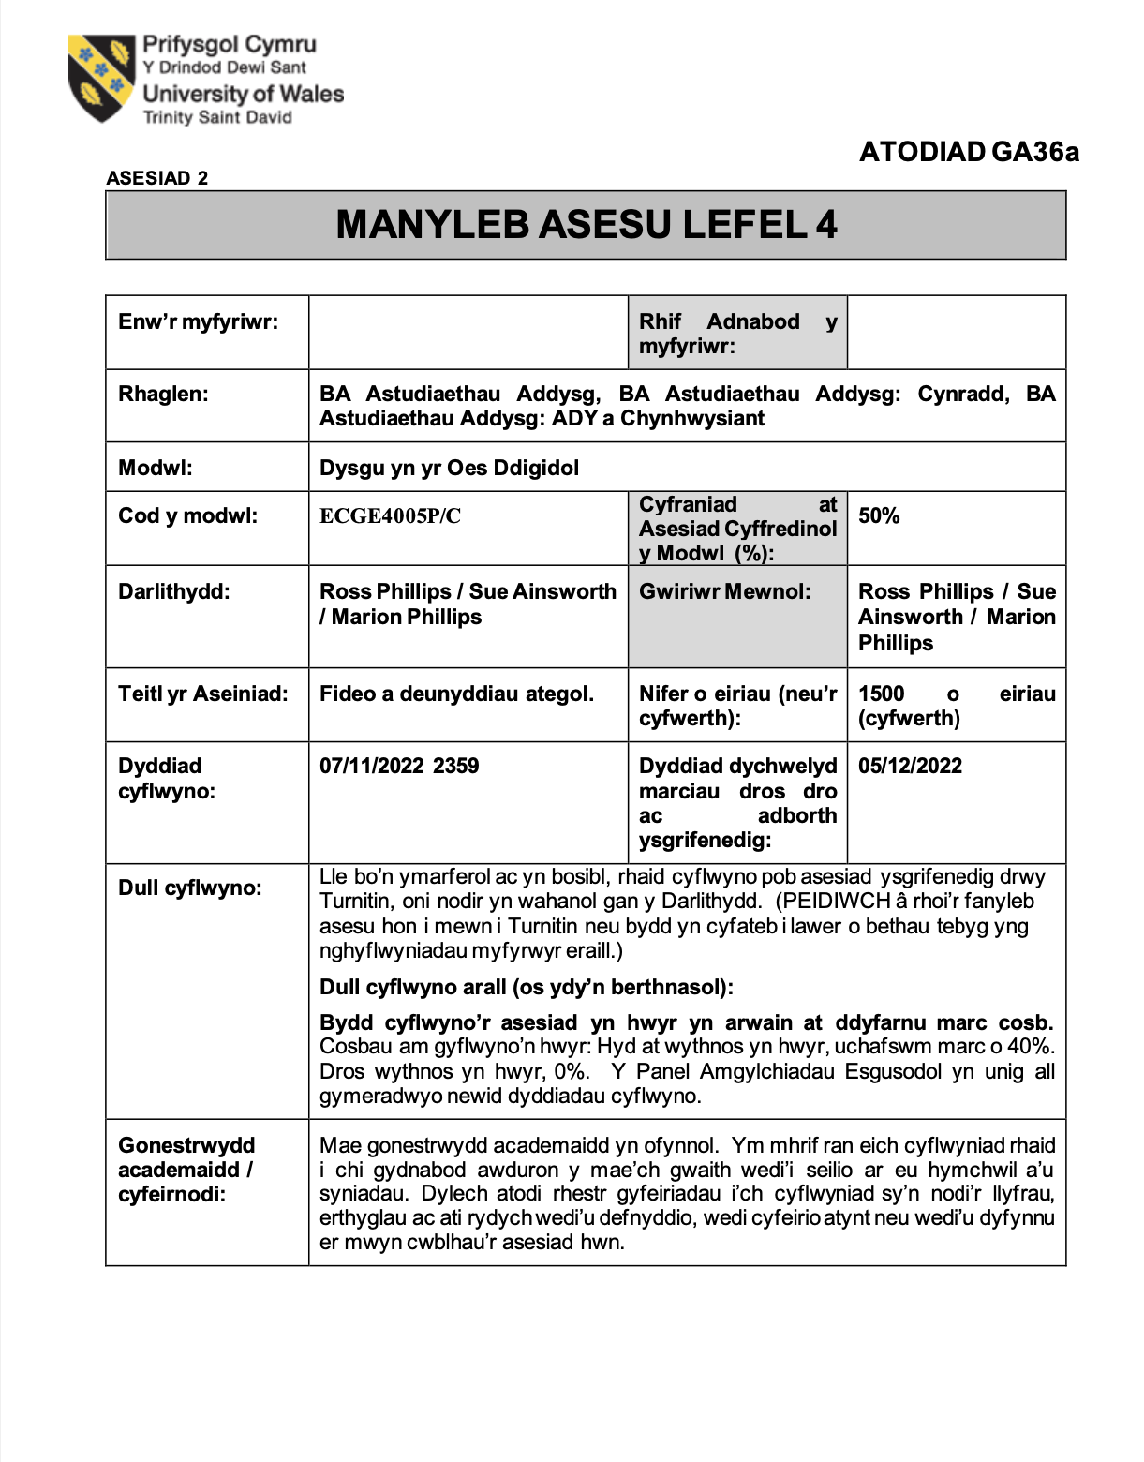
Amelia Williams
1811617
Linc i fy ngyflwyniad:
https://uowtsd.sharepoint.com/teams/DysguynyrOesDdigidolLearningintheDigitalEraECGE4005PC_GRP-AmeliaWilliams/Shared%20Documents/Recordings/New%20channel%20meeting-20221105_143020-Meeting%20Recording.mp4?web=1

Rhestr Cyfeirnodi
Cottrell. S, 2017, Critical Thinking Skills, Effective Analysis, Argument and Reflection 3ydd arg. Llundain: Palgrave
Hedgepath,O. 2015 Ar gael yn: https://cdn.elearningindustry.com/wp-content/uploads/2015/07/teaching-plagiarism-in-online-classroom-990x1024.jpg
PCYDDS: Llyfrgell ac Adnoddau Dysgu d.d. Llawllygr cyfeirnodi Harvard. arg. 1af
Study Hub, 2020, Ar gael yn: https://studyhub.fxplus.ac.uk/sites/default/files/styles/card_image/public/2020-08/referencing_integrity.jpg?itok=QkydwO_e
Thadomal Shahani Centre for Management – TSCFM (2022) Ar gael yn: https://tscfm.org/blogs/the-benefits-of-critical-thinking-for-students/
Toggl, (2018) Ar gael yn: https://toggl.com/blog/wp-content/uploads/2018/08/critical-thinking.jpg
University of Leeds (2022) Critical thinking Ar gael https://library.leeds.ac.uk/info/1401/academic_skills/105/critical_thinking (Cyrchwyd: 4 Tachwedd 2022)
University of Wales Trinity Sant David (2022) Llawlyfrau Cyfeirnodi. Ar gael yn: https://www.uwtsd.ac.uk/cy/llyfrgell/hanfodion-myfyrwyr/llawlyfrau-cyfeirnodi/ (Cyrchwyd: 5 Tachwedd 2022)
UWTSD Library and Learning Resources (2020) Pam mae cyfeirnodi’n bwysig? [fideo] Ar gael yn: https://youtu.be/nkwzktJ_m_o (Cyrchwyd: 4 Tachwedd 2022)

