Systems Thinking Design Report
L5 Systems Engineering Module – ACDA5021
Alex Lamdin
9th June 2025

Abstract
During the Systems Engineering Module, students within the cohort were split into groups and given a design exercise whereupon they had to design a weapon system capable of incapacitating an enemy communications centre housed within an office building with minimal collateral damage. To do this, students were provided with a set of systems engineering tools and were instructed to use them to follow the systems engineering process through from establishing customer requirements through to how they would manufacture and test a critical component. The projects were then presented, with the Author’s group having designed a UAS-based system. This report details how the tools were utilised throughout the process to maximise the quality of the design proposed.
Table of Contents
- Introduction to the brief
- Establishment of Design Requirements
- Determination of Functionality
- Design Concept Selection and Development
- Sub-System & Critical Component Development
- Development of Manufacturing Process
- Trials & Testing
- Conclusion
- Appendix 1 – Generic System Customer Requirements
- Appendix 2 – Initiation Sub-System Functional Requirements
- Appendix 3 – Manufacturing Customer Requirements
- Annex 1 – Project Trojan Systems Engineering Toolset Spreadsheet/Workbook

1. Introduction
In the level 5 combined Systems Engineering/Work-Based Group Project (SEWBGP) module, students within the cohort were tasked with using their acquired knowledge and the toolset from both the level 4 and 5 SE modules to create a solution to fulfil a given mission brief, namely:
“A requirement has been raised for an explosive device capable of neutralising a hostile communications centre, housed in a room within the second floor of an office block building. The design should be capable of accurate delivery into the room from a distance of at least 100m and the effect event should be such that collateral damage to adjacent rooms or potential occupants is minimised.”
To fully utilise the SE toolset, and to be representative of real-world industry, the task required students to design a system from scratch, before continuing to the process engineering & manufacturing stages, development of a test and evaluation (T&E) plan and finally, a disposal plan for end-of-life management of their system.
Due to the time, manpower and resource constraints within the module blocks, the task was completed as a funnelled, or narrowed down example, where once the overall system had been established, the critical sub-system would then be the sole one carried forward, through to a single critical component within it for the process and manufacturing phases of the project. This would allow students to fully utilise the toolset and demonstrate the required skills without the amount of work required becoming insurmountable.

2. Establishment of Design Requirements
Following the briefing of the required mission objectives, the students split into their assigned groups to further evaluate the task they had been given. Whilst the mission brief gave a starting point to develop a concept, it was far from a concise list of requirements, and thus the first task was to draw these out. This was done via a four stage process, namely:
- Identifying Stakeholders by creating a boundary map, then using a stakeholder influence map to identify where and with which communication is required.
- Gathering generic requirements by collating information given in the mission brief and gleaned through customer Interview (both private questioning and open cohort Q&A), before creating a use case and using an Affinity Diagram to identify each stakeholder’s individual needs.
- Writing the final requirement list including clarifying which stakeholder “owns” each one.
- Prioritise the requirements utilising the pairwise comparison tool.
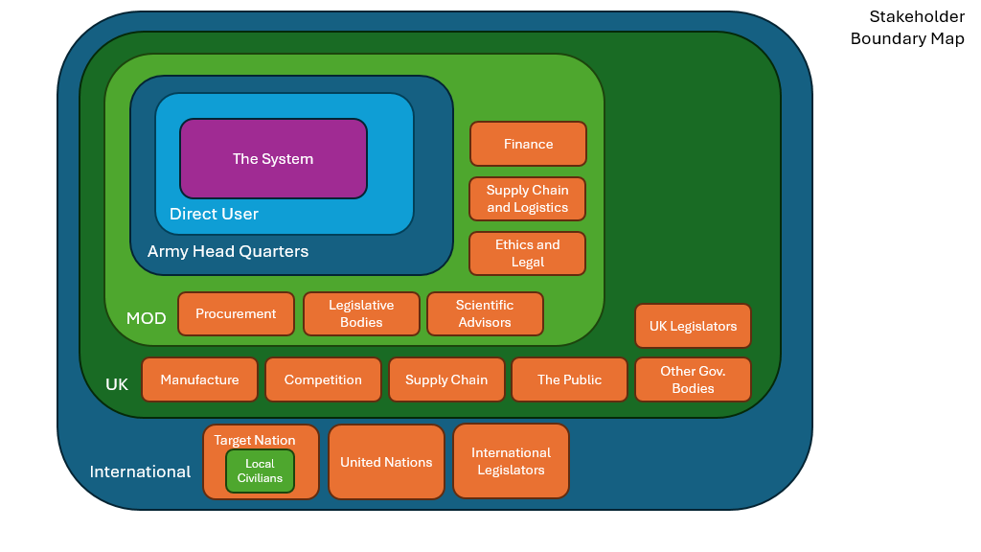
Fig. 1 – Stakeholder Boundary Map
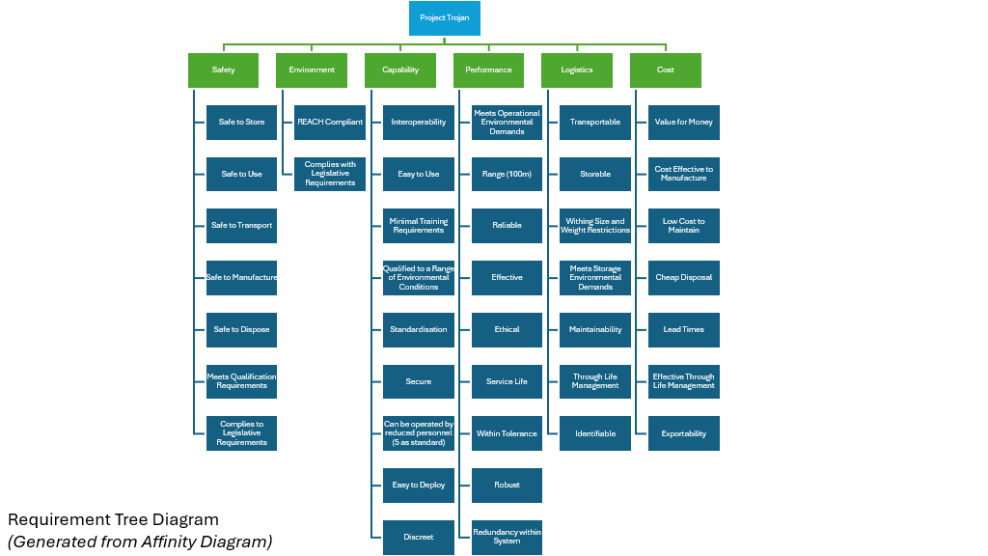
Fig. 2 – Requirements Tree Generated from Affinity Diagram
Following this, the customer requirements were finalised. These can be found in Appendix 1. These requirements were then put into a Pairwise Comparison so that requirements could be prioritised and weighting applied where needed going forwards.
This pairwise comparison, along with all of the other systems engineering tools used throughout this report, can be found in the Excel Spreadsheet submitted as Annex 1 to this report

3. Determination of Functionality
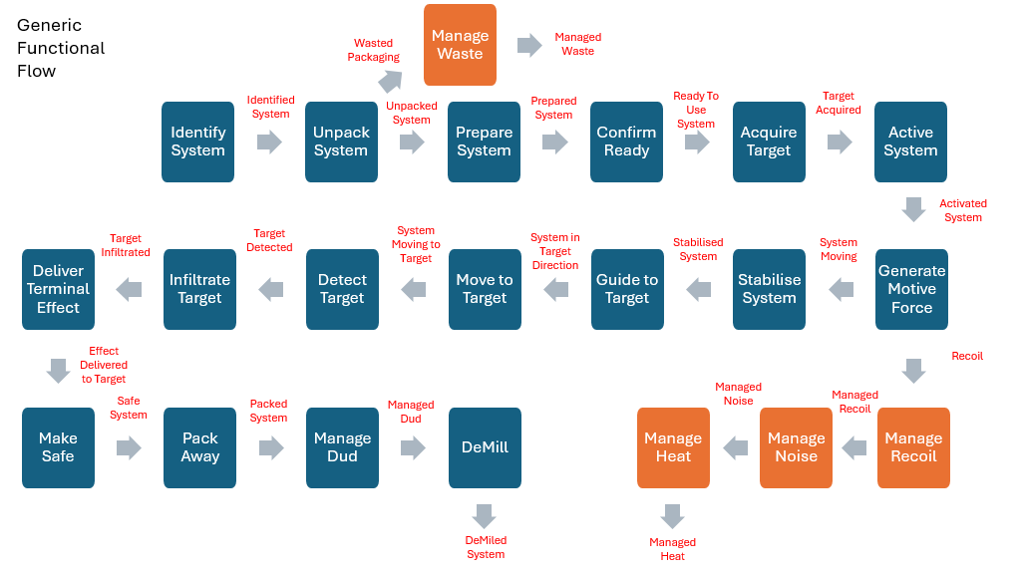
Once the requirements had been specified, the next step in the SE process was to establish the generic functionality. This is functionality that is purely based around the requirements and is independent of any specific method or design solution ( i.e. based on what the final system will be required to do, not how it will do it!). To determine these, a functional flow diagram was used to highlight the required core functionality and identify any emergent behaviours – these are unintentional outputs of the system (e.g. noise, heat etc) that will need to be managed, despite not being core functions of the system. The completed functional flow diagram can be seen below, with the emergent behaviours highlighted in orange.
Fig. 3 – Generic Functional Flow
Once the generic functionality was known, it could be inputted into a Quality Function Deployment, Level 1 (QFD1). This allowed the generic customer requirements to be translated into (generic) measurable technical requirements, as far as was possible at the time with roughly estimated target values for those not explicitly stated by the customer.
Following the completion of QFD1, Function Failure Mode Effect Analysis (FFMEA) was undertaken on the six core generic function of the system, namely “Acquire Target”, “Generate Motive Force”, “Guide To Target”, “Move To Target”, “Infiltrate/Penetrate Target” and “Deliver Terminal Effect”. FFMEA allows the design team to identify potential failure modes for the system, as well as the likelihood of these occurring, and the consequences should they do so. Each function was assigned to a team member. A functional N² Analysis was then used to identify the interfaces between each functional requirement.
4. Design Concept Selection & Development
Once the generic functionality had been established, and it had been confirmed that everyone in the design team was content to proceed, the focus moved to determining potential concepts. To start this process, a Functional means Analysis (FMA) was undertaken to evaluate and brainstorm all possible solutions to achieve each function. From this, components were selected for 3 potential system concepts, each of which would be evaluated against three potential attack methods.
Potential System Concepts
- Robot Dog with EOD-type waterjet disruptor
- Man-Portable Launched Guided Munition
- Modular unmanned aerial system (UAS/Drone)
Potential Attack Methods
- Attack Control Consoles within the Command Centre
- Attack external mains power supply
- Attack antennae array on roof of building
Three system Pugh diagrams were then used to assess each potential system concept against each potential attack method, using the relative importance figures calculated in the earlier QFD1 against each requirement. From these, as well as from a design review/discussion with the customer, it was decided that the attack method to be utilised was to attack the external antennae, and as such the system concept most suited to this would be a modular UAS.
Now that the specific design concept had been selected, a new functional flow diagram and system boundary map were drawn up to reflect the structure of the modular UAS, adding any needed elements and removing any which were now redundant.
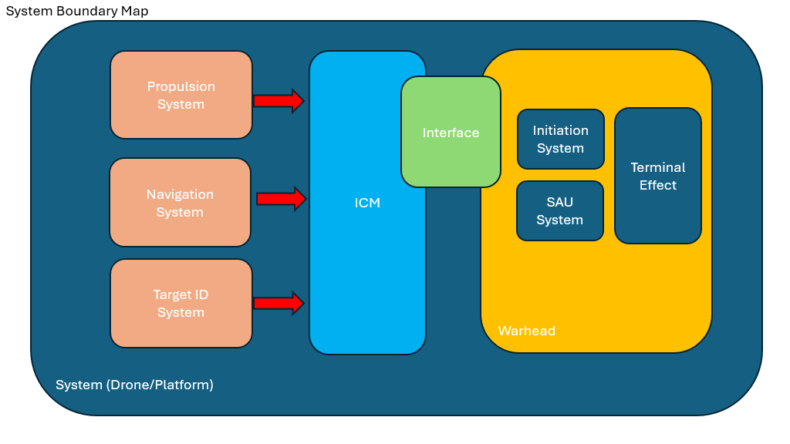
Fig. 4 – Solution-Dependent System Boundary Map
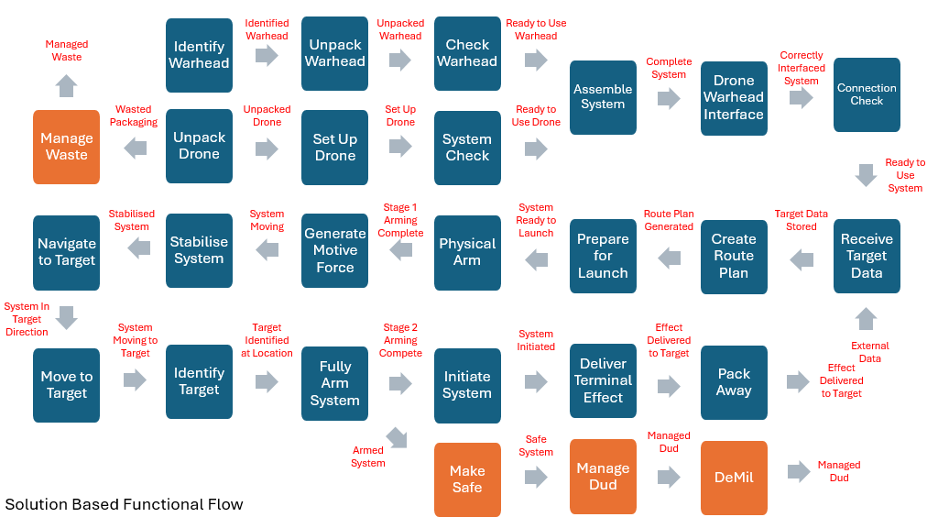
Fig. 5 – Solution-Dependent Functional Flow
Since most of the functions had developed/changed now that a solution had been chosen, the decision was made to perform another QFD1 to provide the design team with an updated relative importance for each of the functions, as well as a similarly updated N² analysis. At this point, as the lead on T&E within the team, the author led a Functional Metrics Analysis to establish how it would be measured that the system’s functional architecture supported the customer requirements.
It was identified through the results of the QFD1, as well as discussion with the customer and the frank realisation that the design team were OME SME’s that the functional system requirement that the team would be focussing on would be “deliver terminal effect”, and thus directing the team’s efforts towards the modular weapon payload sub-system. In a real-life scenario, all of the sub-systems would then follow the full SE process in parallel, with frequent communication so that they interface correctly and work together without issue in the final system.
A second, solution-dependent FMA was performed to establish what components and features would be best suited to each of the respective sub-systems and functions within the UAS.
These were inputted into a QFD2, the next level of the quality function deployment framework, to assess which of these selected components/features would be relevant to which of the functional requirements generated previously, and to what level of importance. In other words, “how” the system would achieve its aim. The eventual results showed that the critical feature within “deliver terminal effect” was to be a safe, reliable initiation sub system. The method chosen for this, due to its proven reliability and safety record, as well as the team’s familiarity and experience with similar systems, was a high-voltage (HV) exploding bridge wire (EBW) detonator. Another Functional Metrics Analysis was performed to determine how the performance of each of the selected functional means would be measured for compliance to the requirements.
5. Sub-System & Critical Component Development
At this point, prior to continuing with the process, a condensed requirements list for the initiation sub-system was drawn up. This can be seen in appendix 2.
Whilst this was occurring, a study was undertaken into the generic functionality of existing HVEBW detonators on the market, led by the author due to his relevant experience. From this, a list of generic functions that such a detonator would need to perform was compiled. These were “Contain Components”, “Seal Components”, “Connect System”, “Receive Input Signal”, “Generate Initial Shockwave”, “Receive Shockwave”, “Amplify Shockwave” and “Interface Materials”.
The earlier stages of the process were then repeated against the initiation sub-system. The importance of each customer requirement was compared and prioritised via a pairwise comparison, the weightings from which were inputted alongside the customer requirement set into a QFD1 and translated into technical requirements for the sub-system. Following this, FFMEA was undertaken against the eight core functions of the detonator identified above, as well as the author undertaking another Functional Metrics Analysis.
An FMA was carried out to identify every possible option for each component/function of the detonator. From this, three possible design options were identified – a “traditional” one utilising the “industry standard” component choices, a “premium” version using the best possible materials and technology, and a “low cost” option using the most economical component choices. A Pugh diagram identified the “traditional” option as the best one, and another N² analysis was used to identify the interfaces between the components.
Once these had been completed, the output of these tools was combined into a QFD2, providing the team with a chosen design solution for the HVEBW, as well as an importance figure for each function. This identified the RDX pellet within the detonator – used as a booster to amplify the energetic shockwave from the initial PETN initiation – as the most important component. It was thus selected as the critical component for the manufacturing part of the design exercise. A final Functional Metrics Analysis was also conducted to confirm how the performance of each of the selected components within the detonator would be measured for compliance to the requirements.

6. Development of Manufacturing Process
Following the selection of the RDX pellet as the critical component, some members of the team then constructed a P-Diagram and What/Why table to identify the key noises and control factors which would need to be controlled during the manufacturing of the pellet. These were used to identify the most important noise factors to be controlled, the major one of which was variation in pellet density.
Returning to the start of the SE Framework for the third time, an Affinity Diagram was used to define a set of customer requirements for the manufacturing process, with a pairwise comparison used to determine the relative importance of each of these. Somewhat unsurprisingly, reliability, ease of maintenance and the requirement to be easily tested for tolerance came out as priorities. The full list of manufacturing customer requirements is available in appendix 3.
Led by the manufacturing SME within the team, a functional flow of the manufacturing process was clarified, with the key functional steps identified and inputted into a QFD1 to determine the requirements and relative importances for the RDX pellet production. The most important steps were identified as weighing the amount of material and pressing the material.
A FMA was conducted, and similarly to previous times, three process options were proposed, a completely manual option, a vacuum-assisted option, and a completely robotic option. A Pugh diagram comparison then identified the vacuum-assisted proposal as the optimal option, and the decision was made to proceed in this way.
The generic process functional steps were the inputted into a QFD2 with the design functions chosen from the FMA, from which it was identified that the digital scale used to weigh out the amount of RDX composition prior to pressing with the most important component within the process.
The QFD3 matrix was then used to establish the correlation between the steps in the manufacturing process and the previously identified requirements for the part (dimensions, quality etc). This confirmed that the digital scale was vital to the final quality of the pellet.
A Process Failure Mode Effect Analysis (PFMEA) for the weighing of RDX was conducted and identified the potential consequences of over/under weighing the composition. It also highlighted the importance of maintenance and calibration of the scales, as this would go a long way towards preventing failures, which was further confirmed via a P Diagram and a What/Why Table, which also added the degradation of equipment to consideration, but it was felt that this could be mitigated via the maintenance program.
Finally, a QFD4 was used to assess the control measures that could be applied to the process to manage the potential noise factors and failures that could arise with the scale. It was confirmed that the most effective way of ensuring quality throughout the weighing of the RDX composition, and thus by extension the density, quality and function of the pellet, was by a good maintenance schedule, calibration testing, and pre-start inspections.

7. Trials & Testing
As the Test & Evaluation (T&E) SME within the team, the author of this report led the development of the T&E program for the designed system, which at this point had been given the name Project Trojan. This work was largely split into two parts, the first being functional metrics analyses throughout the design process alongside each QFD1 and QFD2, specifying the target values and assessing the criteria required for the designed system to meet the technical requirement set created.
The second part consisted of designing a complete trials series for project trojan at each level, the aim being to ensure each component, then lower-level sub-system, then higher-level sub-system would all be tested appropriately and independently to ensure they met the metrics set, thus hopefully ensuring they interface and function with minimal issue when brought together. Translating this across into the real world, this would also ensure that trials and tests had clearly defined aims, were easily measurable, and were the safest they could be. (e.g. fully testing and signing off a safety & arming unit before combining it with a dynamic UAS)
The aims of the T&E program were defined as the following:
- Critical Functionality – Will the system and its elements perform how it is required?
- Safety – Will the system and its elements be safe to use?
- Capability Definition/Limitation Finding – What can the system do above the initial requirements, and what are its limitations?
- Compatibility – are the parts all compatible with each other, as well as is the system compatible with other systems on the battlefield.
Due to the number of parts to be tested decreasing as the system structure is ascended (components to sub systems to the whole systems) the number of trials and tests would be decreasing as the project developed and the parts were brough together, however the complexity of these trials would increase as more elements were added. This is summarised in the graphic below. As can be seen, there were five phases to the testing plan for Project Trojan.
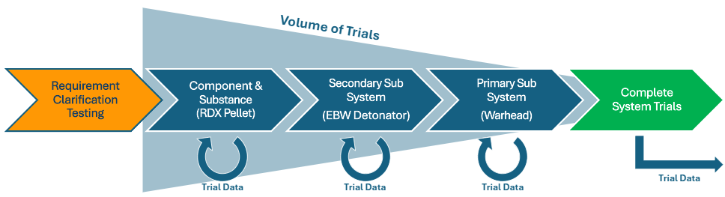
Fig. 6 –Project Trojan Testing Plan
Phase 1 consists of requirement definition testing – where a customer requirement consisted of a qualitative objective (i.e. “destroy antennae array”), trials could be undertaken to further define this, producing a qualitative value that is A) repeatable for system trials later in the development cycle and B) easily used within the QFD framework to track requirements are being met. A value could also be calculated to stay beneath, to achieve the requirement of minimising collateral damage.
Phase 2 is testing of the critical component/substance – Testing of individual components to ensure they meet the specified functional and non functional performance requirements. In the case of project trojan, this refers to the RDX pellet, and would likely include a suite of Small Scale Hazard Testing, Performance Testing of the critical Diameter and Velocity of Detonation, as well as testing to ensure it interfaces and function with the other components within the detonator and has a large enough output to successfully perform as the booster pellet.
Phase 3 is testing of our Secondary Sub-System, so the initiation sub-system, in this case the HVEBW detonator. This would include testing the electrical initiation threshold, time to function and the energetic output of the completed detonator, as these would inform design requirements for the SAU, targeting system and warhead main charge respectively. If this detonator would ever be transported away from the rest of the weapons payload, this would also require UN hazard classification testing in its transport configuration.
Phase 4 is testing the Primary Sub-System (Modular Blast Warhead Weapons Payload). This would involve utilising the figures previously clarified in the requirement definition testing to ensure the blast is both sufficient and not excessive to achieve the desired end effects. Environmental testing would also be undertaken, as well as sensitivity testing of the main fill, such as EMTAP tube tests and frag attack, since we ideally would be complying with insensitive munitions standards. Finally, this would also include testing to ensure the modular payload is capable of interfacing with the rest of the UAS without issue.
The final phase, phase 5, is trials of the complete system. This would include environmental testing of the final system in both shipping and usage configurations, hazard classification testing for the final shipping configuration, system range and endurance testing as well as ECM/EW environment testing given the intended target of an antennae array. Finally this includes representative scenario "field" trials and, arguably most importantly, pre-handover user trials – can they use it? Do they have any suggested improvements? This is critical to successful delivery of the product. If the end user cannot use it to accomplish the given aims, then the design is a failure.

8. Conclusion
Within this report the usage of a variety of Systems engineering tools has been explored, in particular: Affinity Diagrams, Functional Flow Diagrams, Quality Function Deployment levels 1-4, Function Means Analyses, Functional Metrics Analyses, Function Failure Mode Effect Analyses, Pairwise Comparisons, N² Diagrams, Pugh Diagrams, What/Why tables, P Diagrams and Process Failure Mode Analyses.
The deployment of these tools allowed the successful design of a potential solution to the given design task, ensuring traceability of requirements through from the manufacturing process back through to the initial customer request, whilst keeping record of qualitative and quantitative functional metrics at each stage as well as emergent behaviours, noise, and controls throughout.
Most importantly, following the prescribed systems engineering processes ensured that during the system design process, at all levels, a wide variety of options were considered and decisions were made solely on how well they could achieve the requirements.
This prevented the common, yet often serious, scenario in which the solution chosen/designed wasn’t right for the actual requirements in the first place, leading to costly changes, control measures, or in the worst cases, total replacement.
The tools demonstrated in this report are valuable in themselves, however their usage throughout the project has instilled the systems engineering philosophy and mindset into the project team, most importantly how vital it is to take time to clarify the actual customer requirements and their importances (separating the needs from the wants) before beginning the design process. This is extremely valuable given the ever-increasing scrutiny on costs within the defence sector and the desire to fully maximise the benefit from any investment in systems/technologies.

Appendix 1 – Generic System Customer Requirements
- All key stakeholders require that the system must adhere to all relevant regulations & legislation (REACH, UK, International)
- All key stakeholders require that the system must be safe throughout the product life cycle (Manufacture to Target or Disposal Sequence)
- The Command/Tasking Authority, User and the Logistics body all require that the system shall be resistant to the environmental conditions specified within the mission brief (AOP 15A, specified as N. Europe)
- The Command/Tasking Authority, User and Procurement body require that the system shall successfully neutralise the target specififed within the mission brief
- The Command/Tasking Authority and Procurement body require that the system may be capable of being used against a range of alternative targets
- The Command/Tasking Authority, User and Legislative Bodies require that the system's terminal effect(s) shall be contained within the target location specified in the misssion brief.
- The Command/Tasking Authority and User require that the system shall be able to be deployed at a minimum distance of 100m from the intended target
- The Command/Tasking Authority, User and Procurement Body require that the system shall function within its specified performance requirements (TBC) during TBC% of deployments.
- The Command/Tasking Authority, Procurement Body and Logistics body require that the system shall have a shelf life of X years (TBC)
- The Command/Tasking Authority and User require that the system shall be easy to operate, requiring minimal training (X hours per annum)
- The Command/Tasking Authority and User require that the system shall be rapidly deployable within X minutes.
- The Command/Tasking Authority, User and Logistics Body require that the system shall be transportable to the specified firing location, without mechanical assistance, by the 5-man mission team.
- The Command/Tasking Authority and User require that the system should be capable of being utilised operationally by the minimum number of personnel necessary.
- The Command/Tasking Authority, Procurement Body and Manufacturer require that the system should be cost effective throughout the product life-cycle (Manufacture to Target or Disposal Sequence), approximately similar cost-per-shot to NLAW (£30-40k)
- The User, Logistics Body and Manufacturer require that the system shall be easily identifiable throughout the product lifecycle (Manufacture to Target or Disposal Sequence)
- The Command/Tasking Authority, User and Legislative Bodies require that the system's terminal effects should cause minimal harm to any occupants within the target location specified in the mission brief.
- The Procurement Body and Manufacturer require that the system will be constructed utilising technology and components manufacturable within the UK economy.
- The Command/Tasking Authority, Procurement Body and Logistics Body require that the system should be interoperable with current UK and NATO military equipment and infrastructure.
- The Procurement Body, Logistics Body, Legislative Bodies and Manufacturer require that the system shall, at end-of-life, be capable of being broken down to a point where the remaining components can be safely disposed of.

Appendix 2 – Initiation Sub-System Customer Requirements
- All key stakeholders require that the initiation sub-system must adhere to all relevant regulations & legislation (REACH, UK, International)
- All key stakeholders require that the initiation sub-system must be safe throughout the product life cycle (Manufacture to Target or Disposal Sequence)
- The Command/Tasking Authority, User and Legislative Bodies require that the initiation sub-system should only function when the delivery of the terminal effect is requested by the operator.
- The Procurement Body, Logistics Body, Legislative Bodies and Manufacturer require that the initiation sub-system shall, at end-of-life, be capable of being removed from the warhead sub-system to enable safe disposal
- The Command/Tasking Authority, User and the Logistics body all require that the initiation sub-system shall be resistant to the environmental conditions specified within the mission brief (AOP 15A, specified as N. Europe)
- The Command/Tasking Authority, User and Procurement Body require that the initiation sub-system shall function within its specified performance requirements (TBC) during TBC% of deployments.
- The Command/Tasking Authority, Procurement Body and Logistics body require that the initiation sub-system shall have a shelf life of X years (TBC)
- The Command/Tasking Authority, Procurement Body and Manufacturer require that the initiation sub-system should be cost effective throughout the product life cycle (Manufacture to Target or Disposal Sequence).
- The Procurement Body and Manufacturer require that the initiation sub-system will be constructed utilising technology and components manufacturable within the UK economy.
- The Design Engineers require the initiation sub-system shall be activated via an electronic signal (Specification TBD) to allow integration into the system.
- The Design Engineers require the initiation sub-system should be compact (Specification TBD) to allow integration into the system.

Appendix 3 – Manufacturing Customer Requirements
- All key stakeholders require that the system must adhere to all relevant regulations & legislation (REACH, UK, International)
- The Manufacturing Engineers, Safety, Operator and Planning & Logistics body require that the energetics shall be safe throughout the manufacturing process.
- The Manufacturing Engineers, Safety, Operator and Planning & Logistics body require that the non-energetics shall be safe throughout the manufacturing process.
- The Manufacturing Engineers, Quality, Safety, Process Engineers and Operator body require that the manufacturing processes shall be easily trainable.
- The Manufacturing Engineers and Quality body require that the system shall have a low defect rate throughout manufacture.
- The Quality body require that the manufactured system shall have a simple test/inspection process.
- The Manufacturing Engineers and Process engineers require the process should be easily scalable
- The Manufacturing Engineers and Planning & Logistics body require that the system shall be quick to manufacture.
- The Manufacturing Engineers/Safety/Operator and Planning/Logistics body require that the equipment used to manufacture system shall be reliable.
- The Planning & Logistics, Process Engineers and Safety body require that the processes used to manufacture the system shall be easily adaptable when required.
- The Safety body require that system manufacturing shall minimise waste.
- The Process Engineers body require that system manufacturing shall low capital cost.
- The Manufacturing Engineers and Planning & Logistics body require that system manufacturing shall have low labour costs.
- The Quality and Planning & Logistics body require that system manufacturing shall be efficient.
- The Planning & Logistics and Process Engineers body require that system manufacturing shall have a low unit cost.
- The Manufacturing Engineers/Safety/Operator and Planning/Logistics body require that the equipment used to manufacture system shall be maintainable.

Annex 1 – Project Trojan Systems Engineering Toolset Spreadsheet/Workbook
The Project Trojan Workbook will be submitted alongside this report. Should this submission fail, it can also be found here:
https://uowtsd-my.sharepoint.com/:x:/g/personal/2217661_student_uwtsd_ac_uk/EU6raJOjfqtKnmNPeYfaKyYBw4wccv8P1xV2eThnivzQZQ?e=RhT5zZ
(Link will work for D. Holley & J. Steen)
Alternatively, a copy can be shared via email. Please contact the author at 2217661@student.uwstd.ac.uk if needed.

