
Programme:
Master of Business Administration
Module:
Financial Management | Module code: LCMB7002
Module Lecturer:
Dr Shengfeng Mei
Assignment Tittle:
Financial performance and management
Submitted by:
[AJITH NAGARAJAN]
Student ID: [2525947]
Submission Date: 24 April 2026
Company Chosen for Financial Analysis
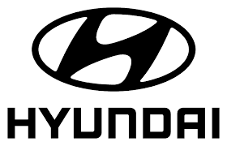

Table of Contents
Table of Contents 2
1. Introduction 4
2.2 Ratio Analysis 4
2.2.1 Profitability Ratios 4
2.2.2 Liquidity Ratios 5
2.2.3 Efficiency Ratios 6
2.2.4 Gearing Ratios 6
2.2.5 Investment Ratios 7
2.2.6 Cash Flow Analysis 7
2.3 Trend Analysis 7
2.4 Strengths and Weaknesses 8
3. Working Capital Management Analysis 9
3.1 Cash Operating Cycle (CCC) 9
3.2 Evaluation of Current Working Capital Position 9
3.3 Recommendations for Improvement 10
1. Inventory Management Strategies 10
2. Credit Control Policies 10
3. Supplier Negotiation Strategies 11
3.4 Financing Options 11
a) Short-Term Financing 11
b) Long-Term Financing 11
3.5 Critical Comparison 11
4. Strategic Financial Restructuring Plan 12
4.1 Identification of Financial Issues 12
4.2 Restructuring Options 13
1. Divestiture (Selling Non-Core Assets) 13
2. Acquisition and Mergers 13
3. Equity Injection 13
4.3 Impact Analysis 14
1. Shareholder Value 14
2. Capital Structure 14
3. Operational Flexibility 14
4.4 International Considerations 14
1. Currency Risk 15
2. Taxation Differences 15
3. Inflation Impact 15
4.5 Ethical and CSR Considerations 15
1. EV Production Sustainability 16
2. Ethical Sourcing 16
3. Environmental Regulations 16
5. Investment Appraisal and Capital Budgeting 16
5.1 Overview of Investment Projects 16
5.2 Investment Appraisal Techniques 17
5.3 Decision-Making Analysis 18
5.4 Recommendation of One Project 19
5.5 Capital Rationing Decision (£100m limit) 20
Combination Evaluation 20
Optimal Choice 20
6. Conclusion 21
Reference 22
Appendices 25
Appendix A: Profitability Ratios 25
Appendix B: Liquidity Ratios 26
Appendix C: Efficiency Ratios 27
Appendix D: Leverage/Gearing ratio 28
Appendix E: Investment Ratios 29
Appendix F: Cash Flow Analysis 30
Appendix G: Working Capital Management Analysis 31
Appendix H: NPV Calculations 32
Appendix I: Payback period Calculations 32
Appendix J: ARR Calculations 32
Appendix K: Profitability index 33
Appendix L: IRR 33
Appendix M: Financial Statements (Data Source) 34

1. Introduction
Hyundai Motor Company is a major automotive manufacturer in the world, based in South Korea and operating in more than 200 countries. The company has built a robust worldwide presence with a varied portfolio of passenger vehicles, commercial vehicles, and an ever-growing range of electric vehicles (EVs). Over the past years, Hyundai has hurried about switching to sustainable mobility, dedicating much of its funds to EVs, hydrogen fuel cells, and smart mobility. This competitive move has made it even stronger among the world automakers, and in tandem with the emerging environmental policies and the consumer needs for cleaner transport (Hyundai, 2024).
This report aims to assess the financial outcomes and strategic standing of Hyundai during the last five years, 2021-2025, based on the information available in the annual reports as attached in the Appendices M. The objective of the analysis is to determine the major financial trends, strengths, and possible risks that the company faces in its long-term sustainability and development.
The four areas are discussed in the report. First, it gives a financial analysis of performance in detail on the ratio techniques. Second, it analyses the working capital management and liquidity status of Hyundai. Third, it suggests a strategic financial restructuring plan to improve efficiency and shareholder value. Lastly, it uses investment appraisal methods to evaluate possible projects and aid capital budgeting.

2.2 Ratio Analysis

2.2.1 Profitability Ratios
The profitability ratios show the effectiveness with which Hyundai is able to make profits in relation to its revenue, assets, and equity within a period of five years (Appendix A).
The gross profit margin is reflecting a more stable trend, ranging between 18.37 in 2025 and a high of 20.58 in 2023. This stability is an indication that Hyundai has been in full control of costs in production despite the challenges in the global supply chain and increased costs of inputs. However, the slight decline in 2025 may indicate increasing production costs or pricing pressures in the competitive EV market (Hyundai, 2025).
The net profit margin shows a fluctuating trend. It increased significantly from 4.84% in 2021 to around 7.5% in 2023 and 2024, before declining to 5.56% in 2025. This indicates that although Hyundai has been able to enhance the efficiency and profitability of its operations during the mid-period, current pressures, perhaps due to the increased financing costs or investment spending, have led to decreased profitability.
The return on assets (ROA) increased consistently, with a low point of 2.43% in 2021 and a high point of 4.35% in 2023, which is an indication of more effective use of assets in generating profit. Nevertheless, the drop to 2.81 % in 2025 shows a decrease in efficiency, which could be attributed to the large capital investments yet to translate to returns (HYUNDAI MOTOR, 2024).
On the same note, the return on equity (ROE) increased remarkably to 12.05% in 2023 as compared to 6.89 in 2021, better returns to shareholders. The following drop to 8.12 in 2025, however, points to deteriorating profitability in comparison to equity and indicates that the addition of more capital or less earnings has diluted shareholder returns.

2.2.2 Liquidity Ratios
Liquidity ratios evaluate the capability of Hyundai to fulfil the short-term commitments (Appendix B). The current ratio was always greater than 1, with a range of 1.30 to 1.46. This shows that the company has enough current assets to pay the short-term liabilities. The high of 1.46 in 2024 is an indication of a robust liquidity position, though the slight decrease in 2025 to 1.36 indicates a slight tightening (Einstein, 2025).
The quick ratio (without inventory), which is also in the range of 1.11 to 1.21, also stood at 1 and above during the period. This indicates that Hyundai has sufficient liquid assets that can be used to pay off short-term commitments without the need to sell inventory. This ratio is stable, indicating good management of working capital. In general, Hyundai has a good and stable liquidity position, which implies a low short-term financial risk.

2.2.3 Efficiency Ratios
Efficiency ratios are used to determine the effectiveness in which the company uses its assets and working capital (Appendix C). The inventory turnover ratio indicates a downward trend from 10.1 in 2021 to 8.85 in 2024 and then slightly rises to 9.01 in 2025. This indicates that there is a longer time in holding inventory, maybe as a result of higher production or slower sales in some segments.
The receivables turnover ratio was the highest in 2023 at 20.05, which implies that it is very efficient to collect the receivables in the year 2023. The drop to 14.12 in 2025, however, indicates that the collection periods will be slow, and this can adversely affect cash flow (Ponsian et al, 2014).
The asset turnover ratio was not very high as it ranged between 0.50 and 0.58. It shows that there is moderate efficiency in the use of assets to produce revenue, but it does not show any substantial change over time.
The payables payment period rose to about 46 days in 2024 after it had risen to 48.1 days in 2021 and decreased to 43.2 days in 2025. This implies that over the last few years, Hyundai has been paying suppliers faster, which might hurt cash reserves, but could help improve relationships with suppliers (Deskera, 2021).

2.2.4 Gearing Ratios
Gearing ratios evaluate the financial structure and risk of the company (Appendix D). The debt-to-equity ratio is also high over the period, which is between 1.77 and 1.89. This means that Hyundai is overly dependent on debt financing. The high level, despite the relative stability, implies additional financial risk and exposure to interest rate risk (HYUNDAI MOTOR, 2024)..
The interest coverage ratio indicates the falling trend of 3.99 in 2021 and 2.48 in 2025. It means that Hyundai has become much less able to fulfil interest payments. Although coverage above 2 is generally acceptable, the downward trend is a concern, indicating increased interest costs or reduced operating earnings. In general, the gearing status of the company indicates the high financial leverage and risk that has been growing in recent years (Yahoo Finance, 2013).

2.2.5 Investment Ratios
The investment ratios are used to determine the investment returns to the shareholders and to the market (Appendix E). The earnings per share (EPS) have risen in 2021 to their highest value of 36.56 in 2023, which is a strong growth in shareholder returns over the three years. The fall to 27.4 in 2025, however, implies a lower profitability or a higher share base (Hyundai Motors, 2022).
The price earnings (P/E) ratio varies considerably, with a high of 7455 in 2025. This very high value can either reflect expectations of future growth or market earnings volatility. The difference between the years indicates market value instability. In general, investment ratios grow at high rates and then become volatile as investor confidence oscillates.

2.2.6 Cash Flow Analysis
The cash flow analysis has shown that the company has the potential to raise cash through its operations (Appendix F). Most years (2021, 2023, and 2025) have an operating cash flow (OCF) that is negative, and the only year with a strong positive value is 2022. This means that Hyundai is not able to make cash out of its core business, even though profits have been reported.
The free cash flow (FCF) is negative in the majority of years, as well as with high capital expenditures. This indicates that the company is engaging in big projects in the long run, especially EV technology and infrastructure (Alexandre, 2025).
Cash flow adequacy ratio is less than 1 in all years except 2022, which implies that the operating cash flows are not enough to meet the capital expenditures, debt payments, and dividends. This brings out a dependence on outside funding. On balance, the cash flow status is poor, and there has been continued negative cash flow over time, which implies that liquidity strains may occur even when accounting profits are high.

2.3 Trend Analysis
In the last five years, Hyundai Motor Company has shown distinct financial trends in terms of profitability, liquidity, efficiency, and cash flow. The change in profitability ratios (net profit margin, ROA, and ROE) reveals that there is an excellent upward trend between 2021 and 2023, which reflects a stronger operating efficiency and post-pandemic recovery. Nevertheless, a decrease in 2025 implies increasing expenses and financial strain. Liquidity ratios are always steady at above 1, which means that it has a strong financial standing on a short-term basis (Hyundai, 2025).
Efficiency ratios indicate a mixed trend: the turnover of receivables increased until 2023, and then decreased, whereas the turnover of inventory increased more slowly, which indicates a decrease in the speed of stock movement. In the gearing ratios, leverage is high, and the debt-to-equity ratio is above 1.7, and interest coverage decreases consistently, which points to the growing financial risk. The most alarming are the trends in cash flow, as the operating and free cash flows are negative in most years, indicating intense capital spending (Snow Flake, 2026).

2.4 Strengths and Weaknesses
The financial analysis reveals a number of strengths of Hyundai Motor Company. The firm has great liquidity, and its current and quick ratios are always higher than 1, which means that it has a good capacity to cover short-term liabilities. The profitability was also enhanced substantially during 2021-2023, which is evidence of an effective cost management strategy and robust growth in revenues. Also, consistent gross margins indicate that the production cost is controlled well amidst the economic difficulties all over the world.
But financial weaknesses are significant. The firm has high leverage, and the debt-equity ratio has been above 1.7, which raises the financial risk. The decreasing interest coverage ratio means that there is less capacity to cover interest payments. Additionally, negative operating and free cash flows persisted, a testimony to dependence on external financing, in large part because of high levels of capital investment. The profitability indicators also indicate a downward trend in 2025, implying an increase in operating costs.

3. Working Capital Management Analysis

3.1 Cash Operating Cycle (CCC)
Cash Conversion Cycle (CCC) is a measure of the time a company requires to turn its investment in inventory and other resources into sales-related cash flows. It consists of three major components, namely: inventory days, receivables days, and payables days (Appendix G).
Hyundai inventory days rose to 49.6 days in 2025, as compared to 44.4 days in 2021. This increasing trend shows that the company is storing inventory longer, and this could be a sign that inventory is turning over at a slower rate or more inventory is on sale because of expansion, especially in the production of electric vehicles (Allianz, 2024).
The days outstanding in receivables varied throughout the years, decreasing to 18.2 days in 2023, and then returning to 25.9 days in 2025. This implies that, although Hyundai showed good credit collection performance in the early years, in recent years, it has declined, pointing to slow customer payment.
The payables days were not that low, as they were between 59.1 days in 2021 and 52.9 days in 2025. Although slightly decreasing, Hyundai continues to delay payments to suppliers, which helps conserve cash.
In general, the CCC had risen considerably in 2021, from 8.2 days in 2021 to 2025 (22.6 days). This means that there has been a drop in efficiency of working capital, with more time being needed to turn the resources into cash. The reduced CCC in 2022-2023 is an indicator of high operational efficiency in these years.

3.2 Evaluation of Current Working Capital Position
The liquidity and efficiency ratios can be used to evaluate the working capital position of Hyundai.
Liquidity-wise, the company is in a good position. The current ratio is always greater than 1, with a range of 1.30-1.46, which means that current assets are adequate to meet the short-term liabilities. On the same note, the quick ratio is greater than 1, implying that despite the lack of inventory, Hyundai will be able to fulfil its short-term liabilities. This is indicative of a stable short-term financial situation.
But there are mixed results on the efficiency of management of working capital. The turnover of inventory has decreased marginally, and the inventory days have grown, implying that there is inefficiency in inventory management. The receivables turnover has been good until 2023, when it began to decline, and this means that the company is taking longer to collect cash from customers (Prasad et al, 2019).
Alternatively, the company has comparatively high payables days, thereby enhancing cash flow through deferral of payments. This is justified but might be detrimental to supplier relationships in case of continuation.

3.3 Recommendations for Improvement
In order to improve the working capital efficiency, a number of approaches can be adopted.

Inventory Management Strategies
Advanced inventory management methods like Just-in-Time (JIT) systems should be implemented by Hyundai to minimize the level of excess stocks. Enhanced demand forecasting and inventory tracking can be used to optimise holding costs and inventory days (Macas et al, 2021).

Credit Control Policies
The receivables days have gone up, and this implies that there is a need to tighten up on credit. Hyundai will be able to set more restrictive credit conditions, perform stricter credit checks of customers, and provide early payment discounts to speed up cash flows. Efficiency can also be enhanced through automation of invoicing and collection systems (Lupi, 2026).

Supplier Negotiation Strategies
Hyundai currently enjoys long payables, but it can also improve on the supplier contracts by negotiating to have flexible payment terms without ruining a relationship. Balancing between cost efficiency and supply chain stability can be achieved through strategic alliances with important suppliers (Lee, 2014).

3.4 Financing Options
The decision of financing sources is also important to good working capital management.

Short-Term Financing
Bank overdrafts offer quick and easy access to money and are therefore appropriate in dealing with temporary cash crises. They do, however, usually attract a higher rate of interest and may lead to greater financial risk when abused.
Trade credit enables Hyundai to pay suppliers on credit and, in this way, fund its operations without any cash leakage. It is also a cheap way of financing, but it can result in poor supplier relations if delays in payments are too much.

Long-Term Financing
Equity financing involves equity raising through the issuance of shares. This reduces the financial risk since it does not need to be repaid, though it may dilute ownership and reduce earnings per share.
Long-term loans provide stable capital to large projects such as the EV development. They do increase the long-term financial commitment and leverage although they have lower interest rates than short-term borrowing.

3.5 Critical Comparison
There are advantages and disadvantages of both short-term and long-term financing.
The short term finance is flexible and readily available finance and thus effective in managing the working capital requirements. However it has a greater interest rate and refinancing risk especially where there is uncertainty in the economy.
Long term financing on the other hand is more predictable and stable and enables strategic investments and growth. It however increases the financial obligations and may reduce the financial flexibility due to a fixed repayment scheme.
A balanced approach has to be considered in the case of Hyundai. The operations of a business can be financed using short-term financing, although it is not advisable because it is risky. Long-term funding should be used to finance large-scale EV investments but this approach should be regulated to avoid over-leverage.

4. Strategic Financial Restructuring Plan

4.1 Identification of Financial Issues
According to the financial analysis, Hyundai has a number of major financial issues that require restructuring.
To begin with, there is a high level of debt. The debt-to-equity ratio of the firm has been consistently high (more than 1.7), implying that the company has relied on external financing. This puts Hyundai at risk financially, especially during the times when interest rates are on the increase. Also, the decreasing interest coverage ratio (3.99 in 2021 to 2.48 in 2025) implies a diminished capacity to cover interest payments, which enhances financial vulnerability.
Secondly, there is pressure on profitability. Despite the increase in profitability in 2021-2023, such key indicators as net profit margin, ROA, and ROE decreased in 2025. It implies that it will increase the operating expenses, competition, and possibly the power of prices in the electric vehicle (EV) market.
Third, Hyundai is directly competing with other major EV manufacturers around the globe. The switch to electric mobility needs significant investments in research and development, as well as infrastructure, which puts an extra financial pressure on the company. Strategic advantage may be enjoyed by competitors that have greater cash flow positions.

4.2 Restructuring Options
Hyundai can implement a number of strategic restructuring strategies in order to overcome its financial problems and attain greater financial stability and long-term growth.

Divestiture (Selling Non-Core Assets)
The sale of non-core or non-performing assets can enable Hyundai to consolidate its financial strengths. The sale of these assets would result in immediate cash flows, less operational complexity, and enable the company to concentrate on its core electric vehicle (EV) operations. Such financial indicators, in particular, the return on assets and liquidity, can be improved by this plan as well, due to redistribution of resources to more profitable fields (Schlingemann et al, 2002).

Acquisition and Mergers
Acquisitions and mergers can be used strategically to improve the competitiveness of Hyundai in the EV market. To illustrate, acquisition of battery technology-oriented companies or autonomous driving systems can aid in long-term innovation and development. Joint ventures and partnerships will also aid in reducing the financial risks by sharing the cost of investments and access to new technologies and markets (Malik et al, 2014).

Equity Injection
Another viable source of raising funds to make sure that reliance on debt is kept to the minimum is equity financing. The problem of new shares will be capable of strengthening the balance sheet of Hyundai and raising the debt-to-equity ratio of the company. This could in the short run, dilute the present shareholders ownership, but will make the organization more financially stable and reduced interest payments, which will facilitate a sustainable future growth.

4.3 Impact Analysis
The proposed financial restructuring strategies are expected to have significant impacts on both the financial performance and operational capabilities of Hyundai.

Shareholder Value
Divestiture and strategic acquisitions have the potential to increase shareholder value by increasing profitability and enabling the enterprise to concentrate on high-growth sectors, especially in the electric vehicle (EV) market. Reducing investment in non-productive areas will give Hyundai better returns in the long run. Equity injection, however, can cause short-term dilution of the earnings per share (EPS) that might adversely affect investor perception. Nonetheless, this is expected to increase the financial strength of the company, which is likely to enhance investor confidence in the long run, leading to sustainable shareholder value generation (Bick, 2009).

Capital Structure
Equity financing and asset divestiture will help decrease the dependence of Hyundai on debt. This will enhance the capital structure of the company as it reduces the debt-to-equity ratio and will also reduce financial risk. The decrease in interest payments will increase the interest coverage ratio, which will increase the capacity of the firm to settle its interest payments. In general, the increased capital structure will make it more resilient to economic uncertainties (Korajczyk and Levy, 2003).

Operational Flexibility
Flexibility in operations will also be enhanced through financial restructuring, which will release financial resources and lessen restrictions. It will be able to invest more in innovation and technological development, especially in EV development, due to lower levels of debt and enhanced liquidity. Moreover, strategic acquisitions may assist in gaining access to new markets and capabilities that help facilitate long-term growth and competitiveness (Yu et al, 2015).

4.4 International Considerations
Hyundai, being a worldwide manufacturer of automobiles, must take into account numerous international elements in its financial restructuring strategy.

Currency Risk
This means that through the operations in various countries, Hyundai is susceptible to fluctuations in the exchange rates which can significantly affect the revenues, costs, and the overall profitability. An example is that the depreciation or appreciation of the foreign currencies can affect the value of international sales and imports. In order to mitigate these risks, Hyundai should employ powerful hedging models, such as forward contracts and currency swaps, to stabilize the cash flows, as well as to reduce the uncertainty in the financial performance (Hassan and Zhang, 2021).

Taxation Differences
Hyundai operates in varying tax environments and the corporate tax rate, regulations and incentives in the various countries are extremely different. These differences can have an impact on investment decision and net profitability. Therefore, it follows that an efficient global tax strategy must be in place to mitigate the tax payable as well as ensure that the company is fully compliant with the international provisions. Strategic distribution of profits and investments in various jurisdictions can enhance tax efficiency even more (Oberholzer and Stack, 2014).

Inflation Impact
The other big challenge is the rising inflation which has increased the cost to produce, particularly the raw materials, energy and labour. In the event that these higher costs cannot be transferred to the consumers through higher prices, then profit margins may be lower. To address the inflationary forces, Hyundai should consider cost management strategies, supply chain management, and flexible pricing. This will contribute to maintaining profitability and financial stability in a constantly fluctuating and volatile global economic situation (Brave and Bruun, 2022).

4.5 Ethical and CSR Considerations
Financial restructuring must take into account ethical principles and corporate social responsibility (CSR) to allow the company to become sustainable in the long-term and to gain stakeholder trust.

EV Production Sustainability
As a major participant in the electric vehicle (EV) sector, Hyundai has a major role to play in the sustainability of the environment. In order to become successful in the long run, it is required to invest in clean energy technologies, reduce carbon emissions, and adopt environmentally-friendly production processes. Sustainable production is not merely advantageous regarding environmental goals, but also brand reputation and customer loyalty in a constantly developing market that is environmentally-conscious (Bailey et al,2017).

Ethical Sourcing
The sourcing of raw materials, particularly EV battery materials, has important ethical implications. Hyundai themselves are also expected to make good sourcing activities by partnering with suppliers that abide by good labor practices and sustainable and environmentally friendly practices. One should not use suppliers who use unethical labor practices or who pollute the environment. Corporate credibility is linked to stakeholders insisting on transparent and traceable supply chains, which are also characterized by corporate credibility.

Environmental Regulations
International environmental laws are to be interpreted. The governments worldwide are putting stricter norms of emission and sustainability. To avoid legal reprimand and remain at the international markets, Hyundai must transform in line with these rules to ensure that its operations are stable in the long run (List and Co, 2000).

5. Investment Appraisal and Capital Budgeting

5.1 Overview of Investment Projects
Hyundai has three mutually exclusive investment options with an initial investment of £50 million and different cash inflow patterns in the next five years.
Project A will produce cash inflows that are moderate and intermittent, with an initial cash outflow of 10 million pounds and reaching a high of 14 million pounds in year 3 and then decreasing. This shows that the growth potential is medium with low long-term consistency.
Project B offers predictable and stable cash inflows of £11 million in a year. This project is a low-risk project that has guaranteed returns but does not have growth potential.
Project C provides irregular yet much larger cash inflows, especially during the years 3 and 4 (£20 million and £25 million). This project indicates a high growth opportunity, but with increased uncertainty since the returns may vary.

5.2 Investment Appraisal Techniques
Various investment appraisal methods have been used to assess the financial viability of the three proposed projects. All the methods offer a different view on performance and allow for comparing them thoroughly.
The Payback Period (PBP) is a measure of time that a project takes to break even. It is more specifically applicable in liquidity and risk assessment, since the payback period is shorter, which means that the money is recovered faster. Project C is the most efficient project between the three, as it can recover the initial investment faster with a payback period of about 3.6 years. Comparatively, Project A will take approximately 4.5 years, whereas Project B will take a little longer at 4.55 years. This implies that Project C is the best choice, which is liquid as it will not be exposed to future uncertainty (Gorshkov et al, 2018).
Accounting Rate of Return (ARR) measures profitability in terms of the average accounting profit versus the investment made. It gives information on the total amount of returns per project. Project C again shows the best performance, having an ARR of 6%, which is much higher than both project B and C, which have 2% and 1.6, respectively. This means that Project C will bring more average profits throughout its life, and it will be more profitable in terms of profitability (Marcelli et al, 2024).
The Net Present Value (NPV) approach considers the time value of money and discounts the future cash flows using a required degree of return (10% here). The three projects have negative NPVs, indicating that none of the projects will be able to achieve the required return threshold. Project C, however, has the smallest negative NPV of -1.99 million as compared to Project B and Project A, which have -8.31 million and -8.69 million, respectively. This implies that none of the projects are optimal, but Project C leads to the least loss in value, hence it is the most acceptable financially (Shou, 2022).
This conclusion is supported by the Profitability Index (PI), which indicates the ratio of the present value of inflows of cash to the initial investment. Project C has the best PI of 0.96, with Projects A and B having PI of 0.83 each. Though all the values are less than 1, meaning that the projects fail to bring about enough returns, Project C is the nearest to the required benchmark (Al-Rikabi, 2021).
The Internal Rate of Return (IRR) is the discount rate at which the NPV of a project equals zero. It is extensively employed in the comparison of the expected payback of various investments. Project C is again the best with an IRR of about 8, whereas Project B has an IRR of about 4.5 and Project A has an IRR of about 4. Project C will have the highest earning potential, although all of the IRRs are below the necessary 10% rate (Yan and Zhang, 2022).
On the whole, the relative superiority of Project C in the course of all appraisal methods can be noted, which points to its higher consistency in performance.

5.3 Decision-Making Analysis
An in-depth analysis of all the methods of investment appraisal evidently points out Project C as the most suitable to Hyundai Motor Company. Project C is financially superior to the other alternatives in all approaches, which payback period, ARR, NPV, PI, and IRR, meaning that the project is more financially viable than the other options.
Despite the three projects having negative NPVs at the 10 percent discount rate, which is necessary, Project C experiences the least loss of value in terms of negative NPV. This renders it the most financially agreeable alternative to the existing options. Moreover, it has a shorter payback period, which decreases liquidity risk, especially considering that Hyundai has negative free cash flows in its recent history.
Project B does not have the potential of growth and it is not a great improvement on the long-term profitability; although it provides stable and predictable returns. Project A on the other hand offers in-between returns but cannot show good financial performance according to all the appraisal methods.
Thus, Project C can be seen as the most balanced investment, which implies a combination of relative higher profitability, a shorter payback period, and greater long-term growth prospects. This is why it is the best option both in financial and strategic terms.

5.4 Recommendation of One Project
Project C is the most appropriate project for Hyundai Motor Company, based on the overall investment appraisal. This suggestion is backed up by its high performance in all methods of evaluation, such as the shortest payback period, the highest ARR, the highest IRR, and the lowest negative NPV.
Financially, Hyundai has recorded a decrease in profitability in 2025 and negative free cash flows over the past few years. This shows strain on the cash generation within the company and the necessity to invest in projects that are capable of providing high inflows in the future. Project C is especially appealing in this regard as it yields much greater cash returns after a few years and returns the investment at the shortest time possible. This enhances the liquidity and alleviates the financial risk.
Project C has more variability in the cash flow than Project B, which is more stable in terms of risk. Although this makes it somewhat uncertain, the greater returns that are likely to come make it worth the risk. Critically, a sustained liquidity position offers a buffer to Hyundai, and the firm can absorb the short-run fluctuations and fund long-term investment plans.
There are also external factors to be taken into consideration. The electric vehicle market in the world is very competitive and prone to any swift technological change, customer preference, and may have political and regulatory uncertainty. Within this environment, a project that has more growth potential is more in line with strategic objectives. Project C will have this benefit, and it will put Hyundai in a position to take advantage of future market opportunities.
In general, Project C offers the most optimal risk-to-return balance and is a suitable investment option.

5.5 Capital Rationing Decision (£100m limit)
With a maximum investment limit of £100 million, Hyundai can undertake any combination of two projects.

Combination Evaluation
- Project A + B
Total NPV = -8.69 + (-8.31) = -16.99 million
- Project A + C
Total NPV = -8.69 + (-1.99) = -10.68 million
- Project B + C
Total NPV = -8.31 + (-1.99) = -10.30 million

Optimal Choice
It is determined that the combination of Project B and Project C is the best investment option, given the constraint of capital rationing of £100 million, since it yields the highest combined Net Present Value (–£10.30 million) compared with the alternatives. The NPV is negative but this choice will result in minimal loss of value hence is financially desirable.

The combination provides a balanced investment plan as both stability and growth opportunities are incorporated. Project B offers regular and reliable cash flows each year and helps minimize uncertainty and allows predictive cash flow. This stability is especially critical considering the fact that Hyundai Motor Company has had some difficulties in its recent experiences with unstable profitability and negative cash flows.

Project C, on the other hand, yields much more cash inflows later and has a good growth potential and better long-term returns. Although Project C has a more risky nature because of uncertainty in cash flows, project B has been included to reduce this uncertainty.

On balance, this mix enables Hyundai to be financially stable and at the same time seek greater growth opportunities. It is a rational and well-reasoned investment choice that is in line with not only the short-term financial priorities, but also the long-term expansion goals.

6. Conclusion
This report analysed the financial performance and strategic position of Hyundai Motor Company over five years. The results show that the company has recorded a high growth of profitability in the years 2021-2023, but in the past few years, the company has recorded a downward trend in profitability and financial pressures. The increasing financial risk is noted by high debt levels and declining interest coverage, whereas the continued negative cash flows mean that it relies heavily on external financing.
The working capital analysis showed that there are high liquidity and decreasing efficiency levels and the cash conversion cycle is increasing which is an indication that the cash is being generated gradually. This highlights the need for improved inventory and receivables management.
Based on the evaluation of the investment, Project C was found as the most appropriate individual investment because it has better performance in all the evaluation methods. With capital rationing, the Projects B and C combination proved to be the best, as it would stabilize and grow at the same time.
In general, Hyundai needs to work on minimizing financial risk, enhancing its cash flow management, and undertaking strategic investments to align with long-term growth in the EV market. The company can bolster its competitive position and achieve sustainable performance by adopting financial restructuring strategies and increasing its operational efficiency.

Reference
Alexandre (2025). Cash Flow Analysis: The Complete Guide for Modern Finance Teams. [online] Cash Flow Analysis: The Complete Guide for Modern Finance Teams. Available at: https://upflow.io/blog/cfo-reads/cash-flow-analysis.
Allianz (2024). Cash Conversion Cycle (CCC): Overview, Formula & Strategies. [online] Corporate. Available at: https://www.allianz-trade.com/en_US/insights/cash-conversion-cycle.html.
Al-Rikabi, N.S. (2021). Profitability index and its impact on short and long-term decisions. Pt. 2 J. Legal Ethical & Regul. Isses, 24, p.1.
Bailey, G., Mancheri, N. and Van Acker, K. (2017). Sustainability of permanent rare earth magnet motors in (H) EV industry. Journal of Sustainable Metallurgy, 3(3), pp.611-626.
Bick, G.N. (2009). Increasing shareholder value through building customer and brand equity. Journal of Marketing Management, 25(1-2), pp.117-141.
Brave, S.A. and Bruun, K.A.Y.L.A. (2022). Measuring the Impact of Inflation on US Consumer Spending. Morning Consult Economic Analysis.
Deskera (2021). What Is Efficiency Ratios? Guide with Examples. [online] Deskera Blog. Available at: https://www.deskera.com/blog/efficiency-ratios/.
Einstein, B. (2025). How to Calculate & Use Liquidity Ratios. [online] Business Insights Blog. Available at: https://online.hbs.edu/blog/post/liquidity-ratios.
Gorshkov, A.S., Vatin, N.I., Rymkevich, P.P. and Kydrevich, O.O. (2018). Payback period of investments in energy saving. Magazine of Civil Engineering, (2 (78)), pp.65-75.
Hassan, T.A. and Zhang, T. (2021). The economics of currency risk. Annual Review of Economics, 13, pp.281-307.
Hyundai (2024). Hyundai About Hyundai | Hyundai Asia&Pacific. [online] HYUNDAI MOTORS. Available at: https://www.hyundai.com/pacific/en/company/about-hyundai.
Hyundai (2025). Hyundai Motor Company And Its Subsidiaries Hyundai Motor Company And Its Subsidiaries Contents. [online] Available at: https://www.hyundai.com/content/dam/hyundai/ww/en/images/company/investor-relations/financial-Information/report-en/2025/2025-q4-consolidated-audit-report-en.pdf.
HYUNDAI MOTOR (2024). Hyundai Motor Company And Its Subsidiaries Hyundai Motor Company And Its Subsidiaries Contents. [online] Available at: https://www.annualreports.com/HostedData/AnnualReports/PDF/OTC_HYMTF_2024.pdf.
Hyundai Motors (2022). Hyundai Motor Company And Its Subsidiaries Consolidated Financial Statements As Of And For The Years Ended December 31, 2022 And 2021 Attachment: Independent Auditors’ Report Hyundai Motor Company Contents. [online] Available at: https://www.annualreports.com/HostedData/AnnualReportArchive/h/OTC_HYMTF_2022.pdf.
Hyundai Motors (2023). Hyundai Motor Company And Its Subsidiaries Hyundai Motor Company And Its Subsidiaries Contents. [online] Available at: https://www.annualreports.com/HostedData/AnnualReportArchive/h/OTC_HYMTF_2023.pdf.
Korajczyk, R.A. and Levy, A. (2003). Capital structure choice: macroeconomic conditions and financial constraints. Journal of Financial Economics, 68(1), pp.75-109.
Lupi, M., (2026). How credit policy ends: Central bankers and the rise and fall of credit controls in Italy, 1973–1983. Contemporary European History, 35, p.e32.
Lee, C.C. (2014). Development and evaluation of the many-to-many supplier negotiation strategy. Computers & Industrial Engineering, 70, pp.90-97.
Marcelli, M., Bi, C., Funder, J.W. and McPhaul, M.J. (2024). Comparing ARR versus suppressed PRA as screening tests for primary aldosteronism. Hypertension, 81(10), pp.2072-2081.
Macas, C.V.M., Aguirre, J.A.E., Arcentales-Carrión, R. and Peña, M. (2021), March. Inventory management for retail companies: A literature review and current trends. In 2021 second international conference on information systems and software technologies (ici2st) (pp. 71-78). IEEE.
Malik, M.F., Anuar, M.A., Khan, S. and Khan, F. (2014). Mergers and acquisitions: A conceptual review. International Journal of Accounting and Financial Reporting, 4(2), p.520.
Oberholzer, R. and Stack, E.M., (2014). Perceptions of taxation: A comparative study of different population groups in South Africa. Public Relations Review, 40(2), pp.226-239.
Ponsian, N., Chrispina, K., Tago, G. and Mkiibi, H. (2014). The effect of working capital management on profitability. International Journal of Economics, Finance and Management Sciences, 2(6), pp.347-355.
Prasad, P., Narayanasamy, S., Paul, S., Chattopadhyay, S. and Saravanan, P. (2019). Review of literature on working capital management and future research agenda. Journal of Economic Surveys, 33(3), pp.827-861.
Schlingemann, F.P., Stulz, R.M. and Walkling, R.A. (2002). Divestitures and the liquidity of the market for corporate assets. Journal of financial Economics, 64(1), pp.117-144.
Shou, T. (2022), July. A literature review on the net present value (NPV) valuation method. In 2022 2nd International Conference on Enterprise Management and Economic Development (ICEMED 2022) (pp. 826-830). Atlantis Press.
SnowFlake (2026). What Is Trend Analysis? How to Analyze Trends Step by Step | Snowflake. [online] Snowflake.com. Available at: https://www.snowflake.com/en/fundamentals/trend-analysis/.
Yahoo Finance (2013). Hyundai Motor Company. [online] Available at: https://finance.yahoo.com/quote/005385.KS/history/?frequency=1mo&period1=1618892826&period2=1776659113 [Accessed 2024].
Yan, R. and Zhang, Y. (2022), March. The Introduction of NPV and IRR. In 2022 7th International Conference on Financial Innovation and Economic Development (ICFIED 2022) (pp. 1472-1476). Atlantis Press.
Yu, K., Cadeaux, J. and Luo, B.N. (2015). Operational flexibility: Review and meta-analysis. International Journal of Production Economics, 169, pp.190-202.

Appendices

Appendix A: Profitability Ratios
Profitability ratios
 | Formulas | 2025 | 2024 | 2023 | 2022 | 2021
Gross margin ratio | Gross Profit/Net revenue | 18.37% | 20.40% | 20.58% | 19.84% | 18.65%
Net profit margin ratio | Net income/Net revenue | 5.56% | 7.55% | 7.54% | 5.60% | 4.84%
Return on assets ratio | Net profit /Assets | 2.81% | 3.89% | 4.35% | 3.12% | 2.43%
Return on Equity ratio | EAIT/Total equity*100 | 8.12% | 11.00% | 12.05% | 8.78% | 6.89%

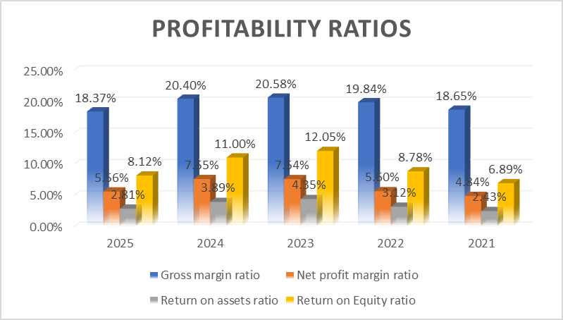

Appendix B: Liquidity Ratios
Liquidity ratios | Formulas | 2025 | 2024 | 2023 | 2022 | 2021
Current ratio | Current assets/Current liabilities | 1.36 | 1.46 | 1.39 | 1.3 | 1.38
Quick Ratio | (current asset-Inventory)/Current liabilities | 1.12 | 1.21 | 1.15 | 1.11 | 1.2

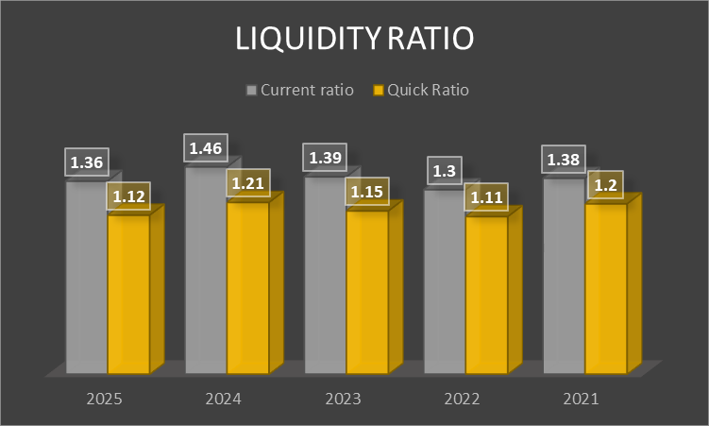

Appendix C: Efficiency Ratios
Efficiency ratio | Formulas | 2025 | 2024 | 2023 | 2022 | 2021
Inventory Turnover Ratio | CGS/Inventory | 9.01 | 8.85 | 9.35 | 9.97 | 10.1
Account receivable turnover ratio | Net sales/Accounts receivable | 14.12 | 18.2 | 20.05 | 16.31 | 15.96
Asset turnover ratio | Net sales/Total assets | 0.51 | 0.52 | 0.58 | 0.56 | 0.5
payable payment period | Average accounts payable/Cost of goods sold*365 | 43.2 | 46 | 44 | 48.8 | 48.1

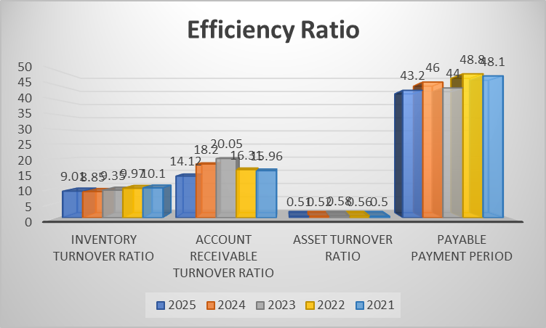

Appendix D: Leverage/Gearing ratio
Leverage/Gearing ratio | Formulas | 2025 | 2024 | 2023 | 2022 | 2021
Debt to equity ratio | Total liabilities/Shareholders' equity | 1.89 | 1.83 | 1.77 | 1.81 | 1.83
Interest coverage ratio | Operating income/Interest expenses | 2.48 | 3.23 | 3.9 | 3.96 | 3.99

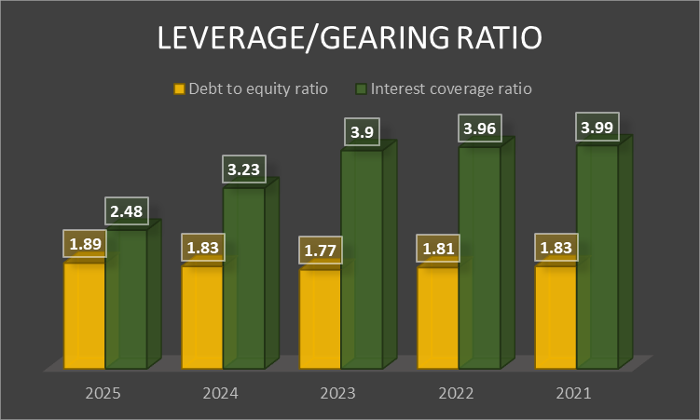

Appendix E: Investment Ratios
Investment ratio | Formulas | 2025 | 2024 | 2023 | 2022 | 2021
Earnings per share | (Net Income-Preferred Dividend)/ Weighted average Number of shares outstanding | 27.4 | 33.33 | 36.56 | 19.97 | 17.08
Price/Earnings ratio | Market value per share/Earnings per share (EPS) | 7455.073 | 4578.4578 | 3104.4858 | 3705.5583 | 5766.979

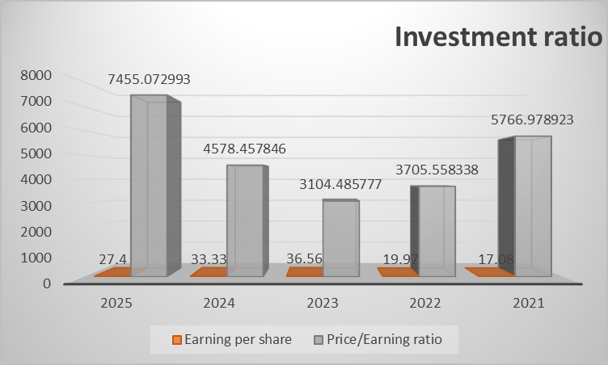

Appendix F: Cash Flow Analysis
Cash Flow Analysis | Formulas | 2025 | 2024 | 2023 | 2022 | 2021
Operating cash flow | Net Income + Non-Cash Expenses (Depreciation/Amortization) - Increase in Working Capital. | -5991270 | -5661641 | -2518760 | 10627311 | -1176416
Free cash flow | Operating Cash Flow (OCF) - Capital Expenditures (CapEx) | -17061126 | -16029096 | -11369941 | 4893609 | -7037743
Cash flow adequacy | Operating cash flow/ (capital expenditure + Debt repayment + Dividend) | -0.09 | -0.09 | -0.05 | 0.29 | -0.03

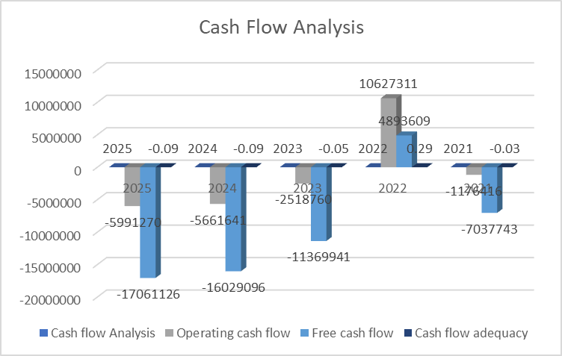

Appendix G: Working Capital Management Analysis
 |  | 2025 | 2024 | 2023 | 2022 | 2021
Inventory Days | (Inventory/COGS) *365 | 49.6 | 51.8 | 49.1 | 45.6 | 44.4
Receivable Days | (Receivable/Revenue) *365 | 25.9 | 20.1 | 18.2 | 22.4 | 22.9
Payables Days | (payable/COGS) *365 | 52.9 | 57.8 | 55.4 | 60.9 | 59.1
CCC | (Inventory days+Receivable Days-Payable days | 22.6 | 14.1 | 11.9 | 7.1 | 8.2

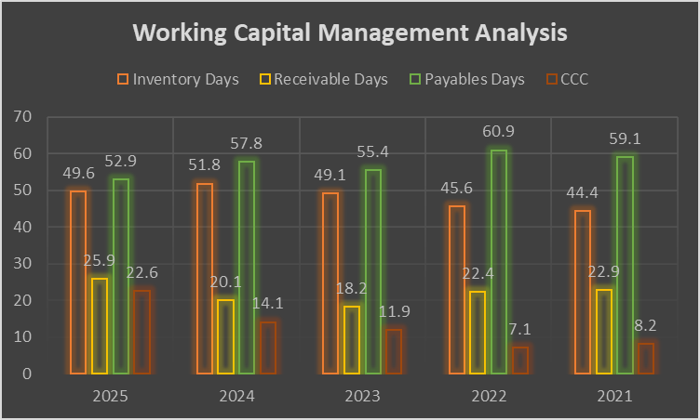

Appendix H: NPV Calculations
Year | Discount Factor (10%) | Cash flow of Project A | Present value | Cash flow of Project B | Present value | Cash flow of Project C | Present value
0 | 1 | 50 | 50 | 50 | 50 | 50 | 50
1 | 0.909 | 10 | 9.09 | 11 | 9.999 | 5 | 4.545
2 | 0.826 | 12 | 9.912 | 11 | 9.086 | 10 | 8.26
3 | 0.751 | 14 | 10.514 | 11 | 8.261 | 20 | 15.02
4 | 0.683 | 10 | 6.83 | 11 | 7.513 | 25 | 17.075
5 | 0.621 | 8 | 4.968 | 11 | 6.831 | 5 | 3.105
Total Present Value |  |  | 41.314 |  | 41.69 |  | 48.01
NPV |  |  | -8.686 |  | -8.31 |  | -2.00

Appendix I: Payback period Calculations
Year | Cash flow of Project A | Cum. Cash flow | Cash flow of Project B | Cum. Cash flow | Cash flow of Project C | Cum. Cash Flow
1 | 10 | 10 | 11 | 11 | 5 | 5
2 | 12 | 22 | 11 | 22 | 10 | 15
3 | 14 | 36 | 11 | 33 | 20 | 35
4 | 10 | 46 | 11 | 44 | 25 | 60
5 | 8 | 54 | 11 | 55 | 5 | 65
Payback period |  | 4.5 |  | 4.55 |  | 3.6

Appendix J: ARR Calculations
Project | Total Cash Flow | Avg Cash Flow | Profit (–10 dep) | ARR
A | 54 | 10.8 | 0.8 | 1.60%
B | 55 | 11 | 1 | 2.00%
C | 65 | 13 | 3 | 6.00%

Appendix K: Profitability index
Project | PV | PI
A | 41.31 | 0.83
B | 41.69 | 0.83
C | 48.01 | 0.96

Appendix L: IRR
Project | IRR
A | 4%
B | 4.50%
C | 8%

Appendix M: Financial Statements (Data Source)


