Student Name: Shevonne Lebert
Module Title: Jurys Inn
Module Code: BMIH5007
Lecturer: Dale Clarke
Module Name: Financial Management in The Hotel Industry

Executive Summary
Jurys Inn is one of the most successful hotel chains in the United Kingdom. Within this report the financial statement will be analysed between 2019 and 2020, a ratio analysis will be performed and trends within the financial statement will be identified, this will aid management in forming strategies to generate more profit and develop a plan after the performance review results are examined. Two diagrams will be within this report which will aid the ratio analysis and help to establish the differences between the 2 years.
The importance of understanding ratios and fluctuations that could affect the financial statement will be discussed. Liquidity, profitability and gearing ratios for Jurys Inn will be discussed and all three ratios will be defined, and their formulas will be explained. This report will discuss how management can strengthen the performance of the company.
The profitability ratio discusses the loss of profit between 2019 and 2020 and how management can improve revenue management.

Table of Contents
Executive Summary 2
Contents Page 3
Introduction 4
Calculations table 6
Ratio Analysis Diagram 2 8
a. Profitability 8
b. Liquidity 10
c. Gearing 10
The Benefits and limitations 12
Conclusion 13
Bibliography 14

Introduction

Jurys Inn is a hospitality company that owns hotels across the United Kingdom. According to (Jurys Inn & Leonardo Hotels City Centre Hotels - Best Prices for the UK & Ireland, 2022) Jurys’s inn operates in the UK, Czech Republic, and Ireland, with over 4,000 employees in over 43 locations. The purpose of this report is to analyze Jurys Inns financial statement. Within this report there will be a calculation of suitable ratios for the period of 2019 and 2020, trends within this ratio will be discussed in detail and a conclusion of findings will be formed liquidity, profitability, and gearing of the hotel will also be explained in detail.
Also, the importance of understanding ratios and possible fluctuations within a busy hotel management setting will be explored, and why it is of great importance that the finance department within Jurys Inn analyze information from the financial statement effectively. Ratio analysis will be explored, plus the advantages and disadvantages, any possible limitations will be discussed and how ratio analysis can support decision making within the hotel industry. Within the conclusion key recommendations for the finance department will be produced and a summarization of findings.
This report will allow the finance department to make necessary changes to the business to generate more profit and possibly sales. By analyzing the company profits and the balance sheet the finance department can pinpoint trends based on the ratio components.
The finance department should be then able to identify Jurys Inns expenses and incoming money to form decisions based on how these are both being managed. This is very important in terms of the finance side of the business as this allows managers to measure Jurys Inns success. When effectively analyzing the financial information for the company the aim is to identify the 3 different ratios, which is liquidity, profitability and gearing, when using these ratios correctly management at Jurys Inn can manage operations effectively over a 2-year
period and make necessary changes. By identifying differences in the operations from year-to-year management will be able to identify the causes of these issues. The use of ratios will help to evaluate and measure the differences within the yearly finance reports by using these figures to measure the performance at Jurys Inn. This will also allow Jurys Inn management to measure the competition within the market which is of great importance too.

Diagram 1- Calculations Table
Formula | Ratio | 2019 | 2020
Gross Profit/Sales x 100 | Gross Profit | 5,500/5050x100=92% | 6000/5150x100=86%
Net Profit/Sales for the year x 100 | Net Profit | 4,008/5500x100=73% | 6000/4073x100=68%
Net Profit for the year+loan interest /total assets less current liabilityX100 | ROCE | 4,008-20-3988/6226x100=64% | 4073-18=4055/6274x100=65
Sales/ Total assets less current liabilities | Total Assets Turnover | 5,500/ 6226=0.88days | 6000/6274=0.95days
Sales/Net Profit Assets | Working Capital Turnover | 5,500/1726=3.18 | 6000/1624=3.69
Current Assets Total/ Current Liabilities Total | Current Ratio | 3065/1339=2.28 | 3,240/1616=2.00
Current assets total – stock / current liabilities total | Quick ratio | 3065-1450/1339=1.20 | 3240-1420/1616=1.12
Debtors x 365 days of the year / sales | Debtor days | 1600x365=584000/5,500=106.18 | 1800x365=657000/6000=109.5  Days
Trade creditors x 365 days /purchases | Creditor days | 800x365=292000/500=5.84 days | 870x365=317,550/850=3.74 days
(Total current liabilities +bank loan) (total current assets + fixed assets) answers divided by one another | Debt days | 1,339+150=1489  3065+4500=7565  7565/1489=0.19 days | 1616+145=1761  3,240+4650=7890  7,890/1761=0.22 days
Net profit of the year + cash in hand / loan interest | Interest cover | 4008 plus 5 divide 20=200.65 | 4,073 plus5 divide 18=226.55

Diagram 2 Ratio Analysis

Financial Analysis Trends

(Trend Analysis, 2022) states that “trend analysis is an analysis of the trends of a company by comparing financial statements to analyse trends in the market or an analysis of the future based on past performances, and it is an attempt to make the best decisions based on the results of an analysis performed”. Performance management systems involve the process of setting goals, and analysing and interpreting performance data, this process is essential in the decision-making process. Understanding why the deficiencies in the financial statements have happened is critical in analysing financial statements and assessing the trends within the financial statement. When a company can successfully analyse performance in financial statements corrective actions can be introduced by management to improve the business.

Profitability
Probability ratios are measurements put in place to assess a businesses ability to earn profits and keep track of a business performance and operations.
The profitability ratio aims to analyse 5 ratios from 2019 to 2020.the net profit margin shows the net profit has decreased by 5 percent from 2019 to 2020 displaying that the company is operating at a loss. Jurys Inn can improve the chances of increasing their net profit by reducing costs and developing new products and services that tailor to the guests needs.
The gross profit has decreased from 92% to 86% this shows that the business has performed worse in 2020 than in 2019 and there is a 6% loss in gross profit. Jurys Inn have a high chance of improving this by increasing sales
. ROCE has decreased from 64% in 2019 to 65% in 2020 this means there was a increase of 1% this displays that the business has some growth and there is room for some of the profits to be invested back into the business. Jurys Inn can improve the ROCE by paying off debt as quickly as possible. This also indicates that the company can effectively utilize its capital and generate more profit but there is still room for improvement.
The assets turnover decreased in 2020 by 0.07 hours compared to in 2019. (What is Asset Turnover Ratio? 2022) suggests that hospitality businesses can improve their assets turnover by leasing. This also shows that the working capital turnover increased in 2020 by 0.51% compared to 2019 this means that the businesses assets are more than its current liabilities meaning the business can increase profits this also means that Jurys Inn has enough financial resources to meet all the liability costs and still make a profit.

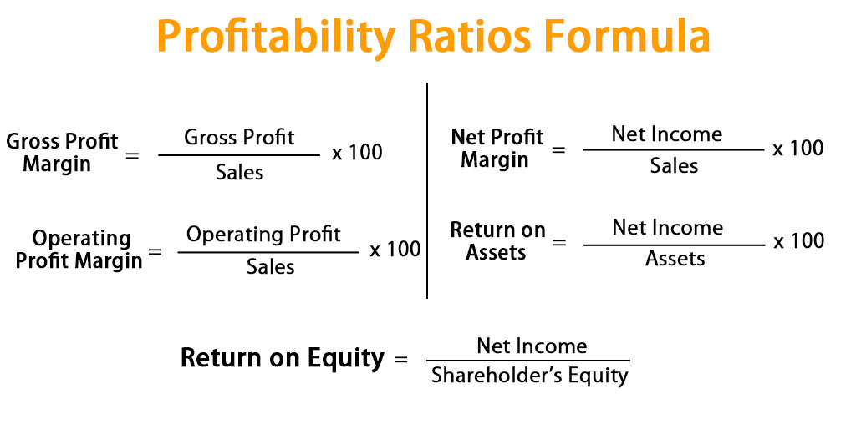
(Formula, 2022)

Liquidity

Liquidity ratio is crucial it is a type of financial ratio that measures a companies ability to pay short term liabilities.it assesses the short-term liabilities and expenses and provides businesses with the correct information which allows them to make changes and analyse whether a company can use its current assets to pay off short term liabilities (Madushanka, K.H.I. and Jathurika, M., 2018).Jurys Inns quick ratio decreased in 2020 by 0.08 percent compared to in 2019 this shows that there has been an decrease in Jurys Inns short term debt if the company can pay off the current liabilities more efficiently this will improve the ratio. Current Ratio has decreased by 0.28%. Debtor days increased by 3.32.the formula for liquidity ratios involve the current assets that are owned by the company and the current liabilities that are owed by the company. Liquidity ratios are important to investors and creditors when assessing whether a business can afford their short-term liabilities.

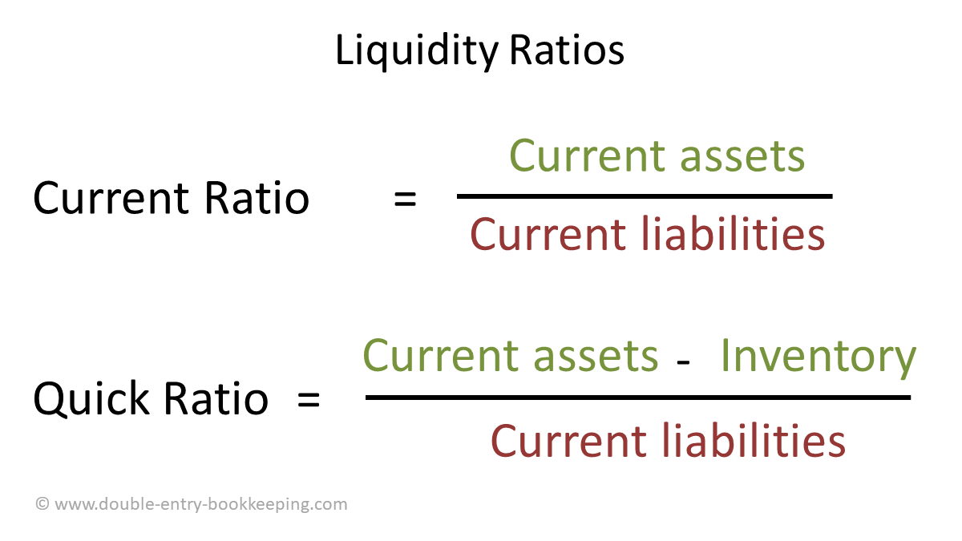
(What is a Liquidity Ratio? | Double Entry Bookkeeping, 2022)

Gearing

A gearing ratio is a financial ratio that compares a business owners’ equity or capital to funds borrowed by the company. Gearing has to do with a company’s leverage. Which shows how a companies activities are funded by shareholders funds compared to creditors funds. (How the Gearing Ratio Works, 2022). Gearing can also be calculated by dividing the total debt by the total shareholders' equity. A low gearing ratio means the business has a small amount of debt compared to equity. The table below shows the formula for working out the gearing ratio.

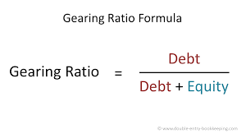
(Gearing Ratio Analysis | Double Entry Bookkeeping, 2022)

Ratios and their fluctuations

According to (Faello, 2015) Companies with hotel management usually have a lot of short-term liabilities in the form of salaries, equipment leasing and various other short-term liabilities. It is important for these companies to have enough current assets to cover the current liabilities. For stakeholders to
see that a company is strong the company must be able to produce a high current ratio usually above 1.
Finance ratios give stakeholders a better understanding of long-term solvency of a hotel business, these ratios measure a hotels ability to meet long term debts.
Hotels have a lot of long-term liabilities too, these types of debt finance large hotels, long term assets are needed to run hotel businesses which correlates with the need for long term debt financing. Financial ratios are important because they allow hotel companies to analyse the industry and track performance within hotel operations. Lending and investments are usually dependant on a ratio analysis because this analyses a business’s financial state.

The Benefits and Limitations of Ratio analysis

Limitations of Ratio Analysis:
- Ratio Analysis is based on information already collected.
- Ratio Analysis does not involve looking at external factors such as the Coronavirus Pandemic and fluctuations.
- Emotional factors are not considered
- Inflation can occur between different time periods, these are not usually reflected in financial statements.
- Changes in accounting policies can affect the financial statements
- Operational changes can be affected, such as changes to a product the company is selling.
- Financial statements are easy to manipulate by management

(Limitations of Ratio Analysis, 2022)

Benefits of Ratio Analysis:

- The finance department can compare figures between certain time periods
- The ability to see strengths and weaknesses
- Measurement of performance can be analysed
- The collection of financial data
- The finance department can study trends in costs, sales, and profit.
- Ratio analysis can improve communication and are important in providing important information between business owners investors and shareholders.
- Ratios help to analyse the liquidity position, in terms of short- or long-term debt
- Ratio analysis can aid decision making
- Ratio Analysis can aid management in understanding financial statements.

(Purpose and limitations of Ratio Analysis - Ratios - Higher Business management Revision - BBC Bitesize, 2022)

Conclusion

To conclude financial Statements are important for the decision-making process of any business. By attaining the right information, analysing, and interpreting the data correctly. By completing a ratio analysis and comparing ratios correctly Jurys Inn finance department should be able to assess management relating to risks and return.
When analysing the revenue growth, it is important for Jurys Inn to look at the measures that need to be put in place these can involve looking at improving asset utilization by looking into the return of investment and the economic value added. To

By investigating the ratio analysis Jurys Inn, management, can see that in 2019 Jurys Inn had a good amount of sales, the results between years also show there was a loss in profit in 2020.The ROCE increased by just 1 percent , showing that the companies’ ability to utilize capital is not doing well , this includes both equity and debt , Jurys Inn debt days and debtor days increased, in 2020 showing that the company is not paying off liabilities efficiently , both the bank loan and creditors liabilities have increased and this should be improved. Jurys Inns profitability ratio also shows that the expenses were greater in 2020 then 2019 and this needs to be reviewed. Business operating costs should be reduced where possible. There was a significant increase in light and heating costs and advertising. Jurys Inn has not capitalised the revenue in depreciation costs and repairs have increased by a huge amount, showing that the companies expenses need to reviewed and cuts need to be made where possible. The net profit for the year has increased by just 65 pounds which is disgraceful.
The liquidity ratio is more in debt in 2020 then 2019 and the gearing ratio shows that current liabilities have increased, and stock assess have decreased in 2020.

From 2019 to 2020 the sales for Jurys Inn increased by 500 pounds but because of debt from bank loans and overdrafts the company can not generate much of a profit. From the analysis of financial statements Jurys Inn is likely to go into administration the results show that there is a lot of debt, and this can be rectified by paying off liabilities as soon as possible, the amount of bank overdraft needs to be lowered and expenses need to reviewed and cuts made where possible, these cuts need to be reviewed carefully and production should not be affected dramatically by these changes.

produce new products and target new customers/markets it is important for management to monitor percentages of revenue for new customers/ markets and the revenues from new products. The ROCE increased by just 1 percent

Bibliography
- BBC Bitesize. 2022. Purpose and limitations of Ratio Analysis - Ratios - Higher Business management Revision - BBC Bitesize. [online] Available at: <https://www.bbc.co.uk/bitesize/guides/zrxn47h/revision/5> [Accessed 16 February 2022].
- Corporate Finance Institute. 2022. Limitations of Ratio Analysis. [online] Available at: <https://corporatefinanceinstitute.com/resources/knowledge/finance/limitations-ratio-analysis/> [Accessed 9 February 2022].
- Double Entry Bookkeeping. 2022. Gearing Ratio Analysis | Double Entry Bookkeeping. [online] Available at: <https://www.double-entry-bookkeeping.com/leverage-ratios/gearing-ratio/> [Accessed 8 February 2022].
- Double Entry Bookkeeping. 2022. What is a Liquidity Ratio? | Double Entry Bookkeeping. [online] Available at: <https://www.double-entry-bookkeeping.com/liquidity-ratios/liquidity-ratio/> [Accessed 8 February 2022].
- Faello, J., 2015. Understanding the limitations of financial ratios. Academy of accounting and financial studies journal, 19(3), p.75.

- Formula, P., 2022. Profitability Ratios Formula | Calculate Profitability Ratios (Excel Template). [online] EDUCBA. Available at: <https://www.educba.com/profitability-ratios-formula/> [Accessed 8 February 2022].
- Investopedia. 2022. How the Gearing Ratio Works. [online] Available at: <https://www.investopedia.com/terms/g/gearingratio.asp> [Accessed 7 February 2022].
- Jurysinns.com. 2022. Jurys Inn & Leonardo Hotels City Centre Hotels - Best Prices for the UK & Ireland. [online] Available at: <https://www.jurysinns.com/> [Accessed 16 February 2022].

- Madushanka, K.H.I. and Jathurika, M., 2018. The impact of liquidity ratios on profitability. International Research Journal of Advanced Engineering and Science, 3(4), pp.157-161.
- Wall Street Mojo. 2022. Trend Analysis. [online] Available at: <https://www.wallstreetmojo.com/trend-analysis/> [Accessed 25 January 2022].

