

Student name: Kinga Motyl
Student ID:2533097

Module name: Introduction to Health and Social Care
Module code: LCHS4003
Lecturer name: Sam Parker

Date of submission: 19.07.2026
Contents

Element 1: Poster
Dentistry Services……………………………… 1

Element 2: 600-word Essay
Community Mental Health Services ………. 2-3

References …………………………………….4
Dentistry Services in the UK

References:
- Department of Health and Social Care (2026). Patients to benefit from improved access to dental appointments. GOV.UK. Accessed: 15 July 2026
- House of Commons Library (2026) NHS dentistry in England. Research Briefing. Accessed: 15 July 2026
- NHS (2025) Dental services available on the NHS. Accessed: 15 July 2026
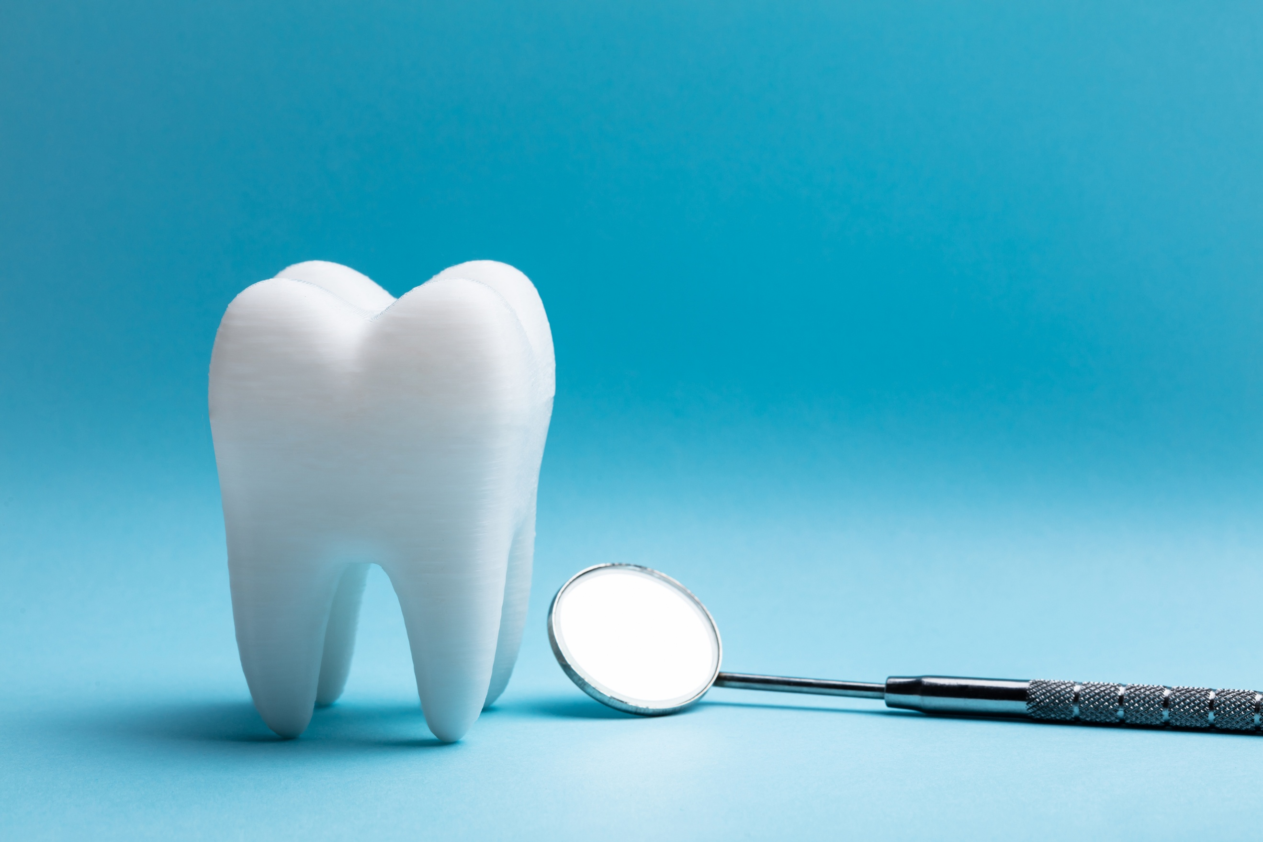
dd
Brief History

Current Functioning

Today, in the UK, dentistry services are provided by the NHS or privately. Patients using NHS services are partially subsidised, and certain groups are exempt, such as children and seniors. The dentist assesses the teeth and implements the treatment plan. The procedures performed include fillings, crown placements, or tooth extractions. Prevention and follow-up are often limited in practice due to the funding pressures (House of Commons Library, 2026).
Why dentistry matters?

Current Two Challenges

What are the Dentistry Services?
Dentistry is a comprehensive service within oral healthcare that provides general dental care. Its primary purpose is to provide diagnosis, treatment, and prevention (NHS, 2025).

Element 2 - 600 -word Essay
Community Mental Health Services

Introduction

Community Mental Health Services (CMHS) are an essential part of modern healthcare to provide care, treatment and rehabilitation for individuals experiencing mental health challenges. The development of community-based mental care has progressed in parallel with political and economic developments, alongside evolving people's perspectives and increasing awareness of mental conditions, which has consequently led to a withdrawal from institutional care. At present, these services are provided by multidisciplinary professionals who work collectively to deliver high-quality person-centred care in the community.

This essay will investigate the origins of the service with brief historical context. It will also evaluate service functioning, explore the challenges and highlight its significance in supporting service users today. This essay is based on academic sources and supported by evidence from the literature.

1. Origins of the service and historic context that shaped its development.
1 :1
The origins of contemporary mental health care began in the eighteenth century, when people with mental health difficulties were often misunderstood and endured inadequate treatment due to insufficient medical understanding, social stigma and dominant social attitudes (Jones, 1972, p.3). Furthermore, rather than receiving appropriate care, many individuals were placed in workhouses, prisons, and early asylums. In the nineteenth century, during the Industrial Revolution, increasing public concern and evolving perceptions of mental conditions prompted the establishment of more organised services. The Lunacy Act of 1845, during the Victorian era, established the Lunacy Commission under the government administration of Sir Robert Peel to expand the state's role.
1:2
According to Ellis and Brumby (2026), the Mental Treatment Act of 1930 allowed voluntary hospital admission and fostered optimism about more therapeutic approaches and improvements for patients. Additionally, the National Health Service Act 1948 established and integrated psychiatric hospitals into the wider healthcare system. The milestone which shifted the focus of mental health care from institutionalisation was the Mental Health Act 1959. Furthermore, the foundation that shaped modern mental health was transformed by the Mental Health Act 1983- 2007, which focused on promoting community-based support and partnerships between services (Burns, 2020).
2. Critical evaluation of how the services function today.
2:1
Today, the service is organised by specialised professionals who provide assessment, treatment, and person-centred care for individuals in their community. NHS England (2025) states that NHS Talking Therapies provide a broad range of mental health support. CBT therapy, counselling, medication, and signposting to other organisations enhance collaboration between the departments. However, despite NHS TT demonstrating positive outcomes, some limitations remain. Abichi et al. (2026, p. 8) state that "this lack of systematic assessment of potential harms represents a vital evidence gap within the NHS TT", suggesting that further evaluation of the service is needed to ensure maximum effectiveness.
2:2
Furthermore, the growing demand, funding limitations, and staff shortages may result in treatment delays and reduce the service's ability to provide high-quality care (BMA, 2026). Additionally, workloads place staff under significant pressure, which may lead to burnout and potentially put patients at risk of underqualified assessment. Moreover, Balbuena Riviera (2024) argues that despite the benefits from the transition from institutional care to community-based services, these challenges persist to this day.

3. Significance in enhancing the quality of life of service users.

CMHS facilitates individuals experiencing mental health challenges and assists them in acquiring greater choice and control over their treatment. It provides holistic support that addresses both health and social needs. Through coordinated strategies such as employment support, people will achieve greater independence, return to work, and participate more fully in community life. This enhances mental well-being and social inclusion, reduces health-related economic inactivity, and highlights the advantages of integrated care (Health and Social Care Committee, 2025).

Conclusion

In conclusion, CMHS has evolved from institutional care into person-centred community-based services. Systematic assessment within the NHS, alongside increased funding and shorter waiting times, would help realise its full potential and provide more efficient support for service users. These services remain essential in promoting independence, recovery and quality of life.

References

Abichi, M.C., Davis, A. A., Proudfoot, H., Norton, S., Moss-Morris, R., and Hudson (2026) ‘Current treatment outcomes and care pathways for people with comorbid physical and mental health conditions using NHS Talking Therapies services in the UK: systematic review of quantitative studies’, BJPsych Open, 12(2), p. e56.doi:10.1192/bjo.2025.10957.

Balbuena Rivera, F. (2024) ' From asylums to deinstitutionalization and after: an analytic review’, The International Journal of Social Psychiatry, 70(8), pp. 1392–1401. doi:10.1177/00207640241268356.

British Medical Association (BMA) (2026) Mental health pressures in England. Available at: http://www.bma.org.uk/advice-and-support/nhs-delivery-and-workforce/pressures/mental-health-pressures-data-analysis (Accessed: 22 June 2026).

Burns, T. (2020) ‘Community-Based Mental Health Care in Britain’, Consortium Psychiatricum,1(2), pp. 14-20. doi:10.17650/2712-7672-2020-1-2-14-20

Ellis, R. and Brumby, A. (2026) ‘Outpatients clinics and the 1930 Mental Treatment Act: Patients and practitioners, c.1888-c.1940’, History of Psychiatry, pp.1-18. doi:10.1177/0957154X261430341

Health and Social Care Committee (2025). Community Mental Health Services. Fourth Report of Session 2024-26. HC 566. London: House of Commons. Available at: http:/publications.parliament.uk/pa/cm5901/cmselect/cmhealth/566/report.html (Accessed:24 June 2026)

Jones, K. (1972) A History of the Mental Health Services. London, Routledge.

