Further Searching using forms

Last week we learned how to feed search data entered by the user from an HTML form through to a PHP query and return some results to the screen.
The database we created had one table, people and looked something like this:

people
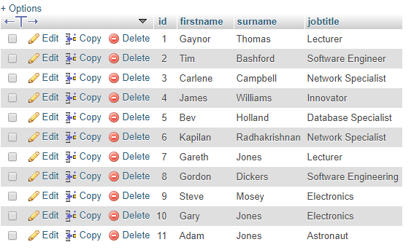

(Note: We have not considered security implications, particularly SQL Injection which our code is currently vulnerable to. Methods of avoiding this will come later in the module)

The code we used is shown below:
entersearch.php
<html>
<head>
</head>

<body>
<form action="showdatabase.php" method="post">

Search: <input type="text" name="mysearch"><br><br>
<input type="submit">

Jones
</form>
</body>
</html>

showdatabase.php
<?
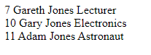
include "conninfo.php";

$search=$_POST["mysearch"];
Jones

$query="SELECT * FROM people WHERE surname like '$search'";

$result=mysqli_query($link,$query);
$numrows=mysqli_num_rows($result);//how many rows were found?

if($numrows==0)//none found
{
echo "Sorry, nothing found";
}
else //print out rows found
{

while($r=mysqli_fetch_array($result))
{
echo $r["id"]." ";
echo $r["firstname"]." ";
echo $r["surname"]." ";
echo $r["jobtitle"]."<br>";
}
}
?>

Exercises

- Extend your search so it works on ANY field (not just surname). For example, if I enter “Jones” or “Astronaut” or “Gordon” etc it will return some results.

Hint: you can have more than one filter in your WHERE clause by using AND/OR

Example output:



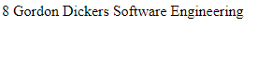



Solution Question 1:
Form remains the same.
PHP mostly stays the same, with a query change as follows:
<?
include "conninfo.php";

$search=$_POST["mysearch"];

$query="SELECT * FROM people WHERE firstname like '$search' OR surname like '$search' OR jobtitle like '$search'";

$result=mysqli_query($link,$query);
$numrows=mysqli_num_rows($result);//how many rows were found?

if($numrows==0)//none found
{
echo "Sorry, nothing found";
}
else //print out rows found
{

while($r=mysqli_fetch_array($result))
{
echo $r["id"]." ";
echo $r["firstname"]." ";
echo $r["surname"]." ";
echo $r["jobtitle"]."<br>";
}
}
?>

- Write a search so that you can search on both first name and surname.

- Write an EXACT match search (ie it will only find a match if the exact first name and surname is entered)

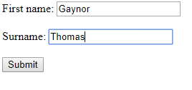

But not:

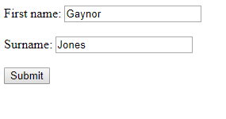

Solution 2a) :

Form:

<html>
<head>
</head>
<body>
<form action="showdatabase.php" method="post">

First name: <input type="text" name="fname"><br><br>
Surname: <input type="text" name="sname"><br><br>

<input type="submit">

</form>
</body>
</html>

showdatabase.php changes to:

<?
include "conninfo.php";

$search1=$_POST["fname"];
$search2=$_POST["sname"];

$query="SELECT * FROM people WHERE firstname like '$search1' AND surname like '$search2'";

$result=mysqli_query($link,$query);
$numrows=mysqli_num_rows($result);//how many rows were found?

if($numrows==0)//none found
{
echo "Sorry, nothing found";
}
else //print out rows found
{

while($r=mysqli_fetch_array($result))
{
echo $r["id"]." ";
echo $r["firstname"]." ";
echo $r["surname"]." ";
echo $r["jobtitle"]."<br>";
}
}
?>

- b) Change your search so that it is less exact, and will match on either field:



Solution 2b):

Same as 2a) above, but with the following query:

$query="SELECT * FROM people WHERE firstname like '$search1' OR surname like '$search2'";

- c) Allow a wildcard search too (%)

Solution 2c)

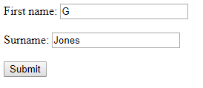

Same as 2b) above, but with the following query:

$query="SELECT * FROM people WHERE firstname like '$search1%' OR surname like '$search2%'";

- Radio button search

Using a radio button, allow the user to select the field of their choice.



The code for your form might look something like this:

<html>
<head>
</head>
<body>
<form action="showdatabase.php" method="post">

Search: <input type="text" name="search"><br><br>

First name: <input type="radio" name="fieldtype" value="f" checked="checked"><br>
Surname: <input type="radio" name="fieldtype" value="s"><br>
Job Title: <input type="radio" name="fieldtype" value="j"><br><br>

<input type="submit">

</form>
</body>
</html>

Note that each radio button in a group has the same name, but can be differentiated by their values.

The output would look something like this:

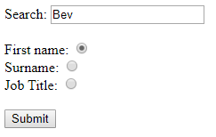


Solution 3:

<?
include "conninfo.php";

$search=$_POST["search"];
$ft=$_POST["fieldtype"];

if($ft=='f')//first name required
{
$query="SELECT * FROM people WHERE firstname like '$search'";
}
else if($ft=='s')//surname required
{
$query="SELECT * FROM people WHERE surname like '$search'";
}
else //job title required
{
$query="SELECT * FROM people WHERE jobtitle like '$search'";
}

$result=mysqli_query($link,$query); //run whichever query was appropriate

$numrows=mysqli_num_rows($result);//how many rows were found?

if($numrows==0)//none found
{
echo "Sorry, nothing found";
}
else //print out rows found
{

while($r=mysqli_fetch_array($result))
{
echo $r["id"]." ";
echo $r["firstname"]." ";
echo $r["surname"]." ";
echo $r["jobtitle"]."<br>";
}
}
?>

Note: a shorter way is shown below:

entersearch.php : Place database field names in the form values
<html>
<head>
</head>
<body>
<form action="showdatabase.php" method="post">

Search: <input type="text" name="search"><br><br>

First name: <input type="radio" name="fieldtype" value="firstname" checked="checked"><br>
Surname: <input type="radio" name="fieldtype" value="surname"><br>
Job Title: <input type="radio" name="fieldtype" value="jobtitle"><br><br>

<input type="submit">

</form>
</body>
</html>

showdatabase.php : Use $ft (holding the correct field name) directly into the query)

<?include "conninfo.php";

$search=$_POST["search"];
$ft=$_POST["fieldtype"];

$query="SELECT * FROM people WHERE $ft like '$search'";

$result=mysqli_query($link,$query); //run whichever query was appropriate

$numrows=mysqli_num_rows($result);//how many rows were found?

if($numrows==0)//none found
{
echo "Sorry, nothing found";
}
else //print out rows found
{
while($r=mysqli_fetch_array($result))
{
echo $r["id"]." ";
echo $r["firstname"]." ";
echo $r["surname"]." ";
echo $r["jobtitle"]."<br>";
}
}
?>

