

Undergraduate assignment feedback form
(to be completed by marker)

Student Name: Jane Elizabeth Manley

Module Code: CSSK4004  Module title: Skills for academic study | Student number: 0202616
For completion by marker:
Comments:

Marker’s signature: |  | Date:
Provisional mark:
NB. All marks are provisional until confirmed by the final examination board.

Week 2 Portfolio – Contextual Skills
Montaigne’s essay ‘Of Conscience’ (1580)

Specific
The thesis of Montaigne’s essay is twofold; the conscience of people will always tell them and reveal to the world the truth, and torture does not work.
From a modern perspective, there is no evidence or research to support his thesis; what he does, is to give the reader examples of how a man’s conscience may lead to discovery of unknown crimes or make his innocence obvious. Young Bessus’s killing of the sparrows leads to his previously well-kept secret of parricide being revealed, and Scipio’s innocence is proven as he was unable to ‘lower himself to the meanness of defending his innocence’. Montaigne also uses personal experience of his travels during the civil wars to explain and discuss his beliefs about conscience; his own and his companion’s fear: ‘It makes us betray, accuse, and fight against ourselves, and for want of other witnesses, to give evidence against ourselves’.
Torture not working as a successful instrument to gain truth, amounts to a discussion of his opinions backed up by Publius Syrus’s quote, and an apocryphal tale concerning a country-woman’s accusation about a soldier stealing food.
However, ‘Of Conscience’ was written in the sixteenth century by an educated man for a similarly educated audience - aristocratic and ecclesiastical elites. Although I have no evidence to back up my supposition, I presume, that providing the work was not blasphemous or treasonable, when published it was seen as a well written, factual essay.
Montaigne uses quotations from classical writers to support and illustrate his essay; Juvenal, Virgil, Ovid and Publius Syrus. By using the words of the great writers, he reinforces the impression that he is an educated man, and shares a similar background to his readers. The quotes are chosen to mirror the sentiment of the paragraph they are relevant to, perhaps to imbue his words with more gravitas; it seems a successful device.
‘The torturer of the soul brandishing a sharp scourge within’ at the end of the first paragraph, appears to back up Montaigne’s claims about the power of conscience, it is the person who examines their own conscience and suffers the consequences. Juvenal was a Roman poet, author of the ‘Satires’ in which he raged against the corruption of Roman society and the follies and brutalities of mankind. Montaigne may have used this quote to emphasise the belief that even if a man presents himself as another, he will be discovered as his conscience will betray him.
‘Ill designs are worst to the contriver’, succinctly sums up the moral of paragraph two and Bessus’s crime. ‘As the wasp stings and hurts another, but most of all its self, for it there loses its sting and use’ defines it completely, these two quotes are by Virgil who was regarded by the Romans as the greatest poet ever.
Ovid was another of the great Roman poets, ‘Metmorphoses’ being one of his great works, used as a reference when Montaigne is telling the reader about ‘a secret knowledge I had of my own will and innocence of my intentions’. If Ovid has similar ideas, ‘Of Conscience’ maybe perceived on a similar level.
Publius Syrus’s line at the end of the section which discusses how the rack is a dangerous invention, and not worth the effort of using it, ‘Pain will make even the innocent lie’, says in seven words what Montaigne takes ten lines to do. Born in Syria, Syrus was a slave who was taken to Rome, educated then freed by his owner and went on to become a renowned poet.
The tone, style and rhythm of the essay stay the same throughout, I will look at the second paragraph on page two to illustrate. The tone, even though discussing such a heinous subject does not alter in pitch, but maintains an even cadence when read aloud. Stylistically it’s conversational, the language of the translation is easily understood, and Montaigne’s argument simply and plainly put with the help of him answering his own questions. The rhythm, again when read out loud, is steady, even ponderous, as if Montaigne is reading it to his audience.

General
Characteristics of this kind of writing are primarily its tone, that is; use of ‘I’, it seems still rooted in a classical world and is aimed at men rather than all of the educated class.
It was probably written this way as it mirrored the contemporaneous society’s views, education and knowledge of the world; Montaigne wished to reach his audience without alienating them, but, also to think for themselves.
‘Of Conscience’ was written for the elite of the late sixteenth century France and maybe for those in a lower social class who could read; servants, priests and clerks.
Explore one of the following - (a)
Montaigne seems to agree with Hesiod rather than Plato, that punishment is born at the same time a sin is committed; so even if that sin is unknown by the world and buried deep by the perpetrator, punishment has commenced. ‘Wickedness contrives torments against itself’ he states.
As happened in the story of Bessus, his conscience would not let him rest, the birds became a physical manifestation of its revenging fury and tormented him; leading to his crime being discovered.
Wickedness will always be punished; if you expect to be punished then you are already suffering, and if you deserve to be punished you are expecting to suffer, you cannot escape your conscience.
A modern translation could be, a person commits a major financial fraud and is not caught, but they will always live with the fear of exposure; living in fear corrupts peace of mind for ever and is your punishment.

Week 3 Portfolio - Library Skills
Bibliography for study skills assignment

Q3. Discuss narration and focalization in narrative fiction and analyse their use in
AT LEAST ONE PASSAGE of Things Fall Apart.

Atkin G. Walsh C. Watkins S. ed Studying Literature A Practical Introduction, (London: Harvester Wheatsheaf 1995) 807 STU
Very useful book, it gives explanations of subject that are easy to understand. Can use distinction between narrator and author, plus section on duration – time spent in text recounting event/s. Quote ‘narration could be described as the way the story is told’.
Use for exploring narration.

Barthes R, Duist L, ‘An Introduction to the Structural Analysis of Narrative’ in New Literary History (Vol 6 No 2 On Narrative and Narratives Winter 1975) 237-272
http://www.jstor.org./stable/468419 accessed 28.10.2017
Good definitions of narration, more useful is discussion of what narrative forms exist and their context in different societies across the world. Discussions regarding common structures of narrative, good for introduction.
Similar books available

Carroll David, Chinua Achebe Novelist, Poet, Critic, (London: Macmillan Press 1980) 828.996 ACH
Gives a good overview of the time novel written, politics of the Igbo and colonialization by the west, and how the two cultures collided. Also discusses how Achebe creates a new form of English which is written with an African colouration. Similar information as Ogede’s book, Ogede’s was written ten years ago, Carroll’s thirty-seven. Both will be useful.

Currie Mark, Post Narrative Theory, (Basingstoke: Palgrave 1998) 808.3 CUR
Another good book to explore narration in the essay, Currie believes readers see verbal narrative in in written fiction in a more obvious way than in film. Maybe use for some discussion in introduction.

Herman D. Jahn M. Ryan ML. eds Routledge Encyclopedia of Narrative Theory, (Abingdon: Routledge 2005) 808.003 ROU
Good definitions of difficult concepts, good primer until get to grips with Rimmon-Kenan.

McCarthy B.E,’ Rhythm and Narrative Method in Achebe’s Things Fall Apart’ in A Forum on Fiction (No 3 Spring 1985) 244 http://www.jstor.org/stable/1345790 accessed 28.10.2017
What a find. In depth discussion of narrative and rhythm in Things Fall Apart. Looks at linguistic patterns of Achebe’s mother tongue and how they relate to the rhythm of oral story telling; difficult not to wonder away from essay question so need to take care.

Styler S. Pridmore J. eds Textual Variations The Impact of Textual Issues on Literary Studies, (Leicester: University of Leicester 2006) 801 TEX
A collection of essays discussing how to bridge the gap between literary and textual criticism. Will be more useful in addressing the narration section of the assignment.

Todorov Tzvetan, trans by Richard Howard, The Poetics of Prose (Oxford: Basil Blackwell 1977) 808.3 TOD
Helpful for background reading, different theories explained in a simple way. Maybe useful for another quote on definition of narrative, but to bear in mind book is forty years old, so would need to be an historical quote.

(Footnotes are books that I have already used for note taking, exceptionally useful).

Week 4 Portfolio – Narrative Understanding
The Changeling 1622 – What Happens Next?

Alsemero, Beatrice, Diaphanta, and Vermandero slowly make their way back to the castle in a well-appointed carriage; Deflores along with the other servants, return in a rough farm wagon pulled by an ox. Deflores shouts that he will never again be humiliated in public by any woman. Beatrice’s gloves are hidden in his clothing, next to his heart.
As the carriage crosses the bridge over the moat, Alsemero looks at the heads of Vermandero’s enemies on spikes which line the wall of the entrance. One looks vaguely familiar to him and he stares at it as they pass, his host is discomforted but continues to chat amiably.
Deflores also looks at the same head, he doesn’t know why, but since childhood he has always felt a connection with it.
Meanwhile, Jasperino and his servants spend a raucous night in the town, they were threatened with jail if they did not leave by dawn. Consequently, they boarded a ship for Valencia, despite the servants concerns regarding the smoke from the day before.
A banquet follows to honour Alsemero, to flaunt Vermandero’s wealth, and reunite Beatrice with her fiancé Piracquo. She sits with Diaphanta and the other women of the household, refuses to allow Deflores to serve her, will not speak to Piracquo and gazes at Alsemero throughout the proceedings.
When not declaring her love for Jasperino, Diaphanta spends her time looking from Alsemero to Deflores trying to comprehend why they look so similar.
Alsemero eats and drinks sparingly, he is convinced he is to be poisoned by his host and his head also placed on a spike. He is horrified to discover that Piracquo is the same age as Beatrice’s father, an uncouth, ill-educated boor with wondering hands.
Vermandero is appalled by his daughter’s behaviour, and sends her and her ladies back to their rooms; as she leaves he shouts that she will be married within four days, wifely duties will improve her manners.
Beatrice is incandescent with rage, there is lots of stamping, shouting and throwing of room contents; her servants cower in the corner of the room. Diaphanta is of similar rank to Beatrice and not concerned about her tirade, she can use it to her advantage. All the servants are dismissed back to their quarters, Diaphanta sits Beatrice down and starts to explain her plan.
Back in the great hall, the banquet is coming to an end; between Alsemero, Vermandero and Piracquo there is much false bonhomie until, Alsemero asks who did the head on the spike come from. Vermandero shouts that it is none of his business, and does not become a gentleman to question his host,’ you will now leave the castle’.
Back upstairs, Diaphanta has told Beatrice she cannot live without Jasperino, and Beatrice tells Diaphanta she will not marry Piracquo; the answer, to disguise themselves and escape the castle, find a ship to take them to Valentia and Jasperino. To ensure their plan works, they must have help from someone they can trust implicitly; Diaphanta will ask Deflores, he will do anything for Beatrice she says. Beatrice is not convinced, her recent behaviour towards him has been unforgivable, he will not help. Diaphanta tells Beatrice to cut off a lock of hair to give to him as a token of her repentance, he will never know she is deceiving him.
Obviously, Deflores is duped into helping the two women flee the castle; he provides wealthy men’s clothing, a bag of gold coins and enough food for a week. Under cover of darkness, they leave in one of her father’s carriages, paying off the groom once they reach the port where they first met Alsemero and Jasperino. In an ale house on the wharf, they find passage to Valencia for the next tide.
Back at the castle there is pandemonium, Vermandero and Piracquo accusing each other of either murdering or spiriting Beatrice and Diaphanta away. The household is turned upside down in the search for the women; during this the gloves that Beatrice threw at Deflores are found in his room, he is incarcerated in the dungeons comforted only by the lock of her hair.
Aboard the ship, Beatrice and Diaphanta meet Alsemero, the ladies keep their caps pulled down low over their faces and adopt a gruff speaking voice. Alsemero is suspicious of the two ‘gentlemen’; he does not voice this as he is curiously drawn to the blonde one (Beatrice), this makes him very uneasy and consequently they do not meet again until they dock at Valencia.
On the dockside Alsemero asks where the gentlemen are travelling to, they reply to the estate of Jasperino’s family some fifty miles away; as he is travelling there they agree to share a carriage with him.
On arrival at the estate Jasperino and Alsemero are overjoyed to see each other again, Jasperino offers the disguised ladies a bed for the night which they accept.
The genuine gentlemen are alone eating and drinking in the great hall, Jasperino tells Alsemero that he was preparing to return to tell him news that was too important to entrust to a servant. On his voyage back, he was drinking with an old mercenary soldier who had fought with Vermandero; it was he and Commander Piracquo that murdered John de Alsemero, his father. The reason for this was that Vermandero was having an affair with his wife who bore him an illegitimate son – Alsemero. Jasperino was travelling back to tell his friend he was in love with his half-sister Beatrice.
Alsemero starts to ask questions but Jasperino says be quiet, there is more you need to know.
Vermandero was forced to marry a local General’s daughter he got pregnant, she died in childbirth and their son Deflores, was taken back to his father’s homeland as a ward of court – not his rightful heir.
The two men run to the door when they hear gasps, followed by a loud thump as Beatrice and Diaphanta faint, their hats have fallen off and their hair is streaming around their faces.
Alsemero, Jasperino, Beatrice and Diaphanta return to the castle at the head of a group of heavily armed soldiers. Vermandero and Piracquo admit all and beg for mercy; they are escorted to the dungeon where they are forced to beg forgiveness from an emaciated Deflores – he is still clutching the lock of Beatrice’s hair. But he has inherited his mother’s compassion and merely banishes the two men from the kingdom, after that is, they have given the head of, as it turns out Deflores and Alsemero’s Uncle, a state funeral. He had also been murdered in the battle where John de Alsemero was killed, thus Vermandero took his brother’s title.
Having become close on the voyage home; Alsemero and Diaphanta, along with Jasperino and Beatrice have a magnificent joint wedding in the cathedral. Deflores rules the kingdom with kindness and understanding, he marries a local beauty and has a long and happy life with many children.

Week 5 Portfolio – Note Taking
CSSK4004 - Study skills Semester 1
Notes from Chapter Two - The Spike - from ‘George Orwell’s Essays’
(18.12.17)

P | Key points/arguments | Quotations | Develop
7 | Written in 1931 when still Eric Blair.  Group 48 men 1 woman, too tired to talk lying outside the Spike - Spike is the workhouse.  In a rural setting but the tramps are all urban.  Tramp Major/Spike Boss – only topic of what desultory talk there was. A violent, stick to the rules man, not to be messed with. | ‘We just sprawled about exhaustedly, with home- made cigarettes sticking out of our scrubby faces’  ‘We defiled the scene, like sardine-tins and paper bags on the seashore’  ‘You couldn’t call your soul your own when he was about, and many a tramp had he kicked out in the middle of the night for giving a back answer’ | Beautiful day, still appreciate beauty despite exhaustion or setting.  Why urban riff raff?  Why just the 1 woman?  How he would have set the tone of the Spike, tramps fear of him. Why was he so violent?  Blair/Orwell burying 8d so it couldn’t be found. Camaraderie of other tramps – united against authority.
8a  8b | Importance of hiding tobacco and papers.  Outed as a gentleman by the Tramp Major.  Identity taken away by nakedness, Spike clothing and sub-standard food. | ‘We stuffed our ankles with contraband until anyone seeing us might have imagined an outbreak of elephantiasis’  And thereafter he took it into his head to treat me with compassion, even with a kind of respect’  ‘All the indecent secrets of our underwear were exposed; the grime, the rents and patches, the bits of string doing duty for buttons, the layers upon layers of fragmentary garments, some of them mere collections of holes, held together by dirt’ | Socks stuffed with contraband, smoking not allowed in Spike’ confiscated if discovered. Unwritten rule that the Tramp Major never searched for contraband below the knee, hence sock stuffing.  What did he see to come to that conclusion?  Was it the state of his hands, his demeaner, accent?  Longer than usual quote, but beautifully illustrates the poverty and degradation of the men.  Reader can almost smell the odour of the men.
9 | Medical inspection.  Further humiliation for 2nd inspection, particularly for smallpox. |  | Out of 48 men not even 10 of them healthy.  Pre-NHS and post WW1.
11 | Waiting, the killing boredom of sitting, doing nothing for 10 hours. | ‘Only an educated man, who has consolations within himself, can endure confinement. Tramps, unlettered types as nearly all of them are, face their poverty with, blank, resourceless minds’ | Could sound overly superior coming from a lesser writer than Orwell.  Is it possible that authorities thought it kinder to keep the men locked up over the weekend or is it just further punishment?
12 | Appalling food wastage, thrown not given to the tramps.  Young tramp who had been on road for short time only, was in agreement with doing it! | ‘You don’t want to go encouraging of them. They’re scum’ | His disgust at this, people semi starved but beef thrown out – don’t want to encourage the wasters.  Shows there is a hierarchy even amongst men on the road.  Orwell seems surprised and saddened.
14 | Outside is so clean and quiet after three days in the Spike.  Scotty returns the smokes Orwell gave him inside. Smiling like a man repaying an obligation. | ‘And he put four sodden, debauched, loathly cigarette ends into my hand’ | Is it possible the environs of the Spike were so bad, or is the countryside just smelling so good because he has been locked up for three days?  Cigarettes such an important currency amongst those with very little.
Orwell George, George Orwell Essays, (London: Penguin Modern Classics), 1984, p7-14.
Week 9 Portfolio – Critique of Essay
“The Watcher on the Column”: Religious Enthusiasm and Madness in Tennyson’s “St Simeon Stylites” by Roger S. Platizky.

Platizky’s essay published in 1987, is the work I am going to analyse for this Portfolio task, the full work is added as an appendix at the end of the assignment on page 18.
The thesis of the work, is that the monologue of ‘St Simon Stylites’, shows how thin the line between religious enthusiasm and madness is drawn. Platizky tells us; ‘distinctions between religious enthusiasm and insanity and between vision and hallucination are pivotal ones’ in lines two and three. By the time the conclusion is reached, when he repeats his viewpoint in more detail, I was in agreement with his thesis. But, I don’t think his evidence and research was sufficient to prove the thesis conclusively, it may well be that I wished to be persuaded.
Summarising the argument. His main argument appears to be based on the belief that other critics of the monologue, see Simeon as a hypocritical figure and not a sympathetic character; they have missed the pivotal distinctions he believes are so important. Madness, insanity, has been reduced to a bit part in the work rather than a major theme.

The evidence and research used ranges from 1806 to 1984 from the Victorian era, it would have been interesting to see more of the Victorian evidence coming from primary rather than secondary sources. One important reference not included, was on p181 of the essay, a quote from Carlyle which is of importance to Platizky’s argument is missing. Carlyle is quoted describing the Victorian age as ‘destitute of faith but terrified at scepticism’, I wanted more information and to be able to verify the information for myself.
Footnote 2 on page 181 was very interesting, it should have been expanded in the body of the work as it was particularly relevant. Here he names some critics as alluding to Simeon being unstable, but appears to deride them for not pursuing the implications of this.
Platizky makes several statements about Tennyson using Simeon to address a fifth century audience as well the modern Victorians (page 181 and 182); both suffering from an insecure relationship with their God. I am unsure if this is sufficiently well referenced, it appears to make sense, but again, I am unable to follow it up.
Page 183, with its statement that Victorian psychiatrists as well as modern ones, would think the visions Simeon saw were madness and not a religious experience, is the most well researched area of the critique. It informs me that this area of the critique is backed up with credible evidence.
Platizky concludes by stating that (St Simeon Stylites) ‘therefore, it is much more than just and attack on ascetism or Catholic religious hypocrisy.’ I believe it is, but, if coming to it from another belief, i.e. Simeon was an appalling hypocrite, I would not be persuaded by the essay.

Style and use of language. Reading this from a non-academic background, required an on-line dictionary, however, once the words were understood it flowed well. During the first reading, it appeared to be an essay that was well written, quite casual, but well researched and referenced with good arguments to back up the thesis of the piece. It was easy to read.
After a second and third reading, however, the missing references became an issue for me, this resulted in his argument not being as effective as it could have been.

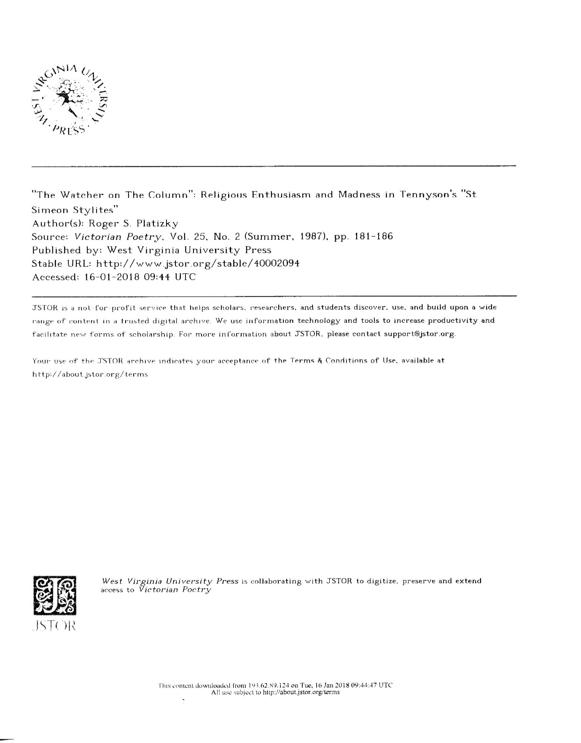

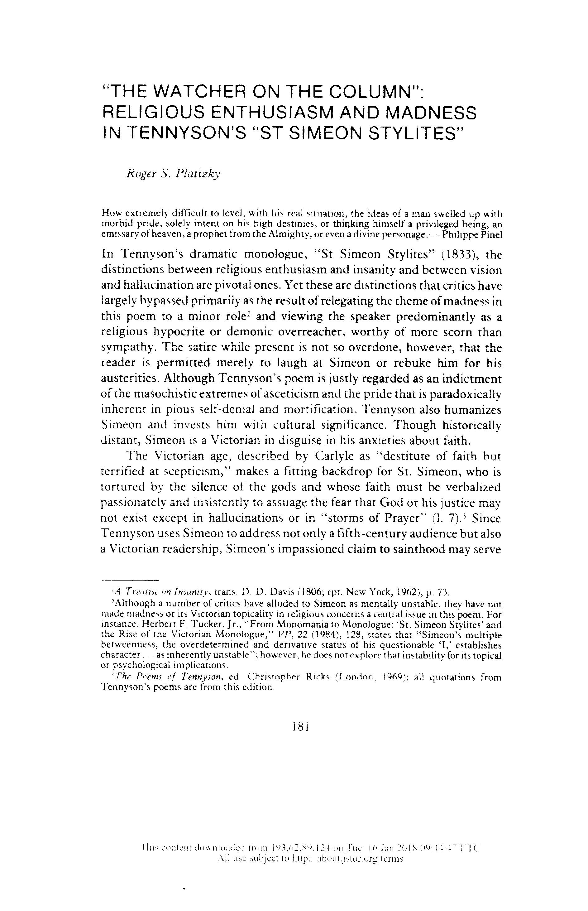
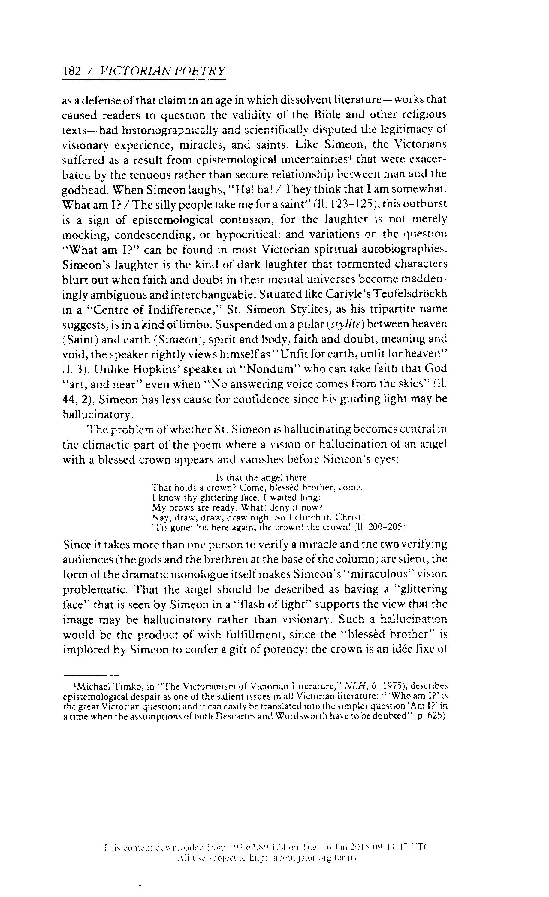
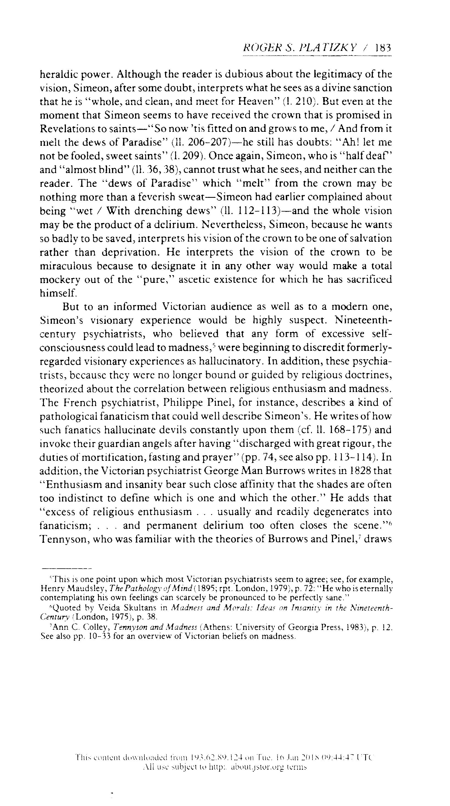
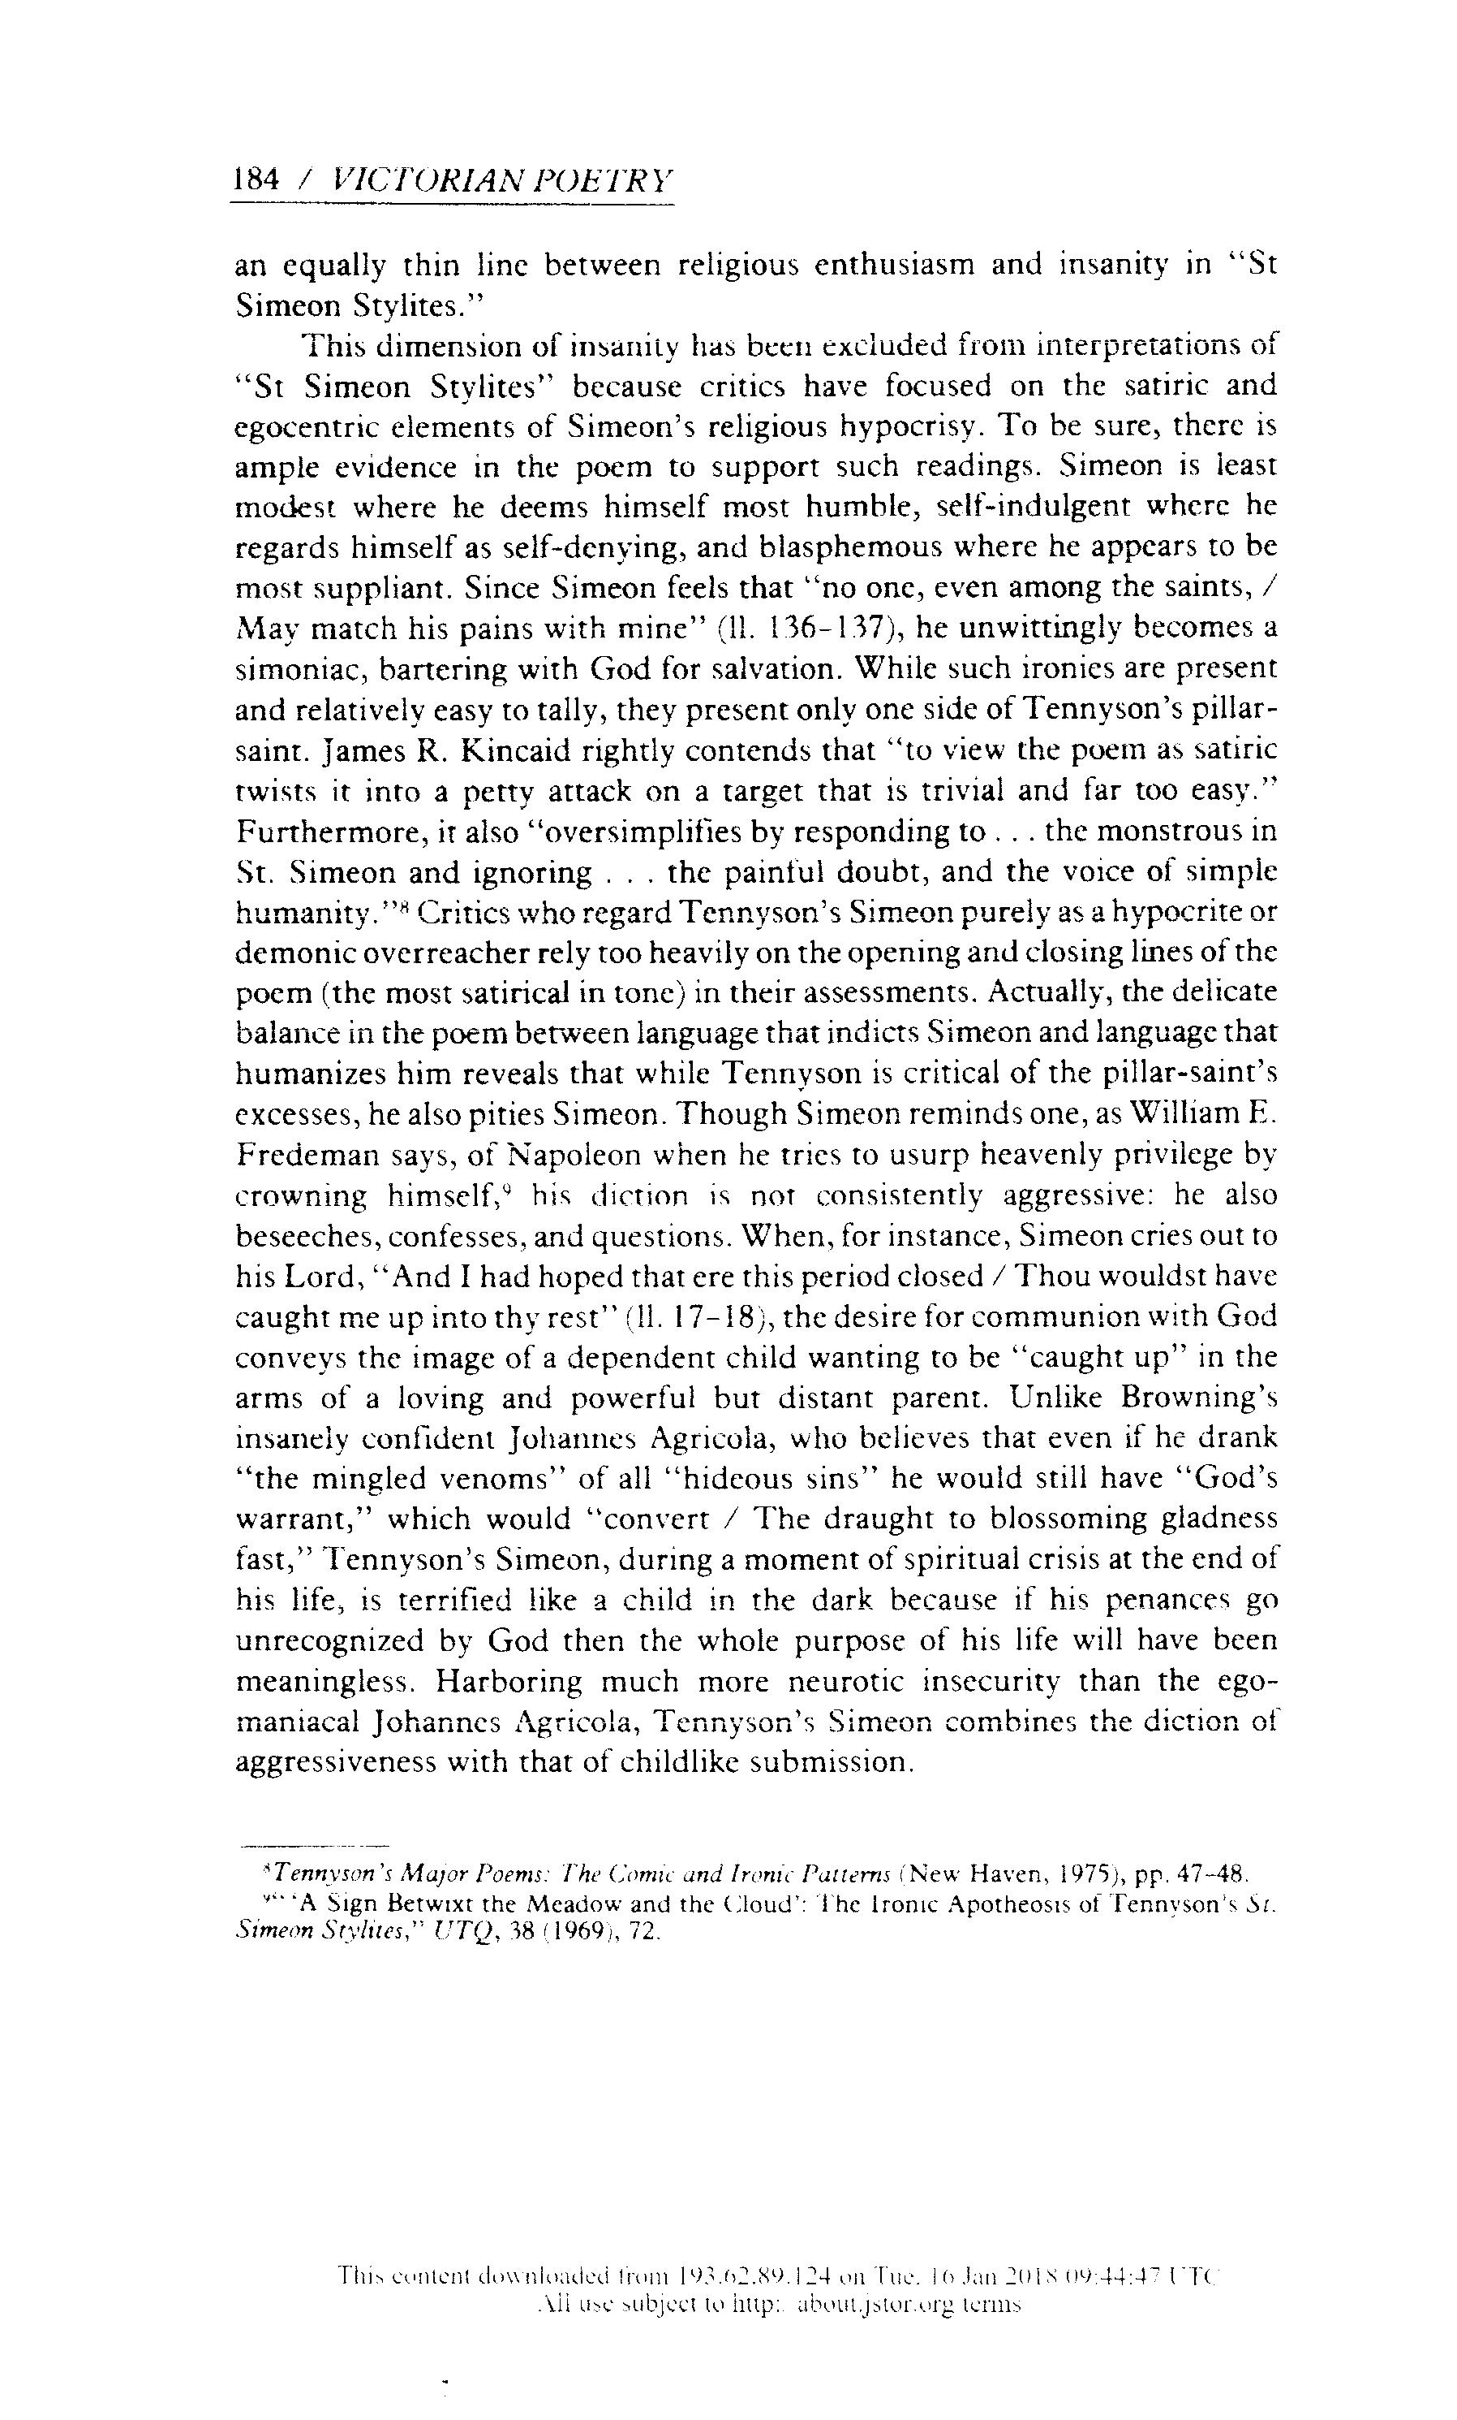
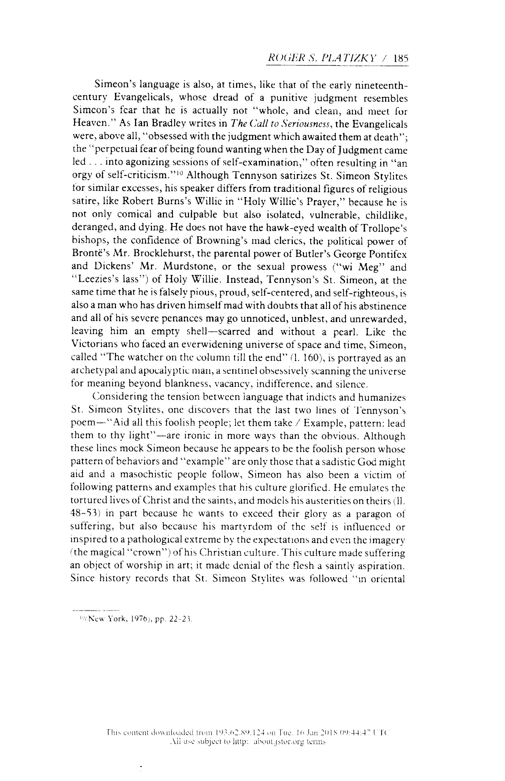
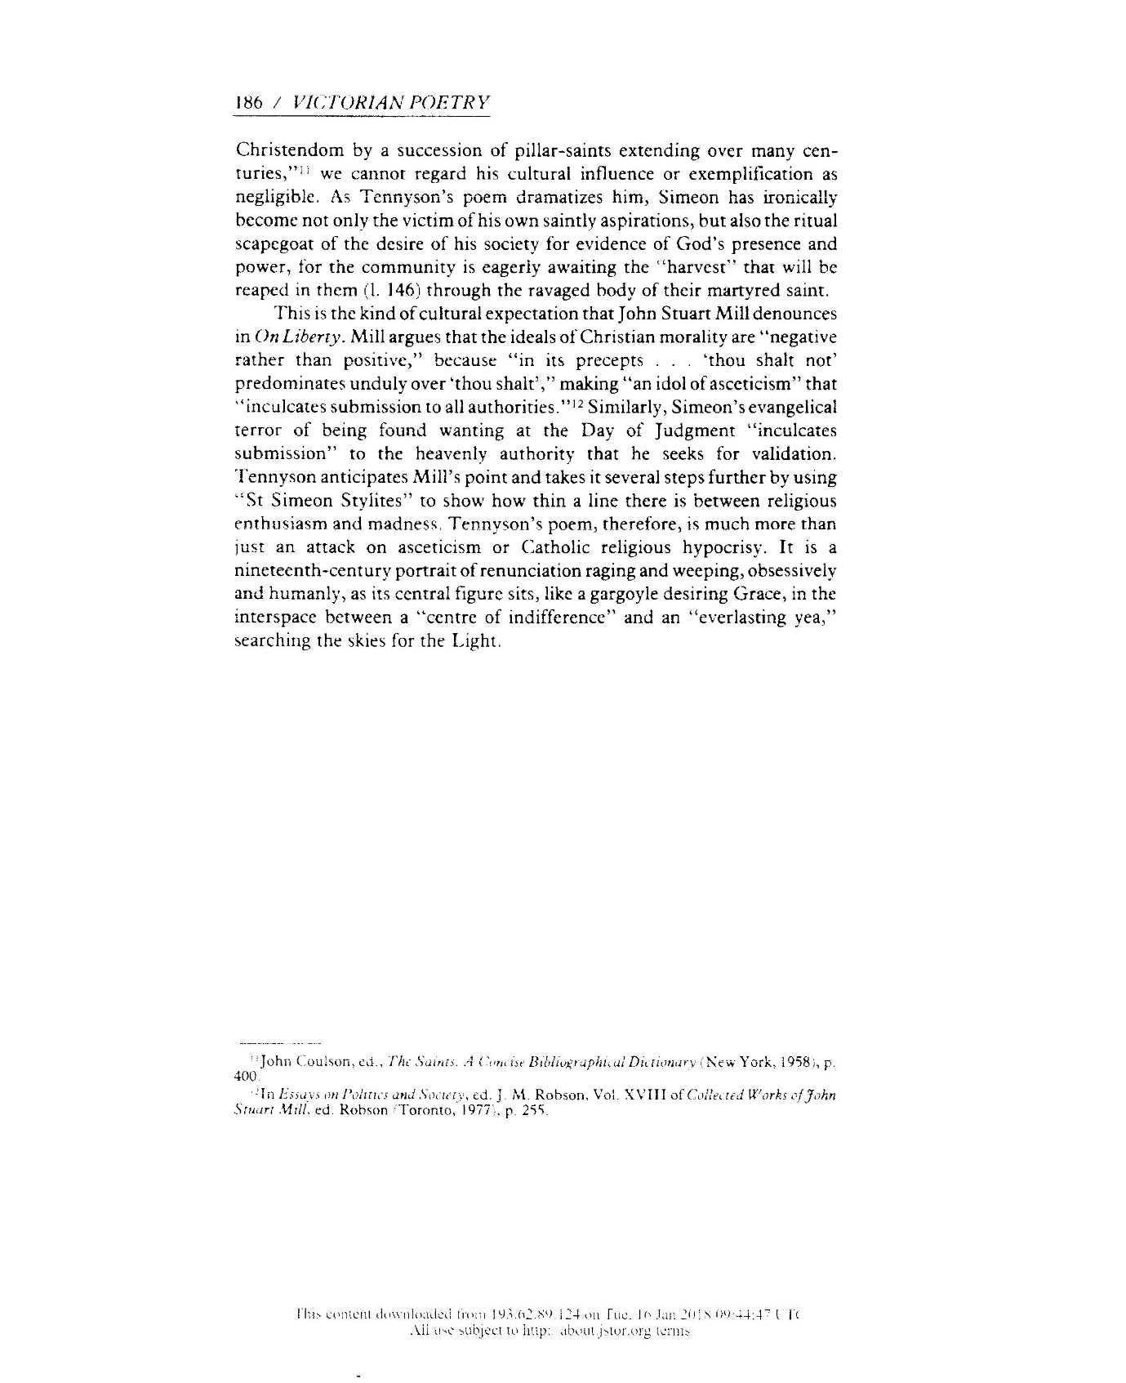

< https://www.brittanica.com/biography/juvenal> accessed 10.01.18
< https://www.brittanica.com/biography/virgil > accessed 10.01.18
< https://www.brittanica.com/biography/ovid-roman-poet > accessed 10.01.18
< http://www.btittanica.com/publilius-syrus > accessed 10.01.18
Porter Abbott H, The Cambridge Introduction to Narrative, (Cambridge: Cambridge University Press 2002)
Webster Roger, Studying Literary Theory, An Introduction, (London: Edward Arnold 1990)
Ogede Ode, Achebe’s Things Fall Apart, (London: Continuum International Publishing Group 2007)
Rimmon-Kenan Shlomith, Narrative Fiction: Contemporary Poetics, (London: Methuen 1983)
Roger S. Platizky, ‘The Watcher on the Column: Religious Enthusiasm and Madness in Tennyson’s St Simeon Stylites’, Victorian Poetry, vol 25, no 2, Summer 1987, p.183, published by West Virginia University Press. <http://www.jstor.org/stable/40002094 > Accessed 20th December 2017.

