

10/6/2020

Name: Nour Srihini
Module Name: Electrical HND 2nd Year Project



Contents
Introduction 2
The project roles: 3
My parts and my experiments: 4
The first design: 4
Metal Sensor diagram 4
the second design: 7
Machine design 8
Second design: 9
Cost 11
Time management 11
Conclusion 12
Refrencing 13

Introduction
As a group we decided to be working on a useful project which would make differences to our environment.

we made some researches to find what kind issues do the environment have. We found the waste is occurring a really big problem as we know it has negative effects on the world.
One of the best ways to get rid of this huge amount of wastes is the recycling.
Main purposes of recycling:
Conserve energy/natural resources
Keep the air, water and landfilled clean
Reduces Pollution
How they separate the waste and how our project will it to make it easier to recycle
Firstly, when the waste arrives.
Pushing the waste on vibration machine to separate cardboards and paper (manually by hands other types of paper sorted)
Also, manually all the unrecyclable waste will be removed form the belt
By using optical scanners, they take the plastic of
Remove the Steel cans by magnets the other aluminium materials will be removed by using the eddy current
Finally, they store all the glass in a big container at the end.
So, after sorting out all the materials, it going to be ready to be recycled
In our project we would like to be splitting the materials into bins/counters which can be used at places such as houses and schools.
Our machine will be going to sort out the waste automatically without any manual help.

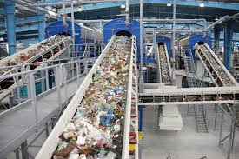

(Citifmonline, 2017)

The project roles:
Our project is consisting three of us, myself, Buthaina and Samih. Each one of us has to do part of this project.
Starting with the electrical side, I had to build a metal sensor and write an Arduino program to control the circuit, Buthaina was meant to build a glass sensor then she has to write another program to control her circuit therefore Sami was doing the colour sensor and control it by an Arduino program.
When it comes to the mechanical part we have split the work between us as we all were working every Wednesday on it so we are working together on all the parts.
According to the sitiuation of the online learning we all couldn’t build the actual device. However befor the college closed we have done many things for our project which im going to write every thing we have done inclouding the unsuccessful experinces.

My parts and my experiments:
First thing I did was reaseaching on how I could creat a metal sensor, I started looking on the types of each sensor and the deffirence between their operations so I could decide the best one for our project. Also I watched many videos on how to build the circuits.
Personally I really like building circuits and know more about each component that I’m using so it was really interesting, also I did many soldering in the past which I love so that would help me doing this project.
It was really hard to do the metal sensor as I tried two ways to build it and finally I almost done it.
My first design was very complicated and wasn’t a suitable for the project job

The first design:
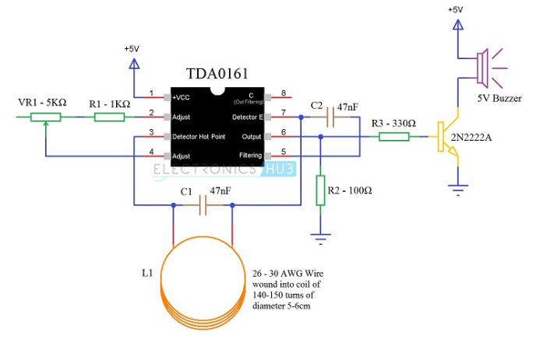
Metal Sensor diagram:

(electronicshub.org, 2020)
Components I will use to build the sensor
1 TDA0161 Proximity Detector IC
2 of 47nF Capacitors {Ceramic Capacitor code 473}
1 KΩ Resistor {1/4 Watt}
330 Ω Resistor {1/4 Watt}
100 Ω Resistor {1/4 Watt}
5 KΩ Potentiometer
2N2222A (NPN Transistor)
5V Buzzer
Coil
Components {for LED}
220 Ω Resistor (1/4 Watt)
5mm LED

This sensor is made of simple components. However, this sensor can’t detect the waste if it was farther than 10mm. in our project we will use this sensor to identify the metal wastes

Metal Detector Circuit Explanation
When the LC circuit which is L1 and C1 has any resonating frequency from any nearby metal, electrical field will be created which will result in the induction of current in the coil and changes in the signal flow through the coil. The variable resistor is used to adjust the proximity sensor value relative to the LC circuit, it is better to check the value when the coil is not close to the wire. The LC circuit will have modified the signal once the metal is sensed. The changed signal is given to the proximity detector TDA 0161, which detects the signal change and then reacts accordingly. The proximity sensor output will be 1mA if no metal is sensed and around 10mA if the coil is near the metal
R3 provides positive voltage to the Q1 when the output pin is high. Q1 is turned on and lead is flickering, and the buzzer is providing the buzz. Resistor r2 is used to constrain current flow.
The Metal Sensor Block Diagram
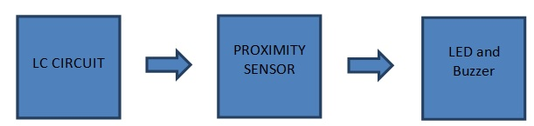

(electronicshub.org, 2020)

LC circuit has parallel connected inductor and capacitor. This circuit resonates once something of the same frequency is similar to it. Alternatively the LC circuit charges condenser and inductor. When the capacitor is fully charged, the inductor will be charged.
Inductor starts charging and in reverse polarity, when charging becomes null across the condenser, it receives power from the inductor. The inductor charge is then reduced, and the process repeats again. Remember inductor is a device for magnetic field storage, and the condenser is a tool for processing electric fields.
The proximity sensor can detect any physical interference with objects out. The proximity sensor will work the same as the infrared sensor, the proximity will also release a signal, it will not give output unless and until the reflected back signal changes.
If a signal change occurs it will detect the output and give it accordingly. For example, there are different proximity sensors to detect plastic material that we can use proximity of the capacitive type and we should use inductive type for metals.

How the circuit works
The primary metal detector component of the circuit is the LC Circuit, which consists of L1 (coil) and C1. The TDA0161 IC serves as an oscillator and oscillates at a specific frequency with the aid of this LC Circuit, which is also known as Tank Circuit or Tuned Circuit.
When the LC circuit detects any resonating frequency from any object (waste), it will generate an electrical field that will result in cause current in the coil and adjust the signal flow through the coil.
Variable resistor is used to adjust the value of the proximity sensor relative to the LC circuit. If you want to check the value you have to make sure that is no metals near the coil to get it better so when the metal is found, the signal transferred to the LC circuit
The changed signal will be given to the detector TDA 0161, which detects the signal change and reacts accordingly. The proximity sensor output will be less than 1mA if no metal is detected and it will be about 10mA (usually greater than 8mA) if the coil is close to the metal.
The resistor R3 can transmit positive voltage to transistor Q1 when the output pin is high. Q1 is going to turn on and LED is flashing (not shown in the circuit) and the buzzer is activated.

the second design:
to do a metal sensor I decided to research more about coil winding calculations.
Components I used:
Coil : inductance L =10 mH , coil inner diameter d = 70 mm, coil length I=13 mm
Nuber of turns = 303
2 circles made of plastic so they wont affect the other sensors or the coil.
Super glue.
After I made all the calculation needed to know the right sizing of the coil and how many layer it has to be windid in between two plastics, I made a plastic connection between the two plastic disks
So I could wind the coil on it, then I didn’t use it to make sure that the glue is fully dried on the next day.
On the next day, firstly I made sure the two disks were stacked, I started to wind the coil with counting the layers.
When I finished, by a multimetre I have tested.
I wanted to use the winded coil on a simble circuit which I was willing to build.
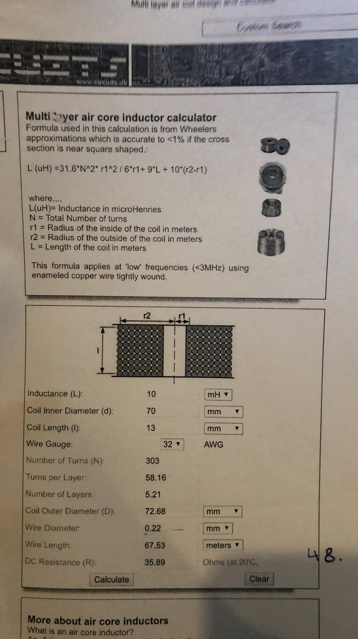

Machine design:
we had different ideas how we want to create our go green machine, as I mentioned this machine going to be work in two parts the mechanical part and electrical.
The electrical part had to include 3 sensors with an Arduino programs, the mechanical part is the part that we where meant to be working on in the college.
Deflector and the conveyor.
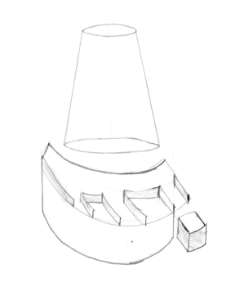
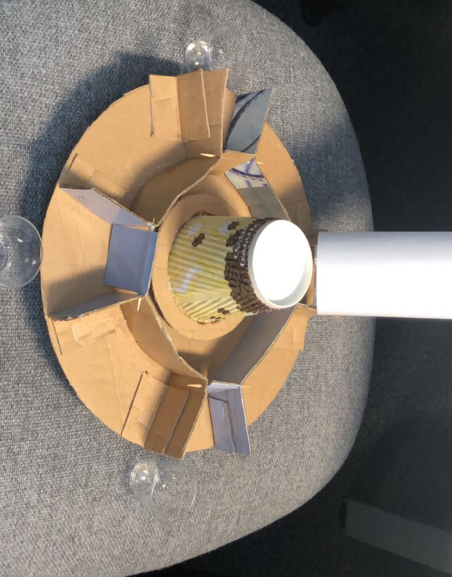
first design:

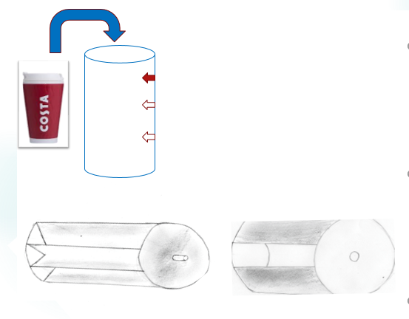
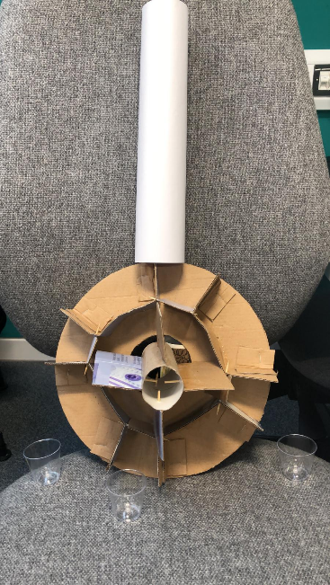

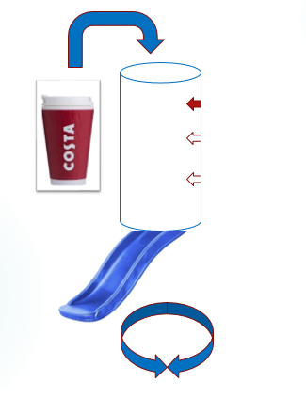
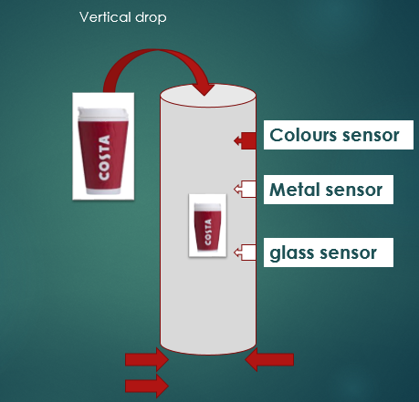

These photos show the designs that we were thinking of as you see we were planning to use a cylinder in a vertical position so we can drop the waste from the top of it, the waste going through the cylinder where it meets the three sensors. In this stage one of the sensor will going to indicate the waste for example the metal sensor indicate a metal can so by programming the gates down the cylinder the metal gate will be open so the waste will go through this gate to its right bin. this process will sort all the waste automatically.
I have thought to do an extra bin/gate for other unrecyclable materials. So basically when non of the sensors indicate the waste this gate will be open to through the waste in its bin as its not metal, glass and its colour is not one of the colours that the sensor can indicate.

Second design:
After we submitted the first report, we have noticed that the project wont be working in a vertical way as a member of our projet done his sensor. Three of us were testing the circuit and see how long it takes to detect the colour, it was not as fast as we have expected so it can be made on a cylinder in a vertical shaped, therefore we had to think off another designing which is a more suitable for the job.
Changing the vertical way to an herezontal was the best idea to start with, as we had an assignment in other module which was based on a conveyor and three sensors ( to detect the sizes) so in that assignment we had to write a program to run a herozental conveyor with all other components. We thought that a great idea to use in our project. So in this way we can control the speed of the conveyor to let each sensor take its time detecting the wastes.
The conveyor we were working on was a conveyor belt which driven by a servo motor So Samih start working on a conveyor befor the college shutted down.

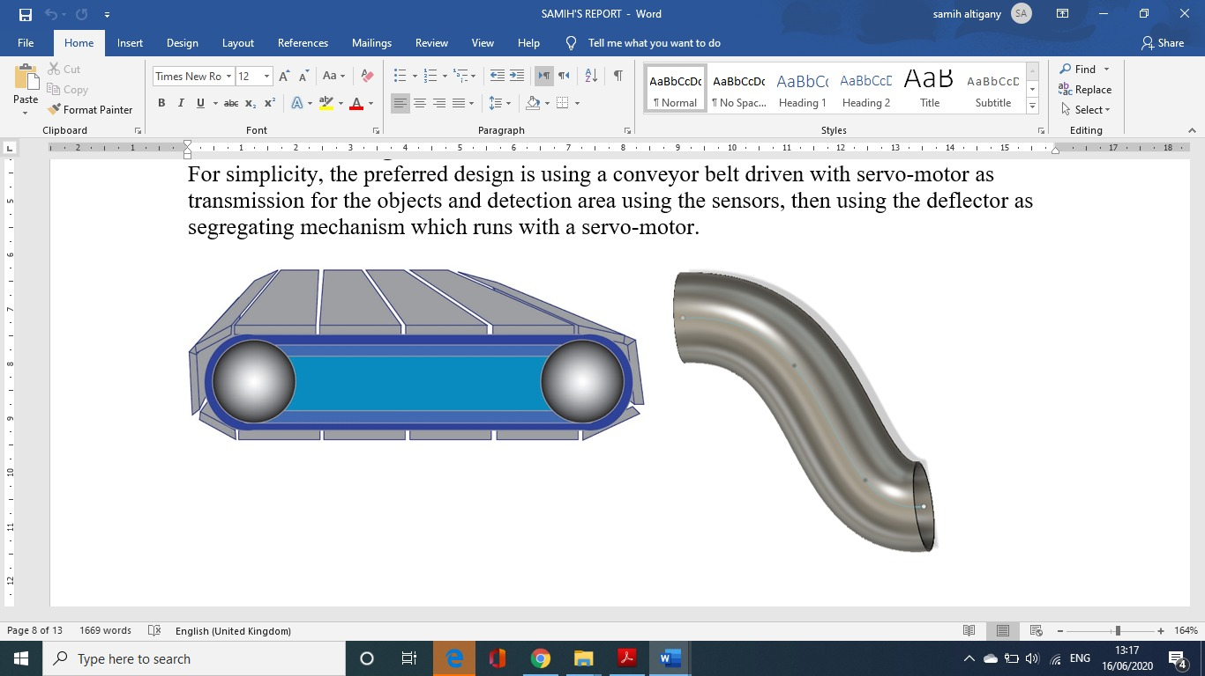

Me and buthaina we meant to do all the deflector work and the researches while working on the other sensors. However the deflector that we wanted to use is also had to be driven by a servo motor where it placed at the end ov the conveyor, so it can move all the way when the waste reach it to put it in the correct bin as the sensors detected.

In the second design we didn’t made any change on the sensors, as we wanted to place them on the conveyor.
deflector
waste

S2
S3
S1

Color sensor
Glass sesnor
Metal sensor

Cost
we have to split the cost for two main parts: mechanical parts, electronic parts.
In the mechanical part we were planning to use a 3D print for the mechanical parts. So by designing these parts of mechanical in small size we will be reducing the cost. If this technic didn’t work, we wanted use metal or another alternative to build the parts.
The other part is the electrical part, in this part we have to minimize the cost as much as we can that is because we will spend our budget on the mechanical parts so we will be reusing electronic components.

Time management
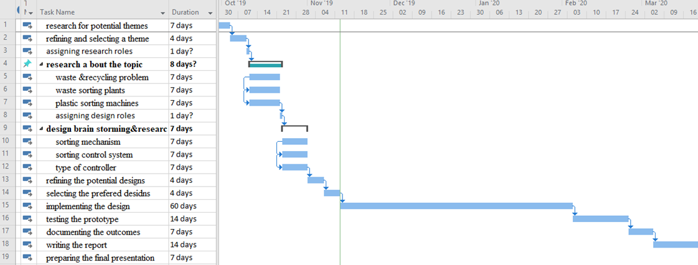

Conclusion
We were have a good knowledge of what are we were going to do/build. However, we started working on the electrical side of the project which is the sensors and writing its programs to control it. Which was not easy to find the right components for the circuit and while tryig unsuccessful experements.
In first design I wanted to order components that I need to build the metal sensor on a breadboard then I was going to write an Arduino program to control the circuit. So I went to the engineering block (to the technician roo) were I was taking all the components I need.
As I mentioned befor we have to stay in a limited budget, so we were trying to minimize our needs to creat this device.
I was really enjoing this experience and looking forword to put all the parts together to see the results. However due to the coronaviruse the collage shutted down so we couldn’t carry on building the actuall machine.
In other hand I have learnt a lot while we were in college every Wednesday we had a lot to do me and my team were a very well organised, enjoyed all the successful and the unsuccessful experements, the team works and the environment I were working in.

Refrencing
Electronicsshub. (2020) Metal sensor. Available at : [WWW] https://www.electronicshub.org/metal-detector-circuit/ (Accessed: 17 January 2020)
Citifomnloine. (2017) photo. http://citifmonline.com/2017/11/govt-developing-3-new-waste-recovery-sites-for-accra/ (Accessed: 17 January 2020)

