Marketing Management

Assignment One

Martina Perencin
2024812

Table of contents

Introduction
Definition of communication
Communication Models
- Linear Model
Integrated Marketing Communications
Current promotions used by easyJet
New promotional strategies
Definition of Branding and Brand Equity
Keller’s Brand Equity of easyJet
Customer Journey Map
Customer Touchpoints
The Total Engagement Model
Conclusion
Reference List

Introduction

Figure 1 EasyJet's Logo
EasyJet is a low-cost airline founded in 1995 by the Greek Stelios Haji-Ioannou and formally known as easyJet Airline Company Limited. Its base of operations is located at Luton Airport in London. The company differs from its competitors because it offers its customers reliable services at extremely competitive prices for the main European cities.
The goal of this assignment is to outline the main marketing strategies of the easyJet company and relate them to the relevant market and to the main differences with competitors. Furthermore, it is necessary to emphasize the main challenges that the company is facing, such as globalization, digitalization, management of its reputation and the relationship with customers.
In March 1998 the company bought a part of a Swiss company for three million francs and Geneva became the company's first European headquarters. In 2002 easyJet also bought rival airline Go Fly for £ 374 million, thus inheriting three new bases at Bristol Airport, East Midland Airport and London Stansted. Also in 2002 it opened its airport in Gatwick and between 2003 and 2007 it created new bases in Germany, France, Italy and Spain. In 2007 I declare that I operate more flights per day than all other European airlines. Again in 2007 it bought the entire group of GB Airway4s of the Bland group for 103.5 million, thus creating a new base in Manchester. In June 2011, the airline opened its 11th British base at London Southend Airport, which offers flights to Alicante, Amsterdam, Barcelona, ​​Belfast, Faro, Malaga, Jersey, Palma de Mallorca and Ibiza. In July 2017, EasyJet announced that it would open a new European office in Austria to allow it to operate after Brexit. On 28 October 2017, EasyJet announced that it will charter 25 former Air Berlin A320 aircraft to operate on EasyJet Europe's network, under its European AOC. Many of these aircraft were based at Berlin-Tegel Airport before its closure. These aircraft were subsequently transferred to the Berlin-Brandenburg airport. Previously EasyJet had operated only from Berlin-Schönefeld Airport and Berlin-Tegel Airport, where EasyJet had taken over some of Air Berlin's old services. On March 30, 2020, EasyJet suspended all flights, grounded the entire fleet and sacked its crews due to the travel restrictions imposed. This came after the company carried out 650 "rescue flights", bringing home 45,000 people. In April 2020 EasyJet secured a £ 600 million loan from the UK government with no environmental conditions attached. In June 2020, EasyJet announced plans to resume flights, making half of the routes in July 2020 and up to 75% in August 2020, albeit at a reduced frequency. In April 2020, EasyJet got involved in a dispute with its owner and largest shareholder, Stelios Haji-Ioannou. Haji-Ioannou criticized the airline's decision not to try to cancel the pending Airbus order, arguing that he would create additional £ 4.5 billion capital that the airline could not afford to spend. He threatened to call a general meeting to remove a director every three weeks, unless subsequent action was taken. A general meeting was held on May 22nd in which the shareholders finally voted over 99% in favour of the board of directors of EasyJet and keeping the contract with Airbus. On May 19, 2020, the company revealed that it was the subject of a cyber-attack resulting in the release of personal information from 9 million customers. On August 17, 2020, EasyJet confirmed in a statement that it would close three bases in the UK. Stansted, Southend and Newcastle since late August due to low levels of air travel demand impacted by the COVID-19 pandemic.

Definition of Communication
Communication is a verbal or textual (but also auditory, visual or physical) process of creating and interpreting a message. To generate the final message or interpret a meaning, people learn to use codes and symbols, consequently, communication is very important in modern society because it allows relationships between human beings. In the Marketing sector, communication is used to promote a product or service and bring it closer to the customer. Furthermore, when companies launch a new product on the market, they must create and then maintain a special relationship with the consumer, to reach his attention and retain him. This process can only happen by implementing a good communication strategy. Furthermore, those involved in communication must know how to solve public relations problems, create and develop product promotion campaigns, define the tone of the brand in communications with customers.

Communication Model
The three best known communication models are:
• Linear: communication is a linear process that starts with a sender and arrives at a recipient.
• Interactional: in this model there are two communication channels between sender and recipient in a process of continuous use of the message.
• Transactional: in this case the sender and receiver become communicators who together create the process and the result of the interaction.
Each model examines the development of communication, but also emphasizes its different parts. They simplify the communication process and show the correlation between the different parts of the communication process. In this assignment we will look at the Linear model.

Linear Models
This model was created by scholars Shannon and Weaver in 1948 and sees communication as a linear process in which the main actors are a sender or speaker, who sends a message to a recipient or listener. A message is a set of sounds, words or behaviours, transmitted through a channel to the recipient of the message. Obstacles, called noises, may be encountered during the process, i.e., interference in the channel or distortions of the message. However, this model also has its disadvantages, in fact it assumes that communication only goes in one direction, so the actors in the process can only be senders or receivers, not both. In reality, communication is much more dynamic and disordered and involves a continuous exchange of information between the actors in the process.

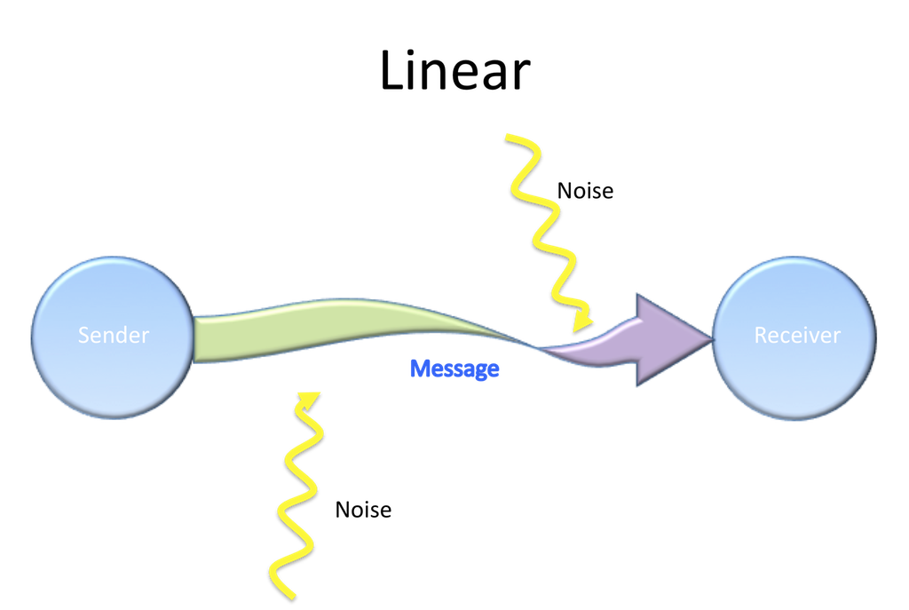
Figure 2. Linear Model of Communication

Integrated Marketing Communications
The Integrated Marketing Communications is the process of interaction and collaboration of marketing and communication activities and tools to reach the attention of the previously selected target and the objectives of the brand. What are the main elements of Integrated marketing communications?
1. Clear and consistent objectives that can be set with the objectives of the brand.
2. A marketing plan that foresees and analyses all communication activities.
3. Different target groups: not only those already acquired or potential, but also suppliers, influencers or niche customers.
4. Accurate management of all communication activities between the organization and the public.
5. Management of all promotional activities and the people involved in them.
6. All elements of the promotion.
7. The message to be proposed must come from a single coherent and reasoned strategy.
8. Management of the different channels of message transmission, both direct and indirect.
EasyJet uses Integrated Marketing Communications to promote the company through the media, penetrate the market and create awareness. In addition, customers buy tickets mainly on the website and easyJet itself is trying to minimize the role of agencies and intermediaries.

Current promotions used by easyJet
EasyJet has always had above all a strong online presence. In fact, for the company it is fundamental and the marketing budget is largely spent on digital content. It was the first company to have its own website for the sale of airline tickets in April 1998. The website and the application allow its customers to:
• Buy airline tickets and evaluate the best quality-price offers.
• Book in addition to the flight, even the hotel and the means of transport with a simple click.
• Contact customer service through online chat.
• Consult frequently asked questions from other customers or read passenger feedback.
Another channel that easyJet often uses to communicate with its customers is the Newsletter. This is sent to subscribers once every three weeks with the main offers or new services, which the customer can learn more simply by clicking on a link that takes you back to the site. Through newsletters. The company also asks its customers to respond to surveys to receive their feedback and improve the service if necessary.
Another very profitable channel is certainly that of television advertisements. For some years, EasyJet has begun to create television campaigns that can be defined as emotional, since the goal is to hit potential customers through emotions. This series of commercials (but also campaigns in newspapers and on major social networks) was launched to shift the focus away from the fact that easyJet is primarily a low-cost airline. The TV commercial showed a passenger as he imagines some beautiful destinations, including an Italian road. The commercial ends with the slogan "Imagine where we can take you".
The easyJet application is also a widely used channel, especially by the young target. A feature of the app called Look and Book allows users to link from a photograph of a destination directly to the destination. In fact, users can take a screenshot and share it or upload it to the easyJet app and thanks to the image recognition tool, the application is able to identify the location and associate a destination with the photo. Furthermore, from the application 8 as well as from the website it is possible to book hotels or apartments directly, in the destination destinations, choosing from many types of residences. This new possibility has allowed easyJet to enormously expand its visibility and its customers, attracting a much wider and more heterogeneous audience. From the site it is in fact possible to book accommodation and pay.

New promotional strategies
The new strategies are all trying to promote a positive and trusting message to customers. In fact, the COVID-19 emergency and the new Brexit policy have greatly damaged airlines such as easyJet.
However, easyJet wants to launch a new vacation package with the specific goal of becoming a customized online site in the travel industry, attempting to revolutionize the tourism market. This new concept will be called easyJet Holidays and will be available on the website and in the application. The service will obviously include the booking of flights and a choice of 5,000 different hotels, the possibility of choosing a means of transport and 23 kg for hand luggage. The hotels and apartments will be divided into categories, such as luxury, adults, families, friends. The airline expects to attract around one million customers with this new service. The basic idea of ​​the marketing campaign for this service is the possibility to start hoping for a better future, starting from the summer holidays.
Also, with regards to collaboration between airlines and new technologies, easyJet is collaborating with Google to create a new map function within the application and website, with which customers can easily explore the area around the hotel or to the apartment before booking, or search for the nearest tourist spots.
As for the new television campaigns, the commercials just released in the main media show young people playing hide and seek by jumping between different destinations. This new series of commercials aims to promote the new easyJet Holidays feature as something new and fresh after such a turbulent and sad time.
Furthermore, easyJet, like the other airlines, is trying to make the best use of its marketing channels to reassure customers about the new flight regulations that the company has adopted with great seriousness. Therefore, a part of the marketing strategies is now orienting themselves to spread this concept as much as possible.
One strategy used by easyJet with this in mind was to send customers an email entitled "Our Europe with commitment and trust", in which the company ensures that it takes the best care of its customers' needs, which at the moment they feel a little lost. The email shows exactly the procedures that the company is adopting and will adopt, such as the deep cleaning of each vehicle and environment or the distribution of passengers on the plane. In addition, during this period easyJet ensures that you can cancel your flight up to 14 days before the flight without paying any fees. It will also soon launch a marketing campaign to explain the anti-Covid - 19 procedures implemented in flights and at airports and will launch lion masks for the little ones to make their journey more fun.

Definition of Branding and Brand Equity
Branding is the mental process of identifying, creating and managing resources that shape the perception of a brand in the minds of stakeholders. It is important not only because it creates a memorable impression on consumers, but allows customers to understand what to expect from the company and what differentiates it from competitors. It is the representation of the company and how it wants to be perceived. There are many elements that come into play in the branding process, including advertising, customer service, and reputation. Here are the main elements that contribute to creating a successful brand:
• Branding is a continuous, never-ending process. The market, customers and companies are constantly changing and branding must adapt to new challenges.
• In branding it is first necessary to identify who and what the company wants to be for its stakeholders, then the company must create a positioning strategy and finally manage the whole process.
• Positioning must translate into resources and practical actions, such as content, ads, customer support, services, which build a relationship with the consumer.
• The perception of the brand or reputation is the association that the customer makes in his mind about the brand and the result of the branding process.
• Customers, whether they are current, possible or future or business partners, build the perception of the brand in their minds and act accordingly.
Brand Equity is the level of influence and recognition that a brand or product has in the minds of consumers. Brand Equity, if well thought out, can make a product or service easily memorable and distinguishable from imitations for customers, who will see it as a reliable and superior quality brand.
What has always characterized easyJet is the low cost, the convenience of its services and the very recognizable colour of the logo, this is its Brand Equity. According to the latest research, easyJet customers, especially families or young adults who reach tourist destinations, are generally among the most loyal and satisfied of the airlines.

Keller’s Brand Equity of easyJet
Identity: Who are you?
The easyJet brand is recognizable above all in two respects: the cheap flight prices and the orange colour of the logo.
Meaning: What are you?
EasyJet offers a quality service at low cost; people can share moments together and enjoy their vacation in maximum safety.
Response: What about you?
EasyJet is now a solid company and economically of a certain weight, customer service takes care of passengers, creating trust. Furthermore, the company invests more and more to have the best technology on the market.
Relationship: What about you and me?
The relationship with customers is getting stronger, the company ensures a punctual and safe service and according to the latest data easyJet is one of the three most popular airlines in the world.

Relationship Resonance
Community, Involvement,
Positive and timely experience
Judgments Feelings Response
Technology, Loyalty, Happiness
Leader Holiday, family and friends
Meaning Performance Imagery
Low-cost Moments to share
Salience
Brand Equity: Company Low Cost, Recognizable orange logo

Identity

Customer Journey Map
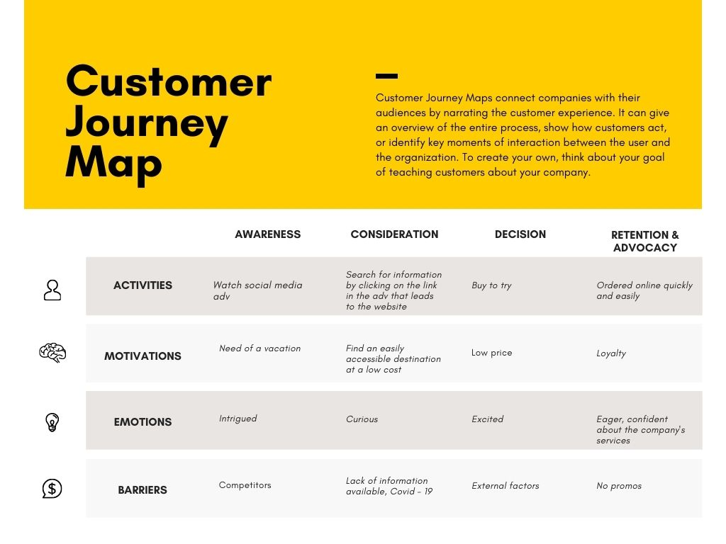
Figure 3 Custumer Journey Map
EasyJet's Customer Journey Map shows that most customers buy a plane ticket simply out of the desire to relax in a tourist destination while on vacation. Most people are attracted to social media or internet campaigns, which the user sees by scrolling to the home page of their favourite social profile or while searching on Google. The next instinct is often curiosity that prompts the user to search for new information on the easyJet website or its application. If the tourist half is economically acceptable (also thanks to a special offer for example), the excited user chooses, in most cases, to buy the ticket. However, there may be factors that stop the choice of him such as the lack of information and the lack of offers. Finally it must be specified that there are also users, in particular of adult age who spend most of their time looking for the best travel offer, also analyzing those of the competitors and surprisingly not getting caught up in emotions, which happens instead in the young target.

Customer Touchpoints
The touchpoints between easyJet and customers take place both online and offline. For simplicity I will divide them as touchpoints before, during and after the purchase.
- Touchpoints before the purchase: Social Media, online Advertisement, Digital Marketing Content, newsletter.
- Touchpoints during the purchase: Website, customer Server Line, online chat, mobile application.
- Touchpoints after the purchase: request for feedback on the service, notifications in the app, thank you emails or requests for renewal of the Newsletter.

Total Engagement Model
EasyJet has always tried to establish a strategic and intelligent relationship between its employees and customers to achieve solid growth in the long term.
Analysing the four elements that make up the Total Engagement Model we can see that easyJet's proposal manages to combine all the factors taking into account both the customer's vision and the role of the staff. The company therefore most of the times respects the promises made in advertising campaigns:
1. The brand represents what it proposes, that is an airline with low-cost offers mainly for families and children who want to reach holiday destinations not too far away.
2. The corporate culture sees the employee first of all as a person who is guaranteed specific rights, including regular contact, health insurance, the ability to attend training courses, benefits, wage and job growth opportunities. The employee in this positive environment interacts with the customer in the best possible way and maintains high company standards.
3. Customers can interact with the company in many ways, including the customer service line, application functions or through the website. For any request or problem, the company is ready to satisfy the customer in the best possible way.
4. The added value of easyJet compared to other airlines is certainly the possibility of reaching the same destinations at a lower price and with a high-quality service.
Conclusion
This assignment demonstrated how easyJet's marketing strategies are evolved and modern, always in step with new trends and how the company itself is able to keep the promises made to its customers.
I can only make three criticisms of the company with its proposals for solutions and recommendations. First of all, I noticed that online market research is essential for easyJet to understand its customer and what their needs are. Analysing the main target of the company, families and young adults, it can be seen that there is a lack of men and women who travel for business or employees of private or government companies. EasyJet should provide specific packages for this category of people, offering more flights with special discounts for companies.
The company sells a lot of its services online, but its goal is to digitize its entire service as much as possible. Unfortunately, it has not yet managed to do this. In fact, its more mature target still prefers to buy tickets from intermediaries such as travel agencies, as they do not believe they will be able to use the easyJet website or application. For this reason, the online resources must be simplified as much as possible to reach this type of customer, for example special discounts can be added for those who book online or for those who download the application.
Finally, the last point I can focus on is the short-term relationship that easyJet establishes with its customers. In fact, most of the time, customers who choose this airline have a very short relationship with it, which coincides with the duration of the trip. the customer therefore chooses easyJet for its cheap flights but does not continue its path of brand loyalty. To solve this problem, the airline must try to get the customer back through specific attention. For example, an email with the customer's name, created ad hoc to propose new destinations that he may like and offers designed exclusively for him.

Reference List
Kotler, P. (2018), Principles of marketing, 17th global edition, Pearson, Harlow.
Sheehan, B., (2011), Marketing management, AVA Pub, Lausanne, Switzerland
Sood, T., (2017), Strategic marketing management and tactics in the service industry, IGI Global, Hershey, Pennsylvania.
Wang, C. (2014), Brand management in emerging markets: theories and practice, Business Science Reference, Hershey, Pennsylvania.
Lee, In., (2018), Diverse methods in customer relationship marketing and management, IGI Global, Hershey.
Temporal, P., (2010), Advanced brand management: managing brands in a changing world, 2nd edition, Wiley, Hoboken, N.J.
Khanlari, A., (2015), Strategic customer relationship management in the age of social media, Business Science Reference, Hershey, Pennsylvania.

