How Environment Design Creates a Sense of Isolation
Liminal Spaces in Videogames Geographies

Ava Daniels
Computer Games Design
Student No. 2218486

University of Trinity Saint David – UWTSD
Swansea, South Wales
Contents
How Environment Design Creates a Sense of Isolation 1
Intro 2
Loneliness and Isolation 2
The Digital World and Gaming 3
Liminal Spaces 4
Liminality and Emotional Space in Games 4
Origins and Cultural Understanding of Liminal Space 4
Why Liminal Spaces Resonate Emotionally 5
Nostalgia and Emotional Liminality 5
Psychological Liminality 6
Emotional Architecture and Cultural Influence 6
The Emotional Impact of Scale (Megalophobia) 7
Psychological Play in Online Environments: Exploring Liminality, Nostalgia, and Emotional Connection 8
Case Studies – Video games 9
Intro 9
Emotional Responses through Environmental Design 9
Methodology 11
Main Game Analysis - Case Studies 12
Summary and Conclusion 16
Bibliography 17

Intro

This dissertation explores how isolation and loneliness are evoked through environmental design, focusing on liminal spaces across different games, referencing film, photography, and art. By analysing literature and case studies, I explore how space alone can tell stories and create emotional resonance.
In recent years, the concept of liminality has gained increasing attention within game studies, particularly in the exploration of how games craft emotional experiences through space, sound, and environmental storytelling. Traditionally associated with transitional or "in-between" states, liminality offers a compelling lens to examine how virtual environments unsettle players, fostering feelings of isolation, disorientation, and emotional suspension. Rather than relying on overt horror tropes or nostalgia, certain games generate a more complex, psychological unease by manipulating familiar structures and subtly distorting the player's sense of agency and place.
This dissertation explores how video games create liminal experiences through environmental and emotional design, with a focus on three main case studies: The Stanley Parable (2013), Firewatch (2016), and Portal (2007). These games were chosen for their distinct approaches to liminality, both in terms of their physical environments and the psychological states they evoke in the player. Each title plays with repetition, emptiness, and fractured guidance to immerse players in unsettling, in-between worlds where traditional rules of space, narrative, and trust are continually challenged.
The Stanley Parable examines structural and psychological liminality by trapping the player in looping, sterile office spaces under the manipulative guidance of a narrator. Firewatch uses the vast, indistinct wilderness of Wyoming to explore emotional isolation and mistrust, where familiar landmarks blur and human connection remains just out of reach. Meanwhile, Portal weaponizes architectural sterility and contradictory messaging to trap the player in a clinical, dehumanizing environment, reinforced by disorienting sound design and fragmented narrative delivery.
Throughout the dissertation, analysis will be framed around how these games embody and manipulate liminal geographies, drawing on theories of space, emotional design, and environmental storytelling. By dissecting these case studies, the aim is to better understand how video games as a medium uniquely evoke liminal experiences, and how these experiences shape player engagement, emotional response, and narrative interpretation.

Loneliness and Isolation

In 2020, COVID isolation was necessary, but few enjoyed the forced reflection. Even after restrictions lifted, meaningful connection remained hard to find. Young adults especially faced major life decisions, moving out, planning a future.
The digital world offers easy “connection,” but it’s often lonely. Gaming can be an escape or a way to forget for a while. During COVID, Twitch and other streaming platforms boomed, with many people tuning in daily. Digital tools like Zoom and chat apps helped us stay in touch, but isolation still took a toll. Not everyone enjoyed the "time off," and the more we observe others' curated lives online, the more we realise we don’t fit in.
Today, the digital disconnect creates emotional isolation. People only show the perfect side of their lives, but beneath the display, loneliness lingers. This disconnect can amplify feelings of depression as we compare ourselves to others. Humans are searching for meaning and belonging in a world where we constantly survey ourselves. The digital world removes the need for real in-person contact, creating isolation through detachment.
Studies show 1 in 3 young adults (34%) feel lonely, reflecting a larger cultural issue. It’s not just physical isolation, but the emotional weight of disconnection. Existential loneliness goes deeper, feeling detached not just from people, but from meaning itself. Liminal spaces in games often bring this feeling out: suspended between two worlds, full of uncertainty, mirroring the sense of being lost in life.
Research by Sjåstad (2023) and others highlights existential loneliness as a profound disconnection, not just from others, but from meaning and purpose. It’s a cosmic isolation that transcends social loneliness (BioMed Central).

The Digital World and Gaming

Many players develop an interest in gaming to escape feelings of loneliness. For many, the gaming world has been a powerful positive force, providing friendships across the globe, social connections, and a deep appreciation for the digital landscape and its possibilities. During the COVID-19 pandemic, this became even more significant: Twitch viewership doubled in 2020 (TwitchTracker), and Steam recorded its highest-ever concurrent user numbers, highlighting how many turned to gaming as a refuge. According to the Entertainment Software Association (2021), 55% of players said that gaming helped them stay connected during lockdowns.
However, forming friendships and social interactions through games can sometimes offer only a temporary sense of connection, allowing players to feel less lonely while remaining isolated—often at the expense of real-life relationships. With major life transitions like moving out or starting new chapters on hold, feelings of isolation and being stuck were common among young players. Extended periods of reflection often led to questioning identity, direction, and belonging.
Visual art and aesthetics often heavily influence the games players choose to engage with. Titles like Gris, Little Nightmares, and Journey are favoured by those drawn to stunning visuals and emotional storytelling. Many gamers also share a fascination with urban exploration and the decay of man-made spaces, finding peace in abandoned architecture or empty cities at night. This attraction to liminal spaces—those existing between two realities—reflects a desire to lose oneself in limbo, to find calm in uncertainty.
For many, COVID-19 overlapped with adolescence, creating a transitional period marked by stasis and limbo. Moving out, witnessing former childhood spaces like bedrooms being repurposed, and dealing with the feeling of time slipping by without progress all contributed to a deep sense of dislocation.
The key concepts explored through this lens include the creation of isolation and loneliness within digital landscapes, and understanding different perspectives on liminal and nostalgic spaces. Initial ideas of liminality often focus on transitional places, but research reveals that nostalgia and liminality are far broader than simple aesthetics. As Sjåstad (2023) highlights, existential loneliness goes beyond social isolation, reflecting a deeper disconnection from meaning and purpose. Liminal spaces can serve as a window into this feeling, showing that loneliness is not simply the absence of people, but a broader emotional and existential separation from life itself. Digital and physical spaces can reveal and amplify these feelings, offering a powerful medium to explore how isolation is visually created and experienced.
Charles Darwin observed, “We stopped looking for monsters under our bed when we realized they were inside us,” suggesting that isolation and fear often originate from within our own perceptions.

Liminal Spaces

Liminality and Emotional Space in Games
Liminality describes transitional states—times or spaces in which people are no longer where they were, but have not yet arrived where they’re going. Rooted in anthropology (Van Gennep, 1909), the concept has grown to include emotional, architectural, and digital spaces that resist fixed identity or purpose. Often ambiguous, these liminal spaces evoke a strange mixture of unease, nostalgia, and disconnection.
Examples of such spaces include waiting rooms, school corridors during holidays, and empty shopping centres. Online, the "liminal space" aesthetic thrives in internet culture, with surreal, eerily vacant images shared to provoke feelings of detachment or distorted memory. These often depict everyday locations stripped of their usual context—an empty stairwell lit oddly, or a deserted hallway at twilight—producing a disorienting familiarity. One Reddit user described these images as places "you feel like you’ve been before, but can’t quite place when."
Video games powerfully evoke such emotional ambiguity. Unlike still photographs, games allow players to inhabit and explore liminal environments. Through ambient sound, light, architectural design, and the absence of life or objectives, games can create a mood of isolation or yearning that feels deeply personal. This study focuses on how spatial and environmental storytelling in games creates these designed experiences of emotional limbo.

Origins and Cultural Understanding of Liminal Space

The term "liminal" comes from the Latin limen, meaning threshold. Arnold Van Gennep’s (1909) work on rites of passage identified the liminal as the middle phase—where identity is suspended. Victor Turner (1967) later expanded this to social and psychological transitions. Today, liminality applies to both real and imagined states of being in-between.
Anthropologist Marc Augé (1995) introduced the idea of "non-places"—locations like airports and motorways that prioritise movement over dwelling. These are emotionally neutral spaces, yet their anonymity can feel oddly charged. Online, liminality has evolved into an aesthetic marked by architectural emptiness and emotional resonance. These are spaces not defined by what’s present, but by what’s missing.
The eeriness often lacks clear threat; the disquiet is in the absence, in the space being somehow "wrong". Games mirror this powerfully, using virtual environments that deliberately avoid typical narrative structure. Here, space becomes the story.

Why Liminal Spaces Resonate Emotionally

These spaces resonate because they mirror transitional phases in life, moving house, graduating, grieving. As Ellen Wright puts it: "A liminal space is the time between 'what was' and 'next.'" These periods blur identity, memory, and potential, making them emotionally charged. The mind craves clarity (Franklin, 2020), but liminal experiences deny it.
John Koenig’s neologism kenopsia, "the eerie, forlorn atmosphere of a place usually bustling with people but now abandoned", captures the emotional afterimage of loss. Like packing up a childhood room, something lingers in these spaces beyond their physical contents.
Games heighten this effect. As Katherine Isbister notes, they offer “embodied emotion”: the player walks the halls, hears the distant echo, opens the forgotten drawer. This active participation deepens emotional impact. The eeriness is not watched—it’s felt.

Nostalgia and Emotional Liminality
Nostalgia in games is often more than memory—it’s a longing for a self that existed within a different context. Saulius Geniusas, in Yearning, explains nostalgia not as a return to a past world, but to the self that once lived in it. This is especially true in liminal spaces where memory feels both near and unreachable.
Geniusas identifies three temporal forms of nostalgia:
For the past – longing for what once was.
For the present (nowstalgia) – awareness of the fleeting now.
For the future (anticipated nostalgia) – missing what hasn’t yet been lost.
In game design, even subtle elements, a looping corridor, can evoke these layered reactions. These design choices don’t explain, they suggest. The result is often a bittersweet emotional immersion.

Psychological Liminality
Liminality is not just external; it happens within. Psychological liminal spaces are periods where identity, belief, or purpose is in motion, when you're no longer who you were, but not yet someone new. Bell Hooks notes: “There’s always some liminal space... harder to inhabit because it never feels as safe.”
These moments can be triggered by major life changes or internal indecision. Whether physical, social, or emotional, transitions bring discomfort but also possibility.
Games can represent this well, not through dialogue, but through space and atmosphere. Sparse rooms, flickering lights, looping hallways, all mirror mental states of confusion, loss, or self-reconstruction.

Emotional Architecture and Cultural Influence
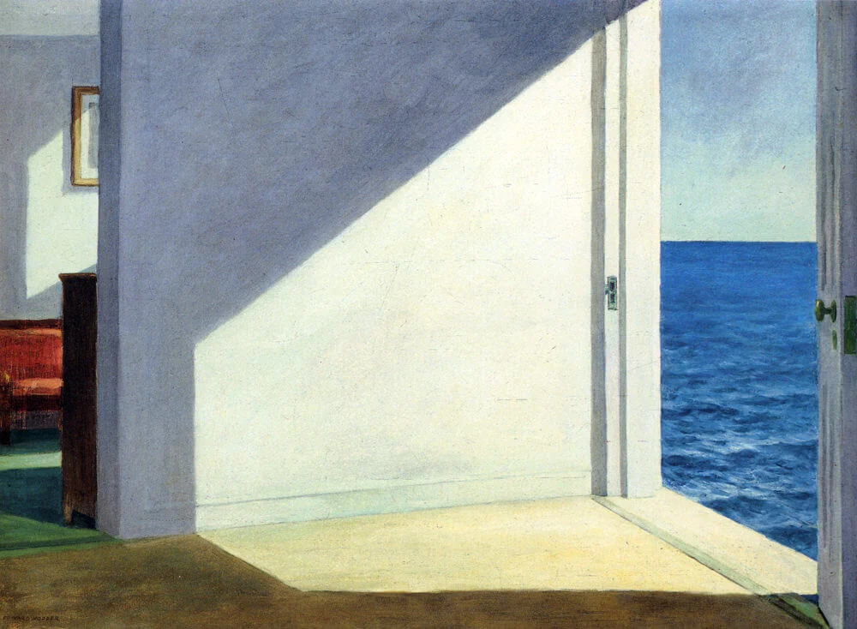
Liminal design principles echo in art and architecture. Edward Hopper’s lonely interiors capture the silence between events.

Figure 1 -Room by the sea, 1951 By Edward Hopper
David Lowery’s A Ghost Story lets stillness and shadow depict grief. Jordan Peele’s Us uses sterile underground corridors to evoke horror through space itself.
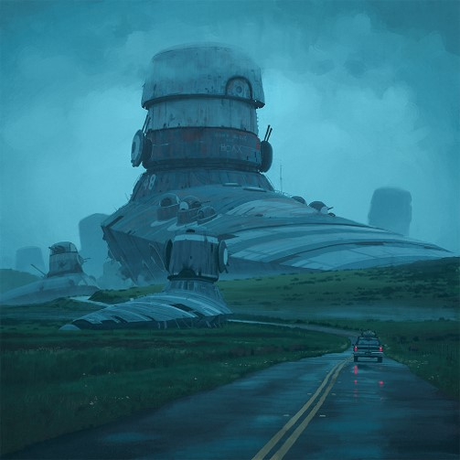
Artists like Simon Stålenhag and Brent Wong explore surreal nostalgia by blending the ordinary with vast, decaying, or futuristic structures. Their art creates emotional dissonance, inviting viewers into worlds that are both remembered and imagined.
In games, this principle is powerful. A broken toy, an abandoned hallway, or a looping room can all feel more potent than explicit horror. The best emotional design often whispers, never shouts.

Art by Simon Stalenhag-

The Emotional Impact of Scale (Megalophobia)
Vast environments evoke feelings of insignificance and awe, megalophobia is not simply fear of large objects, but fear of our own smallness. In games like No Man’s Sky and Subnautica, players explore alien vastness where absence becomes the threat. Like Ann Radcliffe’s notion of terror versus horror, the fear lies in what we imagine.
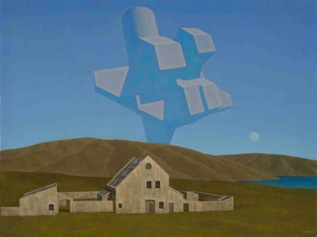
Art By Brent Wong -
Games such as Little Nightmares and INSIDE use towering spaces and limited player agency to evoke vulnerability. In these worlds, isolation is amplified not by emptiness, but by scale. The quiet enormity of the world becomes the story.
By understanding and utilising the emotional and psychological dynamics of liminal space, game designers can craft experiences that reach beyond narrative. Through light, architecture, and silence, they create spaces that linger—not for what happens in them, but for how they make us feel.

Psychological Play in Online Environments: Exploring Liminality, Nostalgia, and Emotional Connection
Online psychological play has become a space where digital environments like The Backrooms let players explore emotions like isolation, nostalgia, and unease. These aren’t just spaces to escape into, they’re places where players confront loss, memory, and disconnection, often finding community in that shared emotional experience.
Samantha J. (2022) explores how the Backrooms reflect collective meaning-making and unconscious expression. She describes them as a form of adult “crowd-sourced play,” where imagination, nostalgia, fear, and loneliness are shared. Drawing on Freud’s ‘uncanny’ and Mark Fisher’s (2007) concept of hauntology, she connects these eerie spaces to feelings of time being “out of joint” where something is missing, but you can’t name it.
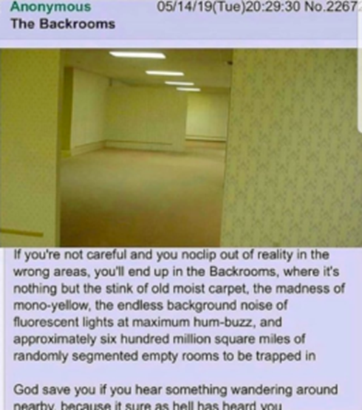
The original Backrooms image, posted to 4chan in 2019, sparked a growing mythos. Players expanded it into hundreds of levels, many focused not on horror creatures but on the horror of emptiness. Levels like the abandoned arcade (Level 25), endless hedge maze (Level 84), and looping roller rink (Level 31) are soaked in memory and emotional weight. They're not just empty—they feel wrong, like places that should be full but aren’t.

Personally, I found myself drawn to levels like 18, 9, and 40, faded childhood suburbs, broken arcades, endless housing estates. They're not traditionally scary, but they echo with absence. They feel personal. Not haunted by ghosts but by what’s gone.
Design-wise, the Backrooms rely on disorientation: looping corridors, dead ends, and subtly broken logic. Environmental nostalgia, TVs, old toys, flickering signs, taps into shared generational memory. Perfect symmetry, crooked signage, and silence push that weird feeling further. Sparse lighting, ambient hums, and echoing emptiness work together to build an atmosphere that unsettles without ever showing a monster. As Samantha J. puts it, these places aren’t scary because of what’s there, but because of what’s missing.
Backrooms games often strip out enemies entirely—the horror is in the silence. The emptiness becomes personal. Outdated classrooms, faded office lobbies, or crumbling public buildings don’t just look abandoned—they feel like someone drained your own memories of warmth. These levels resonate particularly with millennial and Gen Z players, who recognise the details from their own childhoods, now made eerie by stillness and decay.
The Backrooms show how digital environments can explore psychological liminality in ways traditional games don’t. They’re not just creepy—they’re emotionally rich. Whether players are confronting loneliness, memory, or the uncanny, these spaces create a lasting impact through design alone. It’s not the story or characters that stay with you—it’s the space itself, and how it makes you feel.

Case Studies – Video games

Intro
Games come in every shape and size, from puzzles and horror to solo exploration and multiplayer chaos. Across all genres, games offer powerful ways to evoke emotion. Whether through a stunning landscape or a deeply layered narrative, they can make players feel something profound. But when narrative takes a back seat, it’s clever environment design that carries the emotional weight. That’s my focus here: how space alone can speak.
Isolation in games isn’t always about being physically alone. Sometimes, it’s about how the space feels. Even in The Stanley Parable, with its ever-present narrator, you feel like no one’s really there, like you’re being watched by something that never shows itself. This study explores how certain games use space, silence, and mood to build emotional experiences of isolation, loneliness, and nostalgia.

Emotional Responses through Environmental Design
Sometimes loneliness isn't even intentional. Entering an empty VRChat room or a dead multiplayer server feels like stumbling into a digital ghost town.
Minecraft, often known for its creativity, can evoke unexpected solitude when explored alone—its vast, procedurally generated worlds and ambient silence feel infinite and eerily indifferent. Arctico dials this up further: no people, no real goals—just you, your sled dogs, and endless frozen landscapes. It’s peaceful, but heavy. Like being the last one left.
The Long Dark leans into this fully. Dropped into a lifeless, frozen world with no monsters—just silence, cold, and the traces of people who didn’t survive. Through abandoned cabins, frozen corpses, and scavenged remnants, the game tells stories without a voice. Nature is the only threat—indifferent and unstoppable. The emptiness becomes existential, pushing players to reflect on memory, vulnerability, and what it means to endure.
Firewatch explores emotional and geographical isolation differently. Its Wyoming wilderness is both stunning and disorienting. The relationship between Henry and Delilah—intimate but always distant—unfolds entirely through voice, never presence. Trails blur, silence lingers, and the landscape mirrors Henry’s grief. The game becomes a meditation on disconnection, where solitude is both healing and quietly unsettling.
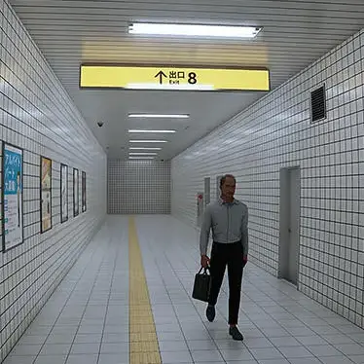
Exit 8 and its prequel Station 8 take liminal unease in another direction. In Exit 8, players walk endlessly through sterile underground corridors, where barely noticeable changes signal wrongness. Repetition, minimalism, and silence create deep psychological discomfort—like being stuck in a dream you can’t wake from. It’s a familiar space made uncanny.
Exit 8, from Steam Page
Alien: Isolation takes a more oppressive route. Set aboard a crumbling space station, it traps you in claustrophobic corridors where silence is as terrifying as sound. The retro-futuristic design—flickering lights, analogue tech—evokes a haunting nostalgia. The unpredictable presence of the Xenomorph turns the environment into a constant threat. It’s not just about surviving—it’s about the slow descent into paranoia.
Little Nightmares and Inside amplify vulnerability through grotesquely scaled environments, silent avatars, and oppressive design. Both turn childhood fears into surreal nightmares. Their worlds feel indifferent and watchful. Players project their own fragility onto these blank-faced characters, making the emotional weight even heavier.
Across all these games, it’s the space that speaks. Abandonment, ambient stillness, and subtle disruption create emotional resonance without relying on cutscenes or dialogue. These aren’t just games. They’re places where you feel the absence.

Methodology

In single-player games, players can fully immerse themselves in liminal spaces, exploring at their own pace without external distractions. This emotional effect is often diminished in multiplayer experiences, where objectives like survival or puzzle-solving take precedence over atmosphere.
All the games discussed here were played and revisited by me for critical analysis. I focus on three titles, Firewatch, The Stanley Parable, and Portal, chosen for their commercial success, single-player design, and use of geographical and emotional isolation. Each features a distant or hidden narrator, adding a subtle emotional layer. While Firewatch is the only one to offer a clear backstory for its protagonist, all three evoke powerful feelings of liminality through environment rather than exposition.
These games use space and minimal narrative to communicate isolation, both physical and emotional. They stand out as strong examples of how environmental design can affect players on a deep psychological level.
Soundscapes play a crucial role in shaping this experience. As Timothy Crick (2011) and Grimshaw et al. (2011) note, ambient audio—whether silence, machinery hums, or distant echoes—amplifies the eerie, dislocated feeling of liminal environments. Sound can signal decay, nostalgia, or absence, deepening emotional immersion. While sound design isn't the central focus of this research, it will be discussed in each case study as a vital component of mood and meaning.
Skalski et al. (2011) argue that players often feel embodied in their avatars, experiencing events as if they were happening in real time. This sense of presence intensifies the emotional effect when environments feel empty, unfamiliar, or subtly wrong.
Academic texts like Navigating the In-Between helped shape my understanding of how games use environment to create emotional responses. It explores how lighting, emptiness, and sound work together to build feelings of disorientation and psychological displacement, especially in games like Portal.
Emma Reay’s work on Inside and Little Nightmares was also particularly influential. She highlights how scale, silence, and child avatars, blank-faced and mute, allow players to project their own vulnerability onto the characters. These games demonstrate how environment and design alone can evoke strong emotional responses, making spaces feel strange, uncanny, or quietly overwhelming.

Main Game Analysis - Case Studies
The Stanley Parable
The Stanley Parable plays extensively with ideas of structural and psychological liminality, subverting both traditional game environments and player expectations. You wake up in an empty office, clean, sterile, looping. There’s no one around, only a disembodied narrator, guiding, or gaslighting, your decisions. Rather than designing the environment to serve the player, the game flips architecture into a tool of entrapment. Repeated layouts, sterile hallways, and looping structures craft a world that feels both too familiar and subtly wrong. You think you are making choices, but the environment is leading you in circles, subtly dismantling your sense of agency.
This creates a deep, lingering isolation, not simply from the absence of other characters, but because the world itself refuses to engage with your actions in a meaningful way. The emptiness and repetition are not merely aesthetic choices; they reinforce a psychological loneliness where the player’s autonomy is an illusion. It’s both haunting and, at times, darkly hilarious.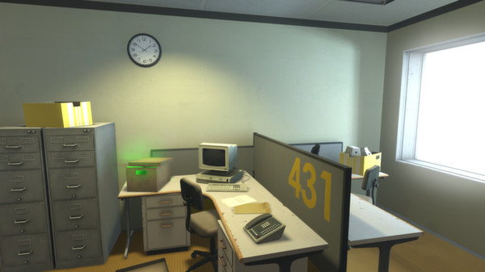
The Stanley Parable perfectly embodies how a game can explore liminality without resorting to horror tropes or nostalgia. It constructs emotional depth through architecture, silence, and mechanical guidance. Nicholson et al. (2017) discuss liminal spaces as "lacking distinctive landmarks," disorienting the player and challenging navigation (as cited in Liminal Geographies, p.7). The Stanley Parable leverages exactly this tactic: sterile offices blur into one another, removing familiar signposts of progression.
The game also uses the narrator’s contradictory instructions to place the player into a constant psychological liminal state. You are continuously questioning whether your choices matter, whether you are resisting authority or falling into a deeper trap. This uncertainty, coupled with looping architecture, transforms the environment into a purgatorial experience. As Liminal Geographies highlights, this constant questioning is fundamental to the emotional tension games can produce within liminal spaces.
Sound design is minimal yet critical: soft background hums, the mechanical clinks of office equipment, and the narrator’s omnipresent voice heighten the sense of being trapped in a sterile, dispassionate system. Here, the silence is weaponized, leaving players constantly unsettled. The Stanley Parable ultimately crafts liminality not just through space, but through experience, dissolving the boundaries between choice and entrapment.

Firewatch
Firewatch is a masterclass in emotional and geographical isolation. Set in the wilderness of Wyoming, you play as Henry, a fire lookout escaping the wreckage of a painful past. Your only contact with another human is through a handheld radio to Delilah, your supervisor. As your bond with Delilah grows, so too does the chasm of distance,mboth physically and emotionally. Despite your conversations, you never meet. At a pivotal moment, overhearing Delilah say,“no I don’t think he has any idea”, “im absolutely sure” “would you?”, could shatter your fragile trust, transforming loneliness into suspicion.
Firewatch’s landscape intensifies this emotional estrangement. The game world feels tangible but desolate: vast forests, rocky cliffs, and winding rivers spread endlessly, creating a confusing space without clear landmarks. You rely heavily on maps and compass navigation—mechanics that mirror the real emotional disorientation Henry experiences. Nicholson et al. (2017) argue that liminal spaces often lack the "distinctive landmarks" of typical game worlds, heightening player reliance on environmental cues and resulting in profound disorientation (as cited in Liminal Geographies, p. 7). Firewatch embodies this principle; although paths exist, the wilderness blends into itself, subtly destabilizing the player’s spatial orientation.

Firewatch, Steam Page
A striking conversation early in the game hints at the deeper themes:
"So what’s wrong with you?"
"…"
"People take this job to get away from something."
Here, the narrative reinforces that emotional escape is as impossible as physical escape. The act of patrolling the forest becomes a metaphor for Henry’s attempt to outrun his own grief.
The soundscape further amplifies this sense of liminality. On my revisited playthrough, I noted the sounds of trees rustling, birdsong, creaking wood, and occasionally the low roar of wind or distant thunder. Pech et al. (2020) emphasize that "terrain elevation, weather patterns, and architectural design markedly influence player perception and interaction" (as cited in Liminal Geographies, p. 7). In Firewatch, sudden weather shifts, like rolling storms or smoke from unseen fires, turn the seemingly benign landscape into something alien and threatening.
Additionally, Inal and Cagiltay (2007) highlight how designers use geographical liminality to elicit targeted emotional responses (as cited in Liminal Geographies, p. 7). Firewatch’s natural setting—constantly changing yet eerily stagnant—serves as a silent antagonist. The landscape is at once beautiful and isolating, a mirror to the protagonist’s fractured inner life.
In Firewatch, geography and emotional narrative are inseparable, and the wilderness becomes an active, living force shaping the player's emotional journey.

Portal
Portal is another seminal exploration of liminal space, isolation, and dehumanization. You play as a test subject inside the Aperture Science facility, guided by the disembodied voice of GLaDOS, a sarcastic and increasingly sinister AI. The environment is meticulously sterile, repetitive, and subtly unsettling. It quickly becomes clear that the facility was not designed for you, but rather against you. Here, the environment itself is hostile.
As REF insightfully states, the "stripped-down environment reflects a focus on dehumanisation, efficiency, and control," prioritizing productivity over human comfort or individuality. Portal’s architecture strips away identity, reducing the player to a subject within a mechanical system. This sterile design, when combined with repetitive testing chambers, creates an uncanny sense of being trapped between reality and simulation.
Portal also revolutionized the concept of glitch space. The Portal Gun enables players to create spatial shortcuts, bypassing traditional game progression. As Liminal Geographies explains, the deceptive and contradictory audio messages constantly force players to question every environmental cue, creating a continuous psychological liminality. Players must stay alert and adaptable, never fully trusting guidance or their surroundings.
The gradual environmental storytelling deepens the psychological unease. At first, you move through pristine chambers. But as you "glitch" into maintenance tunnels and abandoned backrooms, the pristine facade crumbles. Scrawled messages like “The cake is a lie” reveal the cracks in the illusion of control. Suddenly, the sterile space transforms into one of decay and despair—suggesting an unseen, forgotten human presence that has been erased.
Sound design plays a critical role here too. As Crick notes, "soundscapes become a character," shaping emotional experience. Portal’s world is filled with humming machinery, distant echoes, dripping water, and mechanical grinding. These elements reinforce the feeling of being caught between a functional yet decaying world (Liminal Geographies, p. 11). The juxtaposition of mechanical coldness with occasional human traces creates an unsettling auditory liminality, heightening the emotional tension.
Portal's combination of sterile design, environmental storytelling, disorienting mechanics, and oppressive soundscape make it a powerful study in how games manipulate liminality to create lasting emotional impact.

Discussion
The examination of The Stanley Parable, Firewatch, and Portal reveals how games use space, sound, and player agency to create deeply liminal experiences. Across these case studies, environments are not passive backdrops, but active forces that unsettle, isolate, and disorient the player. Rather than relying on traditional horror or nostalgia, these games build emotional tension through repetition, emptiness, and instability within their worlds.
In The Stanley Parable, the looping, sterile office spaces challenge the notion of choice and freedom, generating psychological unease. Firewatch amplifies emotional isolation through a sprawling yet indistinct wilderness, where familiar markers dissolve and trust becomes fragile. Meanwhile, Portal weaponizes architectural sterility and manipulative sound design to trap the player in a constant state of suspicion and alertness.
Overall, these games demonstrate that liminality in virtual spaces is crafted not only through visual design, but through the manipulation of soundscapes, narrative structures, and environmental storytelling. The result is a powerful emotional effect where players are made to feel lost, detached, and suspended between states, an experience that lingers long after the game is finished.
https://www.sciencedirect.com/science/article/pii/S0272494422000895?via%3Dihub
Introducing the Study
To better understand why certain environments evoke unease, I examined the study "Structural Deviations Drive an Uncanny Valley of Physical Places" (2022). Traditionally, the uncanny valley relates to humanoid figures that are almost lifelike—but this research extends the concept to built environments. It finds that architectural spaces with structural anomalies (e.g., distorted layouts, missing features, repetition) elicit discomfort similar to the uncanny valley effect. These spaces break our subconscious expectations of structure, creating eeriness. For instance, Experiment 2 showed that as spatial anomalies increased—such as windowless rooms or distorted proportions—so did participants’ sense of strangeness. Interestingly, human presence reduced uncanniness in public areas but heightened it in private ones, emphasizing how context matters.
This framework supports why online “liminal space” images—featuring sterile halls, repetitive structures, and surreal architecture—feel so unsettling. These deviations subtly distort normality, triggering emotional dissonance.
Summary of Findings
Participant responses to liminal space imagery reveal recurring discomfort triggers: illogical layouts, strange proportions, symmetry, and ambiguous space purpose. Repetitive elements (like endless corridors), unnatural lighting, and visual stillness amplify feelings of isolation and claustrophobia. Many noted an absence of exits, furniture, or identifiable function, making spaces feel abandoned or hollow. Subtle anomalies created more unease than overt distortions, while silence and static environments deepened emotional displacement.
Together, the study and responses show that liminal architecture taps into a psychological in-between—spaces that feel “off” not because of what’s there, but because of what’s missing or misplaced. These environments leave individuals not just alone, but uncertain and emotionally unanchored.

Summary and Conclusion

Across my research, it’s clear that different games use various techniques to evoke isolation, disconnection, and liminality—but the emotional results are strikingly similar. Whether through geography, architecture, silence, or environmental suggestion, the spaces created in these games all leave deep emotional marks. In both Portal and Firewatch, players are unable to fully trust the environment or their inputs, reinforcing psychological tension and disempowerment. These games prove that non-verbal design is powerful. Through composition, emptiness, scale, and sound, they build mood without needing heavy dialogue or cutscenes. Familiar settings like offices, forests, or homes become strange through small shifts, and that subtle defamiliarization is what makes spaces truly feel liminal.
Through this research, several key takeaways have emerged for emotional environment design. Emptiness should not be seen as a lack of design, but rather as intentional silence that creates emotional resonance. Repetition and looping architecture, like in The Stanley Parable and Portal, reinforce feelings of being stuck or powerless. Environmental storytelling through abandoned objects or lifeless spaces can make a world feel both lived-in and haunting. Player disempowerment—achieved through confusing layouts, false choices, or manipulative NPCs—can heighten psychological liminality, leaving players feeling uncertain and vulnerable. Lighting and sound design are crucial: flickering lights, harsh shadows, ambient noise, or total silence all dramatically shape emotional impact. Liminality can feel both freeing and terrifying; games like The Long Dark and Arctico show how absence can invite either existential fear or reflective solitude. Nostalgia can be subtly weaponized, as seen in Backrooms games and Stray, where faded familiar elements evoke sadness, disconnection, and unease. Emotional isolation isn’t always spatial either—Firewatch demonstrates how fractured emotional connections can cause loneliness, even when surrounded by open nature.
Reflecting on all this, I’ve developed a clear vision for the emotional impact I want to achieve through my own design practice. My core design principles are focused on amplifying emotional resonance through space: using silence and emptiness to evoke feelings of isolation and loss, implementing repetition and looping layouts to mirror psychological entrapment, and telling silent histories through objects like CRT screens, broken toys, and abandoned furniture. I will create psychological liminality through undefined spaces, confusing paths, and unreliable cues, while lighting and sound will be dynamic and purposeful, maintaining tension and emotional weight. I also plan to use nostalgic relics to subtly evoke a longing for connection, much like the atmospheres found in Firewatch and The Long Dark.
I am particularly interested in how ambiguity around protagonist identity can enhance emotional dissonance. In many games exploring liminality, the player’s sense of self is fractured or undefined, increasing anxiety and deepening immersion. Following Calleja’s (2011) work on liminal geographies, I aim to explore how hidden or fragmented player identities can drive emotional engagement and reinforce a sense of disconnection. My final design considerations include framing environments carefully to guide emotional beats, leaving narrative gaps open to interpretation, and manipulating scale—through vast, empty worlds or claustrophobic corridors—to amplify vulnerability and existential reflection. Altogether, these insights will shape my approach to designing emotionally resonant, hauntingly liminal spaces that linger with players long after they leave them behind.

Bibliography

N. Valencia, "Why Are Liminal Spaces Eerie? The Case of The Backrooms," ArchDaily, Feb. 22, 2023. [Online]. Available: https://www.archdaily.com/996668/why-are-liminal-spaces-eerie-the-case-of-the-backrooms​
J. Pitre, "The Eerie Comfort of Liminal Spaces," The Atlantic, Nov. 1, 2022. [Online]. Available: https://www.theatlantic.com/culture/archive/2022/11/liminal-space-internet-aesthetic/671945/​
J. Koenig, "Kenopsia," The Dictionary of Obscure Sorrows, Jul. 2012. [Online]. Available: https://www.dictionaryofobscuresorrows.com/post/27720773573/kenopsia​
E. Kuroda, "Kenopsia," Elena Kuroda, [Online]. Available: https://elenakuroda.com/Kenopsia​
"Are you a Hikikomori? | HQ-25M Online Test," Hikikomori-Test.com, [Online]. Available: https://hikikomori-test.com/​
Department for Culture, Media and Sport, "Tackling loneliness evidence review: executive summary," GOV.UK, Jan. 26, 2022. [Online]. Available: https://www.gov.uk/government/publications/tackling-loneliness-evidence-review/tackling-loneliness-evidence-review-summary-report​
"Why Do People Isolate Themselves?" Williamsburg Therapy Group, [Online]. Available: https://williamsburgtherapygroup.com/blog/why-do-people-isolate-themselves​
"Liminal Space," Aesthetics Wiki, [Online]. Available: https://aesthetics.fandom.com/wiki/Liminal_Space​
"Games that make you feel isolated and alone," Reddit, Oct. 2022. [Online]. Available: https://www.reddit.com/r/gamingsuggestions/comments/yidfrs/games_that_make_you_feel_isolated_and_alone/​
"The Eerie Comfort of Liminal Spaces," MetaFilter, Nov. 1, 2022. [Online]. Available: https://www.metafilter.com/197024/The-Eerie-Comfort-of-Liminal-Spaces​MetaFilter
"Why Do Liminal Spaces Feel So Unsettling, Yet So Familiar?" HowStuffWorks, Mar. 7, 2024. [Online]. Available: https://science.howstuffworks.com/engineering/architecture/liminal-spaces​HowStuffWorks+1Wikipedia+1
"Why Are Liminal Spaces So Comforting?" Medium, Jan. 2025. [Online]. Available: https://medium.com/@heimdoodle/why-are-liminal-spaces-so-comforting-223574a65642​Medium
"The Cult Following of Liminal Space," Musée Magazine, Nov. 1, 2020. [Online]. Available: https://museemagazine.com/features/2020/11/1/the-cult-following-of-liminal-space​
M. Sandal, "'The Backrooms Game' Brings a Modern Creepypasta to Life," Bloody Disgusting, Apr. 30, 2020. [Online]. Available: https://bloody-disgusting.com/editorials/3614536/play-shadows-backrooms-game-brings-modern-creepypasta-life/​Wikipedia
"The Backrooms," Happy Mag, [Online]. Available: https://web.archive.org/web/20220201130114/https://happymag.tv/the-backrooms/​
"Liminal Space," Forbes Health, [Online]. Available: https://www.forbes.com/health/mind/what-is-liminal-space/​
"The Rites of Passage," Internet Archive, [Online]. Available: https://ia903106.us.archive.org/16/items/theritesofpassage/The%20Rites%20of%20Passage.pdf​
"COVID-19," Campaign to End Loneliness, [Online]. Available: https://www.campaigntoendloneliness.org/covid-19/​
"Facts and Statistics," Campaign to End Loneliness, [Online]. Available: https://www.campaigntoendloneliness.org/facts-and-statistics/​
K. D. Neumann, "Liminal Space: What Is It And How Does It Affect Your Mental Health?" Forbes Health, Sep. 6, 2022. [Online]. Available: https://www.forbes.com/health/mind/what-is-liminal-space/​Wikipedia
"Liminal Space," Nobu AI Blog, [Online]. Available: https://www.nobu.ai/blog/liminal-space/​
"Structural Deviations Drive an Uncanny Valley of Physical Places," Journal of Environmental Psychology, Aug. 1, 2022. [Online]. Available: https://www.sciencedirect.com/science/article/pii/S0272494422000895​Wikipedia
"The Eerie Comfort of Liminal Spaces," Everand, [Online]. Available: https://www.everand.com/article/604332160/The-Eerie-Comfort-Of-Liminal-Spaces​Everand
"The Eerie Comfort of Liminal Spaces," Pinterest, [Online]. Available: https://www.pinterest.com/pin/the-eerie-comfort-of-liminal-spaces-the-atlantic-in-2023--777082110726876673/​Pinterest
"Gallery of Why Are Liminal Spaces Eerie? The Case of The Backrooms," Pinterest, [Online]. Available: https://fr.pinterest.com/pin/gallery-of-why-are-liminal-spaces-eerie-the-case-of-the-backrooms-3--665477282462444332/​Pinterest
"The Eerie Comfort of Liminal Spaces," Reddit, [Online]. Available: https://www.reddit.com/r/architecture/comments/yjb05s/the_eerie_comfort_of_liminal_spaces_why_were/​Reddit
"There is a serious lack of understanding of what Liminal Spaces are," Reddit, [Online]. Available: https://www.reddit.com/r/LiminalSpace/comments/zpawf1/there_is_a_serious_lack_of_understanding_of_what/​Reddit
"Games that make you feel lonely," Reddit, [Online]. Available: https://www.reddit.com/r/gamingsuggestions/comments/lta3i7/games_that_make_you_feel_lonely/​Reddit
"What are best games that make you feel alone in the world?" Reddit, [Online]. Available: https://www.reddit.com/r/gaming/comments/18go6jf/what_are_best_games_that_make_you_feel_alone_in/​Reddit
"Games to play when you struggle with loneliness / feeling isolated," Reddit, [Online]. Available: https://www.reddit.com/r/CozyGamers/comments/1eg64y1/games_to_play_when_you_struggle_with_loneliness/​Reddit
"Favorite games for when you feel lonely and isolated," Reddit, [Online]. Available: https://www.reddit.com/r/cozygames/comments/1jnrzu8/favorite_games_for_when_you_feel_lonely_and/​Reddit
"Games with depressing world/story that make you feel lonely," Reddit, [Online]. Available: https://www.reddit.com/r/ShouldIbuythisgame/comments/1ev5yvh/games_with_depressing_worldstory_that_make_you/​Reddit
"Open (or semi-open) world games that make you feel 'alone' but not...," Reddit, [Online]. Available: https://www.reddit.com/r/gamingsuggestions/comments/1k887gd/open_or_semiopen_world_games_that_make_you_feel/​Reddit
"Any games that will help me forget this loneliness I feel?" Reddit, [Online]. Available: https://www.reddit.com/r/gamingsuggestions/comments/1j5z66y/any_games_that_will_help_me_forget_this/​Reddit
2The Eerie Comfort of Liminal Spaces," MetaFilter, [Online]. Available: https://www.metafilter.com/197024/The-Eerie-Comfort-of-Liminal-Spaces​MetaFilter
[36] "Why Are Liminal Spaces Eerie? The Case of The Backrooms," ArchDaily, [Online]. Available: https://www.archdaily.com/996668/why-are-liminal-spaces-eerie-the-case-of-the-backrooms/63eed7ca2b866c5f7b28d063-why-are-liminal-spaces-eerie-the-case-of-the-backrooms-photo​ArchDaily

S. E. Jones, The Meaning of Video Games: Gaming and Textual Strategies. New York, NY, USA: Routledge, 2008. ​Routledge
K. Isbister, How Games Move Us: Emotion by Design. Cambridge, MA, USA: MIT Press, 2016. ​
M. M. M. M. (Author's full name not specified), "Navigating the in-between: liminal spaces in video game geographies," Geographical Journal, vol. 89, no. 2, pp. 247–260, 2024. ​ADS+1ResearchGate+1
S. Geniusas, "Yearning for the Irretrievable: Nostalgia and Time," Emotion Review, vol. 17, no. 1, pp. 1–10, Dec. 2024. ​The Philosophy Paperboy
E. Reay, "Secrets, Stealth, and Survival: The Silent Child in the Video Games Little Nightmares and INSIDE," Barnboken – Journal of Children's Literature Research, vol. 43, pp. 1–15, Jun. 2020. ​ORCID+5ResearchGate+5Google Scholar+5
J. McDougall and W. O'Brien, Studying Videogames. Leighton Buzzard, UK: Auteur Publishing, 2008. ​

Video Games:
C. Norori and A. Vargas, Arctico [Video Game], Steam, Feb. 15, 2022. [Online]. Available: https://store.steampowered.com/app/325210/Arctico/
Hinterland Studio Inc., The Long Dark [Video Game], Steam, Aug. 1, 2017. [Online]. Available: https://store.steampowered.com/app/305620/The_Long_Dark/
Valve, Portal [Video Game], Steam, Oct. 10, 2007. [Online]. Available: https://store.steampowered.com/app/400/Portal/
Campo Santo, Firewatch [Video Game], Steam, Feb. 9, 2016. [Online]. Available: https://store.steampowered.com/app/383870/Firewatch/
Galactic Cafe, The Stanley Parable [Video Game], Steam, Oct. 17, 2013. [Online]. Available: https://store.steampowered.com/app/221910/The_Stanley_Parable/
KOTAKE CREATE, The Exit 8 [Video Game], Steam, Dec. 7, 2023. [Online]. Available: https://store.steampowered.com/app/2653790/The_Exit_8/
KOTAKE CREATE, Platform 8 [Video Game], Steam, Feb. 28, 2024. [Online]. Available: https://store.steampowered.com/app/2903560/Platform_8/
Artists & Artworks:
E. Hopper, Rooms by the Sea [Painting], 1951. [Online]. Available: https://www.edwardhopper.net/rooms-by-the-sea.jsp
E. Hopper, Edward Hopper Official Website, [Online]. Available: https://www.edwardhopper.net/
B. Wong, Brent Wong – Parnell Gallery, [Online]. Available: https://www.parnellgallery.co.nz/artists/brent-wong/
B. Wong, Matrix [Painting], 1971.
B. Wong, Untitled (Balloon) [Painting], 1973.
S. Stålenhag, The Electric State [Photo Series], [Online]. Available: https://www.simonstalenhag.se/es.html
T. Nihei, Blame! [Manga Series], Kodansha, 1997–2003.
YokoGao Magazine, "The Infinite World of Blame!," YokoGao Magazine, [Online]. Available: https://www.yokogaomag.com/editorial/infinite-world-of-blame-manga
Opus.ing, "Exploring the Strange Ultra-Futuristic World of Tsutomu Nihei’s Blame!," [Online]. Available: https://opus.ing/posts/exploring-strange-ultra-futuristic-world-tsutomu-nihei-blame
C. T. McGivern, "Vivarium (Lorcan Finnegan 2020)," Estudios Irlandeses, vol. 16, pp. 249–250, 2021. [Online]. Available: https://www.estudiosirlandeses.org/reviews

