Marketing Plan and Slides
HILTON Hotels

Student Name: Oleg Goncear
Student Id: 2231041
Module: Marketing Essentials BMIH4005
Lecture: Luciana Suardi
Course name: IHM
Word Count: 2063 words

Table of Contents
Component A 3
Introduction 3
Situation Analysis 3
Objective 7
Strategy 7
Tactics 9
Actions 10
Control 10
Conclusion 11
Component B 12
References 14
Appendices………………………………………………………………………………..14-16

Component A

Introduction
A marketing plan is an overall strategy which is induced to run the marketing department of an organization. In this assessment marketing plan and its integral parts are discussed with respect to a renowned organization like Hilton hotel to highlight the procedures required in the development of the relative strategies. The marketing plan consists of 7 key elements which are product, price, promotion, place, packaging, positioning and people. These key elements are correlative with the strategy and objectives of the organization according to their effectiveness. Another strategy by which a marketing plan can be deducted is known as Bowman’s strategic clock, it is commonly used in attachments with tools such as the Ansoff matrix and can be witnessed as a supplement for Porter’s generic strategy.

Situation Analysis
One of the key marketing strategies is known as the 5 C’s of marketing which consists of the formula related to the Company, Customers. Competitors. Collaborators and climate. The Hilton Hotel has measurements in its marketing strategy which can be related to these elements.
5 C’s of Marketing
Company: SWOT Analysis
According to the extent of services, Hilton Hotel can be classified as a full-service hotel. The comprehensive SWOT analysis is provided below:

Strengths | Weakness
1. Hilton is a global brand, therefore they have better recognition on the global stage  2. Being a renowned brand they have advantages in local marketing structure. As a result, they have acquired a huge customer base.  3. The employees of Hilton Hotel are reportedly satisfied with their work environment. As a result, Hilton Hotel has a successful workforce. | 1. Due to the generation of fewer market revenues Hilton Hotel is facing greater liability threats.  2. As revenue generation has been low, employee retention has been an issue for the company  3. Due to poor customer reviews, there has been a decrease in customer numbers in their hotel services.
Threats | Opportunities
1. There has been growing criticism by different environmental groups against Hilton.  2. Due to less satisfaction among customers there has been an increased threat through digital marketing (Sánchez-Casado et al., 2019, p. 30). | 1. Company should focus on a better CSR strategy in order to maintain better local popularity.  2. Companies should focus on the development of better services to develop their popularity in digital environments like search engines and social media.

Customers: Segmentation and Targeting
As an all-rounder in hotel and restaurant services, Hilton provides services to both high-end and low-end customers. The company's decision to expand through the urban and rural areas has increased its mode of opportunities. The segmentations that Hilton works on are Geographic, Demographic, and Psychographic and Benefit (Wind and Robertson, 2022, p. 20).
Geographic: In this segment, Hilton targets customers according to their geographical specialities. For instance, in London Hilton hotels are found in popular places such as Aldwych, Canary Wharf, Bankside, Tower Bridge and Trafalgar Square. Therefore, Hilton provides suitable services according to the sectional needs divided into these areas as different people from different places have demands according to their preferences.
Age | 18-60
Income Group | Socio-economic (High income and medium-income groups)
Location | London

Competitors:
According to Bowman's Strategic clock, Hilton follows a Differentiation strategy due to its decreasing market values. They are working on enhancement of their services to the customers with a new range of options along with a better price range. This strategy can be helpful in order to expand their region of services as well as gain new collaborators in order to grow in market share.
Collaborators: Demonstrate an awareness of your organisation's B2B Relationships, Partnerships, and Franchises
According to their business relationships, partnerships and franchises, the essential assessments that Hilton can follow in order to gain new collaborators are:
- They have to survey the environmental status of the potential collaborators.
- Assessment of internal and external communication is needed.
- The prepared strategies need to be analysed.
- The key threats and weaknesses that the potential collaborators are facing have to be identified.

Climate: PESTLE
According to PESTLE analysis factors that impact Hilton are:
Political | Based in London the impact of Brexit was not suitable for Hilton.
Economic | Due to covid, as a big part of the hotel industry Hilton has primarily faced severe economic challenges
Social | The local customers haven't been happy in recent times due to their services forcing them to choose other alternatives.
Technological | Due to bad reviews in social media and search engines Hilton is facing challenges in their operations
Legal | Due to the leakage of data cases in recent times, Hilton has faced high legal obligations which resulted in a decrease in their customer base
Environmental | Successive camping against Hilton by various environmental organisations has decreased Hilton’s popularity.

Objective
Aim: The current scenario that Hilton is operating in has enforced them on expanding by merging and collaborating due to this situation they have organised different market strategies. The objective of the marketing strategy related to Hilton Hotels can be described as
- To gain a potential customer base with better services.
- To organise its strategy on the basis of individual demands according to the places.
- To increase the standard of services
- To increase their popularity in the digital aspect.

Strategy
Hilton Hotels observes that all hotel brands are using digital platforms to improve communication with consumers. Regarding this, Hilton has decided to improve their marketing communication to enhance travellers’ experiences. Therefore, Hilton uses social listening to enhance marketing campaigns in the hospitality industry. In addition, the value proposition is a simple statement which communicates the clearest benefit.
Consumer profile
Gains
Hotel Hilton provides unique quality services to delight the consumers which help to increase brand identity in the business market. The social communication interaction provides feedback, and the company analyses to remove any types of issues.
Pains
The marketing team of Hilton analyses the consumer’s behaviours and monitors their emotions and empathy as such they can develop their communication strategy which would be helpful in future marketing communication.
Consumer jobs
Hilton's team analyses the social, functional and emotional tasks of the consumers and tries to solve them to retain in the competitive market.
Value Map
Gain creators
It has been evidenced that Hilton offers accommodation, hotel restaurants, and different types of drinks to meet the consumer's needs that help to develop consumer’s experiences.
Pain relievers
The quick services and social brand awareness programmes of Hilton Hotel can mitigate the pain of the consumers.
Products and services
The products and services of Hilton Hotels offer accommodation, parking services, restaurants and skilled customer care services to improve organisational performance.

Tactics
Due to the upcoming strategy of their expansions, Hilton has produced strategies according to the 4 P's of marketing strategy:
Product | The products that were in service in the previous destination have not been fruitful for Hilton in order to generate revenues. Therefore, with a site in competition with the market, they have evolved their services and products in different units according to the individual regional demands.
Price | They are focused on providing the best possible products and services at the lowest possible rates, thus achieving their motto of providing customers with value-added services.
Place | The Hilton hotel has sorted out the required places in which they can collaborate with relative organisations who have qualified their needs of collaboration. Therefore, selective places on the outskirts of London and different urban and underdevelopment rural areas have been selected.
Promotion | The Hilton hotel has been way behind in the department of digital marketing in comparison to its competitors. The bad reviews based on customers’ recent experiences have affected their operations and they faced suffering in business. Therefore, Hilton has devised new social marketing-based promotional strategies that can attract generation Zen to acquire their services.

Actions
Justification
According to the Gantt chart, the systematic approach set for 8 weeks for Hilton to launch a new product and services can be measured.
- Due to their decreasing popularity in social media and the digital industry, the successive approach of delivering information through blogs has been set on the agenda for the first two weeks.
- The customers who are enrolled under subscriptions need to be reminded of better service approaches and new products through email marketing.
- Campaigns are to be organised in awareness of new hotels and services to the new regional customers.
- Social media handlers should be appointed in order to organise a successful campaign through social media, this part has taken place from weeks 2-5.
- The remaining attributes related to deliverables (posters and leaflets), launching of products and deadline have been set accordingly in the last two weeks.

Control
According to (Bohdanowicz and Martinac, 2019, p. 90), the success of a dynamic business organisation like Hilton can be variable in different stages. In the current situation according to their market status, Hilton has projected different strategic steps towards the goal of achieving a new and greater customer base. This strategy also includes gaining their missing trust through customer satisfaction and digital marketing output. The new customers are subjected to acquire value-added services by the organisation in order to induce positivity towards the brand; this generates trust and provides better reviews as a result of greater experiences. The success of the organisation can be achieved via these strategies with the help of the above-mentioned criteria and a perspective of better services.

Conclusion
Marketing communication deals with messages and media where the marketers can communicate to target the markets. Indeed, it has been evidenced that marketing communication involves public relations and sales promotion to enhance consumer relationships within the company. The assessment discusses the hotel Hilton marketing plan which focuses on marketing channels used by the marketing team of Hilton. Therefore, it has many competitors in the UK although the products and services qualities of Hilton can minimise the competitor’s threats in future.

Component B
As opined by Shaddiq, and Handayani (2021, p. 26), business plans are involving marketing communication strategies which convey particular messages and target potential consumers via various channels. Therefore, Hilton uses social listening to enhance marketing campaigns in the hospitality industry. Around the globe, Hilton hotels are popular and combine services with luxury and amenities. The greatest strength of the hotel is its brand recognition and satisfied consumers.
The hotel Hilton has a large network chain which helps to expand its horizons all over the world. In addition, Hilton hotel offers hospitality and luxury services such as deluxe rooms, bars and restaurants. It offers resort services and business organisations can arrange meetings and events for commercial purposes. Moreover, the hotel rooms are crafted with modern diligence as well as advanced amenities. It offers exclusive membership discounts which would help to attract more consumers in the future.
Across the globe in 84 countries, Hilton Hotel engages to provide luxurious services for consumers. However, In London Hilton Hotel develops its business operations and it is near to the airport, bus services and taxi services. It also ensures parking services for the consumers. The well-selected manner has been developed to enhance the consumer's experiences and the desirable landing option customises the needs of the geographic population of London.
As a leading brand, Hilton offers high-quality amenities and adopts a premium pricing strategy to scale up its services. The five-star consumer services have been provided with premium pricing techniques. In addition, the hotel Hilton has a dedicated team of experts and researchers who monitor the organisational performance and develop the services of the business organisation.
Regarding business promotion, Hilton chooses unique promotional activities which help to stand out from the crowd. Indeed, it has been evidenced that Hilton provides exclusive membership to the consumers and staff and a well-dedicated team focused on marketing strategies to improve marketing indulgence. As stated by Lukanova, and Ilieva (2019, 160), the luxury and amenities have been provided by hotel Hilton all over the world. Therefore, the tourism and hospitality industry is booming and leading to the rise of competitors in the field. The effective method of implementation in the marketing strategies of Hilton can bring positive evaluation to advertise the tactics of the hotel. Apart from this, Hilton Hotels has decided to develop its social media pages to enhance consumers’ experiences in the competitive market industry. However, it also focuses on CSR strategies and adopts digital media platforms to improve the brand image and establish a unique brand identity in the market.

References
1. B2B International (2022) What is the value proposition canvas?, B2B International. Available at: https://www.b2binternational.com/research/methods/faq/what-is-the-value-proposition-canvas/ (Accessed: February 21, 2023).
2. Introduction to Bowman’s Strategy Clock (2023). Available at: https://getlucidity.com/strategy-resources/introduction-to-bowmans-strategy-clock/ (Accessed: February 21, 2023).
3. Bohdanowicz, P. and Martinac, I., 2019. Determinants and benchmarking of resource consumption in hotels—A case study of Hilton International and Scandic in Europe. Energy and buildings, 39(1), pp.82-95. https://www.diva-portal.org/smash/record.jsf?pid=diva2:10870
4. Bondarenko, V.A., Efremenko, I.N. and Larionov, V.A., 2019. Marketing strategy for hotel and tourist complex companies. https://www.um.edu.mt/library/oar/handle/123456789/45977
5. Buttle, F. and Bok, B., 2019. Hotel marketing strategy and the theory of reasoned action. International Journal of Contemporary Hospitality Management, 8(3), pp.5-10. https://www.emerald.com/insight/content/doi/10.1108/09596119610115943/full/html
6. Hilton, T., Hughes, T., Little, E. and Marandi, E., 2018. Adopting self-service technology to do more with less. Journal of Services Marketing. https://www.emerald.com/insight/content/doi/10.1108/08876041311296338/full/html
7. Lukanova, G. and Ilieva, G., 2019. Robots, artificial intelligence, and service automation in hotels. In Robots, artificial intelligence, and service automation in travel, tourism and hospitality (pp. 157-183). Emerald Publishing Limited. https://www.emerald.com/insight/content/doi/10.1108/978-1-78756-687-320191009/full/Hotels.com

8. Mekhruza, V., Malokhat, S., Rustam, T. and Bakhora, R., 2022. PERFORMANCE OF HILTON: HOW HILTON TACKLES THE EPIDEMIC COVID-19 DISEASE. Thematics Journal of Business Management, 5(2). https://thematicsjournals.in/index.php/tjbm/article/view/1180
9. Reidhead, C., 2020. Impact of organizational culture on employee satisfaction: A case of Hilton hotel, United Kingdom. Journal of Economics and Business, 3(1). https://www.academia.edu/download/84816413/JEB0615_20christine.pdf
10. Ruel, H. and Njoku, E., 2021. AI redefines the hospitality industry. Journal of Tourism Futures, 7(1), pp.53-66. https://www.emerald.com/insight/content/doi/10.1108/JTF-03-2020-0032/full/html
11. Sánchez-Casado, N., Artal-Tur, A. and Tomaseti-Solano, E., 2019. Social Media, Customers' Experience, and Hotel Loyalty Programs. Tourism Analysis, 24(1), pp.27-41. https://www.researchgate.net/profile/Andres-Artal-Tur/publication/331447979_Social_Media_Customers'_Experience_and_Hotel_Loyalty_Programs/links/5cfe31d24585157d15a00fc8/Social-Media-Customers-Experience-and-Hotel-Loyalty-Programs.pdf
12. Shaddiq, S. and Handayani, W., 2021. Communication and interactive marketing management through internet advertising. SMBJ: Strategic Management Business Journal, 1(02), pp.25-29. https://journal.smbjupmi.com/index.php/smbj/article/view/18
13. Wang, C., Hu, R. and Zhang, T.C., 2020. Corporate social responsibility in international hotel chains and its effects on local employees: Scale development and empirical testing in China. International Journal of Hospitality Management, 90, p.102598. https://stars.library.ucf.edu/cgi/viewcontent.cgi?article=1943&context=ucfscholar
14. Wensley, R., 2018. The basics of marketing strategy. In The marketing book (pp. 75-107). Routledge. https://www.taylorfrancis.com/chapters/edit/10.4324/9781315890005-12/quantitative-methods-marketing-steve-baron-rachel-ashman
15. Wind, Y. and Robertson, T.S., 2022. Marketing strategy: new directions for theory and research. Journal of Marketing, 47(2), pp.12-25. https://www.academia.edu/download/47857212/Marketing_Strategy_New_Directions_for_Th20160807-19695-gzt731.pdf

Appendices

Appendix 1

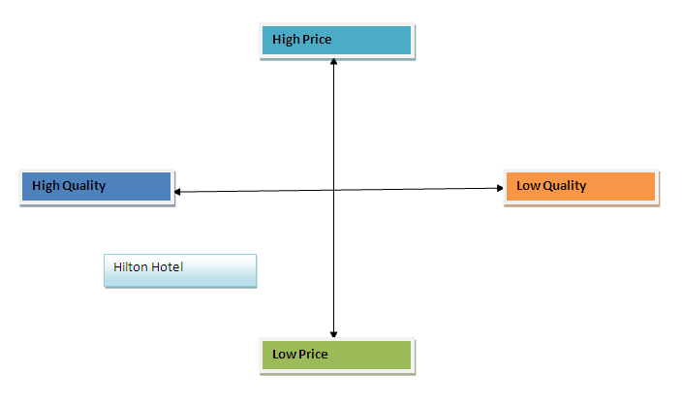
Figure 1: Perceptual Positioning map
(Source: Developed by Author)

Appendix 2

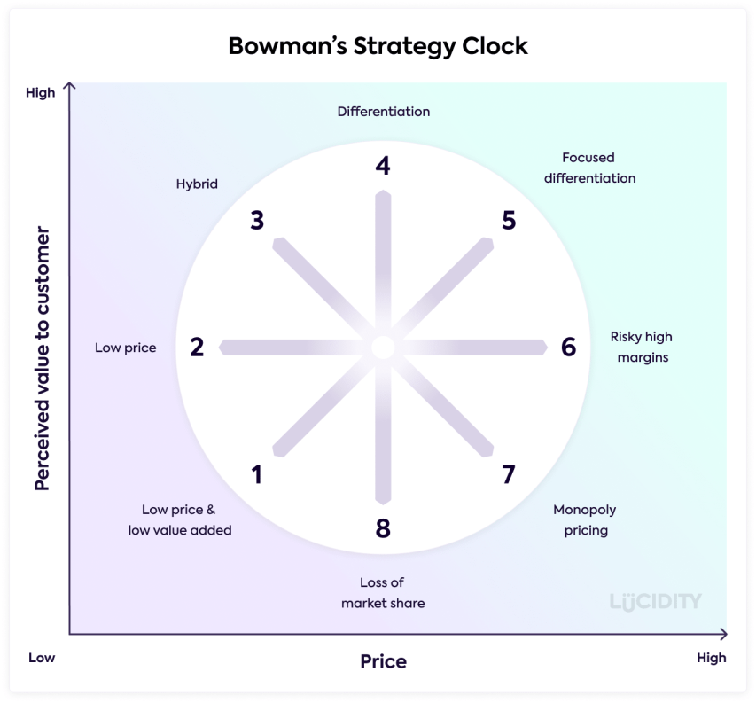
Figure 2: Bowman’s Strategic cycle
(Source: get lucidity.com, 2023)

Appendix 3
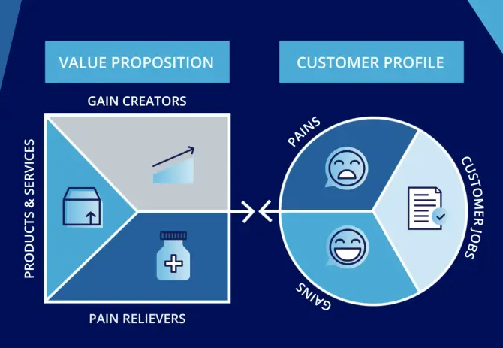

Figure 3: Value proposition canvas
(Source: b2binternational.com, 2022)

Appendix 4
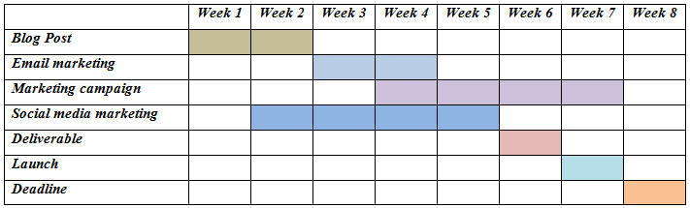
Figure 4: Gantt chart of marketing activities
(Source: Developed by Author)

