

Tesla launched a wholly-owned factory in Shanghai, China

Student Number: 1806564
Module Title: Strategic Change and Organizations (LCDB7005)
Module Lecturer: Dr. Gladius Kulothungan

1 Tesla is building a new plant in China
Established in 2003, Tesla manufactures not only electric vehicles but also unlimited scalable clean energy power generation and storage products. The mission of Tesla is to accelerate the world’s transition to sustainable energy (TESLA, 2019a).

In 2008, Tesla designed the first electric car worldwide, Model S. In 2010, Tesla issued its shares in Nasdaq with financing of $226 million. In 2015, Tesla launched Model X, which is the safest, fastest and most powerful sport utility vehicle in history. In 2016, Tesla launched Model 3, a low-cost, mass-produced electric vehicle. To create a completely sustainable energy ecosystem, Tesla has also created a unique set of energy solutions. Today’s Tesla Energy includes household energy storage products “Powerwall”, commercial and utility energy storage products “Powerpack”, and home solar products “SolarRoof”.

In July, 2018, Tesla signed an agreement with Shanghai Port-Linking Administrator Group to build a Tesla Super Factory, which integrates R&D, manufacturing and sales functions. This is the first overseas Gigafactory in Tesla’s history (Goh, 2018). On the day of the announcement, the share price of Tesla rose 1.5%, and some analysts questioned whether the losing company would receive the funds for building and equip such a large factory (Moss, 2019).

In early 2019, Tesla No. 3 Super Factory officially started construction in Shanghai Port-Linking Industrial Zone, Musk is showing “Tesla Speed” to the world. Recently, the Morgan Stanley Motor Team predicted that Tesla’s Shanghai plant would be completed by the end of September, and that Model 3 would be put into operation as early as November (Yvkoff, 2018). The project plans to produce 500,000 pure electric vehicles annually.

This report adopts PESTEL model to analyze the external environment of Tesla, and SWOT model to analyze its internal strength and weakness, then evaluate if this strategy is appropriate.

2 PESTEL analysis

2.1 Political
The government’s role in regulating the automotive industry is primarily related to energy, environmental policies and legislation. Tesla operates globally and faces risks in the political environment from different countries.

2.1.1 Tax credit policy
Governments have implemented incentives for electric vehicles (EVs). The U.S. government has taken many measures to encourage the production of EVs. In 2010, Tesla received $465 million in low-interest loans from the Department of Energy. The federal government also provides a $7,500 tax credit for the purchase of EVs (TESLA, 2010). State and city-level electric vehicle incentives also play an important role in the early stage, some states such as Arizona, California, Florida, Louisiana, New Jersey, Vermont, offer $500-2500 in rebates to attract customers to buy EVs (TESLA, 2019b).
However, from the beginning of 2019, Tesla buyers can still apply for a tax credit, but this is only half of the previous $7,500, the credit drops to again to $1,875 in the second half of 2019 (Lekach Sasha, 2018). Tax Credit impact price of EVs (Table 1) (Concerned Scientists, 2018).

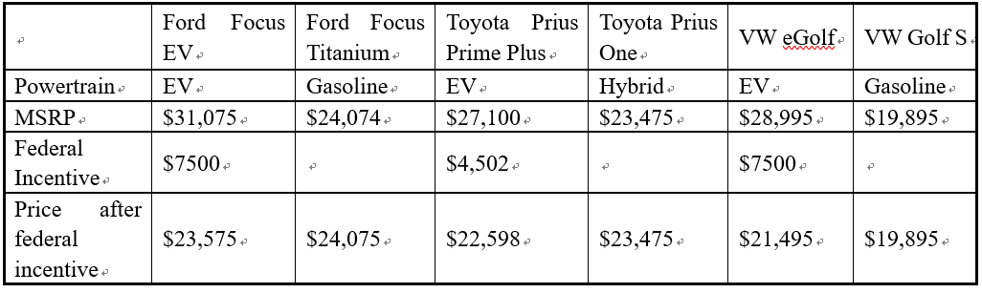
Table 1: The impact of the federal credit on pricing for EVs
Source: Manufactures’ Suggested Retail Price (MSRP) from manufacturer’s websites

Since 2016, in order to promote the development of Chinese new energy automobile industry, the government has issued a series of support policies, including financial subsidies, tax incentives and licensing policies. In June, 2019, the policy of subsidizing new energy vehicles finished (National Energy Administration, 2019), which will intensify the competition between new energy vehicles and between new energy vehicles and traditional automobile manufacturers. Therefore, the changes governments’ policies would either benefit or threaten to enterprises.

2.1.2 Trade tariffs
Tariffs also affect Tesla’s EV sales. The Chinese government announced that it would reduce import tariffs on automobile components and parts from July 1, 2018. The tariff adjustment is to reduce the automobiles’ tariff rate of 25% and 20% to 15%. This is the first time since 2006 that China has lowered the tariff rate on imported vehicles (Xinhua News, 2019). However, due to the Sino-US trade war, China’s import tariffs on American automobiles have been in an unstable situation, Tesla needs to find a market with low or duty-free trade tariffs.

2.2 Economic

2.2.1 Economic growth, sales of EVs are increasing
From 2017 to 2018, developed economies grew steadily at a rate of 2.2%, the unemployment fell to a historic low. In developing economies, East Asia and South Asia continue to maintain relatively strong growth, with growth rates of 5.8% and 5.6% respectively in 2018. United Nations (2019) predict that the global economy will grow steadily at a rate of 3% from 2019 to 2020.

The global economy has improved the sales of EVs. In 2017, more than 1 million EVs were sold worldwide, setting a record. The number of popular Tesla, Nissan Leafs and other EVs worldwide has now exceeded 3 million, an increase of 50% over 2016. By 2018, China had the highest sales figures to date, with 579,000 EVs (Figure 1). Norway is famous for its love of EVs, it sold 62,260 EVs in 2017, with an impressive market share of 39% (McCarthy, 2018). In the first quarter of 2019, Germany overtook Norway to become the No. 1 seller of EVs in Europe (Irle, 2019). However, the constraints of productive capacity faced by some developed economies may have an impact on short-term growth (United Nations, 2019).

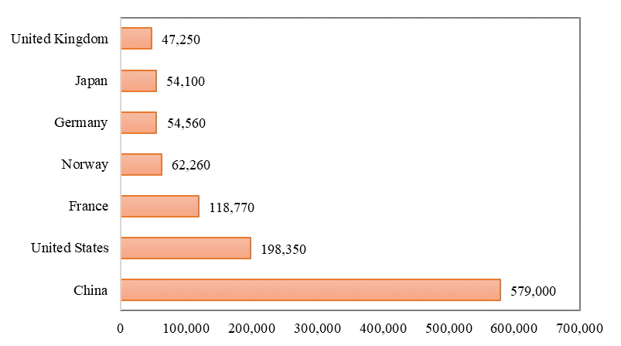
Figure 1: Electric vehicle sales by country in 2017
Source: Statista 2018

2.2.2 The cost of solar energy decline and the price of battery decrease
The growth rate of the solar market determines the growth opportunities for Tesla solar panel business. The cost of all commercial renewable energy technologies fell in 2018, the cost of concentrated solar power (CSP) fell by 26%, and solar photovoltaic (PV) fell by 13% compared with the last year. Solar photovoltaic power generation is now often cheaper than any fossil fuel option (IRENA, 2019). At the end of 2017, the average cost of lithium-ion battery packs was $209 per kwh, a 24% decrease from 2016 and an 80% decrease from prices in 2010.

Due to EV production increases, the battery costs will continue decline, within several years they will reach the $125–$150 target that makes EVs own the competitive advantages with conventional gasoline vehicles. Analysts believe that by 2030, the cost of lithium ion battery packs will be as low as $80 per kwh (Concerned Scientists, 2018) (Figure 2). Bloomberg stated that in 2015, batteries for medium-sized American cars accounted for more than 57% of the total cost, compared with 33% in 2019 and only 20% of the total vehicle cost by 2025 (Bullard, 2019). Tesla launched the Model 3 standard battery pack at an initial cost of $35,000 (Tesla, 2018).

Figure 2: EVs’ battery cost
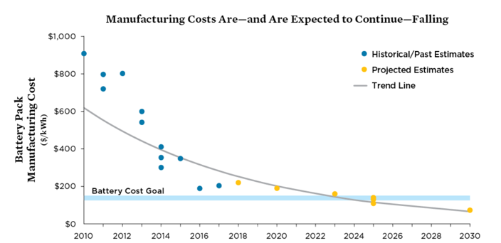
Source: Concerned Scientists, 2018

In addition, the exchange rate is also impacting the strategy and market layout of Tesla. For example, the Federal Reserve’s monetary easing policy has led to a flood of liquidity in global financial markets. In this case, Tesla would borrow money at a lower price, but this strategy will bring risks when interest rates rise. Tesla should also be cautious about foreign exchange risks before entering new markets (Ven den Steen, 2015).

2.3 Sociocultural

2.3.1 Low carbon lifestyle
People’s lifestyle changes can improve the environment, consumers are paying more and more attention to environmental issues. Low-carbon life is getting more popular, which also makes electric cars become a better choice. Tesla has new growth opportunities based on the increasing popularity of low-carbon lifestyles and increasing preferences for renewable energy.

2.3.2 Aging population
In 2017, the global population aged 60 and over reached 962 million, more than twice of the elderly people in 1980 with 382 million. By 2050, the number of elderly people is expected to reach nearly 2.1 billion. On a globe scale, the number of older people is growing faster than any other age groups. The global population aged 80 and over is expected to reach 137 million to 425 million from 2017 to 2050 (Figure 3) (United Nations, 2017). An aging population, especially the number of people with travel-limiting disabilities is projected to increase dramatically, which could drive up demand for accessible autonomous vehicles (Claypool, 2019). The demand for products that cater to this market segment will grow, Tesla should consider demographic trends before developing new products and integrate features.

Different regions of the world have different cultures, which also affect the marketing activities of multinational corporations. For example, the American savings culture has been destroyed because people do not have enough savings. China’s savings culture is completely different, the saving rate in China is about 30%, and less than 15% in US. These consumption and savings culture affect both consumption and consumption (Ven den Steen, 2015).

Figure 3: Number of persons aged 60 years and over by development group, from 1980 to 2050
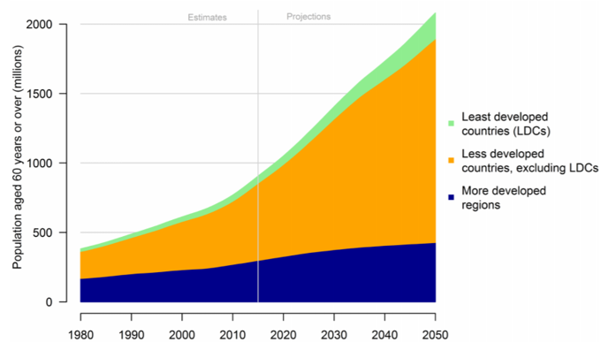
Source: (United Nations, 2017)

2.4 Technology
The new wave of technology, represented by the Internet, big data, cloud computing and artificial intelligence, which are triggering a revolution in the global manufacturing industry. Intelligent vehicles are mainly embodied in two aspects: automatic driving and connected vehicle. AI is the key factor to improve the ability of automatic driving, The progress of technology will greatly reduce the application cost of AI (Zhao et al., 2018).

New technologies are also reducing the cost of batteries and power packs, improving the efficiency of batteries. Technology is the greatest advantage of EVs, which is both an opportunity and a challenge for Tesla. It should keep up with the latest technology and upgrades in order to keep ahead of its competitors, as technology is changing very fast.

2.5 Environment
At the present age, green environmental protection is a very popular term. The rapid warming of the past decade is mainly due to human-induced atmospheric changes (watts, 2018). Many governments have developed impressive environmental, waste, air pollution and ocean strategies (Harrabin, 2019). Greenhouse gas emissions caused by automobiles are receiving more and more attention, and the green energy movement has promoted the demand for EVs. They do not consume greenhouse gases to emit gasoline, nor do they directly produce carbon dioxide. Tesla uses a battery pack that works with solar panels, which complies with regulations in most national environments.

2.6 Legal
Laws concerning the automobile industry include foreign investment, intellectual property protection, anti-monopoly, trade, security, capital operation, environmental protection and other fields (Ven den Steen, 2015).

Tesla holds a direct sales model, while several states, such as Michigan, prohibit Tesla’s cars directly sale from manufacturers to consumers and also forbidden its after-sales services (Lao, Feinstein and Lafontaine, 2015). Such laws protect distributors and harm the interests of consumers and producers. In August 2018, the Securities and Exchange Commission investigated Musk’s statement on the privatization of Tesla. Tesla was also accused by shareholders of misguiding investors and manipulating Tesla’s stock prices. California Occupational Safety Agency has recorded more than 40 violations in Tesla since 2013 (Matousek, 2018). These events will have a negative impact on the brand reputation.

3 SWOT analysis

3.1 Strengths

3.1.1 High brand awareness
Tesla gains high brand recognition worldwide. In 2017, Tesla won the Best Innovative American Brand Award in the BrandZ, the world’s largest brand equity platform. In 2019, Tesla was granted the most popular brand in the 2019 New Car Awards industry by car dealership Auto Trader (Evannex, 2017). Tesla’s cars are distinguished by its pioneering technology and environmentally friendly features, it designs smart and ingenious cars, which won many enthusiastic fans.

3.1.2 Advanced technology
So far, Tesla dominated the premium EVs market. Until July 2018, Tesla’s fleet has accumulated over 1.2 billion miles on Autopilot compare to Alphabet’s fleet of 8 million (Xinhua, 2018). Tesla invest a lot of resources and constantly improving its battery, aerodynamics and rolling resistance. Audi, Mercedes and Jaguar have produced electric models, but none of them rivals Tesla’s battery pack (Boudette, 2019).

Tesla has a clear context in advancing sustainable energy solutions, it is deploying a true electric vehicle ecosystem. In 2012, Tesla developed the energy storage devices Powerwall and Powerpack; Tesla’s energy business unit was established in August 2015; Tesla acquired Solarcity in August 2016 (Miley, 2019). Tesla’s relatively large and expanding supercharger network can also provide an advantage for the company in the short term as new entrants need time to build a nationwide charging network (Trefls Team, 2018).

3.2 Weaknesses

3.2.1 Burning cash with no profit
Since the initial public offering of Tesla eight years ago, there were only three profitable quarters, Tesla burned cash at an alarming rate (Figure 4 and 5). It lost about $2 billion in 2017. As of the end of March 2018, Tesla’s cash was approximately $2.7 billion, it lost nearly $700 million in the quarter ended March 31, 2019, one of the worst quarters of its history (Griswold, 2019). The share price of Tesla fell more than 20% in 2019 (Yoon, 2019).

Although the sales of Tesla have been growing, its market share are low, the market growth is slow, and the economies of scale are poor.

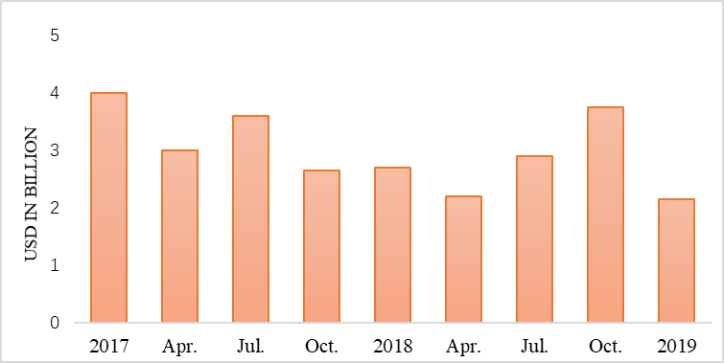
Figure 4: Tesla’s dwindling cash and cash equivalents
Source: Tesla, 2018

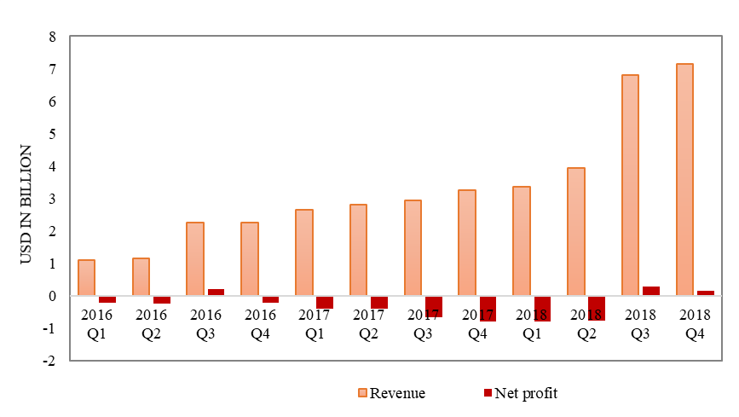
Figure 5: Tesla revenue versus profit
Source: Tesla, 2018

3.2.2 Limited production capability
After two years and several billion dollars to get the Model 3 into production, Tesla experienced months of “production hell” and months of “delivery logistics hell” (Figure 6). It only produces cars at a factory in Fremont, California, which has the capacity to produce 500,000 cars, which is the largest production. Tesla produced 9,766 Model 3s in the first quarter of 2018, a significant improvement from the fourth quarter of 2017. But the company did not reach the target of producing 2,500 Model 3 per week at the end of the first quarter, reaching only 2,020 (Matousek, 2018). This will damage Tesla’s business, financial condition and operational results.

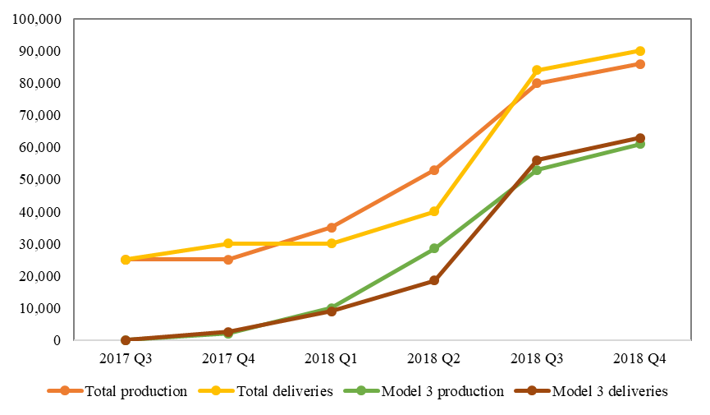
Figure 6: Tesla’ quarterly vehicle production and deliveries
Source: Tesla, 2018

3.2.3 High turnover rate of talents
Tesla is known for its high turnover of executives and senior staff. In 2018, there were 40 vice presidents leaving. In September 2018, vice president Sarah O’Brien, chief human resource officer Gabriel Tolle Dano, and chief accounting officer Dave Morton have left. Justin McAnear, vice president of global finance and operation also left in October, and Phil Rothenberg, vice president of law, left in November (Matousek and Rapier, 2019). Tesla’s top management is very unstable, affecting the efficiency of the company.

3.3 Opportunities

3.3.1 Popular model 3 and increasing sales
Tesla Model 3 has been highly praised since it was released in March 2016. It is an economical model, the products expanding to the mass market. Figure 7 shows that Tesla Model 3 ranked first in global EVs sales in 2018. Model 3 dominated sales growth of EVs in the United States in 2019. By the end of June, less than 150,000 EVs had been delivered in the U.S., while 57% of them were Tesla cars (Schmid, 2019). The financial report of Tesla shows that its total production increased from 120,000 in 2017 to 350,000 in 2018, that’s enough to bring third-quarter profits to $312 million (Coren, 2019).

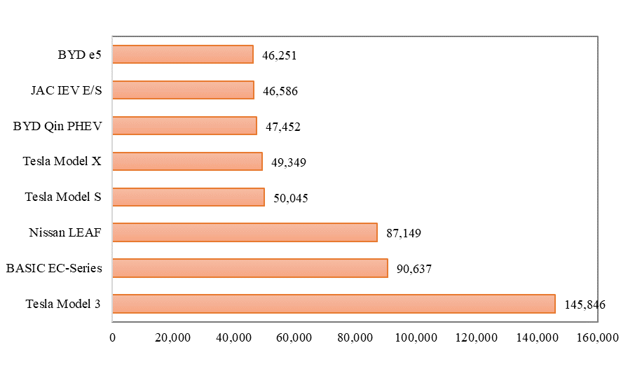
Figure 7: Top 10 electric cars-worldwide sales (2018)
Source: EV Volumes

3.3.2 Expanding international market
Tesla is in an advantageous position in the EV industry, which will take opportunities to expand its market share. Growth in the international market will help Tesla spread risk, as it less relies on domestic market income. Tesla delivers Model 3 to Europe and China on March 2019, according to statistics, Tesla has about 15,000 orders in Europe (Wesoff, 2019).

3.3.3 Expanding new energy market
Some consumers are worried about environmental pollution, they are more willing to buy EVs than cars that produce carbon. Total CO2 saved by Tesla vehicles are 3,530,507.34 tons (TESLA, 2019a). Moreover, the supply of oil is limited, oil prices tend to rise in the future. Therefore, EV is another option for growth in the future (Hayes, 2019).

3.4 Threats

3.4.1 Driving safety
Safety always bothered Tesla. In May 2016, a Tesla Model S driving an autopilot collided with a tractor trailer (Frick, 2016). In March 2018, Model X crashed into the highway barrier in California, the driver died. In May, the driver of Model S and one passenger died after a car accident in Florida. In June, Model S suddenly caught fire in Los Angeles (Matousek, 2018). Tesla should continue to invest in automotive safety research and development.

3.4.2 More intense competition
The worldwide automotive market, particularly for alternative fuel vehicles, is highly competitive. Most of the major automobile manufacturers now have EVs, other current and future automobile manufacturers are also developing EVs (Tesla Annual Report, 2019). In 2018, U.S. News released a list of the top 8 EVs sold, Tesla gained the second and fourth, Chevrolet Volt EV and lonig EV gained the first and third. Tesla has dominated the high-quality EVs market, but some advantages may diminish over time. As well-funded car companies expand their production of EVs, they may further reduce the battery cost and challenge Tesla (Trefls Team, 2018). Porsche and Mercedes’ high-end models will be proposed on the market in 2019. In the low-end market, Volkswagen is launching a new EV with a starting price of $27,000. Competition for EVs will soon heat up (Gaus, 2018).

3.4.3 Possibly hindered by a global shortage of battery minerals
As a leading electric vehicle manufacturer, Tesla required the US government to support the investment in the mining industry to ensure continued supply of key minerals such as nickel and copper to produce lithium-ion batteries. Insufficient battery supply will lead to a decline in Tesla’s productivity (O’Kane, 2019).

4 Strategy choice - improving production capacity and seeking a greater market
PESTEL analysis indicates that political and economic factors are both opportunities and challenges for Tesla; environment and legal factors may be positive in the long run; technology will intensify competition in the future. SWOT analysis shows that Tesla’s advantages mainly include brand, technology and business model; its disadvantages are profit and production capacity insufficient; the opportunities include expanding international and new energy markets, and the threats, such as security problems and fierce competition. Based on external and internal analysis, Tesla’s strategic choice should be expanding production capacity and seek a larger market. This market fits the following characteristics: stable political, active economy, broad market, leading technology and low cost.

5 Why Shanghai, China?

5.1 China is the largest EVs market
First, the Chinese government encourages the purchase of new energy vehicles. In 2018, the automobile production and sales completed 27.8 million units and 28 million units respectively in China, the production and sales falling by 4.2% and 2.8% with the last year. However, the new energy vehicle market is still showing rapid growth, with production and sales of 1.27 million units and 1.256 million units respectively, an increase of 59.9% and 61.7% with the previous year (Guan, 2018). By 2025, more than 20% of cars will be EVs. Therefore, despite the slowdown in economic growth and poor car sales, the EVs market is still growing (Goh, 2018).

Second, China has become Tesla’s largest sales market outside the United States. In 2017, Tesla sold nearly 15,000 EVs in China, with sales totaling more than $2 billion, which accounted for nearly 17% of its total revenue (Tesla Annual Report, 2019). In the past six years, Tesla has opened 60 Tesla locations, with nearly 1,500 superchargers and more than 1,850 destination chargers, it has built a large scale of infrastructure in China (Lopez, 2019).

5.2 China implements a series of favorable policies
On April 17, 2018, China abolished the restriction on foreign-invested shares of new energy vehicles and formally allowed wholly foreign-owned enterprises to set up new energy automobile factories in China. Since July, the vehicle tax rate has been reduced from 25% to 15%. Tesla’s construction will not be dragged down by additional tariffs, the price of model 3 without tariffs will be lower and more popular with Chinese consumers (Alvarez, 2019). In addition, China has also implemented some non-financial incentives for EVs, such as free car licenses, free parking and so on (Lopez, 2019).

5.3 China has the strength to support the technology and resources for EVs production
The technology of automation in developed areas of China has been quite mature, and the battery technique is also leading. China’s lithium resources are the third largest in the world, as there are many salt lakes in Qinghai and Tibet; the world’s four largest lithium mining giants, China owns two (Tianqi and Ganfeng), which have already been distributed globally (Gao, 2018). At present, production capacity is biggest problem of Tesla. China is famous for its rapid construction. A mature automobile factory may take about two years to build, but Tesla get support from the Shanghai government, it can be completed faster, the production can be promoted earlier. Construction of Gigafactory 3 was officially launched in January 2019, and the appearance of the huge building was basically completed in August. It is scheduled to go into production before Christmas (Schmidt, 2019).

5.4 China has cost advantage
Producing in China can significantly reduce manufacturing, labor, tariffs and other costs, the total cost will reduce at least one-third. This will expand the markets in China and Asia Pacific, it can also reduce transportation costs and deliver time (Boudette, 2019).

6 The changes of Tesla

6.1 Organizational structure design
Tesla does not provide an external organizational structure chart or information about its executive team. Therefore, according to some news from Internet, this paper only gives some suggestions for its future organizational structure.

6.1.1 Flat design
The expansion of a company will intensify the hierarchy of its organizational structure. The more hierarchies, the more losses will be suffered in the transmission of employee information, which will lead to the rejection of employee suggestions and strategies, thus make the innovation of the company suppressed. Tesla should re-construct the organizational structure with the completion of the Chinese factory, it should flatten its management structure. The flat organizational structure is a popular concept that can improve operational communication and efficiency, thereby increasing productivity and saving a lot of money for the less managers (Zetlin, 2018).

Tesla found an Asia-Pacific region, which charge the sector of China. With the establishment of the factory in China, the importance of the Chinese market is increasing dramatically. Because Wall Street investors value the sales of Tesla, Musk intends to boost sales and restores investors’ confidence. Therefore, it is suggested that Tesla separate China from the Asia-Pacific region and set up a new Greater China sector covering mainland China, Hong Kong, Taiwan and Macao. This sector should report directly to the CEO Musk, rather than to a vice president as other sectors do.

6.1.2 Decentralized design
In Tesla’s organizational decision-making, its headquarters is responsible for most overseas business decisions. Global centralization is a structural feature that limits the autonomy of overseas divisions in dealing with the local business and problems. It is suggested that Tesla implement decentralized management to improve the autonomy of overseas branches, including China, Europe, Australia and Middle East. Subsidiaries with a high degree of power tend to create more effective competition against local companies in overseas markets (Meyer, 2018).

6.2 Cultural integration
Culture has always been the most elusive problem when multinational companies enter a new market, especially in the arears of marketing, operation and human resources.

First, refers to the marketing side, Tesla produces an economic model 3, adapting to the needs and consumer preferences of the Chinese market. Tesla should adopt localized marketing strategies. For example, Chinese pay more attention to social relations, relationships are marketing channels.

Secondly, in terms of operations, Tesla’s implementation of localization of production can drive the localization of procurement. China hopes that Tesla would bring advanced technology and adopt local suppliers to drive the development of local related industries.

Finally, human resources are the most important part of cultural integration. There has been a lot of news about Tesla’s layoffs and management changes. In order to cut costs, Tesla laid off 9% of the staff in June 2018 and 7% in January 2019 (Matousek, 2019). An analysis from AllianceBernstein showed that Tesla’s executive turnover rate was No.1 in Silicon Valley. Over the past nine months, the annual turnover rate of executives, who directly report to the CEO Elon Musk, was as high as 44%, this was higher than the other six companies (Apple, Facebook, etc.) (Matousek and Rapier, 2019). High-pressure management style is an important reason for the frequent turnover of executives. Tesla should focus on the cultural differences between the United States and China. In China, work should not be completely goal-oriented, social networking and relationships among colleges are very vital to the staff. In addition, Chinese people prefer stable jobs, they do not like to change frequently. Tesla should employ senior managers with Chinese background and local managers, which can not only save labor costs, but also enable local employees to have a sense of belonging to the company, which is conducive to fostering staff coordination and cooperation, and ultimately improve management and productivity.

Reference:
Alvarez, S. (2019) Tesla’s Gigafactory 3 in China on track for May completion: Shanghai official. Available at: https://www.teslarati.com/tesla-gigafactory-3-china-completion-update-shanghai-official/ (Accessed: 29 August 2019).
Boudette, N. E. (2019) Tesla, Facing Setbacks and Skeptics, Tries to Get Back on Course - The New York Times. Available at: https://www.nytimes.com/2019/06/10/business/tesla-elon-musk-outlook.html (Accessed: 1 September 2019).
Bullard, N. (2019) Electric Vehicle Battery Shrinks and So Does the Total Cost - Bloomberg. Available at: https://www.bloomberg.com/opinion/articles/2019-04-12/electric-vehicle-battery-shrinks-and-so-does-the-total-cost (Accessed: 31 August 2019).
Christensen, C. M. (2013). The innovator's dilemma: when new technologies cause great firms to fail. Harvard Business Review Press.
Claypool, H. (2019) An aging population could increase demand for autonomous vehicles - Axios. Available at: https://www.axios.com/an-aging-population-could-increase-demand-for-autonomous-vehicles-b6a9b58e-b073-4151-98bf-5365a5e5ada0.html (Accessed: 31 August 2019).
Concerned Scientists (2018) Electric Vehicle Battery: Materials, Cost, Lifespan | Union of Concerned Scientists. Available at: https://www.ucsusa.org/clean-vehicles/electric-vehicles/electric-cars-battery-life-materials-cost (Accessed: 31 August 2019).
Coren, M. J. (2019) Tesla reports record production numbers in 2018 — Quartz. Available at: https://qz.com/1513166/tesla-reports-record-production-numbers-in-2018/ (Accessed: 29 August 2019).
Evannex (2017) Tesla ranked most innovative brand in the US. Available at: https://www.teslarati.com/tesla-ranked-most-innovative-brand-in-us/ (Accessed: 1 September 2019).
Frick, W. (2016) Tesla, Autopilot, and the Challenge of Trusting Machines. Available at: https://hbr.org/2016/07/tesla-autopilot-and-the-challenge-of-trusting-machines (Accessed: 29 August 2019).
Gaus, A. (2018) Tesla’s (TSLA) 4 Biggest Challenges in 2019 - TheStreet. Available at: https://www.thestreet.com/world/tesla-biggest-challenges-2019-14813474 (Accessed: 1 September 2019).
Goh, B. (2018) Tesla goes big in China with Shanghai plant - Reuters. Available at: https://www.reuters.com/article/us-tesla-china/tesla-goes-big-in-china-with-shanghai-plant-idUSKBN1K01HL (Accessed: 29 August 2019).
Griswold, A. (2019) Tesla is losing money at a frightening pace — Quartz. Available at: https://qz.com/1604080/tesla-is-losing-money-at-a-frightening-pace/ (Accessed: 1 September 2019).
Harrabin, R. (2019) Climate change: Big lifestyle changes ‘needed to cut emissions’ - BBC News. Available at: https://www.bbc.co.uk/news/science-environment-49499521 (Accessed: 31 August 2019).
Hayes, A. (2019) Why Are Tesla Cars So Expensive? Available at: https://www.investopedia.com/articles/personal-finance/032415/why-are-tesla-cars-so-expensive.asp (Accessed: 1 September 2019).
IRENA (International Renewable Energy Agency) (2019) ‘Renewable Power Generation Costs in 2018’. Available at: https://www.irena.org/publications/2019/May/Renewable-power-generation-costs-in-2018#RestrictedModal (Accessed: 31 August 2019).
Irle, R. (2019) EV-Volumes - The Electric Vehicle World Sales Database. Available at: http://www.ev-volumes.com/ (Accessed: 31 August 2019).
Lao, M., Feinstein, D. and Lafontaine, F. (2015) Direct-to-consumer auto sales: It’s not just about Tesla | Federal Trade Commission. Available at: https://www.ftc.gov/news-events/blogs/competition-matters/2015/05/direct-consumer-auto-sales-its-not-just-about-tesla (Accessed: 31 August 2019).
Lekach Sasha (2018) Want a Tesla? Buy it before the $7,500 tax credit cuts in half. Available at: https://mashable.com/article/tesla-tax-credit-end-of-2018-deadline/?europe=true (Accessed: 31 August 2019).
Lopez, L. (2019) Tesla may face challenges in China expansion - Business Insider. Available at: https://www.businessinsider.com/tesla-challenges-china-expansion-2019-2?r=US&IR=T (Accessed: 29 August 2019).
Matousek, M. (2018) Tesla challenges in 2018 - Business Insider. Available at: https://www.businessinsider.com/tesla-challenges-in-2018-2018-4?r=US&IR=T (Accessed: 1 September 2019).
Matousek, M. (2019) Tesla’s biggest challenges in 2019 - Business Insider. Available at: https://www.businessinsider.com/teslas-biggest-challenges-in-2019-2019-3?r=US&IR=T (Accessed: 1 September 2019).
Matousek, M. and Rapier, G. (2019) List: Executives who have left Tesla in recent months - Business Insider. Available at: https://www.businessinsider.com/tesla-executive-departures-list-2018-9?r=US&IR=T (Accessed: 2 September 2019).
McCarthy, N. (2018) Electric Car Sales Are Surging In China [Infographic]. Available at: https://www.forbes.com/sites/niallmccarthy/2018/06/01/electric-car-sales-are-surging-in-china-infographic/#b0cee21d1f71 (Accessed: 31 August 2019).
Meyer, P. (2018) Tesla Inc.’s Organizational Structure &amp; Its Characteristics (Analysis) - Panmore Institute. Available at: http://panmore.com/tesla-motors-inc-organizational-structure-characteristics-analysis (Accessed: 3 September 2019).
Miley, J. (2019) Tesla Warns US Government About the Shortage of Battery Minerals in the Immediate Future. Available at: https://interestingengineering.com/tesla-warns-us-government-about-the-shortage-of-battery-minerals-in-the-immediate-future (Accessed: 31 August 2019).
Moss, T. (2019) Tesla Begins Taking Orders on Its Cheaper China-Built Model 3s. Available at: https://www.wsj.com/articles/tesla-begins-taking-orders-on-its-cheaper-china-built-model-3s-11559297740 (Accessed: 29 August 2019).
Murphey, M., & Gause, R. (1974). UCF Research Guides. Industry Analysis. PESTLE Analysis. Business Horizons, 17(5), 27-38.
National Energy Administration (2019) What to do about new-energy subsidies. Available at: http://www.nea.gov.cn/2019-06/28/c_138181827.htm (Accessed: 30 August 2019).
O’Kane, S. (2019) Tesla posts back-to-back profits for the first time - The Verge. Available at: https://www.theverge.com/2019/1/30/18203886/tesla-earnings-q1-revenue-profit-record-model-3 (Accessed: 29 August 2019).
Schmid, B. (2019) Tesla Model 3 dominates US electric vehicles sales growth in 2019 | The Driven. Available at: https://thedriven.io/2019/08/09/tesla-model-3-dominates-us-electric-vehicles-sales-growth-in-2019/ (Accessed: 1 September 2019).
Schmidt, B. (2019) Construction charges ahead at Tesla’s Shanghai Giga-factory | The Driven. Available at: https://thedriven.io/2019/08/13/construction-charges-ahead-at-teslas-shanghai-giga-factory/ (Accessed: 1 September 2019).
Tesla (2019) Tesla annual report 2018. Washingtion, D.C.
TESLA (2010) Tesla gets loan approval from US Department of Energy | Tesla. Available at: https://www.tesla.com/blog/tesla-gets-loan-approval-us-department-energy (Accessed: 30 August 2019).
TESLA (2019a) About Tesla | Tesla. Available at: https://www.tesla.com/about (Accessed: 30 August 2019).
TESLA (2019b) Tesla takes more than 500 Model S reservations in a week | Tesla Canada. Available at: https://www.tesla.com/fr_CA/blog/tesla-takes-more-500-model-s-reservations-week (Accessed: 30 August 2019).
Trefls Team (2018) Reviewing Tesla’s Competitive Advantages As Jaguar Launches Well-Reviewed I-Pace. Available at: https://www.forbes.com/sites/greatspeculations/2018/06/26/reviewing-teslas-competitive-advantages-as-jaguar-launches-well-reviewed-i-pace/#29a9ba9e738b (Accessed: 1 September 2019).
United Nations (2017) World Population Ageing. Available at: https://www.un.org/en/development/desa/population/publications/pdf/ageing/WPA2017_Highlights.pdf (Accessed: 31 August 2019).
United Nations (2019) World Economic Situation and Prospects 2019 | Multimedia Library - United Nations Department of Economic and Social Affairs. Available at: https://www.un.org/development/desa/publications/publication/world-economic-situation-and-prospects-2019 (Accessed: 31 August 2019).
Ven den Steen, E. (2015) Tesla Motors. Harvard Business School Publishing.
Wesoff, E. (2019) Tesla’s New Products and Challenges in 2019 | Greentech Media. Available at: https://www.greentechmedia.com/articles/read/teslas-new-products-and-challenges-in-2019#gs.01puk6 (Accessed: 1 September 2019).
Xinhua (2018) Alphabet’s self-driving car firm claims new milestone in accumulative driven mileage - Xinhua | English.news.cn. Available at: http://www.xinhuanet.com/english/2018-07/21/c_137338614.htm (Accessed: 1 September 2019).
Xinhua News Agency (2019) Notice on the decision to reinstate tariffs on automobiles and parts from the United States. Available at: http://www.gov.cn/xinwen/2019-08/24/content_5423988.htm (Accessed: 31 August 2019).
Yoon, E. (2019) Tesla’s Strong Brand Gives It Unusual Expansion Potential. Available at: https://hbr.org/2019/05/teslas-strong-brand-gives-it-unusual-expansion-potential (Accessed: 29 August 2019).
Yvkoff, L. (2018) Tesla’s China Strategy Advances With Land Deal For Shanghai Gigafactory. Available at: https://www.forbes.com/sites/lianeyvkoff/2018/10/17/tesla-china-strategy-advances-with-land-for-shanghai-gigafactory/#72e8c4038f44 (Accessed: 29 August 2019).
Zetlin, M. (2018) Tesla Internal Organization Chart Shows Elon Musk Has an Astonishing 29 Direct Reports | Inc.com. Available at: https://www.inc.com/minda-zetlin/tesla-organizational-chart-elon-musk-29-rep.html (Accessed: 2 September 2019).
Zhao, F. et al. (2018) ‘Characteristics , trends and opportunities in changing automotive industry’, Journal of Automotive Safety and Energy, 9(3). doi: 10.3969/j.issn.1674-8484.2018.03.001.

