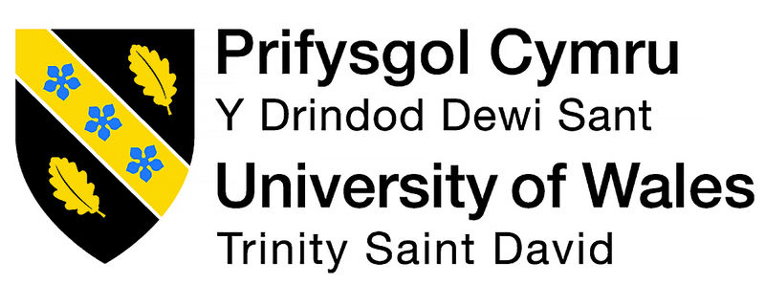

Smart Technology

SUBMITED BY: ENIKO KOVAC
TITLE: SMART TECHNOLOGY
MODUL CODE: 4011
LECTURER: Balendran Kandasamy
ASSIGMENT TITLE: THE MODERN WORLD

Content
  - Introduction……………………………….…………………….3
  - Cloud computing…………………..………………………….3
  - Samsung ………………………………………………………….5
  - iPhone……………………………………………………………..6
  - Skype……………………………………………………………….7
  - Webex…………………………………………………………….7
  - Conclusion………………………………………………………10
  - Reference……………………………………………………….11


The modern world

1.1 Introduction
We are using the internet almost for everything .For music, for downloads, for sharing information’s and for many other thinks. Moreover now with the internet access on Cloud computing we can interact with rich and powerful web based systems and use unlimited processing power. There is so many opportunities to take advantage of by using the modern technology including mobile devices and be successful. There is the few example how can be benefit at workplace by using Samsung and IPhone and also Skype and WEBEX.
1.2 Cloud computing
What is really interesting that sometimes even the IT industry do not know what “cloud computing “it exactly mean. That is Dr Williams’s definition:
“Cloud computing is a model for enabling convenient ,on-demand network access to a shared pool of configurable computing resources that can be rapidly provisioned and released with minimal management ,effort or service provider interaction”. (Anon., 2011)
To run a computer network in a business, it is need to have a system administrators to look after hardware and networking. They have to install applications and updating the operating system.
This is a 3 layer model what is applied to cloud computing:
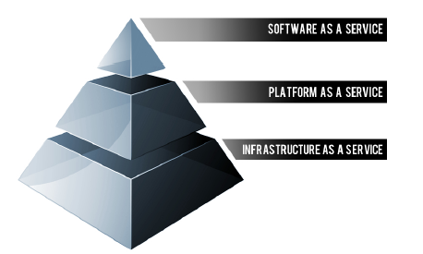

There is 4 type of Clouds, which is:

- Public clouds what is provide by the third party providers to the general public
- Community Clouds ,which is used by distinct groups of organizations
- Private Clouds is the most of the largest organizations are preferred to use, as they want to keep their servers within their own data centres.
- Hybrid Clouds are using those businesses who’s are responsible of them data protection, but they would like to take advantage of the scalability and flexibility that Cloud computing affords. (Cirrus, 2017)

But why computing technology are useful at workplace?

It can improve communication. For example employees from different department can contact each other by text messages or using Skype. Also it is useful when they working together on projects and they can discuss and make decisions together. Moreover many employers now rewarding employees by being creative using new technology ideas and promoting the business. One of the benefit of using the computing technology at work it saving times. For example workers are do not have to waste time to going different departments at the workplace but simply to use scanner or printer to share information. (Ramey, 2013)
We also can use phones at work.
But we have to make sure how we using SMARTLY. At work place to being digital can save us many stress and help us solving problems. Many places are using Android tablets to serve customers quicker. Also they have a WIFI (WLAN) radio, so it can be connected at office networks .Some of them may have the (NFC) Near Field Communications for mobile payments. Moreover we are viable to swap information’s between Android devices. They can include a special service like
- Separate app
- Special cloud which provide backup and restore service.
AWS
One of the top cloud computing provider is the Amazon web service (AWS).It is one of the safest and protected services who are offering computing power, database storage, and networking and also help business scale and grow. One of them product is known as AWS Direct connect which is a private connection between AWS and the datacentre what we are using. It also can help to reduce the network cost. (Anon., 2018)

The second Cloud Computer provider is the Microsoft Azure which was known as Windows Azure. This cloud are used for applications to be managed and design .Azure are providing a code with tools “and then virtual machines execute the rules of the application using Windows Server.” (Junk, 2014)It is easy to use as it similar to other Windows platforms. You can create a hybrid applications which are allowed to use cloud database and storage services. Moreover, we can create applications which can run over 10 million users. (Shinder, 2010)

The third Cloud Computer provider which are more familiar is the Dropbox which I would recommend. It is an online or cloud personal hard drive which allowed to storing files and documents. Over 500 million people are using it because it is an online backup which keep you stay updated .Moreover when we are saving information or any documents it is automatically sync to devices like iOs, Windows or Android.
1.3 Samsung
Many of the companies are started to use the Mobile Device Management (MDM) to manage mobile systems. One of the best phone which we can use well at work place is The Samsung Galaxy phones. Those are just a few advantage of using this phone at business as you can downloaded to your device.
Samsung's Mobile Print App: This app you can use it to printing and scanning by using wireless. It does save a lot time at work. (Anon., 2015)

Samsung KNOX: One of the Cloud business app is provided by Samsung 7 which is already build in the phone .Samsung KNOX are also provided which help to access a business documents. Also we can access our emails at any time which keep us upgraded. (Weekes, 2016) Separates work data beneath multiple layers of security from personal storage on mobile devices.
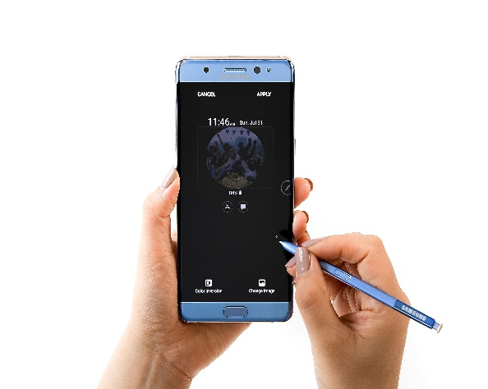

Team Viewer: By this app you are able to use your phone as a remote to access the office desktops, so you are files and all your applications are always can be access.

- Office Suite Pro 7: That’s a program which help to access your PowerPoint, Word processor and Excel capabilities (Nuckles, 2016)
1.4 I phones
I phone have a very powerful hardware which is also secure .It is run by the iOS network. Moreover there is a 235 000 business App Store designed to make the business more powerful.
Because the apple device are easy to use, it is easy also easy to support your business. It is accessible for every ones as it comes with vision, hearing and motor skills. Those are just a few advantage of iPhone why is beneficial to use it at workplace:
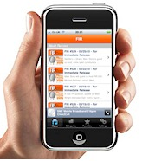
Concur is one of the tool which saved time for employers as they don’t necessary have to keep receipts anymore because by this app is able to automatically uploaded to a system by taking picture.

FreshBooks are a great app which help to record expenses and also profits and file taxes. (Angelo, 2017)

1.5 Skype

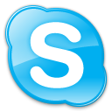
Skype is a communication tools which you can use online. It is an eBay company and it is based in Luxembourg. It has been released in 29 August 2003 by Niklas Zennström and Janus Friis. (Whent, 2012)Thanks for that this tools we are available to be connect with our loved one from anywhere in a world. But how can we take advantage of Skype in a workplace?

Skype in: By phoning up from landline we can reach a Skype user. For this phone number you have to pay to use it regularly for 3 month or for the full year.
Voice Conferencing: This program are available since 2006 to hold a video conference with other Skype user, which is save money and time
Skype Mobile: In April 2008 has been released which we can downloaded to any smartphone.

By using the Record meetings we can sharing advice, idea and many advantage we can take of this tool. (Anon, 2017)

1.6 WEBEX

There is another company which is offering an online meeting, web and video conferencing. It is cold WEBEX. It has been found by Zhu Min and Subrah Iyar in 1996. (Anon., 2018)
There is a few thinks we can take advantage which are:

- WebEx Meetings for free up to 2 people
- WebEx meeting are for more than 2 people, but it can be used up to 100 people for which you have to pay monthly
- WebEx training centre it is when the Instructor can use a high definition audio, video and also are can sharing courses, demonstrations, and events. Those groups can discuss with participants through chat.

- WebEx Event Centre it can be used up to 3000 people in a single event (Anon., 2009)

to share applications, white boards, and d

e The social media is a great opportunity to grown are business. As you can see the statistic below since 2014 the users of social media are keep growing. In 2017 there was a 39 million of people who’s been using social media in UK. From that 67 percent are using Facebook. (Anon., 2018)

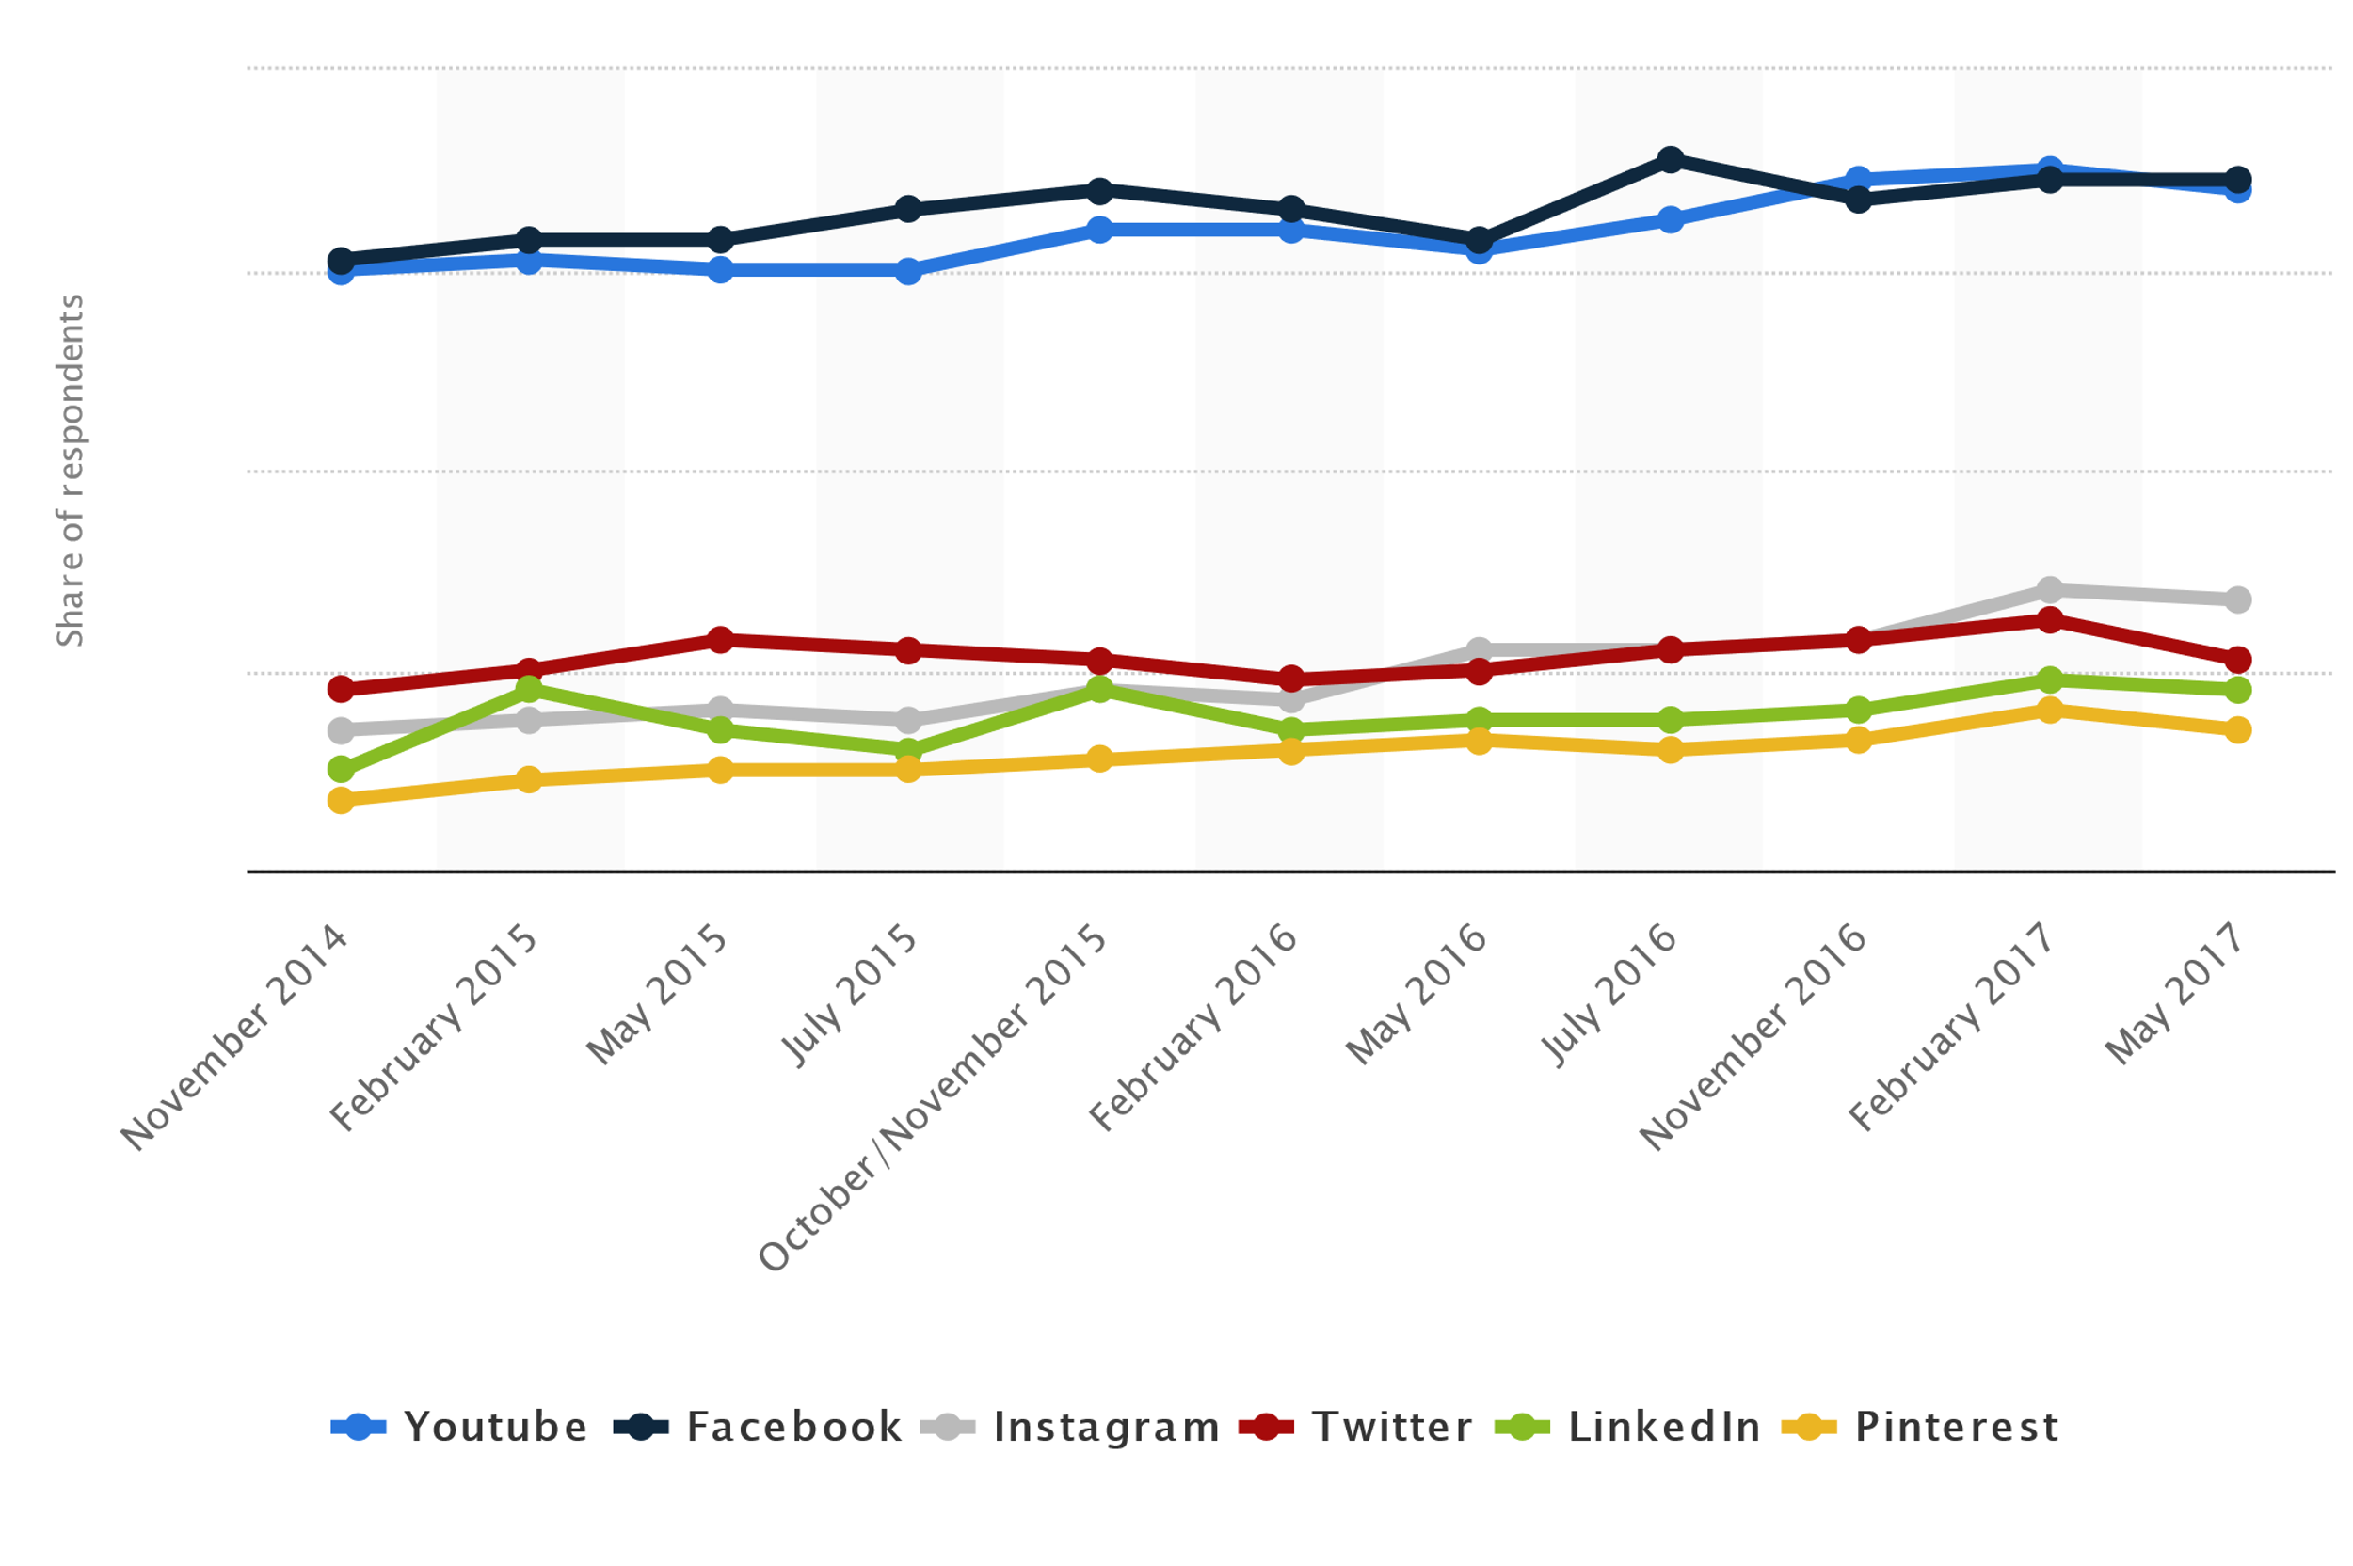
For example, on Facebook and Twitter or LinkedIn we can have a lot follower who relate to other people. Employees, our friend and family or business partners can share and like our web page and that’s how can spread the business worldwide and makes it grows. Advertising by social media were never easier and fast like now.

LinkedIn have 500 million users from over 200 countries. Itis including over 10 million job post and over 9 million of companies. It is again a great opportunity to advertise our business by using LinkedIn.
(Darrow, 2017)

The ninth largest social media is Twitter. There is over 328 million people who are using this media. (Sparks, 2017)As the picture showing below since 2015 the number of users is keep growing.
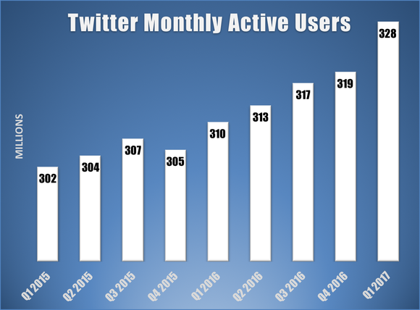

1.7 Conclusion

In a 21.century our life is connected with the fast technology. There is a many advantage and also a disadvantage can be if we are not using it in a right way. But in this stressful life we have to take advantage of the modern world what offering us. Including are smartphone. It has been describe how we can benefit at workplace by using our phones and also how we can be connected at business with other groups. So be SMART to make your life more SUCCESSFUL.be able

  - Reference

Works Cited
Angelo, M. D., 2017. 10 Best iOS Apps for Business. [Online]
Available at: https://www.businessnewsdaily.com/7796-best-ios-iphone-ipad-apps-business.html
Anon., 2009. WebEx Brings Big Benefits to Quest’s Own Operation. [Online]
Available at: https://www.questsys.com/files/Cisco-Webex-SAN.pdf
Anon., 2011. Final Version of NIST Cloud Computing Definition Published. [Online]
Available at: https://www.nist.gov/news-events/news/2011/10/final-version-nist-cloud-computing-definition-published
Anon., 2015. What You Can Do With Samsung Mobile Print App. [Online]
Available at: http://samsungprintingsolutions.com/2015/01/can-samsung-mobile-print-app/
Anon., 2018. AWS Direct Connect. [Online]
Available at: https://aws.amazon.com/directconnect/?p=tile
Anon., 2018. What is WebEx?. [Online]
Available at: https://www.cbronline.com/what-is/what-is-webex-5001596/
Anon., 29.01.2015. What You Can Do With Samsung Mobile Print App. [Online]
Available at: http://samsungprintingsolutions.com/2015/01/can-samsung-mobile-print-app/
Anon., n.d. Your go everywhere office: the business benefits of mobile working. [Online]
[Accessed 27 april 1995-2017].
Cirrus, A.-O., 2017. 4 Types of Cloud Computing. [Online]
Available at: http://www.opencirrus.org/4-types-cloud-computing/
Junk, D., 2014. What Is Microsoft Azure Used for?. [Online]
Available at: https://blog.apterainc.com/what-is-microsoft-azure-used-for
Nuckles, B., 2016. Top 7 Samsung Galaxy Apps for Business. [Online]
Available at: https://www.businessnewsdaily.com/6801-samsung-galaxy-apps-business.html
Ramey, K., 2013. The Advantages and Disadvantages of Technology in the Workplace. [Online]
Available at: https://www.useoftechnology.com/technology-workplace-2/
samsung, 1995-2017. Your go everywhere office: the business benefits of mobile working. [Online]
Available at: http://www.samsung.com/uk/business/insights/others/your-go-everywhere-office-the-business-benefits-of-mobile-working
[Accessed 27 april 2017].
Shinder, D., 2010. 10 reason to use Azure for your cloud apps. [Online]
Available at: https://www.techrepublic.com/blog/10-things/10-reasons-to-use-azure-for-your-cloud-apps/
Weekes, E., 2016. Samsung Business – Your Office On the Go. [Online]
Available at: https://onecom.co.uk/samsung-business-your-office-on-the-go/
Whent, R., 2012. A brief history of Skype. [Online]
Available at: https://www.itbusiness.ca/blog/a-brief-history-of-skype/20750

Anon., 2018. Reach of selected social networking websites in Great Britain (GB) from November 2014 to February 2017*. [Online]
Available at: https://www.statista.com/statistics/269788/social-network-reach-in-the-uk-by-platform/
Darrow, B., 2017. LinkedIn Claims Half a Billion Users. [Online]
Available at: http://fortune.com/2017/04/24/linkedin-users/
Sparks, D., 2017. How Many Users Does Twitter Have?. [Online]
Available at: https://www.fool.com/investing/2017/04/27/how-many-users-does-twitter-have.aspx

I would like introduce my business accounts which I created by using:

LINKDIN

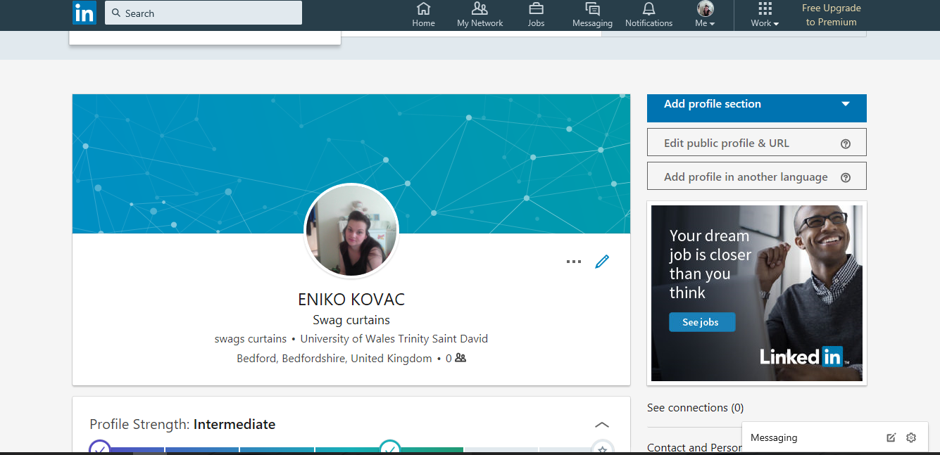

I am designing a swag curtains and also selling them. That is the reason why I choose on LinkedIn and Facebook to advertise.
FACEBOOK

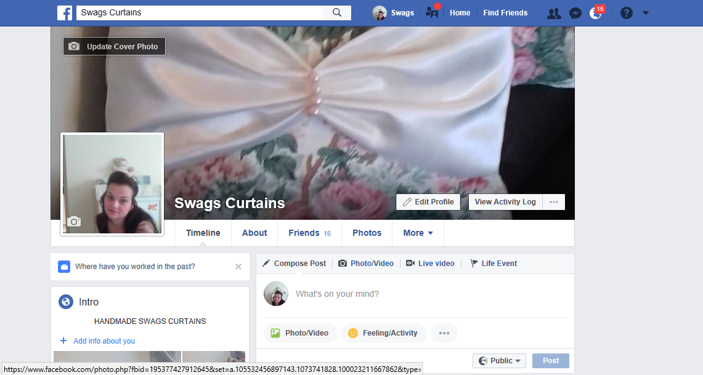

TWITTER

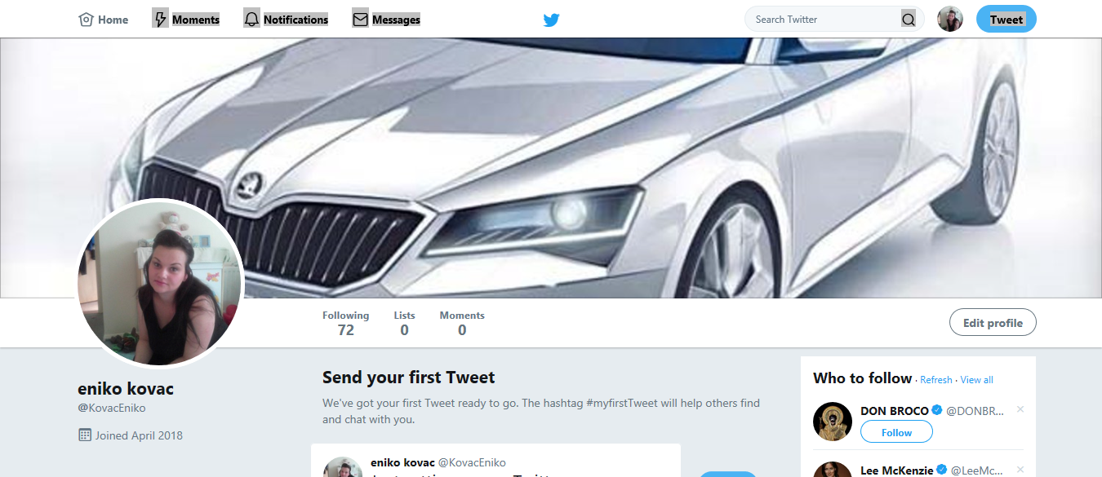

The reason why I choose this pictures because I use to be a car dealer and buying selling cars what is our family business. I used Twitter which was a great opportunity to advertise cars .

