1/9/2023

ECGE4005R: Evidence of learning EPortfolio

Module leader: Dr Stuart Jones and Zoe Cooke

Word count:

Individual Assignment
Anna Bolek, u2222499
Contents
- Contents – page 1
- Summary a article: Mindfulness in psychology- a breath of fresh air? – page 2
- Presentation –link – page3
- Poster – Becoming a Digital Learner – page 4
- Reflection – page 5
- Evidence of team communication – page 7-8
- References - page 9

Task 1
Summary a article: Mindfulness in psychology- a breath of fresh air?
Authors: Edo Shonin, William Van Gordon and MarkD. Griffits.
The authors of the article "Mindfulness in psychology - a breath of fresh air?" pose the question of whether the current popularity of mindfulness in psychology might just be a passing trend or a "breath of fresh air.’ In this article, they outline the strengths and limitations of mindfulness.
Buddhist mindfulness meditation has been practised for more than two thousand years. There are now several different definitions of mindfulness, each with advantages and disadvantages. In the psychological literature, Kabat-Zinn's definition of mindfulness is best known as 'paying attention in a specific way: intentionally, in the moment and without judgment' (1994, p. 4). According to the article’s authors, mindfulness is a process of engaging in full, direct, and active awareness of the phenomena encountered, which has a spiritual aspect and is maintained from moment to moment (Shonin et al., 2014c, p.1).
In the opinion of the authors, mindfulness is one of the most rapidly growing areas of psychological research.
However, there is a concern, about whether the quality of empirical research confirms its effectiveness in applied therapy (MBI) when taken out of its traditional Buddhist context.
The basis for empirical mindfulness research is clinical research. Both the National Institute for Health and Health Care Excellence (NICE) and the American Psychiatric Association (APA) now endorse mindfulness-based cognitive therapy for the treatment of recurrent depression, somatoform disorders, medication problems, and many other conditions. Mindfulness has applications in forensic, occupational, educational, positive, sports, and transpersonal psychology.
In the article's conclusion, the authors discuss the benefits and drawbacks of mindfulness. One of the key benefits is adaptability, as the course program can be easily modified to meet the needs of different groups. The biggest disadvantage of mindfulness is the lack of extensive clinical research.
Despite this, psychologists agree that mindfulness meditation is a reliable and safe method for improving mental health and well-being.

Task two
Video presentation link
https://drive.google.com/file/d/1tfaFh6_rW7SjyLBt9L9mxH83l4csmgtT/view

Task 3 poster

Reflection
Together with Alina Lis and Gurpinder Shink, we worked on a group project aimed at developing an academic poster for the Learning in Digital Era module. We agreed that we would develop a 'Becoming a Digital Learner' module for our poster. It consisted of three topics. I chose 'Finding and using information.' We often met in person, but also communicated online while working on our academic project.
We used PowerPoint to create our poster. Everyone developed their topic, and later Alina created a poster from our studies.
The topic I chose was very interesting, and the information I gained will be useful in the next stages of my studies. Specifically, where to look and how to determine whether the information is accurate and up to date.
I believe that working on the poster was a very fruitful experience for us, thanks to which we learned a lot from each other, especially how to work in a group.

Evidence of team communication

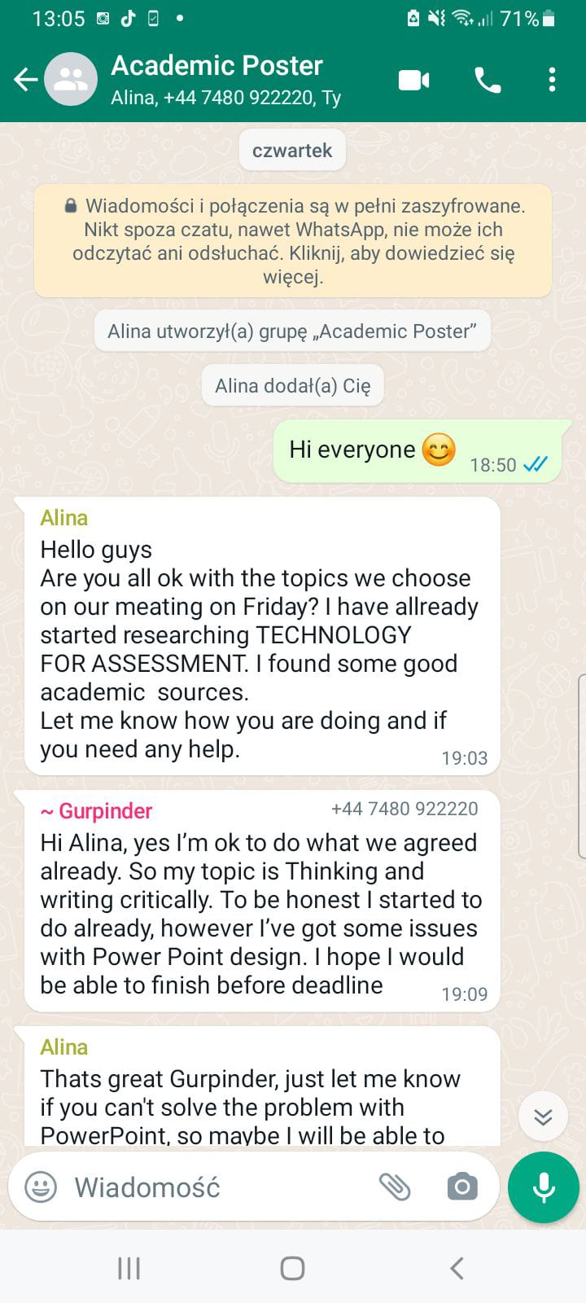
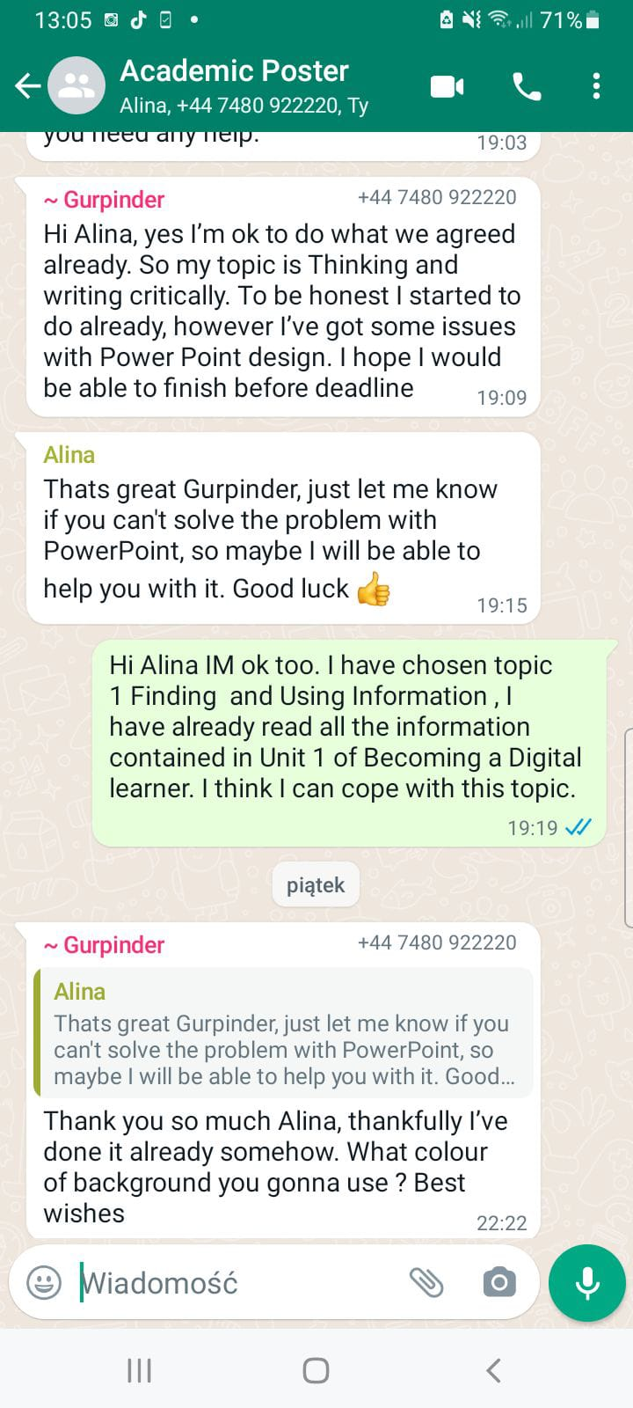
References
Dayle, A. (2022). What are teamwork skills. , https://doi.org/• https://www.thebalancemoney.com/list-of-teamwork-skills-2063773
Dayle, A. (2022). Active listening, definition, skills and examples. , https://doi.org/• Active Listening Definition, Skills, and Examples (thebalancemoney.com)
Dickson, B. (2013). A communications skills that brings the word together. , https://doi.org/• https://www.voiceproinc.com/respect-a-communication-skill-that-brings-the-world-together/
Kabat-Zinn, J. (1994). Wherever you go, there you are: Mindfulness medication in everyday live. New York Hyperion.
Riddle, R. (2020). How to find reliable information. The people Development Magazine. https://peopledevelopmentmagazine.com/2020/12/15/information-internet/
Shonin, E., Gordon, W., & Griffits, M. (2022). Mindfulness in psychology - a breath of fresh air?. , https://doi.org/• Active Listening Definition, Skills, and Examples (thebalancemoney.com)
Shonin, E., Van Gordon, W., Griffits, M., & Cooper, A. (2014). The emerging role of Buddhism in clinical psychology: Towards effective integration. Psychology of Religion and Spirituality.
Wilson, K., Ruch, G., Lymbery, M., & Cooper, A. (2021). An introduction to contemporary practice. Person Addison Wesley.
Newcastle University. Finding information. https://www.ncl.ac.uk/academic-skills-kit/information-and-digital-skills/finding-information/
Evaluating Sources : CRAAP test. University of The West of Scotland. https://uws-uk.libguides.com/evaluating_sources/craap_test

