
Program: Master of Business Administration
Assessment 1
Title: Comprehensive Strategic Management Analysis of Tesco PLC

Name: Anika Ayub
Student ID: 2504343

Module Name: Strategic Management
Module Code: LCMB7003

Lecturer’s Name: Andry Rakotovololona

Word Count: 5331

Term 2

Table of Contents

Section 1
Introduction 3
1. Company Introduction and History 3
2. External and Internal Environment Analysis 5
2.1 PESTEL Analysis 5
2.2 Porter's Five Forces Analysis 7
2.3 Porter’s Diamond Model Analysis 8
2.4 VRIO Framework 10
2.5 Competetive Advantage 11
3. CSR and Sustainability Objectives of Tesco 12
3.1 The CSR Strategy of Tesco 12
3.2 Alignment of the CSR strategy with the business objectives of Tesco 12
4. Comprehensive and Holistic View of Tesco 13
5. Strategic Choices and Implementation 16
5.1 Recommendations 17
5.2 How Tesco has managed change and its impact on strategic Implementation 17
6. Strategic Evaluation and Recommendations 18
6.1 SWOT Analysis 18
6.2 Recommendations 20

Section 2
Reflective Account Using Gibbs’ Reflective Cycle 21
Summary 25
Conclusion 25
Bibliography 26

Section 1
Introduction
Tesco PLC is the largest grocery retailer in the United Kingdom, operating in a highly competitive and low-margin industry driven by scale, efficiency, and pricing strategies. This report provides a comprehensive strategic management analysis of Tesco, evaluating its ability to sustain competitive advantage in a dynamic macroeconomic environment. It begins with an overview of Tesco’s corporate background, followed by an analysis of the external environment using PESTEL and Porter’s Five Forces frameworks to identify key pressures such as inflation and intense market rivalry (Porter, 2008; OECD, 2024). The report then examines Tesco’s internal capabilities through the VRIO framework and Porter’s Diamond Model, highlighting its data-driven strategy and supply chain strengths (Barney, 1991). Furthermore, it evaluates Tesco’s CSR and sustainability initiatives alongside its strategic choices and performance using the Balanced Scorecard (Kaplan and Norton, 1992). Finally, the report presents recommendations and a reflective analysis using Gibbs’ Reflective Cycle, followed by conclusion, summary and references.
- Company Introduction and History
Tesco operates in the grocery retail industry, a highly competitive, low-margin sector driven by scale, supply chain efficiency, and price leadership. Founded in 1919 by Jack Cohen, Tesco grew from a market stall into the UK’s largest retailer, maintaining leadership since the early 2000s. Its evolution includes international expansion and later strategic refocusing on core UK and European markets after divestments in Asia (Tesco PLC, 2023; Tesco PLC, 2024).
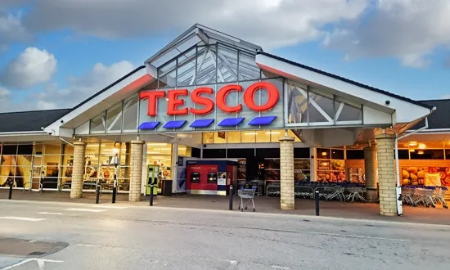
Figure 1: Tesco Outlet (Source: Qureshi, 2025)
Mission & Vision: Tesco’s mission is “serving our customers, communities and planet a little better every day,” reflecting its focus on value, sustainability, and customer satisfaction (Tesco PLC, 2024). Its vision centres on being the most trusted retailer through quality, affordability, and innovation. The company serves millions of customers weekly and employs over 340,000 people globally (Tesco PLC, 2025a; Statista, 2025) .
Tesco’s business model is based on high-volume retailing across groceries, general merchandise, and complementary services such as wholesale (Booker) and data analytics (dunnhumby). Financially, Tesco generated approximately £65.3 billion in 2023, £68.2 billion in 2024, and £69.9 billion in 2025 revenue, showing consistent growth (Tesco PLC, 2023; Tesco PLC, 2024; Tesco PLC, 2025a) . Operating profits reached around £3.1 billion in 2024/25, with margins typically between 3–4%, reflecting industry characteristics .
Operationally, Tesco uses a multi-format strategy (Extra, Superstore, Express) and an omnichannel model integrating over 3,000 stores with strong online grocery operations. Its Clubcard loyalty scheme, used by over 20 million UK households, enables data-driven decision-making and personalised pricing (Tesco PLC, 2025a; The Guardian, 2025) . Structurally, Tesco follows a hierarchical and divisional model organised by geography (UK & ROI, Central Europe) and business units, allowing efficient large-scale management.
Tesco’s key competitors include Sainsbury’s, Asda, Morrisons, Aldi, and Lidl. Despite intense competition, Tesco maintains clear market leadership, holding approximately 27–28.5% of the UK grocery market in 2024–2025 . Its positioning focuses on “value for money,” combining competitive pricing (e.g., Aldi price matching on 600+ products) with quality and availability, reinforcing customer loyalty and volume growth .
In summary, Tesco’s dominance is driven by its scale, data-driven strategy, and integrated omnichannel operations. With nearly £70 billion in annual revenue, approximately 3–4% margins, and approximately 28% market share, Tesco remains the UK’s leading grocery retailer despite ongoing competitive pressures.
- External and Internal Environment Analysis

  - PESTEL Analysis
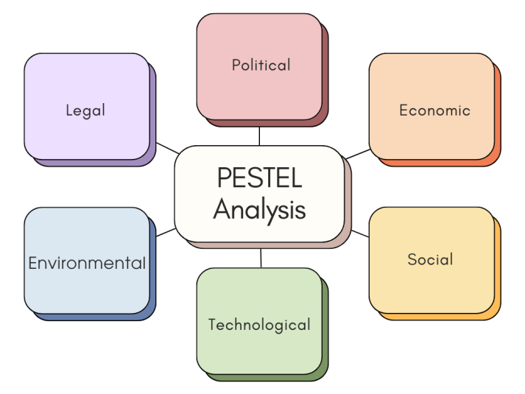
Figure 2: PESTEL Analysis (Source: Self Developed)
A PESTEL analysis is a strategic management framework that examines Political, Economic, Social, Technological, Environmental and Legal macro-environmental factors influencing an organisation’s performance and strategic decisions (Belsare, 2025).
- Political: Tesco operates within the UK and EU regulatory environments, which influence taxation, employment law, and trade policies. For example, post-Brexit trade and customs rules affect supply chain and pricing decisions. Government policy on minimum wage and packaging levies directly raises operational costs, forcing Tesco to adjust pricing and cost structures in its strategy (Reuters, 2025b).
- Economic: Macroeconomic conditions such as inflation and consumer spending patterns shape Tesco’s performance. Group revenue grew to £69.9 billion in 2025, up from £68.2 billion in 2024 and £65.3 billion in 2023, indicating resilience in a volatile economy (Tesco PLC, 2025a). However, high cost-of-living pressures affect consumer behaviour towards value purchases, leading Tesco to emphasise competitive pricing through initiatives such as Aldi price matching.
- Social: Shifts in consumer behaviour, such as growing demand for convenience and healthy products, influence Tesco’s product assortment and marketing. The Clubcard loyalty scheme drives customer engagement and informs strategic decisions on promotions and stock allocation. Changing demographics and social preferences push the company to innovate in healthier, sustainable offerings.
- Technological: Investment in e-commerce and data analytics is vital. Tesco’s online services and use of customer data from Clubcard support personalised marketing and supply chain optimisation. Technology adoption reduces costs and improves customer experience, influencing digital transformation strategies.
- Environmental: Tesco integrates sustainability into strategy. Its 2025 sustainability report shows 87% of own-brand packaging recyclable at kerbside and substantial cuts in operational emissions, guiding strategic investment in green logistics and packaging design (Tesco PLC, 2025b).
- Legal: Compliance with food safety, employment and data protection regulations affects operational policies. Tesco must continuously update practices to meet evolving legal standards across markets.
Critical Analysis: While PESTEL highlights key external pressures, it can be descriptive and lacks weighting of factor impact. In Tesco’s case, economic and political factors (e.g., inflation and regulation) strongly drive pricing strategy and cost management, while technological and environmental trends reshape investment priorities. Strategic decisions increasingly balance regulatory compliance with digital innovation and sustainability commitments, demonstrating PESTEL’s role in informing Tesco’s multi-faceted response to external forces.
2.2 Porter’s Five Forces Analysis
Porter’s Five Forces is a strategic framework developed by Michael E. Porter to analyse the competitive forces that determine an industry’s profitability and intensity of competition. It assesses the threat of new entrants, threat of substitutes, bargaining power of buyers, bargaining power of suppliers, and competitive rivalry to inform strategic decision-making (Porter, 2008).
- Threat of New Entrants (High)
Entry barriers in the UK grocery retail sector are high due to significant capital requirements for store networks and distribution infrastructure. Tesco’s scale—over 4,000 stores and approximately 340,000 employees—and strong brand presence make it difficult for new players to gain meaningful share (MarketScreener, 2025). The capital intensity and regulatory compliance involved in food safety also deter smaller entrants.
- Threat of Substitutes (Moderate)
The threat of substitutes for grocery retail remains moderate. While alternative channels such as online-only grocers or meal delivery services exist, consumers still rely heavily on supermarkets for essential purchases. Value-focused competitors like discount retailers increase substitute pressure, especially among price-sensitive customers.
- Bargaining Power of Buyers (High)
Buyer power is high. Consumers can easily switch between retailers (e.g., Aldi, Lidl, Sainsbury’s), exerting pressure on pricing and service quality. Tesco’s response includes value strategies such as price matching and its Clubcard loyalty programme to retain customers and reduce switching (Reuters, 2025e).
- Bargaining Power of Suppliers (Moderate to low)
Supplier power is moderate to low because Tesco’s scale and purchasing volume strengthen its negotiating position. With annual revenue reported at £69.9 billion in 2025, Tesco can negotiate favourable terms, although specialised suppliers (e.g., for premium products) may exert some influence.
- Competitive Rivalry (Very high)
Competitive rivalry is very high in UK grocery retail. Tesco’s main competitors—Sainsbury’s, Asda, Morrisons and strong discounters—compete aggressively on price, quality and convenience. Market competition has intensified, with rivals adopting price-cutting strategies that impact Tesco’s profit margins and strategic pricing decisions (Reuters, 2025e).
Critical Analysis: Tesco’s success depends on scale economies, strong brand loyalty via Clubcard, supply chain efficiency, and omnichannel capabilities. However, it faces strategic challenges from intense price competition, rising labour and input costs, and shifting consumer preferences toward value and convenience. While Porter’s Five Forces highlights these pressures effectively, it is static and does not fully capture dynamic trends such as digital disruption and regulatory changes.

2.3 Porter’s Diamond Model Analysis
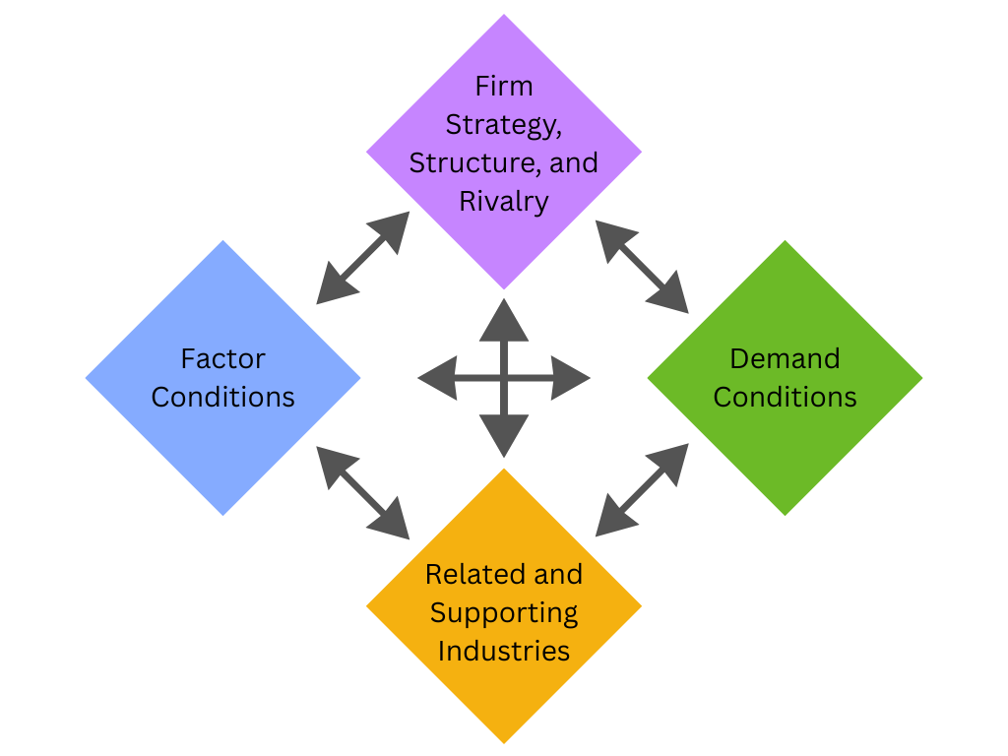
Figure 3: Porter’s Diamond Model Analysis (Source: Self Developed)
Porter’s Diamond Model is a framework developed by Michael E. Porter to analyse the competitive advantage of nations and firms by examining four broad determinants—factor conditions, demand conditions, related and supporting industries, and firm strategy, structure, and rivalry—along with government and chance influences (Porter, 1990)
- Factor Conditions: The UK offers advanced infrastructure, logistics, and a skilled workforce. Tesco benefits from scale and distribution networks across approximately 4,000 stores and extensive online fulfilment, underpinning cost efficiencies and responsiveness (Tesco PLC, 2025a).
- Demand Conditions: UK consumers are sophisticated, value-oriented, and increasingly demand convenience and sustainability. Tesco’s Clubcard loyalty scheme with over 20 million users offers robust customer insights, enabling tailored offerings and strategic pricing (Tesco PLC, 2025a; Reuters, 2025c).
- Related and Supporting Industries: Tesco benefits from strong domestic suppliers and technology partners in data analytics (e.g., dunnhumby). Proximity to logistics providers enhances supply chain performance, critical during economic volatility.
- Firm Strategy, Structure & Rivalry: Tesco’s strategy focuses on value, convenience, and digital transformation. Competitive rivalry with Sainsbury’s, Asda, Aldi, and Lidl drives continuous innovation in pricing and service. This competitive pressure contributes to operational discipline and customer-centric strategic planning.
- Government & Chance: Post-Brexit trade policies and regulatory changes affect import costs and labour markets. Tesco’s agility in responding to these changes has informed strategic decisions in pricing and sourcing.
Critical Analysis: Internally, Tesco’s key resources—its scale, data analytics capability (Clubcard), and extensive logistics infrastructure—are core competencies that support competitive advantage. Its capability to leverage data for personalised marketing and optimise supply chains enhances cost leadership and customer loyalty. However, managing rising input and labour costs remains a strategic challenge that tests operational flexibility. Competencies in digital retail and integrated omnichannel services are increasingly critical for sustaining long-term competitiveness.
2.4 VRIO Framework
VRIO Framework is a strategic tool that evaluates an organisation’s resources and capabilities based on Value, Rarity, Imitability, and Organisation, helping identify which assets can deliver sustainable competitive advantage (Barney, 1991).
- Value: Tesco’s resources generate significant value by enabling cost leadership, operational efficiency, and customer loyalty. For instance, revenue reached £69.9 billion in 2025, supported by scale and efficient supply chains (Tesco PLC, 2025a).
- Rarity: The Clubcard loyalty programme, used by over 20 million UK households, is rare in its ability to provide detailed, actionable customer data for personalised marketing (Tesco PLC, 2025a).
- Imitability: Tesco’s integrated logistics network across approximately 4,000 stores and advanced digital platforms is difficult and costly for competitors to replicate, creating a strong barrier to imitation.
- Organisation: Tesco effectively organises and leverages its resources through a structured store network, data analytics teams, and omnichannel operations, ensuring these capabilities support strategy and performance (Tesco PLC, 2025a).
Critical Analysis: Tesco’s VRIO assessment highlights its competitive differentiation. Its key strengths—advanced data analytics, scale economies, and omnichannel integration—enable superior customer experience, pricing power, and operational efficiency. Unlike competitors such as Sainsbury’s or Asda, Tesco’s combination of rare, hard-to-imitate capabilities, and effective organisational deployment sustains its approximately 28% UK grocery market share and long-term competitive advantage (Reuters, 2025b).
2.5 Competetive Advantage
Tesco’s internal strengths play a critical role in sustaining its competitive advantage in the UK grocery market. One of its key strengths is scale, with revenue reaching £69.9 billion in 2024/25 and a network of over 4,000 stores, enabling strong economies of scale and cost efficiencies (Tesco PLC, 2025a). This allows Tesco to offer competitive pricing strategies, including price matching against discounters, while maintaining profitability.
Another major strength is its data-driven capability, particularly through the Clubcard loyalty programme, used by over 20 million UK households. This provides valuable customer insights, enabling personalised promotions, improved demand forecasting, and optimised inventory management (Tesco PLC, 2025a). Additionally, Tesco’s integrated supply chain and omnichannel operations enhance efficiency and convenience, supporting both in-store and online sales growth.
Critically, these strengths collectively reinforce Tesco’s market leadership, with around 27–28% UK grocery market share (Reuters, 2025c). However, maintaining these advantages requires continuous investment in technology and cost control, especially amid rising labour and input costs. Overall, Tesco’s ability to leverage scale, data, and operational efficiency underpins its sustained competitive positioning.
- CSR and Sustainability Objectives of Tesco

3.1 The CSR Strategy of Tesco
Tesco’s CSR strategy is embedded in its “Planet Plan,” focusing on environmental sustainability, social responsibility, and ethical governance. The company aligns its initiatives with several United Nations Sustainable Development Goals, particularly SDG 3 (Good Health), SDG 8 (Decent Work), SDG 12 (Responsible Consumption), and SDG 13 (Climate Action). For example, Tesco achieved a 65% reduction in operational emissions, redistributed 82% of unsold food, and ensured 87% of own-brand packaging is recyclable (Tesco PLC, 2025a) . Additionally, it invested £900 million in employee pay, supporting workforce wellbeing and SDG 8. These initiatives demonstrate a structured CSR approach integrating environmental, social, and economic responsibilities into core operations.

Examples of Tesco’s CSR activities:
- Tesco focuses on environmental sustainability, aiming to achieve net zero emissions across its operations and supply chain by 2050 through energy reduction and renewable electricity use (Tesco PLC, 2024).
- Tesco operates a Surplus Food Redistribution programme, donating unsold food to charities such as FareShare, helping reduce food waste and support vulnerable communities (FareShare, 2023).
- Tesco promotes healthier consumer choices through its “Better Baskets” initiative, encouraging healthier purchases and improving product labelling (Tesco PLC, 2024).

3.2 Alignment of the CSR strategy with the business objectives of Tesco
Tesco’s CSR strategy is closely aligned with its business objectives of cost efficiency, customer loyalty, and long-term sustainability. By reducing food waste and improving supply chain efficiency, Tesco lowers operational costs while supporting SDG 12. Sustainability initiatives, such as renewable energy adoption and low-carbon sourcing, enhance brand reputation and customer trust, directly supporting revenue growth and competitive positioning. Furthermore, embedding CSR into corporate governance ensures that sustainability is a strategic priority at board level, influencing long-term decision-making (Tesco PLC, 2025a).
Critical Analysis
Tesco’s CSR strategy creates shared value by aligning sustainability with profitability and operational efficiency. Its strong integration of SDGs enhances legitimacy and stakeholder trust. However, achieving net-zero targets and supply chain sustainability (e.g., reliance on suppliers for emissions reduction) remains challenging, requiring continuous investment and collaboration. Overall, CSR is not peripheral but central to Tesco’s strategic competitiveness.

Comprehensive and Holistic View of Tesco
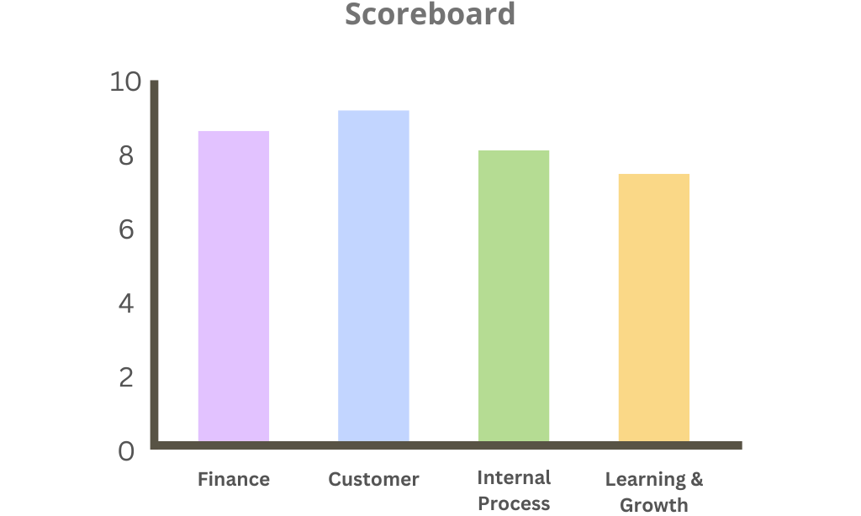
Figure 4: Balance Scorecard of Tesco (Source: Self Developed)
The Balanced Scorecard (BSC) is a strategic performance management framework that translates an organisation’s vision and strategy into a set of financial and non-financial measures across multiple perspectives, enabling a more comprehensive evaluation of organisational performance (Kaplan and Norton, 1992). It moves beyond traditional financial metrics by incorporating broader drivers of long-term success through four core perspectives: Financial, Customer, Internal Business Processes, and Learning and Growth.
Perspective | Strategic Objective | Key Performance Indicators (KPIs) | Key Initiatives
Financial | Increase profitability and market share | Revenue growth, operating margin, ROI | Cost reduction, price competitiveness, expansion of private labels
Customer | Improve customer satisfaction and loyalty | Customer satisfaction score, retention rate, Clubcard usage | Personalised offers, improved in-store and online experience
Internal Process | Enhance operational efficiency | Supply chain efficiency, stock turnover, delivery time | Automation, digital supply chain, inventory management systems
Learning & Growth | Develop employee skills and innovation | Employee satisfaction, training hours, staff retention | Training programmes, leadership development, digital skills investment
Figure 5: Balance Scorecard of Tesco (Source: Self Developed)

Financial Perspective
Tesco’s financial perspective focuses on achieving sustainable revenue growth, profitability, and cost efficiency within a highly competitive grocery market. In 2024/25, Tesco generated approximately £69.9 billion in revenue and over £3 billion in operating profit, demonstrating resilience despite inflationary pressures (Tesco PLC, 2025b). The key objectives include maintaining profit margins, improving return on capital, and ensuring strong cash flow. Key performance indicators (KPIs) include revenue growth rate, operating margin (approximately 3–4%), and cost-to-sales ratio. Targets involve steady year-on-year growth while maintaining price competitiveness. Strategic initiatives such as cost reduction programmes, supply chain optimisation, and price-matching schemes support financial stability. These actions reflect Tesco’s ability to balance cost leadership with profitability, which is critical in sustaining shareholder value.

Customer Perspective
Tesco’s mission emphasises delivering value, quality, and convenience, making customer satisfaction central to its strategy. The company holds approximately 27–28% market share in the UK grocery sector, indicating strong customer loyalty (Reuters, 2025b). Objectives include improving customer retention, enhancing satisfaction, and expanding market share. KPIs include customer satisfaction scores, loyalty metrics, and engagement with the Clubcard programme, which is used by over 20 million UK households (Tesco PLC, 2025a). Targets focus on increasing loyalty participation and improving customer experience. Initiatives include personalised promotions, expansion of online grocery services, and product diversification across value and premium ranges. These strategies strengthen Tesco’s competitive position by aligning closely with evolving consumer preferences.

Internal Business Processes Perspective
Tesco aims to improve operational efficiency, product availability, and supply chain effectiveness. Objectives include reducing operational waste, improving inventory management, and ensuring consistent service quality. KPIs include inventory turnover rates, on-shelf availability, and logistics costs. Tesco’s network of over 4,000 stores and advanced distribution infrastructure provides a strong operational foundation (Tesco PLC, 2025a). Targets include reducing inefficiencies and improving process reliability. Key initiatives include warehouse automation, digital inventory systems, and food waste reduction programmes, with approximately 82% of unsold food redistributed. These improvements enable Tesco to maintain high service standards while controlling costs, supporting its cost leadership strategy.

Learning and Growth Perspective
This perspective focuses on employee capability, innovation, and organisational culture. Tesco employs over 340,000 people, making human capital a critical strategic resource (Tesco PLC, 2025a). Objectives include improving employee engagement, developing digital skills, and fostering innovation. KPIs include employee satisfaction, retention rates, and training participation. Targets focus on enhancing workforce capability and leadership development. Initiatives include investment in training programmes, digital transformation, and increased wages, with over £900 million invested in employee pay. These efforts enhance productivity, motivation, and adaptability, ensuring Tesco remains competitive in a rapidly changing retail environment.

Integrated Analysis
Tesco’s Balanced Scorecard demonstrates strong alignment across all four perspectives, highlighting how internal capabilities drive overall performance. Customer loyalty initiatives, such as Clubcard, directly contribute to financial outcomes by increasing repeat purchases and revenue growth. Efficient internal processes reduce costs and improve service quality, reinforcing customer satisfaction. Simultaneously, investments in employee development and digital innovation strengthen organisational capabilities, enabling continuous improvement. However, Tesco faces ongoing challenges in balancing cost leadership with rising labour and operational expenses. Sustained investment in technology and workforce development is essential to maintain efficiency and competitiveness. Overall, the Balanced Scorecard provides a holistic framework that integrates strategy with operational execution, supporting Tesco’s long-term value creation.
- Strategic Choices and Implementation
Tesco’s strategic choices can be evaluated at both the business level and corporate level, reflecting how the organisation competes and grows within a dynamic and highly competitive retail environment.
- At the business level, Tesco primarily follows a cost leadership strategy, supported by economies of scale, efficient supply chain management, and strong purchasing power. With approximately £69.9 billion in revenue in 2024/25 and a UK market share of 27–28%, Tesco is able to offer competitive pricing while maintaining profitability (Tesco PLC, 2025a; Reuters, 2025d). Initiatives such as Aldi Price Match and the expansion of private-label products reinforce its low-cost positioning. However, Tesco also adopts elements of differentiation, particularly through premium product ranges such as “Finest,” improved in-store experience, and personalised promotions driven by its Clubcard programme, which is used by over 20 million UK households (Tesco PLC, 2025a). This hybrid strategy allows Tesco to appeal to both price-sensitive and quality-focused customers, strengthening its competitive position.
- At the corporate level, Tesco has pursued a strategy of focused diversification and strategic consolidation. The acquisition of Booker has enhanced its wholesale and distribution capabilities, providing an additional revenue stream and strengthening supply chain integration. At the same time, Tesco has reduced its global footprint by exiting less profitable markets, including its operations in Asia, and concentrating on core markets such as the UK, Ireland, and Central Europe (Tesco PLC, 2023). This demonstrates a shift from aggressive international expansion to a more disciplined approach focused on efficiency, profitability, and risk management.
5.1 Recommendations
In terms of recommendations, Tesco should continue to prioritise its cost leadership strategy, as it remains highly relevant in the current economic climate characterised by inflation and cost-of-living pressures. Maintaining competitive pricing is essential to sustain customer loyalty and market share. However, Tesco should also strengthen its differentiation strategy by investing in digital innovation, sustainability initiatives, and enhanced customer experience. At the corporate level, Tesco should adopt selective international expansion, focusing on stable and high-growth markets while reducing risk through partnerships or digital channels instead of capital-intensive store expansion. Furthermore, continued investment in automation, artificial intelligence, and supply chain technologies will be critical in maintaining operational efficiency and long-term competitiveness.
5.2 How Tesco has managed change and its impact on strategic implementation
Tesco has demonstrated a strong capability in managing organisational change, particularly through digital transformation and strategic restructuring. The expansion of its online grocery operations, increased use of data analytics, and focus on core markets have improved both efficiency and customer engagement, supporting effective strategic implementation (Tesco PLC, 2025a). These changes reflect Tesco’s ability to align its internal capabilities with evolving external conditions.
However, external challenges, including the ongoing global geopolitical conflicts such as the Russia–Ukraine war, have significantly affected Tesco’s operating environment. These conflicts have disrupted global supply chains, increased energy and transportation costs, and contributed to inflationary pressures, which impact both operational expenses and consumer purchasing behaviour (OECD, 2024). As a result, Tesco has been required to continuously adjust its pricing strategies, supplier relationships, and cost structures. While Tesco has shown resilience, such external uncertainties highlight the limitations of strategic planning in volatile environments.
Critical Analysis
Critically, Tesco’s success in managing change is underpinned by its strong internal capabilities, including its scale, data-driven decision-making, and efficient supply chain. These strengths enable the organisation to respond quickly to external pressures. However, sustaining this advantage requires ongoing innovation and adaptability. Overall, Tesco has managed change effectively, but its long-term success will depend on balancing cost leadership with differentiation, while maintaining flexibility in response to global uncertainties.
- Strategic Evaluation and Recommendations

  - SOWT Analysis
SWOT analysis is a strategic planning framework that assesses an organisation’s internal Strengths and Weaknesses and external Opportunities and Threats to support decision-making and strategic alignment (Pickton & Wright, 1998).

Strengths | Weaknesses
Tesco’s scale and market dominance remain key strengths. In 2024/25, Tesco reported approximately £69.9 billion in revenue, supported by a large store network and a strong online grocery channel (Tesco PLC, 2025a). Its Clubcard loyalty programme, which engages millions of customers, enables personalised offers and pricing (Tesco PLC, 2025a). The Clubcard’s integration of purchase data allows Tesco to tailor promotions and better understand customer behaviour, reinforcing loyalty and repeat purchases (Tesco PLC, 2025a). | Despite strong data capabilities, Tesco incurs high operational costs from its extensive store network, making it less agile than pure-play online rivals. Balancing competitive pricing with profitability is increasingly challenging, especially as “Clubcard Prices” become central to customer value propositions (NimbleFins, 2026). Integration of online fulfilment with store operations remains complex and expensive.
Opportunities | Threats
Tesco can expand personalised digital engagement further, as seen in AI-powered Clubcard pricing trials, which tailor offers based on purchase behaviour, boosting engagement and basket growth (Grocery Gazette, 2025). Transforming physical stores into fulfilment hubs for faster last-mile delivery presents further opportunity to improve convenience and reduce logistics costs (Ocado, 2025). Tesco’s sustainability agenda, including partnerships with innovators, also offers alignment with ESG trends (FoodNavigator, 2022). | The competitive landscape remains intense, with discount rivals Aldi and Lidl challenging price leadership (Reuters, 2025d). Global geopolitical instability, including the Russia–Ukraine war, continues to disrupt supply chains and heighten inflationary pressures, squeezing margins and affecting consumer spending patterns (OECD, 2024). Technological disruption also gives agile competitors an edge in innovation adoption.

Figure 6: SWOT Analysis (Source: Self Developed)

Critical Evaluation

Tesco’s current strategy shows strong alignment with maintaining competitive pricing and enhancing customer engagement through data-driven loyalty programmes (Tesco PLC, 2025a). Its use of personalised offers and Clubcard segmentation gives it an advantage in customer retention and targeted promotions. However, high operational costs, combined with competitive discount pressures and customer scepticism about loyalty pricing, present strategic weaknesses (NimbleFins, 2026). The ongoing global conflict has compounded supply chain disruption and input cost inflation, highlighting the need for cost control and agile risk management (OECD, 2024).
  - Recommendations

Recommendations | Description | Example
Deepen Data-Driven Personalisation | Tesco should expand hyper-personalised pricing and reward initiatives across all customer segments based on shopping data (Tesco PLC, 2025a). | Expand the “Your Clubcard Prices” pilot to include personalised price points and tailored bundled offers that adapt weekly based on consumer trends (Grocery Gazette, 2025).
Transform Stores into Omni-Fulfilment Hubs | Convert more physical stores into hybrid fulfilment centres to enhance last-mile delivery efficiency and reduce order fulfilment costs (Ocado, 2025). | Integrate in-store picking and rapid delivery slots in urban catchments to better compete with pure-play online grocers.
Strengthen Sustainability and ESG Initiatives | Expand sustainable supply chain partnerships and transparency to meet increasing consumer and regulatory demand (FoodNavigator, 2022). | Launch programmes for plastic reduction, carbon tracking on products, and incentivised sustainable purchases through Clubcard rewards.
Monetise Retail Media Networks | Leverage Tesco’s extensive customer purchasing data to offer targeted retail media solutions to supplier partners (Tesco PLC, 2025a). | Develop premium advertising solutions that allow brands to reach Tesco shoppers with personalised in-app promotions, generating high-margin data monetisation aligned with platform strategies in retail.

Figure 7: Recommendations for Tesco (Source: Self Developed)

Section 2
Reflective Account Using Gibbs’ Reflective Cycle
The Gibbs Reflective Cycle is a structured framework that enables individuals to learn from experience through six stages: description, feelings, evaluation, analysis, conclusion, and action plan, encouraging systematic reflection and continuous improvement (Gibbs, 1988).
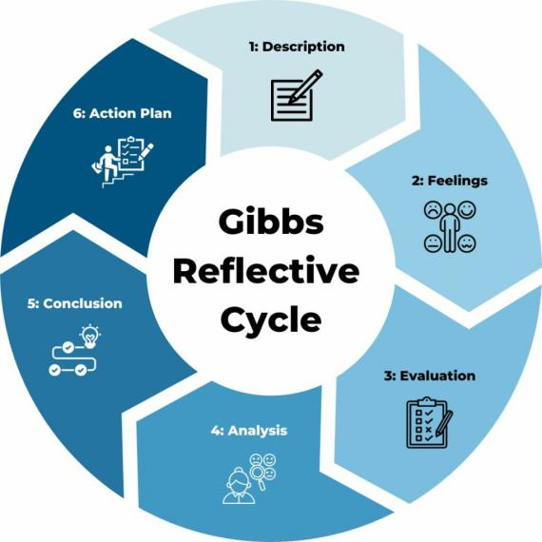
Figure 8: Gibbs Reflective Cycle (Channell, 2025)

Description
The completion of the previous assessment sections required a structured process of research, analysis, and strategic evaluation of Tesco. The research phase involved collecting both quantitative and qualitative data from reliable and credible sources. The primary data source was Tesco’s Annual Reports from 2023 to 2025, which provided key financial information such as revenue of approximately £69.9 billion, operational performance, and strategic priorities (Tesco PLC, 2023; Tesco PLC, 2025a). Additional external data were gathered from sources such as OECD and Reuters to understand macroeconomic conditions, industry competition, and market share, which is approximately 27–28% in the UK grocery market (OECD, 2024; Reuters, 2025e).
After collecting the data, analytical frameworks such as SWOT analysis, Balanced Scorecard, Porter’s Five Forces, and VRIO were applied to structure the evaluation. Each framework was used to analyse different aspects of Tesco’s strategy, including internal capabilities, external environment, and competitive positioning. The findings from these frameworks were then synthesised to develop recommendations focused on enhancing Tesco’s competitive advantage, particularly in areas such as digital transformation, customer personalisation, and sustainability.

Feelings
At the beginning of the process, the research task appeared challenging due to the large amount of available information and the requirement to ensure that all sources were credible and academically valid. There was initial uncertainty in selecting relevant data and aligning it with appropriate frameworks. However, as the research progressed, confidence improved as patterns became clearer, especially regarding Tesco’s cost leadership strategy and its focus on data-driven customer engagement (Tesco PLC, 2025a). The use of structured models helped reduce complexity and provided clarity in organising information. By the later stages, the process became more systematic and manageable, and there was a greater sense of confidence in developing strategic recommendations based on the analysis.

Evaluation
The overall research and analysis process was effective in integrating both quantitative and qualitative data to produce a comprehensive evaluation. The use of Tesco’s annual reports ensured high reliability and accuracy of financial and strategic information (Tesco PLC, 2023; Tesco PLC, 2025a). Applying frameworks such as SWOT analysis and the Balanced Scorecard provided a clear structure for analysing internal and external factors, supporting a balanced assessment (Kaplan and Norton, 1992).
However, there were some limitations. The large volume of information required careful selection, and some potentially relevant details had to be excluded due to strict word limits. Additionally, while external sources such as OECD and Reuters provided valuable insights into macroeconomic and industry conditions, they may not fully capture real-time changes in a dynamic retail environment (OECD, 2024; Reuters, 2025e). Despite these limitations, the process was effective in generating meaningful insights and supporting evidence-based conclusions.

Analysis
The analytical phase involved interpreting the collected data through the application of theoretical frameworks. SWOT analysis was used to identify Tesco’s strengths, such as its scale and loyalty programmes, and weaknesses, including high operational costs. It also highlighted opportunities in digital innovation and threats such as intense competition and geopolitical instability (Tesco PLC, 2025; OECD, 2024). The Balanced Scorecard enabled a broader perspective by linking financial outcomes with customer satisfaction, internal processes, and organisational learning (Kaplan and Norton, 1992). Porter’s Five Forces analysis further emphasised the high level of competition and the strong bargaining power of customers within the UK grocery market (Reuters, 2025a).
The recommendations were developed by connecting gaps identified in the analysis with relevant theoretical concepts. For example, enhancing data-driven personalisation aligns with the concept of customer intimacy, which focuses on tailoring services to individual customer needs (Treacy and Wiersema, 1993). Similarly, transforming stores into fulfilment hubs reflects omni-channel retail strategies that integrate physical and digital operations to improve efficiency and customer experience. Sustainability initiatives were proposed based on corporate social responsibility principles, recognising the growing importance of environmental and social considerations in strategic decision-making.
External factors such as the Russia–Ukraine war were incorporated into the analysis, as they significantly affect supply chains, energy costs, and inflation, influencing Tesco’s cost structures and pricing strategies (OECD, 2024). This ensured that the analysis was grounded in both theoretical frameworks and real-world conditions.

Conclusion
The overall process of researching and analysing Tesco’s strategy was comprehensive and insightful. The use of structured frameworks facilitated a systematic evaluation of the organisation’s internal and external environment. Integrating academic theories with real-world data enhanced the credibility and relevance of the analysis (Kaplan and Norton, 1992; Tesco PLC, 2025a).
However, the process also highlighted the importance of critically selecting relevant information and managing time effectively. It demonstrated that strategic analysis is dynamic and must account for external influences such as economic conditions and geopolitical events (OECD, 2024). This experience reinforced the importance of combining theoretical knowledge with practical evidence to produce well-supported and meaningful strategic insights.

Action Plan
For future assessments, several improvements can be made. Firstly, adopting a more structured approach to data collection, such as categorising sources by relevance, will improve efficiency and organisation. Secondly, increasing the use of peer-reviewed academic journals will strengthen theoretical grounding. Thirdly, better time management will allow more focus on critical analysis rather than data collection.
Additionally, future work will place greater emphasis on incorporating real-time data and emerging trends, particularly in digital transformation and sustainability (Tesco PLC, 2025a). Developing stronger skills in data interpretation and visual presentation will also improve the clarity of analysis. Finally, continued practice in applying strategic frameworks will enhance analytical depth and the ability to generate innovative recommendations. By implementing these improvements, future work will demonstrate stronger integration of theory, data, and strategic thinking, leading to more effective outcomes.
Summary
This report critically analyses Tesco’s strategic position using both internal and external frameworks. It finds that Tesco sustains market leadership through economies of scale, operational efficiency, and data-driven customer engagement strategies. However, challenges such as rising operational costs, strong price competition, and macroeconomic instability continue to impact performance (OECD, 2024; Reuters, 2025a). The analysis emphasises the importance of digital transformation, sustainability integration, and omnichannel retailing in maintaining competitiveness. Overall, while Tesco demonstrates resilience and adaptability, continuous strategic innovation is essential to ensure long-term growth and profitability in a rapidly evolving retail environment.
Conclusion
In conclusion, Tesco’s competitive advantage is primarily driven by its scale, advanced data analytics, and efficient supply chain, supporting its cost leadership strategy. Strategic analysis indicates that although Tesco maintains a dominant market position, it faces persistent challenges from intense competition, economic pressures, and changing consumer expectations (Porter, 2008; Tesco PLC, 2025a). To sustain its leadership, Tesco must balance cost efficiency with innovation, particularly in digital capabilities and sustainability initiatives. Continued investment in technology, customer personalisation, and operational efficiency will be critical for enhancing resilience and securing long-term competitive advantage in the UK grocery sector.

Bibliography
Barney, J. (1991) ‘Firm resources and sustained competitive advantage’, Journal of Management, 17(1), pp. 99–120.
Belsare, H.V. (2025) ‘PESTLE analysis’, International Journal of Advanced Research, 13(2).
Channell, M. (2025) Gibbs Reflective Cycle – A Practical Guide. The Skills Workshop. Available at: https://www.tsw.co.uk/insights/gibbs-reflective-cycle/ (Accessed: 15 April 2026).
FareShare (no date) Surplus food redistribution. Available at: https://fareshare.org.uk (Accessed: 2 March 2026).
FoodNavigator (2022) Tesco sustainable supply chain innovation. Available at: https://www.foodnavigator.com (Accessed: 2 April 2026).
Gibbs, G. (1988) Learning by doing: A guide to teaching and learning methods. Oxford: Oxford Polytechnic.
Grocery Gazette (2025) Tesco trials personalised Clubcard scheme. Available at: https://www.grocerygazette.co.uk (Accessed: 5 April 2026).
Kaplan, R.S. and Norton, D.P. (1992) ‘The balanced scorecard: Measures that drive performance’, Harvard Business Review, 70(1), pp. 71–79.
MarketScreener (2025) Tesco PLC earnings and company profile. Available at: https://www.marketscreener.com (Accessed: 8 April 2026).
NimbleFins (2026) Tesco Clubcard pricing issues report. Available at: https://www.nimblefins.co.uk (Accessed: 12 April 2026).
Ocado (2025) Online grocery fulfilment technologies. Available at: https://www.ocado.com (Accessed: 5 April 2026).
OECD (2024) OECD economic outlook, volume 2024 issue 1: An unfolding recovery. Paris: OECD Publishing.
Pickton, D.W. and Wright, S. (1998) ‘What’s SWOT in strategic analysis?’, Strategic Change, 7(2), pp. 101–109.
Porter, M.E. (1990) The competitive advantage of nations. New York: Free Press.
Porter, M.E. (2008) ‘The five competitive forces that shape strategy’, Harvard Business Review, 86(1), pp. 78–93.
Qureshi, W. (2025) ‘Tesco trials QR codes in move set to reshape UK retail’, Packaging News, 25 April. Available at: https://www.packagingnews.co.uk/news/retailers/tesco-trials-qr-codes-in-move-set-to-reshape-uk-retail-25-04-2025 (Accessed: 15 April 2026).
Reuters (2025a) Tesco market outlook and external pressures. Available at: https://www.reuters.com (Accessed: 15 April 2026).
Reuters (2025b) Tesco UK competitive environment. Available at: https://www.reuters.com (Accessed: 10 April 2026).
Reuters (2025c) Tesco UK grocery market share and performance. Available at: https://www.reuters.com (Accessed: 10 April 2026).
Reuters (2025d) Tesco UK sales growth and competitive environment. Available at: https://www.reuters.com (Accessed: 14 April 2026).
Reuters (2025e) Tesco faces pressure from inflation and rising competition in UK grocery market. Available at: https://www.reuters.com (Accessed: 17 April 2026).
Statista (2025) Tesco profile and employment data. Available at: https://www.statista.com (Accessed: 8 April 2026).
Tesco PLC (2023) Annual report and financial statements 2023. Available at: https://www.tescoplc.com (Accessed: 28 March 2026).
Tesco PLC (2024) Annual report and financial statements 2024. Available at: https://www.tescoplc.com (Accessed: 1 April 2026).
Tesco PLC (2025a) Annual report and financial statements 2025. Available at: https://www.tescoplc.com (Accessed: 13 April 2026).
Tesco PLC (2025b) Sustainability report 2025. Available at: https://www.tescoplc.com (Accessed: 13 April 2026).
The Guardian (2025) Tesco market strategy and operations. Available at: https://www.theguardian.com (Accessed: 11 April 2026).
Treacy, M. and Wiersema, F. (1993) ‘Customer intimacy and other value disciplines’, Harvard Business Review.

