Management of Resources within the Public Sector

Public Service Budgetary Constraints

(Austerity)

Name: Dariel Tunay
Student Number: 1900875
Module code: BMPS6001

Introduction
The topic of discussion throughout this report is based around austerity and how it affects the public services in which they only have various resources of revenue due to yearly reductions, leading to lots of problems.
People may wonder who has all the control of the United Kingdom’s money and who resolves the money issues, this is the Central Government (parliament) in London, England (Gov.uk, 2012). Members of parliament manage the revenue that the United Kingdom brings in, breaking it down and deciding how much each country receives and what they are inclined to spend.
The Welsh Government intakes funds from the central government in London, that they can then distribute around Wales. The Welsh minister determines that the money would be used to establish new schools and centres, among other things. However, the Central Government in London has struggled in recent years with allocating funds to various places around the country and has constrained people's budgets. The United Kingdom experienced a surge in austerity as a result of this.
According to L Bear (2015), austerity refers to a set of political-economic strategies that seek to decrease government budget deficits. Austerity tactics fall into three categories: greater taxes to pay expenditure, higher taxes while lowering spending, and lower taxes and reduced government spending.
The government and parliament in the United Kingdom needed to undertake the danger of imposing austerity since they were deeply in debt and faced a high chance of a default. The austerity was triggered by a UK government budget surplus from the Great depression. Soon after, the country had noticed that they could not afford to keep spending the money like they were. The first United Kingdom's austerity happened in 2010 which led from the aftermath of the Great Depression. (O'Hara, M., 2015.)
David Stuckler et.al. (2017) explains that austerity produced cut backs in individuals 's professions and in the construction of new schools, among other things. Prices in shops steadily climbed, and taxes on residences began to rise. As this sort of thing became more common, the central government in London reduced funding to other governments across the United Kingdom. Austerity ended in 2019, and COVID-19 arrived in 2020. A pandemic had occurred, resulting in a significant fall in people's salaries and revenue as a result of their inability to work. The UK government was subsequently forced to borrow extra money to cover the expenditures incurred as a result of COVID-19. The global epidemic has produced unprecedented times for many people and companies in recent years.

Objectives

Looking into this report, the objectives that are laid out is to look at austerity as a whole and what it is and how it has affected the United Kingdom during 2010 to the current day. The lowering in total spending throughout the 2019 austerity period and the outcoming effects it had on people will be the first topic that will be examined. The study will also do more investigation further regarding austerity measures in police force financing and the effect they made. Lastly, the final purpose of the paper will be to conduct research as to how COVID-19 affects investment in the United Kingdom.

Main Body
During austerity in 2010, it affected the United Kingdom as a whole all the way up until 2019 when it ended. Businesses were affected, schools and children were affected, the youth were affected and also the public services were affected as well as many more. It affected the United Kingdom so badly to the point where homelessness increased and people were losing their homes (Barnes, M.C et.al. , 2016). Austerity has the purpose of lowering government debt. Many others, however, question the effectiveness of this measure, claiming that a large deficit of budgets and money has a greater influence on the economy but not in a positive way. The administration intended to utilise the proceeds of increased taxes to repay the debt and funds owed by the United Kingdom. Furthermore, the government reduced its expenses in order to reduce the level of government debt (Buiter, W.H., 1985).
Discussing the topic of homlessness, many people had lost their homes due to austerity and also lost their jobs which played a part into how they lost their homes.
Copley (2019) had said that residential private rentals climbed to about 24% between 2010 through 2017, but average salaries at houses surged by just about 3%, and the accommodation fund was reduced and capped in 2011. Income support payments for individuals who require assistance paying their accommodation costs have so far not kept pace with increasing private rents, and the financial consequences have been particularly harsh for the working class in large cities such as London. This is due to the fact of London being the capital and a tourist attraction which means the living costs there are a lot more expensive than other parts in the United Kingdom. In some parts of central London, there is a "budget deficit" of around £370 each week between both the current limited housing allowance and the cost of living. This budget decrease is huge to many and people are struggling by losing out on so much. As a result of these austerity policies, which have made private renting housing extremely costly, countless Londoners have been driven into poverty and, in several circumstances, homelessness. The proportion of homeless persons in London would likely more than double throughout 2008/09. The very first drop in a year happened in 2017/18, but quarterly figures from the end of 2018 show that it may rise again.
Ellie Swain (2020), said that the number of homeless people sleeping in London in 2019 rose to a record high of more than 10,000 people.
As well as austerity affecting people and causing them to lose their homes, it also cost a lot of people to lose their jobs due to businesses having to shut down as certain situations were becoming too expensive for them.
Nevertheless, the British government destroyed almost 200,000 public sector employment in 2011 (Oxfam case study, 2013). People's income from various employments did reduce dramatically as a result of firms and business owners receiving fewer incomes to support them functioning and to pay their employees.The data also revealed that those aged 20 to 40 were the most affected as these were the people having to pay the taxes and losing out on their full time jobs that helped them pay their rent (Kamal A, 2018). According to the data, people's yearly salaries were eight hundred pounds lower in 2018 than they were in 2008.
The consequences of austerity in the United Kingdom have resulted in increased poverty and unemployment. Since 2010, the government has planned to make reforms to welfare payments, housing, and social services totaling more than £30 billion (GOV.UK 2015).

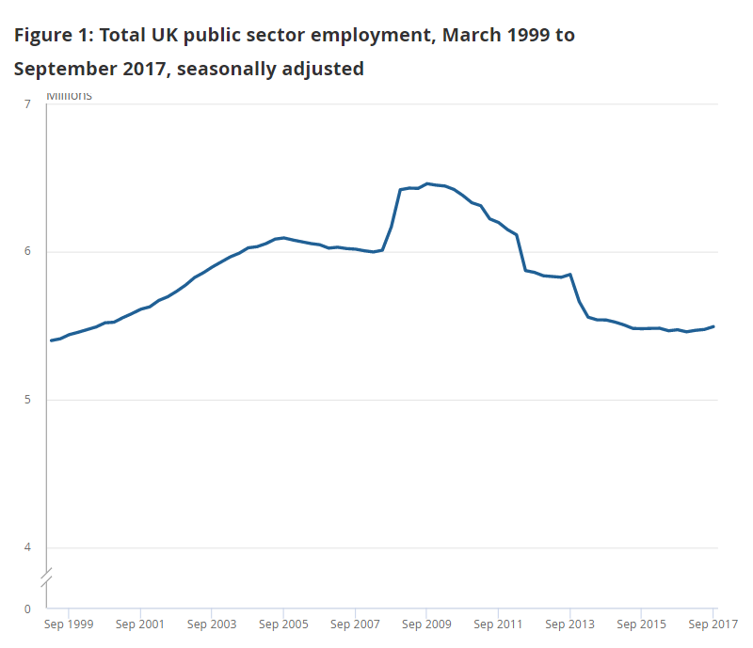
People have lost their employment as a result of the cutbacks and austerity measures, in addition to having their earnings reduced.
Clegg (2017) gathers statistics on the decrease in public sector employment statuses from 1999 to 2017.
As you can see in the image to the left, employment in the United kingdom was on a steady rise from 1999 to 2005/6 and increased rapidly during the year of 2009. However, just as everything was going well, austerity happened. From 2009 onwards to around the time of 2015/6, there was a massive decrease in the amount of employment in the United Kingdom. Reasonings for this was businesses were closing down, managers were having to let off staff due to not being able to pay them wages, some local governments had lost the ability to spend as much money as they used to on things like equipment, resources, and having a large staff working for them. Between 2010 and 2016, the authorities in England trimmed 27 percent of their spending money, with larger cutbacks occurring in more impoverished areas.

The austerity that happened in 2010-2019 created an impact on the public service as a whole. Throughout this section in the report, only the police force will be discussed.
As the London Government decided to create budget cuts to try and save more money to pay off their debt, this might have not been the smartest idea. It created an outlaw in the public services, police and other services were having to have their wages cut back, patrolling with less equipment and also not enough police cars. Due to these budget cuts, people who were employed in the police force found it too stressful and decided to take a leave because of the budget cuts and the extra hours and stress that came along with it. Even though it is not the smartest idea, the politicians of the central government make these decisions in hope that in the long run, the debt of the United Kingdom will be repaid and there would be less stress in the future.
The government imposed job layoffs across the country as part of the austerity programme in order to recoup lost funds.
The financial cuts in the police force turned out to be considerably severe than the administration anticipated. The police budget cuts resulted in a reduction in the number of officers on the force. Police personnel believed they were underpaid for patrolling the areas. Some police officers had to be let go since the police agency did not have enough money for basic resources. Fewer police were scouring the neighbourhoods, therefore meaning there are fewer police vehicles. This was bad since knife crime was on the upswing at the time of the police budget cuts. The police were at a disadvantage in combating knife crime since there were fewer patrols and resources available to them as a public service.
According to Veale (2018), a 37 percent decrease has happened since 2010 along with a 25.5 million budget cut on top. He had also explained that the forces' funding for equipment and other necessary things that they needed to keep the communities safe had been cut by 39 million pounds. The major impact of these budget cuts was the loss of 500 police officers and 50 PCSOs.
A major struggle that was put on the police during austerity in 2016/ 2017, was the rise in knife crimes. Knife crimes had risen due to the fact that there was less funding from the government that was going to places such as community centres and places where children would go to enjoy themselves.
According to Unison (2019), the central government cuts had led to a 17% fall in council spending on local services in England. Grants that were being provided for local fundings were reduced by 16 billion in England as well as significant cuts in Wales and Scotland.
Due to these financial cuts to the local communities and local governments,
There have been 859 closures of children's centres and family hubs and 940 closures of youth centres (Unison, 2019).
Those cut backs then played a part in the rise in knife crime during 2016/17.
Cuts in funding for programmes that give social capital to younger generations, as well as other services such as policing, had resulted in high rates of knife crime in community areas. Increased funding restrictions, according to the Association of Police and Crime Commissioners, posed challenging considerations about how best to construct police forces to adapt to changes in crime, and what this implies for local services supplied to the public.
The number of knife or sharp instrument offences reported by the MPS increased beginning in 2010 and peaked at almost 14,000 instances in 2011/12. The number of documented offences then fell to about 9,700 in 2014/15, before rebounding to around 15,600 in 2019/20, the highest level throughout this time span. (G. Allen, M.Harding, 2021).
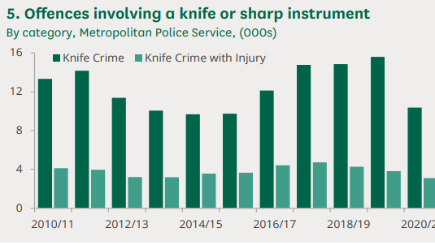
The police had struggled with trying to deal with knife crime and to try and decrease the amount of incidents that were being recorded but they struggled because of the lack of funding and the lack of staff. This was affecting the communities then as fears rose around the neighbourhoods.
According to Preece (2018), she had discussed the statistics that at the end of March 2018, there were just over 4500 burglary cases that had not been brought to justice as the perpetrator was never found.
Stephanie also stated that if your property is burgled in the West Midlands region, there is only a 20% chance that the police will hold and arrest the offender.
To expand on what Stephanie mentioned, burglars benefit from the fact that there are fewer police officers on the streets because they have more opportunities to arise. As you can see further down the line, having major cuts in the government's fundings does not only affect the small number of people who have to pay more taxes. It expanded a lot more than that and had led to knife crime and other crimes rising.

COVID-19
Government budget cuts, along with the global pandemic, had resulted in many individuals becoming unemployed, earning less money, and businesses closing down. Stuckler et al. (2017) states that an impact of the budget cuts impacted people financially but also mentallly due to the increase of people being vulnerable to poverty and unemployment which could lead to homelessness, stress and depression amongst the people who experience. As well as the lack of resources the Nation Health Service can offer due to budget cuts, meaning less staff, medicine and equipment which lead to longer waiting time for patients or delayed appointments etc.
The global epidemic created numerous significant challenges for nations, their citizens, governments, and, most importantly, their economies. The rise in numbers afflicted with COVID-29 forced the United Kingdom to go into quarantine lockdown for nearly two years starting March (2020), causing all types of industries such as retail, hospitality, trades, and many more to cease operations and lay off many staff.
According to Elliot, L. (2021), the epidemic crisis resulted in a record-high increase in spending for the government to aid and keep the country and its people safe from the virus consequently gaining a debt of £251 billion. Despite the massive debt the United Kingdom got into due the the epidemic it is said that the The economy will eventually recover, but at the cost of tax increasing to pay off the debt, as a result of the costs associated with the pandemic. Staff for public services, roadworks, trades, and many other jobs were in high demand. Keep and Brien, (2022) states that the majority of the budget was spent on the NHS.
The NHS sought a funding increase due to the rise in demand for staff and medical supplies as the number of patients in hospitals increased so did the demand that was required to provide for the patients needs. Keep and Brown also mentioned that the remainder of the funds were spent on other public services, economic aid for businesses/ individuals and importantly the funds were also utilised for contamination measures, with the Coronavirus Job Retention Scheme (CJRS), also known as the furlough scheme, as well as NHS Track and Trace.
Another way in which covid has impacted Britain's economy and finances is the supply and demand requirements. Many individuals frantically bought at supermarkets around the country, resulting in a large drop in shop stocks for staples such as groceries, toiletries, and so on, which then became in short supply for the UK population. According to (Schomberg, 2021), the supply problems in the UK were caused by global resource scarcity, staffing shortages, and shipping disruptions, which were also contributing to the UK's current distribution issues amongst the country. Which in turn made it difficult to supply the resources evenly widespread across the stores and supermarkets within the UK. This in turn had a negative impact as it resulted in rising prices for products in short supply, making grocery shopping for necessities and construction materials significantly more expensive for UK residents.

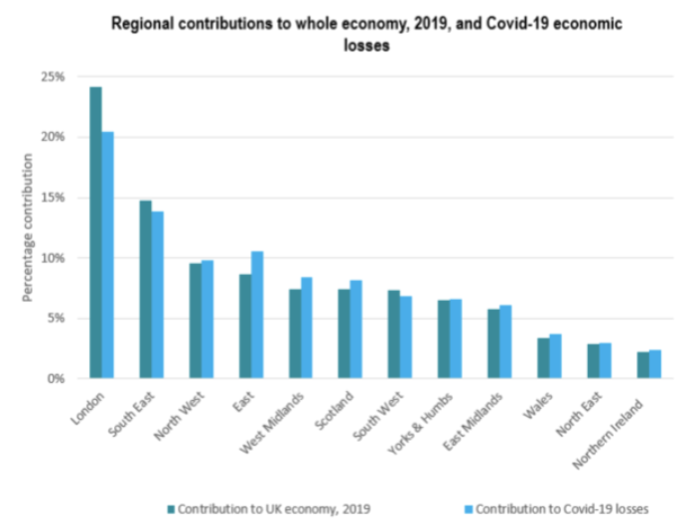
This epidemic had a major economic impact, resulting in significant financial losses all over the country.

(Image - https://cebr.com/reports/one-year-since-lockdown-the-251-billion-cost-to-the-uk-economy/’)
This graph shows the cities within the UK contribution towards the economy before the epidemic outbreak and also how much they lost with their standard economic activity during the COVID-19 lockdown. This shows the significant impact of COVID-19 on the UKs economy, a huge downfall in money generated in each region thus increasing the country's debt. Therefore it was important for the government to spend their budget to help the people financially and to help them keep safe. Thus in addition to record spending and debt during the pandemic, deciding where to spend the budget during this time period resulted in budget cuts in other areas such as public services since combating the epidemic was a priority for the UK government.

CONCLUSION

To summarise what has been mentioned in this study, austerity and spending cuts have had a significant influence on the United Kingdom overall. Setbacks occurred in the law enforcement, institutions, communities, industries, and even the National health service. Austerity and budget cuts had a significant influence on people who have jobs, resulting in a large number of layoffs and workers receiving less money on their income. This caused negative effects to families paying bills and putting food on the table or providing enough to give their children money or packed lunches for schools, due to the lack of financial struggles it occured in more and more families over time. This then correlated to an increase in crime statistics in the United Kingdom especially amongst youngsters as more were reported of being involved in crime related to gang violence, knife crime and robbery and this could be a result of reduced funding and support for the younger generation presenting them less opportunities in school, jobs and apprenticeships that would keep them away from a life of crime. There are many solutions which the government can budget and apply the money towards in order to benefit the members of the public, families and youngsters who are vulnerable to experiencing the impact of Austerity. Examples would be on focusing on intervention methods and presenting opportunities for youngsters. This would help decrease crime statistics as methods and money spent towards the reduction of crime is expensive and could be used to help the families and youngsters who need it. In 2018 the government suggested a way to reduce austerity was for the United Kingdom to leave the EU and proceed with Brexit which did lead to a reduction in Austerity until the global Pandemic hit which caused the United Kingdom to lend more money than before to protect the people by providing vaccines and contamination methods to reduce the spread of the virus. Which in turn increased tax and reduced public spending in order to pay the Debt that the United Kingdom owed with the money lent for the pandemic. However Boris Johnson did succeed in increasing the budget spent on the law enforcement which led to more recruitment within the police force, this shows that the government has moved some budget to help with people having jobs and increasing the number of officers which can help with the safety of communities

Bibliography:

- Bear, L., 2015. Navigating austerity. In Navigating Austerity. Stanford University Press. Available at: Navigating Austerity (degruyter.com)

- Barnes, M.C., Gunnell, D., Davies, R., Hawton, K., Kapur, N., Potokar, J. and Donovan, J.L., 2016. Understanding vulnerability to self-harm in times of economic hardship and austerity: a qualitative study. BMJ open, 6(2), p.e 010131. Available at: Understanding vulnerability to self-harm in times of economic hardship and austerity: a qualitative study | BMJ Open

- Buiter, W.H., 1985. A guide to public sector debt and deficits. Economic policy, 1(1), pp.13-61. guide to public sector debt and deficits | Economic Policy | Oxford Academic (oup.com)

- Copley, T. (2019). Homelessness: the visible effect of austerity. London Assembly Labour. Available at: https://www.london.gov.uk/sites/default/files/tom_copley_am_homelessness_-_the_visible_effect_of_austerity.pdf.

- Clegg R, (2017), ‘The official measure of people employed in the UK public sector, including private sector estimates, based on the difference between total UK employment and public sector employment’. Available at: Public sector employment, UK - Office for National Statistics (ons.gov.uk)

● Elliot, L. (2021), A year of Covid lockdowns has cost the UK economy £251bn, study says. Available at: https://www.theguardian.com/business/2021/mar/22/a-year-of-covid-lockdowns-has-cost-the-uk-economy-251bn-study-says

- GOV.UK 2012, ‘Managing Public Money’, Available at: Managing public money - GOV.UK (www.gov.uk)
- GOV.UK, (2015) government policy: welfare reform 2010 to 2015..Available at: 2010 to 2015 government policy: welfare reform - GOV.UK (www.gov.uk)

- G,Allen. M, Harding,. (2021).’ Knife Crime in England and Wales’. 1.4
Available at: SN04304.pdf (parliament.uk)
- Kamal Ahmed, (2018). Workers are £800 a year poorer post-crisis. Available at: Workers are £800 a year poorer post-crisis - BBC News
- Keep, M. and Brien, P., 2022. Public spending during the Covid-19 pandemic. Available at: https://commonslibrary.parliament.uk/research-briefings/cbp-9309/#:~:text=Current%20estimates%20of%
- Oxfam.org (2013). THE TRUE COST OF AUSTERITY AND INEQUALITY UK Case Study. Published at: Cowley Available at: The true cost of austerity and inequality: UK case study (oxfam.org)
- O'Hara, M., 2015. Austerity bites: A journey to the sharp end of cuts in the UK. Policy Press. Available at: Austerity Bites: A Journey to the Sharp End of Cuts in the UK - Mary O'Hara - Google Books
- Preece S (2018). New burglary figures show how much funding cuts have hurt West Mercia Police. Available at: EDITOR'S VIEW: New burglary figures show how much funding cuts have hurt West Mercia Police | Worcester News

- Swain E, (2020), ‘London Reports Record High Number of Rough Sleepers in 2019–20’. Available at: London Reports Record High Number of Rough Sleepers in 2019–20 - Invisible People

● Stuckler, D., Reeves, A., Loopstra, R., Karanikolos, M. and McKee, M., 2017. Austerity and health: the impact in the UK and Europe. European journal of public health, 27(suppl_4), pp.18-21. https://academic.oup.com/eurpub/article/27/suppl_4/18/4430523?login=false
● Schomberg, W., 2022. UK shoppers cut spending by the most since COVID lockdown in 2021. [online] Available at: https://www.reuters.com/markets/europe/uk-shoppers-cut-spending-by-most-since-covid-lockdown-2021-2022-06-06/
- Unison (2019), ‘Shocking picture of austerity cuts to local services is revealed by UNISON’. Available at:Shocking picture of austerity cuts to local services is revealed by UNISON | Article, News, Press release | News | UNISON National
- Veale M (2018), “Cleveland Police chief: Austerity cuts 'too deep”. Available at: Cleveland Police chief: Austerity cuts 'too deep' - BBC News

