DO ADVERSE CHILDHOOD EXPERIENCES (ACES) SHAPE criminal behaviour in adulthood
Dissertation
Courtney-Alisha Curtis Collins
2204829@student.uwtsd.ac.uk
Declarations –
This work has not previously been accepted in substance for any degree and is not being concurrently submitted in candidature for any degree.

This dissertation is being submitted in partial fulfilment of the requirements for the degree of BSc Professional Policing.

This dissertation is the result of my own independent work/investigation, except where otherwise stated. Other sources are acknowledged in the Reference Section.

I hereby give consent for my dissertation, if accepted, to be available for photocopying for interlibrary loan, and for the title and summary to be made available to outside organisations.

I hereby give consent for my dissertation, if accepted, to be available on the university’s IT system to those who have consent to use the system.

Name: Courtney Curtis-Collins
Signed: C.Curtis
Date: 24th April 2025

Abstract –
Adverse childhood experiences, also known as ACES, are potentially traumatic events that can have negative effects on people. ACES occur during childhood. There are 10 common ACES, some of these include living with a parent who abuses drugs or alcohol, living with a parent with mental health, experiencing the loss of a parent by death, divorce or abandonment and experiencing physical, emotional, sexual or neglectful abuse. The effects of ACES can include lasting effects of an individual’s physical and mental health, brain development, social and behavioural issues, academic performance and intergenerational effects. However, there is one effect that has not been properly accepted or authorised by some professionals, that is criminal behaviour and committing crime. This dissertation will research whether people who have experienced ACES are more likely to commit crime as well as finding out whether people in the local area of Bridgend and Swansea think that experiencing ACES can increase the likeliness of committing crime and criminal behaviour, by using a research questionnaire.
This dissertation research had shown that experiencing ACES is not always going to be lead to criminal behaviour and committing crime. It depends on a lot of factors such as the person themselves who experienced ACES, what the ACE(S) that they experienced were and whether they had any help during childhood for it and a good support system.

Acknowledgements –
I would like to thank everyone who has supported me through university and has aided in the completion of my dissertation, by guiding me and completing my questionnaire that has helped me gather my research. I would like to thank my supervisor, Kelly, who has been a big part of my university experience, by teaching me the whole duration of my time in university, supporting and guiding me throughout my studies and writing my dissertation. I would like to thank my lecturer, Mike, who had taught me how to complete a dissertation and supported me with any questions I had. I would also like to thank my other lecturers I had during my time in university who all contributed to my learning in university.

I would like to thank my mum for her endless support, patience and advice, who always believes in me and is always encouraging me. The endless walks with the dogs and talks we’d have has helped and encouraged me to do and be my best. Without my mum, I would not have had the confidence to think I could go to university or be the person I am today.

I would like to thank my peers in my Professional Policing course who have made my time at university enjoyable by supporting each other during our presentations and exams. I would also like to thank the participants of the survey that I had conducted for this research dissertation.

Contents
1. Introduction 5
Objectives 8
2. Literature Review 9
Identify the types of adverse childhood experiences (ACES) 9
Examine the impact from being exposed to adverse childhood experiences 11
Evaluate the effectiveness of the current public service response to adverse childhood experiences, and crime 14
3. Research Methods 15
3.1 Research Onion 16
3.2 Research Philosophy 16
3.3 Research Approach 17
3.4 Research Strategy 17
3.5 Methodological Choice 18
3.6 Time Horizon 19
3.7 Techniques & Procedures 19
3.8 Strengths & Weaknesses 19
4. Findings 20
5. Conclusion 32
6. References 35
7. Appendices 44
Appendix – Questionnaire 44

Introduction

Adverse childhood experiences are highly stressful events where a child aged 0 to 17 is harmed or lives in an adverse environment (National Institute for Health and Care Research, 2023). Adverse childhood experiences, also known as ACES, occur during childhood and they can include being physically, emotionally, sexually abused and neglected according to Wisner (2022). Living in a household with parents with mental health problems, domestic abuse, or substance abuse, and having divorced parents are also examples of ACES. The Centres for Disease Control and Prevention (2024) concur with these examples of ACES because they also state that experiencing neglect, violence or abuse are examples of traumatic events. Witnessing violence in the home, having family members with mental health problems, or substance abuse problems, or parental separation are also examples of adverse childhood experiences.
The University of Edinburgh (2022) has stated that people who have suffered extreme trauma including ACES are more likely to commit crime as adults than those who have not experienced them. This could be because they have experienced extreme stress, and it can affect people’s behaviour and reactions. Poverty, maltreatment, school exclusion and police contact can all be associated with offending and committing criminal acts in adulthood. Each ACE a child has experienced increases the risk of being a serious offender by more than 35% (Fox et al. 2015, p. 170). These statements show that ACES can shape criminal behaviour by increasing the chance of committing crime.
This is an interesting topic because there are more and more children experiencing ACES every year, which also creates problems for the police and the public. This topic will be explained more by defining ACES, and what the impact it causes for the victims, the police, and the public are. Understanding ACES and finding out how they occur, and examining solutions to prevent and stop ACES will be discussed. This topic will aid in providing knowledge of whether adverse childhood experiences and crime link together and how they do.
The focus will be on how children come to experience ACES and whether ACES shape criminal behaviour and link to crime, this will be by researching ACES and trying to understand them more. Solutions to put a stop to ACES by the police and other agencies to help prevent them will also be discussed. These include education, a variety of activities for children, programmes for parents and the community and trauma-informed policing. This will aid in finding out whether ACES are indeed more likely to lead to criminal behaviour.
Adverse childhood experiences and its link to crime is relevant to policing because ACES and antisocial behaviour is known to coincide with each other, and they both create a lot of problems for society and the police force because of crime. Scottish Government, A (2018) supports this statement because it states that research shows that there is a strong association between ACES and crime because people who experience multiple ACES are more likely to engage in risk taking behaviours. This could suggest that experiencing multiple ACES could increase the risk of committing crime because of the stress that people endured during childhood. This shows that studying ACES and crime is relevant because if ACES are impacting crime, then it is impacting society and police forces. This also shows that it is important to understand ACES and whether they link to crime. This is because if they do link to crime, the more knowledge you have about the subject, the more it will be effortless to create solutions to aid in decreasing ACES. This could then lead to decreasing crime and the polices workload.
Research that will be discussed later on, has shown that experiencing ACES in childhood are associated with an increased risk of poor health and other problems in later life such as committing crime and drug using (Asmussen et al. 2020). Therefore, it is important to research whether there is a link between ACES and criminal behaviour. Considering that there are a lot of impacts associated with experiencing ACES, such as poor health and early death, an increased risk of developing criminal behaviour is a relevant and fitting prediction. People who have experienced four or more ACES have an increased risk of diseases, other health risks, and mental illness (Boullier and Blair, 2018, pp. 132-137). There is an ACES pyramid model that describes the relationship between ACES, disease, and even early death (Boullier and Blair, 2018, pp. 132-137). This could suggest that stress from these poor outcomes like ACES could lead to health risks, mental illnesses, and early death. The University of Edinburgh (2022) states that people who have suffered extreme difficulties in childhood are more likely to commit crimes as adults than those who have not experienced difficulties. They also state that childhood experiences such as poverty, neglect, school exclusion and police contact are associated with serious offending and frequent criminal convictions in adulthood. This could be because these types of experiences show that children from poverty and neglect have less opportunities than those with a good education and a healthier lifestyle. These experiences could change how a child behaves towards people and the police.
Defining ACES and what examples of them are, will be included. The questions that will be researched and discussed include whether negative childhood experiences, also known as adverse childhood experiences, affect children’s behaviour and turn them to crime. Other questions include, how many people have experienced ACES and have committed crime?, what trauma informed policing is and how it aids in policing ACES? And, what the police perspectives on ACES are? There will be three objectives that will be included, these are, what types of ACES are there?, what is the impact from being exposed to ACES?, and evaluate the effectiveness of the current public service response to ACES and crime. Case studies will be included as examples of the impact ACES can have that could lead to show whether ACES can affect people’s behaviour and lead them to crime. Finding out whether ACES link to criminal behaviour in adulthood will be researched thoroughly.
There will be a variety of research methods, these include qualitive and quantitative methods, a questionnaire, and a case study. Examples, written research and evidence of the question in written research will also be incorporated. The literature review will discuss the topic of adverse childhood experiences in detail and examine whether they lead to criminality in adulthood and might be more likely to commit crime because of them.
In this dissertation, it will include discussing the objectives and a case study as an example. The case study that will be included will be used as evidence to show how having ACES can cause people to commit crime and lead to criminality. The case study that will be used will be the Ted Bundy case. The literature review and the case study will include going into detail about the information found. Information such as what ACES are, the several types of ACES and how ACES impact people will be included.
Statistics on ACES will also be researched. Strategies on how the police deal and respond to adverse childhood experiences and crime such as trauma informed policing and whether there is research to prove that ACES do link to crime will also be included. Websites, books, journals, articles, and statistics will be used as research for this topic.
The research method is next, it will entail ten questions to the public discussing questions about ACES and what types of ACES they have heard of and whether they know anyone who has experienced them and if they have committed crime. It will be on an online questionnaire app such as word and there will be around one hundred people that will be asked. The findings of the questionnaire will be discussed next, the findings will include discussing the answers from the questionnaire and examining them to find out whether they coincide with the question of whether adverse childhood experiences do link to crime and make it more likely that people who have experienced ACES commit crime.
The conclusion will discuss the overall information found and the findings from the questionnaire. It will state what the answer that was found for the research question it was on, about whether experiencing ACES is more likely to lead to crime. Lastly, the references will be included at the end in Harvard referencing style.

Objectives

Objective 1
Identify the types of adverse childhood experiences (ACES)
Objective 2
Examine the impact from being exposed to adverse childhood experiences
Objective 3
Evaluate the effectiveness of the current public service response to adverse childhood experiences and crime

Literature Review

This literature review will consist of three sections of research about the objectives spoken about in the introduction. Identifying the types of adverse childhood experiences (ACES), examining the impact from being exposed to adverse childhood experiences and evaluating the effectiveness of the current public service response to adverse childhood experiences and crime will be discussed.

Identify the types of adverse childhood experiences (ACES)

Adverse childhood experiences (ACES) are negative childhood experiences that occur before the age of 17 and they are stressful events that affect children. Each ACE has a score of one and each type of trauma counts as one no matter how many times it occurs, the more ACES a child has, the more at risk they are for future mental and physical health-related issues (Information to Support ACES, Trauma & Challenging Behaviour, A, 2024). This could show that immense stress and trauma could lead to criminal behaviour and changes in behaviour. Information to Support ACES, Trauma & Challenging Behaviour, A (2024) states that if a child has experienced 4 or more ACES, they are more likely to engage in risk-taking behaviours. Adverse childhood experiences can include alcohol or drug dependence, also known as alcohol or drug misuse, childhood physical abuse, sexual abuse, or witnessing parental domestic violence (Fuller-Thomson and Roane and Brennenstuhl, 2016, pp. 1451-1461). Other types of adverse childhood experiences include emotional abuse, living with someone who has gone to prison, or with someone with serious mental illness and losing a parent through divorce, death or abandonment (Manchester University NHS Foundation Trust, 2024). Scott (2020) concurs with these statements because they also state that adverse childhood experiences include physical, sexual, and psychological abuse, violence against people, and living with people who are alcohol or drug misusers. Scott (2020) agrees that living with people who have mental illness or who were imprisoned are also examples of adverse childhood experiences. ACES are defined by traumatic events that are experienced by a child, they are incidents that causes physical, emotional and psychological harm and if ACES occur, then support and time to recover will be needed to regain emotional and mental stability (Cafasso, 2023). Cafasso (2023) states that traumatic events can include rape, physical pain or injury, serious illness, domestic abuse, witnessing a death and living with someone who was or is in prison. There are many adverse childhood experiences, these can include whether they are accidents, crimes or natural disasters (National Centre on Health, Behavioural Health, and Safety, 2024). This suggests that there are different types of adverse childhood experiences as well as different scenarios where children can experience them. There are 10 traditional ACES, these are experiencing physical, verbal and sexual abuse, experiencing physical and emotional neglect, having a parent who is an alcoholic or who is in jail, having a mother who is a victim of domestic violence, having a family member diagnosed with a mental illness and also experiencing the disappearance of a parent through divorce, death or abandonment (Asmussen and McBride, 2021, p. 5). Centre for Child Counselling (2019, p. 1) concurs that physical, emotional and sexual abuse, physical and emotional neglect, household dysfunction, issues around divorce and seeing someone be a victim of domestic abuse are all examples of traditional ACES. Centre for Child Counselling (2019, p. 1) also state that living with someone who has mental illness or who abuses drugs or alcohol or having a parent in prison are also known as traditional adverse childhood experiences. This shows that there are around ten more common ACES, also known as ‘traditional’ ACES. Uncommon ACES could include poverty, online harm, criminal activity, family conflict and violence, bereavement, an unsafe neighbourhood, low school attendance and isolation (Liverpool CAMHS, 2024). These uncommon ACES show that there are more ACES than just the traditional ten, these ACES are not as common as the traditional ten, however they can still occur during childhood. Adverse Childhood Experiences can be acute, chronic or complex, ACES are common with 40% of children under the age of eighteen (ACES Matter, 2022). This means that 40% of children have suffered some sort of trauma, and that each individual experience is different and the traumatic experience on the individual determines the overall influence and impact. Manchester University NHS Foundation Trust (2024) agrees because it states that ACES can affect everyone differently which is why professionals complete an assessment when they are dealing with ACES, to find out what happened and how it affected the individual so that it aids in identifying the right kind of support for them. This means that it affects people mentally, emotionally and physically differently, this could be because it depends on the person and the adverse childhood experiences that occurred. The age when ACES occur are of the utmost importance because if a child experiences trauma before the age of 17, it will have more of an impact on their health than the same trauma taking place at age 17 (ACES Matter, 2022). This suggests ACES can impact a child’s health and future immensely and that a child’s childhood is important to not develop trauma or ACES because of the affect it can do to a child. It also shows that ACES can affect a child more than a young adult and it can influence a child’s health and behaviour more. Public Health Wales (2015, p. 1) states that 23% of people in Wales have experienced verbal abuse, 17% have experienced physical abuse and 10% have experienced sexual abuse. It also states that 20% have experienced parental separation, 16% have experienced domestic violence, 14% have experienced both having a family member with mental illness and a family member that abused alcohol. 5% of people in Wales have also experienced having a family member in prison or who abused drugs. The statistics suggest that experiencing verbal abuse, parental separation, physical abuse and domestic violence were the most common ACES people in Wales had experienced. Having family members in prison, who abused drugs or experiencing sexual abuse were the least common ACES that people had experienced. Having family members who have mental illness or who abused drugs were in between most common and least common ACES that people experienced. Public Health Wales (2015, p. 1) states that for every 100 adults in Wales, 47 people have suffered at least one ACE during their childhood and 14 have suffered 4 or more ACES.

Examine the impact from being exposed to adverse childhood experiences

According to Cleveland Clinic (2023) signs that show that adverse childhood experiences have occurred can include fear of other people, difficulty sleeping or having frequent nightmares, bedwetting, difficulty showing affection, changes to their mood and difficulty learning in school. Avoiding situations or events that relate to a traumatic experience can also be a sign of experiencing ACES. These signs are important to look for when children are involved because it aids in identifying those who are experiencing ACES, and it can decrease the amount of children who experience ACES by helping them. Signs that could occur as a result of ACEs include anxiety, depression, PTSD, insomnia, mood disorders, eating disorders, substance and alcohol abuse and phobias (Cleveland Clinic, 2023). ACEs can have a negative impact on development in childhood, it can risk harmful behaviours, social issues and health problems which can have a negative impact in adulthood. ACEs can cause lifelong poor mental and physical health, increased levels of violence and lower academic success in both childhood and adulthood (Darwen Borough Council, 2024). ACEs can impact adulthood by causing difficulty forming close relationships with others, having trouble keeping a job, difficulty with finances, an increase in violent behaviour and a greater likelihood of ending up in prison (Wisner, 2022). Wisner (2022) also states that higher levels of unemployment, exposure of ACES to their children, a higher risk of alcohol and drug abuse and suicide attempts are also impacts of experiencing ACEs in childhood. Public Health Wales (2015) concurs with these statements stating that ACES have a major impact on the development of health-harming behaviours such as alcohol use, smoking, having a poor diet and violent behaviour. Impacts of adverse childhood experiences include detrimental effects on mental health, negative impacts on academic performance, behaviour changes, increased risk to self-injury, barriers to healthy attachment relationships, predictive adult risky behaviour and poor effects on mental and physical health and overall well-being into adulthood (Breedlove and Choi and Zyromski, 2020, p. 2). These impacts are clearly common impacts and signs that occur when people experience ACEs. They can be both short-term and long-term impacts that vary depending on the person who experiences them and whether they get the right help in good time. The outcomes related with multiple ACES include violence, mental illness, problematic substance abuse, poor academic performance and health outcomes and certain diseases (Hughes et al. 2017, p. 10). This shows that Hughes concurs with the signs and impacts ACES create from childhood into adulthood.
An ACE study found that adults who had experienced 4 or more ACEs showed a 12 times higher increase of risks such as alcoholism, drug use, depression and suicide attempts (Felitti et al. 1998, p. 248). Webster (2022) coincides with Felitti because it states that the more ACEs someone has, the higher the risk of developing health risks such as drug and alcohol abuse, smoking and depression. The impact of experiencing ACES is dangerous because it affects health and a person’s lifestyle, it could affect their social life, education, work and their behaviour. This could lead to a bad and unhealthy lifestyle involving a bad environment, no work, poor health and criminality. This can be because the person who experienced ACES could then lead to drinking, drug abuse, smoking, and an increase of violent and criminal behaviour. Scottish Government, B (2018) states that there is a strong association between ACES and crime, people who experience ACES are 15 times more likely to be a perpetrator of violence and 20 times more likely to have been incarcerated in their lives. It also states that people who do offend are more likely to have experienced traumatic childhoods. This shows that ACEs can affect people’s lives and lifestyles because it can cause criminal behaviour, anti-social behaviour and it can increase the risk of poor social-skills and education. This can cause a rift in society because the more people who experience ACES, the more society takes a toll, and it causes harm. 468 imprisoned men aged 18 to 69 years old participated in a survey in Wales, the survey showed that most of the participants had at least one ACE and around 45.5% had suffered over 4 ACES (Pessoa and Almeida, 2024). Other UK prison surveys had reported similar findings, they found that prisoners with high rates of childhood abuse, family violence, experience of being in care and school exclusion were more likely to become involved in crime and go to prison (Jahanshahi and Murray and McVie, 2021). Williams and Papadopoulou and Booth (2012, p. 29) concurred with this statement by suggesting that people who experienced ACES during childhood had their lives impacted by increasing the likeliness of committing crime, being violent and going to prison rather than people who have not experienced ACES. This could suggest that ACES can increase the risk of violent behaviour and committing crime because most of the participants in these surveys had experienced ACES during childhood. Ted Bundy, the serial killer had also experienced ACES, such as an abusive grandfather, who was violent towards animals and family, and who had a lot of porn lying around. Ted Bundy did not know who his real father was and despised his mother because of it, his mother was neglectful, and he was bullied a lot at school. The impact of experiencing ACES includes that he had also went on to commit crime, this includes being abusive, watching a lot of porn, raping and killing women. This could show that people who experience ACES could be more likely to commit a crime, even if it is low or high-level crime (Kettler and Piccotti, 2023).

Evaluate the effectiveness of the current public service response to adverse childhood experiences, and crime

The current public service response to ACEs and crime is educating people and addressing the issue. The police use prevention techniques, building resilience and trauma-informed practise to police ACEs, it is estimated that 319 million people have suffered at least one type of ACE and 142 million have suffered multiple types of ACES (Public Health Wales, 2023). This is why educating people about ACEs is an efficient way of preventing ACEs. Pre-school enrichment programmes that aim to develop social, emotional and cognitive skills and parent programmes can prevent ACEs by improving parenting practices and educating people on the signs of abuse that can lead to ACEs (Bellis, 2023, p. 33). Family support and training of healthcare workers and other professionals such as teachers, social workers and the police and school-based violence prevention programmes can all increase the awareness of child abuse and maltreatment that link to experiencing ACEs, aiding in identifying signs of experiencing ACEs and how to respond to it (Bellis, 2023, p. 33). Education and healthcare professionals and other sectors all suggest that ACEs training can positively impact staff attitudes and behaviour towards responding to and policing ACEs (Goodall et al. 2023, p. 2). This shows that educating people about ACEs is a beneficial way to prevent them, because it helps people to identify the signs of ACES and whether a child is experiencing them. College of Policing, A (2015) state that police officers are increasingly responding to vulnerability incidents that are related to ACEs. This also suggests that educating police officers about ACEs is effective because they know what it is and how to respond to it and police ACEs in the correct manner. College of Policing, B (2013) suggests that police have the responsibility to be trained for their job role and be aware of any resources and support they need. It is important for police staff to have the knowledge and understanding of what they are policing; this is to ensure that they police the problem to the best of their ability and to solve or prevent the problem. According to the College of Policing, C (2021, p. 6) there are three strategies that are used to tackle ACEs such as focusing on helping those who have already experienced ACEs to stop the cycle, raising awareness and improving the education on ACEs to help and prevent them and a three-day session of what ACEs are and how to police them. Raising awareness in the police force and educating them is essential when they are dealing with cases including ACEs. The police need to understand what ACEs are, and what the long-term and short-term impacts of high-level trauma are, and how to respond to ACEs and vulnerability. They need to be trained to police ACEs and be aware of trauma informed approaches (Janssen et al. 2020, p. 9). This could aid in decreasing ACEs and prevent people from causing ACEs. Trauma-informed policing and care recognises and responds to the signs, symptoms and potential consequences of trauma to support the needs of people who have experienced ACEs and toxic stress (ACES aware, 2020). They help understand, recognise and change the mindset of policing ACEs. It also educates the police on how to respond to ACEs to the best of their ability and it aids in supporting the victims of ACEs effectively. Trauma-informed policing and care aids in decreasing ACEs efficiently because it supports people who has experienced ACEs, and it also educates the police on the signs of ACEs to help prevent them. Accumulating evidence supports that ACEs are associated with an increased risk of crime involvement (Fleming and Nurius, 2020). This shows that experiencing ACEs could increase the likelihood of committing crime and that it is imperative to police ACEs and prevent them from being experienced to be able to decrease crime in general. There are barriers to policing ACEs such as funding, staff shortages and a lack of education and resources for policing ACEs (Knopf, 2024, p. 3). There is not enough money being put into preventing or policing ACEs which is a barrier because people experiencing ACEs are continually rising and it causes police to spend a lot of time trying to prevent and police those who are involved. There is a lack of staff which also prevents police to help decrease people experiencing ACEs because there is not enough staff to educate or police ACEs. The lack of education and resources to police ACEs is a barrier because without these, there would be no way of spreading awareness and trying to decrease ACEs. This shows that education, funding and staff, training and resources and trauma-informed policing and care are all beneficial examples of preventing ACEs.

Research Methods

This chapter will explain and justify the research methods that have been chosen for this research study. It will evaluate the ethics, choices and the strategies of the research study. The strengths, weaknesses and approaches of this research study will also be evaluated.

Research Onion

The research onion is used for writing research methods, it is an approach to writing a methodology by using layers to write it. The steps include the research philosophy, the research approach, the research strategy, the choices that were made, the time horizon and the techniques & procedures that were used (Saunders and Lewis and Thornhill, 2007). The strengths and weaknesses will also be considered. The research onion is used to complete the methodology by peeling off the layers one by one. Each layer consists of multiple research strategies, these will be included and discussed within this dissertation. The research onion will also be used within this dissertation.

Research Philosophy

Ontology is referred to as what the information is and how the information was found and used. It is the reliability and relevance of information, and it is used to understand what the information is. Epistemology is how the information or knowledge was obtained, and how to understand it. It is also how the information required for the research is valid and how it was obtained. Ontology and epistemology are an approach and the foundation for writing the methodology of research questions (Duvvuri, 2016). Interpretivism uses both qualitative and quantitative methods of research because it is believed that there is not just one path to collecting information. They also focus more on the context of research. Positivism and pragmatism are other philosophies that people use. Positivism believes the importance of evidence and scientific methods in finding information whereas pragmatism concentrates on the possible consequences of beliefs and actions (This vs. That, 2023). This research study will be using an interpretivism approach because it is an approach to social sciences. This means that interpretivism is understanding the beliefs, motivations and the reasoning of individuals in a social situation is essential to recording and using data (Nickerson, 2024). The benefits of interpretivism are that it uses qualitative and quantitative methods; this is beneficial because it aids in gaining more of an understanding and it provides more information which can make it more reliable.

Research Approach

Inductive research is an approach that generally is associated with qualitative research whereas deductive research is associated with quantitative research. Deductive research is an aimed and testing theory approach, and an inductive approach is concerned with the generation of new theory emerging from the data (Gabriel, 2013). The deductive approach begins with a hypothesis whereas an inductive approach will use the research questions to help narrow down information from the study. Within my research, both an inductive and deductive approach will be used.

Research Strategy

Research strategies that can be used for researching studies can include surveys, case studies, action research, grounded theories, archival research, ethnography, and experiments. Surveys are a popular method of research that collects data by asking questions to gather information about people’s opinion, beliefs, behaviours and experiences (Hassan, A, 2024). All of the answers get recorded and saved for a purpose of research. Types of research includes descriptive surveys, online surveys, telephone surveys, mail surveys and face-to-face surveys. A case study is an in-depth examination of a case that has already happened in real-life. It is research that is used within different disciplines to explore complex information and intelligence in detail (Hassan, B, 2024). Case studies offer intensive understanding of specific events or situations that have occurred before. Action research is a research strategy that combines research with action and participation in the field (Emerald Publishing, 2025). Grounding theory is a qualitative research method that is used to develop theories directly from data (Hassan, C, 2024). This approach aids in exploring the research areas and it allows to develop theories based on patterns. Archival research methods involve the study of historical documents (Ventresca and Mohr, 2017). Ethnography is a qualitative research method that studies what people do and say. It spends time observing and interacting with social groups to understand how they develop cultural constructions and relations (McLeod, 2024). Experiments are a scientific approach that are procedures that is carried out under controlled conditions to test a theory. Research and surveys will be used. Grounded theory and ethnography will be used from the survey also and a case study of Ted Bundy has also been used within this research. The case study of the serial killer, Ted Bundy, who had experienced adverse childhood experiences will show whether ACES can lead to criminal behaviour. The research for this dissertation includes research that was found online and also that was found in books, articles and journals. These will be included as references in this research study. A survey of around 15 questions regarding adverse childhood experiences and whether experiencing them increases the risk of committing crime will be sent out for around 100 people to take part in if they want to. After the survey has been completed by around 100 people, there will be a findings chapter on what the findings of the survey are, and it will state what the answers from the survey are and whether they agree or disagree with whether experiencing adverse childhood experiences do increase the risk of committing crime.

Methodological Choice

There are three important methodological choices such as the mono method, mixed methods and multi-methods. The mono method comprises of one method for a study. The mixed method is based on using two or more methods of research, it also refers to the use of qualitative and quantitative methodology. The last methodological choice is the multi-method, this method uses a much wider selection of research methods (15Writers, 2024). This research study will use the multi-method choice because multiple methods of study will be conducted such as surveys, a case study, and online and bibliographic research.

Time Horizon

There are two different time horizons including cross-sectional and longitudinal time horizon. The cross-sectional time horizon is when there is a set time that has been established for the collection of data whereas a longitudinal time horizon refers to the collection of data repeatedly over a long period of time (Tourism Teacher, 2023). This research study will use the cross-sectional time horizon because this study will take place over a short period of time that has a set time that has been established for data collection.

Techniques & Procedures

Two of the important types of techniques and procedures include data collection and data analysis. Data collection involves gathering raw data whereas data analysis involves discovering patterns and insights from the collected data (Jyotsna, 2023). Data collection ensures accurate and efficient information and data analysis can aid in providing recommendations based on data. This research study will use both data collection and data analysis because the collection of gathering data will be used and the analysis of discovering any patterns of this data will also be used.

Strengths & Weaknesses

This research study will be using interpretivism as the philosophy, both inductive and deductive research approaches and surveys, grounded theory, ethnography and a case study as the research strategies. Multi-methods will be used as the methodological choice and cross-sectional time horizon will be used for this study. Both data collection and data analysis will be used as the techniques and procedures. The strengths for this research study includes that there are simple and rapid ways of finding the information needed for the topic in question, this includes online research and literature research and information from the survey that will be conducted. These are all efficient and effective research methods. These methods aid in providing clear research for a clear analysis and a well-defined literature review. There are no weaknesses for this research study, however there will be a limitation on the survey of around 100 people so this may limit the research of adverse childhood experiences because the more people who can take part in it, the more reliable the outcome may be. Also, because the survey will be completed by the general public, the outcome of whether adverse childhood experiences does increase the risk of committing crime depends on who completes the survey and whether they know information about adverse childhood experiences and what their opinions are of it. All of the choices made for this dissertation such as the philosophies, approaches, strategies, methodological choices, time horizons and the techniques and procedures were all chosen because they were the best fit for the research dissertation and because they will all aim to answer the question as best as possible. They are also the most efficient, effective and rapid ways of answering the dissertation question for when it needs to be completed for. They are all the best choice for this dissertation because they will also find the clearest answer of whether adverse childhood experiences do lead to criminal behaviour and that it can be more likely to commit crime because of experiencing them.

Findings

A survey was conducted of 100 people within the community, regarding whether or not ACES can lead to criminal behaviour in adults. Every person who had completed the questionnaire had consented for this dissertation to utilise their answers.
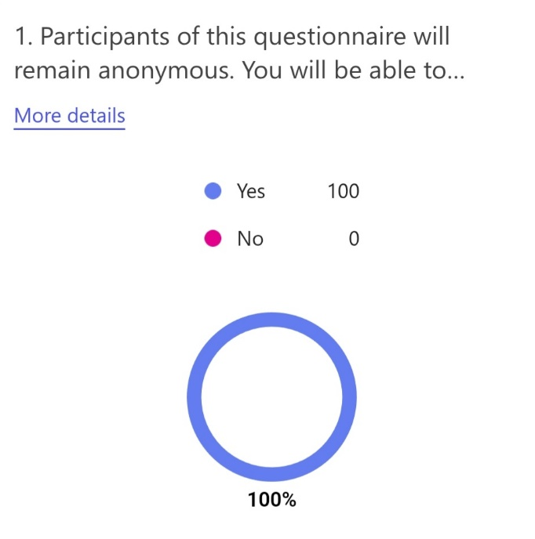
18 people from the age range of 16-24 had completed the questionnaire, 13 people were 25-34, 26 people were 35-44, 23 people were 45-54, 14 people were 55-64 and 6 people were 65-74.
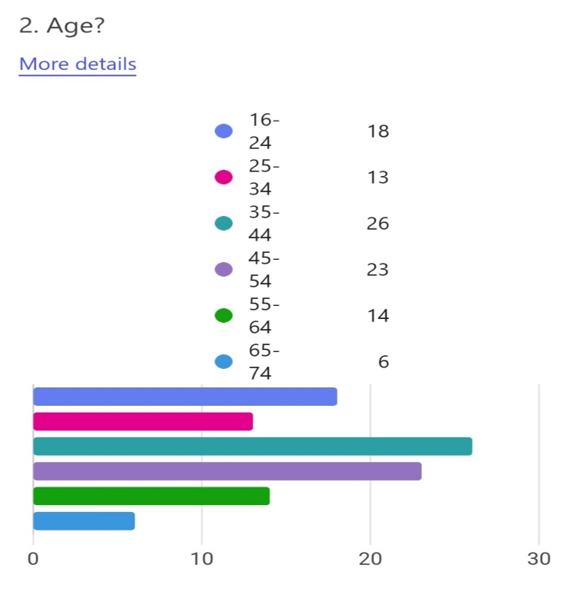
There were 90 females, 9 males and 1 preferred not to say.
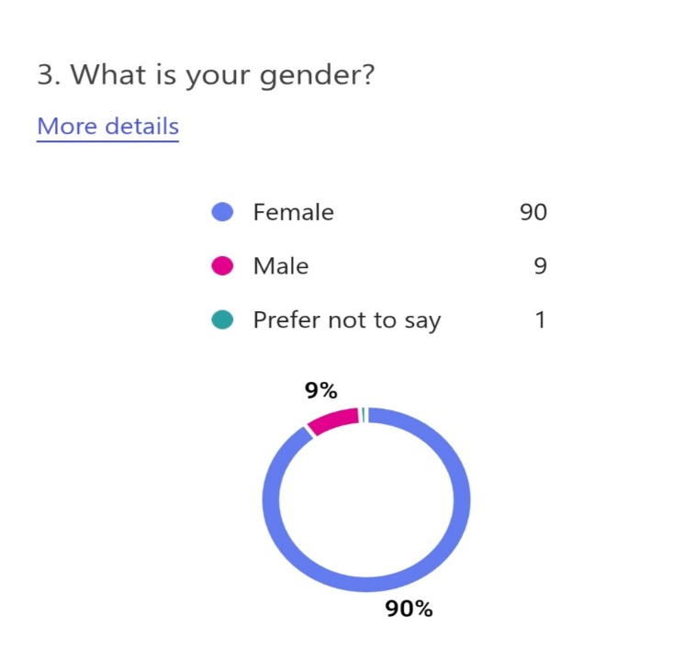
82 people stated they know what ACES are, 6 people stated they do not know ACES and 12 people stated they have heard of ACES, but they have no knowledge of it.
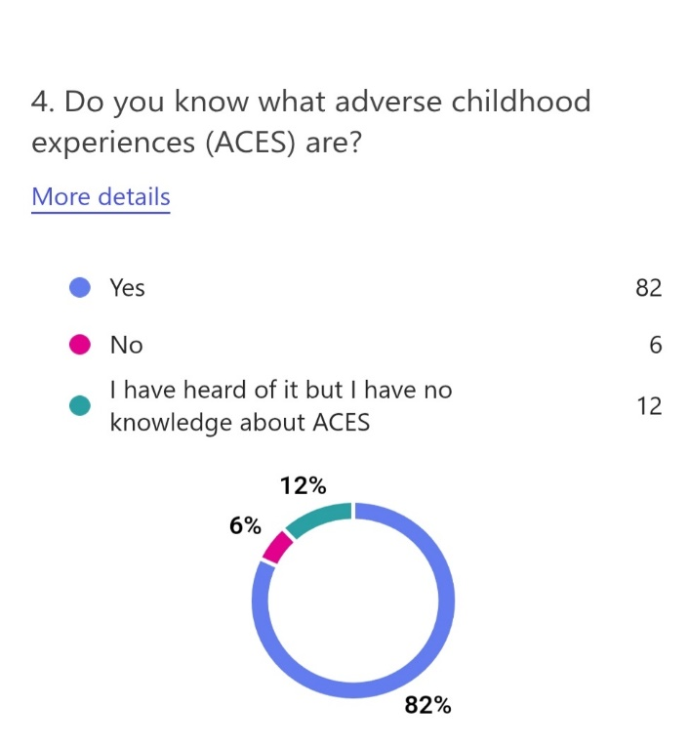
It was stated that 7 people do not know of any ACES. Physical abuse, sexual abuse and emotional abuse each had around 50 people that were aware of these ACES. Living with someone with serious mental illness, who abused drugs and alcohol, and losing a parent through divorce, death or abandonment each had around 40 people that were aware of these ACES. 43 people were aware of exposure to domestic violence, 26 people were aware of living with someone who has previously spent time in prison or is currently serving a prison sentence and 65 people were aware of all of the ACES. Turner (2019) states that the most common, original ACEs are physical, sexual and emotional abuse, and growing up living with someone who has a mental illness, experiences domestic abuse and abuses alcohol and drugs.
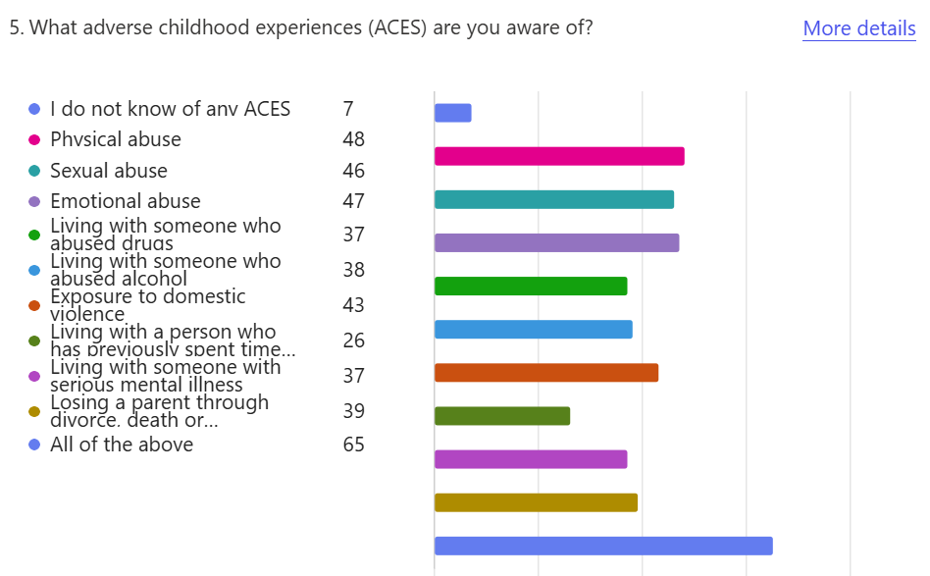
92 people stated that they think adult lives are shaped by childhood experiences, 2 people stated that they do not think adult lives are shaped by childhood experiences and 5 people said that they did not know. Taibbi (2019) stated that our childhood influences the adults we become because the emotional cracks and wounds we endure shape the way we live and act.
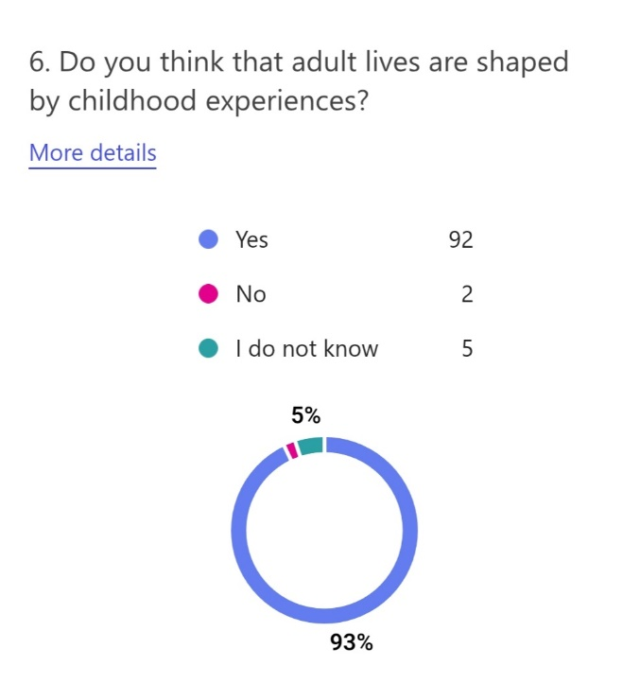
People were asked how powerful they think childhood experiences are in shaping the future adult, the graph shows that level 10 had the most votes, and that the majority of people do think that ACES are powerful and can severely impact adult lives. The average was 8.53. Singh (2014) concurs that early childhood experiences impact people and will continue to influence them well into adulthood.
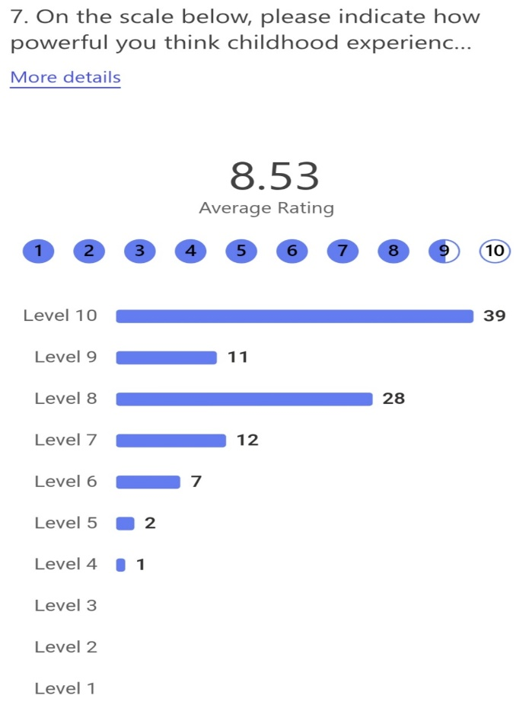
Researchers stated some childhood experiences can be very negative on a child with lasting and damaging impacts, people were asked what kind of experiences they would consider as ‘adverse’, 6 people did not know of any aces, around 21 and 22 people stated they considered emotional, sexual and physical abuse as ‘adverse’. 18 people stated they considered living with someone who abused alcohol and drugs as ‘adverse’ and 20 people stated they considered exposure to domestic violence as ‘adverse’. 13 people considered living with a person who has previously spent time in prison or is currently serving a prison sentence as ‘adverse’, 15 and 16 people considered losing a parent through divorce, death or abandonment and living with someone with serious mental illness as ‘adverse’ and 82 people considered all ACES as ‘adverse’. Ravi (2024) concurs with these statements because ACEs can lead to physical, mental and behavioural health problems which consists with being ‘adverse’.
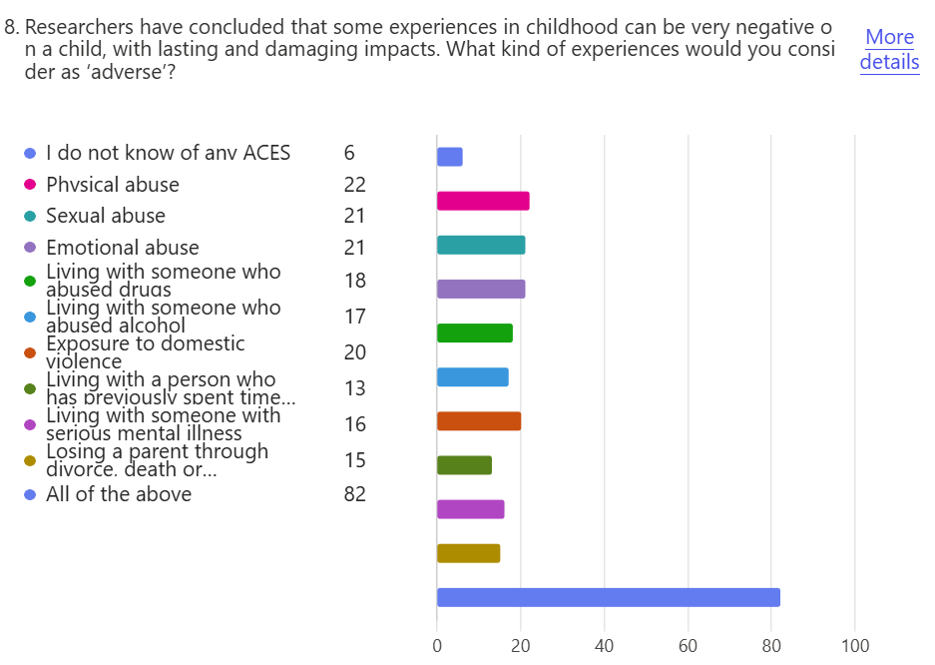
69 and 66 people think that emotional abuse and physical abuse are the most common. 62 people think that exposure to domestic violence is most common. 58 and 53 people think that losing a parent through divorce, death or abandonment and living with someone who abused alcohol are most common. 48 and 45 people think that living with someone with serious mental illness and living with someone who abused drugs are most common. 38 people think sexual abuse is most common and 16 people think living with a person who has previously spent time in prison or is currently serving a prison sentence is most common. Only 6 people did not know of any common ACES. This could indicate that there is a lack of understanding and real knowledge of ACES. His Majesty’s Inspectorate of Constabulary and Fire and Rescue Services (2022) also state that different types of abuse, neglect and living with people who suffer with mental illness, who have spent time in prison or parents that are separated are all common ACEs.
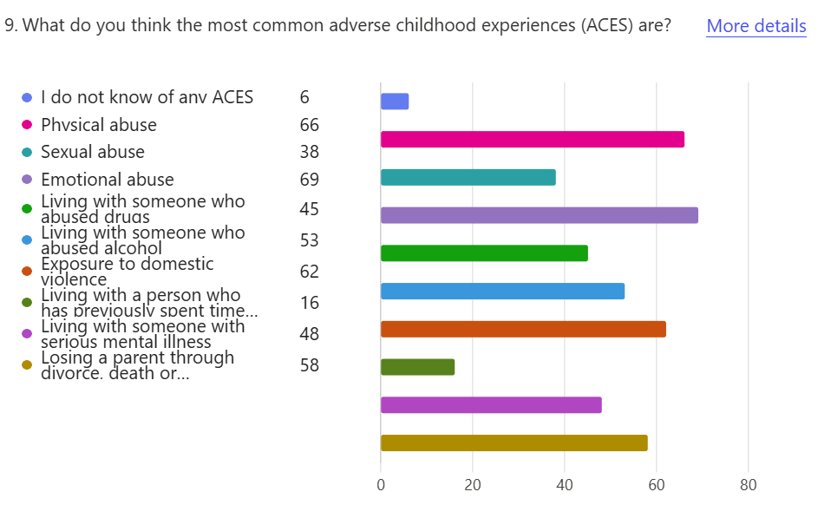
What age do people think is most common for children to experience ACES was asked during this survey, the outcome was that 10 people did not know, 9 people thought ages 0-6 was the most common, 31 people thought ages 7-12, 2 people thought ages 13-17 and 48 people thought all ages, 0-17, was the most common age for children to experience ACES. Gloucestershire Healthy Living and Learning, A (2025) states that ACEs are traumatic events that occur before the age of 18, and that for every 100 adults in England, 48 have suffered at least one ACE during their childhood.
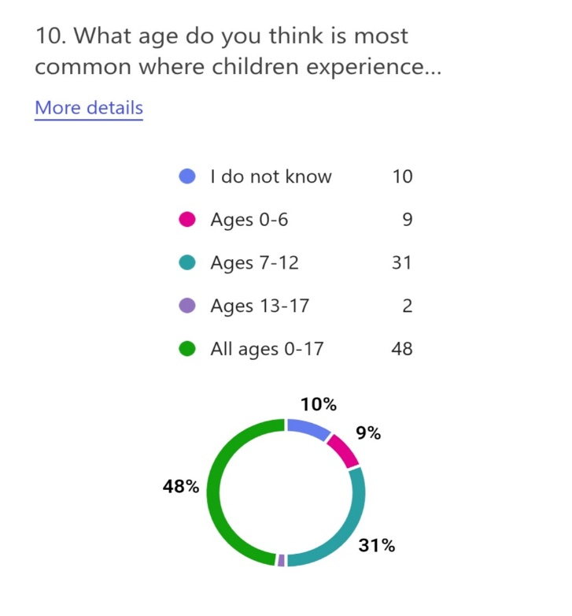
People were asked if they know anyone who experienced ACES and what they are, the results include that 15 people did not know of anyone who experienced ACES, 48 people knew someone who experienced physical abuse, 36 knew someone who experienced sexual abuse, 59 people knew someone who experienced emotional abuse and 50 knew someone who was exposed to domestic violence. 38 and 35 people knew someone who experienced living with someone with serious mental illness and living with someone who abused drugs and 44 people knew someone who experienced living with someone who abused alcohol. 14 people knew someone who experienced living with a person who has previously spent time in prison or is currently serving a prison sentence and 50 people knew someone who experienced losing a parent through divorce, death or abandonment. National Health Service (2025) correlates that these ACEs above are the most common ACEs and that they can have a huge impact to experiencing certain problems in later life.
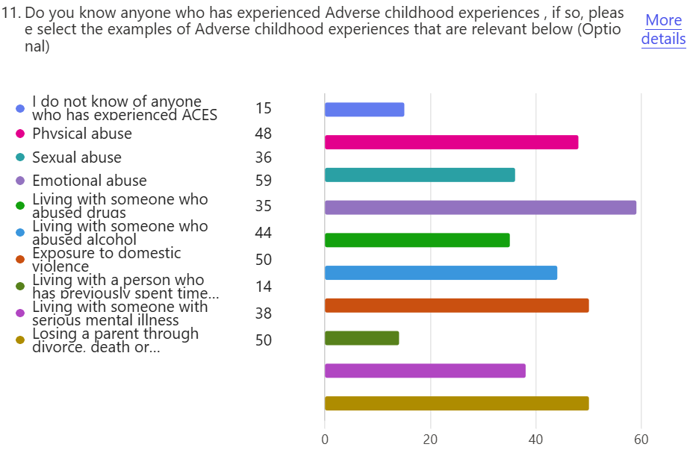
In the survey, some people had stated they knew people who had experienced ACES, it was then asked if they did, whether they had committed crime, a lot of people who knew people that had experienced ACES had committed crime. These crimes mostly include drug and alcohol offences, theft, robbery, assault, driving offences and burglary/ aggravated burglary. Criminal damage, anti-social behaviour, sex crimes, knife crimes, child neglect, domestic violence, county lines, fraud and grievous bodily harm were all also mentioned multiple times as crimes committed. Manslaughter was also mentioned once. Over half knew someone who experienced ACES had committed crime, and some people had said the person is too young to say whether they will commit crime as adults. Action on ACEs Gloucestershire (2025) correlated that anyone can experience ACEs, and they can have a negative impact on children and adults.
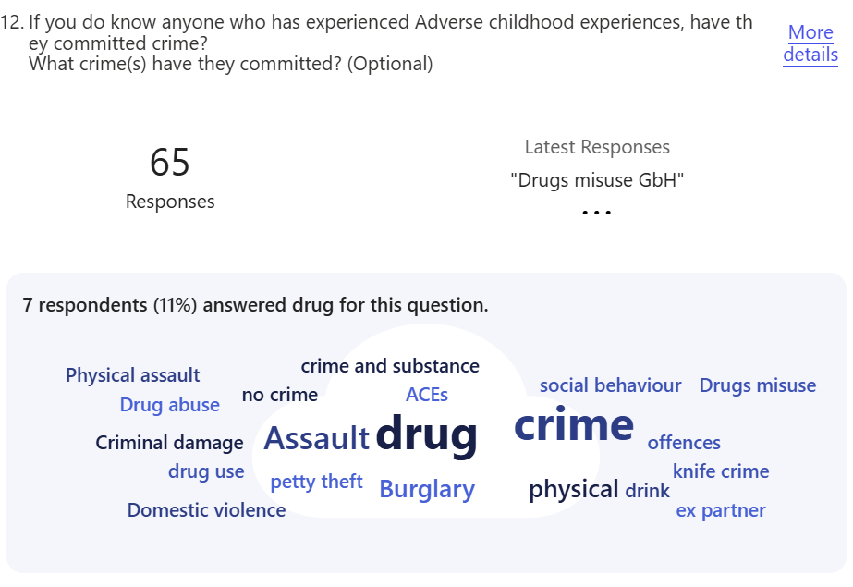
People were asked if they had experienced ACES and what they were, 39 people had not experienced ACES, 19 and 20 people had experienced sexual abuse and physical abuse and 29 people had experienced both emotional abuse and losing a parent through divorce, death or abandonment. 23 people experienced exposure to domestic violence, 13 people experienced both living with someone who abused alcohol and living with someone with serious mental illness and nobody experienced living with a person who has previously spent time in prison or is currently serving a prison sentence. 3 people had also experienced living with someone who abused drugs. The outward-bound trust (2025) states that in the UK almost half had experienced at least one ACE and over 8% have experienced four or more ACEs, they had also stated that people who have been exposed to ACEs are 2 times more likely to binge drink, 7 times more likely to be involved in violence in the last year and 11 times more likely to use heroin, cocaine or be incarcerated.
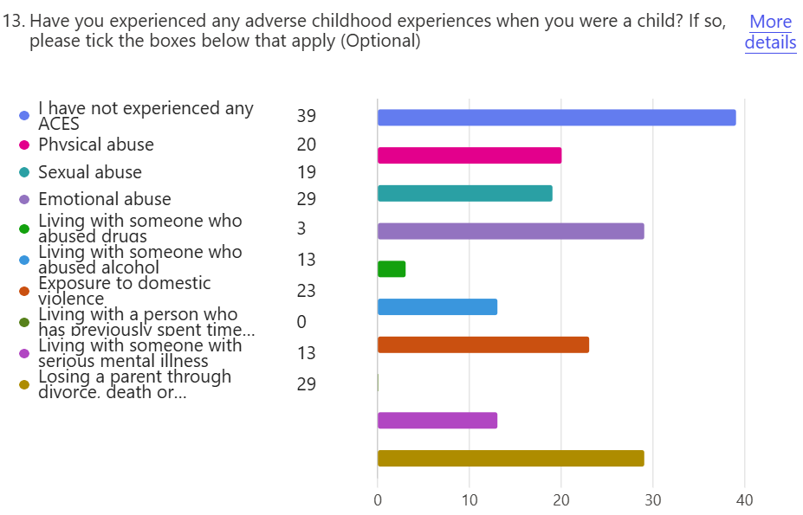
Those that had stated that they had experienced ACES, was also asked whether they had committed crime, those who did experience ACES had committed crimes such as drug use, affray, assault, theft, driving offences and alcohol offences. A minority of people who stated they experienced ACES had committed crime. Godoy medical forensics incorporated (2025) correlates that there is a higher probability that people who experience ACEs will lead to committing crime. Scottish Government, C (2018, p. 1) also states that people with 4+ ACEs were 14 times more likely to be a victim of violence, 15 times more likely to be a perpetrator of violence and 20 times more likely to have been incarcerated.
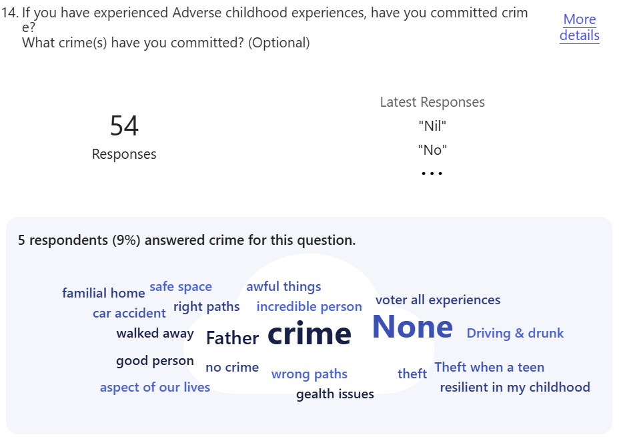
People were asked whether they think bad childhood experiences (ACES) affect children’s behaviour and turn them to crime, on a scale of 1-10, 15 people chosen numbers 9 and 10, 33 people chosen 7 and 8 and 52 people had chosen 6 and under, they were mostly 5s and 6s. TES (2024) agrees with this statement because people who experience ACEs are 4 times more likely to be a heavy drinker, 15 times more likely to commit violence, 16 times more likely to use cocaine or heroin and 20 times more likely to go to prison. They are also said to be affected by having an increased risk of mental health difficulties and developing violent behaviours, difficulties to recognise and manage different emotions, difficulties making and keeping healthy friendships and relationships and struggling in school.
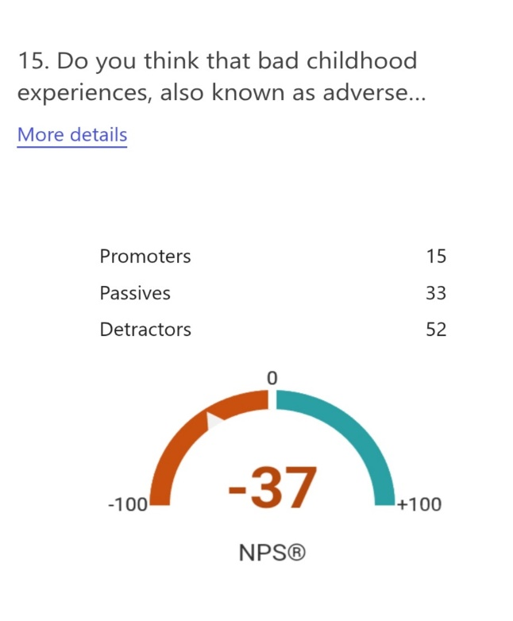
Participants were asked if they thought that ACES affected children’s behaviour and turn them to crime, the answers included that it is ‘learned behaviour from parents, caregivers and others’ that they would mirror their actions as evidenced from the Bobo doll experiment by Albert Bandura in 1961. ‘An environmental factor on how they’re shaped as people’ and ‘It is perceived as normal’ that they would potentially follow the example set from parents/caregivers, so the cycle never breaks. Other people have stated that it varies, ‘not all ACES are equal in scale or impact people’ this means that if it is a low-level ACE, it might not affect them as much as a high-level ACE and that ‘it depends on the length of time they are subjected to the ACE and their age’. Others include ‘ depends on the person themselves and how/if they can manage their emotions and trauma’ and ‘inappropriate or lack of support and positive role models, vulnerability and lack of opportunities’, ‘people may not have access or willing to receive help’, ‘they may not have an emotionally available adult, strong support network, nurture and guidance’, and ‘as a way of dealing with the experiences or to get basic needs met or if they have fallen in with the wrong crowd’. Some got different views that include ‘not everyone who experiences ACES commits crime’, ‘it may be as a result of poor mental health, a coping mechanism, a cry for help’, ‘that it could affect behaviour but not necessarily turn people to crime’, ‘it depends on the support systems put in place’ and ‘to escape reality’. Participants suggested that there are ‘many factors that could tip the scales such as poverty, friendships, society, opportunities and support networks’. Another participant stated that it is ‘nature vs nurture’. Information to Support ACEs, Trauma and Challenging Behaviour, B (2024) states that ACEs including witnessing domestic violence, experiencing sexual, physical, emotional or neglectful abuse could impact a child’s behaviour, this concurs with the statements above because the actions are being taught to the child, so they are more likely to copy the actions they see and have experienced than a child that has not experienced these types of ACES.
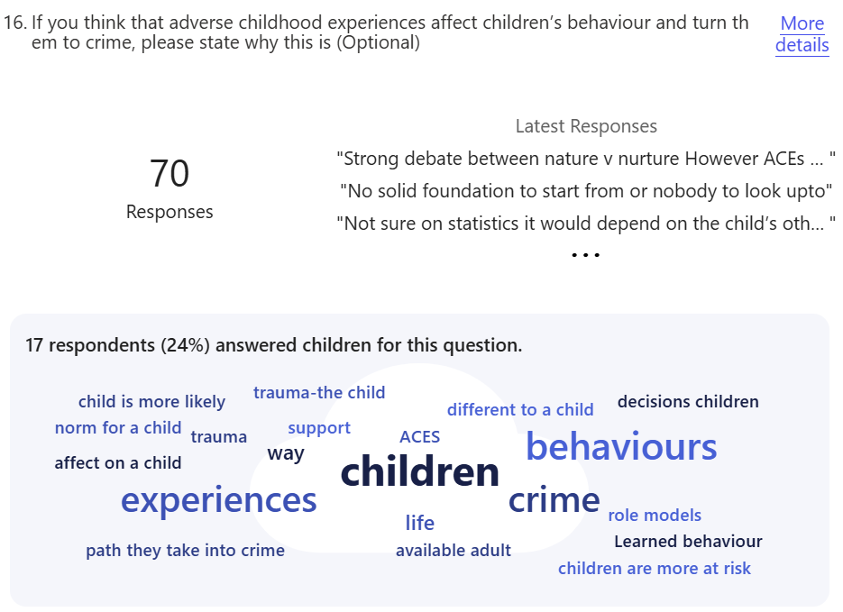
Participants had the opportunity to expand their opinions, a few responses were regarding the Bobo doll experiment and how it can relate to children learning aggressive behaviours from caregivers, that committing crime after experiencing ACES could relate to feeling undervalued and not believed as a child, making it more likely to act out due to the trauma and not trusting the police, social workers or more. Other responses include that childhood experiences help build core values and turning to crime after experiencing ACES depends on how the child/adult perceives the world, it also depends on a person’s mental health, how they cope with their emotions, think about their actions and the consequences of things. Participants have stated that it ‘depends on the opportunities and support they are given’ and ‘children that do not seek help are the ones more likely to turn to criminal behaviour’. A participant has stated they do not think ACES is the whole reason children turn to crime; however, they believe it is a large contributor to a person’s mental wellbeing and actions as an adult. Multiple responses stated that more research and funding should be put into place to ‘see how children can be protected and for more child counsellors to help them process their trauma’ this could be so that the cycle is less likely to continue. Gloucestershire Healthy Living and Learning, B (2025) concurs that preventing ACEs, intervening early and educating people about ACEs could aid in decreasing the amount of children who experience them, which could then lead to decreasing crime. Healthwise Staff (2023) agrees with providing help such as counselling, treatments for mental health conditions, and help for the parents or guardians who are struggling, which could lead to children experiencing ACEs.
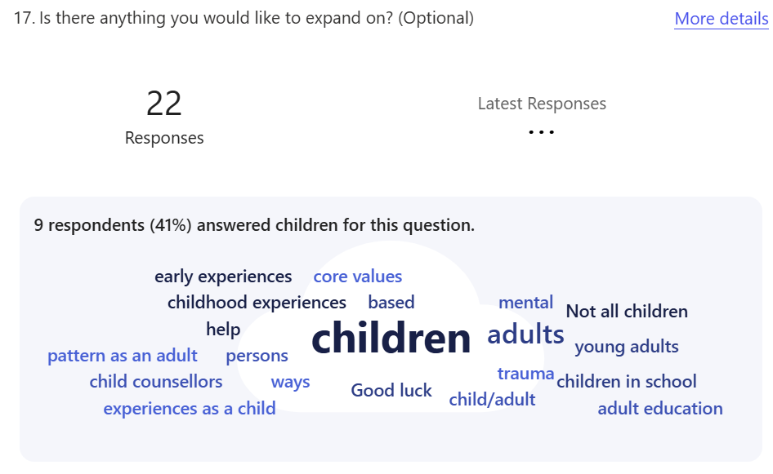

Conclusion
This concludes that experiencing ACES can have a negative impact on people that can make it more likely to develop a change in behaviour and even commit crime. Experiencing ACES have shown to be related to multiple negative outcomes from children into adulthood such as behaviour problems, violent and chronic offending and unable to keep a job (Van Duin et al, 2020, pp. 637-654). Factors that can influence poor outcomes in adulthood could include less common ACES such as poverty, housing, social isolation and discrimination (Bateson and McManus and Johnson, 2020, pp. 131-145). Public Health Wales (2015) has stated that ACES can impact peoples social, emotional and cognitive impairment, they can adopt high risk behaviours and criminal behaviours, and they can create social problems and low productivity. This correlates with the statement that ACES can increase the risk of committing crime and antisocial behaviour. Public Health Wales (2015) also stated that verbal and physical abuse, parental separation and domestic violence are the most common ACES that people have experienced. The survey had stated that physical and emotional abuse, domestic violence and losing a parent through divorce, death or abandonment were also the most common ACES that people have experienced. Providing individuals with training, education, more funding for professionals to help tackle ACES and therapy for children who experience ACES could reduce crime associated with ACES. These crimes include anti-social behaviour (ASB), violence and domestic abuse. Providing positive responses to people regarding ACES, improving information sharing between agencies and collaborating with working practices can enable benefits beyond the police, such as for prisons, probation, youth justice services, social services and healthcare. It could result in a reduction in crime which could also lead to helping the agencies stated above to ease their work load, reduce the prison population, and increase funding for all of the agencies (Ramessur-Williams et al, 2019, pp. 32-36). Other examples to decrease the risk of children experiencing ACES or to aid in identifying and helping people with ACES can include providing clinical support for those who have experienced ACES, providing training to all workers who work with people who have experienced ACES and to develop an efficient approach to trauma-informed practice. Gray and Smithson and Jump (2021, p. 14) concur with this statement because they suggest that dealing with ACES and decreasing the risk of children experiencing them would be ideal in preventing more crime such as anti-social behaviour, they state that to do this, providing funding for delivering training for qualified professionals and anyone in the youth justice system that may come across working with someone who experienced ACES would be effective to ensure that people understand how to help a child and deal with the situation of ACES. These youth justice services could also include the police, professionals that work with children with ACES every day, such as social workers, teachers, nurses, counsellors, therapists and more. Gray and Smithson and Jump (2021, p. 14) also state that developing a systemic approach to trauma-informed practice that educates people on the identification of ACES and trauma-informed interventions should not only be the youth justice systems responsibility. They suggest that trauma-informed practice and education on ACES should be taught to and by schools, children’s services, health services, the police and qualified professionals. Funding to do this could result in a decline of children experiencing ACES because more and more people will be educated and can educate others about the signs and how to deal with ACES and help the children who experience them. If this is offered at an early stage in a child’s life Gray and Smithson and Jump (2021, p. 14) have also concluded that it could reduce the number of children experiencing ACES which later on, could decrease the risk of criminal behaviour and committing crime. The most common ACES that was used in the survey included physical, emotional and sexual abuse, domestic abuse, living with someone who has a mental illness, who was in prison and who abused drugs and alcohol, losing someone from death, divorce or abandonment was also a common ACE that was used in the survey. HM Inspectorate of Probation (2025) concurs that these ACES are the most common ACES that children experience. They also state that experiencing ACES can cause children to develop certain traits due to the trauma as a way to help the child survive, these can include increasing risks of committing crime, ASB and offending behaviour. Socioeconomic disparities, family dynamics, peer influence, substance abuse, lack of access to education, unemployment and mental health disorders are all reasons why people could commit crime (Alliant International University, 2023). These examples concur with the statements why people could commit crime because some of them are also ACES. This could be because they are in a low-income family, living in poverty, difficulty to find and keep a job or have a mental illness which could be difficult to get a job and provide money for themselves and family. They may not have access to a good education to get a good job that pays enough so they turn to crime. Family members could have been involved in crime so they could have been born into a life of crime or just follow their families lifestyle.

References
Asmussen, K., Fischer, F., Drayton, E. and McBride, T. (2020) Adverse childhood experiences: What we know, what we don’t know, and what should happen next. Available at: https://www.eif.org.uk/report/adverse-childhood-experiences-what-we-know-what-we-dont-know-and-what-should-happen-next (Accessed: 17 October 2024).
Asmussen, K. and McBride, T. (2021) Adverse childhood experiences: Building consensus on what should happen next. Available at: aces-building-consensus-on-what-should-happen-next.pdf (Accessed: 11 November 2024).
ACES Matter (2022) Understanding ACEs. Available at: https://www.acesmatter.org/understanding-aces.html (Accessed: 11 November 2024).
ACES aware (2020) Trauma-Informed Care Overview. Available at: https://www.acesaware.org/wp-content/uploads/2020/05/Provider-Toolkit-Trauma-Informed-Care-Overview.pdf#:~:text=Trauma-informed%20care%20recognizes%20and%20responds%20to%20the%20signs%2C,adversity%20and%20their%20impacts%20on%20health%20and%20behavior%3B (Accessed: 21 November 2024).
Action on ACEs Gloucestershire. (2025) Key facts and figures. Available at: https://www.actionaces.org/key-facts-and-figures/ (Accessed: 11 March 2025).
Alliant International University (2023) ‘Why Do People Commit Crimes? (Nine Reasons)’, Forensics [blog]. Available at: https://www.alliant.edu/blog/why-do-people-commit-crimes (Accessed: 13 March 2025).
Boullier, M. and Blair, M. (2018) ‘Adverse childhood experiences’, Paediatrics and child health, 28(3), pp 132-137. Available at: https://www.sciencedirect.com/science/article/pii/S1751722217302913#:~:text=Those%20people%20who%20have%20experienced%20four%20or%20more,relationship%20between%20ACEs%2C%20disease%20and%20potentially%20early%20death. (Accessed: 17 October 2024).
Darwen Borough Council (2024) Childhood trauma. Available at: https://www.blackburn.gov.uk/health/childhood-trauma/impact-aces (Accessed: 11 November 2024).
Breedlove, M. and Choi, J. and Zyromski, B. (2020) Mitigating the Effects of Adverse Childhood Experiences: How Restorative Practices in Schools Support Positive Childhood Experiences and Protective Factors, The New Educator. DOI: https://doi.org/10.1080/1547688X.2020.1807078
Bellis, M.A. (2023) Tackling Adverse Childhood Experiences (ACES). Available at: https://www.ljmu.ac.uk/-/media/phi-reports/pdf/2023-01-state-of-the-art-report-eng.pdf (Accessed: 20 November 2024).
Bateson, K. and McManus, M. and Johnson, G. (2020) ‘Understanding the use, and misuse, of Adverse Childhood Experiences (ACEs) in trauma-informed policing’, The Police Journal: Theory, Practice and Principles, 93(2), pp. 131-145. DOI: https://doi-org.ezproxy.uwtsd.ac.uk/10.1177/0032258X19841409
Centres for Disease Control and Prevention (2024) About adverse childhood experiences. Available at: https://www.cdc.gov/aces/about/ (Accessed: 17 October 2024).
Cleveland Clinic (2023) Adverse childhood experiences (ACES). Available at: https://my.clevelandclinic.org/health/symptoms/24875-adverse-childhood-experiences-ace (Accessed: 17 October 2024).
Cafasso, J. (2023) Traumatic Events. Available at: https://www.healthline.com/health/traumatic-events (Accessed: 08 November 2024).
Centre for Child Counselling (2019) Adverse Childhood Experiences: What Everyone Needs to Know. Available at: https://centerforchildcounseling.org/wp-content/uploads/2020/12/General-ACEs-Brochure.pdf (Accessed: 11 November 2024).
College of Policing (2015, A) College of Policing analysis: Estimating demand on the police service. Available at: https://assets.college.police.uk/s3fs-public/2021-03/demand-on-policing-report.pdf (Accessed: 19 November 2024).
College of Policing (2013, B) Strategic planning. Available at: https://www.college.police.uk/app/operations/operational-planning/strategic-planning (Accessed: 19 November 2024).
College of Policing (2021, C) Evaluation of the trusted adult workers role and Rock Pool train the trainer educational approach. Available at: https://assets.college.police.uk/s3fs-public/2021-07/vvcp-evaluation-taws-ttt-key-findings-practice-implications.pdf (Accessed: 20 November 2024).
Emerald Publishing (2025) How to… Carry out action research. Available at: https://www.emeraldgrouppublishing.com/how-to/research-methods/carry-out-action-research (Accessed: 31 January 2025).
Fox, B.H., Perez, N., Cass, E., Baglivio, M.T. and Epps, N. (2015) ‘Trauma changes everything: Examining the relationship between adverse childhood experiences and serious, violent and chronic juvenile offenders’, Child abuse & neglect, (46), pp. 163–173. DOI: https://doi.org/10.1016/j.chiabu.2015.01.011
Fuller-Thomson, E, Roane, J.L. and Brennenstuhl, S. (2016) ‘Three types of adverse childhood experiences, and alcohol and drug dependence among adults: an investigation using population-based data’, Substance use and misuse, 51 (11) DOI: https://doi.org/10.1080/10826084.2016.1181089
Felitti, V.J., Anda, R.F., Nordenberg, D., Williamson, D.F., Spitz, A.M., Edwards, V., Koss, M.P. and Marks, J.S. (1998) ‘Relationship of Childhood Abuse and Household Dysfunction to Many of the Leading Causes of Death in Adults: The Adverse Childhood Experiences (ACE) Study’, American Journal of Preventive Medicine, 14(4), pp. 245-258. DOI: https://doi.org/10.1016/S0749-3797(98)00017-8
Fleming, C.M. and Nurius, P.S. (2020) “Incarceration and adversity histories: Modelling life course pathways affecting behavioural health”, American Journal of Orthopsychiatry, 90(3), pp. 312–323. DOI: https://doi.org/10.1037/ort0000436
Goodall, K., Brodie, Z., Deacon, K., Collins, K. and Gillespie-Smith, K. (2023) ‘How the police conceptualise and view the relevance of Adverse Childhood Experiences (ACEs) for policing: A qualitative investigation’, Policing an International Journal, 46(2), pp. 1-28. Available at: Goodalletal2023ACEspoliceAAM (2).PDF (Accessed: 19 November 2024).
Gabriel, D. (2013) Inductive and deductive approaches to research. Available at: https://deborahgabriel.com/2013/03/17/inductive-and-deductive-approaches-to-research/ (Accessed: 31 January 2025).
Gloucestershire Healthy Living and Learning. (2025, A) ACEs – Adverse Childhood Experiences. Available at: https://www.ghll.org.uk/mental-health/aces---adverse-childhood-experiences/ (Accessed: 11 March 2025).
Godoy medical forensics incorporated. (2025) Does childhood trauma lead to criminal behaviour? Available at: https://godoymedical.net/does-childhood-trauma-lead-to-criminal-behavior/ (Accessed: 11 March 2025).
Gloucestershire Healthy Living and Learning. (2025, B) ACEs – Adverse Childhood Experiences. Available at: https://www.ghll.org.uk/mental-health/aces---adverse-childhood-experiences/ (Accessed: 11 March 2025).
Gray, P. and Smithson, H. and Jump, D. (2021) Serious youth violence and its relationship with adverse childhood experiences. Available at: https://www.justiceinspectorates.gov.uk/hmiprobation/wp-content/uploads/sites/5/2021/11/Academic-Insights-Gray-et-al.pdf (Accessed: 13 March 2025).
Hughes, K., Bellis, M.A., Hardcastle, K.A., Sethi, D., Butchart, A., Mikton, C., Jones, L. and Dunne, M.P. (2017) ‘The effect of multiple adverse childhood experiences on health: a systematic review and meta-analysis’, The Lancet Public Health, 2(8), pp. 1-11. Available at: https://www.thelancet.com/journals/lanpub/article/PIIS2468-2667(17)30118-4/fulltext (Accessed: 11 November 2024).
Duvvuri, H. (2016) Difference Between Ontology and Epistemology. Available at: https://pediaa.com/difference-between-ontology-and-epistemology/ (Accessed: 16 January 2025).
Hassan, M. (2024, A) Survey Research – Types, Methods, Examples. Available at: https://researchmethod.net/survey-research/ (Accessed: 31 January 2025).
Hassan, M. (2024, B) Case Study – Methods, Examples and Guide. Available at: https://researchmethod.net/case-study-research/ (Accessed: 31 January 2025).
Hassan, M. (2024, C) Grounded Theory – Methods, Examples and Guide. Available at: https://researchmethod.net/grounded-theory/#:~:text=Grounded%20theory%20is%20a%20qualitative%20research%20method%20used,to%20generate%20insights%20grounded%20in%20the%20data%20itself. (Accessed: 31 January 2025).
His Majesty’s Inspectorate of Constabulary and Fire and Rescue Services. (2022) Adverse childhood experiences (ACEs). Available at: https://hmicfrs.justiceinspectorates.gov.uk/glossary/adverse-childhood-experiences/#:~:text=The%20ten%20widely%20recognised%20ACEs%20are%3A%201%20abuse,have%20spent%20time%20in%20prison%2C%20parents%20have%20separated. (Accessed: 11 March 2025).
Healthwise Staff. (2023) Understanding How Adverse Childhood Experiences (ACEs) Can Affect Children. Available at: https://myhealth.alberta.ca/health/pages/conditions.aspx?Hwid=acm1499#:~:text=Adverse%20childhood%20experiences%20%28ACEs%29%20are%20things%20that%20happen,and%20family%20mental%20health%20or%20substance%20use%20problems. (Accessed: 11 March 2025).
HM Inspectorate of Probation (2025) Adversity and trauma. Available at: https://hmiprobation.justiceinspectorates.gov.uk/our-research/evidence-base-youth-justice/specific-areas-of-delivery/adversity-and-trauma/ (Accessed: 13 March 2025).
Information to Support ACES, Trauma & Challenging Behaviour. (2024, A) Adverse Childhood Experiences. Available at: https://helpchildrenlivebetter.co.uk/what-are-aces/ (Accessed: 08 November 2024).
Information to Support ACEs, Trauma and Challenging Behaviour. (2024, B) Adverse Childhood Experiences. Available at: https://helpchildrenlivebetter.co.uk/what-are-aces/ (Accessed: 11 March 2025).
Jahanshahi, B. and Murray, K. and McVie, S. (2021) ‘ACEs, Places and Inequality: Understanding the Effects of Adverse Childhood Experiences and Poverty on Offending in Childhood’, The British Journal of Criminology, 62(3), P. 751–772. DOI: https://doi.org/10.1093/bjc/azab079
Janssen, H., Harker, S., Barton, E.R., Newbury, A., Jones, B. and Ramos Rodriguz, G. (2020) Enabling early intervention and prevention in the policing of vulnerability: An executive summary. Available at: https://www.rsph.org.uk/static/f9b809fe-8938-4480-af323542dcdefa1d/PHW-EAT-Police-Perspectives-report.pdf (Accessed: 20 November 2024).
Jyotsna, S. (2023) Data Collection. Available at: https://www.wallstreetmojo.com/data-collection/ (Accessed: 04 February 2025).
Knopf, A. (2024) ‘Reduce juvenile crime by preventing and treating ACEs’, The Brown University Child & Adolescent Psychopharmacology Update, 26(10), pp. 1-42. DOI: https://doi.org/10.1002/cpu30900
Kettler, S. and Piccotti, T. (2023) Inside Ted Bundy’s Troubled and Disturbing Childhood. Available at: https://www.biography.com/crime/ted-bundy-childhood (Accessed: 02 February 2025).
Liverpool CAMHS (2024) What are Adverse Childhood Experiences ACEs? Available at: https://www.liverpoolcamhs.com/aces/what-are-adverse-childhood-experiences/ (Accessed: 11 November 2024).
Manchester University NHS Foundation Trust (2024) Adverse Childhood Experiences (ACES) and Attachment. Available at: https://mft.nhs.uk/rmch/services/camhs/young-people/adverse-childhood-experiences-aces-and-attachment/ (Accessed: 08 November 2024).
McLeod, S. (2024) Ethnography in Qualitative Research. Available at: https://www.simplypsychology.org/ethnography.html#:~:text=Ethnography%20is%20a%20qualitative%20research%20method%20that%20emphasizes,how%20the%20group%20develops%20cultural%20constructions%20and%20relations. (Accessed: 02 February 2025).
National Institute for Health and Care Research (2023) Adverse childhood experiences: what support do young people need? Available at: https://evidence.nihr.ac.uk/collection/adverse-childhood-experiences-what-support-do-young-people-need/ (Accessed: 17 October 2024).
National Centre on Health, Behavioural Health, and Safety (2024) Trauma and Adverse Childhood Experiences. Available at: https://eclkc.ohs.acf.hhs.gov/sites/default/files/pdf/02728-trauma-adverse-pdf-eng.pdf (Accessed: 11 November 2024).
Nickerson, C. (2024) Interpretivism Paradigm & Research Philosophy. Available at: https://www.simplypsychology.org/interpretivism-paradigm.html (Accessed: 16 January 2025).
National Health Service. (2025) Adverse childhood experiences and the lasting impact. Available at: https://safeguarding-guide.nhs.uk/context-of-NHS-safeguarding/s2-06/ (Accessed: 11 March 2025).
Public Health Wales (2015) Adverse Childhood Experiences (ACEs) in Wales. Available at: https://phw.nhs.wales/files/aces/infographic-aces-and-their-impact-on-health-harming-behaviours-in-the-welsh-adult-population/ (Accessed: 11 November 2024).
Pessoa, T.M.G. and Almeida, T.C. (2024) ‘The Link Between Adverse Childhood Experiences and Mental Health in Offenders: A Systematic Review’, Crime & Delinquency. DOI: https://doi.org/10.1177/00111287241242478
Public Health Wales (2023) Burden of ACEs and evidence for action across Europe brought together for first time. Available at: https://phw.nhs.wales/news/burden-of-aces-and-evidence-for-action-across-europe-brought-together-for-first-time/ (Accessed: 19 November 2024).
Public Health Wales (2015) Adverse Childhood Experiences. Available at: https://phw.nhs.wales/files/aces/aces-and-their-impact-on-health-harming-behaviours-in-the-welsh-adult-population-pdf/ (Accessed: 13 March 2025).
Ravi, R. (2024) Understanding Adverse Childhood Experiences (ACEs): A Guide for Everyone. Available at: https://www.reclaim13.org/hcblog/understanding-adverse-childhood-experiences-aces-a-guide-for-everyone (Accessed: 11 March 2025).
Ramessur-Williams, J., Newbury, A., McManus, M.A. and Rivers, S.A. (2019) ‘Benefits of delivering Adverse Childhood Experience (ACE) training to police: An individual perspective’, Journal of Community Safety and Well-Being, 4(2), pp. 32-36. DOI: https://doi.org/10.35502/jcswb.99
Scottish Government (2018, A) Understanding childhood adversity, resilience and crime. Available at: https://www.gov.scot/publications/understanding-childhood-adversity-resilience-crime/ (Accessed: 17 October 2024).
Scottish Government (2018, B) Understanding childhood adversity, resilience and crime. Available at: https://www.gov.scot/binaries/content/documents/govscot/publications/research-and-analysis/2018/05/understanding-childhood-adversity-resilience-crime/documents/00535550-pdf/00535550-pdf/govscot%3Adocument/00535550.pdf (Accessed: 14 November 2024).
Scott, K. (2020) ‘Adverse childhood experiences’, InnovAiT, 14(1). DOI: https://doi.org/10.1177/1755738020964498
Saunders, M. and Lewis, P. and Thornhill, A. (2007) Research Methods for Business Students. 8th edn. London: Pearson.
Singh, M. (2014) Some Early Childhood Experiences Shape Adult Life, But Which Ones? Available at: https://www.npr.org/sections/health-shots/2014/12/19/371679655/some-early-childhood-experiences-shape-adult-life-but-which (Accessed: 11 March 2025).
Scottish Government (2018, C) Understanding childhood adversity, resilience and crime. Available at: https://www.gov.scot/binaries/content/documents/govscot/publications/research-and-analysis/2018/05/understanding-childhood-adversity-resilience-crime/documents/00535550-pdf/00535550-pdf/govscot%3Adocument/00535550.pdf (Accessed: 11 March 2025).
The University of Edinburgh (2022) Childhood trauma linked to risk of adult crime. Available at: https://www.ed.ac.uk/news/2022/vulnerable-children-more-likely-to-offend-as-adult (Accessed: 17 October 2024).
This vs. That (2023) Positivism vs. Pragmatism. Available at: https://thisvsthat.io/positivism-vs-pragmatism (Accessed: 16 January 2025).
Tourism Teacher (2023) The research onion for beginners. Available at: https://tourismteacher.com/research-onion-beginners/ (Accessed: 04 February 2025).
Turner, A. (2019) Good intentions but the right approach? The case of ACEs. Available at: https://publichealthy.co.uk/good-intentions-but-the-right-approach-the-case-of-aces/ (Accessed: 11 March 2025).
Taibbi, R. (2019) 4 Key Ways Your Childhood Shapes You. Available at: https://www.psychologytoday.com/us/blog/fixing-families/201903/4-key-ways-your-childhood-shapes-you#:~:text=Like%20the%20foundation%20of%20a%20house%2C%20our%20childhood,these%20affect%20the%20structure%20of%20our%20adult%20lives.?msockid=196bd365698361be3365c1226848609b (Accessed: 11 March 2025).
The outward-bound trust. (2025) ‘A focus on ACES – Adverse childhood experiences’, Outdoor learning [blog]. Available at: https://www.outwardbound.org.uk/blog/a-focus-on-aces#:~:text=There%20are%20ten%20ACEs%2C%20divided%20into%20three%20categories%3A,impact%20on%20a%20young%20person%27s%20ability%20to%20learn. (Accessed: 11 March 2025).
TES. (2024) ‘Adverse Childhood Experiences: What are ACEs and how do they Affect Children, Young People and Adults?’, For schools [blog]. Available at: https://www.tes.com/en-gb/for-schools/blog/article/adverse-childhood-experiences-what-are-aces (Accessed: 11 March 2025).
Ventresca, M.J. and Mohr, J.W. (2017) ‘Archival Research Methods’, The Blackwell Companion to Organizations. DOI: https://doi.org/10.1002/9781405164061.ch35
Van Duin, L., De Vries Robbe, M., Marhe, R., Bevaart, F., Zijlmans, J., Luijks, M-J.A., Doreleijers, T.A.H. and Popma, A. (2020) ‘Criminal History and Adverse Childhood Experiences in Relation to Recidivism and Social Functioning in Multi-problem Young Adults', Criminal Justice and Behaviour, 48(5), pp. 637-654. DOI: https://doi.org/10.1177/0093854820975455
Wisner, W. (2022) Adverse Childhood Experiences (ACES). Available at: https://www.verywellmind.com/what-are-aces-adverse-childhood-experiences-5219030 (Accessed: 28 October 2024).
Webster, E.M. (2022) ‘The Impact of Adverse Childhood Experiences on Health and Development in Young Children’, Global paediatric health. DOI: 10.1177/2333794X221078708
Williams, K. and Papadopoulou, V. and Booth, N. (2012) Prisoners’ childhood and family backgrounds. Available at: https://www.researchgate.net/profile/Natalie-Booth-3/publication/296701221_Prisoners'_Childhood_and_Family_Backgrounds/links/56d94afc08aee1aa5f817573/Prisoners-Childhood-and-Family-Backgrounds.pdf (Accessed: 14 November 2024).
15Writers (2024) Understanding the Research Onion. Available at: https://15writers.com/research-onion/ (Accessed: 02 February 2025).

Appendices

Appendix – Questionnaire
Do Adverse Childhood Experiences (ACES) Shape Criminal Behaviour in Adulthood?

16 December 2024
My name is Courtney Curtis, I am in my final year of my Professional Policing degree at UWTSD. This questionnaire will aid in my dissertation research. It will consist of short answer questions that will take approximately 10 minutes.
For further questions, please email me at 2204829@student.uwtsd.ac.uk

- Participants of this questionnaire will remain anonymous. You will be able to withdraw at any time before submitting. By submitting the questionnaire, you are consenting for me to use the information that has been submitted
Yes □
No □

- Age?
16-24 □
25-34 □
35-44 □
45-54 □
55-64 □
65-74 □

- What is your gender?
Female □
Male □
Prefer not to say □

- Do you know what adverse childhood experiences (ACES) are?
Yes □
No □
I have heard of it, but I have no knowledge about ACES □

- What adverse childhood experiences (ACES) are you aware of?
I do not know of any ACES □
Physical abuse □
Sexual abuse □
Emotional abuse □
Living with someone who abused drugs □
Living with someone who abused alcohol □
Exposure to domestic violence □
Living with someone who has previously spent time in prison or is currently serving a prison sentence □
Living with someone with serious mental illness □
Losing a parent through divorce, death or abandonment □
All of the above □

- Do you think that adult lives are shaped by childhood experiences?
Yes □
No □
I do not know □

- On the scale below, please indicate how powerful you think childhood experiences are in shaping the future adult- 1= Not at all, 10= Extremely
Level 1 □
Level 2 □
Level 3 □
Level 4 □
Level 5 □
Level 6 □
Level 7 □
Level 8 □
Level 9 □
Level 10 □

- Researchers have concluded that some experiences in childhood can be very negative on a child, with lasting and damaging impacts. What kind of experiences would you consider as ‘adverse’?
I do not know of any ACES □
Physical abuse □
Sexual abuse □
Emotional abuse □
Living with someone who abused drugs □
Living with someone who abused alcohol □
Exposure to domestic violence □
Living with someone who has previously spent time in prison or is currently serving a prison sentence □
Living with someone with serious mental illness □
Losing a parent through divorce, death or abandonment □
All of the above □

- What do you think the most common adverse childhood experiences (ACES) are?
I do not know of any ACES □
Physical abuse □
Sexual abuse □
Emotional abuse □
Living with someone who abused drugs □
Living with someone who abused alcohol □
Exposure to domestic violence □
Living with someone who has previously spent time in prison or is currently serving a prison sentence □
Living with someone with serious mental illness □
Losing a parent through divorce, death or abandonment □

- What age do you think is most common where children experience adverse childhood experiences (ACES)?
I do not know □
Ages 0-6 □
Ages 7-12 □
Ages 13-17 □
All ages 0-17 □

- Do you know anyone who has experienced Adverse childhood experiences, if so, please select the examples of Adverse childhood experiences that are relevant below (Optional)
I do not know of anyone who has experienced ACES □
Physical abuse □
Sexual abuse □
Emotional abuse □
Living with someone who abused drugs □
Living with someone who abused alcohol □
Exposure to domestic violence □
Living with someone who has previously spent time in prison or is currently serving a prison sentence □
Living with someone with serious mental illness □
Losing a parent through divorce, death or abandonment □

- If you do know anyone who has experienced Adverse childhood experiences, have they committed crime?
What crime(s) have they committed? (Optional)
…………………………………………………………………………

- Have you experienced any adverse childhood experiences when you were a child? If so, please tick the boxes below that apply (Optional)
I have not experienced ACES □
Physical abuse □
Sexual abuse □
Emotional abuse □
Living with someone who abused drugs □
Living with someone who abused alcohol □
Exposure to domestic violence □
Living with someone who has previously spent time in prison or is currently serving a prison sentence □
Living with someone with serious mental illness □
Losing a parent through divorce, death or abandonment □

- If you have experienced Adverse childhood experiences, have you committed crime?
What crime(s) have you committed? (Optional)
………………………………………………………………………..

- Do you think that bad childhood experiences, also known as adverse childhood experiences, affect children’s behaviour and turn them to crime?
Promoters □
Passives □
Detractors □

- If you think that adverse childhood experiences affect children’s behaviour and turn them to crime, please state why this is (Optional)
…………………………………………………………………………..

- Is there anything you would like to expand on? (Optional)
………………………………………………………………………………………..

