
LEVEL/ LEfEL 5

SEMESTER 1

MODULE CODE/ Cod Y modIwl: M5X01050
NETWORK SERVICES
aSSESSMENT TYPE/ mATH O ASESU: aSSIGNMENT
Assessment/Component/ AsESIAD/CYDRAN: 1

COMPONENT WEIGHTING/ PWYSAU’R CYDRAN: 100 %

WORD COUNT (or WORD COUNT EQUIVALENT)/ NIFER Y GEIRIAU:
2500 WORDS/O EIRIAU

MODULE TUTOR / TIWTOR Y MODIWL: Seamus Hillen

SUBMISSION DETAILS/ MANYLION CYFLWYNO:

- Make sure that Your Name , Your Student P Number, Your Module Title, Assignment Title and Your Module Lecturer’s Name are clearly shown on the front page of your assignment
- All assignments must be submitted electronically to Turnitin unless indicated by the module lecturer here: …………………………………………...
- If lecturer additionally requires you to upload coding separately to Moodle it will be indicated here: ………….NO………..….
- If a paper submission is required then it will be indicated here: …NO……….
you will then be required to submit the assignment parts in a suitable report folder– not in poly-pockets - to the library. For paper submissions only this form (ALL PAGES) MUST be printed out, signed, attached to the front of your assignment and submitted to the library separately from your electronic assignment submission. Paper submission assignments will not be accepted without this form as it is a requirement that you sign the disclosure regarding the referencing convention.
- DO NOT put this form into Turnitin or it will match many similarities with other students’ submissions.

71/100

RESULT

School of Applied Computing ASSIGNMENT SPECIFICATION

Student name: | Ryan Gallagher | Student P number: | 1503468
Programme: | HND Computing
Lecturer: | Seamus Hillen | Internal Verifier:
Assignment Title:
Hand Out Date: | Feb 2018 | Submission deadline: | 18th May 2018
Referencing: | In the main body of your submission you must give credit to authors on whose research your work is based. Append to your submission a reference list that indicates the books, articles, etc. that you have read or quoted in order to complete this assignment (e.g. for books: surname of author and initials, year of publication, title of book, edition, publisher: place of publication).
Disclosure: | I declare that this assignment is all my own work and that I have acknowledged all materials used from the published or unpublished works of other people. All references have been duly cited.
Student’s Signature: | Hardcopy assignments will not be accepted without a signature here | Date:
Late submission will result in a late penalty mark, as follows:
Up to one week late, maximum mark of 40% for first attempts. No late submission for resit work.
(Academic Quality Handbook 2016/17 7.5 (5))
Only the Extenuating Circumstances Committee may grant an extension.

Learning Outcomes tested
(from module syllabus)
Design and deploy critical network services and resources within optimised virtualisation based environments.

Demonstrate a systematic understanding of the concepts, principles and technologies within network service architectures.

TASK DESCRIPTION

Problem Specification:

This module is assessed, via a series of Assignment based Worksheets. The worksheets comprise a number of tasks that assess two skill areas, Practical Tasks and Observational Tasks.

The Practical Tasks are to be completed via ‘workshop sessions’ in scheduled/non-scheduled lab time. The Practical Tasks can be submitted based on work as pairs or small groups.

The Observational tasks involve the student undertaking their own reading/literature review into topics discussed. These tasks are to be completed, strictly on an individual basis, the laws of plagiarism, will apply the same here as with all other Assignments at this level of education.

Assignment Instructions:

You should complete the worksheets as instructed. The format for submission should be as follows:

- Use the worksheets from Moodle as discussed in the lecture/lab sessions.

- This document is the Assignment Front Sheet. All completed Worksheets (Practical and Observational Tasks) should be preceded by a title sheet indicating (i).Your Name and (ii).Title of the Worksheet.

- The completed worksheets should be appended to the front cover, and the final submission should be placed into a folder.

- Your documentation should contain a Table of Contents at the start of the submission, detailing all sections along with appropriate page No(s). Structure may be as follows:

Worksheets
p1 –10: Worksheet 1: Group Practical work for RRAS configuration.
Etc. to
PXX – XY: Worksheet 4: Name Resolution using the Domain Name Service (DNS)

Observation Tasks and Clustering Review Worksheet
pYY –YZ: Worksheet 1: Observation Tasks: Sheet.1
Etc. to
pZX – ZZ: Worksheet 5: Investigate Cluster Technologies

To summarise; Each student should submit the following:

- A copy of all the completed worksheets, along with the names of those you worked with in this task.
- A copy of individually completed ‘Observational Tasks’.

GUIDANCE FOR Students IN THE COMPLETION OF TASKS

Marks Breakdown:

There are five worksheets in total, when combined equal 100%. You must attempt all worksheets in order to achieve a pass since outcome literals for this module are distributed amongst the topics assessed in all worksheets.

Worksheet marks are weighted as follows:

Worksheet 1: IP Internetworking Platforms/Network Architectures and Routing and Remote Access Services.
[15 Marks].

Worksheet 2: Managing secure Network Access to services (TCP/ICMP/WWW) utilising Packet Filtering.
[20 Marks].

Worksheet 3: TCP/IP configuration using DHCP
[20 Marks].

Worksheet 4: Name Resolution using the Domain Name Service (DNS)
[25 Marks].

Worksheet 5: Investigate Clustering Technologies.
[20 Marks]

marking criteria and Student FEEDBACK
Common Assessment Criteria Applied | Marks available | Marks  awarded
1. Research-informed Literature
Extent of research and/or own reading, selection of credible sources, application of appropriate referencing conventions.
References to a limited range of mostly relevant sources. Some omissions and minor errors.  Referencing conventions evident though not always applied consistently. | 10 | 4
2. Knowledge and Understanding of Subject
Extent of knowledge and understanding of concepts and underlying principles associated with the discipline.
Knowledge is accurate with a good understanding of the field of study | 20 | 12
3. Analysis
Analysis, evaluation and synthesis; logic, argument and judgement; analytical reflection; organisation of ideas and evidence
Sound, logical, analytical thinking; synthesis and evaluation. Ability to devise and sustain persuasive arguments, and to review the reliability, validity & significance of evidence. Ability to communicate ideas and evidence accurately and convincingly.  Sound, convincing conclusions / recommendations. | 20 | 14
4. Practical Application and Deployment
Deployment of methods, materials, tools and techniques; application of concepts; formulation of innovative and creative solutions to solve problems.
An advanced application of a range of methods, materials, tools and/or techniques.  The context of the application is well considered, with extensive use of relevant examples.  Application and deployment extend beyond established conventions. Innovation and creativity evident throughout. | 40 | 36
5. Skills for Professional Practice
Attributes in professional practice: individual and collaborative working; deployment of appropriate media; presentation and organisation.
Can communicate effectively in a suitable format, but may have minor errors.  Can work effectively as part of a team, with clear contribution to group activities.  Mostly coherent work and is in a suitable structure. | 10 | 5

This section details the assessment criteria. The extent to which these are demonstrated by you determines your mark. The marks available for each criterion are shown. Lecturers will use the space provided to comment on the achievement of the task(s), including those areas in which you have performed well and areas that would benefit from development/improvement.

Assignment Mark (Assessment marks are subject to ratification at the Exam Board. These comments and marks are to give feedback on module work and are for guidance only until they are confirmed. ) | Late Submission Penalties (tick if appropriate) |  | 71%
 | Up to one week late |  | 71%
 | 1st/2nd/3rd attempt? | 1st | 71%

FdSc & HN COMMON ASSESSMENT AND MARKING CRITERIA

 | OUTRIGHT FAIL | UNSATISFACTORY | SATISFACTORY | GOOD | VERY GOOD | EXCELLENT | EXCEPTIONAL
Assessment Criteria | REFER (equivalent to 0-29% | REFER (equivalent to 30-39%* | PASS (equivalent to 40-49%) | PASS (equivalent to 50-59%) | MERIT (equivalent to 60-69% | DISTINCTION (equivalent to 70-79% | DISTINCTION (equivalent to 80-100%
1. Research-informed Literature  Extent of research and/or own reading, selection of credible sources, application of appropriate referencing conventions | Little or no evidence of reading.  Views and findings unsupported and non-authoritative.  Referencing conventions largely ignored. | Poor evidence of reading and/or of reliance on inappropriate sources, and/or indiscriminate use of sources.  Referencing conventions used inconsistently. | References to a limited range of mostly relevant sources. Some omissions and minor errors.  Referencing conventions evident though not always applied consistently. | Inclusion of a range of research-informed literature, including sources retrieved independently. Referencing conventions mostly consistently applied. | Inclusion of a wide range of research-informed literature, including sources retrieved independently.  Selection of relevant and credible sources. Very good use of referencing conventions, consistently applied. | A comprehensive range of research informed literature embedded in the work. Excellent selection of relevant and credible sources. High-level referencing skills, consistently applied. | Outstanding knowledge of research-informed literature embedded in the work. Outstanding selection of relevant and credible sources. High-level referencing skills consistently and professionally applied.
2. Knowledge and Understanding of Subject  Extent of knowledge and understanding of concepts and underlying principles associated with the discipline. | Major gaps in knowledge and understanding of material at this level. Substantial inaccuracies. | Gaps in knowledge, with only superficial understanding. Some significant inaccuracies. | Evidence of basic knowledge and understanding of the relevant concepts and underlying principles. | Knowledge is accurate with a good understanding of the field of study. | Knowledge is extensive. Exhibits understanding of the breadth and depth of established views. | Excellent knowledge and understanding of the main concepts and key theories. Clear awareness of challenges to established views and the limitations of the knowledge base. | Highly detailed knowledge and understanding of the main theories/concepts, and a critical awareness of the ambiguities and limitations of knowledge.
3. Analysis  Analysis, evaluation and synthesis; logic, argument and judgement; analytical reflection; organisation of ideas and evidence | Unsubstantiated generalisations, made without use of any credible evidence. Lack of logic, leading to unsupportable/ missing conclusions. Lack of any attempt to analyse, synthesise or evaluate. | Some evidence of analytical intellectual skills, but for the most part descriptive. Ideas/findings sometimes illogical and contradictory. Generalised statements made with scant evidence. Conclusions lack relevance. | Evidence of some logical, analytical thinking and some attempts to synthesise, albeit with some weaknesses.  Some evidence to support findings/ views, but evidence not consistently interpreted.  Some relevant conclusions and recommendations, where relevant | Evidence of some logical, analytical thinking and synthesis. Can analyse new and/or abstract data and situations without guidance.  An emerging awareness of different stances and ability to use evidence to support the argument.  Valid conclusions and recommendations, where relevant | Sound, logical, analytical thinking; synthesis and evaluation. Ability to devise and sustain persuasive arguments, and to review the reliability, validity & significance of evidence. Ability to communicate ideas and evidence accurately and convincingly.  Sound, convincing conclusions / recommendations. | Thoroughly logical work, supported by evaluated evidence. High quality analysis, developed independently or through effective collaboration.  Ability to investigate contradictory information and identify reasons for contradictions.  Strong, persuasive, conclusions, justifiable recommendations. | Exceptional work; judiciously selected and evaluated evidence. Very high quality analysis, developed independently or through effective collaboration.  Ability to investigate contradictory information and identify reasons for contradictions.  Highly persuasive conclusions
4. Practical Application and Deployment  Effective deployment of appropriate methods, materials, tools and techniques; extent of skill demonstrated in the application of concepts to a variety of processes and/or contexts; formulation of innovative and creative solutions to solve problems. | Limited or no use of methods, materials, tools and/or techniques.  Little or no appreciation of the context of the application. | Rudimentary application of methods, materials, tools and/or techniques but without consideration and competence. Flawed appreciation of the context of the application. | An adequate awareness and mostly appropriate application of well-established methods, materials, tools and/or techniques.  Basic appreciation of the context of the application. | A good and appropriate application of standard methods, materials, tools and/or techniques.  Good appreciation of the context of the application, with some use of examples, where relevant. | A very good application of a range of methods, materials, tools and/or techniques.  Very good consideration of the context of the application, with perceptive use of examples, where relevant.  Evidence of some innovation and creativity. | An advanced application of a range of methods, materials, tools and/or techniques.  The context of the application is well considered, with extensive use of relevant examples.  Application and deployment extend beyond established conventions. Innovation and creativity evident throughout. | Outstanding levels of application and deployment skills. Assimilation and development of cutting edge processes and techniques.
5. Skills for Professional Practice  Demonstrates attributes expected in professional practice including: individual initiative and collaborative working; deployment of appropriate media to communicate (including written and oral); clarity and effectiveness in presentation and organisation. | Communication media is inappropriate or misapplied.  Little or no evidence of autonomy in the completion of tasks.  Work is poorly structured and/or largely incoherent. | Media is poorly designed and/or not suitable for the audience.  Poor independent or collaborative initiative.  Work lacks structure, organisation, and/or coherence | Can communicate in a suitable format but with some room for improvement.  Can work as part of a team, but with limited involvement in group activities.  Work lacks coherence in places and could be better structured. | Can communicate effectively in a suitable format, but may have minor errors.  Can work effectively as part of a team, with clear contribution to group activities.  Mostly coherent work and is in a suitable structure. | Can communicate well, confidently and consistently in a suitable format.  Can work very well as part of a team, with very good contribution to group activities.  Work is coherent and fluent and is well structured and organised. | Can communicate professionally and, confidently in a suitable format.  Can work professionally within a team, showing leadership skills as appropriate, managing conflict and meeting obligations.  Work is coherent, very fluent and is presented professionally. | Can communicate with an exceptionally high level of professionalism.  Can work exceptionally well and professionally within a team, showing advanced leadership skills.  Work is exceptionally coherent, very fluent and is presented professionally.


Cyfadran Dylunio Cymhwysol a Pheirianneg
Faculty of Applied Design and Engineering

Taflen Cyflwyno Aseiniad
Assignment Hand in Sheet (for paper submissions only)

MANYLION Y MYFYRIWR
STUDENT’S DETAILS
ENW:  NAME: |  | RHIF  P Y MYFYRIWR:  STUDENT  P NUMBER: | P
CWRS:  COURSE: | Foundation Year/HNC/HND/FdSc/BEng/BSc/MEng/MComp/MSc * dileer fel y bo'n berthnasol / delete as appropriate |  | LEFEL Y CWRS:  LEVEL OF COURSE:
MODIWL:
MODULE:
TEITL YR ASEINIAD:
ASSIGNMENT
TITLE:
DARLITHIWR/WYR:  LECTURER/S: |  |  | DYDDIAD: DATE:
Staff Llyfrgell YN UNIG / Library Staff ONLY

Derbyniwyd gan / Accepted by: _______ Dyddiad Cyflwyno: Date Submitted: ________________________ Amser / Time: _____

----------------------------------------------------------------------------------------------------------------------------------------------------------

DERBYNNEB / RECEIPT
ENW / NAME: |  | RHIF  P Y MYFYRIWR: STUDENT  P NUMBER: |  | P
CWRS / COURSE: | Foundation Year/HNC/HND/FdSc/BEng/BSc/MEng/MComp/MSc * dileer fel y bo'n berthnasol / delete as appropriate |  | LEFEL Y CWRS / LEVEL OF COURSE:
MODIWL /
MODULE:
TEITL YR ASEINIAD/
ASSIGNMENT
TITLE:

DARLITHIWR/WYR:  LECTURER/S: |  |  | DYDDIAD /  DATE:
Staff Llyfrgell YN UNIG / Library Staff ONLY

Derbyniwyd gan / Accepted by: _______ Dyddiad Cyflwyno: Date Submitted: ________________________ Amser / Time: _____

Table of Contents

Worksheets including Observational Task and Reviews

Worksheet 1: IP Internetworking Platforms/Network Architectures and Routing and Remote Access Services
Pages 10 - 22

Worksheet 2: Managing secure Network Access to services (TCP/ICMP/WWW) utilising Packet Filtering.
Pages 22 - 42

Worksheet 3: TCP/IP configuration using DHCP Pages 43 - 58

Worksheet 4: Name Resolution using the Domain Name Service (DNS)
Pages 59 - 88

Worksheet 5 and Questions and answers to all worksheets
Pages 89 - 96


B.Sc. Level 5
WorkSheet 1:
Facilitating a Virtualised Remote Network Infrastructure utilising Type 1 Hypervisor software, and the RRAS (Routing and Remote Access Services).
Group Name: Ben McCarthy, Ben Archer, James Pugh, Gwyndaf Rees, Ryan Gallagher
Date:
Author(s): Ryan Gallagher
Complete the following tasks:
Task 1: Verifying No Connection
VERY IMPORTANT:
You should provide screen shots and written narrative/observations where appropriate to record completion of these tasks.

You should already have setup, as a pre-requisite, a suitable environment consisting of:
- Installation of virtual machines in a type 1 hypervisor environment
- Creation of 2 Virtual servers, each with 3 network interfaces, a suitably renamed Backbone Connection and a LAN Switch connection.
- Creation of a Windows 7 client with 3 network interfaces, a suitably renamed Backbone Connection and a LAN Switch connection.
- Appropriate TCP/IP configuration for each of the 3 adapters in the two servers (e.g. 192.168.1, 192.168.10 and 192.168.11 networks)
- Creation of suitable admin level user accounts
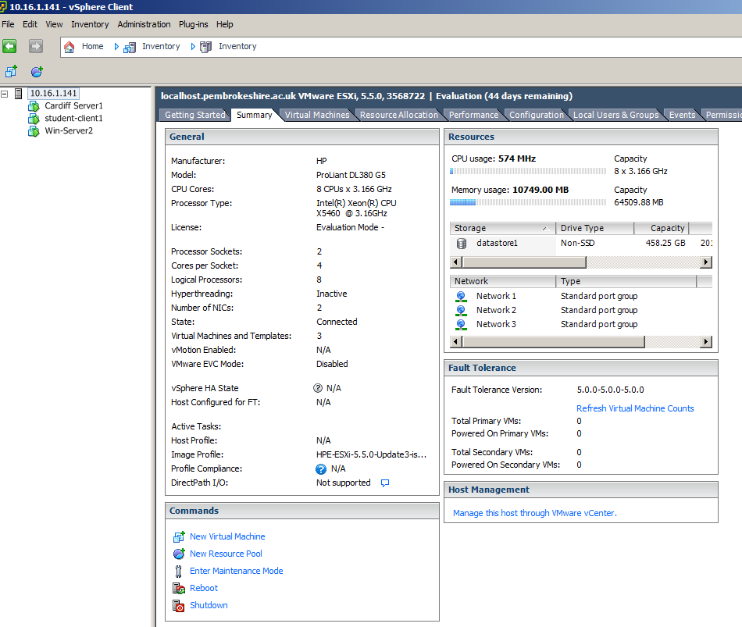

Physical server configuration

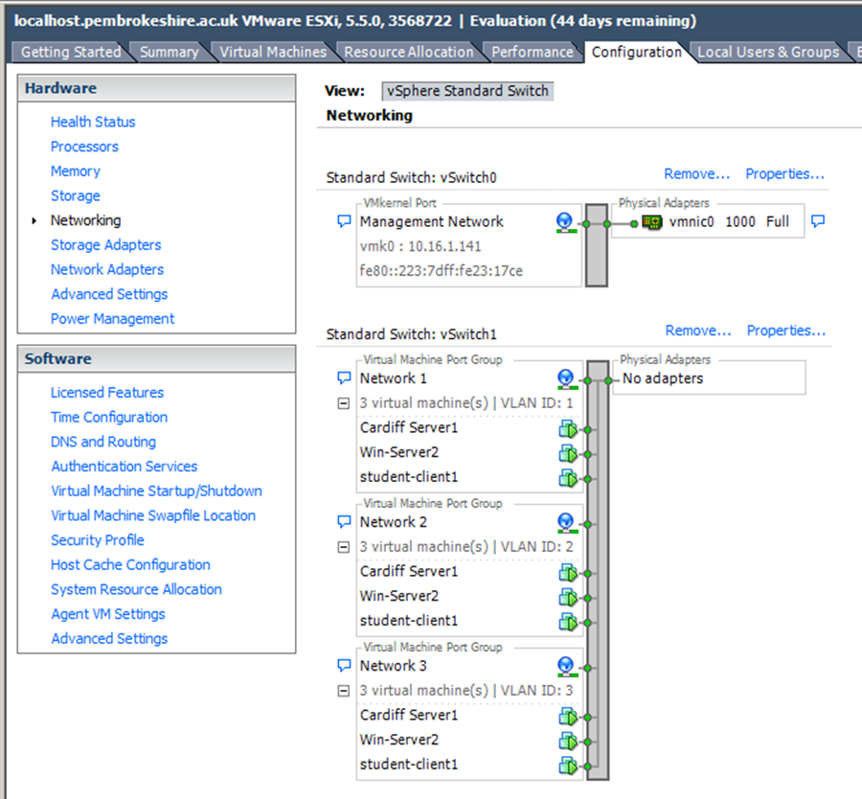
Virtual Server Configuration

Note: The next activity is to disable the Network Interface on the Windows 7 client in the 10 and 11 networks. The only way for these computers to connect to the Backbone network (to access other subnets for example) is utilising each of the networks as a Router. This will be the context in each of our subnets.
192.168.0.1
192.168.0.3
Cardiff
Lab-01-01

192.168.10.1
192.168.10.2
Win-Server2

[Complete this task on the Windows 7 client]

- Log onto the server
- Right click the 0 network connection – then click Properties, click the TCP/IP protocol and click Properties.
- Select Use the Following IP Address. In the Default Gateway box type the IP Address of the 0 network connection of the Cardiff Server in the network.

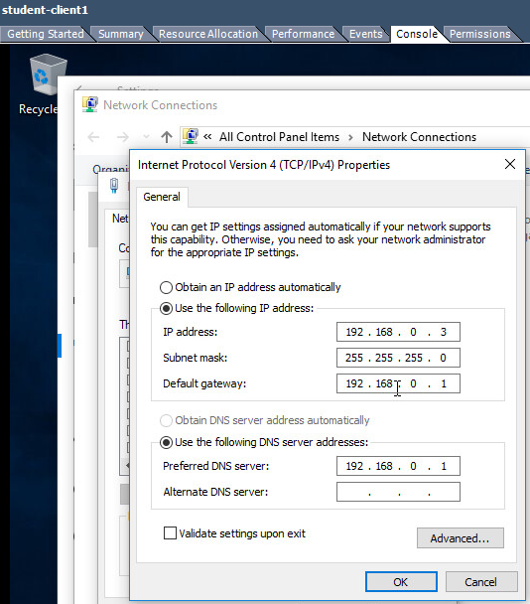

[Complete this task from Win-Server2]

- Set the default gateway of the 11 network to the IP address of the 11 network IP Address of the Cardiff server.
- Use the ping command to attempt to connect to the IP Address of the 11 network IP Address of the Cardiff server.
- 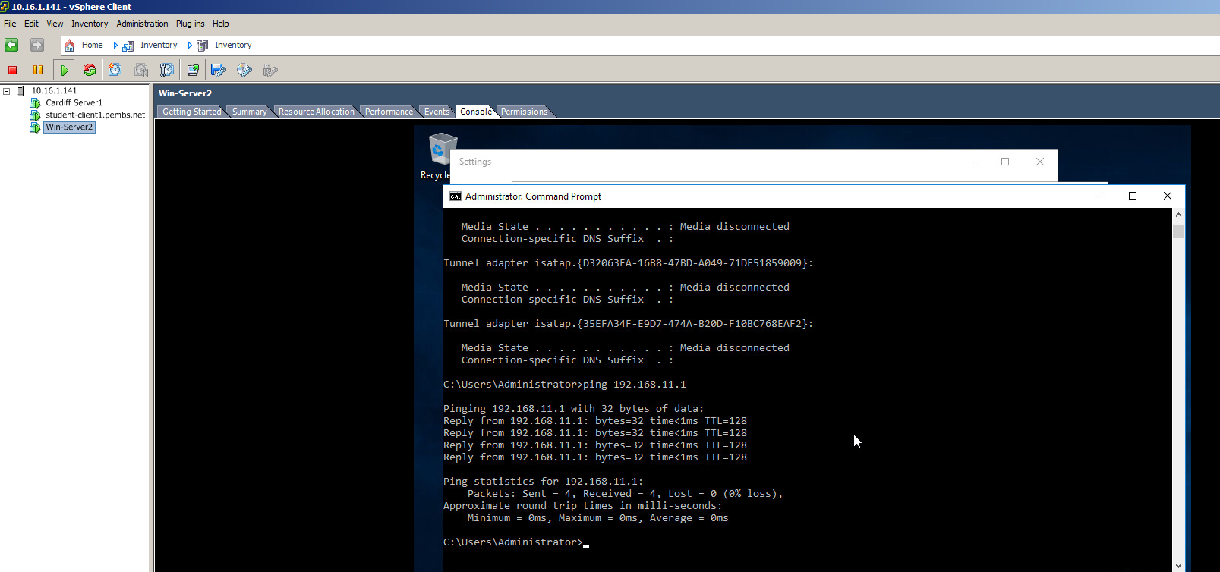

Pinging the Cardiff server – 192.168.11.1 – returns a response.

- Use ping to attempt to connect to the IP address of the 0 network IP Address of the Windows 7 client. You should not get any success at this stage.

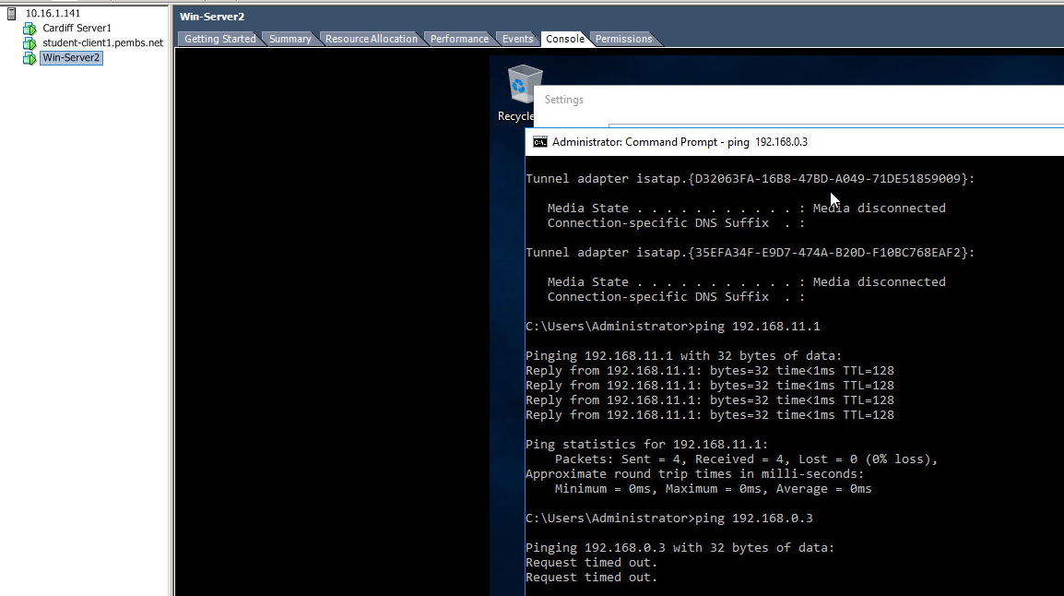

Pinging the client – 192.168.0.3 address brings back Request Timed Out

Task 2: Enabling the Routing and Remote Access Service on a Server:
[Complete this task from the Win-Server2 server]

- Logon to the machine
- From the Server Manager dashboard choose Add Roles and Features
- Choose the Network Policy and Access Services
- Click Next at following page
- Check on Remote Access role.
- When configuring Remote Access, select “Routing”.
- Choose Next/Install.
- Upon completion of the install, choose Start Admin Tools – RRAS (Routing and Remote Access service.
- In the left hand side of the console window right click on your server and choose Configure and Enable Routing and Remote Access.
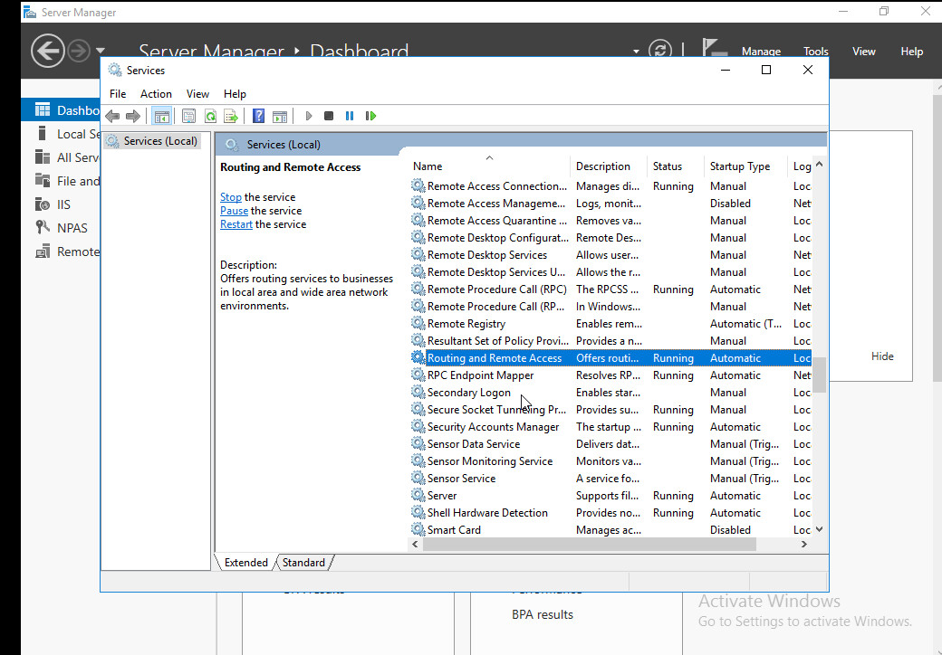
- Choose next
- Choose Custom Configuration
- Select the LAN Routing option, choose Next
- Click Finish.
- The service should be started (choose Yes if asked by the dialog window).

[Complete this task from the Windows 7 client]

Verify Routing to different computers:

- Use ping to attempt to connect to the 11 network IP address of the Win-Server2 server.
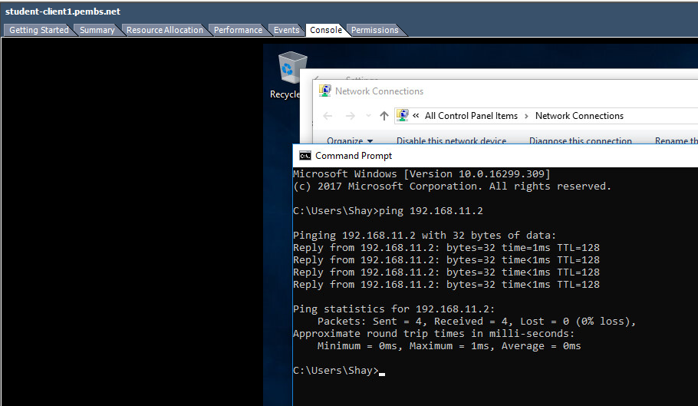
Pinging Win-Server2 – 192.168.11.2 is successful.

- Now try the Internet connection of the other server.
- Finally try to connect to and from the hosts in both of the LAN subnets (e.g. 192.168.0 and 192.168.11)
- You may find that the pings fail

Pinging Cardiff – 192.168.0.1, 192.168.10.1 and 192.168.11.1 all fail.

This is because we do not yet know the routes to these other sub-networks. To accomplish this we need to either statically define these routes, or use dynamic routing via a Routing Protocol.

Task 3: Add Routing Protocols on the Server and Add Two Routing Interfaces to the Routing Protocol on the Server.
[Complete this task from Win-Server2]

- Start – All Programs – Administrative Tools – Routing and Remote Access.
- Expand the name of your Server– expand IP V4, right click General and then click New Routing Protocol.
- In the dialog box displayed – choose RIP Version 2 for Internet Protocol, now click Ok.
- 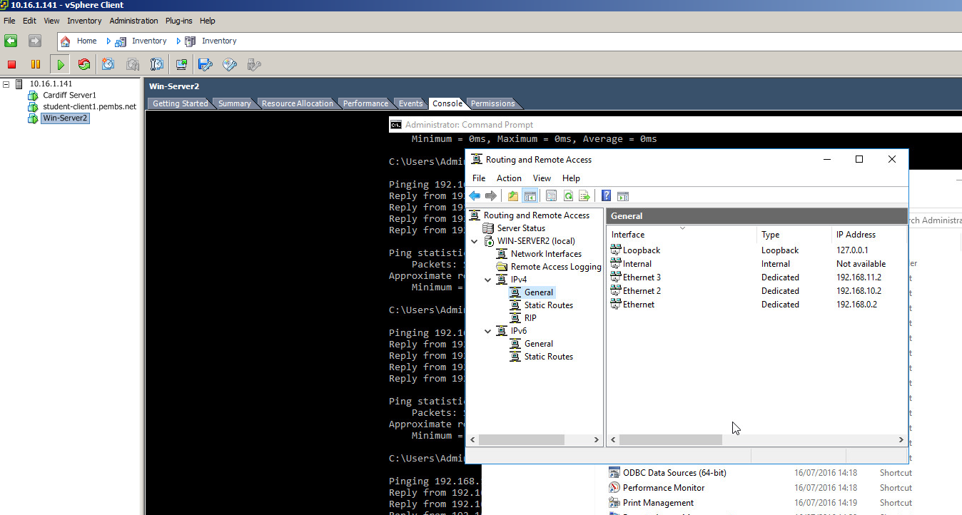

We will now see how to add two Routable Interfaces to the Routing Protocol that has been enabled as part of TCP/IP suite on our Server

The Routing Protocol will learn of the various Routes to other Networks (in our case Subnetworks), hopefully enabling us to be able to send packets directly to other machines on other networks.

- Right click on RIP then select New Interface.
- In the New Interface Dialog Box, select the 0 network – choose Ok
- Repeat the process but now add the 11 network as an additional RIP Interface.
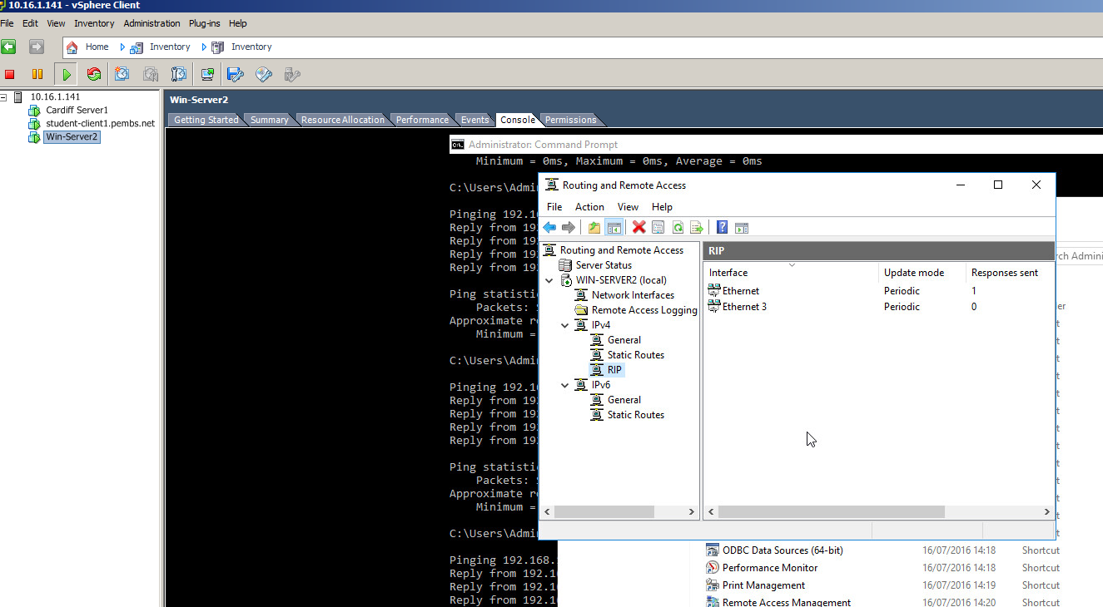

For the last part of this task, look back at your notes and the ping Activities earlier.

You should find that you can now Ping Servers/Clients on other Subnets.
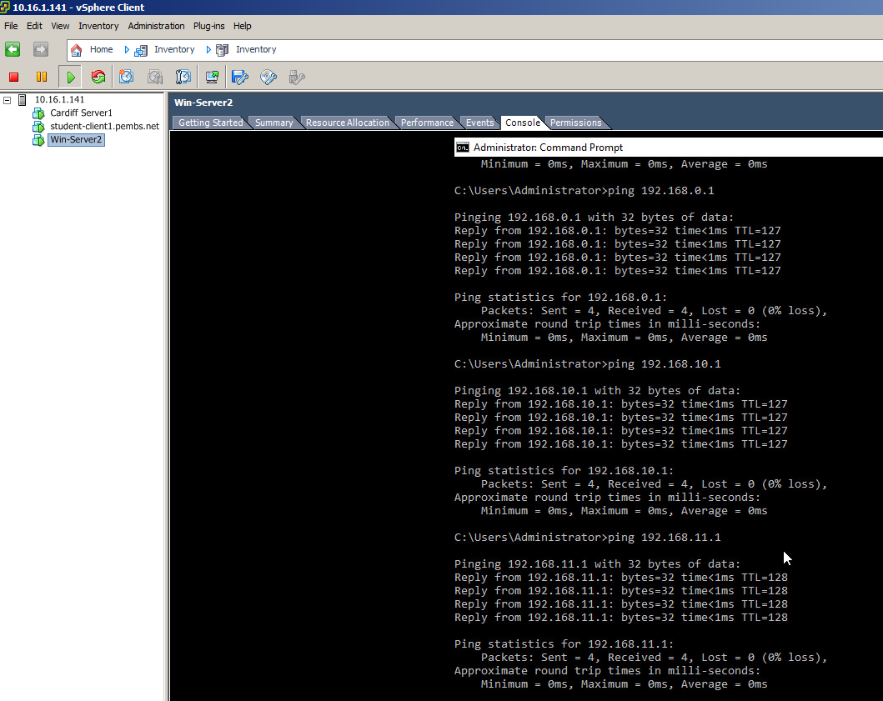

All Subnets are now pinging.
Task 4: Learning about Local Area Network Routing
Question:
- Open up the command prompt, enter the following syntax: route print

What can you determine from the resulting Routing Table?

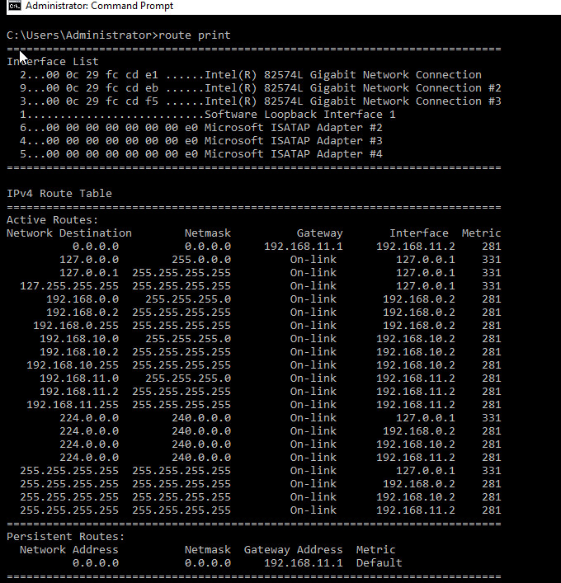
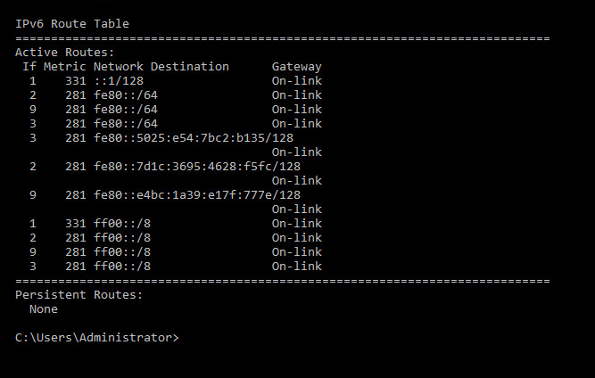

The network routes to all the subnets have been added to the table.

Task 5: Additional Observation Tasks:
Ensure these tasks are answered in appropriate detail and the sources and source materials are referenced using the IEEE Referencing system.
- Identify the benefits of Type 1 Hypervisor software services and briefly evaluate some suitable products.
- Define the role of Routers in the Network Architecture, what types can be used?
- Identify and discuss the usage of common Routing Protocols, what are the associated benefits of using Routing Protocols?
- Define the role of Routing Tables, what are they. Breakdown and analyze the information a Routing Table provides us with.
- What is the Subnet Mask, what is the significance of this in the Routing Table?

B.Sc. Year 2
Network Services
Worksheet 2: Routing and Remote Access Services in Windows Server: ARP, Managing TCP/IP & ICMP Operations using Packet Filtering.
Group Name: Ben McCarthy, Ben Archer, James Pugh, Gwyndaf Rees, Ryan Gallagher
Date:
Author(s): Ryan Gallagher
Complete the following tasks:
Note: you should take observations and screen captures when completing these tasks. It is also essential to produce an introduction to the scenario for this worksheet; you can only write this summary when you have finished all practical tasks.
Task 1: Using the ARP Protocol to obtain Physical/Logical Network Node information
You may need to disable Windows Firewall for part 3 of this worksheet.

[Complete this task from Cardiff]

The ARP table ‘maps’ logical IP (Internet Addresses) to Physical Addresses of Network Interfaces, this is how a packet is sent/received on a Network Interface, or if you like, how packets arrive at your machine over the Internet.

- Click Start – run – cmd
- At the command prompt type ARP -A
- The information you see displayed comprises of:

- The Interface (NIC’s) in your Machine.
- The Physical (MAC) Address of this NIC
- The Internet Address of this NIC.
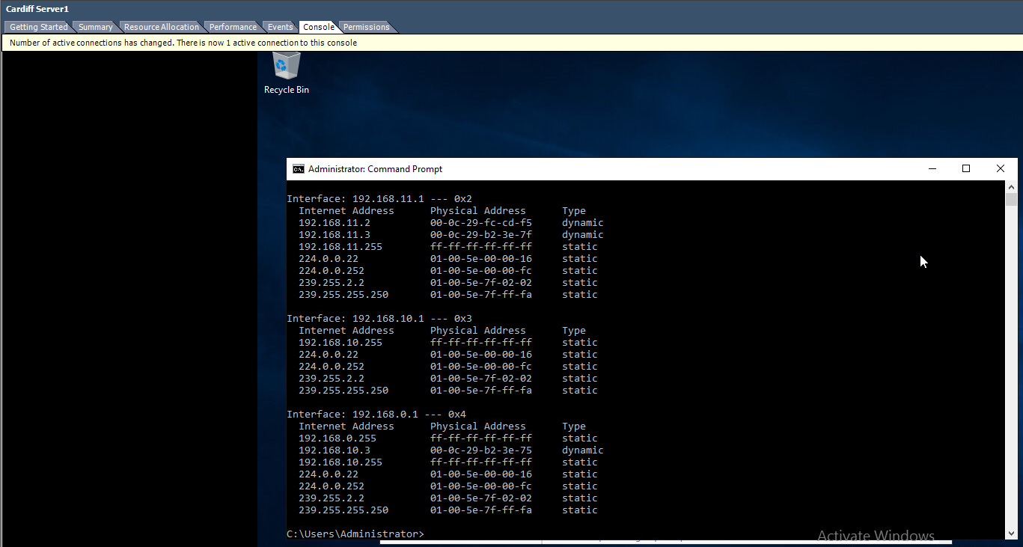
Here I typed ARP –A on the Cardiff server.

You may not at present have any (or you may have very few entries). As you connect to, are connected to; other servers, this ARP Table (MAC Table) will be updated;

One common way to see this in practice, is by using an ICMP operation such as ‘PING’

- Attempt to ping other Servers in the network, note on successful attempts, check your ARP Table using the arp –A command, note the entries being updated as more servers connect/are connected to.

Task 2: Permitted TCP and ICMP Operations
[Using Routing and Remote Access Services for configuring IP packet filtering]

[Complete these tasks from Win-Server2]:

- Navigate to the Server Manager Dashboard.
- Add Roles
- In the list of Server Roles – check on the Web Server (IIS) – Choose Next.
- Choose Next at the Intro to web server (IIS) page.
- At the Select Role Services page, scroll down and check on FTP Service, click Next.
- Now install the service, and wait for the wizard to complete.
- Click Start – Administrative Tools - Computer Management
- Expand Local Users and Groups – Right Click on the Users Folder – New User

*VERY IMPORTANT*
Ensure that you Check off the ‘user must change password at next logon
setting’.

Name: ftpuser
Password: P@ssw0rd

- Start – Administrative Tools – Internet Information Services Manager.
- Expand the Computer Name – Right click on Sites – choose Add FTP Site
- In Site information type test
- Click on the browse button […] next to Content Directory/Physical Path
- Choose root drive (e.g. C:\Inetpub\ftproot) - next
- At the bindings and SSL settings page – choose No SSL
- Take note of the Port Number (20 & 21) can be used via the TCP protocol when using the FTP Service.
- Chose basic authentication as the preferred mode.
- Alongside the authentication textbox, click the drop down menu and choose Specified Users.
- Type in the name of your server (Win-Server2) followed by a backslash and the user account you created above (e.g. Win-Server2\ftpuser).
- Ensure you check on both the read\write options. Choose Finish.
- We can setup banners/welcome greetings as a way of knowing if we are connecting to the right server.
- To setup a banner, choose Start - Administrative Tools – IIS Manager.
- Expand the servername – Expand sites click on your ftp site you created earlier.
- Choose “FTP messages”.
- Here you can enter banners, welcome greetings and exit messages. Set ‘appropriate’ messages up here – you should indicate to the user that they’re connecting to the Win-Server2 server.
- Click Computer - Within the C:\Inetpub\ftproot directory, create a new text file, call it testftpdownload.txt
- We now have our FTP Server running on the Win-Server2 Server:
- We can upload files to or download files from the FTP server (using the appropriate windows authenticated account).
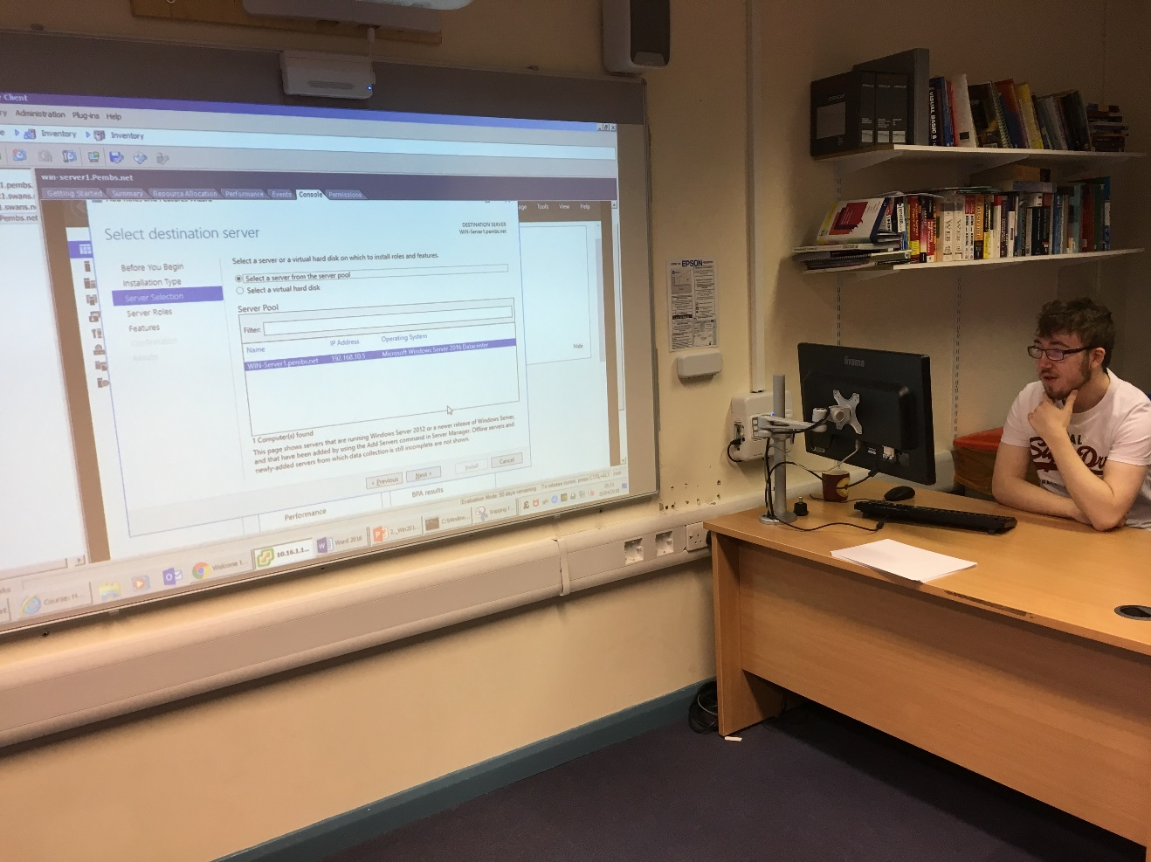
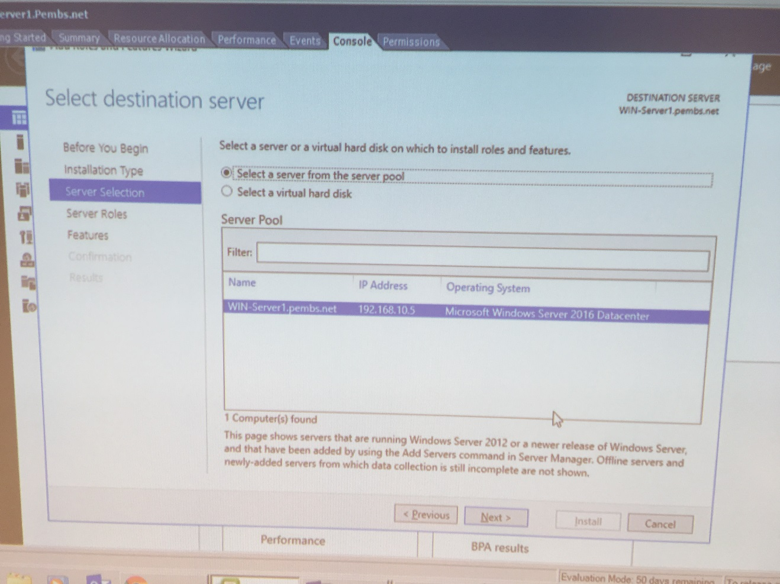
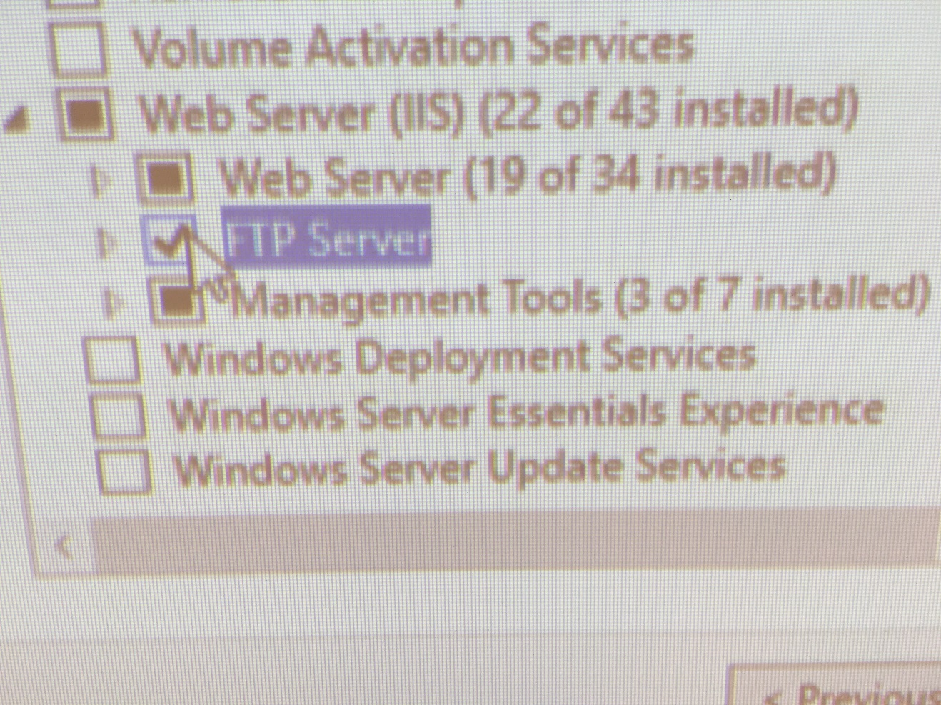
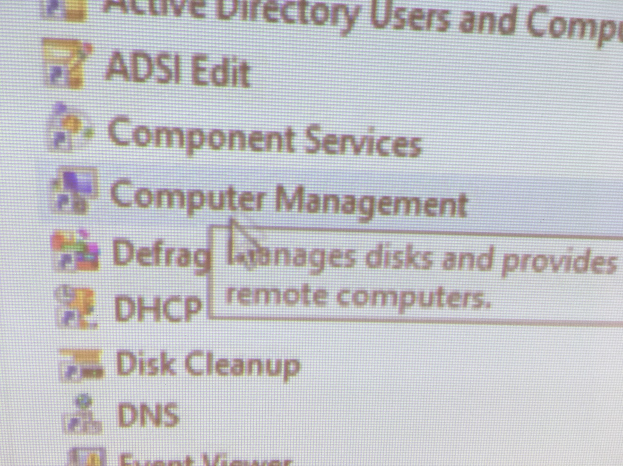
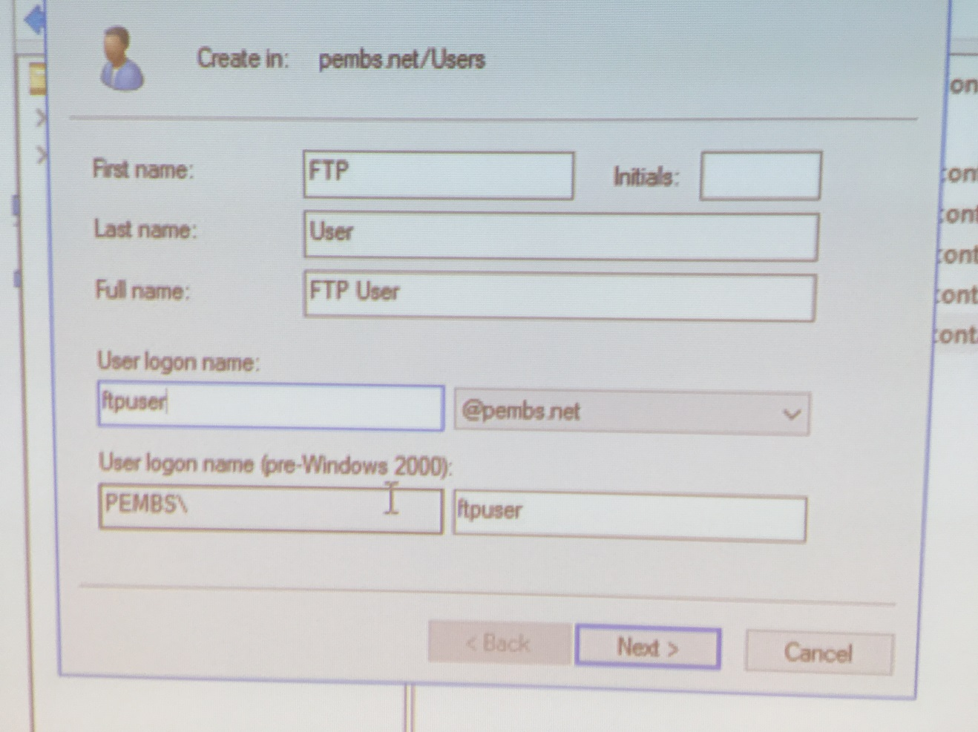
Creating an FTP User account

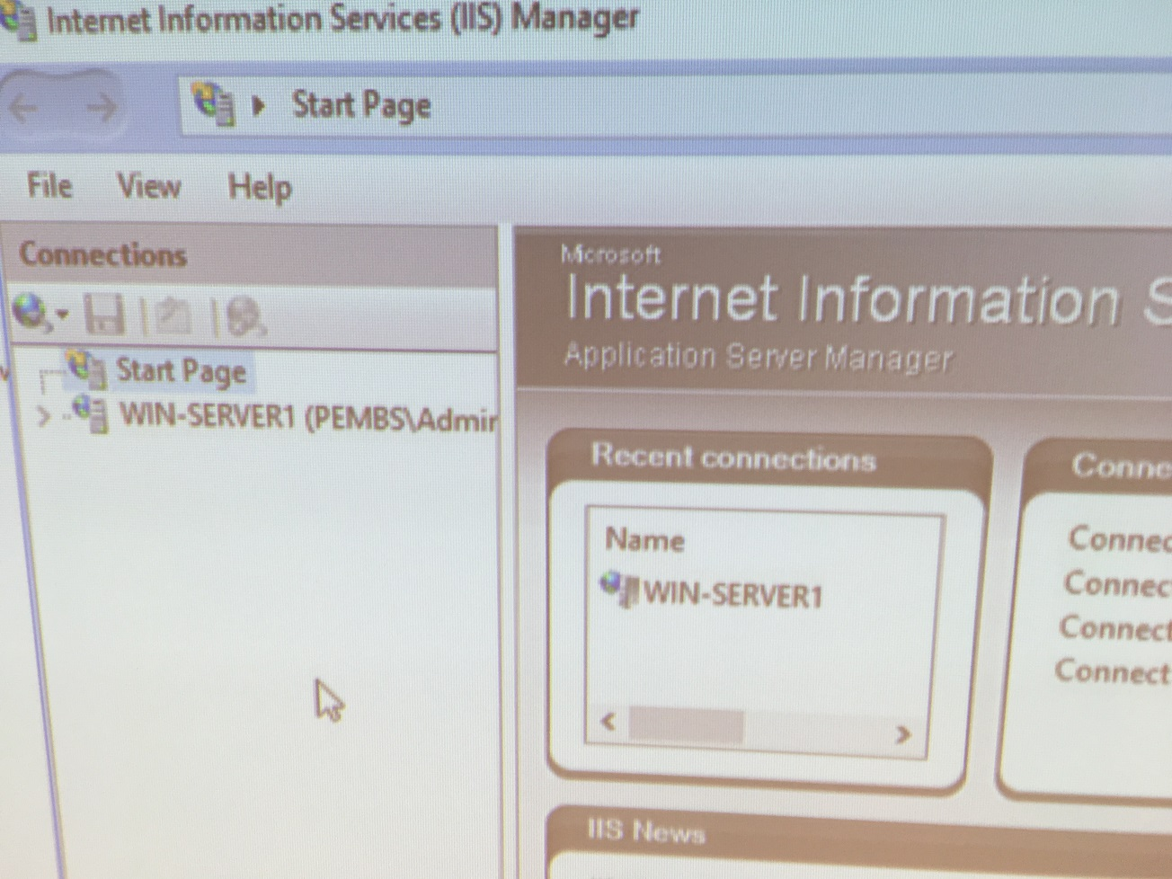
Configuring IIS and adding an FTP Site

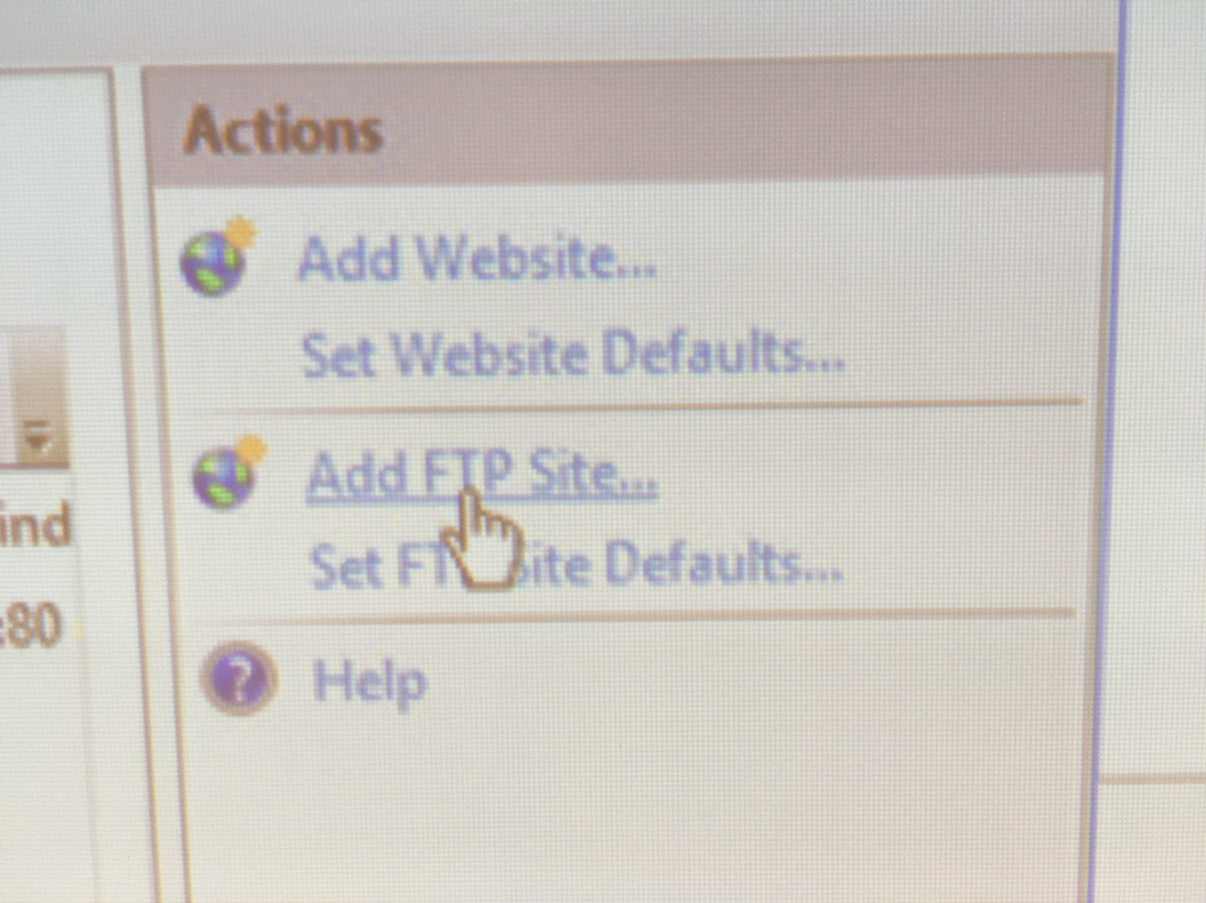
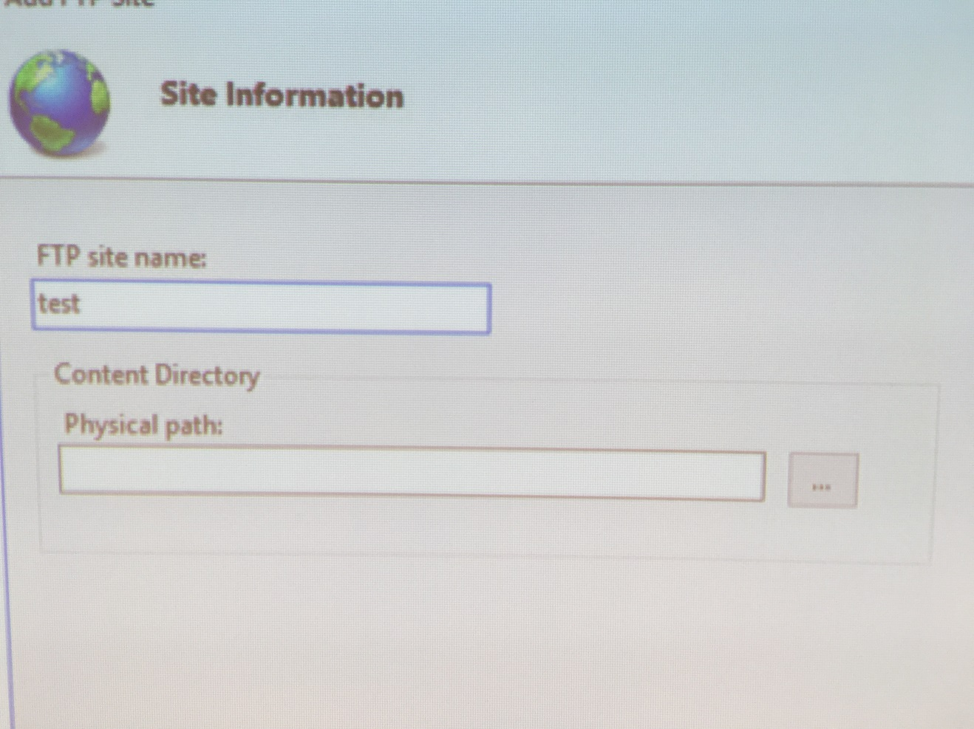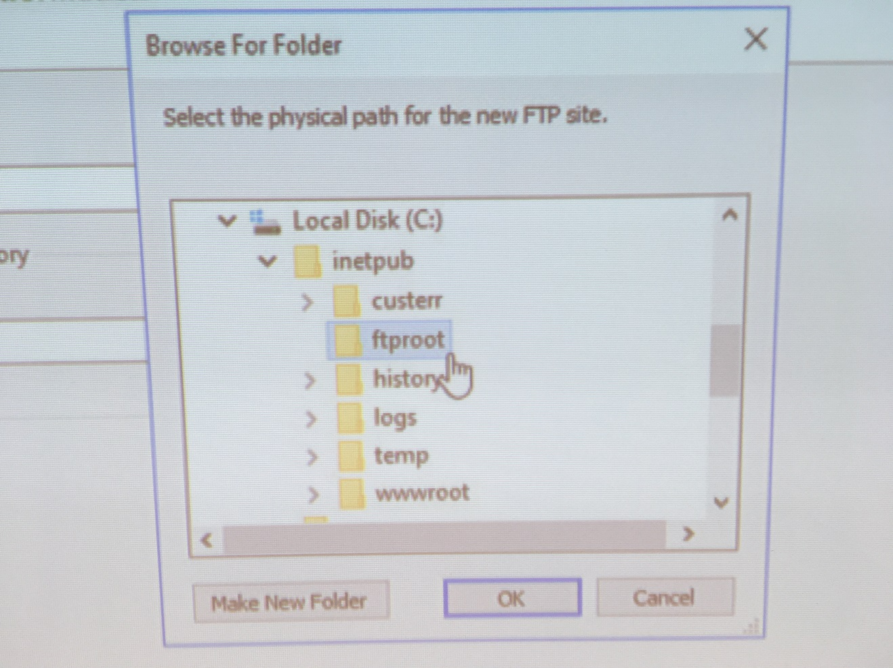
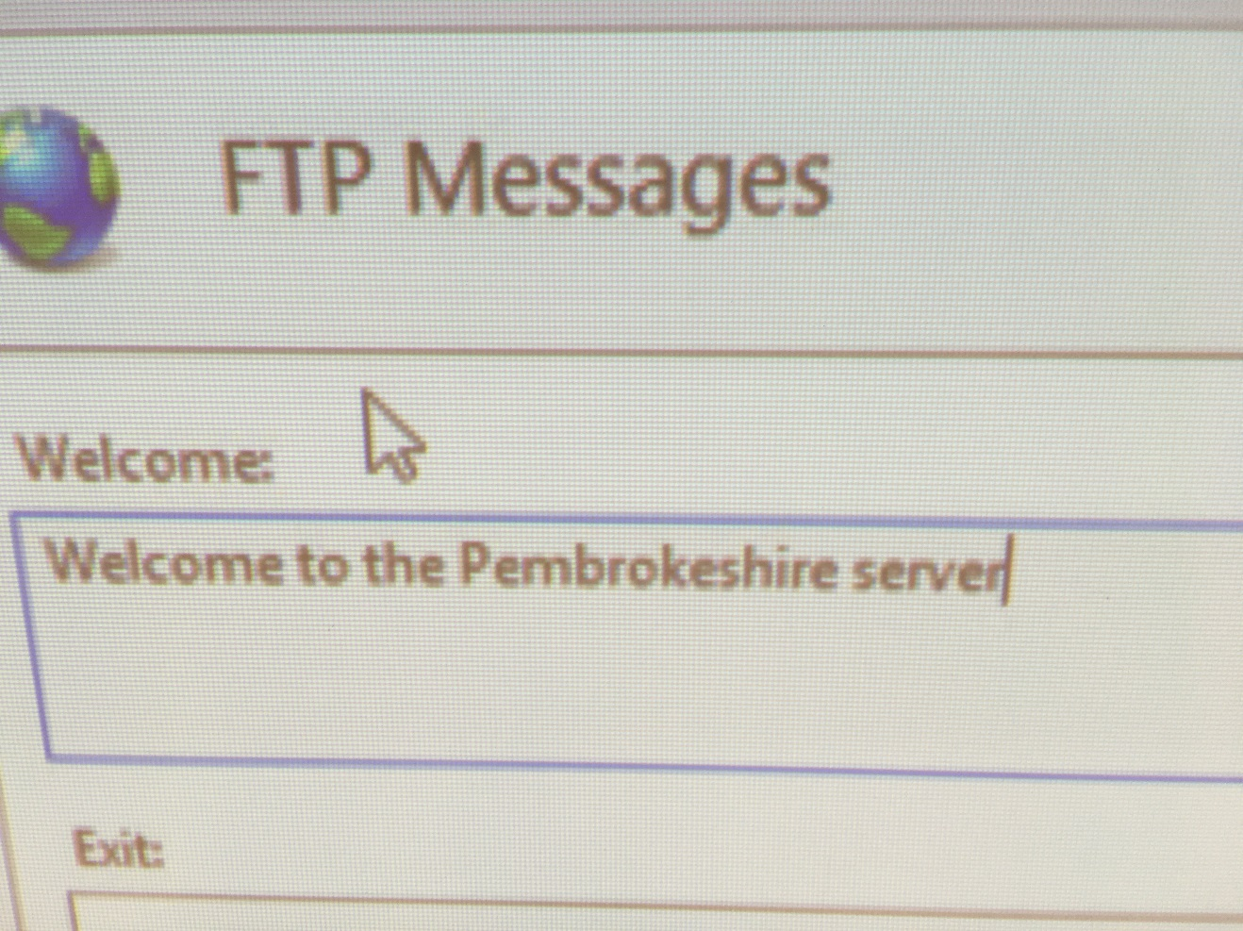
We are now going to attempt an FTP operation from our Cardiff server (The Router) remember:

[Complete this task from the Cardiff]

Important Note: if at any stage your ftp session is ‘timed out’, type CTRL & C and/or type bye at the ftp> prompt;

We need a host directory to store the folder that is going to be ftp’d across from our FTP server.
- Click Start – My Computer – C: and create a new folder called ftpdownloads
- Click Start – Run – Type in cmd to launch the Command Prompt.
- We are now going to access the ftp service on the Win-Server2 – type the following command:

ftp IP of Win-Server2 Server
You may select any network interface from the Win-Server2 server.

- ftp service should be enabled,
- servername\ftpuser [don’t type in servername use your own servers name e.g.) User: Win-Server2\ftpuser.
- password P@ssw0rd.
- You are now logged into FTP server.
- Type dir to give you a list of what is stored in the Host Directory on the FTP Server. Note the file name testftpdownload.txt
- We need to change our Host Directory (done at this server not the ftp server) to specify where we want the FTP server to put the file to when it downloads.
- To do this we need the Local Directory Change Command, type lcd c:\ftpdownloads
- At the ftp prompt, type get testftpdownload.txt
- The ftp program should inform you that the process is complete.
- Go to My Computer, C:\ – create a folder called ftpfilesupload, within this folder create a new text file here call it testftpuploads.txt
- In the ftp prompt type the following
- lcd C:\ ftpfilesupload
- dir
- put testftpuploads.txt
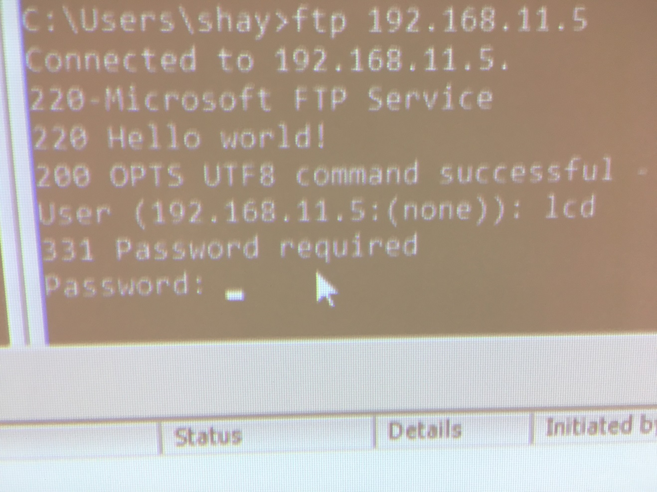
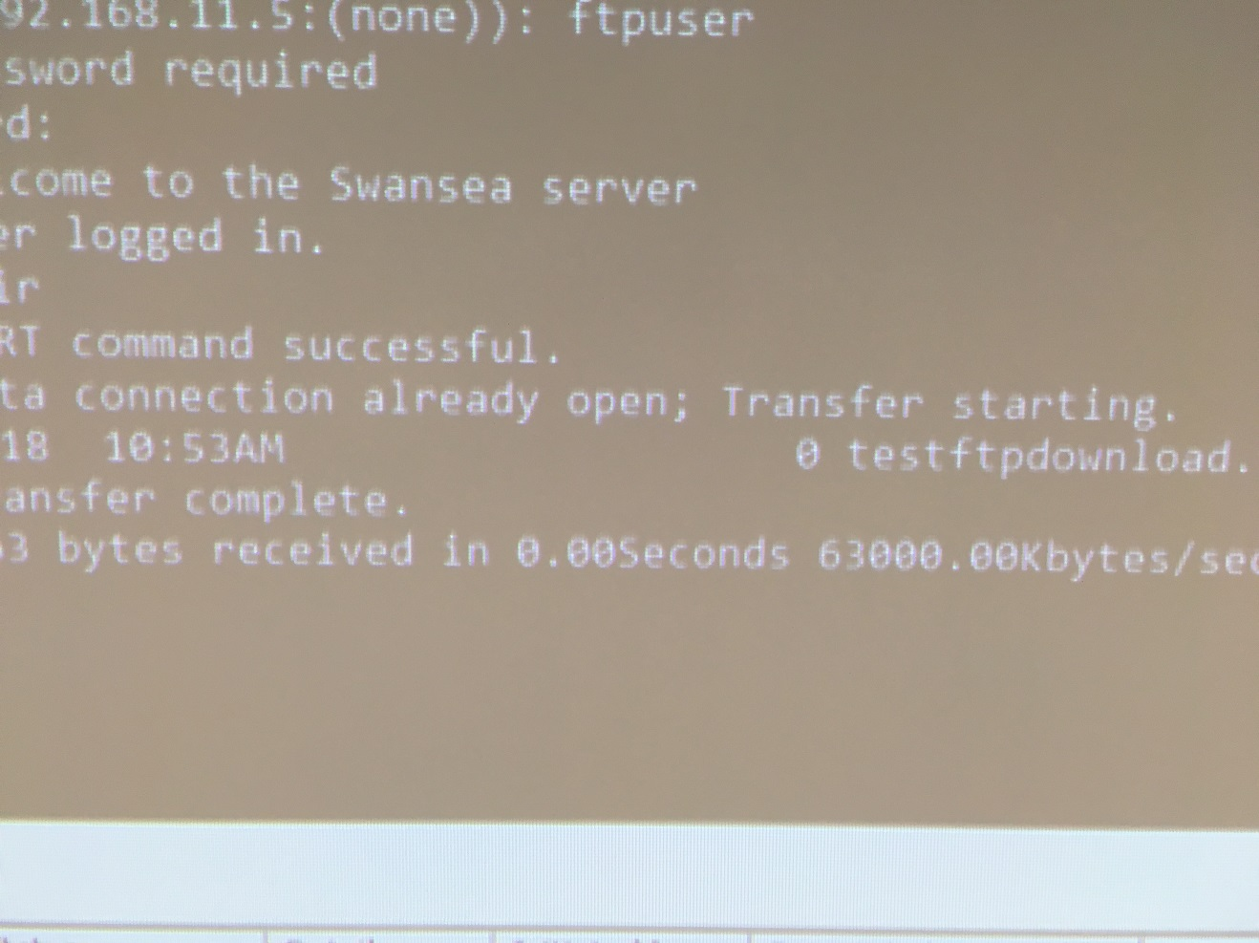
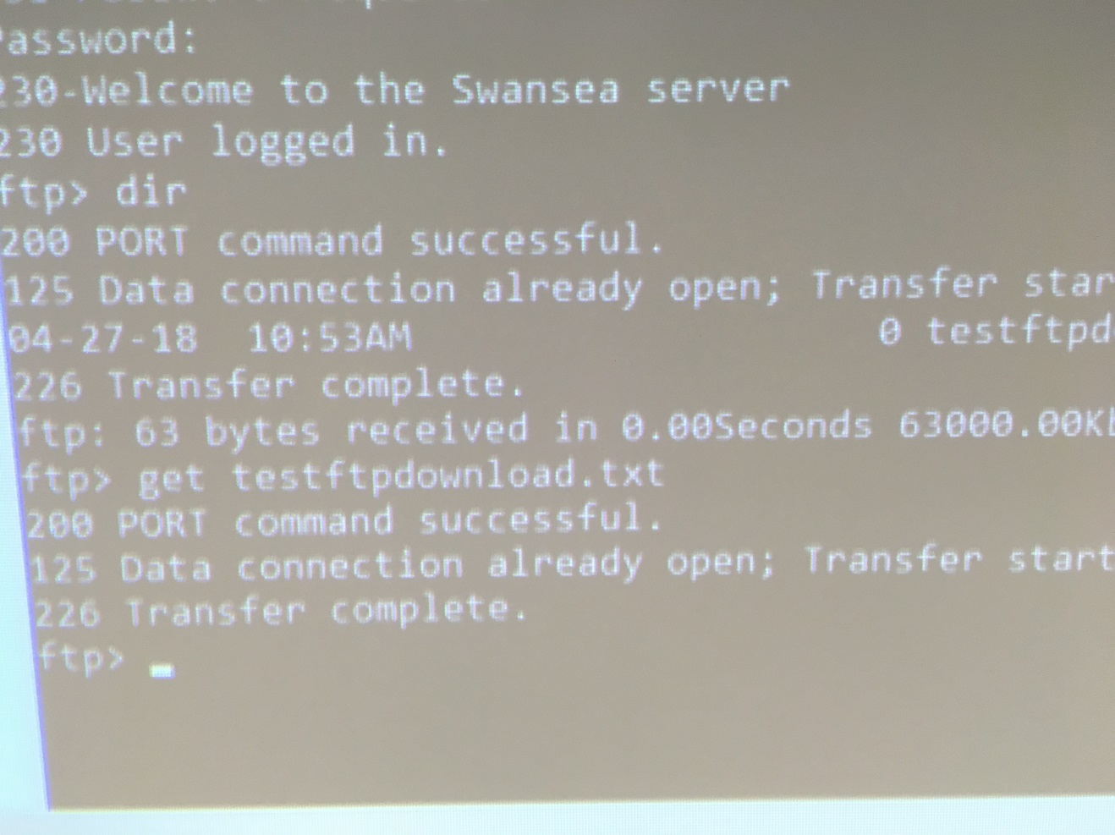
[Complete this task from Win-Server2]
- Go to the c:\inetpub\ftproot folder and verify that the file has been uploaded.

Task 3: Restricting ICMP Operations Using IP Packet Filtering with the Windows 2012 Server Routing and Remote Access Service

[Complete this task from Cardiff]

BEFORE BEGINNING, PLEASE CHECK THAT THE ROUTING AND REMOTE ACCESS SERVICE IS RUNNING ON YOUR MACHINE.

Configuring a Simple Inbound Filter (Remember filters are configured on the Router as traffic into our network arrives here first).

[Stopping the client from Pinging a Particular Network Host]

- Start – Administrative Tools – Routing and Remote Access Console
- Expand the Computer Name – Expand IP Routing – Then Click General
- In the details pane – right click the Partner Network Connection interface, click Properties.
- Click the General Tab – Inbound Filter (anything coming into the Router on this Partner Interface).
- Source IP Address This will be the IP address of the Client that you want to disallow. Set this to 192.168.0.3, and the subnet mask 255.255.255.255.
- Destination IP address: 192.168.0.2
- Destination Subnet Mask: 255.255.255.255 (This is because we know the exact Network/Host Address for the Destination).
- From the Protocol menu – Choose ICMP
- Note: you could also specify the port number here, if you do not specify a port the setting defaults to 255 meaning any type. Ok
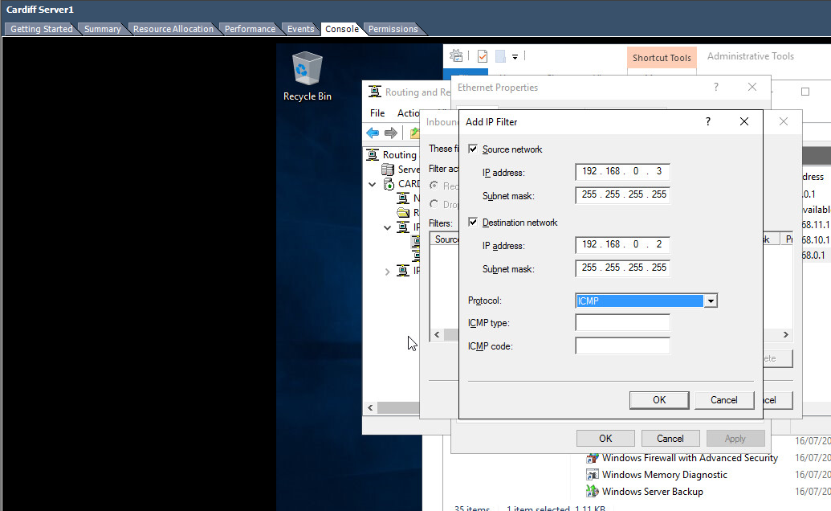
- From the Filters dialog select the Filter Action: Receive all Packets, except those that meet the criteria below

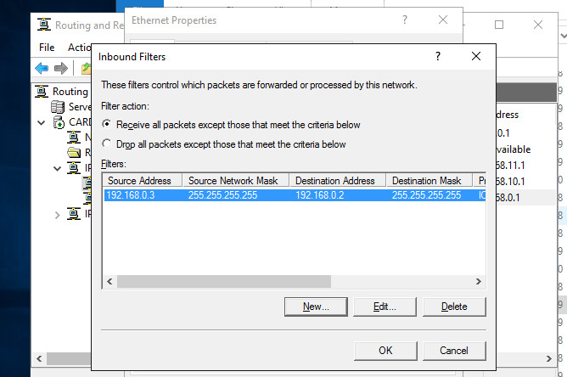

Rationale:

In this instance, we are creating a filter on a specific interface. You should still be able to ping the other network(s) on Win-Server2 from the client.

To confirm this:

[COMPLETE THIS TASK FROM THE CLIENT

- Attempt to PING Win-Server2 (192.168.0.2) you should NOT get any response from this IP address (you may get a reply from another bound IP telling you this host is unavailable).
- 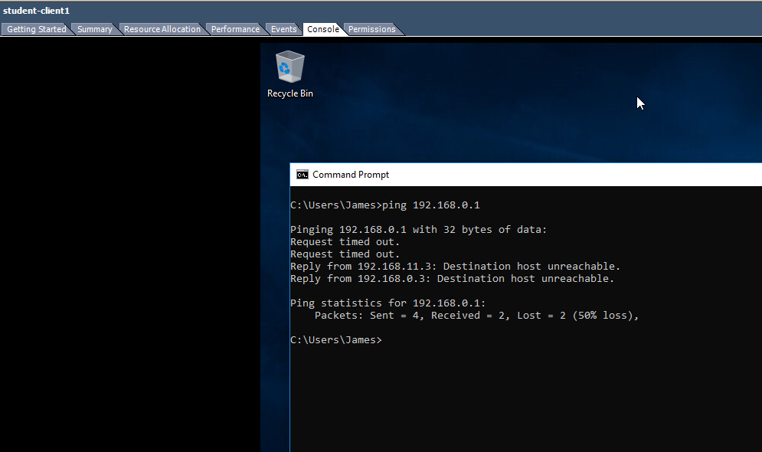
- Attempt to PING the other Private Network (e.g. 192.168.11.2) (This time you should find you receive a response)
- 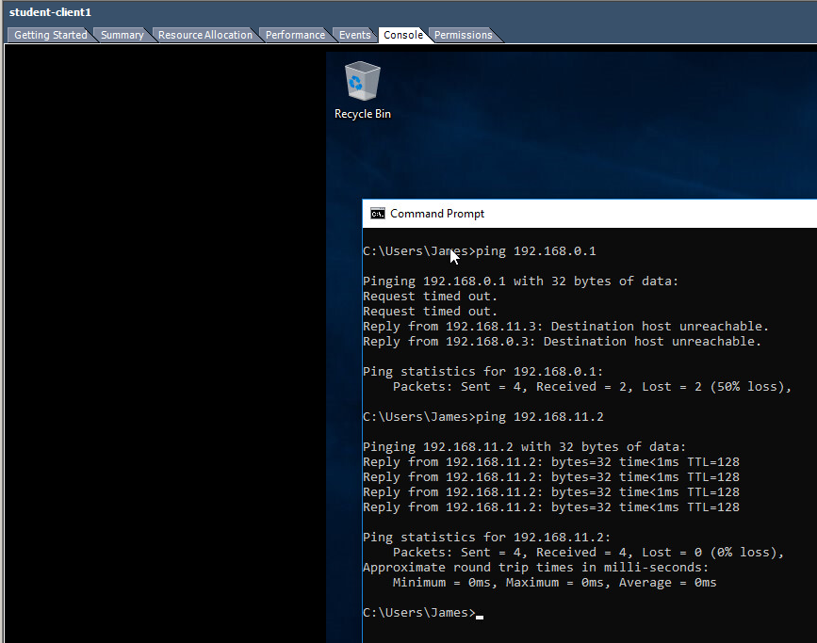

Task 4: Restricting TCP Operations Using IP Packet Filtering with the Windows 2003 Server Routing and Remote Access Service.
[Complete this task from CARDIFF]

Configuring an Outbound Filter (packets travelling out of the Router).

First – remove the previous Inbound & Outbound Filters, this helps us avoid ‘Contradictory Filters’.

Earlier we performed FTP operations from the Win-Server2 Server, we needed to Connect to the FTP Service that was running on this server to complete the FTP operations.

Here we block all outbound traffic from the Router, in this instance we will block every body from accessing the FTP service that runs on the Win-Server2 Server in our Network.

- Start – Administrative Tools – Routing and Remote Access Console
- Expand the Computer Name – Expand IP Routing – Then Click General
- In the details pane – right click the Partner Network Connection interface, click Properties.
- Click the General Tab – Click Outbound Filter.
- Source and Destination IP Addresses these should be left Blank, as we intend to filter all packets that what to go out from the Router on this interface.
- Protocol: TCP (FTP Service is accessed using TCP port 20/21). You may need an identical rule for 20 and then 21
- Destination Port No: 21 (Note this value from earlier when we checked on default ftp site values). Choose OK.
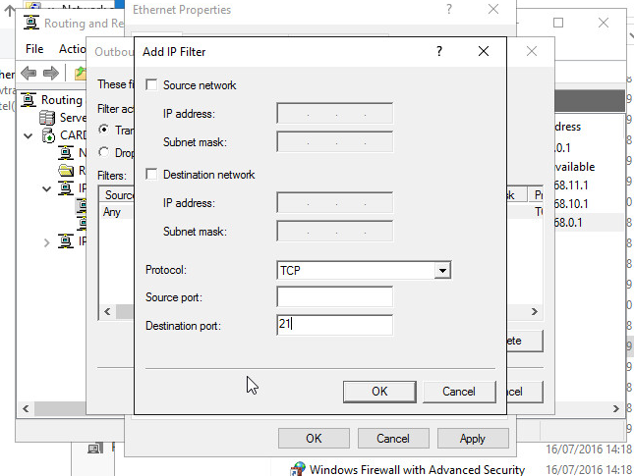
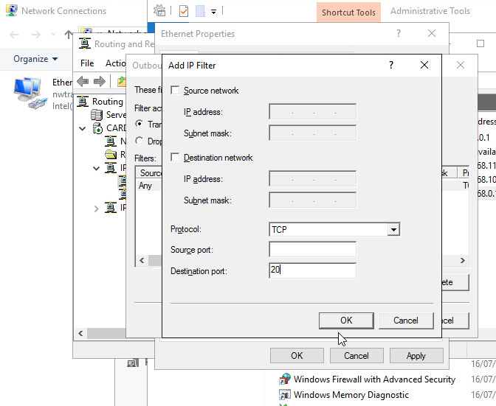

From the Filters dialog select the Filter Action: Receive all Packets, except those that meet the criteria below
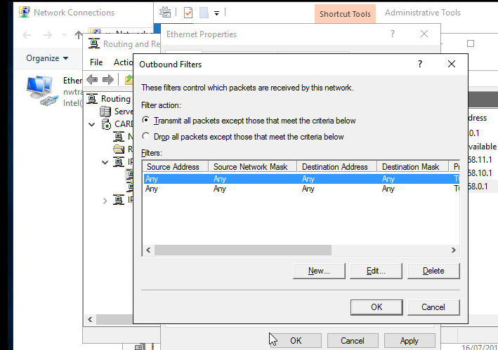
[Complete this task from CARDIFF]

- Click Start – Run – cmd
- ftp (and then the IP Address of your Win-Server2 server e.g. the 0 or 11 address
- You should find that you get no reply, we cannot access the FTP service
- 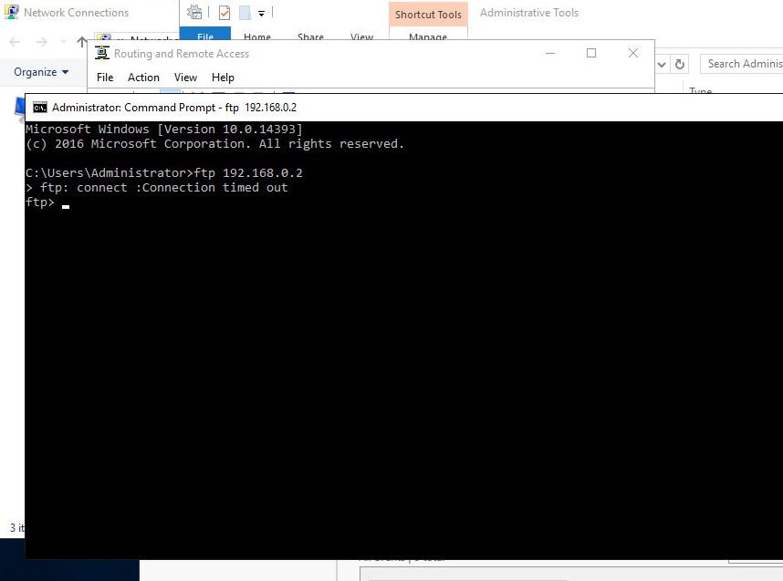

Configuring an Outbound Filter.

[Complete this task from CARDIFF]

Here we will block access to the FTP Server for only our Router (Cardiff). All other Networks should be able to FTP into our FTP Server:

First – remove the previous Inbound & Outbound Filters, this helps us avoid ‘Contradictory Filters’.

- Start – Administrative Tools – Routing and Remote Access Console
- Expand the Computer Name – Expand IP Routing – Then Click General
- In the details pane – right click the Partner Network Connection interface, click Properties.
- Click the General Tab – Click Outbound Filter.
- In the Source IP Address enter the IP Address of the Partner Network Connection on the Router (or the Lower Number Server in your Group).
- Destination IP Address: is the IP address of the Partner Network Connection in the Win-Server2 Server.
- Source Subnet Mask: 255.255.255.255
- Protocol: TCP
- Destination Port: 21
- From the Filters dialog select the Filter Action: Receive all Packets, except those that meet the criteria below.
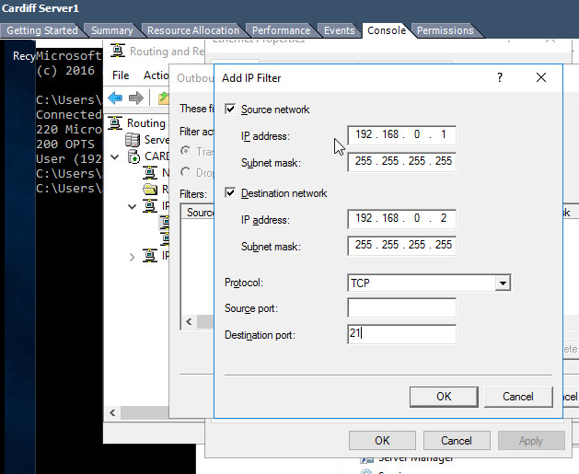

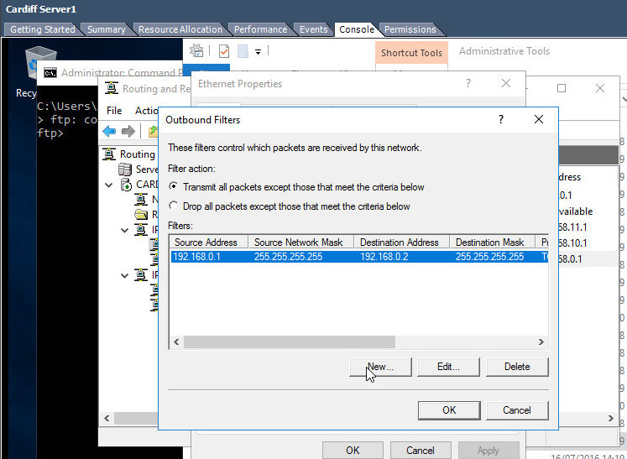

[Complete this task from CARDIFF]

- See if you can access your FTP server from your Router (remember you will need to access the FTP server using the Partner Network Connection).

Rationale:

Our Router will essentially stop itself from sending packets to the Partner Server, via the Partner Network Connection, the filter parameter is the source IP Address: which as specified is indeed the IP Address of the Partner Network Connection Interface on our Router.

No other filters are setup so the Router will forward all other requests from other networks.
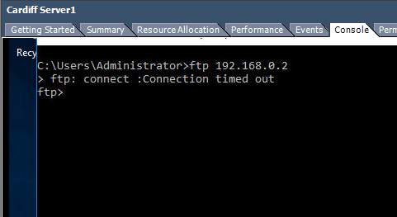

Task 5: Exercise
Here we want to only allow our Router to FTP. All other traffic from our Router and all other traffic from other networks (including PINGS) must be blocked.

Explain your method for achieving this:

On Win-Server2 I created an outbound filter rule to drop all packets except for the defined FTP rule.

Task 6: Observational Tasks
Observational Tasks:

Q1). Describe (using appropriate illustrations) how the ARP process operates in Networking Contexts?

Q2). What is Packet Filtering? In our context, why is Packet Filtering termed ‘IP Packet’ Filtering? Why would you use Packet Filtering in your Network? What are the perceived benefits?

Q3). Why is it possible for contradictory filters to occur when you use packet filtering? Give an example of a Contradictory Filter:

Q4). FTP Server is just one Role/Service we can configure our Server to provide? What other roles can the Server provide that would benefit our Infrastructure in both a local and remote context?


B.Sc. Year 2
Network Services
Worksheet 3: TCP/IP Configuration using DHCP (Dynamic Host Control Protocol).
Group Name: Ben McCarthy, Ben Archer, James Pugh, Gwyndaf Rees, Ryan Gallagher
Date:
Author(s): Ryan Gallagher
Complete the following tasks:
abstract

Task 1: Understanding Different TCP/IP Configurations
We know that Computers use IP addresses to communicate over TCP/IP protocol. Windows 2012 provides three different ways to configure IP Addressing.

Manually – Static IP addresses, usually assigned to Servers running Windows 2012 Server. All the servers on our 192.168.1.0 network are configured, at present with manual/static IP addresses

Dynamically – If a DHCP server is installed IP addresses are assigned automatically on boot-up, DHCP is the default TCP/IP configuration and is in most cases automatically setup on Windows Workstations.

Alternative - When you install Windows 2012 you are automatically configuring that Server to be a DHCP client.

- Obtain an IP address automatically uses a DHCP server for dynamic IP addressing
- Use the following IP address – Statically defines the IP address

If you are a DHCP client, and you are unable to locate a DHCP server, you get your address from a range of IP addresses known as the APIPA (Automatic Private IP Addresses).

An APIPA type address is a class B IP address. It is allocated from the range 169.254.0.1 to 169.254.255.255. It has a Subnet mask of 255.255.0.0. This is a private IP range; you would not find another computer attached to the public internet using any APIPA addresses.

The DHCP client (if no host can be contacted) picks a random IP address from this range, and broadcasts it out on the network. If this address is in use the owner will send a packet informing the client it is already in use. If the IP address is not being used, the client ‘binds’ this IP address to the specific network adapter. The client will send out requests periodically to the DHCP server, until DHCP automatic IP address can be assigned.

VERY IMPORTANT:
BEFORE YOU UNDERTAKE THIS TASK MAKE A NOTE OF ALL STATICALLY DEFINED IP ADDRESSES; YOU WILL NEED THESE LATER ON.

[Complete this task from Swanesa and the Windows 7 client]

* Locate the Apipa setting only for the 0 Network interface
* Set the networking to automatic private IP addressing on both servers (You will only need to complete this task on one of your networks).
* Choose Start – run – cmd
ipconfig/release (just to make sure our static address is completely erased.
ipconfig /renew, it will take a few moments for our computer to realize that it cannot find a DHCP server on the network.

- We will get an error message informing us the request is timed out (because a DHCP server could not be contacted).
- We should now be able to obtain an APIPA, in the cmd prompt type ipconfig
- We should now see for our Network Connection, that an Auto configuration IP address has been assigned, with a subnet mask of 255.255.0.0
- We see now that AutoConfiguration has been enabled, note no Default Gateway is assigned. This means that clients beyond the same switch or LAN that live on remotely separate networks cannot PING each other

Try to ping the two other servers on the other network; record what happens.

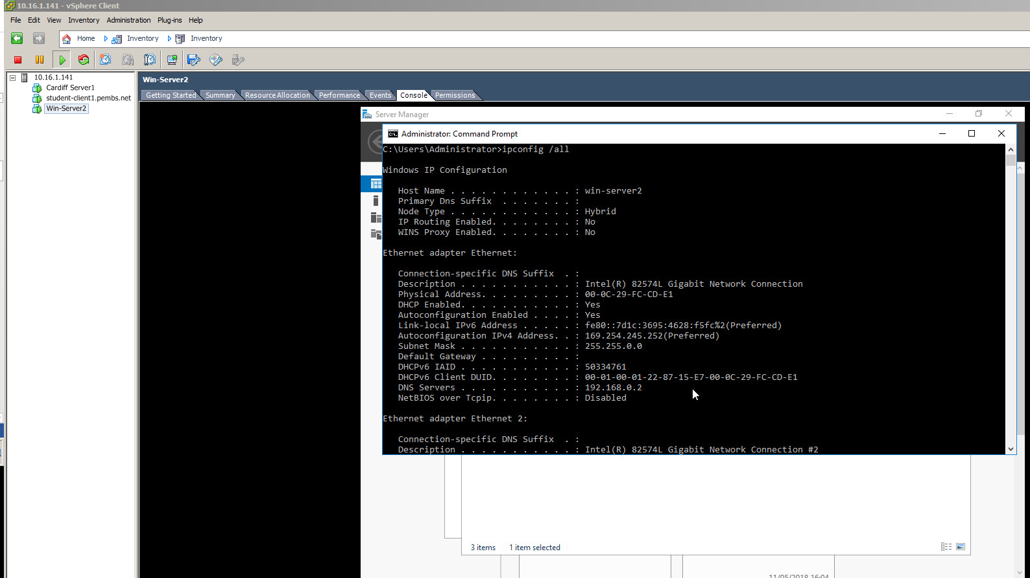

Task 2: Installing the DHCP Server
Installing the DHCP Server:

Note: Before we do this task we need to reset our configuration back to the static IP addresses that were entered earlier, do this here.

We’ve seen previously how to configure dynamic IP addresses on our Network Adapter. DHCP. DHCP gives us centralized control over IP addresses and TCP/IP default settings (subnets, default gateways). When we set up the DHCP server, we can rely on this server to supply the TCP/IP settings.

DHCP lies at the application layer of the OSI model, it is one of the applications, that utilises the services of TCP/IP.

Note at the moment; the Connection is configured with a Dynamic IP address (as a DHCP client).

[Complete this task from Cardiff]

- Add a role from the dashboard.
- Choose next and the default screen
- From the list of available services to install check on DHCP Server - .
- Choose Next at the next notification page. Complete the dialog.
- Access the DHCP Post-Install configuration wizard.
- Select “Commit.”
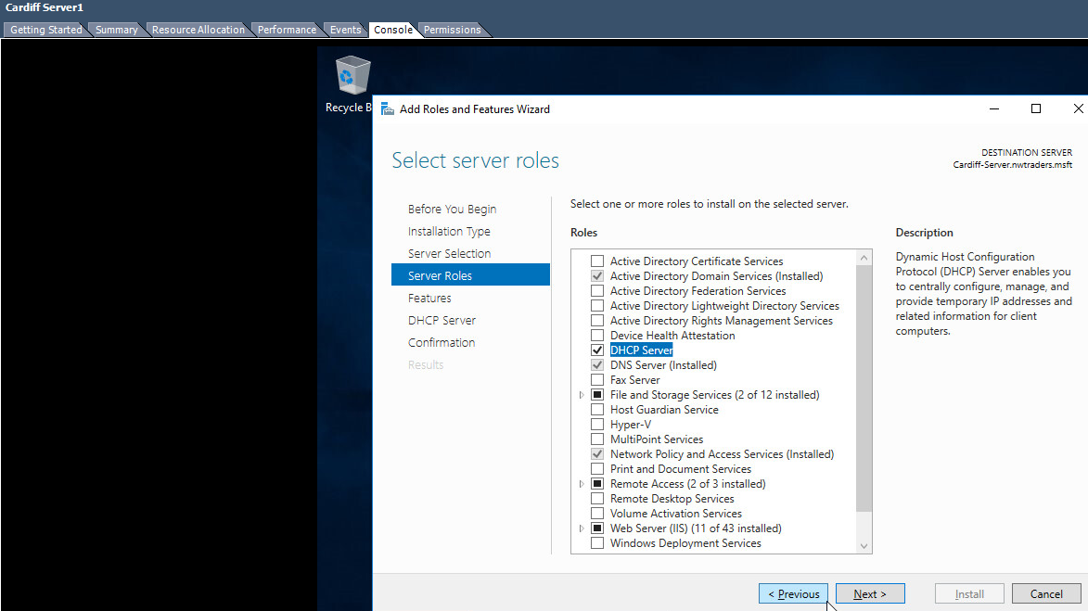
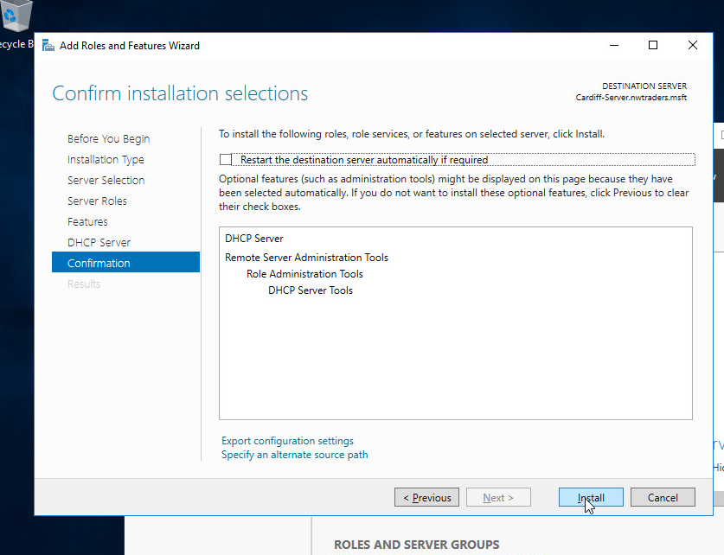

Task 3: Authorising the DHCP Server
YOU WON’T NEED TO DO THIS YET – THIS WILL BE NECESSARY ONLY ONCE WE CONFIGURE ACTIVE DIRECTORY, BUT COME BACK TO COMPLETE IT. WITHOUT COMPLETING THIS STEP, YOUR DHCP SERVER WILL NOT WORK AFTER INSTALLING ACTIVE DIRECTORY.

Authorising the DHCP Server:

One thing that Windows AD Domains protect against, is rogue DHCP servers or rather, the addition of them in our Network Infrastructure. DHCP clients are not really concerned which offer of an IP address they respond to (they just want an IP address).

To avoid network communications problems, we must have a way of ensuring that our clients get a correct address from the right DHCP server in the right scope.

In order for Domain clients to receive IP addresses from a DHCP server, the DHCP Servers must be authorised in Active Directory. To be an authorised the DHCP server must be:
- Running DHCP console
- A member server or a Domain Controller in the Active Directory domain.
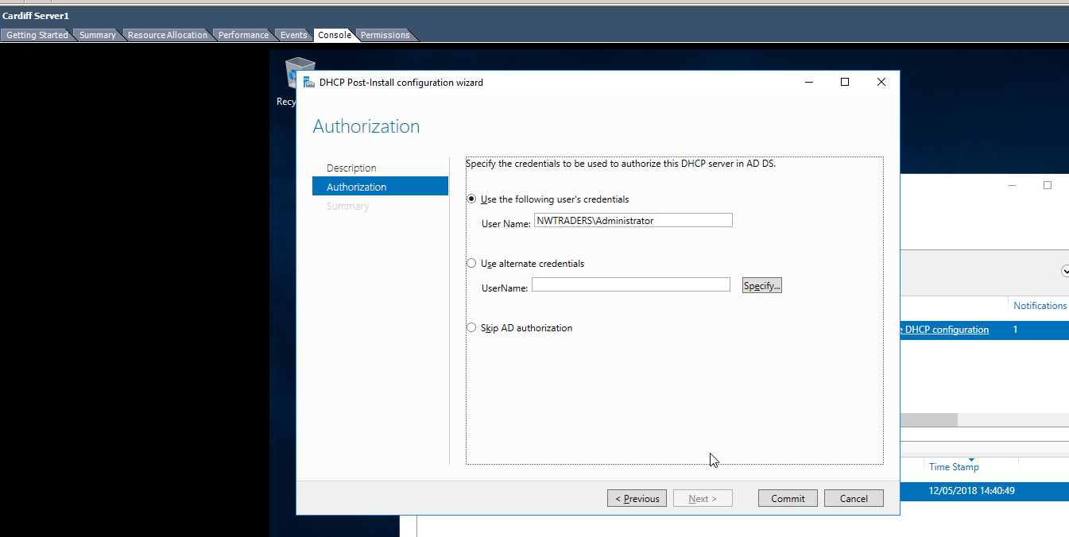
[Complete this task from Cardiff]

- Start – Administrative Tools DHCP
- In the Console Tree – Select the Server
- On the Action Menu – click Authorise

- Verify that the DHCP Service is authorised: in Console Tree, press F5 to refresh
Confirm that DHCP Server now displays with a green arrow that points up

- Close the DHCP console.

Task 4: DHCP Scopes
DHCP Scopes:

When we have installed DHCP onto our Network, the next step is to create a scope.

A scope is a range/pool of IP addresses (held within an IP address database), that are valid to be leased/assigned to DHCP clients within a particular NETWORK. Here we will create a scope for our Private Network.

The scope must be configured before clients can use DHCP server for dynamic TCP/IP configuration.

Each subnet is allowed a single DHCP scope that has a single continuous range of addresses. Specific addresses for applications (e.g. Web Servers, Print Servers) should be made exempt/excluded from the range that DHCP scope specifies (e.g. Reserved IP Addresses).

Question.

Why is it important to use Reservations when using DHCP?

Tasks:

Part A: [Creating a DHCP scope for initialization of ‘Leasing’ IP addresses to DHCP clients on the 0 network]

[Complete this task from Cardiff]

- Navigate to Start – Administrative Tools – DHCP.
- Expand the server name, right click IPv4 and select “New Scope”.
- Name it “0 Network DHCP Scope”.
- Set the start IP address as 192.168.0.2 and the end address as 192.168.0.254.
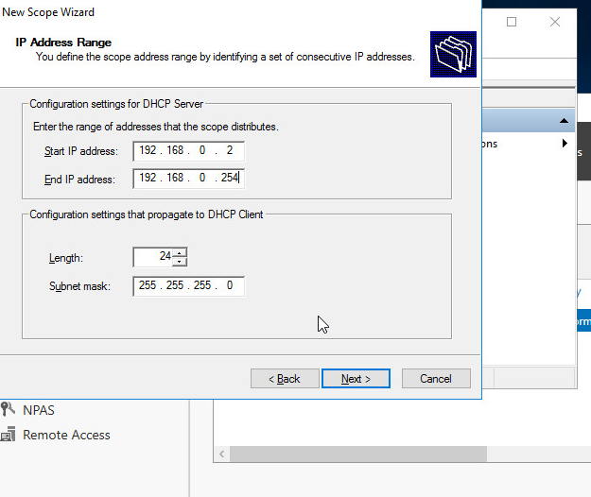
- At the Select Network Connection Bindings screen choose an appropriate Network Connection adapter.
- Do not add an exclusion.
- An 8 day lease is fine, and normal for a wired connection.
- Select “Yes” and continue.
- Enter the IP address Cardiff on the relevant network and hit “Add”.
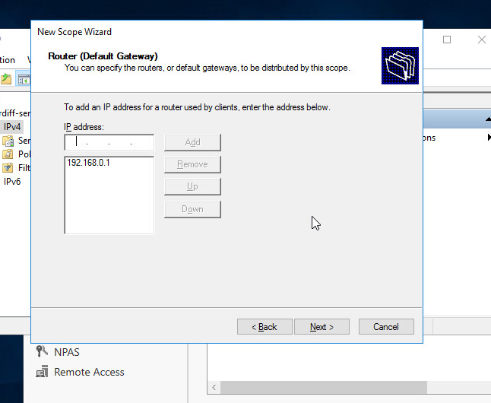
- Immediately hit “Next” on the DNS and WINS options.
- Select “Yes, I want to activate this scope now.”
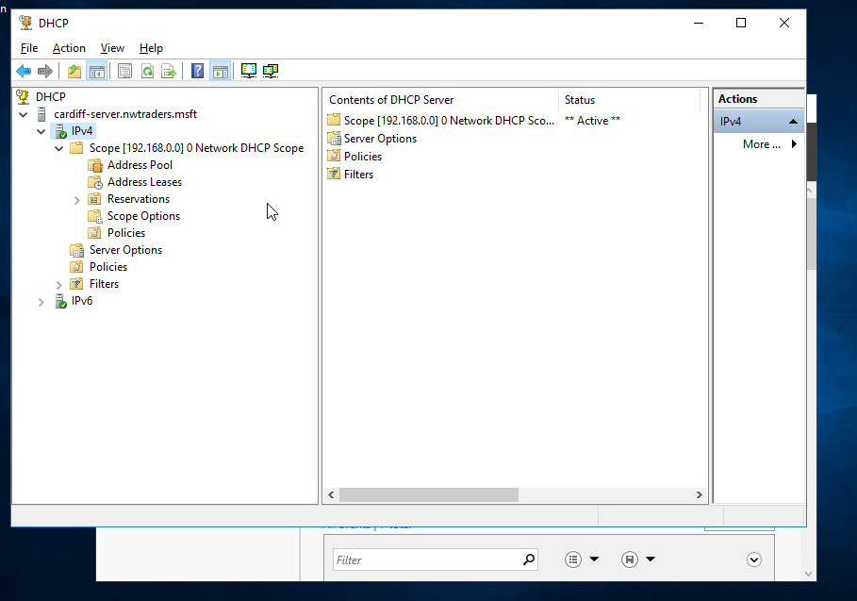

Part B: [DHCP Client obtains a leased IP address]

[Complete this task from Win-Server2]

- Login to the server if needed.
- Choose Start – Control Panel – double click Network Connections.
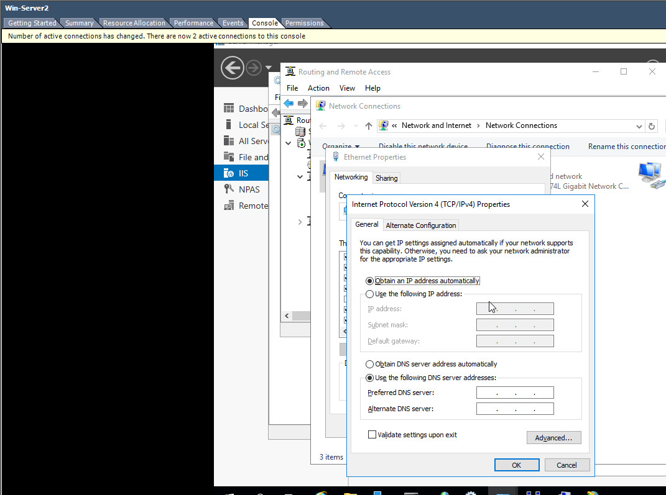
- Right click the Partner Network Connection
- Choose Properties
- Choose Internet Protocol (TCP/IP) click Properties.
- Check on the Obtain IP address automatically option.
- Check on the Obtain DNS Server address automatically option
- Choose Ok – Close

- Start – Run – cmd

- Type: ipconfig /release

- 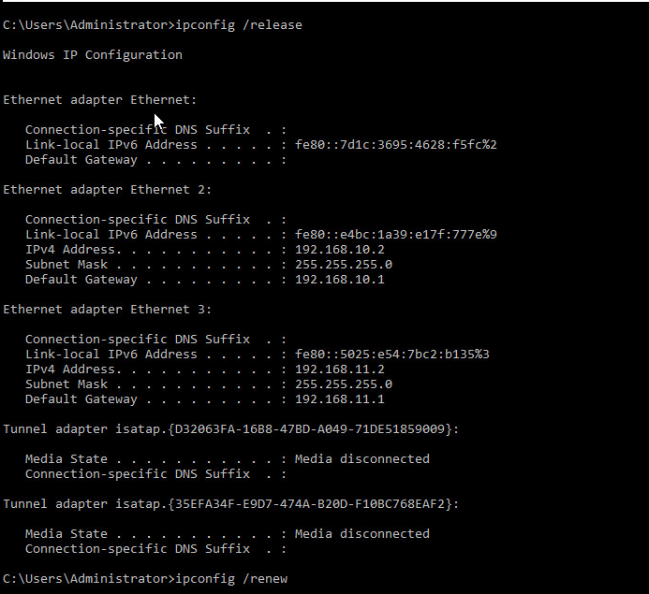
- Type: ipconfig /renew (to obtain an IP address from DHCP Server)
- 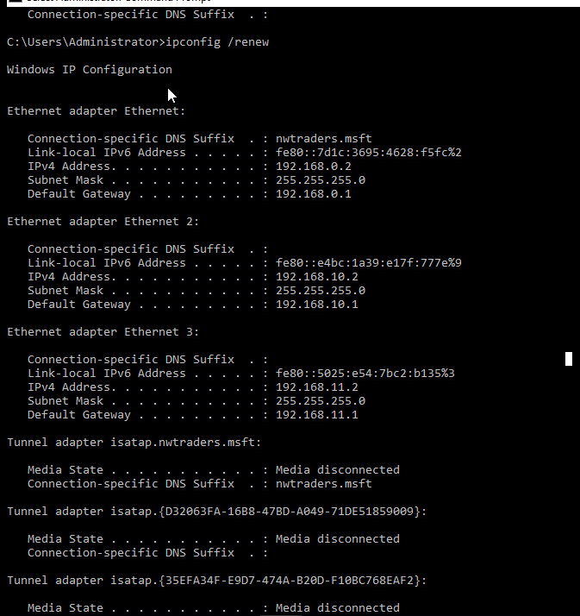
- Type: ipconfig /all
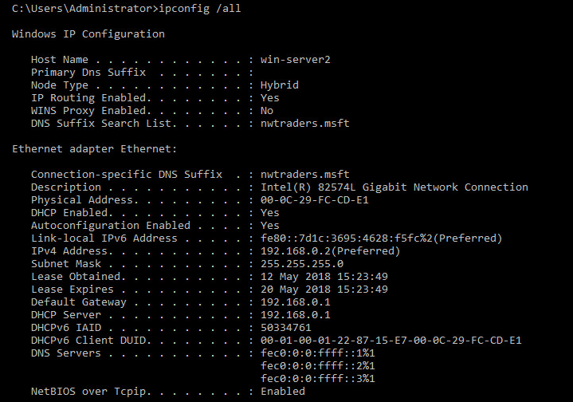
Verify that the DHCP server IP Address for the Partner Network Connection, is the IP Address of Win-Server2 server.

Win-Server2 has got the correct ip address as obtained by the Cardiff-Server DHCP

[Complete this task from Cardiff]

- Start – Administrative Tools – DHCP Console
- In the console tree - Click Address Leases, verify that the Computer Name displayed is that of your Partners Computer.
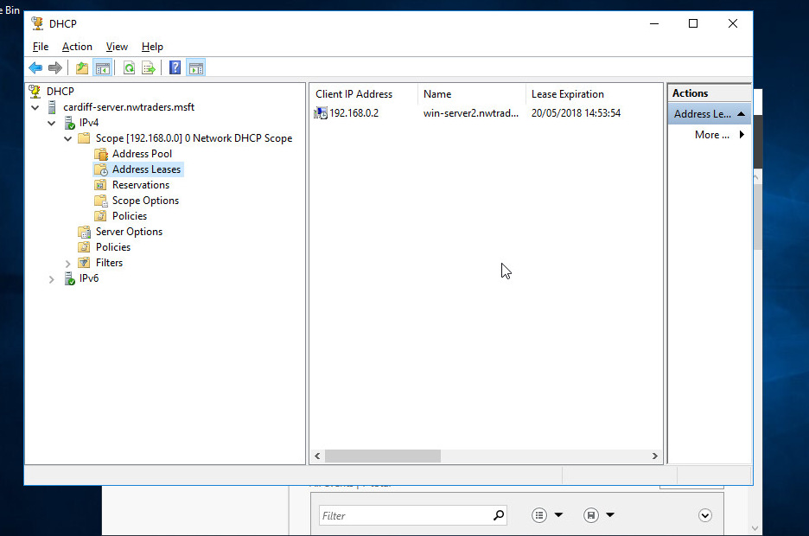
Task 5: Configuring DHCP reservations
Configuring DHCP reservations.

[Complete this task from Cardiff]

- Navigate to Start – Administrative Tools – DHCP.
- Expand the server name, then IPv4 and select “Address Leases”.
- You should see a single lease: 192.168.0.2 – Win-Server2. We’ll convert this into a reservation.
- Right click the reservation and select “Add to reservation”. This will convert the lease into a reservation. This is the easy way to create a reservation when a lease already exists.
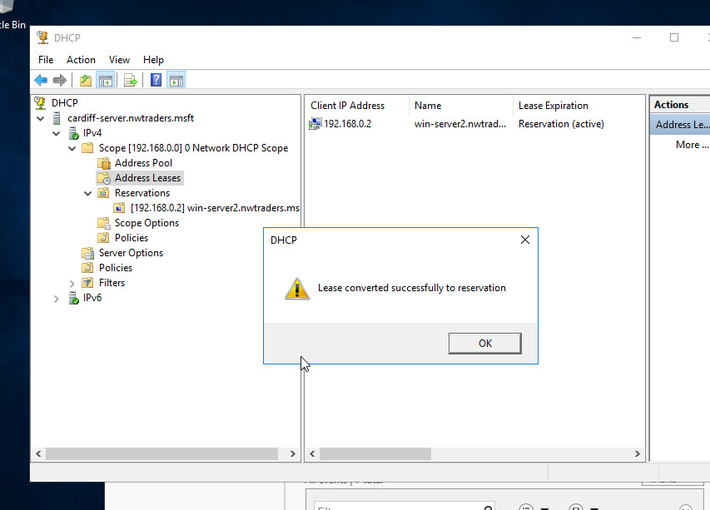
We’ll now create a lease for a computer for which we do not have a lease.

[Complete this task from the Windows 7 client]

- Start – Computer – Right click Network and select “Properties”.
- Change adapter settings.
- Select the 0 network and choose “status”.
- “Details”.
- Copy (exactly) the “physical Address”. It should be in the format 00-00-00-00-00-00, e.g. 00-15-5D-86-03-3F. Close this.

192.168.0.3 – mac address: 00-0c-29-B2-3E-6B

[Complete this task from Cardiff]

- Navigate to Start – Administrative Tools – DHCP.
- Expand the server name, then IPv4 and right click “Reservations” and select “New Reservation.
- Set the reservation name to “Lab-01-01” and the IP address 192.168.0.5.
- Set the MAC Address to the physical address noted above. This must be exact.
- Select “Add”.

[Complete this task from the Windows 7 client]

- Start – cmd.
- Type “ipconfig /release”
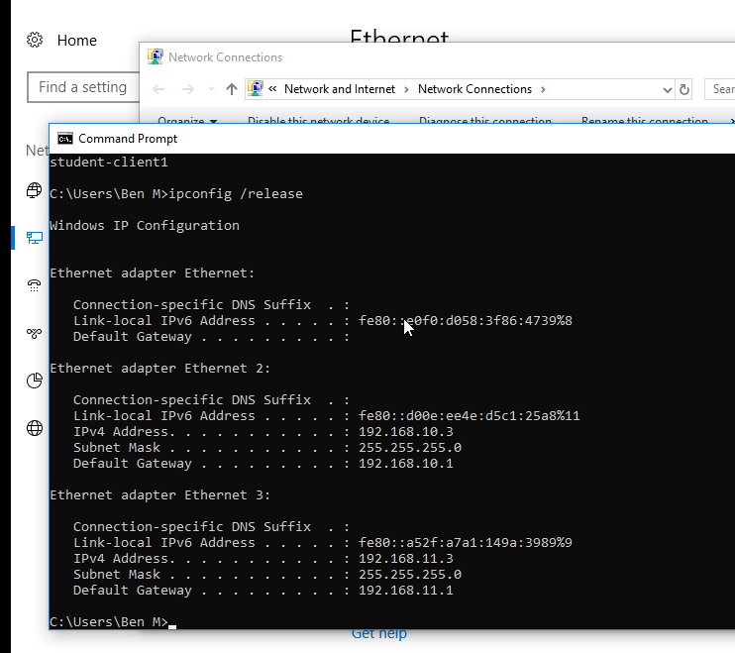
- Type “ipconfig /renew”
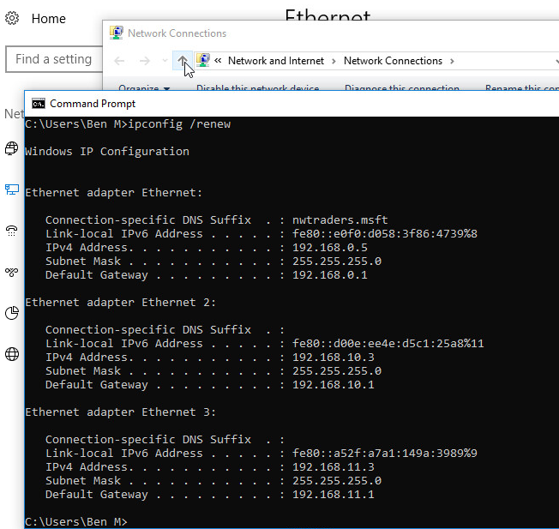
- Type “ipconfig” – what IP address has been obtained?
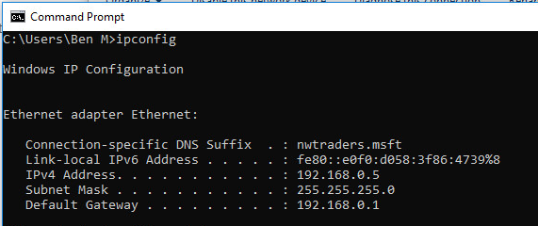

[Complete this task from Cardiff]

- Change the reservation for the Windows 7 client to give it the IP address 192.168.0.3.
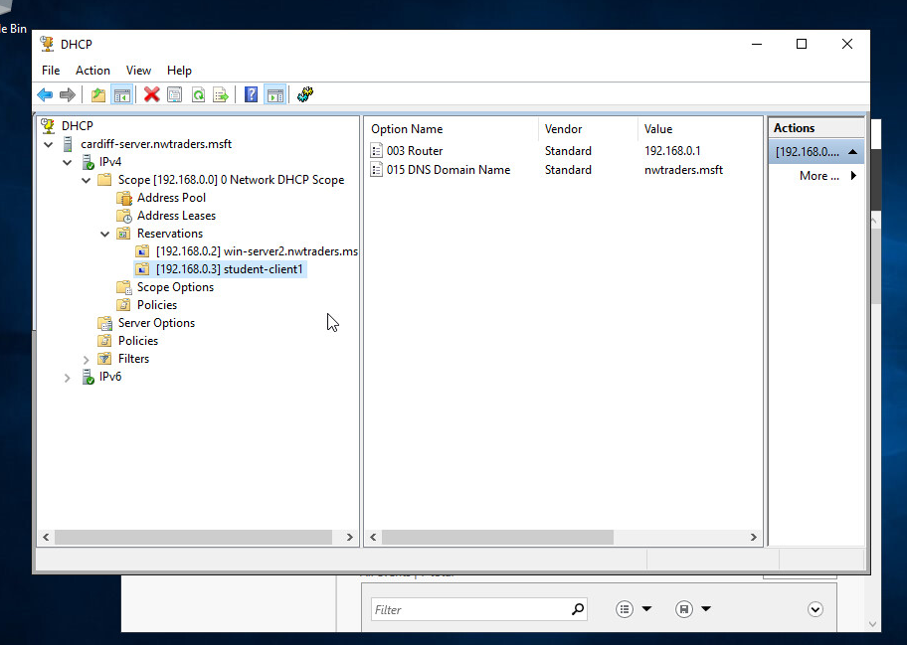

[Complete this task from the Windows 7 client]

- Start – cmd.
- Type “ipconfig” – what IP address has been obtained? Has it changed? If not, why not?
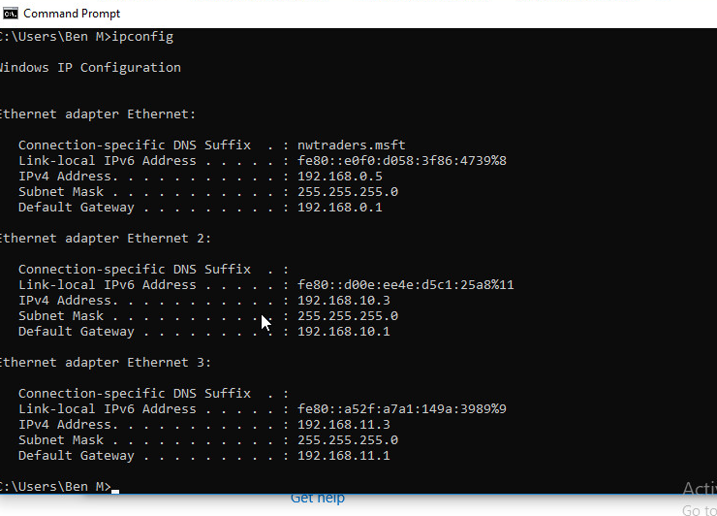
The ip address has not changed (192.168.0.5) because it has leased the current address for the next 8 hours unless the server is restarted or ipconfig /release and renew are performed.

- Again, release and renew the IP address. Has it changed now?
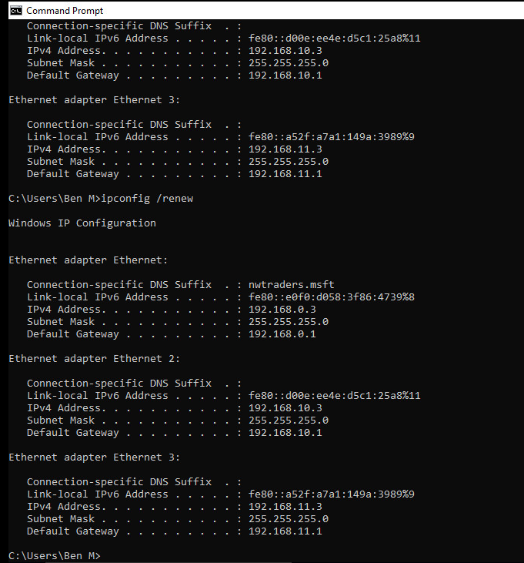

Now the IP address has now changed to 192.168.0.3

Task 6: Observational Tasks:
Q). Define the role of the DHCP Server in your Network?
Q). What happens when we have dynamically configured TCP/IP for our NIC, but then consequently cannot contact a DHCP server?
Q). Illustrate (with illustrations!!) the 4 stage process involved when DHCP clients look to obtain an IP address via DHCP?

Q). Describe the advantages of using a relay agent. Explain (with descriptions and illustrations) how and why we would setup the Relay Agent on our Router?

B.Sc. Year 2
Network Services and Web Technology.
WorkSheet 4: Name Resolution using the Domain Name Service (DNS)
Group Name: Ben McCarthy, Ben Archer, James Pugh, Gwyndaf Rees, Ryan Gallagher
Date:
Author(s): Ryan Gallagher
Complete the following tasks:
[Note you should read the worksheet information carefully as there are a number of written observation tasks. As always, take screen captures and written observations where appropriate].
Task 1: Understanding DNS operation;
Planning and deploying DNS
We need to install the Active Directory on the Cardiff server before deploying a secure DNS:

[COMPLETE THIS TASK UPON THE CARDIFF SERVER]

- Start – dashboard – All roles and features
- Add the role “Active Directory Domain Services”
- Once installed, select the flag with the yellow exclamation mark from the dashboard and select “promote this server to a domain controller”.
- Active Directory wizard loads.
- We are creating a new forest
- The FQDN we are going to use is nwtraders.msft
- Windows Server 2012 R2 is minimum platform we will support. Supply an appropriate restore password.
- Accept defaults until the role installs.
- The computer will restart.

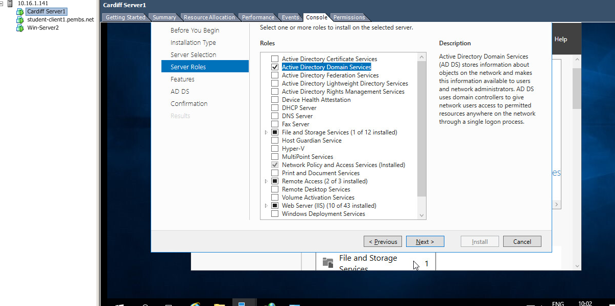
Selecting the Active Directory Role
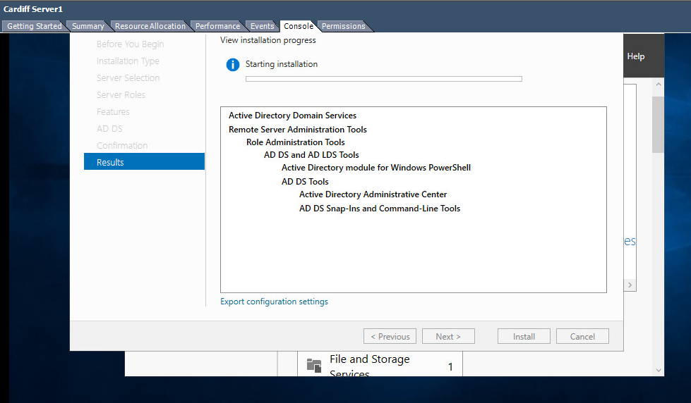
Installing Active Directory
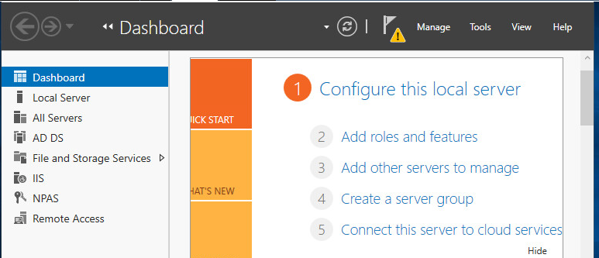
AD DS Role installed

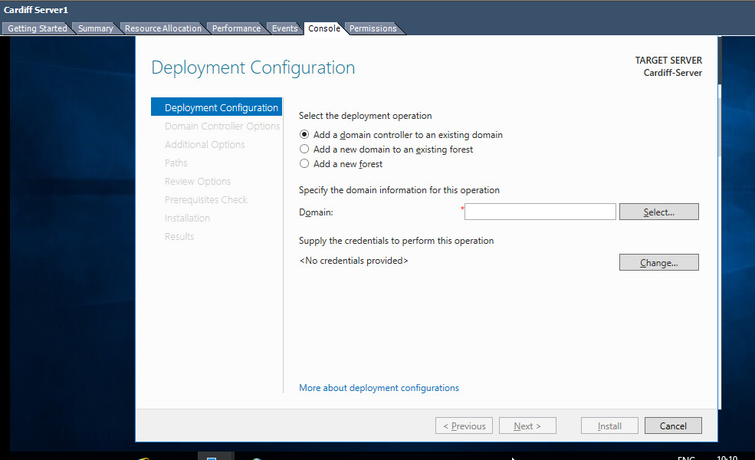
Promoting to a Domain Controller process

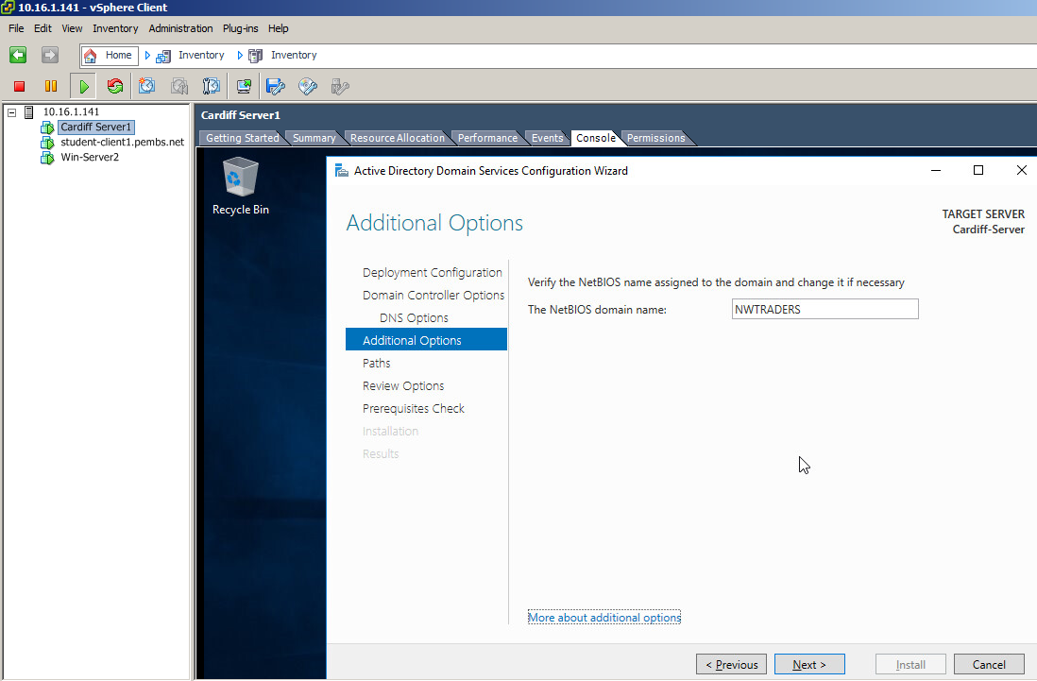
NWTRADERS is now the Domain

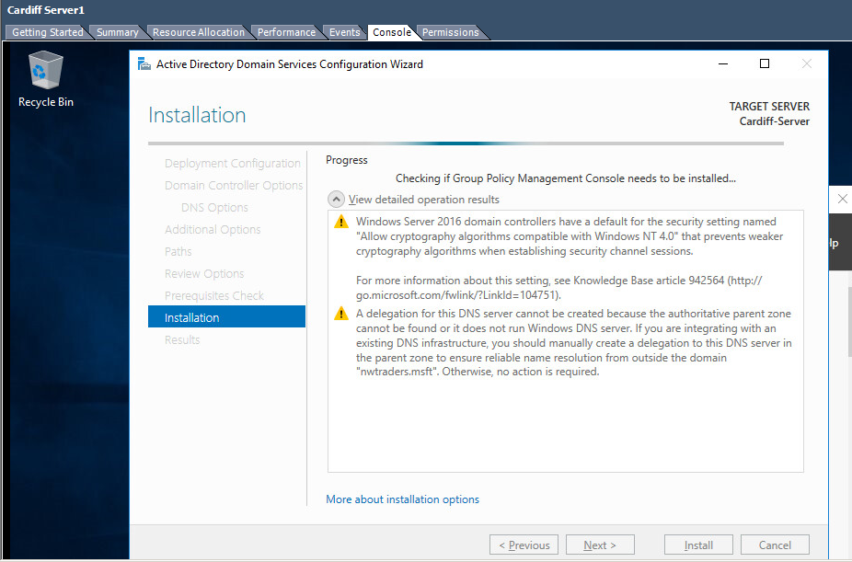

Issues that will need to be addressed once server has restarted.
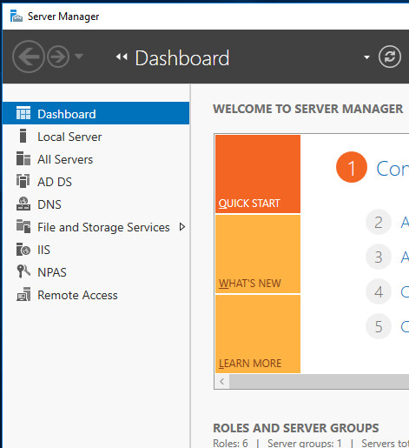
The DNS role has been installed as well.

You will need to login with the administrative account you’ve been using at this point to make any changes in your newly created nwtraders.msft domain (e.g. to create users, install services etc).

Remember: now this server is on a domain, its DHCP server will have to be authorised, otherwise DHCP will not work. Refer back to that tutorial if necessary.

At this stage we will ensure that the other servers we have are added to the nwtraders.msft domain: To do this.

- We’ll now add Win-Server2 and the Windows 7 client to the domain in turn.
- At each VM in turn - right click on Computer – Properties – Advanced system settings
- Click on the Computer name tab
- Click change
- Click the domain option and type in nwtraders.msft
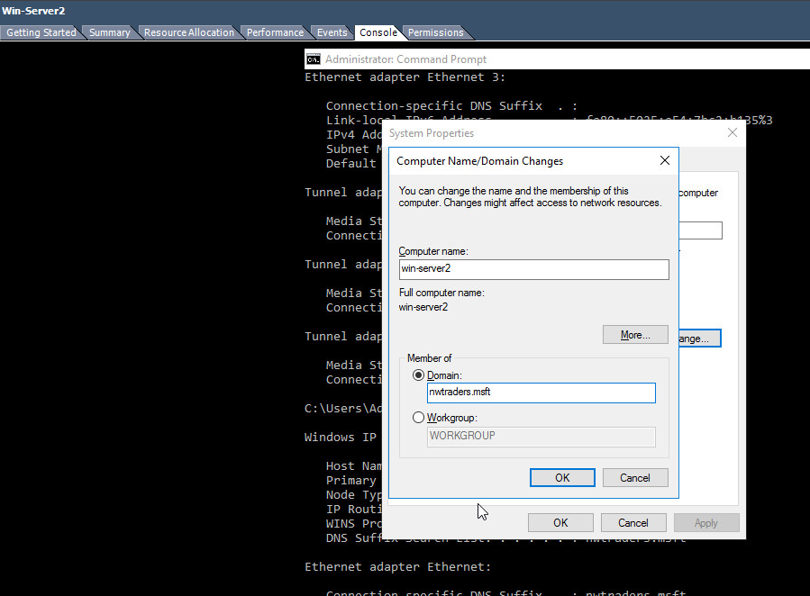
- 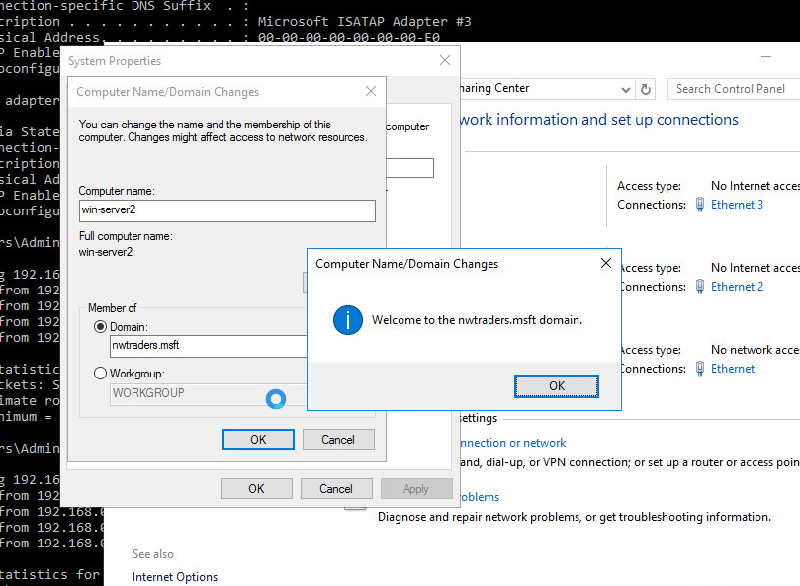
Win-Server2 has joined the nwtraders.msft domain.
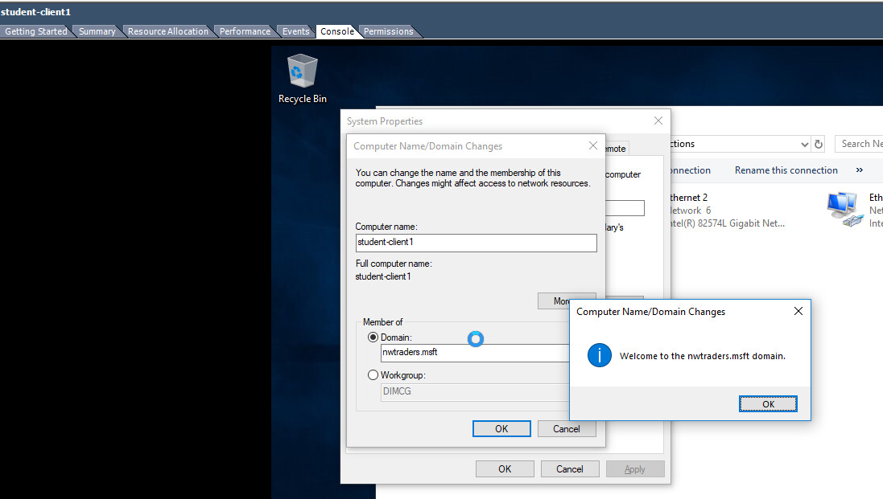
Student-client1 has joined the nwtraders.msft domain.

- When prompted for an account use the administrative account you specified during the Active Directory install.
- When this is done, you should get a welcome message to the nwtraders.msft domain.
- Restart the computer and logon using the active directory account you just used to add the PC to the domain.

[COMPLETE THIS TASK ON Cardiff]

- On Cardiff launch the Active Directory Users and Computers console – Start – Administrative Tools – Active Directory Users and Computers.
- Expand the nwtraders.msft domain namespace in the left hand console view.
- Click on the Computers Organisational Unit (it essentially resembles a folder).
- You should see accounts for the Win-Server2 server and the Student Client you’ve just added to the nwtraders.msft domain
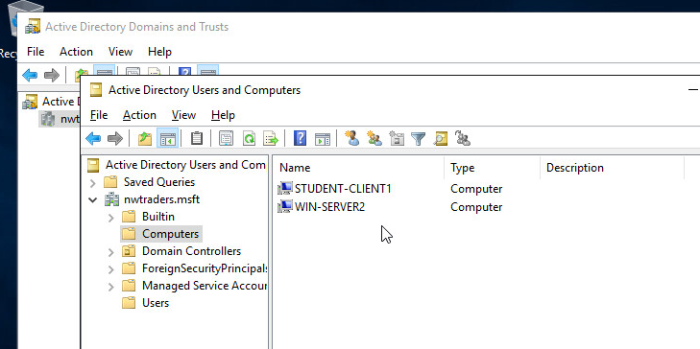

[COMPLETE THIS TASK ON CARDIFF]

We saw previously that the Network Infrastructure needs to implement a Naming System (Host Names) which involves mapping IP addresses to names, as a form of alias. This is because it is very difficult for Humans to remember 32-bit number combinations (the format of logical IP addresses).

You will remember that the DNS Namespace is used to refer to Computers or more specifically Network Cards (after all this is how our devices talk over the Network) as Hosts.

Anything that binds an IP address to it is referred to as a Host in the DNS Namespace. DNS namespace is hierarchical, arranged into Parent and Child Domains, therefore Names can be reused.

Understanding the DNS Namespace.

DNS unlike the NetBIOS namespace is hierarchical; it uses a Parent – Child Domain Structure. This allows for scalability and reuse of names. Take the following example;

Server1.leespace.com

We reuse the domain space of leespace, as long as it’s unique within the Parent Level Domain Space of com.

Can we have more than 1 Server named Server1,again the answer is yes as long as it’s unique within the Domain (no more Server1’s allowed in leespace domain), you could as part of leespace.com have a child domain called sales, therefore we could have

Server1.sales.leespace.com

The other important aspect to understand with DNS Namespace is within the Parent – Child (hierarchical space), we generate names for devices by giving them Fully Qualified Domain Names (FQDN). Example server1.leespace.msft

Server1 identifies the host name and leespace identifies the Parent Domain that this host lives within.

You don’t have to have the DNS Server Service installed to work in an everyday Windows 2012 Server environment; you could be part of a Workgroup or simply a Member Server in the domain.

Choosing/Planning Domain Names using DNS.

- You must use a unique domain, within the parent level domain space.
- Once this is done, you need to select the Name Server that is authoritative for the Domain Space. (E.g. Is Server1 the authoritative Name Server for nwtraders.msft domain space?)

In order to complete Worksheet 4, you will need two name servers in the network; one on Cardiff, one on Win-Server2.

[Complete this task from both servers]

Task (A). Check the Host Name and Fully Qualified Domain Name of your Server.
To better visualize the concept of how the domain name system breaks down host names/fully qualified host names we have 2 methods available to us.

You should record your results:

To check the host name

- Start – run – cmd
- At command prompt, type hostname (Note the result)
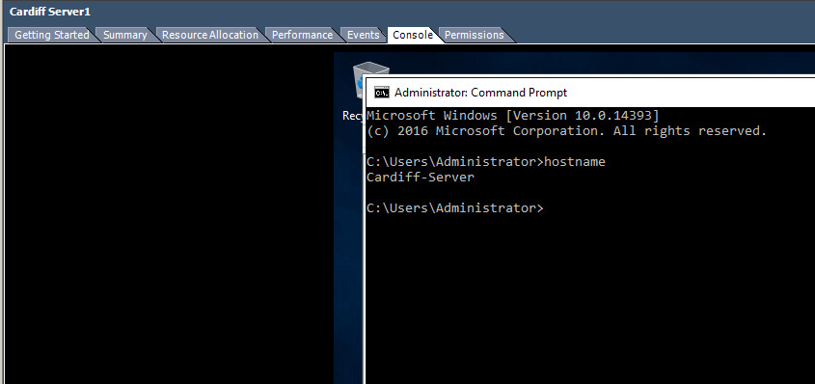
- Cardiff-Server
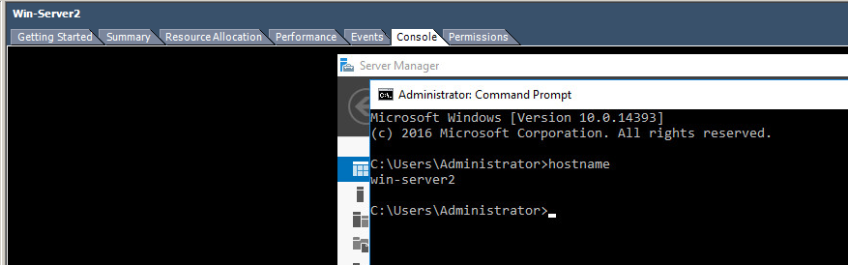
- Win-Server2
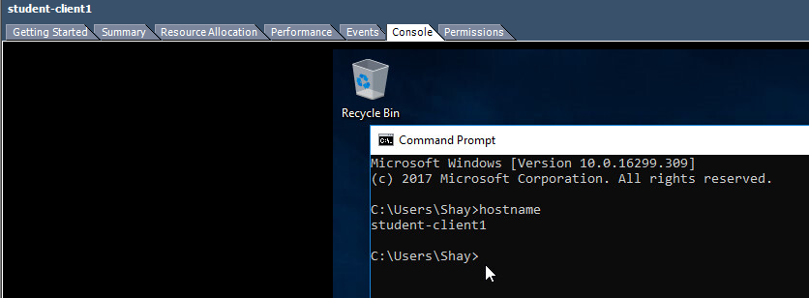
- Student-client1

To check the Fully Qualified Domain Name

- Start – right click on My Computer – choose Properties
- Click on the Computer Name tab
- Note the full computer name provides the Fully Qualified Domain Name.
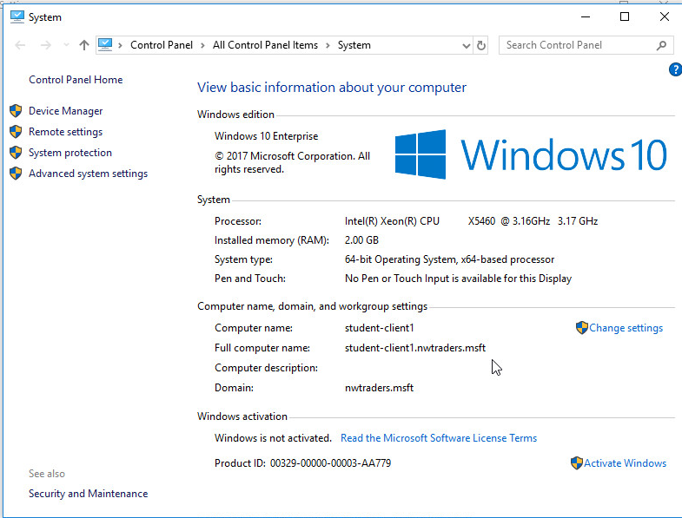
- Student-client1.nwtraders.msft
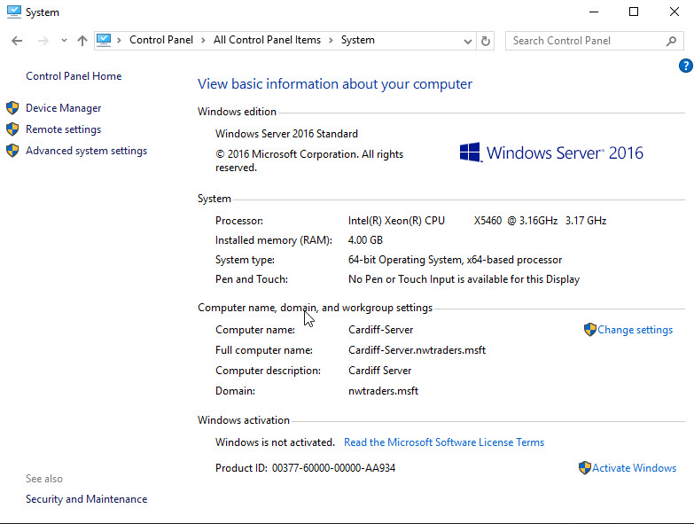
- Cardiff-server
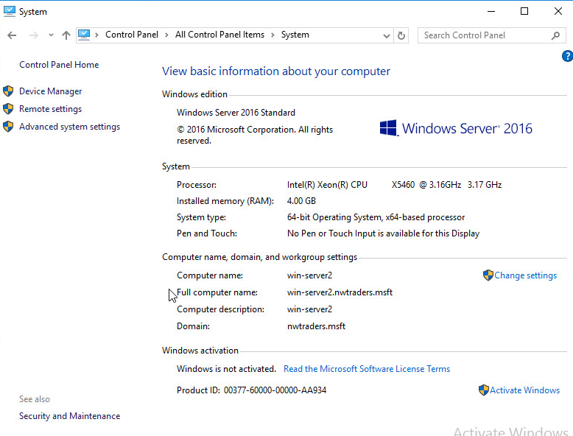
- Win-server2

Task (B). Installing the DNS Server Service.

[Complete this task from Win-Server2]

Login using an administrative account;

- Dashboard – add role
- DNS Server
- Wait for this to install.
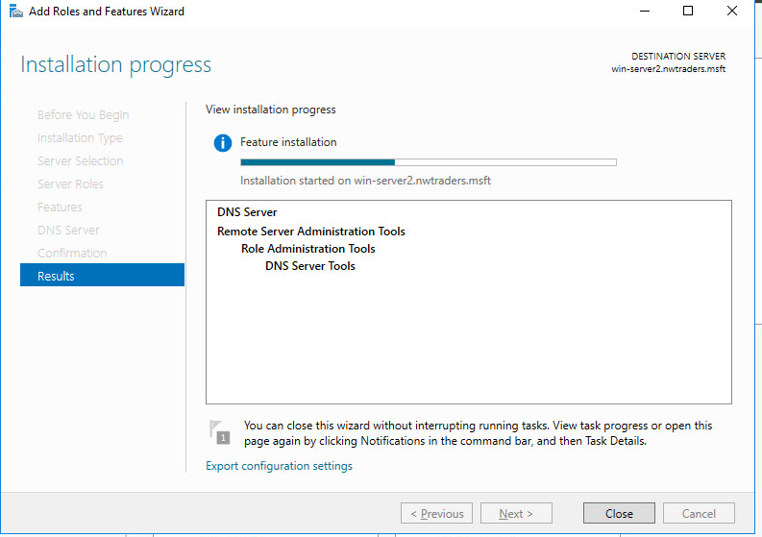

- The DNS Console is now available by choosing Start – Administrative Tools – DNS.
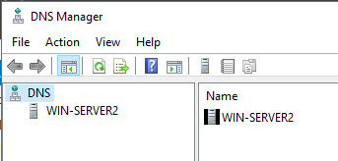
Authoritative and Non-Authoritative DNS Servers.

Authoritative DNS Server – Is authoritative for the namespace of the query, if authoritative, the DNS Server hosts a primary/secondary copy of the query. When queried; the DNS Server will check the Cache then check the Zone and then return the requested address. If it cannot find the address the DNS Server responds to the client with an authoritative No.

Non-Authoritative – Means the DNS Server is non-authoritative for the namespace of the query. The DNS Server will then either Forward the query to another server called a Forwarder, or addresses of multiple root servers to step up the DNS hierarchy to locate an answer for the query (also known as the Root Hints process).

[Complete this task from Cardiff]

Task (C). Configuring the Properties of the DNS Server Service.

Q). We will not configure the DNS server at this time, although it is generally a good procedure to make the DNS Server, a Client of itself. In other words make our computer a DNS client, then this client will be a client of the DNS Server we are installing, why is it important do this?

- Demonstrate how you would make this server a client of itself
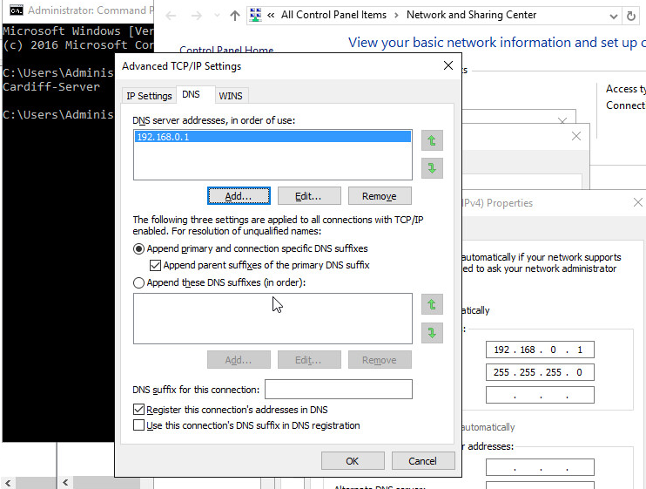
- We added the server address to the DNS setting on the IP 4 nic advanced settings tab
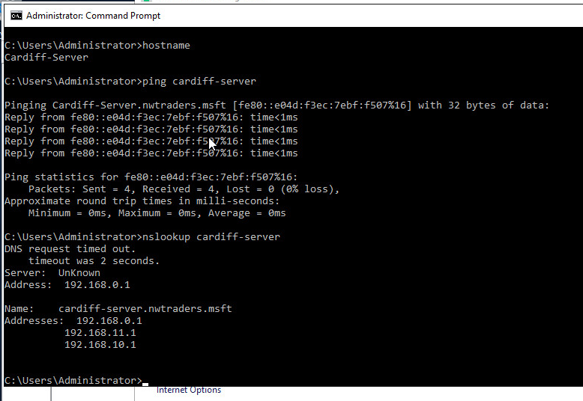

There are Several elements to appreciate when configuring the properties of the DNS Server Service.

When done ensure that you put these settings back to their original value(s).

* DNS Solutions:

Comprise the following elements:

- DNS Server Service (The computer that runs DNS Service, resolves requests/queries that DNS Client – Resolve submits)
- DNS Client – A computer that runs the DNS Client Service
- DNS Resource Records – Information/records of host names to resources.

* DNS Queries:

A client takes several steps when trying to resolve a Name to an IP address, you will recall the process (from last week’s notes) but to refresh your memories the third step involves the client querying a DNS server.

E.g. We are attempting to ping lees-server.com, in order for this action to be completed successfully we need to resolve the name to an IP address.

To better appreciate the principle behind this, we first need to recall the DNS Namespace Hierarchy:

Take the following FQDN (ftpserver.mainservers.sihe.org

Root Level/Top Level Domain – Managed by Internet Controlled Servers (e.g. com, org, edu, ac).
Secondary Level – Our registered domain name (e.g. uwtsd)
Subdomain Level – Subdomain used in our hierarchy (e.g. mainservers)
Host Level – the host name of our Machine (e.g. ftpserver1).

The client (when attempting to resolve the IP address via the DNS service) will walkthrough the DNS Hierarchy of Servers with a series of Recursive and Iterative Queries. A query is the process involved when a DNS client resolver asks the DNS Server for the IP address of the supplied host name.

The reason for the query is for the DNS solution to allow users to access resources by using alphanumeric names.

2 Types Recursive and Iterative;

Keywords; Root Hints: These are resource records stored on a DNS Server that list IP addresses of DNS root Servers.

Task (D). More DNS properties: DNS Forwarders, cache entries and root hints.

This is a DNS Server that other internal DNS servers designate to handle/forward REQUESTS/QUERIES for resolving domain names that reside at external/offsite locations.

Example:

DNS Name Server receives a request so it attempts to locate this information in its own zone files. If this fails (e.g. because the Server is non-authoritative for the domain requested) the server must liaise with other servers to solve the request. This is the function of the Forwarder.

In Wide Area Network contexts, the query may involve interaction with DNS servers across the WAN links.

[Configuring a DNS Server to use a DNS Forwarder].

[Complete this Task from Win-Server2]

- Ensure that DNS Console is open
- Select the server in the console view
- Choose Action – Properties
- In the Selected Domains Forwarder IP address type any IP address of CARDIFF (DNS should be responding for CARDIFF on both):
- Type 10 seconds into the ‘Number of Seconds before forward queries time out’ field.
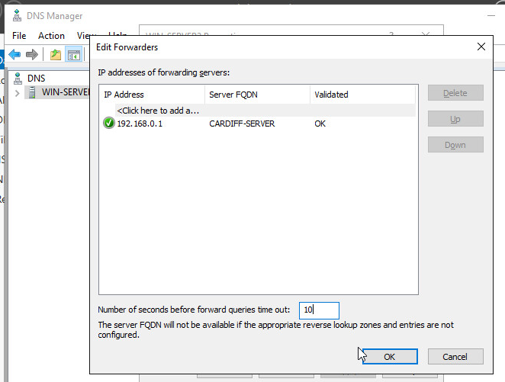

DNS Server Caching.

We use Caching to temporarily store recently accessed information in a nearby memory location for the purposes of fast & efficient retrieval.

DNS Server Caching provides fast responses and reduces DNS formulated network bandwidth. DNS Responses are cached for a certain period (TTL) so that future queries for this record can be resolved quickly from Cache.

[Complete this Task from Cardiff]

[Updating Root Hints].

- Open DNS Console
- Select your Server.
- From the Action Menu – select Properties
- Select the Root Hints tab – click Add: enter the FQDN and 0 Network Connection IP Address of Win-Server2
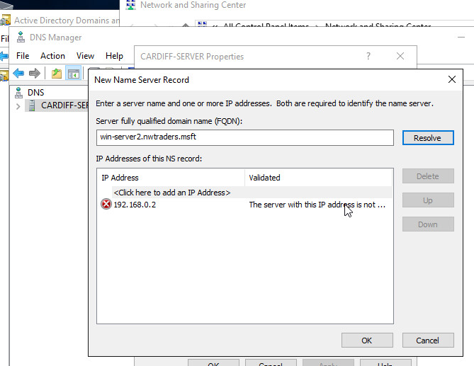
- Click Ok to close the properties dialog box and then close the DNS console.

[Clearing the DNS Server cache using DNS Console].

- Ensure that DNS Console is open
- Select the appropriate Server
- Choose Action – Clear Cache

Q). Why is it important to be able to control the DNS cache and in some cases clear the DNS cache entries?

Task 2: Storing and Maintaining DNS Data.
The Resource Record is a set database structure that contains information needed to process DNS queries. (E.g. Host Name: DNSClient1 IP Address: 192.168.10.100).

The DNS Zones are the physical portion of the domain space, where Resource Records are kept.

Lets say for example we have the following Namespace structure

Second Level Domain: nwtraders.msft

And then within this structure we have two subdomains called Sales and Purchase.
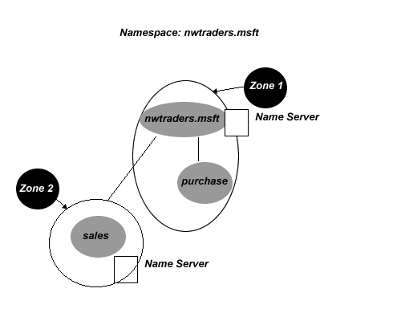
We could have a Zone (Zone 1) that can be Authoritative for both nwtraders.msft domain and the purchase.nwtraders.msft domains.

If we have another Name Server on the Sales Domain, then on this server we have a Zone file. This zone file is authoritative for only a single portion of the DNS Namespace (hosts in the sales.nwtraders.msft domain).

Zones are stored on Name Servers. The Zone file is the file stored on the Name (DNS) Server that contains configuration information for a zone and resource records contained within that Zone.

A DNS Server is authoritative for a Zone, if it hosts resource records for the names and addresses that the clients request, in its Zone File.

DNS Fault Tolerance - DNS Zone Types

There are three different types of DNS Zones, Primary, Secondary and Stub Zone.

It is generally good practice to configure a Primary DNS Zone on one server and configure a Secondary DNS Zone on another, this way if the primary zone fails we have fault tolerance in place.

Primary Zone – The authoritative copy of DNS Zone information, resource records are created and managed here. We setup a Primary Server to host the zones for a domain or domains, this server is usually stored at an accessible location so that we can administer the zone file with any changes

Secondary Zone – This zone contains a copy of the DNS Zone, but in read-only format. Records in the Zone file can only be changed at the Primary Zone.

Stub Zones – A stub zone is a copy of a zone; that contains only the resource records that are needed to identify the authoritative DNS servers for that particular zone. The principle is like a bookmark or pointer that simply points to the DNS Server that is authoritative for a particular zone.

Forward and Reverse Look-up Zones:

Forward Lookup Zone – A query process where the display name for the DNS domain of a host computer is searched in order to find its IP address.

Reverse Lookup Zone – A query that involves searching the IP address of a host computer, in order to establish its display name for the DNS Domain.

Task (A): [Configuring DNS Zones]

Here we will configure a DNS Zone by type and establish the Lookup Zone type:

[Complete this Task from Win-Server2]

- Open the DNS Console
- In the DNS Console, right click on the DNS Server, click New Zone
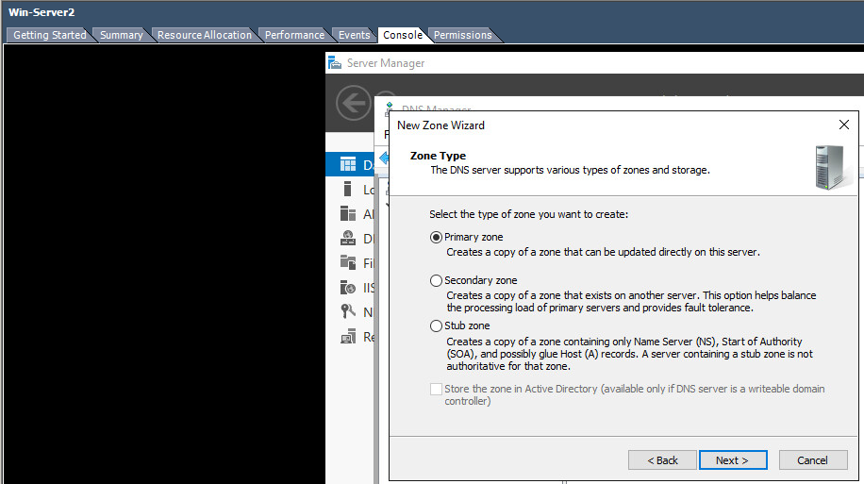
- At the Welcome Wizard Dialog page click Next
- At the Zone Type page – choose Secondary Zone – choose Next.
- In the Forward and Reverse Lookup Zone page, choose Forward Lookup Zone (if it is not already selected). Click Next
- Zone Name: nwtraders.msft
- Master DNS Server requires the IP address of the Master DNS Server: type the IP address of CARDIFF. (You will need to ensure that CARDIFF has allowed for zone updates) don’t worry about this now, we will configure it later.
- Verify that the zone is loaded from the Master DNS Server:
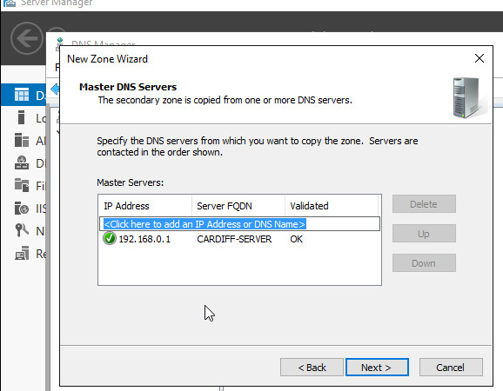
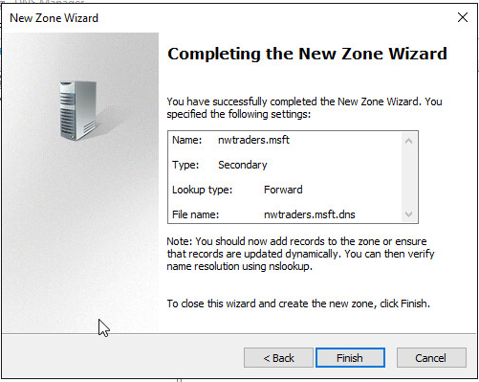
- We may have to ensure that zone transfers are allowed for this zone (security settings) to allow this to occur on our servers.

Q). Identify how you enable zone transfers to allow this zone to store a secondary copy of the nwtraders.msft data.
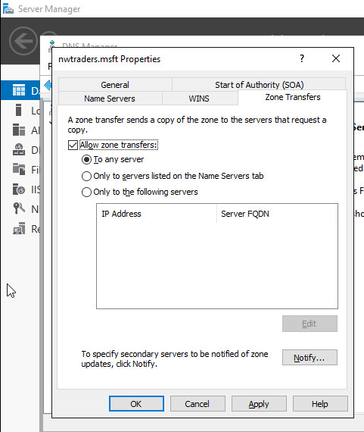

- In the DNS Console select the Secondary Forward Lookup Zone we have just created – in the details pane, view the Resource Records to check that the zone has been loaded from the master server.
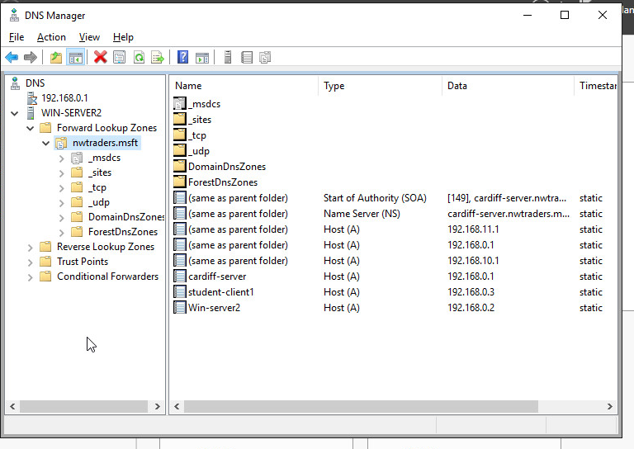

[Here we will configure a Reverse Lookup Zone, each DNS Server in the lab will maintain both a forward lookup zone and a reverse lookup zone]

[Complete this Task from Win-Server2]

- Open the DNS Console
- In the DNS Console, right click on the DNS Server, click New Zone
- At the Welcome Wizard Dialog page click Next
- At the Zone Type page – choose Secondary Zone – choose Next.
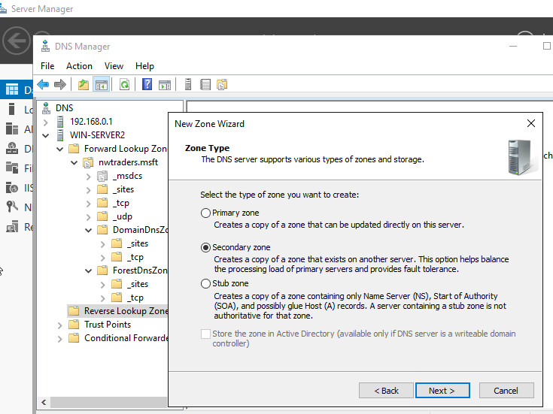
- In the Forward and Reverse Lookup Zone page, choose Reverse Lookup Zone (if it is not already selected). Click Next.
- In the Reverse Lookup Name page – in the Network ID field – type ONLY the Network ID Portion of the 0 Network IP address (E.G. 192.168.0)
- On the Zone file page click Next to accept defaults.
- At the Master DNS Servers page – type the IP address of the Master DNS Server the IP address of CARDIFF.
- Click Finish at the Summary of Selections page.
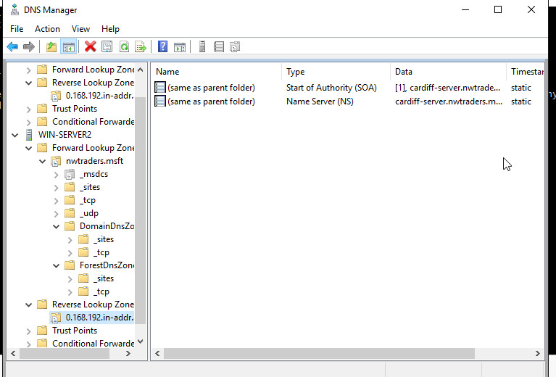
- In the DNS Console select the Secondary Reverse Lookup Zone we have just created – in the details pane, view the Resource Records to check that the zone has been loaded from the master server.

Here we will create a Forward Lookup Zone on a Primary Zone Type on our DNS Server. To achieve this we will need to create our own Primary Zone that will manage the resource records for just the client machine in our private network.

[Complete this Task from Cardiff]

- Open the DNS Console
- In the DNS Console, right click on the DNS Server, click New Zone
- At the Welcome Wizard Dialog page click Next
- At the Zone Type page – choose Primary Zone – choose Next.
- In the Forward and Reverse Lookup Zone page, choose Forward Lookup Zone (if it is not already selected). Click Next.
- At the Zone Name page, we need to type the DNS Name of the Zone that this server will be authoritative for type the following:
- Win-Server2server.nwtraders.msft
- At Zone file page, choose Next to accept the Defaults.
- At the Dynamic Update page (more on Dynamic Updates later on) choose the option; Allow both non-secure and secure dynamic updates.
- On completion of the New Zone – choose Finish. 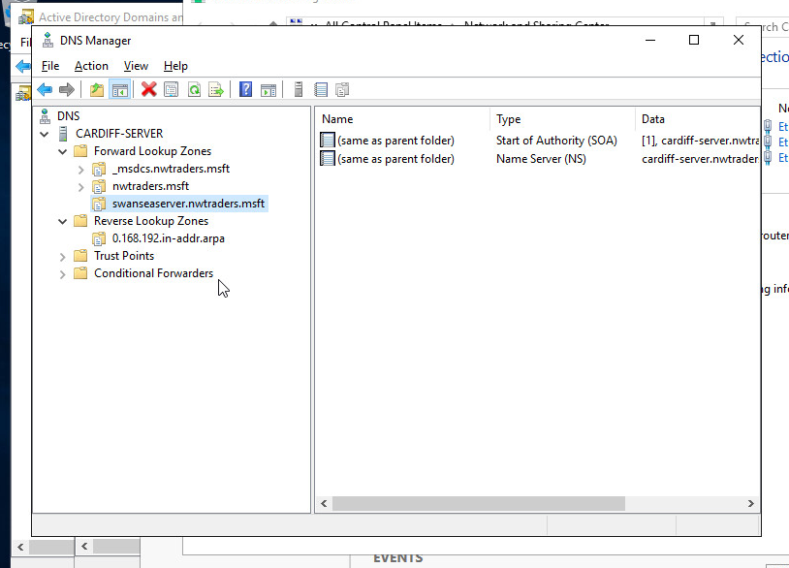

[READ THIS!!!]

It is important to understand here that we have created an additional DNS Zone as well as the default nwtraders.msft zone that exists as part of our Active Directory. The idea here is to show how you can have a default zone which looks after maybe all servers, but a secondary layer of redundancy/load balancing by creating another zone. In our example, the zone we ve created only looks after the Win-Server2 DNS that the Cardiff server is directly connected to. In reality, this could well be another few hundred/thousand machines, in larger enterprise networks.

Implementing Fault Tolerance via DNS Zone Transfers.

A DNS Transfer is the transfer of all data in a particular zone, from the Primary DNS Server hosting the zone to a Secondary Server. The purpose of the Secondary Server is to host a copy of the Zone.

Changes made to the Primary Server need to be reflected at the Secondary Server, thus should the Primary Server ever fail, the Secondary Server has an up to date copy of zone file (including all the resource records).

We may have more than one Secondary Server, so it is important to replicate changes at the Primary Server to all these servers. This is done using DNS Zone Transfers.

DNS Notify – This is the system by which, it is possible for the Primary Servers to notify Secondary Servers when changes to the zone occur.

The purpose of DNS Notify is to enable Secondary Servers, (upon receiving notification that a change has occurred to the zone) to obtain these zone changes from the Master server. This ensures that the local replicas, on the Secondary Server, are up to date.

[Configure DNS Transfers and DNS Notify]

Here we are going to setup a zone transfer using DNS notify from our Primary – Forward Lookup zone (SRV-NWTRADERS.MSFT – in other words our server). We will set the Secondary Server (the Replica Server for our Zone to be the Cardiff Server.

[Complete this Task from Cardiff]

- Open DNS Console
- Expand the Server and then Expand Forward Lookup Zones.
- Select the Primary Zone you previously created.
- Right click- choose Properties
- Click the Zone Transfers tab – verify that Allow Zone Transfers option is enabled/selected.
- Select the option Only to the servers listed on the Name Server tab.
- Within the Zone Transfers category – select the Notify option.
- In the Notify category – choose the option; Servers listed on the Name Servers tab.
- On the Name Servers Tab, click Add.
- In the new resource record dialog box in the Server fully qualified domain name (FQDN) field, type Win-Server2.nwtraders.msft and click “resolve”.
- Click Ok.
- On the Zone properties tab, click Ok.
- Close the DNS Console.
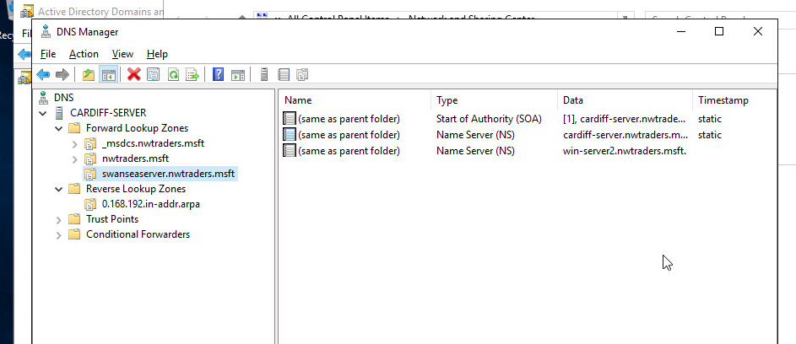
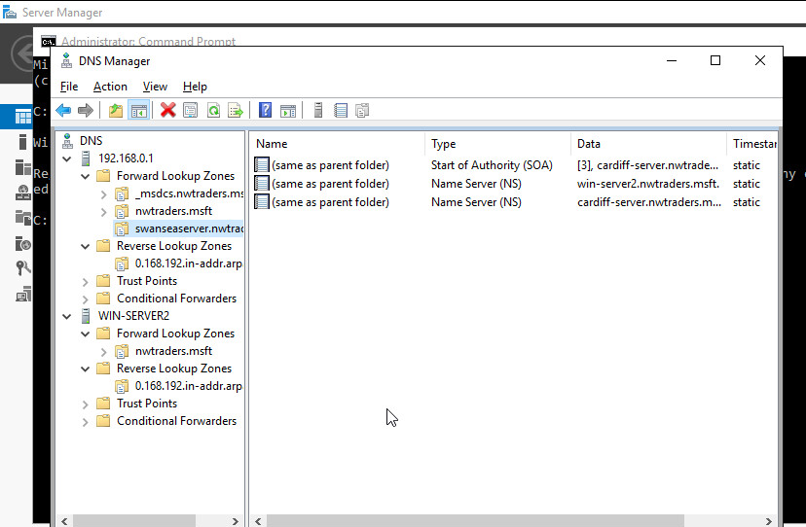
Finally after a few minutes, verify that the zone transfer has taken place on Win-Server2
. (See above steps on how to do this).
Task 3: DNS Application
Here we will begin the steps towards deploying a common network service that relies heavily upon the correct configuration of DNS, the web server service. Before we configure host settings in the zone file, we need to install and configure the web service.

[Complete this task from Win-Server2]

We should already have IIS installed from configuring the FTP server. If you have not yet done this, go back and do this first.

[Creating a virtual directory]

You may remember that a virtual directory is an alias for remote computers to access the files that are stored on one or more of our web servers ‘local disks’. By being local, these disks are not viewable by remote computers. The virtual directory makes this possible.

- Start – Administrative Tools – IIS (Internet Information Services).
- In the console view, expand the local computer, expand the web sites folder, right click on Default Web site and choose Add Virtual Directory.
- Click Next on the Welcome screen
- Give the virtual directory an Alias name. This name is what remote users will insert into their browsers to find the files that live locally on your machine. Ensure the name is relevant to the application you are hosting, e.g. “test”.
- You will also need to point the alias to the local directory where you web site content will be stored. This is usually within the Inetpub/www directory within your local disk (e.g. C:\Inetpub\wwwroot). This is the default web folder for websites in Microsoft windows operating systems. Choose Next
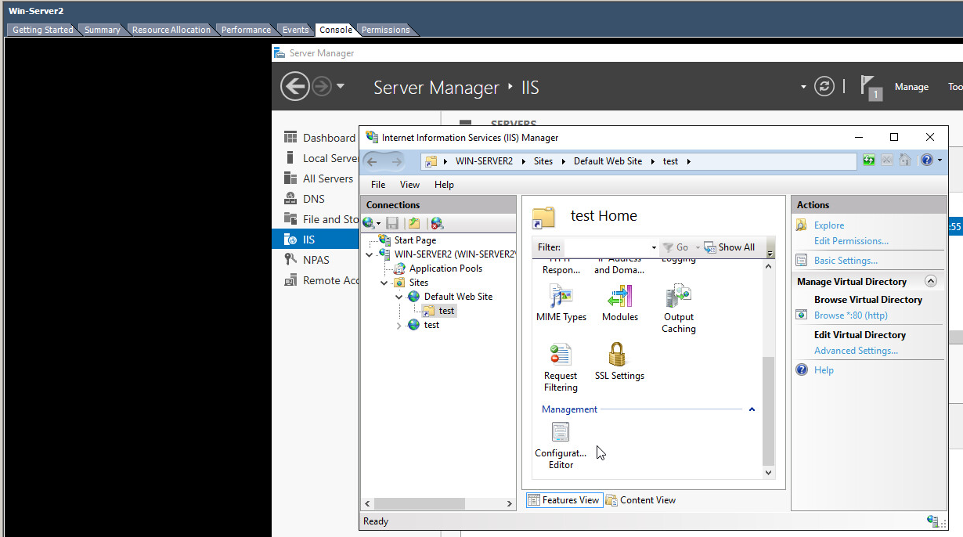
- At the permissions page, ensure that your application has permissions to read files and run scripts. Choose Next and Finish to complete the wizard.
- There are a few more steps to complete to ensure that content is visible from this directory.
- Go into My Computer – C:\Inetpub and right click on the wwwroot folder, chose properties and on the Security Tab, ensure that the Internet Guest Account user has at least modify permissions.
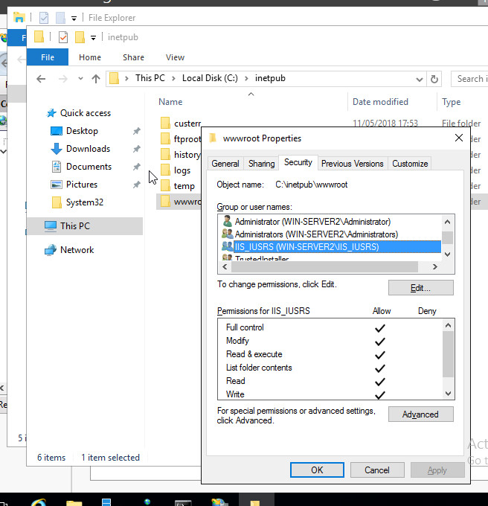
- Finally go to Start – Administrative Tools – Internet Information Services Management.
- Expand the server name and the default web site folder – right click on the Virtual Directory you have just created and choose properties.
- Click on the documents tab – click Add – select the page you just created and ensure it is at the top of the list. This is the only way your page will be set as the default IIS page.

Demonstrate locally how you would test this service is running (e.g. Just from this computer using the Alias you have just created). You will need to create some simple web content, e.g. a simple hello world html page within the C:\Inetpub\wwwroot folder to test the application is operational.

[Test the website]

We will now test whether we can access our website from other networks.

[From the Windows 7 client]

Ask a member of another network to launch an Internet Browser (e.g. Internet Explorer)

* Using the convention:
http://hostname.zonename/aliasname/yourwebpage.html

For example, http://Win-Server2.nwtraders.msft/test/index.htm
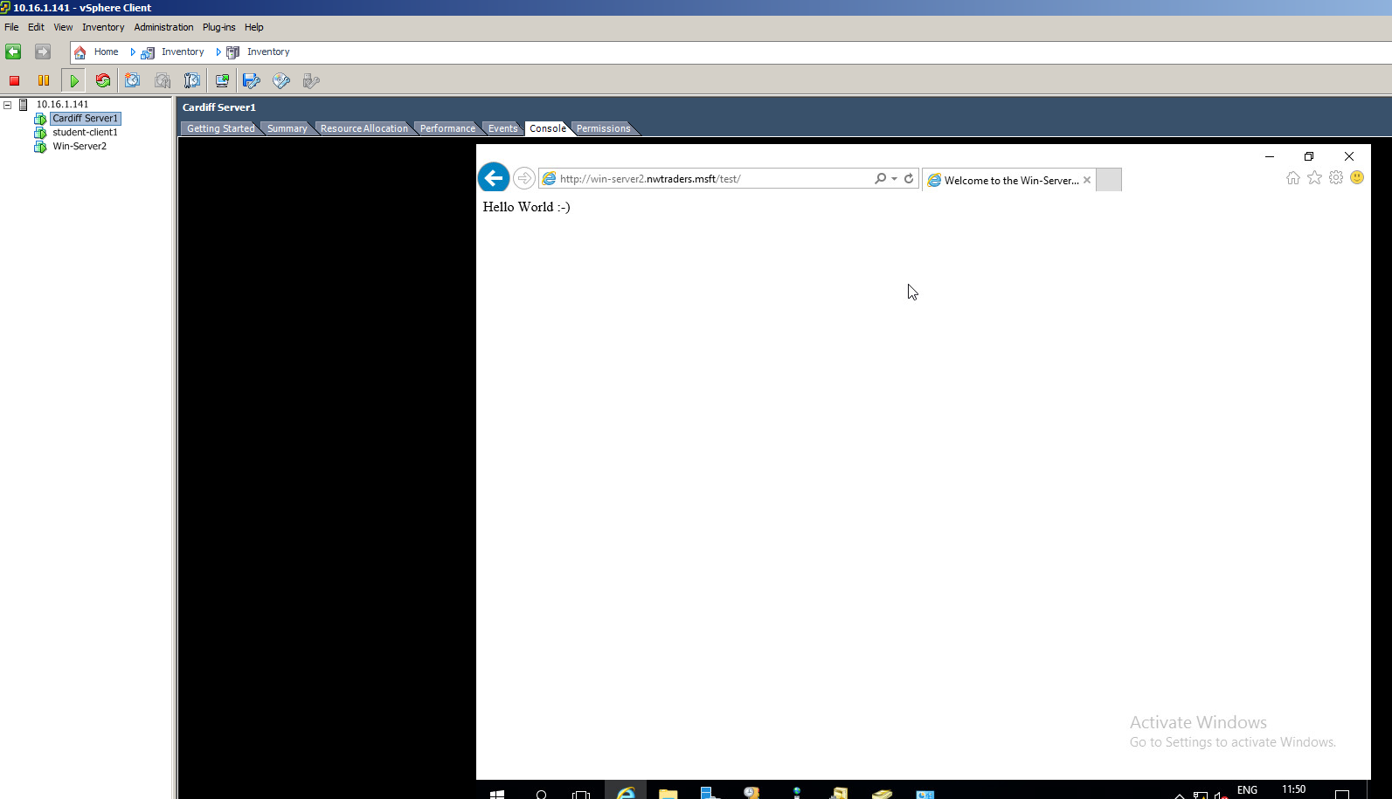

- Where hostname is the name of your server, aliasname is the name of
your virtual directory (created in the previous worksheet) and yourwebpage.html is the name of your webpage, enter the address in the address field. Is your page returned successfully? If not consider the Primary DNS server address that your client is sending its requests to.

Task 4: Observational Tasks
Q). What steps does a client take (what is the process involved) when trying to resolve a Name to an IP address?

Q). Describe how the Recursive Query and Iterative Query Processes resolve DNS Client Requests?

Q). Explain the significance of root hints and how this process enables us to resolve names that are not managed (or kept in an authoritative DNS server in our network)?

Q). We have a Server called Server1, this server will be hosted in a subdomain called ‘subcontA’ with a root domain called nwtraders.msft, answer the following questions:

(1). What is the exact FQDN for this host.
(2). Illustrate how the Domain Name System breaks up this FQDN into Host and
Domain Namespace.

Q). Explain how DNS Zones are used in DNS, give examples to illustrate the use of multiple
zones and how these can be used to manage resource records of domains. What
important factors/characteristics do we need to be aware of?

Questions and Answers

Worksheet 1

Type 1 hypervisors are for virtually running multiple different systems on one piece of hardware, type one has better performance compared to type 2 however, as it lies where the operating system does in the 2nd type, meaning it is closer to “bare metal”
VMware ESX and ESXi.
VMware offers advanced features and scalability, but the licencing costs are much higher than its competition, however they do offer a free version.
Microsoft Hyper-V.
Hyper-V is available in a free edition, and 4 paid packages, it is considered one of the top three best hypervisors.
Citrix XenServer.
XenServer started as an opensource project, offers few advanced features.
XenServer is offered in 4 editions.

Routers examine packets and choose the best path for them to take through the network.
Hardware Routers: a device that performs routing as a dedicated action.
Software Routers: A router that does not perform routing as its core function, but rather performs it alongside the multiple processes currently running on a computer

Routing Protocols:
RIP:
- Small to medium networks
- Uses a routing table
- Easier to configure and manage
- Does not scale well
OSPF
- Designed for very large networks
- Uses a link-state database
- Complex to configure and manage
- Operates efficiently in large networks.
Routing Tables
Routing tables aim to compare the destination IP of incoming packets against the routing table.
The routing table will hold network mask, network address.
The network mask is used to recover the network address from the IP address, and is then compared with the network address, when a match is found the packet is forwarded to the interface specified by that entry
Routing tables find the location a packet is due to go to.
“
- Host on network A generates packet for network B
- Host applies network mask to destination network address of packet and realises it is on a different network
- Host knows the IP address of the router (Default Gateway), so recovers the MAC address for the router using ARP
- Host encapsulates the packet in a Layer 2 frame using its own source MAC address and the destination MAC address of the router
- Router receives frame and recognises its own MAC address, so it strips of the layer 2 framing and passes it to the Layer 3 IP network layer
- Router compares destination IP address with router table to determine the interface by which the packet should be sent
- If the destination network is an Ethernet network directly connected to the router then ARP is used again to determine MAC address of destination host
- Router creates a layer 2 frame using its MAC address for the source and the destination host MAC address
“
Subnet Mask
The subnet mask is used in the routing table to discover where the packet needs to go.
The IP address is ANDed with the mask, to discover the network address.
This is done within the routing table, and is used to ensure the packet goes to where it needs to be.
13/15

Worksheet 2

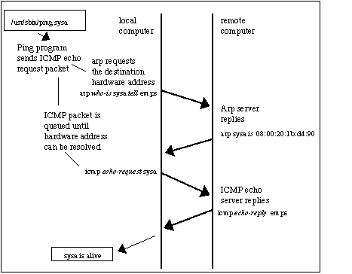
ARP (Address resolution protocol) allows your computer to convert your IP address (192.168.1.1) into a MAC address, and is typically used when IPv4 is used over Ethernet.

This picture shows a computer trying to contact another computer that are both connected to the same LAN (which is known as “sysa”), assuming no previous connection has been made, ARP is the procedure of locating that computers MAC address.

Packet filtering is a firewall technique that is used to control network access by checking source and destination IP addresses, protocols and ports.
During network communication a node transmits a packet that is filtered, and checked against predefined rules and policies, once this is complete the packet can either be accepted or denied.
Most packet filters work in the same general way, operating at the network layer, and transport layer of the TCP/IP protocol.
IP packet filtering is a correctly used term as the packets that are inspected are IP packets, following the IP protocol.
Packet filtering is an inexpensive method of security, needing only the cost of the router it is being used on, and is an appropriate measure for providing isolation of one subnet to another.
Packet filtering allows users to customise their own rules, and unless they know exactly what they are doing, or conduct extensive testing to ensure their rules are filtering out everything they don’t want, and letting in everything they do, then potentially this opens their device to a variety of attacks.
For example:
ACTION-DENY FROM-9.121.0.0/16- Discards all actions from users in network 9.121.0.0
ACTION-ALLOW PORT-1414- allows all packets that are directed towards port 1414
Are contradictory actions, as a user from 9.121.0.0/16 may be wanting to access port 1414, for good reason.
SNMP (Simple network management protocol) aids managing particularly large networks, allowing administrators to manage it from a single interface, SNMP can be configured to monitor routers, printers and even DHCP
SMTP (Simple Mail Transfer Protocol) allows users to send and receive emails, however in practice SMTP is mainly used to send emails, and either POP3 or IMAP is used to receive them, this protocol however can be used locally and remotely.

http://www.erg.abdn.ac.uk/users/gorry/course/inet-pages/arp.html
https://www.giac.org/paper/gsec/131/packet-filter-basic-network-security-tool/100197
https://searchnetworking.techtarget.com/definition/SNMP
12/20

Worksheet 3
Every device on a TCP/IP network must have a unique IP address to access the network and its resources, without DHCP theses IP addresses must be configured manually.
The DHCP server holds a pool of valid IP addresses, and leases them out to relevant clients when they use the network, this allows the server to recall addresses that are not in use, so that it can handle more clients at any one time.
The DHCP server also stores the length of time before the server checks if the allocated IP address is still valid, it will also routinely give you the same IP if you are a returning client, this will make many core functions much simpler.
At point T1, (50% of lease has expired) the server will send out a DHCPRequest to try and renew this lease, if a server is unavailable and 87.5% of the lease has expired (T2), then this process will happen again, and either the server is found, and the lease is renewed, or the lease is 100% expired, and the client immediately unbinds itself and starts the process to obtain a new lease.
If the lease cannot be renewed then the client automatically assigns itself an automatic private IP address.

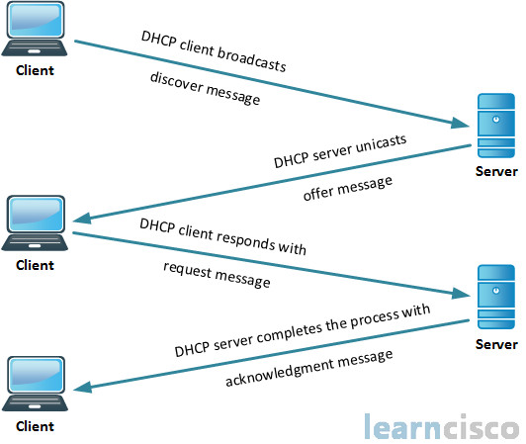

The process to getting an IP address is essentially:
- Client sends discover message.
- Server unicasts offer message.
- Client responds with request.
- Server acknowledges.
a DHCP relay agent is any host or IP router that forwards DHCP packets between clients and servers.
Using a relay agent will mean that you can forward requests and replies between clients that are on different physical subnets
A DHCP Relay Agent will typically be located between a computer and the server it is trying to send request messages to, this allows for the relay agent to unicast them directly to the DHCP server.
Relay agents do not play a part in IP address renewal however, as the messages are broadcast (not unicast) directly to the server the client is connected to.
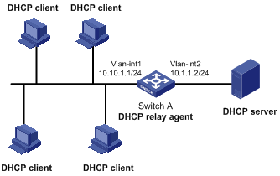

https://docs.microsoft.com/en-us/windows-server/networking/technologies/dhcp/dhcp-top
https://social.technet.microsoft.com/Forums/office/en-US/f946ab4a-e5d5-4044-87a7-e9efb47706a8/whats-happen-if-client-cant-renew-his-ip-from-the-dhcp
https://www.google.co.uk/url?sa=i&rct=j&q=&esrc=s&source=images&cd=&cad=rja&uact=8&ved=2ahUKEwjYupjW8OvaAhXKPhQKHU-LBbcQjRx6BAgBEAU&url=http%3A%2F%2Fwww.learncisco.net%2Fcourses%2Ficnd-1%2Flan-connections%2Frouter-as-a-dhcp-server.html&psig=AOvVaw3ieIegrNE9kRT9jBN50Q7J&ust=1525517182422925
https://www.google.co.uk/url?sa=i&rct=j&q=&esrc=s&source=images&cd=&cad=rja&uact=8&ved=2ahUKEwi33ZrY8uvaAhXCxxQKHZZMD7oQjRx6BAgBEAU&url=http%3A%2F%2Fwww.h3c.com.hk%2FTechnical_Support___Documents%2FTechnical_Documents%2FSwitches%2FH3C_S5120_Series_Switches%2FConfiguration%2FOperation_Manual%2FH3C_S5120-SI_CG-Release_1101-6W105%2F201108%2F723582_1285_0.htm&psig=AOvVaw2OMt9u8K0ab7wvk0Rlx1cn&ust=1525517680599807
15/20

Worksheet 4
A check is made to see if the name is known locally, (if the address has been visited previously)
If no record is found, then a request is sent to the local DNS server, often with your ISP that supplies your internet connection.
The local DNS server checks for if it already has the details of the name being requested, if not then it must find the details of the name server that hosts the address you are trying to reach.
To find this address the server breaks the entire URL down, into three segments, typically “www”, “google”, and “.com”, .com being known as the TLD.
The DNS server will make a request to the TLD name servers asking for details of the name servers that contain the information for this website, who will either send back the address for that site, or the address of a site associated with that one.
The reply could contain an IP address, or a CNAME, which vaguely resembles the original URL, if this is returned instead of an IP then the DNS server will repeat the processes outlined above until it is left with an IP address for the user.
An iterative query will be used by a DNS server to ask another server for its best answer that server can provide without seeking further help from another server, this type of query will mostly be used as part of a Recursive query.

A Recursive Query is used to query a DNS server, and is sent by the DNS client, if the server cannot find the matching record then it uses root hints to get the IP address of DNS root server, it uses recursion to work its way down FQDN to find server with matching name.

Root hints are DNS resource records stored on a DNS server that list IP addresses for DNS root servers
Root hints store a list of preliminary resource records that DNS servers can use to locate other DNS servers that are for the root of the DNS domain namespace tree.
These hints are essential for servers at lower-levels of the namespace when locating and finding servers.
DNS servers need to be able to query root servers for the DNS namespace, which can refer server A to the authoritative servers for the relevant domain
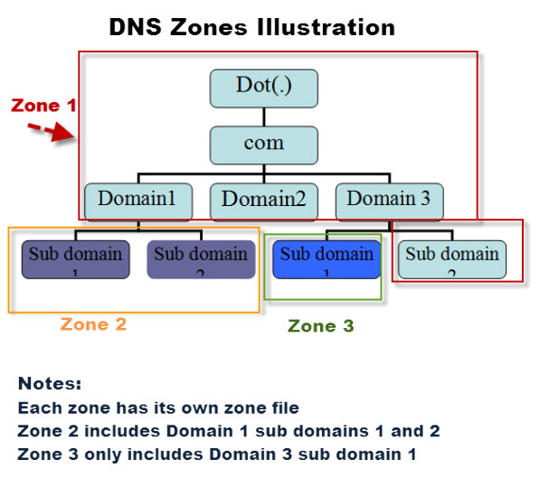
subcontA.nwtraders.msft
DNS will break this up into three parts
“[Hostname].[DomainName].[TLD]”
It will use these three segments separately to acquire the address the client is looking for.

A zone file contains information for a zone, and the resource records within, this file is stored on the server’s hard drive.
Each domain needs its own zone, but will use the same DNS domain, one zone can have multiple domains however.

Zones come in two types: Forward Look Up Zone, Reverse Look Up Zone.
Forward being the type that uses the Hostname to search, and reverse look up using the CNAME

Names of zones must be unique within the resource group, and the zone must not exist already.
Where multiple zones share the same name, each instance is given a different name server address, only one set of these addresses can be configured with the domain name registrar.

http://www.itgeared.com/articles/1134-whats-is-root-hints/
https://techterms.com/definition/fqdn
https://www.lifewire.com/what-does-fqdn-mean-2625883
https://www.google.co.uk/url?sa=i&rct=j&q=&esrc=s&source=images&cd=&cad=rja&uact=8&ved=2ahUKEwi_3ubIvOzaAhVHCcAKHZ-BBfcQjRx6BAgBEAU&url=http%3A%2F%2Fwww.steves-internet-guide.com%2Fdns-zones-explained%2F&psig=AOvVaw01ALW1cF6OCVSVNLBVdYiN&ust=1525537600989898
18/25

Worksheet 5
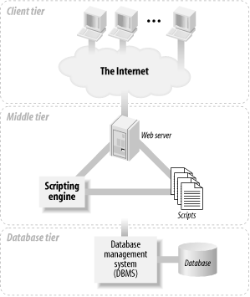
A three-tier application is a type of software architecture that involves three key parts:
- The workstation. (Client Tier)
- The business logic. (Middle Tier)
- The database/programming behind it. (Database Tier)

The Database tier will typically hold the DBMS that is being used to manage your software, which in turn will allow your users to Create, Read, Update, Delete and Query.
The Middle Tier contains most of the application logic that you develop, it contains the “middle-man” between the developer and the consumer, or user.
On the Client tier is typically the clients chosen internet browser, such as chrome or edge, this will typically be used to locate and view your content.
Clustering Strategy
A clustering strategy for a 3-tier web development system would mean that the client would interact with application software deployed on a separate server, and this first server would then interact with another server containing a database.
It essentially is comprised of three parts, the Client tier, Web/App tier, and Database tier.

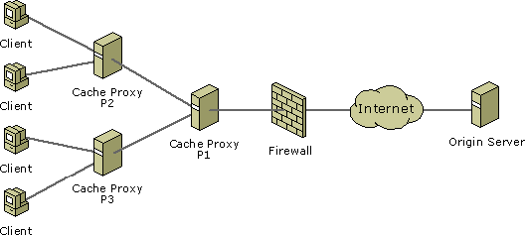

This diagram shows how a Multi-tier Proxy architecture would look like.
A three-tier architecture is important because it is very easy to scale it upwards, as the three tiers all act as stand alone units, with the users never being made aware that they are clustered together, they can then be updated independently.
Having three separate parts of your architecture allows for the creation of a DMZ firewall, which means that if this segment of your strategy gets hacked then all of your important information is safe.
Depending on the initial set-up of the P’x’ servers, they can have a variety of functions, for example p1 could proxy information from the origin server to p3, and P1 can direct the client to an alternate proxy server.
P2 & P3 can forward an upstream authentication challenge from P1.
Downsides to using this strategy include:
- More administration required, as the web servers must be configured manually using third party software.
- Your Limited load options are very limited.
However using a Proxy architecture means:
- You have familiar firewall policies
- And you can utilize existing hardware
- Higher Availability, fewer points of failure
- Improved security options allows a creation of a DMZ
DMZ: a Demilitarized zone, this means that you’ve created a subnetwork that exposes an organisations external facing services to an untrusted network.
Proxy: a proxy is typically a separate standalone server that a user will use to bounce their signal from, so that if they were to be traced their real location would not be found.
Proxy Architecture: a Proxy architecture works from the definition for Proxy, in that the architecture uses a separate standalone segment to create a DMZ, so that in the event of an attack no valuable data is lost.
https://msdn.microsoft.com/en-us/library/windows/desktop/dd893218(v=vs.85).aspx
https://en.wikipedia.org/wiki/DMZ_(computing)
https://docs.oracle.com/cd/E11035_01/wls100/cluster/planning.html#wp1115757
www.codingthearchitecture.com/2012/07/20/when_do_you_need_a_3_tier_architecture.html
https://www.safaribooksonline.com/library/view/web-database-applications/0596005431/ch01.html
https://www.safaribooksonline.com/library/view/web-database-applications/0596005431/ch01.html

13/20

