Introduction
The radio frequency systems assignment is to analyse the effect of interference from random noise in Dual sideband – suppressed carrier and frequency modulated systems in Simulink models.

Background information
RF introduction
Radio frequency is the frequency range from $20K-300GHz$of oscillations of an alternating electric current or voltage or an electromagnetic field or mechanical system. Radio frequency signals can be transmitted over an antenna by a transmitter where the transmitter takes initial data and changes the signal using a modulation technique to encrypt the data into an RF signal in a process called modulation. The antenna collects the signals from the transmitter and directs the RF waves away from the antenna. As the RF waves propagate away from the transmitting antenna, the waves move towards the receiver antenna. The receiver then unencrypts the transmitted signal into the data and the separate signal in a process called demodulation.
Carrier signal will be a high frequency, sine or cosine wave and can be represented as: $c\left(t\right)= A_{c}\sin\left(ω_{c}\right)t$ Modulating signal can be represented as: $m\left(t\right)= A_{m}\sin\left(ω_{m}\right)t$ $A_{c} \& A_{m}$ are the amplitudes of the carrier and message signals $\sin\left(ω_{c}\right)t$ is the carrier signal’s phase $\sin\left(ω_{m}\right)t$ is the message signal’s phase
Modulation
Modulation is the process of changing one or more factors like amplitude or frequency of a periodic waveform called the carrier signal with a different signal called the modulated signal that typically contains information to be transmitted. Message signals are also called baseband signals and are the range of frequencies in the original signal which is the signal being transmitted over the receiver. The baseband signal is generally low and the other signal which is the carrier signal is a high-frequency sinusoidal wave. The carrier signal’s frequency is higher than the baseband signal because it isn’t power efficient to transmit signals with low frequencies. The amplitude of the baseband signal is transferred onto the high-frequency carrier signal. Therefore, modulation is defined as the superposition of a low-frequency message signal on a high-frequency carrier signal. Figure 1 shows the modulation and demodulation of a signal.
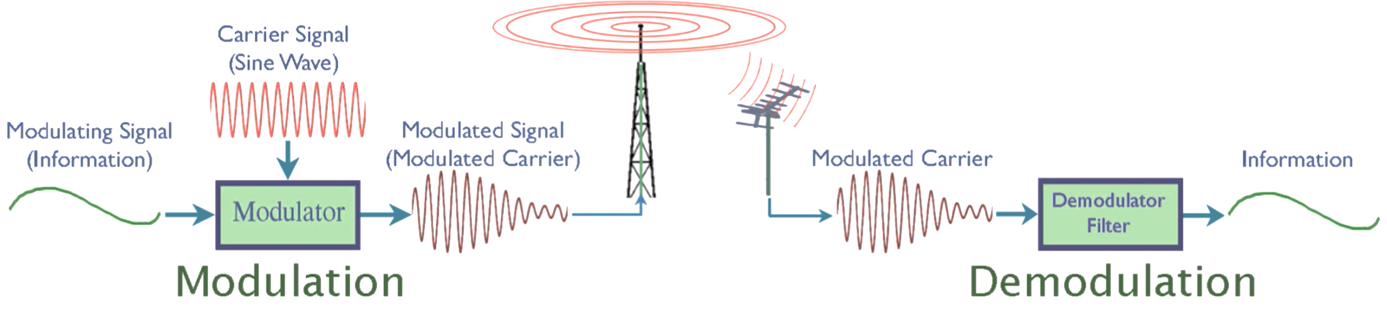
Figure 1 Modulation and demodulation of a signal block diagram (ELPROCUS Electronics|Projects|Focus, What is amplitude modulation, types, advantages, & disadvantages 2019)
Amplitude modulation is a modulation technique where the amplitude of the carrier signal is varied in proportion to the message signal. Frequency modulation is an alternative modulation technique where the carrier frequency is varied in proportion to the message frequency. Figure 2 shows amplitude and frequency modulated waveforms.
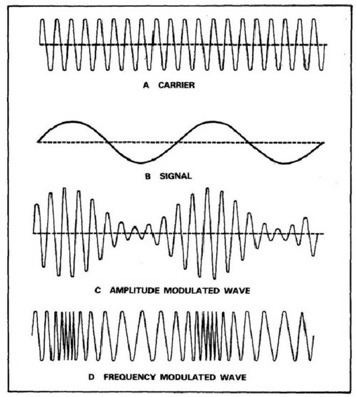
Figure 2 Amplitude and frequency modulation (ELPROCUS Electronics|Projects|Focus, What is amplitude modulation, types, advantages, & disadvantages 2019)
FM system with phase locked loop technique
Frequency modulation of a signal can be implemented using a phase locked loop circuit with a continuous voltage-controlled oscillator, phase detector and a low pass filter. A phase locked loop is a control system that forms an output signal whose phase is proportional to the phase of an input signal. There are several types where the simplest is an electronic circuit formed of a variable frequency oscillator and a 180-degree phase detector inside the feedback loop. The oscillator phase and frequency are controlled in proportion by an induced positive voltage and hence the name voltage-controlled oscillator. The oscillator forms a periodic signal of certain frequency, and the phase detector compares the phase of the signal to the input periodic signal to change the oscillator, so the phase is constant. In addition to synchronizing signals, a phase-locked loop circuit can form a frequency which is a multiple of the input frequency which is commonly implemented for clock synchronization and frequency synthesis. Phase-locked loops are present in telecommunication networks to demodulate a signal, recover a signal from a noisy channel and distribute accurately timed clock pulses in digital logic circuits like timing elements for microcontrollers. Figure 3 shows a phase-locked loop circuit. The information was obtained and referenced in source (Wikimedia foundation, Phase-locked loop 2020).
- 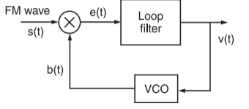
- Figure 3 Phase locked loop circuit (Wikimedia foundation, Phase-locked loop 2020)
DSB SC and balanced modulator system
DSB–SC AM is a form of amplitude modulation where the carrier signal is suppressed and manipulated so the modulating signal is multiplied by the carrier signal, resulting in two sidebands. DSB-SC AM forms of modulation are most implemented in systems like radar where RF is transmitted over large distances and needs to maintain a constant efficiency through transmission. A balanced modulator is a modulation circuit shown in Figure 4 which results in an output signal that is the product of the two input signals the message and the carrier. The circuit consists of at least two active devices implemented with transistors using two AM modulators, a phase shifter circuit and a differential amplifier to suppress the carrier signal. The information was obtained from the source referenced in (Tutorialspoint - Analog Communication - DSBSC Modulation , Analog Communication - DSBSC modulators 2020)
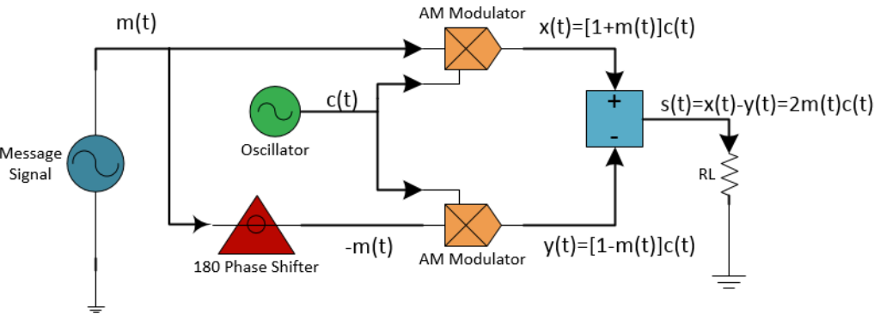
Figure 4 DSB SC AM balanced modulator circuit (ELPROCUS Electronics|Projects|Focus, What is amplitude modulation, types, advantages, & disadvantages 2019)
Critical, over & under modulation & modulation index
Modulation index is a dimensionless ratio between the amplitude, frequency or phase of the carrier or message signal and the amplitude, phase or frequency of the modulated signal. Critical modulation occurs when $m=1, V_{min}=0 \& A_{c}= A_{m}.$ At critical modulation there is no distortion from noise to a radio frequency signal.
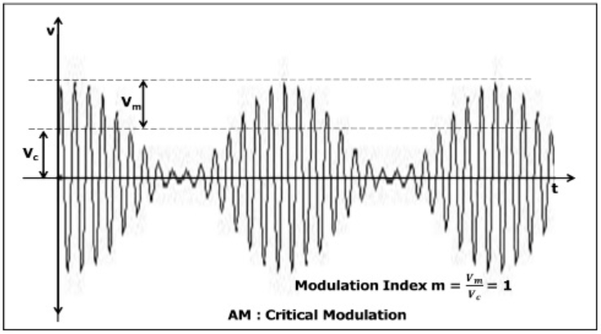
Figure 5 Critical modulation
Over modulation occurs when $m>1$ so ${V_{m}}/{V_{c}}>1$ and therefore, $V_{m}> V_{c}.$ Therefore, the modulating signal is greater than the carrier signal. In over-modulation the carrier wave’s phase is reversed by $180°.$ Under modulation happens when $m<1 \& V_{m}< V_{c}.$ Therefore, the carrier signal is greater than the modulating signal. Modulation index: $M_{i}= \frac{A_{m}}{A_{c}}$
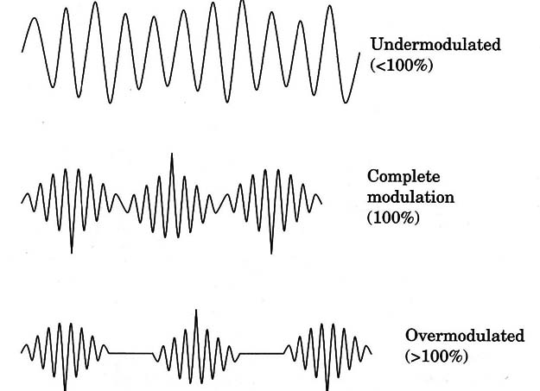
Figure 6 Under, complete & over modulation (ELPROCUS Electronics|Projects|Focus, What is amplitude modulation, types, advantages, & disadvantages 2019)
Random noise
Radio noise is unwanted radio frequency electrical signals and slightly changing voltages that are always present in a radio receiver in addition to the radio signal being transmitted. Radio noise which is similar in frequency to the radio signal being received in the passband of the receiver which interferes with the receiver circuit. Radio noise is a combination of radio frequency interference from other electrical devices collected by the receiver antenna, thermal noise in the receiver input circuits caused by unpredictable thermal movement of particles and natural electromagnetic noise formed by electrical processes in the atmosphere like lightning.
Bandwidth in DSBSC and FM systems - (Tutorials point - Analog Communication - DSBSC Modulators , Analog Communication - DSBSC modulators 2020)
The bandwidth of a signal shown in Figure 7 is the difference between the highest and lowest frequencies in a transmitted signal. Bandwidth can be separated into two subcategories when referring to frequency of signals which are passband and baseband. Passband bandwidth is the difference between the highest and lowest cut-off frequencies for example in a band-pass filter or signal spectrum. Baseband bandwidth is equal to the upper cut-off frequency of baseband signal or low-pass filter which has a zero-frequency value.
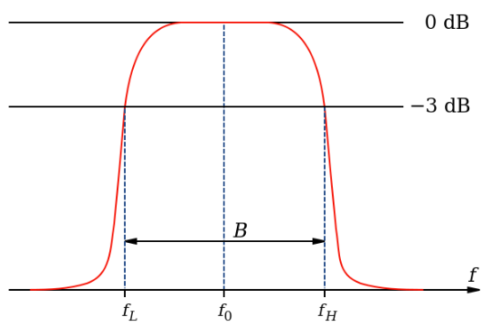
Figure 7 Bandwidth of a signal

Bandwidth of a signal in a Double-sideband suppressed-carrier or amplitude modulated system – The equation of the DSBSC modulated wave is: $s\left(t\right)= A_{m}A_{c}\cos\left(2πf_{m}t\right)\cos\left(2πf_{c}t\right)$ Bandwidth: $BW=f_{max}- f_{min}= 2f_{m}$ Where $f_{m}$ is the modulating frequency
Bandwidth of a signal in a frequency modulated system – $BW=2\left(∆f+ f_{m}\right)=2f_{m}\left(β+1\right)$ where $f_{m}$ is the modulated signal’s frequency and $β$ is the modulation index
Power in DSBSC and FM systems
RF power is the rate of transfer of the energy of oscillations in the radio frequency range in a circuit where the load current and source impedance are constant. Power of a signal in a frequency modulated system – (Tutorials point - Analog Communication - DSBSC Modulators , Analog Communication - DSBSC modulators 2020) Message signal power: $P_{m}= \frac{A_{m}^{2}}{2R}= \frac{A_{m}^{2}}{2}$ Carrier signal power: $P_{c}= \frac{A_{c}^{2}}{2R}= \frac{A_{c}^{2}}{2}$
It’s assumed that it’s an ideal system of minimal resistance so $R=1Ω$. $A_{m} \& A_{C}$ are the amplitudes of the message and carrier signals, therefore are the maximum voltages of both signals.
Power of a signal in a Double-sideband suppressed-carrier system – (Tutorialspoint - Analog Communication - DSBSC Modulators , Analog Communication - DSBSC modulators 2020) Equation of a DSBSC wave: $s\left(t\right)= \frac{A_{m}A_{C}}{2}\cos\left[2π\left(f_{c}+ f_{m}\right)t\right]+ \frac{A_{m}A_{C}}{2}\cos\left[2π\left(f_{C}- f_{m}\right)t\right]$ The total power of a DSBSC signal is equal to the sum of powers of the upper and lower sideband frequencies is: $P_{T}= P_{LSB}+ P_{USB}$ The standard power for a signal is: $P= \frac{v_{rms}^{2}}{R}= \frac{{\left(v_{m}\sqrt{2}\right)}^{2}}{R}$ Upper sideband power: $P_{USB}= \frac{{\left(A_{m}A_{c}/2\sqrt{2}\right)}^{2}}{R}= \frac{A_{m}^{2}A_{c}^{2}}{8R}$ This is the same formula for the lower sideband power. Therefore, the total power is: ${P_{T}= P}_{USB} + P_{LSB} = \frac{A_{m}^{2}A_{c}^{2}}{8R}+ \frac{A_{m}^{2}A_{c}^{2}}{8R}= \frac{A_{m}^{2}A_{c}^{2}}{4R}= \frac{A_{m}^{2}A_{c}^{2}}{4}$ It’s assumed that it’s an ideal system of minimal resistance so$R=1Ω$.
Signal-noise ratio
Signal-noise ratio is the comparison in a ratio of signal power to noise power at the same point in a transceiver system expressed in decibels. A ratio higher than $1:1$so greater than $0dB$ indicates more signal than noise in a system. The information was obtained and referenced from the source (Wikimedia Foundation, Signal-to-noise ratio 2023).
Signal-noise ratio: ${\left(SNR\right)}_{dB}=10log\left(\frac{P_{s}}{P_{N}}\right)$

Task 1
Signal parameters

Initial modulation index $m = 0.5$
Under modulation index $m = - 5$
Over modulation index $m = 5$
Critical modulation index $m = 1$
Carrier frequency $f_{c}=10kHz$
Message frequency $f_{m}=1kHz$
Sample time $T=1/{250}s$
Amplitude $A=1V$
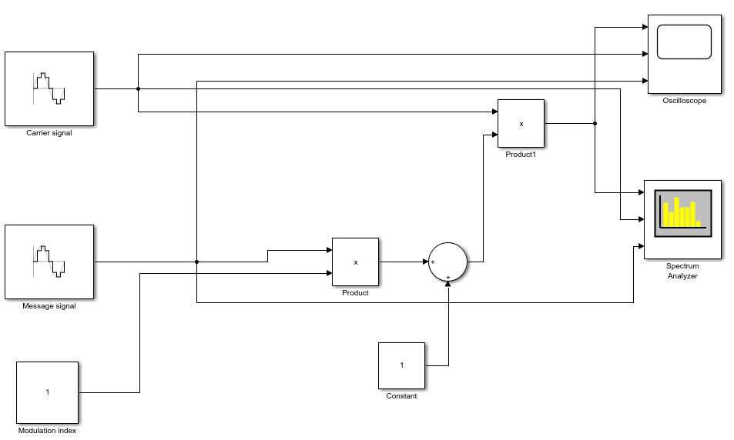
Figure 8 Amplitude modulation Simulink model
Figure 8 shows the basic Simulink model for modulating a sine wave signal by changing the amplitude of the message signal in proportion to the amplitude of the carrier signal.
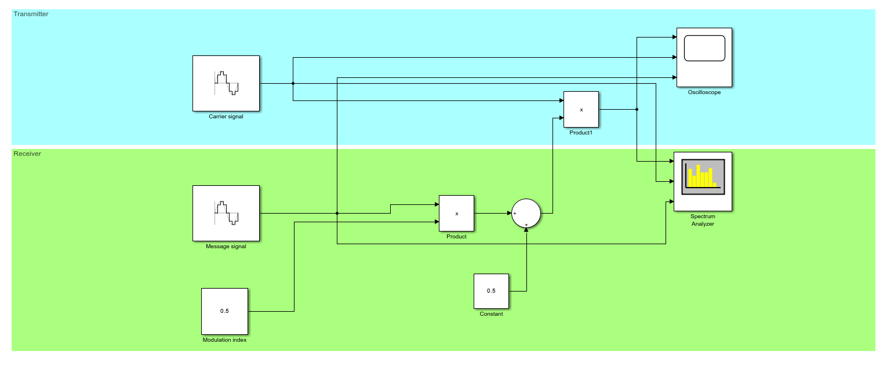
Figure 9 Amplitude modulation Simulink model showing the transmitter and receiver architectures
Figure 9 shows the separate transmitter and receiver designs for the Simulink model in amplitude modulation.
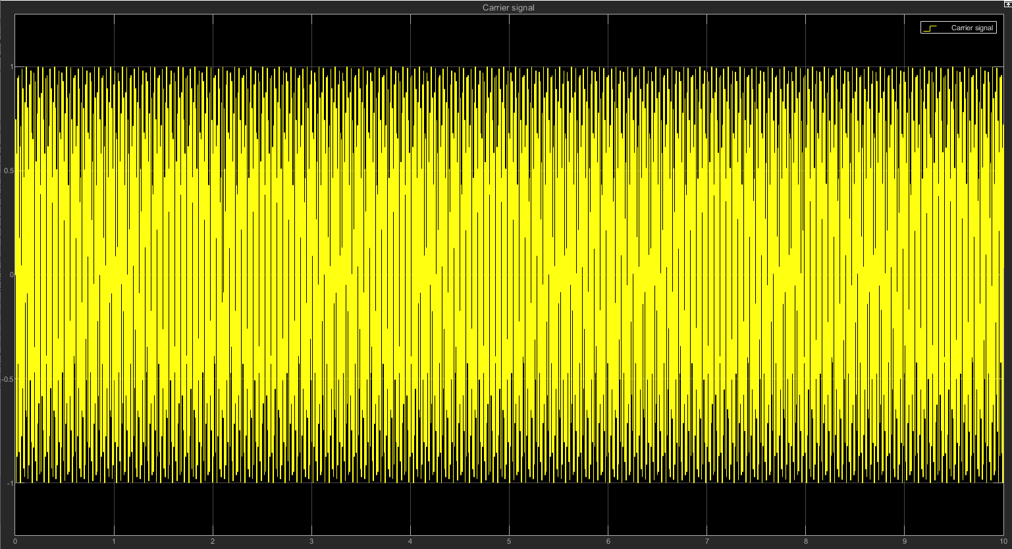
Figure 10 Carrier signal during amplitude modulation
Figures 10, 11 and 12 shows the carrier, message and modulated signals for when the modulation index is m = 0.5. Figure 14 Carrier, message and modulated signals during critical amplitude modulation when m = 1. A higher modulation index indicates that more binary data can be transmitted in the message signal when being modulated however, the frequency needs to increase because more data is being transmitted at the same time. If the frequency increases, then the bandwidth also increases because there’s a greater range of frequencies. The information about the spectrum analyse Simulink block was explained and referenced in source (MathWorks for R2023B, 2023)

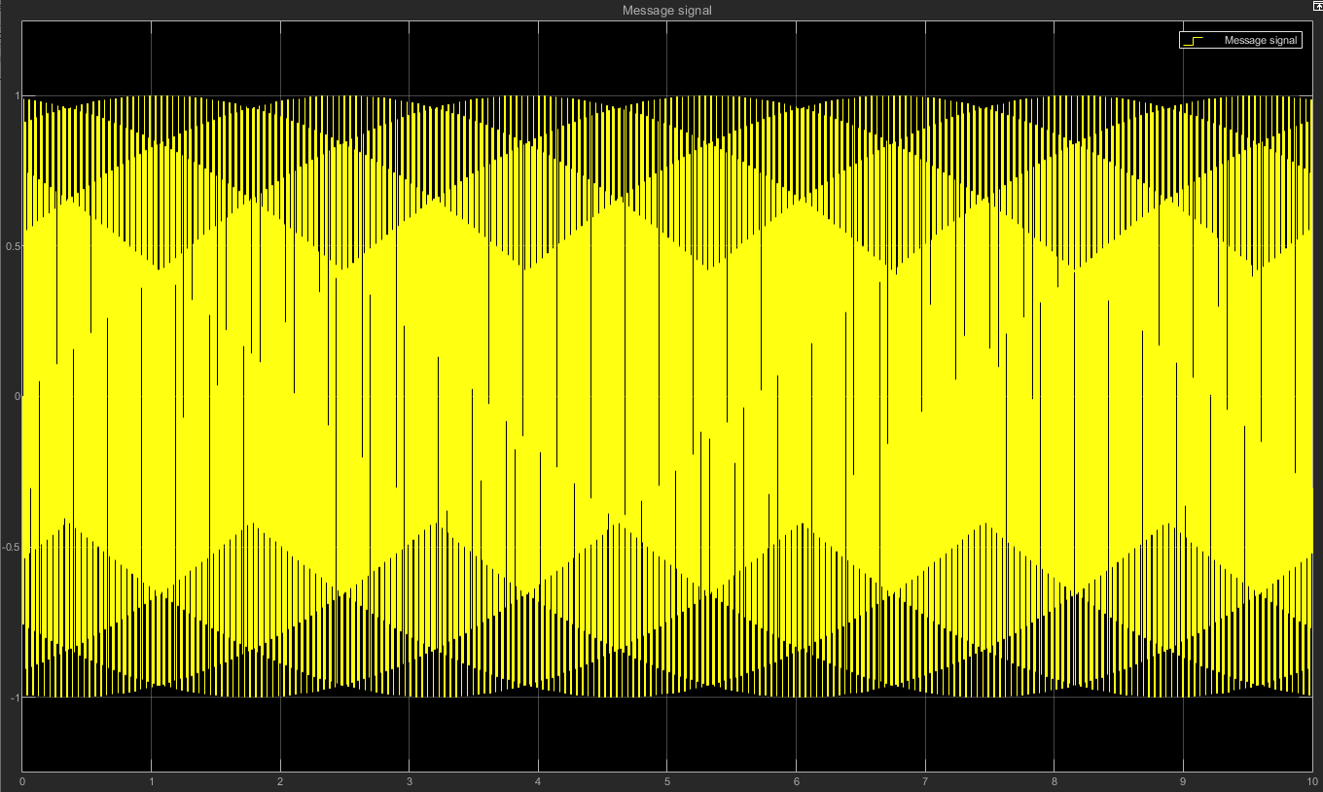
Figure 11 Message signal during amplitude modulation
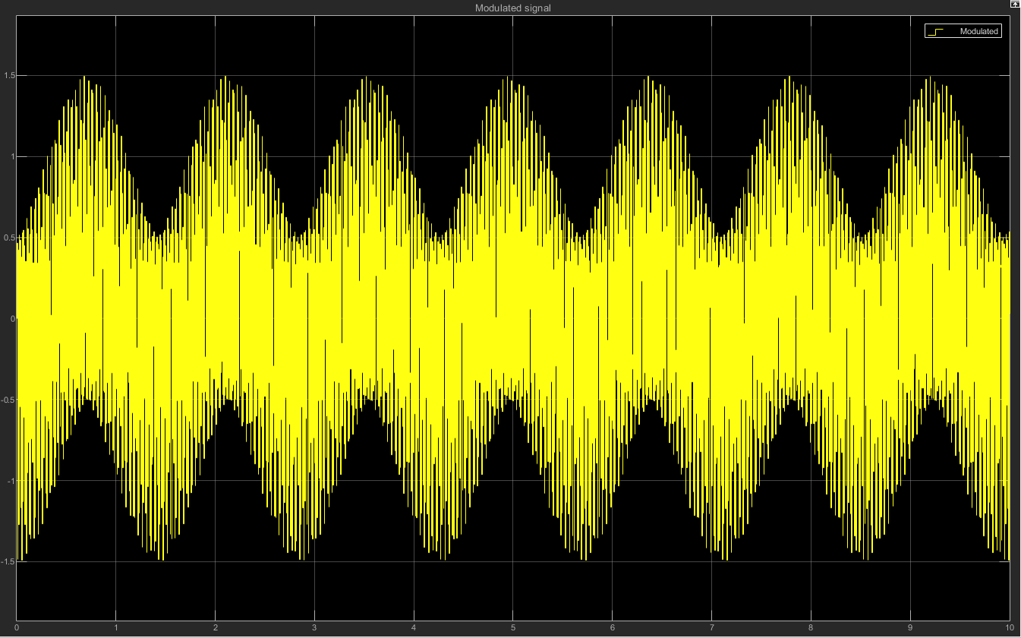
Figure 12 Modulated signal during amplitude modulation
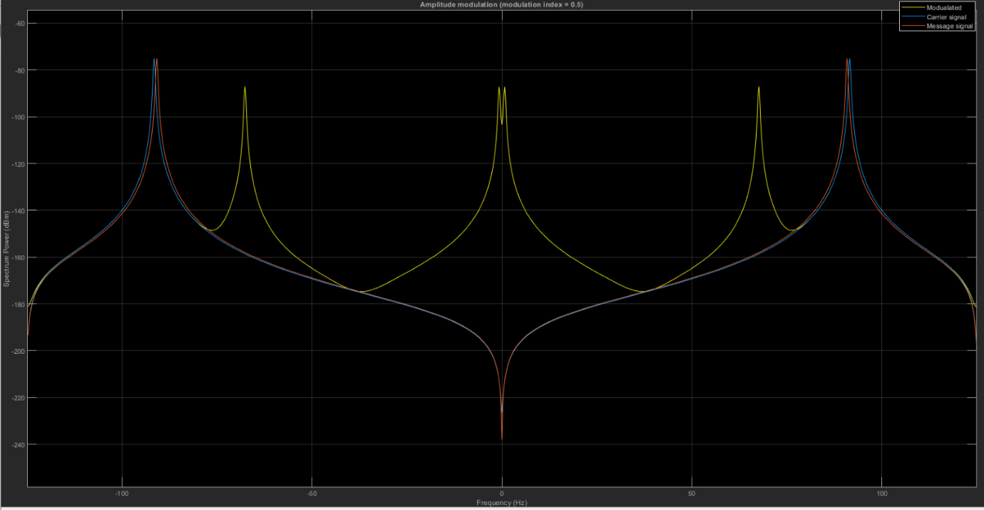
Figure 13 Carrier, message and modulated signal during amplitude modulation on a spectrum analyser
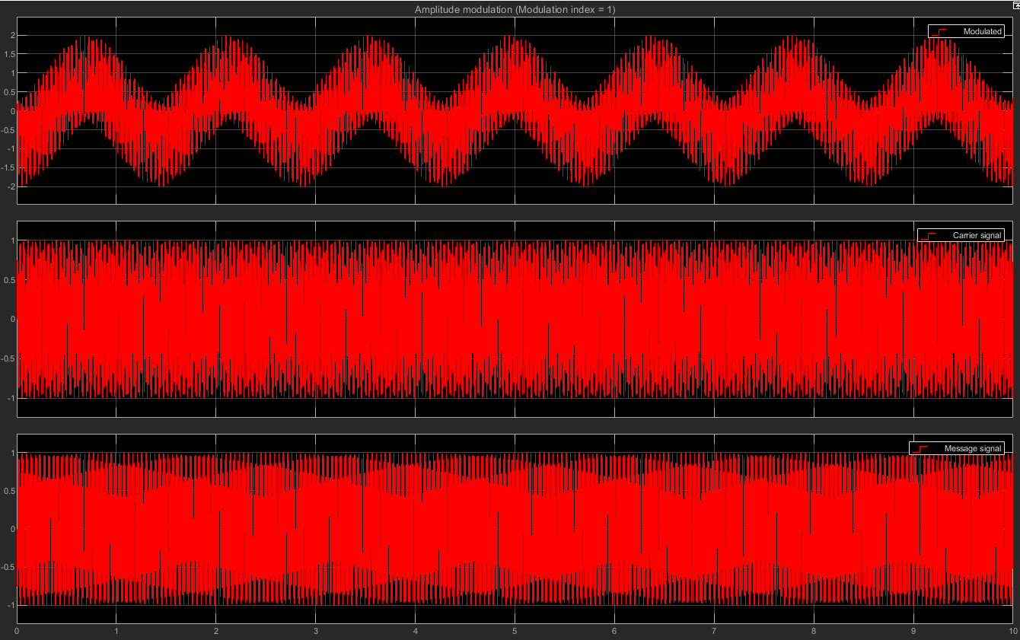
Figure 14 Carrier, message and modulated signals during critical amplitude modulation when m = 1
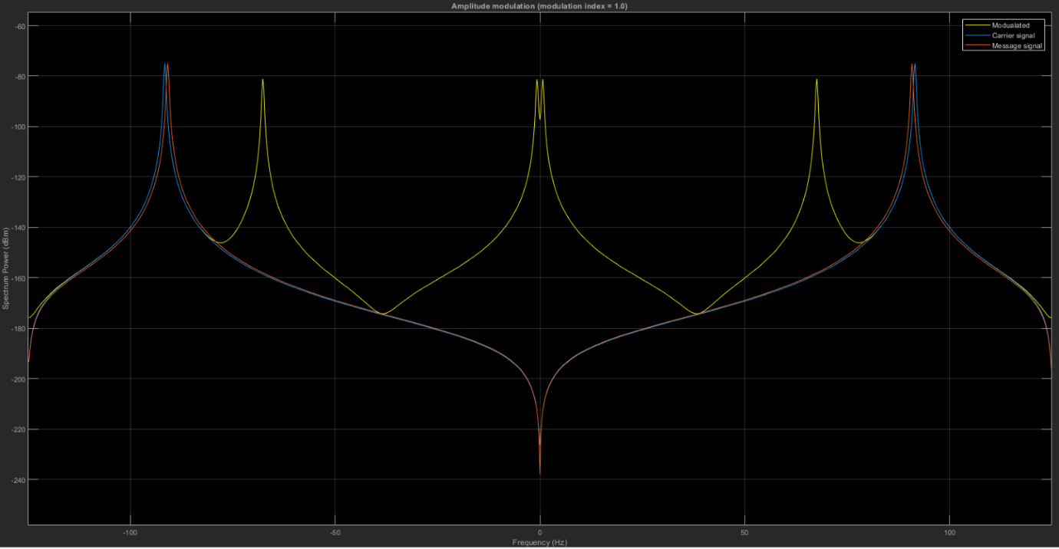
Figure 15 Carrier, message and modulated signals during critical amplitude modulation when m = 1 on the spectrum analyser
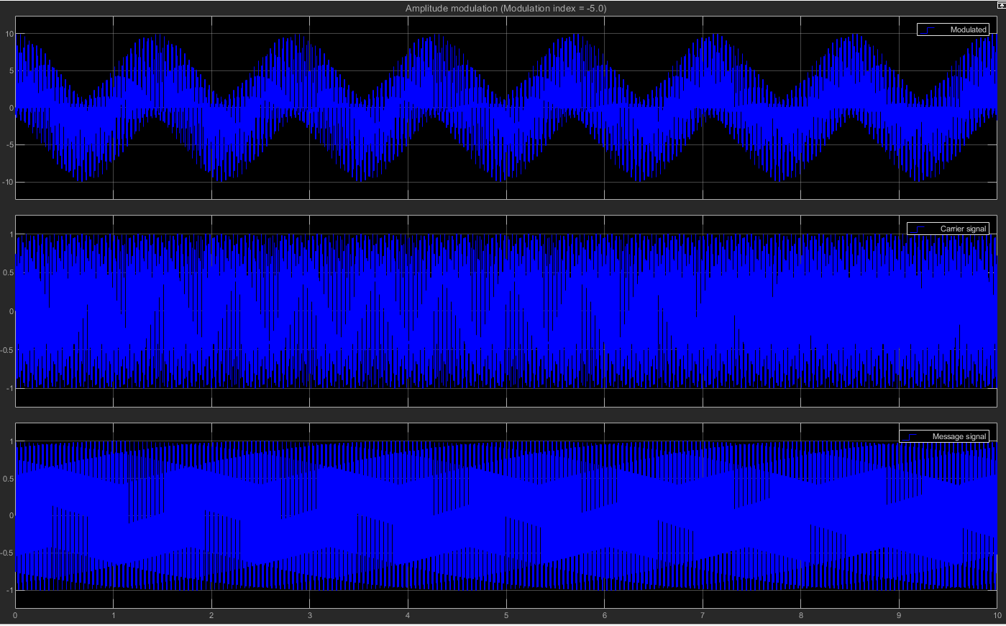
Figure 16 Carrier, message and modulated signals during under amplitude modulation when m = -5
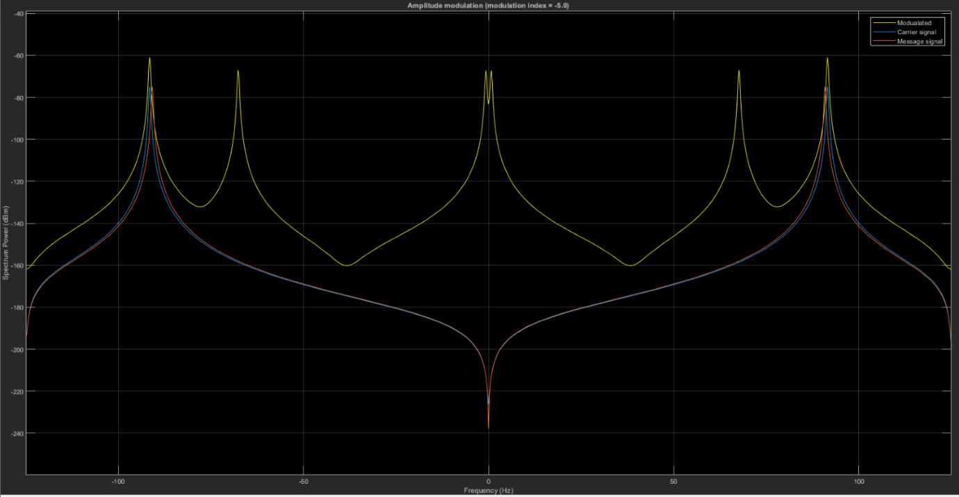
Figure 17 Carrier, message and modulated signals during under amplitude modulation when m = -5 on the spectrum analyser
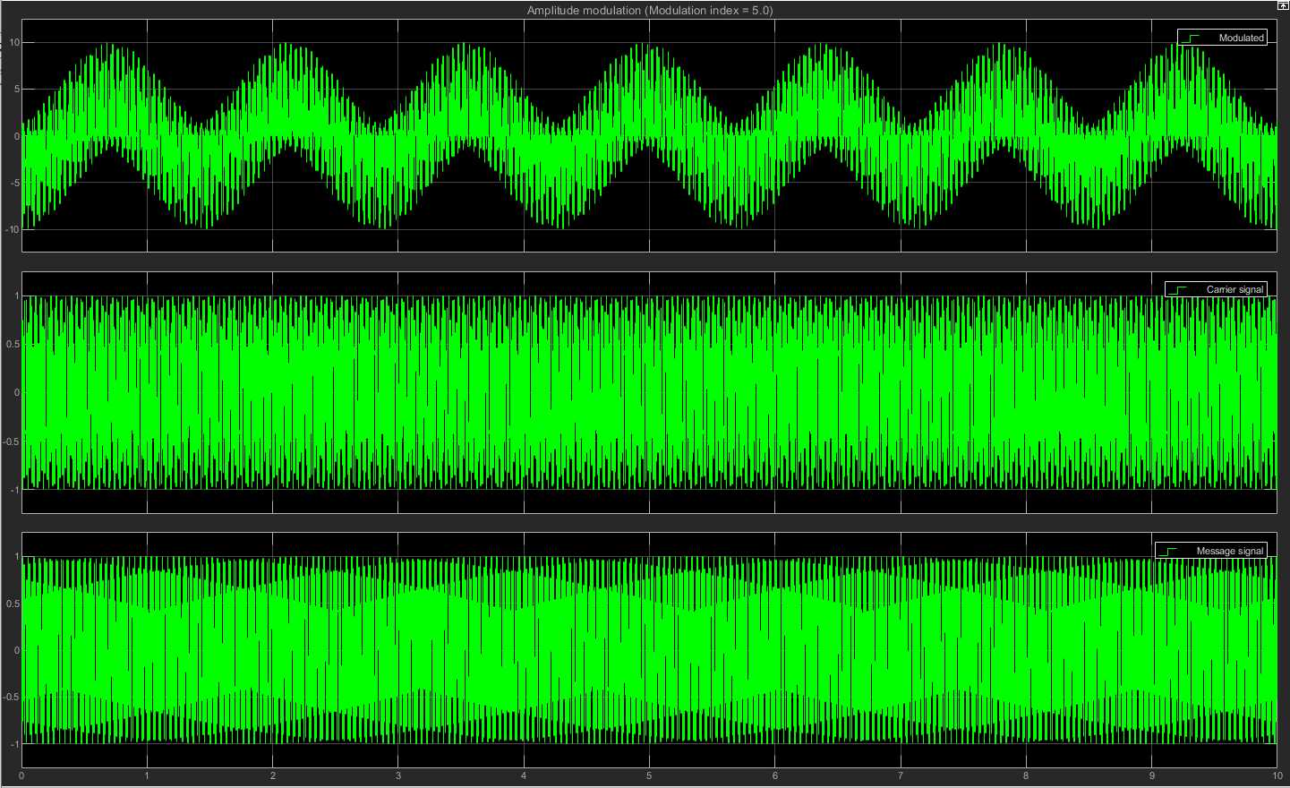
Figure 18 Carrier, message and modulated signals during over amplitude modulation when m = 5
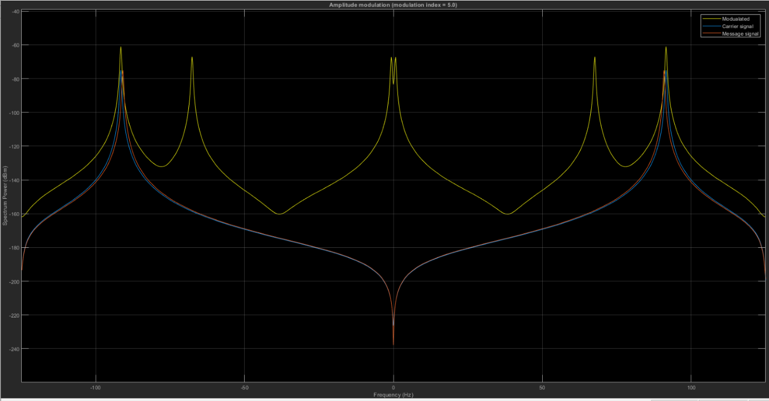
Figure 19 Carrier, message and modulated signals during over amplitude modulation when m = 5 on the spectrum analyser

Task 2
Signal parameters
Modulation index $m=0.5$ Carrier frequency $f_{c}=2×π×20Hz$
Message frequency $f_{m}=2 × π ×10Hz$
With AWGN noise $SNR=10dB$ Without AWGN noise (ideal) $SNR= -1000dB$
Phase $p= π rad$ Low pass filter Hanning window. Sample rate $44100Hz$. Filter order 30
Filter cutoff frequency $f=512Hz$ Sample time $T= 1/{1000}s$
Amplitude $A=1V$
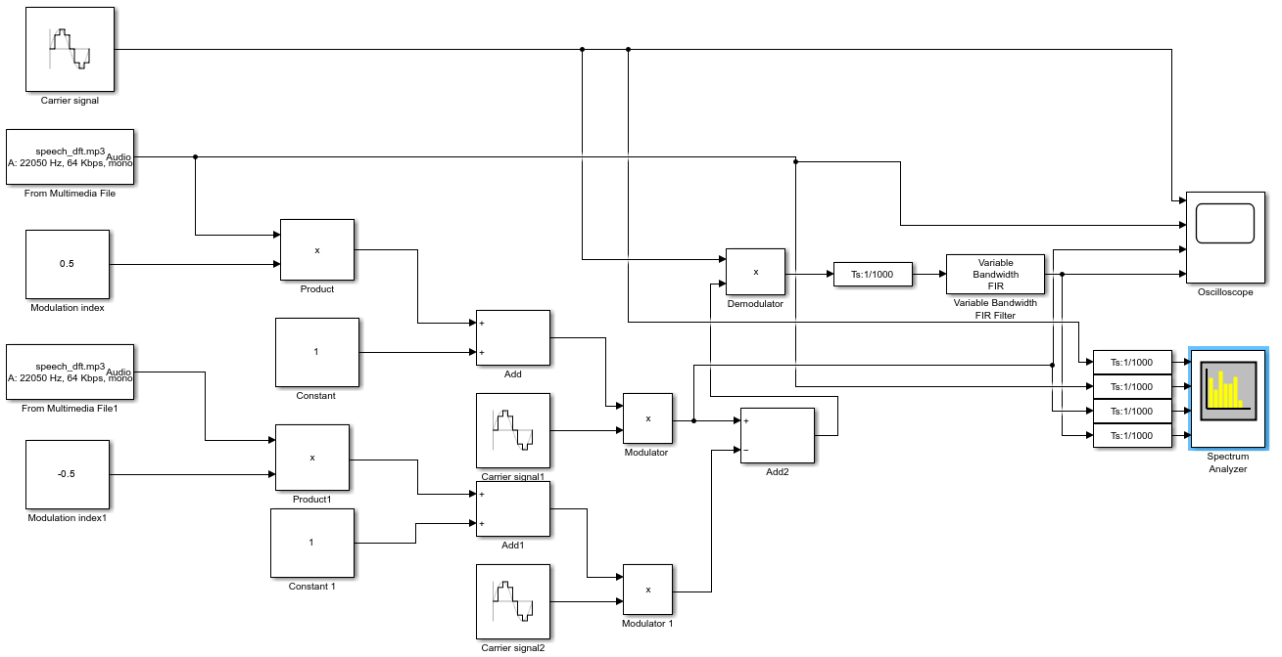
Figure 20 DSB-SC balanced modulator with amplitude modulation with no AWGN noise Simulink model
Figure 20 shows the DSBSC balanced modulator with AM Simulink model without noise and Figure 21 shows it with noise. Figure 22 shows the transmitter and receiver architectures. This information was obtained and referenced from the source (Tutorialspoint - Analog Communication - DSBSC Modulators , Analog Communication - DSBSC modulators 2020).
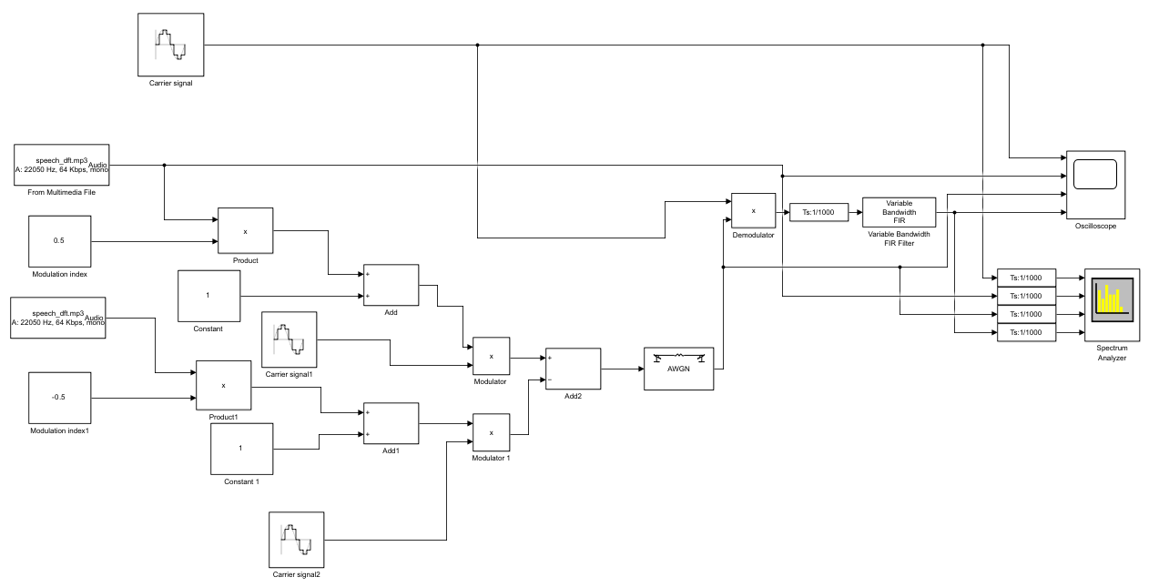
Figure 21 DSB-SC balanced modulator with amplitude modulation with no AWGN noise Simulink model
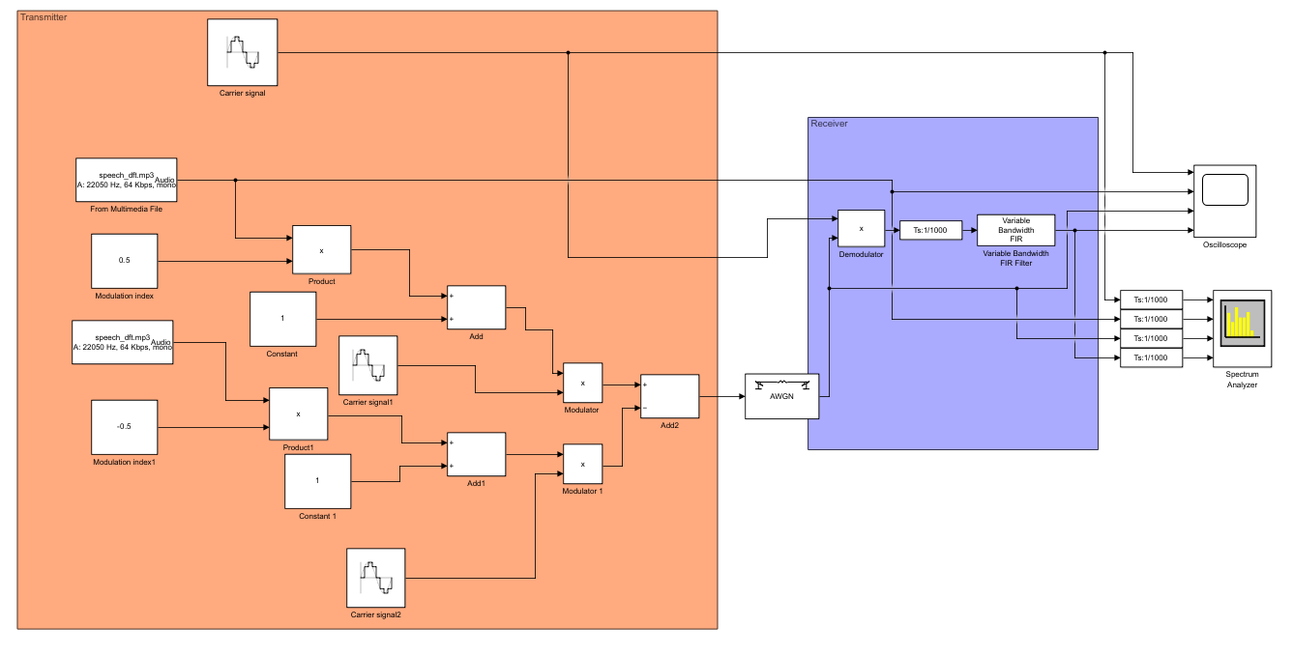
Figure 22 DSB-SC balanced modulator with AM with noise Simulink model for the transmitter and receiver architectures
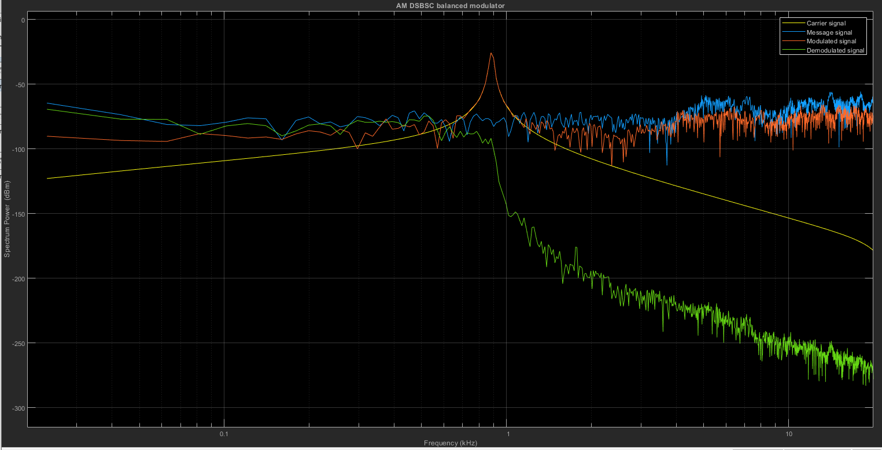
Figure 23 DSB SC balanced modulator with AM showing the carrier, message and modulated signals on the spectrum analyser
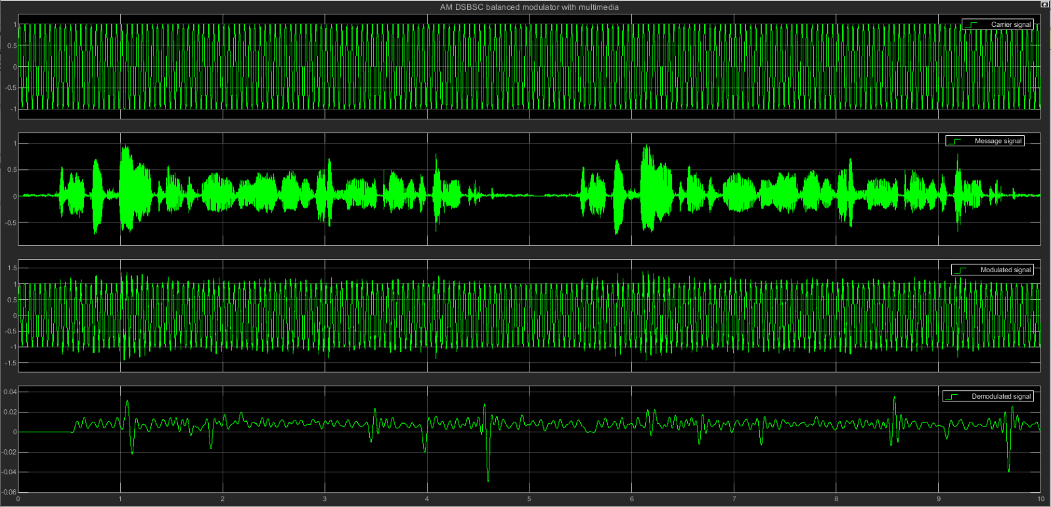
Figure 24 DSB SC balanced modulator with AM showing the carrier, message and modulated signals on the oscilloscope
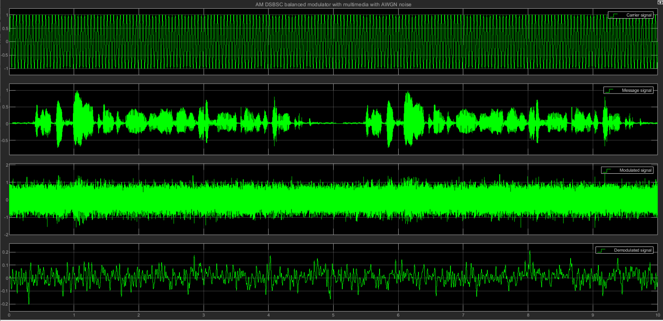
Figure 25 DSB-SC balanced modulator with AM with 10Db noise on the oscilloscope showing the carrier, message and modulated signals
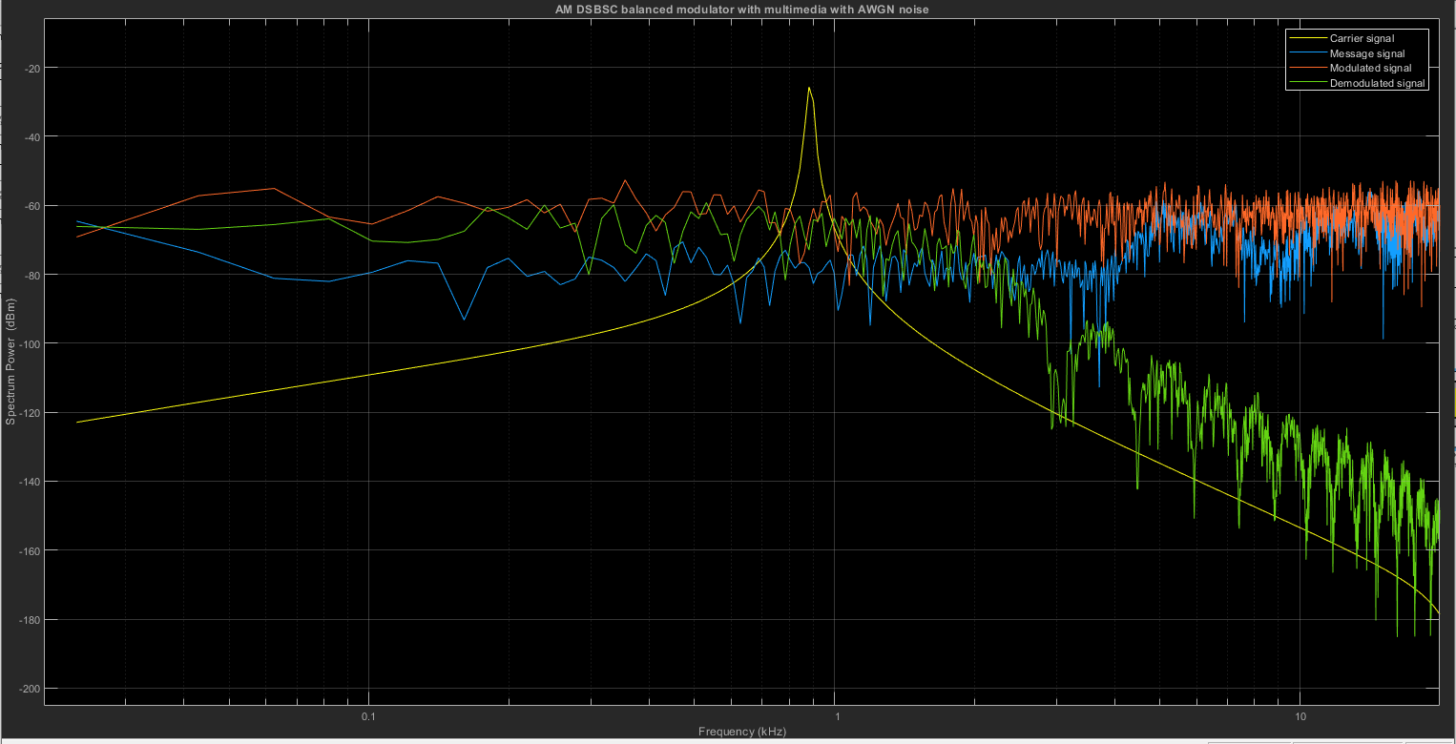
Figure 26 DSB-SC balanced modulator with AM with 10Db noise on the spectrum analyser showing the carrier, message and modulated signals
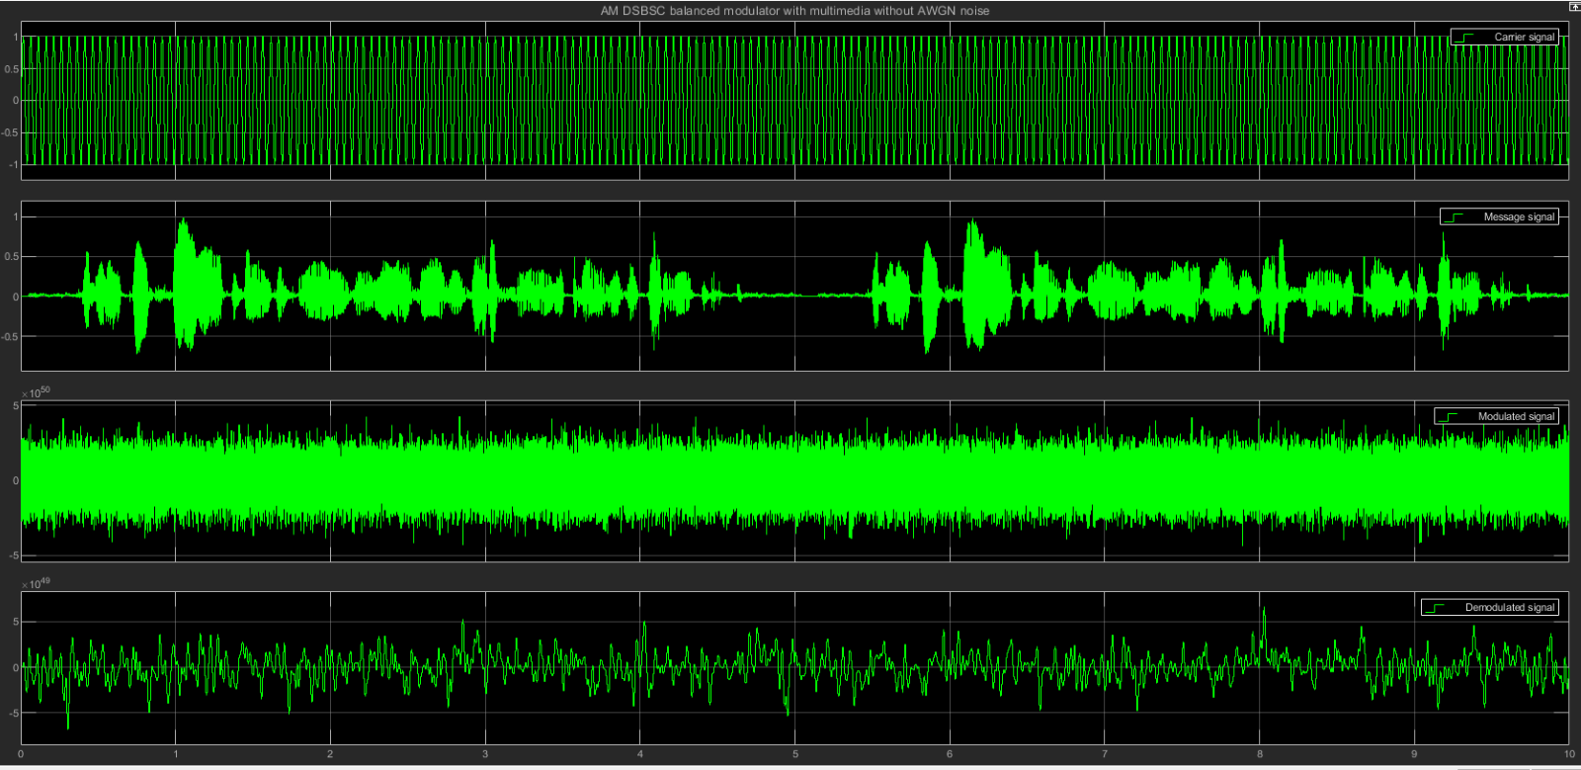
Figure 27 DSB-SC balanced modulator with AM with 10Db noise on the oscilloscope showing the carrier, message and modulated signals
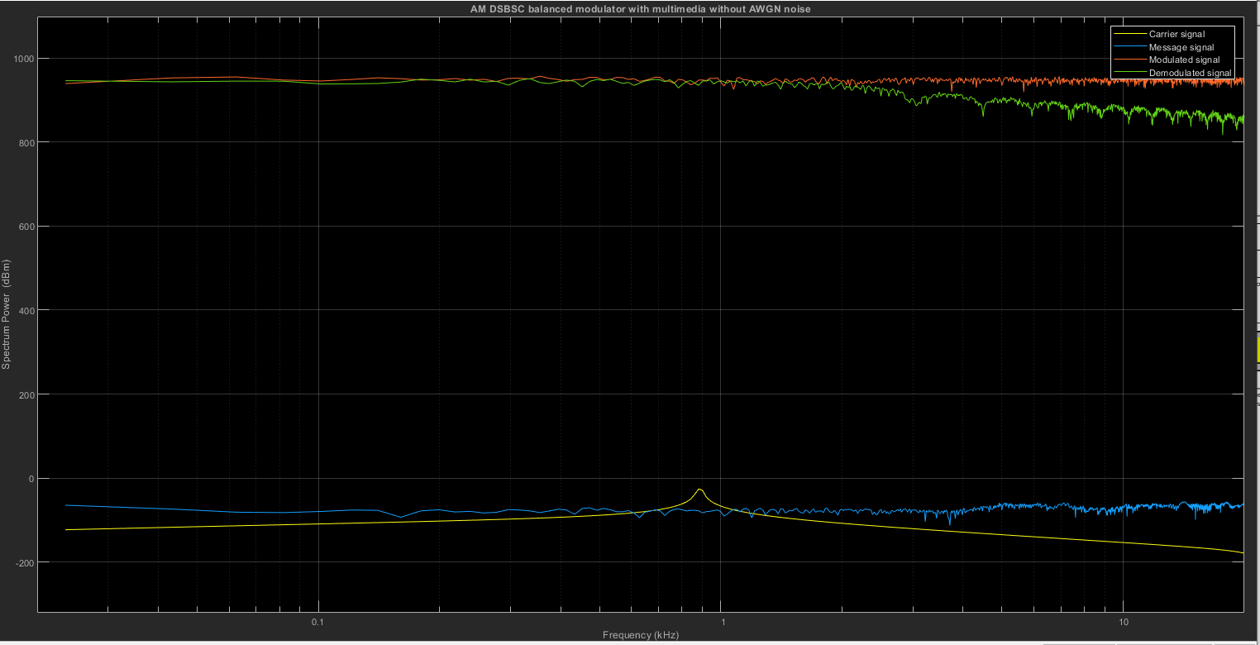
Figure 28 DSB-SC balanced modulator with AM with no noise on the spectrum analyser showing the carrier, message and modulated signals

Task 3
Signal parameters
Modulation index $m=0.5$ Carrier frequency $f_{c}=2×π×20Hz$
Message frequency $f_{m}=2 × π ×10Hz$
With AWGN noise $SNR=10dB$ Without AWGN noise (ideal) $SNR= -1000dB$
Phase $p= π rad$ Low pass filter Hanning window. Sample rate $44100Hz$. Filter order 30
Filter cutoff frequency $f=512Hz$ Sample time $T= 1/{1000}s$
Wave Amplitude $A=1V$
VCO output amplitude $A=1V$ VCO input sensitivity $S= 10/(2*pi) hz/v$ Initial phase $p= \frac{π}{2} rad$ Butterworth filter type
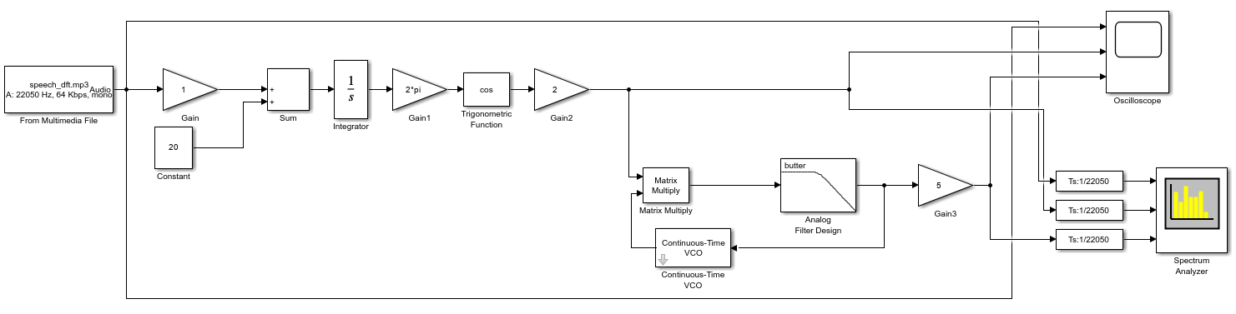
Figure 29 Phase locked loop circuit for an FM system Simulink model without AWGN noise
Figure 29 shows the Simulink model for an FM system using the phase-locked loop technique. In frequency modulation, information is encoded into a carrier signal by changing the instantaneous frequency of the message signal. Figure 30 shows the transmitter and receiver designs for the model. Figure 31 shows the carrier, message and modulated signals for frequency modulation technique on the spectrum analyser. 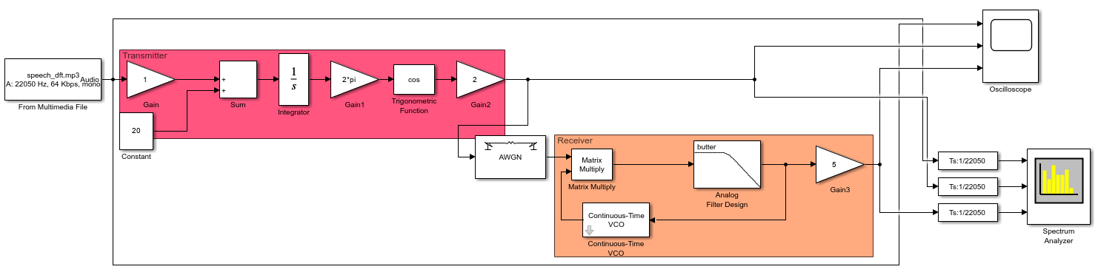
Figure 30 Frequency modulation Simulink model showing the transmitter and receiver architectures
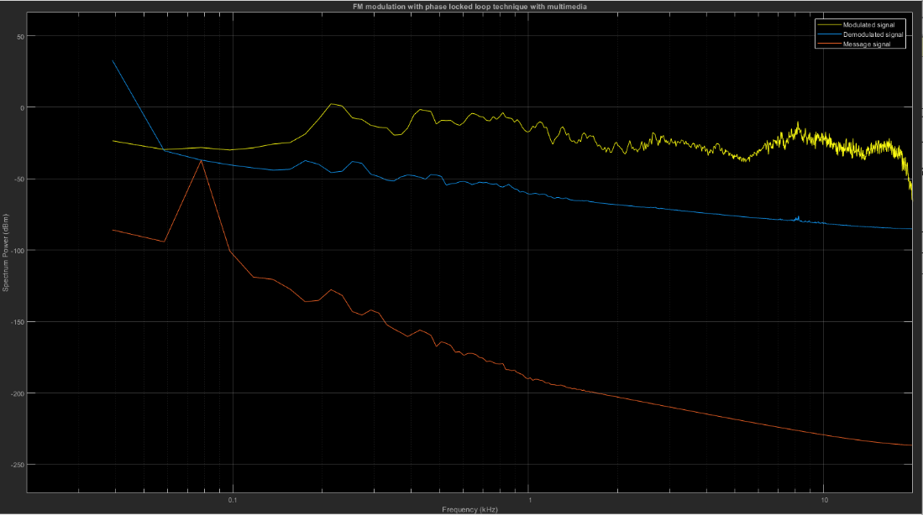
Figure 31 Frequency modulation shows carrier, message and modulated signals on the spectrum analyser
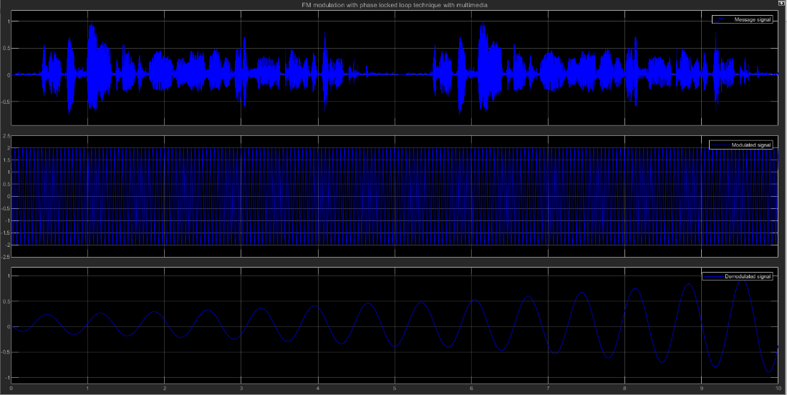
Figure 32 Frequency modulation shows carrier, message and modulated signals on the oscilloscope
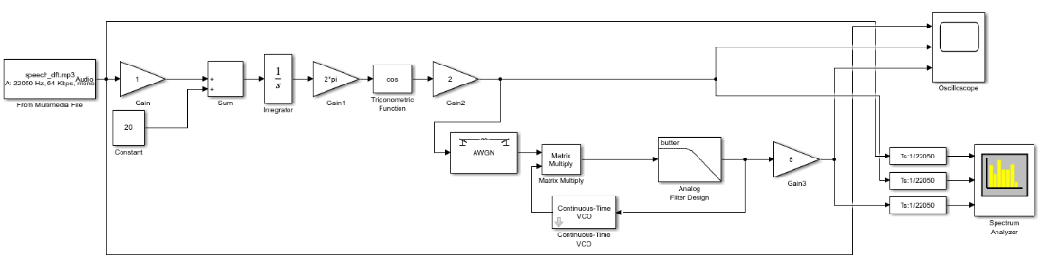
Figure 33 Phase locked loop circuit for an FM system Simulink model with AWGN noise
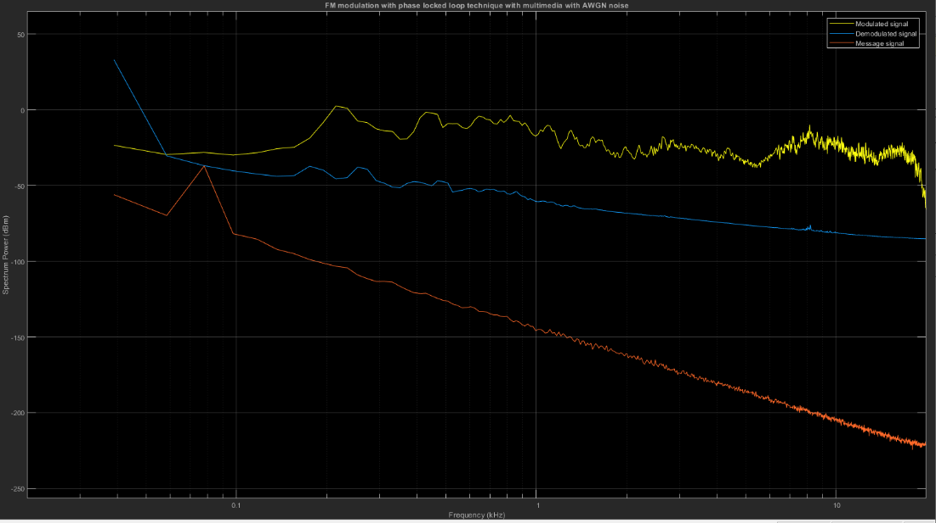
Figure 34 Frequency modulation shows carrier, message and modulated signals with 10Db noise on the spectrum analyser
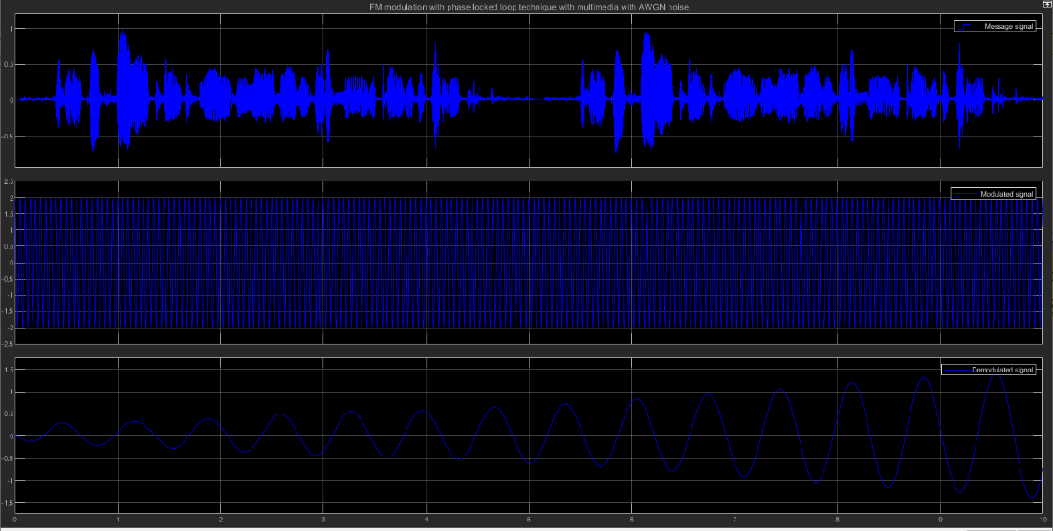
Figure 35 Frequency modulation shows carrier, message and modulated signals with 10Db noise on the oscilloscope
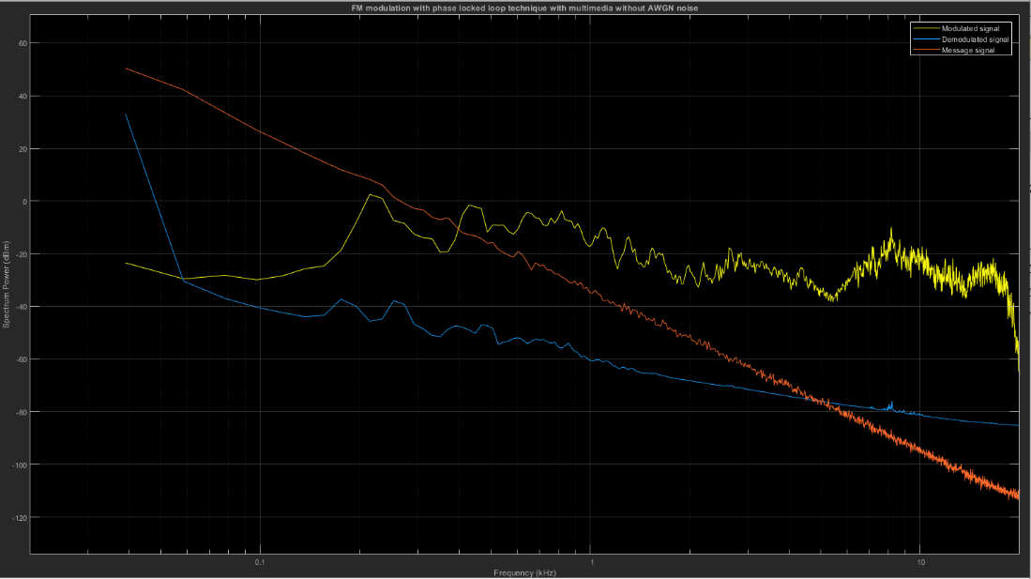
Figure 36 Frequency modulation shows carrier, message and modulated signals with -100Db noise (ideal) on the spectrum analyser
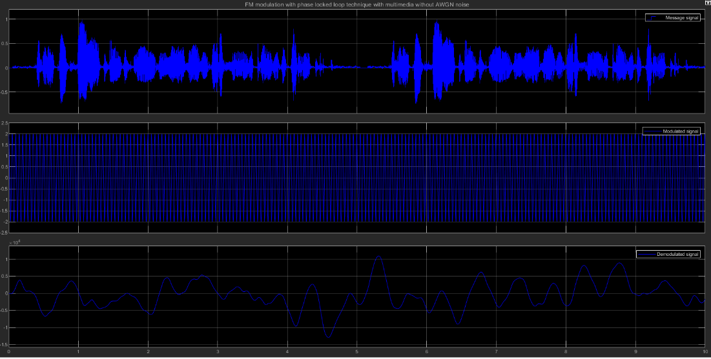
Figure 37 Frequency modulation shows carrier, message and modulated signals with -100Db noise (ideal) on the oscilloscope

Results
Task 1 results
M = 0.5
 | Carrier signal | Message signal | Modulated signal
Maximum frequency (Hz) | $$91.553$$ | $$90.82$$ | $$91.553$$
Amplitude (m) | $$9.998e-01$$ | $$1.00e+00$$ | $$9.938e-01$$

M = 1
 | Carrier signal | Message signal | Modulated signal
Maximum frequency (Hz) | $$91.553$$ | 90.82 | $$91.553$$
Amplitude (m) | $$9.998e-01$$ | $$1.00e+00$$ | $$1.488e+00$$

The modulation index of amplitude modulated signal is independent of the carrier and modulating signal frequencies and hence during amplitude modulation these frequencies are constant. The modulation index is inversely proportional to the amplitude of the carrier signal so as the carrier signal increases the modulation index tends to 0 and closer to under modulation, therefore the distortion in the signal’s decreases.
The amplitude of the signal increases so the oscillating electric voltages are closer together in areas of compression in the medium. Increasing the amplitude of the signal means the energy of the oscillations increases so the signal a greater energy. The amplification of a signal compensates for the attenuation factor and power loss during transmission. Information about AM signals obtained from the source (ELPROCUS Electronics|Projects|Focus, What is amplitude modulation, types, advantages, & disadvantages 2019)
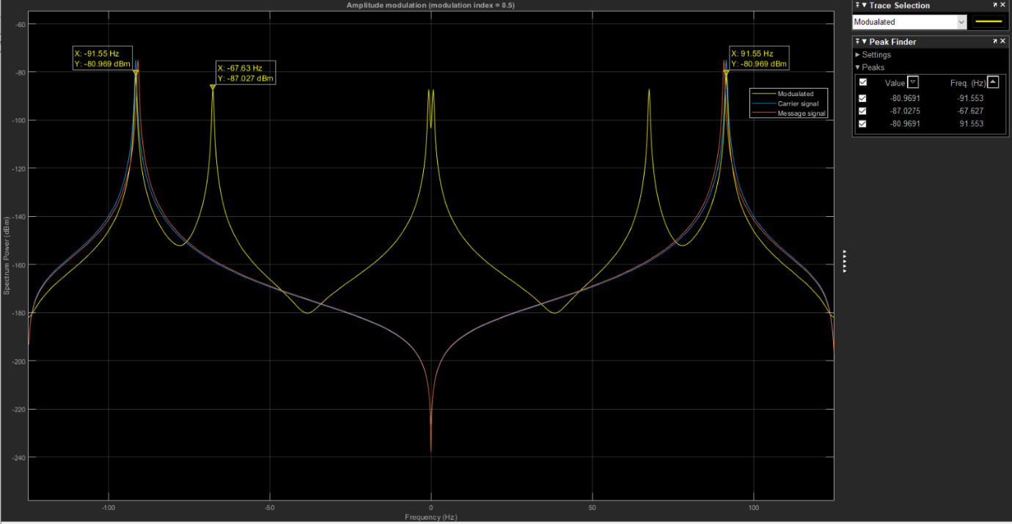
Figure 38 Amplitude modulation, mod index m = 0.5. Maximum frequency fmax = 91.553Hz for the modulated signal
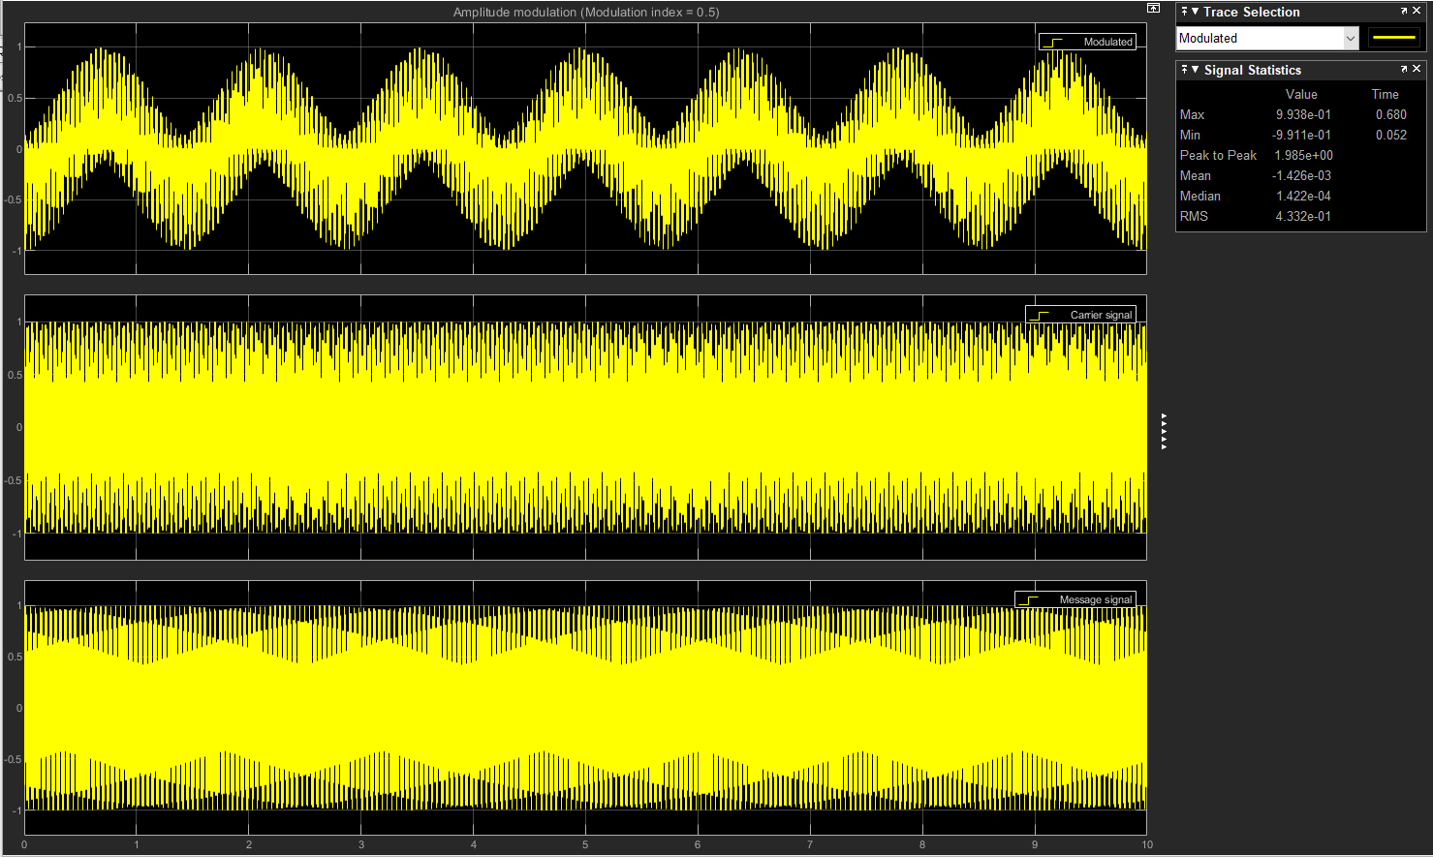
Figure 39 Amplitude modulation, mod index m = 0.5. Amplitude A = 9.938e-01m for the modulated signal
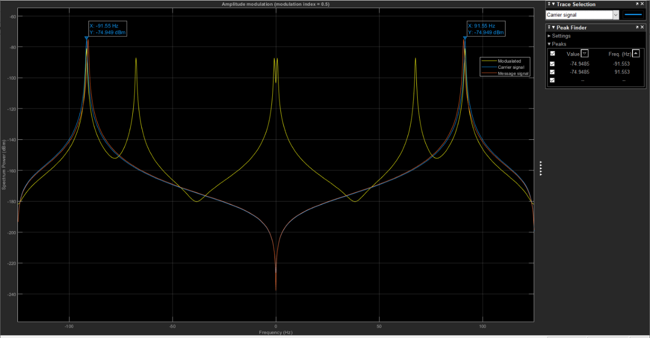
Figure 40 Amplitude modulation, mod index m = 0.5. Maximum frequency fmax = 91.553Hz for the carrier signal
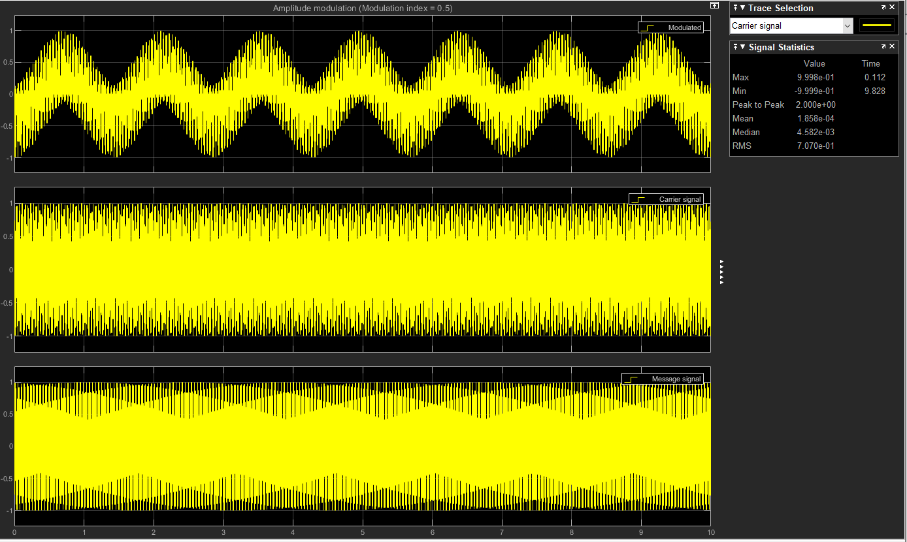
Figure 41 Amplitude modulation, mod index m = 0.5. Amplitude A = 9.998e-01m for the carrier signal
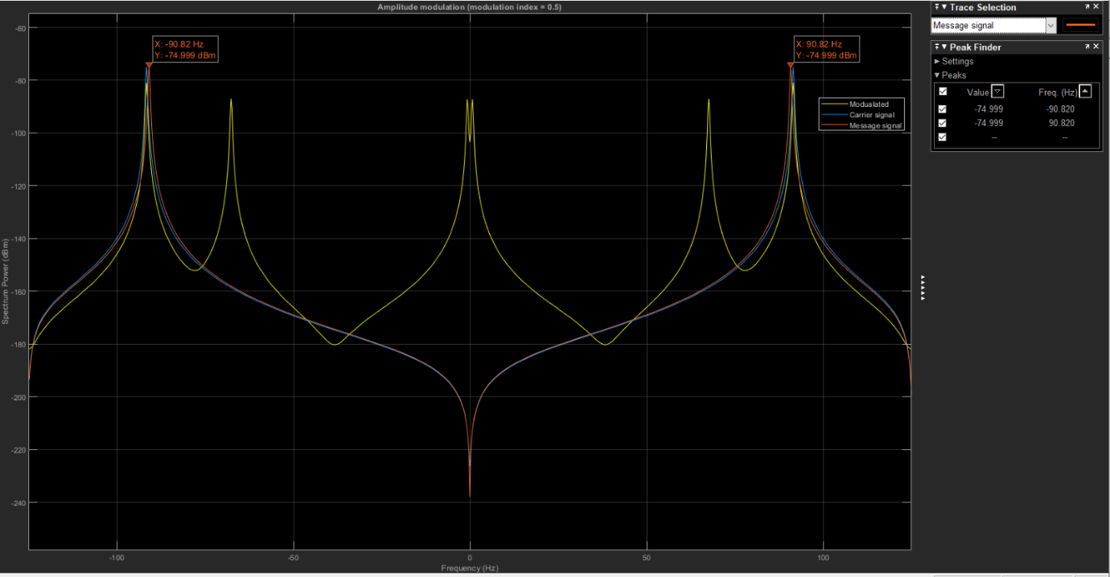
Figure 42 Amplitude modulation, mod index m = 0.5. Maximum frequency fmax = 90.82Hz for the message signal
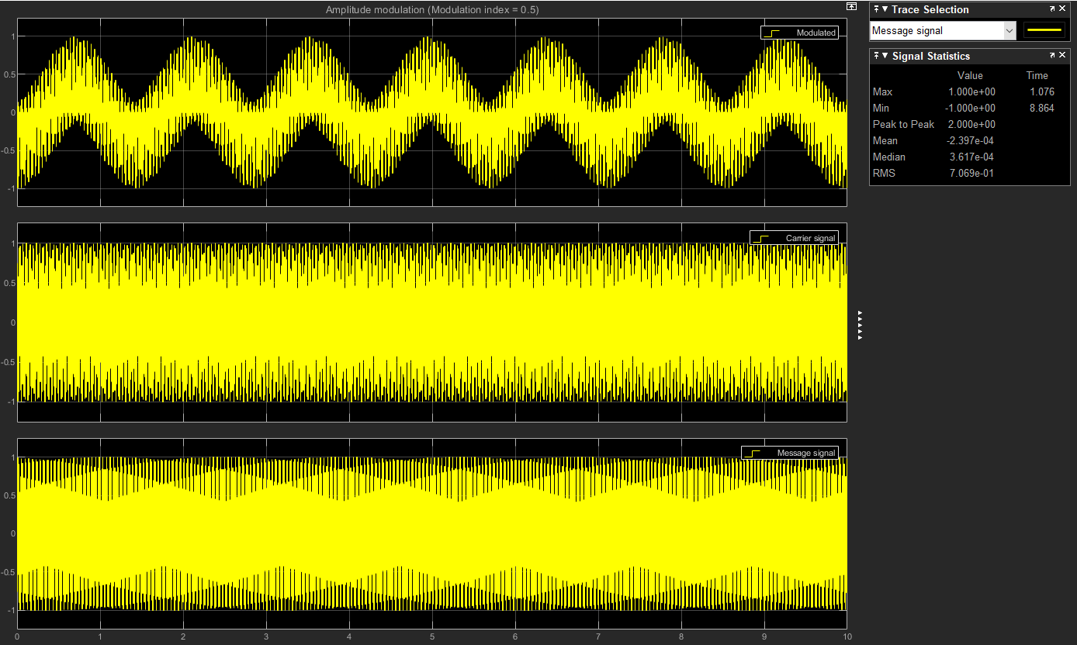
Figure 43 Amplitude modulation, mod index m = 0.5. Amplitude A = 1.00e+00m for the message signal
Task 2 results from measurements on the spectrum analyser and oscilloscope
 | Modulated signal | Demodulated signal
Maximum frequency (Hz) with AWGN noise (Hz) | $$17300$$ | $$530$$
Amplitude (m) with AWGN noise | $$1.674e+00$$ | $$2.149e-01$$
RMS (m) with AWGN noise | $$3.303e-01$$ | $$5.002e-02$$
Maximum frequency (Hz) without AWGN noise (Hz) | $$18490$$ | $$340$$
Amplitude (m) without AWGN noise | $$4.283e+5$$ | $$6.664e+49$$
RMS (m) without AWGN noise | $$9.995e+49$$ | $$1.556e+49$$

 | With noise 10dB | Ideal no noise -100dB
Bandwidth (Hz) | $$2f_{m}=2 ×17300 = 34600$$ | $$2f_{m}=2 ×18490 = 36980$$
Power (W) | $$=\frac{{1.674e+00}^{2} ×{9.980e-01}^{2}}{4}=0.9496W$$ | $$\frac{{4.283e+05}^{2} ×{9.980e-01}^{2}}{4}=4.56×{10}^{11}W$$
Signal-noise ratio (dB) | $$=\frac{29.78}{10}=2.978dB$$ | $$=\frac{126.59}{-100}= -1.2659dB$$

Power of noise in watts when its $10dB$ – $0.01W$
Power of signal in Db when its $0.9496W$ – $29.78Db$
Power of signal in Db when its $4.56×{10}^{11}W$ – $126.59Db$
Power of noise in watts when its $-100dB$ - $∞$ no noise
Carrier signal amplitude with AWGN noise – $9.980e-01m$
Carrier signal amplitude without AWGN noise – $9.980e-01m$
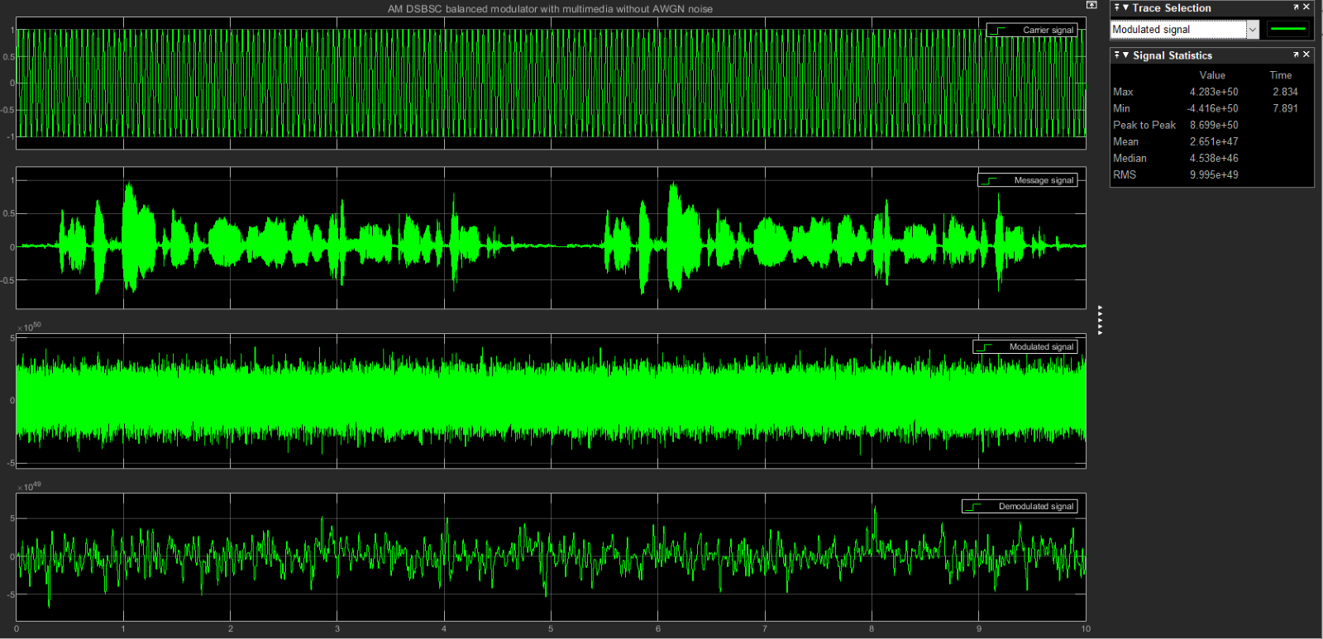
Figure 44 DSB-SC balanced modulator with AM for the modulated signal without AWGN noise Amplitude A = 4.283e+50m
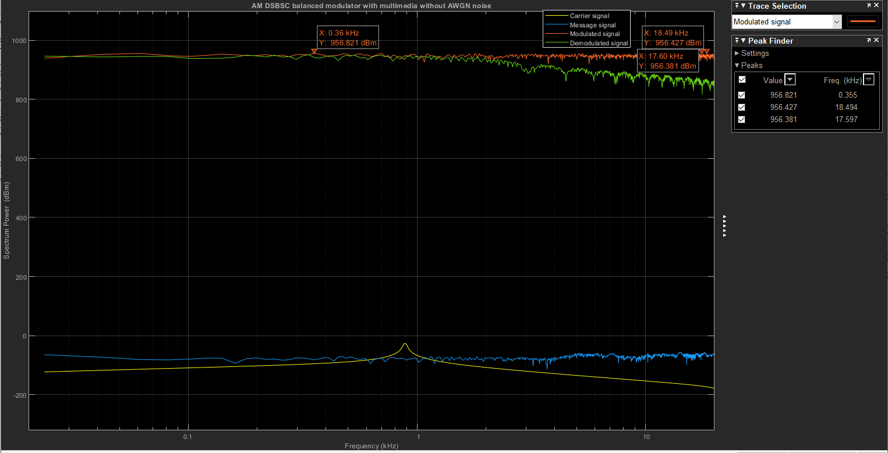
Figure 45 DSB-SC balanced modulator with AM for the modulated signal without AWGN noise Maximum frequency = 18490Hz
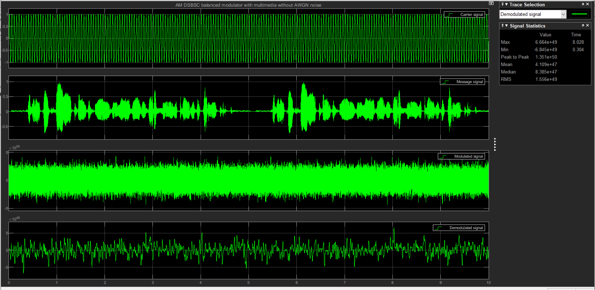
Figure 46 DSB-SC balanced modulator with AM for the demodulated signal without AWGN noise Amplitude A = 6.664e+49m
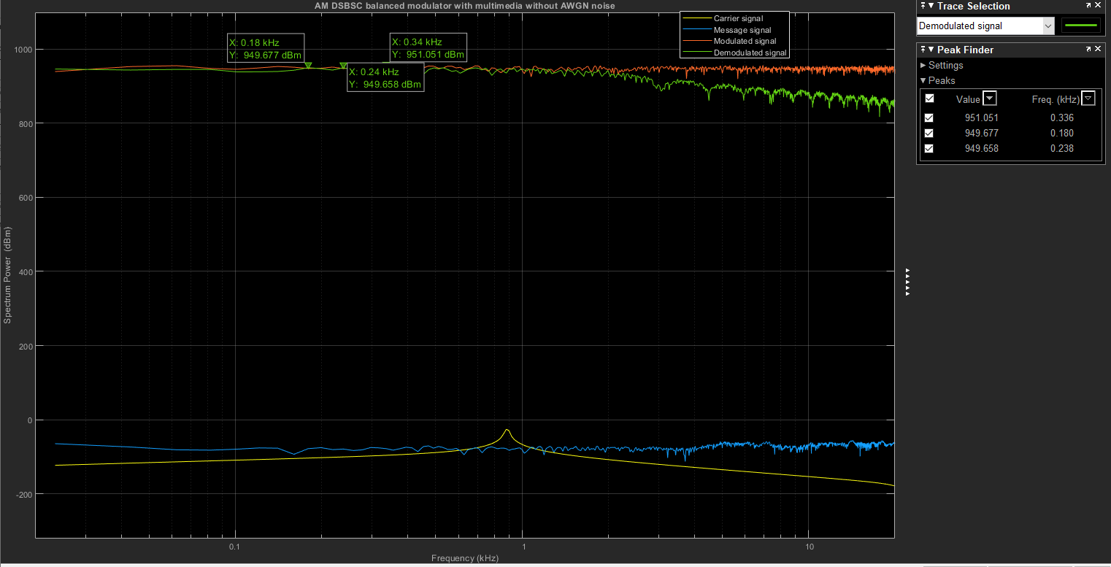
Figure 47 DSB-SC balanced modulator with AM for the demodulated signal without AWGN noise Maximum frequency = 340Hz
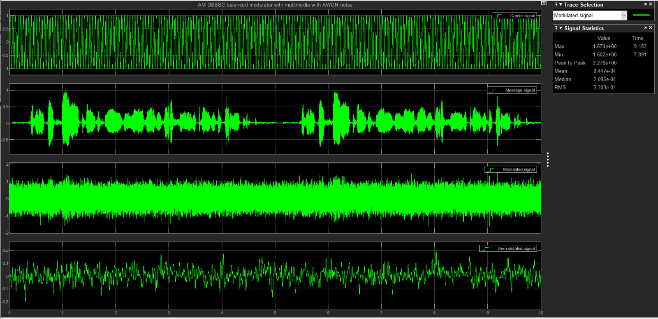
Figure 48 DSB-SC balanced modulator with AM for the modulated signal with AWGN noise Amplitude A = 1.674e+00m
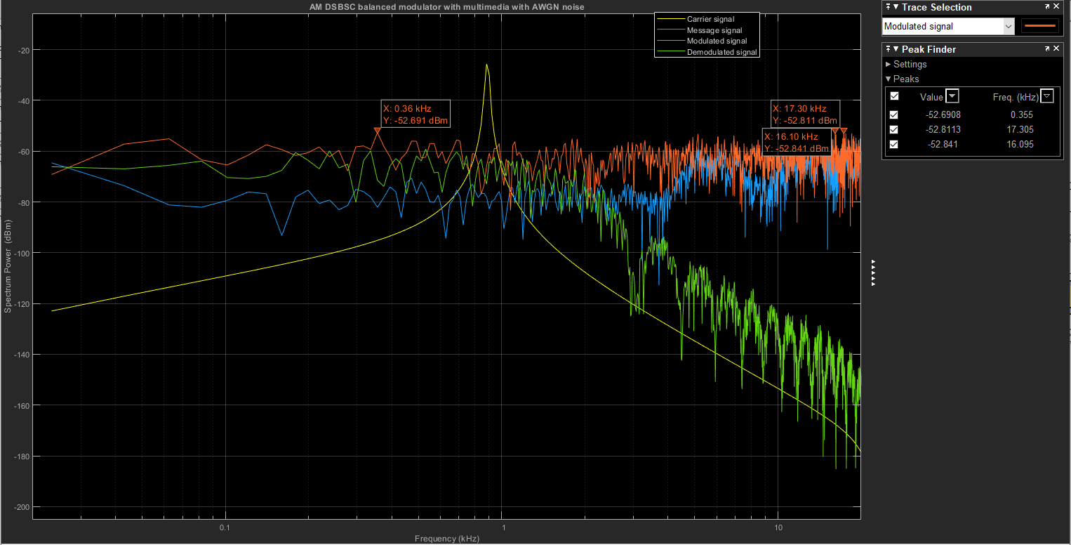
Figure 49 DSB-SC balanced modulator with AM for the modulated signal with AWGN noise Maximum frequency = 17300Hz
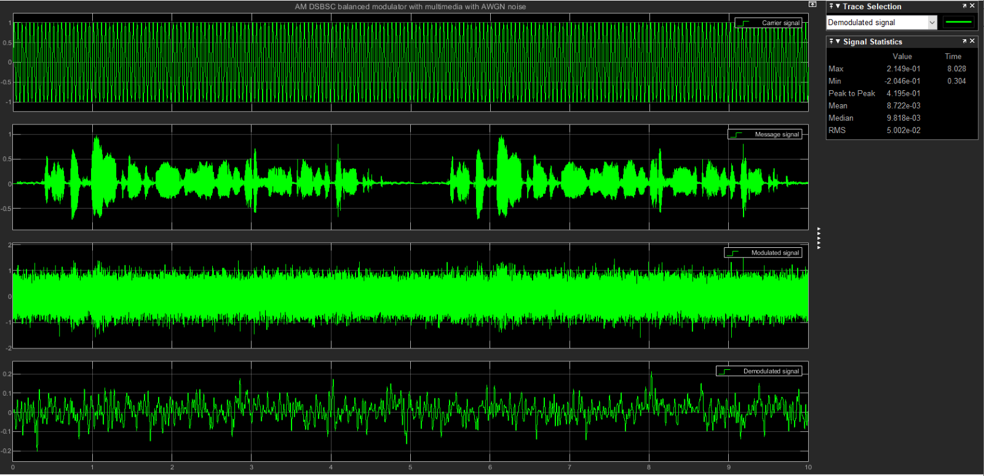
Figure 50 DSB-SC balanced modulator with AM for the demodulated signal with AWGN noise Amplitude A = 1.421e+00m
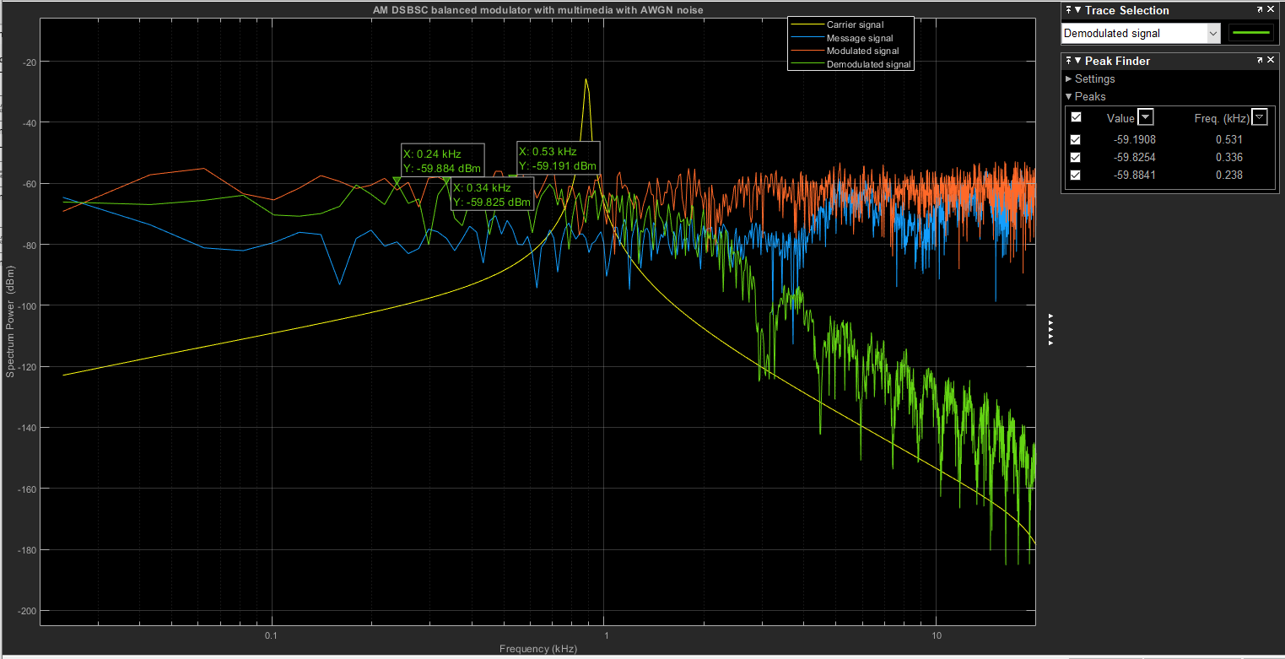
Figure 51 DSB-SC balanced modulator with AM for the demodulated signal with AWGN noise Maximum frequency = 530Hz
Unlike in amplitude modulation, in DSB-SC the carrier signal is not transmitted and because most of the power is distributed between the sidebands this reduces the power loss and means that DSB-SC has a $50\%$ efficiency. The advantages of DSB-SC modulation are that its $100\%$ modulation efficient and due to the suppression and lack of transmission of the carrier signal it consumes less power. However, a disadvantage of this technique is that it can be challenging to recover the signal at the receiver after demodulation. The results show by increasing the transmitter power therefore increasing $A_{c}$ then the signal-noise ratio is increased proportionally. The carrier frequency is independent of the SNR and remains constant. If the signal has a constant amplitude and the bandwidth is increased, then in constant proportion the signal power would increase. If the channel attenuation is increased so the distance between the receiver and the transmitter so the SNR decreases. Increasing the amplitude of the transmitted signal increases the SNR of the transmission channel therefore it doesn’t always lead to an increased bit transmission rate. However, the higher SNR will improve the bit error rate because although the same quantity of bits is received in a second the number of transmission errors is reduced.
Task 3 from measurements on the spectrum analyser and oscilloscope
 | Modulated signal | Demodulated signal
Maximum frequency (Hz) with AWGN noise (Hz) | $$210$$ | $$250$$
Amplitude (m) with AWGN noise | $$2.000e+00$$ | $$1.421e+00$$
RMS (m) with AWGN noise | $$1.414e+00$$ | $$5.794e-01$$
Maximum frequency (Hz) without AWGN noise (Hz) | $$210$$ | $$180$$
Amplitude (m) without AWGN noise | $$2.000e+00$$ | $$1.096e+04$$
RMS (m) without AWGN noise | $$1.414e+00$$ | $$4.010e+03$$

 | With noise 10dB | Ideal no noise -100dB
Bandwidth (Hz) | $$=2×210\left(1+1\right)=840$$ | $$=2×180\left(1+1\right)=720$$
Power (W) | $$=\frac{2^{2}}{2}+\frac{{9.907e-01}^{2}}{2}=2.491W$$ | $$=\frac{2^{2}}{2}+ \frac{{9.980e-01}^{2}}{2}=2.4981W$$
Signal-noise ratio (dB) | $$= \frac{33.96}{10}=3.396dB$$ | $$=\frac{33.98}{-100}=0.3398dB$$

Power of signal in Db when its $2.491W$ – $33.96Db$
Power of signal in Db when its $2.4981W$ – $33.98Db$
Carrier signal amplitude with AWGN noise – $9.980e-01m$
Carrier signal amplitude without AWGN noise – $9.907e-01m$
Modulation index is $m=1$
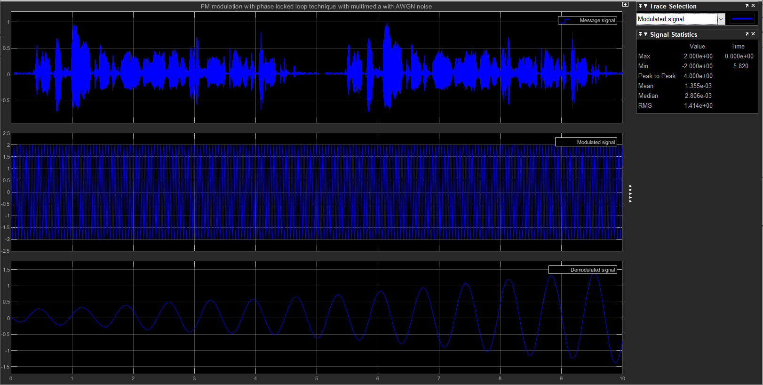
Figure 52 Frequency modulation with PLL, with 10Db noise Amplitude A = 2.000e+00m for the modulated signal
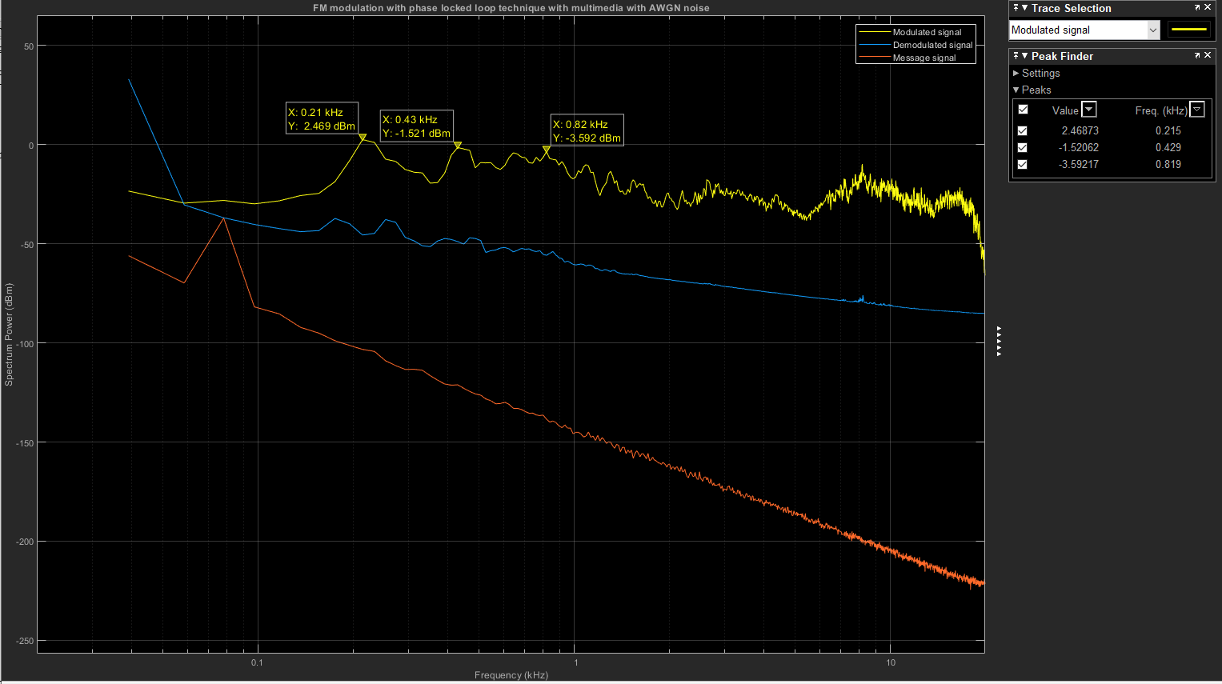
Figure 53 Frequency modulation with PLL, with 10Db noise Maximum frequency = 210Hz for the modulated signal
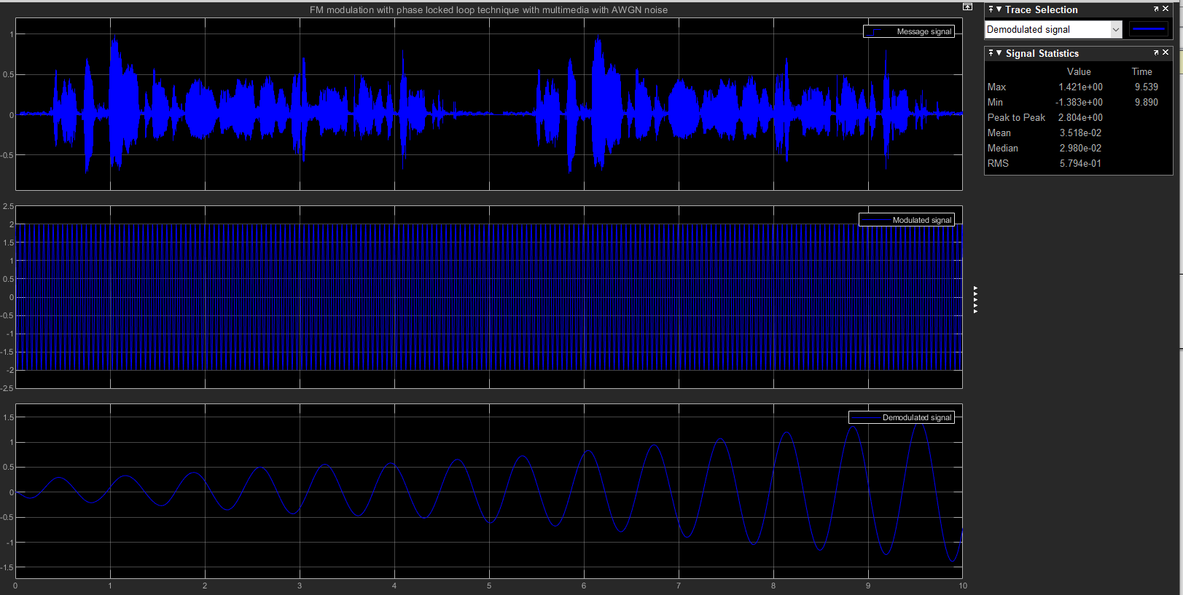
Figure 54 Frequency modulation with PLL, with 10Db noise Amplitude A = 1.421e+00m for the demodulated signal
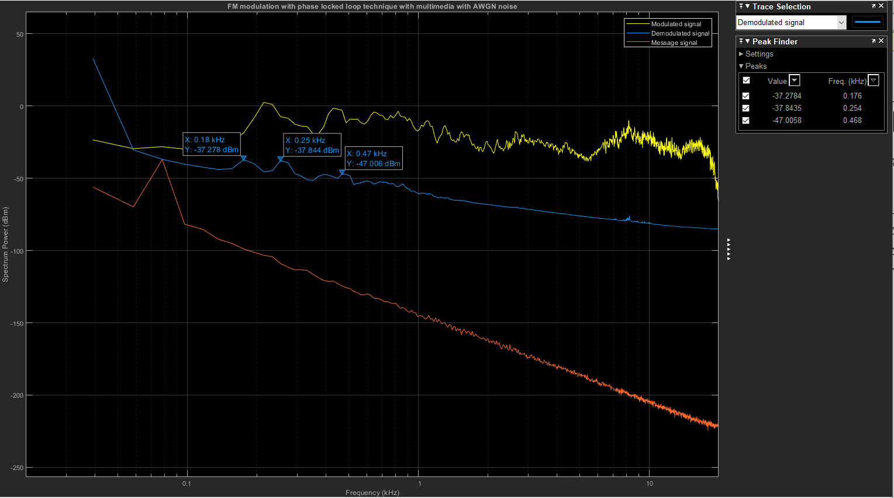
Figure 55 Frequency modulation with PLL, with 10Db noise Maximum frequency = 250Hz for the demodulated signal
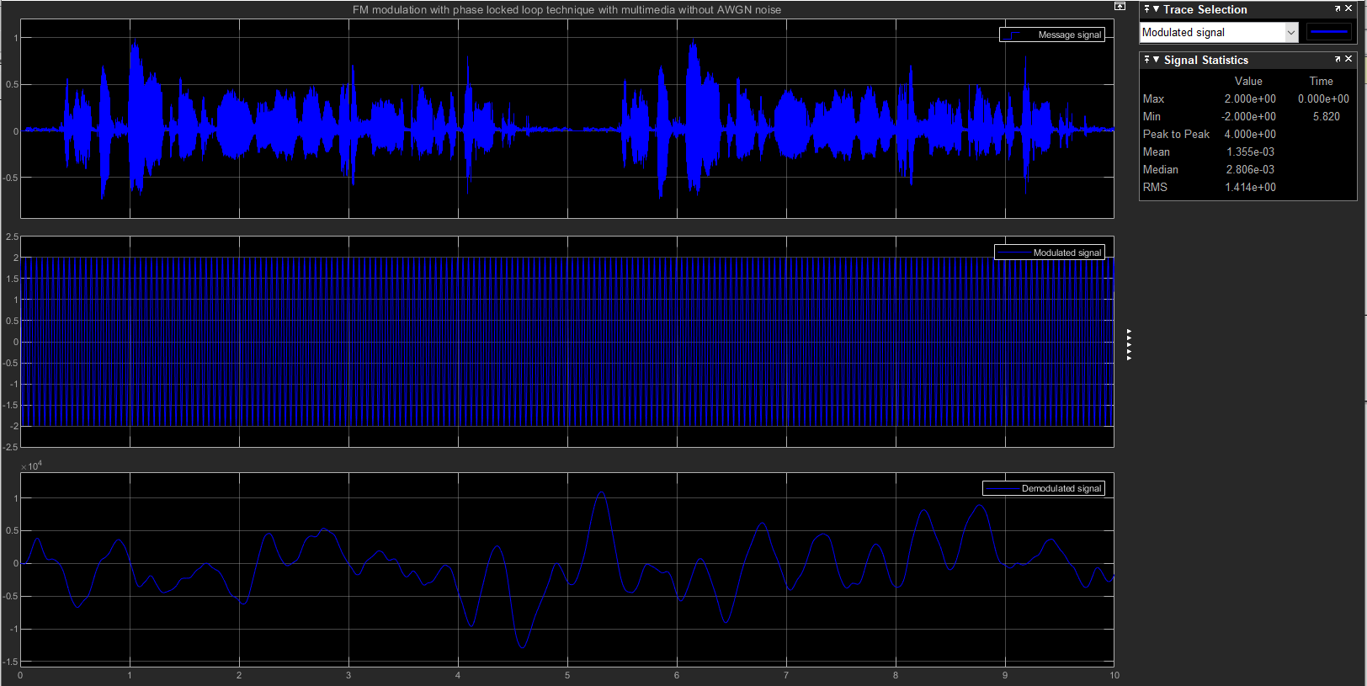
Figure 56 Frequency modulation with PLL, with no noise -100Db noise Amplitude A = 2.000e+00m for the modulated signal
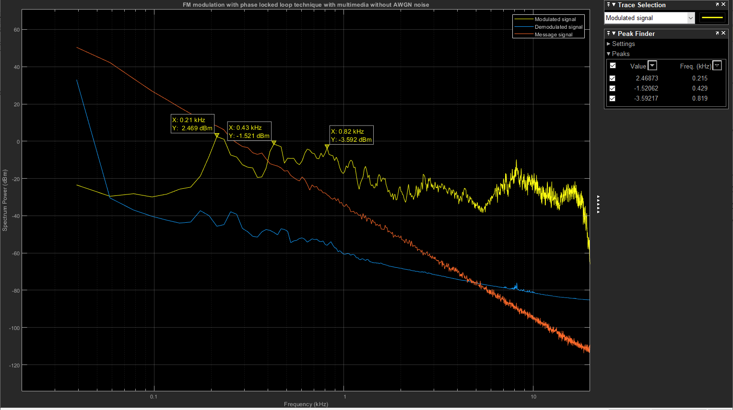
Figure 57 Frequency modulation with PLL with no noise -100Db Maximum frequency = 210Hz for the modulated signal
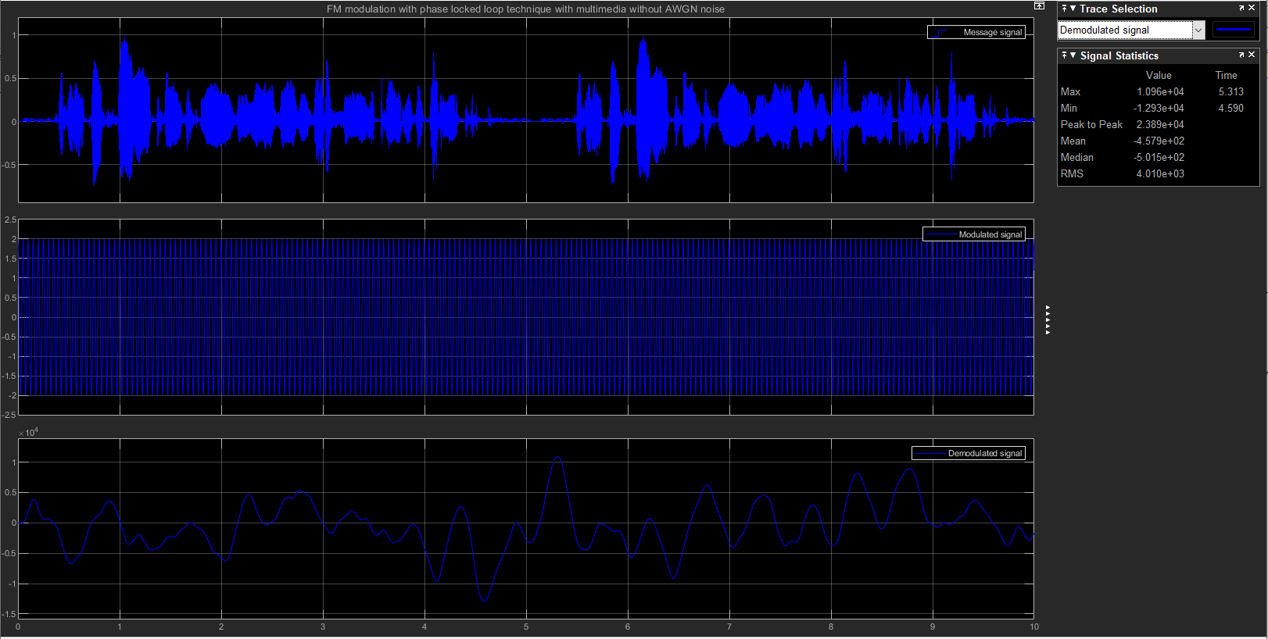
Figure 58 Frequency modulation with PLL, with no noise -100Db noise Amplitude A = 2.1096e+04m for the demodulated signal
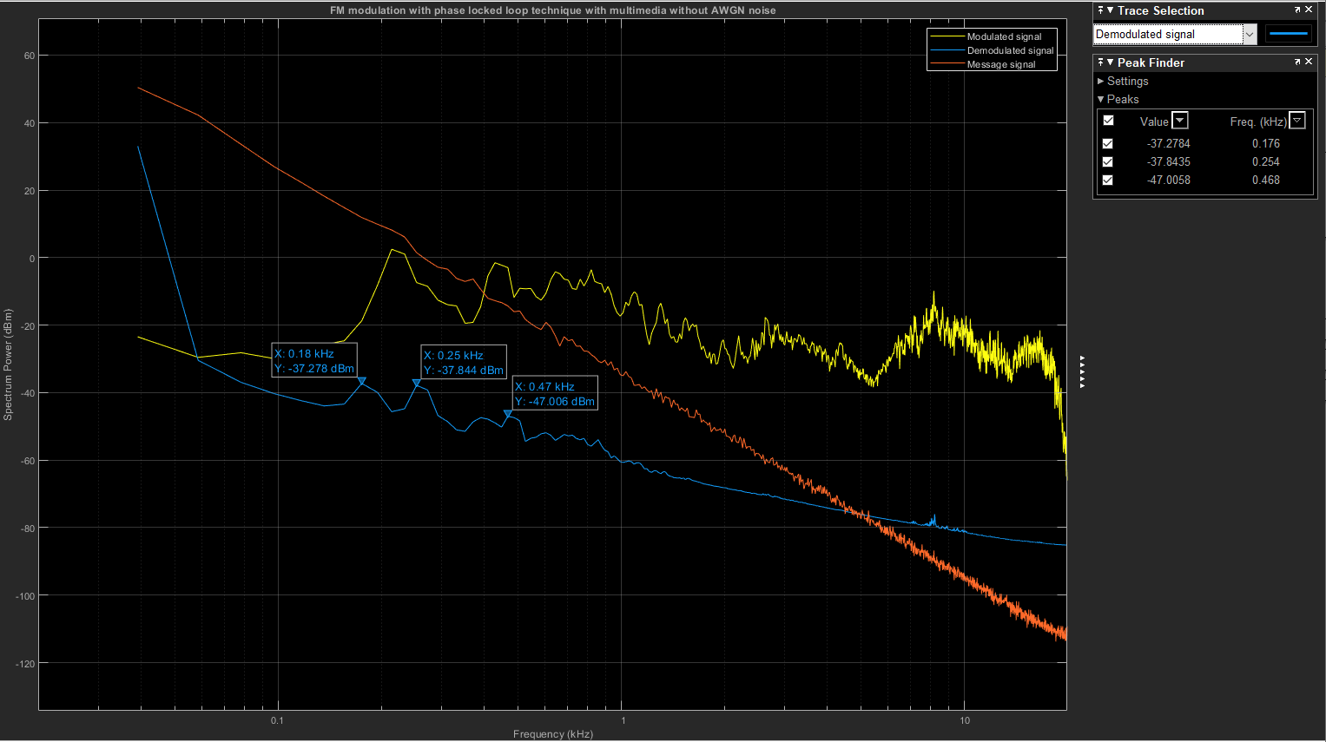
Figure 59 Frequency modulation with PLL with no noise -100Db Maximum frequency = 180Hz for the demodulated signal
If the modulation frequency is constant and the modulation index is increased, then the FM signal bandwidth will increase. Frequency modulation can be classified into narrowband and wideband and is narrowband if the carrier frequency change is like the signal frequency or as wideband if the carrier frequency is higher than the modulation index > 1 than the signal frequency.

Conclusion
In amplitude modulation the signal is modulated by changing the amplitude of the carrier wave and therefore the receiver only has the amplitude of the receiver to retrieve the original data. In frequency modulation the input signal amplitude changes the carrier frequency, and the receiver then processes the frequency changes to reconstruct the original data, so the amplitude of the received signal does affect frequency modulation. FM waves are less susceptible to noise than AM waves because the information in FM is transmitted through changing the frequency not the amplitude. In AM the message information is inside the signal amplitude and additive corrupts the modulated signal and changes the order of the data bits. In FM the message information is inside the signal frequency and the effect of distortion after introducing additive noise in the system is dependent on how much the frequency is changed.
The advantages of DSBSC -AM is that it has a $50\%$ modulation efficiency due to there being no carrier signal transmission and therefore less power consumption. The potential bandwidth to transmit a signal within is greater due to the two sidebands and so the output is twice the frequency of the modulated signal. The advantages of FM systems with PLL are that there’s a large decrease resulting in an increase signal-noise ratio and that the amplitude of the FM wave is unaffected.

References
1 – ELPROCUS Electronics Projects| (2019) What is amplitude modulation, types, advantages, & disadvantages, ElProCus. Available at: https://www.elprocus.com/what-is-amplitude-modulation-derivations-typesand-applications/ (Accessed: 01 December 2023).
2 – Tutorials point - Analog Communication - DSBSC Modulation (2020) Analog Communication - DSBSC modulation, Online Tutorials, Courses, and eBooks Library. Available at: https://www.tutorialspoint.com/analog_communication/analog_communication_dsbsc_modulation.htm (Accessed: 01 December 2023).
3 – Tutorials point - Analog Communication - DSBSC Modulators (2020) Analog Communication - DSBSC modulators, Online Tutorials, Courses, and eBooks Library. Available at: https://www.tutorialspoint.com/analog_communication/analog_communication_dsbsc_modulators.htm (Accessed: 01 December 2023).
4 – MathWorks (2023) Spectrum Analyzer Configuration for Simulink, Display frequency spectrum - Simulink - MathWorks United Kingdom. Available at: https://uk.mathworks.com/help/simulink/slref/spectrumanalyzerblock.html (Accessed: 01 December 2023).
5 – Wikimedia foundation (2020) Phase-locked loop, Wikipedia. Available at: https://en.wikipedia.org/wiki/Phase-locked_loop (Accessed: 01 December 2023).
6 – Tutorials point - Analog Communication - FM Modulators (2020) Analog Communication - FM modulators, Online Tutorials, Courses, and eBooks Library. Available at: https://www.tutorialspoint.com/analog_communication/analog_communication_FM_modulators.htm (Accessed: 01 December 2023).
7 – Wikipedia - SNR (2023) Signal-to-noise ratio, Wikipedia. Available at: https://en.wikipedia.org/wiki/Signal-to-noise_ratio (Accessed: 01 December 2023)

Appendices
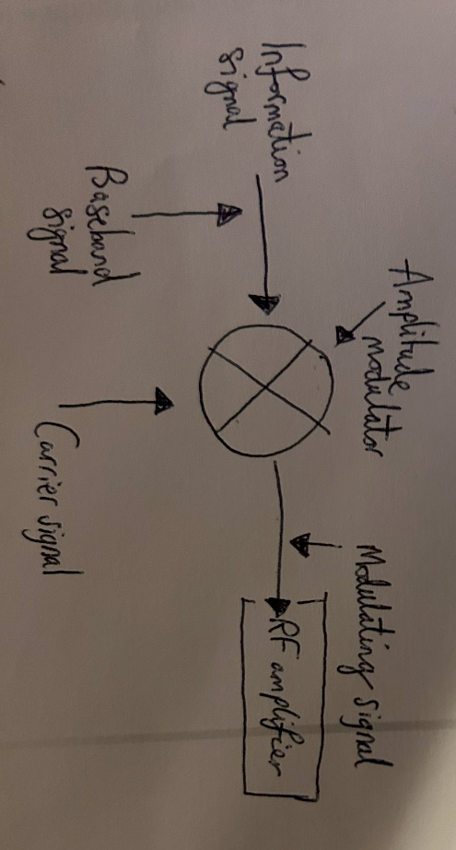
Figure 60 Amplitude modulation
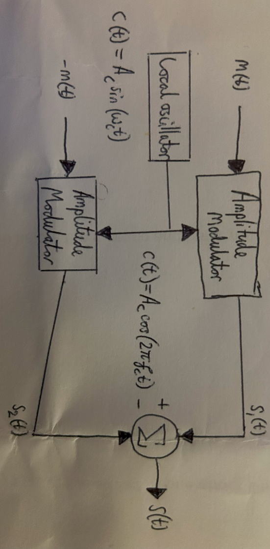
Figure 61 Balanced modulator circuit for DSB-SC AM
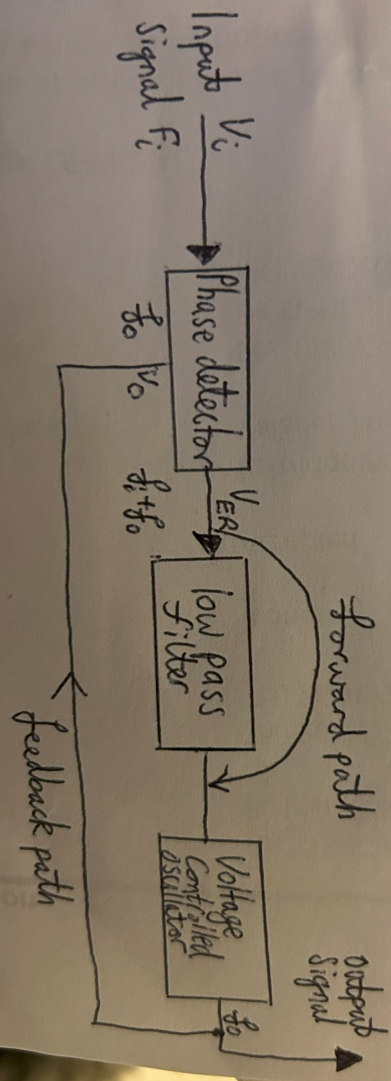
Figure 62 Phase locked loop circuit for FM
Derivation of the formula for the Bandwidth for an amplitude modulated wave
In the time domain, the carrier $c\left(t\right)$and modulating $m\left(t\right)$ signals are represented as: $c\left(t\right)= A_{C}\cos\left(2πf_{c}t\right) \& m(t)= A_{C}\cos\left(2πf_{m}t\right)$ The equation of the amplitude modulated wave is: $s\left(t\right)= \left[A_{c}+ A_{m} \cos\left(2πf_{m}t\right)\right]\cos\left(2πf_{c}t\right)$ Bandwidth: $BW=f_{max}- f_{min}$
$s\left(t\right)= \left[1+ μ \cos\left(2πf_{m}t\right)\right]\cos\left(2πf_{c}t\right)= A_{c}\cos\left(2πf_{c}t\right)+ A_{c}μ\cos\left(2πf_{c}t\right)cos\left(2πf_{m}t\right)$ $s\left(t\right)= A_{c}\cos\left(2πf_{c}t\right)+ \frac{A_{c}μ}{2}\cos\left[2π\left(f_{c}+ f_{m}\right)t\right]+ \frac{A_{c}μ}{2}\cos\left[2π\left(f_{c}- f_{m}\right)t\right]$ Hence, the amplitude modulated wave has three frequencies which are carrier frequency $f_{c},$upper sideband $f_{c}+ f_{m}$ and lower sideband frequency $f_{c}- f_{m}$. Hence, ${f_{max}= f}_{c}+ f_{m} \& f_{min}{= f}_{c}- f_{m}$ Substitute into the bandwidth formula: $BW=f_{c}+ f_{m}- {(f}_{c}- f_{m})= 2f_{m}.$
Derivation of the formula for the Power for an amplitude modulated wave $s\left(t\right)= A_{c}\cos\left(2πf_{c}t\right)+ \frac{A_{c}μ}{2}\cos\left[2π\left(f_{c}+ f_{m}\right)t\right]+ \frac{A_{c}μ}{2}\cos\left[2π\left(f_{c}- f_{m}\right)t\right]$ Power of the amplitude modulated wave is the sum of the power of the carrier, upper and lower sideband frequency components $P_{T}= P_{USB}+ P_{LSB}+ P_{C}$ The standard form for the power of a cosine signal is: $P= \frac{v_{rms}^{2}}{R}= \frac{{\left({v_{m}}/{\sqrt{2}}\right)}^{2}}{R}$ So, $P_{C}= \frac{A_{c}^{2}}{R}= \frac{{\left({A_{c}}/{\sqrt{2}}\right)}^{2}}{R}$ $P_{USB}= \frac{{\left({A_{c}μ}/{2\sqrt{2}}\right)}^{2}}{R} = \frac{A_{c}^{2}μ}{8R}$And the same for $P_{LSB}$ Therefore, $P_{T}= P_{c}+ P_{USB}+ P_{LSB}= \frac{{\left({A_{c}}/{\sqrt{2}}\right)}^{2}}{R} + \frac{A_{c}^{2}μ}{8R}+ \frac{A_{c}^{2}μ}{8R}= P_{c}\left(1+ \frac{μ^{2}}{2}\right)$
Derivation of the formula for the Bandwidth of a DSBSC amplitude modulated signal - (Tutorials point - Analog Communication - DSBSC Modulators , Analog Communication - DSBSC modulators 2020)
Bandwidth: $BW=2f_{m}$ Where $f_{m}$ is the modulating frequency $BW= f_{max}- f_{min}$ The equation of the DSBSC modulated wave is: $s\left(t\right)= A_{m}A_{c}\cos\left(2πf_{m}t\right)\cos\left(2πf_{c}t\right)$ $s\left(t\right)= \frac{A_{m}A_{c}}{2}\cos\left[2π\left(f_{c}+ f_{m}\right)t\right]+ \frac{A_{m}A_{c}}{2}\cos\left[2π\left(f_{c}- f_{m}\right)t\right]$ The DSBSC modulated wave has two frequencies, so the maximum and minimum frequencies are $f_{c}+ f_{m}$ and $f_{c}- f_{m}$. $f_{max}= f_{c}+ f_{m}$ & $f_{min}= f_{c}- f_{m}$ $BW= f_{c}+ f_{m}- \left(f_{c}- f_{m}\right)$ $BW=2f_{m}$
Therefore, the bandwidth of a DSBSC signal is the same as that of an amplitude modulated signal and is equal to twice the modulating frequency.
Derivation of the formula for the Bandwidth of a frequency modulated signal - (Tutorials point - Analog Communication - DSBSC Modulators , Analog Communication - DSBSC modulators 2020)
Carson’s rule states that approximately $98\%$ of the power of a frequency-modulated signal lies inside the bandwidth $BW$ of: $BW=2\left(∆f+ f_{m}\right)=2f_{m}\left(β+1\right)$ where $∆f$ is the peak deviation of the instantaneous frequency $f\left(t\right)$ from the centre carrier frequency $f_{c},$ $β$ is the modulation index which is the ratio between the modulating and carrier signals and $f_{m}$ is the highest frequency in the modulating signal. Carson’s rule is only true if the modulating signals are sinusoidal.
Derivation of the formula for the Signal-noise ratio - (Wikimedia Foundation, Signal-to-noise ratio 2023) $SNR= \frac{P_{signal}}{P_{noise}}= {\left(\frac{A_{signal}}{A_{noise}}\right)}^{2}$ Where $A$ is the root mean square (RMS) amplitude and $V$ is the root mean square voltage. In decibels, dB the formula of signal-noise ratio is: $P_{signal,dB}=10\log_{10}{(P_{signal})} \& P_{noise,dB}=10\log_{10}{(P_{noise})}$ Therefore, the signal – noise ratio is: ${SNR}_{dB}=10\log_{10}\left(SNR\right)=10\log_{10}\left(\frac{P_{signal}}{P_{noise}}\right)$ Using the quotient rule of logarithms: $10\log_{10}\left(\frac{P_{signal}}{P_{noise}}\right)=10\log_{10}\left(P_{signal}\right)-10\log_{10}\left(P_{noise}\right)$ Hence, ${SNR}_{dB}=10\log_{10}\left[{\left(\frac{A_{signal}}{A_{noise}}\right)}^{2}\right]=20\log_{10}\left(\frac{A_{signal}}{A_{noise}}\right)=2\left(A_{signal,dB}- A_{noise,dB}\right)$

