
Hotel standards reputation management and service culture
Module code:BMIH4003

Student id:2227451
STUDENT NAME:FLORIN DRAGOMIR
LECTURER NAME:CHARLOTTE JOYNER

Executive Summary
Waldorf Astoria that has been operating under the name of Hotel Hilton and its emergence as a brand has been well-shed light upon with due consideration to various concepts across the Hotel industry. Across contextual supplements, this essay comprises the inclusivity of all the requisites from varied sources of information, aligning with the hotel industry with exemplified instances for validating important points.

Table of Contents
Introduction 3
Main Findings 3
Service Culture 3
Hotel standards 4
Reputation management 5
Conclusion and Recommendations 7
References 8

Introduction
In association with an integrated comprehension of industry standards, reputation management, and service culture, this assignment has dealt with the hotel industry with reference to Waldorf Astoria of Hilton Hotel. The purpose of this essay is to elucidate various aspects of the Brand Consistency Standards comprising its association with certain amenities, which will be satiating the reasons why Hilton is an international brand even after recovering from the effects of the pandemic 2019 across evidence to be provided.

Main Findings

Service Culture
Service culture basically deals with such an environment where the associated employees are passionate about rendering world-class superior services to their clients. This, therefore, holds pertinent in the concerned landscape of Hilton, which holds fame for its employees for going beyond the call of duty to ensure that customers are provided with the best of services in order to satisfy them. This helps the hotel industry in making it a sensible business that determines the competitiveness of Waldorf Astoria as distinguished in its overcrowded market place.
While service culture in the hotel industry is about making those extra efforts for an impressive comprehension of satisfaction that the guests are demanding for. However, the corporate culture is mainly a decree that propagates the members of an organization, basically the workforce in thinking, acting, and understanding the intricacies of the dynamic external environment (Koc, 2019). Therefore, keywords such as passion and dedication along with obsession well characterize the service culture and corporate culture and have elementary attributes affiliated with satisfaction and well-being of the employees necessary for their productivity. With further discussion, the hotel culture bears the personality of the respective hotel, making it unique. It is the culmination of beliefs, traditions, attitudes, and behaviour (Solnet et al. 2019). The positive work culture at hotels attracts talent and affects the performance of the hotel industry. With the work culture they have produced, it has reflected the service culture of Waldorf Astoria as well. As a part of their service culture, Waldorf Astoria comes up with “True Waldorf Service”, for making their guest feel welcome from the service staff of the hotel (Goodson, 2020).
With globalization, diversity in preferences and tastes of hotel clients is requisite of a cultivated service culture. In due consideration of the amplified diversification assigned with an extremely competitive environment, the service culture in hotels has propelled customer attraction intertwined with an incremented propensity of conversion of potential guests into actual customers, who are addressed with superior services beyond the edge, which generates positive word of mouth. This holds true when the customers, satisfied with an everlasting impression come back frequently. Moreover, it also improvises the bottom line of the hotels in terms of business revenue and long-term operationalisation as a brand.

Hotel standards
Brand Consistency Standards work in cohesion with the customer's recognition of the hotel brands, so much so, that there are positive associations between the customers and their respective hotel brands. With respect to Waldorf Astoria, this is reverted for the purpose of making purchases and commitment to the hotel brand in the long run (ir.hilton.com. 2023). While the ISO standards of Milton brand are ISO 9001 as well as 14001, thereby making sure that it has adopted quality and sustainability in its overall performance standards and operational procedures. Accentuating with its brand consistency, the underlined purpose resonates with provisions enfolded in its mission, vision, and values among its stakeholders.
The Cultural Integrity of the Waldorf Astoria serves its “Code of Conduct”, and works in association with its cultural diversity, safe and harassment-free work culture, fair competition, ethical advertising, and marketing along with the protection of third-party []information with numerous others (ETHospitalityWorld.com. 2020). With good c0ustomer-approach websites, emails, and other platforms, this evidence is well portrayed in its brand consistency standards of Hilton Brand for its customers or guests helps in winning their trust and loyalty.
As key essentialities given to brand consistency standards, hotel brands are engaged in rivalry against one another thereby, continuous endeavours for gaining a huge customer base have been characterized by different brand consistency standards (Chan et al. 2021). Hilton Brand well retrospects its consistent efforts toward brand standards through its unique and overwhelming customer service. With respect to its distinct brand standards, Waldorf Astoria deals with suppliers and distributors. At the same time, this brand ensures compliance with governmental regulations and fair marketing of services and products in the market. The ISO standard followed by Marriot is ISO 50001 “Energy Management Standard” concerning “Energy Management Framework” However, IHG hotel follows the ISO given to the hotel industry which is ISO 9001 along with its operational control over its GHG emissions, whereby succeeding in its reduction (Ihgplc.com. 2022). This ensures that Marriot is optimally operating in providing its services to its guests. Moreover, some of Marriott Brand’s positive brand consistency standards such as non-discriminatory cultural standards, creating the right environment, and its mentioned ethical standards have earned it trustworthiness among its guests (Marriott.com. 2022). While being distinct these are completely different in their approach in comparison to Hilton’s.

Reputation management
Reputation management theory can be well-explained across Game Theory by John Nash. In contemporary times, maintenance of brand consistency standards is not solely sufficient for the hospitality industry-reflected organizations in competing against their contemporaries. Therefore, with much resonance in keeping with the (Reputation Management) theory or RM theory with brand consistency standards, Waldorf Astoria has deployed its resources to achieve its attribute as the most reliable and efficiently managed hotel brand for its guests (Reputation X, 2022). The mentioned attribute of Milton has already earned it a reputation in the market, competing against which neither IHJ nor Marriott, has a chance in the respective industry. Therefore, the other two may deploy their resources in reputation management across their other expertise where Waldorf Astoria has not been able to play a gainful reputational game.
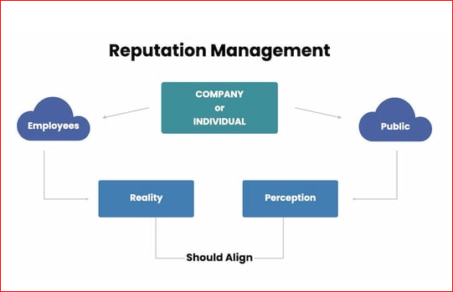
Figure 1: Reputation Management
(Source: Reputation X, 2022)
Holding this, according to Schultz and Werner, the reviews and the perception that the customers or the guests have experienced at Hilton needs to align with the reality being inculcated by the employees of the aforementioned. Unless this alignment is positively oriented there is no reputational management that Hilton could have arranged for itself.
At hotels, the guest review management withholds the monitoring, analysing, and responding to these available on their websites or other social media platforms. In the case of Waldorf Astoria, effective guest review management is important as the negation-propelled reviews can induce a crisis if not met effectively. This will shatter Waldorf Astoria’s reputation within a fraction of a second, thereby, employing regular monitoring and analysis of the review will help Hilton in its sustenance. Moreover, review management may also work against Hilton by diluting the potential customers and terminating the conversion rate. Since around 87% of the customers base their preferences on coming across these reviews, a negative review may turn down this percentage. Over and above, Waldorf Astoria has come quite far across a trusted brand of Hilton. Therefore, refraining from holding it concrete will contribute to its desired efforts towards inefficient guest review management.
As per the study of ITB and the University of Worms, it has been well-concluded through empirical studies that around 35% percent of potential customers refrain from the services of those hotels where reviews are mostly negative in comparison to the positive ones. Along with this, around 20% erode the other set of potential customer base in addition to the existing ones by commuting their findings to this set of customers (Customer Alliance, 2022).
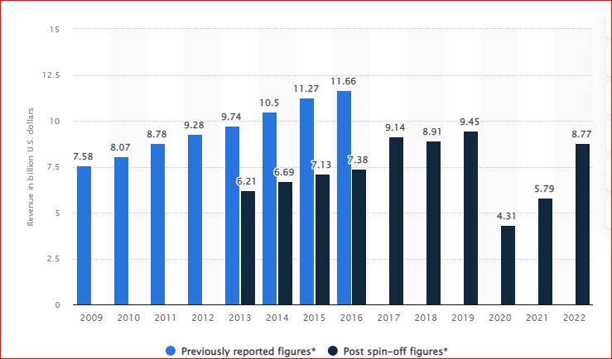
Figure 2: Revenue of Hilton Worldwide Holdings from 2009 to 2022
(Source: Statista, 2023)
International hotel brand Hilton Worldwide Holdings Inc. was generating revenue of around US$8.77 billion revenue in the year 2022. It was approximately US$ 5.79 billion falling from a total of all the previous years (Statista, 2023). This fall was attributed to the pandemic of 2019, with Hilton being forced to shut down internationally. As a part of Hilton Hotels and Resorts, Waldorf Astoria has earned a lot of revenue from the global market. For instance, Waldorf Astoria in New York has earned revenue of $66.9 million, last year.

Conclusion and Recommendations
With reflection on the various aspects of hotel standards and the management of its reputation this essay has been concluded with a special mention made of the difference between the service and the corporate culture of hotel management.
With the onset of globalization, the world has become a smaller place. However, the rise of hotels in the hospitality sector is much accentuated by the customers’ demand and the elementary essentiality of rendering satisfaction. The first challenge is much in contribution to the affordability of hiring a skilled and dedicated workforce affiliated with its retention. This has got much to do with various departments such as administration, housekeeping, kitchen, and front desk operations with hundreds of others. This problem has originated due to the relatable inadequacies associated thereof. However, the possible solution recommended are the strategies implicating emotional attachment with their job and their teammates. This also incentivizes them and instils a sense of responsibility amongst them.
The changing marketing tools due to technological advancements require online and surfing skills which might be too new for obsolete employees. This, therefore, mandates the engagement of such employees with the online platforms along with providing them precision by training them in digital marketing and others. Another complex intricacy has been well launched with rising price inflation harshly affecting the hotels, especially Waldorf Astoria, after the pandemic of 2019. This can be solved by means of controlling inventories, reducing waste, and proper maintenance of stocks through maintaining the books of accounts. Irregular cash flows disrupt the efficiency of the functionality of this industry. This mainly happens due to parties that believe in masking payments after thirty or sixty or ninety days. Even if these amounts are too massive when paid at a point in time, this may result in a “cash crunch”. Therefore, dealing in regular cash payments will reduce bad debts and either type of insecurity.

References
Chan, J., Gao, Y.L. and McGinley, S., (2021). Updates in service standards in hotels: how COVID-19 changed operations. International Journal of Contemporary Hospitality Management, 33(5), pp.1668-1687.
Customer Alliance, (2022). What is the cost of a negative review for your hotel? Available at: https://www.customer-alliance.com/en/resources/article/cost-of-negative-review-for-hotels/#:~:text=Whether%20it%20is%20to%20retain,your%20guests%20in%20the%20future. (Accessed: 15 May 2023).
ETHospitalityWorld.com. (2020). Hotel / Resort ‘Brand Standards’ & their significance - et hospitality world. Available at: https://hospitality.economictimes.indiatimes.com/news/speaking-heads/hotel-/-resort-brand-standards-their-significance/79663108 (Accessed: 15 May 2023).
Goodson, W. (2020). True waldorf service: Making every guest feel welcome... The furry ones too, Waldorf Astoria Magazine. Available at: https://waldorfastoriamagazine.com/personal-concierge-services-for-furry-guests/ (Accessed: 18 May 2023).
Ihgplc.com. (2022). VERIFICATION OPINION DECLARATION. Available at: https://www.ihgplc.com/en/-/media/ihg/files/responsible-business/2018-responsible-business/downloads/2019/rbr/ihg_responsible_business_report_2019_our_culture.pdf (Accessed: 12 May 2023).
ir.hilton.com. (2023). Hilton – Code of Conduct. Available at: https://ir.hilton.com/~/media/Files/H/Hilton-Worldwide-IR-V3/committee-composition/HW-Code-Of-Conduct-OCT2015-L26.pdf (Accessed: 15 May 2023).
Koc, E., (2019). Service failures and recovery in hospitality and tourism: A review of literature and recommendations for future research. Journal of Hospitality Marketing & Management, 28(5), pp.513-537.
Marriott.com. (2022). Business conduct guide our tradition of integrity - Marriott. Available at: https://www.marriott.com/Multimedia/PDF/CorporateResponsibility/Marriott_Business_Conduct_Guide_English.pdf (Accessed: 15 May 2023).
Reputation X, (2022). Reputation Management Theory Basics, Reputation X. Available at: https://blog.reputationx.com/reputation-management-theory (Accessed: 13 May 2023).
Solnet, D., Subramony, M., Ford, R.C., Golubovskaya, M., Kang, H.J. and Hancer, M., (2019). Leveraging human touch in service interactions: lessons from hospitality. Journal of Service Management, 30(3), pp.392-409.
Statista, (2023). Hilton Worldwide Revenue 2022. Available at: https://www.statista.com/statistics/297760/revenue-of-hilton-worldwide-holdings-inc/ (Accessed: 15 May 2023).

