STUDENT NAME: Casiana Adriana Danci
STUDENT ID: 2225536
TOPIC: The Role of Online Marketing on Sales of IT Components in the UK
PROGRAMME : BA ( BUSINESS MANAGEMENT)
MODULE TITLE: Dissertation
LECTURER: Dr Essa Bah

Abstract
The study presented in this dissertation the impact of online marketing to the sales of IT components, i.e. laptops and mobile phones, in the UK market. It will evaluate the performance of online marketing, know which online platforms are the best in selling the IT components, and provide strategic recommendations to the IT retailers in the UK.
The research methodology is a secondary study, which examines academic articles, industry reports, government statistics, and trade journals in the period between 2020 and 2025. It uses thematic and content analysis to conduct a systematic review of this data.
Key finding indicates that search engine marketing is the best method of creating conversions particularly on laptops since it targets high intent search queries. Social media does well to create awareness but not as effective in making direct sales. The UK possesses 28.7% e-commerce penetration and 60 percent mobile commerce dominance, which presents difficulties in revenue attribution, with retailers realising the variation of between £20,000 and 450,000 gaps. Marketing strategies used on laptops and mobile phones should be different: on laptops, the content should be more detailed, whereas mobile phones prefer aspirational messages.
Recommendations to UK retailers in IT are to focus on search engine marketing, adopt category based approaches, cater to mobile first shoppers, improve attribution models beyond the last click approach, and effectively deal with reviews on the internet.
The study presents the UK specific findings on the success of digital marketing in the IT retail industry.
Table of Contents
Abstract 2
Chapter 1: Introduction 5
1.1 Introduction to the Research 5
1.2 Origin of the Research 5
1.3 Problem Statement 6
1.4 Research Aim, Objectives, and Questions 6
1.5 Significance and Rationale of the Study 7
1.6 Outline of the Study 8
Chapter 2: Literature Review 9
2.1 Introduction to Literature Review 9
2.2 Theoretical Frameworks and Foundations 9
2.2.1 Consumer Behavior Models in Digital Marketing 9
2.2.2 Marketing Attribution Theories 10
2.2.3 Digital Marketing Effectiveness Frameworks 11
2.3 Online Marketing Channels and Mechanisms 11
2.3.1 Search Engine Marketing (SEM) 11
2.3.2 Social Media Marketing 12
2.3.3 Digital Marketing Integration and Strategy 12
2.4 Moderating and Contextual Factors 13
2.4.1 Privacy Regulation and Tracking Limitations 13
2.4.2 Product Category and Market Context 13
2.5 UK Market Specifics 14
2.6 Research Gaps and Justification for Current Study 14
2.7 Conceptual Framework Development 15
Chapter 3: Research Methodology 16
3.1 Introduction 16
3.2 Research Philosophy and Design 16
3.3 Data Sources and Collection 17
3.4 Data Analysis Methods 17
3.5 Quality, Ethics, and Limitations 18
Chapter 4: Data Analysis and Findings 19
4.1 UK E-commerce and Digital Marketing Landscape 19
4.2 Online Marketing Channel Effectiveness 20
4.2.1 Search Engine Marketing Effectiveness 20
4.2.2 Social Media Marketing Role 21
4.2.3 Integrated Channel Performance 22
4.3 Attribution Complexity and Measurement Challenges 23
4.4 Consumer Behavior and Decision Journey Patterns 24
4.5 Moderating Factors and Strategic Recommendations 26
Chapter 5: Conclusions and Recommendations 28
5.1 Introduction 28
5.2 Summary of Key Findings 28
5.3 Achievement of Research Objectives 28
5.5 Contribution to Knowledge and Limitations 29
5.6 Future Research Directions 30
References 31
Appendix 35

Chapter 1: Introduction

1.1 Introduction to the Research
Digital technology has transformed a lot over time. It changed the way individuals in the UK discover, consider and purchase items within the retail sector. The percentage of the total retail sales that online shopping contributes has reached 28.7% and is projected to exceed 30% in 2025 (Statista, 2023). Due to this, firms are investing heavily in internet advertisements, with spending via 35bn pounds in 2024 (which is estimated to grow to 7 per cent in 2025) (IAB UK, 2025). Computer parts and laptops and mobile phones are quite crucial in the main product categories, since these are items that consumers make deliberate decisions about.
Stores often struggle to identify which advertising channels actually lead to sales. Customer journeys have become increasingly complex, as people use multiple devices before making a purchase. This complexity can cause attribution gaps worth between £20,000 and £450,000 (QueryClick, 2023). Tracking is further complicated by GDPR regulations and changes in tracking technologies (Mrad and Hnich, 2024). Given that around 60% of online purchases are made using phones and tablets (Ofcom, 2024), it has become crucial to determine which online marketing channels truly deliver results.

1.2 Origin of the Research
This study is motivated by both theory and practice. Kannan (2017) argues that we require complete constructs in the understanding of how digital marketing operates. Shifting to omni-channel retailing instead of multi-channel presented the additional challenge of tracking customer experiences and determining marketing attribution (Verhoeff et al., 2015). Consumers today encounter brands in numerous marketing touchpoints prior to purchase, and it is difficult to tell what marketing activities have the strongest influence on sales (Lemon and Verhoef, 2016).
In practice, the UK e-commerce market continues to expand. According to Mordor Intelligence (2025), further growth is predicted due to the further development of digital infrastructure, the introduction of 5G, and shifting consumer preferences. One of the major aspects of this growth is the IT components market, where the value of sale and the intricacy of making purchasing choices are important. The big UK retailers including Currys, Amazon UK, John Lewis, and Argos are competing fiercely to establish market shares and have adopted numerous online selling techniques (Chaffey et al., 2009). However, even with as much marketing as there has been, there is a paucity of UK specific research that examines the channels that have a propensity to generate sales of IT products.

1.3 Problem Statement
The central issue that this study examines is that the retailers of IT components in the UK lack awareness on the effectiveness of their online marketing. Although they invest billions in digital advertisements, little research has been done to know which promotional channels can provide the highest returns on the investment made in selling laptops and mobile phones. The customers undergo numerous processes until the time they make a purchase; many gadgets are touched, and there are many marketing points observed; and it is difficult to define where the purchase originates. Retailers have also struggled to capture every action of a customer due to new privacy regulations and platform modifications, resulting in gaps in its metrics. It is because the digital marketing tools evolve rapidly thus the results of any research are quickly outdated as few recent studies in the UK can assist marketers in making up-to-date decisions.
These issues impact retailers in real-life. When they make poor budget allocations, they end up wasting money, failing to make profits and lagging behind their rival companies. In the event that, there is no definite evidence as to which channels will work best, the marketing managers have to utilise hasty or old information which may not correspond to the action of the customers today.

1.4 Research Aim, Objectives, and Questions
Research Aim: To evaluate the role of online marketing in influencing sales of laptops and mobile phones in the UK market through systematic analysis of secondary data sources.
Research Objectives:
1.4.1 To examine the impact of online marketing strategies on consumer buying decisions amongst UK consumers of IT Component Market in UK
1.4.2 To find out which online platforms and tools are most effective in selling IT components using published industry data
1.4.3 To study the impact of online consumer interaction on conversion rates using existing retail data and research
1.4.4 To propose recommendations on how online marketing will improve IT retail companies based on the combined findings
Research Questions:
- How does online marketing affect the sales of laptops and mobile phones in the UK?
- Which digital marketing platforms do impact IT component purchases?
- What consumer behaviour patterns are influenced by online marketing?

1.5 Significance and Rationale of the Study
This study is significant in a number of ways. It is theoretically based on digital marketing and applied to the field of UK IT retail. It brings current data to the omnichannel marketing space and fulfils a research gap to examine how digital marketing performs in a particular environment (Kannan, 2017). The methodologically, it demonstrates that a sensible mix of existing data can provide valuable information in rapidly evolving spheres (Saunders et al., 2009).
In practice, the research provides UK IT retailers with a clear idea on how they can make the most out of their digital marketing funds. It reveals the best-selling channels and how each factor impacts marketing effectiveness allowing retailers to make wiser budget plans. Digital marketing agencies can enhance the services that marketing managers receive by providing useful ideas on campaigning.
The research targets the UK in case of laptops and mobile phones due to a number of reasons. These are served as huge purchases, which would require due diligence and, therefore, respond to marketing. The UK is a well-developed e-commerce environment characterised by sophisticated digital marketing, which provides a worthwhile study environment. Additionally, the number of UK research studies is small, and thus this study will contribute to new academic information and support the industry.

1.6 Outline of the Study
There are six chapters in this dissertation. Chapter 2 follows the introduction and discusses the literature of digital marketing, consumer behaviour, marketing attribution models and the specialisation of the UK market. In Chapter 3, the research method has been described, stating that we employed secondary research, which involved examining the available data sources and how we analysed them. Chapter 4 discusses our conclusions on effective channels and consumer behaviour. In chapter 5, the same findings are compared with previous studies and what they amount to in theory and practice. Lastly Chapter 6 concludes with the listing of the key findings, providing practical guidance, explaining how the study contributes to knowledge, identifying limitation of the study and recommending future studies.

Chapter 2: Literature Review

2.1 Introduction to Literature Review
This chapter examines the existing literature on the effectiveness of online marketing with reference to the UK IT components retail market. The review will be presented in stages, discussing theories behind digital marketing, functionality of various online channels, elements that vary outcomes, and what makes the UK market peculiar.
The idea is to provide the theoretical foundation of this research, highlight the gaps in what has been found regarding this area, and establish a framework that demonstrates the influence of online marketing on the sales of laptops and mobile phones in the UK. The papers were selected based on peer reviewed journals, credible industry reports, and popular textbooks published after 2009 and primarily published within 2009 and 2025, so the information is recent and pertinent to contemporary digital marketing (Saunders et al., 2009).

2.2 Theoretical Frameworks and Foundations

2.2.1 Consumer Behavior Models in Digital Marketing
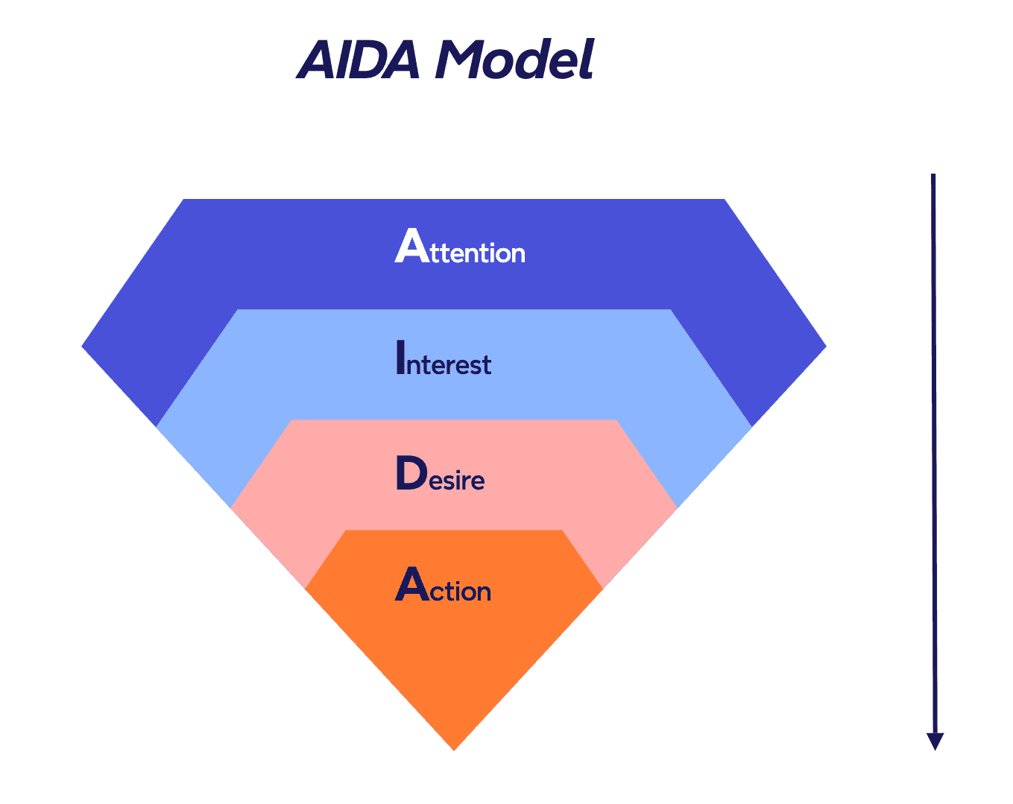
Figure 1: AIDA Model (Hassan et al., 2015)
There is a need to understand how consumers make decisions to purchase online using the concept of models that describe their course of action of telling when, why and how to purchase a product. AIDA model (Attention, Interest, Desire, Action) provides a chronological view of how shoppers go through a marketing funnel. Hassan et al. (2015) demonstrate the application of the AIDA in social media marketing, where customers get attention and guided content in each step. Although it is criticized as over-simplified, AIDA can still be used to plan campaigns and understand fundamental buying behavior.
Contemporary theories indicate that online travels are not linear. Lee and Han (2020) outline the Customer Decision Journey (CDJ), during which shoppers engage with the brands via numerous touchpoints and any sequence of it, in particular, when purchasing high-value products such as laptops or phones. The CDJ reveals that marketers should maintain consistent brand presence and provide harmonious experience throughout channels.

2.2.2 Marketing Attribution Theories
It is difficult to attribute marketing due to the many channels used by customers. Li and Kannan (2014) discovered that different models like the last click, first click models, the linear model, and the time decay models can produce highly divergent outcomes and have implications on how we prioritize our budget. It is stated that we require data driven approaches demonstrating the actual worth of every touchpoint.
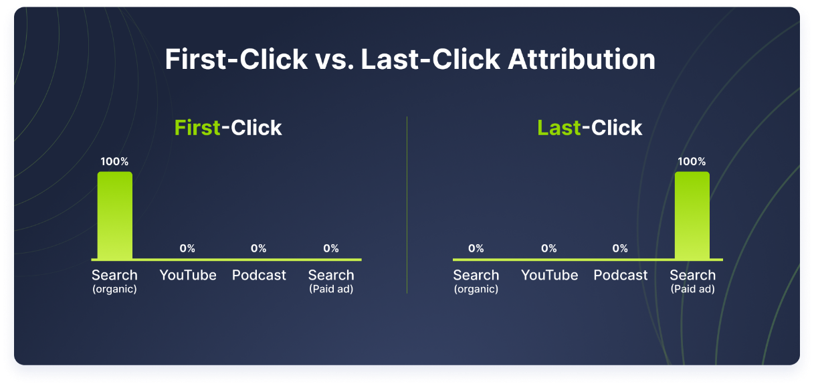
Figure 2: First-CLick vs. Last-Click Attribute
Shao and Li (2011) incorporated machine learning multi touch attribution models that rewards interactions with customers, which is based on actual conversion experience. It is particularly useful to those IT retailers who have a complicated campaign across numerous platforms.
Mrad and Hnich (2024) recently developed models of smart attribution with the help of negative observation propagation and Bayesian networks. Their model forecasts the improvements and indicates the additional contribution of each channel towards conversions so we can optimize budgets. They caution that such models often have to be readjusted when applied to different markets.

2.2.3 Digital Marketing Effectiveness Frameworks
It is crucial that marketing shows its effectiveness more than ever before since business organizations would like to know that their marketing dollar is not going down the drain. Hanssens and Pauwels (2016) discuss how marketing can be demonstrated to be valuable. According to them, it is important to associate marketing processes with business performance by quantifying them. They assert that the value of marketing should be represented and felt through the customer equity, company performance and shareholder value, which involves sophisticated analysis abilities.
Cook and Talluri (2004) examine the transformation of marketing through the focus on a Return on marketing Investment (ROMI). ROMI assists the marketers to estimate the level of monies that they will earn after the marketing funds are invested, thus they can pick the budget that takes their budget into consideration. However, according to the authors, the measurement of ROMI is difficult when dealing with brand building work, which can require time or diffuse impacts.

2.3 Online Marketing Channels and Mechanisms

2.3.1 Search Engine Marketing (SEM)
Search engine marketing involves the utilization of sponsored advertisements and regular search results to advertise a company. Sen (2005) investigated the use of this in the best way. He investigated how businesses ought to use money on Google advertisements and how they ought to get their own pages ranking high.
Paid advertisements appear immediately and can be aimed at individuals that are interested in what you are selling. They are most effective when individuals are in search of an item they wish to purchase such as a particular laptop or phone. Search marketing is effective since individuals are already seeking what they desire. By entering the product names they clearly express interest or desire to purchase and hence traffic they receive is more quality than random advertisements.

2.3.2 Social Media Marketing
Social media as a way to sell products can work but the effectiveness of the process significantly depends on the character of the product. Huang and colleagues (2020) examined 37 million users and 71 products in 25 categories in a large experiment. They discovered that products that provide a status enhancement such as fashion respond highly to social advertisement compared to products such as electricity appliances. This implies that in the case of IT stores, social media is most likely to be useful in establishing a brand and building awareness rather than encouraging people to make an immediate purchase, particularly in the case of practical technology items.
Lamberton and Stephen (2016) followed the development of digital marketing, social media marketing, and mobile marketing over the time span of 2000-2015. They indicated that user-generated content, influencer marketing and crossplay of mobile and social platforms became more prevalent. Social platforms became also not only a tool to talk to but also a place to shop, and there are also new functions like Instagram Shopping and Facebook Marketplace, which allow buying items directly.

2.3.3 Digital Marketing Integration and Strategy
According to Chaffey and others (2009), internet marketing is most effective when a few of these channels are utilized and each channel serves a different step taken by a customer. Chaffey and Smith (2022) further postulated that it should be important to plan, tweak, and assemble everything in complex online ecosystems.
According to Ryan (2020), digital marketing succeeds when it communicates interesting content, knows what the audience desires, and remains consistent across all platforms. According to Kumar and Reinartz (2018), it is also necessary to retain and create loyalty among a new customer and this cannot be achieved without good marketing. They imply that quick conversions are not the sole measure of the performance of a channel, but by the extent of the long term value they bring.

2.4 Moderating and Contextual Factors

2.4.1 Privacy Regulation and Tracking Limitations
Privacy regulation and technological restrictions on customer tracking are increasingly defining the nature of online marketing success. Goldfarb and Tucker (2011) examined the influences of these rules on online advertisements. They discovered that advertisements are less effective where there are regulations that prohibit companies to advertise depending on behavior. Their research indicates that advertisements involving the use of information about what an individual does perform significantly more effectively than generic advertisements. However, regulations such as GDPR in the UK have placed novel restrictions on data gathering volume and behavioral basis targeting.

2.4.2 Product Category and Market Context
The effectiveness of various marketing channels can vary quite differently by the nature of the product and the market environment. A big experiment provided by Huang and others (2020) demonstrated that product characteristics determine the most effective channels. Technological goods where people need to put in more consideration such as laptops and phones are likely to respond differently to marketing when compared to luxury goods and day-to-day purchases.
Table 1: Moderating Factors in Online Marketing Effectiveness
Factor Category | Specific Factors | Impact on Marketing Effectiveness | Key Source
Regulatory Environment | GDPR, privacy laws, tracking limitations | Reduces targeting precision; limits attribution capabilities | Goldfarb and Tucker (2011)
Product Characteristics | Involvement level, complexity, price point | High-involvement products require multi-touch journeys | Huang et al. (2020)
Consumer Journey Stage | Awareness, consideration, conversion | Different channels effective at different stages | Lee and Han (2020)
Attribution Model | Last-click, linear, data-driven | Model choice significantly affects perceived channel value | Li and Kannan (2014)
Channel Integration | Single vs. multi-channel approach | Integrated strategies outperform isolated channel efforts | Chaffey and Smith (2022)
Customer Lifetime Value | New vs. repeat customers | CLV perspective changes optimal acquisition cost | Ali and Shabn (2024)

2.5 UK Market Specifics
UK is a developed digital marketing economy with large investment and gross use of e-commerce. IAB UK (2025) indicates that in 2024 the digital advertising amounted to £35M billion in search, display, social media and video. E-commerce constitutes 28.7% of retail purchases (Statista, 2023), mobile purchases are nearly 60% of everything purchased online (Ofcom, 2024), and hence sites that are mobile-friendly are of significance.
The improvement of infrastructure, the implementation of 5G, smarter logistics, and changing the habits of consumers lead to the growth of the market (Mordor Intelligence, 2025). Regulations such as GDPR also influence the actions of marketers. Nonetheless, there is the problem of attribution, as the companies lose between 20,000 and 450,000 revenue due to failure in measurement (QueryClick, 2023).

2.6 Research Gaps and Justification for Current Study
Although a significant amount of research has been conducted on the effectiveness of digital marketing, a few misgivings remain. A majority of the research considers US markets or provides general recommendations that do not focus on a given market. The UK research especially in IT retail is meager. Secondly, the way each channel operates is known, but we do not often witness the overall comparisons of numerous channels regarding specific products. Third, the rules of privacy, alterations of platforms and the behavior of consumers go through a rapid transformation, thus even recent research may not be relevant to the current state of affairs.
Fecioru (2022) discusses the concept of digital transformation plans, saying that they cannot be successful without considering the organization and the market, but generic models. This concept enhances the necessity of the research that is suitable to the UK market, IT products, and contemporary digital marketing.

2.7 Conceptual Framework Development
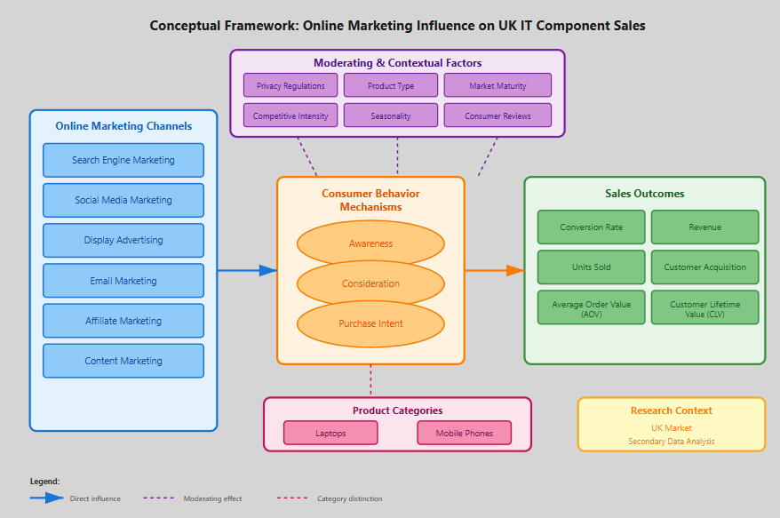
Figure 3: Conceptual Framework (Self Made)
Based on research articles we analyzed, we can draw a clear image that illustrates how online marketing techniques like search, social, display advertisements, emails, and affiliate links are associated with sales outputs such as conversions, revenue, and attract new customers. This connection is clarified by the way individuals get cognized of a product, deliberate on it and decide to purchase it, and varies in response to conditions related to convenience, product information, the level to which the market is mature, and the intensity of competitiveness. The framework is grounded on the established theory and real-life evidence and is the foundation of the investigation of the secondary data and the responses to the research questions in Chapter 1.

Chapter 3: Research Methodology

3.1 Introduction
This chapter describes the process involved in investigating the influence of online marketing on the sale of laptop and mobile phones in the UK. It explains the concepts of the study, design, data collection, data analysis and measures undertaken to ensure that results are correct and valid. The theory is designed to respond to research questions and achieve Chapter 1 objectives.

3.2 Research Philosophy and Design
This research is interpretivist-based, i.e., it views the issue of marketing effectiveness as an understanding that should be interpreted based on analysing the evidence in the particular UK market setting (Saunders et al., 2009). It acknowledges the fact that marketing is a social construction and that it relies on the circumstance, thus having information about the specifics of the UK retail IT environment is paramount. It follows an inductive approach where patterns and themes are drawn out of the data instead of applying set hypotheses (Creswell and Creswell, 2017). This flexibility is particularly useful in that the research is exploratory and that the available literature has little evidence specific to the UK.
The type of research design is exploratory-descriptive and primarily based on secondary desk research. This approach is suitable in situations that have not been thoroughly analysed to detect trends in the available information (Saunders et al., 2009). The paper uses the cross-sectional time frame with consideration given to the 2020-2025 horizon representing the current and emerging trends in digital marketing. The selection of the secondary research is explained by the practical considerations such as cost-effectiveness, time saving, and the availability of all-encompassing data on the level of the market that otherwise could not be obtained by other methods of primary gathering (Johnston, 2014).

3.3 Data Sources and Collection
This research relies on secondary data of numerous locations hence the research is comprehensive and verifiable. Peer-reviewed academic data is also sourced through marketing and business journals which provides a good foundation of theory and evidence. The market researches by Statista and Mordor Intelligence and IAB UK provide industry data containing the most recent market figures and benchmarks. The data provided by the government in the form of the ONS and Ofcom provide consistency that is reliable and informative, and trade magazines offer valuable and practical opinions.
The selection of data sources is strictly guided by selectivity criteria that emphasise relevance, reliability, current information and accessibility (Tranfield et al., 2003). All the sources considered are only those on UK online marketing, IT parts or theories related to them. Credibility is facilitated through the preference of peer-reviewed literature, popular research organisations, as well as government agencies. Recent information is given priority as a priority is made, by considering primarily material published in 2019 to 2025, but older significant pieces are accepted where necessary. The information is gathered by conducting systematic searches of databases using keywords: online marketing, UK e-commerce, IT retail, laptops and mobile phones. Once titles and abstracts that satisfy the requirements have been identified, a review of the full-text determines which sources are the ultimate ones that are utilised.

3.4 Data Analysis Methods
The study is comprehensive and verifiable as it relies on the data of numerous locations. We also refer to academic studies on marketing and business journals which have been peer-reviewed. The most recent industry figures and standards are provided according to research done by Statista, Mordor Intelligence, and IAB UK, respectively. Government statistics on the ONS and Ofcom are coherent, valid and helpful whereas trade magazines provide pragmatic opinions.
Our sources are selected based on relevance, credibility, current materials and accessibility (Tranfield et al., 2003). We simply read sources concerning UK online marketing, IT parts or similar theories. The credibility is achieved by relying on peer-reviewed articles, renowned research organisations, and government agencies. We favour more current, dating between 2019 and 2025, however, when necessary, we do apply older, important studies.
We collect data by searching databases using such keywords as online marketing, UK e-commerce, IT retail, laptops, and mobile phones. We read all the articles when we have titles and abstracts that fit our needs and then we determine which sources to utilise.

3.5 Quality, Ethics, and Limitations
Quality and rigour are maintained with reliable sources provided by universities, business, and government articles and receive supervisory reviews like peer review (Shenton, 2004). Certainty is ensured with supporting all claims with evidence being cited and reliability is improved by maintaining detailed records and a clear trail of audit and not to mention separating data and interpretation.
The ethical issues are highly negligible as there is a utilisation of only publicly accessible secondary data, and thus there is no requirement of consent. Any academic honesty is observed with references and all data is securely maintained, on password-cracking devices with regular back ups.
This approach has its limitations: it relies on the quality of published materials, it has no means of regulating the way original data was collected, and it can only be applied in the UK market, online, mobile phone, and laptop utilisation. Being a descriptive secondary analysis, it cannot show cause and effect. Nevertheless, it provides a good basis to support the purpose of research.

Chapter 4: Data Analysis and Findings

4.1 UK E-commerce and Digital Marketing Landscape
Addressing Objective 1: Understanding the Context for Consumer Decision-Making
UK ranks among the most favourable online shopping locations worldwide. Statista (2023) indicates that online sales were approximately 28.7 percent of all retail sales in 2024 and it predicts that online sales will surpass 30 percent in 2025. It implies that lots of individuals shop online and the online adverts have become an important aspect of the way the shoppers purchase. According to the ONS (2024), online shopping has continued to increase, particularly due to the increasing number of individuals purchasing technological products online.
Most shopping choices are now dominated by purchasing via phones. According to Ofcom (2024), 60 percent of online purchases are made through phones, since the ads, web pages, and the process of entering a checkout has to be phone-friendly. Due to this, the digital ad spending increased. According to IAB UK (2025), digital ad expenditure is projected to be at £35 billion in 2024. Nevertheless, eMarketer (2024) notes that companies desire to have a more definite indication that advertisements are good investments.
Table 4.1: UK Digital Commerce Growth Indicators (2020-2025)
Indicator | 2020 | 2024 | 2025 (Projected) | Source
E-commerce % of Total Retail | 26.5% | 28.7% | >30% | Statista (2023)
Digital Ad Spend (£bn) | £27.2 | £35.0 | £37.5 | IAB UK (2025)
Mobile % of E-commerce | 52% | 60% | 63% | Ofcom (2024)

According to the projections by Mordor intelligence (2025), UK e-commerce market will continue to expand due to the enhancement of digital infrastructure such as 5G, shifting shopping trends, and improved logistics. Such developments allow online marketing to convince individuals to purchase IT components.

4.2 Online Marketing Channel Effectiveness
Addressing Objective 2: Analyzing Platform Contribution to IT Sales

4.2.1 Search Engine Marketing Effectiveness
Search engine marketing (SEM), that consists of paid search and search engine optimization (SEO), is effective in selling IT components. The key advantage of it according to Sen (2005) is that it targets the people who are prepared to make purchases. When individuals seek the specifications of laptops, phone information, or rivals, they demonstrate genuine desire to purchase. That is better than the ads which people simply view and makes search traffic more valuable.
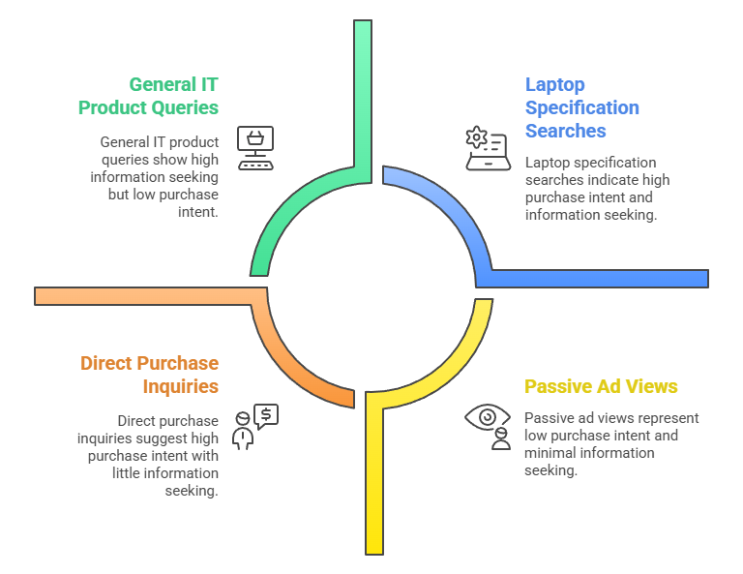
Figure 1: SEM Effectiveness in IT Component Sales (Li and Kannan, 2014)
SEM is further ideal with IT products since customers seek numerous amounts of information first before they make a purchase. Laptops include a lot of technical specifications and thus the search queries are specific and allow advertising to be highly focused. Li and Kannan (2014) discovered that individuals consult search numerous times when making decisions on what to purchase. It implies that SEM is effective not only in terms of sales but also it maintains an awareness of a product a buyer keeps in his/her head.

4.2.2 Social Media Marketing Role
Social media assists with selling IT parts, yet on a less obvious scale compared to search marketing. In a large-scale experiment by Huang and colleagues (2020) of 37 million users and 71 products in 25 categories, they discovered that social ads do not work equally with all goods. Social ads can significantly boost status goods like fashion products, whereas poorly direct sales effects occur with goods like electrical appliances which resemble IT components. The most useful feature of social media to the IT sellers, then, is building awareness and making the customer think about purchasing, but not directly selling.
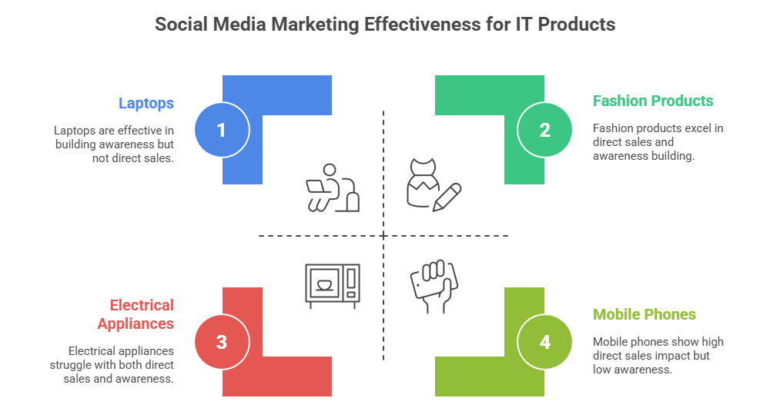
Figure 2: Social Media Marketing Effectiveness for IT Products (Lamberton and Stephen, 2016)
Lamberton and Stephen (2016) followed and studied the evolution of social media marketing. The patterns that they outlined include influencer collaborations, user-created content, and mobile and social convergence. In the case of ordinary technological products such as laptops and mobile phones, the social media should be applied in conjunction with other marketing pipelines, rather than independently to push sales. They analyse that social media are more effective when it comes to IT products: phones are more responsive than laptops due to the higher aspirational numbers of phones.

4.2.3 Integrated Channel Performance
Table 4.2: Marketing Channel Effectiveness by Customer Journey Stage
Marketing Channel | Awareness | Consideration | Conversion | Primary Evidence
Search (Paid & Organic) | Medium | High | Very High | Sen (2005); Li and Kannan (2014)
Social Media | High | High | Medium | Huang et al. (2020); Lamberton and Stephen (2016)
Display/Retargeting | High | Medium | Medium-High | Li and Kannan (2014)
Email Marketing | Low | High | High | Chaffey and Smith (2022)

This table demonstrates the behaviour of various marketing channels at each step in the range of customer journeys. The most effective searches are made when individuals are deliberating and making purchases since it focuses on individuals who have a definite purpose. Awareness can be created most effectively using social media, but it is the weaker option when it comes to converting people directly. People who are already engaged are most effective in email marketing.
According to Chaffey and Smith (2022), the way a channel works relies heavily on how it is integrated and coordinated with other channels. The most effective model applies search marketing to take away high-intent demand, social media to generate awareness, and email to maintain interest and facilitate conversion.

4.3 Attribution Complexity and Measurement Challenges
Addressing Objective 3: Understanding Engagement-Conversion Relationships
The primary lesson is the difficulty of proving what channel of marketing led to a sale. According to QueryClick (2023), in the UK stores, a revenue gap of between 20,000 and 450,000 was not detected due to the difficulty in following shoppers on other devices and channels. Due to such uncertainty, retailers struggle to understand how engagement translates into sales.

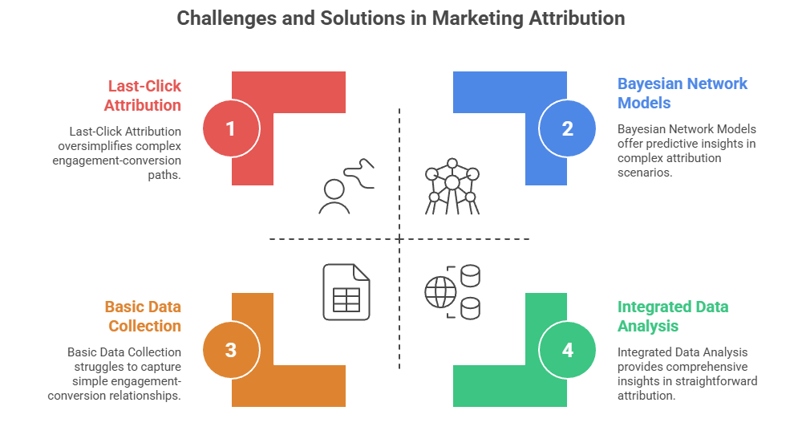
Figure 3: Challenges and Solutions in Marketing Attribution (Li and Kannan, 2014)
Li and Kannan (2014) found that four attribution models such as last click, first click, linear and time-decay assign quite different scores on the effectiveness of marketing channels. The last-click model is particularly detrimental to such upper-funnel activities as social media and content, with an excessively generous reward to search that largely presents already-buy-intent people.
The Bayesian network models employed by Mrad and Hnich (2024) are predictive and they introduced a method known as the negative observation propagation to estimate the additional influence of every channel. They alert that these models need to be re-oriented to new markets.
Wedel and Kannan (2016) discuss what marketing analytics would demand in data-heavy locations. They indicate that good measurement requires beyond fancy models; the companies must also collect, aggregate, and analyse data at all sources. A large number of retailers in the UK possess weak measurement tools. This prevents them using sophisticated attribution tactics and not really understanding how engagement can result in sales.

4.4 Consumer Behavior and Decision Journey Patterns
Addressing Objective 1: Understanding Marketing Impact on Purchase Decision-Making

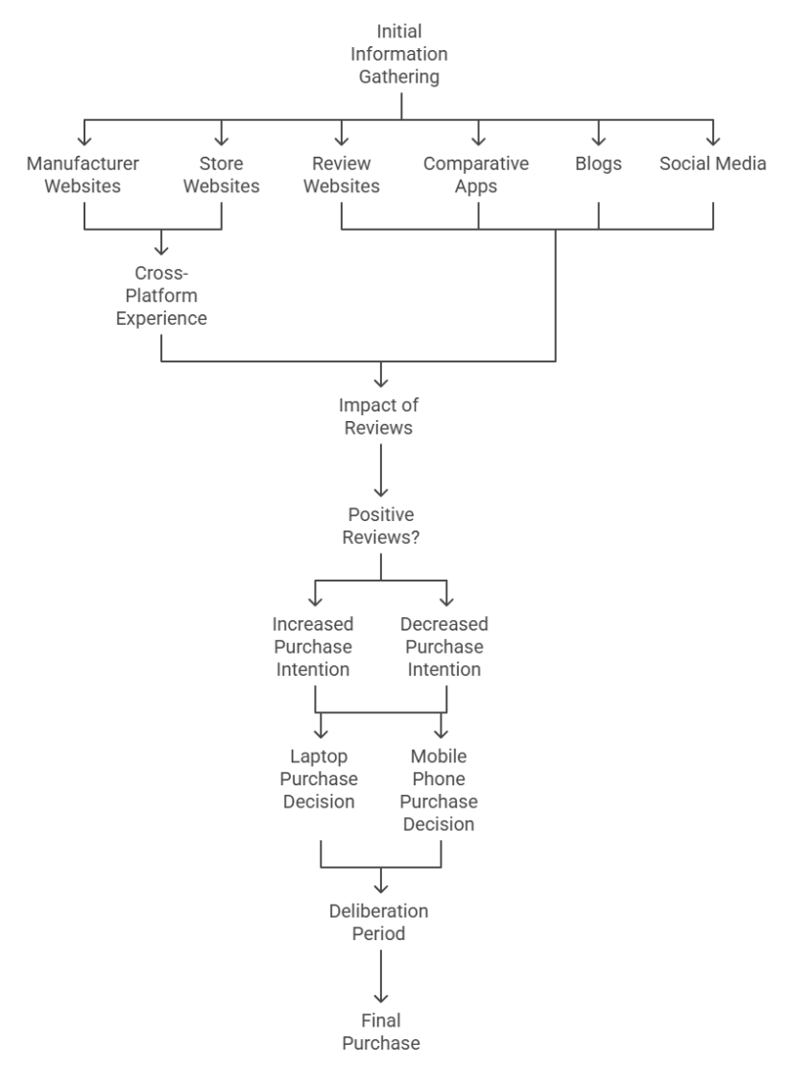
Figure 4: Marketing Impact on IT Component Purchase Decision-Making
Understanding the manner in which individuals purchase IT components is important in evaluating the impact of online marketing. Lemon and Verhoeff (2016) observed that the buying paths are not linear; they comprise numerous touchpoints, loops, and stops as the shoppers gather information and develop confidence.
Purchasing IT components typically involves lengthy investigations on manufacturer websites and store websites, review websites, comparative apps, blogs, and social media. According to Ofcom (2024), a greater number of people use mobiles to search, although they may eventually make the purchase on a computer or in a store, which makes the experience cross-platform.
Eye-tracking was utilised by Chen et al. (2022), who found that negative review drawing much attention and the presence of either positive or negative reviews significantly affects purchase intention. In the case of IT products that its performance is difficult to calculate, reviews reduce the risk and make market even more efficient, specially in the case of positive and authentic reviews.
The consumers purchase trends of laptops and mobile phones are different. Laptops are more expensive, less frequently changed, and require scrutiny of specifications, and therefore shoppers deliberate over 2-4 weeks. Mobile phone decisions are faster (1 3 weeks), individuals remain brand conscious and are more influenced by social and aspirational aspects thus increased relevance of social media and influencers.

4.5 Moderating Factors and Strategic Recommendations
Addressing Objective 4: Developing Strategies to Enhance Marketing Effectiveness
There are numerous factors that influence online marketing. The use of behavioural targeting is restricted by strict privacy rules, in particular GDPR, in the UK. According to Goldfarb and Tucker (2011), such rules render advertising less effective and advertisements that are aimed at particular behaviours are more effective compared to generic advertisements. It is difficult to measure and optimise campaigns because of these restrictions.
Results are also determined by seasonal events. The opportunity to earn bigger profits on the holiday season, back-to-school, and launching of big products push the competition further and demand higher ad costs, particularly in paid search. The prices are more evident to the comparison websites and the brands have to shine
The initial suggestion is that retailers should put a focus on search engine marketing. It influences significantly individuals who consider and purchase products, and its outcomes are easily quantifiable, which correlates with Hanssens and Pauwels’ (2016) call to demonstrate the value of marketing. Include search in other awareness communication mediums, such as social media.

The second guideline is that the marketing must be product specific. In the market of laptops, let go of gadgets and concentrate on the technicalities and comparison. In the case of mobile phones, consider more brand appeal, social proof, and influencers.
The third suggestion is to ensure that companies do a better job of tracking what ads bring customers. Put the last-click rule behind us, and consider something like time-decay: It represents the contribution of early marketing touchpoints and it allows us to make smarter budget decisions.
The last suggestion indicates the significance of customer lifetime value. Ali and Shabn (2024) discovered that in bargaining retailers of IT products, with items that customers change over a long life, channel selection ensuring a customer with more life-time value can justify high initial costs, even when the initial month payoff is less.

Chapter 5: Conclusions and Recommendations

5.1 Introduction
This concluding chapter presents the key findings of the research on the influence of online marketing as a sales driver of IT components in the UK. It presents the key findings, indicates that the research objectives were achieved, also provides recommendations to help IT retailers in the UK, discusses what the research contributes to existing knowledge, addresses the limitations of study, and suggests future research directions.

5.2 Summary of Key Findings
Studies indicate that online marketing has a significant influence on the sales of IT parts in UK. It operates in various manners during every stage of purchasing. The most effective attempt to make people purchase at that moment is through search engine marketing, particularly in laptops where individuals seek specific technical specifications. Social media attracts attention to the people and makes them consider purchasing it, but it is less successful at converting people into buying the tech products themselves. Email marketing is highly effective in retaining existing customers and making them repurchase.
In the UK, two out of every five people make purchases over the internet, 60 per cent use their phone, and companies spend £35 billion annually on online advertising. This produces opportunities, and also problems. Retailers lose between 20,000 to 450,000 at any given time simply because they cannot measure well, given that it is difficult to know where money comes in. GDPR does not allow us to trace individuals and strike them, making advertising less specific.
Laptops require more preliminary investigation, technical contrast, and searching and content. There is a high brand loyalty, faster decision-making, and social media and aspirational posts respond well to mobile phones.

5.3 Achievement of Research Objectives
The study achieved its four objectives. It began by examining the impact online marketing has on shoppers in the UK in the stages of awareness, consideration, and purchase where it was established that marketing influences the way consumers search information, contemplation, and decision to purchase.
It researched the online market that offers the highest selling IT parts. It discovered that search marketing works best in getting people to purchase, whereas social media works best in creating awareness.
It discussed the ways of engagement resulting in sales. The analysis revealed that determining which marketing touches led to a sale is quite complex and requires more intelligent approaches than merely examining the final touch.
5.4 Recommendations for UK IT Retailers
- Prioritize Search Marketing: Invest heavily on paid and free search. Advertise on technical inquiries on laptops and specific brand or model inquiries on phones.
- Use Category-Specific Tactics: In the case of laptops, consider detailed specifications, comparator tools and specification based campaigns.
In the case of phones, include technical information, lifestyle content, social media and influencers.
- Optimize for Mobile: With 60% of purchases on mobile, ensure mobile-first creatives, fast pages, smooth checkout, and mobile payment options.
- Improve Attribution: Go beyond last- click attribution to time-decay or last-non-direct models; larger retailers ought to think of data-driven attribution and marketing mix modelling.
- Manage Reviews Strategically: Request reviews, respond to negative reviews, display reviews on the web, and improve by comments.
- Adopt CLV Focus: Concentrate on the value of every customer in the long run and be prepared to pay more to receive repeaters.

5.5 Contribution to Knowledge and Limitations
This study has provided UK specific findings regarding the effectiveness of digital marketing within the poorly researched IT retail industry. It demonstrates that privacy regulations and mobile-first patterns introduce unique situations which require changes in marketing theories. This research also enables us to learn how the various classes of products are different in the IT components.
Nonetheless, there are certain limitations to the research. It is based on the available data, therefore, we cannot dig deeper or examine the way the original data were gathered. Revolving attention on the UK alone implies that the results may not be relevant in other locations where there are dissimilar regulations or consumer behaviour. The research focuses on a single timeframe, 2020- 2025, and does not illustrate how changes have occurred over a long period. It is not possible to demonstrate cause-and-effect because it employs secondary data.

5.6 Future Research Directions
Further research must gather new information through either surveys or experiments to test findings of available data. With the continued change of technology and rules, long-term studies might be based on how marketing success evolves. The comparison of various markets would assist us to comprehend the factors at a local level. Exploring new features such as voice search, augmented reality, and social shopping would provide valuable perspective in the future.

References
Ali, N., & Shabn, O. S. (2024). Customer lifetime value (CLV) insights for strategic marketing success and its impact on organizational financial performance. Cogent Business & Management, 11(1), 2361321.
Bowen, G. A. (2009). Document analysis as a qualitative research method. Qualitative research journal, 9(2), 27-40.
Braun, V., & Clarke, V. (2006). Using thematic analysis in psychology. Qualitative research in psychology, 3(2), 77-101.
Chaffey, D., & Smith, P. R. (2022). Digital marketing excellence: planning, optimizing and integrating online marketing. Routledge.
Chaffey, D., Ellis-Chadwick, F., & Mayer, R. (2009) Internet marketing: strategy, implementation and practice. Pearson education.
Chen, T., Samaranayake, P., Cen, X., Qi, M., & Lan, Y. C. (2022). The impact of online reviews on consumers’ purchasing decisions: Evidence from an eye-tracking study. Frontiers in Psychology, 13, 865702.
Cook, W. A., & Talluri, V. S. (2004). How the pursuit of ROMI is changing marketing management. Journal of Advertising Research, 44(3), 244-254.
Creswell, J. W., & Creswell, J. D. (2017). Research design: Qualitative, quantitative, and mixed methods approaches. Sage publications.
eMarketer (2024). "UK Digital Ad Spending 2024." Available at: https://www.emarketer.com/content/uk-digital-ad-spending-2024 (Access Date: 5 November, 2025)
Fecioru, C. O. (2022). Digital transformation and interventional models–McKinsey digital transformation frameworks vs. Center for Creative Leadership Direction-Alignment-Commitment approach. An initial review. Manager, (35), 16-24.
Ghirvu, A. I. (2013). The AIDA model for advergames. The USV Annals of Economics and Public Administration, 13(1 (17)), 90-98.
Goldfarb, A., & Tucker, C. E. (2011). Privacy regulation and online advertising. Management science, 57(1), 57-71.
Hanssens, D. M., & Pauwels, K. H. (2016). Demonstrating the value of marketing. Journal of marketing, 80(6), 173-190.
Hassan, S., Nadzim, S. Z. A., & Shiratuddin, N. (2015). Strategic use of social media for small business based on the AIDA model. Procedia-Social and Behavioral Sciences, 172, 262-269.
Huang, S., Aral, S., Hu, Y. J., & Brynjolfsson, E. (2020). Social advertising effectiveness across products: A large-scale field experiment. Marketing Science, 39(6), 1142-1165.
IAB UK (2025) "Digital Adspend 2024: UK's Overall Digital Ad Market Hits £35 Billion." Available at: https://www.iabuk.com/news-article/digital-adspend-2024-uks-overall-digital-ad-market-hits-ps355bn (Access Date: 5 November, 2025)
Johnston, M. P. (2014). Secondary data analysis: A method of which the time has come. Qualitative and quantitative methods in libraries, 3(3), 619-626.
Kannan, P. K. (2017) Digital marketing: A framework, review and research agenda. International journal of research in marketing, 34(1), 22-45.
Kumar, V., & Reinartz, W. (2018). Customer relationship management.
Kwan, I. S., Fong, J., & Wong, H. K. (2005). An e-customer behavior model with online analytical mining for internet marketing planning. Decision Support Systems, 41(1), 189-204.
Lamberton, C., & Stephen, A. T. (2016). A thematic exploration of digital, social media, and mobile marketing: Research evolution from 2000 to 2015 and an agenda for future inquiry. Journal of marketing, 80(6), 146-172.
Lemon, K. N., & Verhoef, P. C. (2016) Understanding customer experience throughout the customer journey. Journal of marketing, 80(6), 69-96.
Li, H., & Kannan, P. K. (2014). Attributing conversions in a multichannel online marketing environment: An empirical model and a field experiment. Journal of marketing research, 51(1), 40-56.
mi Lee, S., & man Han, S. (2020). How Can Customer Experience on CDJ Be Shaped?: Can Rose Be Tamed?. Asia Marketing Journal, 22(3), 5.
Mordor Intelligence (2025) "United Kingdom E-commerce Market - Size & Growth Analysis Report 2025." Available at: https://www.mordorintelligence.com/industry-reports/united-kingdom-ecommerce-market (Access Date: 5 November, 2025)
Mrad, A. B., & Hnich, B. (2024) Intelligent attribution modeling for enhanced digital marketing performance. Intelligent Systems with Applications, 21, 200337.
Nowell, L. S., Norris, J. M., White, D. E., & Moules, N. J. (2017). Thematic analysis: Striving to meet the trustworthiness criteria. International journal of qualitative methods, 16(1), 1609406917733847.
Ofcom (2024) "Online Nation 2024 Report." Available at: https://www.ofcom.org.uk/research-and-data/online-research/online-nation (Access Date: 5 November, 2025)
Office for National Statistics (ONS) (2024). "Retail Sales, Great Britain: Statistical Bulletins." Available at: https://www.ons.gov.uk/businessindustryandtrade/retailindustry/bulletins/retailsales/latest (Access Date: 5 November, 2025)
Pandey, S., Gupta, S., & Chhajed, S. (2021). Marketing Mix Modeling (MMM)-Concepts and Model Interpretation. marketing, 1009, 2.
QueryClick (2023) "Exploring the Benefits of Attribution in UK Retail." Available at: https://www.queryclick.com/blog/benefits-of-attribution-retail/ (Access Date: 5 November, 2025)
Ryan, D. (2020). Understanding digital marketing: A complete guide to engaging customers and implementing successful digital campaigns. Kogan Page Publishers.
Saunders, M., Lewis, P., & Thornhill, A. (2009) Research methods for business students. Pearson education.
Sen, R. (2005). Optimal search engine marketing strategy. International Journal of Electronic Commerce, 10(1), 9-25.
Sen, R. (2005). Optimal search engine marketing strategy. International Journal of Electronic Commerce, 10(1), 9-25.
Shao, X., & Li, L. (2011, August). Data-driven multi-touch attribution models. In Proceedings of the 17th ACM SIGKDD international conference on Knowledge discovery and data mining (pp. 258-264).
Shenton, A. K. (2004). Strategies for ensuring trustworthiness in qualitative research projects. Education for information, 22(2), 63-75.
Statista (2023) "E-commerce Share of Retail Sales in the United Kingdom (UK) from 2015 to 2025." Available at: https://www.statista.com/statistics/285978/e-commerce-share-of-retail-sales-in-the-united-kingdom-uk/ (Access Date: 5 November, 2025)
Tranfield, D., Denyer, D., & Smart, P. (2003). Towards a methodology for developing evidence‐informed management knowledge by means of systematic review. British journal of management, 14(3), 207-222.
Verhoef, P. C., Kannan, P. K., & Inman, J. J. (2015) From multi-channel retailing to omni-channel retailing: introduction to the special issue on multi-channel retailing. Journal of retailing, 91(2), 174-181.
Wedel, M., & Kannan, P. K. (2016). Marketing analytics for data-rich environments. Journal of marketing, 80(6), 97-121.

Appendix
- Value sales, three-monthly and monthly percentage change, seasonally adjusted, Great Britain, September 2025 (Source: ONS, 2024)

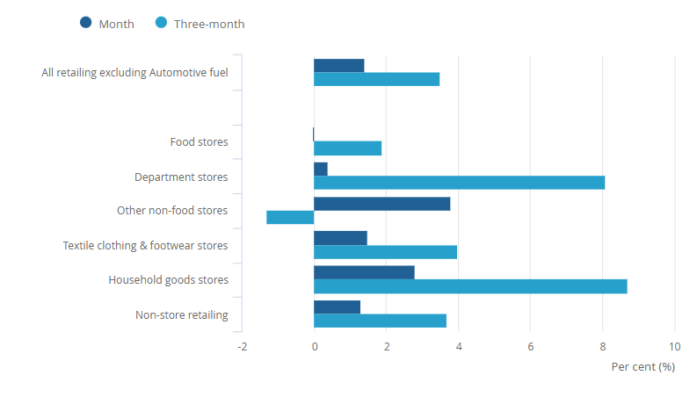

- Rolling three-month and monthly index for the quantity bought in all retailing, seasonally adjusted, Great Britain, September 2022 to September 2025 (Source: ONS, 2024)
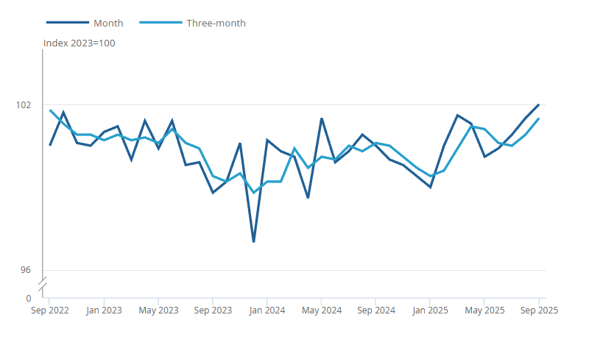
- UK E-commerce Market Size and Share (Source: Mordor Intelligence, 2025)
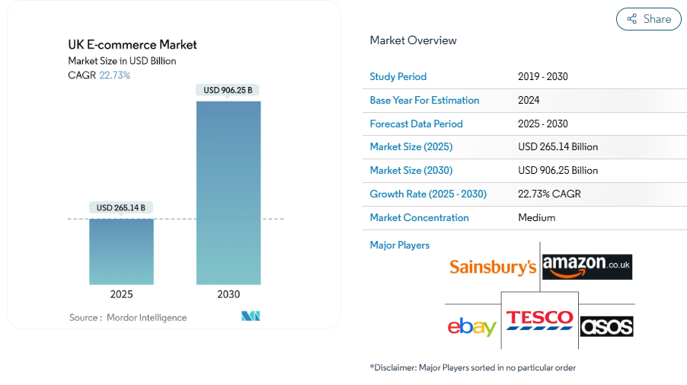

- UK E-commerce Industry Leaders (Source: Mordor Intelligence, 2025)


