2500 illustrated glossary
What, who developed it/uses it, where, when, how it’s applied
Anthropocentric is a term in which people regard humankind as the most important part of their existence or life, which is usually opposed to God or to the natural world. The view that we can gain from this helps us to interpret the world in terms of human values, experiences and what is deemed important. Other scholars of Anthropocentrism say that there could be another way to view it, and that is to acknowledge that the world has to be made continually stable for people and other entities.

Archaeological refers to the scientific study of material remains, which usually relates back to archaeology as its main discipline, which could include pottery and monuments as other objects of study. It can refer to things relating to the archaeological field and the study of the remains of older cultures and civilisations. The first idea of archaeology was coined by an Italian Renaissance humanist historian called Flavio Biondo, who created a system through which he could log and record ruins and topology of Rome in the early 15th century.

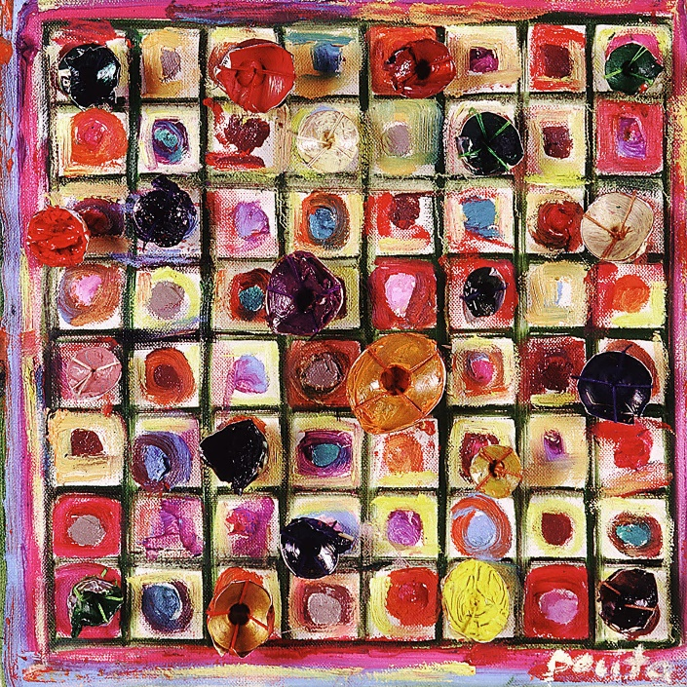
Agency is the action in which something creates a particular effect when interacting with something else. One example of agency is running water creating canals or rivers which run through countries and cities. This term can be traced back to the earliest use, which was a treatise on alchemy in 1471 where the term “agent” was used to indicate “a force capable of acting on matter”. It could be argued that an agent is not specifically an object with agency or a person putting their own agency into that object, it instead could be seen as something similar to a plant which have agency in their own specific way.
Life is a series of doors by Pacita Abad (Fig 1)
Assemblage is the act of collecting together a group of things, people or objects in one place. This could be done to create a piece of artwork by using lots of unrelated objects to create a picture by fitting them together. This can help to give an object a new meaning or help to create something new, therefore remaking the image of the object, either together or separately. This term was first brought about by artists who were experimenting with different forms of media in the early twentieth century, and artist Jean Dubuffet first used the term in the early 1950s. It helped to make the way for other types of artwork and media, for example Pop Art and Installation Art.

Agential Realism is based on the notion of Agency, meaning that an object could have purpose, and gives importance to nonhumans, including objects. This idea was proposed by Karan Barad, who said that it was a theory in which the universe collects phenomena which cannot be separated by acting together as one object. Similarly to something having an “agency”, this idea is adapted into the “realism” of something. Barad writes this as something having agency and a relationship with whatever it is interacting with and not just something that it “has” by default, possibly making the object need to gain that interaction and meaning by having a life through being used by us as people.

The Actor Network Theory is a social theory in which people’s social relationships are seen as constantly shifting and therefore may mean that nothing exists outside of this association. This means that everything we encounter as people is a step in getting us to interact with each other socially. This includes things such as “non-human actors”, which could mean something like things, objects and the natural world itself. The term was coined in the 1980s by scholars who worked in different fields, including science and sociology.

An Actant is something that plays a role in a narrative, usually used as part of a literary theory. It is commonly “something that acts or to which activity is granted by others” . Algirdas Julien Greimas was the first to be known to use this term and is credited for creating the actantial model in 1966 . An actant can also be described as something similar to a narrative foil, for example a hero and a villain or a sword and a shield. Other scholars, such as Julia Kristeva in 1969, have attempted to explain this, and understood that the pairings sometimes overlap which creates a “transformation” in the dynamics which we understand.

Body Boundaries are something which were seen as the baseline for a lot of social interaction, which then build upon the idea of the body itself and people, which take people as the basis for social individuation. This was discussed by the French philosopher Michel Foucault as he and other scholars speak about how the body and other organisms, through interactions, regard themselves as “selves”. Foucault describes the body as being within a kind of field that has true power over it at all times, and can therefore command whatever it needs to, which can be determined by the person or persons in charge; for example, the brain can command the body and the human whose body it is can change that command or agree with it.

Dasein is a term adopted from the German word Dasein which means “existence”, and is a technical term which was used in the philosophy of Martin Heidegger, who used the word to refer to that particular mode of being within human beings. For Heidegger, the term Dasein meant to “be involved in the immediate world around yourself, whilst always being aware of involvement of the world to the self, and of the evolving nature of the self” . Dasein can also mean to “confront” a word or something which is not understood, which can be done in order to find out the meaning or to understand it by your own means.

An Entity is a thing with an independent or distinct life or existence. One example of an entity could be somebody’s bag, or their pencil case inside of that bag. The term was coined by Caesar to be a present participle for esse, meaning “be”. Another meaning was the Greek philosophical term for “that which is”, which is similar to our current definition of the word which could be simply “a thing” or “something”.

Etymology is a branch of linguistics focused on languages and the process of finding out the meaning of where a word comes from and its origins. This can be done by tracing its usage through time and when it was most widely used. This term is derived from the ancient Greek meaning “true”, “true sense” or “sense of a truth”. For languages that have a long history or have a lot of words altogether, people have used texts with knowledge about that particular language in them in order to help them gain an understanding of how the words developed in meaning and in form, including how they were able to enter the language and gain their current meaning.

Enchainment relates to linking parts of objects which are deliberately broken or split to create relations between people and to make two parties connected by sharing the two halves in order to prove the identity of the other. An example of enchainment in the past could have been something like a necklace split between a husband and a wife, therefore resulting in one part being buried with each member of the household as a sign of their connection both in life and in death. We can take this example from the past and apply it to the present, as people have necklaces just like this and have possibly also split it between themselves and a loved one which still tells us that people have and require that connection between themselves.

New Materialism is a theory that considers everything, even if it is immaterial, biological or social to be interconnected and all be working together rather than everything being separate and working apart from each other. This term was coined during the late 1990’s by Manuel DeLanda and Rosi Braidotti. It seems to oppose the humanist and transcendental ideas that have already existed before, and it stands between the modernist and post-modernist ideas, which seems to blur the lines between them even today.

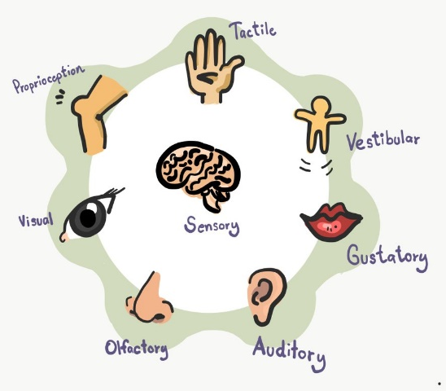
The senses of the human body (Fig 2)
Sensory is a term relating to the sensations of the human body, such as touch and smell, which are transmitted and perceived by these senses. An example of a sensory experience is listening to music, or touching a bumpy surface. This term originally came from the Old French for sens, meaning “one of the five senses” and the Latin sensus meaning “perception, feeling, undertaking, meaning” . Sensory feelings can be perceived in many ways by the human body (see Fig 2), including possibly through dreams and actions that are done to invoke a reaction from the receiver of the actions.

Ontology is a branch of metaphysics which deals with the nature of being and the study of existence. The term Ontology was coined in 1606 by German philosopher Jacob Lorhard , and entered the general usage after it was used in a wider sphere by another German philosopher, Christian Wolff in 1730. The etymology of the word “ontology” dates back to ancient Greek words like ontos, meaning “being” and logia, which means “study of” or “the study of being”.

The Fragmentation Theory is a theory relating to the state in which the ancient world is studied and looked at through a modern lens. It can be done through looking at objects such as statues, which can suffer from fragmentation and therefore tell us more about how the object itself was moved about or cut from its original place. This was developed by Chapman in 2000 in his book, Fragmentation in Archeology . Chapman discusses through his book that some cases of objects being broken, distributed and fragmented may not be an accident and therefore deliberately done for a reason. This could be called something similar to object disposition, wherein the object is broken and split apart from its other fragments and therefore is clearly not an accidental occurrence. We can also learn about past cultures from pieces that were kept in tombs, for example something buried with the deceased that is half of a whole object and therefore being only half of something that is buried somewhere else, which may help to identify why they were buried with these specific people and if they suggested any importance to the deceased.

An Object Biography refers to the ways in which an object can be studied to include its life and history. This is mostly done through examining its production and its exchanges, and the meanings we can get from this. Having an object biography makes it possible to combine different events from the object’s life and turn it into a narrative, therefore composing a conceivable “life” for an item, which could possibly include different owners and places the object has been during its “lifetime”. This may stretch to include the object and when it “died”, which archaeologists may be able to determine from other factors. The term “object biography” was coined in 1929 by a Russian writer called Sergei Tretyakov, but the term was not popularised until 1986 when Igor Kopytoff brought it into the public eye. Kopytoff discussed object biographies in the context of referring to things that we can bring the “life history” from and look at how this could have affected the production and the objects life as a whole from that perspective.

A Network is something that helps us see the connections between societies, both ancient and modern. This can be used to identify trade routes and social interactions that possibly helped to map the civilisation which formed part of the network. The earliest known use of the term network was during the mid 1500s, and has later been used to refer to a system or group of things that are interconnected or have connections to each other which can be used to pass information back and forth over in order to have many different links between them. An example of a network could be a herd of animals or a group of people, as both of these networks are able to communicate within one another and therefore have an interpersonal link which is used to pass information.

The Material Engagement Theory is a theory that focuses on how things that pass through the human mind become implanted in and therefore become mutually dependant on things beyond their control. This theory was coined by Lambros Malafouris and he developed an approach to it, and gave it three central pillars which it works through. These pillars are described as “new means for precisely studying the complex nature of human cognition”.

Metaplasticity is a term coined by Lambros Malafouris and is a term relating to the way the human mind works and calculates ideas. As well as the human mind, the term itself reflects humanity’s way of constantly adopting and transitioning between ideals, identities and traditions throughout many ages and still keep the same ideas between each way of celebrating these things.

Inalienable Possessions was a term discussed and coined by French sociologist Marcel Mauss in his 1925 essay The Gift: Forms and Functions of Exchange in Archaic Societies. Mauss describes inalienable possessions as “pieces of property that a family divests itself of with great reluctance and sometimes never.” Mauss discussed in his essay the idea of “potlaches”, which was some sort of a gift-giving festival or feast done in the Pacific Northwest within some indigenous peoples, which Mauss describes as loans rather than a gift or the people truly giving away their possessions forever.

Bibliography
Rouse, J. (2004). Barad's Feminist Naturalism. Hypatia 19(1), 142-161. https://muse.jhu.edu/article/53926.
Greimas (1973) "Actants, Actors, and Figures." On Meaning: Selected Writings in Semiotic Theory. Trans. Paul J. Perron and Frank H, Collins. Theory and History of Literature, 38. Minneapolis: U of Minnesota P, 1987. 106-120.
Venancio, Rafael Duarte Oliveira, Narrative between Action and Transformation: A. J. Greimas' Narratological Models (December 3, 2016). Available at SSRN: https://ssrn.com/abstract=2879907
Foucault, M. (1976). The birth of the clinic: An archaeology of medical perception. London: Tavistock.
J. Childers/G. Hentzi eds., The Columbia Dictionary of Modern Literary and Cultural Criticism (1995) p. 70
Berto, Francesco; Plebani, Matteo (2015). Ontology and Metaontology: A Contemporary Guide. Bloomsbury Publishing. ISBN 978-1-4725-7330-8. Archived from the original on 30 August
Chapman, J. (2000). Fragmentation in Archaeology: People, Places and Broken Objects in the Prehistory of South Eastern Europe (1st ed.). Routledge. https://doi.org/10.4324/9780203759431
Appadurai, A. (ed.) (1986) The Social Life of Things: Commodities in Cultural Perspective. Cambridge: Cambridge University Press.
Malafouris, Lambros (2013). How Things Shape the Mind: A Theory of Material Engagement. Cambridge, MA: MIT Press. ISBN 978-0262019194.
Marcel, M; 1925, The Gift: Forms and Functions of Exchange in Archaic Societies

https://www.britannica.com/biography/Flavio-Biondo
https://plato.stanford.edu/entries/agency/notes.html#note-1
https://www.nationalgalleries.org/art-and-artists/glossary-terms/assemblage
Rouse, J. (2004). Barad's Feminist Naturalism. Hypatia 19(1), 142-161. https://muse.jhu.edu/article/53926.
https://oxfordre.com/literature/display/10.1093/acrefore/9780190201098.001.0001/acrefore-9780190201098-e-965
http://www.bruno-latour.fr/sites/default/files/P-67%20ACTOR-NETWORK.pdf
Greimas (1973) "Actants, Actors, and Figures." On Meaning: Selected Writings in Semiotic Theory. Trans. Paul J. Perron and Frank H, Collins. Theory and History of Literature, 38. Minneapolis: U of Minnesota P, 1987. 106-120.
Venancio, Rafael Duarte Oliveira, Narrative between Action and Transformation: A. J. Greimas' Narratological Models (December 3, 2016). Available at SSRN: https://ssrn.com/abstract=2879907
Foucault, M. (1976). The birth of the clinic: An archaeology of medical perception. London: Tavistock.
J. Childers/G. Hentzi eds., The Columbia Dictionary of Modern Literary and Cultural Criticism (1995) p. 70
https://www.etymonline.com/word/entity
https://quod.lib.umich.edu/o/ohp/11515701.0001.001/1:4.3/--new-materialism-interviews-cartographies?rgn=div2;view=fulltext#
https://www.etymonline.com/word/sensory
https://www.britannica.com/topic/ontology-metaphysics
Berto, Francesco; Plebani, Matteo (2015). Ontology and Metaontology: A Contemporary Guide. Bloomsbury Publishing. ISBN 978-1-4725-7330-8. Archived from the original on 30 August
Chapman, J. (2000). Fragmentation in Archaeology: People, Places and Broken Objects in the Prehistory of South Eastern Europe (1st ed.). Routledge. https://doi.org/10.4324/9780203759431
https://ndion.de/en/museum-der-dinge-object-biography-as-concept-method-genre/
Appadurai, A. (ed.) (1986) The Social Life of Things: Commodities in Cultural Perspective. Cambridge: Cambridge University Press.
https://www.oed.com/dictionary/network_n?tl=true
Malafouris, Lambros (2013). How Things Shape the Mind: A Theory of Material Engagement. Cambridge, MA: MIT Press. ISBN 978-0262019194.
Malafouris, Lambros (2013). How Thing Shape the Mind: A Theory of Material Engagement. Cambridge, MA: MIT Press. ISBN 978-0262019194.
Marcel, M; 1925, The Gift: Forms and Functions of Exchange in Archaic Societies

