2018
Ranu Begum
1710178
Ryanair – Market Climate
Problem Solving & Decision Making – BMSK4004

Executive Summary
Ryanair is one Europe’s leading airlines (Ryanair 2018). Recent changes in market conditions may impact the status of the company. It is important to consider how market conditions can influence the strategy and decision-making of Ryanair. Firstly, by acknowledging external influences and conducting an inward investigation to better align vision with strategy.
Table of Contents
1.Introduction 3
1.1 Background & Purpose 3
2. Potential Challenges Ryanair are facing 3
2.1 The Macro-environment 3
Political 3
Environmental 4
Social 5
Technological 5
Legal 6
Economic 7
2.2 Stakeholder Mapping 7
3. Internal Challenges 8
3.1 Mismanagement of staff & Leadership 8
4. Conclusion 9
Appendices 10
Figure 1 – Macro-environment 10
Figure 2 – Power Matrix 10
Figure 3 –European Aviation Safety Agency legilsation 11
Figure 4 – Ryanair Fishbone framework 12
References 13

1.Introduction

1.1 Background & Purpose
As a preface to this report it will offer a brief overview of Ryanair. Ryanair is currently one Europe’s top airlines conducting more than 2,000 daily flights, connecting 215 destinations spanning in 37 countries, employing more than 13,000 skilled aviation professionals (Ryanair 2018). The company was founded in 1985-86 by the Ryan family and based in 1990 after some restructuring by CEO Michael O’leary its business model offering low budget fares to passengers which has provided platform to allow Ryanair to become one Europe’s leading airlines (Tungate 2017).
This report will attempt to take a holistic view on issues which can impact Ryanair moving forward. Firstly, it will consider the wider external influences like the macro-environment using the PESTLE framework and how these issues can impact Ryanair’s future strategy. Secondly, it will consider internal challenges within Ryanair, in particular mismanagement of staff and leadership and its implications. Lastly, it will aim to offer solutions using frameworks such as stakeholder mapping/power matrix and fishbone framework.

2. Potential Challenges Ryanair are facing

2.1 The Macro-environment
(See Figure 1) the layers of the business environment is a key concept which can help Ryanair understand its current and potential future position based on these layers of the business environment. This section will focus on the broadest layer, the macro-environment (Johnson et.al 2008). The macro-environment considers the broader environmental factors which can impact a company, these factors can be portrayed by the PESTLE framework; political, environmental, social, technological, legal and economic implications (Johnson et.al 2008). The following will aim to conceptualise external issues which can influence the future strategy of Ryanair using the PESTLE framework:

Political
Political influence can play a significant role in the aviation industry. Recent political uncertainty regarding Brexit can adversely impact Ryanair. As the UK transitions out of the EU it faces challenges in the aviation industry. As of March 29th2019 flying right will no longer be guaranteed for the UK unless transitional deals are put in place (Parliament.uk 2017). A negative outcome of this can see a downturn in the aviation industry as passengers, airlines and airports generally plan travel months in advance (Parliament.uk 2017). A knock-on effect of this can be felt by the aviation industry in the UK. For instance, air transport is important to the UK and is worth around £22 billion to the economy. The UK has the second largest aerospace sector and is the third largest aviation market in the world after US and China (Warner 2018). Post-Brexit trade deals, sees bilateral trade agreements between UK-EU as the most favourable, allowing for greater flexibility for both sides, however this option is time-consuming (Warner 2018). As Post-Brexit trade deals prolong it creates a level of uncertainty for the aviation industry.
More specifically it is important to comprehend how this can impact Ryanair. The company claims it may have to halt flights out the UK for several weeks or months if Theresa May fails to secure a swift bilateral Brexit deal on international aviation (O’Carroll and Topham 2017). This can have a major negative impact on the financials of Ryanair as Britain is a key base for the company; 10% of its aircrafts operate out of 19 UK airports (O’Carroll and Topham 2017). This shows how volatility in politics can adversely impact not just an industry but the future strategic plans of a business. An example of this can be found in the recent ACTE-CAPA global aviation summit in which Norton Rose law firm partner ‘Emma Giddings’ claimed the aviation sector is one of many sectors the UK and EU must negotiate their future relationship (CAPA 2017). It highlights the need for Ryanair to forecast and make contingent plans should Brexit talks swing against the aviation industry.

Environmental
The environment can have a telling contribution on the aviation industry. For example, in in 2015 a United Nations conference was held outlining COP21 (COP21 2015). The objective of COP21 is to diminish greenhouse gasses by 40-70% and aim to reach zero carbon emissions by 2050 to reduce the impact of climate change. This act was the agreed by 196 countries at the UN convention (Harvey 2015). According to Air Transport Action Group (ATAG) (2018), aviation is responsible for approximately 2% of the world’s manmade C02 emissions and this figure is due to rise to 3% by 2050 as emerging markets and demand for air travel increases. This highlights a negative correlation between the UN objectives and the trajectory of the aviation industry. In order to meet the objectives of the UN the aviation industry as a whole must work harder to reduce C02 emissions and combat climate change. One short-term approach the industry is currently undertaking attempting to save 1.5% annual fuel efficiency by 2020 through more efficient operations and greater use of infrastructure and is currently performing well above that figure 2.9% (ATAG 2018).Although, this is a good start it will require greater work to offset climate change and align aviation industry with UN goals, it may require big airlines such as Ryanair to invest in more into technology to help reduce climate change.

Social
The aviation industry can have both positive and negative socio-economic impacts on the word. Air travel has connected people over the globe allowing them the freedom to travel, connecting cultures and providing access to global markets (WHO 2013). Global travel has stimulated economies around the world creating around 57 million jobs globally (IATA 2012; WHO 2013). This shows can correlate to the value of Ryanair upon the industry as the company tends to operate out of more rural airports to save costs, as a result Ryanair can be stimulating job growth in less developed areas. However, flying can cause health, passengers can suffer from jetlag and travel fatigue which is induced from stress of flying coupled with lack of sleep (Wanjek 2013). Moreover, passengers become exposed to different pathogens from other passengers onboard, and low humidity levels on aircrafts can weaken natural human defences (Wanjek 2013). Airlines such as Ryanair should investigate ways the accommodate passengers, by offering greater service to mitigate concerns of travel-related stress, this can be mutually beneficial as Ryanair’s brand reputation increases through excellent customer service.

Technological
The aviation industry will invest $1.3 trillion into planes and each generation of aircrafts are expected to be 20% more fuel efficient each decade (ATAG 2018). The industry is also looking at alternative fuel sources, such as biofuels (ATAG 2018). However, it faces some obstacles, firstly the industry can not rely on a single feedstock for alternative fuel and must find different pathways to cultivate source of fuel. Secondly, the use of biofuel is unpopular and may require some sort of incentive mechanism for airlines to adopt this method. There positives and negatives for Ryanair to invest and adopt biofuel as source of fuel. Johnson et.al (2008) claims early adopters in new markets/products can be seen as the trendsetters and gain a large market share or profit. Although, of in its infancy due to developmental costs and other variable overheads some products fail during their development/ infancy stage in the product life cycle (Johnson et.al 2008). Ryanair must be wary should it look to adopt biofuel as source for their airlines.

Legal
Legal ramifications can often be ad hoc to political decisions. For instance, for as long as the UK remained a member of the EU, the majority of its aviation system has been developed through EU law and access to different markets such as Canada and US secured through the bloc (Warner 2018). One of major agencies in the aviation industry is the European Aviation Safety Agency (EASA). EASA has helped liberalise air travel by providing reciprocal flying rights between nations. Moreover, in regards with article 20 of basic regulation (See Figure 3) provide certificates of air worthiness this permeates to organisational responsibility of training, maintaining and manufacturing. A particular problem with this is that as the UK leaves the EU these certificates become redundant unless new legalisation is put in place to support current regulations. This can adversely impact Ryanair financially as they would need ensure all their pilots and equipment etc. qualify for new UK standards, should they be implement. Furthermore, it is important to consider time sensitivity, securing new certificates can be time consuming which can harm organisational performance (Johnson et.al 2008).
Moreover, Ryanair is Dublin based company which functions out of the UK under EU ‘open-skies’ regulation which allows all EU airlines and other which are in the common travel area fly in and out of any country which is signed into the open-skies pact (O’Carroll and Topham 2017). If transitional legislation is not put in place there could be a scenario where there are no flights in or out of the UK to Europe for a period of time, states O’Carroll and Topham (2017). As Ryanair operates of the UK this can be a very concerning factor and signifies the need for contingency plans amidst new legalisation. This also highlights that Ryanair must be flexible and adaptable to market change through legal implications.

Economic
Favourable or unfavourable market conditions can have a telling impact upon Ryanair and the aviation industry. For example, the current rise in oil price is placing a squeeze on airline costs and can lead to rise in airfares, claims Freed (2018). Moreover, oil prices contribute to approximately 30% of an airlines overheads and the gradual fare increases have failed to keep pace with rising oil costs (Freed 2018). This can be problematic for Ryanair and its external stake holders i.e. customers. Ryanair’s business model is based on offering cheap airfares to consumers, as oil price inflation is driving airfare fees higher it jeopardises Ryanair’s business model. Customers may look to alternatives, especially as airfares become more competitive and may decide against opting for Ryanair as their amenities are less so than rivals which has helped them keep costs and airfares low (Tungate 2017; Warner 2018).

2.2 Stakeholder Mapping
The macro-environment provides a host of challenges for an industry or company, all of which come in the form of different stakeholders. Therefore, it becomes imperative to gage which stakeholders should be given greater attention to tackle the challenges of the macro-environment, one way of achieving this is through stakeholder mapping (Johnson et.al 2008.0 (See Figure 2) the power matrix can allow Ryanair to identify stakeholder expectations and prioritise them depending upon their influence. For instance, the Government and government agencies such as EASA can be identified as D-key players with substantial power as they control the legislation which impacts the industry as a whole, so Ryanair should be working closely with them. Employees can be seen as B on the power matrix, as they are directly involved in Ryanair they would have high interest in the company’s strategy but may have little influence in terms of power depending on their position within the organisation. Johnson et.al (2008) indicates segment C stakeholders on the matrix can be difficult to pinpoint as their position remains passive, but is subject to change and a sudden reposition could find them as segment D. In the case of Ryanair, this can be environmental agencies as their interest into aviation industry can be high due to the industry’s carbon footprint, but power remains subdued for now. However, as acts such COP21 come into effect it can see them shift from C to D on the power matrix. It is important to consider that not all stakeholders remain in their segments and are subject to change, therefore Ryanair must manage its strategy accordingly to accommodate all its stakeholders.

3. Internal Challenges

3.1 Mismanagement of staff & Leadership
A fishbone framework developed by Ishikawa (1976), can help conceptualise the causes to the root of the problem within Ryanair. The ‘head’ is considered the effect and other factor branching off are considered the causes. (See figure 4) a fishbone diagram has been created to construct probable cause for the poor relationship between management and employees which will be discussed further in this section.
Recently Ryanair and CEO Michael O’Leary have been branded disgraceful by a group of pilots after failing to meet a deadline to adhere to employee demands on improved employment terms e.g. bonus related working hours, it has risked extreme labour disputes which has expanded to the cabin crew. Moreover, it is reported Ryanair CEO accused pilots of being precious and questioned the capabilities required to do their job (Davies 2017). This discord between management and staff can have adverse implication to Ryanair in terms of brand reputation, profitability and customers satisfaction. Supported by Davies (2017) indicating the lack of acknowledgment of staff concerns forced the company to cancel approximately 50 flights a day impacting 315,000 passengers. A negative manifestation of this can be, customers led to believe Ryanair is unreliable as flights which can drive customers towards competitors impacting Ryanair’s profitability and damaging the company’s reputation in the process. Prompt action must be taken to offset internal strife and foster greater working relationships between management and staff.
Management must work harder to foster greater relationship with employees, this can be achieved through communication and engagement. Firstly, by acknowledging the message of their employee concerns it help develop stronger relationships (Armstrong 2012). As employees feel their voices are heard this can lead to greater employee engagement. A benefit of employee engagement; it fosters greater organisational commitment as values align which can lead to enhanced employee performance (Caldwell et.al 1990; Armstrong 2012). By listening to employee demands regarding improvement employment terms Ryanair can effectively manage and lead staff in a more cohesive manner. However, it is important to understand there will be future issues which would need addressing and that employee engagement is not a singular transaction, the company must find a way to continue to keep employees engaged so that they perform at an optimal level. Therefore, Ryanair must offer a platform for employees to voice opinions and actively manage the working relationship to mitigate factors impacting the working relationship.

4. Conclusion
Overall, there are a wide range of issues which can influence the decision-making and strategy of Ryanair. The external macro-environment proposes challenging times ahead for Ryanair, especially the uncertainty surrounding Brexit talks (O’Carroll and Topham 2017; Warner 2018). Using the power matrix (See Figure 2) Ryanair can identify key stakeholders aligning their values with the company objectives to produce a holistic strategy moving forward. However, the company must take precautions as stakeholder interest are subject to change especially during volatile market conditions (Johnson et.al 2008; Freed 2018). Therefore, there is need for Ryanair to be agile to changing market conditions so they may adapt and seek new opportunities for growth.
Moreover, the company must look to rectify internal disputes, failure to do so can harm the organisations capabilities (Johnson et.al 2008; Armstrong 2012). Conducting a cause and effect analysis allows the company to seek and correct probable causes of problems (Ishikawa 1976). By rectifying internal problems it can foster greater working relationship and create employee engagement which extends beyond the contact (Caldwell et.al 1990; Armstrong 2012). The fishbone framework is something Ryanair should actively use to eliminate existing internal issues. It also provides a solid base to mitigate risk of future disputes.
(Word Count: 2,540)

Appendices
Figure 1 – Macro-environment (Johnson et.al 2008)
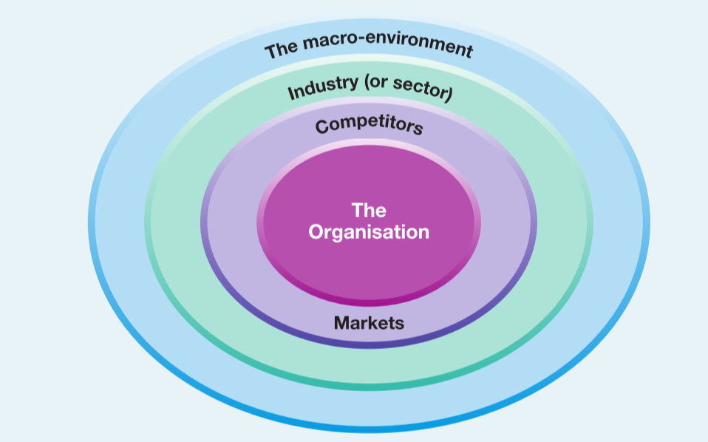
Figure 2 – Power Matrix (Johnson et.al 2008)
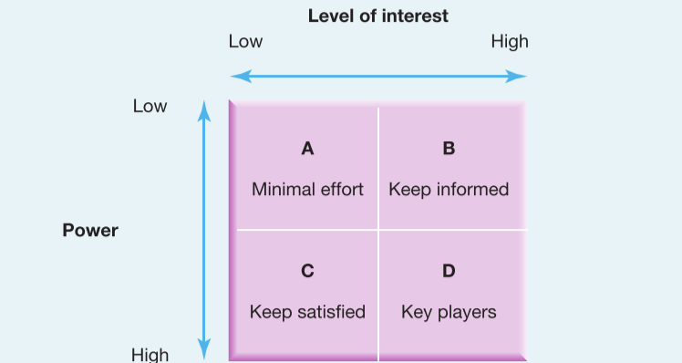

Figure 3 –European Aviation Safety Agency legilsation (EASA 2018)
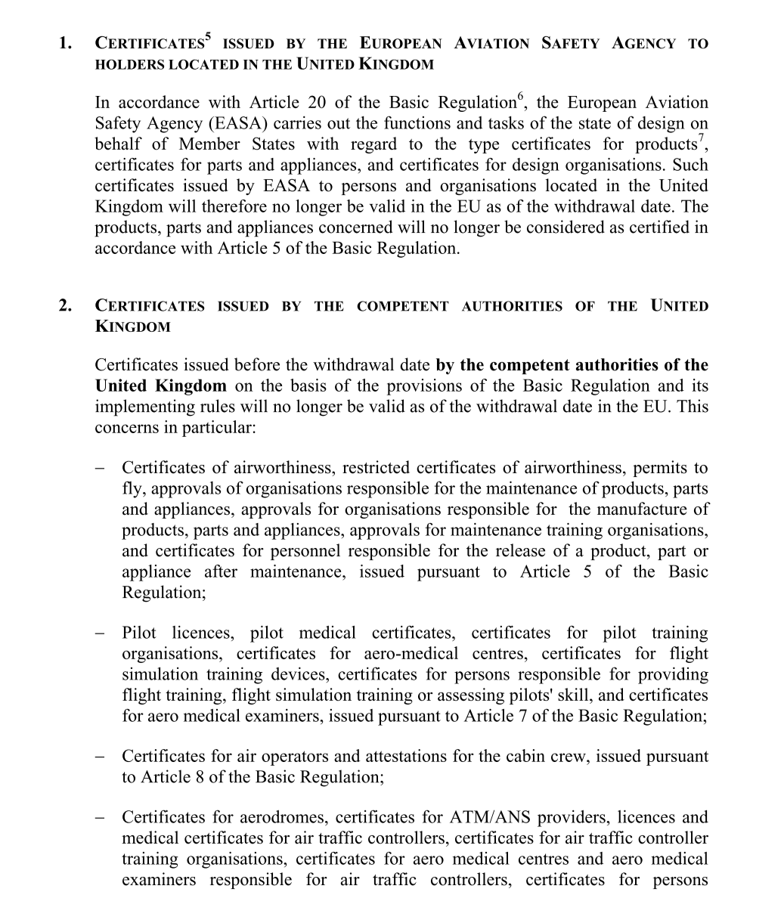

Figure 4 – Ryanair Fishbone framework

Measurement
People
Lack of communication with employees

No system in place to facilitate/police engagement
Poor employer -employee relationship

Incompatible management & leadership style
Unfavourable working hours
Working conditions
Management

References
Armstrong, M. (2012). Armstrong’s Handbook of Management and Leadership. 3rd Edition. London: Kogan Page.
ATAG. (2018). Aviation and Climate Change. ATAG. [Online]. Available at: https://aviationbenefits.org/environmental-efficiency/our-climate-plan/aviation-and-climate-change/. [Accessed on 6th June 2018].
ATAG. (2018). Climate Action Takes Flight. ATAG. [Online]. Available at: https://aviationbenefits.org/environmental-efficiency/our-climate-plan/. [Accessed on 6th June 2018].
CAPA. (2017). The Great Brexit Aviation Debate. A Transition deal is Needed to Avoid Disaster for UK Airlines. CAPA. [Online]. Available at: https://centreforaviation.com/analysis/reports/the-great-brexit-aviation-debate-a-transition-deal-is-needed-to-avoid-disaster-for-uk-airlines-380522. [Accessed om 6th June 2018].
Caldwell, D., Chatman, J., & O’Reilly, C. (1990). Building Organisational Commitment: A Multifirm Study. Journal of Occupational Psychology. 63. Pp. 245–261
COP21. (2015). UN Climate Change Conference. COP21. [Online]. France. Available at: http://www.cop21.gouv.fr/en/one-hundred-billion-dollars/. [Accessed on 10th June 2018].
Davies, B. (2017). Ryanair Staff Brand Company a ‘Disgrace’ Over Handling Issues. The Guardian. [Online]. Available at: https://www.theguardian.com/business/2017/sep/22/ryanair-pilots-michael-oleary-cancellations. [Accessed on 10th June 2018].
EASA. (2018). European Commission Directorate General for Mobility and Transport. European Commission. [Online]. Available at: https://ec.europa.eu/transport/sites/transport/files/legislation/brexit-notice-to-stakeholders-aviation-safety.pdf. [Accessed on 10th June 2018]/
Freed, J. (2018). Airfares to Jump As a Result of Rising Oil Price: Airline Exclusive. Reuters. [Online]. Available at: https://www.reuters.com/article/us-singapore-airshow-iata/airfares-to-jump-as-a-result-of-rising-oil-price-airline-executives-idUSKBN1FP04J. [Accessed on 10th June 2018].
Harvey, F. (2015). Paris Climate Change Agreement: the World’s Greatest Diplomatic Success. TheGaurdian. [Online]. Available at: https://www.theguardian.com/environment/2015/dec/13/paris-climate-deal-cop-diplomacy-developing-united-nations. [Accessed on 10th June 2018].
IATA. (2012). Economic and Social Benefits of Air Transport. International Air Transport Association. [Online]. Available at: <http://www.iata.org/pressroom/facts_figures/fact_sheets/pages/economic-social-benefits.aspx>. [Accessed on 10th June 2018].
Ishikawa, K. (1976). Guide to Quality Control. Tokyo: JUSE
Johnson, G, Kevan, S & Whittington, R. (2008). Exploring Corporate Strategy: Text & Cases. 8th Ed. Prentice Hall: Harlow.
O’Carroll, L., & Topham, G. (2017). Ryanair Will Have to Suspend UK Flights Without Early Brexit Aviation Deal. The Guardian. [Online]. Available at: https://www.theguardian.com/business/2017/apr/06/ryanair-uk-flights-brexit-deal-wto. [Accessed on 6th June 2018].
Parliament.uk (2017). Impact of Brexit on Aviation Examined. www.parliment.uk. [Online]. Available at: https://www.parliament.uk/business/committees/committees-a-z/commons-select/transport-committee/news-parliament-2017/brexit-and-aviation-one-off-evidence-17-19/. [Accessed on 6th June 2018].
Ryanair. (2018). ‘History of Ryanair’. Ryanair. [Online]. Available at: https://corporate.ryanair.com/about-us/history-of-ryanair/. [Accessed on 6th June 2018].
Tungate, M. (2017). A Brief History of Ryanair. Management Today. [Online]. Available at: https://www.managementtoday.co.uk/brief-history-ryanair/any-other-business/article/1449458. [Accessed on 6th June 2018].
Wanjek, C. (2013). Real Hazards of Air Travel. LiveScience. [Online]. Available at: http://www.livescience.com/13878-health-hazards-air-travel.html. [Accessed on 10th June 2018].
Warner, J. (2018). How Will Brexit Impact Airlines and the Wider Aviation Industry. IG. [Online]. Available at: https://www.ig.com/uk/shares-news/how-will-brexit-impact-airlines-and-the-wider-aviation-industry--180316#information-banner-dismiss. [Accessed on 6th June 2018].
WHO.(2013). Environmental Health Inequalities in Europe. World Health Organisation. [Online]. Available at: <http://www.euro.who.int/__data/assets/pdf_file/0010/157969/e96194.pdf>. [Accessed on 10th June 2018].

