Programme: Business Management
Module: Data Handling and Business Intelligence
Module code : LCBB5000
Lecturer: Zahra Mohammadnazari
Component 2:Coursework (Written Report)

Student Name:Elena Muscinschi 2114907

Table of Contents
Introduction 3
Part 1 3
Task A 3
Task 2 7
Task 3 7
Part 2 8
References 12

Introduction
In today's business, sophisticated data visualization tools are often utilised to help employees interpret information that can impact the future success of the business. While Excel has some significant characteristics, Tableau, a tool that has been accessible since 2003, is sometimes the first choice. Excel looks dated compared to Tableau. Spreadsheet systems such as Microsoft Excel can be used for a variety of applications, from simple mathematical and statistical computations to multifaceted data analysis and reporting (Amadio and Haywood, 2019, p. 36). It has been observed that better software can enhance data analysis, elevating accuracy and efficiency of results. Moreover, Tableau and Microsoft Excel are instances of the multitude of data analysis tools accessible. Such tools, although different, all have the similar objective: to research information so that applicants can make unhindered assessments (Hoelscher and Mortimer, 2018, p. 105). However, they can explore the data and do Excel calculations if they wish. Tableau users can improve products, businesses, and even organisations by making decisions on the basis of data-driven visual communications (Cainas, Tietz, & Miller-Nobles, 2021, p. 46). Tableau is a business data visualisation and analysis program that explores trends and validates hypotheses. Tableau and Excel are both useful analytical and data management applications. However, each has innovative benefits that lead to its business likelihood.

Part 1

Task A
1. What is the mean value for coffee consumption (in cups) per day?
In Excel, the mean is the aggregate of all values divided by the overall number of values. In this regard, the mean value for coffee consumption (in cups) per day is 3.625 ≈ 3.62. The following formula was used to calculate the mean value for coffee consumption:
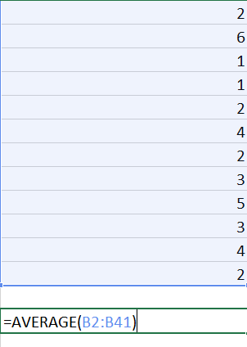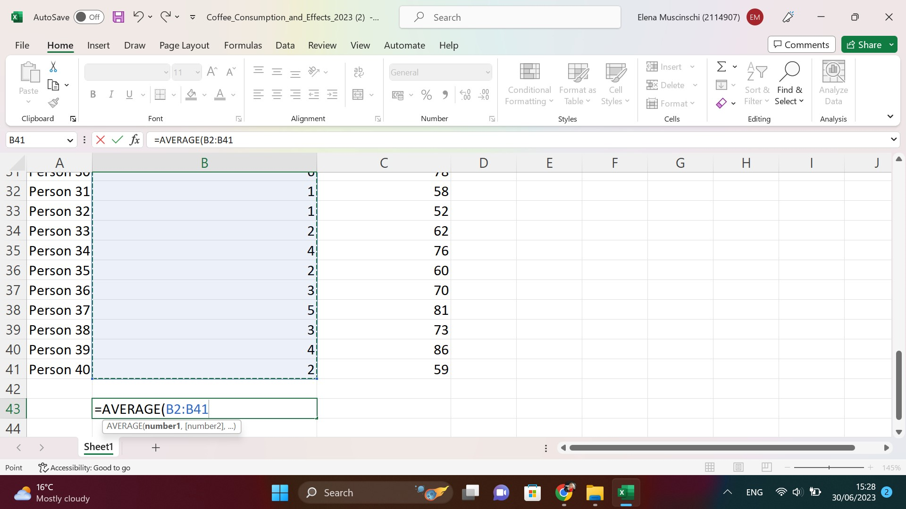
2. What is the median value for coffee consumption (in cups) per day?
The median is the value segregating the higher half from the lower half of a data sample in statistics and probability theory. With respect to the question asked, the median value for coffee consumption (in cups) per day is 3.5. The following formula was used to calculate the median value:
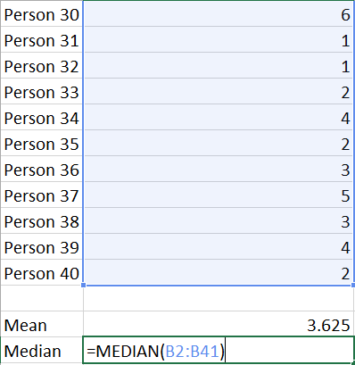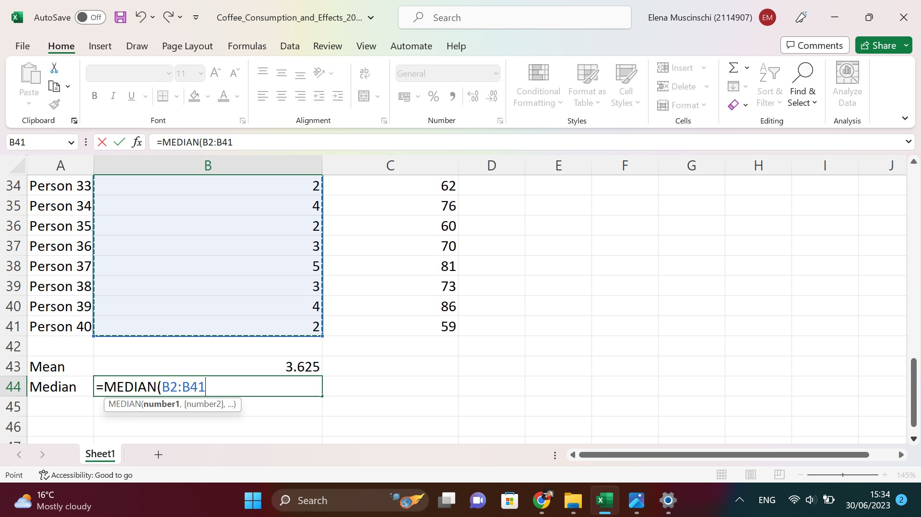

3. What is the mode of the coffee consumption (in cups) per day?
It has been observed that the mode is the value that emerges most commonly in a series of data values. It is also considered as a measure of central tendency such as the mean and median. In this regard, the mode value of the coffee consumption (in cups) per day is as follows:
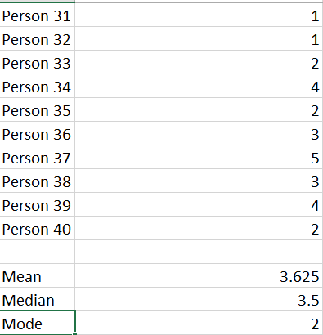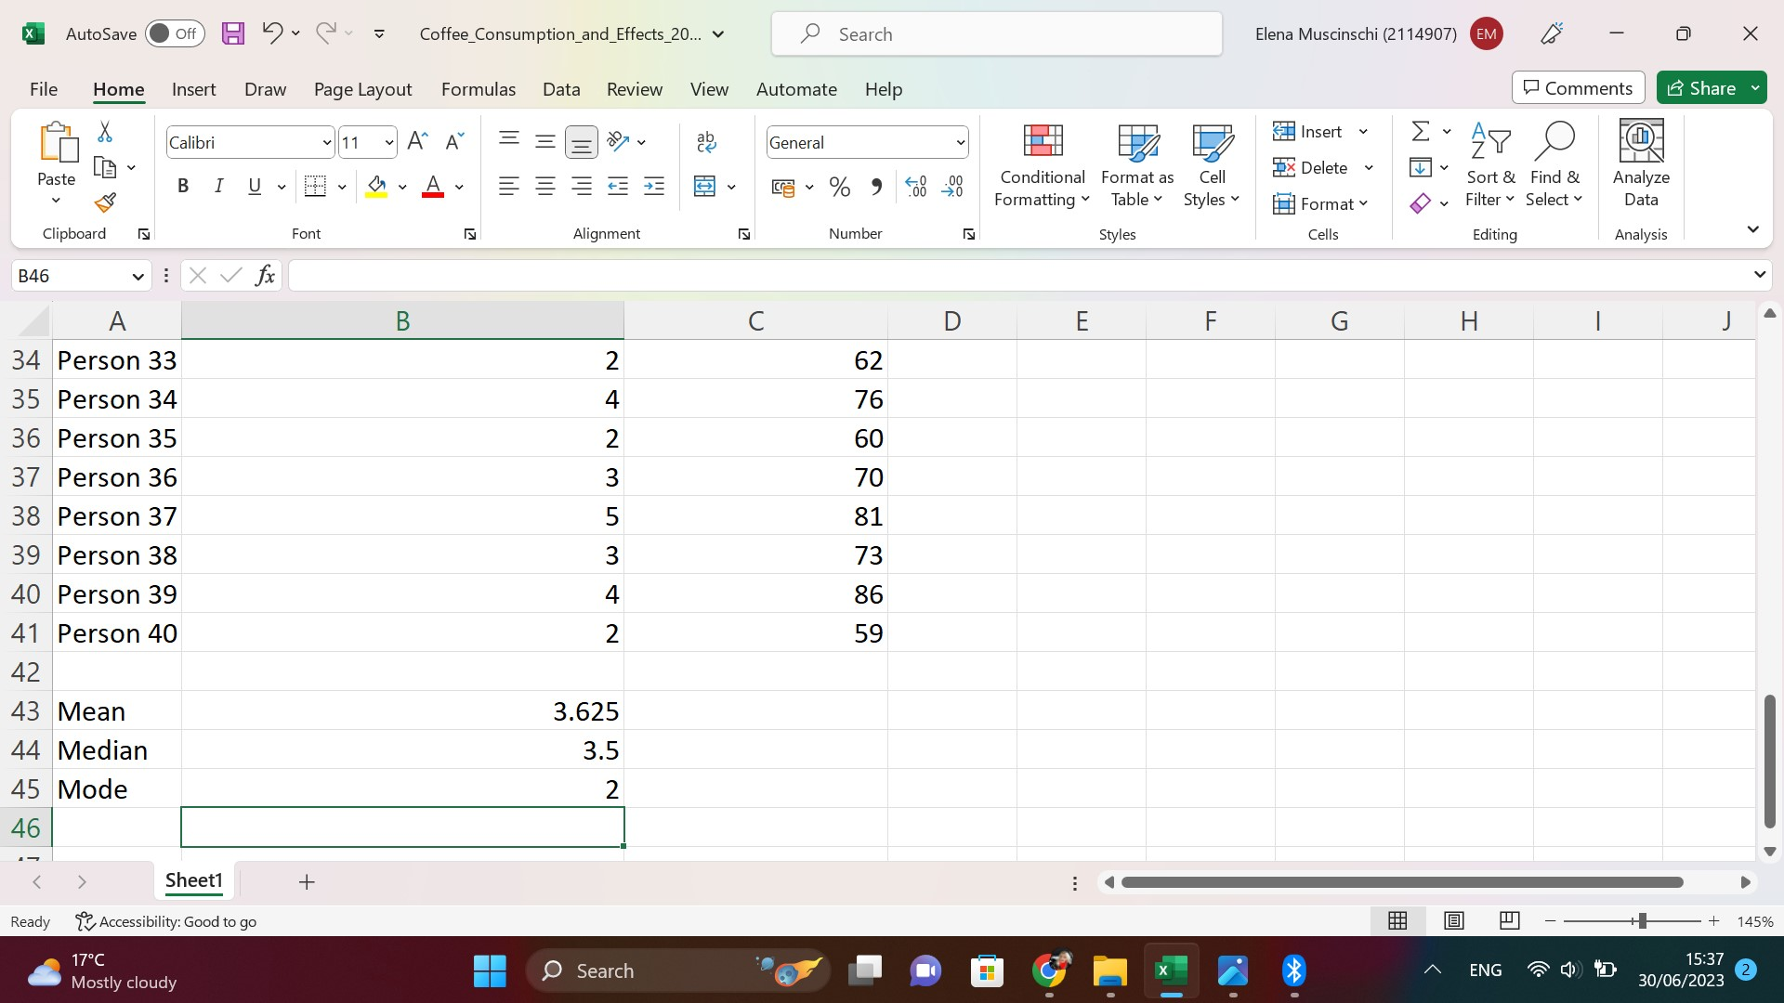
The following formula was used to calculate the mode value of the coffee consumption (per day):
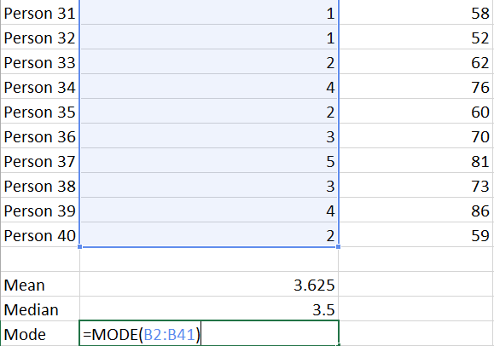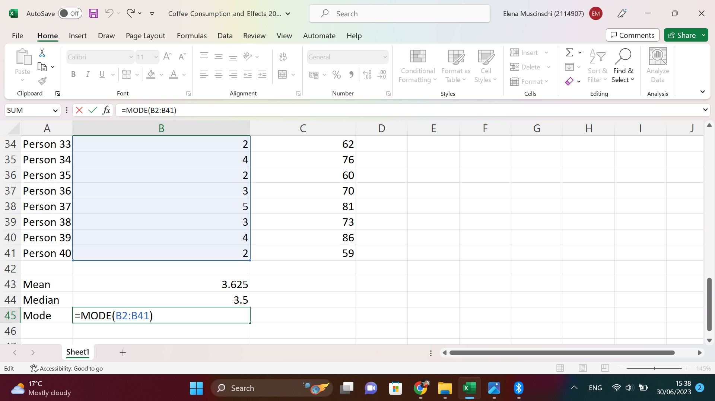

4. What is the standard deviation for effects on the human body (based on a health index score)?
A standard deviation is an estimate showing the extent of data dispersion with respect to the mean. The low standard deviation indicates that data are clustered around the mean whereas the high standard deviation indicates that data spreads the centre of the mean.
Based on the aforementioned explanation, the standard deviation for effects on the human body or health index score was 13.412 ≈ 13.41. The following formula was used to calculate the standard deviation of health index score:
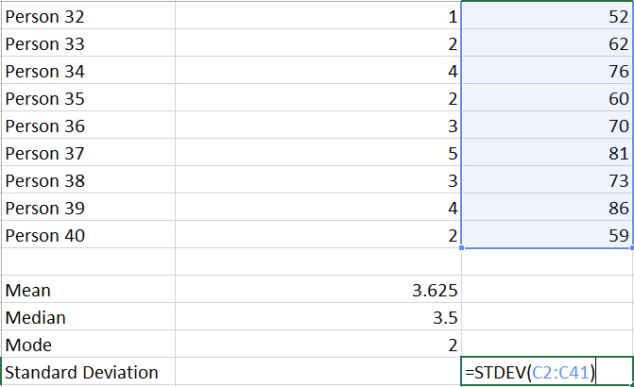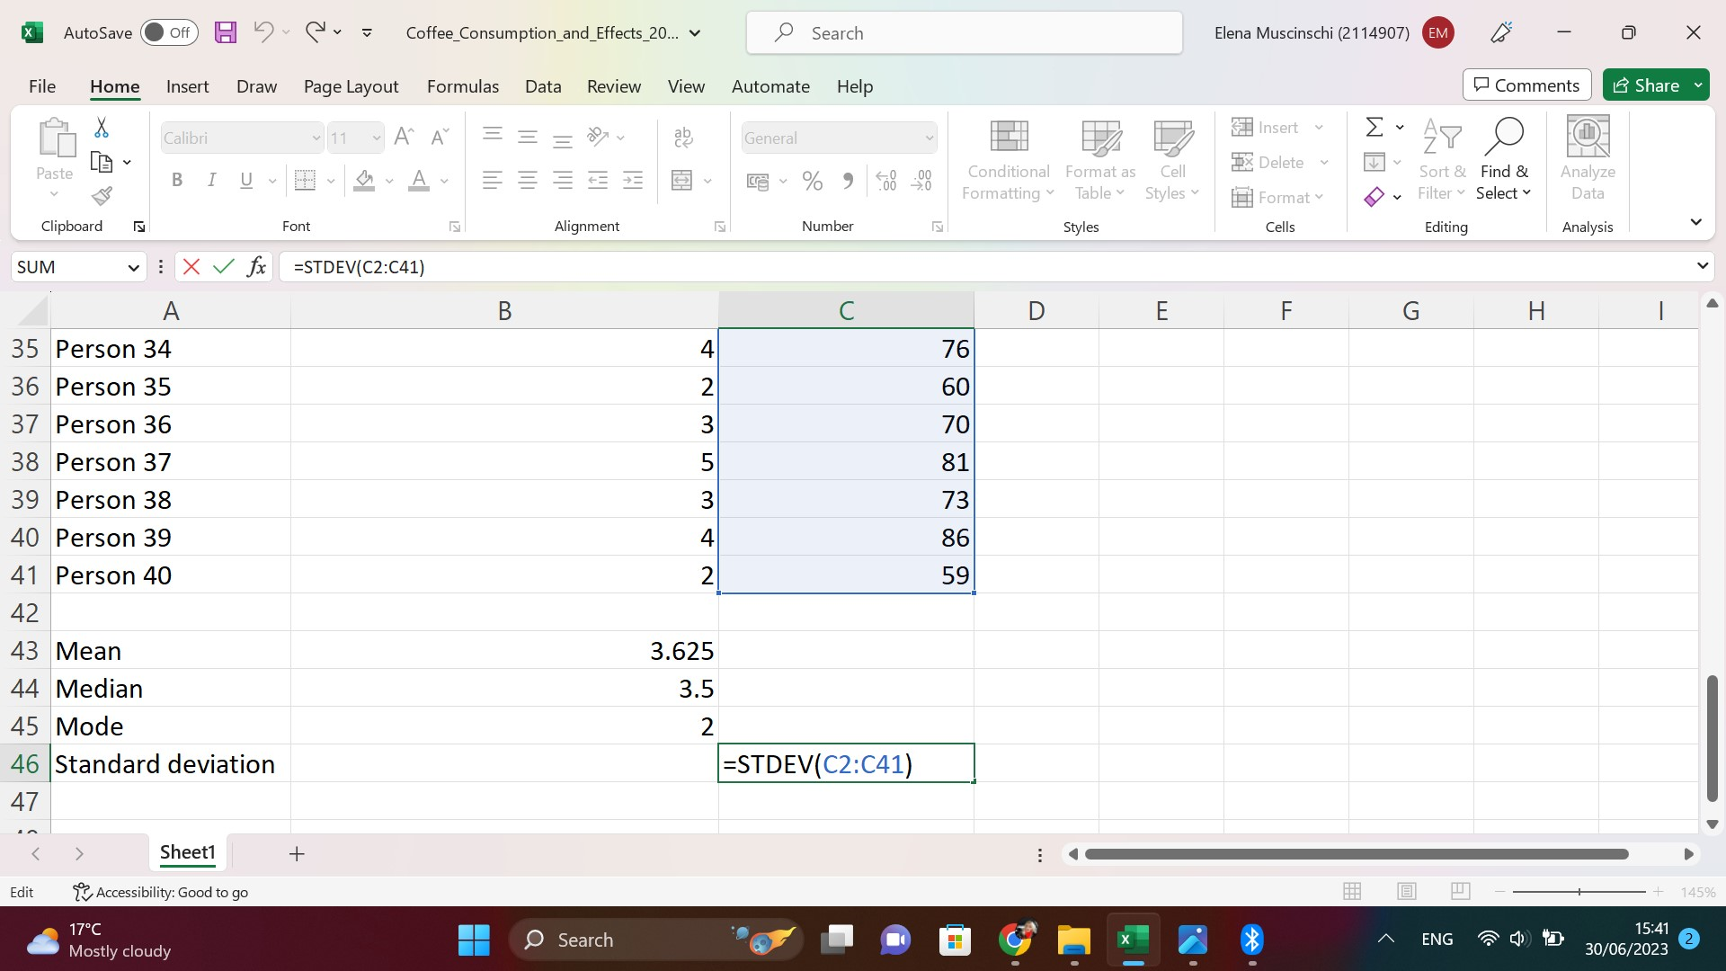

5. Which one of the two variables has a larger variance?
It should be noted that variance is an estimate of dispersion that considers the spread of all data points in a given data set as compared to range and interquartile range. Moreover, it is the estimate of dispersion, which is commonly used along with the standard deviation. The latter is mostly defined as the square root of the variance. On the other hand, the larger variance indicates that at least some of the numbers in the data set are far away from the centre. Based on the question enquired, it has been observed that health index score has a larger variance compared to coffee consumption (per day).
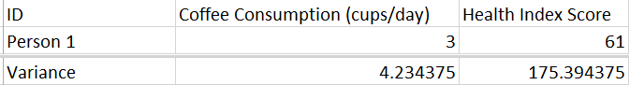

6. Which one of the two variables has a larger standard deviation?
Amongst the two variables, the larger standard deviation was observed for health index score as compared to coffee consumption.

Task 2
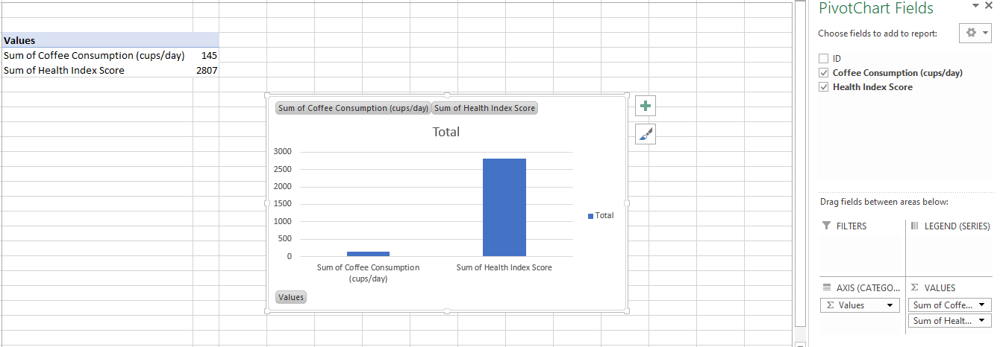

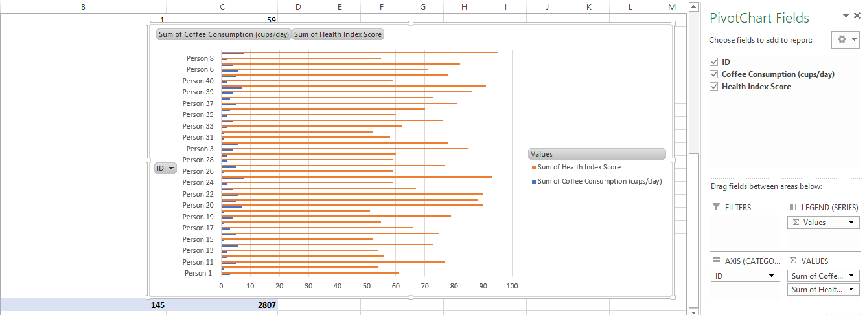

Task 3
Correlation
The first part presents correlation between health index score and coffee consumption. To identify the following correlation, SPSS software was used and bivariate correlation was selected. Based on the correlation analysis, it has been observed that there is a statistically significant correlation between health index score and coffee consumption (r = .995, p = .000).
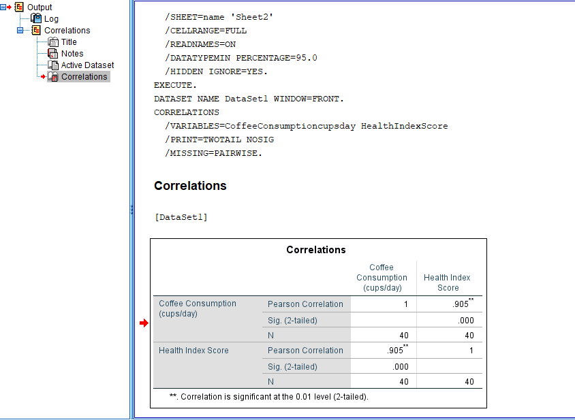
The following scatter plot shows graphical representation of health index score and coffee consumption. The graphical representation shows a linear relationship between the two variables indicating that health index score is improved with the daily consumption of coffee.

Part 2
Data can be displayed in columns and rows using Microsoft Excel. Data can be arranged properly in boxes, and eye-catching diagrams including graphs and charts can be embedded to entice readers. Tableau is business intelligence tool that facilitates visualisation tools and teamwork with interactive dashboards (Cotter-Reilly, 2020, p. 46). By presenting information graphically from the start, Tableau makes the importance of the data most apparent. Microsoft Excel is an essential part of spreadsheet software that can perform different mathematical and statistical operations on data. Once information has been cleaned, it should be organised so that it is efficient. Precisely, Tableau has established itself as a competitive analytics software.
It has been observed that Excel is best for Visual Basic programmers whereas Tableau's user-friendly interface makes it easy for creating custom dashboards. The easy drag-and-drop infrastructure of interface is a big selling point of the program (Cainas, Tietz, & Miller-Nobles, 2021, p. 38). Excel's open infrastructure is compatible with a variety of applications. Tableau's ability to engage to multiple data sources is one of its different advantages, as is its interoperability with the cloud. Developing and using Excel requires proper installation. Interacting with a live database is simple with Tableau (Murphy, 2013, p. 187). The widespread use of Excel for tasks such as calculating vacation pay and accruals is a testament to the popularity of spreadsheet programs as a mathematical solution tool in the corporate world.
As a bonus, Excel is said to be easier to explore trends and patterns than before, when additional time was spent poring over piles of paper (Cotter-Reilly, 2020, p. 105). On the contrary, many of Excel's benefits also come with drawbacks. Sharing spreadsheets can be awkward, particularly if performed entirely online, and making corrections can be time-consuming. Excel's built-in, ready-to-analyse features are promising for statistically data assessment. Due to the simplicity of saving and processing data, it is easy to perform related activities. Businesses can start via Excel regardless of estimating the data, financials, and reports that should be created (Cainas, Tietz, & Miller-Nobles, 2021, p. 38). It has been noted that Tableau is a business intelligence tool that allows users to quickly and efficiently prepare interactive dashboards, explore data and interact to different data sources. Tableau Dashboard's powerful reporting abilities facilitate the user interface to be adapted to individual needs.
It is unthinkable without a mobile phone or computer. Tableau surpasses at performing accurate and quick inspections of large datasets. Tableau is so renowned because of its aesthetic appeal of data visualisation. Spreadsheet programs like Excel are great to extract knowledge like calculations and formula updates (Park, Malhan, & Rudna, 2022, p. 38). Based on well-organised data, tables and graphs, it is possible to understand the most complex ideas and engage a wide range of people. Because of its powerful analytics capabilities, Tableau has gained immense traction as the analytics solution of choice for visual analytics. Both Tableau and Excel are competent of displaying data, but Tableau is much better to report and analysis.

Data Mining
Data mining is the procedure to search and analyse large amounts of raw data for identifying trends and extracting crucial information. It has been observed that companies are using data mining software for learning more regarding their consumers. It helps them in reducing costs, increasing sales, and creating more effective marketing strategies. Data mining is based on efficient data collection, storage and computer processing. Moreover, data mining programs identify patterns and relationships in data based on user requirements. It further organises information into categories. For instance, a restaurant might desire for using data mining for determining which specialties to provide and on which days. It has been noted that data can be organised into categories on the basis of when users visit and what they order.
In other instances, it has been observed that miners explore groups of information on the basis of logical alliances, or examine relationships and sequential trends for drawing conclusions regarding patterns in consumer behaviour. Warehousing is an essential part of data processing. A warehouse is the centralisation of the company's data into a single database or application. It facilitates organisations to carve out data for certain users to analyse and utilise according to their requirements.
There are two core forms of data mining: descriptive and predictive data mining. It has been observed that predictive data mining extracts information that can help determine outcomes. Descriptive data processing informs the user about a particular result. Data mining depends on big data and advanced computational processes, such as machine learning and other types of artificial intelligence (AI). The objective is to explore trends that can be inferred or predicted from large unstructured data sets.
Data mining applications are devised for taking on any job that depends on big data. organisations in the financial sector search for trends in the market. The government tries for identifying possible security risks. Companies, especially Internet and social media firms, utilise data mining for creating profitable marketing and advertising campaigns that target certain groups of users. Modern companies have the skill-set to collect information about their consumers, employees, products, stores, and production lines. These random bits of information might not indicate the story, but using data mining techniques, programs and tools can help place the information together. The last objective of the data mining cycle is to gather data, analyse the findings, and implement operational plans on the basis of the results of the data mining.
Data analysis usually needs technical skills and specific software tools. Smaller firms might explore this a difficult barrier to entry. It has been observed that data mining does not always confirm success. A firm can perform statistical analysis, draw interpretations based on data set, adopt changes and not receive any benefit. With imprecise results, market modifications, model errors or inaccurate data sets, data mining can merely enable decisions, not guarantee results. Data mining also has a cost factor. Data tools can require expensive subscription fees and some data can be costly to obtain. It has been observed that privacy and security concerns can be put to rest, but additional IT infrastructure can also be expensive. Data mining can also be most effective when working with immense data sets; however, these datasets must be retrieved and need significant computing power to examine.

References
Ahmed, A.C.A. (2010) ‘BMW AG; Financial Performance Analysis’, Available at SSRN 1616827 [Preprint].
Albright, S.C. and Winston, W.L. (2014) Business analytics: Data analysis & decision making. Cengage Learning.
Amadio, W.J. and Haywood, M.E. (2019) ‘Data analytics and the cash collections process: An adaptable case employing excel and tableau’, in Advances in Accounting Education: Teaching and Curriculum Innovations. Emerald Publishing Limited.
Ardito, L. et al. (2019) ‘Towards Industry 4.0’, Business Process Management Journal, 25(2), pp. 323–346. Available at: https://doi.org/10.1108/BPMJ-04-2017-0088.
Bastien, H. (2017) ‘Analyse marketing de BMW sur le marché de l’automobile haut de gamme’, Publications Études & Analyses [Preprint].
Cainas, J.M., Tietz, W.M. and Miller-Nobles, T. (2021) ‘KAT Insurance: Data Analytics Cases for Introductory Accounting Using Excel, Power BI, and/or Tableau’, Journal of Emerging Technologies in Accounting, 18(1), pp. 77–85.
Cotter-Reilly, K. (2020) ‘Using Excel to Deal with Uncertainty in Managerial Decision Making’, Management Accounting Quarterly, 21(4), pp. 1–8.
Hoelscher, J. and Mortimer, A. (2018) ‘Using Tableau to visualize data and drive decisionmaking’, Journal of Accounting Education, 44, pp. 49–59.
Ivey Business School Foundation (2019) BMW MINI: BIG DECISIONS UNDER THE BREXIT CLOUD.
Murphy, S.A. (2013) ‘Data visualization and rapid analytics: Applying tableau desktop to support library decision-making’, Journal of Web Librarianship, 7(4), pp. 465–476.
Nobanee, H. et al. (2021) ‘Financial Analysis of BMW & Daimler (Mercedes-Benz)’, Available at SSRN 3766088 [Preprint].
Park, A., Malhan, A. and Rudna, O. (2022) ‘Effectiveness of Teaching Supply Chain Analytics using Tableau’, 프로젝트경영연구, 2(2), pp. 16–22.
Xu, X. (2019) ‘Assessment of Profitability of the Company BMW AG’.

