
Feel the Best with Us

Valentine Special Menu

14 February 2023
[Everyone will be served by a Glass of complimentary soft drink]
Select one from each section.

Starter:

Spicy Tuna Roll with Soy Sauce
(Tuna, Rice, Soy Sauce, Sriracha)

Baked Brie with Apricot Jam
(Brie Cheese, Apricot Jam, Crostini)

Grilled Asparagus with Lemon Vinaigrette
(Asparagus, Lemon Vinaigrette, Parmesan)

Main Course:

Pan-Seared Scallops with Brown Butter Sauce
(Scallops, Butter, Lemon, Herbs)

Filet Mignon with Roasted Garlic Compound Butter
(Filet Mignon, Garlic, Butter, Roasted Potatoes)

Grilled Eggplant Parmesan with Tomato Sauce
(Eggplant, Mozzarella, Parmesan, Tomato Sauce)

Dessert:

Flourless Chocolate Cake with Raspberry Coulis
(Dark Chocolate, Eggs, Sugar, Raspberries)

Strawberry Shortcake
(Strawberries, Whipped Cream, Shortcake)

Classic Apple Tart with Cinnamon Whipped Cream
(Apples, Cinnamon, Whipped Cream)

Drinks:

Champagne - £35

(A variety of Champagne & sparkling wine options, ranging from classic to premium brands, offered by the glass or bottle)

Cocktails - £40
(Strawberry Daiquiri, Pomegranate Martini, or Rose Petal Fizz, made with premium spirits & fresh ingredients)

Wine - £45
(A carefully curetted wine list featuring red, white, and rose wines from various regions & countries, available by the glass or bottle)
Price per Couple: £96
Price per Person: £50
*Please note drinks are not included on any offer

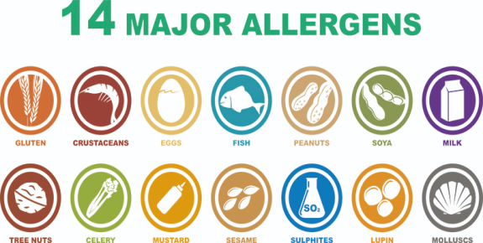
*Please speak to our staff if you have any requirements in terms of Allergies & Dietary.

No Pre-Order & Booking Available
City Square, Leeds, West Yorkshire, LS1 1PJ, the Trinity Hotel

References:
- O'Ceallaigh J. (2014) Valentine's Day special menus and dining offers at London restaurants [Blog] 6 February. Available at: https://www.telegraph.co.uk/travel/destinations/europe/united-kingdom/england/london/articles/Valentines-Day-London-restaurant-special-menus-and-dining-deals/?WT.mc_id=tmgoff_psc_ppc_performancemax_dynamiclandingpages&gclid=CjwKCAiA0JKfBhBIEiwAPhZXD0tcHiRueGEFNb0Ylx7M779-630Vnrb7hrDOi4T20fTU1u4xP7uSARoCH9EQAvD_BwE (Accessed: 9 February 2023)
- Kosinska J. (2018) “Image’’ 6 February, Available at: https://unsplash.com/photos/P9oOLKNhIYU (Accessed: 9 February)
- Peachy Essay (2019) Food and beverage operations in the hospitality industry: menu engineering [Blog] 24 June. Available at: https://peachyessay.com/sample-essay/menu-engineering-in-hospitality-industry-food-and-beverage-operations/ (Access: 16 February)
- Raab, C., Mayer, K. and Shoemaker, S. (2009) “menu engineering using activity-based costing.,” Journal of Hospitality & Tourism Research, 34(2), pp. 204–224. Doi: https://doi.org/10.1177/1096348009349823.
- Kwong, L.Y.L. (2005) “Asian restaurants' use of engineering and design techniques for menus,” International Journal of Hospitality Management, 24(1), pp. 91–106. Available at: https://doi.org/10.1016/j.ijhm.2004.05.002.
- SungYoon, R. (2009) “a case study on the use of the menu engineering approach in contract food service for government workplaces.,” The Korean Journal of Nutrition, 42(1), pp. 78–96. Available at: https://www.cabdirect.org/abstracts/20093077904.html.
- Merckaert G. (2023) Menu Engineering: How Big Restaurant Owners Increase Their Profits by 10-15% by Continuously Enhancing Their Menus [Blog] Available at: https://get.apicbase.com/restaurant-menu-engineering/ (Accessed: 16 February 2023)
- Jeong, W., Byun, K.-I. and Park, S. (2008) “Utilizing menu engineering and cost/margin analysis, this article analyzes a Japanese restaurant's menu in the context of a first-class (A) hotel.,” Journal of the Korean Society of Food Culture, 23(5), pp. 595–604. Available at: https://www.kci.go.kr/kciportal/ci/sereArticleSearch/ciSereArtiView.kci?sereArticleSearchBean.artiId=ART001288301.

