UNDERSTANDING AND ENGAGING IN THE CUSTOMER EXPERIENCE
A CASE STUDY OF SAINSBURY, UK
STUDENT NAME: ADRIANA TRIFU
STUDENT ID: 1812538
MODULE CODE: BMSW5103
LECTURER: KENNY TANG
Table of Contents
INTRODUCTION 2
COMPANY BACKGROUND 2
MAIN BODY 3
CRITICAL ANALYSIS OF FACTORS AFFECTING THE ABILITY TO MAXIMIZE THE CUSTOMER VALUE IN AN ORGANIZATION 3
Organizational structure 3
CULTURE WITHIN AN ORGANIZATION 4
FACTORS INFLUENCING ORGANIZATIONAL ABILITY TO MAXIMIZE CUSTOMER VALUE 6
SYSTEM SUPPORTING QUALITY PROCESS OF THE ORGANIZATION 8
CRITICAL UNDERSTANDING OF MEETING CUSTOMER NEEDS 13
Kotter’s 8 step model 13
CONCLUSION 18
RECOMMENDATION 19
REFERENCES 21

INTRODUCTION
With the motive of achieving the growth and development within an organization, there finds the need to evaluate the customer experiences and their experiences on introducing the new set of products and services as per the demands and needs of customers. The major term which needs to be focused on evaluating the customer experience includes the critical way of determining the customer values. The customer value has been defined as the way of treating the customers and its needs with full dignity and respect as per the aim of maintaining loyalty over an organization. The need for understanding the customer needs could be processed within an organization. The major term which needs to be focused includes the term defined as customer relationship management. This helps in managing the entire procedures defined over the interaction and potential customers.

COMPANY BACKGROUND
For understanding the needs and demands of customers, the organization which has been focused over an organization named as Sainsbury. It has been defined to be recognized as the retail sector industry which has been working over the country named as UK. It has been defined as a public limited company which was founded in year 1869 (Rohwer and Topić, 2019). It’s headquarter is located in Holborn, London, UK.
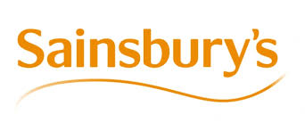
Figure 1: Symbol
Source: (Rohwer and Topić, 2019)
The organization was founded by John James Sainsbury. In order to regulate the progress and development of an organization, customer relationship management has been analysed and defined over the working structure and development of an organization. The value of an organization has been defined to be the UK’s most trusted retailers over which the people love to work and shop. This has been evaluated to be the social, economic, and environmental responsibility over which the success of an organization has been dependent over the progress and development factors (Rohwer and Topić, 2019).

MAIN BODY

CRITICAL ANALYSIS OF FACTORS AFFECTING THE ABILITY TO MAXIMIZE THE CUSTOMER VALUE IN AN ORGANIZATION
In order to maximize the aim of gaining the customer values, Sainsbury has focused to determine the way of delivering the number of strategies and procedures as per the needs and development abilities of customers. The implementation of strategies and procedures over an organization has been done on the basis of including the organizational structure. The mission statement of an organization is to develop the strategies as per the priorities of customers to provide the great service of working in faster and simpler mode. The vision statement of Sainsbury is to assure that retail merchant where people love to shop and work (Rohwer and Topić, 2019). In order to achieve the needs and demands of customers, an organizational structure has been developed over an organization.

Organizational structure
Sainsbury has been found to implement the hierarchical type of structure. There are series of degrees’ people and degree above which controls each degree. Each degree has been defined to act as the duty of degree. This has been processed by including the number of senior directors which are held responsible for the line directors which are held responsible for the gross revenues helpers (Armstrong et al., 2018).
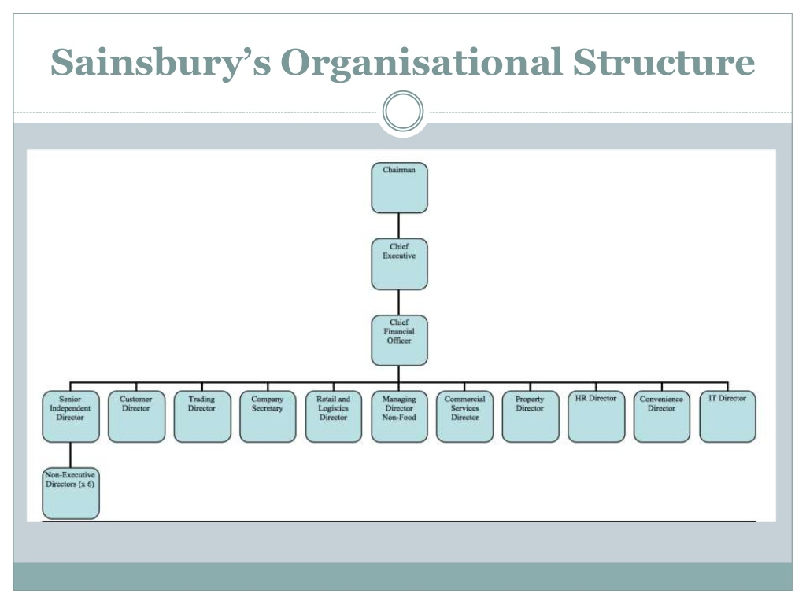
Figure 2: Organizational structure
Source: (Armstrong et al., 2018)
The movement of ranks could be defined to be from highest to lowest. In Sainsbury, the managers of an organization have been held responsible for developing most effective set of strategies and procedures as per that of the working ability and needs of an organization. The decision making ability of an organization has been also found to be processed by including the views provided by the number workers and managers working over an organization (Armstrong et al., 2018).

CULTURE WITHIN AN ORGANIZATION
The organizational culture has been defined to act as the most suitable form of providing and processing the set of procedures has been analysed over an organization. According to views provided by Fatehi (1996), organizational structure has been defining to be analysed over the three basic models which are categorised into five basic traits and structure defined as geographical, functional, product, mixed and matrix structure. The functional structure includes the way of arranging different parts of business according to which the business has been processed and the size of regulating the operating structure of an organization.
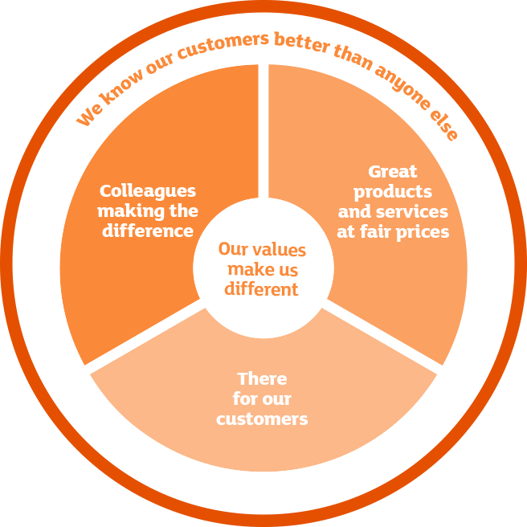
Figure 3: Organizational Values
Source: (Armstrong et al., 2018)

The geographical structure of Sainsbury includes the way of providing the set of tasks which includes the local community needs and to manufacture the products as per the varying cultural needs of an organization. The product structure includes analysis and development of products and services under the guidance of product6 manager which has been held responsible for development of products by analysing the raw materials being utilized to produce the final product (Armstrong et al., 2018).
On being recognized as the famous industry in UK, Sainsbury has been focused to regulate the hierarchical type of structure. The accurate implementation of this would help in analysing the products, cultural and other needs which have been found to be evaluated as per the implication of customer relationship management factors.

FACTORS INFLUENCING ORGANIZATIONAL ABILITY TO MAXIMIZE CUSTOMER VALUE
Customer value has been defined to act as the perception of what the product or service which has been analysed to be worth as per the customer needs by including the possible set of alternatives. The critical implication of customer values helps in satisfying the needs and demands of customers (Wali and Nwokah, 2018). It affects the overall working ability of an organization and the decisions which have been defined o over an organization. The in depth analysis of customer values have been evaluated by including the perceptions of customers as per that of the changing working environment of an organization. The critical evaluation of these factors would help in manufacturing the products and services based over the customer needs (Wali and Nwokah, 2018).
According to Simchi-Levi (2008), the way of regulating this fact has been processed by including the customer values categorized on the basis of five major dimensions. The implication of these dimensions could be developed in Sainsbury could help in achieving the needs and demand of customers. The five major dimensions have been evaluated as:
- Conformance to requirement
With the aim of determining the conformance to requirement, efficiency improvement has been made by including the skills as per the training abilities, the utilization of new technologies have been processed by including the improved set of practices (al Habibi, 2019). In addition to this, the integration practices have been applied by that of needs and demands being defined with that of local communities.
- Product selection
The product selection has been processed by including the key raw material standards in order to deal with the requirement related to the products and hotspot specified over the number procedures which would be focused to improve and addressed over an organization. The every single KRM standard has been analysed to act as the sensitive factors which include demands being directly related with that of define set of products and services which would be affected by that of the various hotspots which would affect the farmers, suppliers and growers (al Habibi, 2019). The accurate implementation of these factors would include potential needs of satisfying the sustainability as per that of the varying demands of customers defined over the varying working environment.
- Price and Brand
Sainsbury has been rolling out the successful brand match scheme to online orders. This has been defined to be classified as the longstanding commitment to assure that the customer gets great value over the grocery brands (al Habibi, 2019). The pricing strategy applied over an organization includes the implication of price matching against the thousands of items which assures that the customers are not forced pay the additional or more price of the defined ser of products being made available over an organization. The pricing the strategy has been also made over the online as well as the offline customers (al Habibi, 2019).
- Value added services
The progress and growth of an organization has been to be applied by including the number of services which are found to be related with that of the value added services. This has been focused by including that the products and services have been processed over an organization (Lancaster and Massingham, 2017). Sainsbury has been reinforcing its commitment of providing the great number of offers related with that of providing the services at fair price by implementing the Brand Match Scheme to the majority of customers.
- Experiences and Relationships
The focus of becoming the most famous retail organization, the quality and products have been manufactured by including the variety of demands and needs over the large number of customers (Lancaster and Massingham, 2017). The mission statement of an organization is to develop the strategies as per the priorities of customers to provide the great service of working in faster and simpler mode. The vision statement of Sainsbury is to assure that retail merchant where people love to shop and work. In order to achieve the needs and demands of customers, an organizational structure has been developed over an organization (Lancaster and Massingham, 2017)

SYSTEM SUPPORTING QUALITY PROCESS OF THE ORGANIZATION
The growth and development of an organization could be defined to act as the basis of including the most suitable set of procedures defined as per that of the varying working environment. To provide and determine quality delivery as per that of organizing the process of an organization, Sainsbury has been categorized to act as the longest standing the food retailing chain in UK (Sisakht and Ansari, 2017). The number of products has been offered to about 30,000 products and it has been defined to act as 50% of which brand has been defined and analysed over an organization. The wide range of products and quality delivery services by offering the number of offers and discounts provided as per that of varying set of activities. The system which has been supporting the quality process of an organization includes the internal as well as external forces. The internal force includes the accurate execution of human resource problems and prospects which includes the relationship defined over the employees and job dissatisfaction has been analysed over an organization (Sisakht and Ansari, 2017).
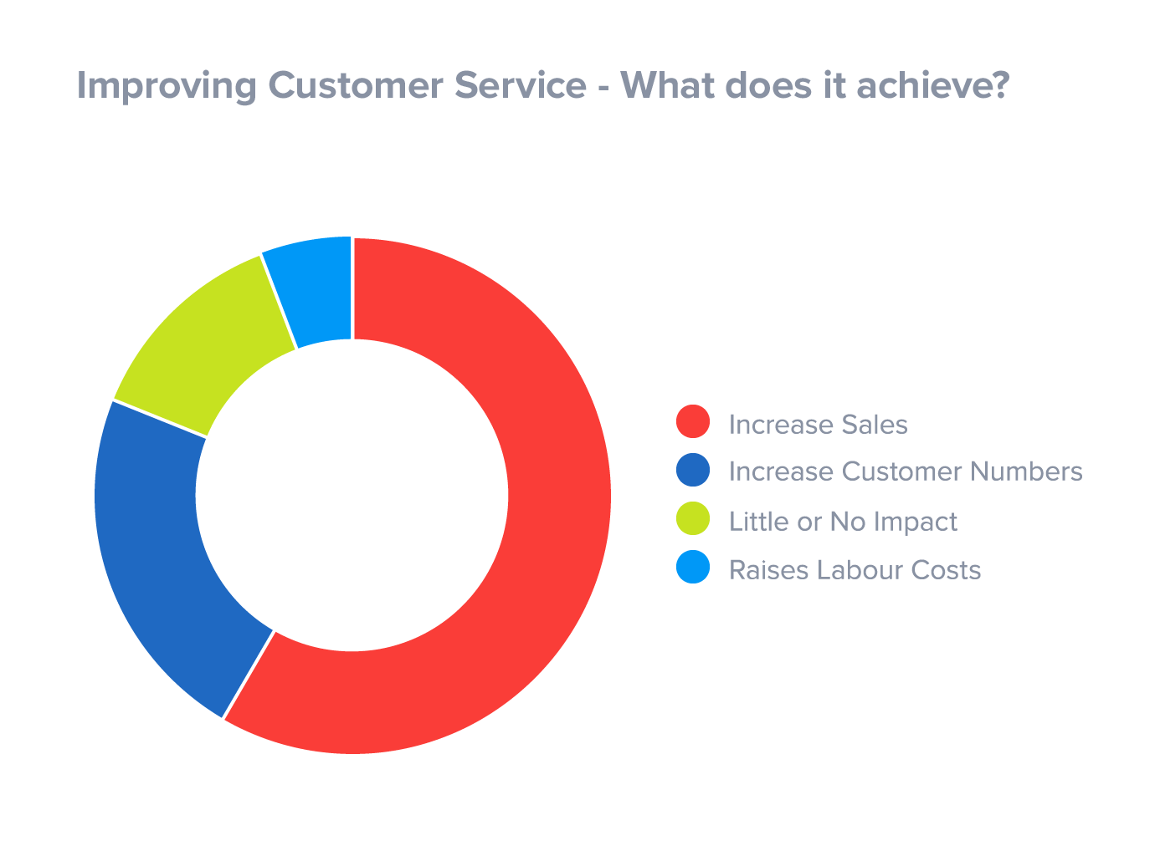
Figure 4: Customer services
Source: (Armstrong et al., 2018)
In addition to this, managerial behaviour and decisions have been applied by including the excessive interpersonal conflict between the managers. The employees as well as the number of managers play an important role to define the most effective set of skills.
The external forces include the analysis done on the basis of demographic traits. The two trends which has been focused in Sainsbury includes the workforce supported by that of the diversity and business to manage diversity in most effective form (Reinartz and Linzbach, 2018). This has been processed buy including the maximum contribution and commitment being defined over an organization. The emergence of global economy has been forcing Sainsbury to alternate the strategies and procedures as per the needs and demands of customers. The analysis of social as well as the political factors including the legal policies and procedures has been made by including competitive benefits (Reinartz and Linzbach, 2018).
This has been supported by including the SERVQUAL frameworks in Sainsbury are determined as following:
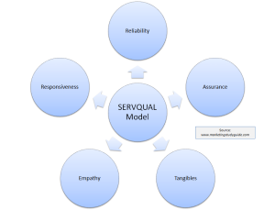
Figure 5: Servaqual Framework
Source: (Armstrong et al., 2018)

- Reliability
The accurate implication of products and services as per that of analysing the customer needs have been found to act as the most effective and reliable form of processing the number of services and procedures that could be analysed to provide the growth and progress within an organization (Kumaradeepan and Pathmini, 2017).
- Assurance
The assurance of providing the most effective set of policies and procedures could be defined as per the way of analysing the number of services to assure the fact of satisfying the needs and demands of customers (Kumaradeepan and Pathmini, 2017).
- Tangibles
In order to regulate the progress and development of an organization, customer relationship management has been analysed and defined over the working structure and development of an organization. The value of an organization has been defined to be the UK’s most trusted retailers over which the people love to work and shop (Kumaradeepan and Pathmini, 2017). This has been evaluated to be the social, economic, and environmental responsibility over which the success of an organization has been dependent over the progress and development factors.
- Empathy
The emergence of global economy has been forcing Sainsbury to alternate the strategies and procedures as per the needs and demands of customers. The analysis of social as well as the political factors including the legal policies and procedures has been made by including competitive benefits (Kumaradeepan and Pathmini, 2017). The focus of becoming the most famous retail organization, the quality and products have been manufactured by including the variety of demands and needs over the large number of customers by defining the most effective set of policies that satisfies legal factors over an organization.
- Responsiveness
By implementing the various set of procedures and legal factors due to the varying ability of customers as per that of the customer needs, the overall implication of legal policies supported by that of the ethical values has been defined to act as the responsive way of applying the new set of strategies as per that of varying procedures (Kumaradeepan and Pathmini, 2017).
Despite of this, the 5 major service gaps which could be analysed over the working environment and operational structure of an organization has been categorized as follows:
Service gap 1: Unknown with the customer expectations
On being recognized as the most famous and popular food retailing organization of an organization, the service gap which could be analysed over an organization includes the improper implication of factors and manufacturing of the products that could be responsible for decreasing the customer satisfaction level (Morgan, 2017). This affects the customer expectations and development of an organization in negative forms. This could be defined to act as the factor held responsible for decreasing the growth and development over an organization.
Service gap 2: Wrong implication of service standards
In order to meet the defined set of services and procedures as per that of the needs and factors defined over an organization, the inaccurate interpretation and wrong implication of the service standards could affect the quality delivery and standards of an organization in negative form. This would lead to affect the unhealthy implication of relationship defined among the customers and that of employees working within an organization (Morgan, 2017).
Service gap 3: Service performance gap
The service performance gap has been defined to be the gap being generated over the working ability of an organization as per the define set of tasks and procedures demanded by that of an organization. This has been defined to act the main factor held responsible for decreasing the overall profitability and reliability defined over the working environment of an organization (Morgan, 2017).
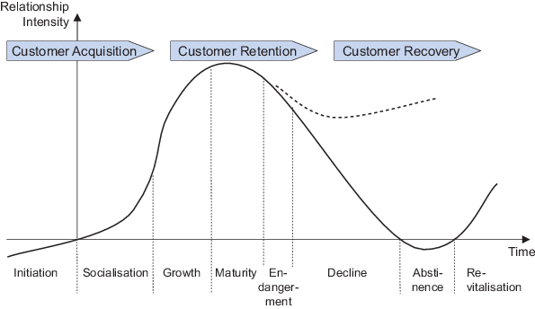
Figure 6: CRM Framework Analysis
Source: (Armstrong et al., 2018)

Service Gap 4: Promises not as per the delivery of products
As per the rise in global economy, the number of factors and services has been found to be dependent over the products and services being demanded and analysed as per the working abilities and needs of an organization. The delivery of products which does not satisfies the demand and needs of customers has been found to decrease the entire number of policies and procedures being defined within an organization (Morgan, 2017).
Service Gap 5: Difference in customer perception and expectation
In order to achieve the success and development of an organization named as Sainsbury in retail sectors, the differences being analysed among the perceptions and that of expectations defined to that of number of customers must be analysed over an organization (Morgan, 2017). The difference in perceptions and expectations could be analysed as following:
Customer perception | Customer expectation
customer perception is an interpretation of collective information after purchase | Customer expectation is an statement in deciding the purchase
Customer perception is a re-evaluate of the experience. It’s a precedent oriented concept. | Customer expectation is the expectation of understanding. It’s a future-oriented concept
Customer expectation is prejudiced by civilizing background, demographic factors, advertising, family standard of living, individuality, values, reviews and understanding with analogous products. | Customer perception is a result of customer’s individual assessment of product or service quality based on consumption and interaction with the seller (Taylor et al., 2020).
Customer perception can be calculated through survey and marketplace investigates surrounded by customers who tried the product or service at slightest Taylor et al., 2020. | Customer expectation can be considered via survey and promote research among potential customers who are the segmented target viewers for the artefact or service the organization is submission.

CRITICAL UNDERSTANDING OF MEETING CUSTOMER NEEDS
As per the above discussed fact, it could be analysed that the most effective way of regulating progress and growth within an organization named as Sainsbury could be achieved by that of including and deploying the definite set of models held responsible for defining the change management concept over an operational structure of an organization (Taylor et al., 2020). In order to develop the customer needs, the change management could act as the major factor that affects the entire working ability of an organization.
The two main models which could be processed over the change management concept have been determined as follows:

Kotter’s 8 step model
With the aim of working over the defined set of procedures as per that of the varying needs and demands of an organization, the need of applying the most effective and reliable change management model could be applied over an organization. The impaction of Kotter’s 8 step model was done by John Kotter in 1996 (Kyaddondo et al., 2017). The discussion of this model was done in his book named as leading change. According to which development and implication of 8 step model was made to regulate the process of change. In terms of analysing the facts and ways of analysing the customer needs and demands and to determine the customer relationship management, the implication of this mode done over Sainsbury has been determined and analysed to determine as following:
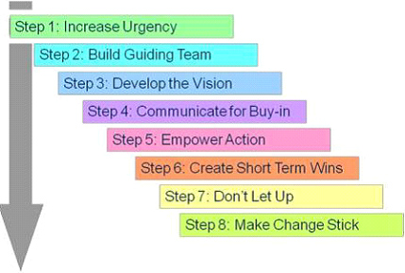
Figure 7: Kotter’s Model
Source: (Kyaddondo et al., 2017)
- To create an urgency
In Sainsbury the detailed analysis of customer needs could be defined by identifying and highlighting the probable fear and the repercussion which force to congregate up in the expectations. This could be also achieving by investigating the opportunity which can be tapped through successful intervention (Kyaddondo et al., 2017). The process of determining a truthful dialogue and consultation to make people believe over the widespread issue and give believable reason to them could also act as the way of budding necessity within an organization. Regardless of this, the demand connection and sustain of the production people, key stakeholders and consumers on the issue of change (Kyaddondo et al., 2017).
- To perform the powerful guiding coalitions
In Sainsbury, to perform the powerful guiding coalitions the way of identifying most effective and appropriate number of change leaders needed to guide and perform the procedures as per the changes defined over an organization needs to be processed over an organization (Keiningham et al., 2019). It could be supported by that of implementing the most powerful change coalition which would be defined to work as the team. The process of identifying work areas within the coalition teams and to assures the fact that the teams include the majority of influential defined at various cross functional department working over the different levels of an organization could be developed and defined over an organization for having the accurate implication of the strategies as per that of the varying set of strategies (Keiningham et al., 2019).
- To develop the vision and strategy
In Sainsbury, the development of strategies as per that of the vision provided over an organization could be processed by analysing the core values which defines the ultimate way of defining the vision and strategies based over the concept of change management.
- To communicate the vision
The vision statement defined by an organization named as Sainsbury must be developed and defined in a powerful and convincing form. The set of components which needs to be discussed over an organization includes performance reviews, training sessions being performed by an organization (Keiningham et al., 2019).
- To remove the number of obstacles
With the aim of achieving the growth and development of an organization in most effective form, this has been accessed by developing the most effective set of strategies as per that of procedures and strategies applied over an organization. In Sainsbury, this could be processed by analysing the number of factors and people who resist over the change. The implication of proactive forms could be included (Keiningham et al., 2019).
- To create and defined the short term wins
In Sainsbury, by developing the short term wins over the early process could include the early stage defined over the change. This could be achieved by creating the majority short term targets despite of developing the long term goals. The contribution of rewards to people included for meeting the target could be defined.
- To consolidate gains
The profit generated in Sainsbury could be analysed by including continuous improvement processed by analysing the progress of improving the experiences defined by individual (Pearson, 2016).
- To anchor the alterations defined over corporate culture
In terms of defining the accurate implication of alternative procedures, the need for defining the change initiatives needs to provide the number of opportunities generated over an organization. This acts as the way of assuring the fact that the existing and new number of leaders could act as the way of supporting over the change (Pearson, 2016).
The in-depth analysis of this model in Sainsbury could act as the way of providing the clear description and guidance being provided over the defined number of change management process defined over an organization.
- Stakeholder mapping
The stakeholder mapping has been defined to be the process of identifying the major stakeholders as per the implication of defined aims and objectives of projects. In other words, it is a way of identifying the entire set of individuals who are interested in accomplishing the desired set of research outcomes. The process of analyzing the employees has been categorised to be done in two ways defined as:
The level of interest
This includes that stakeholders have been affected by the project outcome but does not holds the power affect the requirement of project.
The level of influence
This includes the fact the number of stakeholders have power to modify and set up the needs and demands of project. The stakeholders have been affected by the project result (Pearson, 2016).
For providing the effective facts defined over the stakeholder mapping, the focus of project manager must be made over the aim of satisfying the expectations of stakeholders to affect the existing project. In Sainsbury, the implication of stakeholder mapping would help in providing the success and development defined within an organization. This would serve as his way of involving majority of stakeholders to participate over the development and need of the project management concept defined as per the varying set of procedures and strategies (Pearson, 2016).

CONCLUSION
The entire implication of this report has been done to analyse the factors being responsible for determining the customer relationship management concept determined over the working structure of an organization named as Sainsbury. In addition to this, the major term which has been focused on evaluating the customer experience includes the critical way of determining the customer values. The customer value has been defined as the way of treating the customers and its needs with full dignity and respect as per the aim of maintaining loyalty over an organization. The need for understanding the customer needs could be processed within an organization. The major term which needs to be focused includes the term defined as customer relationship management. This helps in managing the entire procedures defined over the interaction and potential customers. The value of an organization has been defined to be the UK’s most trusted retailers over which the people love to work and shop. This has been evaluated to be the social, economic, and environmental responsibility over which the success of an organization has been dependent over the progress and development factors.

RECOMMENDATION
For the growth of the company this is very important that the manager have to implement Greiner growth model which have a 5 crisis. This model will explain some of the faces that the organisation has to implement this for the growth of the company. Greiner model of organisation growth is one of the most important strategic management tool which will help every modern business to make their correct strategic decision to gain maximum amount of profit. this model will also help to understand the main reason of management style organisation structure and why they are not work for some specific area to improve their business (Pearson, 2016). By using this model, the company will easily grow their creativity level which will beneficial for the company. This was identifying that this model can be a most important tool for the organisation to handle the sum of the subsequent growing pain. If the organisation is facing any growing pains, then they are prepared before due to which they will resolve this pain in successful manner. There are many positive effects of the company by growing pains. Stakeholder identification is one of the most important procedure through which the company will identify all the stakeholders for the project which is very beneficial for them for their future (Pearson, 2016). This is also very important that they have to understand that all the stakeholders are not similar to influence or effect on a project and also they are not affected in the mutual way. Most of the time the company was mainly focus on making a good relationship with their target customer which will help them to managing the entire procedure to interact which target customer.
Stakeholder can be an individual work on a project group of people or organisation. Stakeholder may be actively involved in all the project work which will effect on the result of the company. Decide to through some analysis this was identified that stakeholder are the internal part of the project organisation or external like customer creditor and many more. it is important to understand that all the stakeholders will not influence or effect on the project. There are many different type of waves which the company have to take at the time of identify the stakeholder for their project work (Pearson, 2016). Greiner curve is a very useful model for thinking about some of the crisis that organisation have to take experience for their growth of the company. Also this will help to identify some problems with the customer was reaching at the time of buying the product. By using both this model will help the organisation to gain the maximum amount of profit and to achieve their objective in successful way. The manager of the company will also satisfy the need and wants of their target customer by providing a good quality of product and services and they will also have trained their employees who working in the organisation by implementing this model which will help to grow the revenue of the company (Pearson, 2016).

REFERENCES
al Habibi, B., 2019. HR practices of Marks & Spencer, Selfridges, Primark, and Sainsbury’s (Doctoral dissertation, University of Science & Technology).
Armstrong, G.M., Kotler, P., Harker, M. and Brennan, R., 2018. Marketing: an introduction. Pearson UK.
Keiningham, T., Aksoy, L., Bruce, H.L., Cadet, F., Clennell, N., Hodgkinson, I.R. and Kearney, T., 2019. Customer experience driven business model innovation. Journal of Business Research.
Kumaradeepan, V. and Pathmini, M.G.S., 2017. Customer Satisfaction and Customer Loyalty: Leading Super Markets in Jaffna District, Sri Lanka. Macrothink Institute, 19, pp.67-75.
Kyaddondo, D., Mugerwa, K., Byamugisha, J., Oladapo, O.T. and Bohren, M.A., 2017. Expectations and needs of Ugandan women for improved quality of childbirth care in health facilities: A qualitative study. International Journal of Gynecology & Obstetrics, 139, pp.38-46.
Lancaster, G. and Massingham, L., 2017. Evaluating and controlling strategic marketing. In Essentials of Marketing Management (pp. 381-401). Routledge.
Morgan, A., 2017. A Chronological literature review of Retail Internationalisation: From the 50’s to the ‘00’s-Towards a perspective of current market inclines in retail internationalisation 2010–2015.
Pearson, S., 2016. Building brands directly: creating business value from customer relationships. Springer.
Reinartz, W. and Linzbach, P., 2018. Customer loyalty and reward programs in retail in the digitalage. In Handbook of Research on Retailing. Edward Elgar Publishing.
Rohwer, L. and Topić, M., 2019. The communication of Corporate–NGO Partnerships: analysis of Sainsbury’s collaboration with Comic Relief. Journal of Brand Management, 26(1), pp.35-48.
Sisakht, M.S. and Ansari, Y., 2017. The effect of relationship marketing on customer loyalty to the brand, the Agricultural Bank in Kohgiluyeh and Boyer. JOURNAL OF MANAGEMENT AND ACCOUNTING STUDIES, 5(01), pp.55-60.
Taylor, S., Wilson, E., Murfitt, K. and Balandin, S., 2020. Communication access in the retail environment for people with complex communication needs. Disability and Rehabilitation, pp.1-10.
Simchi-Levi, D., Kaminsky, P., Simchi-Levi, E. and Shankar, R., 2008. Designing and managing the supply chain: concepts, strategies and case studies. Tata McGraw-Hill Education.
Wali, A.F. and Nwokah, N.G., 2018. Understanding customers' expectations for delivering satisfactory and competitive services experience. International Journal of Electronic Marketing and Retailing, 9(3), pp.254-268.

