Marketing Plan for Best Western

Student Name-

Diana Gabriela Grecu
__________________________________________________

Student ID number

2232653
___________________

Marketing Essentials (BMIH4005)

Lecturer-
Dr. Huw Thomas
Chris Wilkin
______________________________

Table of Contents
Introduction 3
Component A 4
Situational Analysis- 5Cs 4
Company SWOT Analysis of “Best Western” 4
Customers: Segmentation Targeting/ Customer Profile 4
Competitors: Porters Five Force Model 5
Collaborators: B2B Relationships, Partnerships and Franchises 5
Climate: Pestle Model (Macro) 6
Objectives 8
Strategy 9
Tactics 10
Marketing Mix 10
Action Plans 11
Control 12
Identify USP, Features and Benefits 12
How to measure business performance 12
Conclusion 13
References 14
Appendix 15
Component B- PPT 15

Introduction
Marketing is the heart of business functions of the “Best Western” Hotel and using the marketing essentials and functions this hotel company can develop content and reach targeted customers with valuable information so that guests can be attracted to visit and experience hotel services. The Covid-19 pandemic also negatively affected “Best Western” Hotel, but it now recovered, and some other factors positively affect the hotel business industry to ensure smooth operations. The marketing essentials play a vital role for the “Best Western” Hotel to progress and recover losses (Ghandour et al., 2020).
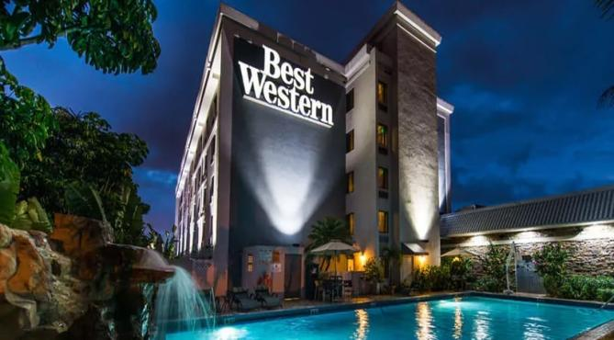
Figure: “Best Western” (Ghandour et al., 2020).

Component A

Situational Analysis- 5Cs

Company SWOT Analysis of “Best Western”
SWOT Analysis Model
Strengths | Best Western has developed a brand name and a large proven network of hotels that have ensured a friendly work culture by which employees can offer the best performance that can meet guests’ expectations and needed more effectively. (Nikolskaya et al., 2021)
Weaknesses | Best Western however faces inconsistent quality, and has a limited marketing budget. Besides, it depends on travel industry trends and has to make a marketing budget based on economic conditions (Nasir et al., 2022).
Opportunities | Best Western has growth and expansion opportunities in European and Asian countries and can go for sustainable and environmentally friendly practices to capture new markets.
Threats | Best Western faces huge threats from rivals in terms of new and improved products and services, from changing customers' preferences and on-going fluctuation in demands (Nikolskaya et al., 2021).

Customers: Segmentation Targeting/ Customer Profile
Best Western has segmented its total market into some sub-sectors based on geographic, demographic, and psychographic factors and it has used income level, personality, economic condition, regions and gender to segment and target customers based on the needs and expectations of different customer segments Best Western has developed best marketing mix to deliver the best and quality product and services to the targeted customers that can bring greater benefits to Best Western (González et al., 2022).

Competitors: Porters Five Force Model
From analysing Porter's five forces model, it can be concluded that Best Western faces huge competition from existing rivals especially from Holiday Inn, Radisson Blu, Hilton, and Premier Inn. However, Best Western has a good relationship with suppliers and they are loyal to delivering quality materials. Besides, customers are loyal and repeat and it is also evident that Best Western faces less competition from new entrants (Nikolskaya et al., 2021).
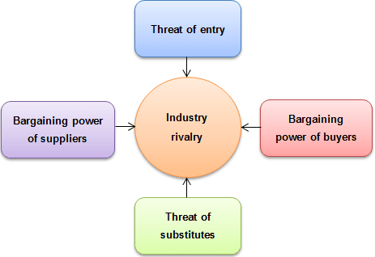
Figure: Competitor analysis (Nikolskaya et al., 2021).

Collaborators: B2B Relationships, Partnerships and Franchises
The marketing managers of Best Western developed policies to manage and maintain good relations with different travel agencies, and other suppliers for good quality of raw materials. The collaborators of Best Western are so effective that Best Western can use the resource to satisfy the needs and expectations of guests. (Nikolskaya et al., 2021)

Climate: Pestle Model (Macro)
The marketing managers of Best Western applies Pestle Model to understand how the broad macro environment affects this hotel and based on the findings they developed effective marketing strategies to ensure the selling of products and services. (Haniffa et al., 2022)
Political
Government rules and regulations affect Best Western in case of business operations and profitability and sometimes it faces challenges due to sudden rules and restrictions imposed by government authorities from time to time. (González et al., 2022)
Economic
The major economic factors that affect Best Western include economic fluctuations and changes in exchange rates. For example, economic upheaval can reduce travel rates and changes in exchange rates can affect costs and revenue (Haniffa et al., 2022).
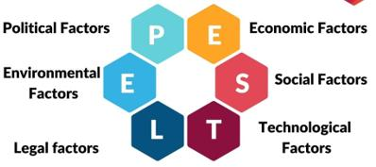
Figure: Pestle analyses (Haniffa et al., 2022).
Social
The changing customer demands and on-going changing preferences can affect Best Western. Besides, the social concern has forced Best Western to follow sustainable business practices and green practices that enhanced efficiency. (González et al., 2022)
Technological
The advances in modern technology and the use of online platforms have increased the competitive advantage of Best Western and this hotel can use modern tools and technology to conduct activities and meet changing needs (Nasir et al., 2022).
Legal
Best Western faces huge challenges and hurdles due to legal issues because aroused from different legal issues whether employee-related or customer related and this has, although costly, increased the favourable work environment. (Haniffa et al., 2022)
Environmental
The environmental factor force Best Western to develop and use environmentally friendly practices and make the best use of natural resources without wasting resources to ensure sustainability and long-term business operation for the future (González et al., 2022).

Objectives
Best Western has developed some objectives using the SMART model. The objectives are specific and measurable, and the marketing unit will develop courses of action to attain within the stated period.
- To increase occupancy rate by 12 per cent within 6 months through marketing campaigns. (González et al., 2022)
- To increase customer satisfaction by 16 per cent by offering quality service based on a feedback system.
- To increase revenue by 8.2 per cent within 12 months by improving the revenue technique system. (Haniffa et al., 2022)

Strategy

Organizational Value Proposition
The marketing unit develops different marketing strategies and tactics like SEO, Social Media Marketing to promote its brands and sell its products and services so that Best Westerns can develop and deliver the best value to its targeted customers and gain business success and operational efficiency in the long run (Ghandour et al., 2020).
The product differentiation strategy
Best Western is committed to meeting the changing demands of customers and the marketing unit of this hotel develops and conducts an integrated marketing approach to make a difference from others so that guests can easily identify Best Western as a source of great recreation and a place for entertainment and other business purpose. (Nasir et al., 2022)
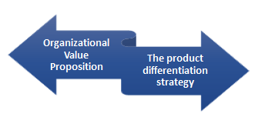
Figure: Strategy (Ghandour et al., 2020).

Tactics

Marketing Mix
Product
Best Western provides its guests with accommodation facilities such as personalized and budgeted hotels, resorts, and business meeting spaces endowed with amenities like breakfasts, lunch dinners, Wifi etc. (González et al., 2022)
Price
Best Western has developed and applied combo and dynamic pricing strategies which is dependent on the demand and supply of products at different seasons. Besides, it offers discounts (Khalayleh, 2022).
Place
Best Western has more than 4700 facilities in more than 100 countries to help visitors access different areas of the world more easily and enjoy themselves in the most convenient and possible ways. (Haniffa et al., 2022)
Promotion
The marketing unit applies a holistic marketing approach which includes the use of social media sites, email marketing, personalized marketing and collaboration with travel and air agencies to reach customers (Wichmann et al., 2022).
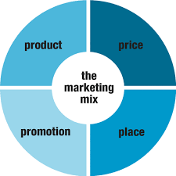
Figure: Marketing mix (Khalayleh, 2022).

Action Plans
Particulars | March  2023 | April  2023 | May  2023 | June  2023 | July  2023 | August  2023
Market Research
Aims and Objectives
Develop Market Strategy
Define Target Audience
Develop Materials
Launch Marketing Campaign
Monitor and Review
Track and Analyse
Review Decisions

Control

Identify USP, Features and Benefits
Best Western uses and applies the USP tool to develop a unique approach to develop and design improved products and services and meet the needs of guests more effectively compared to competitors. The best practices and unique services offered by Best Western attract more and more customers (Ghandour et al., 2020).

How to measure business performance
To measure the business success, it has developed a controlling and measuring technique that includes stating standards, assessing current performance and comparing with state standards to identify performance gaps and make the best decisions needed to revise the marketing strategy to promote brands. From time to time it faces challenges due to surprising policies and regulations imposed by way of authorities every now and then (Haniffa et al., 2022)

Conclusion
Best Western is committed to developing and offering the best quality product and services to its targeted customers and that’s why the marketing unit of this hotel has applied the 5cs technique to develop and conduct excellent marketing campaigns to reach customers with quality products and services which can enhance customers’ base, retention rate and on-going business success for future. Government policies and rules have an effect on Best Western in the case of commercial enterprise operations and profitability (Minazzi, 2020).

References
Ghandour, R., Bilal, J. and Mudassar, H., (2020). Relationship between Service Quality, Customer Retention, and the role of social media-Case Study Food & Service Industry. (UK). Journal of Organizational Studies and Innovation, 2(4), pp.1-12.
González, F., Hernandez, J.V., Ramirez, R., Linares, C.M., Peinado, J.A. and Daniel, J., (2022). Strategic planning for repurposing kitchen equipment production operations during COVID-19 pandemic. Operations Management Research, pp.1-16.
Haniffa, H.M., Muzaffar, W.W., Kemala, D., Ismail, F.F.N., Tan, W.E. and Manaf, N.A., (2022). Analysing the viability of starts-ups by SWOT/PESTLE analysis: Case study in Malaysia. In AIP Conference Proceedings, 6(4), pp.23-72.
Khalayleh, M. and Al-Hawary, S., (2022). The impact of digital content of marketing mix on marketing performance: An experimental study at five-star hotels in UK. International Journal of Data and Network Science, 6(4), pp.1023-1032.
Minazzi, R. and Lagrosen, S., (2020). Investigating social media marketing in the hospitality industry: Facebook and European hotels. In Information and Communication Technologies in Tourism 2020, pp. 145-157.
Nasir, M., Aziz, M.A., Zubair, M., Manzar, M.S., Ashraf, N., Mu'azu, N.D. and Al-Harthi, M.A., (2022). Recent review on synthesis, evaluation, and SWOT analysis of nanostructured cellulose in construction applications. Journal of Building Engineering, 46, p.103747.Bappy
Nikolskaya, E.Y., Pasko, O.V., Volkova, I.A., Dekhtyar, G.M. and Lebedeva, O.Y., (2021). Boosting the competitiveness of hotel business operators in current conditions. Journal of Environmental Management & Tourism, 8 (2)), pp.1617-1622.
Nyangwe, S. and Buhalis, D., (2020). Branding transformation through social media and co-creation: lessons from Marriott international. In Information and Communication Technologies in Tourism 2020, pp. 257-269.
Wichmann, J.R., Uppal, A., Sharma, A. and Dekimpe, M.G., (2022). A global perspective on the marketing mix across time and space. International Journal of Research in Marketing, 39(2), pp.502-521.

Appendix

Component B- PPT
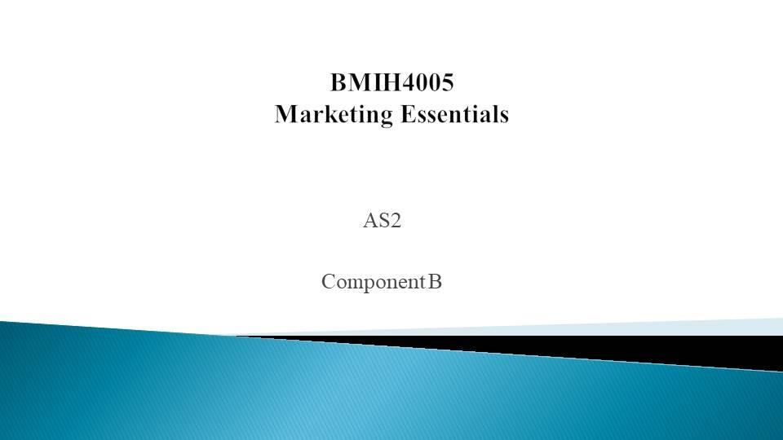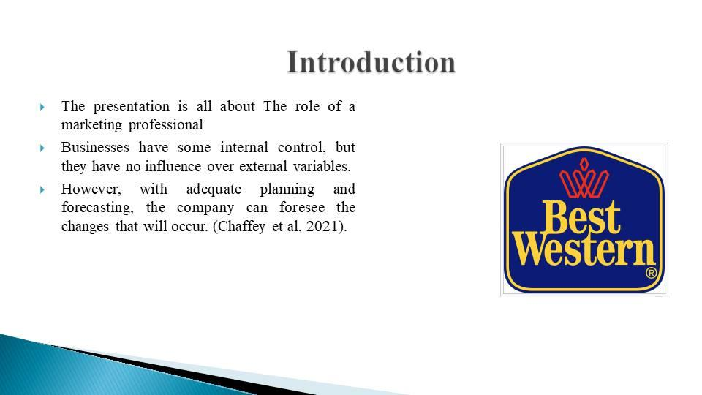
The presentation is all about The role of a marketing professional. Businesses have some internal control, but they have no influence over external variables. However, with adequate planning and forecasting, the company can foresee the changes that will occur. (Chaffey et al, 2021).
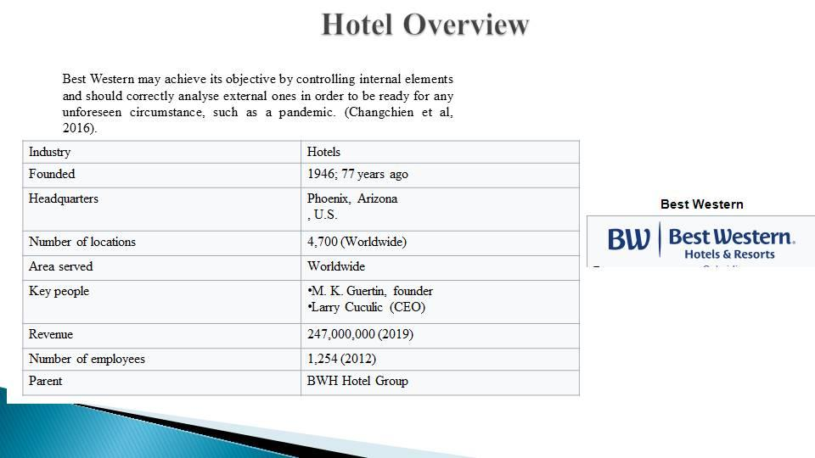
Best Western may achieve its objective by controlling internal elements and should correctly analyse external ones in order to be ready for any unforeseen circumstance, such as a pandemic. (Doole et al, 2016).
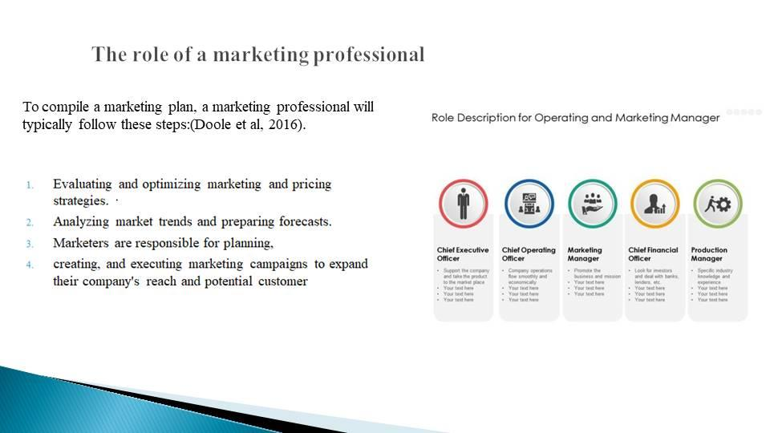
The choice of the target market is the next phase. Urban-dwelling young professionals are prepared to pay more for superior services and prefer the ease of home delivery. Small company owners often need to send items to clients or suppliers, therefore they need dependable and reasonably priced delivery services. For online order fulfilment, e-commerce businesses need a trustworthy delivery service. (Doole et al, 2016).
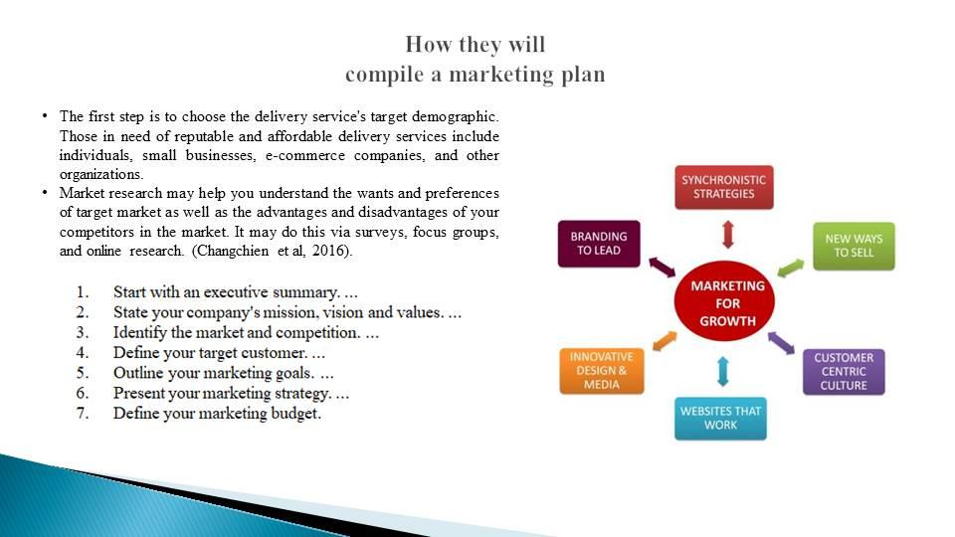
The first step is to choose the delivery service's target demographic. Those in need of reputable and affordable delivery services include individuals, small businesses, e-commerce companies, and other organizations. Market research may help you understand the wants and preferences of your target market as well as the advantages and disadvantages of your competitors in the market. You may do this via surveys, focus groups, and online research. (Changchien et al, 2016).
The last step is to develop a positioning plan that sets the delivery service apart from competitors while also attracting the target market. The transportation service might highlight its reliability and on-time delivery as a significant benefit for its target market, which values simplicity and effectiveness. For small businesses and individuals who often send items and are price cautious, the delivery service may offer itself as a low-cost option (Changchien et al, 2016).
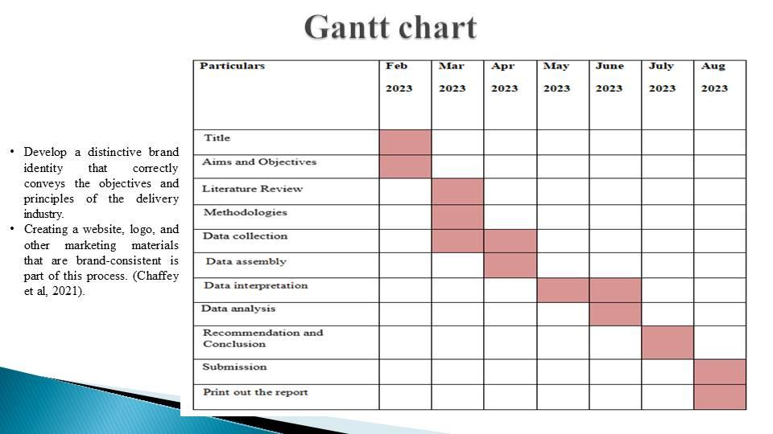
Develop a distinctive brand identity that correctly conveys the objectives and principles of the delivery industry. Creating a website, logo, and other marketing materials that are brand-consistent is part of this process.
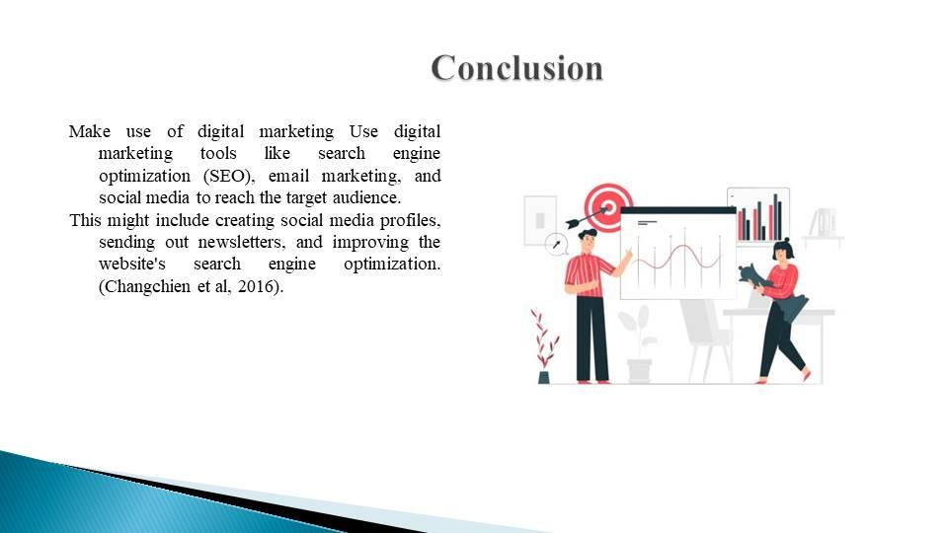
Make use of digital marketing Use digital marketing tools like search engine optimization (SEO), email marketing, and social media to reach the target audience. This might include creating social media profiles, sending out newsletters, and improving the website's search engine optimization. (Changchien et al, 2016).


