
Skills for the Workplace
Module Assignment Submission
Student Name: | Caroline Lewis
Student Number: | 1917865
Module No: | BMSK 5006
Module Title: | Knowledge and Information Management Skills for the Workplace

Statement of Confirmation of Authenticity
By the act of making this submission, the student declares that this is the work of the student named above. The work has not, in whole or in part, been knowingly presented elsewhere for assessment, or where assessment has been built on a previous assessment, this has been identified. Where materials have been used from other sources it has been properly acknowledged. If this statement is untrue, the student acknowledges that an assessment offence has been committed.
Attention is drawn to the plagiarism and unfair practice policies of both the University and of ILM.
Permission for ILM to use this script
ILM uses learners’ submissions – on an anonymous basis – for assessment standardisation. By submitting, both the centre and the learner agree that ILM may use this script on condition that identifying information is removed. However, if you are unwilling to allow ILM use this script, please refuse by ticking the box: □

Table of Contents
Introduction………………………………………………………………………………………3
Management Synopsis 3
1.Provide an evaluation of the concept and importance of knowledge management in the context of an organisation’s knowledge assets 4
2.Demonstrate an understanding of important knowledge management processes in the context of organisational development ……………………………………………..…………….…9
3.Provide a framework for establishing a knowledge management culture …………………...15
References 20
Bibliography 24
Appendix 1 26
Appendix 2 27
Appendix 3………………………………………………………………………….…….…….27
Appendix 4……………………………………………………………………….……………..29
Appendix 5…………………………………………………………………………………..….32
Appendix 6……………………….……………………………………………………………..33
Appendix 7…………………………………………………………………………..………….34
Appendix 8………………………………………………………………………………...……35
Appendix 9………………………………………………………………………..…….………37

Appendix 10…………………………………………………………………………………….38
Appendix 11……………………………………………………………………………….……39
Appendix 12 ………………………………………………………………………….………..40
Appendix 13……………………………………………………………………………………41
Appendix 14…….……………………………………………………………………………...42
Appendix 15…………………………………………………………………………………….43

Introduction
The author is a single mum and has been working for Swansea Council for over ten years. She has worked in several departments including business rates and council tax. For the last two years she has been a rent officer.

Management synopsis
In this report, the author has researched the theory on data, information, knowledge, and wisdom to see if it is a valid theory for her workplace; she has ascertained that another stage would be more beneficial in her role. She has completed a S.W.O.T and a P.E.S.T.L.E analysis to assess the current knowledge management of her workplace and with this information, along with quantitative and qualitive data from questionnaires from her work colleagues, to establish their thoughts on the current knowledge management system and with this data the author established a plan to improve it. The author has learnt the benefits of a flowchart on capturing knowledge management and created one to use in the workplace. The author has looked at the importance of GDPR but has identified its negative points. Throughout this report the author has utilised a C.R.A.A.P test to ensure her research sources are credible and an example of this is in Appendix 15.

1. Provide an evaluation of the concept and importance of knowledge management in the context of an organisation’s knowledge assets

According to Braganza (2004), data are facts and observations, which in a specific framework become information, this information converts into knowledge when it is applied to solve a challenge or complete a task. Ackoff (1989) delivered his theory on data, information, knowledge, and this enabling wisdom (DIKW) for the Journal of Applied Systems Analysis. (Diagram appendix 1). This theory has been questioned by Robinson (2013) and challenged that DIKW jumps in stages, and parts are missing, e.g., where data can be flawed in complex situations, and critical thinking is needed to turn each stage into the next. Robinson stated “Simple examples used in DIKW pedagogy do not reflect complex communication patterns in real-life settings. Context clues are necessary to make sense of the terms.”
Robinson (2013) also cites Frické’s (2008) critiques by disputing that the idea of data in connection to information is seriously flawed. One such debate, to assume information from data is true determines that the judgments must then be also correct. This inductive belief cannot be maintained.
The author in her role as rent officer uses weekly data reports to assist the rent arrears of her area via Microsoft PowerBi. This data gives a history of the city via graphs but can also give details of all tenants rent patterns and payments week by week. She agrees with Ackoff that this data turns into information via reports and graphs enabling her to gain knowledge of homes to focus her priorities on, which are in rent arrears. Without this data, arrears may increase without action, causing her organisation loss of revenue and productivity; ultimately resulting in tenant eviction. Yet, the author also agrees with Robinson (2013) that data can be flawed. The author has experienced issues of human error inputting incorrect information can affect the report e.g., no bank account details, therefore no payments showing, or IT issues, where payments have been inputted twice. Both reasons will show incorrect data, and in turn wrong information to be acted on by the rent team. The author also agrees with Robinson that critical thinking is needed, not to presume that a tenant is not paying due to the figures of the data, causing a court letter to be issued, but to investigate each possible scenario, gaining further knowledge to resolve the issue. She believes a step between ‘information’ and ‘knowledge’ would be more beneficial, this process she would call ‘investigation’, changing to DIIKW, this would be a critique of the information which would be a more accurate conclusion of the wisdom. Overall, the DIKW is a useful theory which enables a base to start a structure of recovery of rent.
According to Ferraris et al (2019), the DIKW Pyramid would commonly be deemed to be inadequate in modern times. It is argued that two more notions, document, and sign, are required to deliver a productive theoretical structure for the organization of knowledge. Document and sign are used in the author’s workplace by her manager to ensure important practices are read and acknowledged. In particular GDPR, reporting of gifts and health and safety requirements as it produces proof if any dispute arises in the future.
Frické’s (2009) criticizes the DIWK theory as being uninspired. “That the DIKW theory encourages uninspired methodology does not mean that it is false. It means that it is undesirable methodologically. Theories are adopted and used for a variety of purposes, in a variety of settings; and decisions regarding adoption may range over, possibly orthogonal, virtues or shortcomings. Methodological weakness is one such shortcoming.” Frické (2009). However, the author believes it is a credit to use in her organisation.

Individual knowledge/organisational knowledge.

Baldé, et al (2018), says as cited in Nonaka (1994), “Tacit” knowledge has a personal quality, that is difficult to formalise and convey when it is deeply embedded in act, dedication, and participation in a particular situation. Baldé, et al (2018) also says as cited to Nonaka and Takeuchi (1995), tacit knowledge contains cognitive abilities including attitudes, perception and psychological simulations, as well as functional talents such as know-how. However, “explicit” knowledge denotes to knowledge that is conveyable in authorised, precise language expressed through words and numbers held and documented records in files, accounts and databases. The relationship between individual knowledge and organisational knowledge is how to identify individual (tacit) knowledge, communicate and store this information, turning into organisational (explicit) knowledge, thus improving, and sharing its’ benefits to increase productivity. Recently the author’s workplace has had a restructure where colleagues with years of experienced have been moved to different areas. The author has replaced them and has sort to gain the knowledge for herself, which is frustrating, time consuming, errors are being made and productivity of the rent team is falling due to this. She is having to search for contacts and establish her own tacit knowledge for the tasks.
The author conducted a survey with other members of her organisation to identify if they had also experienced this loss of tacit knowledge when a colleague has left the team. (Results appendix 2)
Out of a sample of 8, all had experienced loss of knowledge when a colleague left, thus showing the importance of documenting tacit knowledge for others to benefit.
In this modern world of competition an employee can be reluctant to share their knowledge, holding onto their worth, which can be a barrier to gaining explicit knowledge.
According to Paulinbe (2009), a lifetime occupation is a thing of the past, resulting in competitive demands on individuals, expanding varied job paths that are volatile and chaotic. Accountability for continued professional development is now in the control of the individual. For the modern knowledge worker, it is vital that individuals sustain, grow, and promote their abilities to give them any prospect of competitive improvement in the employment market. This can cause conflict between tacit knowledge and explicit knowledge and questions if it can be harmonised.
This tacit knowledge is hard to collect as the author has experienced times when colleagues assumed that she knew the knowledge they had, or some kept their knowledge to themselves to be seen a more competent valued worker.

The author has compiled a SWOT analysis on her workplace knowledge management and identified knowledge assets. (Appendix 3)
SWOT results:
Rent manager: young with new ideas on knowledge management. She is focused on updating technology that the rent team uses, benefiting from Microsoft SharePoint and Teams. She is focused on documenting online and replacing paper files which gains easy access for all team members when they need it without the physical presence of being in the office. She is motivated to improve team morale, effort, and the team’s trust.
Experienced staff: some members of the team have extreme tacit knowledge of over 20 years. Others have specialist areas (especially benefit advice and direct contacts with the Universal credit team). Some staff have worked in other departments which have benefited their current role (e.g., Council Tax)
Commissioning review 2020: identified areas of improvement and budget was awarded to update IT systems, which helps store and share knowledge.
New IT platforms: SharePoint has recently been adapted by the rent team. The rent manager has set up clearly labelled online files that contain knowledge information. All members have Microsoft Teams for communication.
Powerbi: enables the data to identify homes of tenants that may need help, or that require recovery action, therefore improving productivity.
Idea hub: Online idea hub on internal webpage to put forward staff ideas and improve working.

The author has completed a P.E.S.T.L.E to evaluate, and critique actual and potential knowledge assets and knowledge management in her organisation. P.E.S.T.L.E in detail (Appendix 4).
Main points:
Political: recent commissioning review allowed increased IT budget for the use of SharePoint, which helps store knowledge management and prevent breaches of GDPR., yet GDPR can also be a barrier to the author’s organisation in providing assistance and care of its’ tenants and affects productivity.
Economic: SharePoint saves money on knowledge management, frees up office space, as no paper files are needed, and helps prevent breaches and fines to her organisation. Working from home frees up offices as knowledge management is online, however, the cost of IT training will affect the budget.
Social: highly training colleagues are retiring; this tacit knowledge needs to be captured before lost. Buddying exercises have started. Social media, LinkedIn and competitors’ websites can be used to gain extra knowledge.
Technical: New IT systems SharePoint and Teams, enable safe storage and easy access of capturing knowledge management. Many systems to navigate causing difficulty in locating data.
Legal: SharePoint easy to delete what is no longer legally required. GDPR measures are in place to prevent breaches.
Environmental: saving trees as paper files now online. Extreme weather can affect online connection and access.
According to Dubberly (2011) models help bridge the gap between observing and making, which the author agrees with, one such model that can aid knowledge sharing to turn tacit knowledge to explicit is SECI (Appendix 5)

According to Li et al (2018), SECI model is missing a stage between tacit and explicit, this he describes as grey knowledge. “For most individuals, obtaining tacit knowledge is not a simple process. Rather, knowledge is usually acquired through a sequence of interactions. First, tacit knowledge is acquired by observation and experience, whereas explicit knowledge is recorded, as in books. Then, grey knowledge with a certain scale is integrated in the mind by reflection and practice” Li et al (2018). The author agrees with Li et al (2018), tacit knowledge should be tested and reflected on in this grey area to see if it is beneficial to be made explicit. This grey process will give merit and in turn a time scale to turn this tacit knowledge to explicit, e.g., is it urgent, prevents errors etc.
According to Farnese et al (2019) citing (Davenport and Prusak, 1998; Ford, 2004), the SECI basis symbol, which is coiled, varies from the majority of knowledge management process concepts, which mostly suggest an evolutionary route; for example, the making–organisation -transmission–application procedure. Farnese also describes SECI as a holistic approach to knowledge management. The author agrees with both these points that the theory is a coil, therefore always rotating and flowing from one element to another, a holistic ‘as a whole’ approach, each part cannot progress without each other.
The author has completed a SECI to show how it is used in her workplace. (Appendix 6)

2. Demonstrate an understanding of important knowledge management processes in the context of organisational development

Creation of knowledge comes from experience, discussions, collaborating with other organisations etc. Experimenting with new ideas or making suggestions due to observations.
“Knowledge creation puts particular demands on organizational relationships. In order to share personal knowledge, individuals must rely on others to listen and react to their ideas” Krogh et al (2000). The author agrees with Krogh (2000), as she has experienced times where she has made what she thought was a valid suggestion that would benefit the team via online group chat, yet no one answered. This had a negative reaction to the author, she felt foolish to suggest, made her reluctant to suggest further ones and affected her trust in the team. Any reaction from a member of the team would show some respect that it was read and noted, however, ignoring the message made the author feel an outcast.
Trust and care in an organisation are needed in the creation of knowledge. According to Krough (2000) making “care” an essential element of the daily involvement; in aiding, encouragement, and reassuring groups of invention and enjoyment; and in establishing a common area where knowledge is produced, swapped, and applied for constant, competitive improvement. The author has spoken to her manager explaining as the latest member of the team, she sometimes feels foolish asking as question in a team meeting as perhaps the other team members already know the answer. Her manager Andrews (2021) replied “There is no such thing as a bad question”, and she explained that asking questions can start a debate of how others in the group work, sharing and turning a person’s tacit knowledge into explicit knowledge. “From a managerial point of view, it emerges that firms adopting an active open approach to innovation, are more likely to develop innovation capacity.” Santoro (2018). Therefore, the author agrees with Krough (2000) Santoro (2018) and further discussed with the author’s manager Andrews (2021) that a work-based culture of care, empathy is needed to open the channels to communicate and to have an active approach to innovation, can improve the knowledge management.

“Knowledge is broken into two forms and its sharing (through communication channels) can be described as externalization or combination by the SECI model. Such platforms have revolutionized the way developers work, introducing new channels to share knowledge in the form of pull requests, issues and wikis.” Tantisuwankul et al (2019) As Tantisuwankul et al (2019) describes the SECI model provides a platform where information can be shared or pulled from tacit knowledge into explicit.

SECI, Nonaka in 1990.
Socialization (Tacit to Tacit): Sharing knowledge through practice, supervision, imitation, and observation, practice, buddying etc.
Externalization (Tacit to Explicit): tacit knowledge is documented.
Combination (Explicit to Explicit): document knowledge is combined or updated to become new knowledge.
Internalization (Explicit to Tacit): documented knowledge is used to improve and aid tacit knowledge.

Farnese (2018) says according to (Glisby and Holden, 2003; Gourlay, 2006; Bratianu, 2010) the model’s significant generalization has guided numerous writers to disapprove of it, claiming it is mainly built on subjective evidence and does not have a sturdy foundation. Moreover, Farnese (2018) says at cited (Nonaka et al., 1994; Becerra-Fernandez and Sabherwal, 2001; Lee and Choi, 2003), owing to its tacit element, the model can be especially vague and challenging to test. In fact, until now just a small number of researchers have tried to operationalise the model, suggesting tools that reveal its four modes, however displaying indecisive conclusions.
The author disagrees with Farnese as she sees the knowledge management files improving. Not just enlarging the information but also cutting out of date knowledge and combining new for better practice. Her manager is proactive in asking for any procedures that individuals use that could be stored for new starters etc. She promotes this knowledge sharing and is keen to document it.
A similar theory below:
The model for organisational learning. Source Boisot 1987.

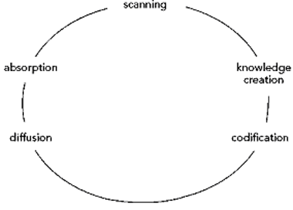

“The codification, diffusion, and absorption phases are directly concerned with leveraging knowledge. They are concerned with transforming individual knowledge into organizational knowledge and with incorporating the knowledge into behaviours and actions of the organizational being.” Merali (2003)
The author recognises the similarities between this and SECI, the ongoing circle between turning tacit to explicit.
Storing this knowledge can be done in several ways. Emails, paper files, online files (SharePoint), recorded videos, minutes of meetings.
Flowcharts can be used to store information; these are used in the author’s workplace to ensure the right course of action is taken when there are multiple choices to aid tenants, who have different circumstances affecting them to pay their rent.
According to Passera (2018) Government-published documents often fail to communicate clearly—not only with public but also with civil servants and other professionals. Her study results show that the illustrative layout, contrasted to text, considerably improves understanding precision and solving speed and is recognized as more attractive and practical by clients. The author agrees with Passera (2018), a flowchart is a quick visual aid to ensure the correct information is given and carried out. The author has compiled a flowchart (Appendix 7) displaying how a new tenant can set up their housing costs to be paid, with directions of yes /no elements such as are they on Universal Credit or Housing Benefit.
The author’s workplace is in the process of scanning their files from paper to online SharePoint, this gives easy access to documents and shares the knowledge without the need for physical files. When emails are used to share information, the author’s manager implements the received and read notification, to acknowledge the information has been received by all. For important information such as health and safety, compliance, legal duties, etc, her manager requests she receives a return email, confirming the information has been read.
Storing of useful emails can be kept and named under files via Outlook.
According to GOV. UK, intellectual property rights support you to stop individuals taking or reproducing: the names of your goods or brands, your creations, the model or look of your manufactured goods, things you compose, create, or produce.
The importance of this owning (Copyright) and having control over the use of forms, creations, badges, brands within the workplace and not for them to be used by any other person or company. The author’s workplace has a logo on all their documents, emails, and badges which acts as a security authorisation, enabling sharing between associates, or to outside organisations validating its’ source. Badges and coats with this logo are worn as a security measure for staff in corporate buildings and when visiting tenants to prove to the tenant that they can confidently discuss their accounts.
The data the author’s organisation holds must be accurate and up to date, at any time an access request can come from a tenant and all information, notes, conversations must be pulled together for the tenant to read.
The author also discussed GDPR with her manager (Appendix 8). Tenants’ paper files are in the process of being scanned online. The access to these files is only for members of staff that need to know the information. Each type of document has a time in which the organisation is legally allowed to hold and store that information, e.g., a tenant file = 12 years after their tenancy ends. Personal information for staff is ‘locked’ online on SharePoint and accessed only by seniors, such as flexi sheets and this has a different store time of 7 years. SharePoint alerts the seniors to inform them the items need to be retained (R ) or if it needs to be removed (NR, not retained). This flag up alert also helps ensure the documents are not kept longer than legally required. This replaced old paper files that had to be locked and stored. This new advancement saves time, office space, and the need to destroy files physically. SharePoint information cannot be exported to anyone outside the organisation, which is an added security, preventing breaches. Information is shared rather than sent via an attachment, again reducing the chance of information being sent to the incorrect person. Random checks on signing into the system where added security questions are asked and authorisation codes are sent to personal phones, to ensure the correct user has access to the system, this is called multi-factor authentication (MFA). Email from author’s organisation promoting security recommendations, including world password day and think before you click (Appendix 9). SharePoint and Teams however is not fool proof; the author has experienced times where master copies have been written over in error by colleagues and times when she has accidentally deleted a colleague’s piece of work. The author’s questionnaire asked if any other member of the team had experienced this, revealing that 3 out of the 8 members of the team had also deleted a piece of work by mistake, which is a high-risk ratio affecting knowledge management and should be questioned further. (Appendix 10)
The author has experienced times when GDPR and sharing of personal information has been a barrier to completing her role. Housing Benefit section needed further information from a tenant to be able to assess their claim and emailed her the information they required. The author noticed her rent account was in arrears and investigated into it. When she spoke to her tenant, she could see the tenant had not replied to the email asking for further information; it transpired she had not received it as she had changed email addresses. The tenant asked the author if she would email Housing Benefit her new email address on her behalf giving her consent, which the author did. However, the reply from the Housing Benefit section said they cannot take this new email address due to data protection and that the tenant would have to call them directly. This hindered the rent account further due to a delay in the tenant re-engaging with Housing Benefit.
The author’s discussion with her manager brought yet another case. Welfare Rights team in the council are trying to target citizens who are eligible and missing out on pension credit, suffering poverty due to this. Housing Benefit have contacts of people who were previously receiving Housing Benefit but have now reached pension age, hence stopping the benefit. These people are likely to be eligible for pension credit due to their previous low income. When Welfare Rights section asked Housing Benefit for names and contacts of these people who are likely to be eligible, this information was denied due to GDPR. Furthermore, the author’s rent team could target face to face or over the telephone, a large majority of these names as they are the councils’ tenants, yet again this information is not allowed to be shared. The author believes in these circumstances, GDPR is not protecting the individual, it is hindering help and causing poverty. According to Hill (2020) Pension credit is currently claimed by just six in 10 of pensioners who are entitled to it, in part because awareness of the benefit’s existence is low: four in 10 people have never heard of it. Of those who have, fewer than half know who it is intended to help. “We actually have a relatively good idea about why uptake is so low. The problem is that the government have no idea who the eligible people not receiving pension credit are and indeed where they are,” said Deborah Alsina, the chief executive of Independent Age, which commissioned the research. Hill (2020). Safeguarding of children (GOV 2018) can override GDPR and the author believes in the cases of elderly poverty, GDPR should also be overridden within council sections as it is an ethical reason for care.

3. Provide a framework for establishing a knowledge management culture
“The knowledge-related processes in each stage are analysed by observing the role of know-what, know-why, and know-how, as well as the links between these different levels of knowledge” Raub (2003). The author agrees with Raub, breaking down and observing what, why, and how are key elements used in gaining knowledge.
“Knowledge assets represent the fount of an organization’s competences and capabilities that are deemed essential for its growth, competitive advantage and human development.” Kamasak (2010). The author agrees with Kamasak (2010), knowledge assets are essential for the organisation to grow in the competitive market. Knowledge assets help to achieve productivity, reducing time and therefore cost, resulting in higher profits, however a lack of knowledge assets can cause confusion, errors, and repeated errors, resulting in a bad reputation for the organisation. It can result in a high change-over of staff as trained respectable employees do not want to be associated with the company. Confidence in the organisation from its’ staff and customers can be lost, affecting employee morale and organisation’s profits.

The documents and its’ knowledge should be assessed regularly to ensure they are up to date and valid, if not, they should be deleted to keep concise, easy to read without overloading information which can put the user off trying to locate the information.

A combination of People, Process and Technology is needed to enhance knowledge management, and this is detailed (Appendix 11)
As per discussed with the author’s manager (Appendix 8). Weekly 30 mins online team meetings would benefit the growth of knowledge management. Problems that arose in the week could be discussed and how the troubles were overcome. This could then be shared, and an email sent to the manager to document the information on SharePoint for knowledge management. According to Jaziri-Bouagina (2017), information, here thought as messages interchange, enable also new ways of dialogue, with significant evolution, which attempt to reduce effects of non-physical workplaces, aiming to improve performance in oral, close communications, along with the availability of services such as social media usage and intensive video sharing platforms. Therefore, the author will suggest a media page especially for tenants when the offices are closed. The rents team can provide videos to help tenants with day-to-day troubles such as updating their housing costs on their Universal Credit journal. This platform can also be used to gain data from the tenant, via online questionnaires or chat discussion, which can in turn result in wisdom needed for further knowledge management e.g., what improvement service would you like to see from your District Housing Office?
The author proposed inhouse training videos showing usual tasks ready for new starters to learn from action, turning tacit to explicit knowledge. The manager was impressed, and the author will be the producer of these videos.
The mode answer from the author’s questionnaire regarding problems with IT knowledge management, was lack of IT training (Appendix 12), therefore specific IT training on the new SharePoint and Teams would be arranged.
The questionnaire (Appendix 13) also revealed buddying was the preferred way of training over online or workshops. The author will suggest a rota of days for members of the team to book a morning to buddy with a colleague or a different department, to gain new knowledge and best practice. This is further evident as, according to Jaziri-Bouagina (2017) tacit knowledge is mostly created, distributed, and controlled in circumstances, and generally described as “learn by doing”. Innovative business models, suggested as both updates or improvements from previous old ones, or real new constructions that are still young, are significantly based on tacit knowledge and its’ relevant management. This can be taken extended by buddying with other area councils and organisations, e.g., Neath Port Talbot, POBL.
The questionnaire also revealed the median thought too many emails were being sent as a way of sharing knowledge management (Appendix 12). The author agrees the information overload of these emails hinders the absorption of the information.
The author believes having a document on SharePoint with all the tacit contacts they have, be stored in one place for all to access. This should be regularly checked to ensure the information is up to date, if not, removed to prevent errors and lost time in searching through too much information.
Regarding barriers to knowledge management of constraints, influence and control, the author, along with her manager, would try to overcome these through open discussions of ways to improve. Making the manager aware of examples when they arise, may result in a change of practice, or set new processes. Some barriers cannot be overcome due to legal reasons, notwithstanding negative impacts from budget and time restrictions.
As team morale is important in gaining trust, the author suggests activities to help team bonding. These could be informal breakout rooms for organised activities. This will help staff feel safe and have the confidence to suggest and experiment new ideas, to promote a positive knowledge management culture.
The author feels staff encouragement helps to adapt to change. Due to the rent commission review, there has been a great change in the author’s team. Change is good for productivity and new ways of knowledge management; however, it has been met with criticism from some members of the team. Change can evoke fear in some of the more elderly team members, but support helps, and the fact we are all learning together. Everyone is on hand via online team chats to help, reassure and encourage.
Benefits of organisation learning can increase job satisfaction, develop staff into leaders and increase efficiency, which benefits staff and organisations.
Acknowledgment of achievements by managers will encourage staff to develop and share their thoughts of new knowledge. Questionnaire results (Appendix 14) showed when asked how you would share new knowledge gained, none of the responses said they would send an email to the manager to inform them of the new knowledge. Without this key element, tacit knowledge will never turn into explicit knowledge. The author surmises that team bonding with grades above and below, need to come together in a relaxed atmosphere to minimise the barrier of this closed communication.

References
BALDÉ, M., FERREIRA, A.I. and MAYNARD, T., (2018) SECI driven creativity: the role of team trust and intrinsic motivation. Journal of Knowledge Management, 22(8), pp. 1688-1711.
Braganza, A (2004) Rethinking the data–information–knowledge hierarchy: towards a case-based model, International Journal of Information Management, Volume 24, Issue 4,Pages 347-356, Available at: https://www.sciencedirect.com/science/article/pii/S0268401204000519 [Accessed 03.05.21]

Dubberly, H. and Evenson, S. (2011) Design as learning---or" knowledge creation"---the SECI model. interactions, 18(1), pp.75-79.
GOV.UK Intellectual property and your work. Available at:
Intellectual property and your work - GOV.UK (www.gov.uk) [Accessed 19.05.21]
GOV (2018) Information sharing Advice for practitioners providing safeguarding services to children, young people, parents, and carers. Available at:
https://assets.publishing.service.gov.uk/government/uploads/system/uploads/attachment_data/file/721581/Information_sharing_advice_practitioners_safeguarding_services.pdf
[Accessed 19.05.21]

Guide to the General Data Protection Regulation. Available at:

ttps://www.gov.uk/government/publications/guide-to-the-general-data-protection-regulation [Accessed 20.05.21]

Hill A. (2020) Four in 10 pensioners missing out on key benefit, says report. Available at:
https://www.theguardian.com/society/2020/sep/14/four-in-10-pensioners-missing-out-on-key-benefit-says-report [Accessed 19.05.21]

Farnese, M.L, Barbieri, B, Chirumbolo, A. and Patriotta, G. (2019) Managing knowledge in organizations: A Nonaka’s SECI model operationalization. Frontiers in psychology, 10, p.2730.

Ferraris, A., Mazzoleni, A., Devalle, A. and Couturier, J., (2019) Big data analytics capabilities and knowledge management: impact on firm performance. Management Decision.

Frické, M. (2009) The knowledge pyramid: a critique of the DIKW hierarchy. Journal of information science, 35(2), pp.131-142.

Jaziri-Bouagina, D., & Jamil, G. L. (2017) Handbook of Research on Tacit Knowledge Management for Organizational Success. IGI Global.
Kamasak, Rifat & Yucelen, Murat. (2010). “The Relationship Between Knowledge Assets and Organizational Strategy Development”. International Journal of Business and Management Studies. 2.
LI, M., LIU, H. and ZHOU, J. (2018) G-SECI model-based knowledge creation for CoPS innovation: the role of grey knowledge. Journal of Knowledge Management, 22(4), pp. 887-911.

Merali Y. (2003) Building and Developing Capabilities: A Cognitive Congruence Framework. Knowledge Management and Organizational Competence. Oxford University Press; https://oxford-universitypressscholarship-com.ezproxy.uwtsd.ac.uk/view/10.1093/acprof:oso/9780199259281.001.0001/acprof-9780199259281-chapter-2. [Accessed 10.05.21]

Nonaka, Ikujiro; Takeuchi, Hirotaka. (1995) The knowledge-creating company: how Japanese companies create the dynamics of innovation. Oxford University Press, Inc., 1995. xii+284 pp. xii+284. Oxford University Press

Nonaka, Ikujiro. (1994) A dynamic theory of organizational knowledge creation Organization Science; Linthicum Vol. 5, Iss. 1

PAULEEN, D. (2009) Personal knowledge management: Putting the "person" back into the knowledge equation. Online Information Review, 33(2), pp. 221-224.

Passera, S. (2018). Flowcharts, swimlanes, and timelines: alternatives to prose in communicating legal–bureaucratic instructions to civil servants. Journal of Business and Technical Communication, 32(2), pp.229-272.

People, process, technology [online image] Available at :
https://www.vulpoint.com/wp-content/uploads/2018/12/0.jpeg [Accessed 18.05.21]

Raub SP. (2003) Towards A Knowledge-Based Framework of Competence Development. Knowledge Management and Organizational Competence. Oxford University Press; Available at: https://oxford-universitypressscholarship-com.ezproxy.uwtsd.ac.uk/view/10.1093/acprof:oso/9780199259281.001.0001/acprof-9780199259281-chapter-5. [Accessed 19.05.21]

Robertson, Terry Dwain. (2013). "The Data/Information/Knowledge/Wisdom Hierarchy Goes to Seminary" Faculty Publications. 1174. Available at:
https://digitalcommons.andrews.edu/pubs/1174 (Accessed 09.05.21)

Santoro, G et al (2018) Technological Forecasting and Social Change Available at :
https://www-sciencedirect-com.ezproxy.uwtsd.ac.uk/science/article/pii/S0040162517302846 [Accessed 18.05.21]

Tantisuwankul, J. et al (2019) A Topological Analysis of Communication Channels for Knowledge Sharing in Contemporary GitHub Projects Available at: https://ui.adsabs.harvard.edu/abs/2019arXiv190503593T/abstract [Accessed 19.05.21]

Von Krogh G, Ichijo K, Nonaka I. (2000) Care in the Organization: Why an Enabling Context Matters. Enabling Knowledge Creation: How to Unlock the Mystery of Tacit Knowledge and Release the Power of Innovation. Oxford University Press; 2000. Available at: https://oxford-universitypressscholarship-com.ezproxy.uwtsd.ac.uk/view/10.1093/acprof:oso/9780195126167.001.0001/acprof-9780195126167-chapter-3. [Accessed 17.05.21]

Bibliography

Account Security and Privacy - Best Practices [Online] Available at:
https://www.linkedin.com/help/linkedin/answer/267/account-security-and-privacy-best-practices?lang=en [Accessed 07.05.21]
Aven, T (2013) A conceptual framework for linking risk and the elements of the data–information–knowledge–wisdom (DIKW) hierarchy. Reliability engineering & system safety, 111, pp.30–36.

Caroline J. Charpentier, Ethan S. Bromberg-Martin & Tali Sharot, (2018) Valuation of knowledge and ignorance in mesolimbic reward circuitry. Proceedings of the National Academy of Sciences - PNAS, 115(31), pp.E7255–E7264.
Duan, Y., Shao, L. Hu, G., Zhou, Z., Zou, Q. and Lin, Z., (2017). Specifying architecture of knowledge graph with data graph, information graph, knowledge graph and wisdom graph. 15th International Conference on Software Engineering Research, Management and Applications (SERA) pp. 327-332.

From Data to Wisdom. [Online] Available at:
https://bio.si/en/program/main-exhibition/17/from-data-to-wisdom/#:~:text=From%20Data%20to%20Wisdom%20is%20a%20text%20by,today%20widely%20known%20as%20the%20Data-Information-Knowledge-Wisdom%20hierarchy%20%28DIKW%29. [Accessed 06.05.21]
ICO, (2018) ‘Guide to the Freedom of Information Act (FOI) [Online] available at https://ico.org.uk/media/for-organisations/guide-to-freedom-of-information-4-9.pdf [Accessed 05.10.21]
ICO, (2018) ‘Guide to the General Data Protection Regulation (GDPR)’ [Online] Available at: https://ico.org.uk/for-organisations/guide-to-the-general-data-protection-regulation-gdpr/ [Accessed 05.10.21]

Lytras, M.D., Raghavan, V. and Damiani, E., (2017). Big data and data analytics research: From metaphors to value space for collective wisdom in human decision making and smart machines. International Journal on Semantic Web and Information Systems (IJSWIS), 13(1), pp.1-10.

UKEssays. November (2018). Importance of intellectual property rights. [Online]. Available from: https://www.ukessays.com/essays/property/importance-of-intellectual-property-rights.php?vref=1 [Accessed 18.05.21]

Appendix 1

Russell L. Ackoff
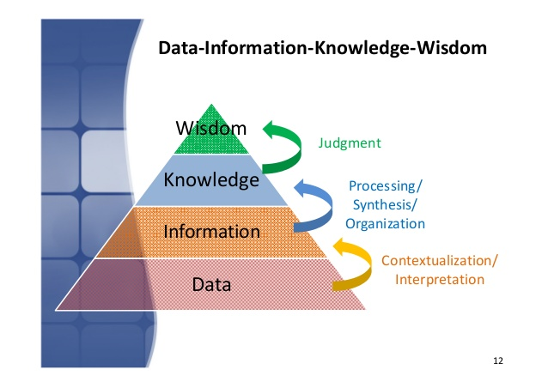

Online image available at: https://www.bing.com/images/search?view=detailV2&ccid=8JyiI8ES&id=377EB9B0FDC086960F35F0B51C9548D8FDBA68C4&thid=OIP.8JyiI8ESXaqazuU9mJUXNwHaFP&mediaurl=https%3A%2F%2Fimage.slidesharecdn.com%2Foverviewofhealthinformatics-140906042258-phpapp02%2F95%2Foverview-of-health-informatics-12-638.jpg%3Fcb%3D1409977616&exph=452&expw=638&q=data+to+wisdom&simid=608025841569892434&ck=8B440EF0AF09C154AB88541CF9DE28B9&selectedindex=35&form=IRPRST&ajaxhist=0&vt=0&sim=11 (Accessed 09.05.21)

Appendix 2
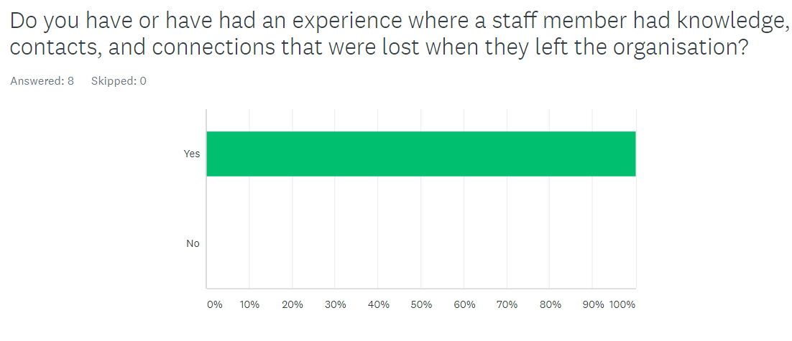

Appendix 3

SWOT on Knowledge management and identifying assists.
Strengths | Weaknesses
New IT systems (SharePoint, Teams,)  Team members have evolved and advanced their IT skills (due to working from home)  Highly skilled members of the team  SharePoint is secure paperless way of storing information.  Security setting can be applied to limit access of this information to only staff that need to know, preventing data breeches.  Young manager with keen interests to modernise rent procedures.  PowerBi reports are run weekly and provide are up to date data to work on. | Not all the team are confident with the new way of knowledge management via SharePoint.  Unable to share information to other sections due to GDPR.  SharePoint master copies can be overwritten by mistake.  Lack of training on the new knowledge management system on SharePoint, which results in more time being used to look for information.  Too much information to look through.  Arrogance of staff, unable to share tacit knowledge.
Opportunities | Threats
New ways of working due to Covid, are continuing to advance advanced knowledge management at a much faster pace…. Paperless tenant files in near future.  Training sessions are to be made, recorded, and stored in SharePoint.  Council has online idea hub has opportunities for staff to put an idea forward to benefit their ways of working, for the organisation or the customers.  Rent commissioning review was granted (2020) by the Government where more budget was granted for the improvements of Council Housing administration (which included knowledge management systems).  New staff have been taking onboard the rent team (after the commission review, which will bring fresh ideas and thoughts into the team, therefore improving the knowledge management. | Losing revenue due to Covid implications, which will affect the budget in future for future advancement.  Highly skilled staff are coming to retirement age and time is needed to make their knowledge explicit.  I T problems enabling access. Systems go down or error.  Team colleagues have deleted a SharePoint teams document by mistake and unable to locate.  Data breech if knowledge management is not secure will cause fines.  Higher pay and better working conditions in competitor companies (POBL) can take our skilled staff.  Losing contacts in different organisations due to their staff movements. Hard to build up new connections.  Lack of communication

Appendix 4

Pestle analysis of Knowledge Management and identifying assist.
Political
Recent commissioning review granted (2020) enabling improvements vis tech and budget, enabling SharePoint etc.
Bureaucracy issues to enable sharing data difficult, formal requests etc.
GDPR is sometimes a barrier, will new laws be put through to enable potential people in need to be allowed to be contacted if the authors organisation has information that could benefit them to contact them directly.
Economic
Local economy affected by Covid, lack of revenue being taking in for the rent as people on 80% furlough and making shortfall to their rent. This putting pressure on budget for IT tech affecting out online knowledge management systems.
Online knowledge management uses less paper and no need for room to store thus saving money on needless rooms for storage.
Cost of set up and usage to Microsoft for PowerBi reports, Teams and SharePoint.
Cost of training for these IT systems.
Council building that store knowledge management are no longer needed and being sold and profit to go back into council budget.
Saving cost of files, saving cost of a team member or organisation to destroy the files as going forward a click of a button can destroy them, rather than a charge to remove confidential waste.
Social
Keeping the moral at work high to keep them engaged in adding to the knowledge management.
Ensure they are trained and happy using the online management tools.
Ethics: is GDPR ethical in some parts? Relaxation of the rules may need to be looked at to share knowledge information to help people in need.
Safeguarding of children can override GDPR, could therefore reducing poverty be also a point to overcome GDPR?
Staff members retiring and the need to store their knowledge before leaving.
Easy to interact with others to discuss knowledge via teams, instant, face to face or via a message.
You can have easy access to this knowledge through home working (computers) no need to be in the office to gain it through paper files.
Technical
Technical issues may prevent knowledge management working via Teams and SharePoint if systems are down.
Deleting important details can cause problems.
Competitor’s technology may improve to better things leaving us behind.
Too many different systems to look for information and other sections have different systems.
Legal
Keeping the information needed for the correct time and not keeping info longer than legally needed.
Preventing data breeches, therefore secure passwords for systems. Locks on accesses for information. Care taking when emailing.
Use of SharePoint rather than emailing attachments prevents breeches.
GDPR important in many areas but also a barrier… unable to share info to enable potential financial help being offered.
Environmental
Moving from paper files on to online SharePoint is benefiting the environment and saving trees. Documents do not have to be printed.
Council buildings that have previously been used to hold files are being sold as now no longer needed. These local old buildings are being sold or being made into homes and improving the local area.
Adverse weather conditions can influence internet connection, and this can be a barrier sometimes to gain the knowledge on the systems.
Able to access information from any location with a computer and internet connection.

Appendix 5

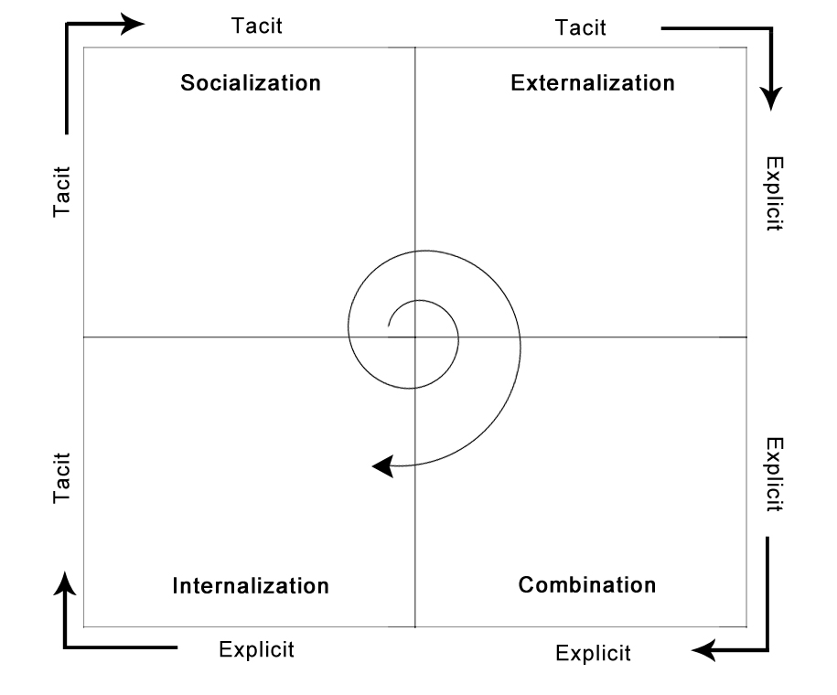

Online image
Available at:

seci model - Bing images (Accessed 10.05.21)

Appendix 6
Examples of SECI in author’s workplace.

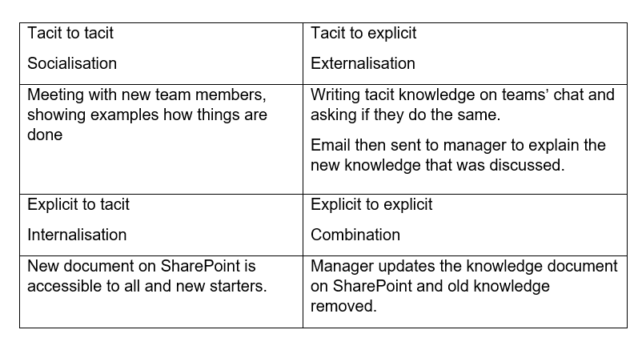

Appendix 7
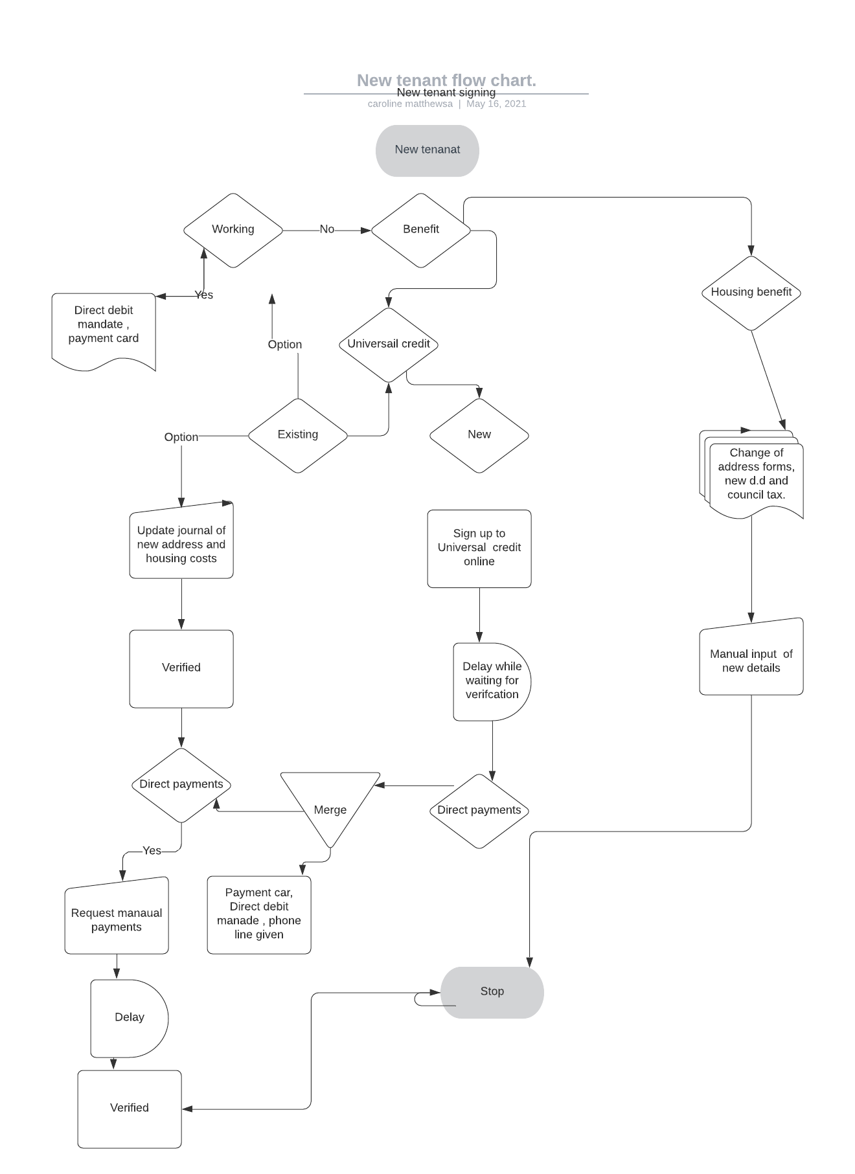

Appendix 8
(Andrew 2021)
Discussion via Teams with manager (Helen Andrew) 10.30 a.m. 13.05.2021
Turning tacit knowledge to explicit knowledge.
Discussed how a member of staff left the organisation after long term leave and we were not prepared and lost her tacit knowledge. This knowledge has taken time to rebuild, and recoup. The post has not been filed and that persons specialised work had to be absorbed into the rest of the team along with their own workload. Each member had to, by trial and error gain the knowledge for themselves to complete the tasks.
The organisation has learnt from this and has recognised key people who have invaluable tacit knowledge and who are close to retirement age to prevent this loss of knowledge again.
They are beginning to document his knowledge. They are also budding other members of staff to share this information with them.
The author suggested as the team have had lots of training sessions lately that we somehow store this knowledge, however, due to copyright the author is aware that this cannot be done. Therefore, the author suggested that in house training videos should be made of tasks, experience knowledge that would be easily accessed via a folder on teams or SharePoint. These folders can be used for new starter or as a refresh when needed. The manager really liked this idea and has suggested that the author be the presenter of one. The author also suggested that stored PowerPoint slides of steps how to do things and contact at the end. This is more for a quick refresh where staff want a quick step that this have forgotten about and can flick through quickly and not watch a presentation.
GDPR
Discussed the good practices to prevent data breeches. Manager suggested always go to global search list and never take the populated name that has previously been used, as this may bring the same first name and wrong person.
Manger also informed that staff personal data is now stored on SharePoint and no longer in paper files eliminating the need for lockable cabinets. This SharePoint has locked accesses and only Seniors are able to view.
The documents have an alert when they are due to be deleted due to time they have been kept, this flag up warning that they should be destroyed when the time has come (R for retain, NR for not retain). Retention for flexi is 7 years. Tenants’ records are kept for 12 years after the tenancy has ended.
SharePoint information cannot be shared or emailed outside the organisation. You can only enable viewing within organisation, and you must invite them to view the information. SharePoint takes away the need to email with an attachment, therefore preventing a data breech occurring if email address is incorrect.
Council have had breeches where letters have been enclosed with others and have been posted out.
Author has experienced this in Council tax, Business Rates and heard about this in rents. The author has also experienced a time when bills have been printed back-to-back and two different accounts have been on one sheet of paper, this error was noticed before they were sent and a whole reprint was actioned.
The author has suggested that a thumbstall be used when enveloping to help prevent statements sticking to others. She also suggests due to home working that small paper shredder be given with the home working kit.
We also discussed password protect where texts are sent to our personal phones as a security measure and a code must be placed.
We also discussed the barriers of GDPR providing a service to our tenants. I explained a time when the benefit section needed further information from the tenant to award a benefit and had emailed the tenant with no response. The author noticed this and when she spoke to the tenant, she said that she has changed her email address, the tenant then asked the author to pass on to the benefit section her new address. The author sent as emailing explaining that the tenant wished her to notify them, the email response from the benefit section was that due to GDPR they could not take the information from the author and that the tenant must call them themselves. This resulted in more delays of the benefit being reinstated.
The manger then just gave an example of now where Welfare rights section of the council are trying to locate and target people who may be eligible for Pension Credit who are not aware of it. Benefit has that information in many cases as it is a natural role on from housing benefit when it stops yet cannot share contacts with the Welfare rights. They cannot share it with the rents team either who are in constant telephone or face to face contact with the tenant to tell them they have been flagged up as a Pension Credit eligible. The take up of Pension Credit is very low.
The author then researched the figures in article below. 4 out of ten missing out and causing poverty to the old age.

Appendix 9


World Password Day
Today is World Password Day which promotes better password habits.
Despite what is going on in the world, this might be the most important Password Day there has been. With so many of us working from home, our cybersecurity will be stretched to the limit.
Unauthorised access to any account or system is an ongoing concern for Swansea Council as the repercussions of unauthorised actions are severe. It can include the loss of sensitive data, the delivery of malware or access to key business applications.
The basis of great cybersecurity is using strong passwords. So please take some time today to reflect on any weak password in your work and home life and change them before a cybercriminal hacks into these accounts. Remember, if a hacker gets access to one account and you use that password across different accounts, they now have access to all of them.
Swansea Council are always looking at ways to improve account access. Multi-factor authentication (MFA) has been introduced in areas which means the user is required to provide two or more different verification factors to gain access to an account. One example of MFA is having to insert your username/password on your ICT device and having to verify via your mobile phone. So, as long as the criminal does not have access to your ICT device and your mobile phone, they will not be able to access an account.
One of the most common ways that hackers break into computers is by guessing passwords. Simple and commonly used passwords enable intruders to easily gain access and control of a ICT device. Does the password Swansea123* look familiar to anyone?

Appendix 10
Questionnaire from a sample of rent officers via messenger 10.05.21.

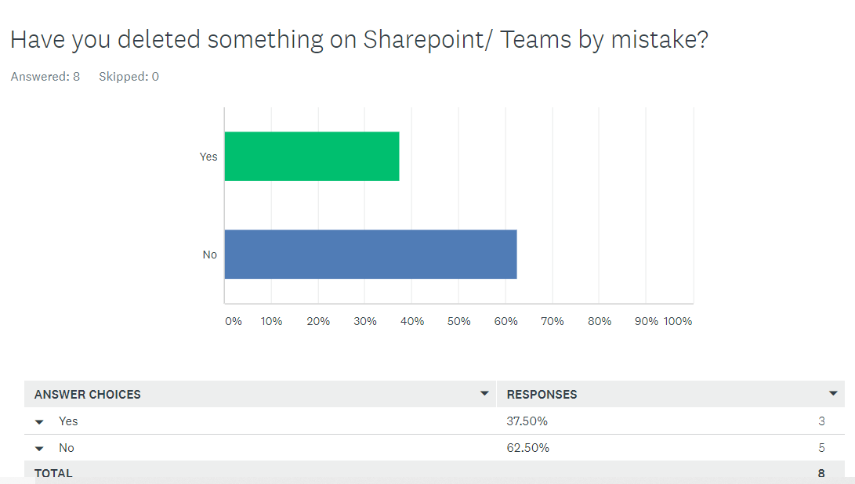

Appendix 11

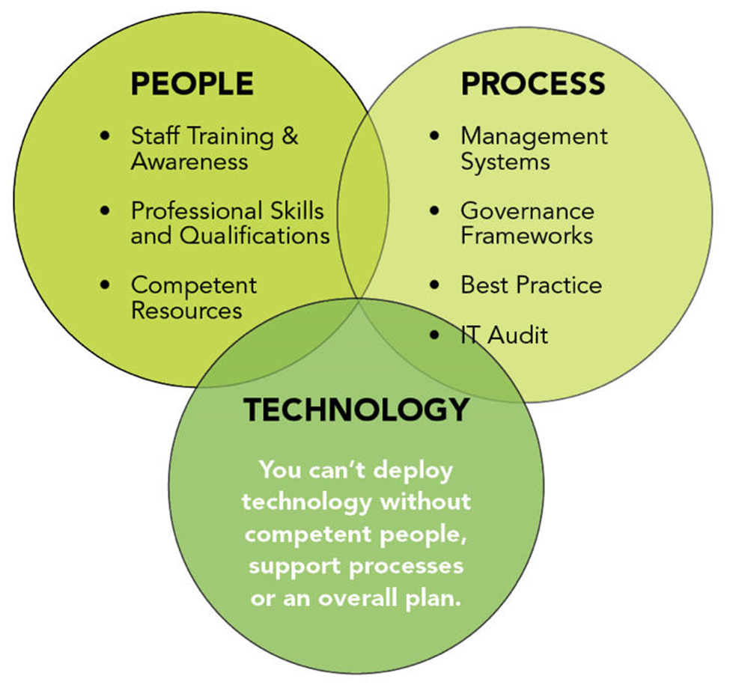

People, process, technology (online image) Available at:
https://www.vulpoint.com/wp-content/uploads/2018/12/0.jpeg (Accessed 18.05.21)

Appendix 12
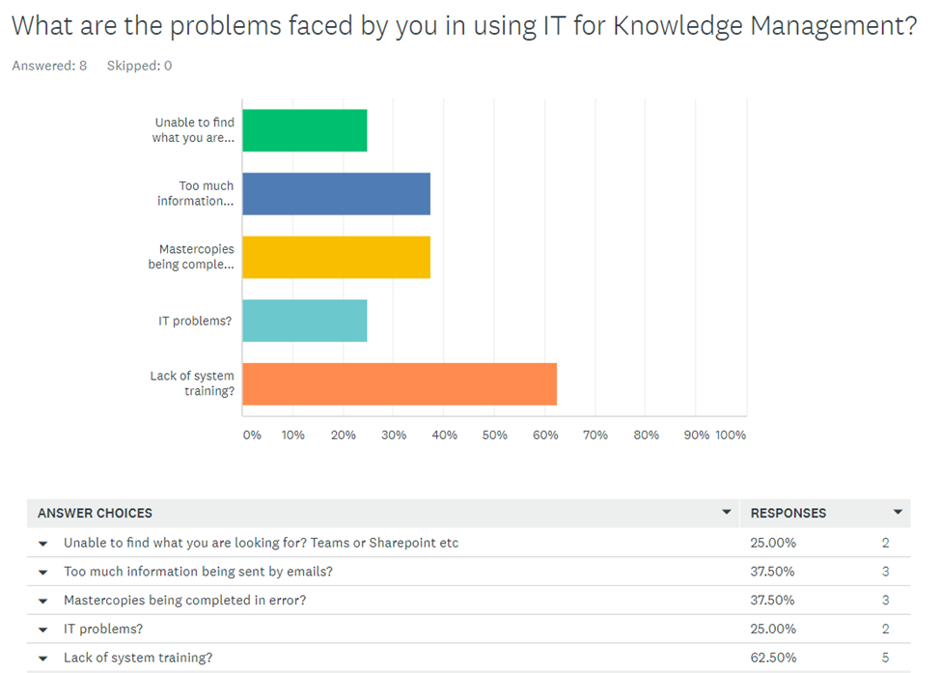

Appendix 13
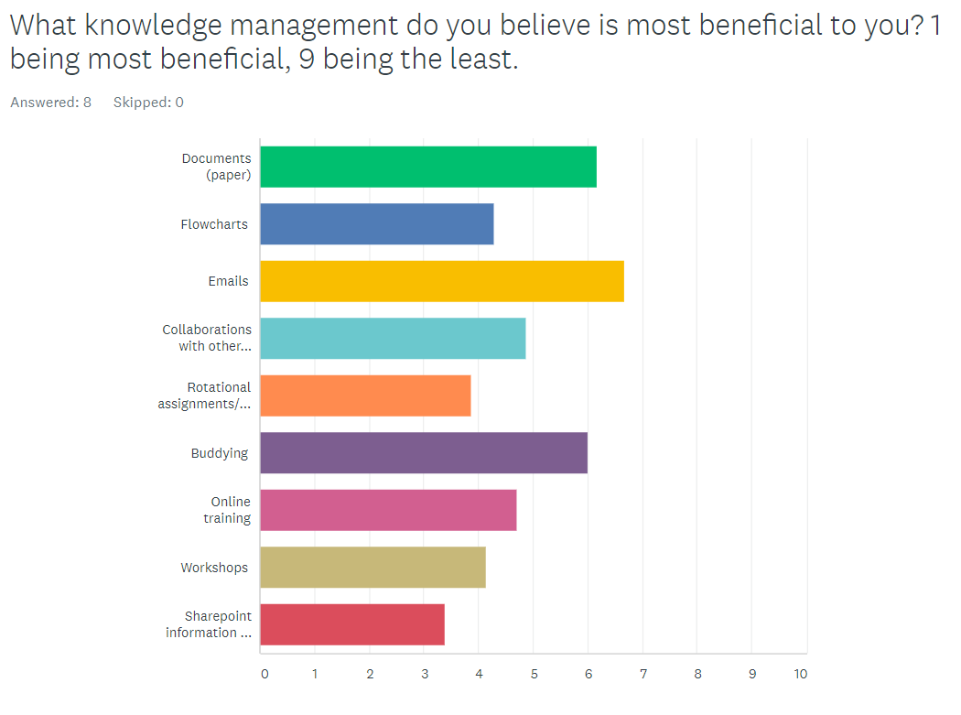

Appendix 14
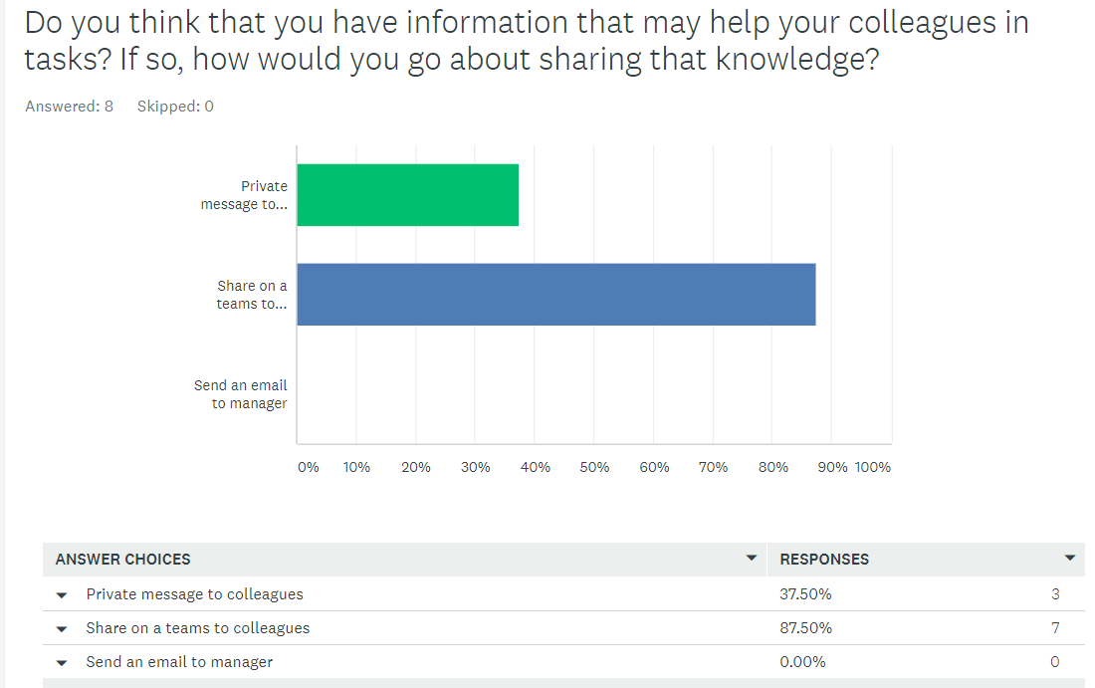

Appendix 15


