
Applied Leadership and Management in the Workplace
Module Assignment Submission
Student Name: | Adela-Maria Fanatan
Student Number: | 2221979
Module No: | BMSK5013
Module Title: | Knowledge and Information Management Skills for the Workplace

Statement of Confirmation of Authenticity
By the act of making this submission, the student declares that this is the work of the student named above. The work has not, in whole or in part, been knowingly presented elsewhere for assessment, or where assessment has been built on a previous assessment, this has been identified. Where materials have been used from other sources it has been properly acknowledged. If this statement is untrue, the student acknowledges that an assessment offence has been committed.
Attention is drawn to the plagiarism and unfair practice policies of both the University and of ILM.

Contents
Introduction 3
Evaluation of the concept and importance of knowledge management in the context of an organisation’s knowledge assets 3
Relationship between data, information, knowledge, and wisdom 4
Relationship between individual knowledge and organisational knowledge 5
Analysis and modelling techniques to identify knowledge assets 7
Evaluate actual and potential knowledge assets 7
Understand the importance of knowledge management processes in the context of organisational development 7
Explain what is required to create, store, apply and integrate knowledge 7
Explain how the organization captures, store and use data, information 9
Importance of Intellectual Property rights 9
Provide a framework for establishing a knowledge management culture 10
Understanding of the concept and importance of knowledge management 10
Identify the key knowledge and information required for operational efficiency within the applicable organization 10
Conclusion 10
Appendix 11
References 20

Introduction

The purpose of this report is to explain the ability of an organization to acquire, retain and share the information in an effective way. And present the process from the standpoint of tacit and explicit knowledge.
Furthermore, explain the relationship between data, information and knowledge, the relationship between individual and organizational knowledge.

Evaluation of the concept and importance of knowledge management in the context of an organisation’s knowledge assets

Nowadays, the business environment is in a rapidly and continuous movement, the ability to use knowledge management in an effective way, can help to the success of the company.
Knowledge management can be defined as a process of acquiring, retention, transfer knowledge within the organisation(Maund 2018), or according Davenport & Marchand (2000) K.M. is presented as a process of sharing, application, and creation of knowledge within a company.
The knowledge management process involves a series of practices and processes that aim to provide value to knowledge to help achieve organizational goals. Here are described some important component of knowledge management:

- Knowledge creation and capture: developing new knowledge as a result of innovation, research, and learning. The perceptions of Davenport and Marchand (2000) highlight the importance of knowledge creation, advising organizations to prioritize it as an important component for their business strategy.
- Knowledge storage: storing knowledge in a manner that it can be easily to find when needed. This often involves the use of databases, document management systems, and other information warehouses.
- Knowledge sharing: knowledge is effectively shared within the organization, this step can be achieved through collaboration tools, intranets, training programs, and other communication channels.
- Knowledge application and utilization: applying the knowledge to make decisions, solve problems, and improve processes. This aspect focuses on ensuring that the right knowledge is available to the right people at the right time.
- Knowledge retention: Retaining critical knowledge within the organization, especially when employees leave or retire. This includes strategies like mentoring, documentation, and knowledge transfer processes.

Relationship between data, information, knowledge, and wisdom

The concept of knowledge as part of knowledge management according to Benbya (2008) requires “some clarifications… and its relationship to action, information and data”.

Data is considered raw, unprocessed facts and figures without context. Data can be numerical, textual, or in other forms, and is usually stored in databases or data warehouses. Data represents events that are related with the company environment before it had been prepared or arranged in a way that people can use and understand. Examples related with workplace (dental practice) of data include:
- A list of numbers: NHS patient number, can be the date of birth of the patient or the date of an appointment, radiographic quality (see Appendix A), recording score gride of Basic Periodontal Examination (see Appendix B).
- Observations: temperatures readings.

Information represents “relevant, or usable, or significant, or meaningful, or processed, data”. Information is deduced from data, and the information system helps to create, store and process data Aven (2013). The difference between data and information is functional, the information gives value to data and makes it relevant.
Example of information: Scoring code of Basic Periodontal Examination (see Appendix B).

According to Dickerson (2022) knowledge “is defined in terms of information and allows us to further transform this information into instruction”. Knowledge comes from understanding, and it develops by learning, interpretating facts, and experience gained over the time.

Wisdom is “a kind of knowledge-how” Tsai (2022), the result of mixture between “experience, cognitive abilities and affect, in order to make good decisions at an individual and societal level” Higgs (2019). Jashapara (2011, p. 19) argue that wisdom is:” the ability to act critically or practically in a given situation. It is based on ethical judgment related to an individual’s belief system.”
When performing a Basic Periodontal Examination (BPE), a dental nurse uses various levels of data, information, knowledge, and wisdom:
- Data: Raw measurements - probing depths in the patient's mouth (e.g., 3mm, 4mm, 5mm).
- Information: The results from BPE, can indicate the presence of periodontal pockets and the overall periodontal status (e.g., Code 2 in the upper right quadrant).
- Knowledge: Understanding the implications of the BPE results, knowing that a Code 3 suggests moderate periodontal disease requiring supplementary assessment.
- Wisdom: Using the BPE results, patient medical history and clinical experience, to make informed decisions about the patient's treatment plan. Deciding to schedule follow-up appointments for scaling.
Understanding and interpreting data and information regarding patient medical status, we can help providing appropriate treatment in time, ensuring that we are managing periodontal health effectively.
In Knowledge Management (KM), data, information, and knowledge have a significant and distinct meanings. “Data are facts or content which can be turned into information by analysis of data and adding value to it. Knowledge is a combination of related information, experiences and values with richer, and deeper perspective. Relationship between individual knowledge and organisational knowledge.” Gyamfi & Williams (2019).

This framework of data-information-knowledge-wisdom is also known as: knowledge pyramid, information hierarchy, knowledge hierarchy, wisdom hierarchy, or by using the acronym DIKW for Data-Information-Knowledge-Wisdom, the DIKW hierarchy (see Appendix C) Brătianu (2015). The DIKW pyramid shows how the elements are connected, the base of the pyramid consists of data followed by information, then knowledge, and finally wisdom at the top. Each level is built on the previous one and is adding more meaning and value. As we add context and understanding to data, we gain knowledge and insights, which help us make better, informed decisions that can lead to achieve the company goal.

Relationship between individual knowledge and organisational knowledge

In a competitive business environment to stay competitive and grow sustainably, companies need to keep generating new knowledge and apply practical wisdom consistently Nonaka and Takeuchi (1995).

According to scholars, knowledge can be divided in two parts:
- Tacit Knowledge: “is personal, specific to particular context, and it is hard to formalize, capture and communicate” Gyamfi & Williams (2019). Maruta (2013) argues the fact that is difficult to put into words tacit knowledge because sharing relies on “using analogy, metaphor, or demonstration.”. Furthermore, he considers that “The competitive strength of a business is its ability to utilize “tacit knowledge.” Example of tacit knowledge: skills like creating new cake recipes. The tacit knowledge can be transferred through mentorship, apprenticeships, and training, and also by encouraging to foster a culture of collaboration and knowledge sharing.
- Explicit Knowledge: Maravilhas, S., & Martins, J. (2019) debate the way that explicit knowledge is obtained from: “facts, from information, almost always through formal education.” and it can be easily expressed and communicated by using “metaphors, analogies, concepts, hypothesis or models”. Explicit knowledge is crucial for the process of creation of new knowledge, it can be “codified communicable through formal and systematic language. It can be stored in manuals, documentation, patents, blueprints, reports and other accessible sources.” Maravilhas, S., & Martins, J. (2019). Example of explicit knowledge recorded and stored in various forms such as: documents, manuals and user guides, academic papers and textbooks, reports and memos, databases and spreadsheets. Although can be shared through training programs, workshops, and online resources.

“Although the two types of knowledge contrast each other, they are not mere opposites, but rather lie on a continuum.” Nonaka, Kodama, Hirose & Kohlbacher (2014). When someone shares their tacit knowledge with another person, it becomes explicit knowledge. When explicit knowledge it combines with other explicit knowledge, does generate new explicit knowledge. The new explicit knowledge can be internalized by a person as tacit knowledge, continuing the knowledge conversion cycle Nonaka, Kodama, Hirose & Kohlbacher (2014).

As a result of the study period at the school of dental nurse, the individual study and the training period at the workplace, the information at hand, transposed into documents, books, protocols, in a word, this explicit knowledge helps to form the assistant but also to the development of tacit knowledge. Here are some examples of tacit knowledge from the daily life of a dental assistant:
- interaction with patients: the ability to recognize an anxious patient and to help him cope better with the treatment through an empathic behavior and communication, reassuring him during the treatment procedure.
- thanks to her experience, a nurse knows what tools and materials she needs to prepare for treatment just by listening to the conversation between the doctor and the patient. She knows when to offer the dentist certain instruments, without being asked, a non-verbal acquaintance and understanding is reached. Thanks to wisdom, it is reach a level where you don't need words to communicate, the collaboration between doctor and nurse is a natural one based on mutual knowledge.
- problem solving: the experience helps to quickly adapt to unexpected situations during treatment a predefined protocol.

Explicit Knowledge for a Dental Nurse:
- dental procedures and protocols: written guidelines and steps for various dental treatments and procedures.
- anatomy and physiology: textbooks, documented information about the structure and function of the teeth, gums, and mouth.
- sterilization techniques: detailed procedures for sterilizing instruments and maintaining a clean environment.
- patient records: electronic and paper-based records of patient, treatment plans, and ongoing care notes.

“Organizational knowledge is a conceptual construct that reflects the convergence of all individual knowledge fields in an organization.” Brătianu (2015). Organizational knowledge is represented by all the knowledge that provides value for the company and is created “through a continuous dialogue between tacit and explicit knowledge” Nonaka (1994).
“Creating new knowledge is also not simply a matter of learning from others or acquiring knowledge from outside” Nonaka & Takeuchi (1995). The process of creating knowledge happens between staff members during “intensive and laborious interaction” Nonaka & Takeuchi (1995). The advantages of creation knowledge lead to continuous innovation that help organisations to gain competitive advantages.
The relationship between individual knowledge and organizational knowledge is crucial to a company for several reason:
- enhanced performance: when individual knowledge is shared and integrated into the organisation, it improves the performances. Employees' skills and insights contribute to a better processes, solutions and innovations.
- learning and growth: employee who decide to share the knowledge by mentoring trainee, can generate the creation of new knowledge and at the same time reduce the cost for providing the supplementary training sessions.
- improved problem-solving: applying the knowledge can generate ideas that enhance the process of making decision in problem solving.

Analysis and modelling techniques to identify knowledge assets

Knowledge assets “can be more challenging to identify. They are the intangible assets that an organisation holds” according to Guidance - The Rose Book: Guidance on Knowledge Asset management in government. The knowledge assets can be categorised as per seen in Appendix E.

Evaluate actual and potential knowledge assets

Understand the importance of knowledge management processes in the context of organisational development

According to Shekar (2022) The Process of knowledge development includes the following:

1.Acquiring new knowledge
2.Applying existing knowledge
3.Retaining knowledge
4.Handling outdated knowledge.

Explain what is required to create, store, apply and integrate knowledge

“Explicit and tacit knowledge complement each other and, through their interaction, create new knowledge.” Maravilhas & Martins (2019). According to Nonaka and Takeushi (1997) the process of creating and transforming the knowledge is completed thru 4 phases also known as SECI model (see Appendix F). Alavi & Leidner (2001) explain the model:

- Socialization – “from tacit to new tacit knowledge” Alavi & Leidner (2001).
- the knowledge can be shared in daily life by the process socialization among the team members through shared work experiences, mentoring – apprenticeship training when a new member learns from another team member that shares from his experience. There are some things that can’t be transferred into words, they can be learn by following others and copy their actions.
- An example from dental practice: during the journey to become a dental nurse, a nurse has the opportunity to follow another member of staff performing dental treatment and learn things that aren’t described in the textbook or in the protocols. Using the dental aspirator during the dental treatment can be challenging. But advice from the dentist and an experienced nurse, can help and improve the procedure in a way that dentist gain a clear way and vision during the treatment, for the patient can be a comfortable experience, and less stress for the person who has to perform the act of aspirating and retracting the soft tissue.

- Externalization: - “converting tacit knowledge to new explicit knowledge” – “articulating tacit knowledge into explicit knowledge” Alavi & Leidner (2001).
Example from dental surgery: sometimes we have booked in the morning a patient who needs a denture or a crown, we know the date when the lab work has to be back in the surgery, but sometimes the Royal Mail arrives after lunch break, so the lab work is available only in the afternoon session. That means that we had to cancel the patient appointment in the last moment, loosing time, without being able to feel the gap in the day list and book another patient. During our monthly staff meeting, the matter has been addressed and after a discussion among staff members, it has been decided that the best way to act is always to book treatments that need the lab work in the afternoon after the lab work has been delivered. Like that was avoided wasting time from both sides practice and patient, reducing the cost for the company and ensure patient satisfaction. The new way to do things has been transferred into words and has been written into Practice protocol.

- Combination – “is the process dedicated to the knowledge sharing”
- Usually, the sharing knowledge has to be from the person who has more experience and has a higher level of knowledge than the person who receives the knowledge Bratianu (2010).
Example from trainee dental nurse journey:
- Before the extraction procedure a dental nurse has to prepare the instruments for the procedure. We must check patient records and read the treatment plan to understand which tooth has to be extracted. On the electronic records we can check if is the whole tooth or a root, if it is an incisor, a premolar or molar, if it is the upper or a lower tooth, if it is in the right or in the left of the mouth. Is important to know because based on this information we can provide the dentist the right forceps and additional instruments that can help the procedure to run smoothly. As much I studied from the textbook and analysed the instruments in the surgery, I’ve been confused, and I was making mistakes. One of the dentists ask me to place all the forceps on the table and explain me that before I have to choose the forceps to have in mind the morphology of the tooth that need to be extracted. Because an incisor has to have the grip curved, after the anatomy of the tooth, for a root I can’t use a different forceps other than the small end because it needs to be well griped. Another advice was to pay attention to the handle, because the handle gives me the clue if it is the forceps for the upper teeth or the lower teeth. They are two forceps for upper molar, and the beak make the difference if is for the right-hand side or for the left one, always to check to have the beak to the cheek, that is goanna give me the answer.

- Internalization – “refers to creation of new tacit knowledge from explicit knowledge” Alavi & Leidner (2001).
An example from workplace: - the protocols state that after the instruments has been sterilised, the following step is to bag them into sealable pouches and then stamp the date has been pouched, and then the person who perform this process has to add the initials. The valability for the instruments that has been bagged is 1 year, if during a year time the instruments haven’t been used, the instruments have to be sterilised again. Once in a month we check the valability on every pouch with instruments. Based on my experience I found that the seal goes on front top of the pouch and is sufficient space to pose the stamp with the date and add the initial. Doing this allows me to do a rapid check when I have to do the monthly verification. My colleagues sometimes are stamping the date at the back of the pouch. Creating this routine has helped me to save time and allowed me to have the tools nicely arranged and the drawers better organized.

Alavi & Leidner (2001) debate that organizations create, develop and learn new knowledge, but at the same time they can forget or lose track of it. The process of storing, organizing, and retrieving knowledge, is known as organizational memory, and is created to sustain an effective knowledge management. Organizational memory includes different types of knowledge “including written documentation, structured information stored in electronic databases, codified human knowledge stored in expert systems, documented organizational procedures and processes and tacit knowledge acquired by individuals and networks of individuals.” Alavi & Leidner (2001).

Furthermore, Alavi & Leidner's (2001) research emphasizes the importance of knowledge application and integration as the process that truly enhances organizational performance. They also mention the phenomenon of discrepancy between what the company knows and what the company does. Sometimes the organisation encounter difficulties and barriers on the process of applying the knowledge. Part of the obstacles that a company faces, can be: the lack of trust on the source of knowledge, fear of not being sanctioned if the use of knowledge generates a failure, the lack of time and chance to apply the knowledge.

Explain how the organization captures, store and use data, information

Importance of Intellectual Property rights

Provide a framework for establishing a knowledge management culture

Understanding of the concept and importance of knowledge management

Knowledge management is vital in a business life of an organisation, from it depends on the success and continuity of the company. According to Gyamfi, A. & Williams, I. (2019) “Knowledge management (KM) is a systematic way of managing the organization’s assets for creating valuable knowledge that can be used across the organization to achieve the organization’s success”.
Knowledge management represent a system, process, methods that helps and support an organisation to create, transform, identify, refine, store and share the knowledge. Managing the knowledge can bring different benefits to a company, some of these benefits are described by Sandrock (2010):
- Best practice shared can help member of the staff performing better their jobs.
- having access to new information can lead to resolving faster and efficiently the problems.
- Reduce cost by having fast access to knowledge.
- Wasting time and cost produced by the repetition of the same mistake can be reduced.
- Rapid and informed decision making.
- Mentorship from employee with more experience, that can help others to perform their job in a effective way.

Identify the key knowledge and information required for operational efficiency within the applicable organization

Conclusion

Appendix

A - Radiographic quality
Available online at:
https://cgdent.uk/wp-content/uploads/2021/08/An-Introduction-to-Research-for-Primary-Dental-Care-Clinicians-part_8-analysing-the-data-WEB.pdf

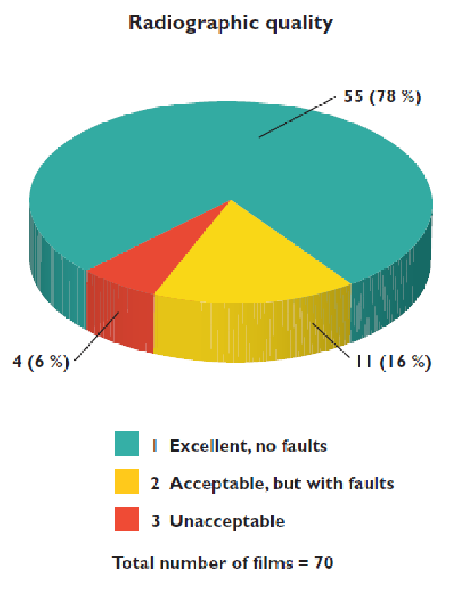

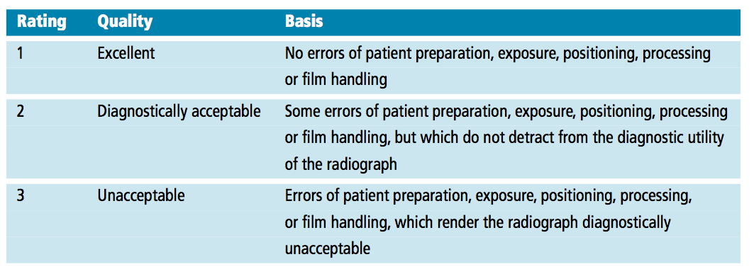

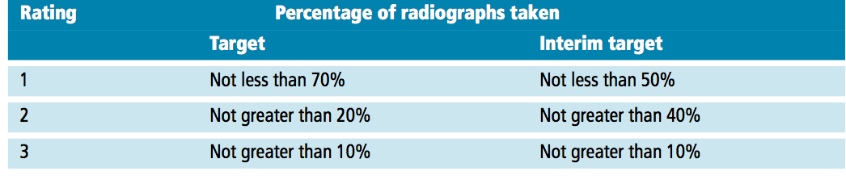

B – Scoring code for Basic Periodontal Examination
Available on line at:
https://www.bsperio.org.uk/assets/downloads/BSP_BPE_Guidelines_2019.pdf

Recording a score grid for Basic Periodontal Examination
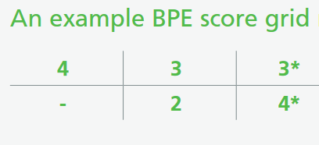
The score codes for Basic Periodontal Examination
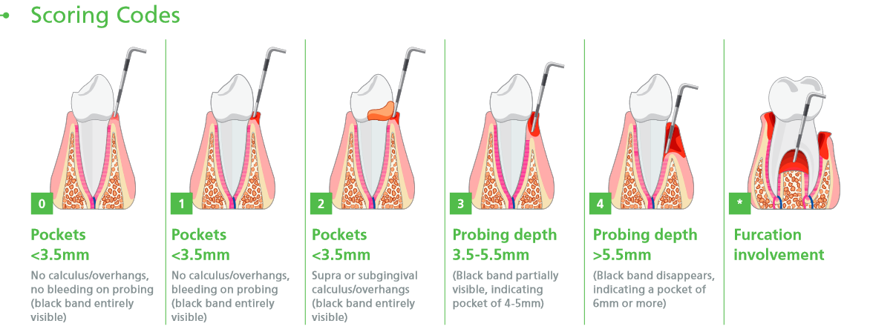

C – The DIKW pyramid
Frické, M. (2019). The Knowledge Pyramid: the DIKW Hierarchy

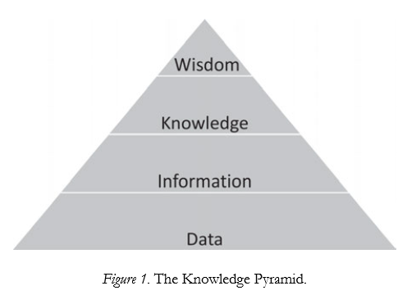

E
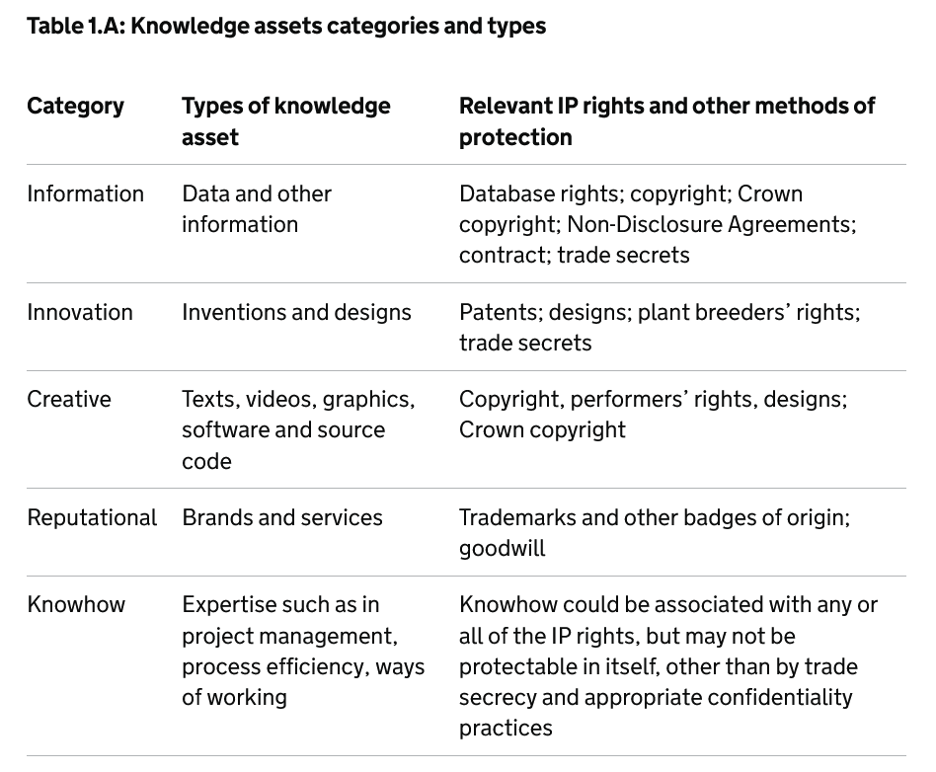

F. Modes of the Knowledge Creation
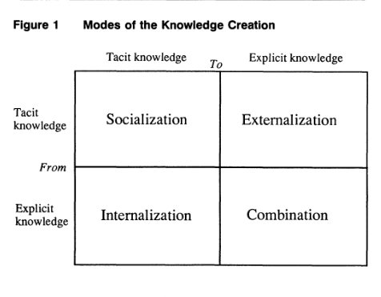
Nonaka (1994) p.19

G.
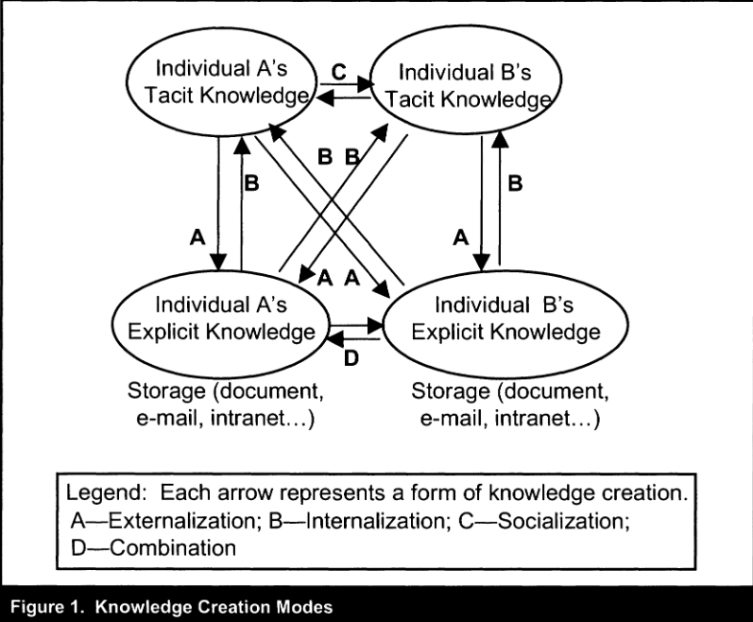

Alavi & Leidner (2001) p.117

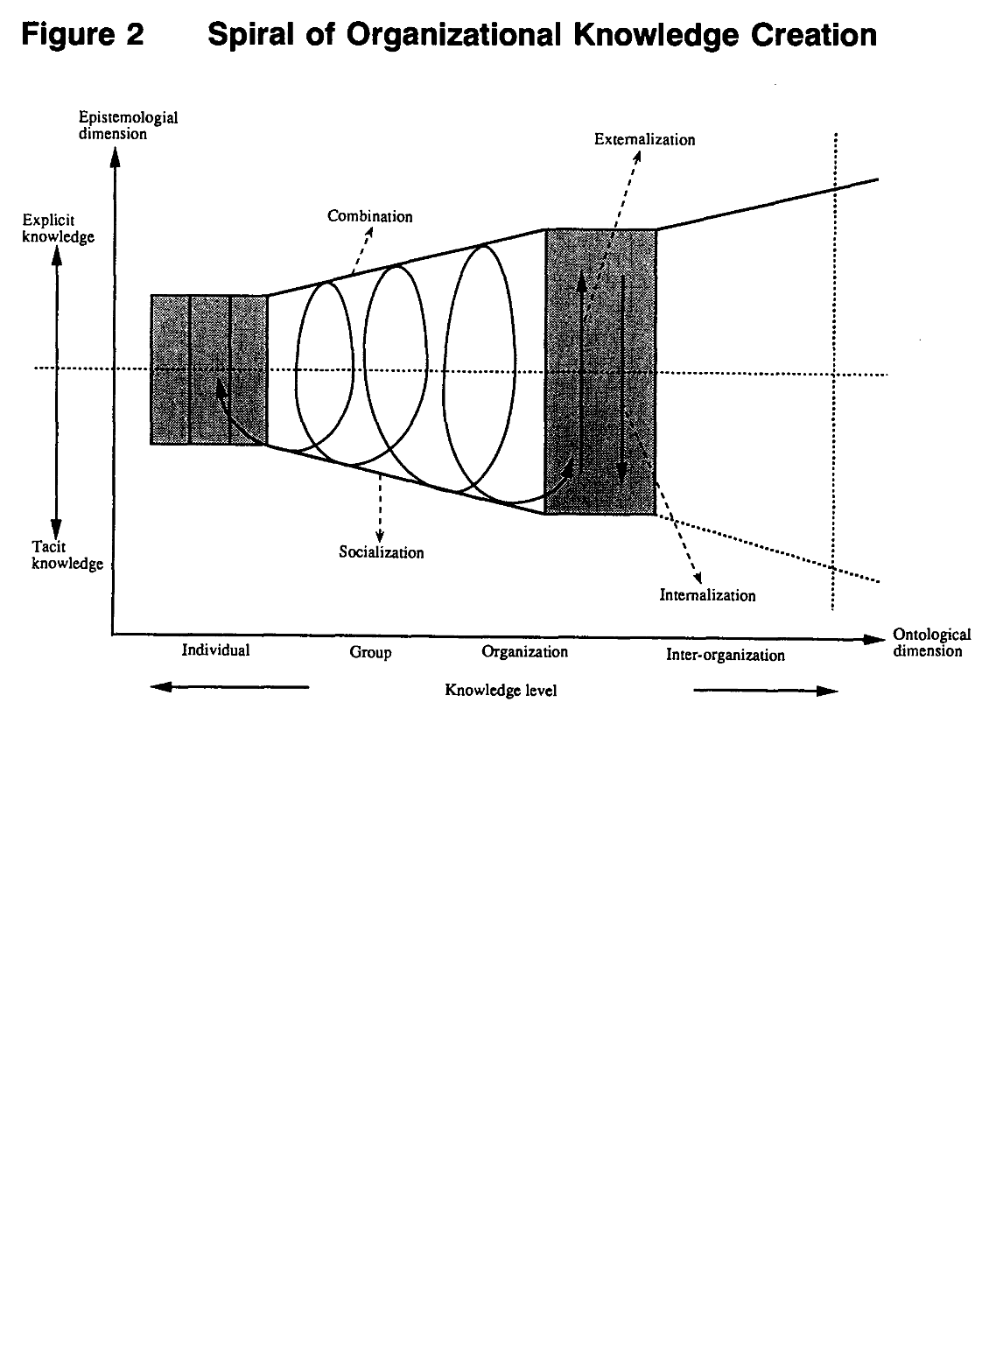
Nonaka (1994) p.20

H. Organizational Knowledge Process
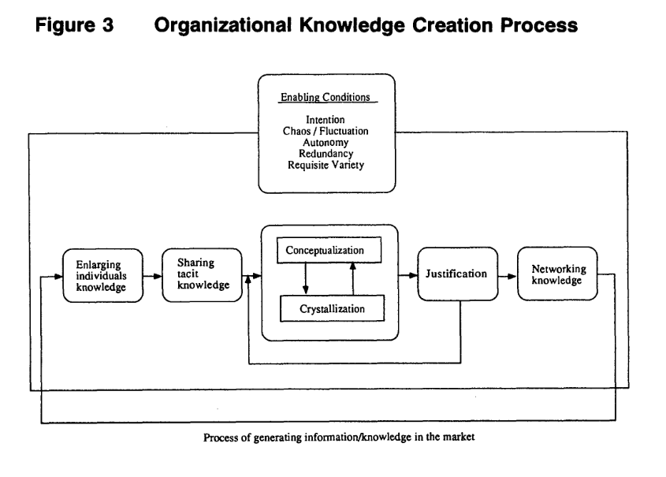
Nonaka (1994) p.27

S.W.O.T.

Strengths: | Weaknesses:
Experienced Staff: Qualified skilled dental professionals.  Established Procedures: Well-documented protocols and best practices for patient care.  Patient Records: Comprehensive patient medical history and treatment records.  Team Collaboration: Effective communication and cooperation between staff members. | Tacit Knowledge Dependency: Relying on the personal knowledge of individual practitioners, which is hard to document and share.  Technology Gaps: Using outdated or inadequate technology for sharing and managing knowledge, like using an old version of software that can cause an ineffective communication and sharing data and information among staff members  Inconsistent Training: differences in training programs, that lead in unequal levels of knowledge among staff.  Limited Knowledge Sharing: Barriers that prevent effective and efficient sharing of knowledge between staff members.
Opportunities: | Threats:
Technology Integration: Advanced knowledge management systems and electronic health records.  Continuous Education: Training and professional development programs to update staff knowledge.  Best Practices Sharing: Creating platforms for sharing best practices and innovative treatments.  Patient Education: Developing comprehensive patient education materials to improve patient knowledge and engagement. | Staff Turnover: Loss of critical knowledge due to high staff turnover.  Data Security: Risks associated with maintaining the confidentiality and security of patient information.  Resistance to Change: Resistance from staff in adopting new knowledge management practices or technologies.  Regulatory Changes: Changes in healthcare regulations affecting knowledge management practices and compliance requirements.

This analysis helps identify areas where the dental practice can influence its strengths, address its weaknesses, seize opportunities, and mitigate potential threats related to knowledge management.

References

Alavi, M., & Leidner, D. E. (2001). Review: Knowledge Management and Knowledge Management Systems: Conceptual Foundations and Research Issues. MIS Quarterly, 25(1), 107–136. https://doi.org/10.2307/3250961

Aven, T. (2013). A conceptual framework for linking risk and the elements of the data–information–knowledge–wisdom (DIKW) hierarchy. Reliability Engineering & System Safety, 111, 30–36. https://doi.org/10.1016/j.ress.2012.09.014
Available online at:
https://www-sciencedirect-com.ezproxy.uwtsd.ac.uk/science/article/pii/S095183201200213X?via%3Dihub

Benbya, H. (2008). Knowledge management systems implementation: lessons from the Silicon Valley. Chandos Publishing (Oxford) Ltd.

Bratianu, C. (2010). A critical analysis of Nonaka’s model of knowledge dynamics. Electronic Journal of Knowledge Management

Brătianu, C. (2015). Organizational knowledge dynamics: managing knowledge creation, acquisition, sharing, and transformation. Information Science Reference. https://doi.org/10.4018/978-1-4666-8318-1

Davenport, T. H., & Marchand, D. A.(2000). Mastering information management. London; New York: Financial Times/Prentice Hall

Dickerson, J. E. (2022). Data, information, knowledge, wisdom, and understanding. Anaesthesia and Intensive Care Medicine, 23(11), 737–739. https://doi.org/10.1016/j.mpaic.2022.08.012

Farnese, M.L., Barbieri, B., Chirumbolo, A., & Patriotta, G. (2019). Managing Knowledge in Organizations: A Nonaka's SECI Model Operationalization. Front Psychol. 2019 Dec 10;10:2730. doi: 10.3389/fpsyg.2019.02730. PMID: 31920792; PMCID: PMC6914727.

Frické, M. (2019). The Knowledge Pyramid: the DIKW Hierarchy. Knowl. Org. 46(2019), No.1. https://doi.org/doi.org/10.5771/0943-7444-2019-1-33

Guidance - The Rose Book: Guidance on Knowledge Asset management in government Updated 27 March 2024
https://www.gov.uk/government/publications/knowledge-asset-management-in-government/knowledge-asset-management-strategies-what-to-include-and-where-to-start#chapter-1-introduction-to-knowledge-assets

Gyamfi, A. & Williams, I. (2019). Big Data and Knowledge Sharing in Virtual Organizations. IGI Global

Helander, N., Kukko, M., & Virtane, P. (2010). Cutting costs and making profits through knowledge management. InTech. doi: 10.5772/9563

Higgs, J. (Ed.). (2019). Practice wisdom: values and interpretations. Brill

Jashapara, A. (2011). Knowledge Management: An Integrated Approach. FT Publishing International

Johnson, T. M., & Santini, A. (2012). An introduction to research for primary dental care clinicians’ part 8: stage 9. Analysing the data. Primary dental care: journal of the Faculty of General Dental Practitioners (UK)

Maravilhas, S., & Martins, J. (2019). Strategic knowledge management in a digital environment: Tacit and explicit knowledge in Fab Labs. Journal of Business Research, 94, 353–359. https://doi.org/10.1016/j.jbusres.2018.01.061

Maruta, R. (2013). The creation and management of organizational knowledge.

Maund, A. (2018). BA in Leadership and Management. Skills for the Workplace Student Yearbook, 1st Year. Sage Publications

Nonaka, I. (1994). A Dynamic Theory of Organizational Knowledge Creation. Organization Science, 5(1), 14–37. http://www.jstor.org/stable/2635068
Nonaka, I. & Kodama, M. & Hirose, A. & Kohlbacher, F. (2014). Dynamic fractal organizations for promoting knowledge-based transformation – A new paradigm for organizational theory. European Management Journal, Volume 32, Issue 1

Nonaka, I. & Takeuchi, H. (1995). The knowledge-creating company: How Japanese companies create the dynamics of innovation. Oxford University Press

Sandrock, J. (2010), The Art of Managing Knowledge: a Practitioner's Guide, Smashwords

Shekar, S. (2022). Design Knowledge Management System. Penman Books

Tsai, C. (2022). Wisdom: a skill theory (1st ed.). Cambridge University Press

