Performance Management

Mangala KW Hettiarachchi

Contents

Introduction
This assignment is to discuss about three main concepts in management literature/practices. Those are contingency theory/approach, performance management cycle, and various stages of the business life cycle from start-up to decline or steady.

Firstly, it will critically discuss how to implement the contingency approach model to support overall business strategy at stages of business life cycle. Then organisational examples will be used to further explore the success of these implementations. Thereafter, this assignment will critically discuss relevant performance management activities for renewal, steady state, and decline reflecting on the post-maturity stage. Then this assignment will move on to discuss how to improve the practice based on module learning and reflection. Finally, recommendations and conclusion will be presented.

Question 1: How to implement the contingency approach model to support overall business strategy at each stage of business life cycle?

A connection between performance management (PM) and human resource management (HRM) can be linked to two strategic approaches: "contingency and "best practices"(Adel,2019). A contingency theory describes the best fit strategy. It emphasizes the essentialness of Human Resource management strategies to meet the organization's plan, in other words HR strategies be supposed to reflect the changes in business environments and challenges of the organisation face in each stage of its business cycle (Adel,2019).

Contingency approach believes the fact that every single stage of the business life cycle of a firm needs a specific PM approach that fits the context factors. Goal of PM is to ensure that PM is a highly valued and embedded part of its overall business strategy. “PM is a process which contributes to the effective management of individuals and teams in order to achieve high levels of organisational performance. As such, it establishes shared understanding about what is to be achieved and an approach to leading and developing people which will ensure that it is achieved” (Armstrong and Baron 2004:4)

Linking contingency approach to PM, contingency theory posits that HRM cannot be effective unless it is in harmony with other components of the organization or the external environment. Contingency theory expects interactions rather than simple linear linkages between HRM and organizational performance, in contrast to universalistic theory (best practices), that assumes a direct association. Contingency theory argues that an all-encompassing approach is inappropriate since the effectiveness of HR practises varies depending on the context in which they are implemented. In HRM, contingency decisions have primarily been explained by internal and external fit (Harney,2016).

Performance management

PM can be defined as “a process which contributes to the effective management of individuals and teams in order to achieve high levels of organisational performance. As such, it establishes shared understanding about what is to be achieved and an approach to leading and developing people which will ensure that it is achieved” (Armstrong and Baron 2004).

Business Life cycle

Business life-cycle model has portrayed a significant role in improving our understanding of the concept of entrepreneurship and the development of entrepreneurial accomplishments over the years. The models were created to help us comprehend shifting organisational dynamics and the growth of overall business strategy as the company grew (Li and Tan, 2004). The inference is that an investor's readiness to support a firm is tied to its stage of development (Lichtenstein and Lyons,2008).
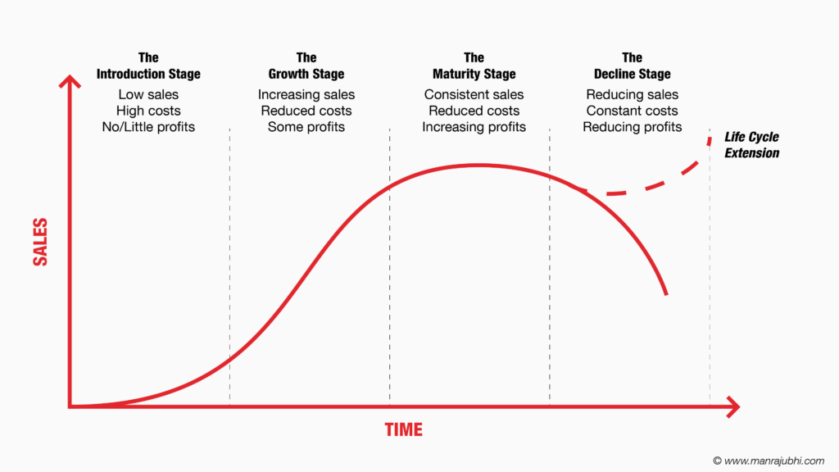

The purpose is to evaluate how can each stage of BLC influence what firms need, precisely what kind of performance management strategies to be used?’ This research argued that each stage of BLC makes selected requirements/demands on a firm –requirements which, if disrupted, influence on a firm’s decline.

Contingency Model

The underline assumption of contingency model is that There isn't a single, ideal design for all phases of an organization's development and that the context factors can vary from one stage to another in the business life cycle in thus the context factors impact the contribution of PM in enhancing overall business strategy. This leads to cooperate business strategy. According to organisational theorists, "the best way to organise depends on the nature of the environment to which the organisation relates." (Scott, 1992: 89) First, there isn't just one ideal method for organising: this is the fundamental premise of contingency theory. Second, not all organisational strategies are equally successful.
The best fit approach underlines the significance of guaranteeing overall performance management, but contingency approaches always focus and giving solutions according to different stages and different situations, on the business grounds (Betts,2003). Prior research has identified contingency variables (organisational and external environment) that influence the adoption of PM systems, as well as the selection of performance measurement instruments and practises in any sectors. According to the contingency approach, size of the business, structure of the organization, strategy, IT, diversity and culture, and leadership are all organisational characteristics that impact on the implementation of PM systems in firms. The external environment is a significant contingent element that encompasses the extent of environmental volatility or uncertainty, the level of competitiveness displayed, and the level of “environmental dynamism” or instability encountered by the firm (Wadongo and Abdel-Kader,2014).

How to apply contingency theory in Start-up stage?
When applying the contingency theory at the start of the business life cycle, the company should be clearly focused on the process of employing the staff according to the company’s vision and mission. The company should select employees who have the right experience with risk management through right recruitment strategies. They should select skilled workers fit for the company’s mission and vision. The selection procedure should be fair. Employees have been given successful proper induction, training, health and safety guidance, and clear job description. There should be a clear contract with employee including their salary, job design.

Scholars in organizational behaviour have long presumed that (Fry & Smith, 1987), organisational effectiveness is produced by the "fit" of organisational subcomponents. Similar to this, the necessity to adapt human resource strategy to the larger organisational context is a recurring issue in the literature on strategic human resource management (HRM).For example, in their strategic HRM review, Lengnick-Hall and Lengnick-Hall (1988) posited that the kind of strategic planning, the firm's growth strategy, product life cycles, and future strategic demands and options should all be taken into account when selecting managers in the recruitment process at introduction stage.

There should be a clear contract with employee including their salary, job design. In the initial start-up stage in any firm, the company's top management is probably more focused on the development aspect of entrepreneurship and short-term survival., and, consequently, pay little attention on support services. So that, management could place no or little weight on purposely getting the HRM fits or developing PM capability aimed at future flexibility. The freshly established company, which operates in an unpredictable environment and has short-term ambitions, should precisely balance out short-range cost effectiveness and long-term adaption.

How to apply contingency theory in Growth Stage?
Moreover, the still-young company often experiences quick growth, product and market expansion, and a growing focus on manufacturing and support services during the second phase. Because of this stage's fluidity and their rapid growth, these companies are probably more likely to value flexibility. (e.g., increased cross-cultural sensitivity). Therefore, even though enterprises will have the option to give fit a little more weight during the second LC stage than they did during the first, finding great flexibility to meet both rapidly changing and new environmental (external and internal) needs will be their main goal. (Baird and Meshoulam,1988).

How to apply contingency theory in Maturity stage?
The firms are subsequently large and mature and has expanded perhaps even to the overseas markets as well. Due to that, the priority of the senior management can be on restructuring the organization and human resource management practices especially in terms of PM practices. Baird and Meshoulam (1988: 119) spotted that firms in the maturity stage should have a great urgency for “measurement and control” and are "characterized by professional management, scarce resources, new acquisitions, and diversified product lines. Here the focus is on productivity and cost effectiveness and the cost of newly proposed programs and added specialization must be justified." Equally, Adler and Ghadar (1989) posited that at the maturity stage the firm should give high importance on “price competition” and reducing unnecessary operational cost.
In this stage the firms should place a greater emphasize on PM and HRM practices which will facilitate the brand quality and control the market operations (Adler & Ghadar, 1989). At this stage, performance management practices which integrated with overall business strategy should be managed by professionals. The use of cutting-edge analytical tools can be beneficial. However, as the firm should principally alarmed with decline, there should be a greater emphasis on control and cost efficiency, The HRM practices such as “long-term career development and cross-cultural sensitivity” can be replaced with rewards and bonus as cost effective strategies to motivate employees. (Adler & Ghadar, 1989, Bakarich, Hossain and Weintrop,2019). Before determining whether to reinvest or not to advance the firm, firms at mature stage will need to keep an eye out for indicators/signs they need to revolutionize the business. Monitor and review are best tools for this.

How to apply contingency theory in Steady / decline stage?
Following contingency approach, Aligning the firm's strategy, structure with PM which include human resource dimensions is one of the biggest challenges. Competent strategic human resource management entails managing both internal and external fits at once (contingency factors). At each significant evolutionary step, the alignment of HRM operations with the organisational environment (e.g., life cycle stages) of the firm can be called as external fit. The internal fit demands that "the components of human resource management must fit with and support each other" (Baird & Meshoulam, 1988: 122). The connection between many different human resource tasks, including as selection, training, performance evaluation, and remuneration, is hence the internal fit. According to a review of the IHRM literature, Baird and Meshoulam's (1988) mentioned that concepts of external and internal fit in contingency model must be developed to adequately address the different needs in life cycle stage and the difficulties of the rapidly changing business context.
“The basic premise of life cycle of organizational life is that the firm in a manner similar to living organism, progressing through a number of stages of life, beginning with birth and ends with death” (Frielinghaus et al.,2005, p.9). The organization’s structural adaptation is the focus of contingency theory. This method tends to foretell the result of an organizational balance disturbance caused by a modification to task environment (Chand,2015). It is a management strategy that consider how an organization’s goals, organizational structure, workforce planning, job design, external environment threats, etc, interact and influence the choices made by the management with regards to planning, acting, monitoring and reviewing (PM cycle).

Over time, a wide range of manufacturing technology-based businesses have grown at an astounding rate, exhibiting quick changes in the competitive dynamics between manufacturers and product attributes.. One of the most obvious instances is the mobile phone business. Since its inception, the international mobile industry has undergone remarkable transformations. quickly changing market characteristics, such as rising market penetration, strong cost rivalry, quickly shorter product life cycles, and product customization, have transformed the sector throughout time. Here, this report discusses three examples from mobile phone industry as the organizational examples.
Samsung
Induction stage: Samsung
Samsung Electronics Company was founded in 1969 in Seoul, South Korea. In 1971, it released its debut product, a television receiver. Throughout its first thirty years, the organisation implemented a wide range of tools and approaches to improve. Total quality assurance, product inventory control, management of customer relationships, and supply management in the supply chain were among them. During the introduction stage, Samsung designs, develops, and releases a new line of mobile phones(hbr.org).

Growth stage: Samsung
During the growth stage, Samsung makes changes and adds better features to their base model by introducing the touch screen model. In 1987, Lee Kun-Hee assumed the position of the second chairman of Samsung, succeeding his father. At this time, Samsung had established itself as the dominant player in the majority of its markets within Korea. Nevertheless, the viability of its overseas role as a cost-effective manufacturer was diminishing due to the emergence of formidable competitors, such as Japanese manufacturers of electronics that were establishing production facilities in Southeast Asia. Additionally, South Korea's progressively opening economy was leading to escalating domestic costs(hbr.org).
Maturity Stage: Samsung
At the mature stage, when the market has reached saturation, Samsung launches its line of smartphones. Lee turned to the continent's western regions for such attributes. He developed the New Management project in 1993 to incorporate Western best practises in strategy formation, management of employees, and compensation into Samsung's existing business model. The goal was to significantly improve marketing, research and development, and design while maintaining fundamental capabilities in production, continual improvement, and the operation of the plant. This mix-and-match method was carried out in three basic ways:
- A structured method for identifying, adapting, and implementing the finest Western practises.
- Consistent efforts to open Samsung's culture to change by bringing in outsiders and relocating staff abroad.
- Cover intervenes to shield long-term assets from short-term financial stress.
Samsung established its series of experiments such as hybrid management system,(see “Seeking the Best of Both Worlds: Samsung’s Hybrid Management System”).
The decline stage /steady stage: Samsung
This is where Samsung faces a drop in interest in its first telephone model series. Samsung releases a new series after a model's life cycle ends to preserve and increase its market share.
Performance Management of a company should look at four stages.

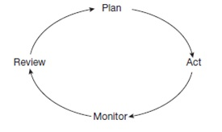

The monitor and review stage of PM cycle play a bigger role in deciding whether the firm is moving towards decline or steady stage for the company. As the company gets older, sales gradually start to decline. Profit margins narrow as cash flow essentially remains same. When businesses get closer to maturity, significant capital expenditures are no longer driving the business; as a result, cash generation exceeds income statement profit. It's crucial to remember, though, that a lot of companies use this stage to reinvent themselves, invest in new technology, and enter emerging markets based on monitoring and reviewing their overall business strategy. This enables businesses to reinvent their market growth and reposition themselves within their dynamic industry.

Apple
This is also a good moment to examine and revise a job description, duties, and responsibilities for an employee. It's also worth looking at any training or personal growth programmes that might be beneficial to the company's long-term goals and the career path of the employee. The monitor phase is when you get a lot of feedback. Supervisors should consider that 'feedback' does not mean finding employees off-task or falling behind; feedback works both ways. Apple's annual performance evaluation procedure comprises semi-annual and year-end reviews. Each employee is examined by a group of executives, as well as direct subordinates and peers, which results in a 360-degree procedure. This allows Apple to have a more comprehensive view of each person's performance, opening new insights on how everyone contributes to the organisation and where improvements may be made.PM, when done correctly, helps to guarantee that employee work performance fits with business standards and policies, while also providing each employee with acknowledgment for their achievements and opportunity to overcome deficiencies. It is important to recognise and reward professionals for their role in contributing to the company's success? Meaningful awards can help drive professionals to go above and beyond their goals and dedicate even more to the cause. In contrast, Unattractive or poorly thought-out awards, on the other hand, may cause people to feel undervalued and perhaps look for a new employment (Armstrong,2010).

Apple Inc. has had a comeback and a paradigm change from being a maker of computers to consumer electronics. When defining the future course, particularly for the introduction of the latest version of the iPhone consumption product, we must first comprehend the dynamics that will affect the strategy going ahead before defining the course that would provide sustainable profitability for the business in the long run. We must first comprehend the product lines of Apple Inc. and where they're situated in the business cycle of life. From 2001 to 2004, unit sales for Macintosh computers were flat; in 2005, they increased, but we believe this was the result of network impacts driven on by a spike in sales for the Apple iPod music player.
The computer product line is now in the "Declining" to "Mature" stages of the industry life cycle. The "Growth" stage of the industry life cycle applies to the iPod product line. Three years in a row, iPod sales have nearly doubled. The freshly released iPhone UPDATED VERSION is always in its "Embryonic" stage. We predict that the iPhone will have positive improvements in unit sales because of the innovation customers have seen in Apple's product lines, just like the Macintosh computer product line has seen a renewed boost in overall product sales. The risk of owning a device that serves as a music player, phone, organiser, and mobile is extremely minimal. Each new feature that the iPhone offers reduces the need for other devices by one. So that, Apple has no risk of moving from mature to decline. Two propositions proposed by Hofer are of specific interest: 1. "The most fundamental variable in determining an appropriate business strategy is the stage of the product life cycle" (1975, p. 798). 2. "Major changes in business strategy are usually required during three stages of the life cycle: introduction, maturity, and decline" (1975, p. 799). In addition, Hofer developed descriptive suggestions for each stage of the PLC.
Motorola
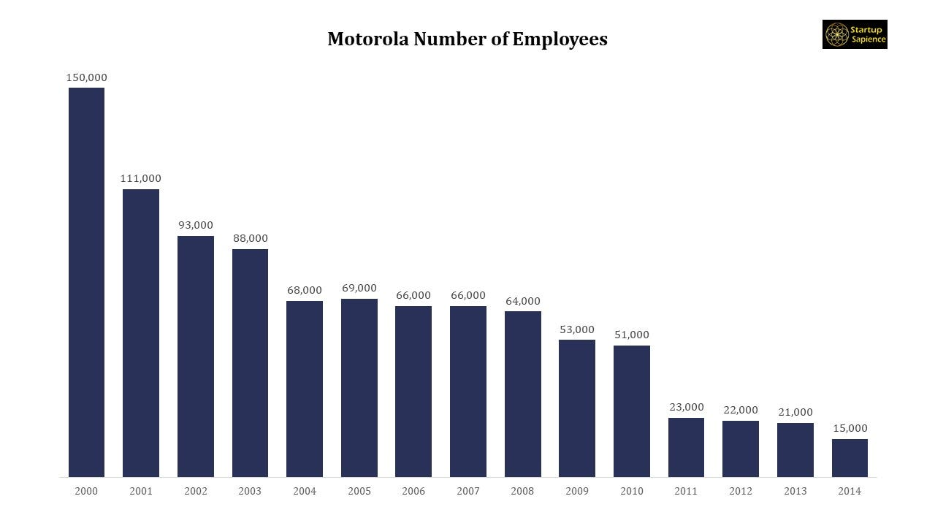
Plan, act, monitor review PM cycle is congruent with start, grow. Mature and steady/decline business life cycle stage model. Here is one example. But what happened to this business that once produced excellent phones? It is true that they suffered significant financial losses, but not everyone is aware of the details of their difficulties. What led Motorola to lose ground after rising so far? Let's investigate what caused Motorola to become obsolete.
startup stage for Motorola: Motorola was founded on September 25, 1928, in Schaumburg, Illinois. Everything began when brothers Joseph E. and Paul V. Galvin acquired all of the Stewart Battery Company's manufacturing machinery. They also bought their ideas for the battery-eliminator. Galvin Manufacturing Corporation was the original name of Motorola. Battery eliminators were first offered for sale. These items made it possible for users to run their radios off of electricity. A relatively little area of a rented building was used to set up the initial shop. Battery-eliminators became less necessary as radio technology advanced over time. Paul Galvin got the notion to collaborate with his engineers after learning that mechanics were putting radios in cars. He eventually was successful. At the Radio Manufacturers Association in June 1930, his team demonstrated one of their radios. He thus had a great deal of sales for the model. Sales of this novel product kept the business running. At that point, Paul Galvin suggested renaming their new vehicle radio. He sought a more appropriate brand name. At the time, firms used “ola” in their names, so he paired “motor” (from motorcar) with it (Failfection,2022).

Growth stage for Motorola: March 23, 1930, saw Motorola's first radio sale. Herbert C. Wall of Fort Wayne purchased the radio model for $30 and became a one of the post popular Motorola radio distributors at that time. Popularity led to the name change to Motorola, Inc.
Maturity stage for Motorola: Motorola introduced the first cell phone in 1973. This company led the cell phone market until 1998. Nokia replaced Motorola as the leader. Motorola debuted the Razr in early 2000 and sold 120 million units worldwide. The company was successful when the Razr was released. In later years, Motorola declined. From 2007-2009, it lost $4.3 billion. The Motorola Razr was debuted at the beginning 2000, and it eventually managed to sell up to 120 million copies worldwide. The corporation was still regarded successful at the time of the Razr's release.
Declining stage of Motorola: It dropped $4.3 billion from 2007 to 2009. As a result, the corporation was divided into two pieces. Motorola Solutions is one of them, and it is regarded as Motorola's immediate successor. Motorola Mobility, which Lenovo acquired in 2014, is the other. This decline can be explained through ineffectiveness in performance management cycle. What caused Motorola's demise? This is exactly what happens when a company fails to maintain the monitor and review stages of Performance Management.It was in the right line of business, but it left too soon.
Motorola had owned many spectrum wavelengths. But it made a costly blunder by exchanging all of it for shares in Nextel. Motorola had no sales year after year, while companies like Sprint and Verizon had customers willing to pay $500 per year. Motorola had the option of acquiring Nokia and/or Qualcomm, but it chose not to do so (Failfection,2022).
Motorola missed the 3D update.
Most phone makers were foresighted enough to consider implementing 3G, and they did it in time to dominate the industry. Motorola, on the other hand, did not do the same, or did not do it at the correct moment. Motorola's major customers were US telecom operators, who thought 3G was unnecessary. However, it's been a costly error for the corporation. Instead, it should have responded to its customer's needs. It was too late for Motorola to join 3D trends.
Lack of innovation
A company's survival is dependent on its ability to innovate in mature stage. People's requirements vary, and organisations must innovate to fulfil these new expectations if they wish to remain relevant. Motorola failed to invest on innovation, allowing other businesses such as Apple to invasion. With alternatives coming, demand for Motorola was enormously low. For example, firms such as Apple and Blackberry introduced innovative goods and services to the market, and customers fell in love with them. At similar time, Motorola continued to offer up the Razr, which, as we all know, did not go well.
Missed the trend in Android phones.
The Android operating system was a game changer that would become a standard feature in many telephones. Consumers were far more interested in Android when it became accessible than in old phones with outdated systems of operation. Unfortunately for Motorola, it did not contemplate developing Android-based phones in a timely manner. When it did, it was too late, and the brand began to deteriorate.
There are numerous lessons we may take from this firm. First and initially everyone who runs a company must consider innovation. Otherwise, the company will have trouble surviving when customer demands alter. Firms will fail in the end if people are uninterested in their products or services. Motorola clearly did not innovate (Failfection,2022)

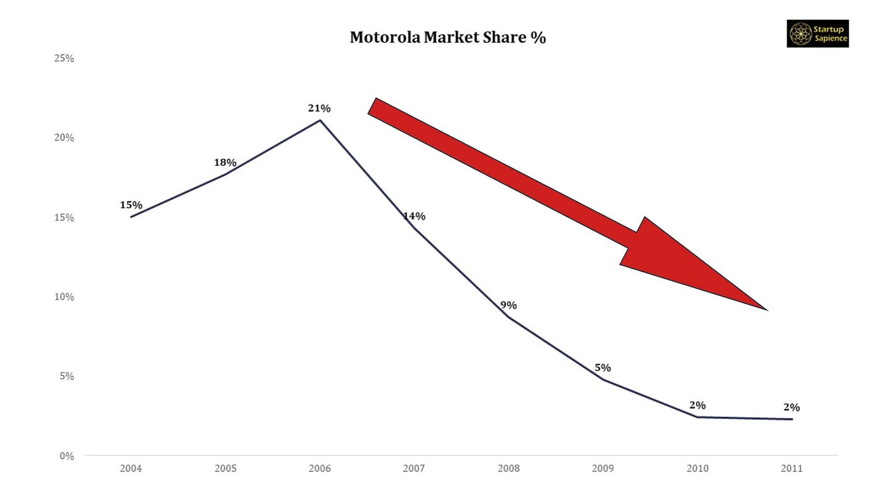

In retrospect, we can identify one major learning outcome. Apple devoted all its resources to refining one phone, whereas Motorola worked on dozens of phone designs at the same time. Apple was also fast to recognise the change in the mobile phone business from hardware to software. As a result, it invested much in design, whereas Motorola did not. Motorola unveiled the Droid, a smartphone meant to compete with the iPhone, in October 2009. Although the Android sold well at initially, it was absolutely insufficient to stay competitive with the current wave of smartphones. Competitors like as Samsung, LG, and other companies were pretty more aware of what customers desired. This shows Motorola has failed in all four stages of PMC which are plan, act, monitor and review. Motorola is an example of start, grow, mature and decline whereas Apple is the best example of start, grow, mature and steady (Dubashi,1991).

Reflecting on the post-maturity stage, critically discuss the relevant performance management activities for renewal, steady stage and decline.

Prior studies in the area of the strategic management have mostly concentrated on turnaround strategies for companies that fail. (Pant, 1991). Many firms are applying inaccurate measures, many of which are wrongly named KPIs. The example of Motorola above mentioned has demonstrated the fact that timely measurement is important. The organizations who working with inaccurate KPI measures incorrectly termed KPIs. There are four types of KPI measures which can be classified again into two groups: They are “result indicators and performance indicators”.
In order to reflect the fact that many measures are an aggregation of input from more than one team, the term result indicators can be useful. Result indicators can be valuable to evaluate the collective teamwork but, sadly, cannot help the management to fix a problem. This is because, it does not help to decide which teams are performing well or not. Performance indicators, in contrast, are measurements that can be connected to a team or a group of teams that collaborate closely for a single goal. One team is now in charge of both good and negative performance. Clarity and ownership are thus provided by these methods (Parmenter,2015). These clarity and ownership can help to avoid decline. Recently, there were some scholars replace KPI with KRI. major performance indicators for the private sector would be: Net profit before tax, Net profit on major product lines Return on invested capital, Employee happiness (by groups showing the trend over an 18-month period), and Customer satisfaction (by customer group, showing the trend over an 18-month period).
Key result indicators (KRIs) are what? KRIs are measurements that are frequently confused with KPIs. These measures have the trait of being the end result of numerous acts carried out by numerous teams, hence the name "result." Additionally, they are effective summary measurements, therefore the term "key." They give the firm a good insight of how the organization's strategy is progressing. These criteria are simple to identify and typically previously disclosed to the senior management. Key performance indicators, or KPIs, have an issue that many organisations are unaware of. They don't know why performance fluctuates and seems to be beyond the control of management team. These key performance indicators, which are normally evaluated on a quarterly or monthly basis cycle, only allow you to determine whether the horse has fled like what has happened in Motorola in the previous example. As a result of being published too late, key performance indicators are of limited benefit to management especially in post maturity stage. This is again what happened with Motorola when they were too late to invest in smart phone, 3Ds trend and Android phones (Parmenter,2015).
The emphasis placed on "stay, say, strive" and the motto "encouraging innovation that matters" are both ways that Toyota's Kaizen initiative seeks to ensure that employees are paid attention to, successfully involved, and always determined to do tasks better. There is no weighting for "accurate timely information that helps decisions" because other work teams, such Information technology and accounting, are more accountable (Parmenter, 2015:327).
Adizes et al. (2017) states that “the stages of the business life cycle model are predictable and repeatable, assisting in understanding interpersonal reactions, as well as the accumulation and dispersion of capital”. Thus, the understanding of the position in the business life cycle of a firm permits the firm to take preventative measures beforehand in order to address future problems in business survival and avoid them.

According to Michelin et al (2022), the stages of the business life cycle that involve starting, growing, and stabilising a company determine the extent to which the manager engages in entrepreneurial behaviour. It is acknowledged that managers exhibit constant entrepreneurial behaviour up until the point at which the business has stabilised, but that, beyond that, managers must exhibit entrepreneurial behaviour at a higher level to meet the difficulties and opportunities of the next levels. The post maturity stage calls for managers to demonstrate creative ideas that can entail breaking into new markets or segments, exhibiting entrepreneurial qualities that aid in the company's expansion.
Whatever one may think about the desirability or likely efficacy of an active governmental concern with the issues of exhausted industries, the author clearly establishes that there is no one set of business strategies or legislation appropriate for declining businesses in general, without respect to the significant variations in products and markets, industry competitive structure, and economic environment of individual firms. This is mainly the contingency approach (Rosegger,1981). The chance of recovery has been considered in research on turnaround tactics. The choice and effectiveness of turnaround strategies are influenced by the firm's fierce rivalry and the industry's level of maturity from an outside perspective (Morrow, Johnson, and Busenitz, 2004).
Two primary growth techniques are diversification and business concentration. According to Ramanujam and Varadarajan (1989), diversification is a firm's introduction into new activities through internal growth or acquisition. Internal development might involve investing in novel goods or services, client segments, entering to new regional markets, and international expansion. External diversification methods include acquisitions and joint venture capitalism. Growth can be vertical or horizontal. Vertical expansion occurs when a company takes over a supplier or distributor's function. A company grows horizontally by expanding into new markets or offering more goods and services in existing markets. Many empirical studies of large corporations have focused upon diversifying strategy (Rasheed,2005).
Prior research has suggested that declining organisations' strategy choices are influenced by historical financial performance record. Firms operating significantly beneath financial break-even, for example, may undertake asset lessening measures, whereas businesses operating around break-even might employ generate income or cost cutting methods (Hofer, 1980). Robbins and Pearce (1992) similarly related strategy selection for falling firms to monetary performance. They proposed that as the severity of the downturn intensified, downsizing measures shift from cost cutting to asset decline. Sudarsanam and Lai (2001) also stated that the severity of the decline played a role in whether the firm regained. If severity is a performance factor, historical monetary performance should be analysed in the strategic decision:
Given the very high death rate, the topic of decline is of relevance to small enterprises (Chowdhury and Lang, 1993). Previous small business studies focused on specific factors of failure and decline, but it was inconclusive. Boyle and Desai (1991) found from their review of the literature that small business failure was often due to managerial control concerns. According to Chowdhury and Lang (1993), the amount of the performance decline and the availability of resources are significant determinants in the effectiveness of a turnaround effort.
Reflecting on this module, how would you improve your practice using what you learned.

Following monitor and review very strictly at any stage of BLC and in particular in maturity stage to avoid decline, different strategies can be used.
Product diversification: It is critical for a company to recognise its unique and unrivalled competitive assets before attempting to apply them elsewhere,
Invest Innovation and reinvention/redesign: Overcomplicated design becomes a risk element that may bring a company into bankruptcy when it comes to declining items. That was an issue for Ricochet360, a cloud phone system and CRM platform that Eleken was redesigning. Ricochet360 was a software package. It took the product's team more than a month to assist clients set up the app, customise it, and train an administrator to use it. The administrator then had to train additional contact centre employees on how to utilise the new software. For the delay in time, the company resigned the software and managed to recover from declining. Reflecting on this, investment in research and development activities should continue to plan reinvention and redesign. The skills and practises related with turnaround plans should be learned by business managers. Invest in research and development: Nonetheless, Businesses are under pressure to keep spending under control and liquidity high as the crisis and worries expand. In this circumstance, R&D efforts, like all other corporate operations, may be scrutinised more closely. Leaders face several quandaries as they strive to reconcile the need to cut costs with the possibility of compromising technological benefits due to reduced funding availability. Multiple studies conducted during various economic recessions have demonstrated that organisations that maintain substantial investments in research and development (R&D) are likely to see growth, whereas competitors that decrease their efforts are more susceptible to a loss in performance. Research and development (R&D) operations serve as a means to establish credibility with both consumers and financiers by showcasing the company's ability to consistently produce high-quality products.

Conclusion
Businesses must create business models that can support the stability of the specified and utilized components that make up an effective business model, regardless of where they are in their development and operational stages. To accomplish so, individuals must make choices that are appropriate for the stage of life they are in. An acceptable degree of growth and development of the firm can only be ensured by a business model, PM and strategy that are designed in accordance with a specific stage of the company's development, serving as the foundation for managing.

References

Adizes, I.K., Rodic, D. and Cudanov, M., 2017. Estimating consultant engagement in the corporate lifecycle: study of the bias in South Eastern Europe. Management: Journal of Sustainable Business and Management Solutions in Emerging Economies, 22(2), pp.1-12.
Armstrong, M., 2010. Armstrong's handbook of reward management practice: Improving performance through reward. Kogan.
Atmaja, D.S., Zaroni, A.N. and Yusuf, M., 2023. Actualization Of Performance Management Models For The Development Of Human Resources Quality, Economic Potential, And Financial Governance Policy In Indonesia Ministry Of Education. Multicultural Education, 9(01), pp.1-15.
Baird, L., & Meshoulam, I. 1988. Managing two fits of strategic human resource management. Academy ol Management Review. 13: 116-128.
Bakarich, K.M., Hossain, M. and Weintrop, J., 2019. Different time, different tone: Company life cycle. Journal of Contemporary Accounting & Economics, 15(1), pp.69-86.
Betts, S.C., 2003. Contingency theory: science or technology?. Journal of Business & Economics Research (JBER), 1(8).
Boyle, RD and HB Desai (1991). Turnaround strategies for small firms. Journal of Small Business Management, 29(3), 33–43.
Chowdhury, SD and JR Lang (1993). Crisis, decline, and turnaround: A test of competing hypotheses for short-term performance improvement in small firms. Journal of Small Business Management, 31(4), 8–18.
DUBASHI, J., 1991. Motorola: The Bells Aren't Ringing. Financial World, 160(18), pp. 16.
Failfection, K.(2022), Motorola’s rise and fall-How it lost its relevance,Accessed on 17/10/2023.
Fry. L. W , & Smith, D. A. 1987. Congruence, contingency, and theory building. Academy ol Management Review. 12: 117-132.
Harney,B.(2016), Contingency theory, in book: An Encyclopedia of Human Resource Management, Wilkinson Adrian, Johnstone Stewart(eds.) (pp.72-73), Edward Elgar.
Lengnick-Hall C. A., & Lengnick-Hall, M. L. (1988) Strategic human resources management: A review of the literature and a proposed topology. Academy ol Management Review. 13: 454-470.
Li, H. J. K., and Tan, K. H. (2004), ‘Taking product to market: aselection framework based on life cycle theories’, International Journal of Services and Standards, Vol 1, No 1, pp4–17.
Lichtenstein, Gregg. A.., & Lyons, T. S. (2008). Revisiting the Business Life-Cycle: Proposing an Actionable Model for Assessing and Fostering Entrepreneurship. International Journal of Entrepreneurship and Innovation, 9(4), 241–250. https://doi.org/10.5367/000000008786208759
Michelin, C., Minello, I.F., Siluk, J.C., Gerhardt, V., dos Santos, J. and Neuenfeldt, A., 2022. Evaluation of entrepreneurial behavior of technology-based companies in stages of the business life cycle. Intangible Capital, 18(1), pp.1-19.
Milliman, ]. F., & Von Glinow, M. A. 1991. Strategic international human resources: Prescrip- tioris for MNC success. In K. Rowland (Ed.), RetearcH in personnei and iiuman resources management. Supplement 2: 21-35. Greenwich, CT: JAI Press.
Milliman, von Glinow, M. A., & Nathan, M. (1991). Organizational Life Cycles and Strategic International Human Resource Management in Multinational Companies: Implications for Congruence Theory. The Academy of Management Review, 16(2), 318–339. https://doi.org/10.2307/258864
Morrow, JL, RA Johnson and LW Busenitz (2004). The effects of cost and asset retrenchment on firm performance: The overlooked role of a firm’s competitive environment. Journal of Management, 30(2), 189–102.
Pant, LW (1991). An investigation of industry and firm structural characteristics in corporate.
Parmenter,D. (2015). Key performance indicators : developing, implementing, and using winning KPIs (Third edition.). Wiley.
Ramanujam, V. and Varadarajan, P., 1989. Research on corporate diversification: A synthesis. Strategic management journal, 10(6), pp.523-551.
Rasheed, H.S., 2005. Turnaround strategies for declining small business: The effects of performance and resources. Journal of Developmental Entrepreneurship, 10(03), pp.239-252.
Robbins, DK and JA Pearce (1992). Turnaround: Retrenchment and recovery. Strategic Management Journal, 13, 287–230.
Rosegger, G. (1981). [Review of Strategies for Declining Businesses., by K. R. Harrigan]. Journal of Economic Literature, 19(1), 132–133. http://www.jstor.org/stable/2724266.
Scott, W.R. 1992. Organizations: Rational, Natural, and Open Systems. Englewood Cliffs, N.J.: Prentice.
Sudarsanam, S and J Lai. Corporate financial distress and turnaround strategies: An empirical analysis. British Journal of Management, 12(3), 183–205
Wadongo, B. and Abdel-Kader, M., 2014. Contingency theory, performance management and organisational effectiveness in the third sector: A theoretical framework. International Journal of Productivity and Performance Management, 63(6), pp.680-703.

