University of Wales Trinity Saint David

School of Engineering



Front Suspension Kinematics and Performance Analysis of a Formula Ford Chassis

Motorsport Technology (ACHA012)
BEng Motorsport Engineering

Franklin Spencer Tim Attwood

2004876

November 2021
Table of Contents
Table of Figures 3
1 Introduction 4
2 Laboratory Sessions 5
2.1 Equipment Used 5
2.1.1 Wheel Position Test 5
2.1.2 Un-sprung Mass 5
2.1.3 Spring Stiffness Test 5
2.1.4 Vertical Tyre Stiffness Test 5
2.1.5 Accuracy 5
2.2 Methodology 6
2.2.1 Wheel Position Test 6
2.2.2 Un-sprung Mass 6
2.2.3 Spring Stiffness Test 7
2.2.4 Vertical Tyre Stiffness Test 7
2.3 Results 8
2.3.1 Wheel Position Test 8
2.3.2 Un-sprung Mass 11
2.3.3 Spring Stiffness Test 12
2.3.4 Vertical Tyre Stiffness Test 13
3 WinGeo Kinematic Simulation 14
3.1 Methodology 14
3.2 WinGeo Results and Comparison to Measured Values 15
3.3 Roll Centre Migration 21
4 Suspension Calculations 23
4.1 Calculations 23
4.1.1 Wheel rate 23
4.1.2 Front Sprung Mass/Ride Natural Frequency 23
4.1.3 Front Un-sprung Mass Natural Frequency 23
4.2 Discussion 24
5 Conclusion 25
6 Reference 26
7 Appendices 27
7.1 Equipment Details 27
7.1.1 Wheel Position Test 27
7.1.2 Un-sprung Mass 27
7.1.3 Spring Stiffness Test 27
7.1.4 Vertical Tyre Stiffness Test 28
7.1.5 Accuracy and Alternatives 28
7.2 Methodology Details 29
7.2.1 Wheel Position Test 29
7.2.2 Un-sprung Mass 29
7.2.3 Spring Stiffness Test 29
7.2.4 Vertical Tyre Stiffness Test 30

Table of Figures
Table 1 – Wheel Position Data 7
Table 2 - Toe Span 7
Table 3 - Un-sprung Mass 10
Table 4 - Spring Stiffness Data 11
Table 5 - Tyre Stiffness Data 12

Introduction
This report will investigate the characteristics of a Van Diemen single seater race car, Van Diemen made a few different race cars but for this report it will investigate the front suspension of the Formula Ford chassis. The front suspension used was a fully independent double wishbone design utilising inboard coil spring and damper assemblies connected to the lower wishbone via a push rod and bell crank.

Laboratory Sessions

Equipment Used
For full equipment details please see appendices Chapter 7.1

Wheel Position Test
- Formula Ford Suspension Rig
- Toe Plate
- Vernier Calliper
- Steel Rule
- Digital Height Gauge
- Camber Gauge
- Two Dial Test Indicators (DTI) With Holder

Un-sprung Mass
- Formula Ford Suspension Rig
- Corner Weight Scale

Spring Stiffness Test
- Coil spring
- Hydraulic Spring Compressor
- Corner Weight Scale
- Dial Test Indicator (DTI)

Vertical Tyre Stiffness Test
- Tyre and rim
- Hydraulic Press
- Corner Weight Scale
- Dial Test Indicator (DTI)
- Tyre Inflator

Accuracy
In these tests the biggest inaccuracies are generally human errors reading measurements and the equipment uncertainties which are in explained in detail in Chapter 7.1.5

Methodology
For full Details please see appendices Chapter 7.2

Wheel Position Test
Setup the formula ford rig with all the measuring equipment required and rotate the thread link to change the hub height and take measurements.
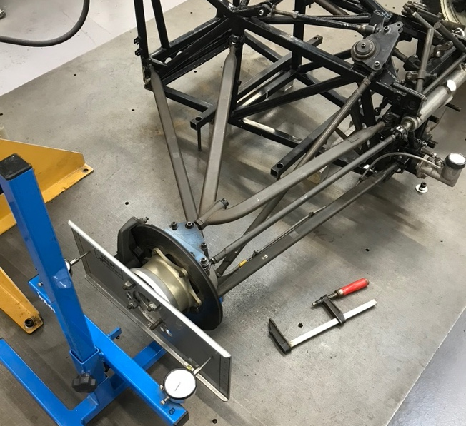
Fig. 2.2.1.1

Un-sprung Mass
Measure suspension mass with wishbones on and off the rig.
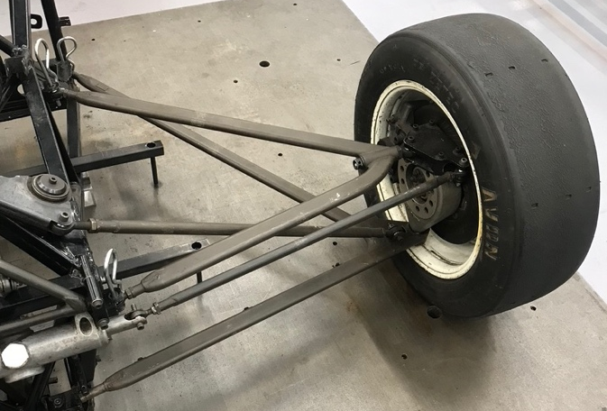
Fig. 2.2.2.1

Spring Stiffness Test
Use the spring compressor to compress the spring and measure the force.
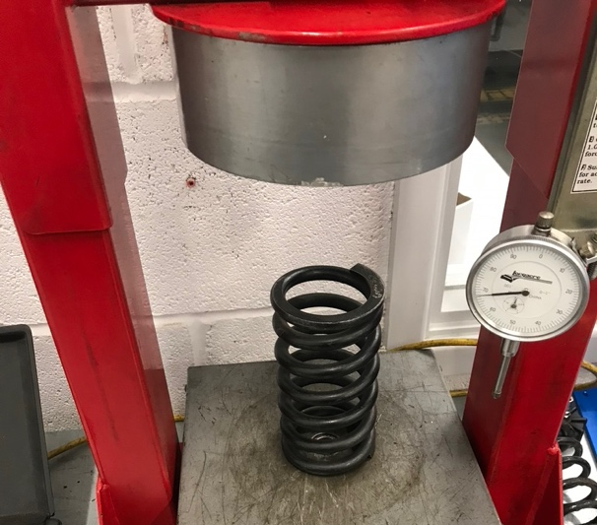
Fig. 2.2.3.1

Vertical Tyre Stiffness Test
Use the hydraulic press to compress the tyre and measure the force.
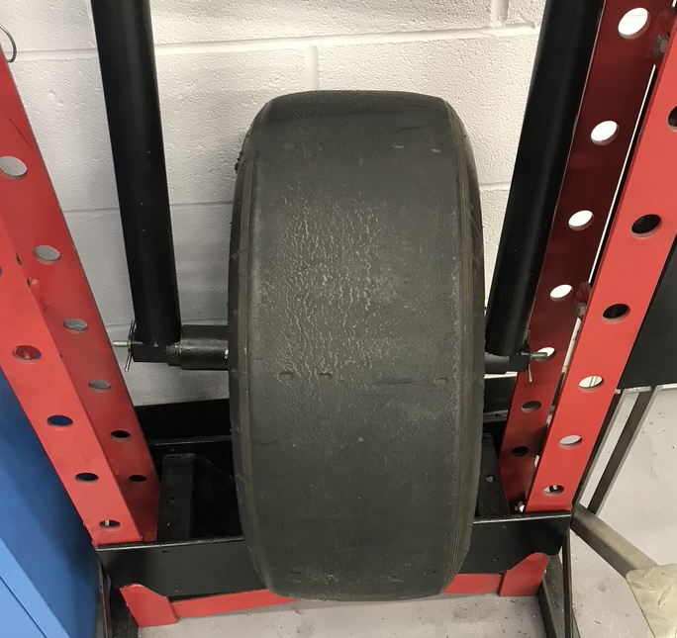
Fig. 2.2.4.1

Results

Wheel Position Test

Raw Data
Grey columns = raw data measured
Table 1 – Wheel Position Data
Wheel Position | Approx. Ride Height | Measured Camber | Zeroed Camber | DTI A | DTI B | Calculated Toe | Zeroed Toe | Spring / Damper Length | Change in Spring Length from Start position | Spring Length Compression
mm | mm | Degrees | Degrees | Inches | Inches | Degrees | Degrees | mm | mm | mm
0 | 26.28 | -1.17 | 0.29 | 0 | 0 | 0 | -0.246891 | 54.9 | 0 | 0
6.67 | 19.61 | -1.24 | 0.22 | 0.028 | 0.014 | 0.059594421 | -0.187297 | 51.6 | -3.3 | 3.3
15.18 | 11.1 | -1.31 | 0.15 | 0.054 | 0.025 | 0.123445587 | -0.123446 | 48.9 | -6 | 6
19.79 | 6.49 | -1.38 | 0.08 | 0.078 | 0.034 | 0.187296753 | -0.059594 | 46 | -8.9 | 8.9
26.28 | 0 | -1.46 | 0 | 0.099 | 0.041 | 0.246891175 | 0 | 42.9 | -12 | 12
32.75 | -6.47 | -1.54 | -0.08 | 0.117 | 0.046 | 0.302228852 | 0.0553377 | 40 | -14.9 | 14.9
39.26 | -12.98 | -1.62 | -0.16 | 0.133 | 0.05 | 0.353309785 | 0.1064186 | 37.1 | -17.8 | 17.8
45.54 | -19.26 | -1.71 | -0.25 | 0.147 | 0.051 | 0.408647462 | 0.1617563 | 33.9 | -21 | 21
51.86 | -25.58 | -1.8 | -0.34 | 0.159 | 0.051 | 0.459728394 | 0.2128372 | 31.1 | -23.8 | 23.8

Table 2 - Toe Span
Toe span (inches) | 13.46
mm | 342

Analysed Data

Fig. 2.3.1.2.1 – The relationship between ride height and camber angle is very close to linear when ignoring point A, this point looks like an anomaly value which was most likely caused by human error. Looking at the results table for the ride height, the of value of 11.1mm doesn’t seem to sit correctly. Looking at the camber angle trend, it shows at normal ride height the camber angle is 0º which means the tread pattern of the tyre will be making full contact with the ground, however when the wheel moves up the wheel goes into negative camber and the opposite happens when the wheel goes down. This is not ideal because the contact area of the tyre reduces when the cars wheel position changes vertically, it’s important to remember that the only variable here is the ride height and does not consider roll or steering.

Fig. 2.3.1.2.2 – This graph has a similar shaped line to the camber angle graph flipped on the x axis. Since both graphs use the ride height variable of 11.1mm (point B), the ride height value is affecting the trend of both graphs supporting an error in measuring. Observing the toe and ride height relationship it shows that when the wheel has fully compressed the suspension the front wheels are toed in and as the suspension fully decompresses the toe angle becomes negative (toe out). This change in toe versus ride height is known as bump steer and is undesirable.

Fig. 2.3.1.2.3 – This graph shows spring length change in relation to wheel position, the gradient this line gives the motion ratio of the front suspension, in this case is 0.46.

Un-sprung Mass

Raw Data
Table 3 - Un-sprung Mass
Un-sprung Mass on Car | Un-sprung Mass off Car
Kg | Kg
21.5 | 23.5

Analysed Data
From this test it is apparent that when the wishbones bolted onto the Formula Ford, the chassis takes 2 Kg of the total weight of the suspension components.

Spring Stiffness Test

Raw Data
Table 4 - Spring Stiffness Data
Spring Deflection | Spring Deflection | Measured Force | Measured Force
Inches | mm | lbs | N
0 | 0 | 0 | 0
0.1 | 2.54 | 31 | 137.8948701
0.2 | 5.08 | 68 | 302.4790698
0.3 | 7.62 | 106 | 471.5114912
0.4 | 10.16 | 144 | 640.5439126
0.5 | 12.7 | 184 | 818.4727772
0.6 | 15.24 | 224 | 996.4016418
0.7 | 17.78 | 264 | 1174.330506
0.8 | 20.32 | 304 | 1352.259371
0.9 | 22.86 | 344 | 1530.188236
1 | 25.4 | 385 | 1712.565322

Analysed Data

Fig. 2.3.3.2.1 – This graph has a linear trend which is as expected from a spring, the gradient of this line gives the average spring rate of 68.16 N/m.

Vertical Tyre Stiffness Test

Raw Data
Table 5 - Tyre Stiffness Data
Tyre Vertical Deflection | Scale Reading | Applied
mm | Kg | N
0 | 0 | 0
2 | 37.5 | 367.88
4 | 66.5 | 652.37
6 | 93.5 | 917.24
8 | 127 | 1245.9
10 | 152 | 1491.1
12 | 195.5 | 1917.9
14 | 207 | 2030.7

Analysed Data

Fig. 2.3.4.2.1 – Here the change in vertical tyre deflection versus the applied force is shown, the gradient of this line gives the average vertical tyre stiffness of 147.68 N/m.

WinGeo Kinematic Simulation

Methodology
Using WinGeo and the Formula Ford front suspension file, simulations can be carried out to change the ride height and roll angle:
- The ride height was changed from +25mm to -25mm in 5mm increments and the camber, motion ratio and toe steer was measured
- The roll angle was changed from 0º to 1.5º in 0.1º increments and the camber left, and right was measured.
The roll centre migration was plotted out by making the roll centre and changing the roll angle and ride height to simulate braking, cornering, and acceleration as follows:
- Start Position Ride height = 0mm – Roll angle = 0º
- Full Braking Ride height = -20mm – Roll angle = 0º
- Half Braking and Half Cornering Ride height = -10mm – Roll angle = 0.75º
- Full Cornering Ride height = 0mm – Roll angle = 1.5º
- Half Accelerating and Half Cornering Ride height = +10mm – Roll angle = 0.75º
- Full Accelerating Ride height = +20mm – Roll angle = 0º

WinGeo Results and Comparison to Measured Values

Fig. 3.2.1 – Comparing simulated camber and measured camber it is seen that the trends of both lines are similar with the measured camber having more of a curve than the simulation.

Fig. 3.2.2 – Looking at the WinGeo toe, it has a linear line which has the same direction as the measured toe however there is a large difference between the measured and simulated toe. Ignoring point D on the measured toe which looks like an anomaly in measuring, the rest of the measured toe values look straight, and it should be questioned if the simulation model provided is accurate.

Fig. 3.2.3 – This graph shows the motion ratio from the WinGeo simulation versus the ride height, using this graph it shows that the motion ratio at ride height is 1.02.

Fig. 3.2.4 – When the roll angled increases, the camber on the left goes from neutral to negative and on the right wheel the camber goes from neutral to positive at the same rate as the left wheel. This is far ideal because as the car is rolling there is less of the tyre contact on the ground however, these simulation results do not represent the car going around a corner because the steer angel is neutral so it may be the case that as the wheel is turned and the car is rolled the camber values are suitable for maximum tyre contact when cornering which would be best.

Instant centre at normal ride height – Vertical = 57.39mm - Transvers = 4190.543mm

Roll centre value at normal ride height – Vertical = 11.479mm – Transverse = 0mm

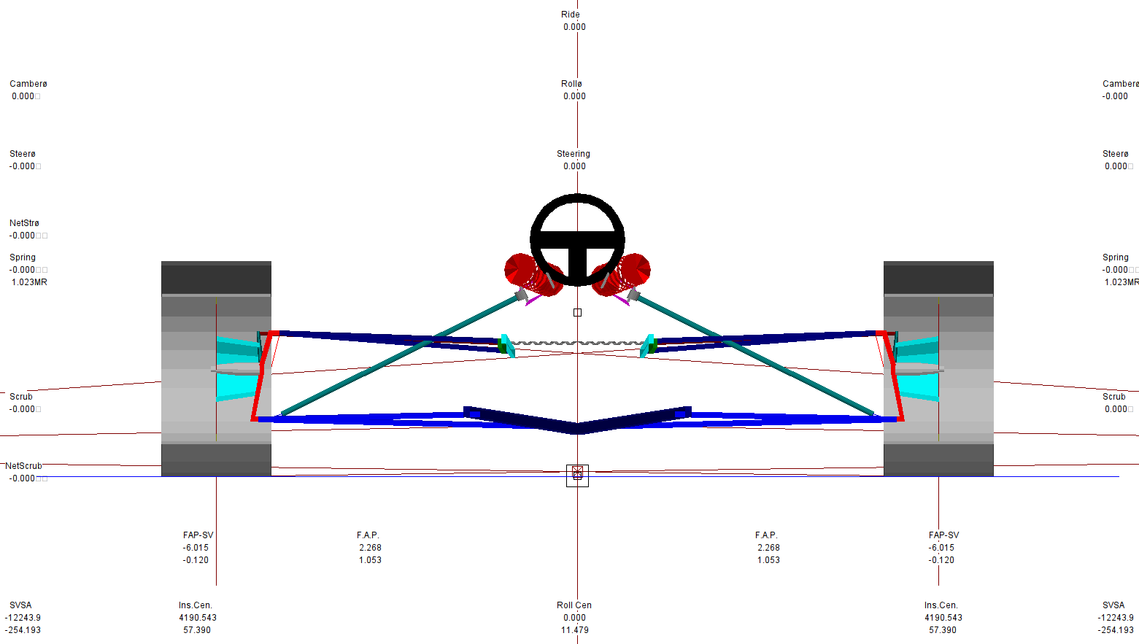

Fig. 3.2.5 Rear view of WinGeo simulation.

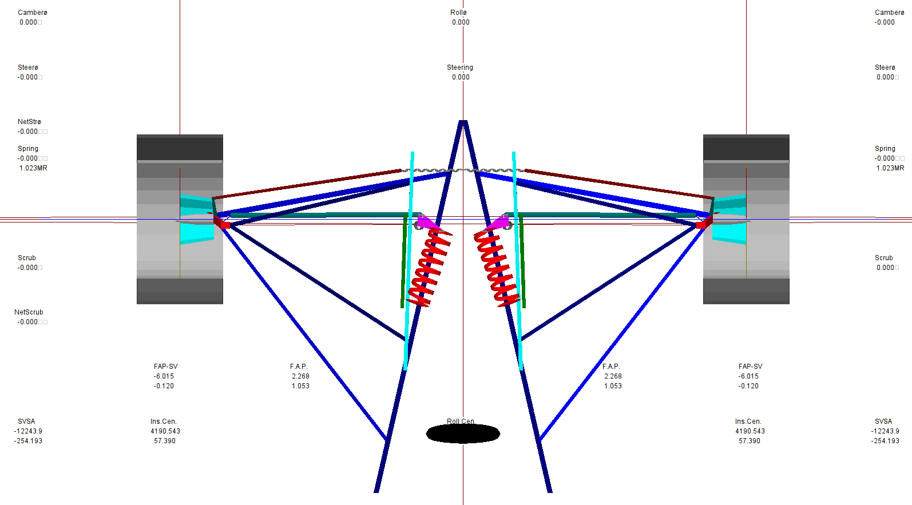
Fig. 3.2.6 Top view of WinGeo simulation.
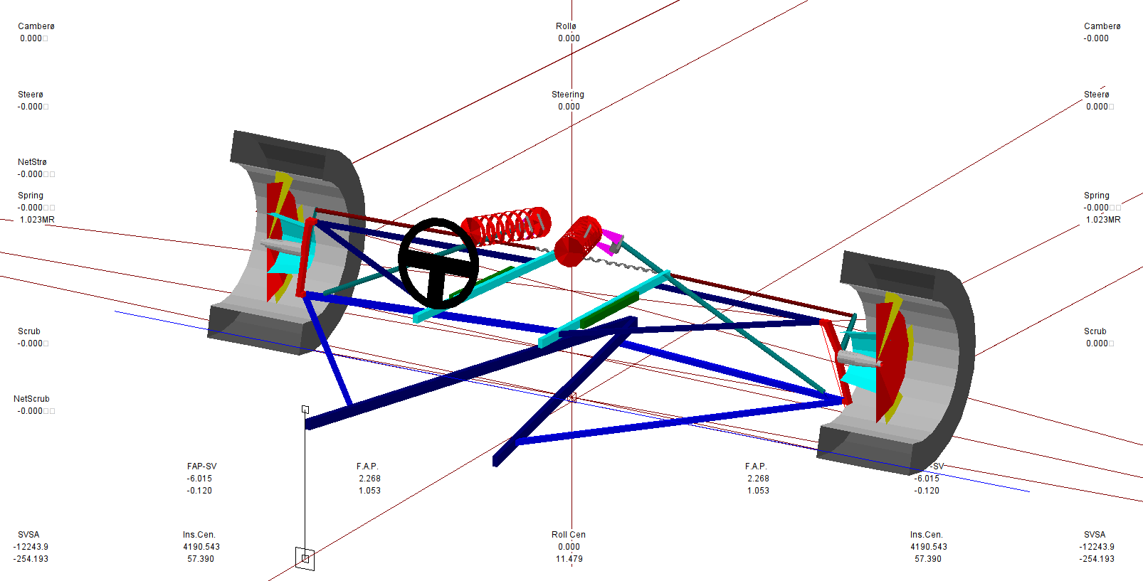
Fig. 3.2.7 Offset Views of WinGeo simulation.

Roll Centre Migration
The roll centre is a virtual point and uses the instant centres which are where the wishbones would cross if they were extended until they meet, this is done for both sides of the car. Then a line is drawn from the tyre contact patch to the appropriate instant centre for both sides, the point at which these two lines cross defines the roll centre point.
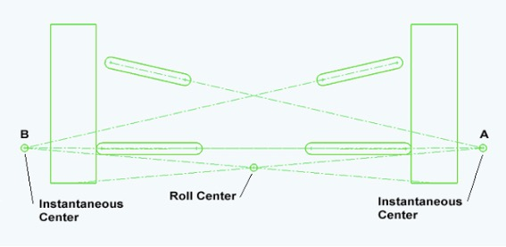
Diagrams showing the instant centres and roll centre (2021, Jonathan Vogel)

The roll centre has a big impact on the handling of the car more so than spring and dampers “because the roll centre has an immediate effect on a car’s handling, whereas anti roll bars, shocks and springs require the car to roll before they produce an effect”. Roll Centre Understood (Serpent.com, 2004)

LOWER front roll centre
* More on-throttle steering
* Car is less responsive
* Better on smooth, high grip tracks with long fast corners
HIGHER front roll centre
* Less on-throttle steering
* Car is more responsive
* Use in high grip conditions to avoid traction rolling
* Use on tracks with quick direction changes (chicanes)
Roll Centre Understood (Serpent.com, 2004)
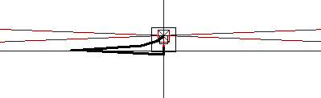
Fig.3.3.1 – In this diagram from the simulation the roll centre is shown as the car was set to change in ride height and roll as if the car was going around a corner. From the diagram it is seen how the roll centre location moves around in relation to the ride height and roll values set out in the methodology section.

Suspension Calculations

Calculations
Total Corner Mass = 115 Kg
Un-sprung Mass = 23.5 Kg
Tyre Stiffness = 147680 N/m
Spring Rate = 68156 N/m
Motion Ratio = 0.46

Wheel rate
$$Wheel rate=Spring Rate*{Motion Ratio}^{2}$$
$$Kw=Ks*{MR}^{2}$$
$$Kw=68156*{0.46}^{2}$$
$$Kw=14497.15 N/m$$

Front Sprung Mass/Ride Natural Frequency
$$Natural Frequency Sprung Mass=\frac{1}{2}√\frac{Wheel Rate}{Sprung Mass}$$
$$f= \frac{1}{2}√\frac{Kw}{Ms}$$
$$f= \frac{1}{2}√\frac{14497.15}{115}$$
$$f=1.79 Hz$$

Front Un-sprung Mass Natural Frequency
$$Natural Frequency Unsprung Mass=\frac{1}{2}√\frac{Wheel Rate+ Tyre Stiffness}{Unsprung Mass}$$
$$fus=\frac{1}{2}√\frac{Kw+Kt}{Mus}$$
$$fus=\frac{1}{2}√\frac{14497.15+147680}{23.5}$$
$$fus=13.82 Hz$$

Discussion
Looking at the natural ride frequency of the Formula Ford chassis of 1.79 Hz it falls into the non-aero race car category. At this frequency the ride would be hard which for a race car is not seen as a concern but for passenger vehicles comfort is generally what manufacture are after. In this case manufactures aim to go between 1 and 1.5 Hz which stays out of the motion sickness range of 0.7 Hz but can still make a car feel well panted to the road at the higher end of 1.5 Hz.

0.5 – 1.0 Hz Passenger cars, typical OEM
1.0 – 1.5 Hz Typical lowering springs
1.5 – 2.0 Hz Rally Cars
1.5 – 2.5 Hz Non-Aero race cars, moderate downforce Formula cars
2.5 – 3.5 Hz Moderate downforce race cars with up to 50% total weight in max downforce capability
3.5 – 5.0+ Hz High downforce race car with more than 50% of the weight in max downforce

Spring Rates & Suspension Frequencies (DRTuned Racing, 2017)

Conclusion
To summarise, the Van Diemen Formula Ford front suspension analysed in this report has significant camber change in relation to ride height and the WinGeo simulation agrees with this trend. The same can be said for the toe angle versus ride height because there is a lot of bump steer taking place especially in the simulation, however this is most likely due to the simulation file provided. In the simulation results for the camber versus roll angle, the values for corning are again not ideal but the steer angle was not changed during the simulation. The roll centre height in the simulation is seen to be on the lower side making the car less responsive but smoother on high-speed tracks with fast corners. The ride frequency of the Formula Ford looks to be suitable for a low aero race car and for moderate down force Formula cars.

Reference
DRTuned Racing (2017) Spring Rates & Suspension Frequencies
Available at: https://www.drtuned.com/tech-ramblings/2017/10/2/spring-rates-suspension-frequencies
(Accessed: 11/12/2021)

Serpent.com (2004) Roll Centre Understood
Available at: https://www.serpent.com/xcart/cart.php?target=news_message&id=10089
(Accessed: 10/12/2021)

Jonathan Vogel (2021) Tech Explained: Roll Centre
[Diagram]
Available at: https://www.racecar-engineering.com/tech-explained/tech-explained-roll-centre/
(Accessed: 10/12/2021)

Appendices

Equipment Details

Wheel Position Test
- Formula Ford Suspension Rig – The rig consists of the front half of a Formula Ford chassis which is mounted to a test bed. The right-hand side Formula Ford suspension components are then bolted to the chassis and the coil spring and damper assembly replaced with a thread link which allows the hub position to be changed height wise.
- Toe Plate – A flat plate which is bolted the front face of the hub where the wheel normally mounts and gives a true flat plane for measuring the toe distance.
- Vernier Calliper – In this case an analogue version measuring in millimetres which is an accurate way to measure the length of exposed thread on the threaded link which replaces the coil spring and damper assembly.
- Steel Rule – Used to measure the distance between the two DTIs when mounted in the DTI holder, unable to use the vernier calliper due to the distance between the DTIs being greater a vernier calliper can measure.
- Digital Height Gauge – Very similar to a vernier calliper above however it is a digital device and it’s mounted to a base plate which sits on the test bed to measure the height of the wheel hub.
- Camber Gauge – This device is a digital angle finder which is zeroed to the test bed and used to measure the angle of the hub which will be the camber angle.
- Two Dial Test Indicators (DTI) With Holder – These DTIs are very sensitive and, in this case, measures distances down to 0.001”. In this test they are mounted to a holder which holds them apart so one DTI measures the distance to the toe plate forward of the hub and other DTI rearward of the hub. These two reading measure the toe of the wheel hub.

Un-sprung Mass
- Formula Ford Suspension Rig – The same rig which is used in the wheel position test however on the left-hand side it’s simply the wish bones, track rod, spring push rod, hub, and wheel.
- Corner Weight Scale – Simply a wireless digital scales used to measure a mass.

Spring Stiffness Test
- Coil spring – The coil spring which was used on the Formula Ford chassis.
- Hydraulic Spring Compressor – Used to compress a spring controllably and safely.
- Corner Weight Scale – Simply a wireless digital scales used to measure a mass
- Dial Test Indicator (DTI) - The DTI is very sensitive and, in this case, measures distances down to 0.001”. In this test it is mounted to the spring compressor to measure the distance between press face and base.

Vertical Tyre Stiffness Test
- Tyre and rim – These are the same trye and rim combination from the Formula Ford which will be tested.
- Hydraulic Press – Used to compress an item, in this case the tyre and rim, controllably and safely.
- Corner Weight Scale – Simply a wireless digital scales used to measure a mass.
- Dial Test Indicator (DTI) - The DTI is very sensitive and, in this case, measures distances down to 0.01 mm. In this test it is mounted to the press to measure the distance between press face and base.
- Tyre Inflator – Used to inflate the tyre to the desired pressure and to check the pressure in the tyre.

Accuracy and Alternatives
In these tests an analogue vernier calliper was used however since these require someone to read the very fine scale it can easily be misread, an alternative to this is a digital vernier calliper which displays the measurement in a decimal form on a display. For measuring the height of the hub, a digital height gauge is used which is nearly identical to a digital vernier calliper, both are not without their fault though because they need to be zeroed when you use them and if they get contaminated with oil or dirt, they struggle to pick up the measurements. The steel rules are often used when fabricating and in the case of a guillotine it is not uncommon for the end of the rule to be left on the work piece when cutting material, as a result the end of the rule can be cut making it shorter making measurements inaccurate. The comer weight scales used only measures down to 0.5kg which reduces the accuracy especially when calculating the spring and wheel rates.

Methodology Details

Wheel Position Test
- Ensure the rig is reset ready for new measurements by winding the threaded link which replaces the coil spring and damper assembly fully anticlockwise, then half a turn clockwise to take out any backlash in the threads. The wheel hub should now be at full droop.
- Using the vernier calliper measure the exposed thread on the threaded link and note down the measurements.
- Clamp the camber gauge to the back face of the hub confirming it’s clamped onto a vertical machined surface such as the brake calliper mounting lugs. Power on the camber gauge and make a note of the reading remembering that the reading is a negative value due the camber gauge being mounted on the back face of the hub.
- Attach the toe plate to the hub face and zero the digital height gauge to the top surface of the toe plate, then move it aside to allow free movement of the hub.
- Connect the two DTIs to the holder and measure and record the distance between the DTI which is the Toe span.
- Position The DTI holder so the stem of the DTIs is touching the toe plate and about 50% of the DTI’s stem is sticking out. Zero the clock faces on both DTIs.
- Wind the threaded link 2 turns clockwise to rise the wheel hub then position the height gauge back to the top surface of the toe plate and note the reading.
- Measure the thread on the threaded link with the vernier calliper and check the camber gauge noting their readings.
- Record the values on the DTI gauge noting if they are negative or positive because the values can increase and decrease.
- Repeat steps 6 to 7 until the hub height is maxed out.

Un-sprung Mass
- Power on one corner weight scale and zero it.
- With the wish bones and track rod still bolted to the rig, place the tyre on the scales and take the reading.
- Unbolt the wish bones and track rod from the rig and weight the whole assembly and note the reading.

Spring Stiffness Test
- Place the coil spring in the hydraulic spring compressor with the scales under the spring and bring the press face down until it just contacts the top of the spring.
- Bring the DTI down to the scale face and zero the clock face
- Zero the scales and pump the handle until the DTI reads 0.1 inches (1 revolution on the DTI)
- Note the measured force
- Repeat steps 3 to 4 until the DTI reads 1 inch.

Vertical Tyre Stiffness Test
- Place the Tyre in hydraulic press with the scales under the tyre and bring the press down to compress the tyre slightly.
- Using a tyre inflator, inflate the tyre to the desired pressure and note the pressure reading.
- Bring the DTI down to the top of the tyre jig and zero the clock face
- Zero the scales and pump the handle until the DTI reads 2mm (2 revolutions on the DTI)
- Note the measured force
- Repeat steps 3 to 4 in 2mm steps until the DTI reads 14mm.

