University of Wales
Trinity Saint David
School of Applied Computing

Title: Synthesize a Solution to a Real-Life Scenario

Module: Networks and Cybersecurity Essentials
Code: ACCA 4024
Student: Martin Darzins
Student no.: 1909722
Programme: BSc HND Computing Portfolio
Lecturer: Nitheesh Murugan Kaliyamurthy
Due Date: 8th January 2021

Abstract
In 2006, British data scientist and mathematician Clive Humby was quoted as saying “Data is the new oil”’, where “a lot of money can be made…and lost” [1], which still today confirms the importance of data and its security, both personal and within organisations.
With this importance, this report analyses the potential cybersecurity threats surrounding the scenario of a world-wide construction-based company (Che-Si). Through evaluation, the report will demonstrate an understanding of the various security measure & policy mitigations available to mitigate both internal and external network attacks.
Focusing on personal mobile internet devices, the report will show the vulnerabilities, threats and attack possibilities that could arise while accessing the Che-Si systems and make recommendations as to techniques that should be adopted in order to mitigate such threats, without adversely affecting profitability, productivity and performance.
Culminating in a proposed IT security policy strategy for Che-Si to adopt in order to mitigate against any flaws, including those concerning the security of staff personal data, company business and client data.
The report concludes that Che-Si senior management need to act now to protect the business against legal actions and regulatory requirements, and to ensure the company’s future sustainability and profitability by immediately incorporating a number of the Strategic Policy actions identified.

acknowledgements
The author acknowledges the UWTSD Lecture notes provided within the Network and Cybersecurity Essential module course ACCA 4024.

Table of Contents
1 Abstract 2
2 acknowledgements 3
4 Introduction 6
4.1 Aims 6
4.2 Objectives 6
5 Background & assumptions 7
5.1 Personal Mobile Internet Devices 7
5.2 Attacks and Threats – Internal & External 7
6 vulnerabilities, threats & attacks 8
6.1 Adverse Effects 8
6.2 Mitigations 9
6.2.1 General 9
6.2.2 Specific 9
6.2.3 Confidentiality 10
6.2.4 Integrity 10
6.2.5 Availability 11
6.3 Digital Signatures 11
7 recommendations & conclusion 12
7.1 Board Level 12
7.2 Next Steps 12
7.3 Conclusion 12
8 annexure 1 13
8.1 Policy Strategy 13
8.1.1 Risk Management 13
8.1.2 Secure Configuration 13
8.1.3 Network Security 13
8.1.4 User Privileges 13
8.1.5 Education and Awareness 14
8.1.6 Incident Management 14
8.1.7 Malware Prevention 14
8.1.8 System Monitoring 14
8.1.9 Media Controls 14
8.1.10 Mobile Working 14
8.1.11 Other Frameworks and Countermeasures 15
8.2 Examples 16
8.2.1 Ping/Traceroute 16
8.2.2 Ipconfig/all command 17
8.2.3 MAC Filtering 17
8.2.4 Address Resolution Protocol (ARP) 18
8.2.5 Nslookup 18
8.2.6 Wireshark 19
8.2.7 Network Mapper (nmap) 19
8.2.8 Steganography 20
8.2.9 Digital Signatures 20
8.2.10 System Hardening 21
8.2.11 NetStumbler 21
9 References 22
10 Report Planning Methodology 23

Introduction

Aims
This report aims to demonstrate the systematic understanding of security policies and measures to mitigate internal and external attacks and threats in a network. It will demonstrate the flaws in existing Che-Si company policies and infrastructure and will propose guidelines to senior management for an IT security framework to be adopted.

Objectives
The report will show potential, threats, attacks and vulnerabilities to the Che-Si systems, primarily assessed from the various personal internet devices and world-wide location aspect and offer a series of recommendations to mitigate such threats without adversely affecting company productivity and performance.
The reports’ guidelines will highlight the need for staff, suppliers and clients to each be responsible for their use of personal mobile internet devices.

Background & assumptions
Che-Si construction company has site offices located world-wide and requires 24hr/7day connectivity with its clients and offices. All current communication technologies including video conferencing and cloud storage facilities are utilised.
Currently Che-Si allow all staff, clients and suppliers unfettered access to their network, from any location world-wide, from any device.
No detailed comprehensive IT security policy or guidelines presently exist, and in-house security personnel lack the ability to design and recommend an IT security framework to protect the company’s assets.
Whilst it is recognised that attacks on the company IT systems can originate from numerous Internal and External sources, the focus of this report shall be on personal mobile internet devices.

Personal Mobile Internet Devices
These are any device that provides a mobile multi-media capability via wireless internet access. Typically, designed to provide business and/or personal business and entertainment use. Allowing 2-way communication and real-time sharing and can include; smartphone, tablet, mobile and wearable computers/personal digital assistant (PDA)/laptop devices, digital cameras, personal navigation devices, and smartcards etc.

Attacks and Threats – Internal & External
An external attack, through the use of malware such as worms, Trojan horse viruses and phishing etc, can steal confidential information. Most commonly targeting customer data held by companies, which can be valuable on the ‘dark web’.
Insider threats from a current or even former employee, supplier or other business client with access to the Che-Si network, data or systems whose access results in misuse or with the intent to misuse them.
A number of internal cyber-attacks search for staff information, possibly for recruiting or poaching purposes. But also, instances include disgruntled employees who had/have access to servers and confidential information, target intellectual property for personal revenge.
Even though certain internal threats are not intended, (i.e., accidental), whenever sensitive data is compromised, the effects are similar [2].

vulnerabilities, threats & attacks
A threat can be described as a potential danger to an asset such as data or network, whereas a vulnerability is a weakness in a system or in its design that could be exploited by a threat. Risks can be categorised as the likelihood that a particular threat will exploit asset vulnerabilities and result in unsought consequences.
Malware utilised to exploit these vulnerabilities are code/software designed to damage, disrupt, steal and/or inflict unscrupulous/illegitimate action on data, hosts or networks. The most common types are Virus, Worm, Trojan horses and Ransomware, examples are Phishing, Vishing, Pharming, Whaling as well as various Spam and Spyware packages that are designed to gather information about a user.

Adverse Effects
Compromised network security will have major implications/consequences that adversely affect the entire business. Theft, loss of privacy and information are dangerous for any business, therefore it should be treated with a special attention along with due consideration of any/all costs of security, being regarded as an investment on the future profitability and health of Che-Si. As no (or very little) protection is currently available within the Che-Si network against any of these possibilities, the Risks of adverse effects to the company are high, immediate and can include [3];
- Enablement of unauthorised access and file transfers.
- Provide threat actors with sensitive data (i.e., passwords).
- Corruption and/or deletion of files.
- Use of Che-Si computers as the source device for an attack on another.
- Stopping of antivirus or firewall programmes from functioning.
- Slows and/or halts network activities.
- Attempted theft of confidential information (i.e., credit card details) through recording keystrokes.
- Particularly for mobile devices attacks can come from;
- Grayware which makes applications behave in an undesirable manner.
- Smishing which sends fake text messages to trick users into visiting websites or calling telephone numbers in an attempt to solicit credit card details etc.
- Rogue Access Points are a wireless access point installed on a secure network without authorisation.
- Bluejacking sends unauthorised messages to another Bluetooth device, and Bluesnarfing copies email and contact list information from a victim’s account [4].

Mitigations
The most important thing Che-Si can do is to immediately create and implement a cybersecurity strategy that works to address vulnerabilities, complete with deliberate steps to undertake in the event of an internal or external breach. It is unlikely to be able to protect against every possible threat, but efforts must be made, as Network security is the basis for commercial success, but should not be excessive to make it unproductive or inefficient toward Company operations and profitability. The right balance needs to be reached between usability and security. A secure network needs to be robust and a base for implementing latest technologies, these will significantly add to reducing operating costs, increasing productivity, and will lead the Che-Si becoming more; information secure, stronger, flexible and competitive.

General
User awareness is key in preventing cyber-attacks and so the following is recommended to better protect Che-Si assets;
- Educate all staff with regard the various forms a cyber threat can take. From malware to disgruntled employees, as explained previously, multiple methods potentially place the system and business at risk.
- Train staff re: correct cybersecurity policies and procedures and ensure adherence.
- Establish access rights and seniority levels, only giving staff what is they need to be able to carry out their job duties.
- Ensure basics are in place, such as email security, antivirus programs and intelligent firewall.
- Encrypt information shared over networks, secure servers and Wi-Fi.
- Protect software/hardware and ensure all work & personal devices have appropriate password protection and remotely erasable.
- Review regularly with cyber security consultants/professionals to ensure no vulnerability is overlooked [2].

Specific
Implement Wi-Fi Protected Access (WPA2) as the improved version of the Wired Equivalent Privacy (WEP) to provide security protocols to a wireless local area network (WLAN). WPA2 does not have the same encryption issues, but is still susceptible to attack because criminals can analyse the packets transferring between access point and legitimate user, thru the use of a packet sniffer.
Web application Cross-site scripting (XSS) vulnerabilities allow attackers to inject scripts into web pages, which itself could contain malicious code. Website can be protected by utilising a database to store data at a website, such as Structured Query Language (SQL) or Extensible Mark-up Language (XML) database, which will not validate Code Injection Attacks [5].
Computer network security implementation process should consider the importance of Confidentiality, Integrity and Availability, along with the principles of the McCumber cube. Where network capability provides access to information only to authorized persons, is confidential. Where information/data has not been altered by unauthorised persons dictates integrity and availability as the time the computer network and resources within it are operational. Each of these aspects have an attack/threat potential [3].
Specific defences against wireless attacks can also be achieved by;
- Restricting access point placement and utilising tools such as NetStumbler to discover any rogue access points or unauthorised workstations.
- Developing a guest policy for those who need to connect to the internet while visiting.
- Writing solid prudent programming code by treating all input from outside a function as hostile.
- Validate all inputs as if they were hostile.
- Keep all software, OS and applications up-to-date and adhering to update prompts.
- Select manual updates, as not all will update automatically
- Use of ciphers to encrypt/decrypt data when stored and transmitted, so that only the intended recipient can read and process.
- Adopt asymmetrical encryption processes, where the public key for encryption is different from the key utilised for decryption with methods including; Rivest Shamir Adleman (RSA), Diffie Hellman, ElGamal and Elliptic Curve Cryptography (ECC).
- Of these four protocols using asymmetric key algorithms the Secure Shell (SSH) provides a secure remote access connection to network devices and would be recommended to Che-Si.

Confidentiality
Prevents disclosure of information to unauthorised people, resources and processes. Che-Si need to train staff about best practices in safeguarding information through Data Encryption, Authentication (verification of user identity), Access Control (determining which services/resources users can access and actions that they can perform) and Accounting to keep track of what users do, when where, how etc and any changes made.

Integrity
Implement Hashing to ensure that the data quality is accurate consistent and trustworthy. Hashing takes a ‘snapshot’ of data at an instant of time by taking binary data (the message) and producing a fixed length representation called a hash value. The most popular being Message Digest 5 (MD5) and Secure Hash Algorithm (SHA), these themselves are made more secure via Salting, which adds a random string of characters to a password before hashing. Further strengthening of hashing is completed via hash-based authentication code (HMAC’s), which use an additional secret key as input to the hash function, this combines integrity assurance with added authentication.

Availability
Attacks can prevent user accessibility and in order to maintain information systems and service availability at all times. Introducing; redundancy & back-up systems, equipment maintenance, up-to-date OS and software and disaster recovery plans, reliable crossovers, eliminating of Single Points of Failure and the detection of Failures in real-time, will increase resilience [6].

Digital Signatures
Are a mathematical method of checking the authenticity and integrity of a message, digital document or software and can determine whether someone edits a document after signature and is based on asymmetrical cryptography.
They reduce the risk of duplication or alteration of the document and ensure that signatures are verified, authentic and legitimate. Signers are provided with PINs, password and codes that can authenticate and verify their identity and approve their signature [7]. Digital signatures have proved themselves to;
- Offer added security
- Be of high (2 key) standard
- Be globally accepted and legally compliant
- Have long-term retention and accessibility qualities
- Withstand independent verification and cannot be altered by unauthorised parties.

recommendations & conclusion

Board Level
Protecting information is also a board-level responsibility as it is supporting economic growth, improving collaboration, innovation and job creations. Important to both competitiveness and business sustainability, cyber security is not just an IT concern, but rather a strategic risk management issue.
It is important to determine the various Che-Si key information assets, explore who might compromise this information and why, and instil pro-active cyber risk management from Board level and throughout.
Companies benefiting from managing risks across their organisations, draw effectively on senior management support, risk management policies and processes, a risk-aware culture and the assessment of risks against objectives, with the resulting benefits being [8]:
    - Strategic - Corporate decision making improved through the high visibility of risk exposures.
    - Financial - Through reduction of losses and improved value for money opportunities.
    - Operational - Greater preparedness for eventualities, assures adequate contingency planning.

Next Steps
Before investing in IT security countermeasures, first ascertain evidence that Che-Si will be targeted, by specific threats. Even though it may be difficult to accurately assess specific threats to the business, every organisation is potentially a victim, as all have something of value to someone, somewhere.
As more fully explained in Annexure 1 – Policy Strategy & Examples, there are effective and affordable ways to reduce Che-Si’s exposure to the more common types of internet attacks which need to be immediately incorporated.

Conclusion
The Che-Si company need to act now in order to protect the viability of their business and protect themselves against any legal actions, brought about from their failure to abide by the various legal and regulatory requirements.
The recommendations and mitigations proposed within this report and annexure 1, will (if implemented) reduce the threats of cyber-attacks, help further the profitability of the company and thereby safeguard its future. It is not a matter of whether this should be implemented…but rather how soon can it be!

Word count: 2,047 (excluding Title page and sections 1- 3, & 8 -10)

annexure 1

Policy Strategy
The strategy to update Che-Si’s exiting IT security policy will respect the following elements [9];

Risk Management
Embed a risk management regime across Che-Si, reinforced by a board supported governance structure. Clearly communicate the risk management approach with the development of applicable policies and practices. Ensure that all staff employees, clients and suppliers are aware of the approach, how decisions are made and any applicable risk boundaries.

Secure Configuration
Identify baseline technology builds and processes to improve configuration management and system security, including that an appropriate password policy is in place and followed. Develop a strategy to remove or disable unnecessary functionality from systems, quickly fixing known vulnerabilities, via patching. Failure will result in increased risk of system and information compromise, as patching known vulnerabilities with the latest version of the software, will prevent attacks which exploit software bugs.
Restrict the functionality of every device, operating system and application to the minimum needed for business to function via secure configuration.

Network Security
Connections from Che-Si networks to the Internet and other partner networks, expose the systems to attack. These can be reduced by creating and implementing simple policies and appropriate architectural and technical responses. As Che-Si's networks will span many sites and due to the increased use of mobile/remote working, and cloud services etc, defining a fixed network boundary is difficult. So rather than focusing purely on physical connections, consider where the data is stored and processed, and where an attacker would have the opportunity to attack it.
Establish network perimeter defences, particularly web proxy, web filtering, content checking, and firewall policies to detect and block executable downloads, block access to known malicious domains and prevent users’ computers from communicating directly with the Internet.

User Privileges
All users should be provided with a reasonable (but minimal) level of system privileges and rights needed for their role. The granting of highly elevated system privileges should be carefully controlled and managed, in line with the principle of ‘least privilege’, which will limit user access control, including normal user execution permissions.

Education and Awareness
Users are critical to the organisation’s security and therefore it is important that security rules and the technology provided enable users to do their job as well as help keep the organisation secure. This should be supported by a systematic delivery of awareness programmes and training that deliver security expertise as well as establishing a security-conscious and reporting of unusual activity culture.

Incident Management
With all organisations eventually experiencing security incidents at some point, investing in effective incident management policies and processes will improve resilience, support business continuity, improve client & stakeholder confidence and reduce adverse impacts on the business.
Consideration should be given to recognised sources (internal or external) of specialist incident management expertise, as should establishing security incident management response plan(s) to handle any attack.

Malware Prevention
Malicious software/malware covers any code or content that could have an undesirable impact on systems. All exchanges of information carry risk that malware might be exchanged, but this risk can be reduced by maintain, developing and implementing appropriate anti-malware policies as part of a layered/defence in depth approach to detect/respond to attack codes.

System Monitoring
Provides a capability that to identify any unexpected/suspicious activity and detect actual/attempted attacks on systems and business services. Reliable monitoring is essential to effectively respond to attacks, as it ensures systems are being used appropriately and in accordance with Che-Si policies, along with compliance to various key legal or regulatory requirements.

Media Controls
Removable media provides a common route for the introduction of malware and the accidental or deliberate export of sensitive data. Transparency should be issued concerning Che-Si’s business need to use removable media and apply appropriate security controls to its use. Prevent whitelisting and execution control/unknown software from being able to run or install itself, including AutoRun on USB and CD drives [8].

Mobile Working
Home, mobile working and remote system access has benefits, but exposes additional risks that require managing, therefore risk-based policies/procedures need to be established that support this need. Users will require training on the secure use of their mobile devices in the environments they are likely to be working in.

Other Frameworks and Countermeasures

Frameworks to incorporate include;
- Software based Technology Safeguards
- Hardware based Technology Safeguards
  - Firewalls
  - Intrusion Detection Systems (IDS)
  - Intrusion Prevention Systems (IPS)
  - Content Filtering Systems
- Network based Technology Safeguards
  - Virtual Private Networks (VPN)
  - Network Access Control (NAC)
  - Wireless Access Point Security
- Cloud based Technology Safeguards
  - Software as a Service (SaaS)
  - Infrastructure as a Service (IaaS)
  - Virtual Security Appliances
- Security Policy – ISO/IEC/OSI network model
  - Standards
  - Guidelines
  - Procedures
    - Network Security
    - Risk Management
    - Security Policy
    - Organisation of Information Security
    - Asset Management
    - Human Resources
    - Physical & Environmental Security
    - Communications & Operations Management
    - Information Systems Acquisition, Development & Maintenance
    - Access Control
    - Information Security Incident Management
    - Business Continuity Management
    - Compliance

Countermeasures to incorporate include;
- Establish user account policies for passwords and threshold lockouts
- Access control policies, standards, procedures and guidelines
- Apply and update security patches in accordance with defined policies
- Enable an automated antivirus solution to scan systems and update antivirus software
- Disable internal CD drives and USB ports
- Use content filtering and antivirus scanning for downloaded files
- Secure wiring closets, data centres, computer rooms
- Define strict access control policies, procedures and guidelines
- Restrict access privileges for folders and files, based on need
- Implement policy to patch and update OS
- Require passphrase or authentication for wireless networks
- Implement encryption between devices and wireless networks
- Implement LAN server configuration standards
- Conduct post configuration penetration tests
- Develop disaster recovery and business continuity plans
- Implement badge encryption for entry access
- Conduct regular security awareness training
- Test building security using cyber and physical means to covertly gain access
- Implement an asset tagging system
- Establish policies and procedures for visitors
- Implement CCTV entrance coverage

Examples
The following examples show how various mitigation processes can be deployed by Che-Si to protect against cyber-attacks;

Ping/Traceroute
Ping performs a basic test to determine if a remote host is available, while traceroute tests the complete route network packets take from one host to another and is used for diagnosing where network slowdowns and congestion occur.
Figure 1 - Ping/Tracer to check connection status
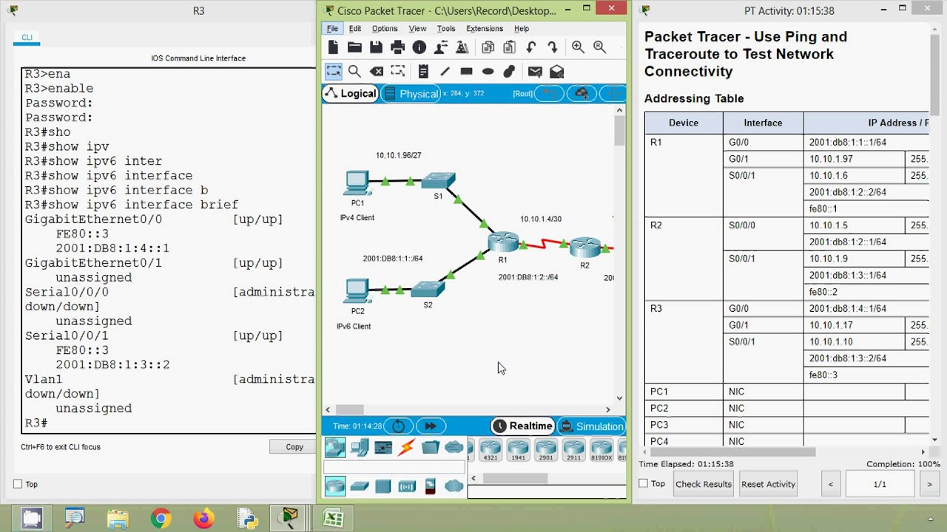

Ipconfig/all command
Ipconfig displays all current TCP/IP network configuration values and refreshes Dynamic Host Configuration Protocol (DHCP) and Domain Name System (DNS) settings. Used without parameters, ipconfig displays the IP address, subnet mask, and default gateway for all adapters.
Figure 2 - ipconfig/all command to determine MAC
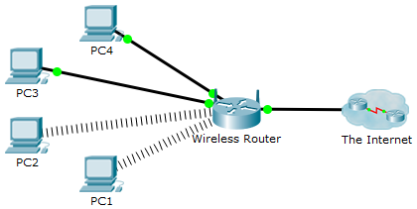

MAC Filtering
MAC filtering is a security method based on access control, where each address is assigned a 48-bit address which is used to determine whether we can access a network or not. It assists in listing a set of allowed devices which you need (and may not require) on your Network/Wi-Fi. It is an important element of computer networking, as it uniquely identifies a computer on the LAN and is an essential component required for network protocols like TCP/IP to function. Computer operating systems and broadband routers support viewing and sometimes changing MAC addresses.
Figure 3 - MAC Filtering
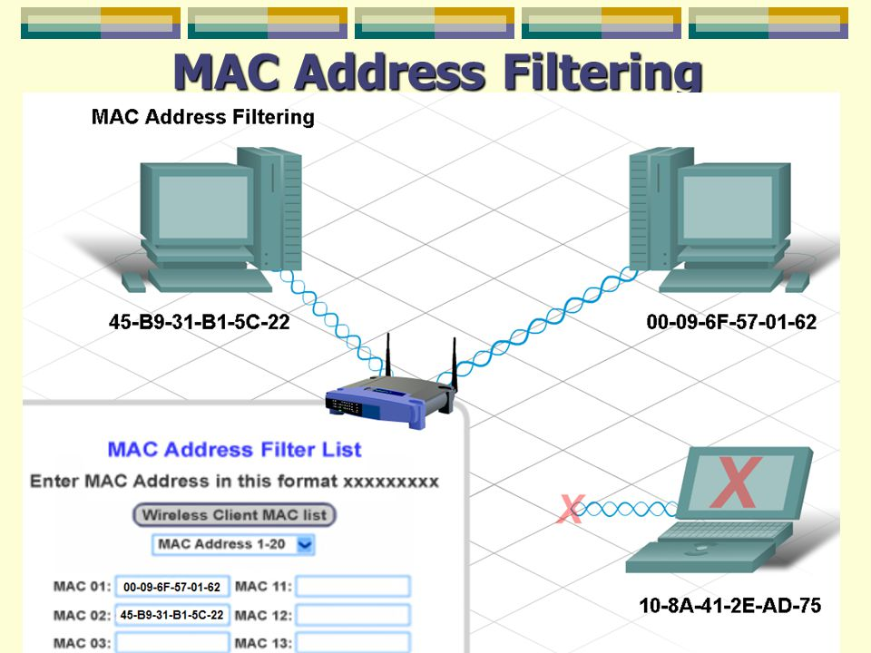

Address Resolution Protocol (ARP)
The Address Resolution Protocol (ARP) is a communication protocol used for discovering the link layer address, such as a MAC address, associated with a given internet layer address, typically an IPv4 address. This mapping is a critical function in the Internet protocol suite.
Figure 4 - Address Resolution Protocol (ARP)
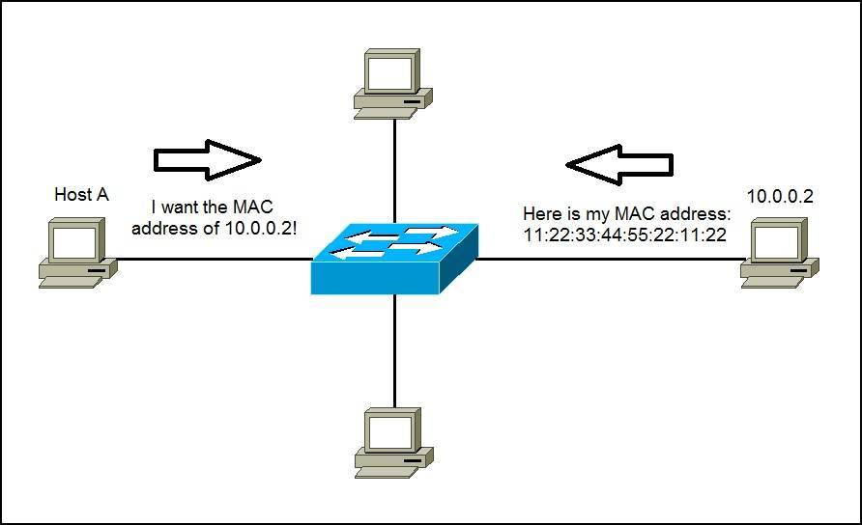

Nslookup
This is a suite of tools for looking at DNS records, the command allows you to question your domains nameserver's and ascertain much more information regarding your domains DNS. It is useful for checking certain subdomains exist on your domain name and can also be used to check multiple email records to ensure emails are routed correctly.
Figure 5 - Name Server Lookup (nslookup)
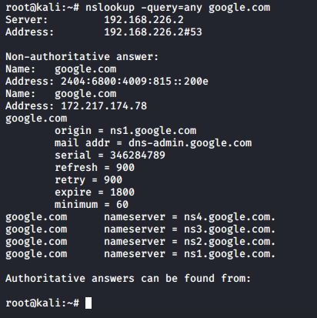

Wireshark
Wireshark is a packet sniffer/network traffic analyser with filtering options, an essential tool for security systems administrators, it enables analysis of network traffic in real-time and network troubleshooting issues, capturing network traffic from Ethernet, Bluetooth, Wireless, Token Ring connections etc.
Figure 6 – Wireshark
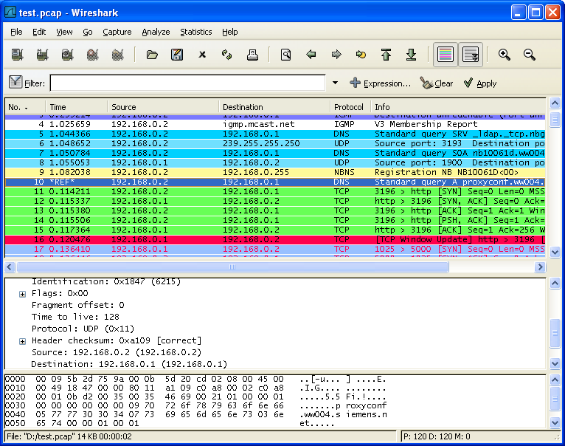

Network Mapper (nmap)
Nmap is a free, open-source tool for vulnerability scanning and network discovery, used by Network administrators to identify what devices are running on their systems, discovering hosts that are available and the services they offer, finding open ports and detecting security risks.
Figure 7 - Network Mapper (nmap)
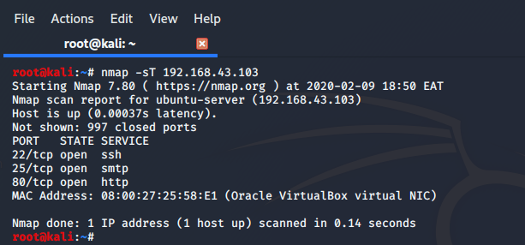

Steganography
Steganography is the practice of concealing a message within another message or a physical object, in a way that does not allow others to detect that there is a second message present. Steghide is one of these data hiding techniques and aims at transmitting a message on a channel where some other kind of information is already being transmitted [10].
Figure 8 – Steganography
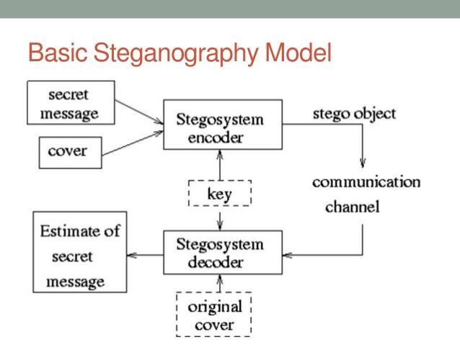

Digital Signatures
Digital signatures are a mathematical scheme for verifying the authenticity of digital messages or documents, where the prerequisites are satisfied, it offers the recipient very strong reasons to believe that the message was created by a known sender (authentication) and that the message was not altered in transit (integrity). They are a standard element of most cryptographic protocol suites and are commonly used for software distribution, financial transactions, contract management software, an important factor in detecting forgery or tampering.
Figure 9 - Digital Signatures
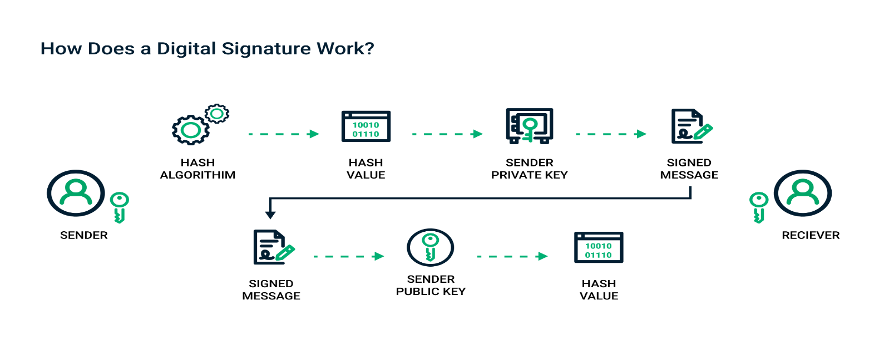

System Hardening
System hardening adds to the various levels of security to protect users and their servers by reducing risks/eliminating potential attacks, by removing superfluous/disabled files, programs, functions, applications, ports etc, that are often forgot about and provide attackers cloaked access to the system.
Figure 10 - System Hardening
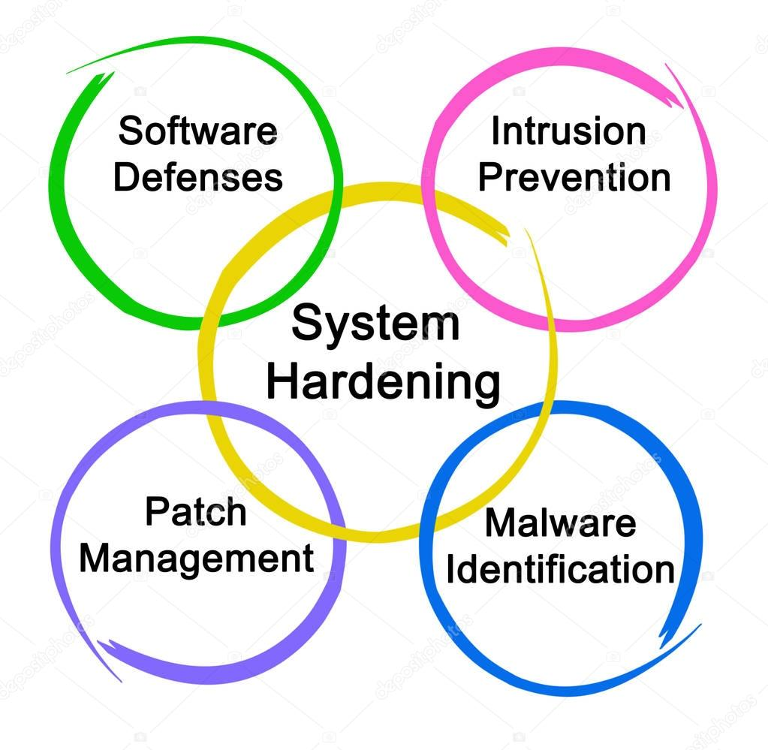

NetStumbler
Network Stumbler is a Windows-based application tool generally used to discover WLAN networks and help detect other networks that may cause interference to your network. It is generally used for:
- Searching for Wi-Fi wireless networks (Wardriving) and verifying network configurations
- Finding locations with poor coverage in a WLAN
- Detecting causes of wireless interference and unauthorized ("rogue") access points
- Aiming directional antennas for long-haul WLAN links
Figure 11 – NetStumbler
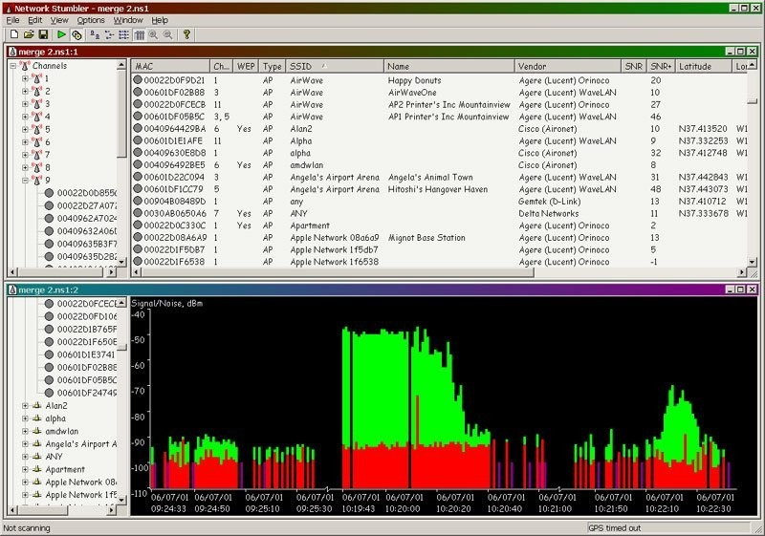

References

[1] C. Arthur, “Tech giants may be huge, but nothing matches big data,” 2013. [Online].
Available: https://www.theguardian.com/technology/2013/aug/23/tech-giants-data
[Accessed: Dec. 29, 2020].

[2] Cytex Cyber Security, “Prevention Used To Be Enough But Today Organisations Need To Take A Stratified Approach To Cyber Security,” 2020. [Online].
Available: www.cytex.co.za/protect-cyber-detection/
[Accessed: Jan. 03, 2021].

[3] UKdiss.com, “Security Procedures for a Small Computer Network,” 2019. [Online].
Available: https://ukdiss.com/examples/small-computer-network-security-procedures.php
[Accessed: Jan. 03, 2021].

[4] National Cyber Security Centre, “About Cyber Essentials,” 2020. [Online].
Available: https://www.ncsc.gov.uk/cyberessentials/overview
[Accessed: Dec. 30, 2020].

[5] A. Sahia, “5 Steps to Turn the NIST Cybersecurity Framework into Reality,” Jan. 4, 2020. [Online].
Available:https://www.securitymagazine.com/articles/88624-steps-to-turn-the-nist-cybersecurity-framework-into-reality
[Accessed: Dec. 30, 2020].

[6] C. Easttom, “Introduction to Computer Security,” Nov.15, 2019. [Online].
Available: https://www.pearsonitcertification.com/articles/article.aspx?p=2990398&seqNum=6
[Accessed: Dec. 30, 2020].

[7] TechTarget, “digital signature,” 2020. [Online].
Available: https://searchsecurity.techtarget.com/definition/digital-signature
[Accessed: Dec. 30, 2020].

[8] Sector Forensics, “Corporate Sector Forensics,” 2020. [Online].
Available: https://www.sectorforensics.london/corporate-sector-forensics/
[Accessed: Jan. 03,2021].

[9] National Institute of Standards and Technology, “Cybersecurity Framework,” 2020. [Online].
Available: https://www.nist.gov/cyberframework
[Accessed: Dec. 30, 2020].

[10] Coursehero.com, “Introduction Steganography,” 2021. [Online].
Available: https://www.coursehero.com/file/60198811/359408014-Steganographydocx/
[Accessed: Jan. 03, 2021].

Report Planning Methodology
This synthesizing a solution report assignment was completed by following the activities below;
- Read and understand the report brief.
- Make plan (Gantt chart) including time management – planning/research most time consuming, cater for other exams.
- Create report format and style – use Moodle template example.
- Follow structure
  - Abstract
  - Introduction
  - Main Body
  - Conclusion
  - Reference
- Define the problem and purpose of the report – decide assignment title, aims & objectives.
- Define audience – Lecturer/Tutor (Nitheesh Kaliyamurthy/Carlene Campbell).
- Brainstorm (Mindmaps) and Determine ideas to include.
- Research and gather information (Library, internet etc).
- Collect, sort, evaluate organise material.
- Complete references (as you go) during all researching phases
- Analysing my research/material.
- Prepare outline drafts.
- Write the report, check spelling and grammar.
- Peer Review – (Terri Darzins 1909721).
- Incorporate peer comments into final redraft.
- Check via Turnitin DRAFT and redraft (if necessary).
- Submit final report via Turnitin.

