Early Years Guidance Handbook for Keyworkers:
The importance of effective communication during transitions.



(source:teachers of tomorrow, 2019)

Contents

- Introduction Page. 3

- How to use the Handbook Page. 3

- What are Transitions? Page. 4-5

- The role of the Adult Page. 6-7

- The needs of the child Page. 8-9

- Partnerships Page.10-11

- Interventions Page. 12

- Proposed outcomes Page.13

- Reference List Page. 14-16

Introduction
This handbook is for the use of early years practitioners working with children who are starting in a nursery setting for the first time. This handbook will help support correct transitions for young children. The main aspect through this handbook will be the importance on effective communication between all people involved during the time of this transition. The key messages in this handbook are aimed at supporting young children and the adults in the transitions both between and within the settings.

How to use this handbook
This handbook is specifically aimed for keyworkers, working in a nursery setting with young children from the age of 6 months up to 3 years where they will then start school. In this handbook it will focus on how important effective and successful communication between all involved during a child’s transition into a nursery setting.
Practitioners will be able to learn and recognise how to help and support young children into having the best possible transition by working alongside parents and other outside agencies if any are involved with any children. This handbook will be looking into depth of different theorists and how they will link into supporting smooth transitions. There will be split sections focusing on the needs of the child, the role of the adult, working well with partnerships and Interventions that could be put into practice. Lastly there is a proposed outcomes section on how we can measure and monitor progress and development.

What are Transitions?
Teach early years, (2022) suggest that young children will experience many different types of transitions from birth, having stability is essential in children’s early years, but often change is inevitable for many children and they will certainly experience several emotional and environmental transitions before they even reach school age. Teach early years, (2022) also imply that practitioners need to manage transitions in a careful manor, it will help ease the process of the transition giving reassurance to the child and their family.
Pacey (2016) implies that transitions can be very stressful on children, practitioners can help a young child cope with transitions by making them as smooth as possible. By doing this it will then help them with future transitions weather they are big or small, such as a young child starting nursery for the first time, or even smaller ones during the day such as moving from an activity to a mealtime.
Pacey (2016) suggest it is important that early years practitioners need to be mindful that the transition for a young child to go from being at home to nursery in a significant experience. During Transitions the child will need to feel welcomed and valued when going through this change. This is a big step in a child’s social life that not only does it involve the child but also their parents or carers and practitioners together. Preparation for this transition should begin as early as possible to ensure it to be successful (Daly, Byers, Tayler, 2009).
Effective communication between all involved during this transition is key, if not the child’s development could be majorly affected in a negative way. It is vital that these kinds of transitions are done as smoothly as possible, as the child will need to feel happy and content to settle into their new environment as they will be leaving their ‘comfort zone.’ (Daly, Byers, Taylor, 2009).
Bronfenbrenner (1974) developed a theory called the ecological systems theory. This shows how a child develops through many stages of the environment around them, from immediate settings and family members to a broader cultural and government outlook. These four systems were the microsystem, the mesosystem, the exosystem and the macrosystem. Bronfenbrenner (1974) Talks about the different sections in his theory, the macrosystem is the section that has the most effect on a child’s development surrounding the child’s family, school and peers. The mesosystem then involves the connections between the child’s microsystems, such as the connections between the child’s parents/carers and childcare, or between school friends and siblings. For instance, if the child’s parents have effective communication with their childcare providers, then this will have a positive effect on the child’s development, however if the child’s parents do not have that effective communication with their childcare provider this may result in negative development. The exosystem is made up of other formal and informal influences for example these may include neighbours, parents, friends and media. These are external and not as such involved in the child but do influence the child’s development, for instance if the child’s parent had a bad day in work and they come home with a negative mindset they may have a short temper, resulting in the child having the negative outburst off the parent. Finally, the macrosystem is a component that focuses on the cultural and religious influence and how this may affect a child’s progress such as wealth, poverty and culture.
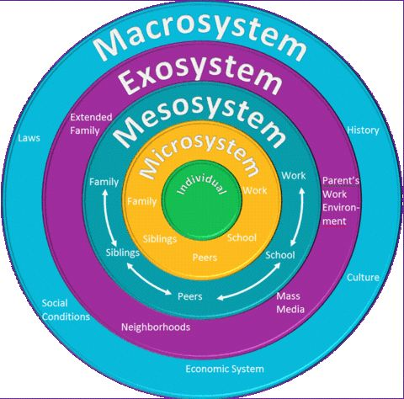

(Sourse: Study of the mind, Psychologydos. 2015)

The Role of the Adult
Croneri (2022) suggest young children who start in an early year setting like a nursery experience many exciting possibilities, as well as many different challenges. During this transition childcare practitioners need to manage this in a sensitive and effective way. Once a young child leaves their home for the first time it can often be a nervous and sensitive time for not only them but their family as well. Practitioners need to develop some policies and procedures to guarantee that they support children to have the most positive and smooth transitions (Croneri, 2022). When a young child starts a nursery setting, they will have to create new bonds with people they may not be familiar with. Young children will need to familiarize themselves with an adult during transitions to ensure they feel comfortable during the transition. Dawling (2014).
The environment that the setting provides for the children is the most important factor in determining how the child will deal with the transition, the adults must ensure that it is warm and welcoming. (Allingham 2011).
Allingham (2011) indicates that a key person has many duties for working with different children, giving all the children comfort to feel that they are safe and wanted as well as building strong bonds with the child’s parents/carers. Having a keyworker for a child in a nursery setting will also help the transition run smoothly as this key person will build a relationship with the parents/caregivers ensuring they give effective communication. Furthermore Allingham (2011) highlights that the keyworker will be beneficial for the young child to help them to meet their specific needs and attention, for instance getting dressed and toileting weather this is nappies or potty training. The key person’s position is to help ensure that every child’s individual needs are met, this will help the child become familiarized with the new setting. Department of education (2021) also agrees that all children must be allocated a key worker and that the setting should provide parents or cares of their child keyworkers name and explain what the keyworker will do when a child starts nursery. Department of education (2021) implies that the key person must be involved and help to support the parents or carers in assisting their child’s development at home. They should also help families with more professional support if needed. Pacey (2022) highlights that each setting will have their own policies on settling in, in most cases these settling in periods should last between two and four weeks. When doing a settling in session it is essential that the child’s keyworker will be present and not away during the child’s settling in period. Pacey (2022) also suggests that during a settling in period the parent or carer and child should take their time in getting to know the setting and the staff members especially the assigned keyworker. Practitioners should make sure the introduction to the setting is slow and steady, starting with the child joining with you. Pacey (2022) implies that some settings suggest doing this in steps to settling in for example:
- Letting the child play with their allocated key person while the child’s parent is nearby.
- Getting the child to interact with their key person and other children with the parent beside at first, then the parent will come in and out of sight
- Child is with the key person doing activities with other children while the parent comes in and out of room for 20/30 minutes.
- The child can attend a morning or afternoon session on their own then before coming in for a full day.
Eventually, after doing these settling in steps this will help the child build confidence in attending for a full session. Once the child comes in for a full session the keyworker will then stay in contact with the parent throughout the time the child is left, via a call or message. If the child is appearing to be upset and is not settling properly then the parent should be contacted. The nursery setting should have a set routine so that the child knows what to do when they are dropped off at their nursery and what to expect throughout the day. (Pacey, 2022)

The Needs of the Child
Young children are best supported by adults who really care for them and their wellbeing as individuals. Having a holistic view on the child as an individual and their development is good practice (Lindon, 2010). When you consider what a child needs in specific areas of development, practitioners need to keep in mind the different theories of child development that have informed recent practice (Lindon, 2010). To enable us as practitioners to care for a child, it is important on getting to know the child and their likes and dislikes and how they think and what their interests are, Dowling (2014).

Maslow’s Hierarchy of Needs (1943) is a motivational theory describing the human needs of an individual. At the bottom of the triangle are the needs that must be satisfied before the needs higher up can be achieved. This is important in transitions because, if a child doesn’t feel safe and protected, they may refuse the most basic of needs, food and water, and as a result they are unlikely to form relationships, build self-esteem or develop as independent learners.
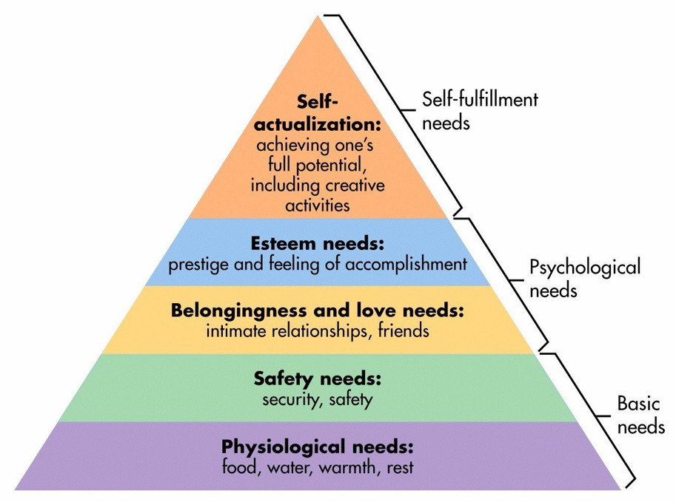

(Source: simplypsychology, 2022)

Smidt, (1998) highlights that all children need to be included and cared for in a loving and secure environment. Children should not be exempt from doing things because of culture, religion or ethnicity. Neither should they be excluded for having special educational needs. Young children need to develop a strong bond with their keyworker, as some babies and children may experience a sense of loss when they leave their mother figure. Smidt, (1998) also suggest that practitioners should consider doing appropriate activities that are relevant to the level of the child’s needs and offer them enjoyable experiences as if not then this can lead to having a negative impact on their well-being, as well as the child’s development.
A practitioner’s position in supporting young children is vital as this will more than likely be the child’s first kind of education outside of the home. Therefore, practitioners should make this a positive time for every child (gov.uk, 2022). For a young child to be able to form good communication and social skills it is essential that keyworks and practitioners respond to their every need for example babies and children crying or if a baby is babbling or a young child talking is talking to them appropriately (Harvard University, 2022). Keyworkers and practitioners should use kind gestures such as using eye contact when a baby or child is talking to them. These are known as ‘serve and return’ interactions. By practitioners doing this it will help to form a good bond with the child. If these interactions are inappropriate or unreliable, then the child may not form strong bonds, and this could cause development issues (Harvard University, 2022). John Bowlby (1953) created a theory of attachment, this implies that babies will have a strong attachment or bond to their main carer in most cases this will be their mother. Babies who have a strong attachment to their mother are often seen to be more confident, happy and more secure. While Bowlby, (1953) does not rule out a baby or child forming a bond with other significant adults, he suggested the importance on their being one main primary bond. Although Ainsworth, (1971) who worked with Bowlby’s theory of attachment indicates that babies and young children can infact form multiple attachments, whether this be with siblings, father or even their keyworker in a nursery setting. As practitioners it is essential to form these attachments with your key children, this will help to ensure a smooth transition for the baby or child as they will feel secure around you.

Partnerships
As early years practitioners it is essential that we include the child’s parents and carers in their learning, it is an essential factor in assisting some children in their transitions from home life to nursery life (gov.uk, 2022).
Working alongside parents creating an effective partnership is vital in the early years. This relationship may start by inviting parents and carers into the setting to help settle their child. By putting them first by inviting them in they can share information about themselves and their family and community culture. Gov.uk (2022) suggests asking the parents and carers what they expect from us as a nursery setting and work together to ensure smooth transitions. Parents and carers need to be given the chances to have a say in their child’s journey in the setting. Gov.uk (2022) highlights the importance of offering a variety of chances for the child’s parents and carers to have more input in their child’s learning. As Practitioners you should consider how you will support any barriers the parents or carers may have when it comes to working together. For example, parents’ childhood experiences in nursery settings, possible language barriers, different cultures and different values. (Gov.uk, 2022).
Below are some different ways to include parents:
- Daily discussions with key person on drop off and handover
- time for the child to settle in
- home visits/nursery visits
- phone calls home
- being parent governors or steering group members
Gov.uk (2022) Indicates that the child’s parents like to receive photos and information of their child too. If you are sharing information, it is important that this is a two-way conversation with both parents and the setting about the child’s learning and development. By sharing any information with parents this will help them to encourage similar learning in their home what will contribute to the child’s overall development and learning (gov.uk, 2022).
Keyworkers must always recognise the parent is the main person in their child’s care and development. Childcare settings have an obligation to get parental permission about any matters that may arise in a child’s development before contacting any outside agencies, such as health visitor, speech and language therapists or support assistants. The Welsh Government, (2017) is dedicated to assisting parents for any extra help and support for their child to get the best outcomes. This help is based on the values of the UNCRC in article 3 (the best interests of the child). This multiagency method is significant and needs to be implemented by everybody involved with the child. They must all come together to ensure effective communication from all involved including outside agencies if they are needed to help improve the child’s development and life chances.


(Source: clipart library, 2019).

Interventions
In this part of the book, it will talk about different actions and activities what will help to support the transition to go as smoothly as possible. Some examples could be:
Home visits
Before a child starts in a nursery setting, some settings offer home visits where the child’s keyworker and manager will go and visit the child in their own home. (Keenan, Evans and Crawley, 2016) highlights that home visits can allow the child to see that their parent/carer trusts us enough to let us into their home, this will build up a close relationship with the family as one. In doing this it will provide practitioners the opportunity to see exactly how the child feels in their home environment. It is also an opportunity to chat with families to discover the child’s interests, likes, dislikes, fears etc. (Keenan, Evans and Crawley, 2016).
Welcome Pack
Each family will be given a welcome pack at the home visit. This will contain all the forms to be completed, including a ‘child record’ or ‘all about me’ form. This is where the family will have to provide the setting with written confirmation of all appropriate information concerning the child, including any allergies or if a child has a comfort item from home for example dummies, blankets or a teddy.
Settling in sessions
Before a child starts in the nursery, they will be invited to have a few settling in sessions. The first of which, parents and carer are encouraged to stay with their child to provide reassurance. Afterwards, the child will stay without a parent for a morning or afternoon. The amount of settling in sessions will vary from child to child. Settling in sessions are usually done over a 2-week period. These are a time for parents or carers to share information about the child (Collins, 2010, p.233).
Handovers
At the end of every day in nursery the child’s key worker will do an informal handover with the parents, this is an opportunity to discuss any issues or concerns. Information gathered at these handovers can help practitioners plan activities to support children (Collins, 2010, p. 234).

Proposed outcomes
All children are unique, and they all develop at their own pace. They all have different backgrounds and experiences. Babies and children will familiarise themselves to new settings in different ways. Good practice highlights how important transitions are, and therefore they need to be planned out to meet the individual needs of a child. A child’s transition has been successful once the child proves that they have settled. This will be obvious if the child begins to play independently, and they are less dependent on their key person for reassurance. They will begin to develop relationships, not only with peers but possibly with other practitioners within the setting. The child will begin to show an understanding of their environment once they become more comfortable within it. They will start to demonstrate a sense of self, understanding where they fit into their surroundings. A child who is settled will demonstrate that they are responsive, consistent, sensitive, emotionally mature, happy, secure and are able to explore their surroundings independently. Parents and carers should also feel supported through the transition stage, by having a strong bond with their child’s keyworker and having effective communication. This will make the parent feel more at ease leaving their child in the safe hands of the staff.


(Source: pngitem, 2019).

Reference list
Allingham, S. Transitions in the early years. London: MA Education Ltd.

Clipart library. (2019) school parent involvement. [image] Available at: http://clipart-library.com/clipart/parent-involvement-cliparts_12.htm (accessed on 1/12/2022).

Collins, S (2010) ‘Thinking through the uses of observation and documentation’ in
Moyles, J. (ed) Thinking about play. Berkshire: Open University Press.

Conkbayir, M. and Pascal, C. (2014). Early childhood theories and contemporary issues. London: Bloomsbury.

Croneri. Managing transitions in early years provisions. Available at: https://app.croneri.co.uk/feature-articles/managing-transitions-early-years-provisions (accessed on 26/11/2022)

Daly, M. and Byers, E. and Taylor, W. (2009) Early years management in practice. 2nd Ed. Essex:Heinmann, Pearson Education Limited.

Department for education. (2021) Setting the standards for learning, development and care from children from birth to five. Available at: https://assets.publishing.service.gov.uk/government/uploads/system/uploads/attachment_data/file/974907/EYFS_framework_-_March_2021.pdf (accessed on 30/11/2022).

Dowling, M. (2014) Young Children’s Personal, Social and Emotional Development. 4th Ed. London: Sage.

Gov.uk. (2022) Meeting the needs of all children. Available at: https://help-for-early-years-providers.education.gov.uk/get-help-to-improve-your-practice/meeting-the-needs-of-all-children (accessed on 1/12/2022).

Gov.uk. (2022). Working in partnerships with parents and carers. Available at: https://help-for-early-years-providers.education.gov.uk/get-help-to-improve-your-practice/working-in-partnership-with-parents-and-carers (Accessed on 1/12/2022).

Harvard University. (2022) Science key concepts. Available at: https://developingchild.harvard.edu/science/key-concepts/serve-and-return/ (accessed on 1/12/2022).

Keenan, T. and Evans, S. and Crowley, K. (2016) 3rd ed. An introduction to Child Development. 3rd Ed. London: Sage.
Lindon, J. (2012) Understanding child development 0-8 years. 2nd ed. London; Hodder Education.

Lindon, J. (2012) Understanding Child Development 0-8 years. 3rd Ed. London: Hodder Education.

PACEY. (2022) Helping your child settle in. Available at: https://www.pacey.org.uk/parents/working-with-your-childcarer/helping-your-child-s
ettle-in/ (accessed on 30/11/2022).

PACEY (2016) Transitions and settling in. Available at:
https://www.pacey.org.uk/Pacey/media/Website-files/PACEY%20member%20practice%20guides%20(PDFs)/PG10-transitions-and-settling-in.pdf (accessed on 25/11/2022)

PNGitem. (2019). Kids playing clipart. [image] Available at: https://www.pngitem.com/middle/ihbbTow_kids-playing-clipart-png-clipart-for-kids-transparent/ (accessed on 2/12/2022).

Simply Psycology (2020) Bronfrenbrenner’s ecological systems theory. Available at: https://www.simplypsychology.org/Bronfenbrenner.html (accessed on 25/11/2022)

Simply Psychology (2022) Maslow’s hierarchy of needs. Available at: https://www.simplypsychology.org/maslow.html (accessed on 30/11/2022).

Simply Psychology.org (2022) Maslow’s Hierarchy of Need. [image] Available at: https://simplypsychology.org/maslow (Accessed: 30/11/2022).

Smidt, S. (1998) A guide to early years practice. 3rd ed. Oxon: Routledge.

Study of the mind (2015) Urie Bronfenbrenner’s Ecological system theory. [image] Available at: http://psychologydos.weebly.com/psych-journal/journal-8-urie-bronfenbrenners-ecological-systems-theory

Teach Early Years (2022) Transitions in early years. Available at: https://www.teachearlyyears.com/a-unique-child/view/supporting-transitions-in-the-early-years/ (accessed on 25/11/2022)

Teachers of Tomorrow (2019) Parent-Teacher partnership in the 21st century to create well rounded individuals. [Image] Available at: https://connectedtot.com/2019/05/15/parent-teacher-partnership-in-the-21st-century/ (accessed on 18/11/2022)
Unicef. (1990). A summary of the un convention on the rights of the child. Available at: https://www.unicef.org.uk/wp-content/uploads/2019/10/UNCRC_summary-1_1.pdf (accessed on 1/12/2022).

Welsh Government. (2017). Parenting in Wales: Guidence on engagement and support. Available at: https://gov.wales/sites/default/files/publications/2019-10/parenting-engagement-and-support-guidance-for-providers.pdf (accessed on 1/12/2022).

