Developing Relationship and Workplace Achievement

University Name: University of Wales Trinity Siant David
University Campus: The Quay Place
Module Code: BMSW 5102
Student Name: Babar Hussain
Student ID: 2014975
Assignment Title: Developing Relationship and Workplace Achievement
Lecturer: Sujeewa Herath

Contents
Introduction 3
Company Introduction 3
Human Resources Management 3
Motivation 4
Theories of motivation 6
Performance Management 8
Training and Development 9
SWOT Analysis and PDP 10
Conclusions 11

Introduction

Within this report as being assigned the role of Human Resource (HR) Manager. A critical report needs to be created to assess why Fresh Direct is having problems with its staffing and productivity. The HR manager will try to identify the problem and let Fresh Direct know how they can overcome its problems. Different HRM theories, models, and concepts will be used. Different development vehicles will also be recommended for fresh Direct to adopt to improve their operational productivity and employee relations.

Company Introduction

Fresh direct is a distributor of fresh food products through an online ordering platform in Birmingham. They initially started off as a family business and over time have employed 100 members of staff. Fresh Direct due to Covid 19 got very busy with online order and were finding it very hard to meet customer demands and decided to employ more members of staff. They did this by advertising online for employees to send their CVs by email to the managers. After they received the CVs, the employees took part in a short 20 min interview and then if selected were employed straight away. They were given a tour of the farm and for one day worked alongside an existing employee and then were given individual responsibilities. After about 2 weeks they started to experience some problems. They found that the effective productivity that was in place started to decrease. The company was finding their orders were left incomplete or late and they also found that first-time customers were starting to complain. Some members of the staff have had to work longer hours, and some are leaving.
Motivation, performance management, and training and development are development vehicles available to Fresh Direct for them to meet their needs.

Human Resources Management

“Human resource management (HRM) is the practice of recruiting, hiring, deploying, and managing an organization’s employees.” (Chai, 2020). Human resource management is a department within an organization that supports the organization to achieve the objective to develop and put in place human resource strategies. Human Resource management ensures they have talented engaged and skilled people working within the organization they do this by having a very consistent recruitment selection process. Once the HRM has recruited the right staff they ensure they keep their employee’s training and development up to date. They offer them promotions and motivate them to ensure their employees work to the best of their ability.
In the case of Fresh Direct, the problem occurred when they started the recruiting process, they simply put an online advertisement online and maybe did not specify exactly what they are looking for. Their new employee selection process was not very strategically planned they rushed the whole process. They once recruited did not give the new employees enough time to learn what they needed to do. One day of being guided by other existing staff was not enough. They put a lot of pressure on existing employees as well as trying to meet existing customer demands they were having to train new members of staff which took a toll on their goals and therefore had to work extra hours to try and catch up on the workload. This makes the employees feel overworked and exhausted which may have led some old employees to look elsewhere for new jobs and leave.

Motivation

“motivation is a psychological process through which a person acts or behaves towards a particular task or activity from start to completion. Motivation drives or pushes a person to behave in a particular way at that point.” (Team, 2021). Motivation is a reason for doing something. It is the drive that leads the employee’s behavior toward their goals. Motivation can push the employees to work to the best of their ability and be committed and focused even when things are getting tough within the organization. Employees can be motivated in different ways. They can be motivated within their job because of:
Money- Need the income. Good pay
Family-due to the family commitment they need to work hard and provide for their family
Doing what they like- they are doing what they like have a passion for their job
Colleagues- having good work colleagues encourages you to work harder.
Learning new things- additional training and courses while on the job
Good working conditions
Additional benefits- Company car and bonuses, etc.
Interesting, varied work- doing a job that is not repetitive
Curiosity- learn new skills and techniques
Appreciation- feeling valued and being apricated
There are two types of motivation extrinsic and intrinsic.
Extrinsic Motivation- “Extrinsic motivation involves completing a task or exhibiting a behavior because of outside causes such as avoiding punishment or receiving a reward” (SENNETT, 2021) Extrinsic motivation is when an employee performs a task or learns a new skill because they will get a reward at the end of it. In other words, if they do not enjoy what they are doing but will continue to be motivated to work because of the reward they will get or maybe they will continue to work because they may get punished if they don’t do the job at hand. An example of extrinsic motivation will be if an employee is going to work only because they want to earn money, or a negative one will be if an employee is told to go on a business trip and only goes because if they do not go, they will lose their job.
Intrinsic motivation- “refers to behaviour that is driven by internal rewards” (Morin, 2019). Intrinsic motivation is when an employee is doing a job or task that will not have an external reward at the end. The employee is doing the job because they are enjoying it and finding it interesting. Intrinsic motivation is about growing within yourself, feeling that the employee has a feeling of duty towards their job, and they are getting recognition for the job they are doing. For example, when an employee tries to be a good leader not because they will get paid better but because they want to inspire, or if they want to learn about personal development because they want to improve themselves. Looking at both extrinsic and intrinsic motivation the intrinsic motivation is better as the employee will want to work in an organization longer as they are not driven by rewards or punishments.
Fresh Direct did not motivate existing staff well enough. They did not value their old employees. They just put more pressure on them with the new members of staff. If Fresh Direct gave a bonus to old employees or paid extra to their staff for the extra hours, the employees would have felt more valued and never thought of leaving. They may have also put in extra effort to meet demands and be happy and satisfied with their workplace. As the Human Resource Manager, I feel that Fresh Delight should use both extrinsic motivation and intrinsic. They should use the extrinsic for old staff as they have increased their workload and need the extra bonus or extra pay for them to feel appreciated for the extra work they are having to do. For the old staff, they should use intrinsic motivation to try to help the new employees to grow within themselves by learning more about the organization. They need to be motivated to feel a sense of belonging and straight away try to increase productivity to meet customer demands.

Theories of motivation

There are many theories of motivation the two that will be discussed further are Maslow’s Hierarchy of needs and Herzberg two factor theory.
Maslow’s Theory of Hierarchical Needs-

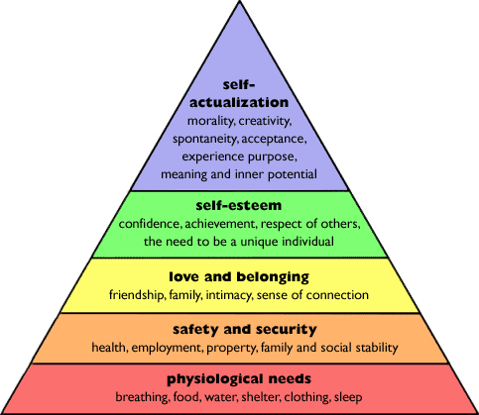

(History, 2012)
According to Maslow’s theory he believed that if basic needs are met then employees can move up to the next step for example if an employee is hungry and needs to eat, they are not going to think about their safety. In this theory, the way it works is that an employee will move up the steps one at a time. Until they are not fully satisfied with the step, they are on they will not think about the next step. Maslow’s theory is more about needs. Looking at Fresh Direct this Maslow’s theory of needs is essential for their employees as it will allow them to move up and grow personally which will then reflect in their productivity. It is essential for Fresh Direct owners to provide their employees with the basic needs, so they are then able to focus on building their self-esteem and self-actualization.

Frederick Herzberg two Factor Theory
“Herzberg’s Theory of motivation tries to get to the root of motivation in the workplace.” (Management, 2018). The Herzberg two factor theory defines that people are motivated factors that can be listed in two categories. They are hygiene factors and motivation factors. The hygiene factors avoid job dissatisfaction and the motivation factors encourage job satisfaction. Below is a table with the list of then factors.
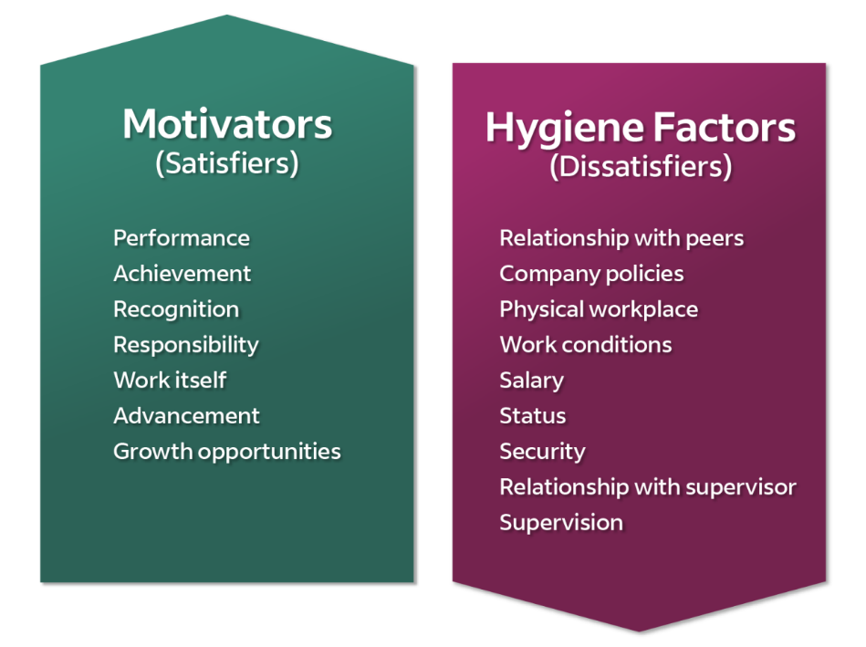
(Team I. E., 2022)
They can also be said to be extrinsic and intrinsic. According to Herzberg if an organization wants its team to perform at I high level it will need to give them the appropriate motivation. To make sure the organization is a success the hygiene factors need to be addressed and then the conditions for motivation will follow. Fresh Direct if they use this theory will need to fulfil the hygiene needs first, they can do this by giving their new employees time to familiarise themselves with the organization and their fellow colleagues and understand better what is required of them. This way they will be able to work more adequately avoiding errors and customer complaints. The negative side to this theory is that the organization does not have time as the demands from customers are coming in very fast.

Performance Management

“Performance management can be defined as a systematic process for improving organizational performance by developing the performance of individuals and teams.” (Michael Armstrong, 2006). The performance management program can help managers and employees to understand each. Performance management can be put into a cycle.
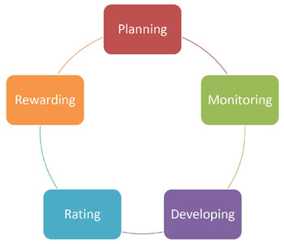
(Policy, Data, Oversight. Performance Management , n.d.)

This cycle is continuous it involves Planning, Monitoring, developing, rating, and rewarding.
Planning stage- the Fresh Direct managers will the goals and let employees know what they expect from them. At this stage, they can put in to place measures that will be used to determine the channels they will be using to focus on achieving their goals to produce more to meet demands. At this stage, it is important for Fresh Direct to involve their employees in the planning so there is a clear understanding of what goals are being set and what kind of work is expected of them.
Monitoring- at this stage Fresh Direct need to consistently measure the performance of their staff and provide continuous feedback to their staff. They need to see if they are on the track to meeting their goals. Continuous feedback and monitoring give the opportunity to make sure employees/ staff are doing what they are supposed to and are on track. If any changes need to be made can be identified and resolved at an early stage before it too late.
Developing- within this stage Fresh Direct can help increase the training that new staff needed. They can give the employees the right training and improve the skills they need to be more responsible and therefore improve their performance and keep up with the increasing demands they are facing.
Rating- Fresh Direct should evaluate their staff performance at this stage and rate their standard of work.
Rewarding- at this stage, Fresh Direct can put in place incentives to give employees who need recognition some sort of reward to make them feel motivated to work harder. They may give the best performing team or employees some sort of reward or let them know if they meet certain targets, they will receive a bonus or something.
The problem with the rating point is that when rating employees Fresh Direct may easily be able to tell who the highest performers are and who the lowest performers are. They will not be able to determine the inbetweeners. This group of staff may need that extra training to boost them up to a good standard level.
Managers can work their way through this cycle at every point that they interact with their employees. They do not need to wait until the end of the year for a yearly check.

Training and Development

“Training and Development is the continuous process of improving skills, gaining knowledge, clarifying concepts and changing attitude through structured and planned education by which the productivity and performance of the employees can be enhanced” (team, 2021). Training and development are important for human resource management within the organization. The purpose of training is to enhance the skills of employees. Fresh Direct need to make sure they train their new staff adequately as just one day following existing employees and just a tour of the organization is not enough. Fresh Direct needed to teach their employees skills and train them so they would not have made errors. The training and development of employees help them to perform better which then increases their efficiency and productivity of work. Fresh Direct can use training and development for existing staff so they learn new skills and techniques to handle the new demands from customers. There are a number of different training programs. Some of them maybe
manual skills
computer/ IT skills
leadership and management skills
interpersonal skills-team building
training in organizational procedures.
Some of these skills can be taught to Fresh Direct employees. It will be essential for Fresh Direct staff to have manual skills as the organization is a farm. The existing staff members if they will be training new staff should train their personal skills so they are able to coach and communicate appropriately with new staff.

SWOT Analysis and PDP

SWOT Analysis
The SWOT Analysis Is the strength, weaknesses, opportunities, and Threats.
Below is SWOT Analysis for Fresh Direct
Strengths- grows and distributes fresh food
Delivery is direct to customers so ensures freshness
Increase in demand in the market
Weaknesses- distribution is limited as it is only Birmingham based
Only accessible online. So, customers who do not have access to the internet will not be able to order
Cannot meet customer demands
Understaffed and need equipment
Opportunity- Due to COVID 19 a lot of customers were stuck at home and need order online
Customers are more conscious about their health and the environment, so they prefer fresh and locally sourced food
Fresh Direct can expand into different areas
Threat-The business is based online, so they are dependent on the internet connection.
Competition from another local store
If demands are not met customers will go elsewhere

Personal Development Plan-PDP
“A PDP is a form of self-evaluation and self-reflection that is typically used in higher education and the workplace” (Putter, 2021) it’s a process that helps employees to achieve their goals. There are five stages to the PDP
1. Identify – Strengths, skills and realistic goals
2. Plan- what resources that will be needed e.g. website, work experience etc. plan how much time will be needed
3. Action- do what you intended and make note of any new skills that were learnt in the process
4.Record- Progress that was made and the skills that were gained and think about where improvement is needed.
5.Review- Look back at what was done and try to see where improvement can be made

Below is PDP for the employees of Fresh Direct

Long Term Goals | Identify | Plan | Action | Record | Review
-Meet goals to keep customers of fresh direct happy and the business running efficiently.  -Become managers at Fresh Direct | -Employees need to increase their knowledge in Fresh Direct | -Tour of business  -Train to do the job without errors  - | Learn new techniques to use the equipment correctly | -Team working skills learned | - improve the process by taking time to learn further before taking responsibilities

Looking at the SWOT analysis and the PDP plan it is essential for Fresh Direct to concentrate on ensuring its recruitment process is improved. They need to make sure employees spend more time on training and learning the skills they need to increase their productivity without making errors. They need to make sure their customers are satisfied.

Conclusions

In Conclusion what Fresh Direct need to do is they need to keep their existing employees motivated and keep their new employees by giving them the appropriate training. They should not rush the process as this is what is causing errors and they are losing customers and staff.

References
- What is Human Resource Management (HRM)? - Definition from WhatIs.com (techtarget.com)at https://www.techtarget.com/searchhrsoftware/definition/human-resource-management-HRM

- Motivation Meaning, Importance, Types, Factors & Example | MBA Skool at https://www.mbaskool.com/business-concepts/human-resources-hr-terms/7312-motivation.html

- Understanding intrinsic and extrinsic motivation | Emerging Leaders | University of Rochester at https://www.rochester.edu/emerging-leaders/understanding-intrinsic-and-extrinsic-motivation/

- What Does Intrinsic Motivation Mean? (verywellmind.com) at https://www.verywellmind.com/what-is-intrinsic-motivation-2795385

- Maslow’s Hierarchy of Needs – Research History at https://www.researchhistory.org/2012/06/16/maslows-hierarchy-of-needs/

- Herzberg's Motivation Theory (Two Factor Theory) (expertprogrammanagement.com) at https://expertprogrammanagement.com/2018/04/herzbergs-two-factor-theory/

- How To Improve Employee Motivation With the Herzberg Theory | Indeed.com at https://www.indeed.com/career-advice/career-development/herzberg-theory

- (PDF) Michael armstrong-performance management | Yusra Hassan - Academia.edu at https://www.academia.edu/37034843/Michael_armstrong_performance_management

- Performance Management Cycle (opm.gov) at https://www.opm.gov/policy-data-oversight/performance-management/performance-management-cycle/#url=Overview

- Training and Development Meaning, Importance, Process & Example | MBA Skool at https://www.mbaskool.com/business-concepts/human-resources-hr-terms/8685-training-and-development.html

- What is a personal development plan? | SWOT Analysis, How To Write (cpdonline.co.uk) athttps://cpdonline.co.uk/knowledge-base/business/what-are-personal-development-plans/

Bibliography
Chai, W. (2020, December). Human resource management. Retrieved from TechTarget: https://www.techtarget.com/searchhrsoftware/definition/human-resource-management-HRM
History, R. (2012, June 16). Maslow’s Hierarchy of Needs. Retrieved from Research History: https://www.researchhistory.org/2012/06/16/maslows-hierarchy-of-needs/
Management, E. P. (2018, April). Herzberg’s Motivation Theory – Two Factor Theory. Retrieved from Expert Program Management: https://expertprogrammanagement.com/2018/04/herzbergs-two-factor-theory/
Michael Armstrong. (2006). Michael armstrong-performance management. Retrieved from Academia: https://www.academia.edu/37034843/Michael_armstrong_performance_management
Morin, A. (2019, September 27). Intrinsic Motivation. Retrieved from verywell mind: https://www.verywellmind.com/what-is-intrinsic-motivation-2795385
Policy, Data, Oversight. Performance Management . (n.d.). Retrieved from OPM . Gov: https://www.opm.gov/policy-data-oversight/performance-management/performance-management-cycle/#url=Overview
Putter, M. (2021, June 01). What is a personal development plan? Retrieved from CPD online College: https://cpdonline.co.uk/knowledge-base/business/what-are-personal-development-plans/
Review, C. (2020). Clear Review. Retrieved from Management System? (2020 Guide): https://www.clearreview.com/resources/guides/what-is-effective-performance-management/
SENNETT, P. (2021, JUNE 29). Understanding intrinsic and extrinsic motivation. Retrieved from University oF Rochester: https://www.rochester.edu/emerging-leaders/understanding-intrinsic-and-extrinsic-motivation/
Team, I. E. (2022, February 8). How To Improve Employee Motivation With the Herzberg Theory. Retrieved from Indeed: https://www.indeed.com/career-advice/career-development/herzberg-theory
Team, M. S. (2021, August 29). mba Skool. Retrieved from Motivation Meaning, Importance, Types, Factors & Example: https://www.mbaskool.com/business-concepts/human-resources-hr-terms/7312-motivation.html
team, m. S. (2021, August 05). Training and Development Meaning, Importance, Process & Example. Retrieved from mba Skool: https://www.mbaskool.com/business-concepts/human-resources-hr-terms/8685-training-and-development.html

