THE IMPACT OF EMPLOYEE ENGAGEMENT AND MOTIVATION ON ORGANIZATION PERFORMANCE IN THE UK

Student Name: Krisztina Pocsik
Student ID: 2115263

Chapter 1: Introduction 4
1.1 Introduction 4
1.2 Background of the study 4
1.3 Problem statement 4
1.4 Aim, objectives, Research questions, and proposition of research 4
1.5 Scope of the study 5
1.6 Rationale of research 6
1.7 Methodology 6
1.8 Structure of dissertation 6
1.9 Summary 7
Chapter 2: Literature Review 8
2.1 Introduction 8
2.2 Evaluating Professional Development opportunities to incorporate Employee development 8
2.3 Impact of Employee engagement on enhancing organizational performance 9
2.4 Effect of incentives in enhancing or boosting motivation 10
2.5 Theories 10
2.6 Gaps identified in research 14
2.7 Summary 14
Chapter 3: Research Methods and Methodology 15
3.1 Introduction 15
3.2 Research philosophy 15
3.3 Research approach 15
3.4 Methodological choice 16
3.5 Research Strategy 16
3.6 Determination of descriptive research Design 17
3.7 Data collection and Data analysis 17
3.8 Ethical Considerations 17
3.9 Summary 18
Chapter 4: Data Analysis 19
4.1 Introduction 19
4.2 Data Analysis and Discussions 19
4.3 Summary 28
Chapter 5: Research Objectives, Recommendations, Discussion and Conclusion 30
5.1 Research Objectives 30
5.2 Recommendation 31
5.3 Discussion 32
5.4 Conclusion 33
References 34

Chapter 1: Introduction

1.1 Introduction
Motivated staff are regarded as loyal to their business organization and often helps in finding value and manage social status within their work. High employee engagement often known to impact on enhancing organizational effectiveness in terms of managing better rate of retention. When employees working in an organization feel valued and connected within their workplace, they are less likely for looking into various opportunities in other business venture.

1.2 Background of the study
The employee engagement assists in promoting organizational effectiveness as it helps in driving innovation within the business. In this context, an engaged employee often comes up with innovative ideas in business that in turn can drive organizational productivity.

1.3 Problem statement
This study evaluates on managing impact of employee motivation in accelerating organizational performance. Motivated staff within the business organization maintains loyalty towards business as they tend to find value and manage social status with their work. Whenever, any employee tried on providing best to their staff, the entire workflow or business process becomes more efficient in nature (Adisa, Ogbonnaya and Adekoya, 2023). 45 % of employees in the hospitality and tourism sector occupy positions where their behaviour rather than technical skills plays a key role in delivering an excellent customer experience (GOV.UK, 2019). Identifying and implementing the most impactful engagement and motivation strategies is essential for an organization.

1.4 Aim, objectives, Research questions, and proposition of research
Aim
The aim of this study incorporates investigating impact of employee engagement and managing motivation on organizational performance within hospitality sector in UK. It seeks to identify key factors that enhance employee engagement and motivation, analyse their effects on productivity and customer satisfaction, improve employee satisfaction, and reduce turnover. This research will contribute to developing effective strategies for enhancing workplace dynamics and achieving organisational success.
Objectives
- To explore concepts of employee engagement and motivation for accelerating organizational performance
- To analyse relationship between employee engagement along with motivation, productivity and employee satisfaction
- To identify business strategies that influences employee engagement and motivation in UK
- To provide recommendations for organization in UK on improving engagement and motivation among staff
Research Questions
- What is the current level of employee engagement and motivation within the UK hospitality?
- What factors contribute to employee engagement and motivation?
- How does employee engagement connect with customer satisfaction and productivity?
- What are the most effective strategies for enhancing employee engagement?

Proposition of research
Managing motivation among employee is regarded as one of the key factors for driving and accelerating organizational success. Providing better salary, providing higher incentives, efficient working conditions are different essential factors that in turn helps to motivate staff (Verčič, 2021). In addition, recognition often makes an employee confident that in turn inspire management and leaders on taking up new challenges, thereby, staff tend to be motivated to promote business success.

1.5 Scope of the study
According to research, it is evident that implication of employee recognition can assists in driving motivation in a significant way. Business organizations that often recognises both achievement and efforts of staff tend to achieve higher productivity due to boosting in motivational factors. In addition, recognition often provides staff a sense of accomplishment in long-term (Aldabbas, Pinnington and Lahrech, 2023). The research will cover different organizational sizes, from small enterprises to large companies within the UK.

1.6 Rationale of research
Demonstration of this study is essential as in order to enhance organizational performance, motivation plays an important role. Motivation aids in driving success rate of an employee and that in turn plays a vital role in accelerating satisfaction level of staff which can drive performance level. Motivated staff are effective on adopting to change which in turn at collaboration with their teammates. Within a business organization, team possess highly motivated staff can be beneficial as it assists in reducing rate of turnover and absenteeism within team thereby boosting or accelerating overall performance of team members. Accountability plays an important role in accelerating motivation among staff. In order to stay motivated and being accountable, it is important for a leader for effectively measuring performance level of an employee where they need to possess clear goals on achieving an organizational success (van Tuin et al. 2020).

1.7 Methodology
Quantitative research is often regarded as an effective method employed by various researchers to collect measurable data related to their study topics. Ontology research philosophy is used in this research as it helps in conducting ethical research for mitigating potential source of biasness that in turn aids in influencing findings. On the other hand, positivism research has been used in this research as this process aids in collecting data from sample of business organization across UK. In addition, Deductive approach is used along with using quantitative data for enabling testing of hypotheses (Awan et al. 2020).

1.8 Structure of dissertation
The structure of dissertation examines the integration of Maslow’s hierarchy of needs, Self-efficacy, and Hofstede’s cultural dimensions, focusing on their application and implications within the UK. These theories provide a multi-faceted understanding of motivation and behaviour which is essential for effective organizational management. Maslow’s hierarchy of needs may not fully account for the cultural diversity within the UK, different communities might prioritize needs differently. Self-efficacy refers to an individual belief in their ability to achieve specific goals. Often promoted through educational and training programs to help build confidence. However, is highly context-dependent, varying significantly across different situations. This variability can complicate generalizations and may sometimes lead to overconfidence, where individuals underestimate challenges. While Hofstede’s framework provides a comprehensive tool for analysing cultural impacts, it also has limitations. These dimensions can lead to underscore about cultures, individual differences.

1.9 Summary
It can be summarized that motivating employees often helps in driving quality of work that in turn can assist in boosting performance within a business organization. For any type of business organization, managing customer satisfaction is of utmost importance as it helps business venture on building loyal audiences and aids in transforming the business to a well-known or recognized brand. It can further be evaluated that despite size of organization, it is responsibility of leader for investing in effective online recognition-based platform for attaining best results for business organisation.

Chapter 2: Literature Review

2.1 Introduction
One of the most effective engagement strategies primarily depends on factors depending on industry and type of job people belongs. Implication of performance management can aid in driving engagement, and it is essential for a management team to adopt these strategies that tend the workforce. One of the major strategies that aids in fostering engagement implies in evaluation of Employee Recognition programs. According to research, it is evident that regular employee recognition is regarded as one most effective way for engaging people working within an organization. While positive employee engagement and motivation are often related with improved performance, certain negative consequences can arise if these elements are poorly managed or misunderstood.

2.2 Evaluating Professional Development opportunities to incorporate Employee development
Demonstration of employee development along with management of growth opportunities are considered to one of 5 major drivers of promoting engagement. It is considered to be an excellent way of providing motivation to staff along with retaining and driving talent. This involves assessing training programs, workshops and courses. Key criteria include relevance to job roles, potential skill enhancement, and applicability of new knowledge. Employees are likely to stay within their workplace as long they possess opportunity to grow in their career. Moreover, considering employee feedback and engagement levels ensures the chosen opportunities meet their professional growth needs. Regularly updating and diversifying these opportunities fosters continuous learning and adaptation, which are vital in maintaining a competitive and innovative workforce. Different process that can be followed by management team on fostering open communication that in turn can aids in encouraging rate of engagement can be discussed as like, implementation and monitoring of weekly, providing staff an opportunity for connecting with their peers and it can either be implemented through internal clubs, implication of different mentorship programs along with promoting cross departmental methods of collaboration (Kalogiannidis, 2021). Sending surveys to employees with aim of getting actionable feedback on different topics including managing of company policies (Kalogiannidis, 2021).
On the other hand, Engagement may lead to burnout and stress, reducing productivity and increasing absenteeism. Inequitable engagement strategies can foster resentment and lower morale. Overly competitive environments and heightened expectations can lead to stress and argue among team members (CIPD, 2022). That in turn helps to foster rate of engagement among employees (Tensay and Singh, 2020).

2.3 Impact of Employee engagement on enhancing organizational performance
There are different strategies that companies can adopt on enhancing their operations, one of the essential factors include to promote employee engagement. When employees are known to be engaged within their work, they tend to become more productive, being motivated along with managing high level of commitment towards achieving organizational goals and objectives (Aldabbas, Pinnington and Lahrech, 2023).
Engaged employees are regarded as backbone of any successful business organization. Engaging staff is one of the most essential things than a business organization can implement in order to drive success. When any employees feel values and they know that their hard work will be appreciated by their manager, they in turn tend to become invested in enhancing mission and goals of business organization (Awan et al. 2020).
It can also be achieved by involving staff within decision making process along with recognizing their level of contribution in long term. It is essential for a manager for creating a culture that aids in fostering engagement within the business organization. It can be summarized that promotion of employee engagement is essential for attaining success and productivity of business organization. This in turn can result in gaining positive outcomes that includes strengthening level of collaboration among colleagues, reducing rate of turnover along with enhancing level of customer experience (van Tuin et al. 2020).
Advantages and disadvantages on promoting employee engagement and motivation
According to report passed as on 29th February in financial year 2024, promotion of employee engagement and motivation is effective as it helps in increasing level of productivity. Promotion is advantageous as it increases performance that in turn tends to affect productivity of staff along with increasing prosperity. On the other hand, it is also advantageous for increasing loyalty as an employee who receives promotion are likely to stay within the business organization. It also tends to increase the sense of belonging to the business organization.
As on report provided on 14th December in financial year 2023, it can be determined that seeking participation of employee can be considered as time consuming process. The decision-making process may take longer period of time primarily in larger business organizations which possess multiple tiers of employee representative. This in turn can adversely impact on managing agility of business organization and affect responsiveness to promote industrial trends (Kalogiannidis, 2021).

2.4 Effect of incentives in enhancing or boosting motivation
Employee incentive along with evaluation of reward programme often aim at accelerating positive actions and managing long term behaviours. This in turn helps in aligning actions and behaviours with managing business objectives and values which can reward staff for enhancement of job performance and creation of contributions. According to implication of Business Leadership, evaluation of incentive programmes can aim at increasing employee performance by estimated around 44% and often tend to motivate 66% of staff on remaining with an employer. On the other hand, according to report passed as on 21st November in financial year 2023 it can be seen that performance management tends to impact on increasing team performance. It can be evaluated by assisting people so that leaders and top-level management can help in building positive source of relationship in between different team members. Moreover, this in turn can help in creation of culture based on feedback that can often motivate staff for working together effectively (Verčič, 2021).
If any employees feel that his attempted work will be rewarded with evaluation of fair compensation system, in this scenario staff will be satisfied and will be motivated on producing effective performance level. It can further be demonstrated that a motivated employee working within a business organization can often lead to increase levels of productivity which in turn can allow a business organization on achieving higher level of output in long term (Akpa, Asikhia and Nneji, 2021).

2.5 Theories
Self-efficacy theory
This theory often refers to an individual’s belief within their capacity for execution of behaviours that are important for producing specific attainments within 4 different factors that are related to self-efficacy theory are known from 4 different sources including promotion of mastery expectations (EJER, 2024). Other factors include evaluation of vicarious level of experiences, promoting verbal persuasion factor along with development of physiological and affective states in long term (Adisa, Ogbonnaya and Adekoya, 2023). Higher self-efficacy boots confidence and perseverance leading to better performance and lower turnover. In a workplace employee performance, the companies use self-efficacy theory to design training and development programs that enhance employee’s confidence in their skills and abilities, leading to better job performance. Leadership programs focus on building leaders’ self-efficacy, helping them to lead, delegate more effectively and inspire confidence in their teams.

Hofstede's cultural dimensions
This is a framework that identifies six dimensions that describe the effects of a society’s culture on its members values and behaviours. In the UK, Individualism is high, emphasizing personal achievements, individuals prioritize their own goals over group objectives. The UK scores high on the Indulgence dimension, indicating a society that values free gratification of desires, enjoyment of life, and leisure activities. This cultural aspect is reflected in the emphasis on personal freedom, lifestyle choices, and a positive attitude toward fun and pleasure, contrasting with restrained cultures that prioritize strict social norms and self-discipline. Towards a balanced mix of femininity and masculinity. While it values competitiveness and achievement (masculine traits), it also emphasizes quality of life, nurturing relationships, and work-life balance (feminine traits). This blend supports both individual success and social well-being, reflecting a nuanced cultural landscape (The Culture Factor, 2024).

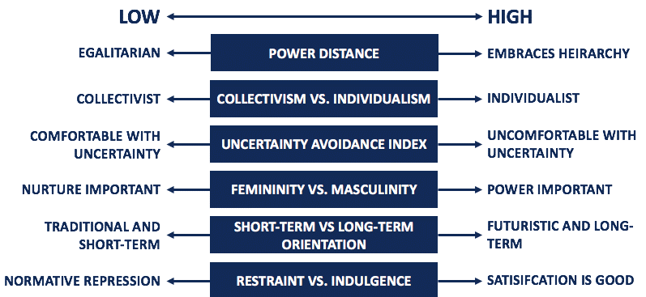Figure 1: Leadership Training UK, 2024
Source: (Corporate Finance Institute, 2024)

Maslow's Hierarchy of Needs
This theory is known to be the motivational theory in psychology which often contains 5 models that are based on managing individual needs. From bottom based on hierarchy going upward these needs includes managing psychological including food and clothing, managing safety including job safety. It also includes managing needs based on love and belongings in terms of friendship, management of self-esteem power along with building of self-actualization (Al-Refaei et al. 2023). In the UK, the general well-being of people as using Maslow’s hierarchy of needs is varies. Community and cultural initiatives support social, esteem, and self-actualization needs. However, challenges like inequality and mental health issues face it out, impacting overall happiness and fulfilment across all levels of the hierarchy (Science direct, 2024).
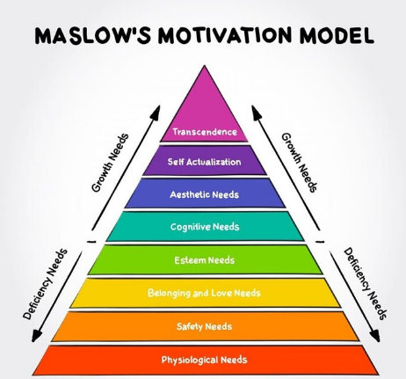
Figure 2: Maslow’s hierarchy of needs
Source: (Simply Psychology, 2024)

Herzberg’s two-factor theory
This is considered to be a motivational theory that often suggests that managing satisfaction and dissatisfaction within work are influenced by two major sets of factors (Winasis, Riyanto and Ariyanto, 2020). These factors include maintaining hygiene along with various motivators. The hygiene factors are known to be based on managing basic job necessities including management of effective working conditions. In the UK, include fair and clear company policies, safe and comfortable working environments, competitive salary and benefits, job security supported by strong employment rights laws (Researchgate, 2024). In addition, according to motivators are primary factors that can often lead to attain job satisfaction along with motivating staff for performing in an effective way, recognition of good work, increased responsibility, career opportunities, personal and professional growth training and development programs (Sopiah et al. 2020).

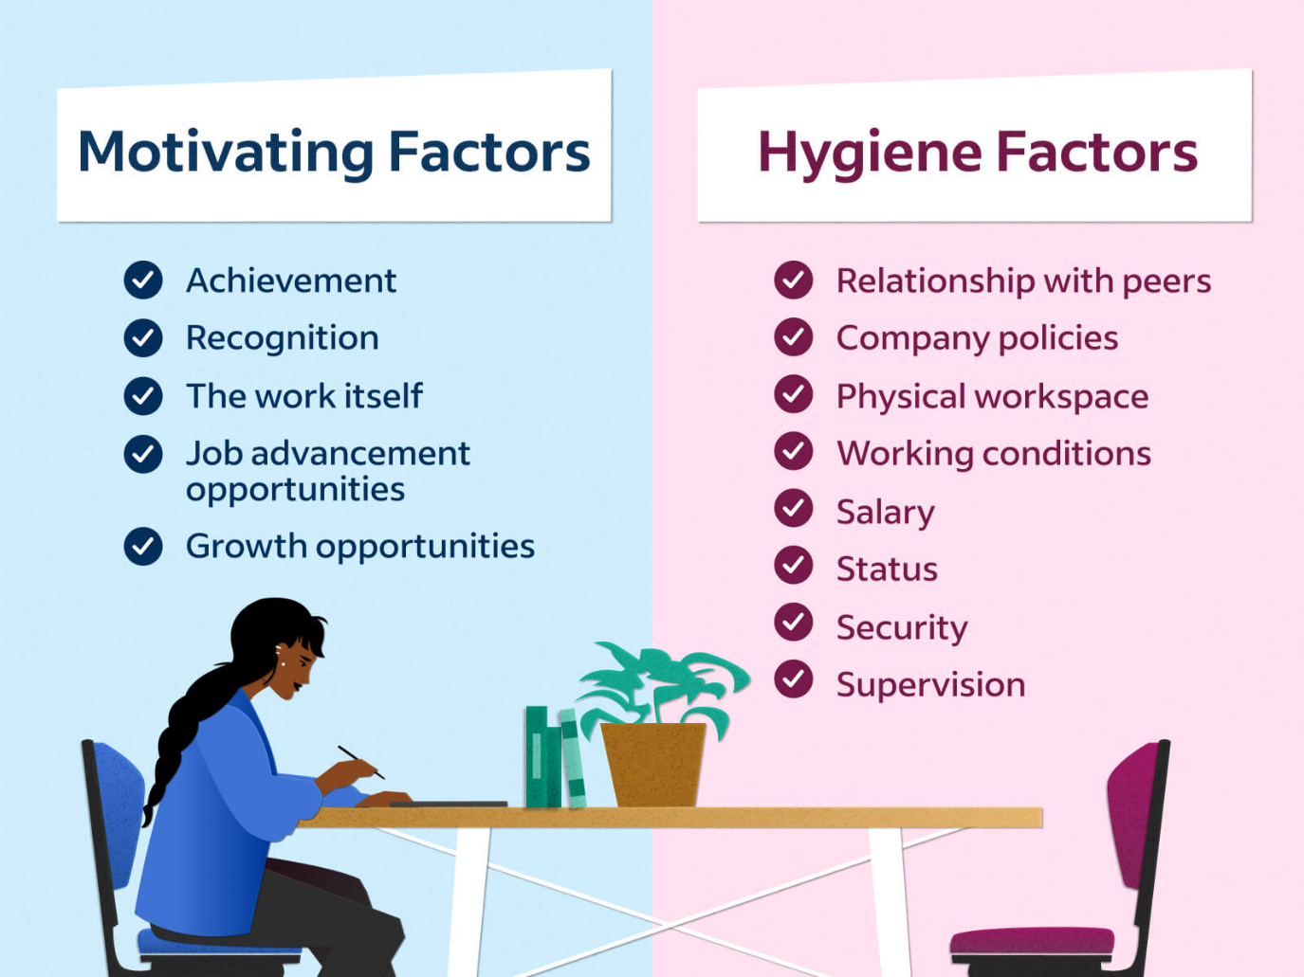Figure 3: Herzberg’s two-factor theory
Source: (Herzberg's Two-Factor Theory, 2024)

2.6 Gaps identified in research
While conducting this research, researcher identified various gaps that in turn hinders effectiveness and operation. These gaps include knowledge gap where researcher does not possess sufficient knowledge based on evaluating the impact of employee engagement along with developing motivational factors to drive organizational success in near future. Other gaps include managing evidence gap based on research, implication of empirical gap along with demonstration of theoretical gap (Adisa, Ogbonnaya and Adekoya, 2023).

2.7 Summary
Hence, based on above discussion it can be summarized that it is the sole responsibility of an employer to inspire innovation within an employee. In this context, an engaged employee often comes up with innovative and inspiring ideas along with solutions that in turn aids in enhancing success rate of business organization. Moreover, it can be noticed that an effective performance management practice can assists in improving engagement and thereby keeping virtuous cycle going at faster pace.

Chapter 3: Research Methods and Methodology

3.1 Introduction
Research Methodology can be demonstrated as a way of explaining how a researcher often intends on carrying out the activities of research. It is a logical, systematic plan that is applicable for solving or mitigating a research problem. This chapter shed light on discussing about reasons for adoption of Ontology research, implication of positivism research along with managing usage of deductive approach. Moreover, this research will determine descriptive research design along with demonstrating survey using Survey Monkey tool.

3.2 Research philosophy
Ontology is considered to be a branch of metaphysics and philosophy that often deals with studying being, management of existence along with evaluation of reality process. This specified research is specifically based on study of existence along with managing its nature. In addition, theories associated with ontology research aids in explaining nature of existence in terms of describing its substances of causes (Sanders, 2019).
According to an article passed as on 2nd May in financial year 2017, it can be demonstrated that undertaking ontology research will be beneficial for researcher for recognizing nature and existence of objects. Researchers undertake ontology research as they can take advantages of hierarchies that are known to be inherent within an ontology with aim of aiding with enhance data analysis and interpretation. On the other hand, using ontology often allows researchers for categorizing observations along with identifying the general principles (Verma, Verma and Abhishek, 2024).

3.3 Research approach
Positivism research will be adopted by researcher as this method tend to cover wide range of situations that can be implemented within a shorter period of time. This research often relies on experience as implication of valid source of knowledge in long term. On the other hand, using wide range of basic and essential concepts including cause, time and space fails to be primarily based on experience. Research tends to rely on this positivism research philosophy as this process often assumes that different types of process can estimated to be perceived as certain variation based on determining actions of individuals or maintaining relationships in between individuals (Sanders, 2019). Positivist paradigm is primarily based on exploring social reality which is primarily based on long term idea that researcher can understand human behaviour through observation and reasoning (Dubey and Kothari, 2022).

3.4 Methodological choice
A deductive approach is mainly concerned with developing a hypothesis which is based on existing theory and then this approach incorporates designing research strategy on testing hypothesis. Deductive approach will be used in research as it can be explained by means of hypothesis that in turn can be derived from long term proposition of theory. In other words, research tend on using Deductive approach as it is primarily being concerned with deducting conclusions from premises or demonstrating propositions. Using the specified approach is considered to be beneficial as it helps in evaluating the possibility on explaining the casual relationship in between concepts and variables (Newman and Gough, 2020). Apart from that, this research approach also known to explore known theory along with phenomenon and make test for checking whether the theory is valid within provided circumstances. In addition, studies using deduction approach incorporates on following different stages that can be discussed as:
- Deduction of hypothesis from application of theory
- In addition, using of deductive approach aids in formulation of hypothesis within operational terms that in turn can help in proposing relationships among two specific variables.
- Based on testing hypothesis within application of relevant methods is possible through use of deductive approach. Moreover, these are known to be quantitative methods including regression and correlation analysis, demonstrating mean, mode apart from median (Zhou, Li and Sun, 2022).
- Apart from that, based on examining the outcome based on the demonstration of test helps in either confirming or rejection on the output of theory. While analyzing final outcome of test, it is primarily important for comparing findings of the research with findings based on evaluating Literature Review.
- Lastly, based on modifying theory fails to implement that hypothesis fails to be confirmed within time frame (Zhang, Gong and Brown, 2023).

3.5 Research Strategy
Quantitative research can be demonstrated as a powerful tool that are primarily used by different researcher on gathering empirical data based on topic of study. In this form of research, usage of statistical models and math is effective as it aids researcher on evaluation of hypothesis. Researchers lean on using quantitative research as this process aids in capturing both real and measurable data in form of numbers along with diagrammatic evaluation. This form of research is a powerful tool for researcher for gathering empirical data about topic of study. By using statistical models and math it aids researchers on evaluation of hypothesis. Use of quantitative research is beneficial to be adopted by researcher as it is mainly designed for capturing numerical data for purpose of studying either fact or phenomenon within population. Moreover, this form of research activity is beneficial for production of data points while analysing a particular group of people (Dzwigol, 2022). Researchers use this specified method as it helps in capturing vast amount of data for attaining quicker result than any other research activities. Apart from that, ability to work within real time often allows a researcher and analyst for immediately initiating and incorporating new insights and alteration in work.

3.6 Determination of descriptive research Design
Descriptive research can be demonstrated as a type of research which often focuses on describing characteristics of either a sample or population. Moreover, this type of research can primarily be used for studying different topics associated with marketing, social science along with health care. Use of descriptive research is effective as it helps in collecting data from large number of participants. This in turn can be beneficial for gaining knowledge about different complex subtopics (Al-Ababneh, 2020). Major reason for the researcher for adopting descriptive research design as it helps in exploring varied aspects of a particular topic. This in turn can be beneficial while understanding how people tend to use varied products and how people tend to feel in a particular scenario. In addition, using of above specified research is considered to be cheaper, easier and quicker to be carried other than any methods. It is also important for accelerating reliability of results as participants are less likely on selection on inappropriate answers.

3.7 Data collection and Data analysis
Survey data collection method is used in this research as it is used for supporting or refuting research hypotheses and helps in drawing conclusions about subject matter of the study. Excel data analysis tool will be used in this study as it is effective for making informed and better decisions (Budianto, 2020).

3.8 Ethical Considerations
Researchers need to secure store along with anonymize data by means of protecting address and sensitive information of participants. Thus, it can be effective for maintaining any potential harm or any level of discomfort among different participants during process of data collection is imperative. Confidentiality protects private information. Integrity requires honesty and upholding ethical standards. Accountability means taking responsibility for your actions. These principles guide responsible and ethical behaviour in various contexts.

3.9 Summary
Hence, based on above discussion it can be summarised that this study used quantitative approach based on analysing employee engagement and motivational factors. Moreover, managing rights and privacy of research participants has focused in providing protection to manage highest ethical standards.

Chapter 4: Data Analysis

4.1 Introduction
The pie chart represents the responses from a survey conducted with 65 participants, each engaged in various types of work within the organization. The respondents include professionals from diverse roles, such as administrative staff, technical experts, customer service representatives, and management personnel. The chart provides a visual overview of how frequently these employees interact with customers, reflecting the nature of their daily tasks and the varying degrees of customer engagement across different roles.

4.2 Data Analysis and Discussions
1. What is your age?
The pie chart shows that the majority of respondents 51% are aged 35-44, with 35% aged 25-34. Younger 18-24 and older 45-54 age groups are underrepresented, at 3% and 10% respectively. The survey primarily reflects the views of middle-aged adults.
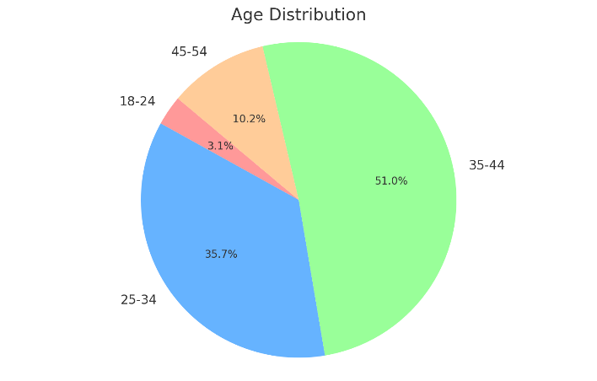
Figure 4: What is your age?
(Source: Self-created)

2. About How long have you been in your current position?
40% of respondents have been in their current position for 4-6 years, it show a stable workforce. A significant portion are recent hires, with 20% having less than 1 year and 26% with 1-3 years in their roles. Only 14% have over 6 years, that lower percentage might suggest lower opportunities for long-term career progression, or it could reflect a dynamic environment with frequent role changes.
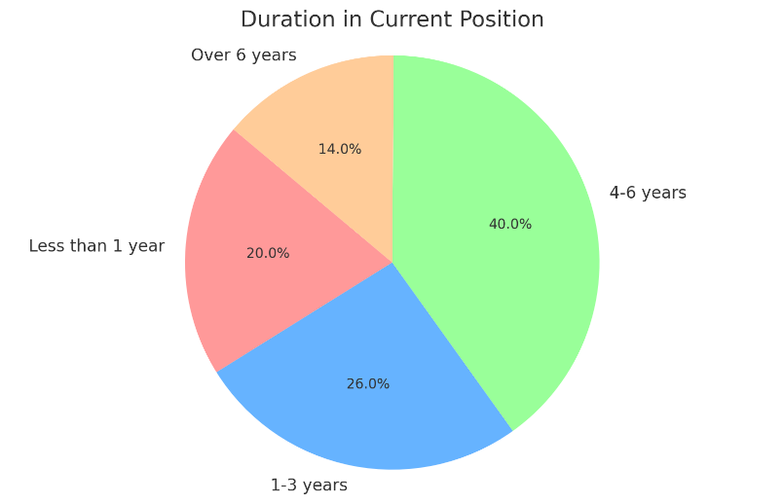
Figure 5: About How long have you been in your current position?
(Source: Self-created)

3. How satisfied are you with your current job?
A majority of respondents are satisfied with their job, 35% very satisfied and 25% satisfied. The most employees feel positively about their work. While 25% are neutral and 15% are dissatisfied. Job satisfaction is generally high but there is need for improvement among those who feel neutral or dissatisfied.
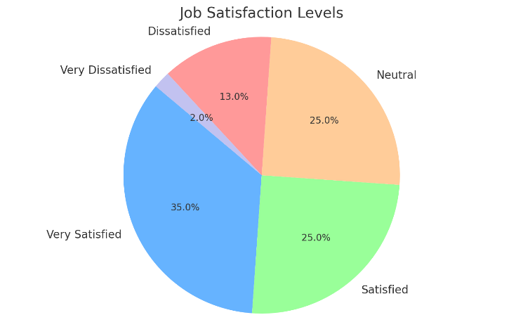
Figure 6: How satisfied are you with your current job?
(Source: Self-created)

4. In a typical week, how often do you feel stressed at work?
38% feeling stressed somewhat often, 22% often, 35% not feeling stressed often, and only 5% rarely feel stressed. Work-related stress is a common issue, with over half of the respondents experiencing frequently.
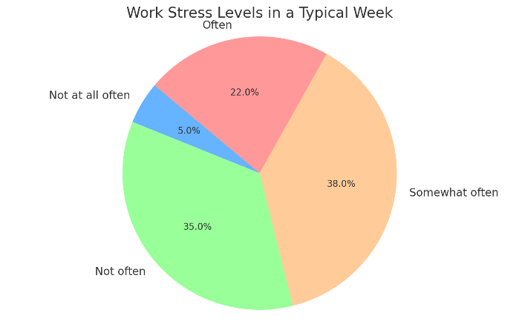
Figure 7: In a typical week, how often do you feel stressed at work?
(Source: Self-created)

5. In your daily work, what are the factors that help you feel motivated at work?
The chart shows that a supportive team 35%, and professional development 30% are the top motivators. Regular recognition 25% while clear goals are at 10%. Emphasizing teamwork, growth opportunities, and recognition is key to operate high employee motivation.
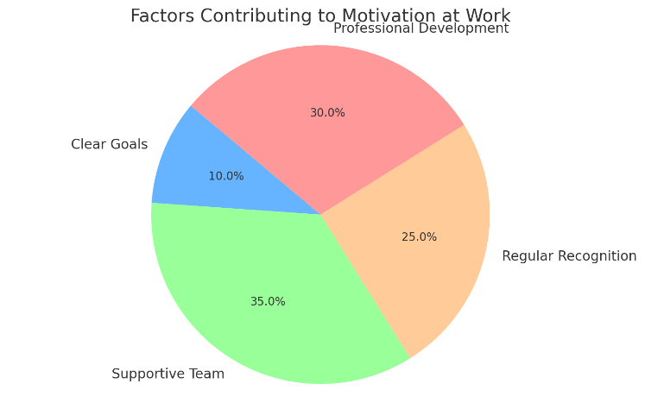
Figure 8: In your daily work, what are the factors that help you feel motivated at work?
(Source: Self-created)

6. How frequently do you receive recognition for doing good work?
According to the result with 28% always receiving recognition and 25% often receiving. The largest group 36% only sometimes receives while 11% rarely do. Importantly, no candidate reported never receiving recognition. Regular, consistent recognition can strengthen morale and foster a more positive, motivated work environment.
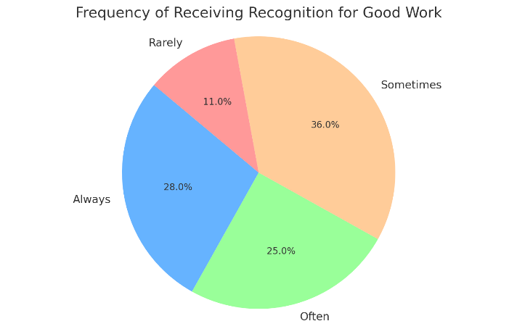
Figure 9: How frequently do you receive recognition for doing good work?
(Source: Self-created)

7. How difficult was it for you to balance your work life and personal life while working here?
The chart reveals 35% of respondents struggle significantly with balancing work and personal life, while 40% manage it without much difficulty. 15% feeling neutral and only 10% finding it easy, it is clear work life balance is a challenge for many. Although no one finds it extremely difficult.
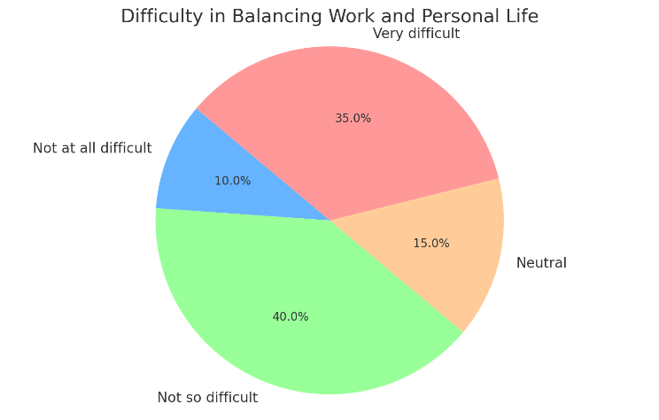
Figure 10: How difficult was it for you to balance your work life and personal life while working here?
(Source: Self-created)

8. How much do you enjoy the work you do?
The chart shows that 62% of respondents enjoy their work, 39% enjoying and 23% a lot. While 24% feel moderate enjoyment, 14% have a little to no enjoyment. Addressing these areas could improve overall workplace morale and productivity, ensuring that more employees find their work meaningful and enjoyable, involve offering more challenging tasks, opportunities for growth. The most employees engaged and satisfied.
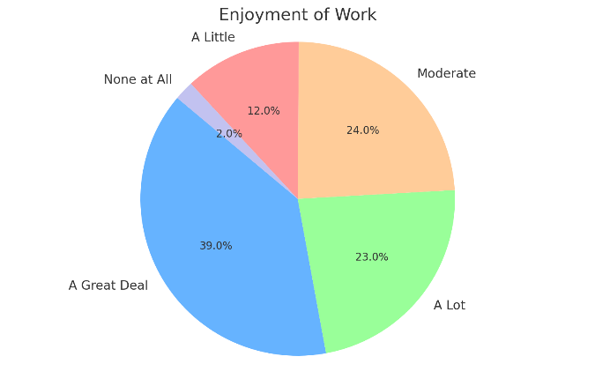
Figure 11: How much do you enjoy the work you do?
(Source: Self-created)

9. What factors contribute to your motivation at work?
The chart shows that salary and benefits are the top motivators, followed by team support 25% and recognition 17%. Work environment is the least important, but it should not be overlooked it, while financial incentives and team dynamics are crucial.
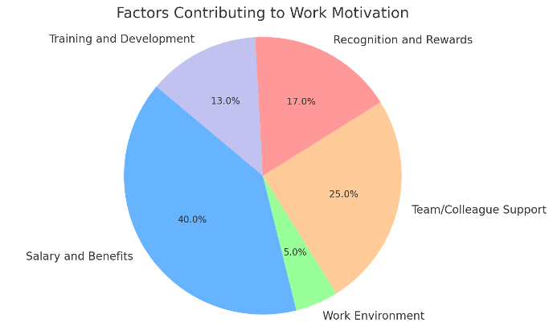
Figure 12: What factors contribute to your motivation at work?

(Source: Self-created)

10. How far do you agree that process of employee engagement helps in management of effective rates of attrition?
According to the result, 25% of employees are strongly agree with employee engagement helps in management of effective, 45% of employees are agree with it while the other 25% claim disagree for them. 5% of them are strongly disagree. While employee engagement is generally seen as beneficial there may be areas where it is effectiveness could be communicated more clearly to address concerns among those who are less convinced.
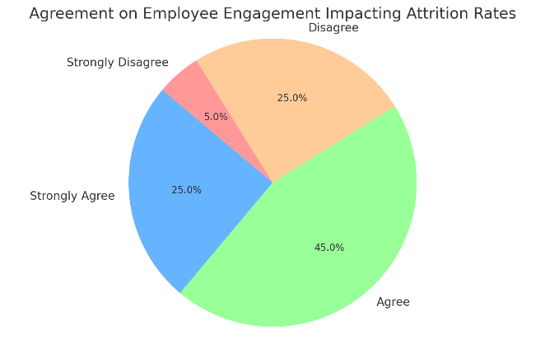
Figure 13: How far do you agree that process of employee engagement helps in management of effective rates of attrition?
(Source: Self-created)

11. How far do you agree that form of employee experience can helps in increasing motivation?
The pie chart reveals that a strong majority of respondents believe the form of employee experience significantly impacts motivation. Only 5% are neutral. This suggests that enhancing employee experience is widely seen as a critical factor in boosting motivation, organizations should prioritize initiatives that improve employee experience.
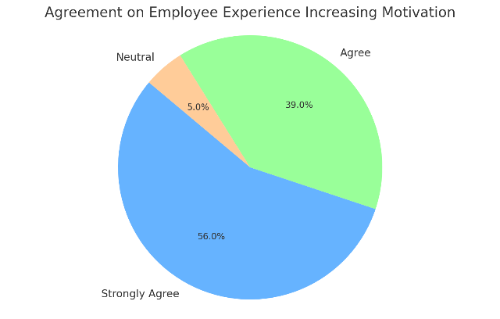
Figure 14: How far do you agree that form of employee experience can helps in increasing motivation?
(Source: Self-created)

12. How far do you agree that leadership and mode of communication are major factors affective performance of a business in UK?
The chart reveals the most respondents view leadership and communication as main to business performance in the UK. The small group who are neutral or disagree suggests that while leadership and communication are widely recognized as essential, there might be other factors some consider important. Management structures, leadership might play a less important role, cultural differences can also shape perceptions or individual focused on short-term results.
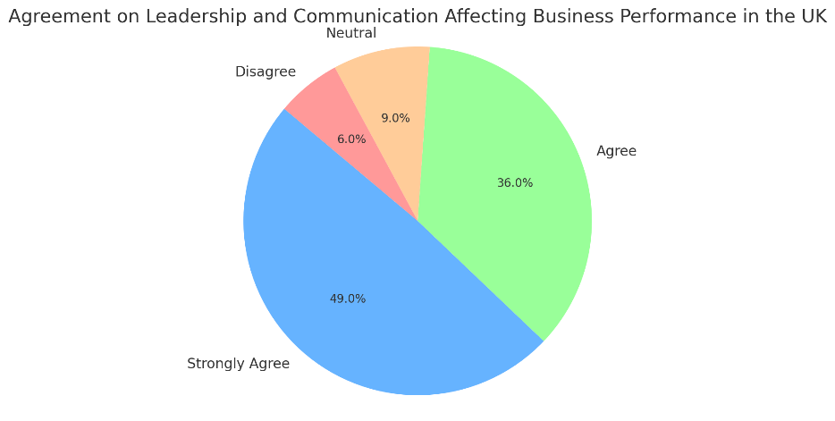
Figure 15: How far do you agree that leadership and mode of communication are major factors affective performance of a business in UK?
(Source: Self-created)

13. Do you think increasing employee engagement initiatives (like team-building activities, development, etc.) would lead higher productivity?

A combined 98% of respondents believe that increasing engagement activities would likely enhance productivity, with 41% saying it definitely would, 57% saying it probably would. Only a small minority 2% are sceptical. The importance of investing in engagement strategies as a key driver of productivity in the workplace.

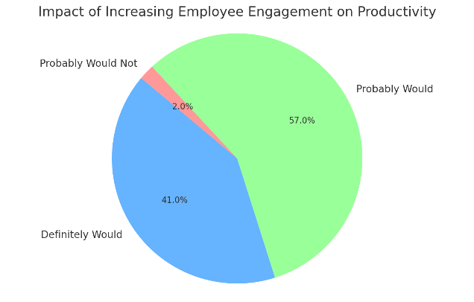
Figure 16:
Do you think increasing employee engagement initiatives (like team-building activities, development, etc.) would lead higher productivity?
(Source: Self-created)

14. Do you agree that motivation strongly impact on managing employee performance within an organization?
A significant part of respondents recognize motivation as essential for managing employee performance, 38% strongly agreeing and 39% agreeing. The neutral stance of 22% suggests that some may see other factors as equally important. The 1 % who did not answer showing minimal doubt about motivation impact.
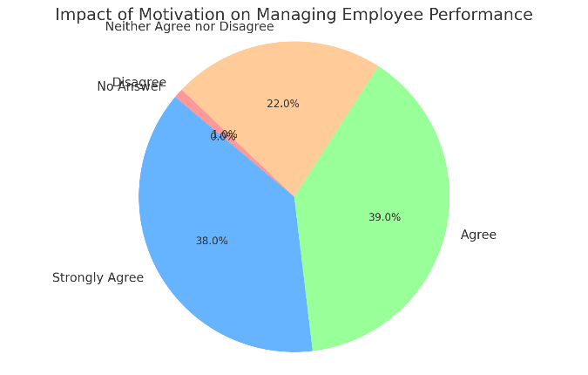
Figure 17: Do you agree that motivation strongly impact on managing employee performance within an organization?
(Source: Self-created)

15. How often do you interact with customers?
Candidates frequently interact with customers, with 86% engaging in daily, customer interaction is a central part of their roles. 8% interact with customers several times a week, and a small minority 6% never interact with customers. They are likely in roles on operations, such as finance, IT or software development. These roles are essential for the organization functioning but do not involve direct customer contact.
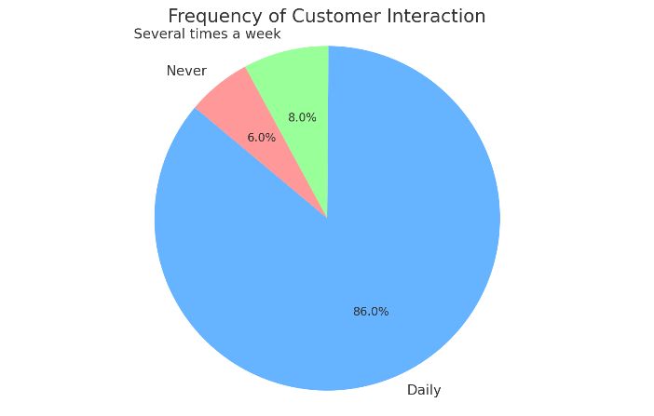
Figure 18: How often do you interact with customers?
(Source: Self-created)

16. Have you received feedback from customers about the service you provide?
27% of respondents frequently receive feedback, 18% receive feedback occasionally, suggesting that while some interactions occur it may not be consistent enough to regularly inform their work. 30% no, never and 19% never, they do not receive feedback which could point to either a lack of customer interaction. This may make difficult their ability to improve or feel connected to customer satisfaction. Customer interactions are frequently negative or overwhelming, they can also lead to stress and dissatisfaction. It shows the importance of support and training in these roles. The 6% who find this question not applicable likely do not interact with customers at all.
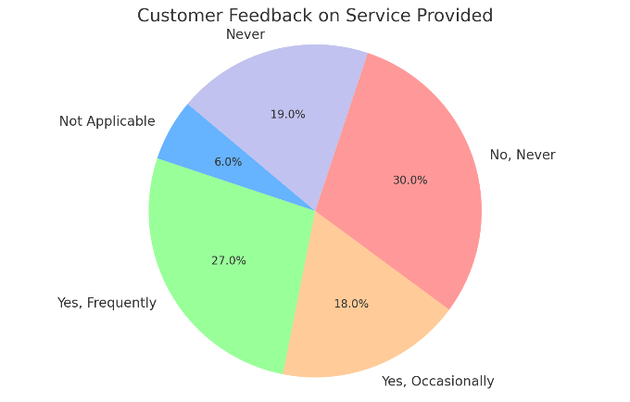
Figure 19: Have you received feedback from customers about the service you provide?
(Source: Self-created)

4.3 Summary
The analysis of the pie charts provides valuable insight into the organisation of employee engagement, customer interaction, and impact of leadership and communication on performance. First, it is evident that customer interaction plays a significant role in many employees’ daily routines. This interaction likely contributes to positive feedback where employees can directly see the results of their work, which is important to continuous improvement and job satisfaction. However, the data also shows that a considerable number of employees either rarely or never receive customer feedback. This lack of feedback might indicate a disconnect for those in non-customer facing roles, which could lead to disengagement or a lack of understanding about how their contributions affect the organization success. Addressing this gap by enhancing feedback could better integrate all employees, ensuring they feel valued and informed about their impact. Second, the importance of motivation and engagement is clearly highlighted with most respondents agreeing that these factors significantly impact employee performance and organizational success. The strong belief in the leadership and communication underscores the necessity of effective management practices in fostering a productive and motivated workforce. The respondents who are neutral or disagree suggests that not all employees feel the effects of these equally. This may be due to variations in how engagement programs are implemented across different departments. Recognition and rewards play a pivotal role in maintaining high levels of engagement as employees feel appreciated are more likely to be motivated and committed. Opportunities for professional development are essential in sustaining engagement as they offer employees a vision of their future within the organization encouraging them to invest in their roles. In conclusion, the pie charts reveal that leadership, communication, customer interaction, recognition and development opportunities are key drivers of employee engagement. By focusing on these areas, the organization can foster a more motivated, connected, and productive workforce, leading to improved performance and job satisfaction.

Chapter 5: Research Objectives, Recommendations, Discussion and Conclusion

5.1 Research Objectives
Research objective 1, Concepts of employee engagement and motivation for accelerating organizational performance. The research objective focuses on understanding the concept of employee engagement and motivation as key drivers for accelerating organizational performance. Employee engagement involves the emotional and psychological commitment employees have towards their work and the organization in applying Herzberg’s theory. The focus should be on enhancing motivators while ensuring that hygiene factors meet baseline expectations. Start by understanding what motivates employees through surveys or feedback. Once these motivators are identified the organization can create programs and initiatives that emphasize these aspects (Shasha Zeng, 2024). For instance, implementing recognition programs or offering career development opportunities can help employees feel more engaged and satisfied with their roles. It is essential to ensure that hygiene factors, which might not directly increase satisfaction but can cause dissatisfaction. This includes maintaining competitive salaries, ensuring job security, and providing a positive work environment. Regular reviews and updates to these areas can prevent dissatisfaction and help maintain a stable work environment. Research objective 2, Relationship between employee engagement along with motivation, productivity, and employee satisfaction. Exploring the relationship between employee engagement, motivation, productivity, and employee satisfaction through the lens of Maslow’s Hierarchy of Needs. Fulfilling employees’ basic needs such as fair wages and safe working conditions is just the starting point. For instance, a tech company might ensure competitive salaries and comfortable office, which aligns with Maslow’s lower-level needs. However, as employees move beyond these basics, their focus shifts to belongingness and esteem. This could manifest in the need for collaborative culture and regular recognition, where team members are encouraged to participate in decision-making processes, reflecting their desire for inclusion and respect. In today’s diverse and dynamic work environments, employees might seek fulfilment at different level and what motivates one individual might differ significantly from another. For example, an employee in a start-up might prioritize the need for self-actualization through creative freedom and innovation over job security while another in the same company might be more concerned with job stability. Companies must recognize that employees might not always follow a linear path through the hierarchy and that their motivations can based on personal circumstances, career stages. Effective application of Maslow’s theory involves creating a work environment that is flexible enough to address a range of needs ensuring that employees are both engaged and satisfied which in turn drives productivity and overall organizational success. Research objective 3, business strategies that influences employee engagement and motivation in UK. Hofstede’s Cultural Dimensions Theory provides a valuable framework for understanding how business strategies in the UK can influence employee engagement and motivation. Hofstede’s research identifies as having a high degree of individualism and a relatively low power distance. Business strategies that empower employees such as offering flexible working arrangements, opportunities for personal development and recognition of individual contributions. Employees are likely to be motivated by opportunities that promise long-term benefits, like career progression, continuous learning, and rewards.

5.2 Recommendation
Based on the insights from this research, several recommendations emerge for organizations seeking to enhance employee engagement and motivation within the UK. Firstly, it is imperative for organizations to develop strategies that align with the cultural liabilities identified by Hofstede, particularly the high degree of individualism and low power distance in the UK. This entails fostering a work environment that values autonomy, recognizes individuals and open communication between all levels of staff. Integrate wellness and mental health programs as a core component of employee engagement. To implement this companies can introduce comprehensive wellness program that include mental health resources, such as access to counselling services, stress management workshops and training. Promoting work-life balance through policies, mental health days and reasonable work hours can significantly reduce burnout and improve overall job satisfaction (Jacqueline M. Zeeman, 2024). Addressing the motivational needs by Maslow’s Hierarchy organizations should ensure that basic physiological and safety needs are fair compensation and job security. Beyond these needs emphasis should be placed on creating opportunities for social belonging, esteem, and self-actualization. This can be achieved by promoting team-building activities, providing platforms for employee recognition, and professional development and career development. Furthermore, organizations should adopt a flexible and adaptive approach to their engagement strategies, acknowledging the diverse and evolving nature of the modern workforce. This includes accommodating varying work preferences, such as flexible working hours or remote work options and being responsive to feedback through regular employee surveys. Additionally, investing in leadership development is essential. Leaders should be equipped with the skills to foster an inclusive and supportive work environment, where employees feel valued, heard and empowered. Effective leadership is key to driving engagement and motivation. By implementing these recommendations, organizations can build a more engaged, motivated and productive workforce.

5.3 Discussion and Findings
Managing of employee engagement is vital as without this process there is no team engagement which often makes it difficult for improving level of business outcomes. It can further be estimated that around 70% of variance in team engagement can primarily be determined by top level manager. Managing employee engagement is regarded as primary responsibility of any manager as they oversee ensuring that staff knows for work to be accomplished effectively. In order to succeed with managing responsibility, managers are required to be equipped for possessing ongoing coaching-based conversation with staff (Zhang, Gong and Brown, 2023). It is the sole responsibility of a leader for redefining roles and expectations of manager along with providing training tools. Moreover, leader need to provide resource and development tools which is needed by managers for coaching and meeting higher level of expectations. On the other hand, a leader is also being responsible for creation of evaluation practices that in turn will assists managers for accurately measuring of business performance, holding each staff accountable and coaching for future. It can be determined that various business organization who possess highly engaged staff primarily outcome companies with disengaged staff on all accounts. These includes managing higher mode of profitability, managing high level of productivity, managing customer metrics along with decreasing the rate of staff turnover. High performing based teams are top scorers when it helps in managing level of engagement among staff (Al-Ababneh, 2020). Based on statistics of evaluating employee engagement it further reveals that in Europe only 10% of staff are estimated to remain motivated at staff which can be compared to about 33% for US. Moreover, based on statistics of employee motivation for UK are regarded as more alarming with number as evaluated to be 8% with noticeable decline over financial years (Zhou, Li and Sun, 2022). Motivated staff are considered to be loyal to business organization and often finds value and helps in managing social status within work. Thus, these staff are driven for discovering their best selves for promoting and enhancing business organization. Whenever staff are providing their best within workplace, the entire workflow often becomes efficient in nature (Verma, Verma and Abhishek, 2024).

5.4 Conclusion
Employee engagement and motivation are pivotal drivers of organizational performance in the UK, where workplace cultural and expectations have evolved significantly in years. The relationship between these factors is complex and multifaced with both direct and indirect effects on productivity, innovation, and overall business success. Highly engaged employees are more likely to exhibit increased commitment to their roles, leading to higher level of productivity and efficiency. This in often leads to incorporate higher rate of productivity that in turn allows management for producing more quality work. In the UK, where individualism is valued, engagement often correlates with employees feeling that their contributions are meaningful and recognized. Impact of employee motivation within business venture incorporates on promoting loyalty among employees. It is sole responsibility of managing staff for motivating employees for doing best and rewarding for hard work. Moreover, well-motivated workforce is loyal and primarily possess higher level of morale on being more committed to manage organizational business goals, engage in creative problem solving and innovation. Theories such as Herzberg’s two-factor theory and Maslow’s hierarchy of needs suggest that motivation is not merely about financial rewards or job security but also involves the fulfilment of higher order needs like recognition, personal growth, and self-actualization. However, the impact of employee engagement and motivation on organizational performance is not without challenges. While engaged and motivated employees can drive significant improvements in performance, organizations must be aware of the potential for burnout and disengagement if these factors are not manged carefully. In the UK, where work-life balance is increasingly prioritized, organizations must balance the demands placed on employees with support.
Hence, based on above discussion it can further be concluded that major factors that tend to affect employee engagement and managing higher levels of motivation includes determining culture and values of business. In addition, evaluating strong along with positive cultures often aligned on raising values of staff based on fostering higher level of engagement. On the other hand, leadership and management style incorporate of evaluating transparent and evaluation of supportive leadership assists in driving satisfaction and performance.

References
Adisa, T.A., Ogbonnaya, C. and Adekoya, O.D., 2023. Remote working and employee engagement: a qualitative study of British workers during the pandemic. Information Technology & People, 36(5), pp.1835-1850.
Akpa, V.O., Asikhia, O.U. and Nneji, N.E., 2021. Organizational culture and organizational performance: A review of literature. International Journal of Advances in Engineering and Management, 3(1), pp.361-372.
Al-Ababneh, M., 2020. Linking ontology, epistemology and research methodology. Science & Philosophy, 8(1), pp.75-91.
Aldabbas, H., Pinnington, A. and Lahrech, A., 2023. The influence of perceived organizational support on employee creativity: The mediating role of work engagement. Current Psychology, 42(8), pp.6501-6515.
Al-Refaei, A.A.A., Ali, H.B.M., Ateeq, A.A. and Alzoraiki, M., 2023. An integrated mediating and moderating model to improve service quality through job involvement, job satisfaction, and organizational commitment. Sustainability, 15(10), p.7978.
Al-Swidi, A.K., Gelaidan, H.M. and Saleh, R.M., 2021. The joint impact of green human resource management, leadership and organizational culture on employees’ green behaviour and organisational environmental performance. Journal of cleaner production, 316, p.128112.
Awan, S.H., Habib, N., Shoaib Akhtar, C. and Naveed, S., 2020. Effectiveness of performance management system for employee performance through engagement. SAGE open, 10(4), p.2158244020969383.
Budianto, A., 2020. Legal research methodology reposition in research on social science. International Journal of Criminology and Sociology, 9(1), pp.1339-1346.
CIPD. (2019). Building Inclusive Workplace.
CIPD. (2024, 4 12). Retrieved from Employee engagement and motivation: https://www.cipd.org/uk/knowledge/factsheets/engagement-factsheet/#how-engaged-are-uk-employees
Corporate Finance Institute. (2024, 8 15). Retrieved from Hofstede’s Cultural Dimensions Theory: https://corporatefinanceinstitute.com/resources/management/hofstedes-cultural-dimensions-theory/

Dubey, U.K.B. and Kothari, D.P., 2022. Research methodology: Techniques and trends. Chapman and Hall/CRC.
Dzwigol, H., 2022. Research methodology in management science: Triangulation. Virtual Economics, 5(1), pp.78-93.
EJER. (2024, 8 28). Retrieved from The Role of Self-Efficacy in Job Satisfaction, Organizational Commitment,: https://dergipark.org.tr/en/download/article-file/960160
Herzberg's Two-Factor Theory. (2024, 8 16). Retrieved from Structural Learning: https://www.structural-learning.com/post/herzbergs-two-factor-theory
Jacqueline M. Zeeman, E. S. (2024). Assessing Workplace Factors that Influence Burnout and Identifying. American Journal of Pharmaceutical Education, 1-7.
Kalogiannidis, S., 2021. Impact of employee motivation on organizational performance. A scoping review paper for public sector. The Strategic Journal of Business & Change Management, 8 (3), 984, 996(3).
Mark Saunders, P. L. (2019). Research Methods for Business Students eight edition. Pearson Education, Limited.
Newman, M. and Gough, D., 2020. Systematic reviews in educational research: Methodology, perspectives and application. Systematic reviews in educational research: Methodology, perspectives and application, pp.3-22.
Pandey, P. and Pandey, M.M., 2021. Research methodology tools and techniques. Bridge Center.
Researchgate. (2024,8,27.) Retrieved from The Investigation of Effects of Job Satisfaction on Performance Among: http://www.researchgate.net/profile/Mohammad-Dawude-Temory-2/publication/369957701_The_Investigation_of_Effects_of_Job_Satisfaction_on_Performance_Among_Academicians_Using_Herzberf’s_Theory/links/6486ccf22cad460a1b0ff6cb
Riyanto, S., Endri, E. and Herlisha, N., 2021. Effect of work motivation and job satisfaction on employee performance: Mediating role of employee engagement. Problems and Perspectives in Management, 19(3), p.162.
Science direct. (2024, 8 26). Retrieved from The hierarchy of needs empirical examination of Maslow’s theory and lessons for development: https://www.sciencedirect.com/science/article/abs/pii/S0305750X23000037
Shasha Zeng, B. P. (2024). Exploring Key Factors In Understanding Graduate Turnover Through Herzberg’s Two-Factor Theory: A Literature Review. Educational Administration: Theory and Practice, 1-8
Simply Psychology. (2024, 8 15). Retrieved from Maslow’s Hierarchy Of Needs: https://www.simplypsychology.org/maslow.html
Sopiah, S., Kurniawan, D.T., Elfia, N.O.R.A. and Narmaditya, B.S., 2020. Does talent management affect employee performance?: The moderating role of work engagement. The Journal of Asian Finance, Economics and Business, 7(7), pp.335-341.
Tensay, A.T. and Singh, M., 2020. The nexus between HRM, employee engagement and organizational performance of federal public service organizations in Ethiopia. Heliyon, 6(6).
The Culture Factor. (2024, 8 28). Retrieved from COUNTRY COMPARISON TOOL: https://www.theculturefactor.com/country-comparison-tool?countries=united+kingdom
van Tuin, L., Schaufeli, W.B., Van den Broeck, A. and van Rhenen, W., 2020. A corporate purpose as an antecedent to employee motivation and work engagement. Frontiers in Psychology, 11, p.572343.
Verčič, A.T., 2021. The impact of employee engagement, organisational support and employer branding on internal communication satisfaction. Public Relations Review, 47(1), p.102009.
Verma, R., Verma, S. and Abhishek, K., 2024. Research Methodology. Booksclinic Publishing.
Winasis, S., Riyanto, S. and Ariyanto, E., 2020. Digital transformation in the indonesian banking industry: Impact on employee engagement. International Journal of Innovation, Creativity and Change, 12(4), pp.528-543.
Zhang, C., Gong, Y. and Brown, S., 2023. Research methodology. Autores, Blockchain Applications in Food Supply Chain Management. Contributions to Management Science, pp.77-98.
Zhou, Y., Li, H. and Sun, H., 2022. Metalloproteomics for biomedical research: methodology and applications. Annual Review of Biochemistry, 91, pp.449-473.

