Analysis of Results Chapter: The Taboo of Mental Health in Policing. Is Mental Health Stigmatised in the Police?
As stated above, my survey and questionnaire were regarding the taboo of mental health in policing, and whether mental health is stigmatised in the police. My main objectives are,
- Is mental health stigmatised in the police?
- Why do police officers feel they cannot be open about their mental health?
- Is their support for police officers who struggle with their mental health?
So, all my questions were related to the above three objectives. As this is a sensitive subject, to open my survey, I included an introduction reassuring the respondents that all answers are anonymous and will be shared via the University.
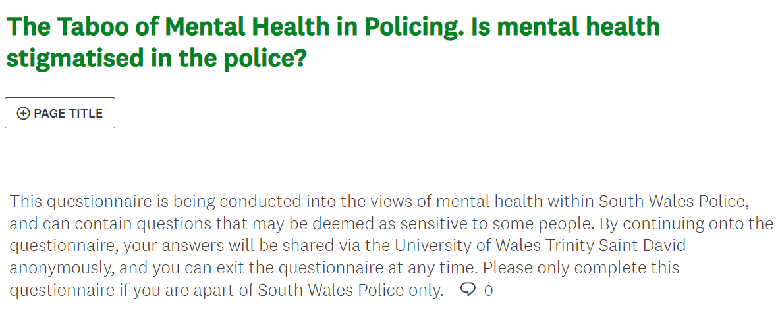

In total, 43 South Wales Police employees completed my survey. However, I can only view 25 responses due to the creating tool that I used, if I wanted to view all the answers, I would have had to pay £30.00.
In addition, most of my respondents were male, with 68% and were in the older age gap of 36 – 45 years old. However, most persons completing my survey only had 1 – 4 years’ service in the force.
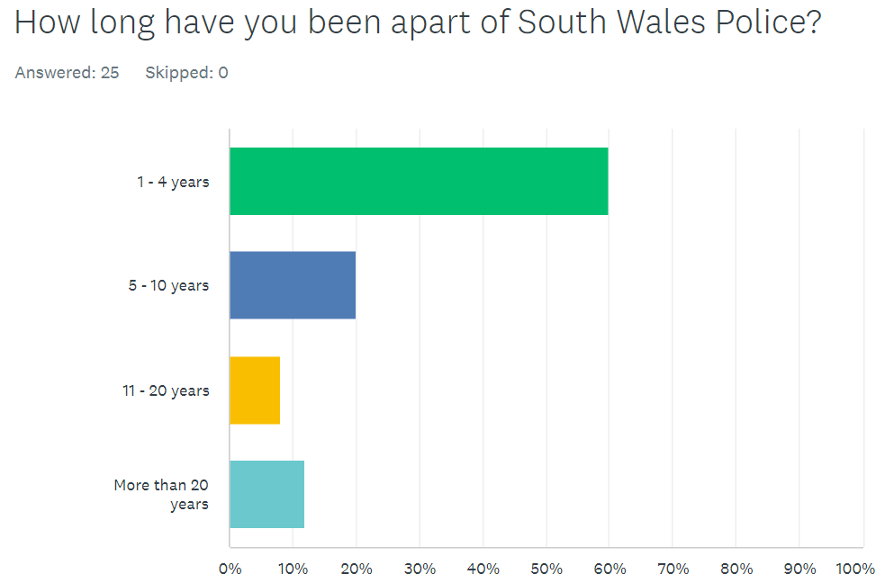
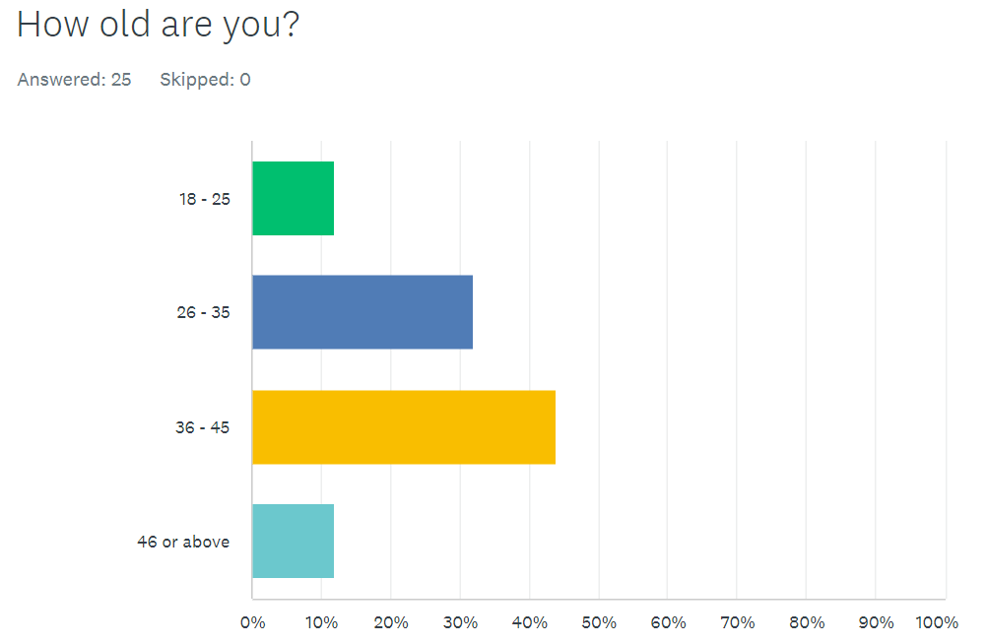
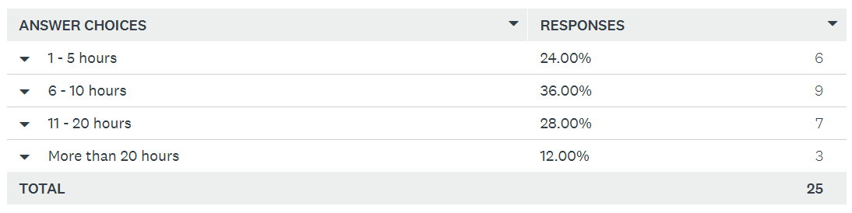
Question four asked, “On average, how many hours do you spend answering calls related to mental health in a week?”. The answers to the right, display that although there is no significant answer, the highest percentage is 6 – 10 hours.

Carrying on from this question, I asked the respondents to describe their standard of service when attending mental health calls, and to comment on why they have chosen such answer.
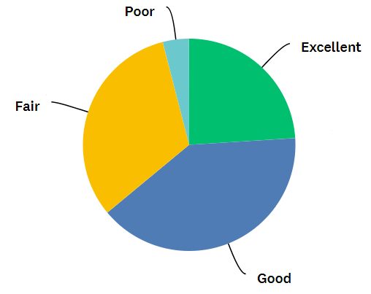
As shown in the diagram, although most answers shown were positive, I have identified some themes in the comment section. 12 respondents all had very similar answers stating that there is a lack of training in mental health, and that we are not the professionals to deal with such calls. Other respondents stated that due to this lack of training, they turn to giving advice off their own experience with mental health. Similarly, Dodd 2023 stated in an article in The Guardian that the Metropolitan Police force will no longer be diverted from crime related calls to do the role of a health worker like the NHS as they are better trained. Another answer that I found interesting was that their standard of work can be poor due to them constantly attending a mental health call back-to-back.
I then switched the questions to focussing on the officer, and their own mental health. Though 52% of respondents have experienced poor mental health due to work related issues, 76% would not sought for support from their workplace. Themes in the comment section revealed that this is because they’re not comfortable approaching their supervisor as they feel they could be judged as ‘police have to be strong’, and they could be viewed as unfit for the job which could therefore jeopardize their future progression in the role. Other views consisted of that they don’t believe the force’s counselling system is not funded enough so would rather acquire support elsewhere.
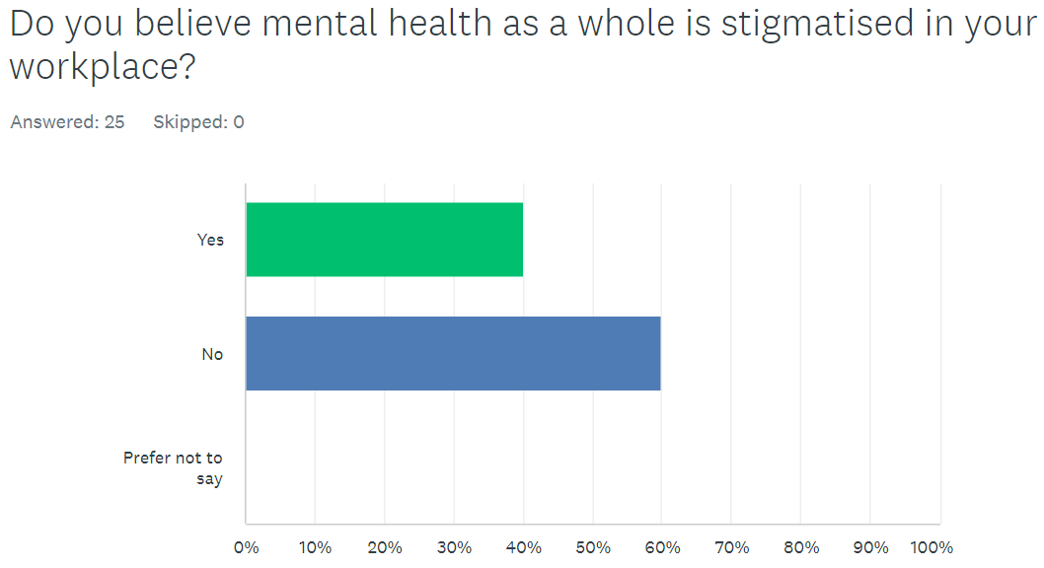
This was my last question in the survey, and surprisingly 60% stated ‘No’, even though answers to my previous question all related to individuals feeling judged about being open regarding their mental health.
Comments revealed that they believe the force is now encouraging officers to be open, so more people are talking about how they feel so in turn, breaking the stigma. Likewise, as officers must deal with these calls so often, they have learned how to provide adequate advice. On the other hand, many respondents also reiterated that they became a police officer to fight crime, and not deal with health-related calls which is why there is a possible stigma around this. Other answers included that it is hard to be open regarding their own mental health when they are the ones who must provide support and advice to others about the same matter.
Limitations
There were many limitations when conducting this survey. The main one being the tool I used to create my survey. As mentioned earlier, I used ‘Survey Monkey’, and they wanted me to pay £30.00 to have full access to the tools of the website. Therefore, I could only ask nine questions meaning I was very limited in what I could ask. Also, even though I had 43 respondents, I could only view 25 responses. If I had full access to these other answers, this could have a major impact on my overall findings and could show completely different results. So, it could be argued that my current findings are not reliable or accurate. Even though this research method was the most cost effective and time efficient, in the future I would consider conducting interviews to gain results with more detail. The average time a respondent completed the survey in was 3 minutes and 25 seconds. This is a very short time, and answers that were provided were mainly a one liner. By conducting interviews, I could ask the respondent to expand on their answers and create more questions based off those answers given.
Conclusion
To conclude, my results from the survey have proven that there is still some stigma regarding mental health in policing. Many officers stated that they will not approach their workforce for support in fear that they will be judged and not suitable for the role, or that this will affect them progressing in the future. As shown in previous research, many respondents were in agreement that mental health calls are not a police related concern and that often they do the work of a medical professional. Even though this does not necessarily affect the service they provide, it is clearly pulling resources away from criminal activity. However, it is evident through the survey that officers are becoming more comfortable with being open about their mental health, encouraging others to do the same and so breaking this stigma. This is a new theme that I did not view when doing my literature research prior to the survey, and could be investigated further. I believe that my questions and findings have covered my objectives which the results I have achieved.
Word Count: 1015 words.

Bibliography
Dodd, V. (2023). ‘Met wins battle with NHS over not attending mental health call’. Available at: https://www.theguardian.com/uk-news/2023/aug/17/met-police-mental-health-calls-nhs-mark-rowley (Accessed on: 1st February 2024).

Student ID: 2031234 // Antonia Rose Matthews

Link to survey: https://www.surveymonkey.com/r/JLP8X8N

