Report on

The forces that a conrod undergoes inside the engine of the

Audi Quattro group 4, 2144cc 5 cylinder (1981).

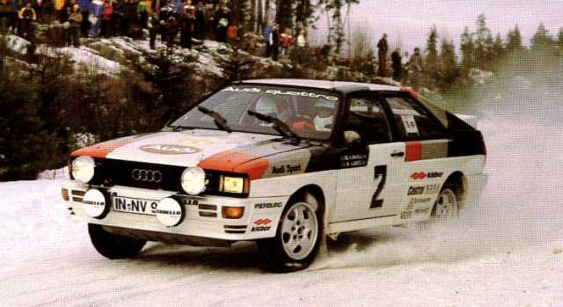

Audi Quattro Group B. 1981 Swedish Rally.
(Image source - http://groupbrally.com/)

By: Daniel Davies.

Student Number: 1801345.

Date: 1st December 2018.
Report on the forces that a conrod undergoes inside the engine of the

Audi Quattro group 4, 2144cc 5 cylinder (1981).

Abstract:

The purpose of this report is to identify and examine the different forces that act on the connecting rod of the 5 cylinder engine of the 1981 Audi Quattro group 4 rally car.
The assignment will research the history and specification of both the engine and the car. And with the use of spreadsheets will identify the forces acting on the conrod and any changes to these figures when some aspects of the specifications are changed. The report will then use the resulting graphs to examine and analyse any changes in these values.

Contents:

Section 1. (Page 4) The Audi Quattro (1981).
  - Engine Specification.
1.2 Introduction.
1.3 Research.
1.4 History.

Section 2. (Page 8) Analysis.
2.1. Methodology.
2.2 Initial values used for research.
2.3 Experimental values.

Section 3. (Page 9) Graphs.

3.1. Graphs. (Set 1). Based on Standard spec.
Fig 1. Height. Fig 2. Velocity. Fig 3. Acceleration and force.

3.2 Graphs (Set A). Engine revs changed from 7500 rpm to 6000rpm.
Fig 4. Height. Fig 5. Velocity. Fig 6. Acceleration and force.

3.3 Graphs (Set B). Change in conrod length from 144mm to 133mm
Fig 7. Height. Fig 8. Velocity. Fig 9. Acceleration and force.

3.4 Graphs (Set C). Change in piston mass from 0.4kg to 0.3kg.
Fig 10. Height. Fig 11. Velocity. Fig 12. Acceleration and force.

3.5 Graphs (Set D). Change in crank radius from 43.2mm to 47mm.
Fig 13. Height. Fig 14. Velocity. Fig 15. Acceleration and force.

Section 4. (Page 19) Conclusion.

Section 5. (Page 20) Reference List.

Section 1. Audi Quattro (1981).

1.1 Engine Specification.
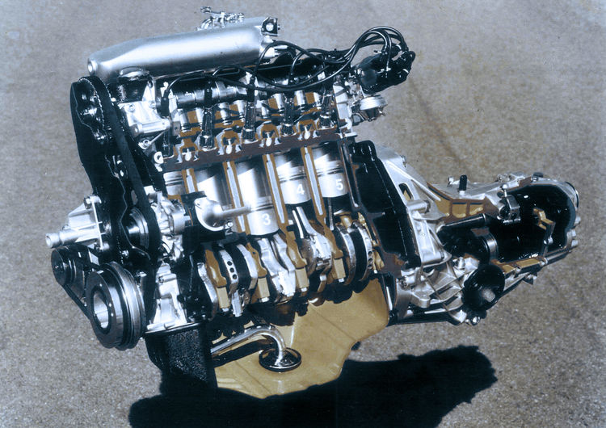

5 Cylinder Audi Engine
(Image source-
https://www.audi-mediacenter.com/en/press-releases/40-years-of-audi-five-cylinder-engines)

Audi Quattro Group 4 (1981).

Engine Type. Straight, 5cyl, 10v, 4 stroke, petrol engine. ª
Cubic Capacity. 2145cc ª
Bore and Stroke 79.51 x 86.4 ª
Crank Radius 43.2 mm ^{b}
Connecting rod length. 144 mm ^{b}
Mass of the Piston. 400 g. ^{b} (0.4kg)
Max RPM. 7500 revs per min ª
Compression Ratio. 9.3: 1 ª
Power Output. 300 - 320 HP @ 6500 rpm. ª
Torque. 42.0 kgm (412 Nm) @ 3500 rpm ª

(Sourced information from.
ª https://rallygroupbshrine.org/the-group-b-cars/rally-cars/audi-quattro-a1a2/#quattrospecs
^{b} http://www.dialynx.co.uk/)
Section 1.2 Introduction
This assignment will consider the 5 cylinder 2.1 engine of the Audi Quattro from 1981. And will explore, identify and report on the forces that act upon the connecting rod.

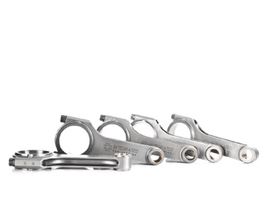
“Perhaps no part of an engine is hit with as much stress as the connecting rods. Connecting rods are subjected to both compressive and tensile forces during the 720 degrees of the four-stroke combustion cycle.” ¹ (Kerry Novak, Crower Engineering.)

Conrods for 5 cylinder Audi engine.
(Image source- https://www.performancebyie.com/integrated-engineering-10v-and-20v-aan-5-cylinder)

The connecting rod or conrod as it is more popularly known plays an important role in the function of an internal combustion engine. Designed to withstand high tensile and compressive forces from the combustion cycle, its purpose is to convert the linear or vertical motion of the piston to a circular or rotating motion of the crankshaft, similar to the function of a lever arm. This rotational motion is then transferred to the driveshaft via the clutch and gearbox. The conrod is connected at its top end to the piston by a piston pin, often known as the ‘small end’ and at the bottom by a half round journal bearing, often known as the ‘big end’. A removable half round cap secures the conrod to the crankshaft.
Both upper and lower ends of the conrod are subject to different forces. During the ignition/compression stroke, as the pressure increases a force acts down on the conrod. Whilst during the exhaust stroke an upwards force acts on the conrod as the crankshaft pushes the conrod and piston upwards to push the remaining gasses through the exhaust valve or valves in a multi valve engine.¹ As it reaches top dead centre on the exhaust stroke the conrod is subject to tensile force as a result of the momentum of the piston. This assignment aims to identify these forces using the graphs.

¹ https://www.enginelabs.com/tech-stories/connecting-rod-tech-forged-and-billet-steel-rods/

Section 1.3. Research

Through the use of the relevant websites listed at the end of this section, the book ‘Audi Quattro, The Rally History’ by John Davenport and knowledge already known, this assignment will research a brief history of the car and its engine and the specifications. It will then aim to identify the values of the various forces that act upon the conrod and will investigate how these forces may be affected by the chosen changes in specification. Such as, changes to the mass of the piston, the length of the conrod itself, and engine speed (RPM) and the radius of the crankshaft.


Sec 1.4 History of the Quattro 2.1, 5 cylinder.

“The Ur Quattro redefined both road and race cars and is still influencing car design since its launch in March, 1980”.^{1.} (Audi Quattro Owners Club).

Audi Quattro Group B. 1984 Rally Monte Carlo
(Image source- https://www.audi-mediacenter.com/en/press-releases/40-years-of-audi-five-cylinder-engines-6616)

In 1978 in preparation for their commitment to motorsport, the Audi Sport team was established by Dr Ferdinand Piech and in less than three years, the team celebrated their debut win on the Janner Rally in Austria followed by another win on the Swedish Rally a month afterwards.² Introduced to the world at the Geneva motor show in 1980 as a serious contender for the international rally championships, the Quattro was designed to take advantage of the rule changes of the same year that permitted four-wheel drive for international Group B rallying.
Designed by Ferdinand Piech, the 2144cc engine of this car was chosen because the Audi Quattro group 4 became a rally legend and was powered by a straight – line 5 cylinder engine, unusual for the era.

“Dominant victories and two drivers’ and manufacturers’ titles with the ‘Ur-quattro’ in the World Rally Championship between 1982 and 1984 were important factors for the market success of Quattro drive”. ³ (Audi Media Marketing).

Famously known as the car that pioneered Audi’s successful world rally championship campaign in the 1980s it was powered by what was considered to be one of the most robust rally engines of its era. Since it was released as a revolutionary prototype in 1980, the Quattro not only went on to lead the rally world but continued to set new records on the famous Pikes Peak Hill Climb. Using uprated versions of the 5 cylinder powered Quattro, the team won the event three times between 1984 and 1987. With the German driver Walter Rohrl setting the record for the fastest time whilst completing the climb in under eleven minutes in 1987.⁴
As a result of its success in world rallying, the original Audi Quattro road car powered by the same 5 cylinder engine retained its popularity and sales and stayed in production for eleven years. ⁴
The model led the way for the future development of other turbocharged four-wheel drive cars from Audi and rival manufacturers.
Such is the recognition of the success of the car that even on today’s marketing website they state - ‘Since the debut of the Audi Quattro in 1980, we've sold more than five million cars with permanent all-wheel drive’.⁵
During ten years of motorsport with the Quattro, Audi Sport had won the Manufacturer’s World Title twice and the Driver’s world championship once.⁶

¹ http://www.quattroownersclub.com/about-us/

^{2,3,4} https://www.audi.com/gbp2/en/experience-audi/audi-sport/audi-racing/racing-history/quattro.html

⁵ https://www.audi-mediacenter.com/en/audi-sport-gmbh-formerly-quattro-gmbh-2946

^{2, 4, 6} ‘Audi Quattro, the Rally History’. Authors- John Davenport/Reinhard Klein. 2009, 1st Edition. Publisher McKlein Publishing, Germany.

Section 2 Analysis

2.1 Methodology

The assignment will research information on the Audi 5 cyl engine of the Audi Quattro available on the internet and literature. And by the effective use of Excel spreadsheets, using ConrodAssignment1.xlsx, it will examine the possible changes to the original forces acting on the conrod when some aspects are experimentally changed. The resulting graphs will be examined and analysed in order to identify any possible changes.

Section 2.2 Initial values used for research.

Audi Quattro 2145cc
Standard Engine Specs.

Graphs 1.
Connecting Rod Length – 144 mm.

Engine Speed /RPM – 7500rpm.

Piston mass – 0.4 kg.

Crankshaft Radius – 43.2 mm

Section 2.3 Experimental values.

Graphs A. Change in conrod length from 144mm to 133mm.

Graphs B. Engine revs changed from 7500 rpm to 6000rpm.

Graphs C. Mass of piston changed from 0.4kg to 0.3kg.

Graphs D. Changing the crank radius from 43.2mm to 47mm.

Section 3 Graphs

3.1 Graphs (Set 1.) Standard specification.

Height travelled by conrod.
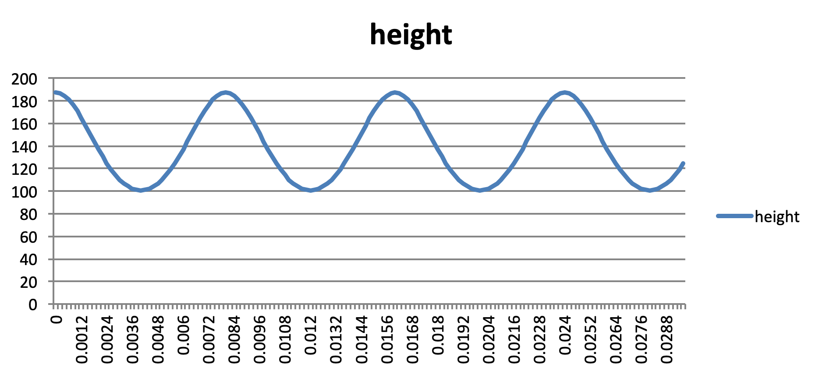

Y axiss

X axiss
Fig 1.
This graph shows the vertical ‘up and down’ distance travelled by the conrod and the piston in the time stated, the value also relates to the stroke of the engine (86.4mm) as the distance in height from 100mm to 186.4mm).

Velocity of conrod (Standard spec.)

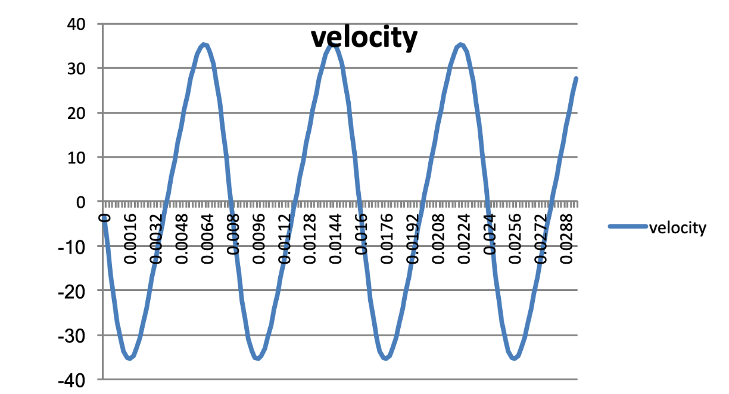

Y axis

X axiss
Fig 2.

This graph refers to the velocity of the conrod as it moves vertically, which peaks at 35 m/s.

Acceleration and force on conrod (Standard spec.)

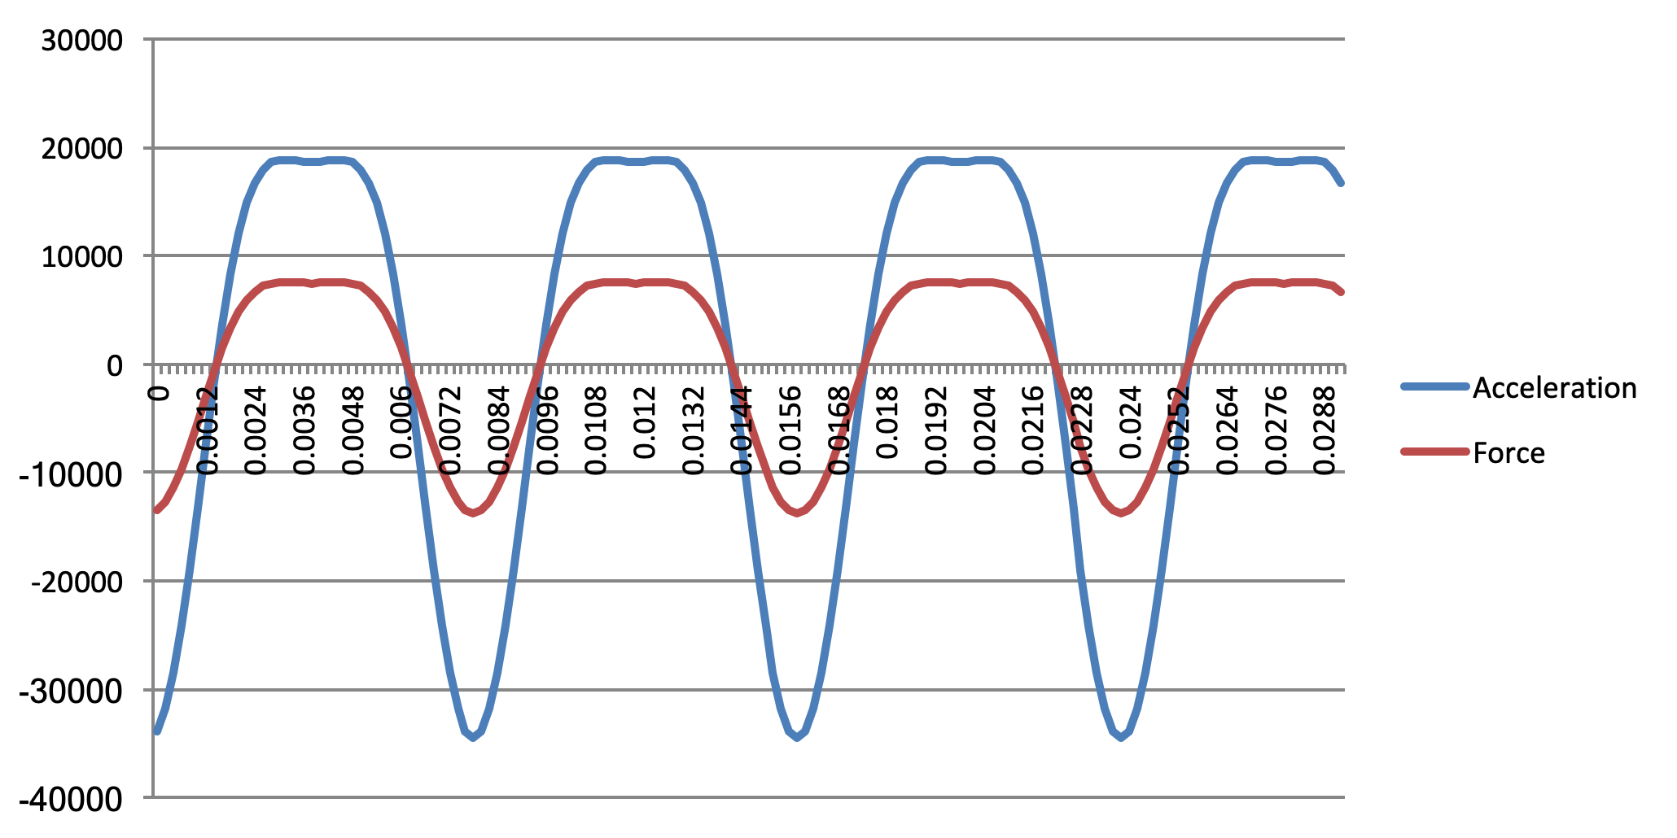

Y axis

Fig 3.
X axiss

The graph shows the acceleration of the conrod and the force acting on it.
The compressive force on the conrod is positive and the tensile force is negative.

As these forces increase at higher revs both values follow the same pattern. During combustion, the compression force increases to 7,548N. This maximum compression force takes place during compression/ignition. Whilst there exists a tensile force of -13,800N for a shorter period of time which takes place as the weight of the piston reaches ‘top dead centre’. It is interesting to note that a greater tensile force exists compared to the compression force.
The results are based on the maximum rev limit of the engine, which is 7500rpm. Therefore, the values should represent the safe working limit of the engine.

3.2 Graph A. Engine revs changed from 7500 rpm to 6000rpm.

Height travelled by conrod.

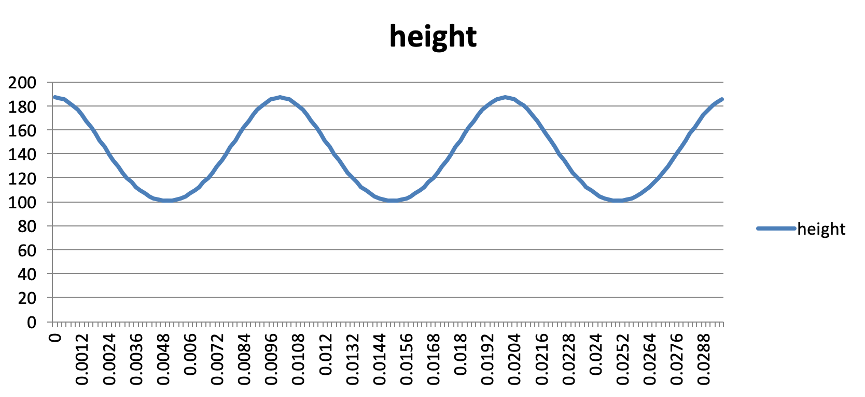

Y axis

Fig 4.
X axiss
Height
This shows that whilst the height is exactly the same, there is a change in the time that the conrod travels this distance. Compared to the ‘original’ values in graph 1 this is slightly flatter. This is because the stroke of the engine stays the same whilst the lower revs of 6000rpm in relation to 7500 rpm means that the conrod travels at a slower speed.

Velocity of conrod at 6000rpm.
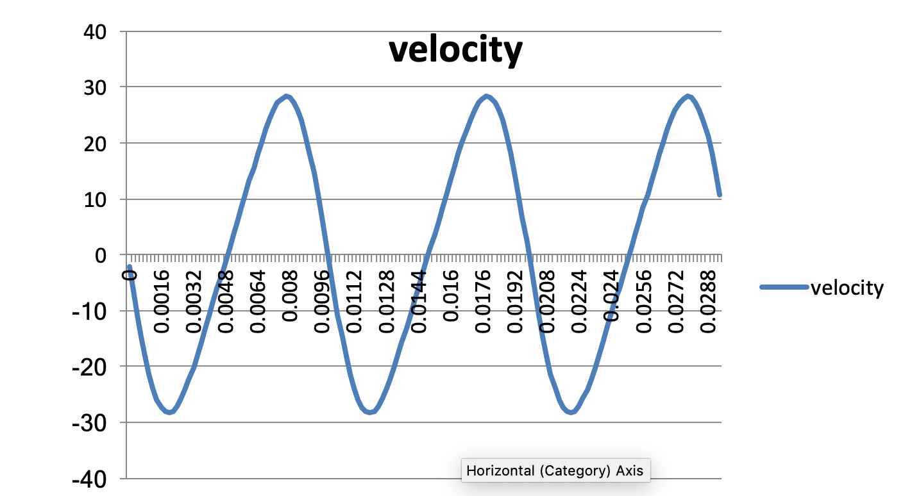

Y axis

Fig 5.

X axiss
Velocity
Compared to the values in graph 1, this is slightly flatter and peaks at under 30m/s.
Again, this can be expected because the engine is turning at a slower rpm and therefore the speed of the conrod is lower.

Acceleration and Force on conrod at 6000rpm.

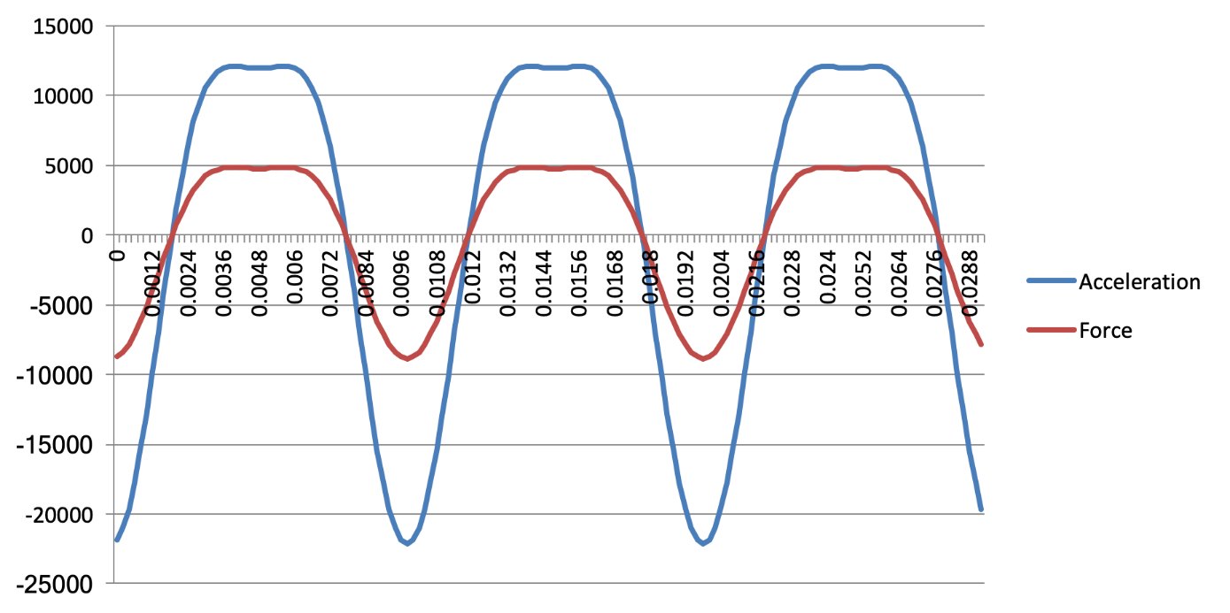

Y axis

X axiss
Fig 6.
Acceleration/force

Showing a reduction of 2714N in the compression force from 7548N down to 4834N and a reduction of 4961N in the tensile force from 13810N to 8849.42N.

The graph also shows a reduction in the acceleration in the conrod to 12,085 under compression and - 21,839 in tensile state.

The results show that by lowering the revs of the engine by 1500rpm to 6000rpm the forces acting on the conrod decrease. It also interestingly shows that greater tensile force still exists compared to the compression force and that this tensile force exists for a shorter period of time than the compression force.

3.3 Graph B. Change in conrod length from 144mm to 133mm.

Height travelled by conrod. Length 133mm.

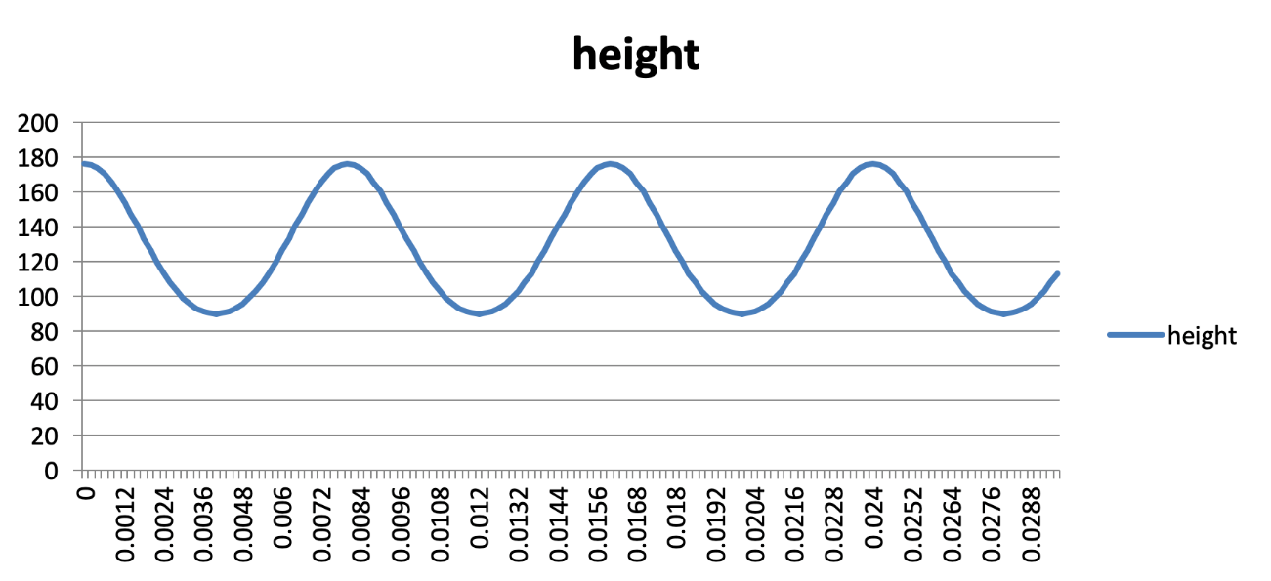

Y axis

Fig 7.
X axiss
Height
There is very little change in this graph. The only difference is that the values are 11cm lower than the original values which equates to the 11cm difference in the conrod length. The timing remains the same.

Velocity of conrod. Length 133mm
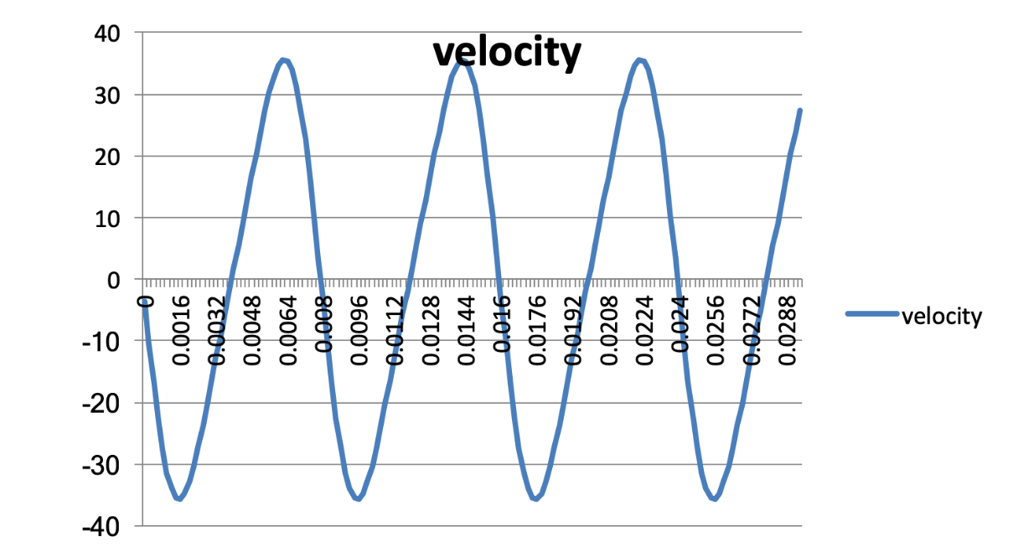

Y axis

Fig 8.
X axiss
Velocity
Even though the conrod has been shortened by 11cm, there is no change on the velocity graph and the values remain the same due to the fact that the rpm and therefore the speed remains the same .

Acceleration and Force on conrod. Length 133mm.

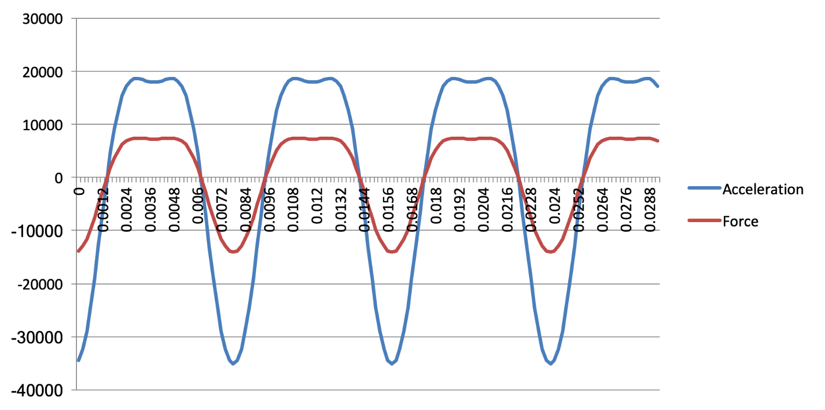

Y axis

X axiss
Fig 9.

Acceleration/Force

It is interesting to note that while the value of one force is increased, the other is lowered.
The shorter conrod length of 133mm results in an increase of 262.78N in the tensile force from 13810.56N to 14073.34N.
While there is a slight reduction of 108.96N from 7548.58N to 7439.9N in the compression force. There are only slight changes in the acceleration graph, showing a reduction of 236 in the positive and an increase of 632 in the negative values.

3.4 Graph C
Change in the mass of the Piston from 0.4kg to 0.3kg.

Height travelled by conrod.

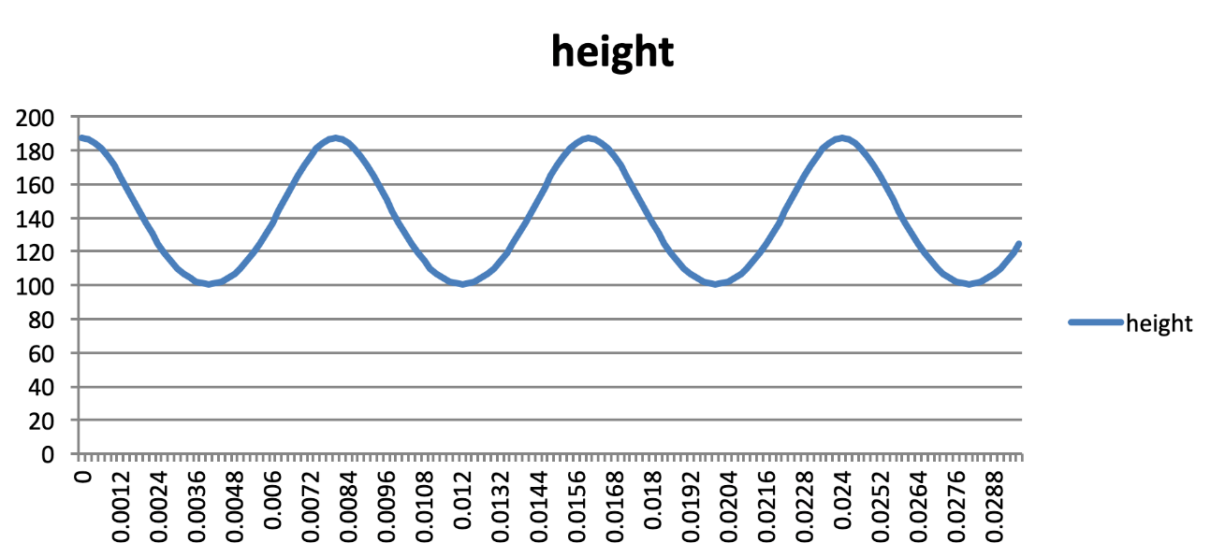

Y axis

X axiss
Fig 10.

Height
After changing to mass of the piston to 0.3kg, there is no change in the height that the piston and conrod travels, therefore these values remain the same. This can be expected as the stroke of the engine stays the same.

Velocity of conrod. Piston mass 0.3kg.

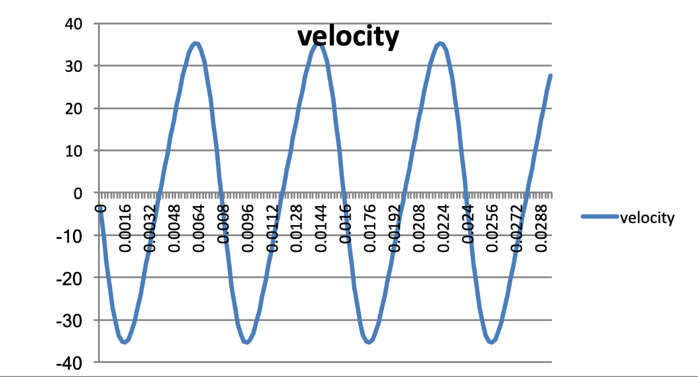

Y axis

Fig 11.
X axiss
Velocity

These values remain exactly the same.

Acceleration and Force on conrod. Piston mass 0.3kg.

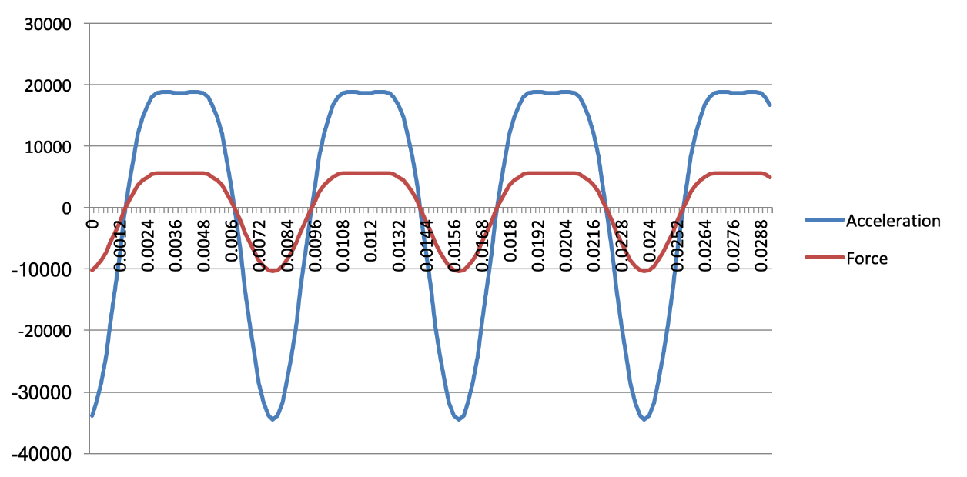

Y axis

X axiss

Fig 12.

Acceleration/Force

The overall pattern of the graph remains the same, however there is a decrease of 1797N in the compression force from 7458N to 5661N and a decrease of 3452.64N in the maximum tensile force from 13810.56 to 10357.92.
The results show that there are no changes in the acceleration values.

A piston of lower mass therefore results in a reduction of forces on the conrod. This suggests a possible reason why competition race engines are sometimes fitted with special lightened alloy pistons or conrods.

3.5 Graph D.
Changing the crank radius from 43.2mm to 47mm.

Height travelled by conrod.

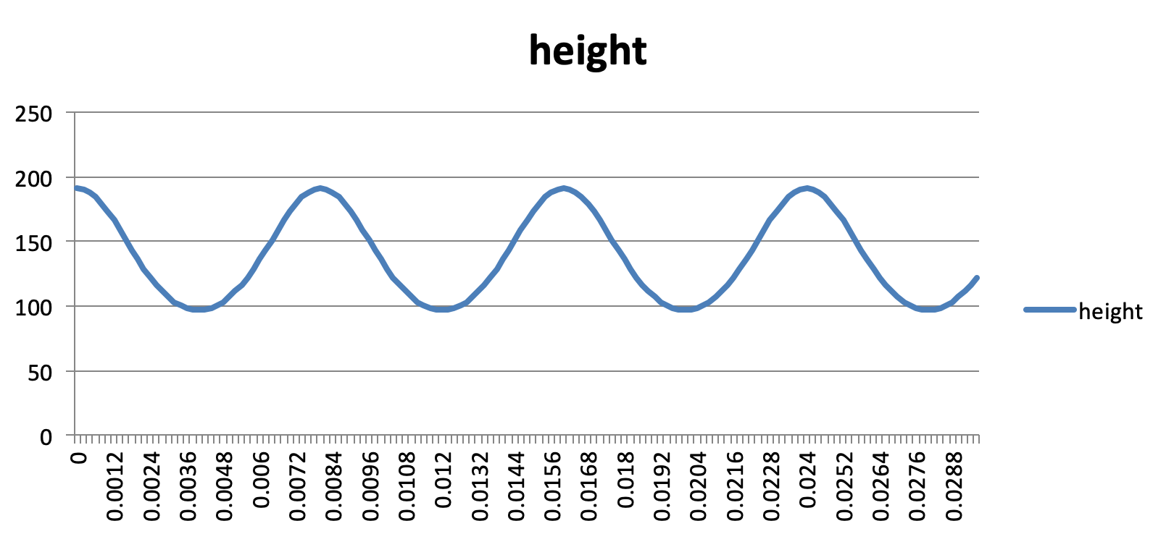

Y axis

Fig 13.
X axiss
Height
A change in the radius in the crank has resulted in an increase of 3.8mm to the maximum height from 187.2mm to 191.
The minimum height has increased by the same amount from 97mm to 100.8. This is the result of the increase of the crank radius which pushes the conrod and piston higher.

Velocity of conrod. Crankshaft radius 47mm.

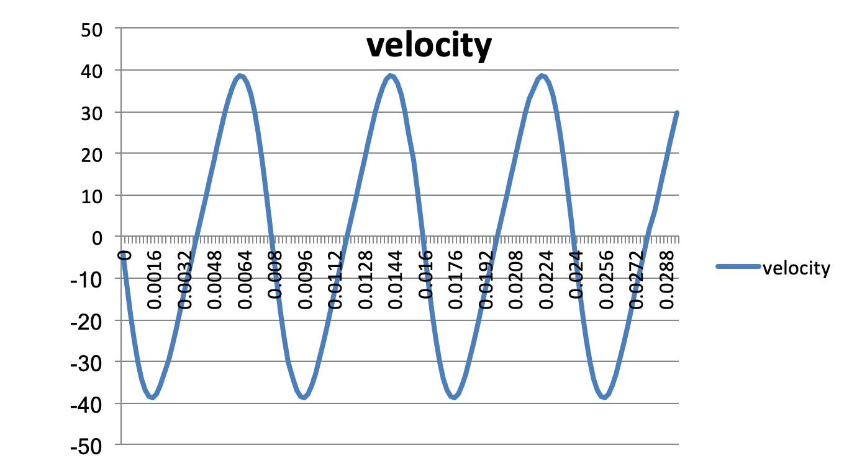

Y axis

Fig 14.
X axiss
Velocity
The trend of the graph stays the same however, it shows an increase of 3.36m/s from 35.36m/s to 38.92m/s in the highest peak of the oscillations, and an increase of 3.47m/s from 35.04m/s to 38.51m/s.
These results show that an increase in the radius of the crank would result in a larger throw of the crankshaft pushing the conrod.

Acceleration and Force on conrod. Crankshaft radius 47mm.

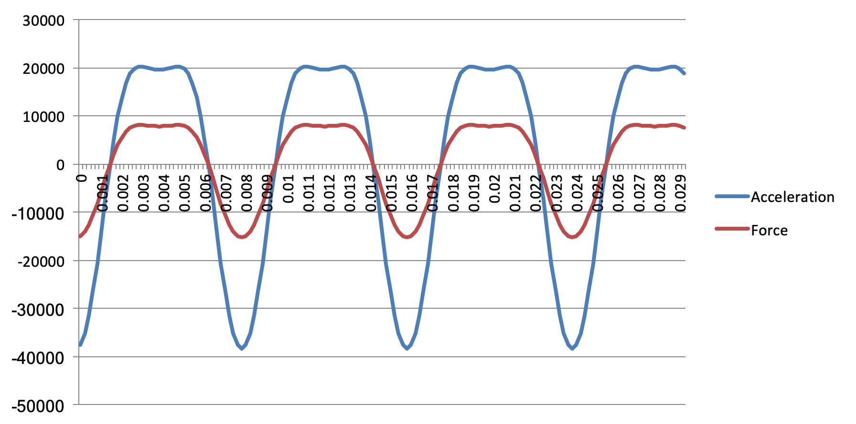

Y axis

X axiss
Fig 15.

Acceleration/Force
The general trend of the graph remains the same to the original spec.
However, the acceleration peak has increased by 1345.54, from 18,871.47 to 20,217.01. The results show an increase in the forces reacting on the conrod.
The compression force has risen by 538.42N from 7548.57N to 8087N.
Whilst the tensile force has changed by 1519.4N, from -13,810N to -15,329.4N.

It is surprising that these differences have resulted after only a small increase of 3.8mm in the radius of the crank shaft.

(The reason for choosing an increase of 3.8mm was the fact that Audi now produce a 5 cylinder 2.5 litre engine, with a larger stroke of 92mm. The original 1980 5 cylinder 2145 cc engine had a stroke of 86.4mm. The aim was to compare the results of the original spec to the spec similar to a modern 5 cylinder engine.)

Section 4. Conclusion

Using standard specifications for Graph 1, a value of 7500rpm for the engine revs was used, as this would offer and provide a base line, when forces could be measured with the engine at its highest rpm limit.
The results show that after the engine revs were lowered from 7500rpm to 6000rpm there was a decrease in both values. With a reduction of 2750 N in the compression force and a reduction of 4961.56N in the tensile force. Revealing that the conrod is under less force at lower revs. It was interesting that a reduction of only 19% in the revs resulted in a reduction of close to 35% in the forces acting on the conrod.
Changing the conrod length from 144mm to 133mmª resulted in both positive and negative changes in values with a surprising increase of 262.76N in the maximum tensile force and a decrease of 108.68N in the compression force.
A change in the mass of the piston from 0.4kg to 0.3kg found that a piston of lower mass resulted in a reduction of the forces. With a decrease of 1797N in the compression force and an even larger reduction of 3452.64N in the maximum tensile force. Showing that a lighter piston creates a lower tensile force on the conrod whilst travelling upwards. A change in the crank radius resulted in an increase in both compression and tensile forces acting on the conrod. Even after a small increase of 3.8mm, the compression force showing an increase of 538.42N. Whilst the tensile force also increasing by 1519.4N.
The exercises showed that a marked increase in both compression and tensile forces resulted after only small changes in values. With each difference of a drop of -1,500rpm in the revs , -11mm in conrod length, -0.1kg in piston mass or +3.8mm on the crank radius having very notable effects on the forces.
The results also suggest one possible reason why performance engines are specified with special ‘lightened pistons’ or other lightened components. The reduction in mass reduces the force acting on these components. Therefore, offering more reliable and higher performing engines. The increase in forces at higher revs also suggest the importance for performance engines to have rev-limiters fitted or they would eventually self-destruct as a result of the increase in forces.
It was interesting to see that all the graphs showed that a greater negative tensile force exists on the conrod compared to the positive compression force. Possibly taking place when the conrod begins it’s downwards movement while pulling against the piston. This point could represent the time that the conrod would be most likely to fail under extreme conditions such as over revving. The results of the research show that the conrod plays an important part in an engine and is subject to substantial compressive and tensile forces.

ª A change in conrod length to 133mm was chosen for this experiment because during research, it was discovered that the original 5 cylinder Audi engine was fitted with a conrod of this length. However during development for motorsport, Audi Sport increased the length of the conrod to 144mm ª
ª Information supplied by Dialynx Performance Ltd, Audi Quattro Specialist Engineers. Dialynx.co.uk

Reference List

Books

‘Audi Quattro, The Rally History’, has provided useful relevant reading material in producing this report. Authors- John Davenport/Reinhard Klein. 2009, 1st Edition. Publisher McKlein Publishing, Germany.

Websites

Audi MediaCenter. (2018). Audi Sport GmbH (formerly quattro GmbH). [online] Available at: https://www.audi-mediacenter.com/en/audi-sport-gmbh-formerly-quattro-gmbh-2946 [Accessed 2 Dec. 2018].
Audi UK. (2018). Audi quattro technology. [online] Available at: https://www.audi.co.uk/audi-innovation/quattro-all-wheel-drive.html [Accessed 24 Nov. 2018].
audi.com. (2018). Racing history | audi.com. [online] Available at: https://www.audi.com/en/experience-audi/audi-sport/audi-racing/racing-history.html [Accessed 1 Dec. 2018].
audi.com. (2018). Racing history | audi.com. [online] Available at: https://www.audi.com/en/experience-audi/audi-sport/audi-racing/racing-history.html [Accessed 1 Dec. 2018].
audi.com. (2018). 1978–1987: The quattro era | audi.com. [online] Available at: https://www.audi.com/gbp2/en/experience-audi/audi-sport/audi-racing/racing-history/quattro.html [Accessed 2 Dec. 2018].
Braithwaite-Smith, G., Braithwaite-Smith, G. and Braithwaite-Smith, G. (2018). Is this Europe’s best car museum? | Motoring Research. [online] Motoring Research. Available at: https://www.motoringresearch.com/car-news/features/europes-best-car-museum/ [Accessed 2 Dec. 2018].
EngineLabs. (2018). Connecting Rod Tech: Forged and Billet Steel Rods - EngineLabs. [online] Available at: https://www.enginelabs.com/tech-stories/connecting-rod-tech-forged-and-billet-steel-rods/ [Accessed 2 Dec. 2018].
Quattroownersclub.com. (2018). Quattro Owners Club › quattro Owners Club. [online] Available at: http://www.quattroownersclub.com/ [Accessed 27 Nov. 2018].
Rally Group B Shrine. (2018). Audi quattro A1/A2 (Group 4 / B) | Rally Group B Shrine. [online] Available at: https://rallygroupbshrine.org/the-group-b-cars/rally-cars/audi-quattro-a1a2/#quattrospecs [Accessed 26 Nov. 2018].

