Module: Research Methods II (ECPS5009)

Exploring the effect of emotional intelligence on memory recall of emotion-induced words.

Abstract
Emotional Intelligence (EI) refers to a person's ability to perceive, understand and manage emotions of oneself or others (Mayer & Salovey, 1997) This study hypothesises that highly EI individuals would have a better working memory capacity when dealing with emotionally charged stimuli when compared to lower EI people. Utilising The Schutte Self-Report Emotional Intelligence Test (Schutte et al., 1998), two groups of either high or low EI were asked to recall emotion-induced stimuli in the form of words taken from Affective Norms for Emotional Words (Bradley & Lang, 1999) (20 positive, 20 negative, 20 neutral) with an inter-stimulus interruption of 400ms between words as well as distraction prompts. A 2x3 mixed design ANOVA was used to investigate the effects of High/Low EI on memory recall of the different emotional levels of groups. Results showed that lower EI participants and a generally better recall of total words (M = 9.92, SD = 1.65) over high EI (M = 7.98, SD = 2.95) The two-way interaction of levels of EI and emotional words displayed no significance (F(2,72) = 1.57, p > .05, np² = .04), Implying that emotional stimuli would make more of an impression on those with lower EI, strong suggestions for further research and implications are discussed.

Introduction
While the concept of ‘mental/emotional strength’ has been part of psychology for decades, the term Emotional Intelligence (EI) is a relatively newly coined term having first being popularised by the book ‘Emotional Intelligence – Why It Can Matter More Than IQ’ which proposed that our outlook on human intelligence is far too narrow and instead emphasises the differences between IQ and EI stating that characteristics such as self-awareness, impulse control and motivation are important traits needed to excel (Goleman, 1996). This would open a gateway for fresh literature and theories to begin exploring the concept of EI, the Four-Branch Model of EI was devised soon after and broke EI down into a four-level hierarchy of skills needed to perceive personal or other people's emotions appropriately, these include 1) perceiving emotions in oneself and others accurately, 2) using emotions to facilitate thinking, 3) understanding emotions, emotional language, and the signals conveyed by emotions and 4) managing emotions to attain specific goals (Mayer & Salovey, 1997) This model reflects a modern therapeutic outlook that may define EI as the understanding of how we act based on our feelings and how being appropriately Intune with our emotions can improve wellbeing and relationships (Corrie, 2009) while other perspectives may view EI levels more in relation to a variety of dispositional positive traits such as optimism, self-esteem and happiness (Mayer et al., 2008).
Regardless of whether EI is being presented as a skill to be learned or an innate trait some may possess more than others, almost all definitions echo the sentiment that EI allows us to maintain balance within ourselves to become more successful in our interactions with others and feature common words such as ‘self’ ‘others’ ‘awareness’ and ‘manage’ (Wharam, 2009). The consensus from academic meta-analysis is that higher levels of EI contribute to better performance in a variety of fields, it has been widely explored that higher EI can improve critical and strategic decision-making and is particularly necessary for leadership under stressful situations (Alzoubi & Aziz, 2021; Drigas & Papoutsi, 2020). In addition, EI has also been found to have positive associations with people's job and academic performance, with numerous meta-analyses supporting this assumption (MacCann et al., 2020; Perera & DiGiacomo, 2013). This report will investigate one of the many potential factors that contribute to the positive correlation between EI and generally improved performance, that is the effect of EI on memory recall.
Previous investigations into EI have used self-report scales such as “The Schutte Self-Report Emotional Intelligence Test” (Schutte et al., 1998) or the “Mayer-Salovey-Caruso Emotional Intelligence Test” (Mayer et al, 2002) to assess an individual/participant's EI from a personal perspective and to see how people self-assess their own emotional ability. A few previous studies have used such tests to investigate the relationship between EI and our working memory capacity (WMC), one relevant study investigated this relationship using emotionally “hot” or “cold” performance tasks that provided evidence of better performance from higher EI participants when under emotionally “hot” conditions (Gutiérrez-Cobo et al., 2017). This implication that highly EI people have a more finely tuned WMC under different levels of emotion is something that this investigation will explore further. This report hypothesises that higher emotional intelligence levels will result in greater performance on a memory recall task when presented with emotionally inducing stimuli.

Method
Participants
Participants were recruited via the online EMS system. The 38 participants that took part in this study consisted of 14 males, 22 females and 2 non-binary. This sample had an age range of 19 to 59 (M = 29.05, SD = 8.883)
Design
This study featured a two-way mixed multi-factorial design to explore the relationship between two independent variables (IV). IV1 is the affective trait of emotional intelligence, this is a between-subjects factor devised into two levels, either ‘Low‘ or ‘High’. Participants were separated into either category based on their scores in relation to the mean score of all participants. With those scoring beneath the mean being categorised as Low and those scoring above being categorised as High
IV2 is the within-subjects factor of emotion-inducing stimuli, participants were exposed to three levels of words, these words being typical positive, neutral and negative words in their respective sets that participants were asked to recall.
The Dependant Variable (DV) was the number of words recalled correctly by participants for each positive, neutral and negative trial.
For analysis, a mixed-design ANOVA was the most appropriate method to examine a fixed effect between-subjects variable (IV1) and a random effect within-subjects variable (IV2)
Materials
This experiment utilised The Schutte Self-Report Emotional Intelligence Test (SSEIT) to measure the participants' emotional intelligence levels (Appendix A) (Schutte et al., 1998). This is a 33-item questionnaire featuring statements regarding participants' self-reported perceptions of their emotionality, examples of such statements include “When my mood changes, I see new possibilities” and “I am aware of my emotions as I experience them”. Participants completed this questionnaire using Qualtrics on a laptop set up within a controlled environment. Participants were required to give a numbered response using a 5-point Likert scale with scores equalling 1 = strongly disagree, 2 = disagree, 3 = neither agree nor disagree, 4 = agree and 5 = strongly agree. Therefore, each item has a scoring range between 1 and 5, a lower score would indicate less EI and a higher score would indicate a higher EI (except for 3 items which were negatively worded and required reverse scoring before analysis). Cronbach’s alpha value for internal reliability in this 33-item scale is reported to be 0.73 based on standardised items for this study, this is lower than the 0.90 consistency analysis found in the original SSEIT study but still shows sufficient internal reliability.
Participants were also asked to complete a memory recall task using the Qualtrics survey system that was created on the Superlabs program which would be presented on a PC screen. The task provided instructions regarding the structure of this task which would involve three experimental trials displaying 20 positive, 20 neutral and 20 negative words in each respective trial, taken from the Affective Norms for Emotional Words (ANEW) (Appendix B) (Bradley & Lang, 1999). Each word would be presented for 2000ms and separated by a blank screen of 400ms. At the end of each set, participants would be asked a distraction prompt, such as “Think about the last time you lost a sock” for one minute before the screen would automatically move onto the recall stage where participants were asked to recall as many of the 20 words as possible of the preceding set, this would be repeated for each trial. Participants will be scored out of 20 for each trial set.
Procedure
University participants were recruited online via the Experiment Management System (EMS), which briefly described the experiment and its purpose. Once recruited, participants would report to a controlled lab environment and would be presented with a laptop with the Qualtrics survey already loaded. Participants would receive an information sheet (Appendix C) and a consent form (Appendix D) to agree to the study. Once consent had been obtained the participants would begin the demographic data collection section and identify their age and gender. Following this, the participants would be asked to complete The SSEIT on the laptop before being directed to the Superlabs computer to complete the memory recall trials. Once all relevant data, details and trials had been completed, Participants were shown debrief information (Appendix E), including the hypothesis behind the study and informed of their right to withdraw their data at this point. If participants were happy to continue, they would select the Submit button and were finally thanked for their time and participation and allowed to leave.

Results
This study utilised a 2 x 3 Mixed-design ANOVA to investigate the effects of high and low levels of Emotional Intelligence on the memory recall of emotional induced words (Positive/Negative/Neutral). Participants showed a mean total score of 105.82 (Min = 84, Max = 132) Participants with an average EI between 84 and 105 were categorised as low EI and participants between 106 and 132 were categorised as High EI. Descriptive statistics (Mean, Standard Deviation) for all variables can be found in Table 1 below.
Table 1: Descriptive statistics for Variables
 | Low EI |  |  | High EI
 | M | SD | N | M | SD | N
Positive | 11.52 | 2.42 | 21 | 8.53 | 3.68 | 17
Negative | 9.62 | 2.60 | 21 | 8.00 | 3.22 | 17
Neutral | 8.62 | 2.66 | 21 | 7.41 | 3.41 | 17

The two-way interaction between the emotional inducing words and levels of emotional intelligence showed no statistical significance, F(2,72) = 1.57, p > .05, np² = .04. This would indicate a lack of significant interaction between the two levels of emotional intelligence and the memory recollection of emotionally induced words.
The main effect of emotional intelligence levels did show significance F(1,36) = 6.55, p < .05, np² = .15. This would imply that there is indeed a difference between the memory recall ability of participants with low EI compared with those with high EI. Interestingly, participants with lower EI levels, on average recalled more words in total (M = 9.92, SD = 1.65) when compared with those of higher EI (M = 7.98, SD = 2.95). This relationship is displayed in Figure 1 below.
The main effect of emotionally induced words also showed significance, F(2,72) = 7.35, p < .05, np² = .17. This identifies a significant difference in the ability to recall words between the different levels of emotional words. After conducting a pairwise comparison, there is shown to be a significant difference between the recollection of positive (M = 10.18, SD = 3.36) and negative words (M = 8.89, SD = 2.97) as well as positive and neutral words (M = 8.08, SD = 3.04). No significant difference was found between the recollection of negative and neutral words. (A complete set of SSPS outputs can be found in Appendix F) This means that the initial hypothesis that high EI will result in significantly more emotionally induced words being remembered must be rejected.
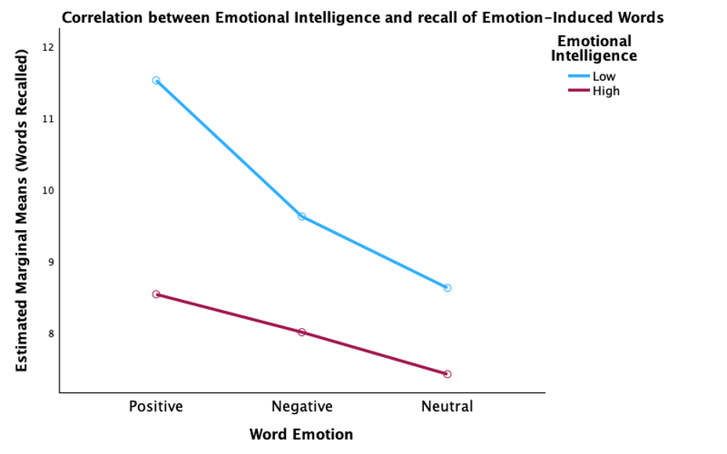
Figure 1: Line graph showing the correlation between EI and recall of emotional words.

Discussion
One of the more notable aspects of the results is the fact that, out of the three emotional conditions given to the two groups, both were able to recall significantly more positive words than either negative or neutral words. Affect congruence is the idea that a person’s current mood will result in a difference in recollection, for example, a person in a positive mood, when asked to recall a memory will usually recall more positive events, the opposite can also be found when a person is in a negative mood, will recall and focus on more negative aspects (Ciarrochi et al., 2006), there is the potential that the ‘distraction question’ meant to divert participants focus away from the memory task, may have inadvertently induced positive (or other) emotional states which would influence the current results. While this factor could be explained as the average participant being in a naturally positive mood that day, a previous study of a similar nature otherwise correctly predicted that highly EI people would recall a high and equal amount of pleasant, neutral and unpleasant words while those with lower EI would struggle to recall neutral words and focus more on the emotional extremes (Toyota, 2011) These findings are in line with the common assumption that EI people are more aware of their emotional states and can manage them while being asked to perform when compared to less EI people who may more easily fall victim to induced emotional states (Paoletti & Ben-Soussan, 2021).
Given that the results of the present study show that lower EI participants performed better across the board, rejecting the hypothesis drawn from other literature, Further investigations should explore the causality behind the results and potential refocus on the various brain processes involved in emotional learning and memory recall. This study was also limited in that all participants in this study were psychology students taken from a single university campus, not only does this damage the population validity of the study, but these psychology participants would also likely be already aware of concepts such as affect congruence, emotional intelligence and mechanisms of memory recall (Gallander Wintre et al., 2001), additionally, the male population is underrepresented here, while the inclusion of non-binary participants is positive, it is shown that women in general score higher on EI tests, particularly when measured through self-report questionaries when compared to men which may have influenced these results (Bloise & Johnson, 2007; Schutte et al., 1998). Subsequent investigations of this nature should utilise a wider participant pool as well as strive for a more balanced male/female participant base with a wider age demographic.
In conclusion, the outcome of this report suggests lower EI individuals are more prone to recall more emotionally charged words simply due to them being more susceptible to the effects of emotion. Emotional memories are stored in the Amygdala while more ‘dry’ information is processed in the Hippocampus, the stronger the arousal of the amygdala the more powerful the imprint in those less capable of dealing with emotional stimuli (Goleman, 1996), and so emotionally charged words would remain more prominent in the WMC of low EI minds.

References
Alzoubi, H. M., & Aziz, R. (2021). Does emotional intelligence contribute to quality of strategic decisions? the mediating role of open innovation. Journal of Open Innovation: Technology, Market, and Complexity, 7(2), 130–150. https://doi.org/10.3390/joitmc7020130
Bloise, S. M., & Johnson, M. K. (2007). Memory for emotional and neutral information: Gender and individual differences in emotional sensitivity. Memory, 15(2), 192–204. https://doi.org/10.1080/09658210701204456
Bradley, M.M., & Lang, P.J. (1999). Affective Norms for English Words (ANEW): Instruction Manual and Affective Ratings.
Ciarrochi, J., Forgas, J. P., & Mayer, J. D. (2006). 4. Affective intelligence: Understanding the role of affect in everyday social behaviour. In Emotional intelligence in everyday life (pp. 77-99). Psychology Press.
Corrie, C. (2009). 3. understanding and managing behaviour. In Becoming Emotionality Intelligent (pp. 31–38). essay, Bloomsbury.
Drigas, A., & Papoutsi, C. (2020). The need for emotional intelligence training education in critical and stressful situations: The case of covid-19. International Journal of Recent Contributions from Engineering, Science &amp; IT (iJES), 8(3), 20–36. https://doi.org/10.3991/ijes.v8i3.17235
Gallander Wintre, M., North, C., & Sugar, L. A. (2001). Psychologists’ response to criticisms about research based on undergraduate participants: A developmental perspective. Canadian Psychology / Psychologie Canadienne, 42(3), 216–225. https://doi.org/10.1037/h0086893
Goleman, D. (1996). Emotional intelligence: Why it can matter more than IQ. Bloomsbury.
Gutiérrez-Cobo, M. J., Cabello, R., & Fernández-Berrocal, P. (2017). Performance-based ability emotional intelligence benefits working memory capacity during performance on hot tasks. Scientific Reports, 7(1). https://doi.org/10.1038/s41598-017-12000-7
MacCann, C., Jiang, Y., Brown, L. E., Double, K. S., Bucich, M., & Minbashian, A. (2020). Emotional intelligence predicts academic performance: A meta-analysis. Psychological Bulletin, 146(2), 150–186. https://doi.org/10.1037/bul0000219
Mayer, J. D., & Salovey, P. (1997). What is emotional intelligence? In P. Salovey & D. Sluyter (Eds.), Emotional development and emotional intelligence: Educational implications (pp. 3-31). New York: Basic Books.
Mayer, J. D., Salovey, P., & Caruso, D. R. (2002). Mayer-Salovey-Caruso emotional intelligence test (MSCEIT) users manual.
Mayer, J. D., Salovey, P., & Caruso, D. R. (2008). Emotional intelligence: New ability or eclectic traits? American Psychologist, 63(6), 503–517. https://doi.org/10.1037/0003-066x.63.6.503
Paoletti, P., & Ben-Soussan, T. D. (2021). Emotional intelligence, identification, and self-awareness according to the sphere model of consciousness. In The Science of Emotional Intelligence (pp.31). IntechOpen.
Perera, H. N., & DiGiacomo, M. (2013). The relationship of Trait Emotional Intelligence with academic performance: A Meta-Analytic Review. Learning and Individual Differences, 28, 20–33. https://doi.org/10.1016/j.lindif.2013.08.002
Schutte, N. S., Malouff, J. M., Hall, L. E., Haggerty, D. J., Cooper, J. T., Golden, C. J., & Dornheim, L. (1998). Development and validation of a measure of emotional intelligence. Personality and Individual Differences, 25(2), 167–177. https://doi.org/10.1016/s0191-8869(98)00001-4
Toyota, H. (2011). Individual differences in emotional intelligence and incidental memory of words. Japanese Psychological Research, 53(3), 213–220. https://doi.org/10.1111/j.1468-5884.2011.00467.x
Wharam, J. (2009). 1. What is emotional intelligence? . In Emotional intelligence: Journey to the centre of yourself (pp. 3–15). essay, O Books.

Appendices
Appendix A - Schutte Self-Report Emotional Intelligence Test (Schutte et al., 1998)
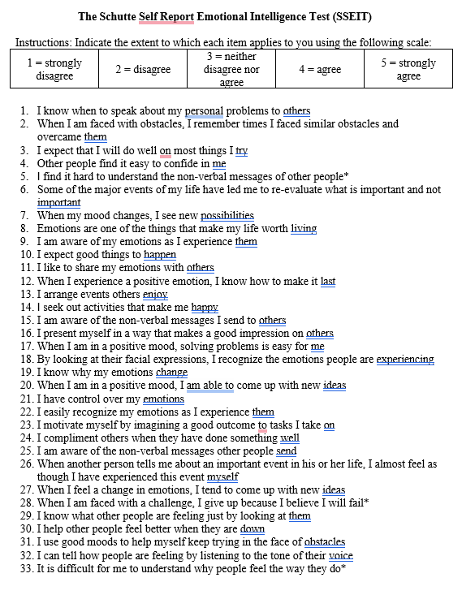
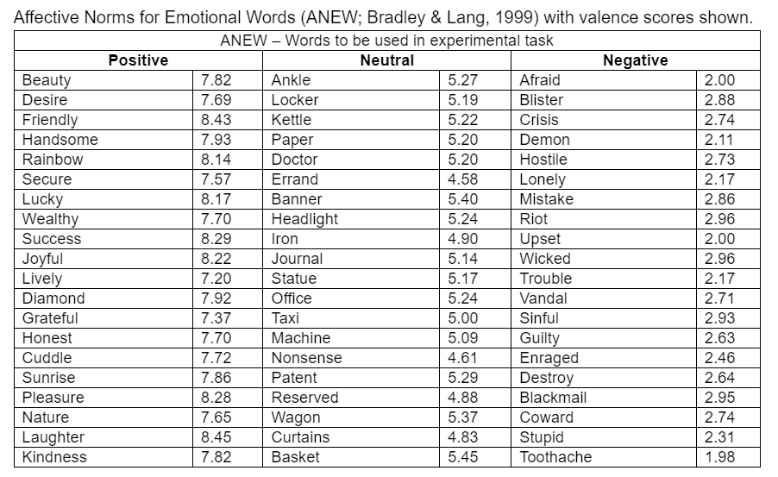
Appendix B - Affective Norms for Emotional Words (Bradley & Lang, 1999

Appendix C - Information sheet
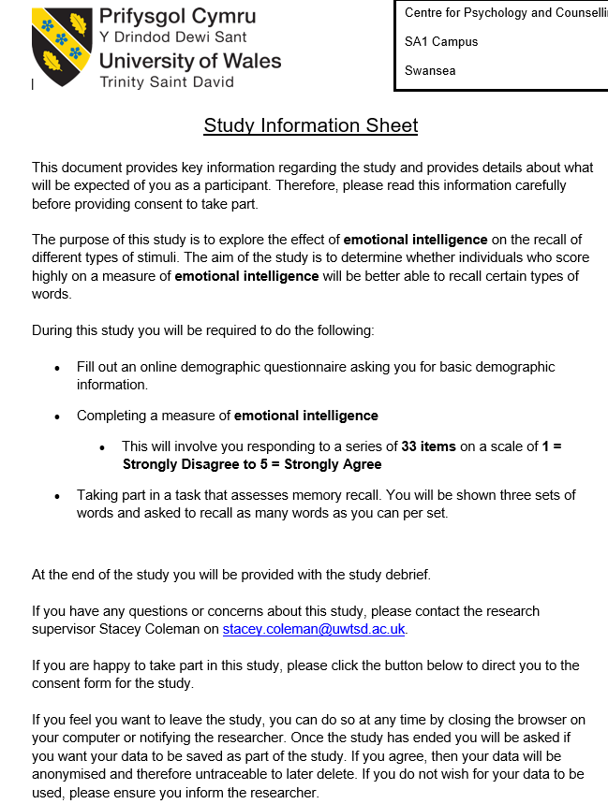

Appendix D - Consent form.
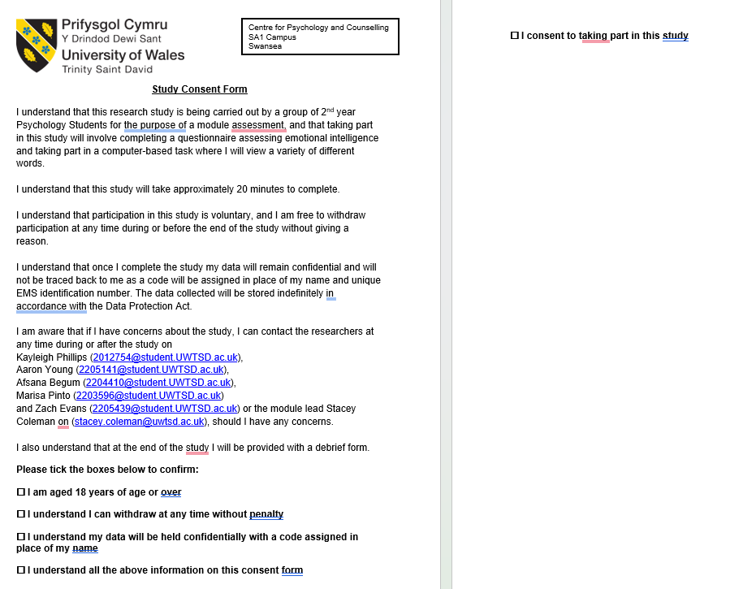

Appendix E – Debrief Information
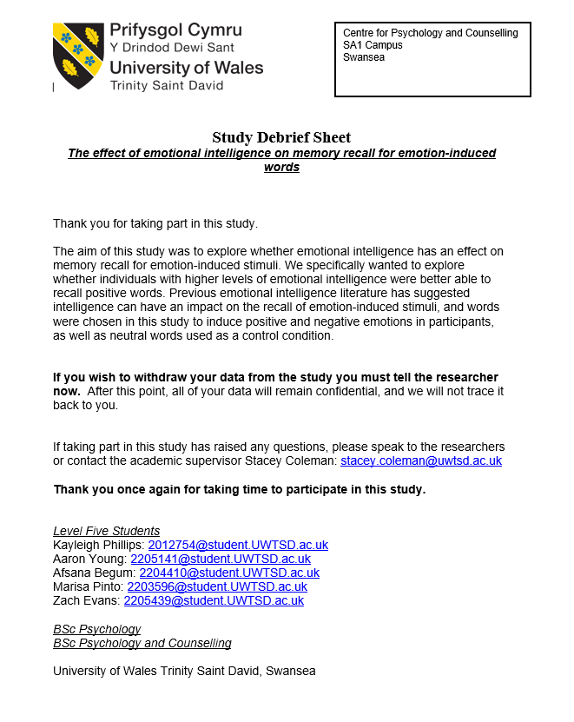

Appendix F – FULL SSPS OUTPUT (Reverse Scoring, Box’s Test, Lavine’s Test, Descriptive Statistics, Mauchly’s Test, Reliability check, pairwise comparison, etc)
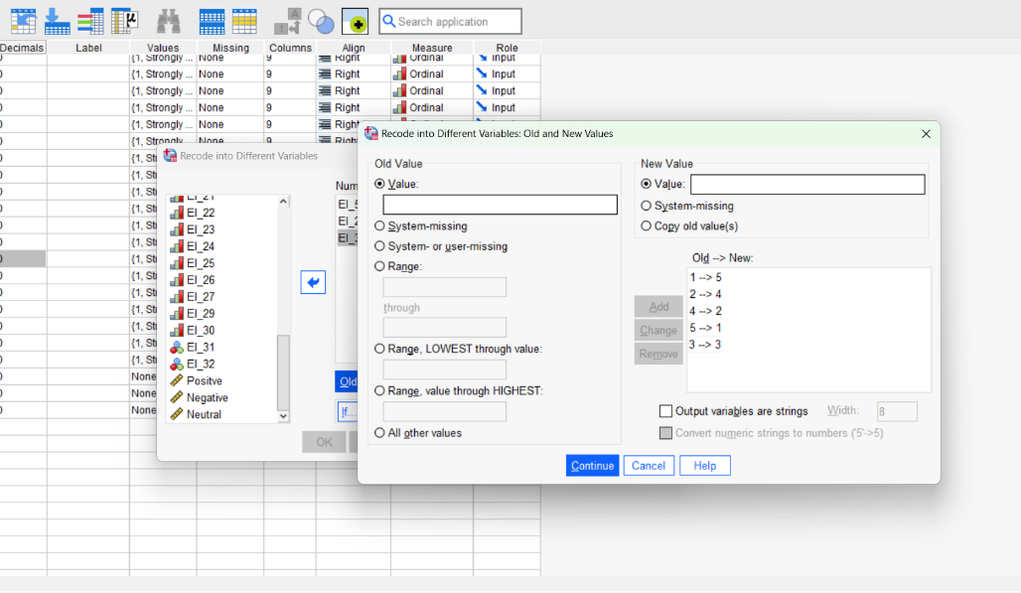
Reverse Scoring

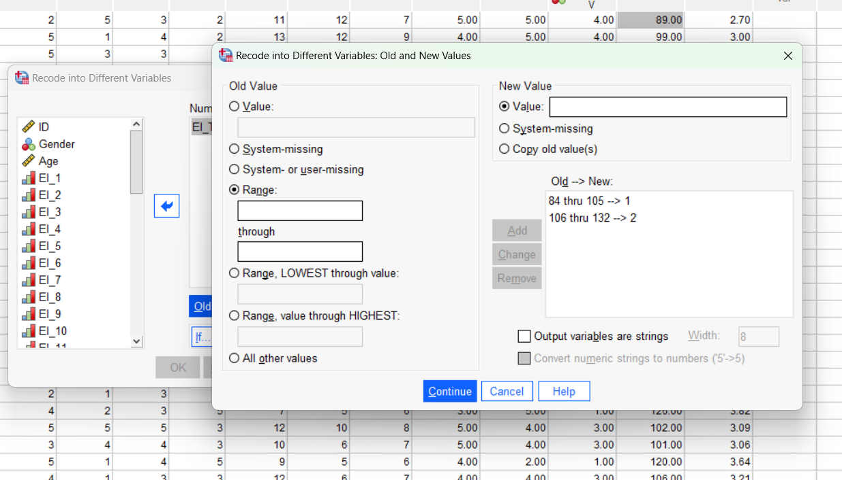
Categorising Data



