
Integrated Group Project: ACBA 6003
Project Title: UWTSD Leisure Complex – Feasibility Study

Location: SA1, Swansea.


Prepared by: Jon Langstone

Dated: Wednesday 3rd of May 2023

Feasibility Report |  |  |  |  |  |  |  |  |  | 
Project: | UWTSD Leisure Complex |  |  |  |  |  | Report No: |  |  | 001
Prepared By: | Jon Langstone |  | Validated: |  |  |  |  | Date: | 03/05/23
Reporting Period From: |  | Feasability study ( Jon’s elements ONLY) |  | To: |  | UWTSD Team

- Site/Location | Status
Commentary: | Green
4.4.2 Contaminated Land
Although it has not been identified that all excavation works throughout the substructure, externals and groundwork are to be closely monitored to ensure any signs of contaminants in the ground will be identified and further investigated if required. Further material testing will be undertaken to determine the ‘nature’ of the arising’s. The management of findings and material will align with the established SEMP and procedures therein findings and material management will align.
Precautions will be taken when excavating to ensure silts cannot migrate to any watercourse within the site boundary. A method statement will include a de-watering solution for excavating drainage and substructure groundworks. This will also be closely developed with the groundwork specialist.
No significant risk to controlled waters. A piling risk assessment is likely required to review the risk of driven piles.
4.4.3 Radon
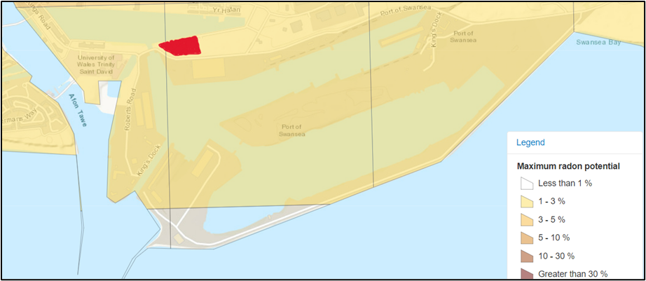
The Radon Map indicates the percentage of homes at or above the action level of possible Radon dispersing through the ground. The proposed site sits inside the 1-3% of maximum radon potential, indicated in the key. The image was generated using the roaming map from UKradon.org. This evidence concludes that the risk percentage is low enough to rule out any further surveys for radon in the area of interest.
  - Ground levels
The ground levels of the site are generally flat to the naked eye. As for the boundary to the south and west, there are existing fences that belong to the businesses situated there. The area is designated as a brownfield site.
The figure below shows the clear topographical issues:
As previously mentioned, this area of land is designated as ‘made ground’, but it has a large amount of rubble, which seems buried below the site, lots of foliage, primarily overgrown bushes, and the potential risk of Japanese knotweed. Even though no Japanese knotweed is visible on the surface of the proposed site, it has been found to be situated just a few meters from the proposed site. Thus, making it highly likely that this invasive plant contaminates the site.
The images below offer a closer look at the topography described:

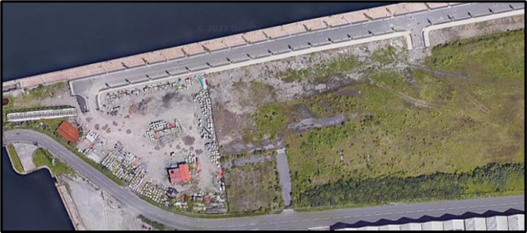
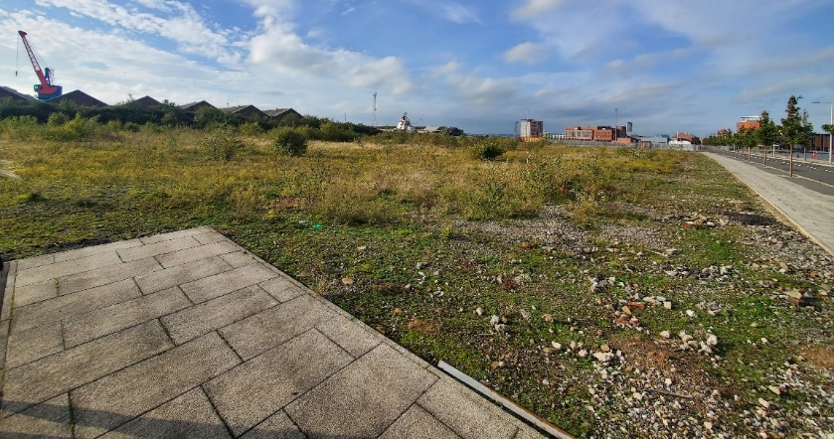
After the site walkover, the team determined that the site would need further topographical, geological, and ground-level surveys to determine the next steps to mitigate further risk. Especially with the extensive groundwork proposed for the substructure of the building (underground car park).
Langdon Road leading to Fabian Way we envisage being the main incoming access to the site with very few restrictions identified. The roundabout prior to accessing Fabian Way could pose as a bottle neck during mass flow of traffic as it does experience this now however, these low flow/high surge times will be uncommon and subsequent changes to this area can be made if highways see fit during the planning application. In the event of this, time traffic can be allowed to build up along Langdon Road and subsequently there is another way into the site from Fabian Way.
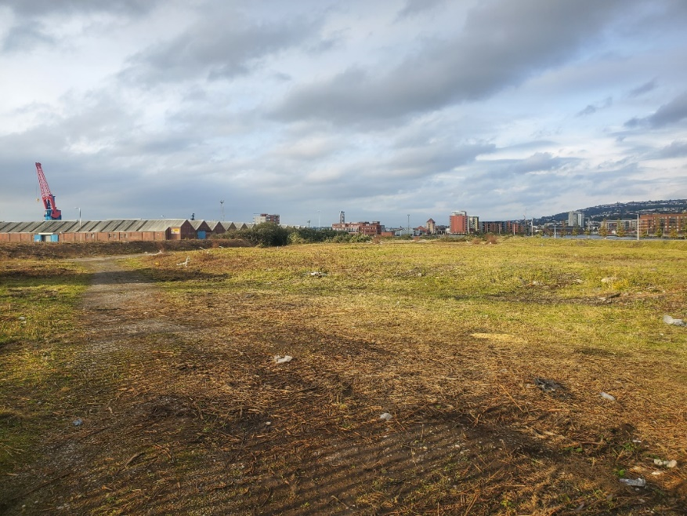
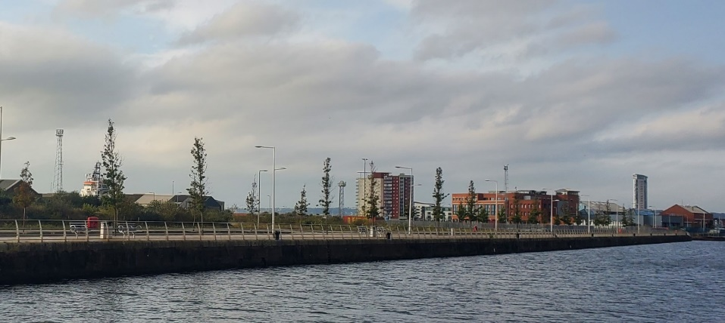
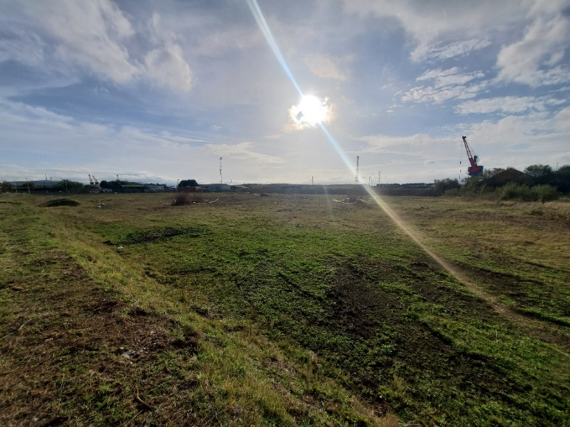

  - Surrounding development
The site has the prince of Wales dock bordering it to the North with the small supply channel to the West between this dock and the Kings dock. This small channel has an existing bridge present which was not accessible during our site survey; this area over the bridge houses the UWTSD waterfront campus as well as residential flats, commercial premises (restaurant, café etc) and industrial units. To the opposite side of The Prince of Wales dock directly adjacent to the site is a relatively new residential development constructed in brick looking over the dock, to the East of this site is the main access road into the proposed site which also accesses a range of commercial business-like car dealerships and fast-food outlets. To the West of the residential development is the HMT Sancta Maria hospital and a Premier Inn hotel, by following this road around it will lead you either to Fabian way dual carriage way or to the previous mentioned University campus and other development areas. This hotel will support the large competitions held in the centre and the hospital can be linked to the centre through a rehabilitation centre. Lastly to the East and South of the site are a range of industrial zones all being part of the ABP (Associated British Ports). Access to the site has already been detailed in above within section 4. This main access road to the site does have adequate foot paths either side however we do wish to include pedestrian access to the bridge to link the two portions of land and create a link with the adjacent university. There is no current parking available. From our investigations we do not believe the adjacent industrial units are high noise areas, moderate levels of noise may be produced by incoming ships. Likewise, during the construction, noise will have to be considered due to the relatively adjacent residential development and university to the North and West.

- Development Constraints | Status
Commentary: | Green
  - Planning
Planning - Listed building status, Local Plan/ Development Plan Conservation Area, CADW, Tree Preservation Orders, and Hedgerow preservation requirements. Adjacent buildings of architectural interest. Planning consent required. Do previous planning consents exist? Planning restrictions or prohibitions on development?
5.1.1 SA1 Swansea – Local Area Planning
SA1 has been subject to several approved master plans in the past 12 years. However, these masterplans have only been partially implemented, which has resulted in a somewhat barren and lifeless environment in many parts of the site, most notably on the Peninsula. The areas that have been implemented, predominantly in the northwestern quadrant, are starting to show what the character of the rest of the SA1 area could be like in the future.
The East end is the eastern part of the SA1 regeneration site and was previously referred to as the ‘leisure quarter. The site is accessed by Fabian way and comprises a large expanse of land that has been levelled, and initial elements have been developed.
2.1.3Conservation Area
The area is not classed as a conservation area. Neither does the area have any trees labelled for tree preservation.
2.1.4 Area Constraints
This site is particularly complex, mainly due to its location and surrounding land use. The space currently feels expansive but exposed. The development will need to respond to the climactic conditions. Combining a mix of activities with usable public open spaces that are appealing at all times of the year will need to be at the heart of proposed developments for the University and its commercial partners. Another aspect to consider is the Disconnected bridge directly west of the proposed site. The area would benefit from reinstating the bridge for public use.

2.1.5 Relevant Local planning legislation
The planning legislation which is relevant to the proposed site in the SA1 area are as follows:
Future Wales (the National Plan 2040) (published February 2021)
Future Wales is the Welsh Government’s twenty-year national development framework for shaping Wales’s future growth and development.
Policy 1 identifies Swansea Bay as a National Growth area with growth in employment and housing opportunities and investment in infrastructure.
Policy 2 refers to growth and regeneration, contributing positively to building sustainable places and identifies a series of placemaking principles.
Policy 28 states that Swansea Bay and Llanelli will be the focus for growth and investment in the Southwest region.

Strategic and Local Development Plans should recognise the National Growth Area as the focus for strategic economic and housing growth; essential services and facilities; advanced manufacturing; transport and digital infrastructure.
The Welsh Government will work with regional bodies and local authorities to promote and enhance Swansea Bay and Llanelli’s strategic role and ensure key investment decisions support places in the National Growth Area and the wider region.
Planning Policy Wales (Edition 11, 2021)

Planning Policy Wales (PPW) is the Welsh Government’s principal statement of national policy and sets out the land use planning policies that local planning authorities should consider in Wales and may be material to decisions on individual planning applications.

PPW identifies that the goal of the land use planning system in Wales is the creation of Sustainable Places and seeks attractive, sociable, accessible, active, secure, welcoming, healthy and friendly (2.2 and 2.3).
PPW refers to supporting the growth of output and employment in Wales by ensuring no land shortage for economic uses (para 5.4.1).
PPW recognizes that any statutory body carrying out a planning function must exercise those functions in accordance with the principles of sustainable development as defined in the Well-being of Future Generations Act. “Sustainable Development” means the process of improving the economic, social, environmental and cultural well-being of Wales by acting, in accordance with the sustainable development principle, aimed at achieving the well-being goals. Acting per the sustainable development principle means that a body must act in a manner that seeks to ensure that the needs of the present are met without compromising the ability of future generations to meet their own needs.
Paragraph 2.8 states that decisions must seek to promote sustainable development and support the well-being of people and communities across Wales.

  - Contaminated Land
5.3.1 Contaminated Land - Building Regulations Approved Document C
5.3.2 Approved Document C provides instruction on resistance to contaminants and moisture, including ensuring buildings are protected from both weather and water damage, from dangerous substances such as radon and methane, and that guidelines are followed when preparing a site for construction to take place.
The Site-specific environmental issues:
5.3.3 Potentially contaminated substructure
Land affected by contamination (or the possibility of it) is a material planning consideration to
be considered to ensure that land is made suitable for use when redeveloped.
The development or redevelopment during the planning or building control processes will
continue to be the primary mechanism for ensuring the remediation of contaminated sites within Wales.
For all new developments, it is the responsibility of the developer to carry out any necessary
site assessments and remediation to ensure the site will be made suitable for its Proposed future use and that there are no unacceptable risks to human health, the environment, property and/or controlled waters.
Due to the site being of made-up ground, The local planning authority will require planning applications to be accompanied by Contaminated Land Reports (CLR) which may be known as a Phase 1 Contamination Report or a Contamination Risk Assessment. This ensures that the land being developed does not suffer from previous contamination. These reports will normally include a desk study and site walkover to provide a risk assessment, including a Conceptual Site Model. Hopefully, this will confirm that no risk of contamination exists. Phase 2 work on site can consist of simple soil sampling and lab analysis using hand tools or an excavator to dig out trial pits. More intrusive sampling using borehole drilling can also be used to understand the content of any soil. This method is also used to sample groundwater and install gas monitoring wells. Phase 3 would consist of a report which would produce a detailed design, planning and implementation stage, which may also include plans for long-term monitoring post-development.
5.3.4 Radon & Methane Requirements
Approved Document C provides instruction on resistance to contaminants and moisture, including ensuring buildings are protected from both weather and water damage, from dangerous substances such as radon and methane, and that guidelines are followed when preparing a site for construction to take place. Guidance is provided on preparing a building site and its foundations for construction, detailing precautions that must be taken in advance. Steps must be taken to guarantee that pre-existing foundations, vegetation, tree roots or topsoil will not damage new building foundations. Ground moisture must be contained and removed using suitable drainage pipes to avert damage to buildings. The contaminated ground must be cleared before contaminants, adhering to health and safety procedures. Evidence gathered from the desktop study suggests that no further surveys will be necessary regarding Radon & Methane, as the risk is very low.

Phasing arising from the nature of work.
Construction works can be planned as a series of stages or phases rather than as one continuous process. Phasing construction works can be beneficial in allowing a project to move forwards despite there being no guarantee of funding to complete it. Completing certain sections of work can make funding more attractive to potential lenders and investors than if the project has not begun at all. It can also enable the client to generate income from the completed development parts when other building elements are incomplete.
The proposed construction project phases are broken down into three main areas; they are as follows:

Phase 0 - Groundworks and underground Carpark Construction
Phase 1 – Olympic Swimming Pool leisure complex with tennis courts, gym, and general leisure areas.
Phase 2 – Rugby/football pitch, additional changing area, function rooms, and stand/wind barriers, with First-floor bridge walkway.

  - “The Act provides a framework for preventing or resolving disputes in relation to party walls, party structures, boundary walls and excavations near neighbouring buildings. Anyone intending to work (anywhere in England and Wales) of the kinds described in the Act must give Adjoining Owners notice of their intentions. The Act applies even to Crown, government, and local authority-owned property.” (GOV) Further information will be required regarding the area's use, adoption, and maintenance of roads. We have vital routes currently controlled as an industrial-only area by Associated British Ports (ABP). From the Fabian Way Innovation Corridor Masterplan Framework (2015), indications have been made that ABP are happy to hand over access and infrastructure in line with commercial development and diversification of use in this area.

- Planning | Status
Commentary: | Green
  - Environmental Protection requirements (methane/radon protection/detection
For all new developments, it is the responsibility of the developer to carry out any necessary site assessments and remediation to ensure the site will be made suitable for its proposed future use and that there are no unacceptable risks to human health, the
Environment, property, and controlled waters.

Due to the site being of made-up ground, the local planning authority will require planning applications to be accompanied by Contaminated Land Reports (CLR), Which may be known as a Phase 1 Contamination Report or a Contamination Risk Assessment. This ensures that the land being developed does not suffer from previous contamination. These reports will typically include a desk study and site walkover to provide a risk assessment, including a Conceptual Site Model. Hopefully, this will confirm that no risk of contamination exists. Phase 2 work can consist of simple soil sampling and lab analysis using hand tools or excavators to dig out trial pits. More intrusive pieces using borehole drilling can also be used to understand the content of any soil. This method is also used to sample groundwater and install gas monitoring wells. Phase 3 would consist of a report which would produce a detailed design, planning and implementation stage, which may also include plans for long-term monitoring post-development.
7.7.2 Radon & Methane Requirements
Approved Document C provides instruction on resistance to contaminants and moisture, including ensuring buildings are protected from both weather and water damage, from dangerous substances such as radon and methane, and that guidelines are followed when prep weather and water damage, from dangerous substances such as radon and methane, and that guidelines are followed when preparing a site for construction to take place. Guidance is provided on preparing a building site and its foundations for construction, detailing precautions that must be taken in advance. Steps must be taken to guarantee that pre-existing foundations, vegetation, tree roots or topsoil will not damage new building foundations. Ground moisture must be contained and removed using suitable drainage pipes to prevent building damage. The contaminated ground must be cleared before contaminants, adhering to health and safety procedures. Evidence gathered from the desktop study suggests that no further surveys will be necessary regarding Radon & Methane, as the risk is low.
The ground is the primary source of radon. Remedial work aims to reduce radon levels as low as possible. Several methods can be used to reduce high radon levels. Have you already tested? Use our interactive tool to help you decide whether to reduce your radon level and, if so, how

  - Maintenance
Maintenance ensures that buildings and other assets retain an excellent appearance and operate at optimum efficiency. Inadequate maintenance can result in decay, degradation and reduced performance and can affect health and threaten the safety of users, occupants, and others in the vicinity.
7.9.1 At the point of completion, an Operations and Maintenance Manual, or O&M Manual, will be given to the client on behalf of the contractor that built the asset. The O & M manual compiles all the information on the operation, maintenance, decommission, and demolition of a building. Although an O&M isn't mandatory by law, it is often required after a project is completed or for contractor handoffs. All relevant maintenance procedures and requirements associated with the proposed building will be correctly listed and catalogued in the O & M manual.
It might also be necessary to update project documentation with the benefit of operational experiences, such as the following:
- Building owner's manual.
- Plain language-building user's guide.
- Building logbook.
- Technical guide.
- Health and safety file.
- Cobie files (BIM)

7.9.2 Building maintenance routines, schedules, personnel
Depending on the chosen contractor for the project in question, this might bring about the end of appointments on a traditional project. However, the soft landings framework proposes that extended aftercare should be provided for three years after occupation:
- In year 1, problems are identified, training provided, and systems fine-tuned, with regular reviews carried out. Aftercare user meetings might be held to explain how the building operates, answer questions and obtain feedback.
- In years 2 and 3, performance is reviewed but reviews becoming less frequent.
- There should be regular reviews of energy performance, with a written review of energy and systems performance every six months and a review meeting at least annually.
- Independent post-occupancy surveys might be undertaken annually.

Many communities with leisure complexes open to the public prefer to use specialized contractors to maintain buildings such as gyms, swimming pools, and outdoor sports such as rugby and athletics. In the case of the proposed building, it should be advised to either employ a local team to manage the maintenance of the leisure complex in question or directly employ personnel to routinely survey the building and its services to allow the building to be used to its full potential.

  - Carbon emissions targets
If Wales is to meet its climate targets, buildings must operate near zero emissions by 2050. This will require a substantial change in how we heat and power buildings in the future. The energy used in our buildings will have to be significantly lower. The electricity we use to light and increasingly heat our buildings will be from low-carbon and renewable sources.

