
Series Hybrid Vehicle (A2)

Name: Irfan Yaqoob
Student ID: P145563
Module: Electric and Hybrid Propulsion Control
Course: BSc Automotive Engineering
Lecturer: Mark Sandford
Date: 22nd -March- 2018

Table of Contents

1. INTRODUCTION 1
2. TECHNOLOGY REVIEW 2
2.1. SERIES HYBRID VEHICLE 2
2.2. ENGINE/GENERATOR TYPE 3
2.3. MOTOR AND CONTROLLER 4
2.4. BATTERY 6
3. COSTINGS 9
3.1. BUGGY WEIGHT 9
4. SYSTEM SPECIFICATION AND DISCUSSION 10
5. CONCLUSION 11
6. REFERENCE/ BIBLIOGRAPHY 12
APPENDICES 13

List of Figures

Figure 2.1.1 shows the diagram of electric vehicle 2
Figure 2.2.1 shows the generator for electric buggy (Evwest, 2017) 3
Figure 2.2.2 shows the electric motor for buggy (Alibaba, 2017) 4
Figure 2.3.1 shows the motor and controller for electric buggy (Electricmotorsport, 2017) 4
Figure 2.3.2 shows the controller system for buggy (Electricmotorsport, 2017) 5
Figure 2.4.4 shows the relationship between Acceleration and Time 5
Figure 2.4.1shows the battery package for buggy (Evwest, 2017) 7
Figure 2.4.2 shows the relationship between power and time 8
Figure 2.4.3 shows the relationship between battery and time 8
Figure 2.4.5 shows the relationship between Velocity and Time 9

List of tables

Table 3.1 shows the cost on the electric buggy (EBay, Evwest, Electricmotorsport, 2017) 9
Table 3.1.1 shows the weight on electric buggy 9

INTRODUCTION

This report will explain the further development of the Vigilante off-road buggy used previously in the development of duty drive cycle. In this report, the buggy will be further developed by conversion into a series hybrid vehicle. This will involve replacing the engine with a smaller internal combustion engine (ICE), which will provide average locomotive power. Also included will be a generator, battery and controller, motor and a final drive solution. Functional advantages and costs will be discussed at the end of this paper. This paper will review the technology available. A system specification and the justification of it will be included along with preliminary costings.

TECHNOLOGY REVIEW

In the last 20 years, studies have been made into hybrid electric vehicles (Burke, 1992). These use an electric driveline and an engine to generate the power and energy required for propulsion. Primarily hybrid propulsion systems overcome range limitations occurring in pure electric vehicles only powered by batteries. To demonstrate the viability of various approaches to a hybrid powertrain a number of hybrid vehicles have been built and tested. In this study, the Vigilante off-road buggy has been designed into a series hybrid vehicle. It is first necessary, in order to accurately model a series HEV to understand the operation of the individual components in that system. In addition, understanding of the interactions between components is required. Finally, an understanding is required of the behaviour of the whole system. The figure (2.1) below shows the components of the whole system.

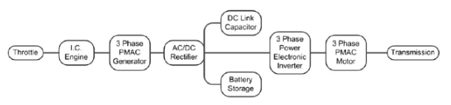
Figure 2.1.1 shows the diagram of electric vehicle (Taylor, 1998).

SERIES HYBRID VEHICLE

A series hybrid vehicle is an e1ectric vehicle with an engine/generator which supplies electrical energy to the vehicle’s battery. This occurs when the battery has been so discharged that it can no longer provide the energy and power needed to propel the vehicle. The function of the engine/generator is primarily to extend the range of the electric vehicle further than that possible using only batteries. The weight and size of the electrical components in electric drivelines have greatly reduced in recent times (Sharma, 2013). In addition, recent improvements in electric motor and power electronics technologies have permitted an increased in the peak power from the motor. The design of a hybrid driveline involves key considerations. These are the specification of the maximum motor torque and power, the maximum power of the generator and the usable electric range. In the series hybrid, application engine/generator efficiency is important but is not the critical factor. The reason for this is due to the vehicle being operated on the battery using wall-plug electricity (DC) for 80-90% of the vehicle miles (Sharma, 2013).

ENGINE/GENERATOR TYPE

The buggy was enhanced with 1200 cc and 2000 cc engines as was mentioned previously in the assignment (A1). Therefore, it was necessary to downsize the engine for this buggy because the series hybrid technology requires smaller engines. There are two operating modes for the series hybrid:
(1) A pure electric mode where the engine is off and all the energy to power the vehicle comes from the battery.
(2) A hybrid mode, where the engine is on and the engine/generator unit provides the electrical energy to power the vehicle while any excess energy is used for battery recharging (Taylor, 1998).
The engine control strategy for a particular series hybrid depends on the key parameters of the battery SOC at the time that the engine/generator is turned on and the battery SOC at the time that the engine is turned off. The difference between these two SOC is indicative of the energy returned to the battery during recharge and the specified engine/generator output power during the time that the engine operates in hybrid mode (Taylor, 1998). The engine that has been chosen as suitable for the buggy is the Genuine DLE 120cc in figure (2.2.1). According to the spreadsheet calculation, the buggy average power was 7 kW. This has the ability to produce average power of 11.88 kW at 7500 RPM with max efficiency 87%. This is higher than the average power of the buggy ICE engine. The full specification is shown in appendix (4), it has an engine compression ratio of 10.5:1.

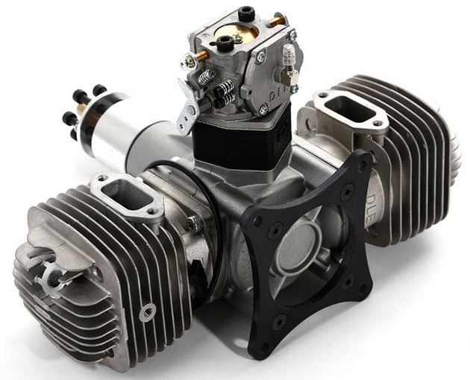
Figure 2.2.1 shows the generator for electric buggy (Evwest, 2017)

The chosen generator for the buggy was the HPQ3.5-60-18N Electric Vehicle AC Motor with max efficiency 79% (Alibaba, 2017).
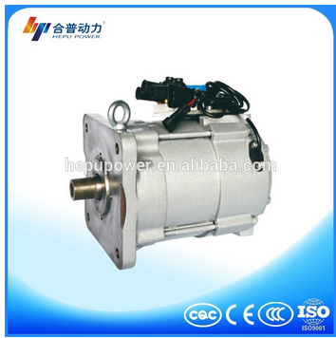
Figure 2.2.2 shows the electric motor for buggy (Alibaba, 2017)

MOTOR AND CONTROLLER

The Curtis 1239e-8521 HPEVS AC-35 Brushless AC Motor Kit - 144 Volt synchronous motor with max efficiency 88% can be seen in the figure (2.2-1). The full specification is shown in appendix (1). Due to its high power density, its ease of assimilation with other components, its cost, and its availability this was the main choice. While the vehicle is coasting and the motor is being turned through the transmission by the wheels the motor charges the battery pack as it is equipped with regenerative braking capability (Manning, 2013). This option is quite useful if driving over steep terrains. This is the same effect as the engine braking effect, which occurs in the ICE in a conventional vehicle (Manning, 2013).
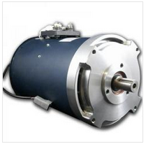
Figure 2.3.1 shows the motor and controller for electric buggy (Electricmotorsport, 2017)

The motor is controlled by an HPEVS Curtis 1239e-8521 144V 500 AMP controller which can be seen in figure (2.2-2). This is produced by Curtis also and is optimized for use with the AC35 motor. The full specification controller is shown in appendix (2). Overheating and over-voltage in the controller is prevented by design. The controller is limited to 650 amps current. This prevents any damage occurring through thermal runaway to the motor. The current varies according to the demands made by the driver and also by the road load. The road load includes hill-climbing load, inertial losses, aerodynamic drag and rolling resistance, (Anon, 2013).
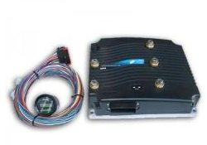
Figure 2.3.2 shows the controller system for buggy (Electricmotorsport, 2017)

2. 4 FINAL DRIVE RATIO CALCULATION
A final drive ratio was calculated 10.02:1 as shown below and in figure (2.3.5).
Max tractive effort = 3248 N
Max velocity = 15.65 m/s
Circumference = 1.885 m

Figure 2.3.3 shows the relationship between tractive effort and Time

The value of the max tractive effort at the wheel was obtained from the graph (2.4.4)
$$Tf=3248 ×0.3=974.4 Nm$$

Max tractive effort at the motor
$$Tf=974.4 ÷10=97.44 Nm$$

The max velocity value was obtained from the graph (2.4.5) below.

Figure 2.3.4 shows the relationship between Velocity and Time

Vmax = m/s in rev/min

$$Vmax=\frac{15.65}{1.885}=8.31 rev/s$$
$$=8.31 ×60=498.6 revs/min$$

Max RPM of the motor 5000

So, final drive ratio $=\frac{5000}{498.6}=10.02:1$
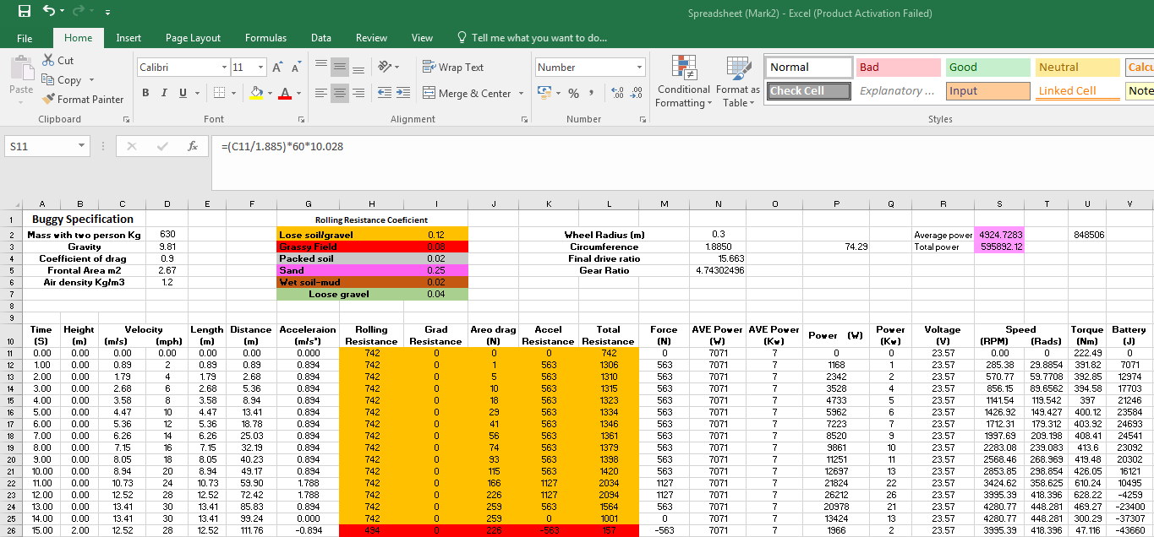
Figure 2.3-5 shows the excel spreadsheet for final drive

BATTERY

The three types of batteries that, at the moment, appear to be the most feasible are the leadacid (PbA), the nickel metal hydride (NiMH), and the nickel cadmium (NiCd). For long-term implementation, however the lithium-ion battery is more the favoured (Sharma, 2013).
The chosen battery for the buggy is GBS 48V 100Ah Li-Ion Battery Pack with EMUS BMS and Charger. Full battery specification is shown in appendix (3). This battery has a charging unit which charges the battery when the buggy is stationary. When the buggy is in use the battery will be charged by the generator as mentioned previously. At maximum cruising speed, the engine would be operating continuously to charge the battery. A main consideration with regard to battery storage is that the battery needs to store power in order to supply sufficient power to the motor. As shown in the spreadsheet in the previous assignment (1A), the power has been calculated in the Joules (14897.825). It was necessary to calculate the output power for the GBS 24V 100Ah Li-Ion in order to compare the output power from both.
The following equation has been used:
$$Power=Volts×Amp×minute×seconds$$

$Power=24×100×60×60=8640000 joules$ = 8.64 mj

The above calculation shows that the battery produces sufficient output power to supply the motor.
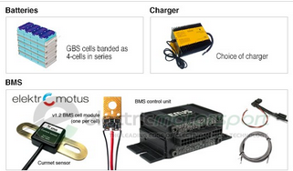

Figure 2.4.1shows the battery package for buggy (Evwest, 2017)

Graph (2.4.2) below shows the relationship between power VS time.

Figure 2.4.2 shows the relationship between power and time

Graph (2.4.3) below shows the relationship between battery VS time

Figure 2.4.3 shows the relationship between battery and time

COSTINGS

Table 3.1 shows the cost on the electric buggy (EBay, Evwest, Electricmotorsport, 2017)
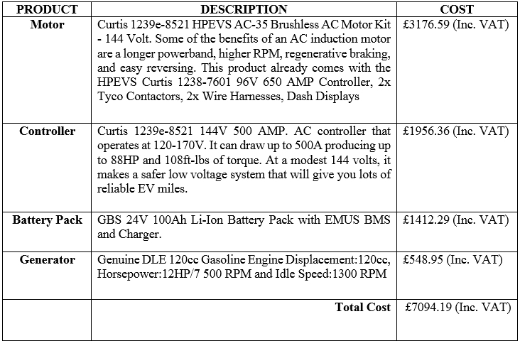
In addition, the generator motor cost £279.00.

BUGGY WEIGHT

The buggy was found to weigh a total of 500 kg. After conversion to a hybrid the components weight was found to be 122.12 kg.
Table 3.1.1 shows the weight on electric buggy (Evwest, ebay, 2017)
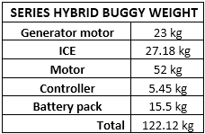

SYSTEM SPECIFICATION AND DISCUSSION

The most suitable motor for the buggy was AC35 because it is lighter in weight compared to the other electric motors. This motor is used in many electric vehicles at the moment. This brushless motor has advantages such as it does not have brushes or a physical commutator. Thus, it has fewer parts that can wear or break down. It is more reliable, more efficient and will last longer (Manning, 2013). It also has a less noisy operating system
The chosen controller was the Curtis 1239e-8521 144V which is recommended by Curtis for use with the above AC35 motor. This can produce more power and torque than AC35 motor as can be seen in appendix (3).
The reason the Genuine DLE120 cc Gasoline Engine has been chosen is because it is smaller than the existing buggy engine. This reduces the buggy weight and reduces fuel consumption (Manning, 2013). This engine/generator has a better capacity, which produces more power to drive the Brushless AC Motor and the other components. It is easy to replace in the event of any accidental damage or breakdown due to the terrain track.
The chosen battery was the GBS 48V 100Ah Li-Ion, which has a capability to supply sufficient voltage to the motor and another component. Another great advantage of the AC35 motor is that it has built in regenerative brake technology. This allows the battery to be charged by the motor. It also helps the battery in the case of failure of the main sources of power. This helps the battery during cruising.
Related maintenance and safety on series hybrid vehicles is less than ICE engines. This is due to it containing fewer moving parts. As the hybrid vehicle has a built-in regenerative braking system it significantly reduces brake wear. Fewer oil changes are required and no regular maintenance is necessary. It has a safety related battery pack, high voltages and the battery is sealed with shells. These seals protect the battery in various conditions such as collision, water immersion, vibration, overcharging, short circuits, fire and extreme temperature and humidity. One of the main features of this high-insulated battery is the deactivation of the electrical system in the event of short circuit or unknown events.
The application of series hybrid vehicles engine should be easier than for conventional ICE vehicles. This is because the operating speed and power ranges of the engine are more limited, and emission control is less difficult in series hybrid vehicles (Yamaguchi, 1996). This is because, if the series hybrid is operating in pure electric mode, the vehicle emissions will be zero (Rizoulis, 2001).

CONCLUSION

In this study of the design of a series hybrid vehicle, it was concluded that the components needed to meet the vehicle performance specification could be packaged in the available vehicle space. In addition, the operation of the series hybrid vehicle was simple, and control of the system was not difficult.

REFERENCE/ BIBLIOGRAPHY

Burke, A., 1992 "Hybrid/Electric Vehicle Design Options and Evaluations," SAE Technical Paper
Ebay, Genuine DLE120 Petrol/Gasoline Engine CDI Ignition & Muffler for RC Airplane. eBay. Available at: https://www.ebay.co.uk/itm/Genuine-DLE120-Petrol-Gasoline-Engine-CDI-Ignition-Muffler-for-RC-Airplane-/173056766380 [Accessed February 15, 2018].
Evwest, Curtis 1239e-8521 HPEVS AC-35 Brushless AC Motor Kit - 144 Volt, EV West - Electric Vehicle Parts, Components, EVSE Charging Stations, Electric Car Conversion Kits. Available at: http://www.evwest.com/catalog/product [Accessed February 12, 2018].
Electricmotorsport, GBS 24V 100Ah Li-Ion Battery Pack with EMUS BMS and Charger. ElectricMotorsport.com. Available at: http://www.electricmotorsport.com/gbs-24v-100ah-li-ion-battery-pack-with-emus-bms-and-charger.html [Accessed February 12, 2018].
Hayashida, M., Narusawa, K., Odaka, M., and Noda, A., 1997 "Study on Series Hybrid Electric Commuter-Car Concept," SAE Technical Paper
Manning, P., White, E., Caroncino, K., 2013 Ashworth, T. et al., "Vehicle Design and Implementation of a Series-Parallel Plug-in Hybrid Electric Vehicle," SAE Technical Paper
Rizoulis, D., Burl, J., and Beard, J., 2001 "Control Strategies for a Series-Parallel Hybrid Electric Vehicle," SAE Technical Paper
Taylor, W., Kellermeyer, W., Napier, R., Ralston, B. et al., 1998 "Development and Testing of a Second Generation ULEV Series HEV at West Virginia University," SAE Technical Paper
Senger, R., Merkle, M., and Nelson, D., 1998 "Validation of ADVISOR as a Simulation Tool for a Series Hybrid Electric Vehicle," SAE Technical Paper
Sharma, S. and Kumar, V., 2013 "Optimized Motor Selection for Various Hybrid and Electric Vehicles," SAE Technical Paper
Stewart, P. et al., 2008. Generator voltage stabilisation for series-hybrid electric vehicles. ISA Transactions, 47(2), pp.222–228.
Yamaguchi, K., Moroto, S., Kobayashi, K., Kawamoto, M. et al., 1996 "Development of a New Hybrid System - Dual System," SAE Technical Paper

APPENDICES

Appendix 1
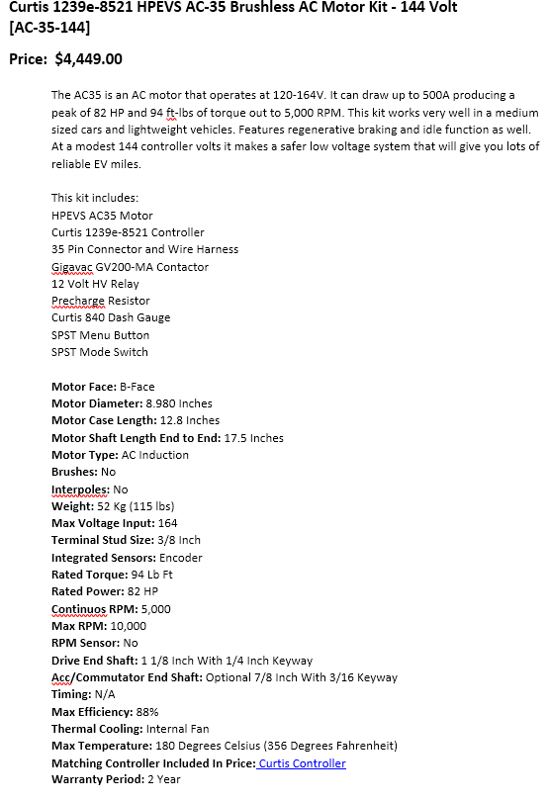
Appendix 2

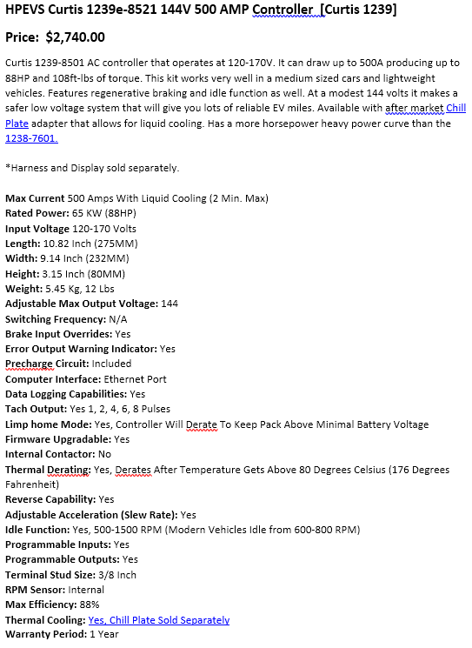

Appendix 3

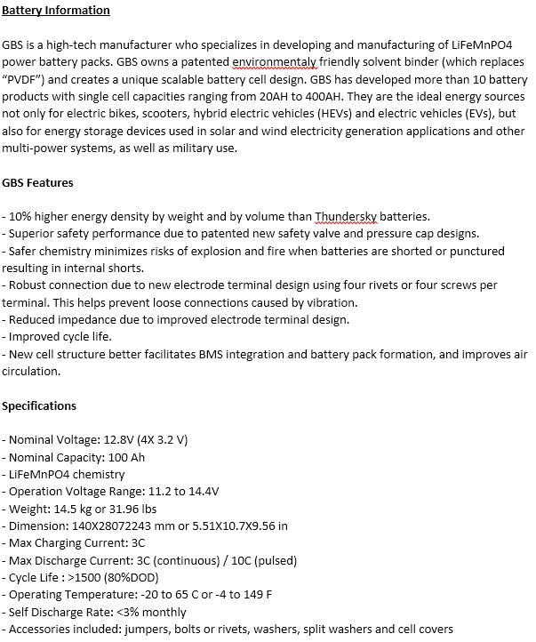

BMS Information
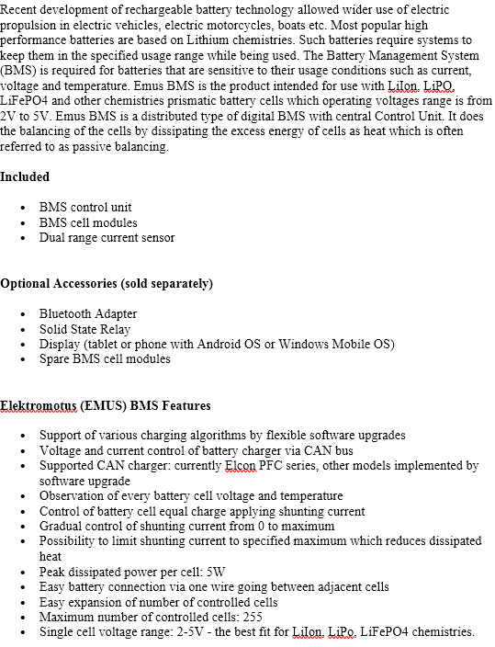
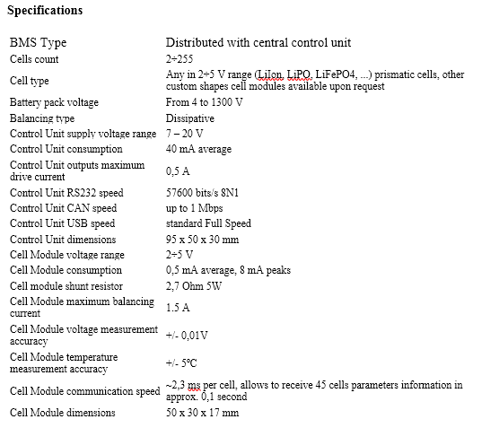

Appendix 4
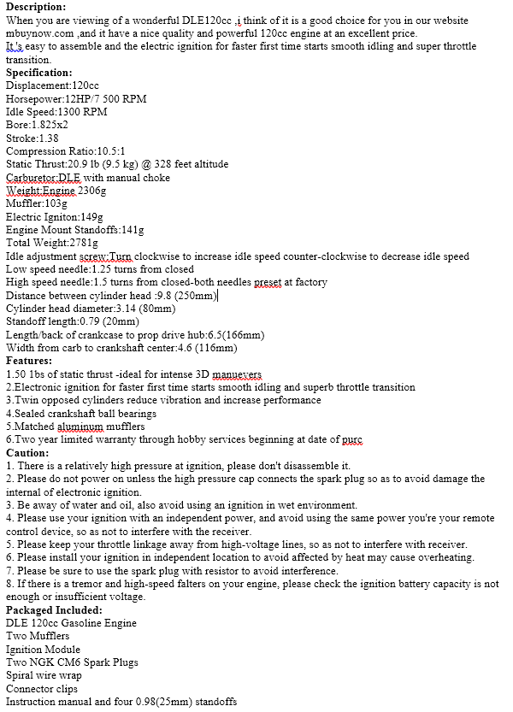
ICE engine
Appendix 5
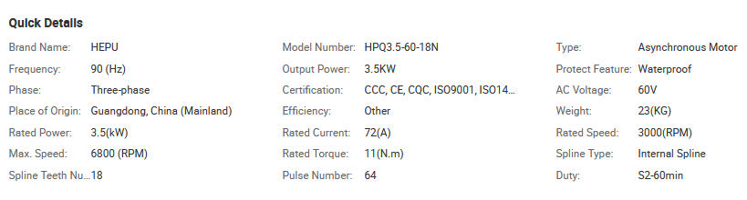
Generator motor.

