
Student name: Sheneya Akther Peya
Student ID:2442413

Module name: Introduction to Physiology
Module code: BMHP5023
Lecturer name: Shaila Hussain

Assessment: Component 1: Written Assignment (Case Study Report)

Table of Contents
Introduction 3
Structure of the Respiratory System and Mechanical Respiration 4
Gas Exchange in the Lungs 5
How Irritants Cause Inflammation and Affect Breathing 7
Recording and Tracking Respiratory Function 8
Evidence-Based Lifestyle Recommendations 9
Conclusion 10
References 11

Introduction
Asthma is a common chronic respiratory disorder that needs to be properly monitored and self-managed, especially in adolescence (WHO, 2026). A practice nurse has been allocated to work in the local GP surgery environment, where a growing number of youths in asthma clinics have deteriorating symptoms and more frequent attacks. Conversations with the health care team have revealed that a shift in adolescent behaviour, such as the initiation of smoking, vaping and time spent in crowded social places, could also lead to diminished control of asthma. Consequently, further elucidation of the information on the teenage population regarding their state, treatment needs and habits is significant in advancing safer respiratory health control.
Asthma is a chronic disorder of the airways and in this condition, inflammatory reactions make the respiratory tubes become hypersensitive and easily narrowed. When exposed to triggers during an asthma exacerbation, the airway lining can become swollen, the surrounding smooth muscles can contract due to bronchoconstriction and more mucus of thick consistency can be produced (NHS, 2025). Such reactions decrease the amount of space in which air is able to pass, causing it to be more difficult to transport air in the lungs. This can result in symptoms such as coughing, wheezing, chest tightness and difficulty breathing.
Asthma is a risk factor whose development is affected by various factors. These are hereditary predisposition, family history of asthma or allergies, atopic inflammation like eczema and allergic rhinitis, tobacco smoke exposure and vaping, air pollution, recurring infections affecting the respiratory system in childhood and some environmental or work irritants.
Adolescents need education and self-management since the phase of life can be marked by exposure to more triggers and inconsistent administration of prescribed treatment. Knowing how to look at the early signs, properly using an inhaler, understanding individual triggers and adopting an asthma action plan could assist the adolescent in making correct decisions that are related to their health and prevent a severe asthma attack.

Structure of the Respiratory System and Mechanical Respiration
The respiratory system delivers air to the lungs, aids in gas exchange and gets carbon dioxide out of the body. When inhaling, the air passes either through the mouth or the nose. Mucus and minute hairs cover and warm and humidify the air in the nasal cavity. It goes through the pharynx, which allows the passage of food and air, after which it reaches the larynx, which safeguards the airway when swallowing (Çelikhisar et al. 2023). Air passes through the trachea, with the cartilage rings to sustain an open airway and cilia to eliminate debris. The trachea also branches into right and left bronchi, which penetrate the lungs and form smaller branches called bronchioles. Airflow in these bronchioles is controlled by smooth muscle. They terminate in the alveoli, which are tiny air sacs encircled by capillaries, where gases exchange oxygen and carbon dioxide. Coupled with these structures, the lungs are made up and aid ventilation and gaseous exchange (Do and Musch, 2022).
Breathing is an active mode of inhalation. The diaphragm contracts and pulls downwards and the external intercostal muscles pull the rib cage upwards and outwards. This makes the thoracic cavity fuller and reduces the pressure in the lungs to below the atmospheric pressure. Air is thus reconciled through the lungs until there is equality of pressures.
The normal exhalation is predominantly passive. The diaphragm and external intercostal muscles relax and the thoracic volume is decreased by the elastic recoil of the lungs. The pressure within the lungs is elevated above that of the atmosphere, and this causes the air to be forced out of the lungs. When it comes to forced exhalation, the abdominal and internal intercostal muscles tighten to expel air more intensely (Hall and Hall, 2021). In asthma, excess mucus, bronchoconstriction and inflammation cause the bronchioles to become narrow. This adds to the difficulty in breathing out, forcing exhalation to be lengthy and challenging and results in wheezing, chest tightness, breathlessness and air trapping.
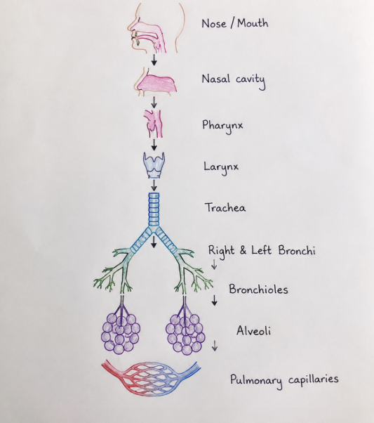
Figure 1: Human Respiratory System Diagram
(Source: Author)

Gas Exchange in the Lungs
Gas exchange refers to the inhalation of air and the uptake of oxygen in the blood and the release of carbon dioxide through the lungs, respectively. It takes place along the respiratory membrane created by the alveoli and pulmonary capillaries that surround it. The microscopic air sacs are modified to facilitate good gas exchange because alveoli are large enough to facilitate a high surface area, each cell wall is no more than one cell thick, there is a moist lining that enables the dissolution of gases, and the alveoli have a broad capillary network. All these characteristics lead to a very short distance of diffusion between blood and air (Petersson and Glenny, 2023).
In the inhalation, isolation of rich oxygen-containing air goes to the alveoli. The alveolar pressure of oxygen is higher than that of the deoxygenated blood as it enters the pulmonary capillaries. The diffusion of oxygen across the walls of the alveoli and capillaries into the blood therefore occurs. When this happens, it combines with haemoglobin within the red blood cells to produce oxyhaemoglobin. This oxygen is delivered to the body tissues by the circulatory system, which helps to maintain aerobic cellular respiration and the generation of energy (Wagner et al. 2022).
Carbon dioxide flows in the opposite way. It is formed as a waste product of cellular metabolism by body cells and carried in the blood to the lungs. The carbon dioxide diffuses across the respiratory membrane into the alveolar air since it has a higher partial pressure in the blood of the pulmonary capillaries than in the alveoli. It is then eliminated from the body via exhalation.
In asthma exacerbation, there is inflammation, bronchoconstriction and excessive mucus that make the bronchioles narrow and decrease the volume of air delivered to the alveoli (Aegerter and Lambrecht, 2023). This restricts blood flow and oxygen diffusion, inducing a balance between blood flow and ventilation. When a severe attack occurs, gas exchange can be highly compromised, leading to hypoxia and, with further worsening of ventilation, a decreased ability to remove carbon dioxide.
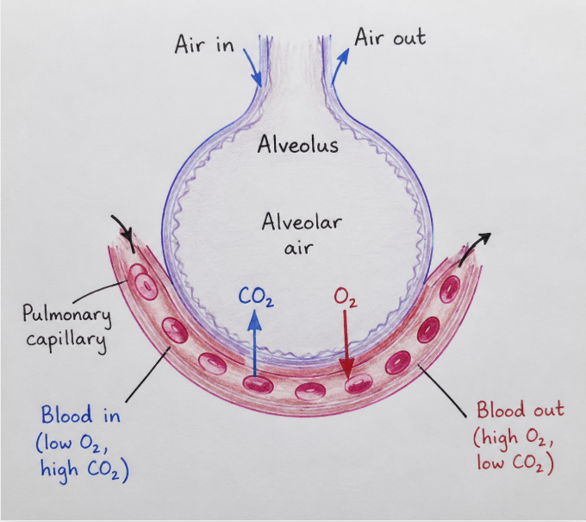
Figure 2: Gas Exchange in the Lungs
(Source: Author)

How Irritants Cause Inflammation and Affect Breathing
Asthma is a condition that is characterised by hyper-irritation of airways and airway hyper-sensitivity that is chronic. They cause the activation of the mast cells and other immune cells of the airway lining when irritants like cigarette smoke, vaping aerosol, or polluted air are inhaled (Oronsky et al. 2022). These cells give out inflammatory chemicals, such as histamine and leukotrienes. This reaction leads to the swelling of the airway walls, narrowing the smooth muscles surrounding the bronchi, which is called bronchospasm, and to an increase in the amounts of secretions. When combined, these alterations constrict the airway lumen and raise airflow resistance.
Cigarette smoke is made up of toxic substances and fine particles that irritate the respiratory lining. It kills the cilia, which help to clear the airways of mucus, dust and microorganisms (Zeng et al. 2023). In case of ineffective cilia, the mucus and other harmful elements get stuck in the bronchi. Smoking is known to enhance the production of mucus, enhance chronic inflammation, expose the victim to respiratory infection and complicate asthma management.
Asthma can also be aggravated by vaping. Nicotine, flavouring agents, ultrafine particles and other chemicals that irritate the respiratory tract may be present in e-cigarette aerosols (Beigh et al. 2026). These compounds may enhance bronchial hyper-responsiveness and inflammation of the airways. The effect of frequent exposure can be coughing, wheezing, tightness and breathlessness in the chest. For adolescents with already-sensitive airways, vaping can increase the frequency and severity of asthma symptoms.
Airways may also be further inflamed by respiratory infections like colds and influenza (Al-Harrasi and Bhatia, 2022). Individuals affected with asthma are especially susceptible as their airways are already hyper-reactive and swollen. Young individuals who go to large bars or clubs are at risk of being more exposed to respiratory infections as well as cigarette smoke and vaping aerosols.
In the asthma attack, inflammation, excess mucus and bronchoconstriction limit airflow. The exhalation is also slowed and laboured, resulting in wheezing, dyspnoea, chest tightness, chronic coughing and trapping of air. Less oxygen can reach the body due to diminished airflow to the alveoli as well.

Recording and Tracking Respiratory Function
Peak expiratory flow rate (PEFR) is the maximum rate of expelling air that a person can push out of the lungs during one complete breath (Mehta and Satani, 2022). A handheld peak flow meter is used to measure it. The man trims the beat, gives a wheeze at the rim of his mouth, and presses his lips tight around the mouth, and blows as forcibly and swiftly as he can. This has to be done thrice and the maximum reading of the three counts is taken.
Frequent follow-up is more beneficial than a single measure since it indicates the change in and trends of lung performance over time. A decrease in peak flow could signal airway constriction prior to the onset of severe symptoms. Surveillance may detect degradation, implicate precipitants, demonstrate medication efficacy, aid clinical decision making, and decrease the likelihood of ED visits (Sosan et al. 2025).
The effects of peak flow should be documented with the accompaniment of symptoms, inhaler utilisation, actions, and potential triggers. These log entries can be associated with a customised asthma action plan, defining what to do in case the readings fall outside of the normal range for the individual. In the case of adolescents, this instils responsibility and enhances their awareness of their condition (Hall and Hall, 2021). During clinic sessions, the records can be reviewed and the practice nurse and the GP decide that the medication control, the inhaler technique, or the trigger-management measures should be changed to sustain asthma control.

Evidence-Based Lifestyle Recommendations
The lifestyle interventions make big impacts on the improvement of asthma management and asthma attacks in adolescents. The former is the one hundred percent smoking avoidance. Cigarette smoke has also been known to contain damaging chemicals that irritate the lining of the airways, kill the cilia, increase secretion of mucus and promote chronic inflammation (NICE, 2021). These effects heighten bronchospasm, decrease airway clearance and complicate the symptoms of asthma. These dangers should be publicised among the adolescent smokers and they should be made to require the necessary guidance and support services like NHS Stop Smoking Services. The cessation therapy may be nicotine replacement therapy (NRT or varenicline), and along with the discussion of treatment with behavioural support and proper cessation therapy, it is possible to discuss it after a clinical assessment.
Another concern to be discussed is vaping because it is not a harmless option among asthmatic adolescent patients. Nicotine, flavouring agents, ultrafine particles and other chemicals that irritate sensitive airways can be found in the e-cigarette aerosols (Beigh et al. 2026). Exposure could increase airway inflammation, bronchial hyper-responsiveness, coughing, wheezing and puffing. The teens should, therefore, stop vaping with the help of medical practitioners.
The other important aspect of asthma management is the avoidance of the environmental triggers. Teenagers ought to reduce their smoking of cigarettes, smoking aerosols, air pollutants, heavy perfumes as well as dust, mould and allergens. With respect to the case study, accessing congested bars and clubs could result in the inhalation of respiratory diseases, substandard ventilation and air pollutants, exposing one to the risk of asthma attacks. Traditionally, monitoring air-quality data could also assist adolescents to avoid outdoor activities in the case of high levels of pollution (NHS, 2025).
Medications and behaviour acting on inhalers will aid in the management of asthma. Adolescents have been recommended to take preventer medicine as prescribed, reliever inhalers accordingly and have frequent asthma reviews. Practice nurses should also observe the inhaler administration, show and encourage inhaler use of a personalised asthma action plan.
Exercising also needs to be done regularly as it enhances breathing capacity and heart strength. An exercise-related symptom and medication intake among the teens should be exercised and warmed up by using the weaknesses, as recommended by the physicians. Further prevention of infection-induced worsening of asthma may be done by influenza vaccination (where feasible) annually, superb hand hygiene, and reduced intimate contact with individuals with respiratory diseases.

Conclusion
In conclusion, Asthma is a long-lasting respiratory disease that leads to abnormal airway functioning due to inflammation, bronchoconstriction and excess secretion. The report has discussed the role of the respiratory system in ventilation, uptake of oxygen and elimination of carbon dioxide and also details how vices like smoking, vaping and respiratory diseases can exacerbate airway constriction and difficulty in breathing.
As has been established in the discussion, knowledge of respiratory physiology can be of great use in enabling adolescents to realise the impacts of asthma on their bodies. It is very useful in the management of asthma as symptoms of symptoms worsening can be easily detected with regular observation of respiratory performance, especially by measurements of peak flows. Asthma can be better controlled and exacerbations decreased by changing the lifestyle and preventing triggers, using proper inhaler technique, using prescribed medication, and adopting healthier behaviours.
Among the adolescents visiting asthma clinics, what is needed is effective education and self-management in order to have improved health outcomes. By learning their status, recognising their triggers and completing their own asthma action plans, youth can become more responsible in managing matters related to their breathing systems and lower the chances of deadly asthma attacks.

References
Aegerter, H. and Lambrecht, B.N., 2023. The pathology of asthma: what is obstructing our view?. Annual Review of Pathology: Mechanisms of Disease, 18(1), pp.387-409.
Al-Harrasi, A. and Bhatia, S., 2022. Epidemiology respiratory infections: Types, Transmission, and risks associated with Co-Infections. In Role of Essential Oils in the Management of COVID-19 (pp. 7-17). CRC Press.
Beigh, S., Jawed, A. and Dar, S.A., 2026. Beyond Nicotine: Toxicological Insights Into Metals, Nanoparticles, and Flavoring Agents in E‐Cigarette Aerosols. Journal of Applied Toxicology.
Beigh, S., Jawed, A. and Dar, S.A., 2026. Beyond Nicotine: Toxicological Insights Into Metals, Nanoparticles, and Flavoring Agents in E‐Cigarette Aerosols. Journal of Applied Toxicology.
Çelikhisar, H., Cingi, C. and Scadding, G., 2023. Airways: Physiology. In Airway Diseases (pp. 31-42). Cham: Springer International Publishing.
Do, K. and Musch, G., 2022. Basic physiology of respiratory system: gas exchange and respiratory mechanics. In Mechanical Ventilation from Pathophysiology to Clinical Evidence (pp. 3-12). Cham: Springer International Publishing.
Hall, J.E. and Hall, M.E. 2021 Guyton and Hall Textbook of Medical Physiology. 14th edn. Philadelphia: Elsevier.
Mehta, B.M. and Satani, K., 2022. Study of peak expiratory flow rate in young smokers in community. Int J Community Med Public Health, 9(2), pp.872-876.
NHS 2025 Asthma - NHS. Available at: https://www.nhs.uk/conditions/asthma/ (Accessed: 17 July 2026).
NICE 2021 (Online) Overview | Tobacco: Preventing Uptake, promoting quitting and treating dependence | guidance | nice. Available at: https://www.nice.org.uk/guidance/ng209 (Accessed: 17 July 2026).
Oronsky, B., Caroen, S. and Reid, T., 2022. What exactly is inflammation (and what is it not?). International journal of molecular sciences, 23(23), p.14905.
Petersson, J. and Glenny, R.W., 2023, October. Gas exchange in the lung. In Seminars in Respiratory and Critical Care Medicine (Vol. 44, No. 05, pp. 555-568). Thieme Medical Publishers, Inc..
Sosan, N.Y.N., Almonis, J.A.M., Almones, R.A.M 2025. The Impact Of Nursing Interventions In Emergency Care Settings: A Comprehensive Review Of Clinical Decision-Making, Patient Safety, And Outcome Improvement. The Review of Diabetic Studies, pp.901-911.
Wagner, P.D., Malhotra, A. and Prisk, G.K., 2022. Using pulmonary gas exchange to estimate shunt and deadspace in lung disease: theoretical approach and practical basis. Journal of Applied Physiology, 132(4), pp.1104-1113.
WHO 2026 (Online) Asthma. Available at: https://www.who.int/news-room/fact-sheets/detail/asthma (Accessed: 17 July 2026).
Zeng, T., Liu, Y., Jiang, Y 2023. Advanced materials design for adsorption of toxic substances in cigarette smoke. Advanced Science, 10(22), p.2301834.

