

‘Coping with Change: Exploring the Lived Experience of Moving to a New Campus’
University of Wales Trinity Saint David

Abstract
This study explores the experiences of how 2nd year university students have coped with moving to another university. This involved conducting a semi-structured interview in which participants were asked questions about various aspects of their transition to the new campus. Results identified four key themes of Coping Flexibility, Socialising, Facilities and Travel, with associated sub-themes also identified as these had a significant affect upon the participant’s ability to cope with the transition. Implications for the study discussed coping flexibility, with recommendation to further research of how external factors may affect the individual’s ability to discard ineffective means of coping with new situations and environments to replace with more effective and relevant means.

Introduction
The topic of how someone can cope with a change in environment has received minimal research (Cheng, Lau & Chan, 2014). However, Cheng et al (2014), suggests that research for this subject is becoming more prevalent with various suggestions involving how the transition of one’s environment may affect several facets of their life. In context to a learning environment, Lippman’s (2010) suggestion of a relationship between environment and the individual as a learner, with the learning environment being composed of the learner, their peers, their teachers and the physical environment they inhibit (Lippman, 2010). Additional research by Harrop and Turpin (2013) discuss the factors which influence a student’s attitudes, behaviours, and preferences towards a learning environment. These factors include learning theory, placemaking, and the architecture of the environment and how these three interact with each other to affect the learner (Harrop and Turpin, 2013). Other suggestions include how the stress found in one’s environment may affect their ability to adapt (Bunce & West, 1994). Bunce and West (1994) also suggested factors from one’s environment such as social interaction had prompted the most frequent use of coping strategies from participants. This indicates that elements such as socialising may affect the coping ability of an individual’s adaptation to a given environment.

With regards to coping, it is suggested by Woodward and Hendry (2004) that the Change Process Models generally determine individuals as being resistant to change. However, their study demonstrated that factors such as personal attitudes and opinions were significant determinants for an individual’s ability to change (Woodward & Hendry, 2004). Another study sought to examine the relationship between an individual’s ability to cope with change and depressive symptoms, using the ‘coping flexibility’ hypothesis (Kato, 2015). Coping flexibility hypothesis suggests that those with an ability to discard previous ineffective means of coping in place of new, effective coping strategies, will possess higher psychological health and a reduction in depressive symptoms (Kato, 2012). Kato’s (2015) study demonstrated congruency with the hypothesis as results correlate with the notion that coping flexibility is associated with reduced depressive symptoms (Kato, 2012; 2015). This is to suggest that individual’s ability to adapt to new situations has a significant impact upon their mental state, affecting how effectively they cope with various situations as a result. With the research provided, this study will seek to investigate how university students who have moved to a new campus have coped with this transition.

Method
Participants
Participants consisted of three undergraduate, second-year students in a course that has been moved to a new university campus within the last year. Participants were approached through means of opportunity sampling in the new campus. The study had consisted of two males and one female. Ages ranged from 22-56 (M= 35.00, SD=18.24).

Design
The design of the study involves a qualitative, one-to-one semi-structured interview with the participant. This interview involves asking the participant various questions related to their transition from one campus to another. The interviews were recorded and transcribed and analysed in an Interpretive Phenomenological Analysis (IPA) format.

Materials
Materials consisted of a form to acquire consent for the study, including the recording of the interview. This also included a study schedule, prepared by the interviewer, with a variety of questions relating to transitioning from one university campus to another. This included questions focusing on different aspects of university life such as socialising, facilities, etc with additional prompts for information. An example of these questions includes ‘How do you feel about the facilities on/in the new campus?’ Other materials consisted of a sound recording device on the interviewer’s phone, which is password protected to prevent the data from being accessed from anyone other than the interviewer. A debrief form was also provided to inform the participant about the purpose of the study.

Procedure
The study involved the participant engaging in a one-to-one interview for an expected ten minutes within an isolated environment, answering various questions relating to their transition from their previous campus to the new campus. The procedure began with informing the participant of the recording, topic of discussion and allowing for verbal consent and written consent (Appendix A) to be given both before and during the recording. Recording consisted of the participant answering questions from an interview schedule (Appendix B), with the interview being recorded on a device (Appendix C). The participant sat at the opposite end of a small table with the recording device placed in the centre to ensure both the interviewer and interviewee’s voices are clearly recorded. When the study was completed, the participant was handed a debrief form (Appendix D) and the recorder was switched off.

Results
The analysis discovered four themes, with associated sub-themes, across the three interviews, a table of the themes have been included in Figure 1.

Figure 1.
Bold numbers on quotes correlated to Sub-Theme numbers:
Themes | Participant 1 | Participant 2 | Participant 3
Coping flexibility  1. Lack of impact  2. Adaptation to new environment  3. Personal Situations  4. Learning Atmosphere  5. Difficulty with change | 1. (18, p. 1) – “Its alright”  2. (116-118, p. 6) – “…I’ve been in the army for years, so every little while you would move from one unit to another unit…so to me it’s been no different”.  3. (78-79, p. 4) - “No, because being a parent and having kids at home, and being married, and having my wife around, my social life is about the same as it was.”  4. (23, p. 2) – “Feels more like a campus.” | 2. (25-26, p. 2) - “…I didn’t like it, I didn’t want to come. But after the Christmas break…I don’t know, I feel bit more settled here now…”  5. (54-55, p. 4) – “I like the library now, whereas I didn’t at the start, well I suppose because it was new wasn’t it?” | 2. (18-19, p. 1) – “Well,  so far, I would say I’ve  enjoyed my time in the  new campus. I prefer the  location of it, so to me  that means I’m enjoying  it more.”  4. (33-34, p. 2) – “In the  new campus, um a lot of  people are there so it sort  of makes it a better  environment.”
Socialisation  1. Age  2. Lack of impact  3. Improvement of social life | 1. (83-85, p. 5) – “...as a mature student…I can it being better for younger students, it makes no difference at all to me” | 3. (153-154, p. 6) – “No, I feel since we’ve moved to this new campus though, our class has become a lot more (PAUSES) closer…” | 3. (110-111, p. 5) – “…I  wouldn’t say there’s  been a great deal of  change, but I would say  that there has been a  small degree of positive  change…
Facilities  1. Technology  2. Canteen  3. Library  4. Staff | 1. (33, p. 2) – “Availability for computers is much better as well.”  2. (37, p. 1) – “Canteen’s a bit small, and expensive, where it was big and expensive before…  3. (38, p. 1) – “…the library’s much better, better laid out.” | 2. (29, p. 2) – “The coffee shop is small, too small.”  3. (54-55) – “I like the library now, whereas I didn’t at the start, well I suppose because it was new wasn’t it? But yeah no, I like it here now, it’s nice.”  4. (18, 23, p. 1-2) – “The parking was an issue, the man was an issue…you know the car parking man?...” | 1. (63-64, p. 3) – “…the  library has got more  computers…”  2. (44-45, p. 3) – “…nice  places to sort of spend  leisure time and on  campus itself because of  the new learning  facilities, the new  library, the new café…”  3. (63-65, p. 3) – “the  library has got more  computers, it’s got more  space, I think its got  more sort of learning  utensils and sort of  facilities…”
Travel  1. Lack of difficulty  2. Stress from travel | 1. (60-61, p. 3) I used to just drop in after I drop off my wife at work, and I just do the same now, I come in a different direction now. | 1. (117, p. 6) – “Oh I hate it, it is horrendous.” | 1. (74-75, p. 4) – “Um, I think, um, travelling to the new campus, I myself personally find it easier because it’s close to the city centre…”

The first theme of coping flexibility is highly prevalent throughout each interview, as this appears regularly in sections in which the individual is required to adapt to various situations. An example of this would include “…I’ve got life experiences, I’ve been in the army for years, so every little while you would move from one unit to another unit…so to me it’s been no different”. (P1: Line 115-118, p. 6) which may suggest that the personal experiences of the individual may have had a significant impact upon an individual’s ability to successfully cope with and adapt to new environments. Other examples would include “…I couldn’t settle here, I didn’t like it, I didn’t want to come. But after the Christmas break…I don’t know, I feel a bit more settled here now, I’m used to it now.” (P2: Line 25-26, p. 3) which may suggest that the individual was not able to cope and adapt to the new environment effectively, with the participant being able to cope and adapt at a later point. The third participant also notes “Well, so far, I would say I’ve enjoyed my time in the new campus…” (P3: Line 18, 22-23, p. 1) which suggests that the individual’s ability to cope with new environments and situations is tied to the facilities of said environment, presenting a potential link of themes between an individual’s ability to flexibly cope with new situations and the facilities of the environment.

The second theme presented includes socialisation, referring to socialisation aspects of the individual’s transition to the new campus. It is consistent for participant one and three that the transition has not impacted their social life in any significant way. An example of this includes “For me, it personally makes no difference…I can see it being better for younger students…it honestly makes no difference to me at all” (P1: Line 83-85, p. 4), this possibly being the case because of the participant’s age. However, participant two and three notes that “…I feel since we’ve moved to this campus though, our class has become a lot more closer…” (P2: Line 153-154, p. 7), “…I wouldn’t say there’s been a great deal of change, but I would say that there has been a small degree of positive change because um as we’re in the city centre…” (P3: Line 110-111, p. 5), suggesting that the participant’s social interactions within the class have improved due to the transition. This is to suggest that whilst socialisation has not seen a significant impact in any of the three interviews, it has still been somewhat affected in both participant two and three, which may be due to the age of participant one.

The third theme presented includes the facilities of the campus, as extracts from each interview may indicate this to be a significant improvement in comparison to the previous campus. An example would include “Oh much better, psych labs are a lot better, more chance for doing different things in them.” (P1: Line 28-29, p. 2). This may suggest the participant believes they are better enabled to engage in their learning due to various facilities, such as the new facilities in the psychology labs. Another example of this suggestion includes “Oh, much better here, they are much better…but now, like cause I don’t really go to the…I go up upstairs to the computer room, it’s more relaxed there y’know?” (P2: Line 60, 62-64, p. 3). This notes that the computer room is quite significant to the participant, due to its relaxed environment, this may potentially suggest that this has aided the participant’s transition. Participant three also states “Oh, I much prefer them… there’s more sort of course related sort of study areas and facilities such as sort of laboratory booths, workshops, that sort of thing” (P3: Line 58, 62-63, p. 3). This demonstrates that each participant views the facilities as an improvement over the previous campus. This may indicate they have transitioned well to the new campus’ facilities as each of these factors allow for more opportunities to engage in their learning.

The fourth theme presented includes the participant’s travel, as each interview demonstrates significant differences between each participant travel situations. For example, participant one suggests “I used to just drop in after I drop off my wife at work, and I just do the same now, I come in a different direction now.” (P1: Line 60-61, p.3). This suggests that the participant’s travel arrangements saw no change, resulting in their transition to the new campus being neither improved nor at detriment. Therefore, their transition has not been affected by their travel. However, participant two notes how stressful travel to the new campus is now in comparison to the previous campus “Because you have to come about 2-3 miles further into the city and it’s absolute chaos. Like whereas before, you’d turn off to go up wouldn’t you?” (P2: Line 121-122, p. 6). The participant is now required to enter the city as opposed to previous campus which avoided the city centre traffic, which has resulted in issues with stress when travelling to and from the campus. However, participant three suggests “Um, I think, um, travelling to the new campus, I myself personally find it easier because it’s close to the city centre…” (P3: Line 74-75, p. 4) This contrasts significantly with the previous participants as the participant now finds their travel arrangements to be more convenient due to the additional suggestion “I get the train from (HOME TOWN OF INTERVIEWEE) into (CITY NAME) and now I walk from the train station to the (NEW CAMPUS NAME) which takes about 10-15 fifteen minutes” (P3: Line 95-97, p. 5). This suggests that the participant’s use of the public transportation allows for more convenient travel than in the previous campus, allowing for a positive transition due to these improvements in convenience.

Discussion
Results from this study demonstrate congruency with previous literature. As previously mentioned, the coping flexibility hypothesis (Kato, 2012) proves relevant to this data as it contextualises the coping mechanisms of participants during their transition. An example of this would include the relationship between learning environment and learner proposed by Lippman (2010), as it is evident within each of the interviews that the facilities of the campus appear to be heavily implicated in the participant’s ability to successfully cope with the environment. As participants relate their opinions to their overall transition experience. These results implicate that an individual’s ability to flexibly cope with change have been affected by various factors such as the facilities of said environment.

The earlier suggestion of stress affecting an individual’s ability to cope with transition (Bunce & West, 1994) is also congruent with the results as one participant experienced significant stress due to difficult travel conditions, resulting in issues with coping with the transition. With the evidence provided, this would then suggest that the individual’s ability to cope to new situations and environments is not only determined by discarding ineffective internal coping mechanisms (Kato, 2012), but also external factors. This is to suggest that whilst new means of coping are created to replace ineffective coping mechanisms, there are external factors such as physical aspects of the environment i.e. facilities or personal situations of the individual i.e. travel, which may affect the process of discarding ineffective means of coping to replace with more effective means. A limitation of the study would include the experience of the researcher as certain points raised by the interviewee were not prompted for further information. Doing so may have resulted in more detailed answers from participants

In conclusion, the literature provided supports this research (Bunce & West, 1994; Lippman, 2010; Kato, 2012) as various factors of the learning environment have been linked to the individual’s ability to cope with transition. However, further research into how external factors for coping mechanisms adapt may provide further insight for how individual cope with change.

.

Word Count (Excluding titles, tables, quotations and references): 1,650

Reference List:
Bunce, D. & West, M. (1994). Changing work environments: Innovative coping responses to
occupational stress. Work & Stress. 8(4). p. 319-331.
Cheng, C., Lau, H.P.B. & Chan, M.P.S. (2014). Coping flexibility and psychological
adjustment to stressful life changes: A meta-analytical review. Psychological bulletin.
140(6). p. 1582.
Harrop, D. & Turpin, B. (2013). A study exploring learners’ informal learning space
behaviours, attitudes, and preferences. New Review of Academic Librarianship. 19(1).
p. 58-77.
Kato, T. (2012). Development of the Coping Flexibility Scale: evidence for the coping
flexibility hypothesis. Journal of counselling psychology. 59(2). p. 262.
Kato, T. (2015). Testing of the coping flexibility hypothesis based on the dual-process theory:
Relationships between coping flexibility and depressive Symptoms. Psychiatry
research. 230(2). p. 137-142.
Lippman, P.C. (2010). Can the Physical Environment Have an Impact on the Learning
Environment?. CELE Exchange, Centre for Effective Learning Environments.
2010(11-14). p. 1-5.
Woodward, S. & Hendry, C. (2004). Leading and coping with change. Journal of Change
Management. 4(2). p. 155-183.

Appendices:
Appendix A: Consent Form
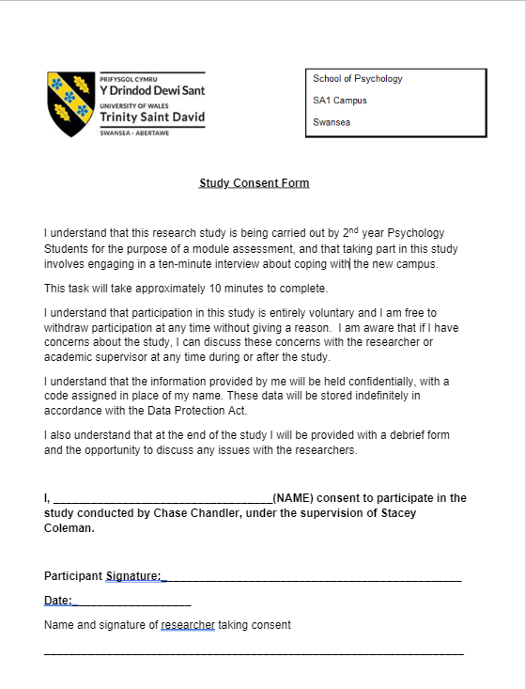
Appendix B: Interview schedule
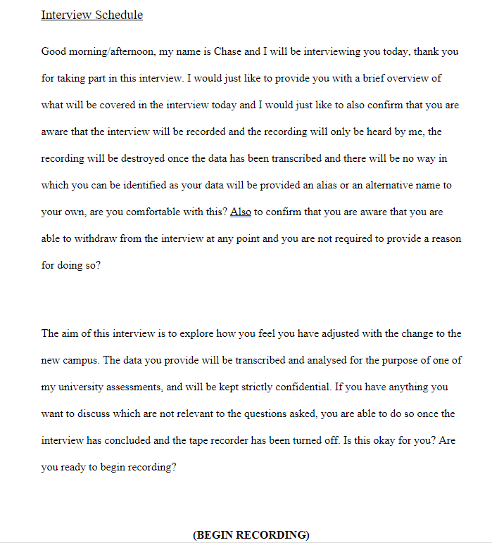
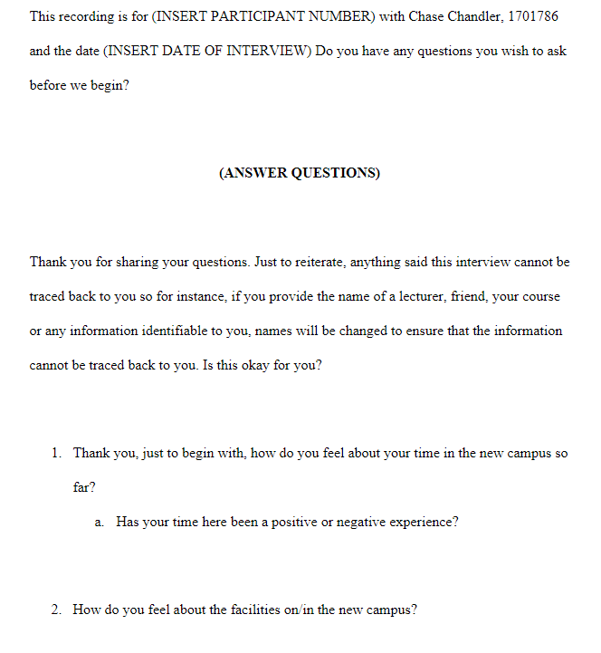
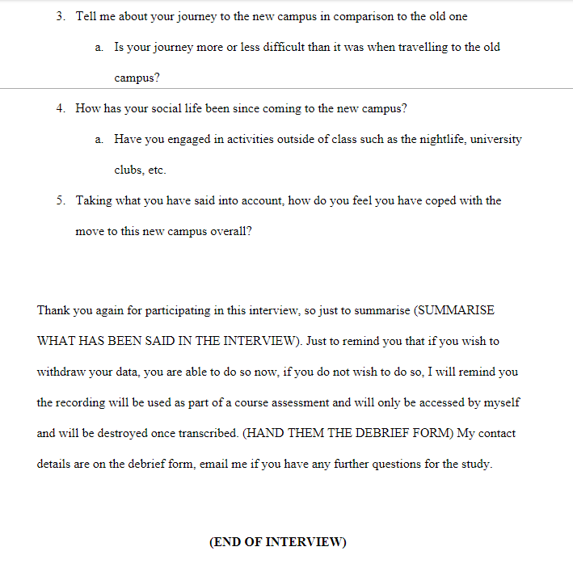
Appendix C: Recording Device
Appendix D: Debrief form
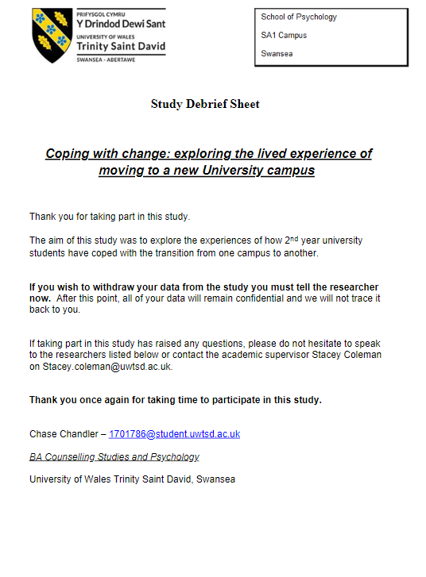
Appendix E: Transcript 1 (To be submitted as a hard copy)
- Chronological list of emerging themes:
  - Coping Flexibility
  - Facilities
  - Travel
  - Socialisation
Appendix F: Transcript 2 (To be submitted as a hard copy)
- Chronological list of emerging themes
  - Facilities
  - Coping Flexibility
  - Travel
  - Socialisation
Appendix G: Transcript 3 (To be submitted as a hard copy)
- Chronological list of emerging themes
  - Coping Flexibility
  - Facilities
  - Travel
  - Socialisation

