Name | Ana-Maria Nastac
Student number | 2119513
Module Code | LCBB5000
Module Name | Data Handling and Business Intelligence
Assignment Title | Coursework (Written Report)
Lecturer | Zahra Mohammadnazari

Table of Contents

Introduction 3
Discussion 3
1. Present Business Intelligence Trends 3
2. Business Intelligence Procedures 4
3. Value of analytical and prescriptive software 5
Conclusion 6
Reference 7

Introduction
BI (Business Intelligence) is a technology-driven process that analyzes data and presents actionable information to enhance management decision-making. With the emergence of "big data," BI has become crucial in helping organizations leverage massive and diverse datasets (Puklavec et al., 2018). This report examines BI trends, including agile methods, quick analytics, data science, and BI implementation factors. Agile development, cooperation, and adaptation are needed to handle "big data" in BI. Agile BI initiatives allow companies to adapt to changing business demands and produce value quickly. Fast analytics is also driven by data speed and volume. In today's fast-paced business climate, organizations need near-real-time data processing to make educated decisions. In-memory databases, stream processing, and parallel computing allow organizations to get meaningful insights from massive datasets quickly. Data science in BI workflows helps provide deeper insights. Machine learning, predictive analytics, and other data science methods improve BI by finding patterns, anomalies, and correct forecasts. This connection enables data-driven proactive decision-making (Brachman & Anand, 2016). Organizations may use data to make educated decisions and get a competitive edge in today's data-driven business world by recognizing and implementing these BI trends. Key research pieces, such as 'A review and future direction of agile, business intelligence, analytics, and data science,' will be used to analyze and analyze these trends and dimensions throughout this report.

Discussion

1. Present Business Intelligence Trends
Several contemporary Business Intelligence (BI) developments that are reshaping the industry are highlighted in the research report titled "A review and future direction of agile, business intelligence, analytics, and data science." Some of these developments include adopting agile processes, the rise of quick analytics, and incorporating data science techniques into conventional BI workflows (Chen et al., 2012). Agile approaches' ability to adapt to changing business requirements and progressively provide value has given them popularity in the BI market. Agile BI strongly emphasizes flexibility, tight stakeholder involvement, and iterative development. Organizations may improve the responsiveness of their decision-making processes by using an agile strategy, allowing them to swiftly adjust to changing market conditions (Mason & Mitroff, 2013). Driven by the growing volume and pace of data, fast analytics has become a critical trend in BI. For businesses to act quickly and wisely, they need information available almost immediately. Fast analytics uses parallel computing, stream processing, and in-memory databases to quickly handle and analyze massive datasets. This trend helps businesses to get insightful information quickly, promoting proactive decision-making (Larson & Chang, 2016).
Another significant development is the incorporation of data science methodologies into BI procedures. Data science improves conventional BI procedures by adding cutting-edge algorithms and statistical models. Organizations can find trends, spot abnormalities, and make precise forecasts thanks to machine learning, predictive analytics, and data mining. Organizations may use data science to make better decisions by gaining deeper insights from their data (Puklavec et al., 2018).

2. Business Intelligence Procedures
a) Data Warehousing: A key BI process, data warehousing is gathering, storing, and organizing data from diverse sources into a single repository (Larose & Larose, 2014). Data warehouses give an organization a uniform view of its data, facilitating effective querying and analysis. Organizations may get complete insights and make wise decisions based on a full understanding of their operations by combining data (Eidizadeh et al., 2017).
b) Data mining: Data mining is the method of sifting through vast databases to find useful patterns and information (Negash & Gray, 2008). To find hidden patterns, correlations, and trends, statistical and machine learning methods are applied. Organizations may generate predictions based on past data and acquire actionable insights through data mining. It helps with decision-making by seeing trends that human analysts might not notice right away (Eidizadeh et al., 2017).
c) Information Systems: By allowing data integration, analysis, and reporting, information systems are essential to business intelligence (BI). A platform for data collection, archiving, and processing is offered by these systems (Thomsen, 2019). They frequently include reporting capabilities, query languages, and data visualization tools, allowing users to efficiently access and analyze data. In order for organizations to get insights and assist decision-making, information systems act as the framework for BI implementations (Eidizadeh et al., 2017).

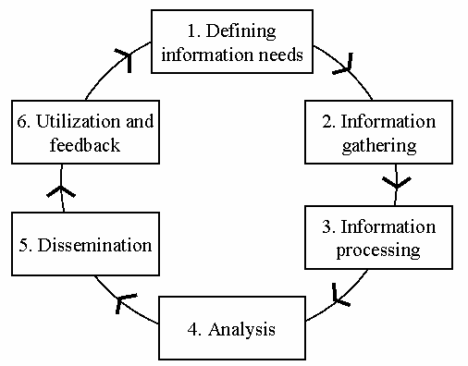

Figure 1 - A generic business intelligence process model.
Source- Vuori, Vilma. (2006).

3. Value of analytical and prescriptive software
A crucial part of contemporary BI systems are analytical and prescriptive software tools. These solutions provide businesses the data insights they need to make wise decisions (Turban et al., 2019). Some crucial categories of analytical and predictive software are listed below:
a) Statistical Analysis Tools: These tools offer a variety of statistical approaches for investigating data, spotting connections, and drawing conclusions. Organizations may undertake descriptive and inferential statistical analysis using these technologies, allowing them to get valuable insights from their data. To inform decision-making, statistical analysis techniques are crucial for spotting trends, correlations, and patterns (Eidizadeh et al., 2017).
b) Data visualization tools: These tools provide visual representations of data, improving accessibility and comprehension of complicated information. These programs turn plain data into interactive graphs, charts, and dashboards that let users explore and evaluate information visually (Tan et al., 2013). By displaying information engagingly and understandably, data visualization improves the sharing of insights and supports data-driven decision-making (Eidizadeh et al., 2017).
c) Predictive Analytics Software: The software analyses previous data and forecasts future outcomes using sophisticated algorithms and models. Organisations may use these technologies to recognise patterns, predict trends, and simulate situations to aid in decision-making. To implement proactive strategies and make wise decisions, predictive analytics assists organisations in anticipating market trends, consumer behaviour, and potential hazards (Eidizadeh et al., 2017).
d) Machine Learning Platforms: Organisations may create and use machine learning models with the help of a collection of tools and algorithms provided by machine learning platforms. These systems simplify the creation, training, and deployment of models, making it simpler for businesses to integrate machine learning into their business intelligence (BI) operations. For businesses looking to include data science methodologies into their BI processes, machine learning platforms are essential (Puklavec et al., 2018).
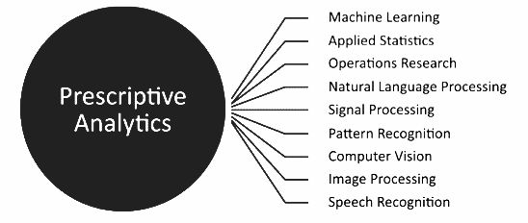

Figure 2 - Technical disciplines of prescriptive analytics.
Source- Selvaraj, Poornima & Marudappa, Pushpalatha. (2016).

Conclusion
Extensive data and sophisticated analytics drive Business Intelligence (BI) trends. Agile methods let companies adapt to changing business needs and provide value progressively. Fast analytics allows companies to process and analyze data in near-real time for faster decision-making. Using data science approaches to typical BI procedures has improved insights and enabled proactive decision-making based on predictive models and sophisticated algorithms. BI implementations also depend on data integration, analytical capability, content quality, and decision-making culture (Sammut & Webb, 2017). The BI framework uses data warehousing, data mining, and information technologies to gather, organize, and analyze data efficiently. Analytical and predictive software technologies, including statistical analysis, data visualization, predictive analytics, and machine learning platforms, are crucial to exploiting data's value (Thomas & Davenport, 2018). In today's data-driven market, organizations may unleash the full potential of their data assets, get important insights, and make data-driven choices that create competitive advantage and commercial success by embracing these trends.

Reference

Brachman, R. J., & Anand, T. (2016). The process of business intelligence. In Engineering Principles of Systems for Biological Defense (pp. 293-307). CRC Press.

Chen, H., Chiang, R. H., & Storey, V. C. (2012). Business intelligence and analytics: From big data to big impact. MIS quarterly, 36(4), 1165-1188.

Eidizadeh, R., Lechtenbörger, J., & Stieglitz, S. (2017). Business Intelligence and Decision Making: Foundations, Dimensions and Challenges. International Journal of Information Management, 37(6), 803-814.

Larose, D. T., & Larose, C. D. (2014). Discovering knowledge in data: An introduction to data mining. John Wiley & Sons.

Larson, B., & Chang, V. (2016). A Review and Future Direction of Agile, Business Intelligence, Analytics and Data Science. International Journal of Information Systems and Software Engineering for Big Companies, 3(2), 53-73.

Mason, R. O., & Mitroff, I. I. (2013). Challenging strategic planning assumptions. Organizational Dynamics, 42(3), 191-199.

Negash, S., & Gray, P. (2008). Business intelligence. Communications of the Association for Information Systems, 23(1), 177-195.

Puklavec, B., Farkas, M., & Slavec, A. (2018). A review and future direction of agile, business intelligence, analytics and data science. International Journal of Business Intelligence Research, 9(4), 29-42.

Sammut, C., & Webb, G. I. (2017). Encyclopedia of machine learning and data mining. Springer.

Tan, P. N., Steinbach, M., & Kumar, V. (2013). Introduction to data mining. Pearson Education.

Thomas, H., & Davenport, T. H. (2018). Process innovation: reengineering work through information technology. Harvard Business Press.

Thomsen, E. R. (2019). Agile Business Intelligence: The Future-Proof Enterprise. Springer.

Turban, E., Sharda, R., Delen, D., Aronson, J. E., & Liang, T. P. (2019). Business intelligence: a managerial approach. Pearson.

