

[APPENDIX GA36b
LEVEL 7 ASSESSMENT SPECIFICATION

Student name: | Paul Boxer | Student ID number: | 0250199
Programme: | MSc Programme
Module: | Postgraduate Research Method
Module code: | ACFA 7004  20 CREDITS | Contribution to Overall Module Assessment (%): | 100%
Lecturer: | Chris House | Internal Verifier: | REJ
Assignment Title: | Research Proposal & presentation | Word count (or equivalent): | 12 min presentation plus A4 summary sheet (30%) 4,000 word Research Proposal (70%)
Submission deadline: | 2nd March-10th March  (PRESENTATION)  Tuesday 26th March 2022 (Research Proposal Report and Ethics form) | Return date of provisional marks & written feedback: | 20/04/22
Submission method: | All written assessments, where practical and possible, must be submitted via Turnitin unless otherwise instructed by the Lecturer. (Please DO NOT put this assessment specification into Turnitin or it will match many similarities with other students’ submissions.)  Alternative submission method (if applicable):  Late submission of the assessment will result in a late penalty mark. Penalties for late submission: Up to one week late, maximum mark of 50%. Over one week late, 0%. Only the Extenuating Circumstances Panel may approve a change to submission dates.
Academic honesty / referencing: | Academic honesty is required. In the main body of your submission you must give credit to authors on whose research and ideas your work is based. Append to your submission a reference list that indicates the books, articles, etc. that you have used, cited or quoted in order to complete this assessment.

Table of Contents
Background 1
Climate Change 1
COP26 1
Energy usage 2
Energy Costs 2
Operational Buildings 3
Case Study Building 3
Aim & Objectives 4
Aim 4
Objectives 4
Literature Review 4
Lighting Improvement (LED) 5
Air Source Heat pumps 6
Solar Photovoltaics (PV) 7
Loft Insulation 7
Window insulation / replacement 8
Wall Insulation 9
Change process 10
Methodology 10
Results & Contribution to literature 11
Timeline & Project Risks 12
Conclusion 13
References 14
Appendix 1 – Questionnaire 1 17
Appendix 2 – Questionnaire 2 19
Appendix 3 – Baseline Data 21
Appendix 4 – Research Timeline 22

Background

Climate Change
Nasa (2022) suggest that the Earth’s surface continues to significantly increase in temperature, with recent global temperatures being the hottest in the past 2,000-plus years. Figure 1 shows how the earth’s temperature is rising on an annual basis. Roper (2021) suggests that there is a direct relationship between global warming and catastrophic weather events such as flooding.
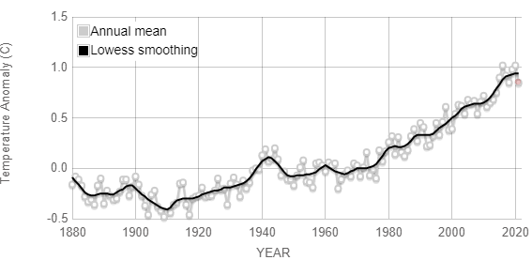
Figure 1, Global Land-Ocean temperature index. Nasa (2021)

COP26
The COP26 summit held in Glasgow, Scotland during 31st October to 13 November 2021 brought parties together to accelerate action towards the goals of the Paris Agreement and the United Nations Framework Convention on Climate Change. Countries have developed ambitious plans to reduce energy emissions by 2030 that align with reaching net zero by 2050. These initiatives include accelerating the phase out of coal, investing in renewable energy, Speeding up the switch to electric vehicles and curtailing deforestation.

WAG (2021) suggest that Senedd Cymru have approved the below targets to achieve net zero by 2050.
These targets are set against a base year as established in the Environment Wales Act 2016.
2021 – 2025 | 37% reduction (Average)
2026 - 2030 | 58% reduction (Average)
2030 | 63% reduction
2040 | 89% reduction
2050 | 100% reduction
Table 1 Senedd Cymru carbon reduction targets (2021)

Energy usage
Global Warming and Climate change is caused by the increase of greenhouse gasses in the atmosphere. Reducing the operational carbon (Energy) or decarbonising reduces the amount of emissions of carbon dioxide and other global warming gasses during the in-use operation of a building by reducing the amount of fossil fuels such Coal, Gas and oil used in the manufacture of energy.

Energy Costs
Ofgem (2022) suggests fuel prices have risen over the last 12 months and expect this price to continue to rise throughout 2022 and remain at this higher price for the next three to five years. This increase in energy costs eats into the budgets of organisations but helps when carrying out cost benefit and Net Present Value (NPV) calculation for decarbonisation strategies.
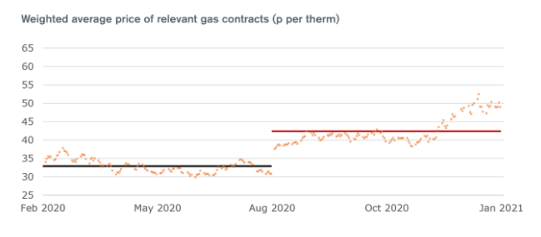
Figure 2 – Average Gas Prices (OFGEM)
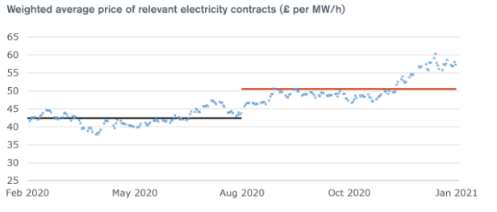
Figure 3 – Average Electricity Prices (OFGEM)

Operational Buildings
Horan et al (2019) suggest that buildings by design occupy people and historically when a major renovation is undertaken in a building, the building users are moved out to minimise disruption caused from associated Health and Safety risks such as noise and that clients believe there is a reduction in overall costs as the contractor has free rein to complete the work. Horan et al (2019) further suggests that these perceived benefits are never weighed up against the costs of moving people in additional office space, the additional travelling employees undertake, the effect on their ability to work effectively or work life balance from longer commuting time.
South Wales Police has 107 properties within its portfolio, 45% of these properties are converted 3 bedroom detached properties in the heart of local communities.

Case Study Building
For this research, I have selected a typical South Wales Police property, the uniqueness around this building is that it must remain operational through the project due to the nature of the work being carried out at this location.
There are several elements of the property that cannot be divulged such as the location, specific network and power details and the nature of the work being undertaken, however none of these will affect the research proposal aim and objectives.

The property is an extended 3 bedroom detached house originally built in the 1970’S and converted to the police premises it is now in the early 1980’s.

The next section highlights the aims and objectives of this research proposal by reducing the speed and impact of global warming by reducing the carbon output within buildings

Aim & Objectives

Aim

To investigate how to effectively decarbonise an operational building – Case Study a police custody unit’

Objectives

- Critically evaluate the theories, effectiveness and complexity of each decarbonisation method.
- Identify the perceptions and barriers within operational building to decarbonise.
- Critical evaluation of the decarbonise techniques used during in the implementation of the project based on actual benefits, costs and disruption to building users.
- Production of an ease benefit matrix for decarbonising operational buildings.

The next section identifies the literature already present around decarbonisation and critically evaluates these techniques, identifies literature around retrofitting existing and operational buildings and building users perceptions to change.

Literature Review

To deliver the first objective of the research presentation, the literature review will focus on the following topics
- Decarbonisation rationale and techniques
- Decarbonisation effectiveness based on costs, risks, barriers and benefits
- Retrofitting of existing & operational buildings
- Perceptions of change

Quingley (2019) identifies five deep decarbonisation strategies these include Electricity decarbonisation where electricity generation emissions are reduced at source; Energy efficiency where the amount of energy consumed is reduced; Fuel decarbonisation where the emissions from intensity of liquid and gaseous fuels is reduced; Carbon capture where hydrogen technologies are used to capture CO2 from a facility or remove it from the atmosphere and electrification where end users switch from fossil fuels to electricity. Table x identifies the targets for each strategy. This research only focuses on energy efficiency and reducing the energy consumed in an operational police custody building.
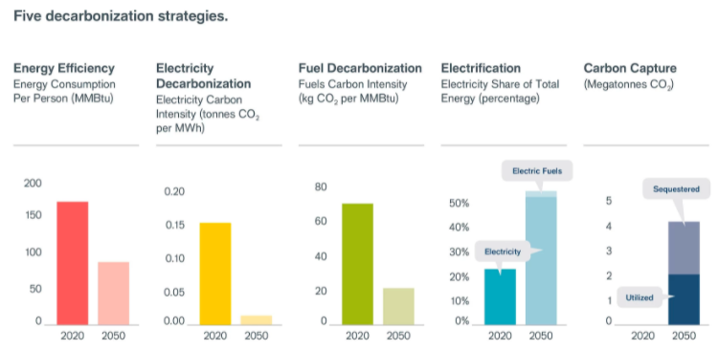
Table x five decarbonisation strategies (Quingley, 2019)

Shell (2021) suggest that once a company has decided to decarbonise there are 5 ways to achieve this these including seeing the opportunity in change; get an accurate carbon footprint; invest in technology, create a sustainable supply chain and collaborate or partner with others. Most of the literature researched identifies the need to invest in technology, there is little literature though explaining in any clear format which technology to invest in and why.

Cole et al (2018) suggest that the MOJs decarbonisation strategy has identified some key thematic projects that can be used to decarbonise their estate. These methods do not focus on the fabric of the building such as energy efficient windows, roof insulation or wall insulation. The methods identified by the MOJ, and the individual fabric elements are what will be used in this research and critically evaluated within the literature review.

Lighting Improvement (LED)

Haynes (2021) suggests LED lighting has now replace 60% of the worlds traditional lighting, this has been expedited with governments phasing out the incandescent filament lights. LEDs have many advantages over traditional fluorescent, MH, CFL and HPS lamps from being recyclable; low power compared to traditional lamps, high lifetime of 5 years plus, cool to touch and can change colours.

IET (2021) suggest that LED Lights were seen as expensive by consumers so had a slow start and only adopted by a few companies as early adopters with the majority being chines imports with poor quality control standards. Technological advantages have reduced the cost of the fittings and increased the life span to a point where these fittings are virtually “fit and forget”. The IET (2021) further suggests that install PIR controls on the lighting systems can potentially double the savings seen from converting to LED fitting.

There are hundreds of energy saving calculators available on the internet, below shows the theoretical savings based on the data from the Selected South Wales police property.
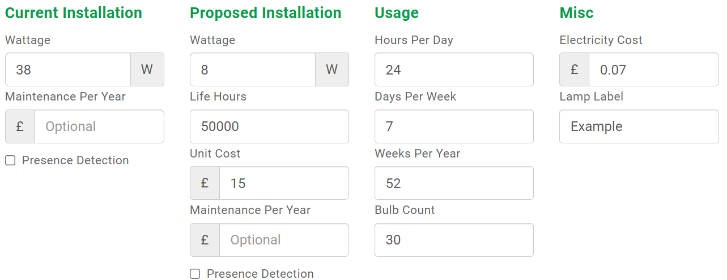
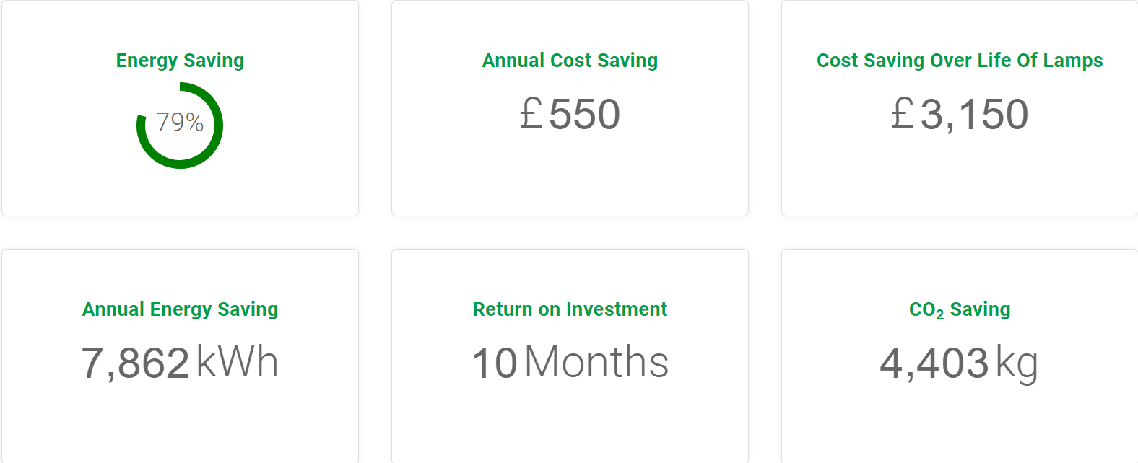
Source: LED Energy Savings Calculator | Lightsave LED | Energy Saving LED

Air Source Heat pumps

Adam (2021) suggests Air source heat pumps (ASHP) are the most efficient way to replace old gas boiler as air source heat pumps are good for the environment as they do not produce carbon emissions and have cheaper running costs, can be used in the summer to supply cool air; they are low maintenance and have a life span of twenty years. There are currently grant schemes available for low-income households, which do not apply to government bodies such as SWP.

CIBSE (2013) Suggests that air source heat pumps disadvantages include being noisy, retrofitting is difficult and not all properties have the space for outside unit or internal space for hot water cylinder.
Reduced efficiencies in winter will lead to an increase in electricity required to run the units, which with electricity already being more expensive than gas could increase the consumers energy bills

CIBSE (2013) there is a fundamental requirement that the property is well insulated to make it efficient and reduce the overall unit size to a minimum. As the temperature of the water is lower radiators may need resizing or underfloor heating installed.

Adam (2021) that an ASHP installation can cost between seven and eleven thousand pounds and provide an annual energy saving of four to six hundred pounds providing a payback time of over ten years

Solar Photovoltaics (PV)

Green (2012) suggest that solar PV panels are increasing becoming a popular choice as more consumers are turning to green energy to power homes and businesses.

Green (2012) suggest the advantages of solar PVs is that they generate free electricity based on daylight, they do not need the sun to be shining a common myth to work. System costs have dropped by over 50% in the last decade making the systems much more affordable and even though feed in tariffs have reduced in the same time frame still have a relatively quick payback and require little maintenance.
The main disadvantages are that even though costs are decreasing, they are still expensive, they are not always viable if the roof, assuming there is adequate space is North or east facing and where tall buildings or trees create shade. Solar panels are low maintenance, but the system does require invertors and batteries which have been known to fail.

Loft Insulation
The Energy Saving Trust (2022) suggest that 25% of the heat in a building is lost through an uninsulated roof and furthermore suggest the that correctly installed loft insulation will pay for itself several times over a 40-year life.

Loft insulation is not always selected as historically in the household trade it has a bad reputation mainly due to incorrect installation, Incorrect amount of insulation and the dreaded DIY enthusiast.

Pearson (2014) identify several pitfalls when installing loft insulation include, not having enough insulation installed; using the loft for storage where either the insulation is squashed, lowering the insulation properties or not enough insulation as boards are applied directly to the existing joists; not having enough ventilation in the roof therefore insulated attic spaces are cooler, introducing or worsening damp or condensation issues and similarly from blocking vents, grills and sir bricks; Insulating the roof rafters and missing out gable ends, party walls or chimneys which heat will use to bypass making the insulation ineffective.

The quantitative benefits for installing loft insulation can be seen in the graphs below


Cost to install, Savings per year and CO2 savings (kgCO2/Year)
Figures are based on a detached house, using energy figures from November 21

Window insulation / replacement

Applied Product (2022) suggest that a single glass pane will lose ten times the amount of heat as the same area of insulated wall. Guardian (2019) back this up by suggesting window film blocks blocking 70% of solar heat gain and provides 50% reduction in heat loss.
Kukoska (2021) suggest the most typical form of window insulation is replacement with 60% of houses having double or triple glazed windows with lower U values to retain heat within a property, however Wallender (2022) suggests that adding a film to a window can have similar benefits but is considerably cheaper and typically maintenance free. Guardian (2019) however suggest there are several drawbacks using window film including trapped moisture and poorly installed film is not aesthetically pleasing.

Brinkley (2020) suggest that using the U value is a rough and ready measure of comparing window performance, this is due to the best U Value widow that is poorly installed will never be as good as a properly installed window with a higher U value.

Brinkley (2020) further suggests that windows will always be the weak spot compared to walls that typically have a U value of 0.3 or lower. Triple glazed windows on a typical detached house can save £120 per annum in energy costs and will pay back in ten to fifteen years. Typical U vales for windows are shown below.

Glazing | U Value (W/m2k)
Single Glazed | 5
Double Glazed | Used to be over 3, manufacturing process improvements have led to building regs insisting on a max U Value of 1.6, 16mm argon filled gap
Triple Glazed | Passivhaus standard windows have a u value of no more than 0.8

Wall Insulation
Pullen (2021) suggests that correctly specified internal wall insulation to the interior face of an external wall can improve a buildings thermal efficiency, hence provide a reduction in heating bills. The most common is a new stud wall with insulation (not always most effective)
Pullen (2021) also suggests internal wall insulation is disruptive as electrical items such as light switches; plumbing and radiators and kitchen units will need to be removed and ultimately the NIA of the building is reduced.
The table below shows the U values for different wall types
Wall type | U Value (W/m2)
Solid Stone | 1.4 – 1.7
Solid 225mm Brick wall | 1.9
Uninsulated cavity wall | 1.5
Current building regulations | 0.2 – 0.3

External wall insulation for a three-bedroom detached property typically costs eight to fifteen thousand pounds and is likely to require planning permission a certain requirement in conservation areas and if not properly installed can cause issues around windows and eave areas. Where cavity walls are in place, cavity wall installation should be the used. Stevens et al (2020) suggest that poorly installed cavity wall insulation is widespread issues in buildings such as condensation, dampness and cavity wall tie degradation where cowboy builders were cashing in on a government insulation drive filling cavities with a material that allows water to cross the cavity causing damp on the internal walls.

Passivhaus targets the total energy used in a building to be less than 80kW/m2

Change process

Rawlinson (2010) identifies the requirement for end users to be included early within a refurbishment project to minimise risks in the design and specification stage of a project were building users needs are not captured. Rawlinson (2010) further suggests for medium size refurbishment projects such as building fabric where work is undertaken in occupied buildings the impact of the project on the end user should be considered.
Rawlinson (2010) requirement looks at project timeframe; sequencing; on site supervision and end user effecting scope creep and does not capture the element that affect the day-to-day operation from noise, Dust, limited access, loss of power and such disruptions within an occupied building. Feiring (2019) further backs this up by suggesting ends users are the ultimate stakeholders and their involvement is critical to the success of any project as not understanding the end users’ requirements is the most common reason for project failure or rework and is essential for budget management.

The next section highlights the methodology used to complete the research, using both qualitative and quantitative measures.

Methodology

To complete this dissertation a case study will be created identifying the ease and benefits of implementing several different decarbonisation techniques on an operational building within the south Wales police estates portfolio.

To deliver objective one, an initial questionnaire will be produced (See Appendix 1) which will incorporate a mixture of both quantitative and qualitative questions and delivered to a sample of the building users to understand their perception of each decarbonisation methods in terms of KWH reduction, cost and their impact on the user during installation. The questionnaires will be issued by the property admin staff, this removes any bias I may introduce in the selection of individuals The Questionnaires will also be delivered to the estates staff who regularly deliver this type of project and specialist contractors

To complete the second objective the actual current energy usage in KwH/M2 for both gas and electricity from a baseline year of 2018/19 (see appendix 3) is used. This year was selected as it is the most recent full years data available before the covid pandemic where building utilisation was changed due to absenteeism and working pattern changes to reduce the impact the pandemic had on operational policing.
The theoretical benefits of each method will be mapped to understand the maximum theoretical benefit in KWH/M2 reduction. A TAS model of the building will be generated to produce a dynamic thermal model to understand overheating area, poorly ventilated and combined with a thermal imaging survey determine the heat loss areas.

The second questionnaire (see appendix 2) will be distributed in the same manner as the first questionnaire to understand if building user’s perceptions have changed after the work was completed in relation to disruption and energy benefit. This will identify whether the same population was captured and provide a mixture of both Quantitative and Qualitative data.

The next section highlights the potential results and how they will be collated to form the ease benefits matrix. The section further identifies how this research contributes to literature and its use worldwide.

Results & Contribution to literature

The results obtained from the first questionnaire will be graphed to show what building users who have limited knowledge, but a “large voice” perceive how each of the energy reduction methods identified will have on the building i.e., energy reduction, financial implications, costs and how the installation will impact on the end user i.e., disruption and noise.
This will be compared against the theoretical benefits of each benefit on the building and a pre-installation ease benefit matrix created.

Once the project is completed the actual qualitative benefits in reduction of kWh of energy used for each method can then be quantified and graphed against the theory. The reason for any differences between theory and practical can then be addressed.
The results from the second questionnaire will again be graphed to show if building users attitude to disruption and benefits of each method changed over the project time frame.

This will allow analysis of perceived energy benefit pre & post decarbonisation, perceived disruption pre and post decarbonisation and actual energy benefits against theoretical benefits.

An ease benefit matrix will be created, identifying the various types of decarbonisation techniques and scored on actual energy benefits aligned to building users perceptions. I believe the results will identify the need to carry out a fabric first approach to decarbonisation to minimise the Kw/m2 energy usage to a minimum before sizing and installing the more expensive Solar Photovoltaics and Air source heat pumps.

This research proposal will contribute to knowledge as other Facility Managers across the world within police forces and other essential blue light services will be able to understand the best approach to decarbonising a building whilst remaining operational and taking the building users on the journey with demonstrable evidence that can be used to reduce or eliminate perceived issues before any project commences.

This will allow companies to benefit from the decrease in energy costs and increased environmental performance of their buildings without having the losses in costs of relocating staff during refurbishments.

The next section identifies the timeline to completing the research, implementing the project and completing the analysis. The timeline also identifies risks that the researcher has identified and where possible identified counter measure should these risks materialise.

Timeline & Project Risks

To ensure the dissertation is completed prior to the submission date a project timeline has been created, this can be seen in appendix 4. Whilst each element of the timeline is not fixed and can be adjusted to suit the researcher, the timeline does identify key fixed milestones such as the submission date.
The timeline also identifies the risks within the dissertation, the biggest risk identified is that the project will not be completed on time.

The start and finish of the overall project is not within the control of the researcher, there are risks that the project is delayed, or the project is not completed on time. The researcher can overcome a delay in completion by reducing the amount of decarbonisation methods reviewed. For example, if only four methods have been installed by the time the dissertation requires the results, then only these methods will be reviewed in the research.

The next section concludes all the work identified in this research proposal.

Conclusion

This research identifies how facility and Project managers can meet the World and government targets of preventing the earth from increasing in temperature to an unsustainable level by reducing carbon usage within buildings, whilst they remain operational. Keeping a building operational whilst decarbonising will reduce the parent companies costs in relocation, proving other facilities and reduces the impact on their employees both mentally and physically. This research focuses on a police custody unit where relocation of staff during renovation is almost impossible. The title and main aim of this research is below:

To investigate how to effectively decarbonise an operational building – Case Study a police custody unit’

To achieve this aim, several objectives will need to be met, these are:
- Critically evaluate the theories, effectiveness and complexity of each decarbonisation method.
- Identify the perceptions and barriers within operational building to decarbonise.
- Critical evaluation of the decarbonise techniques used during in the implementation of the project based on actual benefits, costs and disruption to building users.
- Production of an ease benefit matrix for decarbonising operational buildings.

The literature research will identify the theories, effectiveness and complexity of each decarbonisation method. The researcher will critically evaluate these and produce a theoretical matrix comparing each technique.

An Initial questionnaire will be developed and delivered to a sample of the users within the building to understand the perception of business users on the benefits of each decarbonisation method and the barriers and disruption caused by installing each of these. At the same time the existing building energy usage will be derived from the last five years energy usage.

The decarbonisation strategies will be implemented within a police custody unit and a second questionnaire will be developed to understand if and why perceptions of decarbonisation benefit and disruption during installation has changed.

From this an ease benefits matrix will be created to show the best methods of decarbonise
This research proposal will contribute to knowledge as other Facility Managers across the world not just in the police forces, but other blue light essential services will be able to understand the best approach to decarbonising a building whilst remaining operational. Allowing companies to benefit from the decrease in energy costs and increased environmental performance of their buildings without having the losses in costs of relocating staff during refurbishments.

References

Adam (2021) Air source heat pumps, available at: Air Source Heat Pumps: Advantages and Disadvantages | Boiler Guide. Accessed 14/03/2022

Anon (2021) Climate Change targets and carbon budgets, available at: Climate change targets and carbon budgets | GOV.WALES. Accessed 09/03/2022

Applied Products (2022) 6 Ways to insulate your windows, available at: 6 Ways to Insulate Your Windows and Beat The Cold (appliedproducts.co.uk). Accessed 18/03/2022

Barret, John; Cooper, Tim; Hammond, Geoffrey; Pidgeon Nick (2018) Industrial Energy, material & products: UK Decarbonisation challenges & opportunities, available at: Industrial energy, materials and products: UK decarbonisation challenges and opportunities — the University of Bath's research portal. Accessed 08/03/2022

Brinkley, Mark (2020) Triple Glazed windows do they make sense, available at: Triple Glazed Windows: Do They Make Sense? | Homebuilding. Accessed 16/03/2022

CIBSE (2013) Can retrofitting ASHP provide significant CO2 reductions, Section 6 Paper 2 CIBSE Technical Symposium, Liverpool university 11-12 April 2013; available at: CIBSE - Building Services Knowledge. Accessed 14/03/2022

Cop26, (2021) Climate change conference, available at: HOME - UN Climate Change Conference (COP26) at the SEC – Glasgow 2021 (ukcop26.org). Accessed 09/03/2022

Cole, John; Soroczynski, Claire (2018) “Ministry of Justice Estates directorate carbon & energy reduction strategy” pp11-14, available at: Sustainable Operations - Carbon and Energy Reduction Strategy (publishing.service.gov.uk). Accessed 09/03/2022

Doukas (2019) Understanding Risks and uncertainties in energy & climate policy
Energy Saving Trust (2022), Roof insulation guide, available at: Roof and loft insulation guide - Energy Saving Trust. Accessed 17/03/2022

Feiring, Cliff (2019) End users – the ultimate stakeholders, available at End-Users: The Ultimate Stakeholders (temple.edu). Accessed 03/03/2022

Forbes, McGain; Burch, Hayden (2021) Victorian public healthcare chief executive officers view on renewable energy, available at: Victorian public healthcare Chief Executive Officers' views on renewable energy supply - PubMed (nih.gov). Accessed 17/03/2022

Gerfen, Kate (2020) Requirements for green restoration and renovation of existing buildings, available at Renovation, Restoration, and Adaptive Reuse: The Understated Value of Existing Buildings | Architect Magazine. Accessed 13/03/2022

Green, Dino (2012) Advantages and disadvantages of solar photovoltaic, available at Advantages and disadvantages of Solar Photovoltaic – Quick Pros and Cons of Solar PV (renewableenergyworld.com). Accessed 13/03/2022

Guardian Window Film (2019) Thermal window film – does it work, available at: Thermal Window Film: Does it Work? | Guardian Window Film. Accessed 18/03/2022

Haynes, Roxanne (2021) The pros and cons of LED lighting, available at LED Lighting Benefits and Drawbacks - TACHYON Light. Accessed 10/32022

Horan, William; Shawe, Rachel; Moles, Richard, O’Regan, Bernadette (2019) Development & evaluation of a method to estimate the potential of decarbonisation technologies deployment at higher education campuses, available at: Development and evaluation of a method to estimate the potential of decarbonisation technologies deployment at higher education campuses - ScienceDirect. Accessed 12/03/2022

IET (2021) Code of practice for the application of LED lighting systems (2nd Edition) pp 228, available at: The IET Shop - Code of Practice for the Application of LED Lighting Systems. Accessed 16/03/2022

Jones, Ewan (2021) The need for decarbonisation, available at: The need for decarbonisation - Special Issue Editor Ewan Jones, 2021 (sagepub.com). Accessed 08/03/2022

Kukoska, Ana (2021) Double Glazing in the UK, available at: Double Glazing Windows & Doors (2022 Guide) | GreenMatch. Accessed 16/03/2022

Levesque, Antoine; Pietzcker, Robert; Baumstark, Lavinia; Luderer, Gunnar (2021) Deep decarbonisation of building energy services through demand and supply transformation in a 1.5^C Scenario, available at: Deep decarbonisation of buildings energy services through demand and supply transformations in a 1.5°C scenario - IOPscience. Accessed 09/03/2022

McGinley, Orlaith; Moran, Paul; Goggins, Jamie, (2022) An assessment of the key performance indicators of energy efficient retrofits in existing residential buildings, available at: (PDF) An Assessment of the Key Performance Indicators (KPIs) of Energy Efficient Retrofits to Existing Residential Buildings (researchgate.net). Accessed17/03/2022

Nasa (2022) Climate Change, available at: Global Temperature | Vital Signs – Climate Change: Vital Signs of the Planet (nasa.gov) Accessed 09/03/2022

OFGEM (2022) Energy price cap, available at: Energy price cap to increase in April but consumers should switch to save money | Ofgem. Accessed 09/03/2022

Pearson, Andy (2014) Residental retrofit to Passivhaus standards, available at: CIBSE - Building Services Knowledge. Accessed 12/03/2022

Pullen, Tim (2021) Internal wall construction, available at: Internal Wall Insulation: The Complete Guide | Homebuilding. Accessed 10/03/2022

Quingly, Eileen (2019) 5 deep decarbonisation strategies, available at: Five Deep Decarbonization Strategies (cleanenergytransition.org). Accessed 16/03/2022

Rawlinson, Simon (2010) Procurement Refurbishment, available at: Procurement refurbishment | Features | Building. Accessed 15/03/2022

Roper, Willem (2021) Global Warming Chart, available at: Global Warming Chart - Here's How Temperatures Have Risen Since 1950 | World Economic Forum (weforum.org). Accessed 09/03/2022

Shell (2021); Five ways to decarbonise your business, available at: Five key ways to decarbonise your business (shellenergy.co.uk). Accessed 16/03/2022

Stevens; Collier (2020) Identifying cavity wall insulation problems, available at: Identifying cavity wall insulation problems | Collier Stevens (collier-stevens.co.uk). Accessed 12/03/2022

Turhan, Cihan; Kocyigit, Filiz; Zinkci, Merter; Sayesthnom, Miromid (2019) Feasibility of Nearly Zero energy building retrofits by using renewable energy sources in an educational building, available at: (PDF) FEASIBILITY OF NEARLY-ZERO ENERGY BUILDING RETROFITS BY USING RENEWABLE ENERGY SOURCES IN AN EDUCATIONAL BUILDING (researchgate.net). Accessed 16/03/2022

Wallender, Lee (2022), How to insulate windows, available at: How to Insulate Windows (thespruce.com). Accessed 18/03/2022

Appendix 1 – Questionnaire 1

Paul Boxer- MSc Research Proposal - Questionnaire 1

Department ___________________________
Job Title ___________________________
Length of service ___________________________

Please circle answer below
Sex M F Other Prefer not to say
Age 18 – 29 30 – 39 40 – 49 50+

Please base all your answers on the following property only:
1-2 Cowbridge Road RJ100519

Q1) For each of the decarbonisation (Energy Reduction) methods below, please circle the score based on your thoughts of the installation cost and provide estimate price.
Q2) For each of the decarbonisation (Energy Reduction) methods below, please circle the score based on your thoughts regarding the ease to install.
Q3) For each of the decarbonisation (Energy Reduction) methods below, please circle the score based on your thoughts on the overall reduction in energy usage from that strategy.
Q4) For each of the decarbonisation (Energy Reduction) methods below, please circle the score based on your thoughts of the overall onsite time taken to install the equipment.
Q5) For each of the decarbonisation (Energy Reduction) methods below, please circle the score based on how disruptive you believe the installation will be to your daily task.
Q6) For each of the decarbonisation (Energy Reduction) methods below, please provide reasons for the score given in Question 5

Appendix 2 – Questionnaire 2

Paul Boxer- MSc Research Proposal - Questionnaire 2

Department ___________________________
Job Title ___________________________
Length of service ___________________________

Please circle answer below
Sex M F Other Prefer not to say
Age 18 – 29 30 – 39 40 – 49 50+
Di you answer Questionnaire 1 Y N

Please base all your answers on the following property only:
1-2 Cowbridge Road RJ100519

Q1) For each of the decarbonisation (Energy Reduction) methods below, please circle the score based on the installation cost and provide estimate price now the work is complete.
Q2) For each of the decarbonisation (Energy Reduction) methods below, please circle the score based on the ease to install now the work is complete.
Q3) For each of the decarbonisation (Energy Reduction) methods below, please circle the score based on your thoughts on the overall reduction in energy usage from that strategy.
Q4) For each of the decarbonisation (Energy Reduction) methods below, please circle the score based the overall onsite time taken to install the equipment.
Q5) For each of the decarbonisation (Energy Reduction) methods below, please circle the score based the actual disruption caused whilst carrying out your daily task.
Q6) For each of the decarbonisation (Energy Reduction) methods below, please provide reasons for the score given in Question 5

Appendix 3 – Baseline Data

Building number | Building type | Gas kWh consumption April 2018 to March 2019 Reference Baseline Year | Gas cost in 2018-2019 at 3 p/kWh | Gas cost for the 2018-2019 consumption at rate of 8p/kwh
RJ100516 | Three storey detached dwelling; gas boiler; natural ventilation. DEC C | 53,551 | £2,073 | £4,284

Site Number | GIA (m2) excluding plant rooms and internal car parks | Gas kWh consumption April 2018 to March 2019 Reference Baseline Year | Gas kWh /m2 in 2018-19 | Gas cost £/m2 in 2018/19
RJ100516 | 1,180 | 53,551 | 45 | £2

Site Number | Building type | Elec kWh consumption April 2018 to March 2019 Reference Baseline Year | Elec cost 2018-2019 @ 15p/ kWh | Benchmark 2018-19 year @ 27p/kwh
RJ100516 | Three storeys detached dwelling: Electric Showers, CFL Lighting | 184,620 | £28,801 | £49,847

Site Number | GIA Area m2 (excluding plant rooms and internal car parks | Elec kWh consumption April 2018 to March 2019 - Reference Baseline Year | Elec kWh /m2. year | Elec cost /m2. year
6 | 1,851 | 184,620 | 100 | £16

Appendix 4 – Research Timeline

