I confirm that I have not presented any AI generated text as my own work. I confirm I have copies of my drafts, notes, and other resources I used before, and after the use of AI tools which I may be asked to provide in evidence.

Reporting the results of a study exploring the difference in levels of social media use between extroverts and introverts
Abstract
The present study examined the relationship between extraversion and social media use. It was hypothesised that individuals with higher levels of extraversion would report greater social media use. A sample of 34 undergraduate psychology students (aged 18–69) was recruited using convenience sampling. Extraversion was measured using items from the Big Five Inventory (BFI), and social media use was assessed using the Social Media Use Questionnaire (SMUQ). Participants were categorised into high and low extraversion groups, and an independent samples t-test was conducted. Results indicated no significant difference in social media use between individuals high and low in extraversion groups, t(32) = 1.02, p = .16. These findings are inconsistent with previous research suggesting that extraverted individuals are more active on social media. The lack of significant results may be explained by methodological limitations, including a small sample size and a student-only sample. Future research should address these limitations to further explore this relationship.

Introduction
Social media use has increased significantly worldwide. An estimated 5.66 billion people had some kind of social media presence in 2025 which is believed by researchers to keep rising for years to come (Datareportal, n.d). Many studies examine demographic characteristics of users (Wilson, Gosling, & Graham, 2012) while others examine how personality traits relate to the use of social media (Amichai-Hamburger & Vinitzky, 2010; Moore & McElroy, 2012; Ross et al., 2009).
According to recent research, belonging and self-presentation are the motivations behind the usage of social media (Seidman, 2013). Personality trait theories, particularly the Five Factor Model, or “The big 5” developed by Costa and McCrae (1992) explain individual differences in behaviour by offering a structured framework for understanding people’s thoughts, emotions, and social interactions, commonly measured using the NEO Personality Inventory (Gross, 2020).
The model organises personality traits into five categories: openness, conscientiousness, extraversion, agreeableness, and neuroticism. Its purpose is to predict and describe an individual's behaviour (American Psychological Association, 2018). Extraversion can be described in people who are active, sociable, talkative and assertive (McCabe & Fleeson, 2014; Bowden-Green et al., 2020), in contrast to an introvert who is more comfortable in their own company and who are increasingly more selective when it comes to building social relationships (Tuovinen et al.,2020).
According to Seidman (2013), social media use is motivated by individuals’ desire for a sense of belonging and their need to present an idealised image of themselves in order to gain respect from others. Huang (2025) reported that findings from a questionnaire survey found that “individuals with higher extraversion showed higher activity on social media, including more posting, liking and commenting behaviours”. Participants high in extroversion from this study were also found to be more likely to post selfies, indicating a positive correlation between self- presentation on social media and extroversion traits relating to the Big Five personality model.
The aim of this study is to further explore the relationship between extraversion and social media use in a sample of first year psychology students. Based on the literature presented throughout, it is hypothesised that individuals with higher levels of extraversion will report significantly greater social media use than individuals with lower levels of extraversion.

Methods

Participants
There were 34 undergraduate psychology students that were recruited via convenience sampling to take part in the study (13 males, 19 females, 2 non-binary). Participants ranged in age between 18 and 69 (M=29.26, SD=11.34).
Design
A between- subjects design was employed for this study in order to assess the levels of extraversion (IV) and social media use (DV). Participants were categorised into groups of low or high levels of extraversion based upon sample mean. An independent-samples t-test was used to analyse the data.

Materials
The Big Five Inventory (BFI; John & Srivastava, 1999) was used to assess levels of extraversion in participants (see appendix A). The full BFI includes 44 items, however only items related to the trait of extraversion were used in this study. A total of eight items, therefore, were used to measure extraversion levels. Participants were instructed to respond to each of the eight statements based on how they generally see themselves, and the anchor ‘I see myself as someone who…’ was provided at the beginning of the questionnaire. Responses to each statement, including “... generates a lot of enthusiasm”, were given on a 5-point Likert scales anchored from 1 = strongly disagree to 5 = strongly agree, with total scores on the scale subsequently ranging from eight to 40. Three items were negatively worded and required reverse scoring prior to analysis. Higher scores for this personality trait indicate a more outgoing and sociable person. Internal reliability for the extraversion scale in this study was initiated to be .56 which is lower than that reported by John, Donahue and Kentle (1991) (Cronbach’s alpha = .83). To measure level of social media use, the Social Media Use Questionnaire (SMUQ; Xanidis & Brignell., 2016) was used. This questionnaire contained nine items that aimed to assess levels of dependence to social networking sites (SNS). Participants were asked to provide a response to statements, such as “I spend a large proportion of my day using social network sites”, on a five-point scale anchored between zero (never) to five (always). Final scores ranged between zero and 36, with higher scores indicative of higher levels of dependence on SNS. Internal reliability for this scale was .90, which corresponds with previous research using this scale (e.g., Xanidis & Brignell, 2016)

Procedure
Participants were recruited via the Experiment Manager System (EMS) offering students to take part in an online study. Once the participants clicked on the relevant link, they were first presented with an information sheet (See Appendix B) and consent information (see appendix C) and asked to read and agree to take part in the study. Once consent was provided, participants were then presented with the demographic questionnaire to gather information such as age and gender (see appendix D). The participants then completed the extraversion questionnaire (see appendix A) followed by the social media use questionnaire (see appendix E). Once all the information was submitted by the participants, the debrief (see appendix F) and a thank you for participating in the study was provided.

Results
An independent samples t-test was conducted to explore the difference in social media use between introverts and extraverts (See appendix G). Descriptive statistics are presented in table 1.
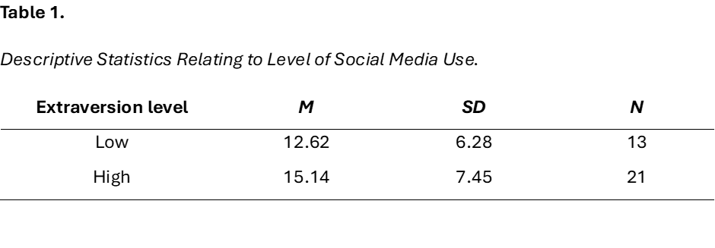
The t-test showed that there was no significant difference in the level of social media use between participants categorised as introverts and extraverts; t (32) =1.02, p=.16 (See appendix H). The hypothesis that participants high in extraversion would use social media more than those low in extraversion must, therefore, be rejected.

Discussion
As outlined above, the hypothesis has to be rejected due to the findings of this study which highlights that there is no significant differences in levels of social media use in extroverts and introverts. The findings by Moore and McElroy (2012) and Huang (2025) found that extroverts spend more time using social media by measuring the number of likes, comments, friends and content posts opposes the results of this study. The discovery by McCabe and Fleeson (2014) and Bowden-Green et al (2020) also found that extroverts were more likely to “feel connected” online by having fun and interacting with others on social media. Although Ross et al (2009) did not measure the time spent specifically using social media, findings, however, did show that participants high in extroversion reported being active in more social media groups than those participants who were reported to be lower in extroversion. Additionally, Amichai-Hamburger and Vinitzky (2010) who measured personality traits found that although the participants in the extraversion group had a “significantly higher” number of friends, there was found to be no significant difference found in relation to participating in Facebook groups, opposing Ross et al (2009). The big Five personality traits were tested to see the relationship between belonging and self-presentation where Seidman (2013) found a correlation between extroversion and levels of communication in contrast to Moore and McElroy (2012). Therefore, the results in this study are contrasting those of previous literature.
There are, however, limitations to this study which needs to be considered when comparing these results to previous studies. Firstly, extroversion was not the only personality trait to be considered when exploring the differences in levels of social media use between personality traits, other studies took The Big Five and measured each trait to conclude different findings, consequently providing a stronger analysis on social media behaviours. Secondly, the population in this study were university students which research suggests are more likely to use social media than the rest of the population, therefore, limiting generalisability, although Chen (2005) found that this could be as a result of peer support to assist participants with their studies. Lastly, using an independent samples t-test with a sample size of 34 does not conclude a strong validity for the wider population.
In conclusion, this study aimed to investigate the relationship between extraversion and social media use but found no significant difference between individuals with high and low levels of extraversion. These findings contrast with much of the existing literature, which suggests that extraverted individuals are more active on social media. However, methodological limitations, including a small sample size and the use of a student population, may have influenced the results. Future research should aim to include larger and more diverse samples, as well as more reliable measures of personality, in order to better understand the relationship between personality traits and social media behaviour.

References

American Psychological Association. (2018). APA dictionary of psychology. https://dictionary.apa.org/trait-theory
Amichai-Hamburger, Y., & Vinitzky, G. (2010). Social network use and personality. Computers in Human Behaviour, 26(6), 1289-1295. https://doi.org/10.1016/j.chb.2010.03.018
Bowden- Green, T., Hinds, J., & Joinson, A. (2020). How is extraversion related to social media use? A literature review. Personality and Individual Difference. 1-11.
Costa, P. T., & McCrae, R. R. (1992). The five-factor model of personality and its relevance to personality disorders. Journal of Personality Disorders, 6(4), 343–359. https://doi.org/10.1521/pedi.1992.6.4.343
Datareportal (n.d). Global social media statistics. https://datareportal.com
Huang, Y. (2025). How does extroversion affect an individual’s frequency of interaction and self- presentation on social media platforms? Proceedings of the 2nd international Conference on Global Politics and Socio-Humanties, 108(1), 62-68. https://doi.org/10.54254/2753-7048/2024.25008

John, O. P., Donahue, E. M., & Kentle, R. L. (1991). The Big Five Inventory--Versions 4a and 54. Berkeley, CA: University of California, Berkeley, Institute of Personality and Social Research.
McCabe, K. O., & Fleeson, W. (2012). What is extraversion for? Integrating trait and motivational perspectives and identifying the purpose of extraversion. Psychological Science, 23(12), 1498–1505. https://doi.org/10.1177/0956797612444904
Moore, K., & McElroy, J. (2012). The influence of personality on Facebook usage, wall postings and regret. Computers in Human Behaviour, 28(1), 267-274. https://doi.org/10.1016/j.chb.2011.09.009
Ross, C., Orr, E. S., Sisic, M., Arseneault, J. M., Simmering, M. G., & Orr, R. R. (2009). Personality and motivations associated with Facebook use. Computers in Human Behaviour, 25(2), 578-586. https://doi.org/10.1016/j.chb.2008.12.024
Seidman, G. (2013). Self- presentation and belonging on Facebook: How personality influences social media use and motivations. Personality and Individual Differences, 54(3). https://doi.org/10.1016/j.paid.2012.10.009
Tuovinen, S., Tang, X., & Salmela-Aro, K. (2020). Introversion and social engagement: scale validation, their interaction, and positive association with self-esteem. Frontiers in psychology, 11, 590748. https://doi.org/10.3389/fpsyg.2020.590748
Wilson, R. E., Gosling, S. D., & Graham, L. T. (2012). A review of Facebook research in the social sciences. Perspectives and Psychological Science, 7(3), 203-220. https://doi.org/10.1177/1745691612442904
Xanidis, N., & Brignell, C. M. (2016). The association between the use of social network sites, sleep quality and cognitive function during the day. Computers in Human Behaviour, 55(Part A), 121-126. https://doi.org/10.1016/j.chb.2015.09.004
Appendices
Appendix A.

Appendix B.



Appendix C.

Appendix D.
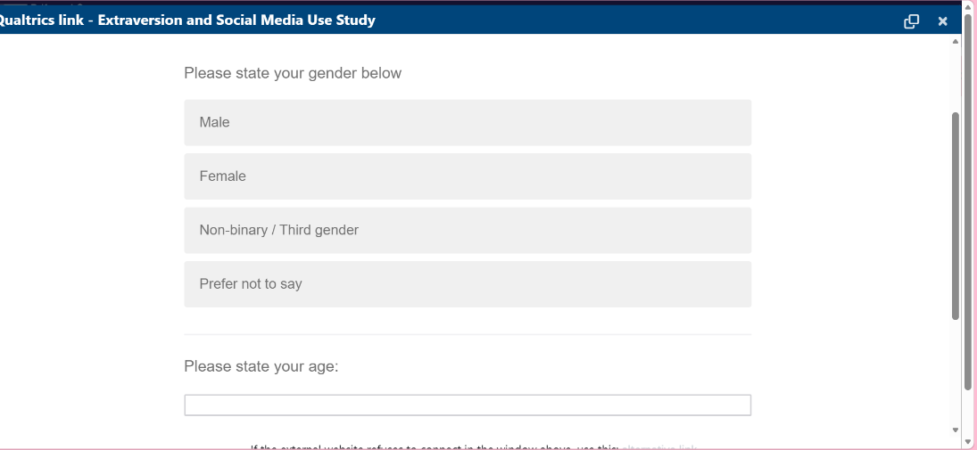

Appendix E.


Appendix F.

Appendix G.
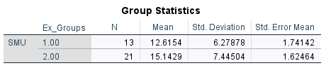

Appendeix H.


