Student Number: 1702665

BA Course Title: Ways of Perceiving

Word Count: 1452

Tutors Name: Ryan L. Moule

In a time where human activity is overpowering the growth of our natural world, we, as humans, seem to have only now realised the damage done. The question still remains, are we too late? In 2019, NASA released statistics which show the appalling figures we are up against. “Global average sea level has risen nearly 7” (178mm) over the past 100 years.” (Holly Shaftel, April 5th 2019) Countries all over the world are being affected at different stages and are receiving dangerous impacts on their ways of living. Whilst there are plenty of topics various newspapers and online articles could inform us about, the only things that seem to be hitting the headlines are Brexit or the Kardashian family scandals. Just over a week ago, a catastrophic ‘natural disaster’ swept away the lives and homes of thousands of innocent people across Africa, nevertheless, this has not been given the desperate attention it needs. “Cyclone Idai has devastated people's lives. They need your help.” (Lucian Msamati, 2019)

After years of being encouraged to shop online, which includes ordering your weekly food shop to buying all the latest clothing trends, online shopping or ‘click and collect’ which it is more famously known as, has been becoming more frequently used in the modern generation. This is increased by the persuasive tactics of countless discount codes and shopping at the comfort of your own home. We are now fighting back for manual labour as our shops are closing down and staff are being replaced by self-checkout machines. Individuals seem to only be heading into a supermarket to pick up their click and collect parcels than spending the time to look around the stock in the actual store itself. These days, companies are using the smart techniques of allowing their store to become a click and collect point, purely down to it getting consumer attention and they can hopefully use it as an opportunity to purchase some items whilst actually leaving their house to pick up their parcels. “Rock bottom prices alone no longer cut it. Britain's biggest grocers are being forced to try new tactics to hold on to customers.” (Alyi Ram and Michael Pooler, March 2016)

Deforestation, fast fashion and the meat industry are having a frightening impact on the environment. We can assume due to unrevealing facts that everybody should do their part to help the environment, knowing the unsettling consequences we are up against. Whether it be cutting down on meat, lowering the amount of single use plastic or shopping sustainably, most people can do at least something. In the book called ‘Epochs of Nature by Georges-Louis Lectlerc, Comte de Buffon (1778)’ stated “The entire face of the earth today bears the imprint of human power.” Humans have used and abused their powers.

I have chosen to base my exhibition in the Mission Gallery Swansea, I think that the layout offers a good range of space to explore all the different mediums I have decided to
Include. As my exhibition is based on the environment and the way we live today i have tried to cover all aspects.

Firstly, as you walk into the room you would notice it is glowing bright green, when you look up you will see ‘Green Light’ by Olafur Eliasson which is these beautiful handmade green lamps hanging down from the beams. I chose this work very specifically as I knew I wanted a green glow throughout the space, it is also going to be interfering with each of the other pieces as there will be a green hue bouncing off each piece of art. The work ‘Green Light’ was designed to be made in a group project of refuge and diverse people coming from all backgrounds, but directed and designed by Olafur Eliasson. Each person got to take part in building sustainable lamps which helped expand on their team building and creative skills. “Green light is an act of welcoming, addressed both to those who have fled hardship instability in their home countries” (Olafur Eliasson, 2016). The lamps act as the glue of the whole exhibition, everything is revolved around them.

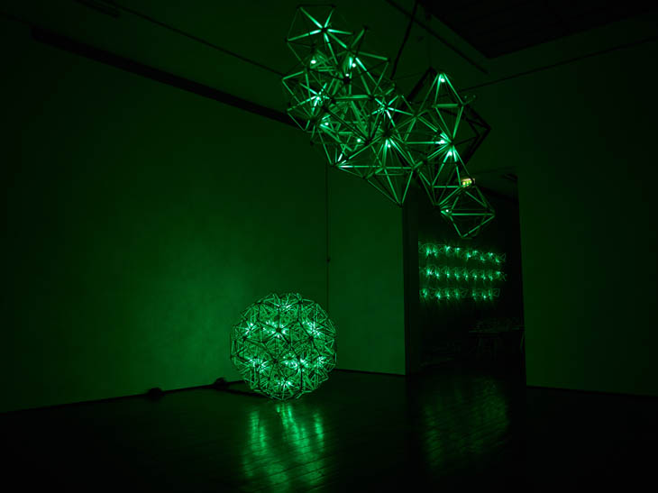 Figure 1

On the right hand side is a photograph by Francesca Woodman called Untitled, 1972. The image is of a woman which is most probably Woodman herself, as she often would work with self-portraits. The woman is laying down naked on the ground and in black and white. The image itself is very tiny to scale ‘10.00 x 8.00 inches’ so the viewers would have to go up close to view it in detail. I chose this piece of work as Woodman is my favourite photographer who influences me a lot in the way I work, I think that she would have always saw the deeper meaning of everything. To me, when the work is placed in an exhibition about global damage she represents poverty and loneliness.
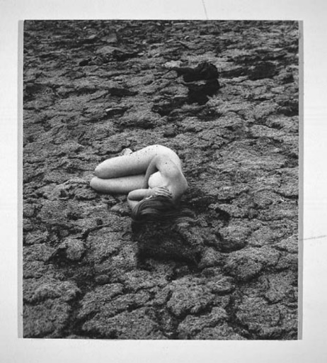 Figure 2

Pale Blue Dot is the most distant image of the Earth ever taken, “Our planet was caught in the centre of the scattered light rays resulting from taking the image so close from the sun.” (NASA/JLP) The image is fascinating and draws you in so much as you can barely notice the tiny dot that is the earth we live on today. In Carl Sagan's 1994 speech on Pale Blue Dot he said that “Our planet is a lonely speck in the great enveloping cosmic dark.”(Carl Sagan, 1994) The image of earth was taken at such a distance, from Voyager 1 that it is quite unbelievable to understand the greatness of life it holds. “Although its painted images are two-dimensional, its potential of illusionism is far greater than that of sculpture, for it can suggest objects possessing colour, texture and temperature, filling a space and, by implication, filling the entire world.” (John Berger, Ways of seeing) One of my reasons for having this work in my exhibition is how each piece represents a different perspective of earth and everything in it. The quote by ‘John Berger’ describes how i want people to feel when walking into my room but also when looking deep into the individual pieces of work.

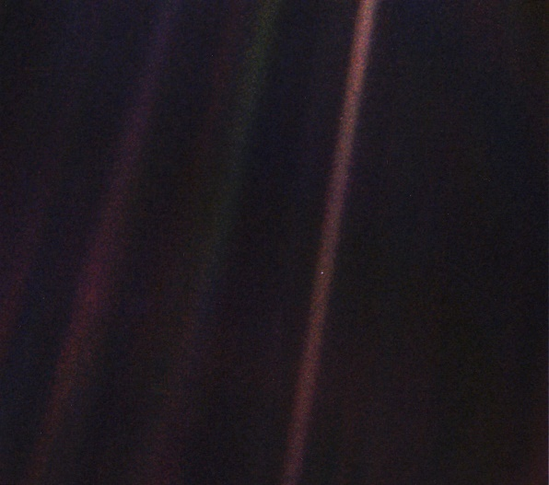Figure 3

On the left side of the room will be an iPad on the wall which is showing a live feed of Jim Carrey's Twitter page. It will refresh itself every time he tweets, likes or shares something new. This way the viewers can interact with the work as well as looking at it. Carrey's Twitter is famous for his influential opinions and drawings he does mostly of the US Government and Donald Trump. He seems to have made it very clear of his feelings of dislike against the President and his ways of ‘leadership’. I wanted to include this into my space as it brings a feel of the new digital age into an exhibition warning us about modern day living.

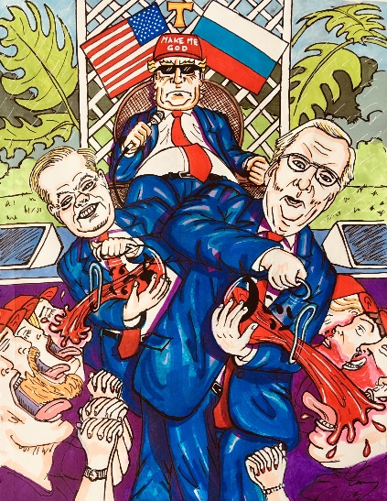 Figure 4

Lastly, in the room at the back will be a projector which is playing a short film created by Helen Sear from her exhibition Prospect Refuge Hazard. The clip, which is called ‘Wahaha biota’ is of a forest with sounds playing over the top which she created during her residency leading up to the project. “Their calls and whispers mingle with bird song and barking deer across the physical space of the forest.”(Helen Sear 2019) As you walk into the final part of the exhibition you will be taken back by the sanctuary type feeling, i want the viewers to be taking back by the calming sound of nature and the stillness of the environment in the video.

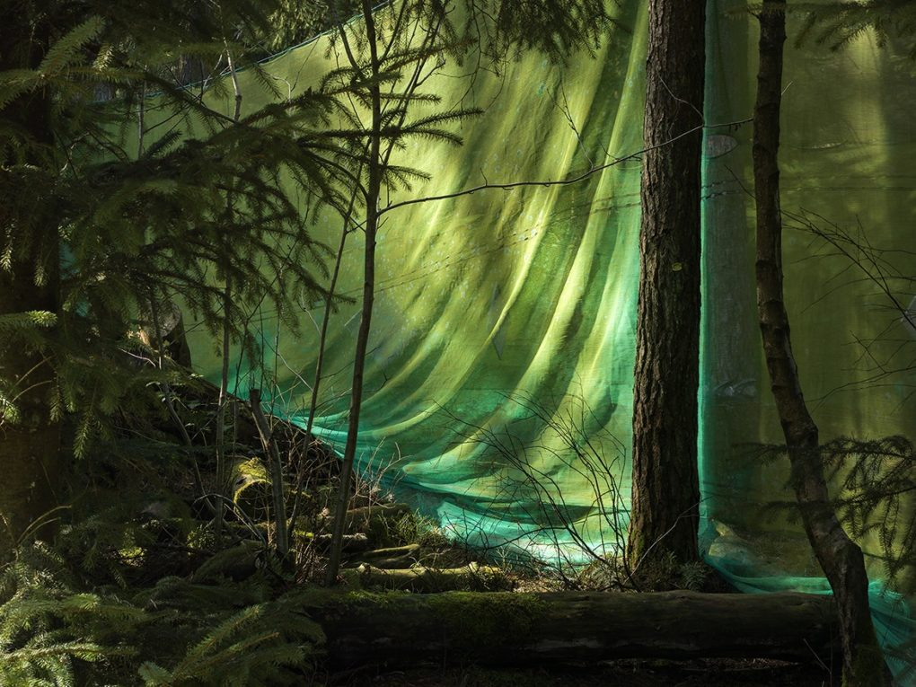 Figure 5

In this crucial time we are up against, our planet needs more help than ever. Recently in London, Climate Change activists have been protesting the streets as it seems to be the only way of getting a point across. By causing a scene, they seem to be following in the steps of famous historical people like Martin Luther King, Jr and Rosa Parks, as they stood up for what they believed in and made a difference. It has also gained a lot of media coverage which I think is already making a difference in how much we are thinking about the Climate Crisis. “Can humans flourish on a rapidly changing planet, or is the future one of grim survival, or even our own extinction?”(The human Planet, Simon L. Lewis, Mark A. Maslin) We are in the middle of a global crisis, which is why this exhibition means so much to me. I have attempted to cover all aspects of the world we live in so everyone can take a look in their preferred way, but could help broaden some people’s knowledge on ways of trying to reverse the damage we have created.

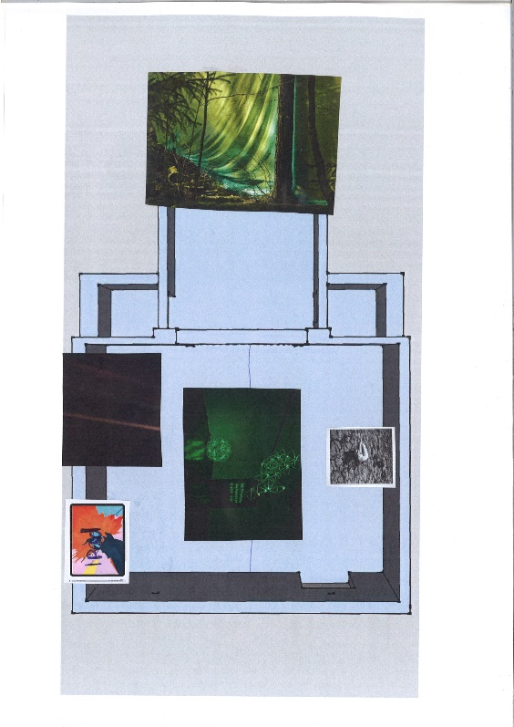 Floor plan of Exhibition

Bibliography

https://climate.nasa.gov

https://www.theguardian.com/commentisfree/2019/mar/28/cyclone-idai-zimbabwe-mozambique-malawi-destruction

https://www.ft.com/content/6134ae84-cf21-11e5-831d-09f7778e7377

https://olafureliasson.net/archive/artwork/WEK109681/green-light

https://www.artspace.com/francesca_woodman/untitled-1

The Human Planet - how we created the Anthropocene by Simon L. Lewis and Mark A. Maslin

https://medium.com/starts-with-a-bang/the-pale-blue-dot-celebrates-its-29th-anniversary-reminding-us-how-small-and-fragile-we-are-6c3d48e683d7

Ways of Seeing - John Berger

Figure 1 - https://www.bmiaa.com/olafur-eliasson-green-light-an-artistic-workshop-at-the-national-gallery-in-prague/

Figure 2 - https://www.artspace.com/francesca_woodman/untitled-1
Figure 3 - https://solarsystem.nasa.gov/resources/536/voyager-1s-pale-blue-dot/
Figure 4 - https://twitter.com/JimCarrey?ref_src=twsrc%5Egoogle%7Ctwcamp%5Eserp%7Ctwgr%5Eauthor
Figure 5 - https://spectrumphoto.co.uk/helen-sear-prospect-refugee-hazard

