BEng ELECTRONICS AND ELECTRICAL ENGINEERING

PROGRAMMABLE LOGIC CONTROLLERS
ASSIGNMENT

SAMIH ALTIGANY

Table of Contents
Introduction 4
Literature 4
Mitsubishi controllers 4
Siemens controller 6
Hitachi controller 7
The factory system design 7
The operation of the system 10
Section one 11
Section two 13
Section three 14
Section four 15
Section five 16
Alarms and warnings strategy 17
The warnings 17
Pusher1 counter difference warning 17
Pusher1 lost packages warning 17
Small & medium box counter warning 17
Small box counter warning 17
Medium box counter warning 18
Pusher2 large counter warning 18
Pusher2 lost packages warning 18
Large box counter warning 18
Palatized box warning 18
Master counter warning 18
The alarms 18
Max pusher1 counter 18
Max pusher1 lost packages 18
Max small and medium box counter 18
Maximum small boxes counter 18
Maximum medium box counter 19
Emergency switch alarm 19
Max pusher2 large counter 19
Max pusher2 lost packages 19
Max large box counter 19
Max palatized box 19
Max mater counter 19
Alarm master 19
HMI operation 19
The root screen 20
The alarms screen 21
The warnings screen 22
The engineering’s screen 23
The alarms pre-set screen 24
The warnings pre-set screen 25
Alarms and warnings operational start-up parameters 25
The PLC programmes 27
Network one 27
Network two 27
Network three 28
Network four 29
Network five 30
Network six 31
network seven 35
Network eight 36
Network nine 37
References 38

Introduction
Programmable logic controller PLC are industrial computers monitors the state of the inputs and outputs and make decisions according to the customised programme built in it.
Before the plc was invented, the control process used to be carried out using the relay logic systems which was very expensive and time intensive to customise and modify tasks on the programme as the relays has to be rewired individually.
In the 1980s Bedford associates presented their 084 PLC as a proposal for GM company as a solution to replace the relay logic system in the automotive industry, which solved the issue by electronically rewire the hard-wired control panels. [1]
Nowadays, the application of PLC is not exclusive to automotive industry as it has extended to transport, glass industry, paper industry, cement manufacturing and many other industries.

Literature

Mitsubishi controllers
Mitsubishi has a very wide and comprehensive range of controllers called MELESC series which shown a wide success in many industries like automotive where it improved the productivity in different automotive assembly lines because of its motion control accuracy, in automated warehouses it has shown high capabilities in errors elimination in repetitive processes, high speed material handling and accurate positioning which leads to productivity increment.
In addition, it has been used in food and beverages industry semiconductors manufacturing, chemicals, inspection machines, renewable energy, building automation, printing, injection modelling and general automation. [2]
Here is a comparison between different models of MELSEC series controllers

Series | 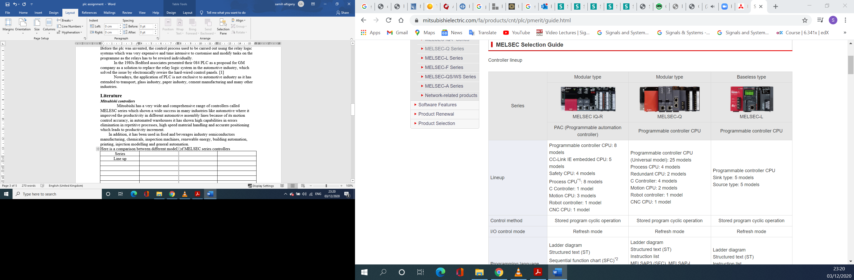
Description | MELSEC iQ-R | MELSEC-Q | MELSEC-L
Control method | Stored programme cyclic operation | Stored programme cyclic operation | Stored programme cyclic operation
I/O control mode | Refresh mode | Refresh mode | Refresh mode
Programme language | - Ladder diagram  - Structured text  - Sequential function chart  - Function block diagram  - Function block  - C/C++ | - Ladder diagram  - Structured text  - Instruction list  - MELSAP3, MELSAP-L  - Function block diagram  - Function block  - C/C++ | - Ladder diagram  - Structured text  - Instruction list  - MELSAP3, MELSAP-L  - Function block
Programme size (K step) | 1200 | 1000 | 260
Number of I/O points | 4096 | 4096 | 4096
RAM KB | 3380 | 1792 | 768
Data memory ROM byte | 40 M | 16 M | 2M
LD instructions ns | 0.98 | 1.9 | 9.5
MOV instructions ns | 1.96 | 3.9 | 19
Floating point addition $µS$ | 0.01 | 0.014 | 0.057
Operating temperature | 0$℃$ to 55$℃$ | 0$℃$ to 55$℃$ | 0$℃$ to 55$℃$
Key features | - Efficient in line manufacturing and distributed control  - Has small scale I/O control and large scale I/O control  - Has high security  - Includes inter-modular synchronization  - Has built-in data base and integrated network  - Has multiple CPU  - Very efficient in process control  - Supports programming in C language  - Supports data logging  - It includes real time monitor. | - Efficient in line manufacturing  - Has high performance in distributed control.  - Includes large scale I/O control.  - Includes integrated network and multiple CPU.  - It Has high processing control and high reliability.  - Supports programming in C language.  - Has data logging feature. | - Efficient in machine control and distributed control.  - Has small and large scale I/O control.  - Include extensive built-in functions.  - Has data logging function.  - Efficient in motion control.  - Includes real time monitor.
Table 1: highlights the essential features of some of MITSUBISHI controllers [2]

Siemens controller

 | 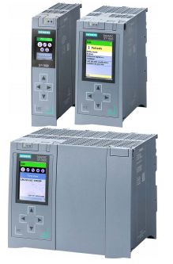
 | SIMATIC S7-1200
Data work memory | 20MB
Code work memory | 6 MB
Load memory/mass storage | 32GB
I/O address area | 32 / 32 Kbytes
Integrated interfaces | 2 PROFINET I/O  1 PROFINET  1 PROFIBUS
Technology integrated | - Motion control and PID control  - C-CPUs high speed counters, PMW, PTO, frequency output
Protection rate | IP20
Operating temperature | 0$℃$ to 60$℃$
Relative humidity | 10% t0 95%
Voltage supply | 24V
Number of input modules | 16
Input volt | 24V
Output modules | 8
Output current | 2A
Table 2: highlights the essential features of some of SIEMENS controllers [3]

Hitachi controller
 | 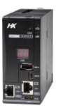
 | Hitachi HX-CP1S08
User programme memory | 8MB
Source file memory | 8MB
Non retain data memory | 8MB
Retain data memory | 500KB
Max expansion bases | 5
Max expansion distance | 8m
Programming language | LD/FBD/SFC/IL/ST/CFC
Ethernet | 2 ports (10/100BASE-T/TX)
Serial port | 1 port - RS485
USB port | 1 port (Mini-B type connector) for programming
USB host (USB memory) | 1 port (A type connector): for data storage
Real time clock | Built-in RTC
Start-up time | Approx. 20 to 30 sec
Table 3: highlights the essential features of some of Hitachi controllers [4]

The factory system design
As requested, to design and control a factory system to sort four different types of package based on size and weight, the factory below as in the photo has been designed and controlled using PLC programme. The designed system includes a control panel which on it there are two switches, a siren and two stack lights, one resembles the system when it is on by flashing the green light, and flashing the yellow light when there is a warning and the red light when an alarm occurs. The other stack light resembles the operation of the emergency button by flashing the red, yellow and green when the emergency button is on, and all the them will go off when the emergency button is off.
The system also includes seven conveyor belts, one curved conveyor, one straight spur conveyor, one conveyor scale, two pushers, one emitter, four removers, one pop up sorter, nine diffuse sensors and nine stack lights installed on columns as shown below.

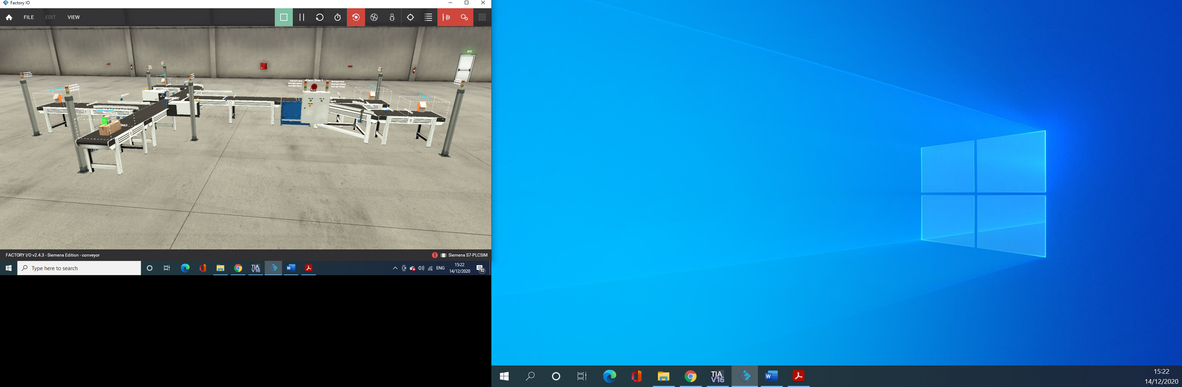

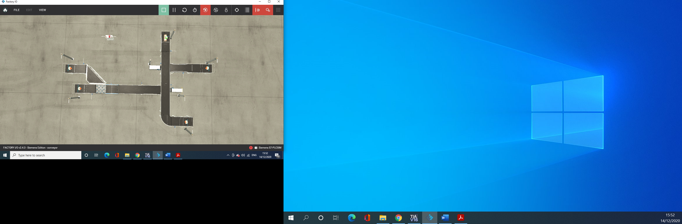

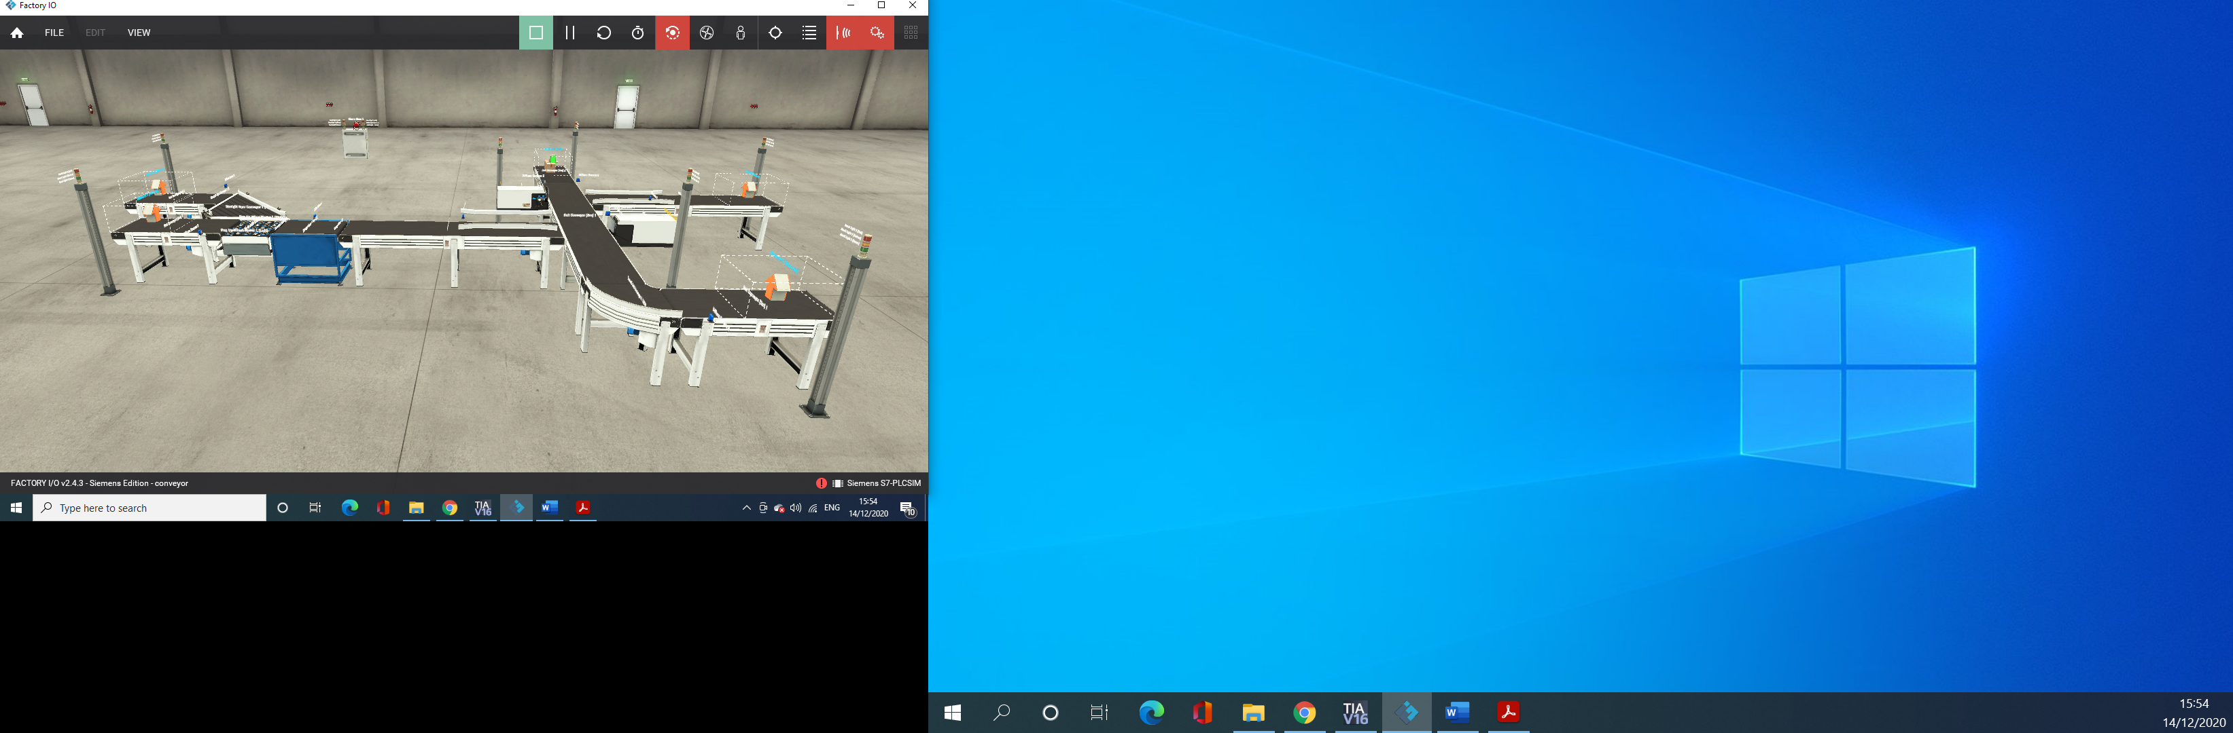

The operation of the system
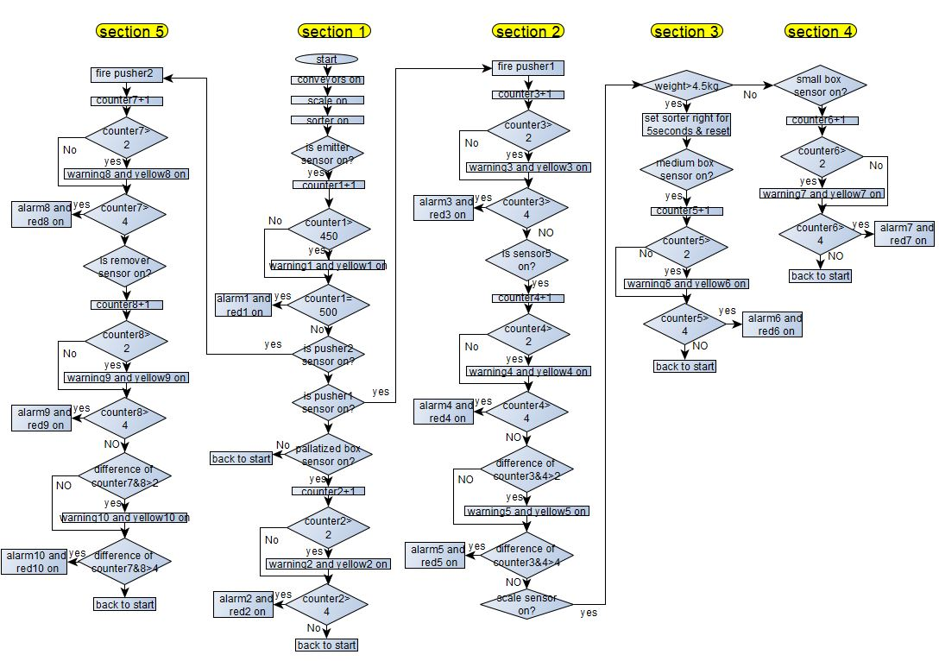
The flow chart has been divided into five sections as shown on the photo above

Section one
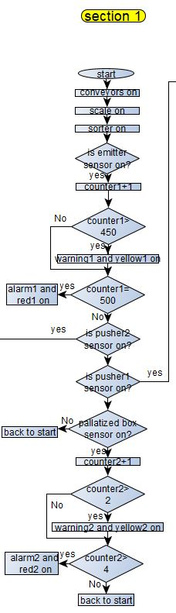
- The operation starts when the operator presses the start button which activates the siren alarm for three seconds then all the conveyors, the weight scale and the pop-up sorter in sequence with half a second different one after the other which limits the current draw on the start-up.
- If sensor3 “emitter sensor” is on, which indicates presence of a box, then “counter1” increases by one.
- If this counter exceeds the threshold for warning which could be any arbitrary number like 450, then yellow light will flash on the stack light No5 indicating a warning.
- If counter1 does not exceed the warning threshold, then the operation continues without warning or yellow light.
- If the counter reaches the alarm threshold which could be 500, then the system will stop and the red light on the stack light No5 indicating an alarm.
- But If “counter1” threshold did not exceed the threshold for an alarm them the operation continues.
- If pusher1 and pusher2 are not on which indicates that their sensors did not detect a box, then sensor4 “palatized box sensor” will be checked.
- If sensor4 on, the counter for this sensor “counter2” will increase by one.
- If this counter exceeds the threshold for warning which in this case set as 2, then yellow light will flash on the stack light No3 indicating a warning.
- If counter2 does not exceed the warning threshold, then the operation continues without warning or yellow light.
- If sensor4 “palatized box sensor” is not on, then the programme will start back from the beginning.
- If the counter reaches the alarm threshold which is set as 4, then the system will stop and the red light on the stack light No3 indicating an alarm.
- But If “counter1” threshold did not exceed the threshold for an alarm then the operation continues by going back to the start point.

Section two
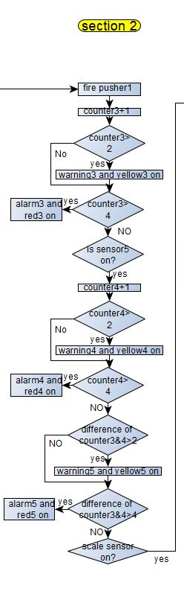
- If the sensor of pusher1 is on, then fire pusher1, and the counter of this pusher “counter3” increases by one.
- If this counter exceeds the threshold for warning which is set as 2, then yellow light will flash on the stack light No7 indicating a warning.
- If counter3 does not exceed the warning threshold, then the operation continues without warning or yellow light.
- If counter3 reaches the alarm threshold which is set as 4, then the system will stop and the red light on the stack light No7 indicating an alarm.
- If the alarm threshold hasn’t been reached, then if sensor5 is on, the counter for this sensor “counter4” will increase by one.
- If this counter exceeds the threshold for warning which is set as 2, then a warning will be set.
- If counter4 does not exceed the warning threshold, then the operation continues without warning.
- If counter4 reaches the alarm threshold which is set as 4, then the system will stop and an alarm will be set.
- If the alarm threshold hasn’t been reached, then if the difference between counter3 and counter4 is bigger than 2, put yellow light on indicating a warning.
- If the difference does not exceed the warning threshold, then the operation continues without warning.
- If the difference reaches the alarm threshold which is set as 4, then the system will stop and an alarm will be set.
- If the difference did not reach the alarm threshold which is set as 4, then sensor7 on the scale will be checked.

Section three
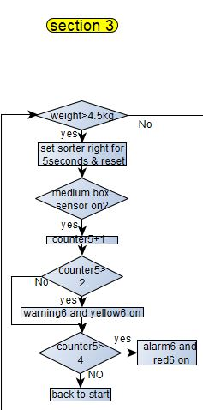
- If the weight of the box is bigger than 4.5KG, activate the pop-up sorter to the right for 5 seconds then rest it.
- If the sensor8 “for the medium and small boxes” is on, then “counter5” increases by one.
- If this counter exceeds the threshold for warning which is set as 2, then yellow light will flash indicating a warning.
- If counter5 does not exceed the warning threshold, then the operation continues without warning or yellow light.
- If counter5 reaches the alarm threshold which is set as 4, then the system will stop and the red light indicating an alarm otherwise the programme will start over.

Section four
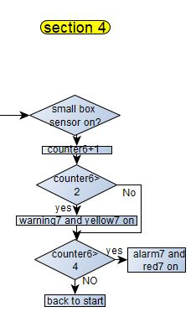
- If the weight of the box is less than 4.5KG, if sensor9 “small box sensor” then “counter6” increases by one.
- If this counter exceeds the threshold for warning which is set as 2, then yellow light will flash indicating a warning.
- If counter6 does not exceed the warning threshold, then the operation continues without warning or yellow light.
- If counter6 reaches the alarm threshold which is set as 4, then the system will stop and the red light indicating an alarm otherwise the programme will start over.

Section five
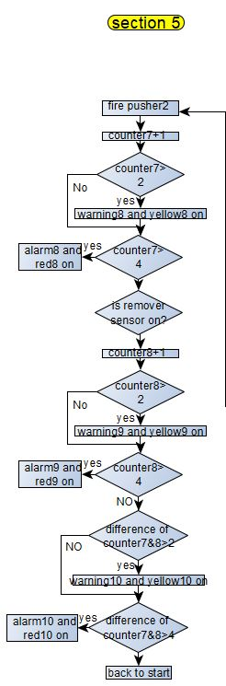
- If the sensor of pusher2 is on, then fire pusher2, and the counter of this pusher “counter7” increases by one.
- If this counter exceeds the threshold for warning which is set as 2, then yellow light will flash on indicating a warning.
- If counter7 does not exceed the warning threshold, then the operation continues without warning or yellow light.
- If counter7 reaches the alarm threshold which is set as 4, then the system will stop and the red light on indicating an alarm.
- If the alarm threshold hasn’t been reached, then if sensor6 “remover sensor” is on, the counter for this sensor “counter8” will increase by one.
- If this counter exceeds the threshold for warning which is set as 2, then a warning will be set.
- If counter8 does not exceed the warning threshold, then the operation continues without warning.
- If counter8 reaches the alarm threshold which is set as 4, then the system will stop and an alarm will be set.
- If the alarm threshold hasn’t been reached, then if the difference between counter7 and counter8 is bigger than 2, put yellow light on indicating a warning.
- If the difference does not exceed the warning threshold, then the operation continues without warning.
- If the difference reaches the alarm threshold which is set as 4, then the system will stop and an alarm will be set.
- If the difference did not reach the alarm threshold which is set as 4, then programme will go back to the start point.

Alarms and warnings strategy
The factory system has been designed with alarms and warnings on all the counter, and as there are several counters in the system, therefore there are several alarms and warnings as well detailed as follows

The warnings

Pusher1 counter difference warning
Pusher1 counter counts the number of times pusher1 fires, and it has maximum number it could count up to, therefore this warning indicates reaching a threshold close to the maximum allowed boxes number which will activate the amber light on the specified stack light.

Pusher1 lost packages warning
This warning indicates reaching a threshold close to the maximum number of boxes pushed by the pusher but they did not go on the required path or fallen of the conveyor which will activate the amber light on the specified stack light.

Small & medium box counter warning
This warning indicates reaching a threshold close to the maximum number of small and medium boxes could be counted which will activate the amber light on the specified stack light.

Small box counter warning
This warning indicates reaching a threshold close to the maximum number of small boxes could be counted which will activate the amber light on the specified stack light.

Medium box counter warning
This warning indicates reaching a threshold close to the maximum number of medium boxes could be counted which will activate the amber light on the specified stack light.

Pusher2 large counter warning
This warning indicates reaching a threshold close to the maximum number of boxes pushed by the pusher but they did not go on the required path or fallen of the conveyor which will activate the amber light on the specified stack light.

Pusher2 lost packages warning
This warning indicates reaching a threshold close to the maximum number of boxes pushed by the pusher but they did not go on the required path or fallen of the conveyor which will activate the amber light on the specified stack light.

Large box counter warning
This warning indicates reaching a threshold close to the maximum number of large boxes could be counted which will activate the amber light on the specified stack light.

Palatized box warning
This warning indicates reaching a threshold close to the maximum number of palatized boxes could be counted which will activate the amber light on the specified stack light.

Master counter warning
This warning indicates reaching a threshold close to the maximum number of boxes could be counted by the emitter which will activate the amber light on the specified stack light.

The alarms

Max pusher1 counter
This indicates the maximum number pusher1 counter could count up to has been reached, which will be followed by a red light on the stack light and emergency stack light will flash and the system will stop.

Max pusher1 lost packages
This alarm indicates that the number of boxes pushed by pusher1 but they did not go on the required path or fallen of the conveyor has reached the maximum which will flash the red light and stop the system which will flash the stack light.

Max small and medium box counter
This alarm indicates that the number of small and medium boxes has been counted reached the maximum number which the counter had been set to, this leads to the system shut down and the red-light flash and the emergency stack light will flash.

Maximum small boxes counter
This indicates that the maximum number of small boxes the counter could count up to has been reached which leads to shut down the system and flash the red light and the emergency stack light.

Maximum medium box counter
This indicates that the maximum number of medium boxes which the counter had been set to count up to, has been reached which leads to shut down the system and flash the red-light and the emergency stack light.

Emergency switch alarm
This alarm indicated that the emergency switch is activated either the physical button on the factory or on the HMI screen, which leads to shut the system down and flash the red, amber and green of the stack light on the panel box.

Max pusher2 large counter
This alarm indicates that the counter of this pusher has reached the maximum number of large boxes it could count up to which is already had been pre-set, this leads to shut the system down and flash the red-light by the pusher and the emergency stack light.

Max pusher2 lost packages
This alarm indicates the number of large boxes pushed by pusher2 but they did not go on the right path or fallen of the conveyor which leads to activating the red light and shutting the system down and flashing the emergency stack light.

Max large box counter
This indicates the number of the large boxes reached the remover is has reached the maximum number had been set which leads to shut the system down and flash the red light and the emergency stack light.

Max palatized box
This indicates the number of the palatized boxes reached the remover has reached the maximum number had been set which leads to shutting the system down and flashing the red light and the emergency stack light.

Max mater counter
This indicates the number of the boxes emitted by the emitter has reached the maximum number had been set which shuts the system down and flash the red light and the emergency stack light.

Alarm master
This alarm will be activated whenever any of the alarms is activated in order to ensure that the alarms will be reset only by the interference of an operator or an engineer.

HMI operation
The HMI screen consists of several screens which are the root screen, alarms screen, warnings screen, engineering screen, alarms pre-set screen and the warnings pre-set screen.

The root screen
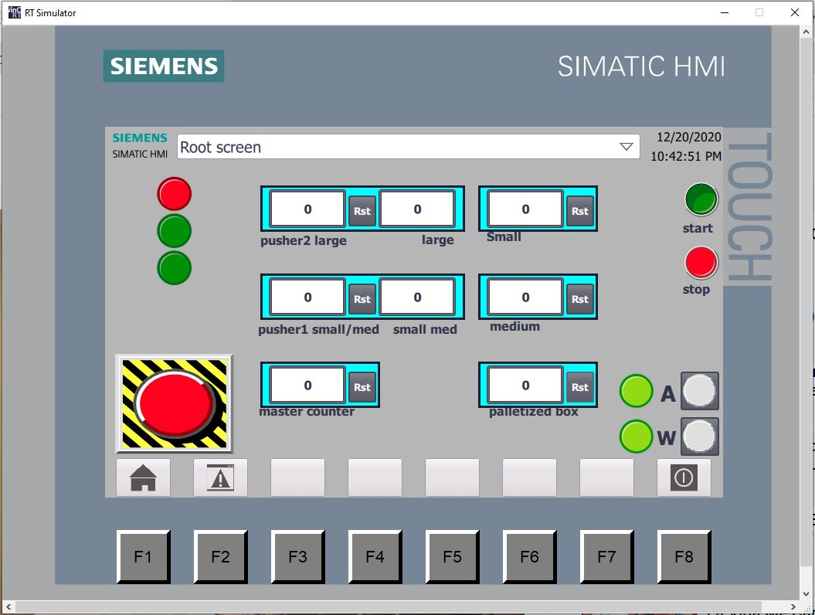
The root screen contains a start and stop buttons and a replication of the stack light which flashes green when the system is on, amber when there is an a warning and red in case of an alarm or the system shuts down.
The root screen also includes emergency button. And to navigate to the other screens there are two buttons for the alarms screen and the warnings screen linked to lights flash green when there is no alarm or warning and red in case of an alarm or warning.
In addition, it contains seven counters which are for pusher2 counter, large boxes counter, small boxes counter, pusher1 counter, small and medium counter, medium boxes counter, master counter and the palletised box counter and also includes reset buttons for every counter.

The alarms screen
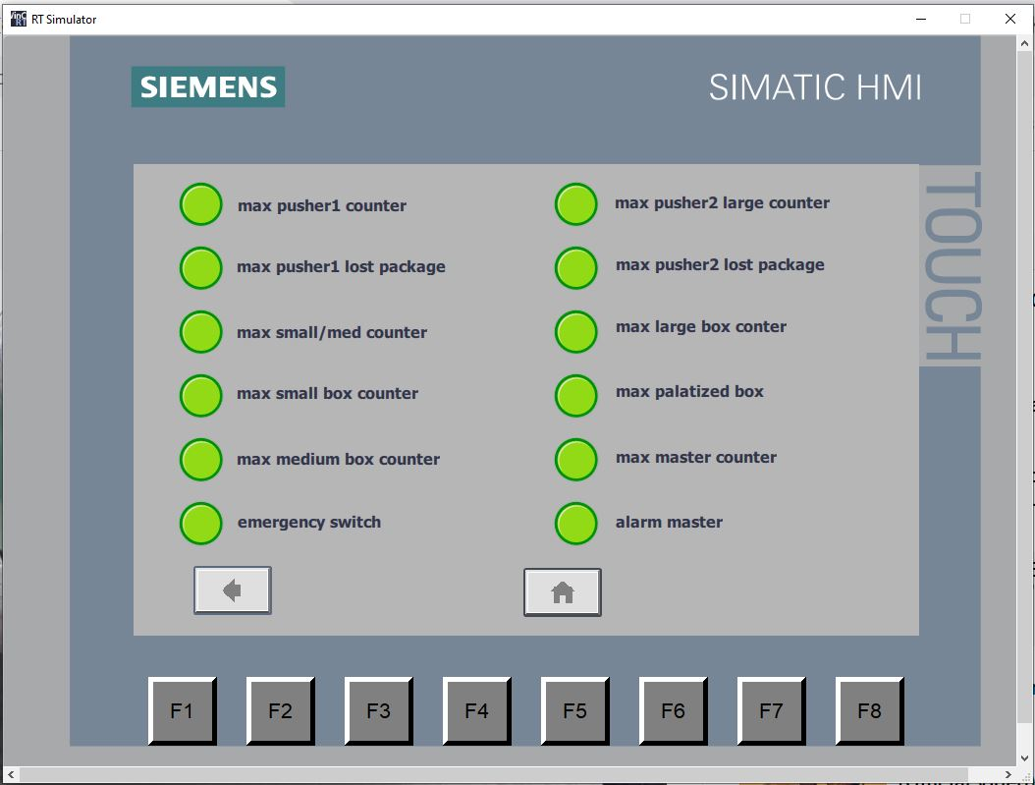
The alarms screen includes all the alarms linked to pilot lights flash green when there is no alarm and red in case of an alarm. In addition, there is a home button which change the screen to the root screen, and another button changes the screen to the engineering screen.

The warnings screen
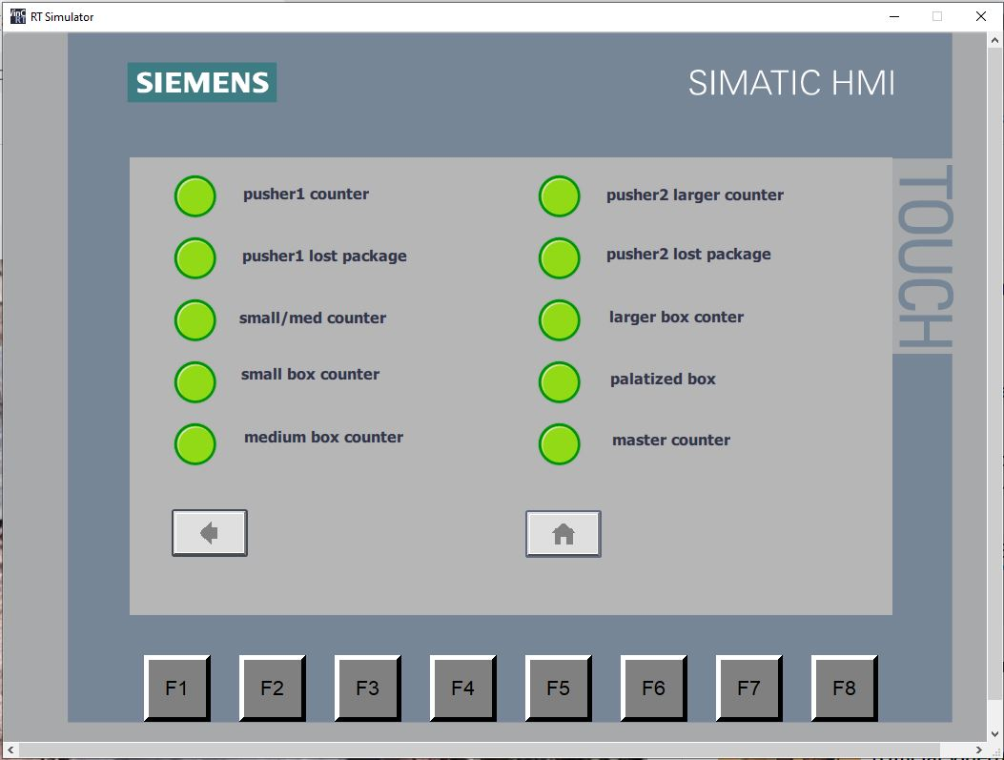
The warnings screen includes all the warnings and pilot lights replicating the warnings by flashing red when there is a warning and green when there is no warning.
In addition, there is a home button to swap between the root screen and the warnings screen, and another button to swap between the warnings screen and the engineering screen.

The engineering’s screen
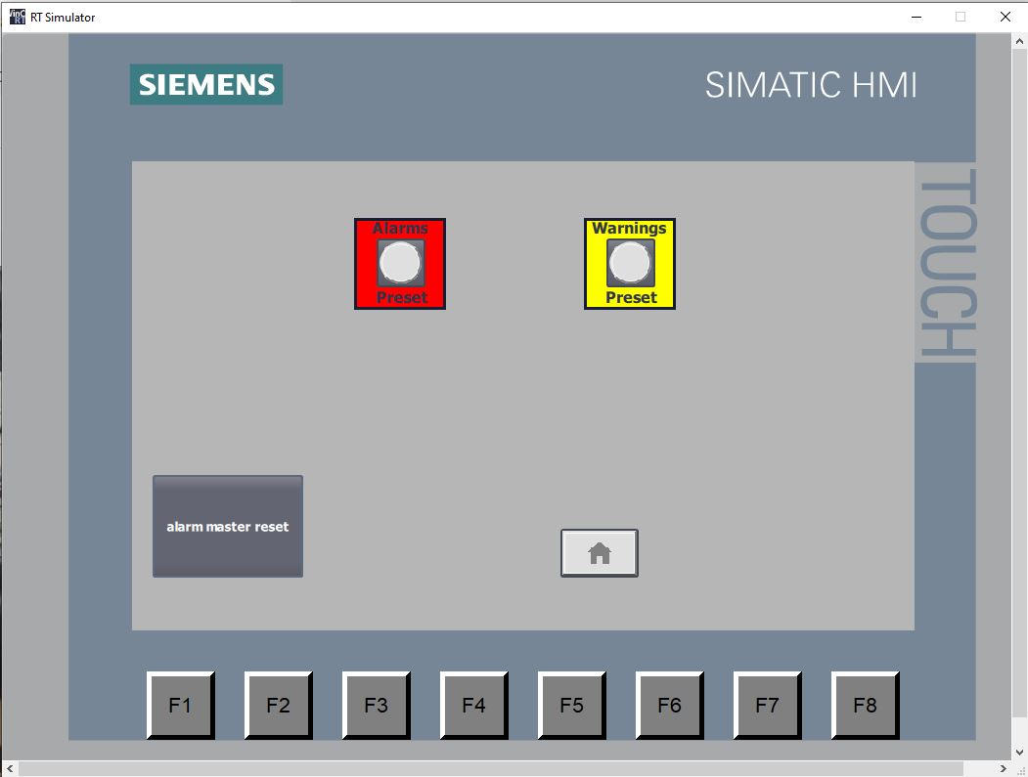
This screen includes a button to reset the alarms, a home button to swap to the root screen and alarms pre-set and warnings pre-set buttons to access the alarms re-set screen and the warnings pre-set screen.

The alarms pre-set screen
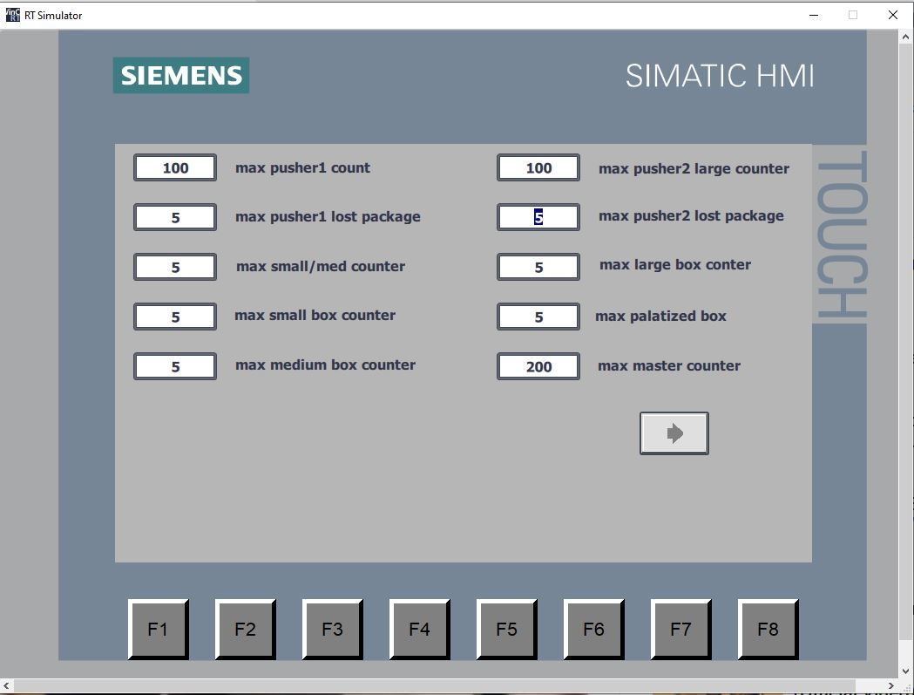
This screen access buttons to enter and modify the alarms values, and also a function button to swap to the engineering screen.

The warnings pre-set screen
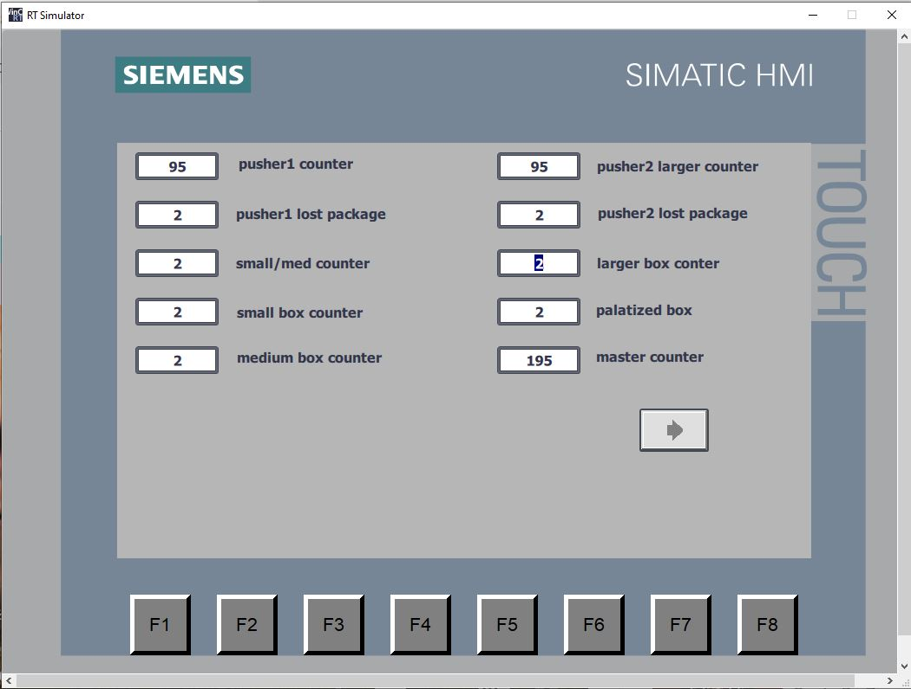
This screen access buttons to enter and modify the warnings values, and also a function button to swap to the engineering screen.

Alarms and warnings operational start-up parameters
after the start-up of the programme the alarms and warnings parameters have to be defined on the alarms pre-set screen and the warnings pre-set screen with the recommended parameters as follows

The PLC programmes

Network one
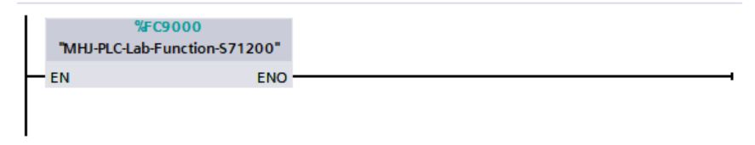
This is a link between the PLC simulation and the factory simulator.

Network two
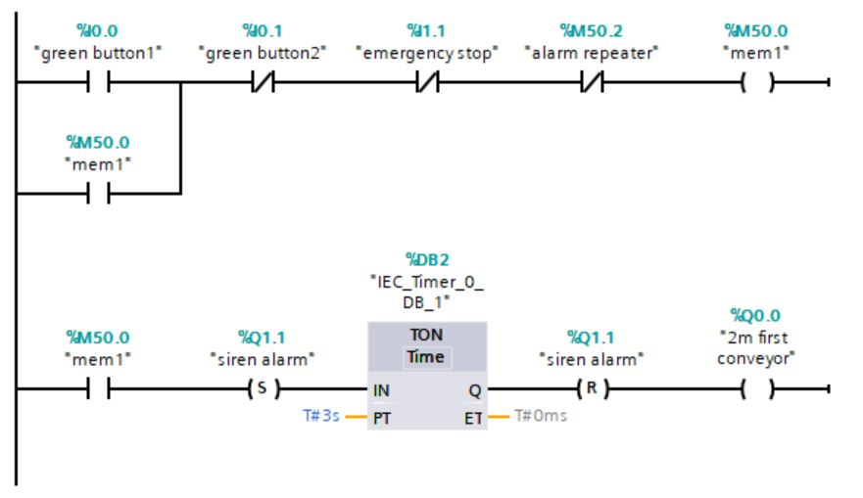
This network illustrates the process of setting the green button to start the system when the emergency button is in the off position, and the red button to stop the system, and the second rung deals with activating the alarm siren for three seconds when the pushbutton is pressed followed by activating the 2 meter conveyor.

Network three
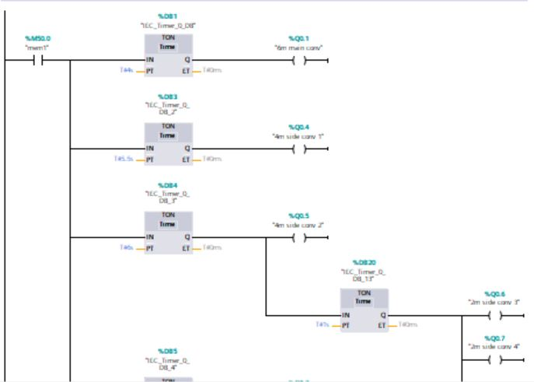
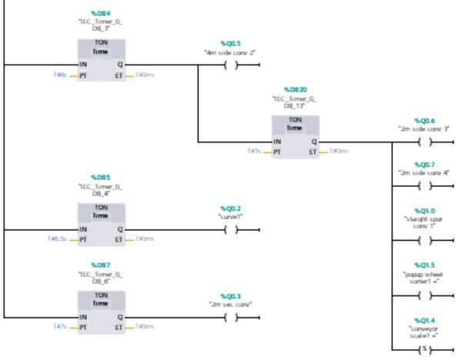
In this network all the conveyors are activated in sequence with time delay between one and the other, as it starts with activating the 6 meter conveyor after a second of activating the 2 meter conveyor, then activating the 4 meter side conveyor after half a second and another 4 meter sider conveyor after a second. And after a second later two of the 2-meter conveyors and the straight spur conveyor and the pop-up sorter and the conveyor scale will be activated together.
Then half a second later the curve conveyor will be activated and after a second delay time another 2-meter conveyor will be activated.

Network four
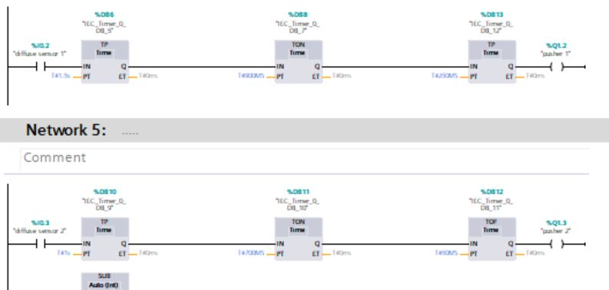
In this network, pusher1 and pusher2 will be activated and that by checking if diffuse sensor1 is active by a box breaking the light beam, then a delay time will be set in order to wait for the box to reach pusher1 then pusher1 will be activated using the pulse for 250 mS.
The same process will be applied for pusher2 by checking diffuse sensor2 if it is activated by a box blocking the light beam, then pusher2 will be activated but in this time using TOF timer.

Network five
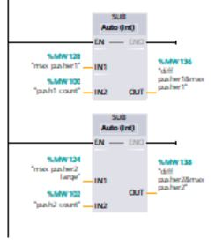
As the counters of the pushers have maximum number they could count up to, then this network illustrates how the maximum and the minimum number of boxes is calculated using the SUB function in order to set the values ready for the alarm and warning.

Network six
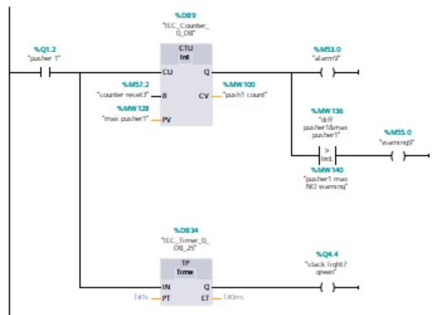
In this rung whenever pusher1 is activated the counter counts up and the green light on stack light No7 will flash for one second, and when the counter reaches the warning threshold warning 9 will be set and when it reaches the maximum, alarm 9 will be set.
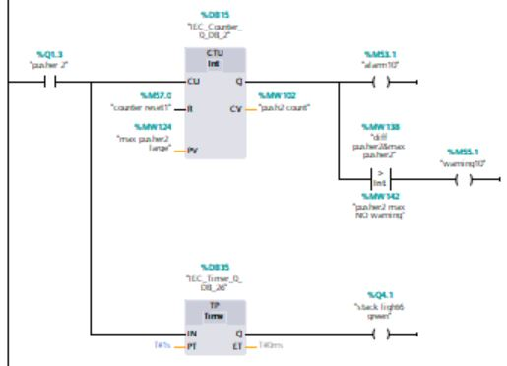
In this rung whenever pusher1 is activated the counter counts up and the green light on stack light No6 will flash for one second, and when the counter reaches the warning threshold warning 10 will be set and when it reaches the maximum, alarm 10 will be set.
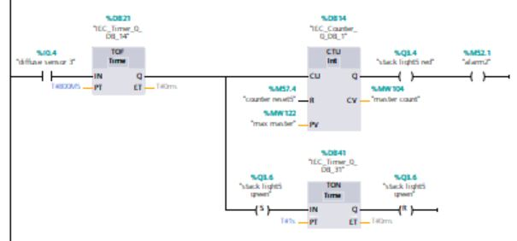
In this rung the alarm for the master counter is set as whenever diffuse sensor3 is activated the counter counts up and the green light on stack light No5 will flash for one second, and when the counter reaches the warning threshold warning 2 will be set and when it reaches the maximum, alarm 2 will be set.
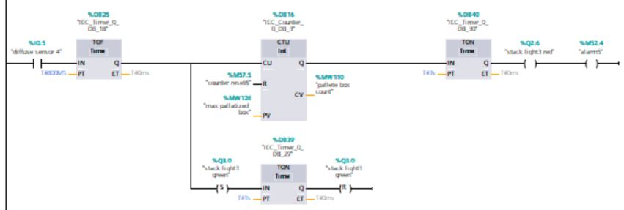
In this rung the alarm for the palatized box counter is set as whenever diffuse sensor4 is activated the counter counts up and the green light on stack light No3 will flash for one second, and when the counter reaches the maximum, alarm 5 will be set.
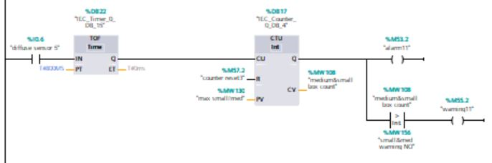
In this rung the alarm for sensor5 which is the recheck sensor for pusher1 is set as whenever diffuse sensor5 is activated the counter counts up, and when the counter reaches the maximum, alarm 11 will be set.
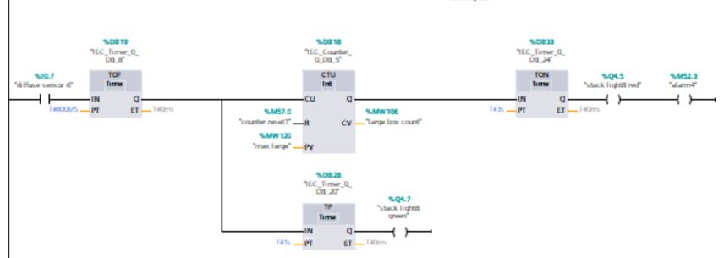
In this rung the alarm for the remover of large box counter is set as whenever diffuse sensor6 is activated the counter counts up and the green light on stack light No8 will flash for one second, and when the counter reaches the maximum, alarm 4 will be set.
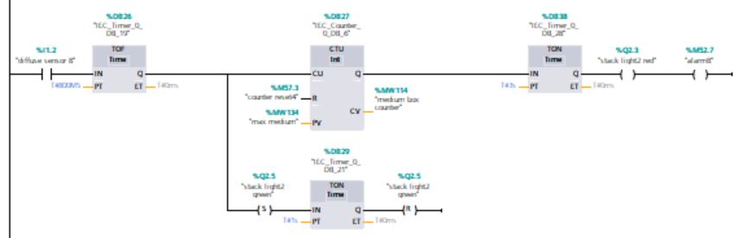
In this rung the alarm for the remover of medium box counter is set as whenever diffuse sensor8 is activated the counter counts up and the green light on stack light No2 will flash for one second, and when the counter reaches the maximum, alarm 8 will be set.
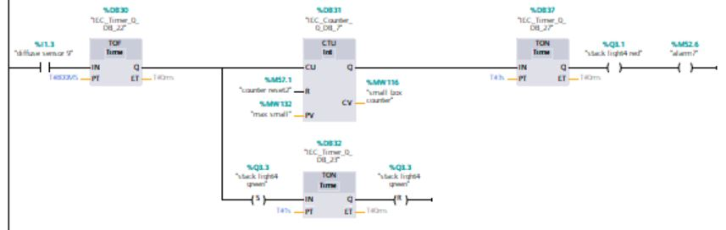
In this rung the alarm for the remover of small box counter is set as whenever diffuse sensor9 is activated the counter counts up and the green light on stack light No4 will flash for one second, and when the counter reaches the maximum, alarm 7 will be set.
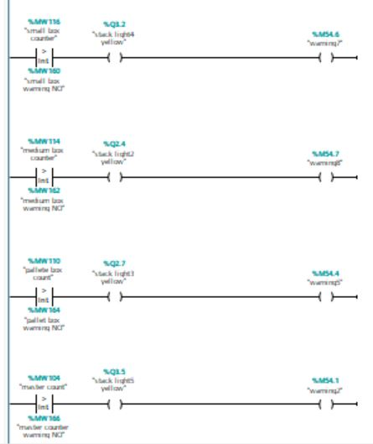
In this rung a set of warnings is activated as follows
- when small box counter is bigger than threshold, then warning7 followed by flashing the amber light on stack light4
- when medium box counter is bigger than threshold, then warning8 followed by flashing the amber light on stack light2
- when palatized box counter is bigger than threshold, then warning5 followed by flashing the amber light on stack light3
- when large box counter is bigger than threshold, then warning4 followed by flashing the amber light on stack light8
- when master counter is bigger than threshold, then warning2 followed by flashing the amber light on stack light5
- when small box counter is bigger than threshold, then warning7 followed by flashing the amber light on stack light4

network seven

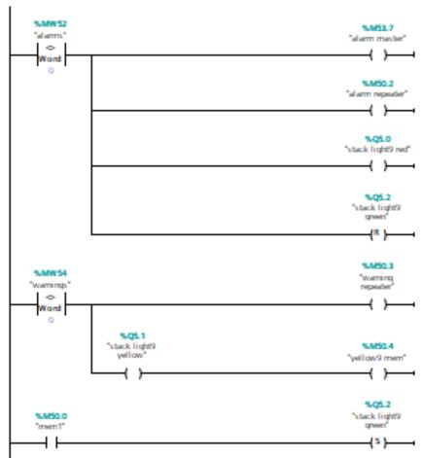

This rung shows the how the master alarm is set when any of the alarms has been activated which leads also to activate the alarm repeater, and flash the red light on the stack light No9 on the panel.

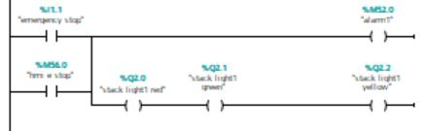
This rung shows the how the warning repeater is set when any of the warnings has been activated which leads also to flash the red light on the stack light No9 on the panel.

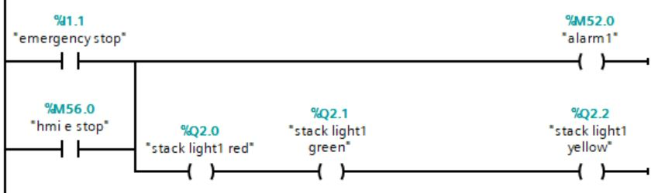
Whenever the emergency stop is activated on the factory or on the HMI, then alarm1 is activated as well as the red, amber and the green lights on stack light No1.

Network eight
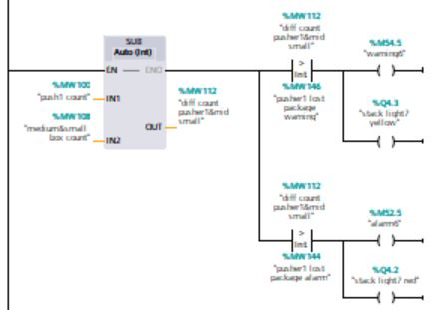
This rung is a comparison between pusher1 counter and the recheck sensor counter which is sensor5 counter, if the difference between these two counters is bigger than a threshold which can set to be 1, this indicated a lost package leads to flagging warning6 and the amber light on stack light No7. But if the difference is gigger than a threshold which can be set to be 5, alarm6 will be set and the red light on stack light No7.

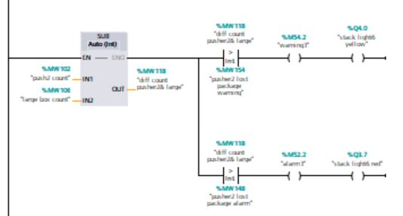
This rung is a comparison between pusher2 counter and the recheck sensor counter which is sensor6 counter, if the difference between these two counters is bigger than a threshold which can set to be 1, this indicated a lost package leads to flagging warning3 and the amber light on stack light No6. But if the difference is gigger than a threshold which can be set to be 3, alarm6 will be set and the red light on stack light No6.

Network nine
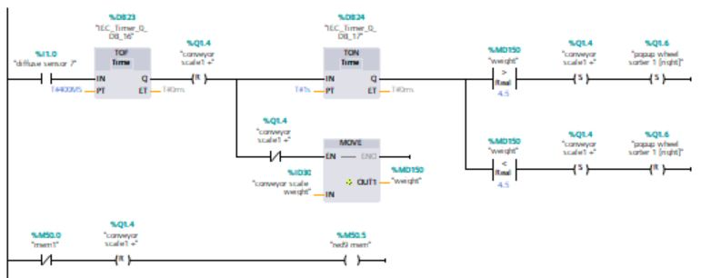
When the diffuse sensor7 is activated by a box blocking the light beam, the conveyor scale will be reset followed by a delay for one second in order to leave the box on the conveyor scale for one second to take the measurement.
If the weight of the box bigger than 4.5 Kg then the scale will be set and the pop-up sorter will be set to the right. But if the weight is less than 4.5 Kg then the scale will be set and the sorter will be reset.

References
[1] https://learntechnique.com/plc-history-development-functions-system-tools/
(Accessed: 2nd December 2020)
[2] https://www.mitsubishielectric.com/fa/products/cnt/plc/pmerit/guide.html
(Accessed: 3rd December 2020)
[3] https://cache.industry.siemens.com/dl/files/357/109481357/att_903671/v1/s71500_et200mp_in_a_nutshell_en-US.pdf
(Accessed: 4th December 2020)
[4] https://www.hitachi-ies.co.jp/english/catalog_library/pdf/SI-E129P.pdf
(Accessed: 4th December 2020)

