Low Pass & High Pass Filter Findings & Report

Shay Quinn
2319936

ACDB4002 (PT)

Abstract
In this report I conducted 2 experiment using a Low Pass Filter & a High Pass Filter sending 5 Volts through the circuit with a change of frequency, using A Function Generator to control this, and altering the frequency once each frequencies data was recorded, the output was recorded through an oscilloscope. The results showed the Low Pass Filter leaves less voltage through higher frequencies while the High Pass Filter leaves lower voltages through at Lower frequencies.

Introduction
A filter circuit is used for passing or amplifying certain frequencies while attenuating other frequencies. There are four uses for filters:
- Radio Communication – Filters in a radio allow the receiver to only ‘see’ the desired signal while rejecting all other signals.
- DC power supplies – Filters are used to eliminate undesired high frequencies, or noise that are present on AC input lines. They are also used on the output to reduce the ripple.
- Audio electronics – A Filter provides smoother signal, removing short term fluctuation and leaving the longer term trend.
- Analog to Digital conversion – A filter aids in minimizing aliasing.
There are four kinds of filters, this includes the Low Pass, High Pass, Band-Pass, and Notch Filter.
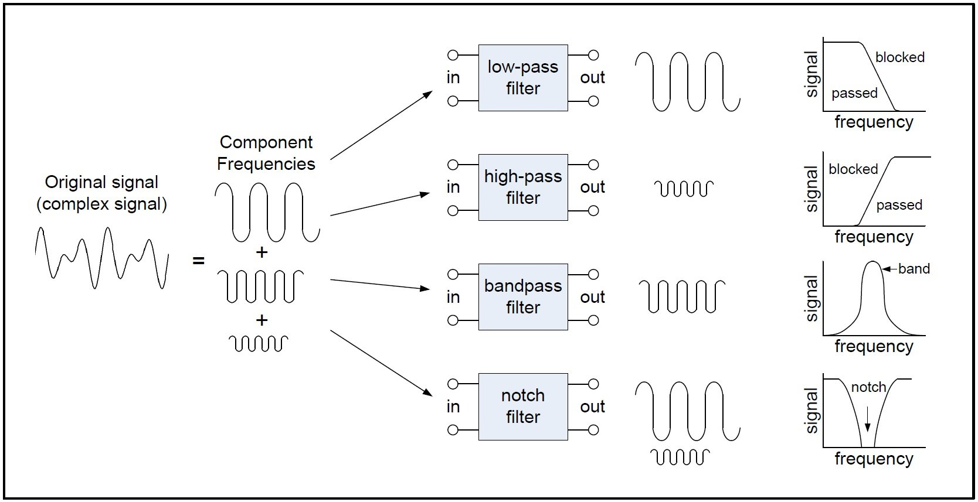
(An Introduction to Filters, Nick Davies, 2023)
The Filters used in the two circuits made were the Low Pass Filter and the High Pass Filter. These filters block signals determined on the frequency of the signal.

Low Pass Filter
A low pass filter is a circuit designed to take all high frequency electrical signals and modify, change or reject them while only accepting the signals wanted by the circuit. Low pass filters are typically made from simple Resistor-Capacitor networks.
High Pass Filter
A high pass filter is the opposite of a low pass, it offers easy passage of a high frequency signal and difficult passage to a low frequency signal.

Circuit Description
From the circuits we are evaluating the point at which the voltage output begins to drop on both circuits, in the low pass filter the output voltage should drop as the frequency increases, while the high pass filter’s output voltage drops as the frequency decreases.
Figure 1
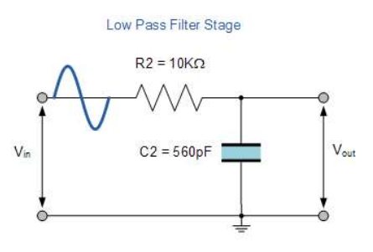

Figure 2
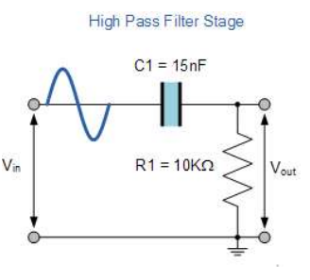
Figure 1 consisted of a 5K resistor a ceramic capacitor and 4 wires an input and output, the function generator was connected to the input wires and output wires connected to the oscilloscope. The frequency was then changed in intervals the output voltage was recorded.
Figure 2 consisted of a 5K resistor paired with a 15nK100 Capacitor and again paired with 4 wires to for input and 2 for output, the function generator was connected to the input wires, and the output wires connected to the oscilloscope. The frequency on the function generator was then changed in intervals, and the output voltage was recorded.
The voltage used for the experiments was 5V, this did not change between each circuit, and the output voltage was then recorded upon every frequency change. The frequencies used, was between 1 and 300KHz, I changed frequency intervals when necessary, some were changed by 5KHz, some 100Hz and others 10KHz.
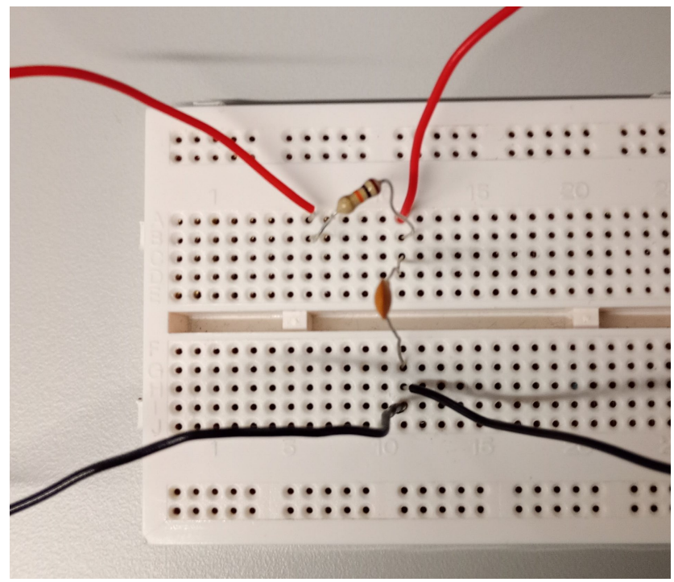
The above picture is the low pass filter used and made, the left red wire was the input wire and right red wire was the output. These were connected using 2 banana splitters which were connected to the oscilloscope and function generator and 2 sets of crocodile clips.

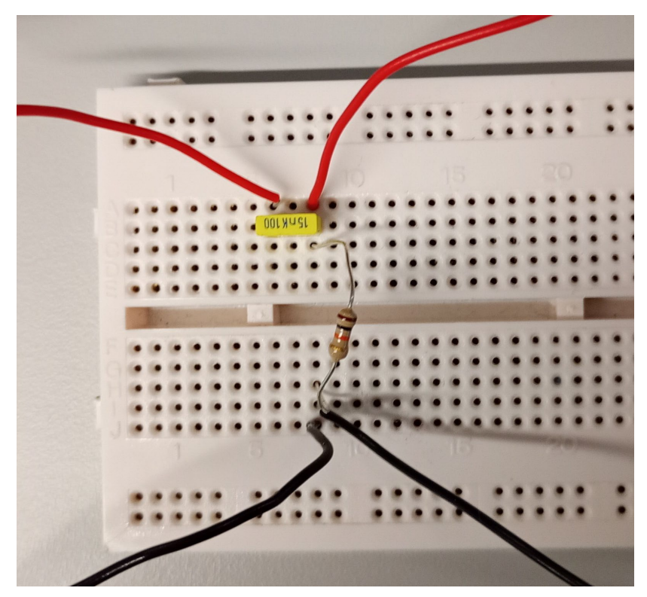
The above picture is the High Pass Filter made, the left red wire being the input wire and the right red wire being the output. These were connected using 2 banana splitters connecting them to the oscilloscope and function generator and 2 sets of crocodile clips to connect them to the board.
Components Used:
Ceramic Capacitor – A ceramic capacitor uses a ceramic material which acts as a dielectric, this means the ceramic acts as an insulator. Ceramics were one of the first materials to be used in capacitors for an insulator.
Resistors – A resistor is a passive electrical component, and creates a resistance in the flow of the electric current. Resistors have many purposes and there are many types of values for resistors and they all range.

Results & Discussion
Low Pass Filter Data
Figure 3

As shown in Figure 3, it can be seen there is a steady decline in voltage as the frequency gets higher. However, it is not a smooth decreasing curve due to power losses through the wires and tolerance on the resistor and capacitor, the tolerance was 5% of the resistor therefore there was going to be losses, likewise, the Capacitor had a tolerance of 10%. Similar to this the power would also have tolerances, being with the cables that the voltage was run through into the breadboard, the breadboard itself and the crocodile clips and wires connected to the Oscilloscope and Function Generator.

Figure 4

As seen in Figure 4, the attenuation of the frequency is declining as the frequency gets higher, again this is due to knock on effect of tolerances and power loss through the circuit. However, still shows the decline in attenuation as frequency goes on.
Figure 5

Figure 5 is a comparison of what the Vout should look like theoretically as apposed to the experimental data recorded. The graph shows both are of a similar decline, however, there are points at which the experimental data is more than the theoretical data, as stated this can be due to losses through the circuit or components including tolerances of them all. This will always lead to the Experimental data being slightly different to the theoretical data, due to the theoretical data not taking into account the tolerances and losses of the components.
Figure 6

Figure 6 shows the comparison between the theoretical data worked out and the actual data recorded from the lab exercises. There are multiple spots where the attenuation for the experimental was more, again this is a knock on affect from the Vout of the experimental data due to loses and tolerances within the circuit and the components used. Despite this the experimental data smoothly before becoming more disarrayed towards the end of the frequency range.

High Pass Filter Data
Figure 7

In Figure 7 there is a clear decrease in voltage as the frequency gets lower, this is due to the high pass filter blocking lower frequencies so the circuit was working as intended. There are points in the graph where they don’t follow the curve of the line but then return to the curve, this is as stated previously due to the components having tolerances, the circuit itself having tolerances and power loss throughout the circuit through any of the components and wires used. This is normal and should be expected as long as the graph is a clear decline in voltage through all the points plotted. All in all the graph line follows the plateau then begins decreasing the voltage as the frequency decreases and then plateaus at the cut off db.

Figure 8

In Figure 8 the start of the graph is very inaccurate however, is still correct due to graph steadily increases and then plateaus smoothly as it comes to the end of the frequency range and plateaus smoothly. The inaccuracy at the start of the graph can be due to issues with the voltage and not taking enough points at the start of the experiment as if there were more points then the graph would be much smoother as most of the points were taken towards the middle and start of the frequency range, so between 150KHz to 1Hz, as this is where the voltage changed most through the circuit.

Figure 9

As seen in Figure 9 there is a large gap between the theoretical data and the experimental data, again this can be down to losses and tolerances of the circuit and tools used. The gap is approximately 10KHz apart and due to either my error or just losses which is expected. However, the experimental data graph follows the theoretical graph smoothly then before plateauing coming to the end of the frequency range.

Figure 10

Figure 10 shows the experimental graph with an increasing attenuation as the frequency increases, however, the theoretical data is an instantly increasing graph through the frequencies, I believe this is an error on my part as the attenuation for the theoretical data should similarly follow the Experimental data. Again this is an error on my part and I could not work out why. However, apart from the start the graph follows the trend increasing and then plateaus as it increases in frequency.

From all the results shown we can see that apart from the theoretical attenuation on the High Pass Filter (Figure 10), all the experimental data’s follow the theoretical data in curvature, some have anomaly points in them, however, this can be anything from losses within the circuit and power to human error but they then continue to return to the graph’s curve.
As stated the losses can be put down to tolerances of the components, the resistors have a tolerance of 5% of the resistance this would be a loss of 50Ω through the circuit, along with this the capacitor had a tolerance of 10%, for the low pass filter the capacitor would have had a loss of 5.6pF through the circuit. While the High Pass Filter would have had a 100Ω loss in the resistance, while the capacitor would have a loss of 0.15nF through the circuit. So the losses and some changes in the experimental graph was expected as the theoretical data did not take into account the tolerances and losses of each of the components, if this was done the theoretical and experimental would be more similar. Along with this the experimental data had a voltage between 5V and 5.2V, again reiterating the tolerances of the components and circuit used, thus not being able to get as accurate of a result when compared to the theoretical data.

Conclusion
In this experiment it was determined that the theoretical and experimental data’s were very accurate. However, the experimental data produced anomalies compared to the theoretical data as stated the theoretical data did not take into account the tolerances of the components & circuit along with power losses from the Function Generator to the circuit and from the circuit to the Oscilloscope.
The low pass filter circuit showed results of a -3db cut off between 30KHz and 27.5KHz as shown in Figure 3. This then concludes the theory of low pass filter circuits producing higher attenuation at greater frequencies.
The high pass filter circuit showed results of a -3db cut off between 1KHz & 1.1KHz as shown figure 8. This concludes the theory of high pass filter circuits producing higher attenuation at decreased frequencies.
To conclude this report, the figures of graphs presented show the results of the high pass and low pass filter being, the low pass filter has high attenuation at greater frequencies, while the low pass filter produces a higher attenuation at lower frequencies, the figures shown could be more accurate with the theoretical data taking in to account the losses and tolerances of the components and board used.

References
Nick Davies (2023)
An Introduction to Filters - Technical Articles (allaboutcircuits.com)
(N/A)
Passive Low Pass Filter - Passive RC Filter Tutorial (electronics-tutorials.ws)
(N/A)
Ceramic Capacitor | Types | Capacitor Guide (eepower.com)

