HTML & CSS Web Development
Bartosz Galantowicz
1700994
Internet Technology and Security – ACCA4018
Kemi Ademoye

Table of Contents
Introduction 3
Requirements 3
Implementation 4
Logo 4
Home page 5
Newsletter form 6
“PSU” – section 7
“GPU”- section 9
“CPU”- section 11
“Motherboard”- section 12
“PC Case” – section 13
Validation 14
Evaluation 15
Bibliography 19

Introduction

Because of web development studies and the given assignment, it is required to provide evidence of obtained programming knowledge and apply it in practice. Namely, the main task of the project is to design and program a website by using web standards. The various methods and fundamentals of creating webpages are described in this report and presented in the relevant example of the internet portal. Furthermore, to handle all raised objectives, the project has been coded in Visual Studio 2017 due to using the core web technologies – HTML and CSS. However, during the work on the assignment also other skills, such as logical and abstract thinking or design imagination have been involved.

Requirements

The purpose of the website is to show web development skills gained during university education in a real-life scenario. Therefore, to achieve the aims of the assignment, the following plan of the site has been invented. The main idea was to create the thematic website about computer hardware. Hence the promotion of pc components and describing them became the leading topic. The site was divided into sections, which present a single pc component, whereas the main webpage has a form of welcoming and introduction to the main issue.
Apart from fundamental knowledge about pc parts, users can find out more about interesting hardware easily and quickly outside the website, without losing navigation to the origin webpage. Moreover, the visitors are informed that the site is in development progress and they may track that the new features or sections have been added by subscribing the newsletter.
To sum up, the created website is a place on the Internet for people, who want to start to learn the fundaments of computer architecture or need advice in this field of science. They have got the opportunity to identify the right part, learn about it, discover how to get it, how to choose the best one and how much does it cost.

Implementation

The name of the created website is “PC Components”. For realisation, the concept of design and form the unique logo and favicon have been created. In addition, the idea for the layout of the portal is that it must be responsive and adaptable to different screen sizes. In result, most of the elements of the website project are fulfilled this function.
Furthermore, some features of the layout are standard for each webpage related to “PC Components”. Accordingly, the navigation menu is always on the top of the current page as well as the footer involving copyright description, date and name of the author is on the bottom. Likewise, the sides of the site are organised. The left side is a spot for relevant advert widget, whereas to the right side belongs to social media icons, search bar and email access.

Logo




Fig 1. The logo was designed in Adobe Illustrator. In this case, the symbol of the power button is used to replace “P”. However, this symbol was also an inspiration for the favicon, which was created by using the tools at https://www.favicon.cc/.

Home page

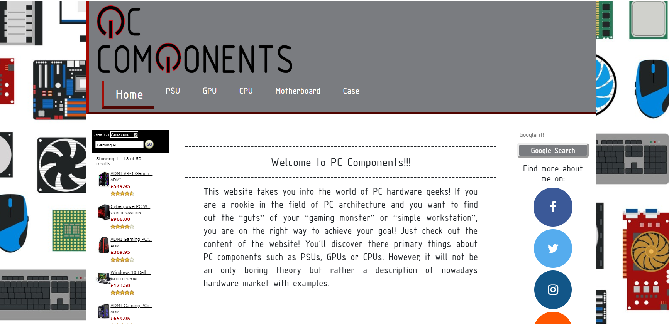
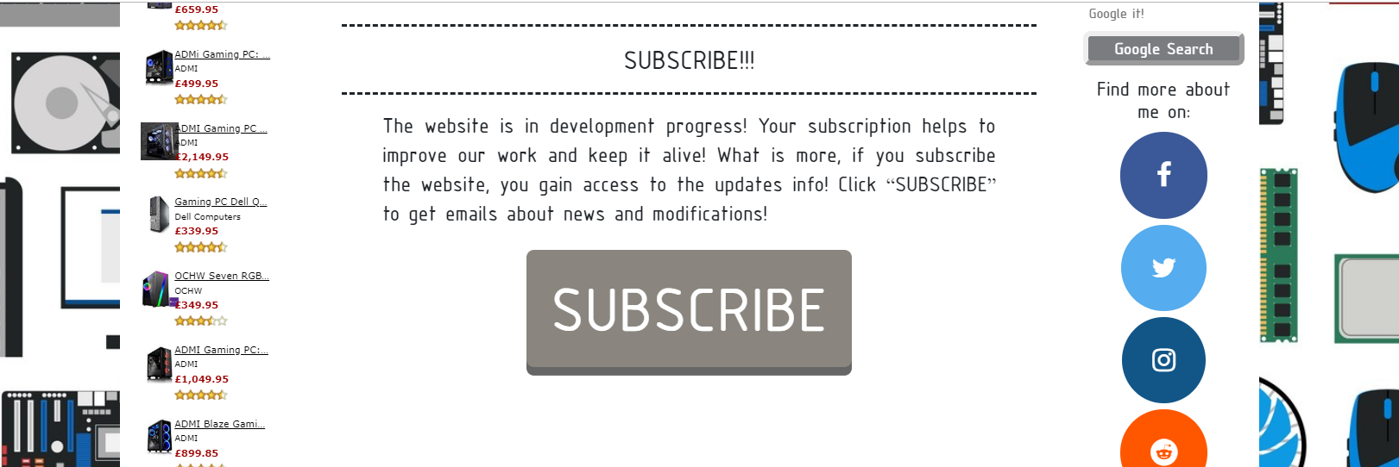
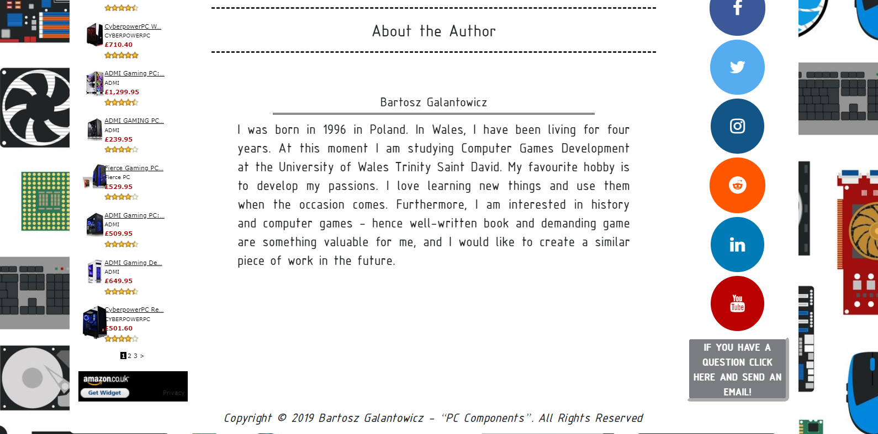
Fig 2. This image is showing the home page where visitors can read about the purpose of the website, subscribe it and discover something more about the author. By clicking the subscribe button, the newsletter form is opened.

Newsletter form

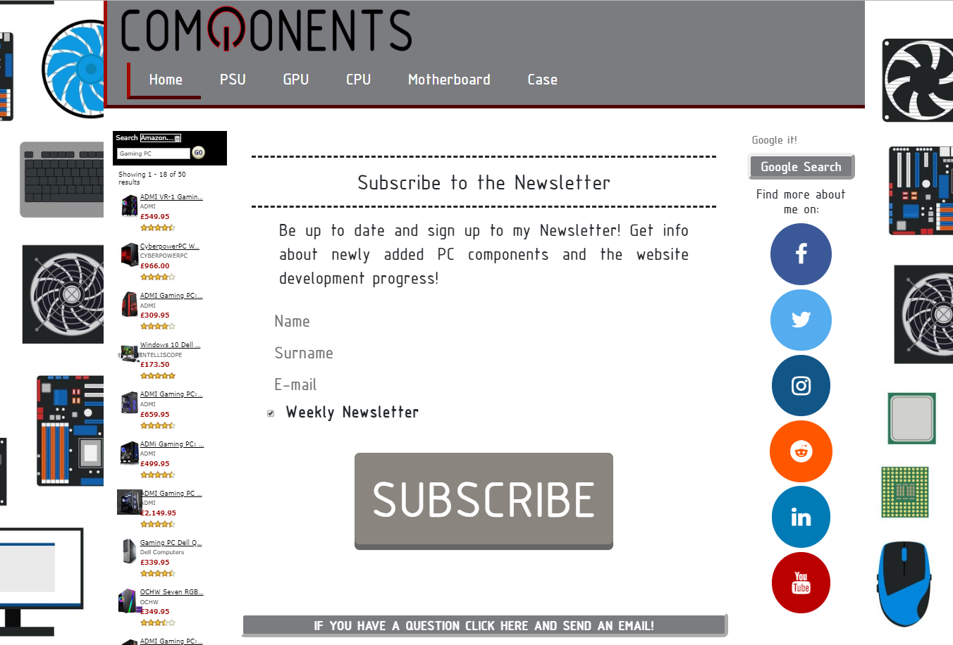
Fig 3. After clicking the subscribe button on the web page, users are transferred to the Newsletter page where personal data can be provided to access weekly update about the project development.
Correspondingly for each section of the described components has been made a simple template for keeping the feeling of integrity and order. Therefore the first thing to notice is a slide show of chosen pc hardware corresponded to the actual page title, e.g. if a user is on the “GPU” webpage a slideshow of various graphics cards is displayed. Further, after article about a specified component, the short youtube videos were implemented. The videos are related to the topic of the webpage and are an additional source of information for recipients.

“PSU” – section

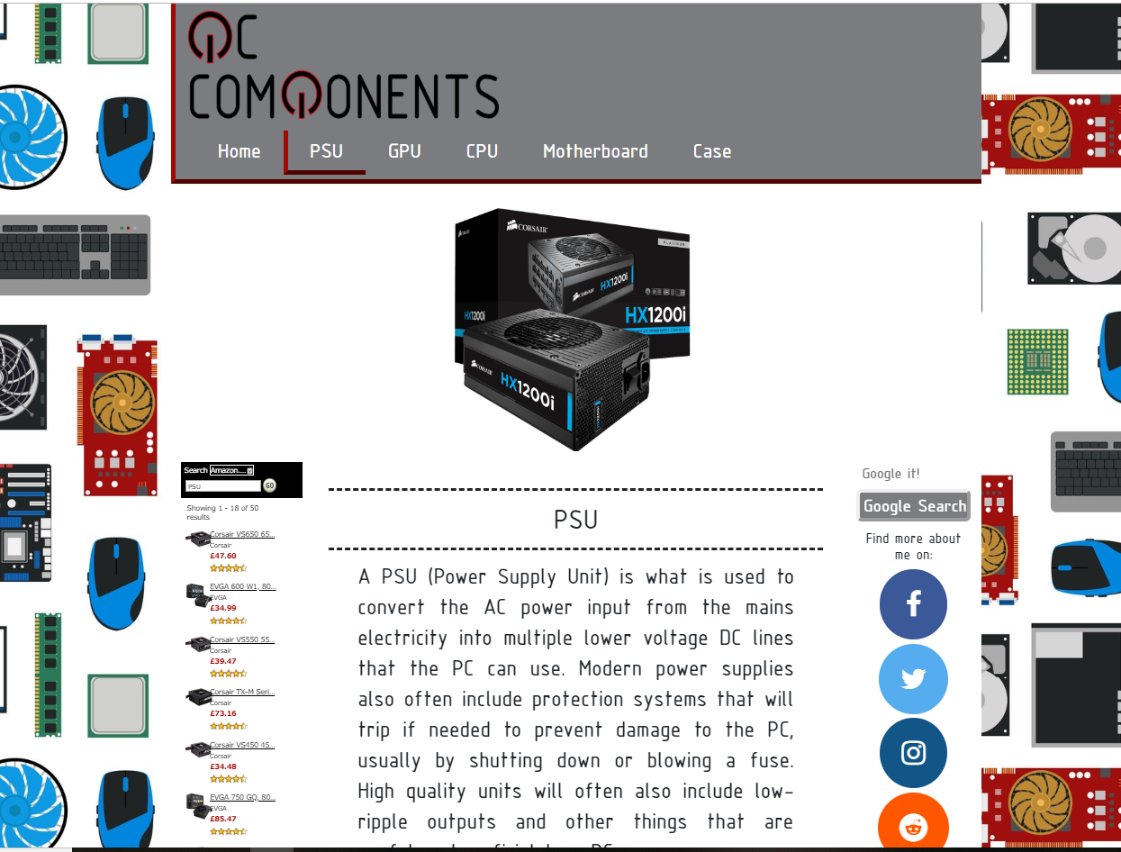
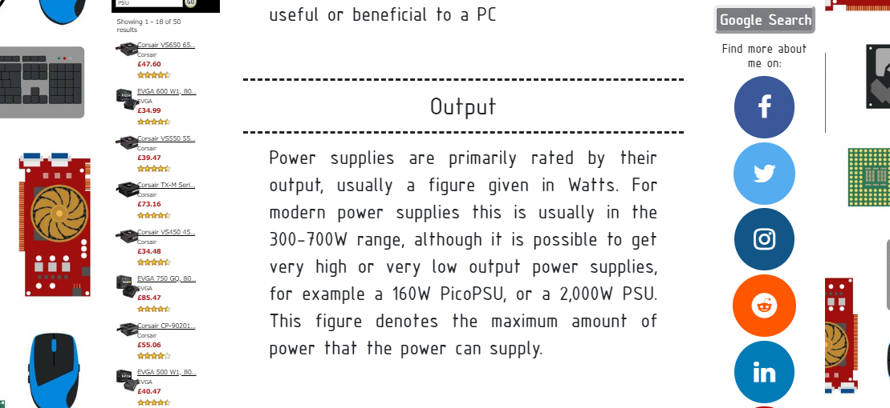
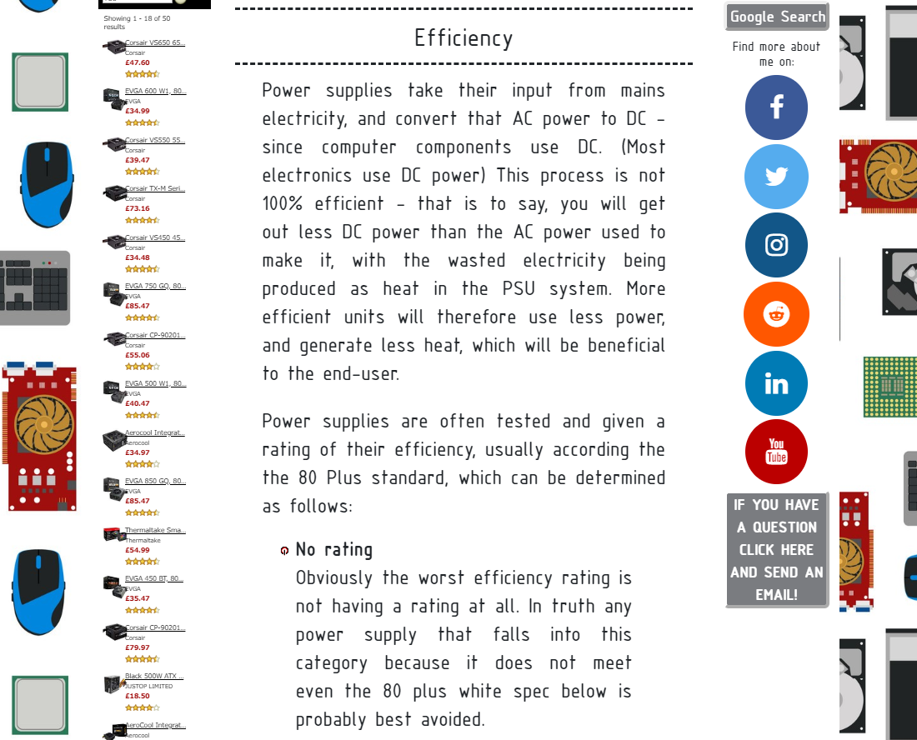
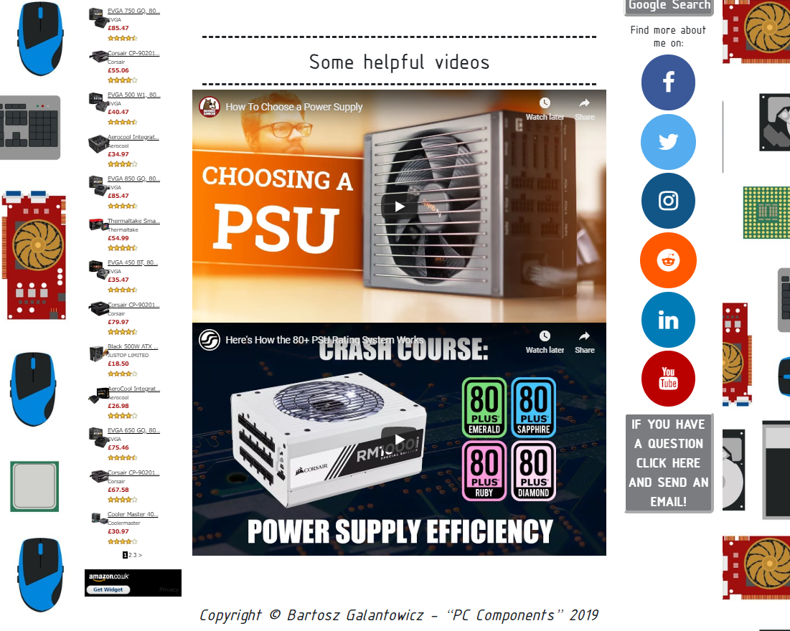
Fig 4. In the “PSU” section the concept of power supply unit is presented. At this point, the favicon icon is used instead of bullets points as it is more suitable to the overall design.

“GPU”- section

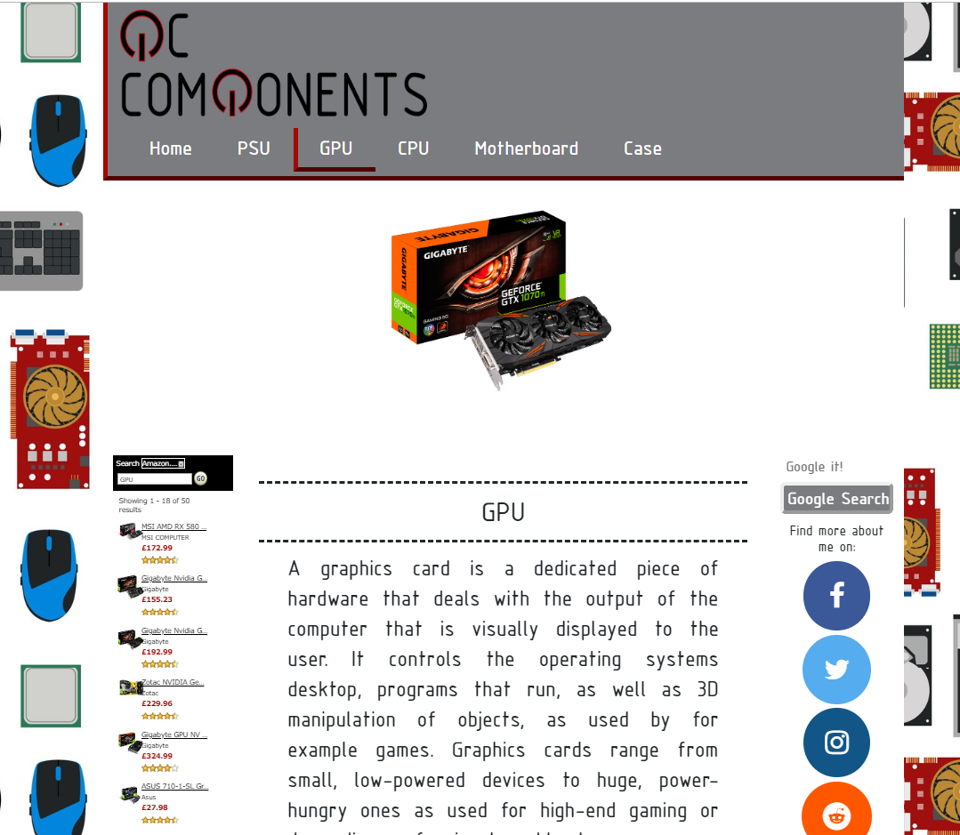
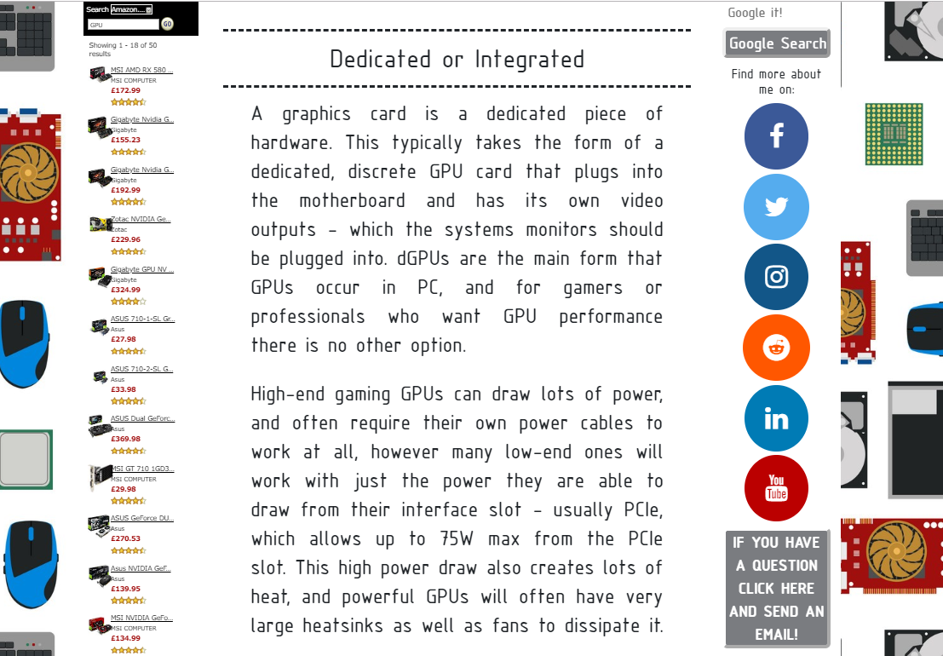
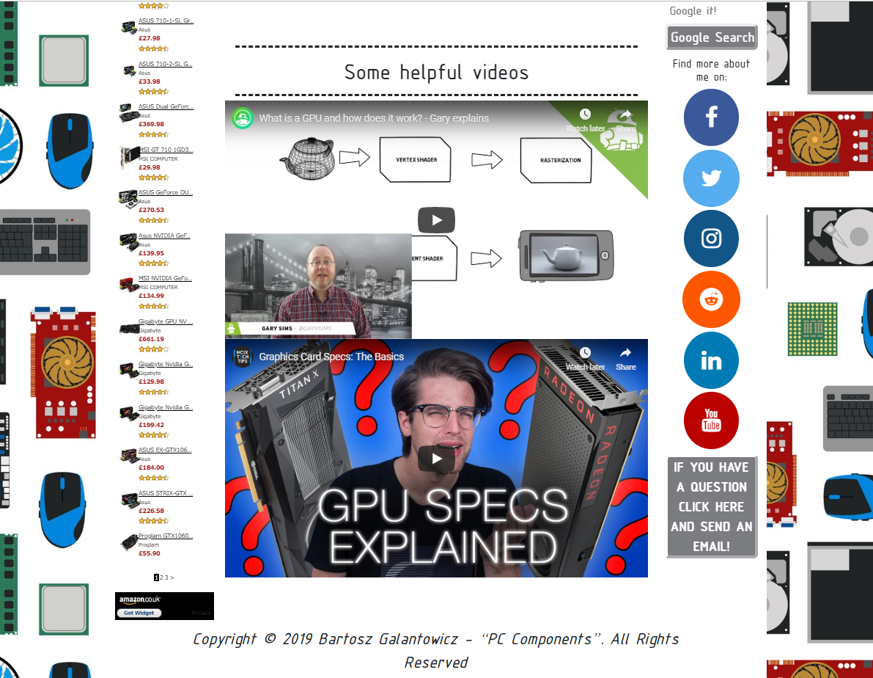
Fig 5. The section “GPU” is about properties of graphics cards.

“CPU”- section

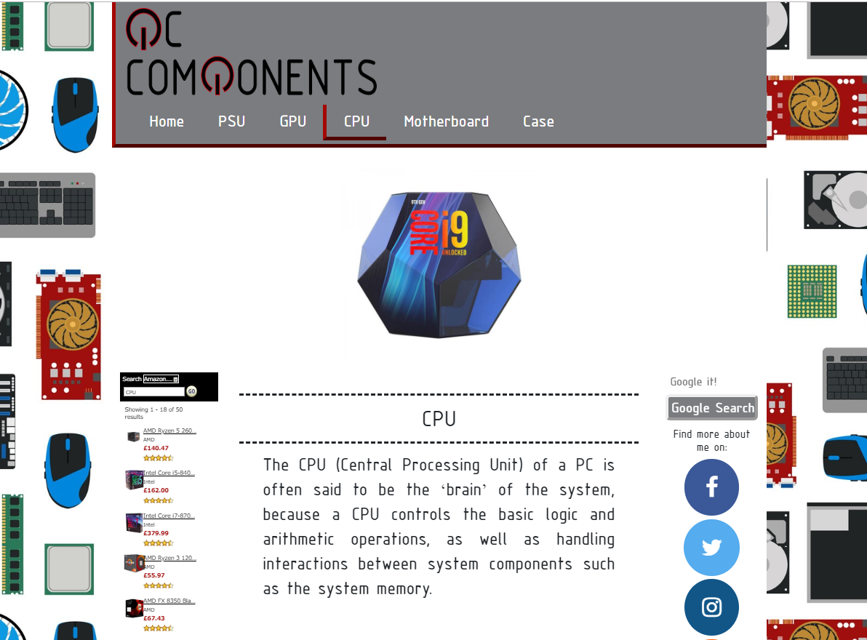
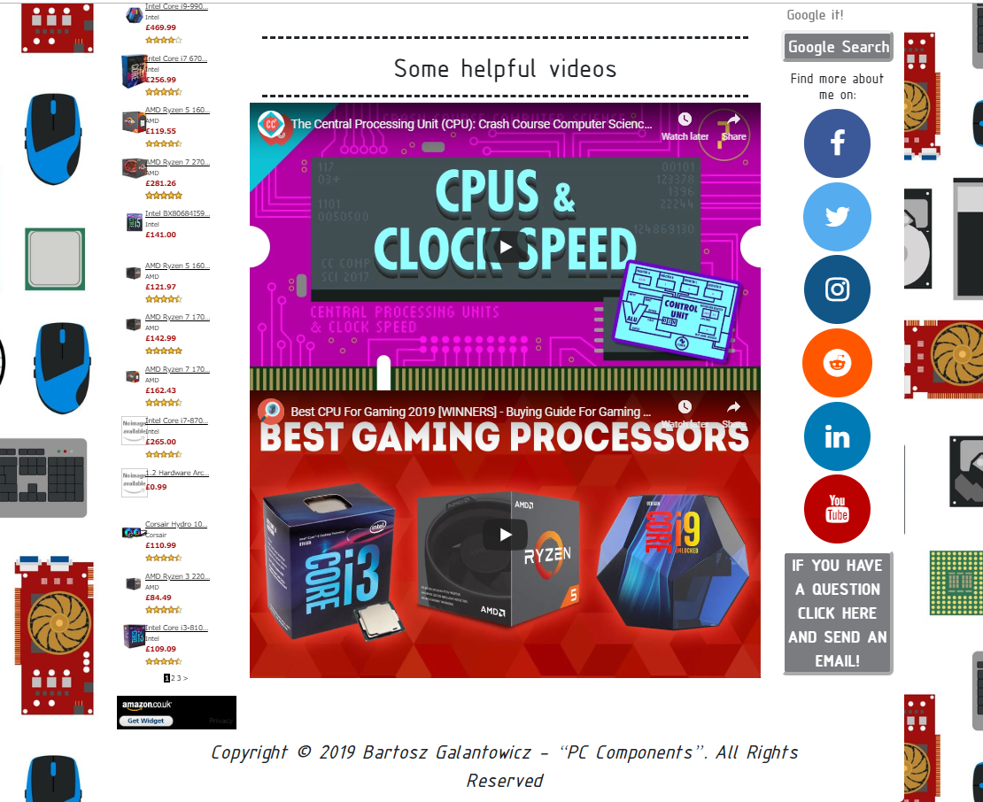
Fig 6. In the “CPU” section all essential functions of the central processing unit are described.

“Motherboard”- section

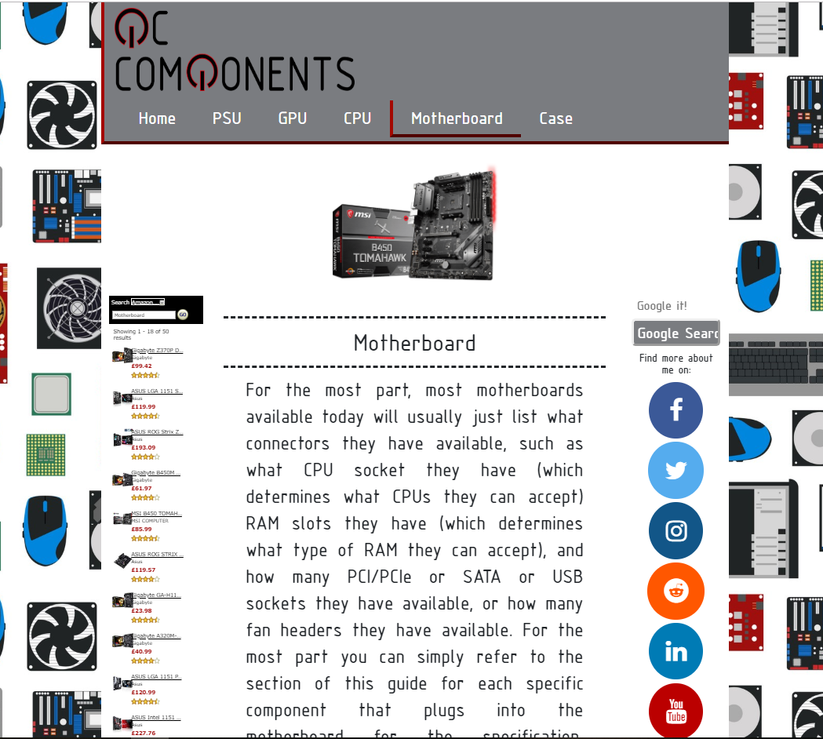
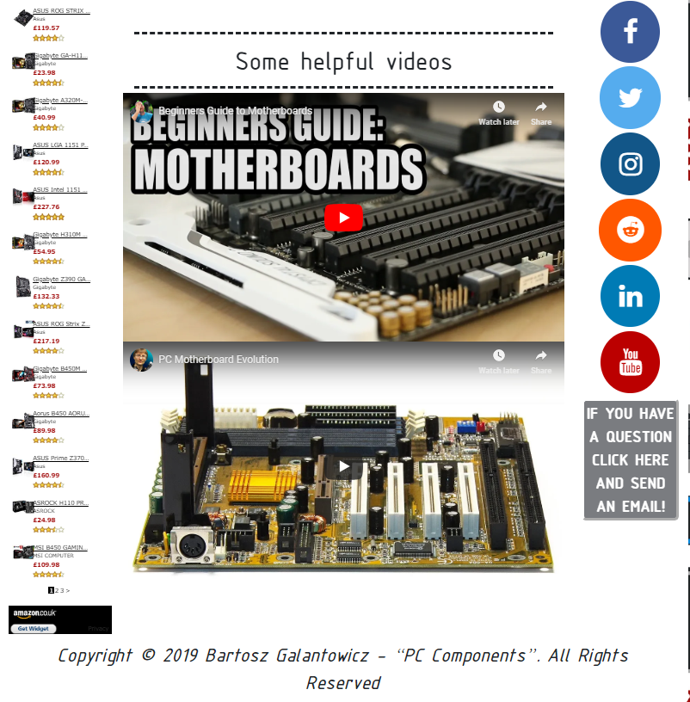
Fig 7. The fundamental knowledge in the field of motherboards is revealed in section “Motherboard”.

“PC Case” – section

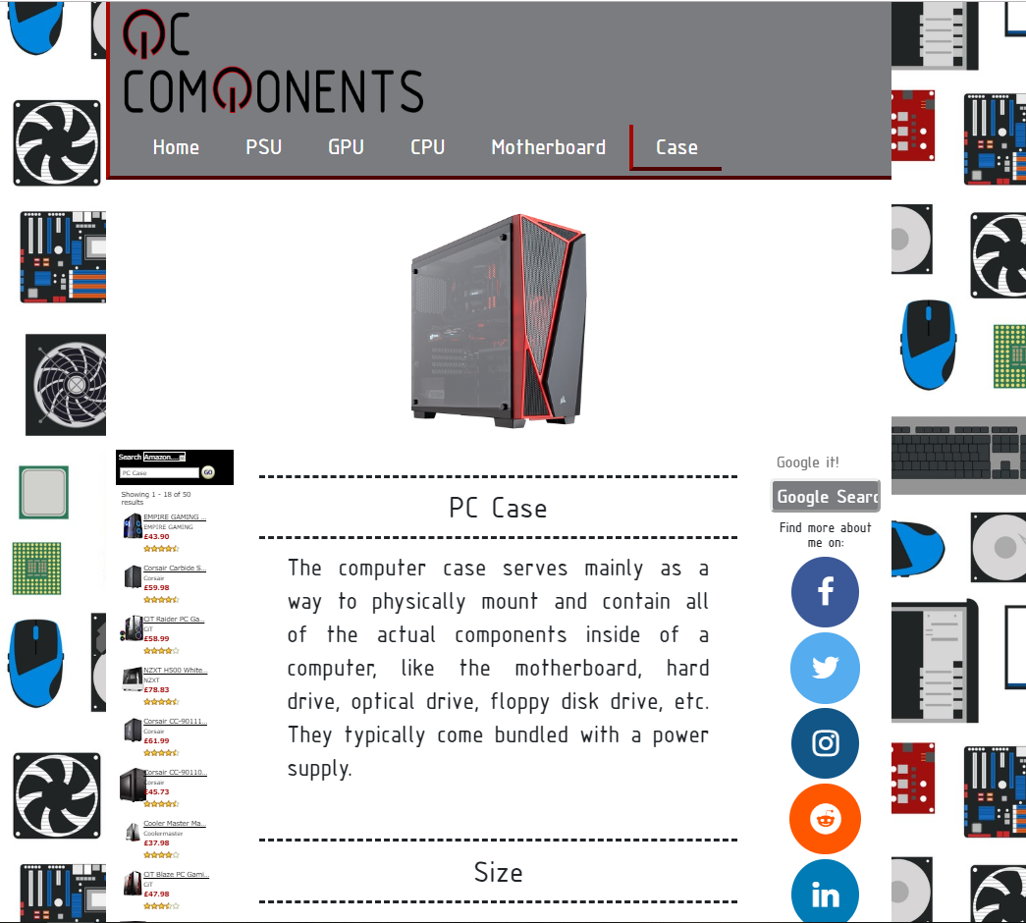
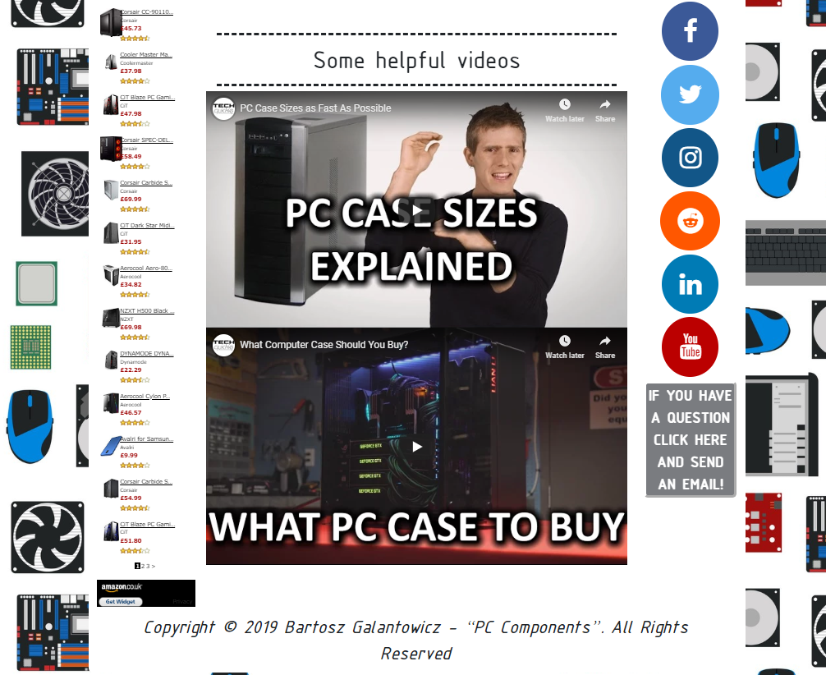
Fig 8. The “Case” section is all about pc cases and their varieties.

Validation

Because the correctness of the code is essential and it is a valuable characteristic of proper programming manner the validation of the website has been done for HTML and CSS documents. The following screenshots are showing tests of chosen elements of the project, accordingly for the main page and main style files.
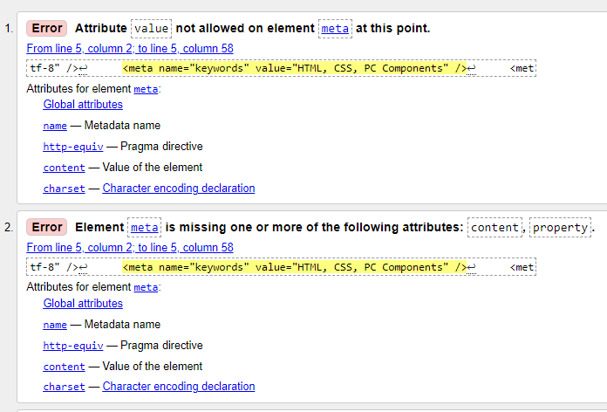
Fig 9. Validation of the home page HTML file emphasises two related to themselves errors. The attribute value is not an appropriate part for meta element, hence missing attributes are suggested to apply by the validator. Replacing “value” by attribute “content” solve this problem.

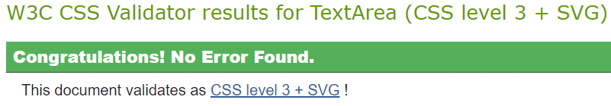
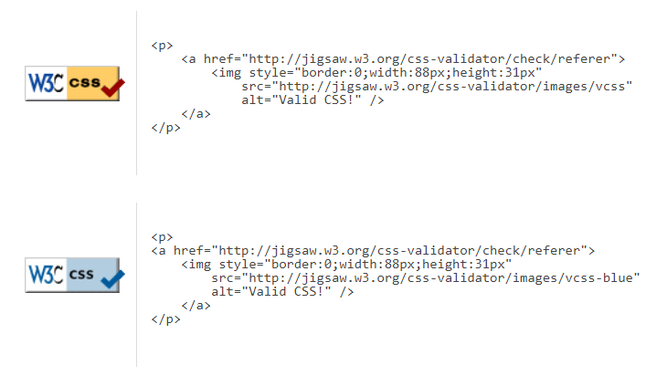
Fig 10. The test for correctness of CSS document has been passed without any complications.

Evaluation

Web Content Accessibility Guidelines is a vast source of tips to make a website open for people with various disabilities. The Four Principles of Accessibility are:
- Perceivable – all information on the side cannot be invisible to all senses.
- Operable – users must be able to deal with website interface in the most not complicated way.
- Understandable – the content of a website must be easy to understand and readable. Also, the interface should be intuitive in use.
- Robust – access to the content given by a site should be independent of the technological evolution and used browsers.
If those principles are not honorary, then people with disabilities may be cut out of using websites. Modern web developers must remember about it because the free and equal access to information is the fundaments of human rights and democracy.
For the project website – “PC Components” – different techniques have been introduced to make the end form accessible for all and intuitive in use. The main aspirations were a simple design and transparent layout of the webpages. Additionally, the responsive techniques were applied to achieve flexibility in displaying on various devices. Furthermore, toned colours were implemented, because they do not disturb users in operations on the website. Another advantage of those colours is smooth but noticeable borders between elements on the screen.
Moreover, the “play of colours” and simple animations support the visibility of clickables elements of the user interface. Changes colours, sizes and styles give a natural feeling of making interaction with some of the components such as buttons or search bars and make the interface readable and intuitive. For instance, if a specific section of the website is open in the window, then it is indicated by the changing size and border colour of the relevant active button in the navigation menu.
Further, the font used in website - “DS ISO 1” – is original but also it does not make any problems in distinguishing letters. The large part of displayed texts is black and have white background what is even better for the human eye to identify sentences as this kind of representation is common in many magazines, books and other websites. Also, more important text-content on the portal is a bit larger than the main text, and it is represented in white on grey or red colour background. It is effected in “catching attention” of users and make the overall layout tidier. The resizing ability of any text on the page is beneficial as it may fit in diverse of screen resolutions, but it is also an advantage for a person who needs to zoom the content to make it visible.
The other essential features which help to extend the access to the “PC Components” for the public is an organisation of the content. Consequently, the provided descriptions are not too overwhelming and are user-friendly. The assumption is that a potential visitor just began its journey into computer architecture technologies. What is more, texts are supported by additional sources, namely pictures and videos which provide extra information and explain the same things but in other words or by just simple visualisation of the mentioned topic.
Despite design stuff its worth to remember about accessibility on other levels. Especially on the technological level. Nowadays there are many browsers and supported them devices, so it is a massive responsibility on web developers to enforce website compatibility with as many numbers of platforms as possible. In this case for stylesheet of “PC Components” project, special prefixes have been implemented. Their role is to display the content of the page correctly on various browsers.
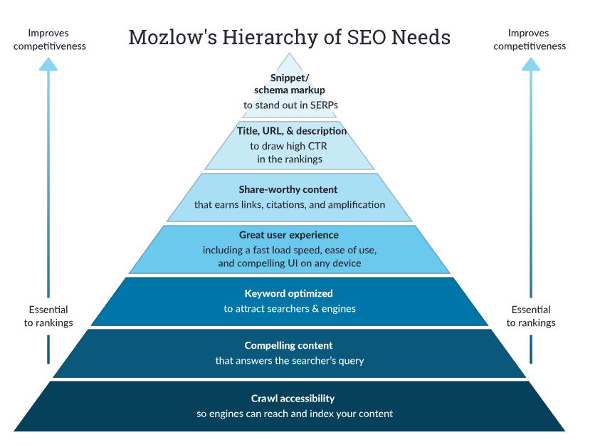
Fig 11. The guide to the hierarchy of Search Engine Optimisation (https://moz.com/beginners-guide-to-seo).
However, the key to release a competitive website on the market is well-organised structure of the HTML program itself. Accordingly, Search Engine Optimisation is a powerful and suitable tool to achieve the well-structured site. At this stage of the website development “PC components” fulfil most of the required criteria. The end project is not only attractive for users directly, but also due to implemented keywords in the code, allowing potential users easy finding “PC Components” from own searchers or engines. Additionally, Google Analytics account has been established to analyse the popularity and actual state of the website on the Internet. The obtained knowledge from this source may be vital for further works on the project.
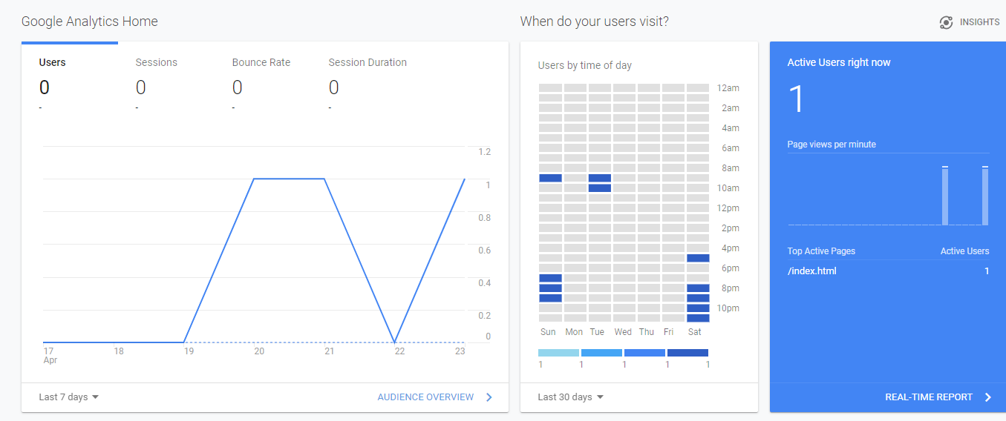
Fig 12. The figure is showing real-time statistics for “PC Components” due to Google Analytics reports.
Summarising, the created website is adapted to a wide range of recipients. It is made up of reasonable content and simple form. Furthermore, the “PC Components” website follows the rules of Search Engine Optimisation, and it is an attractive option for computers hobbyists.

Bibliography

[1] | J. Duckety, HTML & CSS: Design and Build Websites, Indianapolis, Indiana: John Wiley & Sons, 2014.
[2] | M. McGrath, HTML5 In Easy Steps, Southam, Warwickshire: In Easy Steps, 2011.
[3] | w3schools.com, “HTML5 Tutorial,” [Online]. Available: https://www.w3schools.com/html/default.asp.
[4] | w3schools.com, “CSS Tutorial,” [Online]. Available: https://www.w3schools.com/css/default.asp.
[5] | W3C, “HTML & CSS,” W3C, [Online]. Available: https://www.w3.org/standards/webdesign/htmlcss.
[6] | Adobe, “Adobe Color,” [Online]. Available: https://color.adobe.com/create.
[7] | MOZ, “The Beginner's Guide to SEO,” MOZ, [Online]. Available: https://moz.com/beginners-guide-to-seo.
[8] | W3C, “Web Content Accessibility Guidelines (WCAG) 2.1,” W3C, 5 June 2018. [Online]. Available: https://www.w3.org/TR/WCAG21/.
[9] | W3C, “Markup Validation Service,” W3C, [Online]. Available: https://validator.w3.org/#validate_by_input.
[10] | W3C, “CSS Validation Service,” W3C, [Online]. Available: https://jigsaw.w3.org/css-validator/validator.html.en#validate_by_input.
[11] | favicon.cc, “www.favicon.cc,” [Online]. Available: https://www.favicon.cc/.

